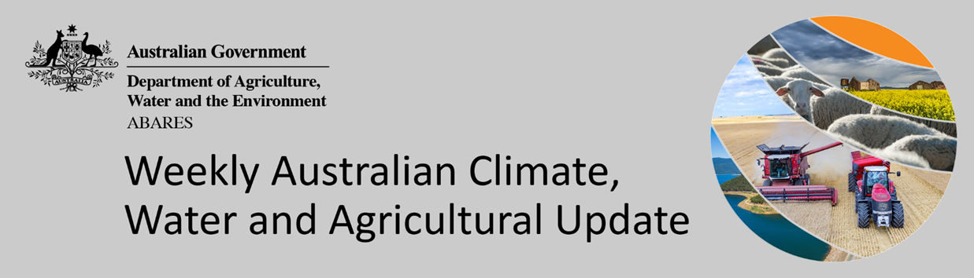
No. 9/2022

10 March 2022

Summary of key issues
- For the week ending 9 March 2022, low-pressure troughs persisted across eastern Australia bringing heavy rainfall. The low-pressure system that brought heavy rainfall to south-east Queensland and northern New South Wales in previous weeks shifted southward, resulting in significant flooding to central and southern coastal regions New South Wales and south-east Queensland. Ex-Tropical Cyclone Anika brought storms and heavy rainfall to parts of Western Australia. In the south, high-pressure systems resulted in clear, dry conditions for large areas of central, western and southern Australia (see Section 1.1).
- Following the heavy rainfall and flooding in parts of northern New South Wales and southern Queensland, field access would still be limited by boggy soil conditions. Continued dry conditions will be required for harvesting of early sown summer crops to resume. The wet conditions have caused damage and quality downgrades to a small proportion of summer grain crops in affected areas.
- Atmospheric and oceanic indicators suggest that a La Niña remains active in the tropical Pacific. La Niña events are typically associated with above-average rainfall for northern and eastern Australia during spring and summer. The Madden-Julian Oscillation is currently weak and unlikely to have a significant impact on Australia’s weather over the coming weeks (see Section 1.2).
- The outlook for April 2022 indicates that there is a 75% chance of rainfall totals between 10 and 50 millimetres across eastern New South Wales, eastern and northern Queensland, southern Victoria, isolated parts of southern South Australia, southern and northern parts of Western Australia, the north of the Northern Territory and Tasmania (see Section 1.3).
- The outlook for April to June 2022 suggests there is a 75% chance of rainfall totals between 50 and 200 millimetres across central and eastern New South Wales, eastern Queensland, southern parts of South Australia and Western Australia, northern parts of the Northern Territory and much of Victoria and Tasmania. Rainfall totals in excess of 200 millimetres are forecast for alpine regions in New South Wales and Victoria, coastal parts of New South Wales and Queensland, as well as western Tasmania.
- Over the 8-days to 17 March 2022, low-pressure troughs are expected to bring rainfall to eastern and northern Australia. Meanwhile, high pressure systems are expected to bring mostly dry conditions to the remainder of western, central and southern Australia (see Section 1.4).
- Water storage in the Murray–Darling Basin (MDB) increased by 2 gigalitres (GL) between 2 March 2022 and 9 March 2022. The current volume of water held in storage is 22,208 GL, which represents 88 per cent of total capacity. This is 68% or 9,000 GL more than at the same time last year.
- Allocation prices in the Victorian Murray below the Barmah Choke decreased from $70 per ML on 25 February 2022 to $67 per ML on 4 March 2022. Prices are lower in the Goulburn-Broken, Murrumbidgee and regions above the Barmah choke due to the binding of the Goulburn intervalley trade limit, Murrumbidgee export limit and Barmah choke trade constraint.

Climate

Rainfall this week
For the week ending 9 March 2022, low-pressure troughs persisted across eastern Australia bringing heavy rainfall. The low-pressure system that brought heavy rainfall to south-east Queensland and northern New South Wales in previous weeks shifted southward, resulting in significant flooding to central and southern coastal regions New South Wales and south-east Queensland. Ex-Tropical Cyclone Anika brought storms and heavy rainfall to parts of Western Australia. In the south, high-pressure systems resulted in clear, dry conditions for large areas of central, western and southern Australia.
Rainfall totals of between 10 and 100 millimetres were recorded across eastern New South Wales and Victoria, south-east and northern Queensland, south-west South Australia, central and northern parts of Western Australia, the north of the Northern Territory and parts of Tasmania. Rainfall totals in excess of 100 millimetres were recorded in parts of eastern New South Wales and northern parts of Western Australia. Remaining parts of Australia received little to no rainfall.
In cropping regions, rainfall totals of between 10 and 100 millimetres were recorded across central parts of New South Wales, far south-east Queensland and eastern Victoria. Little to no rainfall was recorded across cropping regions in remaining parts of New South Wales, much of Queensland, western Victoria, as well as South Australia and Western Australia.
Following the heavy rainfall and flooding in parts of northern New South Wales and southern Queensland, field access would still be limited by boggy soil conditions. Continued dry conditions will be required for harvesting of early sown summer crops to resume. The wet conditions have likely caused damage and quality downgrades to a small proportion of crops. Central Queensland cropping regions received little to no rainfall over the last 8-days, and soil moisture levels remain mixed for late sown summer grain crops.

Rainfall for the week ending 9 March 2022

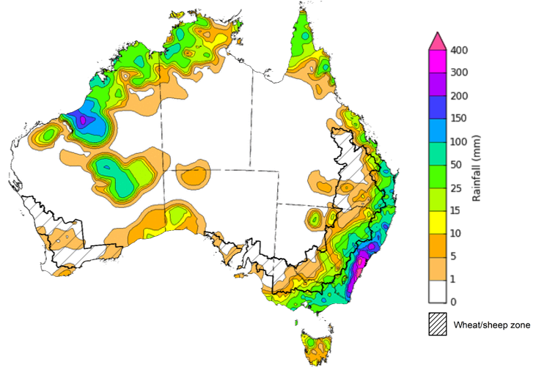

©Commonwealth of Australia 2022, Australian Bureau of Meteorology Issued: 9/3/2022
Note: The rainfall analyses and associated maps utilise data contained in the Bureau of Meteorology climate database, the Australian Data Archive for Meteorology (ADAM). The analyses are initially produced automatically from real-time data with limited quality control. They are intended to provide a general overview of rainfall across Australia as quickly as possible after the observations are received. For further information go to http://www.bom.gov.au/climate/rainfall/

Climate Drivers
Throughout autumn the climate drivers with the largest potential impact on Australia’s climate patterns are the El Niño–Southern Oscillation (ENSO) and the Madden-Julian Oscillation (MJO). These climate drivers are likely to influence the growth and development of later planted summer crops in northern growing regions, pasture growth across both northern and southern Australia and planting opportunities for winter crops.
Atmospheric and oceanic indicators suggest that a La Niña remains active in the tropical Pacific. La Niña events are typically associated with above-average rainfall for northern and eastern Australia during spring and summer. International climate models expect the La Niña event will dissipate over the coming months. Despite the easing of La Niña atmospheric and oceanic patterns, they are likely to continue influencing rainfall patterns in northern and eastern Australia over the coming months. The MJO is currently weak and unlikely to have a significant impact on Australia weather over the coming weeks.
Below average sea surface temperature (SST) anomalies have persisted in the equatorial region of central and eastern Pacific Ocean over the past two weeks. Sub-surface water has continued to warm across the western Pacific, as well as warm anomalies emerging in the eastern Pacific. Current SST anomalies reflect typical La Niña patterns, with below average SST along the equator, and warm SST anomalies to the north and south. However, the development of warm sub-surface anomalies in the eastern Pacific suggests the imminent breakdown of the current La Niña event.

Difference from average sea surface temperature observations 21 to 27 February 2022
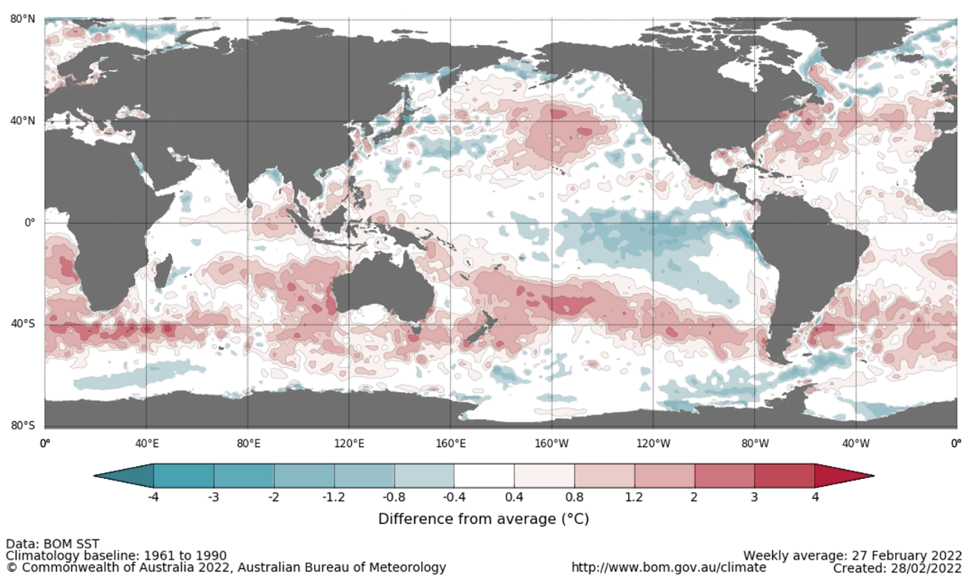

International climate model outlooks for the NINO 3.4 region in April 2022
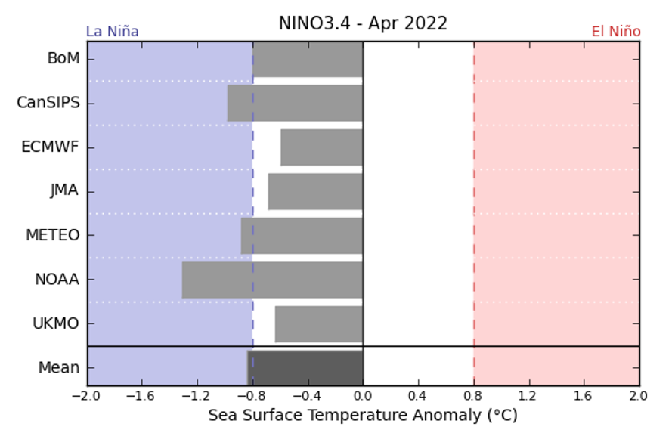
©Commonwealth of Australia 2022, Australian Bureau of Meteorology Issued: 1/2/2022
The La Niña event in the Pacific Ocean is now past its peak and is expected to continue to dissipate through autumn. Most climate models surveyed by the Bureau of Meteorology expect the La Niña event to dissipate by April, with only two of the seven models expecting it to remain active in May 2022. ENSO events are most active throughout spring and summer, then decay and return to neutral conditions in autumn. For the period ending 27 February 2022, the 30-day SOI was +9.6 and the 90-day SOI was +8.6, both above the La Niña threshold of +7. Above average SST anomalies have continued across parts of the Maritime Continent and strengthened over north-eastern and north-western Australia. Trade winds across the western tropical Pacific have remained stronger than average, while cloudiness near the Date Line has been consistently below average since June 2021.These indications are consistent with the ongoing La Niña event.

30-day Southern Oscillation Index (SOI) values ending 7 March 2022
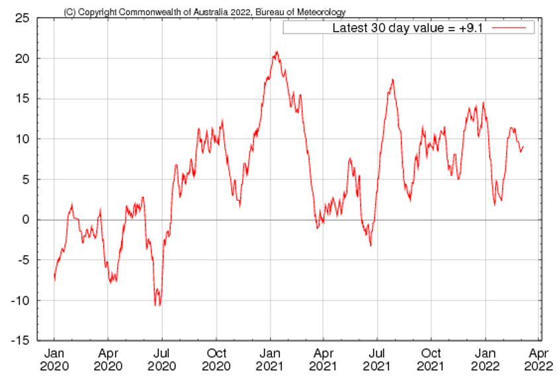

National Climate Outlook
These climate outlooks are generated by ACCESS–S (Australian Community Climate Earth-System Simulator–Seasonal). ACCESS–S is the Bureau of Meteorology's dynamical (physics-based) weather and climate model used for monthly, seasonal and longer-lead climate outlooks.
For further information, go to http://www.bom.gov.au/climate/ahead/about/
The Bureau of Meteorology’s latest rainfall outlook indicated wetter than average conditions are expected across parts of eastern Australia during April. The ACCESS-S climate model suggests there is close to a 55% chance of exceeding median April rainfall totals across eastern New South Wales and Queensland.
The outlook for April 2022 indicates that there is a 75% chance of rainfall totals between 10 and 50 millimetres across eastern New South Wales, eastern and northern Queensland, southern Victoria, isolated parts of southern South Australia, southern and northern parts of Western Australia, the north of the Northern Territory and Tasmania. Rainfall totals in excess of 100 millimetres are expected in parts of north-eastern New South Wales, northern Queensland and western Tasmania.
Across cropping regions there is a 75% chance of rainfall totals of between 10 and 25 millimetres across central and northern New South Wales, south-eastern and central Queensland, parts of southern Victoria and and eastern parts of Western Australia. There is a 75% chance of rainfall less than 10 millimetres for south-western New South Wales, south-western and northern Queensland, as well as much of South Australia and remaining parts of Western Australia. The wetter than average conditions expected for most eastern Australian cropping regions is likely to support the growth and yield potentials of late-sown summer crops in New South Wales and Queensland.
Rainfall totals that have a 75% chance of occurring April 2022
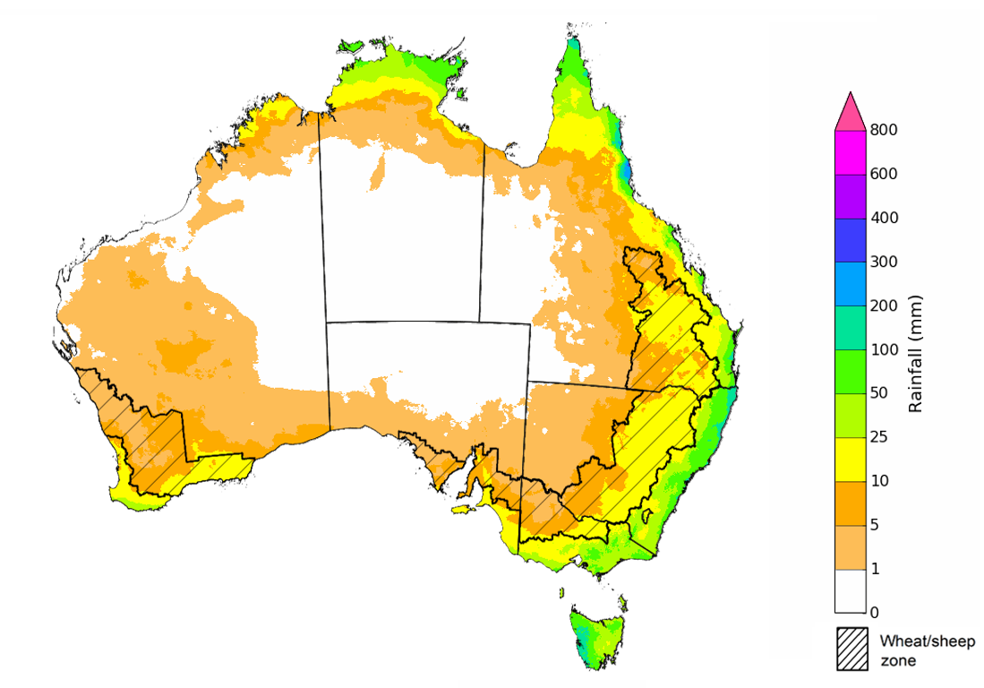
©Commonwealth of Australia 2022, Australian Bureau of Meteorology Issued: 3/3/2022

The rainfall outlook for April to June 2022 suggests there is a greater than 60% chance of exceeding median rainfall across large parts of New South Wales and Queensland, and isolated parts of Victoria, South Australia, Western Australia and the Northern Territory. There is a greater than 70% chance of exceeding median rainfall across north-eastern New South Wales, eastern Queensland and Victoria, the north-west of Western Australia and northern parts of the Northern Territory. For remaining regions of Australia, there is roughly an equal chance of above and below median rainfall, with only isolated areas western Tasmania expecting to receive below average rainfall between April and June 2022 (Bureau of Meteorology ‘National Climate Outlook’, 7 March 2022).
Bureau of Meteorology rainfall outlooks for April to June have greater than 55% past accuracy across most of eastern and western Australia. Outlook accuracy is greater than 65% across isolated parts of the country. However, there is low past accuracy for parts of northern Queensland, western Victoria, the north and west of South Australia, the east of Western Australia and northern parts of the Northern Territory.
Chance of exceeding the median rainfall April to June 2022
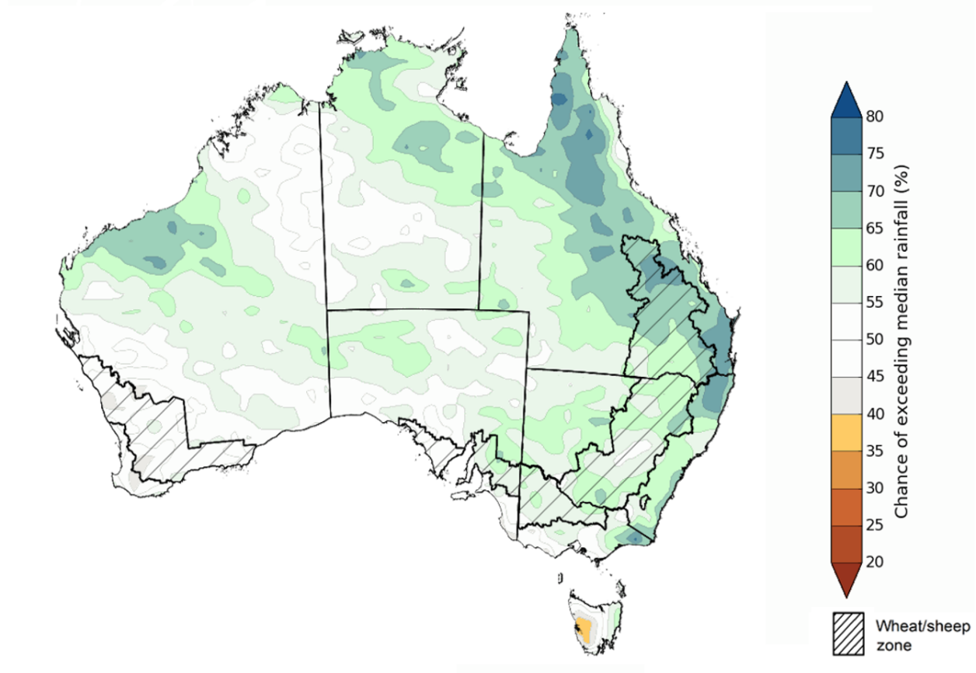
©Commonwealth of Australia 2022, Australian Bureau of Meteorology Issued: 3/3/2022

The outlook for April to June 2022 suggests there is a 75% chance of rainfall totals between 50 and 200 millimetres across central and eastern New South Wales, eastern Queensland, southern parts of South Australia and Western Australia, northern parts of the Northern Territory and much of Victoria and Tasmania. Rainfall totals in excess of 200 millimetres are forecast for alpine regions in New South Wales and Victoria, coastal parts of New South Wales and Queensland, as well as western Tasmania.
Across cropping regions, there is a 75% chance of receiving between 50 and 200 millimetres across much of New South Wales, Queensland, Victoria, South Australia and Western Australia. Totals of less than 50 millimetres are expected across isolated parts of cropping regions in northern Victoria, South Australia and Western Australia.
These rainfall totals are slightly below average to average for this three-month period across most New South Wales and Queensland cropping regions, and slightly below average for cropping regions in Victoria, South Australia and Western Australia. Following heavy rainfall over recent weeks, upper layer soil moisture levels are above average to average across summer cropping regions in New South Wales and Queensland, which will support the establishment and development of late sown summer crops. Likewise, lower soil moisture levels are above average to average across summer cropping regions, which will support yield potentials of earlier sown crops with long growth periods.
Rainfall totals that have a 75% chance of occurring April to June 2022

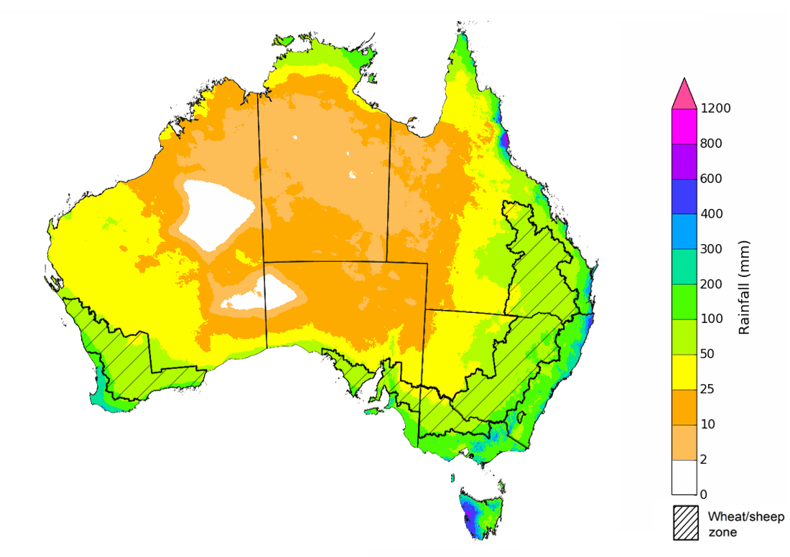
©Commonwealth of Australia 2022, Australian Bureau of Meteorology Issued: 3/3/2022
The temperature outlook for April to June 2022 indicates that maximum temperatures across most of Australia are likely to be close to the 1990-2012 average (- 1°C to 1°C). Minimum temperatures are expected to be slightly above average for parts of Queensland, Western Australia, the Northern Territory and Tasmania, and close to average for the rest of Australia (Bureau of Meteorology ‘National Climate Outlook’, 7 March 2022).
Predicted maximum temperature anomaly for April to June 2022

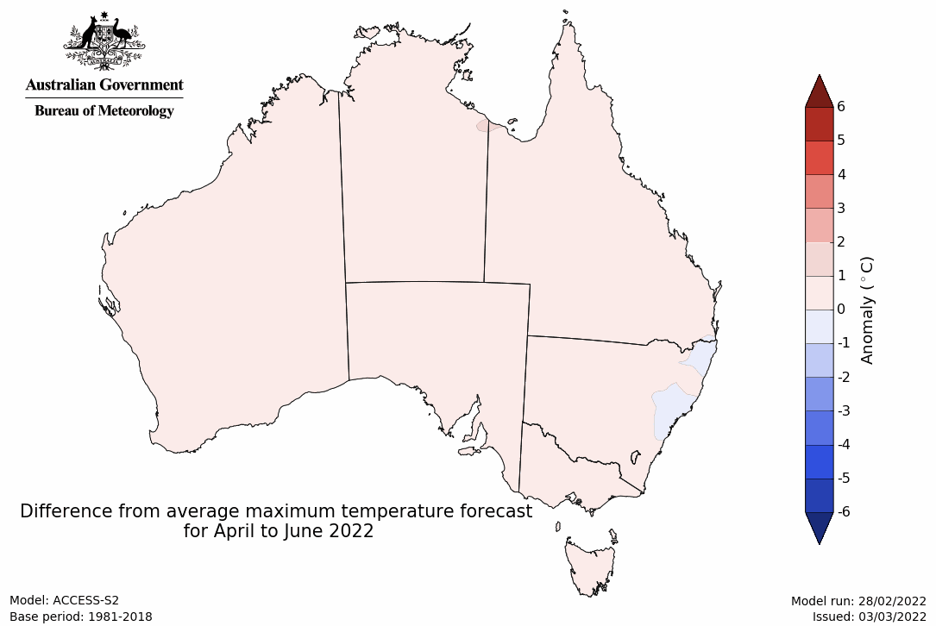
Predicted minimum temperature anomaly for April to June 2022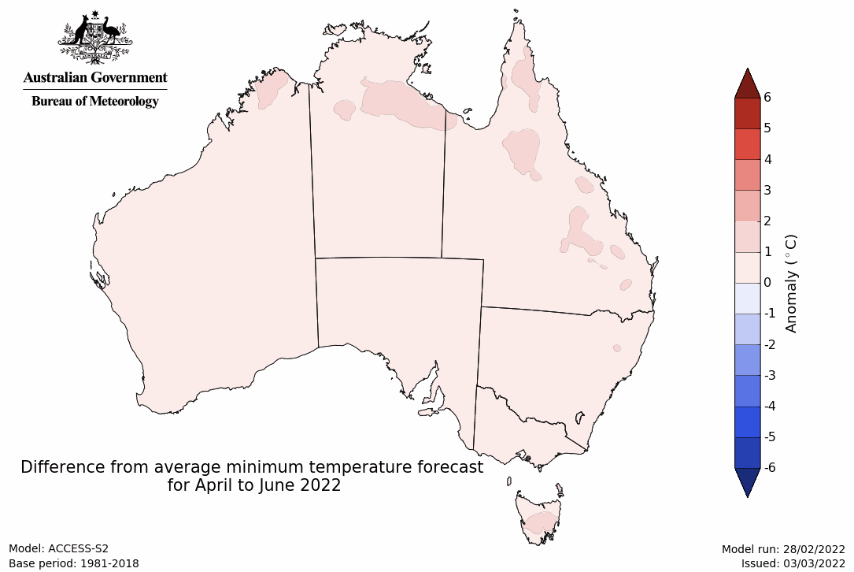

Rainfall forecast for the next eight days
Over the 8-days to 17 March 2022, low-pressure troughs are expected to bring rainfall to eastern and northern Australia. Meanwhile, high pressure systems are expected to bring mostly dry conditions to the remainder of western, central and southern Australia.
Rainfall totals of between 10 and 50 millimetres are forecast for central and eastern New South Wales, south-western, eastern and northern parts of Queensland, much of Victoria, as well as northern parts of Western Australia the Northern Territory and parts of Tasmania. Rainfall in excess of 100 millimetres is expected in northern parts of Queensland and the Northern Territory.
In Australian cropping regions, rainfall totals of between 10 and 50 millimetres are expected across the south-west of New South Wales, north-east Queensland, and eastern Victoria. Little to no rainfall is forecast for all remaining cropping regions during the next 8-days.
The dry conditions forecast across northern New South Wales and southern Queensland will allow for the continued draining of soil moisture profiles, following significant rainfall and flooding in recent weeks. If the forecast drier conditions are realised, harvesting of early sown summer crops will be able to resume. For early sown summer crops with longer growth periods, such as cotton, root zone soil moisture levels across most summer cropping regions are above average to average and will help support them through critical stages of flowering and boll filling. The expected rainfall for parts of Central Queensland will support later sown summer crops through establishment and improve plant available moisture.

Total forecast rainfall (mm) for the period 10 March to 17 March 2022
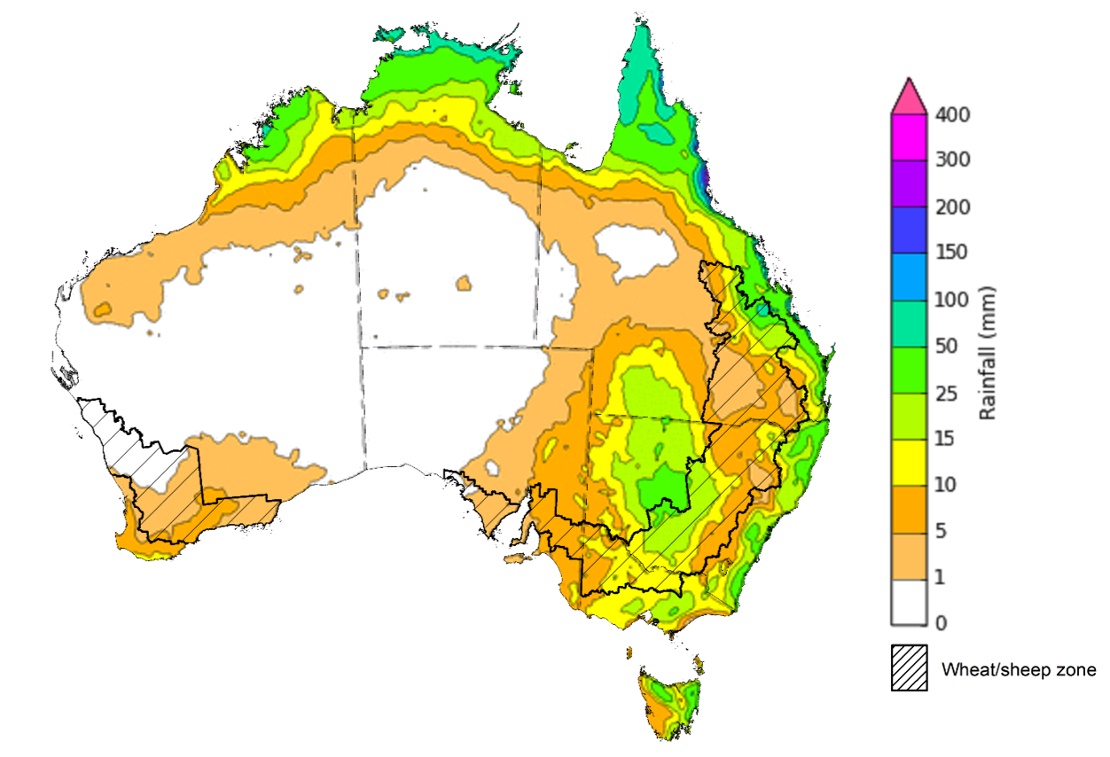
©Commonwealth of Australia 2022, Australian Bureau of Meteorology Issued: 10/3/2022

Water
Note: This rainfall forecast is produced from computer models. As the model outputs are not altered by weather forecasters, it is important to check local forecasts and warnings issued by the Bureau of Meteorology.

Water markets – current week
Water storage in the Murray–Darling Basin (MDB) increased by 2 gigalitres (GL) between 2 March 2022 and 9 March 2022. The current volume of water held in storage is 22,208 GL, which represents 88 per cent of total capacity. This is 68% or 9,000 GL more than at the same time last year.

Water storages in the Murray-Darling Basin, 2013–2022
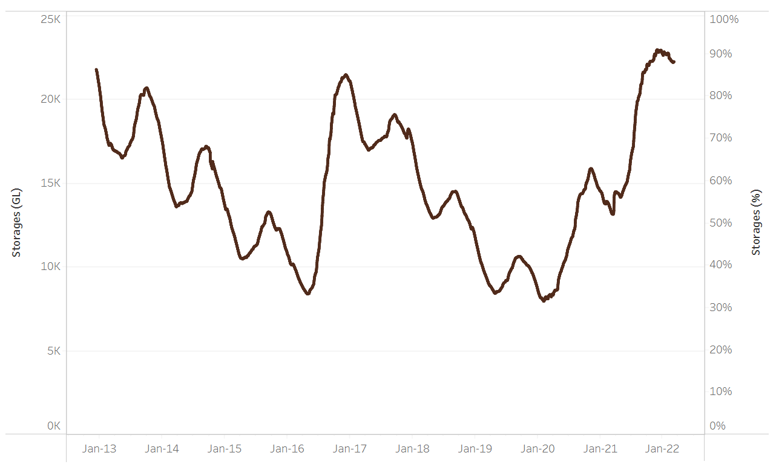
Allocation prices in the Victorian Murray below the Barmah Choke decreased from $70 per ML on 25 February 2022 to $67 per ML on 4 March 2022. Prices are lower in the Goulburn-Broken, Murrumbidgee and regions above the Barmah choke due to the binding of the Goulburn intervalley trade limit, Murrumbidgee export limit and Barmah choke trade constraint.
Water storage data is sourced from the Bureau of Meteorology.

Region | $/ML
NSW Murray Above | 31
NSW Murrumbidgee | 18
VIC Goulburn-Broken | 50
VIC Murray Below | 67

Surface water trade activity, Southern Murray–Darling Basin

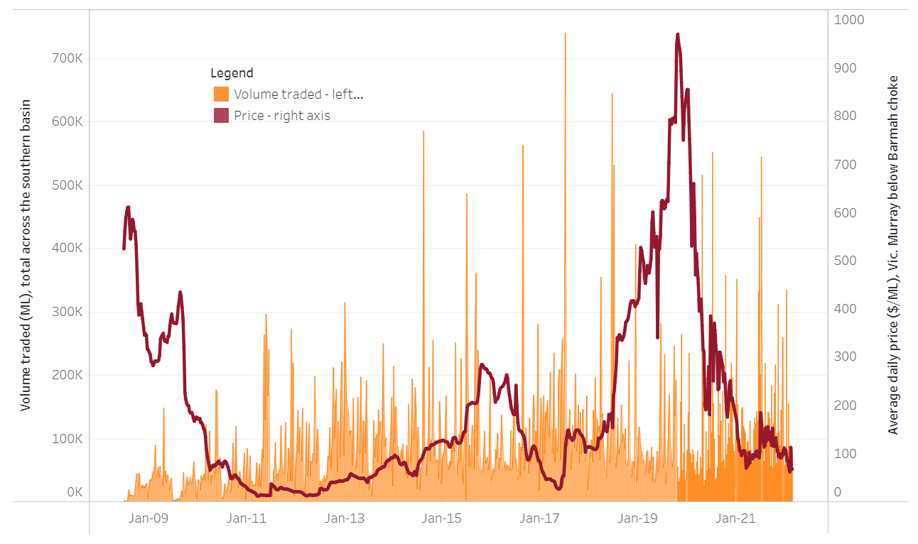
To access the full, interactive, weekly water dashboard, which contains the latest and historical water storage, water market and water allocation information, please visit http://www.agriculture.gov.au/abares/products/weekly_update/weekly-update-100322
The trades shown reflect estimated market activity and do not encompass all register trades. The price is shown for the VIC Murray below the Barmah choke. Historical prices (before 1 July 2019) are ABARES estimates after removing outliers from BOM water register data. Prices after 1 July 2019 and prior to the 30 October 2019 reflect recorded transaction prices as sourced from Ruralco. Prices after the 30 October 2019 are sourced from Waterflow. Data for volume traded is sourced from the BOM water register. Data shown is current at 10 March 2022.

Commodities

Indicator | Week ended | Unit | Latest price | Previous week | Weekly change | Price 12 months ago | Annual change
Selected world indicator prices
AUD/USD Exchange rate | 09-Mar | A$/US$ | 0.73 | 0.72 | 1% | 0.78 | -5%
Wheat – US no. 2 hard red winter wheat, fob Gulf | 09-Mar | US$/t | 539 | 444 | 21% | 274 | 97%
Corn – US no. 2 yellow corn, fob Gulf | 09-Mar | US$/t | 351 | 321 | 9% | 248 | 42%
Canola – Rapeseed, Canada, fob Vancouver | 09-Mar | US$/t | 907 | 893 | 2% | 668 | 36%
Cotton – Cotlook 'A' Index | 09-Mar | USc/lb | 133 | 135 | -1% | 92 | 44%
Sugar – Intercontinental Exchange, nearby futures, no.11 contract | 09-Mar | USc/lb | 19.2 | 18.0 | 7% | 16 | 23%
Wool – Eastern Market Indicator | 09-Mar | Ac/kg clean | 1,432 | 1,447 | -1% | 1,202 | 19%
Wool – Western Market Indicator | 02-Feb | Ac/kg clean | 1,443 | 1,455 | -1% | 1,024 | 41%
Selected Australian grain export prices
Milling Wheat – APW, Port Adelaide, SA | 09-Mar | A$/t | 551 | 508 | 9% | 356 | 55%
Feed Wheat – ASW, Port Adelaide, SA | 09-Mar | A$/t | 522 | 478 | 9% | 354 | 48%
Feed Barley – Port Adelaide, SA | 09-Mar | A$/t | 431 | 403 | 7% | 301 | 43%
Canola – Kwinana, WA | 09-Mar | A$/t | 1,116 | 1,050 | 6% | 672 | 66%
Grain Sorghum – Brisbane, QLD | 09-Mar | A$/t | 375 | 375 | 0% | 364 | 3%
Selected domestic livestock indicator prices
Beef – Eastern Young Cattle Indicator | 09-Mar | Ac/kg cwt | 1,112 | 1,123 | -1% | 860 | 29%
Mutton – Mutton indicator (18–24 kg fat score 2–3), Vic | 09-Mar | Ac/kg cwt | 592 | 552 | 7% | 645 | -8%
Lamb – Eastern States Trade Lamb Indicator | 09-Mar | Ac/kg cwt | 807 | 817 | -1% | 846 | -5%
Pig – Eastern Seaboard (60.1–75 kg), average of buyers & sellers | 26-Jan | Ac/kg cwt | 357 | 357 | 0% | 309 | 16%
Goats – Eastern States (12.1–16 kg) | 09-Mar | A$/US$ | 0.73 | 0.72 | 1% | 0.78 | -5%
Live cattle – Light steers ex Darwin to Indonesia | 09-Mar | US$/t | 539 | 444 | 21% | 274 | 97%
Live sheep – Live wethers (Muchea WA saleyard) to Middle East | 09-Mar | US$/t | 351 | 321 | 9% | 248 | 42%

Indicator | Week ended | Unit | Latest price | Previous week | Weekly change | Price 12 months ago | Annual change
Global Dairy Trade (GDT) weighted average prices ª
Dairy – Whole milk powder | 02-Mar | US$/t | 4,757 | 4,503 | 6% | 3,233 | 47%
Dairy – Skim milk powder | 02-Mar | US$/t | 4,481 | 4,295 | 4% | 3,036 | 48%
Dairy – Cheddar cheese | 02-Mar | US$/t | 6,394 | 5,881 | 9% | 4,302 | 49%
Dairy – Anhydrous milk fat | 02-Mar | US$/t | 7,048 | 6,889 | 2% | 4,626 | 52%
a Global Dairy Trade prices are updated twice monthly on the first and third Tuesday of each month.

Selected world indicator prices
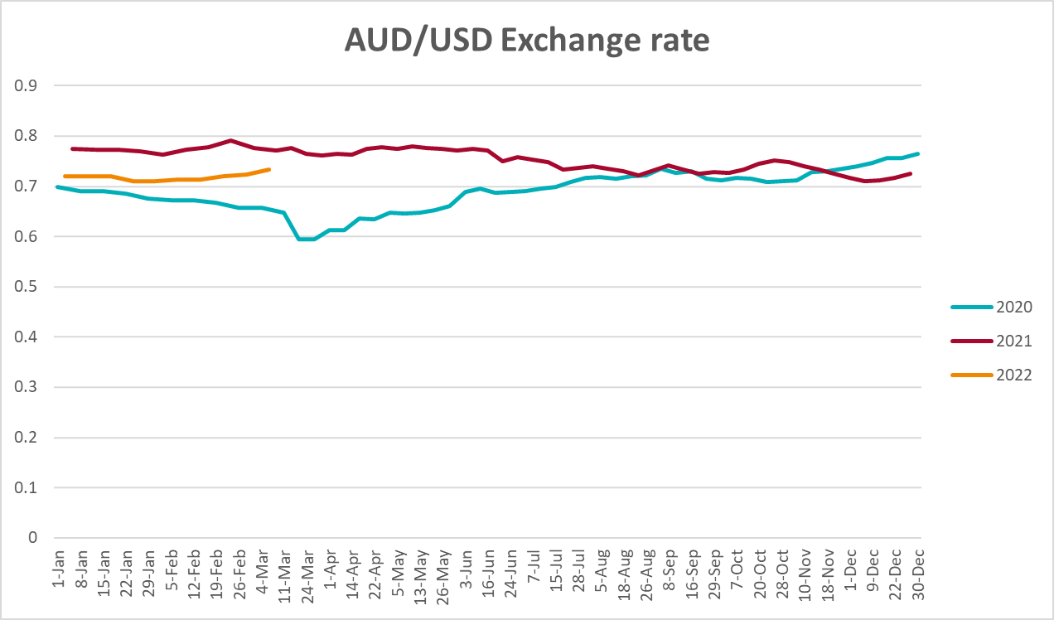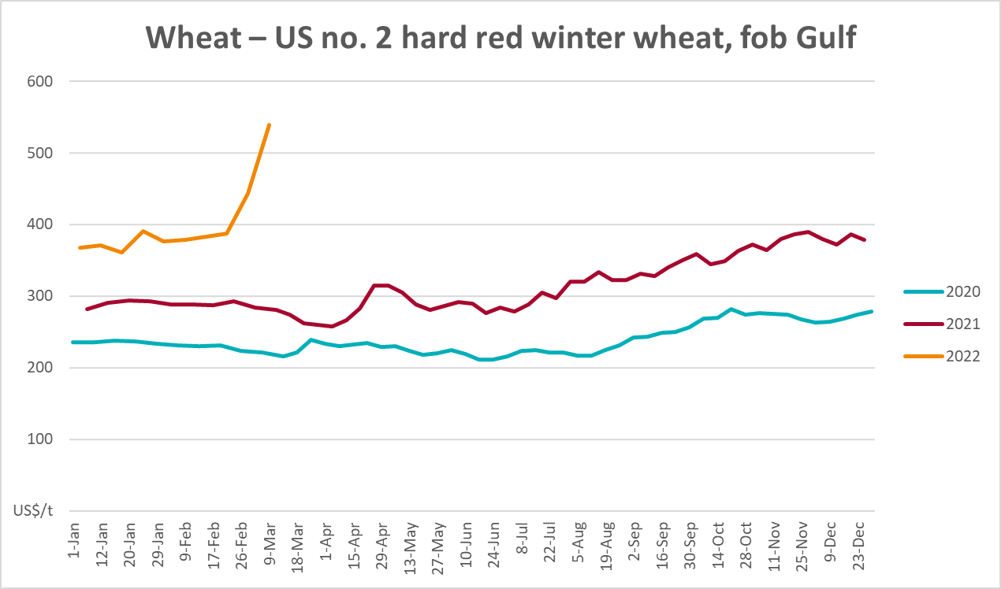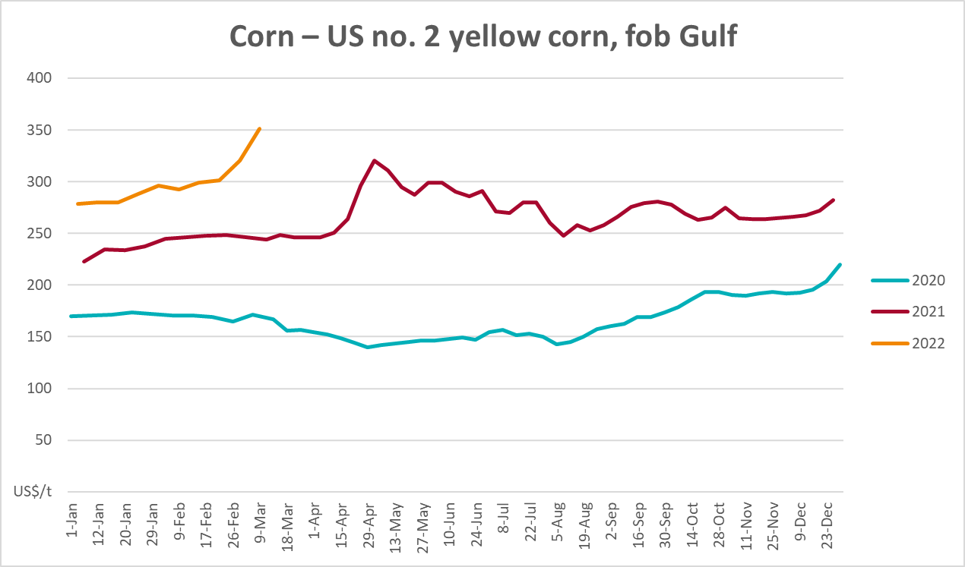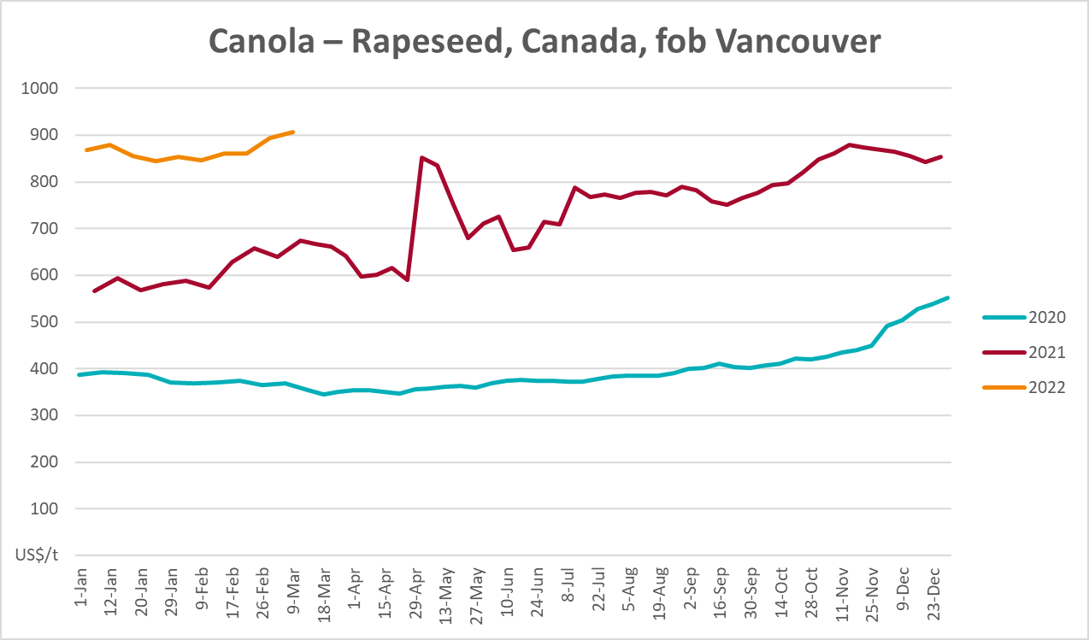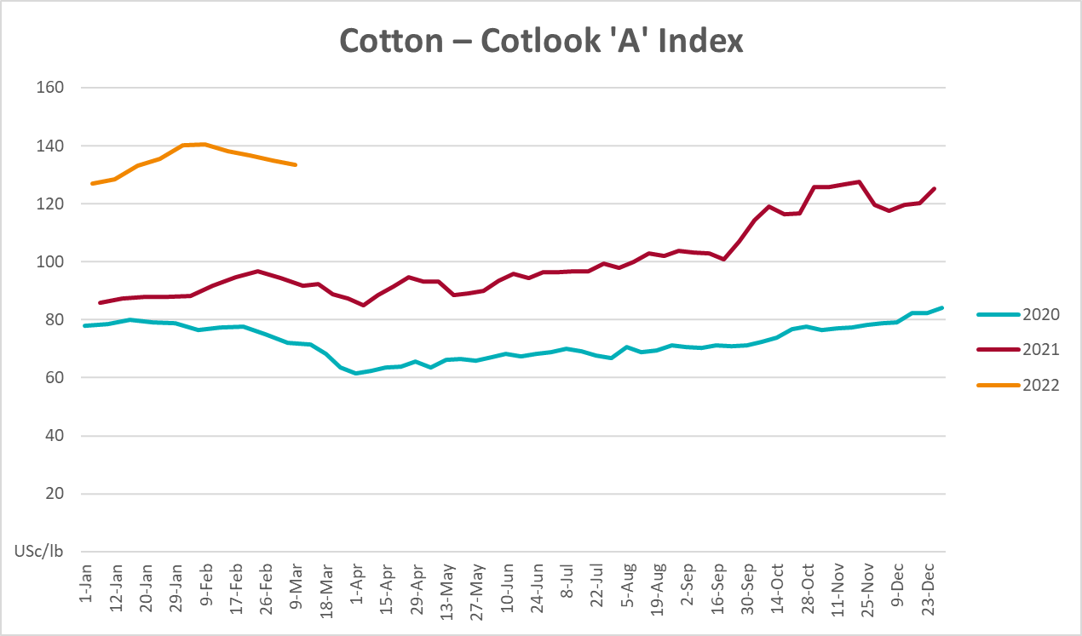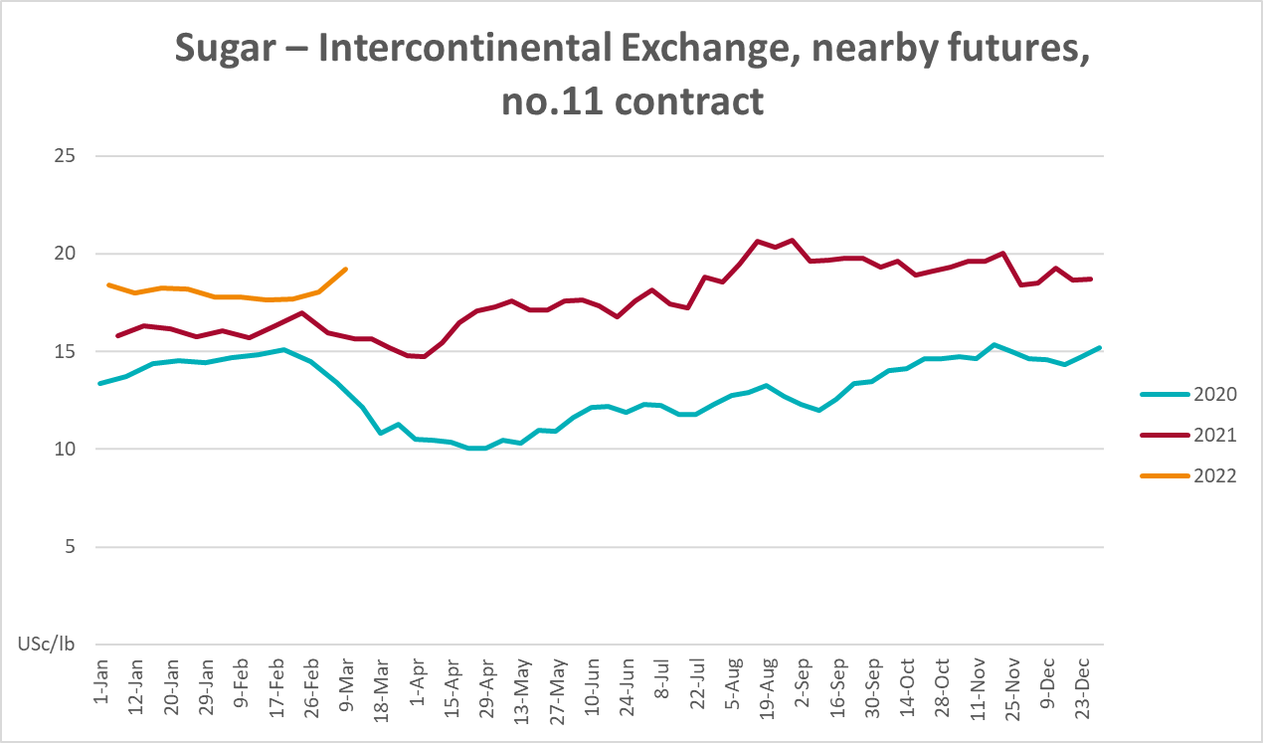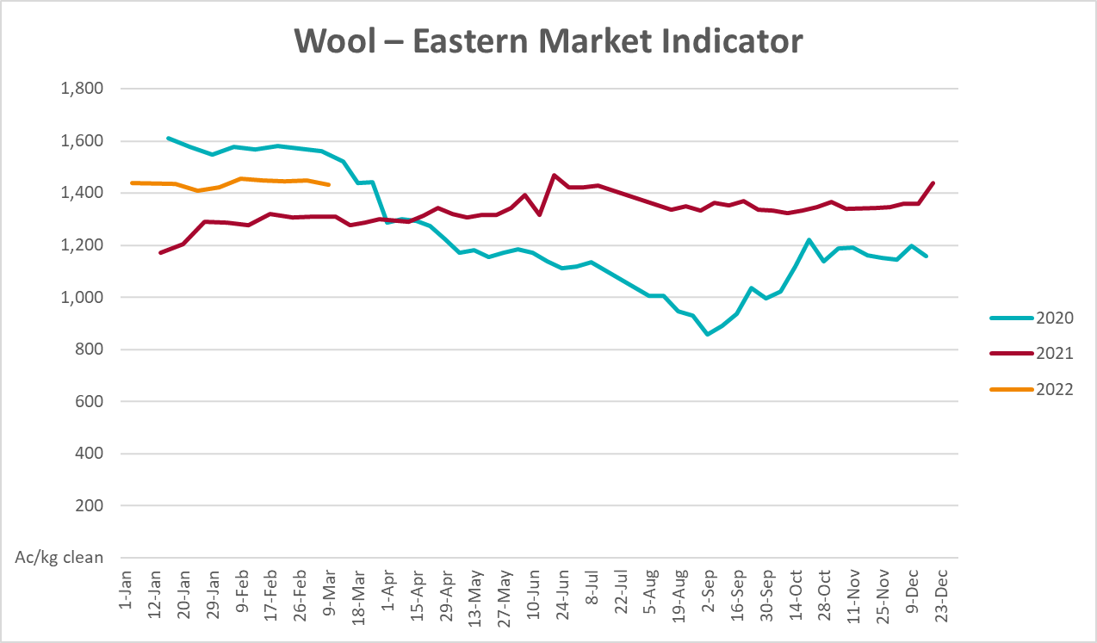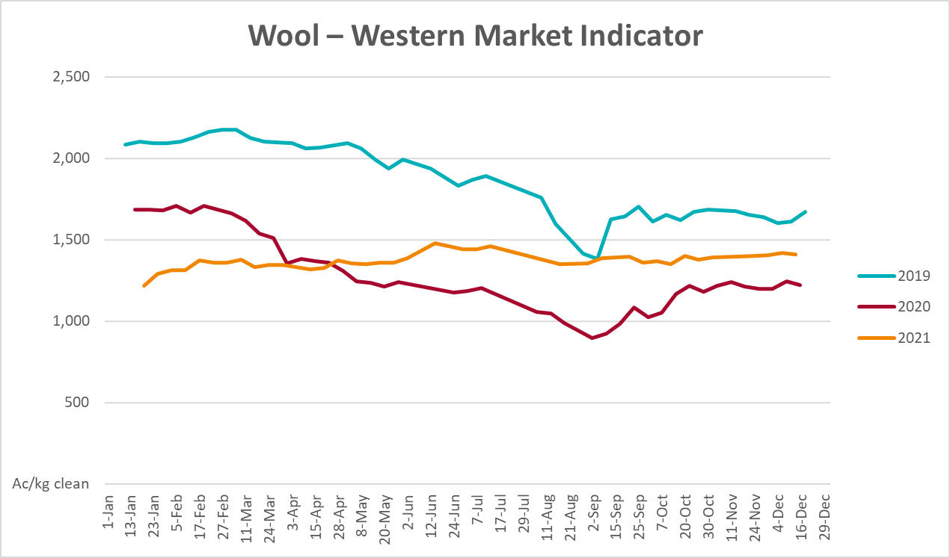

Selected domestic crop indicator prices
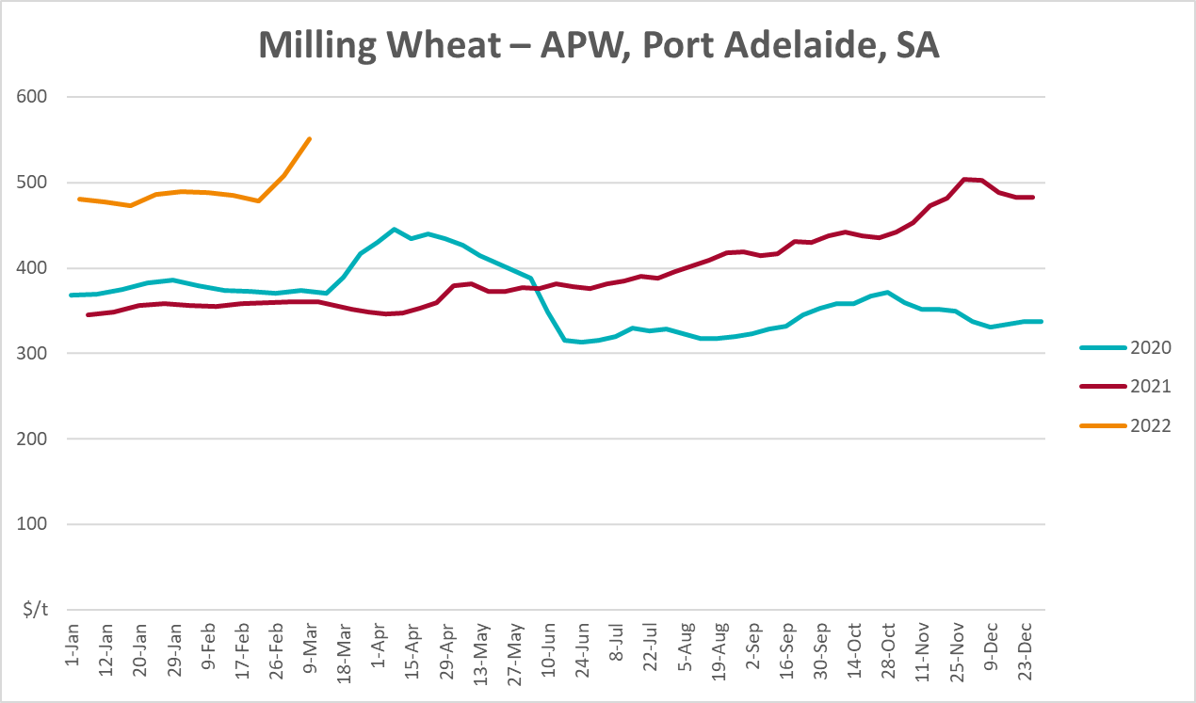
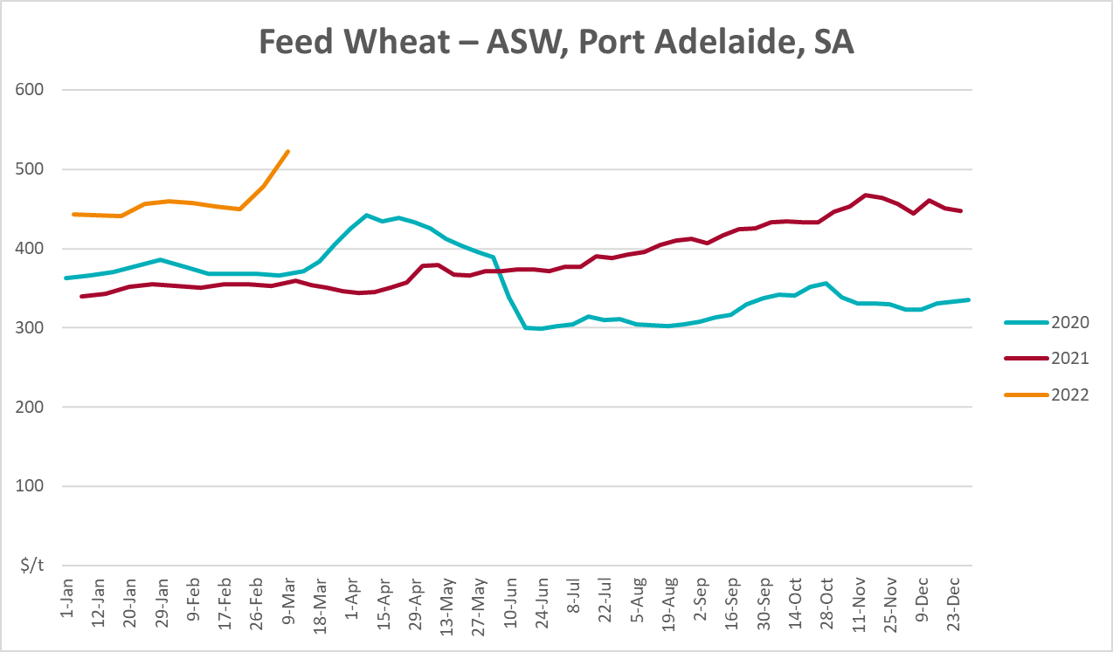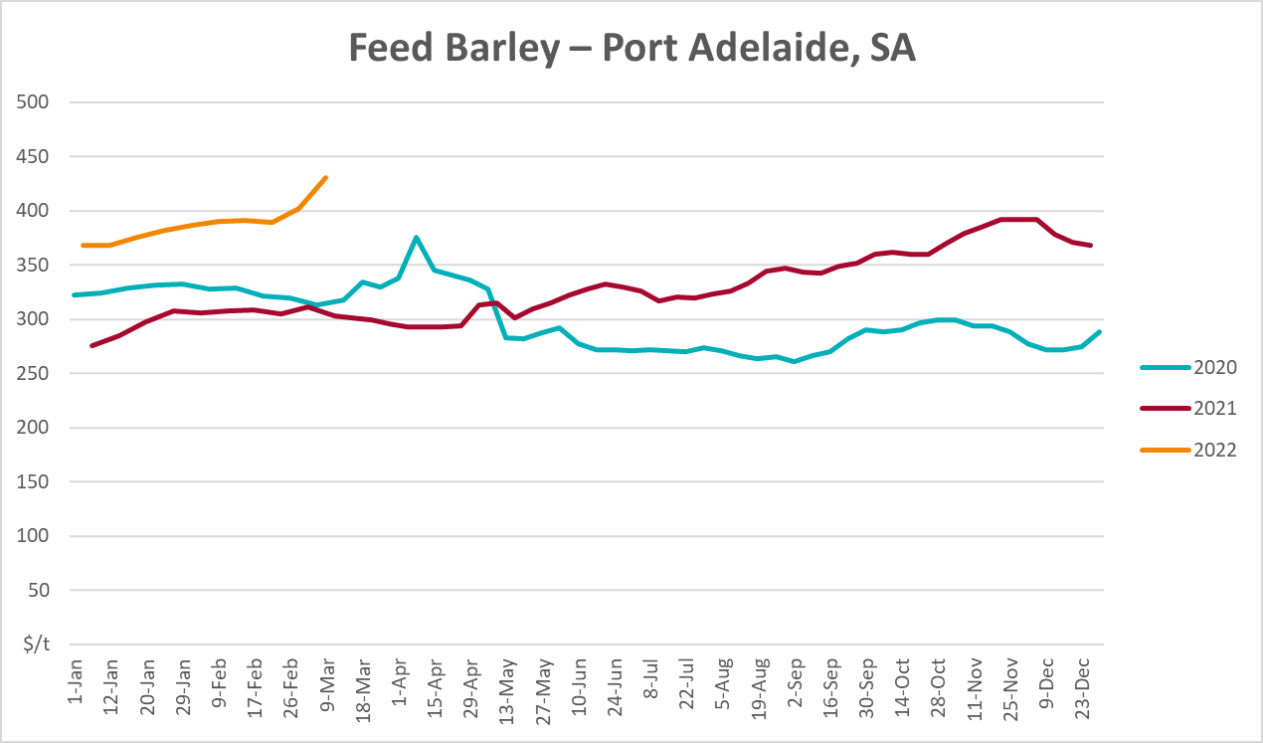
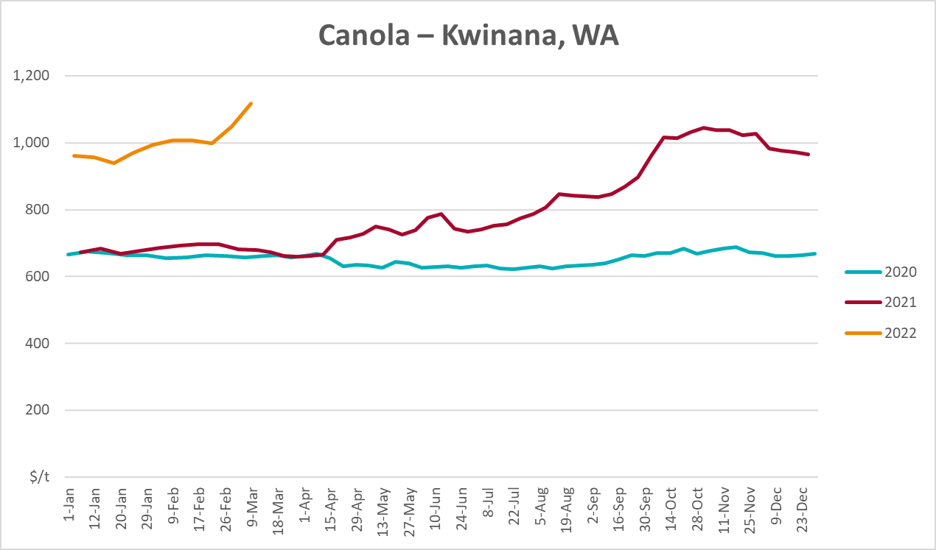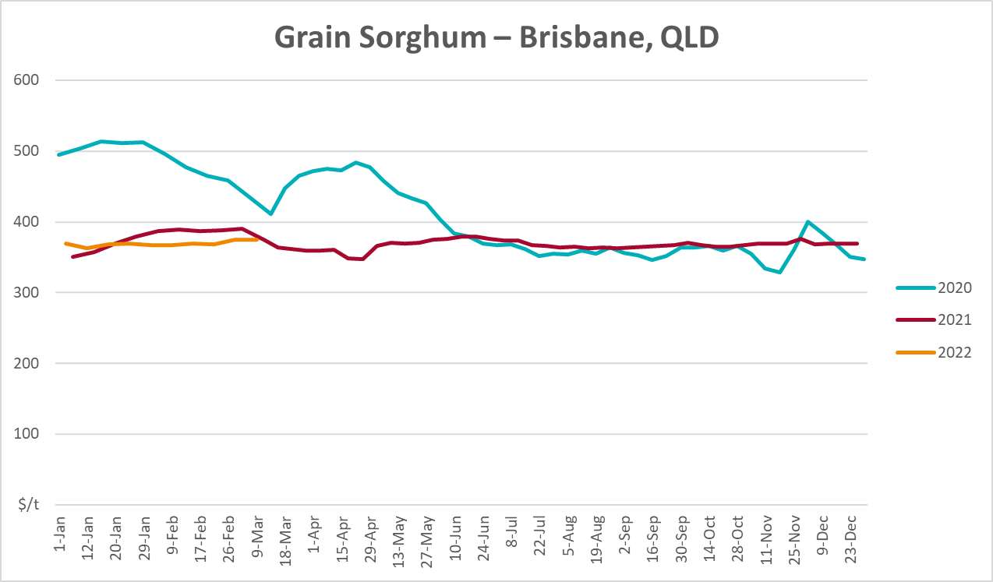

Selected domestic livestock indicator prices
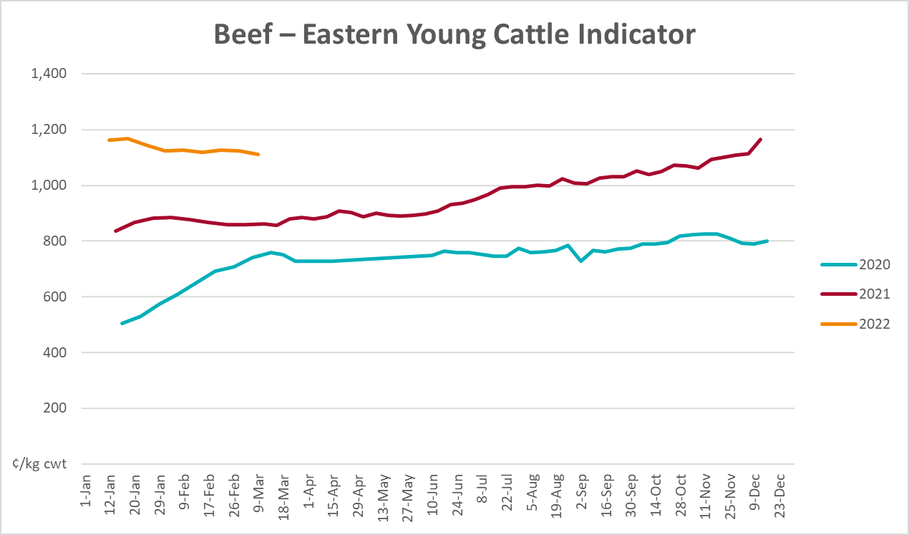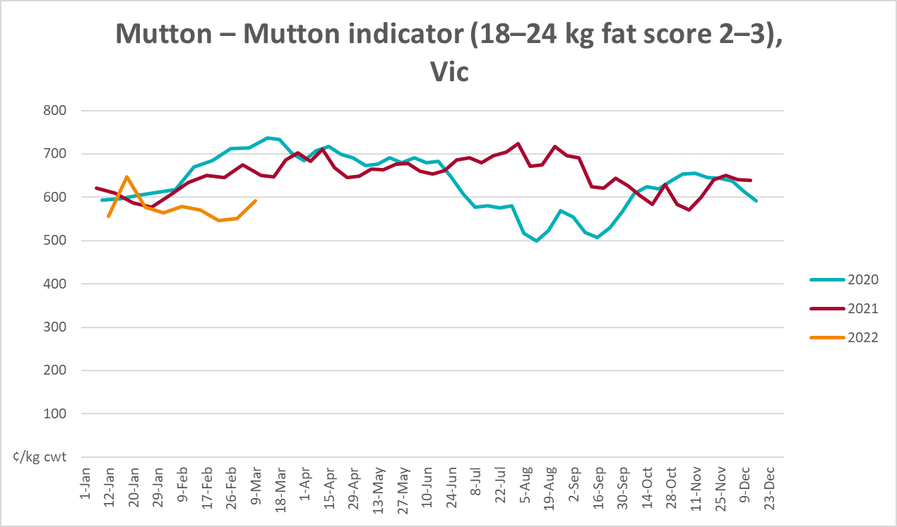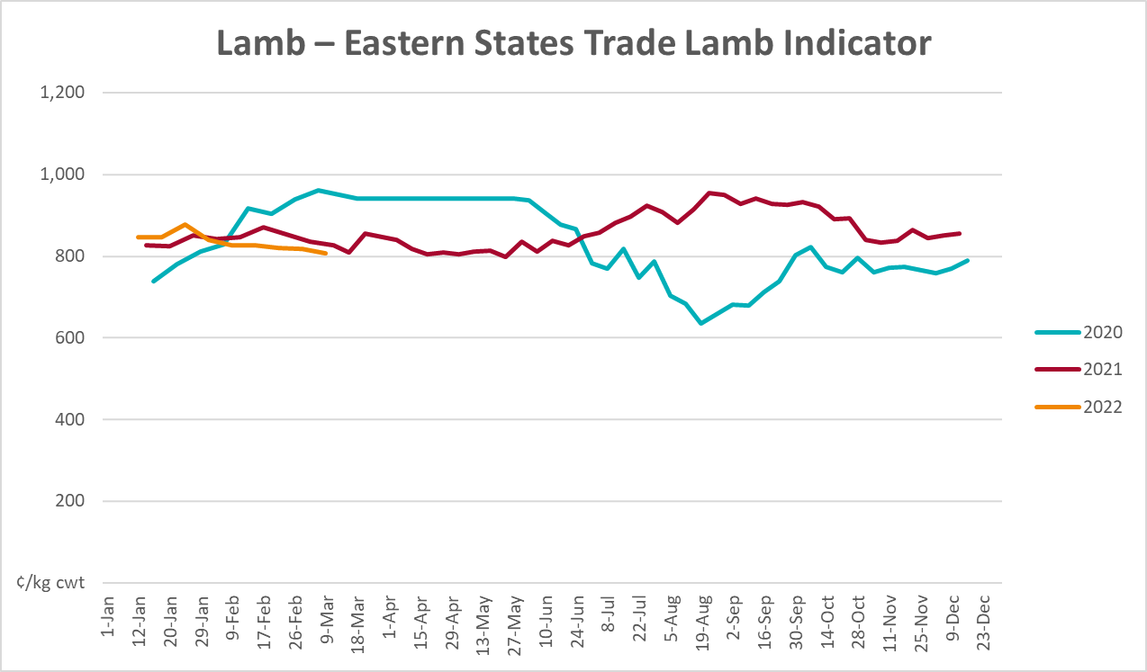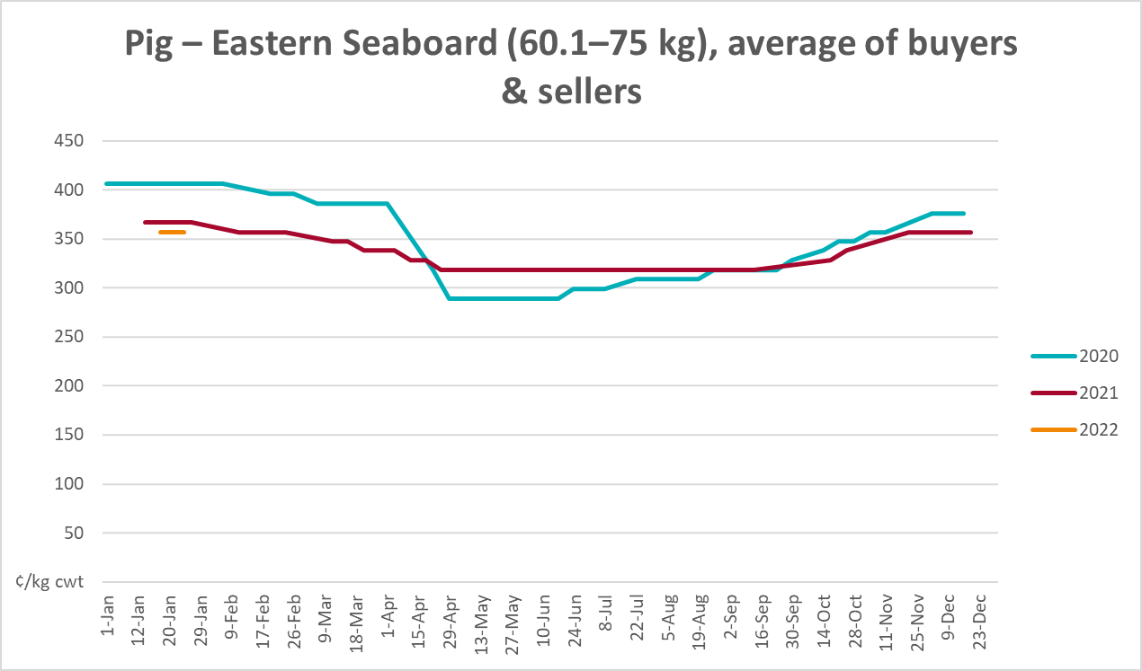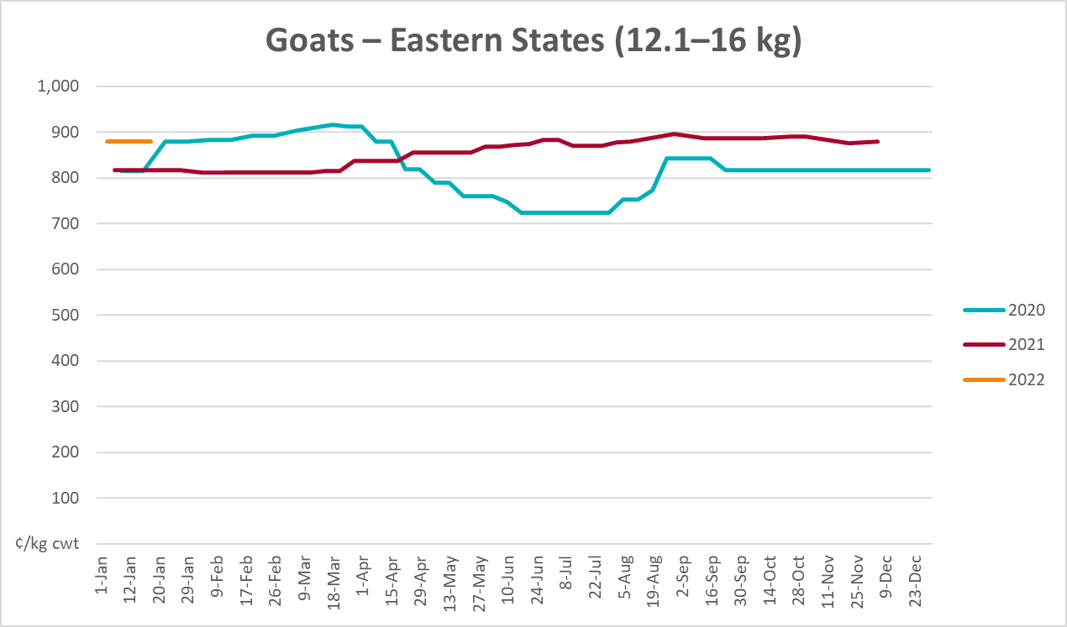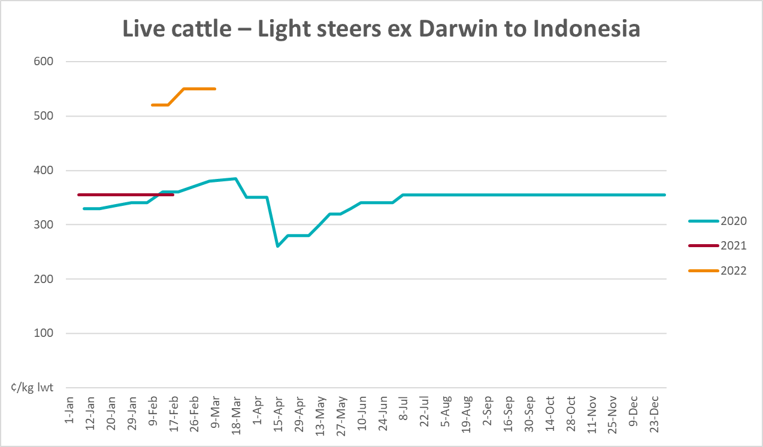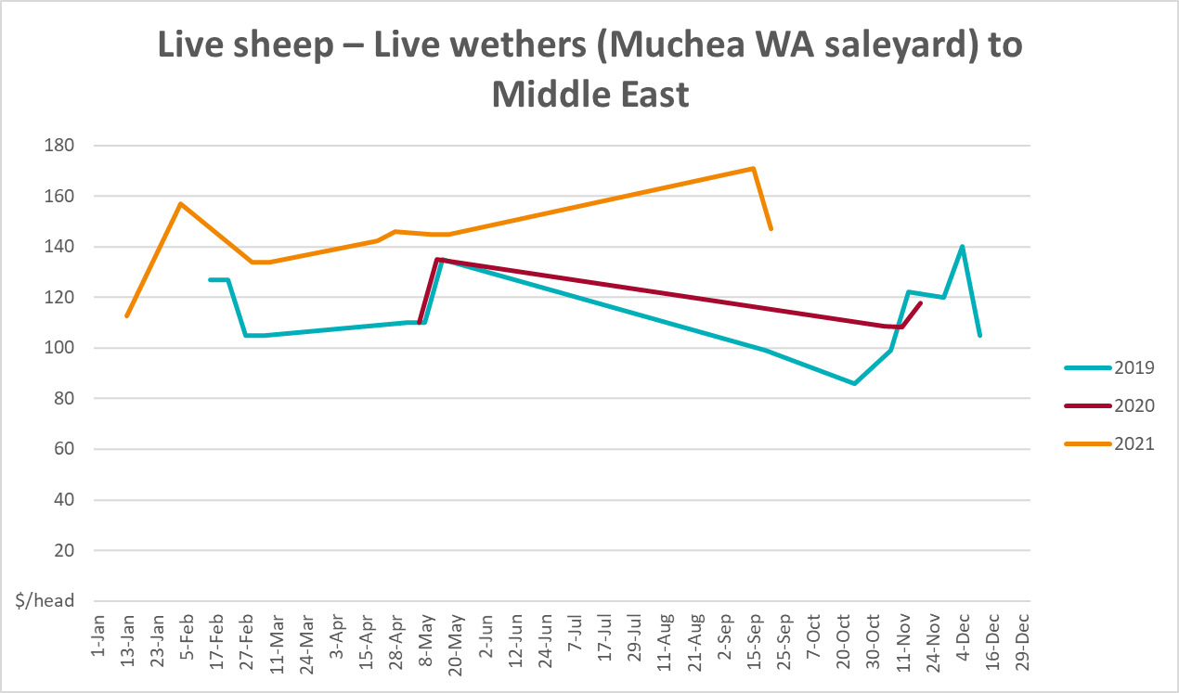

Global Dairy Trade (GDT) weighted average prices
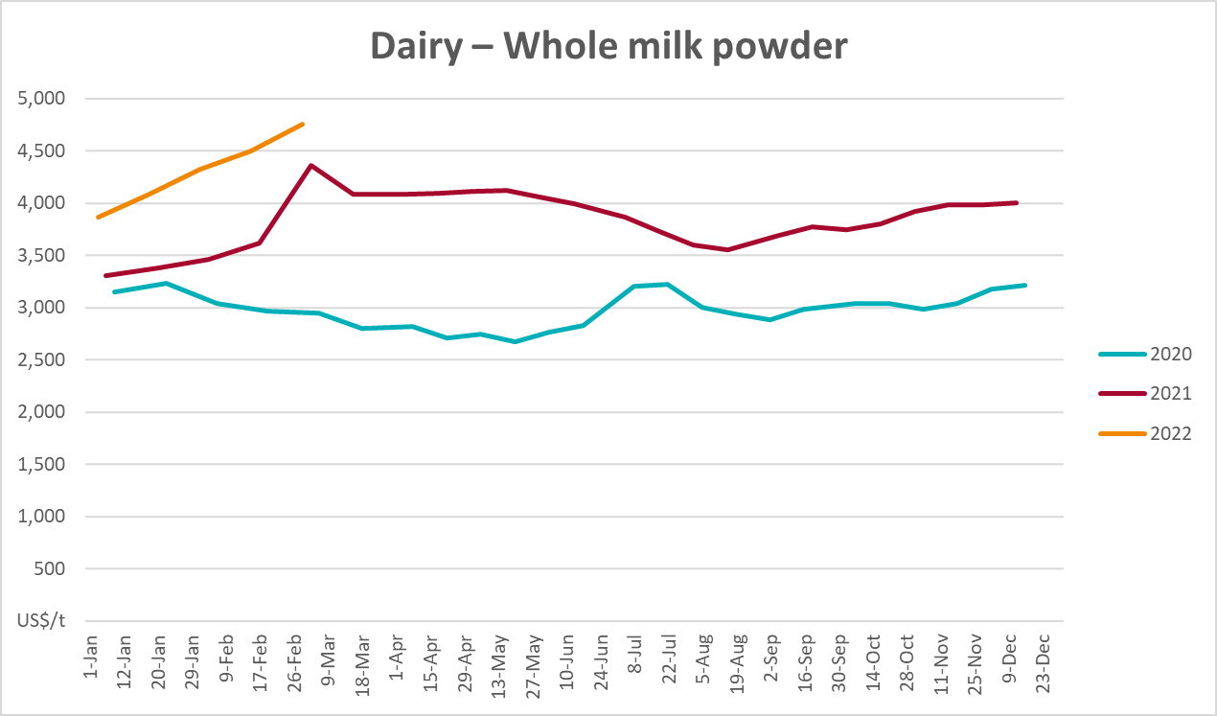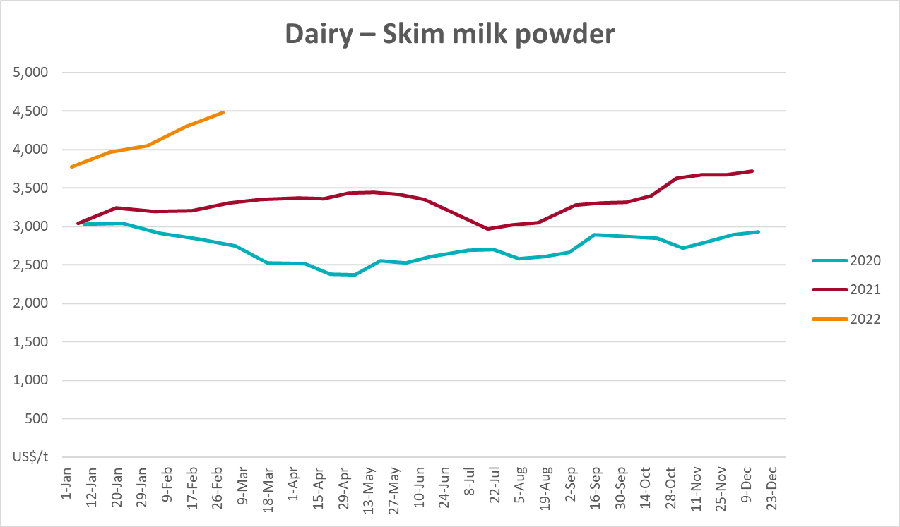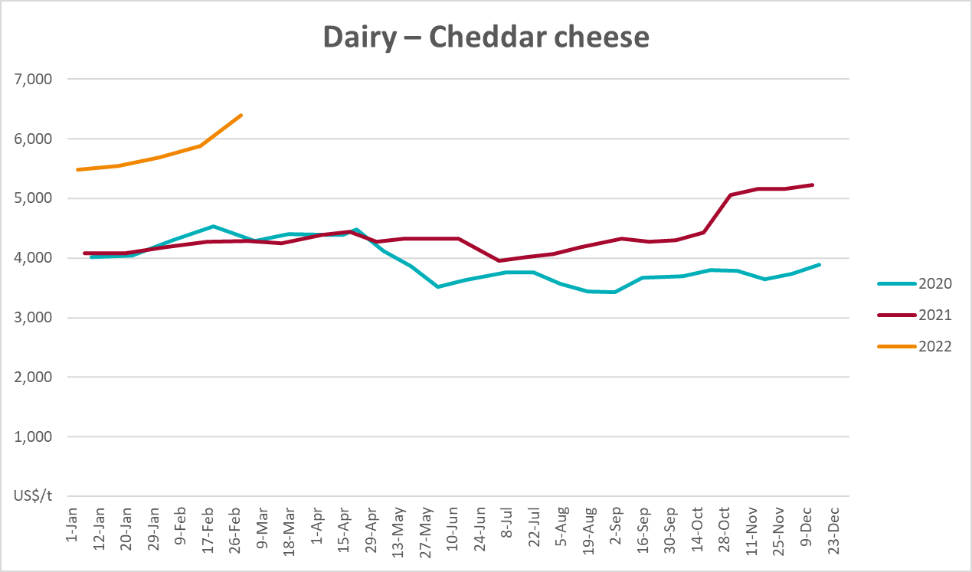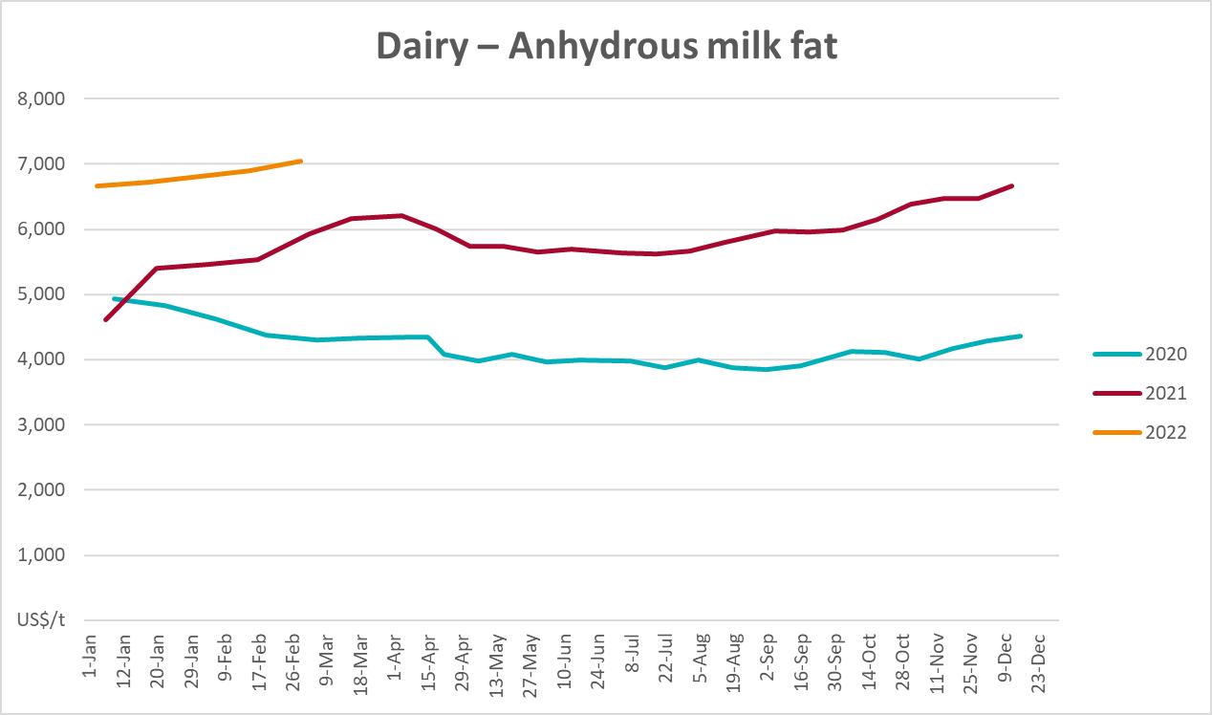

Selected fruit and vegetable prices
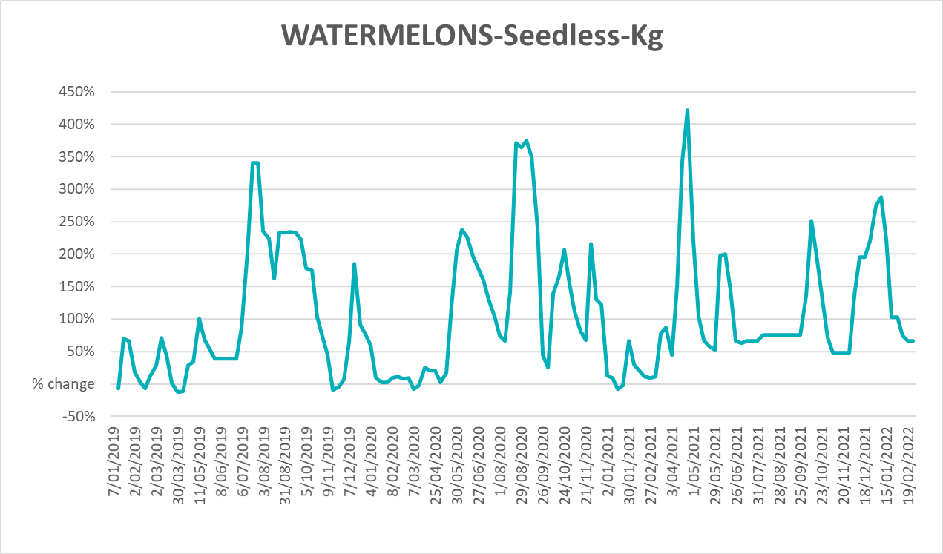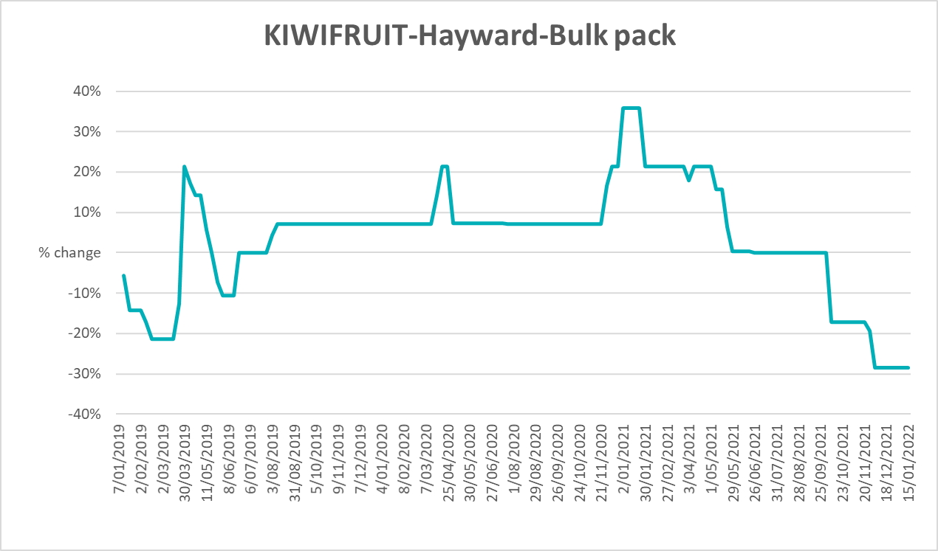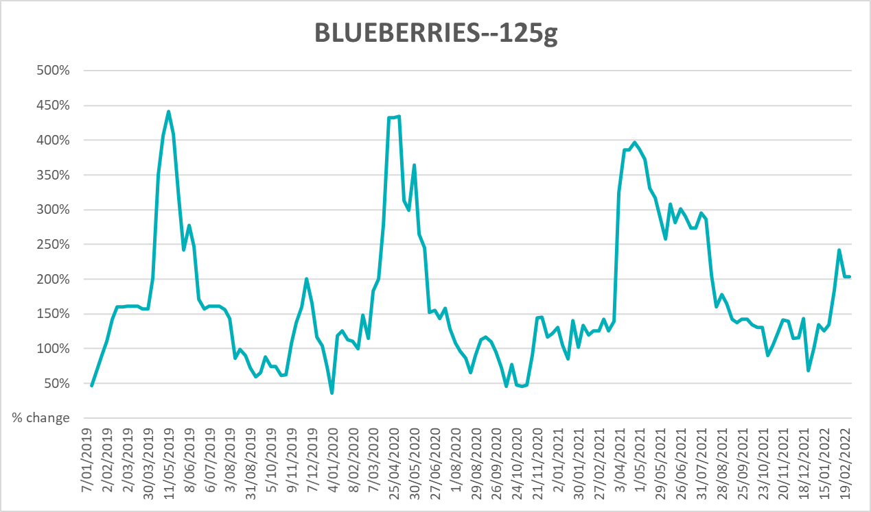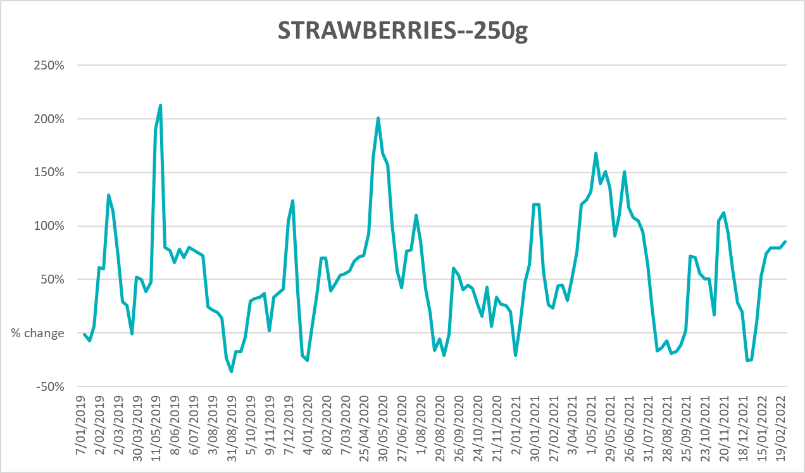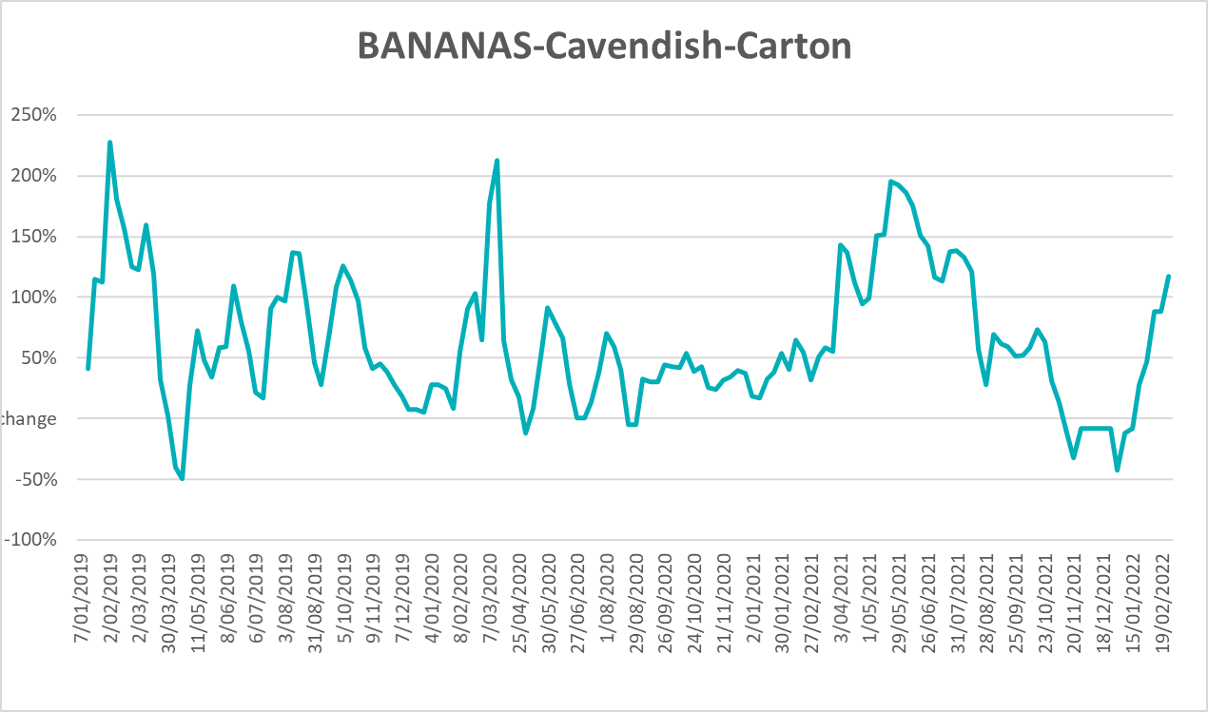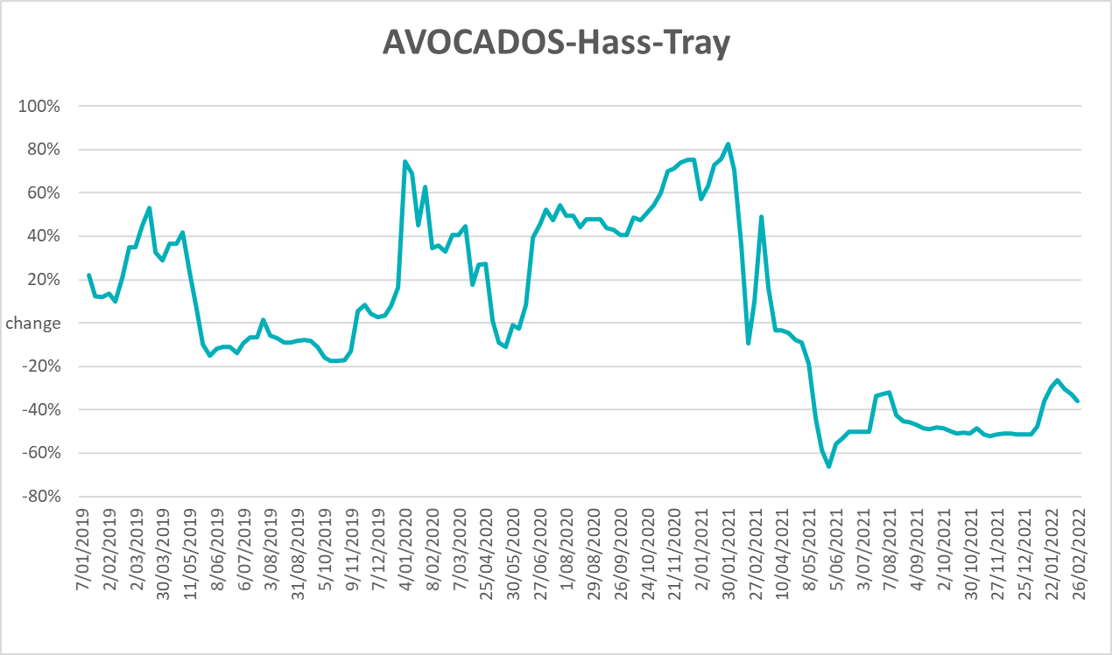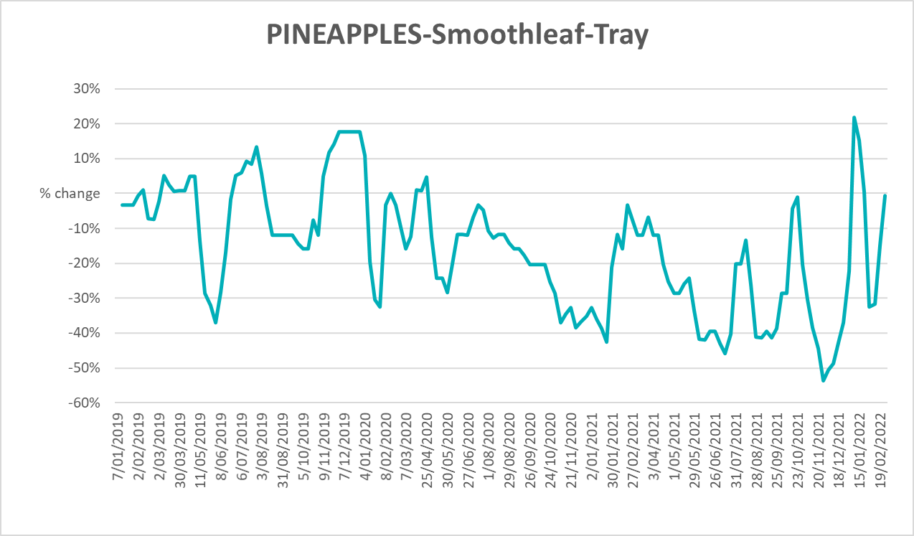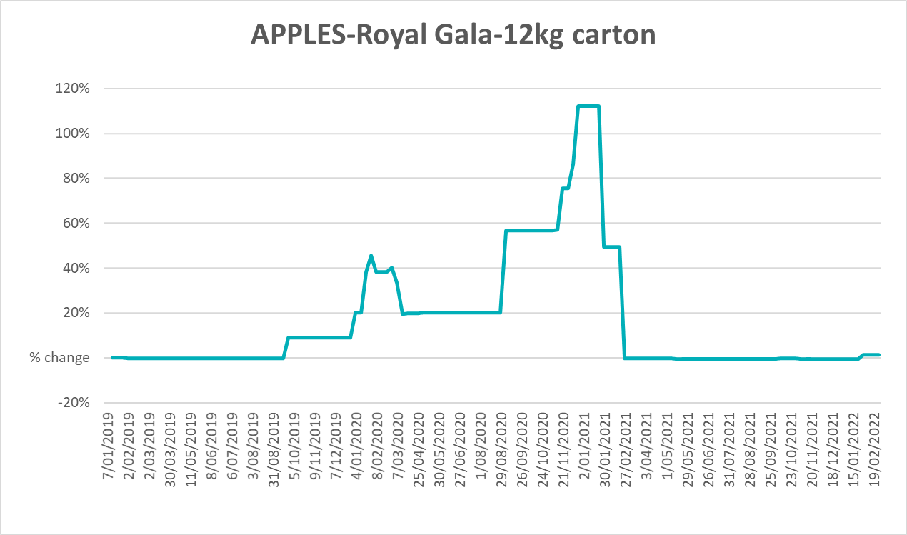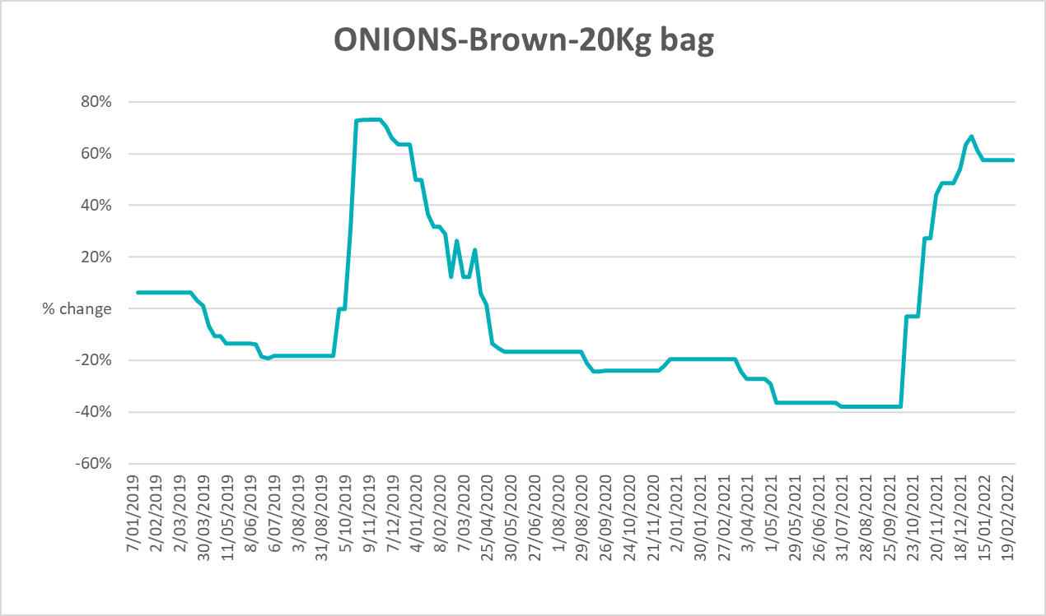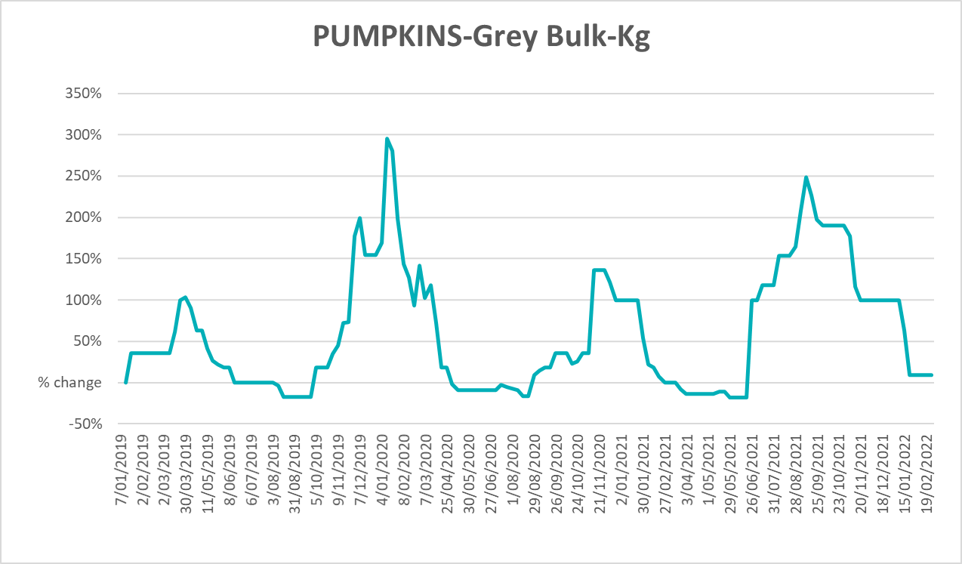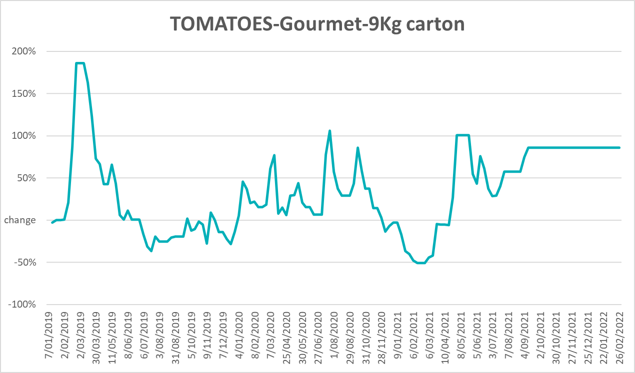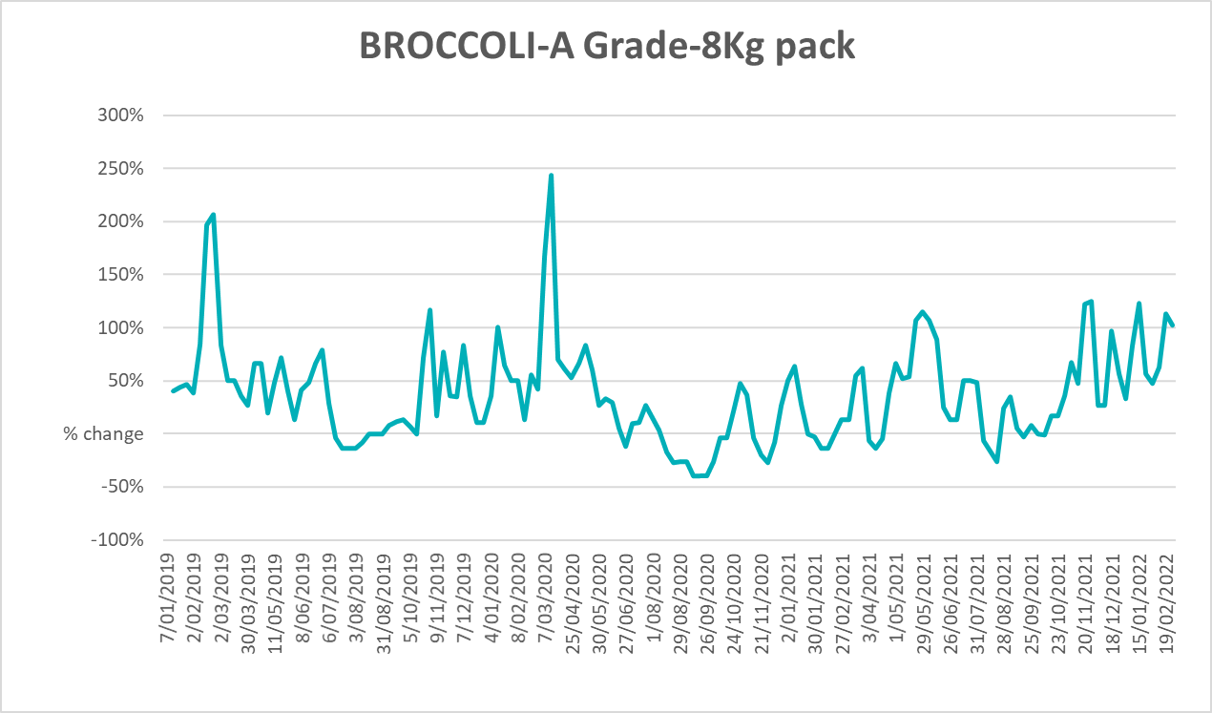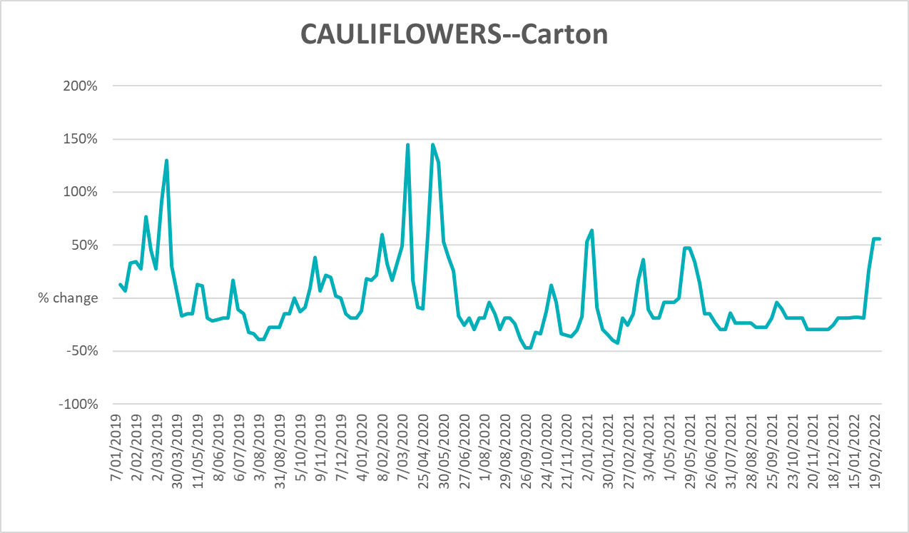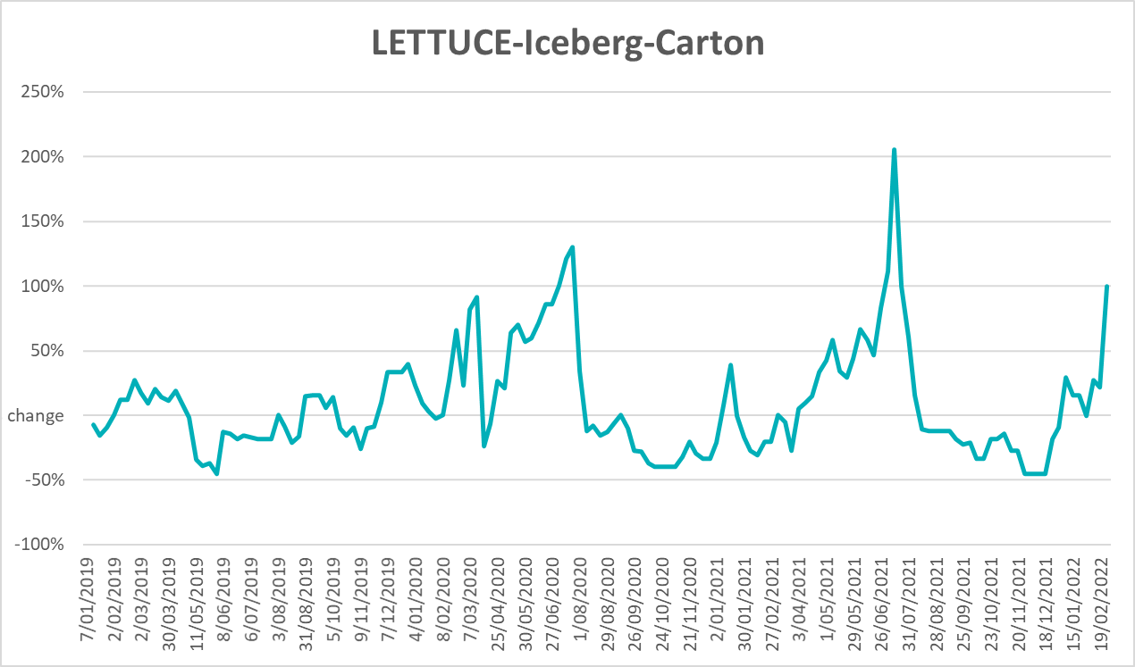
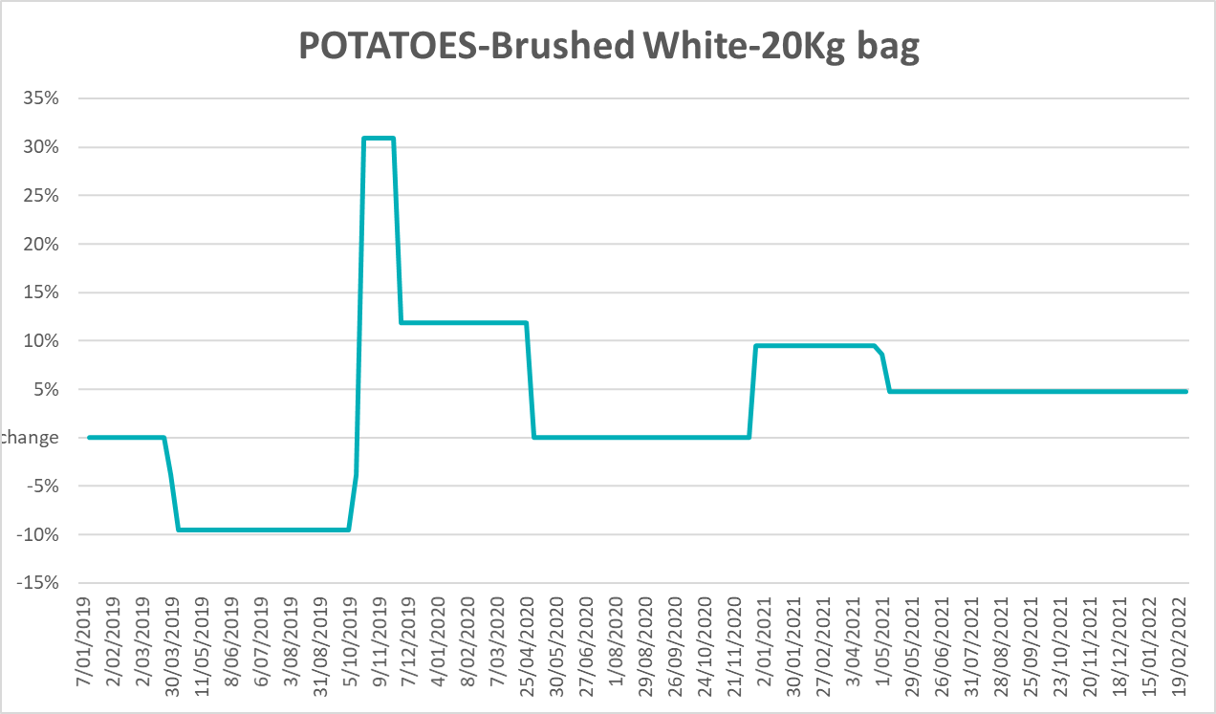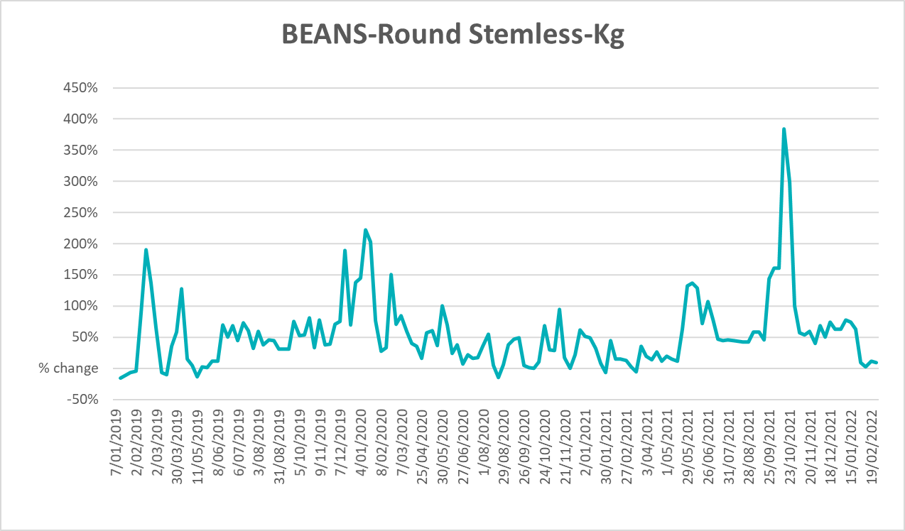

Selected domestic fodder indicator prices
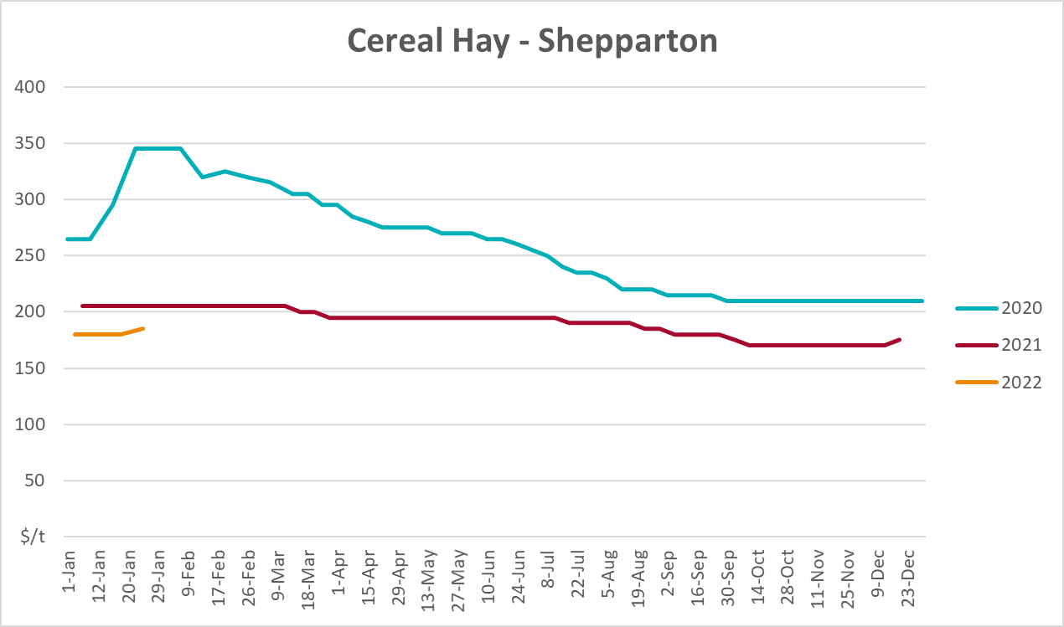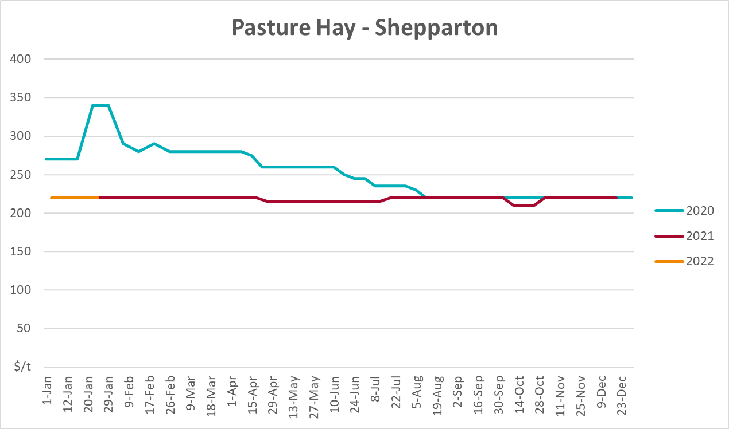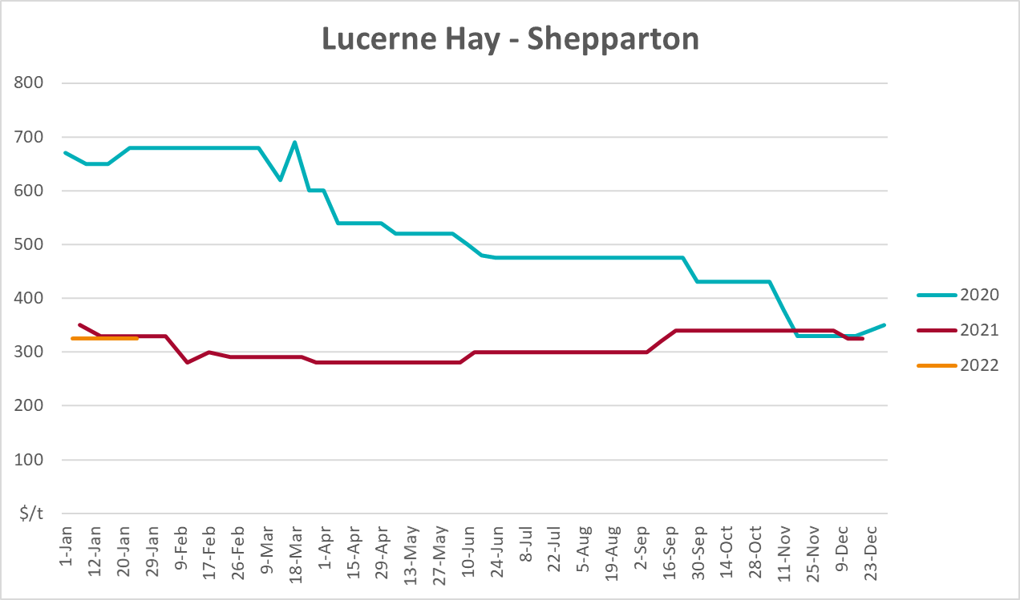

Data attribution

Climate
Bureau of Meteorology
- Weekly rainfall totals: www.bom.gov.au/climate/maps/rainfall/
- Monthly and last 3-month rainfall percentiles: www.bom.gov.au/water/landscape/
- Temperature anomalies: www.bom.gov.au/jsp/awap/temp/index.jsp
- Rainfall forecast: www.bom.gov.au/jsp/watl/rainfall/pme.jsp
- Seasonal outlook: www.bom.gov.au/climate/outlooks/#/overview/summary/
- Climate drivers: http://www.bom.gov.au/climate/enso/
- Soil moisture: www.bom.gov.au/water/landscape/
Other
- Pasture growth: www.longpaddock.qld.gov.au/aussiegrass/
- 3-month global outlooks: Environment and Climate Change Canada, NOAA Climate Prediction Center, EUROBRISA CPTEC/INPE, European Centre for Medium-Range Weather Forecasts, Hydrometcenter of Russia, National Climate Center Climate System Diagnosis and Prediction Room (NCC), International Research Institute for Climate and Society
- Global production: https://ipad.fas.usda.gov/ogamaps/cropmapsandcalendars.aspx
- Autumn break: Pook et al., 2009, https://rmets-onlinelibrary-wiley-com.virtual.anu.edu.au/doi/epdf/10.1002/joc.1833

Water
Prices
- Waterflow: https://www.waterflow.io/
- Ruralco: https://www.ruralcowater.com.au/
Bureau of Meteorology:
- Allocation trade: http://www.bom.gov.au/water/dashboards/#/water-markets/mdb/at
- Storage volumes: http://www.bom.gov.au/water/dashboards/#/water-storages/summary/drainage
Trade constraints:
- Water NSW: https://www.waternsw.com.au/customer-service/ordering-trading-and-pricing/trading/murrumbidgee
- Victorian Water Register: https://www.waterregister.vic.gov.au/TradingRules2019/

Commodities
Fruit and vegetables
- Datafresh: www.freshstate.com.au
Pigs
- Australian Pork Limited: www.australianpork.com.au
Dairy
- Global Dairy Trade: www.globaldairytrade.info/en/product-results/
World wheat, canola
- International Grains Council
World coarse grains
- United States Department of Agriculture
World cotton
- Cotlook: www.cotlook.com/
World sugar
- New York Stock Exchange - Intercontinental Exchange
Wool
- Australian Wool Exchange: www.awex.com.au/
Domestic wheat, barley, sorghum, canola and fodder
- Jumbuk Consulting Pty Ltd: http://www.jumbukag.com.au/
Cattle, beef, mutton, lamb, goat and live export
- Meat and Livestock Australia: www.mla.com.au/Prices-and-market
© Commonwealth of Australia 2022

Ownership of intellectual property rights
Unless otherwise noted, copyright (and any other intellectual property rights, if any) in this publication is owned by the Commonwealth of Australia (referred to as the Commonwealth).

Creative Commons licence
All material in this publication is licensed under a Creative Commons Attribution 4.0 International Licence except content supplied by third parties, logos and the Commonwealth Coat of Arms.
Inquiries about the licence and any use of this document should be emailed to copyright@awe.gov.au.


Cataloguing data
This publication (and any material sourced from it) should be attributed as:
ABARES 2021, Weekly Australian Climate, Water and Agricultural Update, Australian Bureau of Agricultural and Resource Economics and Sciences, Canberra, 10 March 2022. CC BY 4.0 DOI: https://doi.org/10.25814/5f3e04e7d2503
ISSN 2652-7561
This publication is available at https://www.awe.gov.au/abares/products/weekly_update
Department of Agriculture, Water and the Environment
GPO Box 858 Canberra ACT 2601
Telephone 1800 900 090
Web awe.gov.au/abares

Disclaimer
The Australian Government acting through the Department of Agriculture, Water and the Environment, represented by the Australian Bureau of Agricultural and Resource Economics and Sciences, has exercised due care and skill in preparing and compiling the information and data in this publication. Notwithstanding, the Department of Agriculture, Water and the Environment, ABARES, its employees and advisers disclaim all liability, including liability for negligence and for any loss, damage, injury, expense or cost incurred by any person as a result of accessing, using or relying on any of the information or data in this publication to the maximum extent permitted by law.

Statement of Professional Independence
The views and analysis presented in ABARES publications, including this one, reflect ABARES professionally independent findings, based on scientific and economic concepts, principles, information and data. These views, analysis and findings may not reflect or be consistent with the views or positions of the Australian Government, or of organisations or groups who have commissioned ABARES reports or analysis. More information on professional independence is provided on the ABARES website.

Acknowledgements
This report was prepared by Matthew Miller and Cameron Van-Lane.

