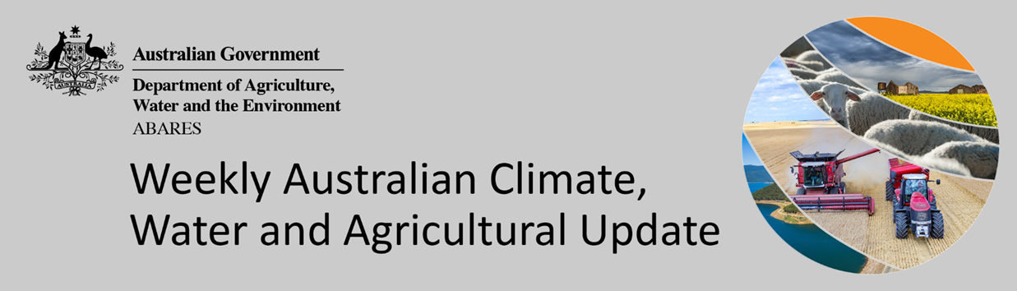
No. 12/2022

31 March 2022

Summary of key issues
- For the week ending 30 March 2022, low-pressure troughs across northern and eastern Australia resulted in heavy rainfall in the east and parts of the far north. Ex-tropical cyclone Charlotte, and associated low-pressure troughs brought heavy rainfall to large parts of Western Australia. High-pressure systems in the south resulted in clear, dry conditions for large areas of southern Australia (see Section 1.1).
- The heavy rainfalls across cropping regions in northern New South Wales and southern Queensland have prevented field access for harvesting of what remains of early sown summer crops. The wet conditions will also have prevented the harvesting of early sown summer crops with long growth periods, such as cotton, in northern Queensland, and increased the risk of quality downgrades. On the other hand, the rainfall will have supported vegetative growth of late sown summer crops in Central Queensland, as well as boosting soil moisture levels across eastern and western cropping regions, as the planting window for winter crops approaches.
- ABARES analysis of daily rainfall data sourced from the Bureau of Meteorology indicates that an early autumn break has been achieved across large areas of northern, eastern and southern New South Wales, southern Queensland, parts of central and eastern Victoria and large areas of northern Western Australia (see Section 1.2)
- Over the 8-days to 7 April 2022, low-pressure systems drawing down moisture laden air are expected to bring rainfall to parts of south-eastern and western Australia. Meanwhile, high pressure systems are expected to bring mostly dry conditions to central and southern Australia (see Section 1.3).
- Water storage in the Murray–Darling Basin (MDB) decreased by 143 gigalitres (GL) between 23 March 2022 and 30 March 2022. The current volume of water held in storage is 21,717GL, which represents 87 per cent of total capacity. This is 51% or 7,307 GL more than at the same time last year.
- Allocation prices in the Victorian Murray below the Barmah Choke increased from $55 per ML on 24 March 2022 to $60 per ML on 30 March 2022. Prices are lower in the Goulburn-Broken, Murrumbidgee and regions above the Barmah choke due to the binding of the Goulburn intervalley trade limit, Murrumbidgee export limit and Barmah choke trade constraint.

Climate

Rainfall this week
For the week ending 30 March 2022, low-pressure troughs across northern and eastern Australia resulted in heavy rainfall in the east and parts of the far north. Ex-tropical cyclone Charlotte, and associated low-pressure troughs brought heavy rainfall to large parts of Western Australia. High-pressure systems in the south resulted in clear, dry conditions for large areas of southern Australia.
Rainfall totals of between 10 and 100 millimetres were recorded across eastern and north-eastern parts of New South Wales, south-eastern to north-western and far northern Queensland, western and northern parts of Western Australia, as well as parts of the north and centre of the Northern Territory. Rainfall totals in excess of 100 millimetres were recorded across coastal areas of New South Wales and, south-east and northern Queensland. Remaining parts of Australia received little to no rainfall.
In cropping regions, rainfall totals of between 10 and 100 millimetres were recorded across northern New South Wales, much of Queensland and Western Australia. Rainfall in excess of 100 millimetres was recorded in isolated parts of cropping regions in north-eastern New South Wales and south-eastern Queensland. Little to no rainfall was recorded across cropping regions in southern New South Wales, Victoria and South Australia.
The heavy rainfalls across cropping regions in northern New South Wales and southern Queensland will have prevented field access for harvesting of what remains of early sown summer crops. The wet conditions will also have prevented the harvesting of early sown summer crops with long growth periods, such as cotton, in northern Queensland, and increased the risk of quality downgrades. On the other hand, the rainfall will have supported vegetative growth of late sown summer crops in Central Queensland, as well as boosting soil moisture levels across eastern and western cropping regions, as the planting window for winter crops approaches.

Rainfall for the week ending 30 March 2022

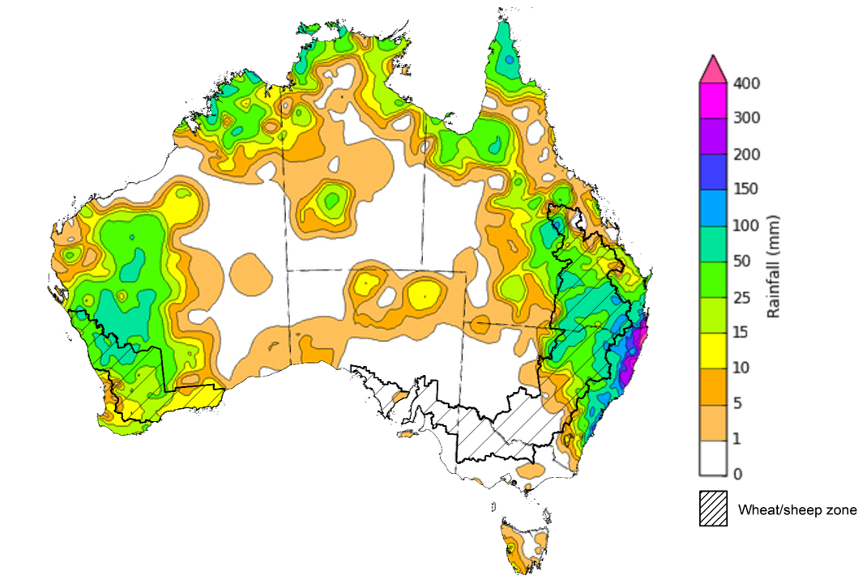

©Commonwealth of Australia 2022, Australian Bureau of Meteorology Issued: 30/3/2022
Note: The rainfall analyses and associated maps utilise data contained in the Bureau of Meteorology climate database, the Australian Data Archive for Meteorology (ADAM). The analyses are initially produced automatically from real-time data with limited quality control. They are intended to provide a general overview of rainfall across Australia as quickly as possible after the observations are received. For further information go to http://www.bom.gov.au/climate/rainfall/

Early autumn break
In southern Australia, the timing of the autumn break is an important ingredient for a successful pasture and crop production season. The autumn break is the first significant rainfall of the winter growing season and provides enough moisture to initiate crop and pasture germination and support early plant growth. The break generally applies to the southern pasture and cropping areas mainly in New South Wales, Victoria, South Australia, Western Australia and Tasmania — and occasionally parts of southern Queensland.

Areas likely to be influenced by the autumn break
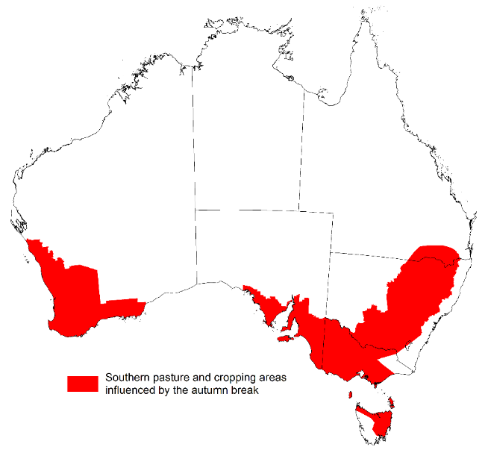
Source: ABARES
An early autumn break can increase the length of the growing season, potentially improving production and yield. The definition of the autumn break in southern Australia varies. Pook et al. (2009) suggested an ideal break for north-western Victoria occurs during March–June when a mean fall of 25 millimetres or more is recorded over a period of 3 days or less, or when a mean fall of 30 millimetres or more is recorded over a period of 7 days or less.
It is important to remember that while the timing of the rain is important, as to whether it constitutes a break or not, it is the weather following this early break that will determine whether this is a ‘false’ break or a true early break. For example, a 30mm rainfall event in March followed by warm, dry weather may not constitute the break. However, if a similar rainfall event were to occur during April, it will likely be the break that many southern farmers have been waiting for. Furthermore, an early autumn break, in and of itself, does not guarantee a successful growing season; sufficient winter and spring rainfall is still required, particularly in areas with little to no stored soil moisture, to deliver a successful crop and pasture production season.

Southern pasture and cropping areas that have achieved 30 millimetres in any 7‐day period from 1 March to 30 March 2022
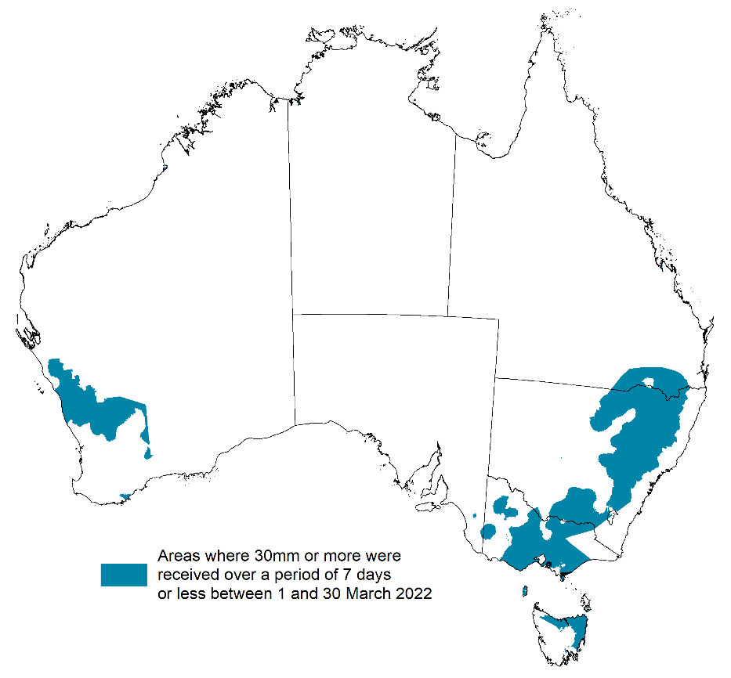
Source: Bureau of Meteorology, ABARES
ABARES has adapted the Pook et al. (2009) autumn break definition of falls of 30 millimetres or more recorded within any 7-day period from 1 March to identify where the autumn break threshold has been achieved across southern Australia. ABARES analysis of daily rainfall data sourced from the Bureau of Meteorology indicates that the autumn break has been achieved across cropping regions of northern, eastern and southern New South Wales, southern Queensland, parts of central and eastern Victoria and large areas of northern Western Australia.
Typically, the autumn break is driven by westerly fronts moving across southern Australia and cut-off low pressure systems. This uncharacteristic early autumn break in south-eastern Australia has been driven by series of east coast lows pulling in moist tropical air from Coral Sea resulting in substantial rainfall. While in Western Australia the early autumn break has been the result of the break down and movement of Ex-tropical cyclone Charlotte as it tracks south down the Western Australian coast.

Rainfall forecast for the next eight days
Over the 8-days to 7 April 2022, low-pressure systems drawing down moisture laden air are expected to bring rainfall to parts of south-eastern and western Australia. Meanwhile, high pressure systems are expected to bring mostly dry conditions to central and southern Australia.
Rainfall totals of between 10 and 50 millimetres are forecast for eastern New South Wales and Victoria, as well as parts of south-eastern and northern Queensland, western parts of Western Australia, the far north of the Northern Territory and north-east Tasmania. Rainfall in excess of 50 millimetres is expected for south-eastern New South Wales, eastern Victoria and the far west of Western Australia.
In Australian cropping regions, rainfall totals of between 10 and 50 millimetres are expected in parts of north-eastern New South Wales and south-eastern Queensland, as well as across Western Australia. Little to no rainfall is forecast for all remaining cropping regions during the next 8-days.
The dry conditions across northern cropping regions will be a welcome break from heavy rainfalls in the past month. Soil moisture levels are well above average for parts of southern Queensland and much of New South Wales, delaying the harvesting of summer crops and planting of long season winter crops. The forecast dry conditions will allow soil profiles to drain and mature crops to dry out. There are reports of yield losses for early sown sorghum crops due to grain shattering, as well as a high risk of quality downgrades for mung bean crops in southern Queensland and northern New South Wales due to recent rainfall. If dry conditions persist, planting of winter crops is likely to get underway in the coming weeks, with plentiful plant available water to support germination and establishment.

Total forecast rainfall (mm) for the period 31 March to 7 April 2022
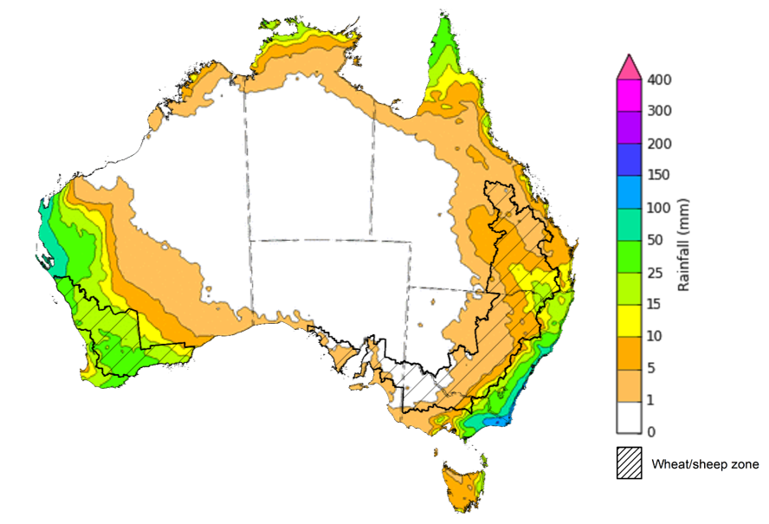
©Commonwealth of Australia 2022, Australian Bureau of Meteorology Issued: 30/3/2022
Note: This rainfall forecast is produced from computer models. As the model outputs are not altered by weather forecasters, it is important to check local forecasts and warnings issued by the Bureau of Meteorology.

Water

Water markets – current week
Water storage in the Murray–Darling Basin (MDB) decreased by 143 gigalitres (GL) between 23 March 2022 and 30 March 2022. The current volume of water held in storage is 21,717GL, which represents 87 per cent of total capacity. This is 51% or 7,307 GL more than at the same time last year.

Water storages in the Murray-Darling Basin, 2013–2022
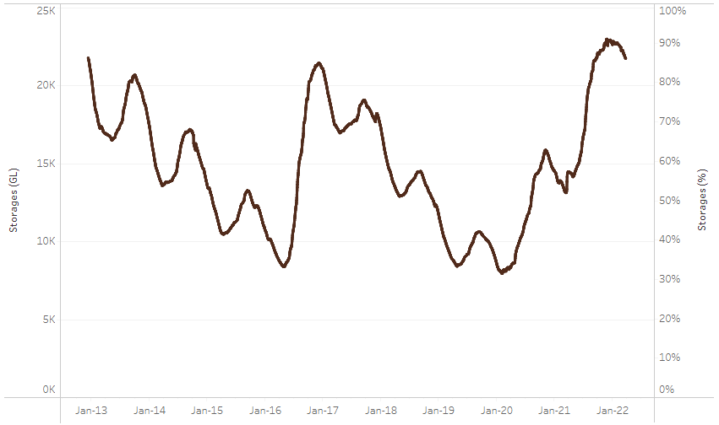
Allocation prices in the Victorian Murray below the Barmah Choke increased from $55 per ML on 24 March 2022 to $60 per ML on 30 March 2022. Prices are lower in the Goulburn-Broken, Murrumbidgee and regions above the Barmah choke due to the binding of the Goulburn intervalley trade limit, Murrumbidgee export limit and Barmah choke trade constraint.
Water storage data is sourced from the Bureau of Meteorology.
Region | $/ML
NSW Murray Above | 18
NSW Murrumbidgee | 8
VIC Goulburn-Broken | 45
VIC Murray Below | 60

Surface water trade activity, Southern Murray–Darling Basin

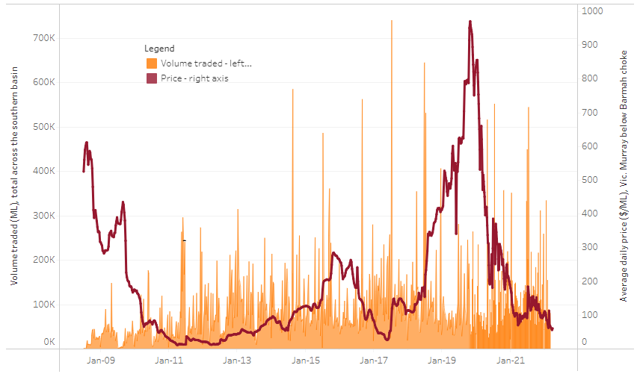
To access the full, interactive, weekly water dashboard, which contains the latest and historical water storage, water market and water allocation information, please visit http://www.agriculture.gov.au/abares/products/weekly_update/weekly-update-310322
The trades shown reflect estimated market activity and do not encompass all register trades. The price is shown for the VIC Murray below the Barmah choke. Historical prices (before 1 July 2019) are ABARES estimates after removing outliers from BOM water register data. Prices after 1 July 2019 and prior to the 30 October 2019 reflect recorded transaction prices as sourced from Ruralco. Prices after the 30 October 2019 are sourced from Waterflow. Data for volume traded is sourced from the BOM water register. Data shown is current at 31 March 2022.

Commodities

Indicator | Week ended | Unit | Latest price | Previous week | Weekly change | Price 12 months ago | Annual change
Selected world indicator prices
AUD/USD Exchange rate | 30-Mar | A$/US$ | 0.75 | 0.74 | 1% | 0.76 | -2%
Wheat – US no. 2 hard red winter wheat, fob Gulf | 30-Mar | US$/t | 479 | 483 | -1% | 257 | 86%
Corn – US no. 2 yellow corn, fob Gulf | 30-Mar | US$/t | 358 | 368 | -3% | 246 | 45%
Canola – Rapeseed, Canada, fob Vancouver | 30-Mar | US$/t | 966 | 950 | 2% | 598 | 62%
Cotton – Cotlook 'A' Index | 30-Mar | USc/lb | 156 | 145 | 7% | 85 | 83%
Sugar – Intercontinental Exchange, nearby futures, no.11 contract | 30-Mar | USc/lb | 19.0 | 19.1 | -1% | 15 | 29%
Wool – Eastern Market Indicator | 30-Mar | Ac/kg clean | 1,395 | 1,429 | -2% | 1,275 | 9%
Wool – Western Market Indicator | 02-Feb | Ac/kg clean | 1,443 | 1,455 | -1% | 1,024 | 41%
Selected Australian grain export prices
Milling Wheat – APW, Port Adelaide, SA | 30-Mar | A$/t | 535 | 594 | -10% | 346 | 55%
Feed Wheat – ASW, Port Adelaide, SA | 30-Mar | A$/t | 620 | 560 | 11% | 344 | 80%
Feed Barley – Port Adelaide, SA | 30-Mar | A$/t | 455 | 461 | -1% | 293 | 55%
Canola – Kwinana, WA | 30-Mar | A$/t | 1,181 | 1,166 | 1% | 662 | 79%
Grain Sorghum – Brisbane, QLD | 30-Mar | A$/t | 375 | 375 | 0% | 360 | 4%
Selected domestic livestock indicator prices
Beef – Eastern Young Cattle Indicator | 30-Mar | Ac/kg cwt | 1,093 | 1,115 | -2% | 856 | 28%
Mutton – Mutton indicator (18–24 kg fat score 2–3), Vic | 30-Mar | Ac/kg cwt | 569 | 571 | 0% | 646 | -12%
Lamb – Eastern States Trade Lamb Indicator | 30-Mar | Ac/kg cwt | 799 | 801 | 0% | 827 | -3%
Pig – Eastern Seaboard (60.1–75 kg), average of buyers & sellers | 26-Jan | Ac/kg cwt | 357 | 357 | 0% | 309 | 16%
Goats – Eastern States (12.1–16 kg) | 19-Jan | Ac/kg cwt | 879 | 879 | 0% | 818 | 8%
Live cattle – Light steers ex Darwin to Indonesia | 30-Mar | Ac/kg lwt | 550 | 550 | 0% | 260 | 112%
Live sheep – Live wethers (Muchea WA saleyard) to Middle East | 22-Sep | $/head | 147 | 171 | -14% | 126 | 17%

Indicator | Week ended | Unit | Latest price | Previous week | Weekly change | Price 12 months ago | Annual change
Global Dairy Trade (GDT) weighted average prices ª
Dairy – Whole milk powder | 16-Mar | US$/t | 4,596 | 4,757 | -3% | 3,039 | 51%
Dairy – Skim milk powder | 16-Mar | US$/t | 4,545 | 4,481 | 1% | 2,907 | 56%
Dairy – Cheddar cheese | 16-Mar | US$/t | 6,412 | 6,394 | 0% | 4,526 | 42%
Dairy – Anhydrous milk fat | 16-Mar | US$/t | 7,111 | 7,048 | 1% | 4,379 | 62%
a Global Dairy Trade prices are updated twice monthly on the first and third Tuesday of each month.

Selected world indicator prices
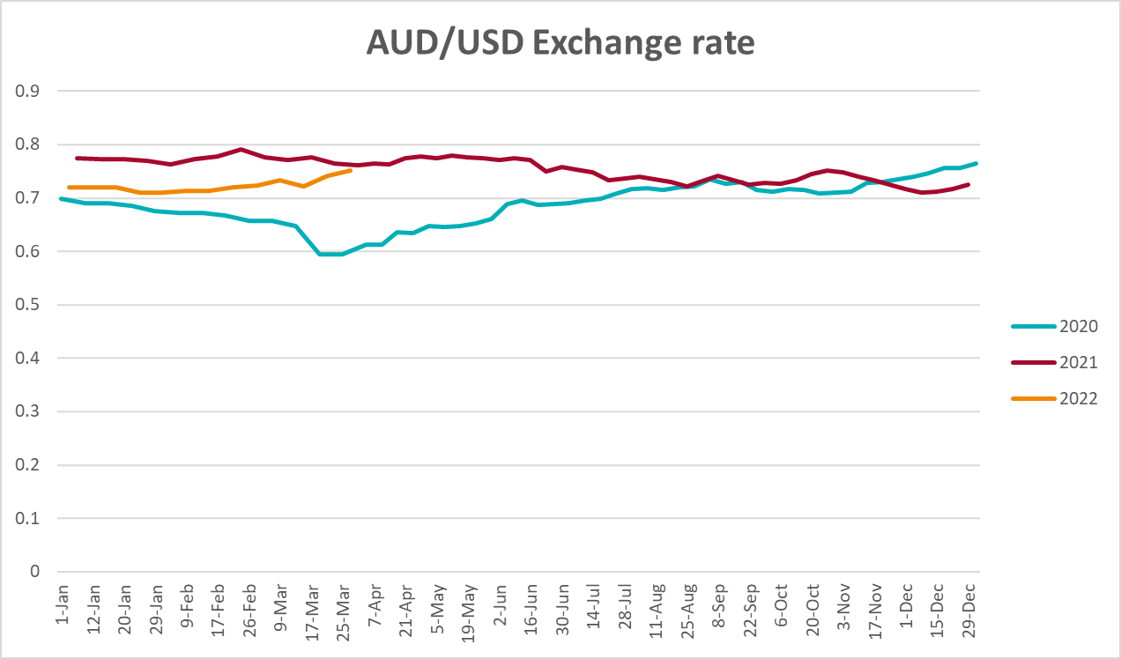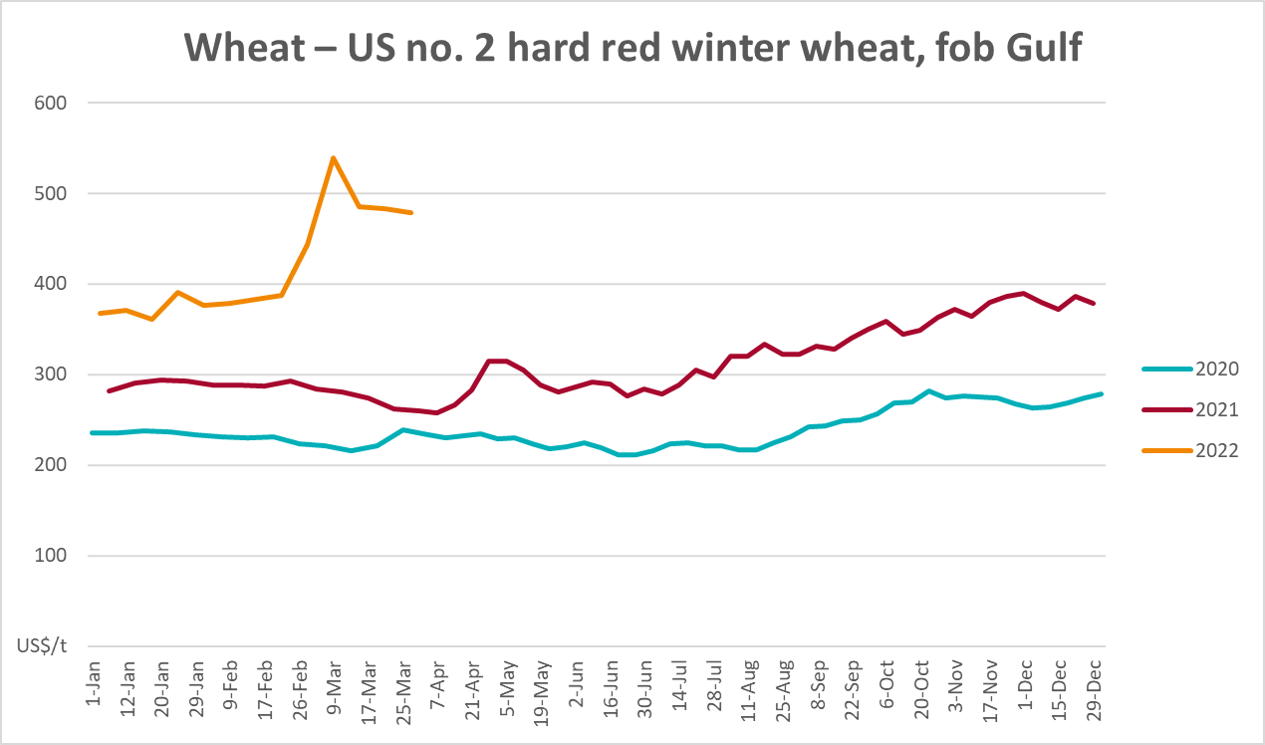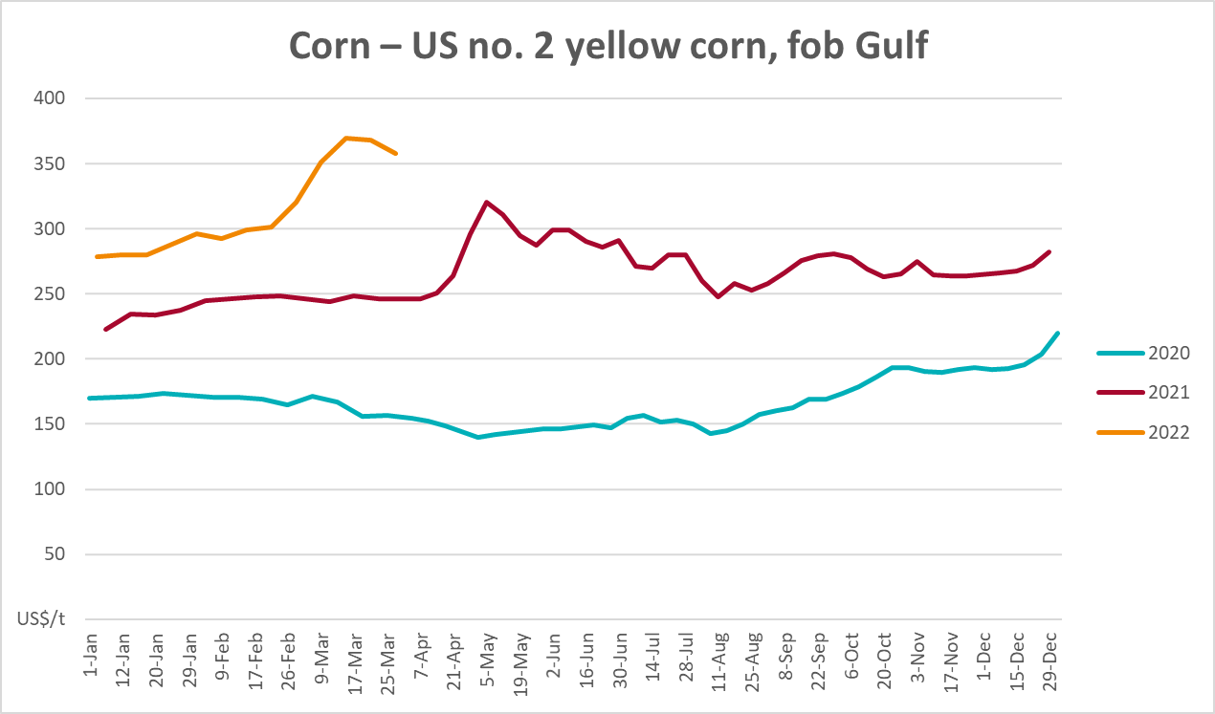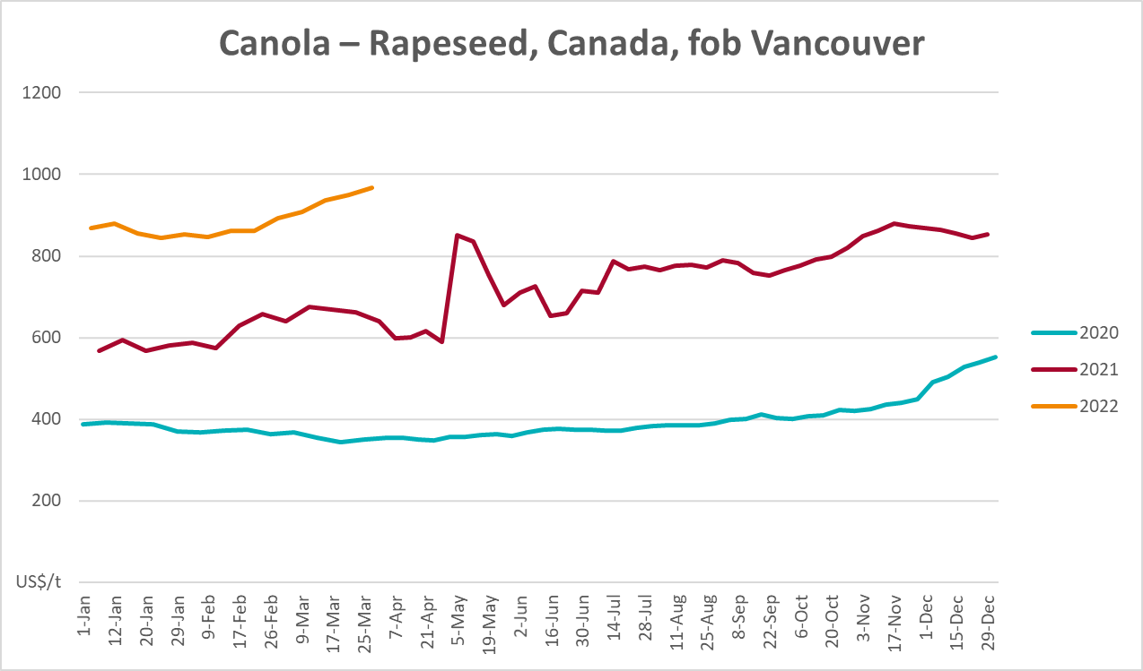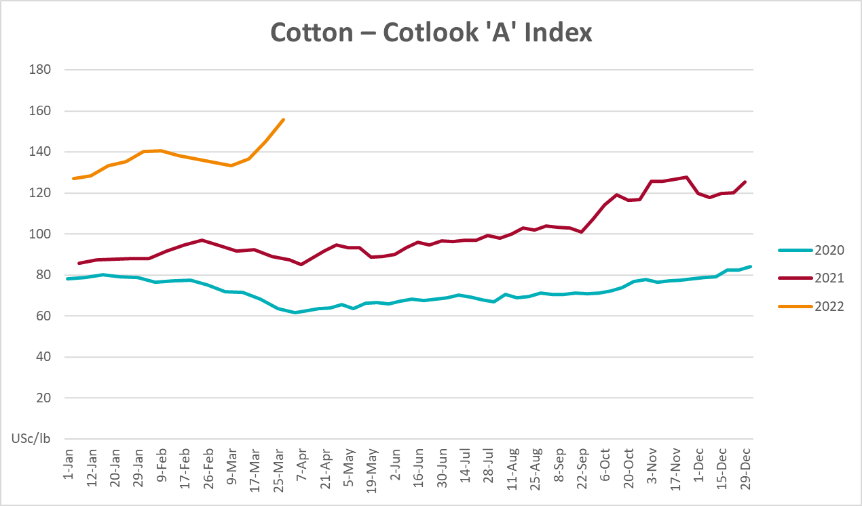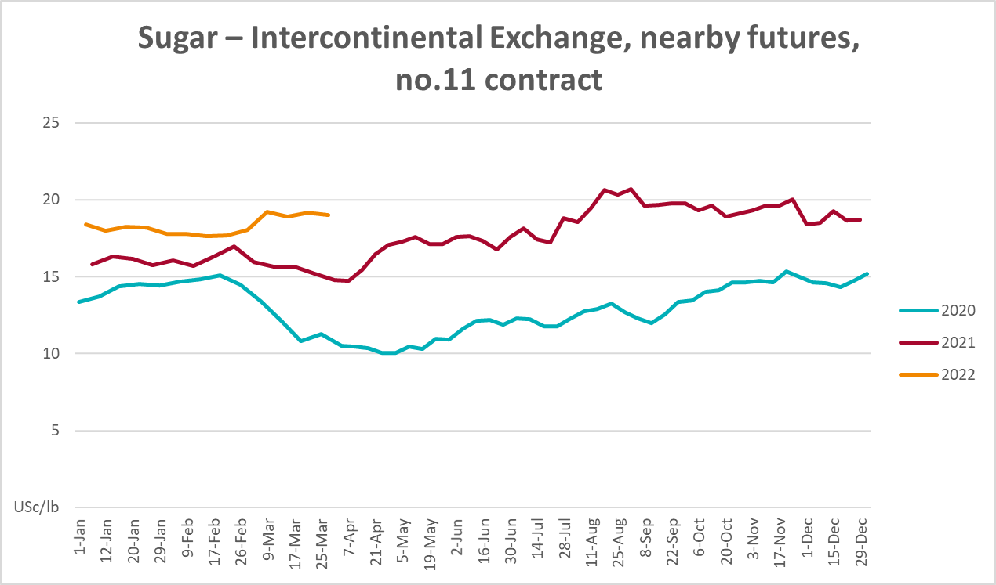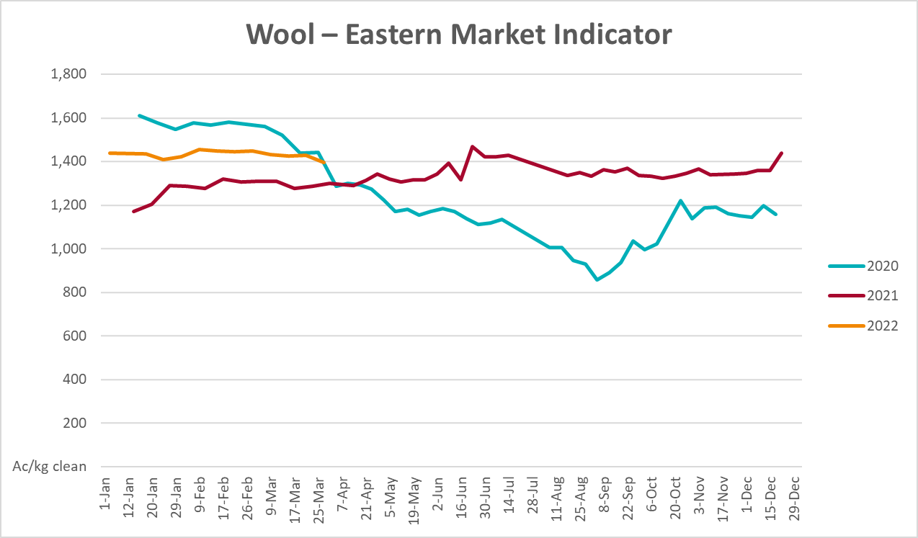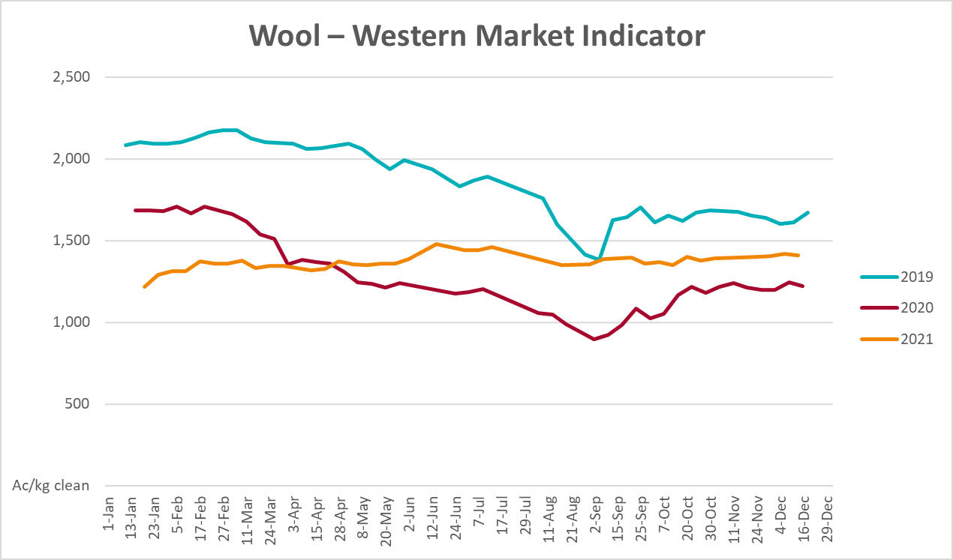

Selected domestic crop indicator prices
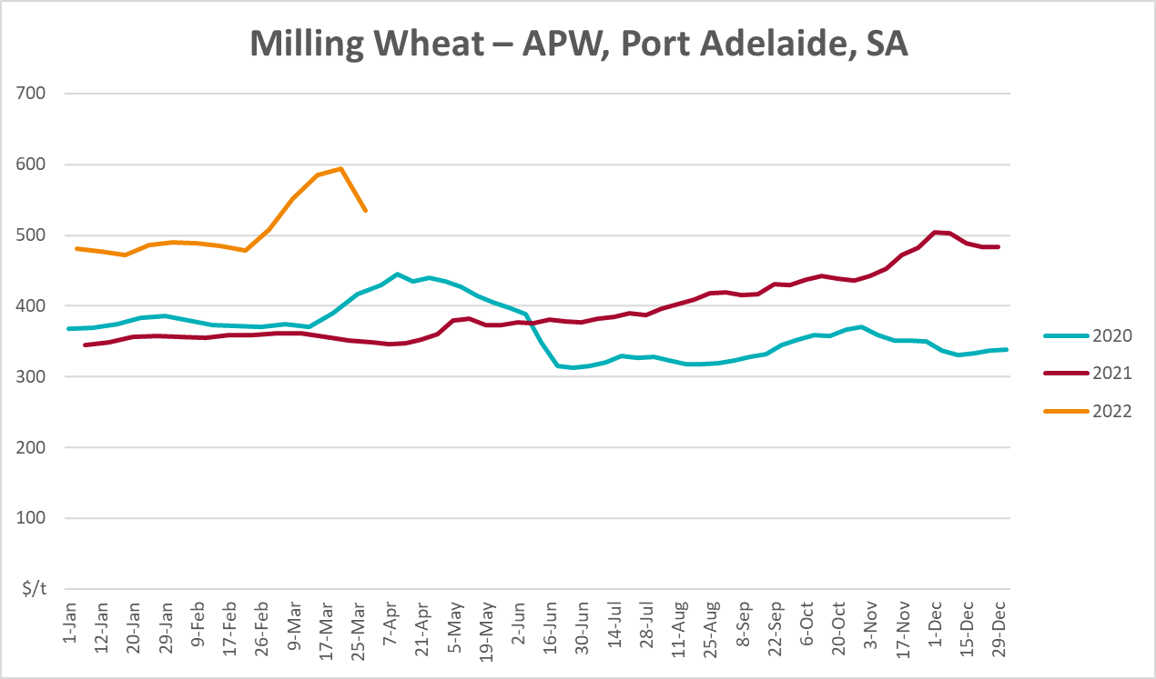
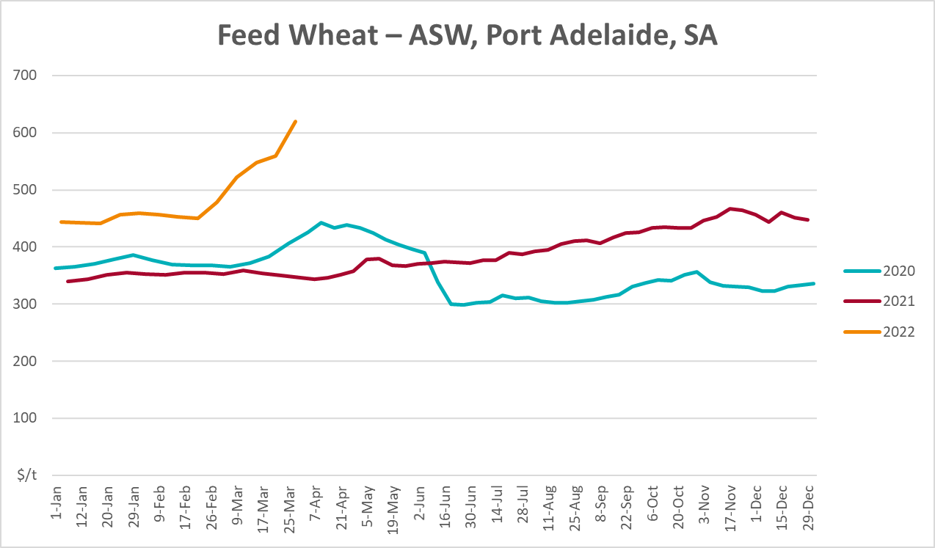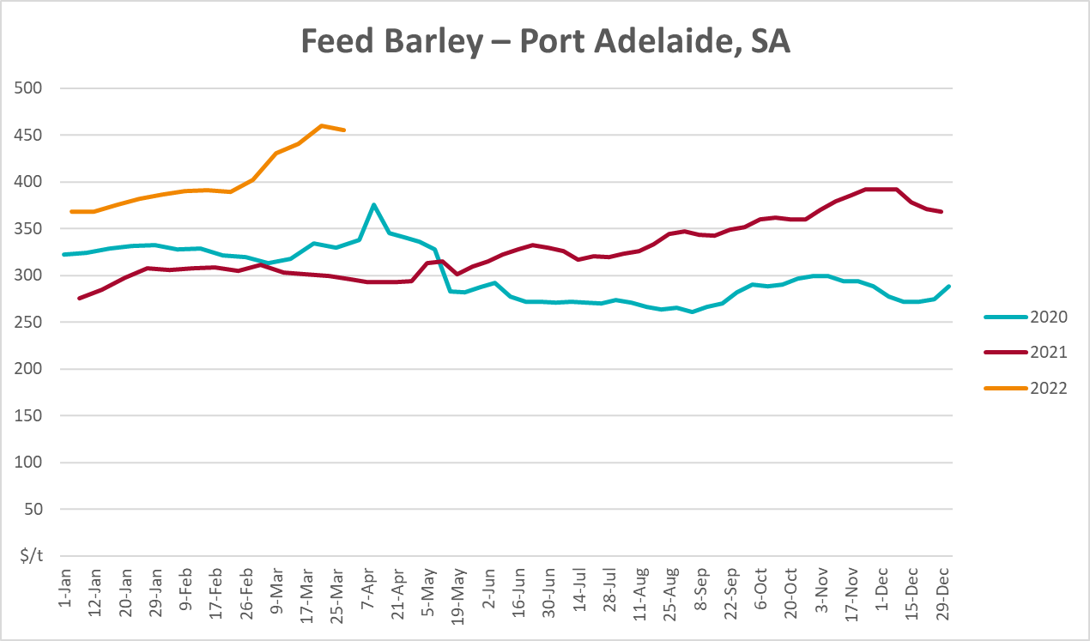
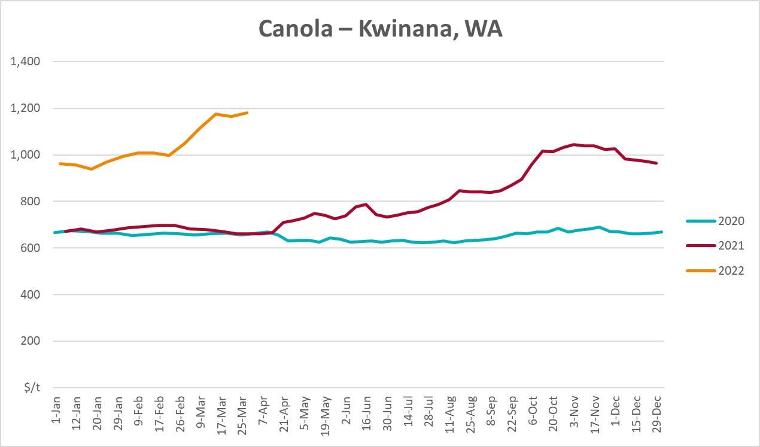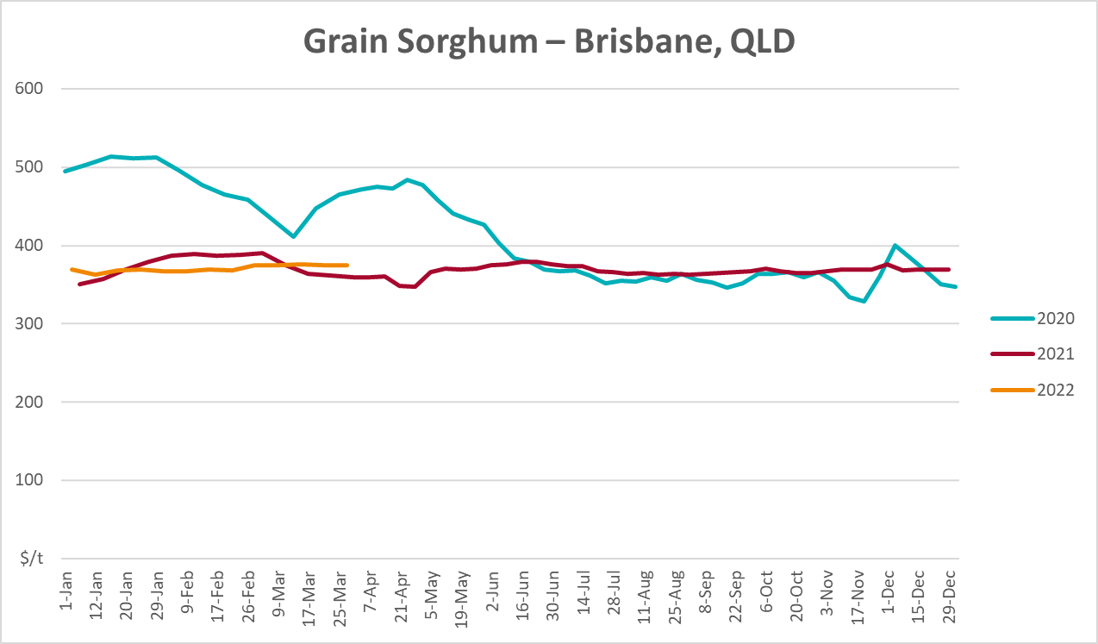

Selected domestic livestock indicator prices
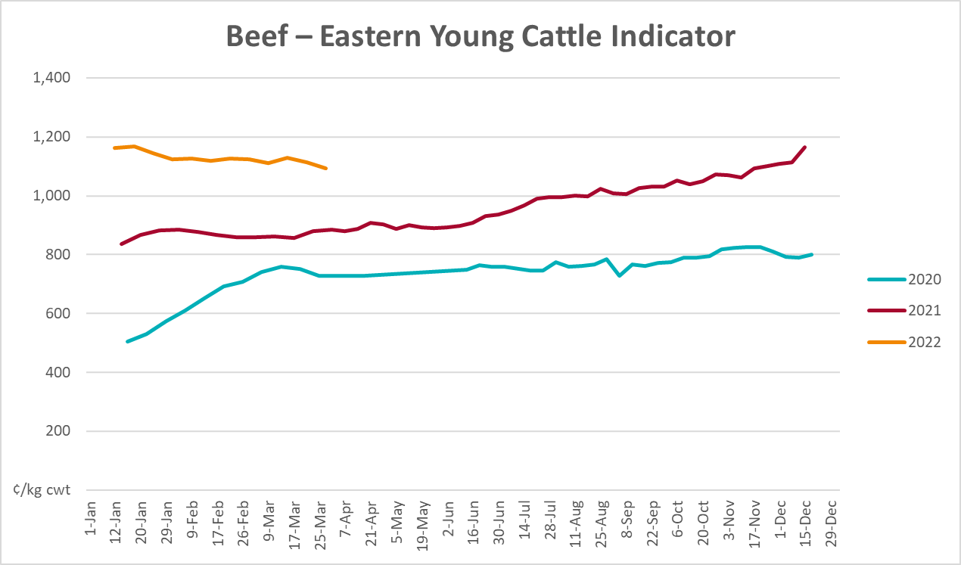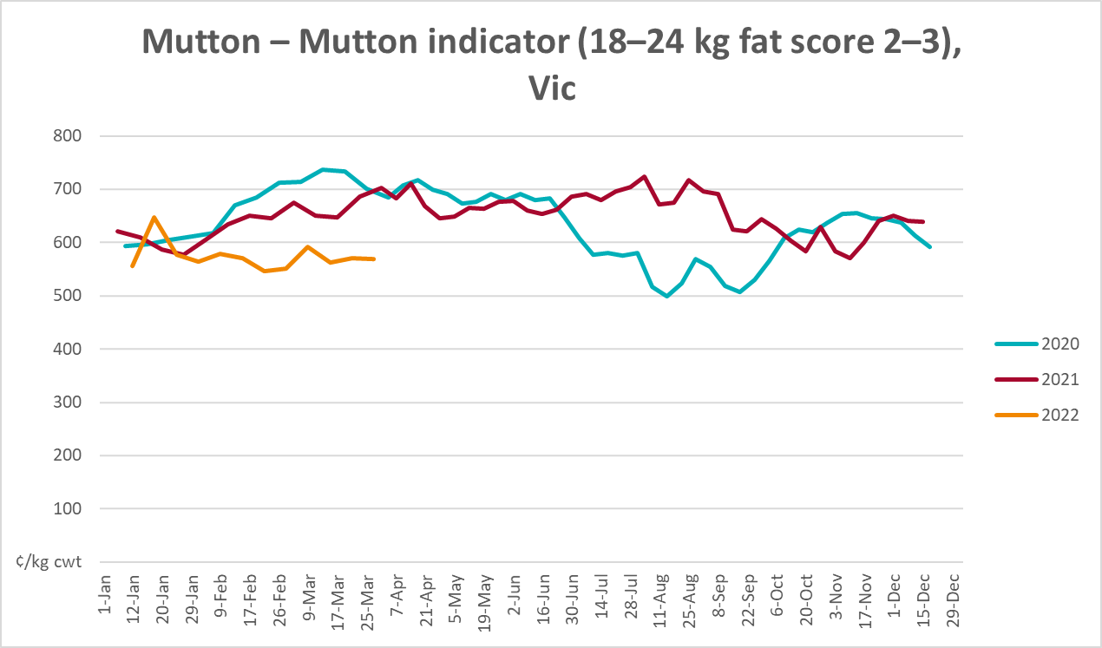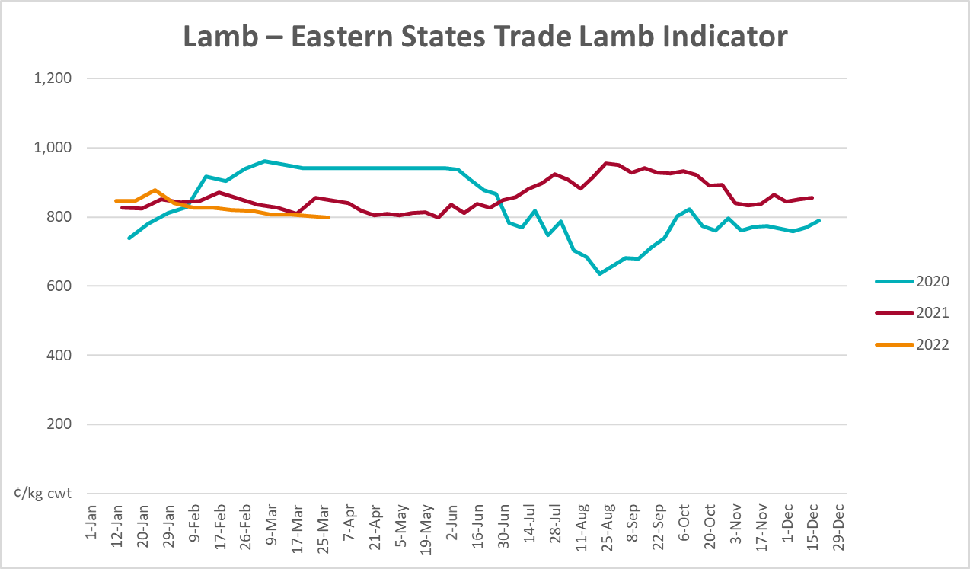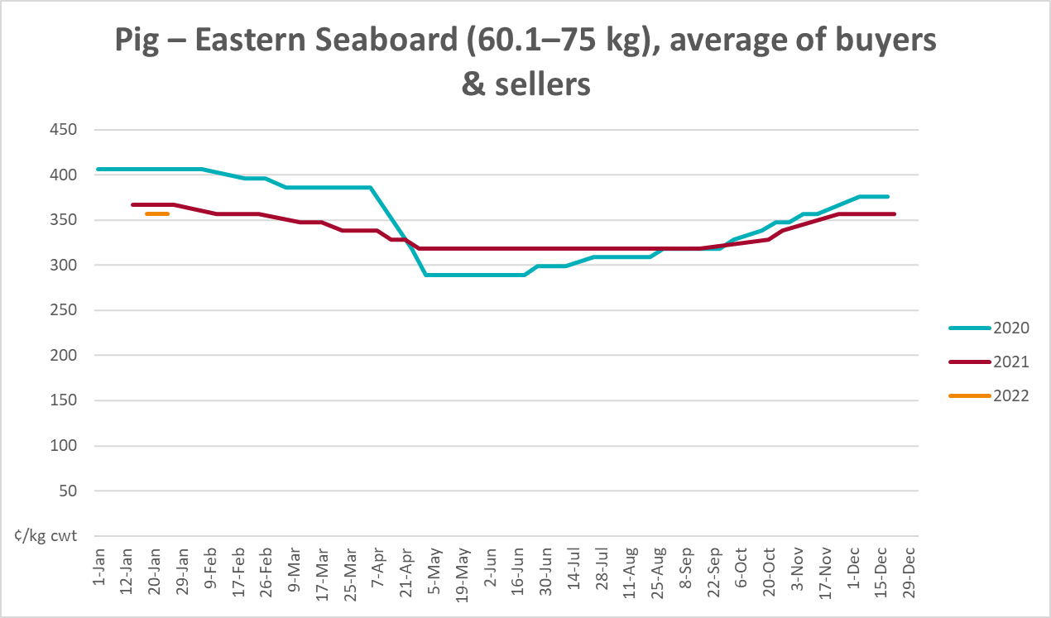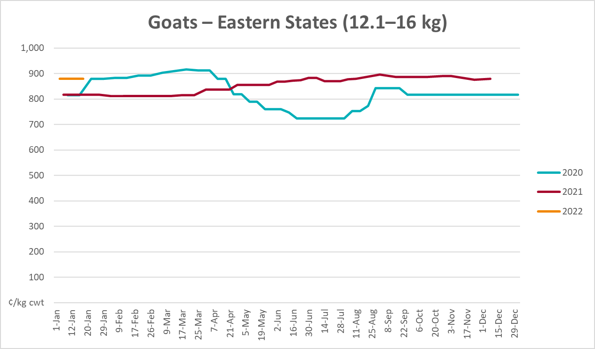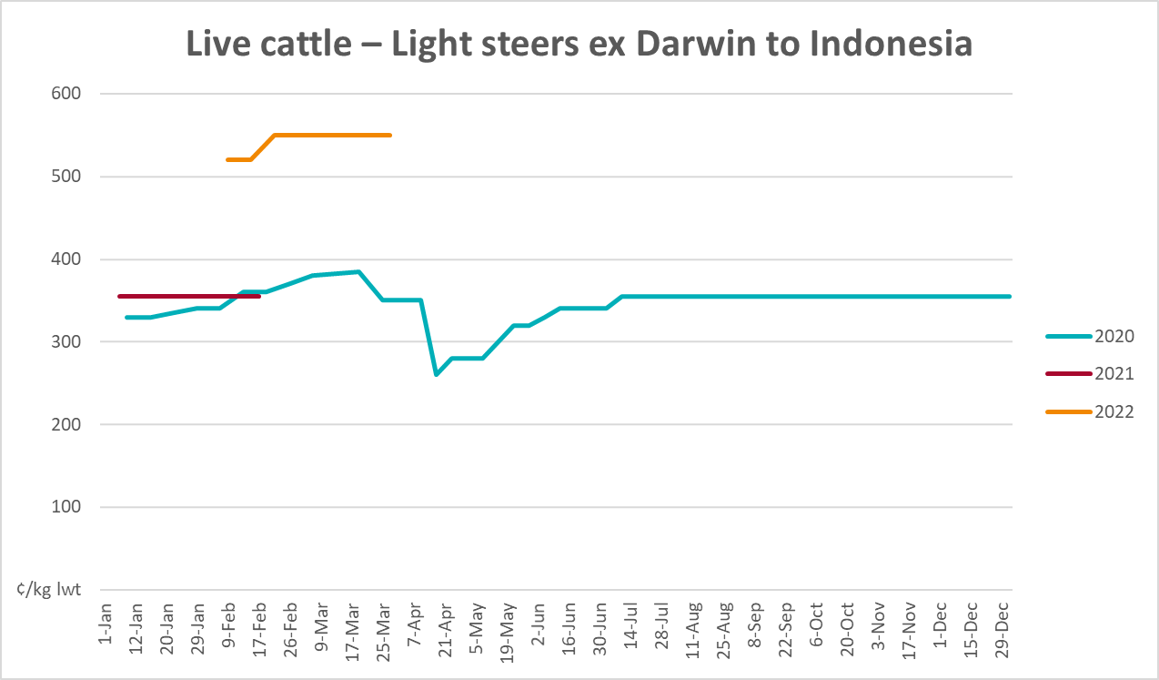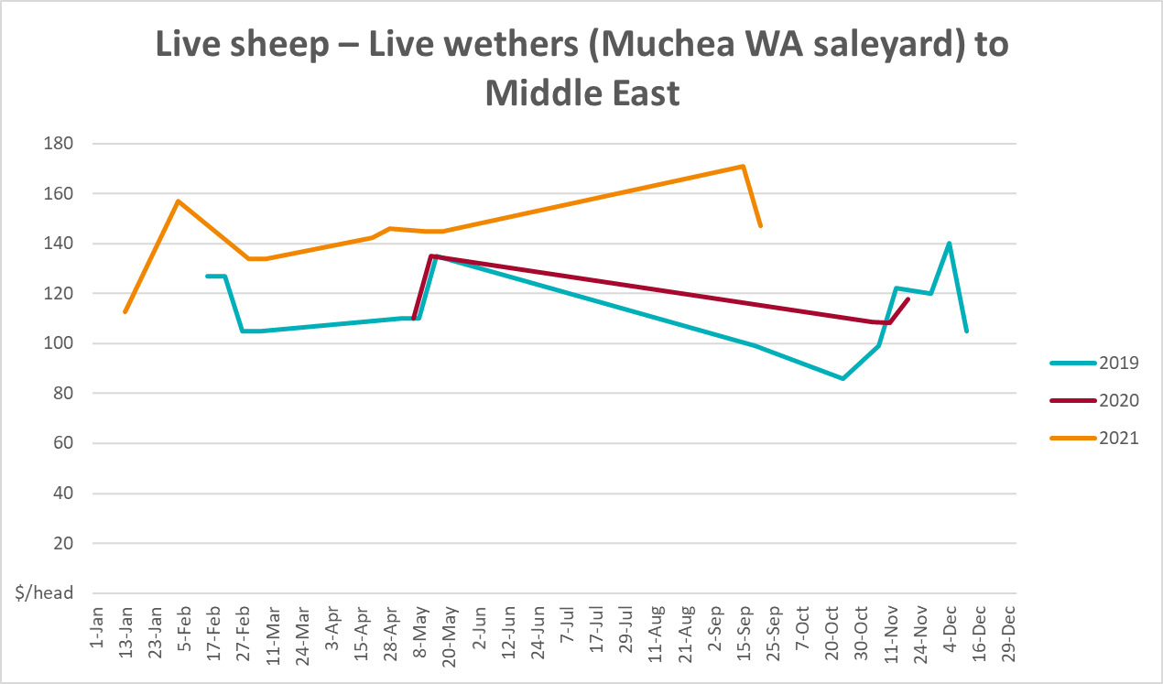

Global Dairy Trade (GDT) weighted average prices
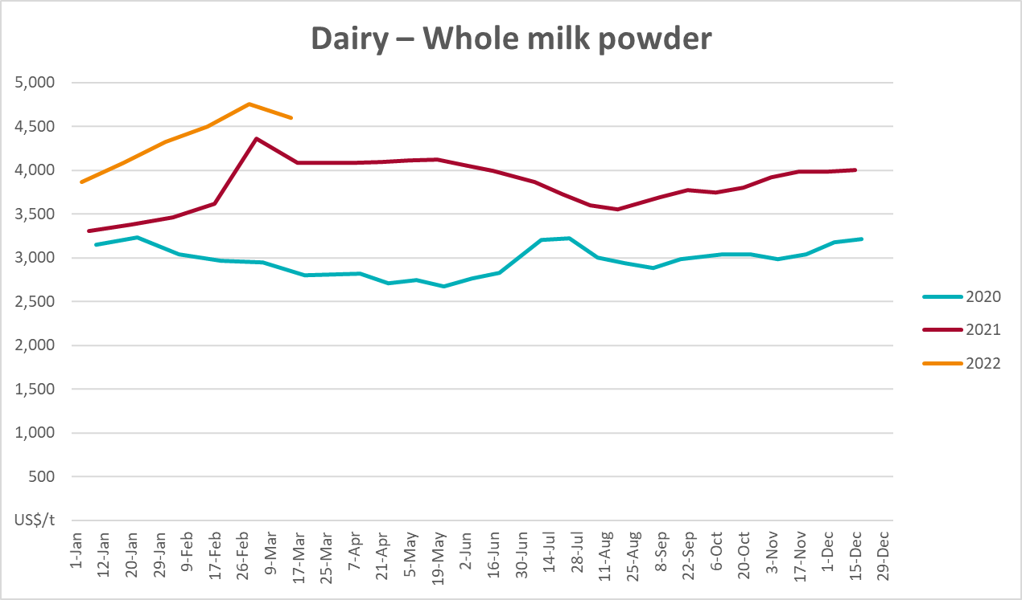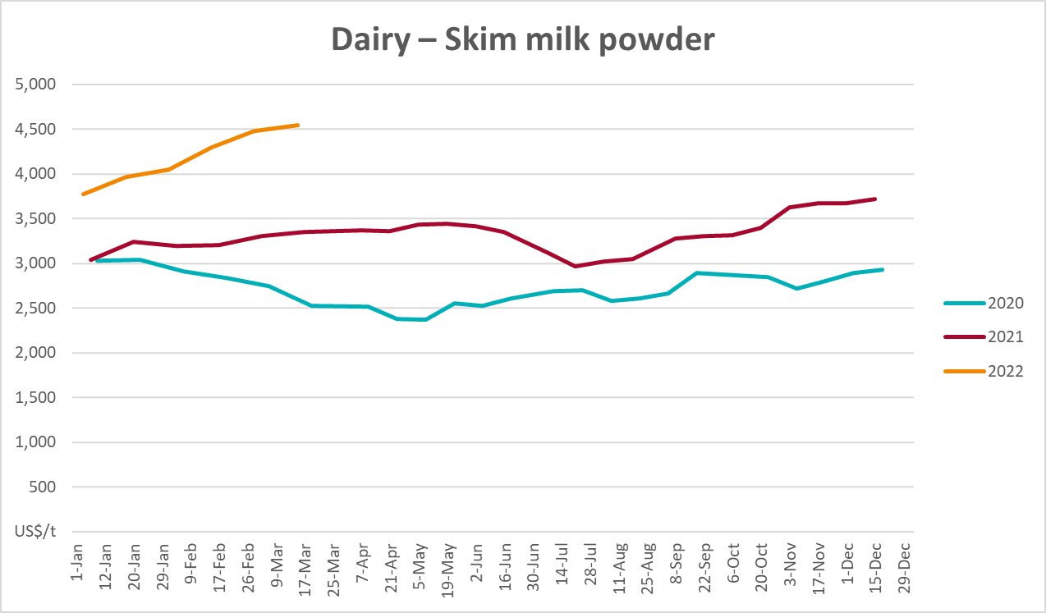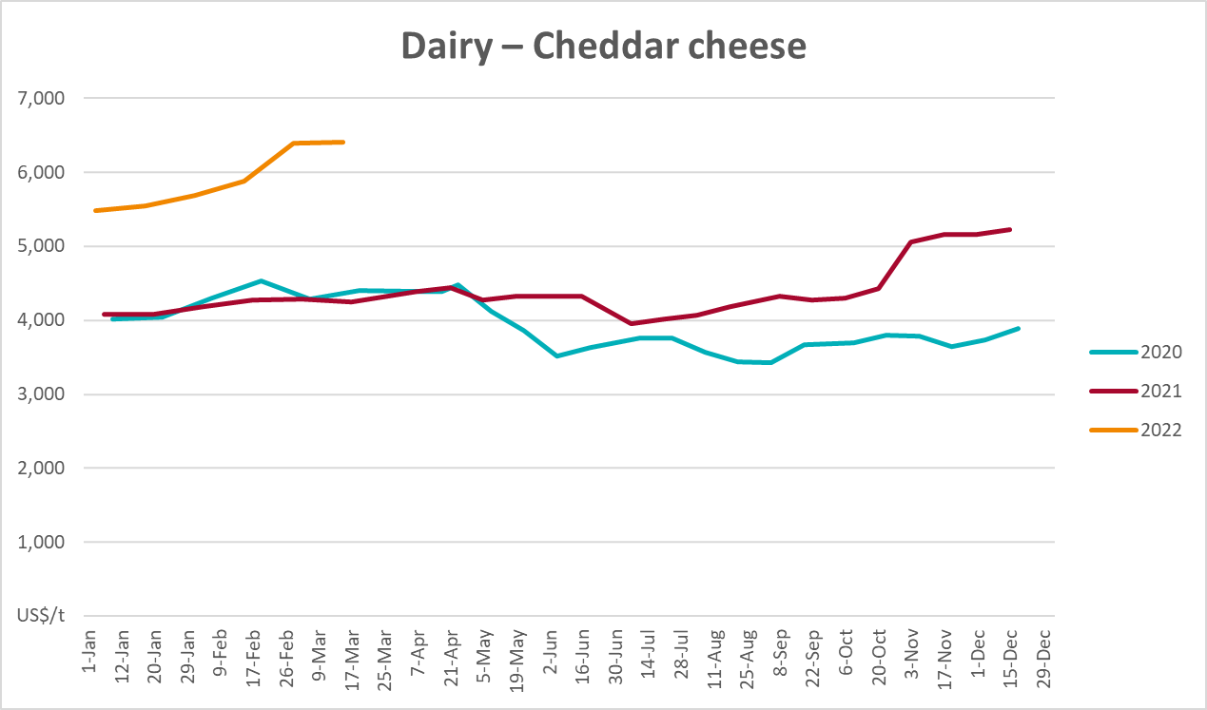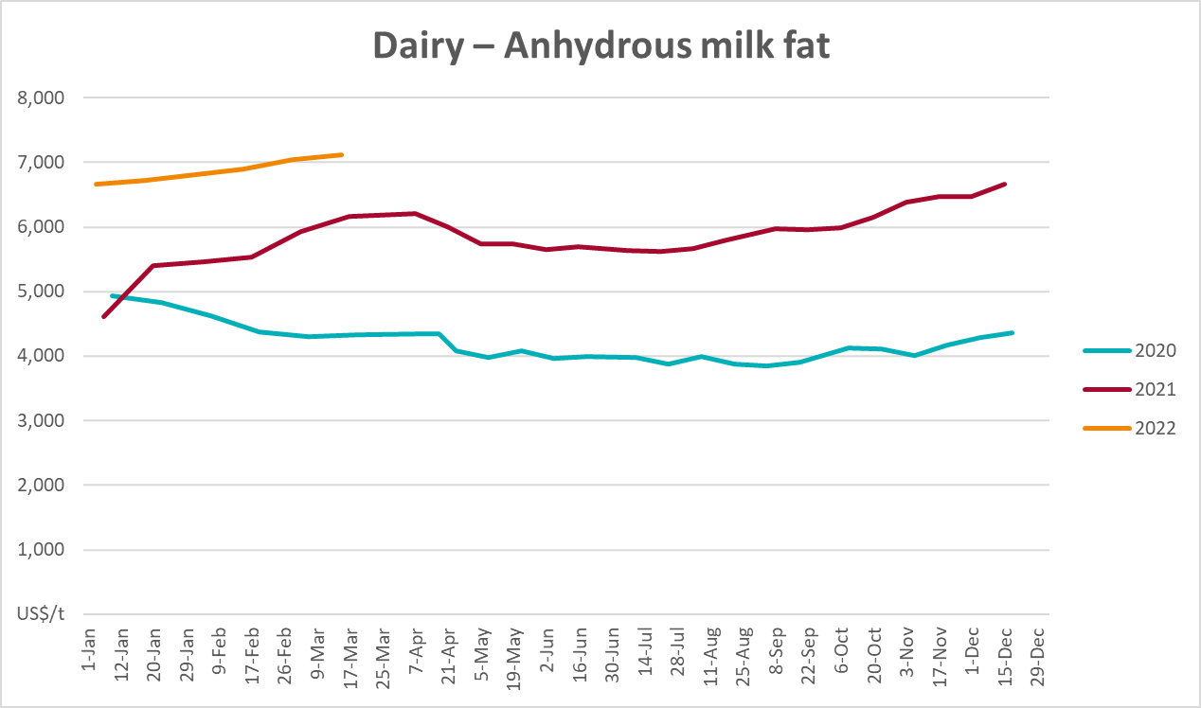

Selected fruit and vegetable prices
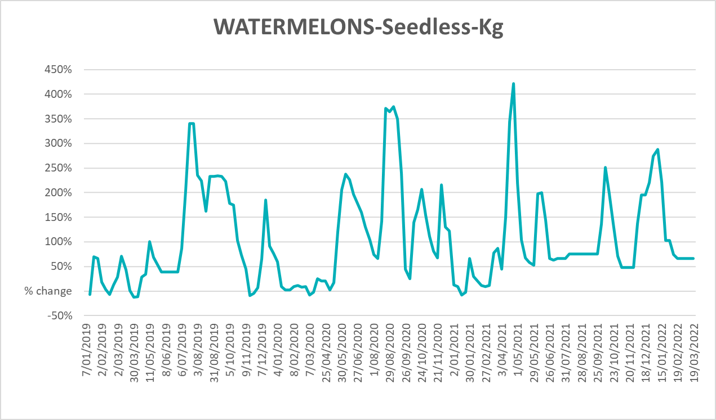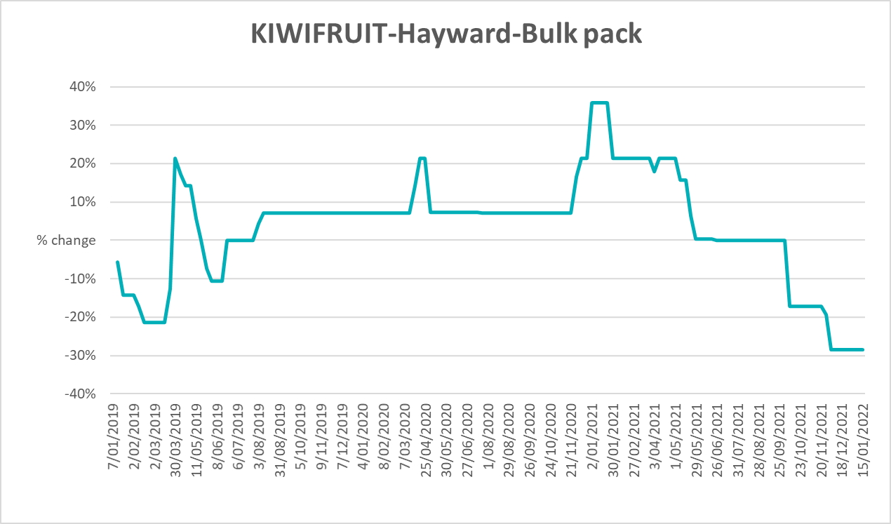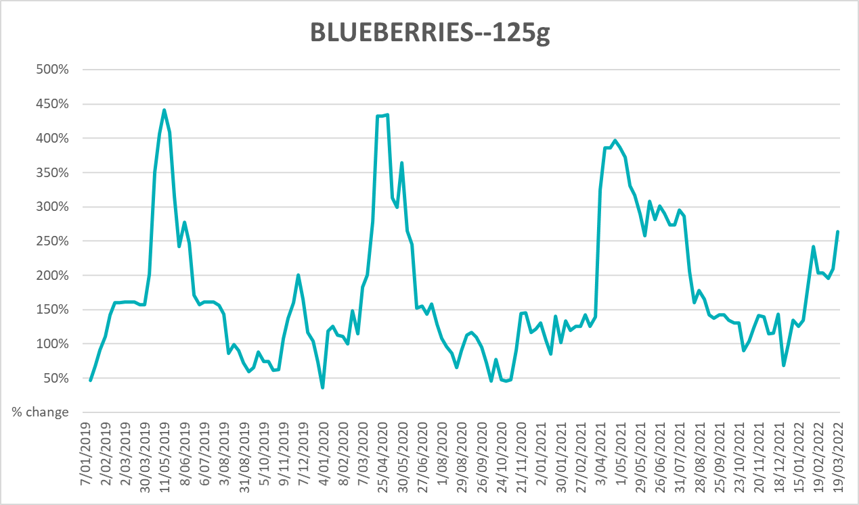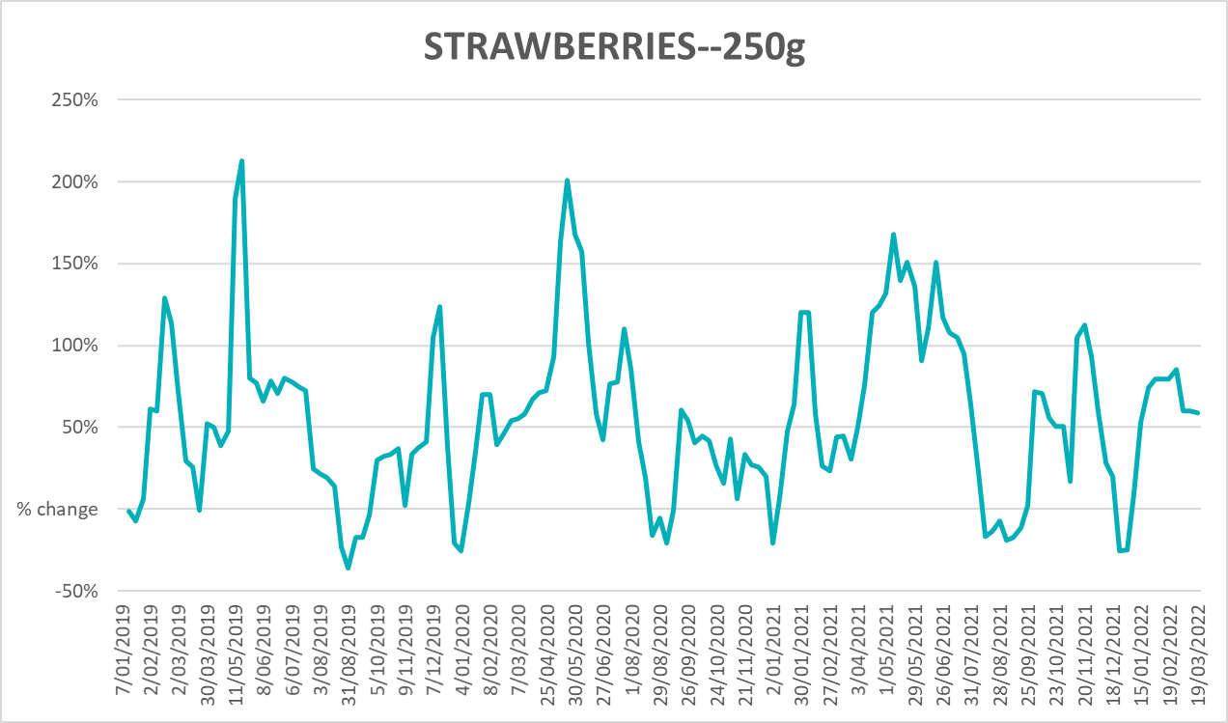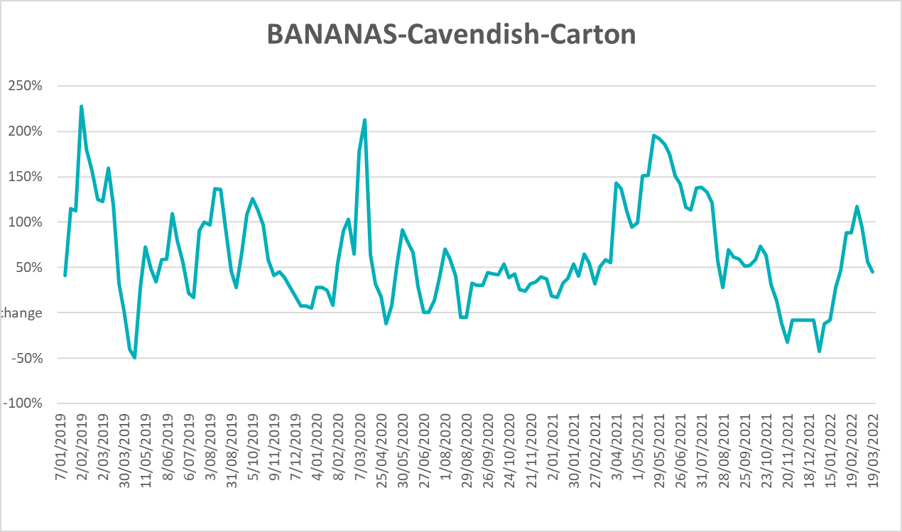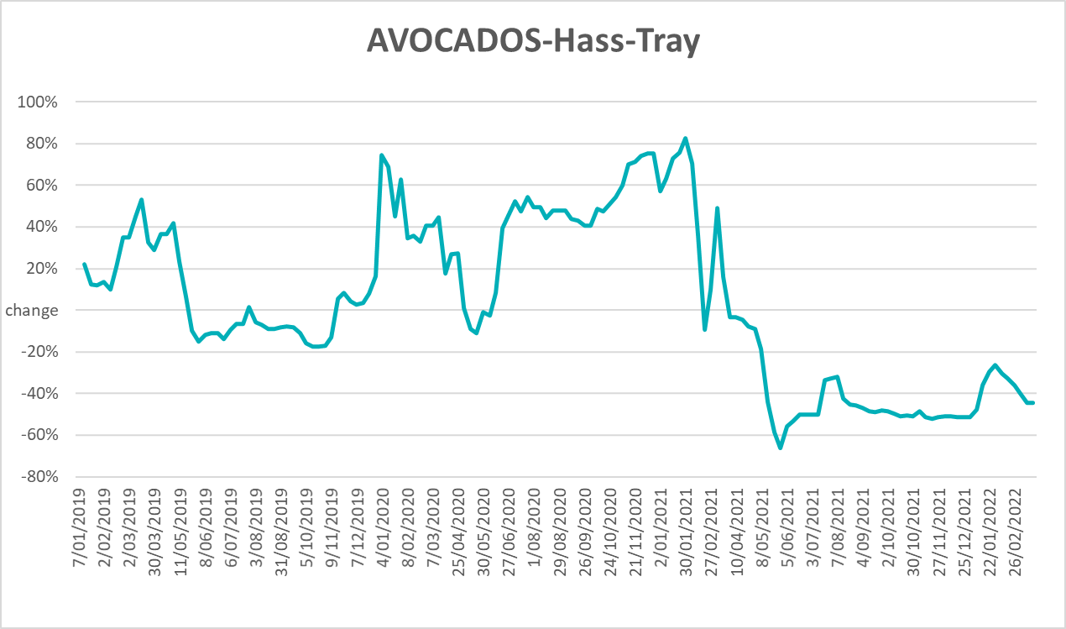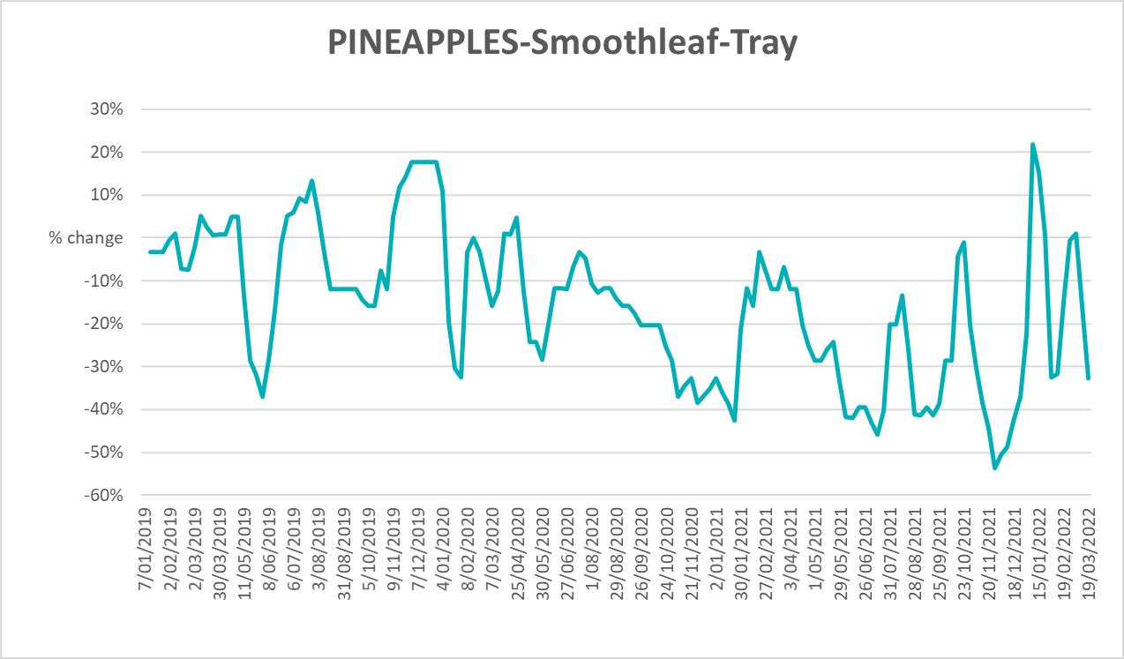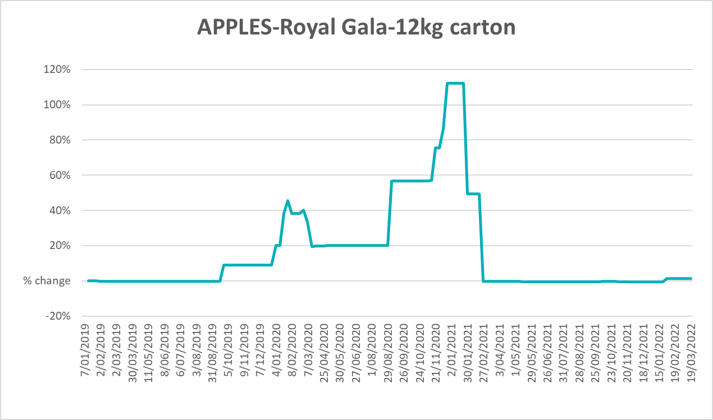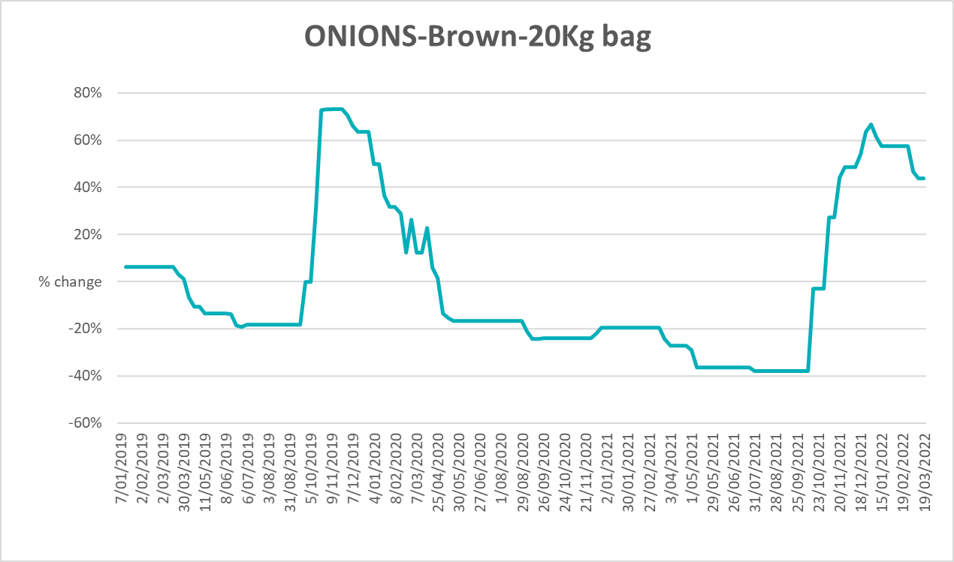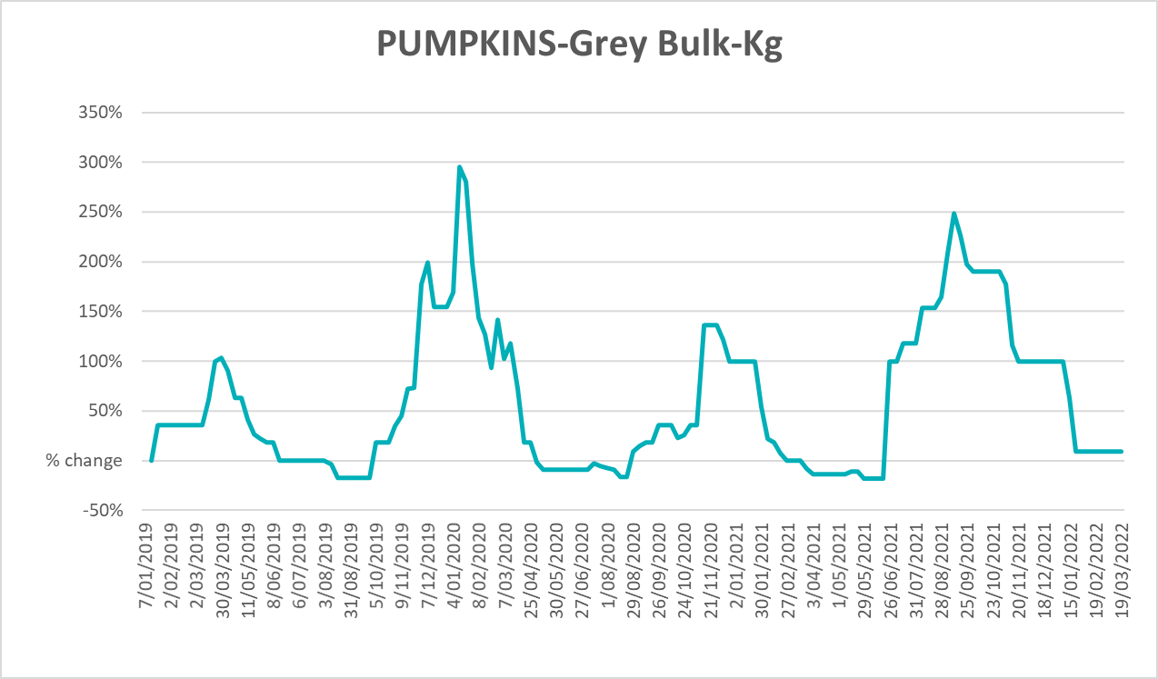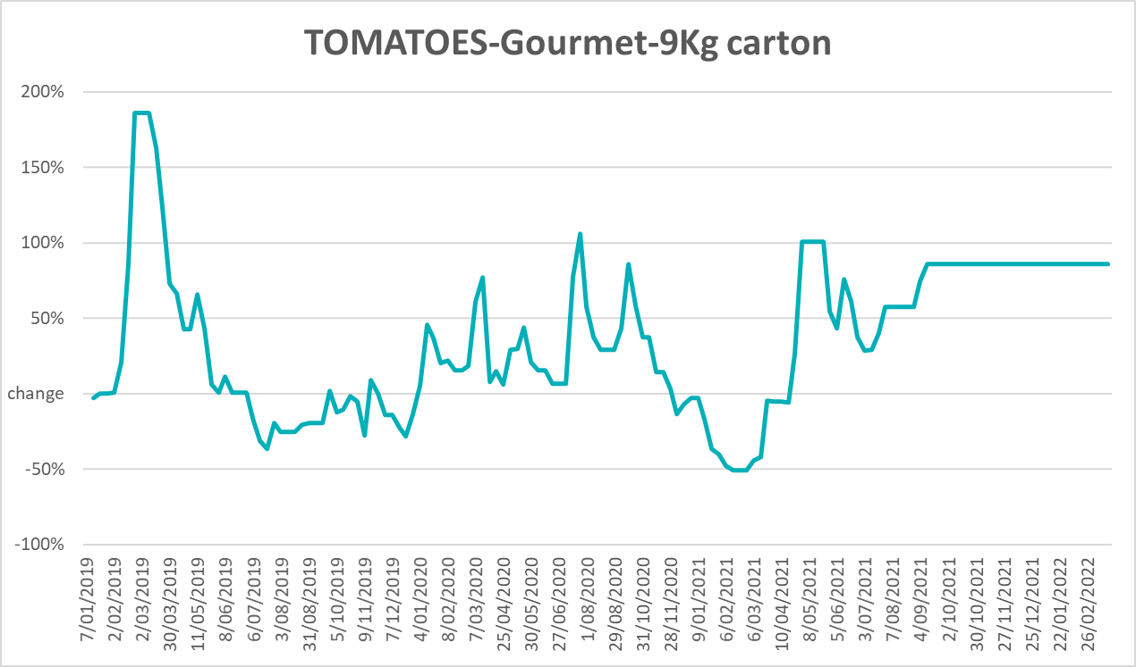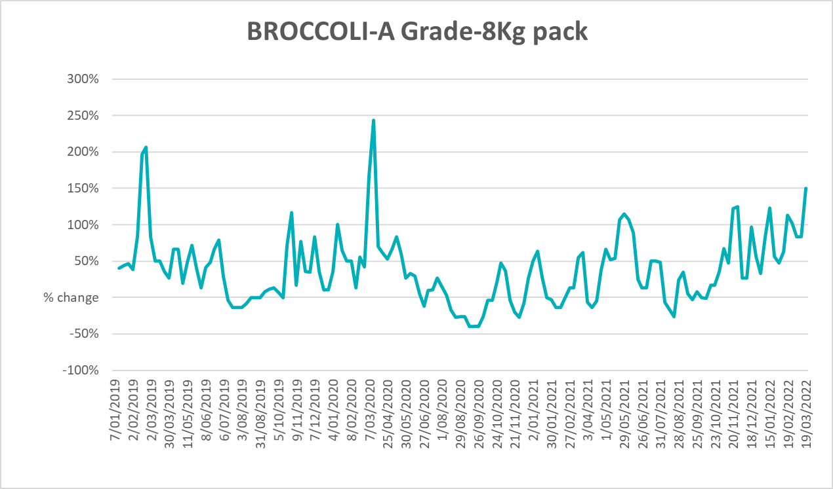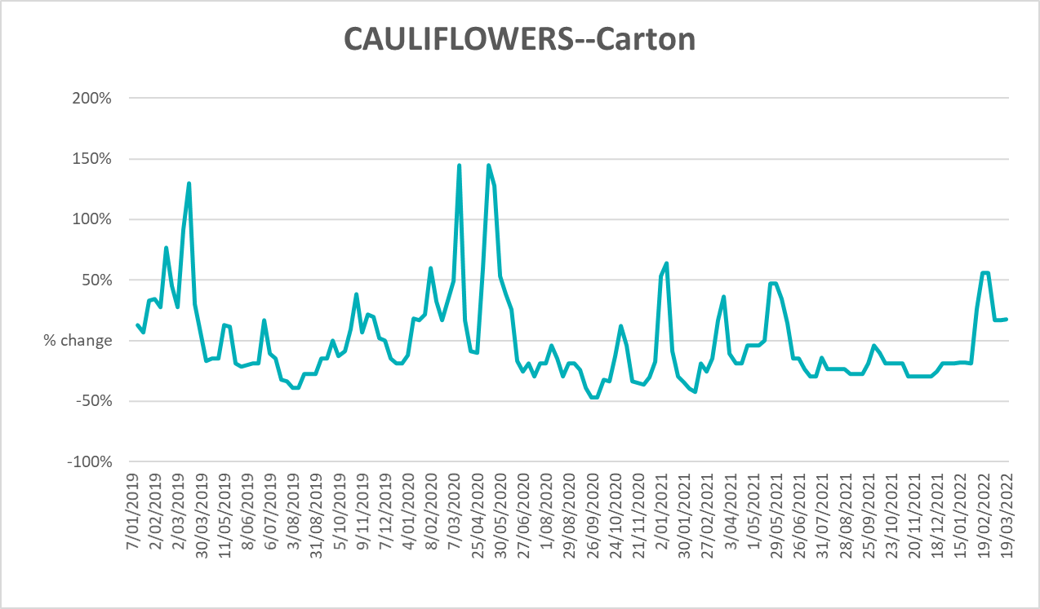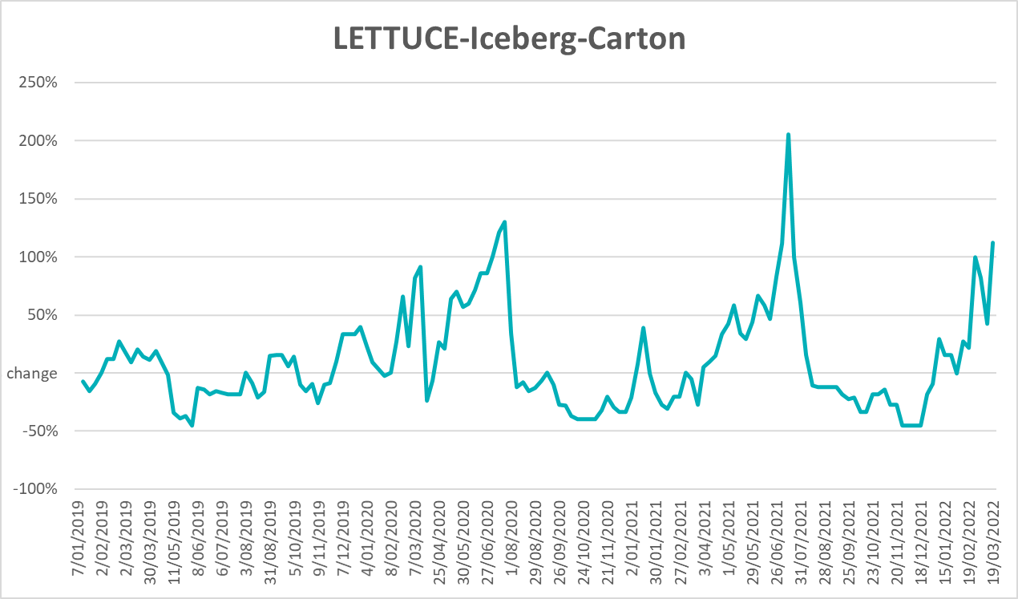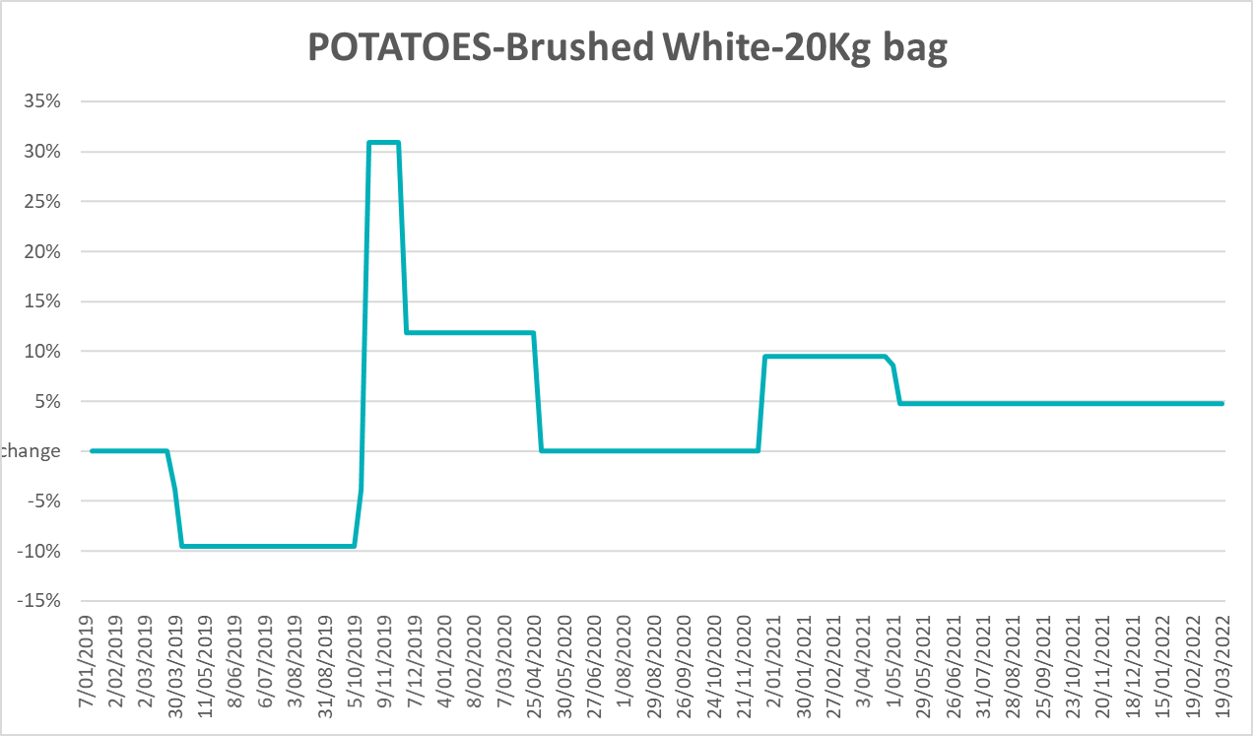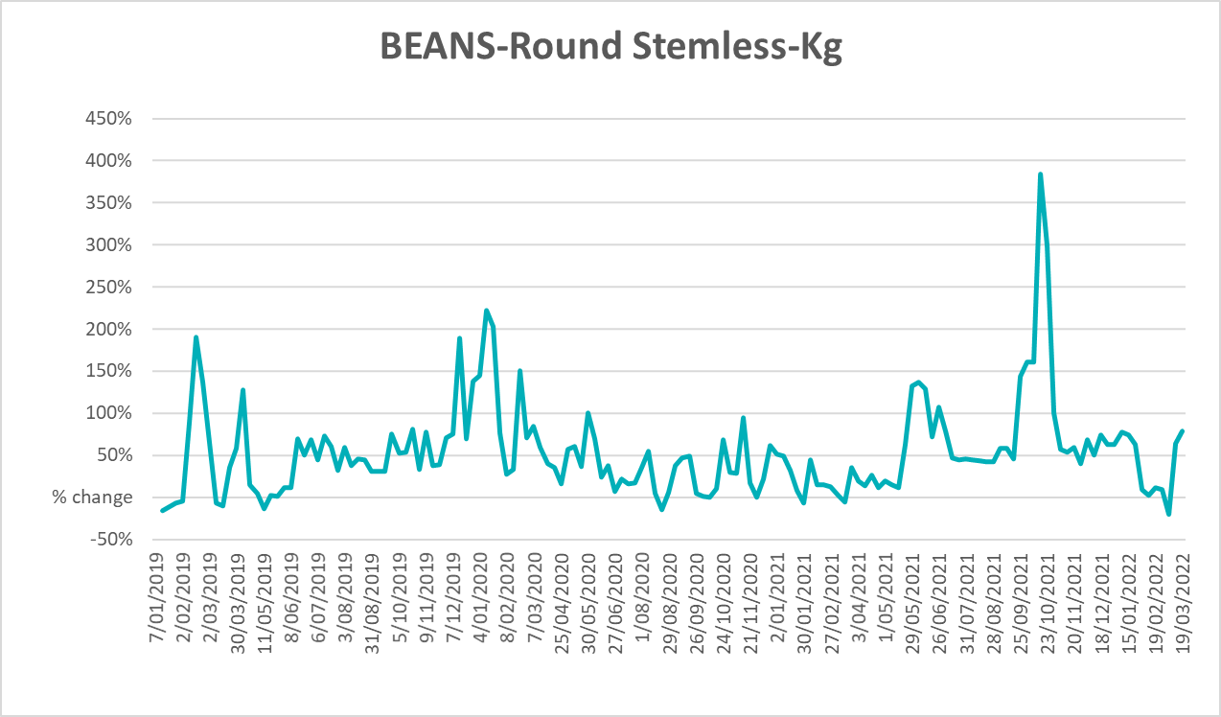

Selected domestic fodder indicator prices
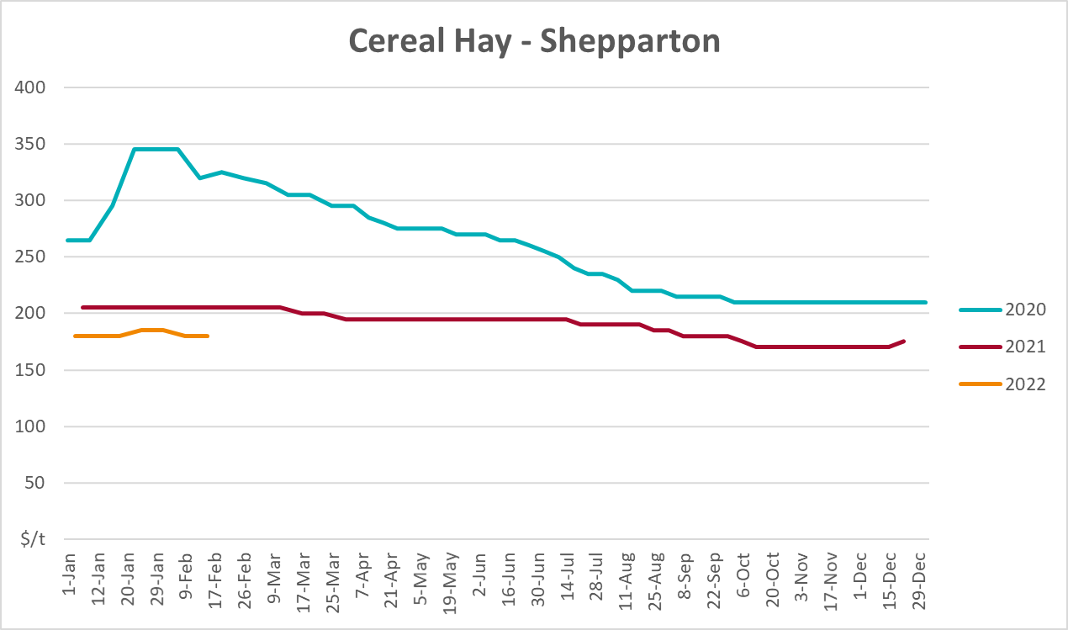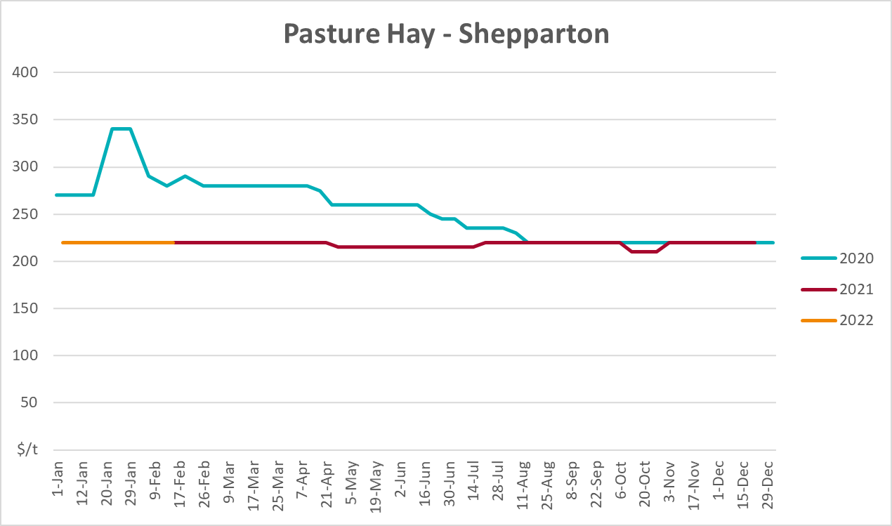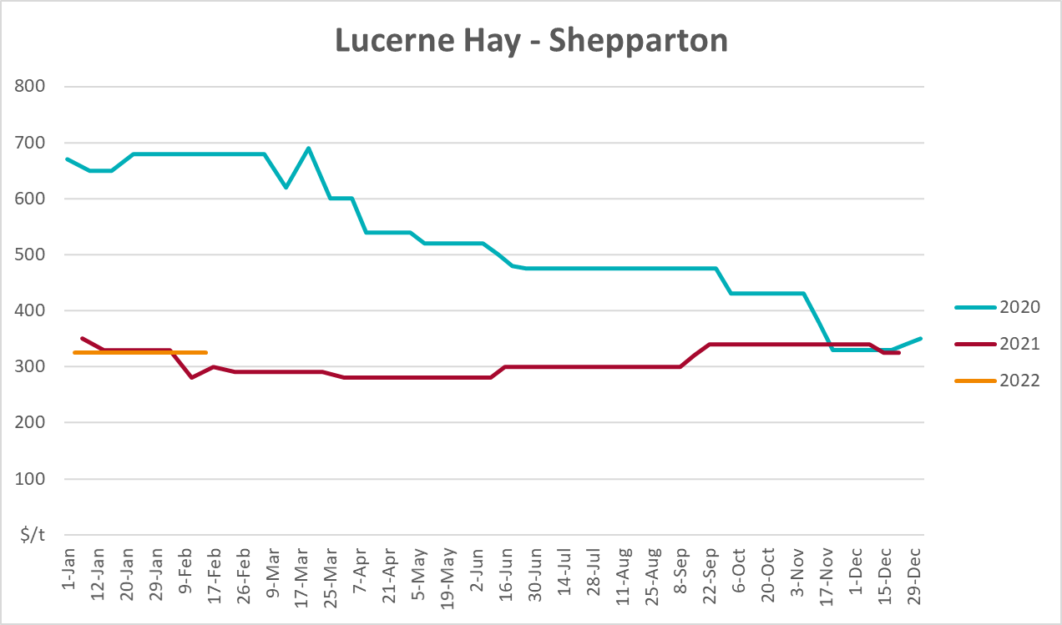

Data attribution

Climate
Bureau of Meteorology
- Weekly rainfall totals: www.bom.gov.au/climate/maps/rainfall/
- Monthly and last 3-month rainfall percentiles: www.bom.gov.au/water/landscape/
- Temperature anomalies: www.bom.gov.au/jsp/awap/temp/index.jsp
- Rainfall forecast: www.bom.gov.au/jsp/watl/rainfall/pme.jsp
- Seasonal outlook: www.bom.gov.au/climate/outlooks/#/overview/summary/
- Climate drivers: http://www.bom.gov.au/climate/enso/
- Soil moisture: www.bom.gov.au/water/landscape/
Other
- Pasture growth: www.longpaddock.qld.gov.au/aussiegrass/
- 3-month global outlooks: Environment and Climate Change Canada, NOAA Climate Prediction Center, EUROBRISA CPTEC/INPE, European Centre for Medium-Range Weather Forecasts, Hydrometcenter of Russia, National Climate Center Climate System Diagnosis and Prediction Room (NCC), International Research Institute for Climate and Society
- Global production: https://ipad.fas.usda.gov/ogamaps/cropmapsandcalendars.aspx
- Autumn break: Pook et al., 2009, https://rmets-onlinelibrary-wiley-com.virtual.anu.edu.au/doi/epdf/10.1002/joc.1833

Water
Prices
- Waterflow: https://www.waterflow.io/
- Ruralco: https://www.ruralcowater.com.au/
Bureau of Meteorology:
- Allocation trade: http://www.bom.gov.au/water/dashboards/#/water-markets/mdb/at
- Storage volumes: http://www.bom.gov.au/water/dashboards/#/water-storages/summary/drainage
Trade constraints:
- Water NSW: https://www.waternsw.com.au/customer-service/ordering-trading-and-pricing/trading/murrumbidgee
- Victorian Water Register: https://www.waterregister.vic.gov.au/TradingRules2019/

Commodities
Fruit and vegetables
- Datafresh: www.freshstate.com.au
Pigs
- Australian Pork Limited: www.australianpork.com.au
Dairy
- Global Dairy Trade: www.globaldairytrade.info/en/product-results/
World wheat, canola
- International Grains Council
World coarse grains
- United States Department of Agriculture
World cotton
- Cotlook: www.cotlook.com/
World sugar
- New York Stock Exchange - Intercontinental Exchange
Wool
- Australian Wool Exchange: www.awex.com.au/
Domestic wheat, barley, sorghum, canola and fodder
- Jumbuk Consulting Pty Ltd: http://www.jumbukag.com.au/
Cattle, beef, mutton, lamb, goat and live export
- Meat and Livestock Australia: www.mla.com.au/Prices-and-market
© Commonwealth of Australia 2022

Ownership of intellectual property rights
Unless otherwise noted, copyright (and any other intellectual property rights, if any) in this publication is owned by the Commonwealth of Australia (referred to as the Commonwealth).

Creative Commons licence
All material in this publication is licensed under a Creative Commons Attribution 4.0 International Licence except content supplied by third parties, logos and the Commonwealth Coat of Arms.
Inquiries about the licence and any use of this document should be emailed to copyright@awe.gov.au.


Cataloguing data
This publication (and any material sourced from it) should be attributed as:
ABARES 2021, Weekly Australian Climate, Water and Agricultural Update, Australian Bureau of Agricultural and Resource Economics and Sciences, Canberra, 31 March 2022. CC BY 4.0 DOI: https://doi.org/10.25814/5f3e04e7d2503
ISSN 2652-7561
This publication is available at https://www.awe.gov.au/abares/products/weekly_update
Department of Agriculture, Water and the Environment
GPO Box 858 Canberra ACT 2601
Telephone 1800 900 090
Web awe.gov.au/abares

Disclaimer
The Australian Government acting through the Department of Agriculture, Water and the Environment, represented by the Australian Bureau of Agricultural and Resource Economics and Sciences, has exercised due care and skill in preparing and compiling the information and data in this publication. Notwithstanding, the Department of Agriculture, Water and the Environment, ABARES, its employees and advisers disclaim all liability, including liability for negligence and for any loss, damage, injury, expense or cost incurred by any person as a result of accessing, using or relying on any of the information or data in this publication to the maximum extent permitted by law.

Statement of Professional Independence
The views and analysis presented in ABARES publications, including this one, reflect ABARES professionally independent findings, based on scientific and economic concepts, principles, information and data. These views, analysis and findings may not reflect or be consistent with the views or positions of the Australian Government, or of organisations or groups who have commissioned ABARES reports or analysis. More information on professional independence is provided on the ABARES website.

Acknowledgements
This report was prepared by Matthew Miller and Cameron Van-Lane.

