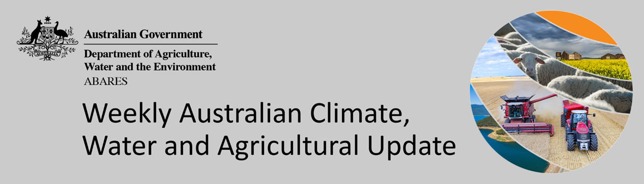
No. 23/2022

16 June 2022

Summary of key issues
- For the week ending 15 June 2022, low-pressure systems and associated cold fronts brought rainfall to western and southern parts of the country, while high-pressure systems were the dominant climate feature across remaining parts of Australia bringing clear, dry and colder than normal conditions (see Section 1.1).
- Dry conditions across New South Wales and Queensland would have been a welcome reprieve for many growers, with soil moisture levels above average to well above average. Further dry conditions and clear, sunny skies will be needed across most regions over the coming weeks to allow field access for harvesting of summer crops and planting of winter crops to resume. If wet conditions return to northern cropping regions over the coming weeks, many growers are likely to fallow fields over winter and plant a larger area to summer crops later in the year. Most growers have completed their winter planting programs across cropping regions of Victoria, South Australia and Western Australia, with previous rainfall supporting the establishment and development of crops. Rainfall across Western Australian cropping regions has provided a much-needed boost to soil moisture levels, where dry conditions have persisted over recent weeks.
- Below average rainfall globally during May is likely to result in lower-than-expected wheat production potential in the United States, the European Union, and parts of Canada. Further, the conflict in Ukraine has generated additional levels of uncertainty around wheat, corn and sunflower production for 2022. Below average rainfall and above average temperatures in recent months have also negatively affected corn and soybean production across parts of Argentina and Brazil. Global production conditions have deteriorated compared to those used to formulate ABARES forecasts of global grain supplies and world prices in its June 2022 edition of the Agricultural Commodities Report. As a result, global grain and oilseed production is likely to be lower than that forecast in June (see Section 1.2).
- Over the 8-days to 23 June 2022, a cold front moving across southern Australia is expected to bring moderate rainfall to parts of south-western and south-eastern Australia. Meanwhile, high pressure systems are forecast to be the dominant climate feature across much of the country, resulting in clear, dry conditions (see Section 1.3).
- Water storage in the Murray–Darling Basin (MDB) increased by 195 gigalitres (GL) between 8 June 2022 and 15 June 2022. The current volume of water held in storage is 22,139 GL, which represents 88 of total capacity. This is 44% or 6,729 GL more than at the same time last year.
- Allocation prices in the Victorian Murray below the Barmah Choke decreased from $21 per ML on 3 June 2022 to $19 per ML on 10 June 2022. Prices are lower in the Murrumbidgee and regions above the Barmah choke due to the binding of the Murrumbidgee export limit and Barmah choke trade constraint.

Climate

Rainfall this week
For the week ending 15 June 2022, low-pressure systems and associated cold fronts brought rainfall to western and southern parts of the country, while high-pressure systems were the dominant climate feature across remaining parts of Australia bringing clear, dry and colder than normal conditions.
Rainfall totals of between 10 and 50 millimetres were recorded across alpine areas of New South Wales and Victoria, isolated parts of northern Queensland, southern Victoria, the south-west of Western Australia and parts of Tasmania. Rainfall totals in excess of 50 millimetres were recorded in isolated parts of the south-west of Western Australia, as well as western Tasmania. Remaining parts of Australia received little to no rainfall.
In cropping regions, rainfall totals of between 10 and 50 millimetres were recorded in isolated parts of South Australia and most of Western Australia. Little to no rainfall was recorded across cropping regions in New South Wales, Queensland, Victoria and remaining parts of South Australia.
Dry conditions across New South Wales and Queensland would have been a welcome reprieve for many growers, with soil moisture levels above average to well above average. Further dry conditions and clear, sunny skies will be needed across most regions over the coming weeks to allow field access for harvesting of summer crops and planting of winter crops to resume. If wet conditions return to northern cropping regions over the coming weeks, many growers are likely to fallow fields over winter and plant a larger area to summer crops later in the year. Most growers have completed their winter planting programs across cropping regions of Victoria, South Australia and Western Australia, with previous rainfall supporting the establishment and development of crops. Rainfall across Western Australian cropping regions has provided a much-needed boost to soil moisture levels, where dry conditions have persisted over recent weeks.

Rainfall for the week ending 15 June 2022

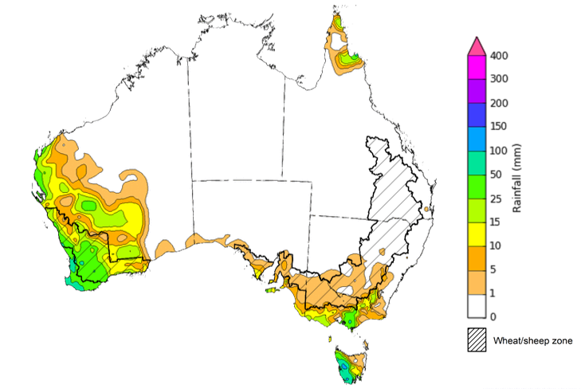

©Commonwealth of Australia 2022, Australian Bureau of Meteorology Issued: 15/6/2022
Note: The rainfall analyses and associated maps utilise data contained in the Bureau of Meteorology climate database, the Australian Data Archive for Meteorology (ADAM). The analyses are initially produced automatically from real-time data with limited quality control. They are intended to provide a general overview of rainfall across Australia as quickly as possible after the observations are received. For further information go to http://www.bom.gov.au/climate/rainfall/

Global production conditions and climate outlook
Crop production is affected by long-term trends in average rainfall and temperature, interannual climate variability, shocks during specific growth stages, and extreme weather events (IPCC 2012). Some crops are more tolerant than others to certain types of stresses, and at each growth stage, different types of stresses affect each crop species in different ways.
The precipitation anomalies and outlooks presented here give an indication of the current and future state of production conditions for the major grain and oilseed producing countries which are responsible for over 80% of global production. This is an important input to assessing the global grain supply outlook.
May precipitation percentiles and current production conditions
As of the end of May 2022, rainfall was mixed for the world’s major grain-producing and oilseed-producing regions.
In the northern hemisphere, precipitation was below average in south-western and central United States, across much of the European Union, eastern China, Ukraine and parts of Kazakhstan. Precipitation was above average for north-eastern United States, central Canada, southern India, southern China and parts of western Russia. Precipitation was close to average across the remainder of the major grain-producing and oilseed-producing regions in the northern hemisphere.
In the southern hemisphere, May precipitation was below average for Argentina, as well as much of Brazil. Precipitation was above average for parts of South Africa, the far south of Brazil and much of eastern Australia. Precipitation was close to average across the remainder of major grain-producing and oilseed-producing regions in the southern hemisphere.

Global precipitation percentiles, May 2022
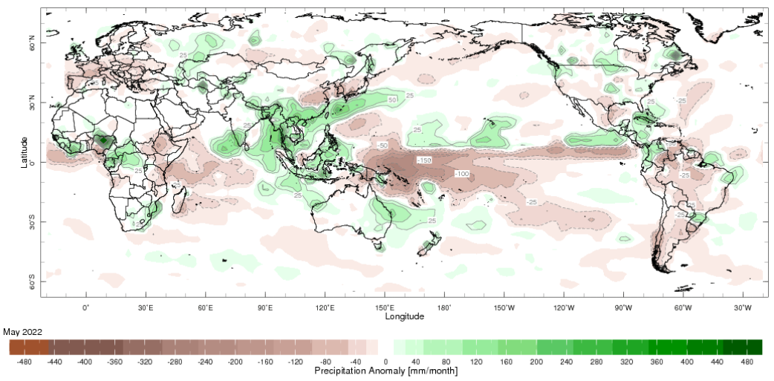
Note: The world precipitation percentiles indicate a ranking of precipitation for May, with the driest (0th percentile) being 0 on the scale and the wettest (100th percentile) being 1 on the scale. Percentiles are based on precipitation estimates from the NOAA Climate Prediction Center's Climate Anomaly Monitoring System Outgoing Precipitation Index dataset. Precipitation estimates for May 2022 are compared with rainfall recorded for that period during the 1981 to 2010 base period.
Source: International Research Institute for Climate and Society
As at 28 May 2022 global production conditions were mixed for the production of wheat, corn, rice and soybean.
In the northern hemisphere production conditions for wheat have been mixed. Climatic conditions have been favourable for wheat development in the Russian Federation and the United Kingdom. Production conditions were mixed for the European Union, Canada and the United States due to dryness in some areas and excessive moisture in others. Flooding along the Yellow River in China last year delayed and reduced sowing of winter wheat in autumn, which is expected to negatively impact production. The conflict in Ukraine is expected to restrict access to inputs and limit field access, which has generated additional levels of uncertainty for the wheat production outlook.
In Argentina, harvesting of early planted corn is continuing with reduced yields expected due to earlier hot and dry weather. Conditions of the late-planted crop remain favourable. In Brazil, conditions are mixed for the summer-planted crop as a lack of rain in the central-west and south-east regions is likely to impact yields for later sown crops. In South Africa and Mexico harvesting is ongoing under favourable conditions. In the United States, Canada and the European Union sowing is progressing slower than usual due to cool and/or wet weather. In China and Russia growing conditions are favourable of the spring-planted crop. In Ukraine, sowing of corn is progressing despite the uncertainties of the ongoing war.
In India, harvesting of the Rabi rice crop is wrapping up under favourable conditions. In China, conditions are favourable for both single-season rice and early-season rice. In the Philippines and Thailand, harvesting of dry-season rice is underway. Yields in the Philippines are average thus far, however yields have been affected by damaging rains in Visayas and pest infestations in Mindanao. While in Thailand, harvested area has increased since last year. Winter-spring rice in northern Vietnam is in the grain development growth stages under favourable conditions, while harvesting is underway in the south with increased yields from last year
Harvesting of soybean is progressing for both the early-planted crop and the late-planted crop in Argentina. Dry conditions throughout the growing season have led to mixed yields across the different regions. In the United States, sowing progress is catching up after earlier delays due to cold and wet weather in the northern Corn Belt; however, sowing remains behind in Minnesota and the Dakotas. In Canada, sowing is ongoing under favourable conditions in Ontario and Quebec, while excess moisture in Manitoba and eastern Saskatchewan, as well as dry conditions in western Saskatchewan, are of some concern. In China, sowing has begun under favourable conditions. In Ukraine, sowing is progressing despite the uncertainties of the ongoing war.
Crop conditions, AMIS countries, 28 May 2022
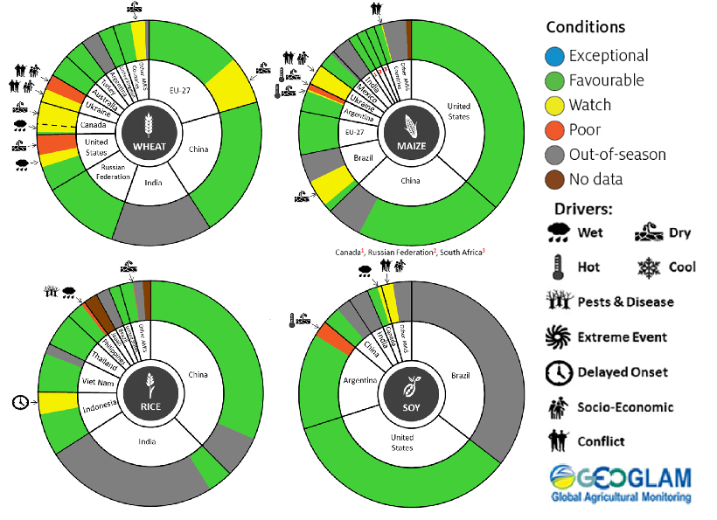
AMIS Agricultural Market Information System.
Source: AMIS
The global climate outlook for July 2022 to September 2022 indicates that variable rainfall conditions are expected for the world's major grain-producing and oilseed-producing regions. Outlooks and potential production impacts for the major grain and oilseed producing countries are presented in the table.
Rainfall outlook and potential impact on the future state of production conditions between July 2022 to September 2022
Region | July - September rainfall outlook | Potential impact on production
Argentina | Below average rainfall is expected across most of Argentina between July and September 2022. | Below average rainfall across Argentina is likely to adversely affect the establishment and growth of wheat. Dry conditions in September could adversely affect wheat yields and delay planting of corn and cotton.
Black Sea Region | Ukraine - Average rainfall is more likely across parts of Ukraine.  Kazakhstan - Average rainfall is more likely across parts of Kazakhstan.  The Russian Federation – Average rainfall is more likely across most of Russia. | Average rainfall across much of The Russian Federation, Ukraine and Kazakhstan will support yield potential for spring wheat, corn, cotton and sunflower during flowering and grain filling in July and August 2022.
Brazil | Above average rainfall is more likely across parts of northern and southern Brazil and below average rainfall is more likely across parts of central Brazil between July and September 2022. | Below average rainfall in July 2022 across central Brazil may adversely affect the establishment and growth of wheat. Dry conditions in August to September could adversely affect wheat yields and delay the planting of corn and soybean.
Canada | Average rainfall is more likely for much of Canada, especially across major production regions between July and September 2022. | Average rainfall is likely to positively impact yields for spring wheat and canola during critical stages of flowering and filling in July and August. Likewise, average rainfall conditions will support the development and growth of corn, soybeans and sunflower.
China | Below average rainfall is more likely across parts of north-western, central and eastern China, and above average rainfall is likely in north-eastern and southern China between July and September 2022. | Below average rainfall across parts of north-western, central and eastern China is likely to negatively impact cotton, spring wheat, sunflower and rice yields in affected regions. The dry conditions, however, may assist harvesting of spring wheat in September. Above average rainfall across north-eastern China is likely to support the yield potential for corn, sorghum and soybean between July and August 2022.
Europe | Below average rainfall is more likely for parts of southern and eastern Europe between July and September 2022. | Below average rainfall across parts of southern and eastern Europe may adversely affect the yield potential of corn, soybean, sorghum and sunflower seeds during flowering and grain development. The dry conditions, however, will assist with harvesting of winter wheat.
South Asia (India) | Average to above average rainfall is more likely across much of India between July and September 2022. | Average to above average rainfall across much of India is likely to benefit the yield potential of non-irrigated rice, corn, millet and sorghum from July 2022.
Southeast Asia (SEA) | Above average rainfall is more likely for parts of southern Southeast Asian countries and below average rainfall is more likely for southern Myanmar and the Philippines between July and September 2022. | Average or better rainfall across most of Southeast Asia is likely to benefit corn and rice potential yields. Below average rainfall across parts of Myanmar and the Philippines may adversely impact rice and corn production.
The United States of America | Above average rainfall is likely for much of the eastern US and below average rainfall is more likely for most northern and central growing regions between July and September 2022. | Average or better rainfall across the eastern US is likely to support the yield potential of cotton, corn, groundnuts and soybeans during the flowering and grain development in July and August. Below average rainfall in northern and central US is likely to adversely impact canola, cotton, sorghum and spring wheat yields in affected regions.

Rainfall forecast for the next eight days
Over the 8-days to 23 June 2022, a cold front moving across southern Australia is expected to bring moderate rainfall to parts of south-western and south-eastern Australia. Meanwhile, high pressure systems are forecast to be the dominant climate feature across much of the country, resulting in clear, dry conditions.
Rainfall totals of between 10 and 50 millimetres are forecast for alpine regions of New South Wales and Victoria, southern parts of Victoria and South Australia, parts of the south-west of Western Australia and northern Tasmania. Little to no rainfall is forecast across remaining parts of Australia over the next 8-days.
In Australian cropping regions, rainfall totals of between 10 and 50 millimetres are expected in isolated parts of south-eastern New South Wales, southern and eastern Victoria, central parts of South Australia, as well as western parts of Western Australia. Little to no rainfall is forecast for all remaining cropping regions during the next 8-days.
A second week of dry conditions across cropping regions in New South Wales and Queensland should see soil moisture levels continuing to decrease, allowing improved access to fields. A significant proportion of summer crops are still awaiting harvesting in southern Queensland and northern New South Wales. Likewise, progress on winter crop plantings have been limited due to the wet conditions. If dry conditions persist, growers may have an opportunity to plant winter cereals in the coming weeks before the planting window closes. Despite relatively dry conditions across cropping regions of southern Australia, soil moisture levels remain average to above average. The large winter crop planting is expected to have sufficient plant available water to support crop development over the coming weeks.

Total forecast rainfall (mm) for the period 16 June to 23 June 2022
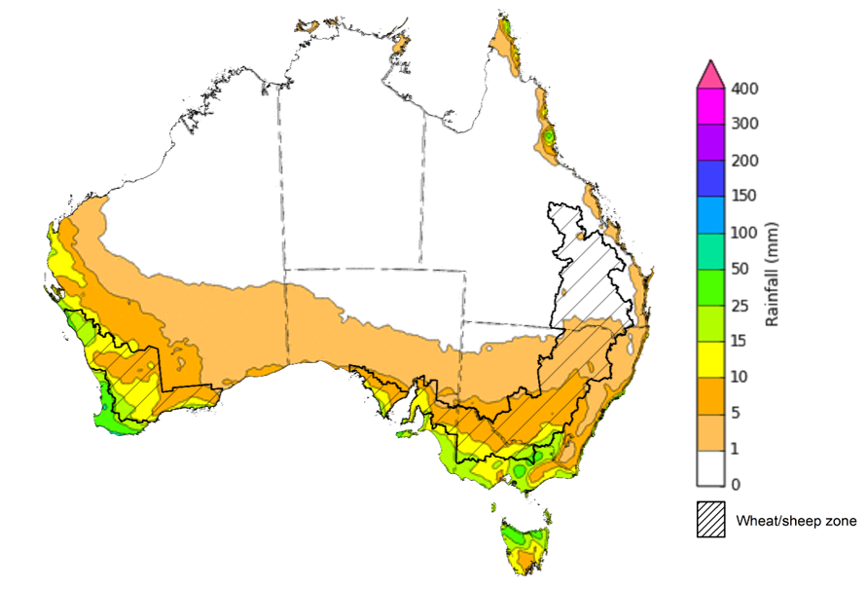

©Commonwealth of Australia 2022, Australian Bureau of Meteorology Issued:15/6/2022

Water
Note: This rainfall forecast is produced from computer models. As the model outputs are not altered by weather forecasters, it is important to check local forecasts and warnings issued by the Bureau of Meteorology.

Water markets – current week
Water storage in the Murray–Darling Basin (MDB) increased by 195 gigalitres (GL) between 8 June 2022 and 15 June 2022. The current volume of water held in storage is 22,139 GL, which represents 88 of total capacity. This is 44% or 6,729 GL more than at the same time last year.

Water storages in the Murray-Darling Basin, 2013–2022
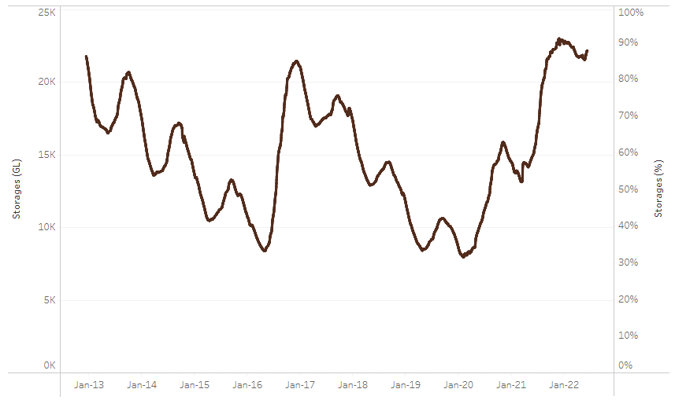
Allocation prices in the Victorian Murray below the Barmah Choke decreased from $21 per ML on 3 June 2022 to $19 per ML on 10 June 2022. Prices are lower in the Murrumbidgee and regions above the Barmah choke due to the binding of the Murrumbidgee export limit and Barmah choke trade constraint.
Water storage data is sourced from the Bureau of Meteorology.

Region | $/ML
NSW Murray Above | 1
NSW Murrumbidgee | 1
VIC Goulburn-Broken | 20
VIC Murray Below | 19

Surface water trade activity, Southern Murray–Darling Basin

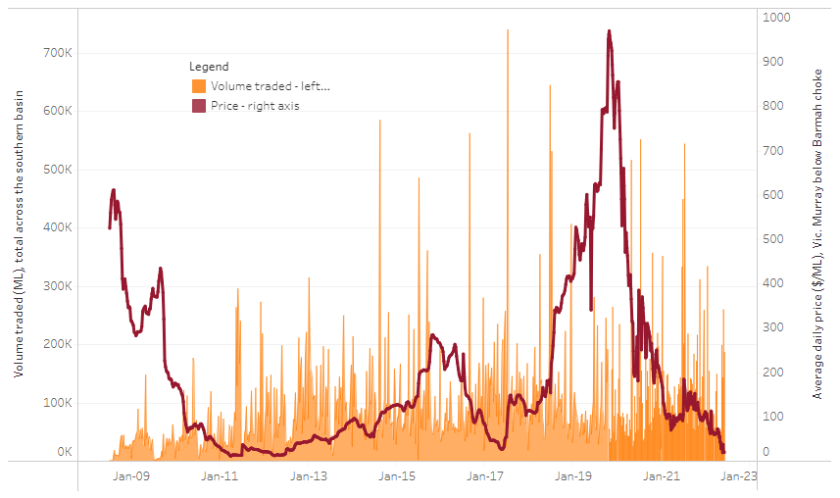
To access the full, interactive, weekly water dashboard, which contains the latest and historical water storage, water market and water allocation information, please visit http://www.agriculture.gov.au/abares/products/weekly_update/weekly-update-160622
The trades shown reflect estimated market activity and do not encompass all register trades. The price is shown for the VIC Murray below the Barmah choke. Historical prices (before 1 July 2019) are ABARES estimates after removing outliers from BOM water register data. Prices after 1 July 2019 and prior to the 30 October 2019 reflect recorded transaction prices as sourced from Ruralco. Prices after the 30 October 2019 are sourced from Waterflow. Data for volume traded is sourced from the BOM water register. Data shown is current at 16 June 2022.

Commodities

Indicator | Week ended | Unit | Latest price | Previous week | Weekly change | Price 12 months ago | Annual change
Selected world indicator prices
AUD/USD Exchange rate | 15-Jun | A$/US$ | 0.70 | 0.71 | -1% | 0.75 | -6%
Wheat – US no. 2 hard red winter wheat, fob Gulf | 15-Jun | US$/t | 482 | 485 | -1% | 277 | 74%
Corn – US no. 2 yellow corn, fob Gulf | 15-Jun | US$/t | 343 | 330 | 4% | 286 | 20%
Canola – Rapeseed, Canada, fob Vancouver | 15-Jun | US$/t | 927 | 956 | -3% | 659 | 41%
Cotton – Cotlook 'A' Index | 15-Jun | USc/lb | 163 | 156 | 5% | 94 | 73%
Sugar – Intercontinental Exchange, nearby futures, no.11 contract | 15-Jun | USc/lb | 18.8 | 19.5 | -4% | 17 | 12%
Wool – Eastern Market Indicator | 1-Jun | Ac/kg clean | 1,420 | 1,420 | 0% | 1,312 | 8%
Wool – Western Market Indicator | 06-Apr | Ac/kg clean | 1,417 | 1,421 | 0% | 1,222 | 16%
Selected Australian grain export prices
Milling Wheat – APW, Port Adelaide, SA | 15-Jun | A$/t | 629 | 629 | 0% | 378 | 67%
Feed Wheat – ASW, Port Adelaide, SA | 15-Jun | A$/t | 595 | 593 | 0% | 373 | 59%
Feed Barley – Port Adelaide, SA | 15-Jun | A$/t | 553 | 554 | 0% | 332 | 67%
Canola – Kwinana, WA | 15-Jun | A$/t | 1,238 | 1,272 | -3% | 744 | 66%
Grain Sorghum – Brisbane, QLD | 15-Jun | A$/t | 470 | 471 | 0% | 379 | 24%
Selected domestic livestock indicator prices
Beef – Eastern Young Cattle Indicator | 15-Jun | Ac/kg cwt | 1,107 | 1,122 | -1% | 891 | 24%
Mutton – Mutton indicator (18–24 kg fat score 2–3), Vic | 15-Jun | Ac/kg cwt | 688 | 634 | 9% | 679 | 1%
Lamb – Eastern States Trade Lamb Indicator | 15-Jun | Ac/kg cwt | 788 | 813 | -3% | 836 | -6%
Pig – Eastern Seaboard (60.1–75 kg), average of buyers & sellers | 30-Mar | Ac/kg cwt | 368 | 357 | 3% | 347 | 6%
Goats – Eastern States (12.1–16 kg) | 12-Jan | Ac/kg cwt | 879 | 879 | 0% | 818 | 8%
Live cattle – Light steers ex Darwin to Indonesia | 01-Jun | Ac/kg lwt | 480 | 480 | 0% | 320 | 50%
Live sheep – Live wethers (Muchea WA saleyard) to Middle East | 20-Apr | $/head | 113 | 113 | 0% | 122 | -7%

Indicator | Week ended | Unit | Latest price | Previous week | Weekly change | Price 12 months ago | Annual change
Global Dairy Trade (GDT) weighted average prices ª
Dairy – Whole milk powder | 08-Jun | US$/t | 4,158 | 3,934 | 6% | 2,707 | 54%
Dairy – Skim milk powder | 08-Jun | US$/t | 4,240 | 4,116 | 3% | 2,380 | 78%
Dairy – Cheddar cheese | 08-Jun | US$/t | 5,365 | 5,635 | -5% | 4,480 | 20%
Dairy – Anhydrous milk fat | 08-Jun | US$/t | 6,201 | 6,043 | 3% | 4,083 | 52%
a Global Dairy Trade prices are updated twice monthly on the first and third Tuesday of each month.

Selected world indicator prices
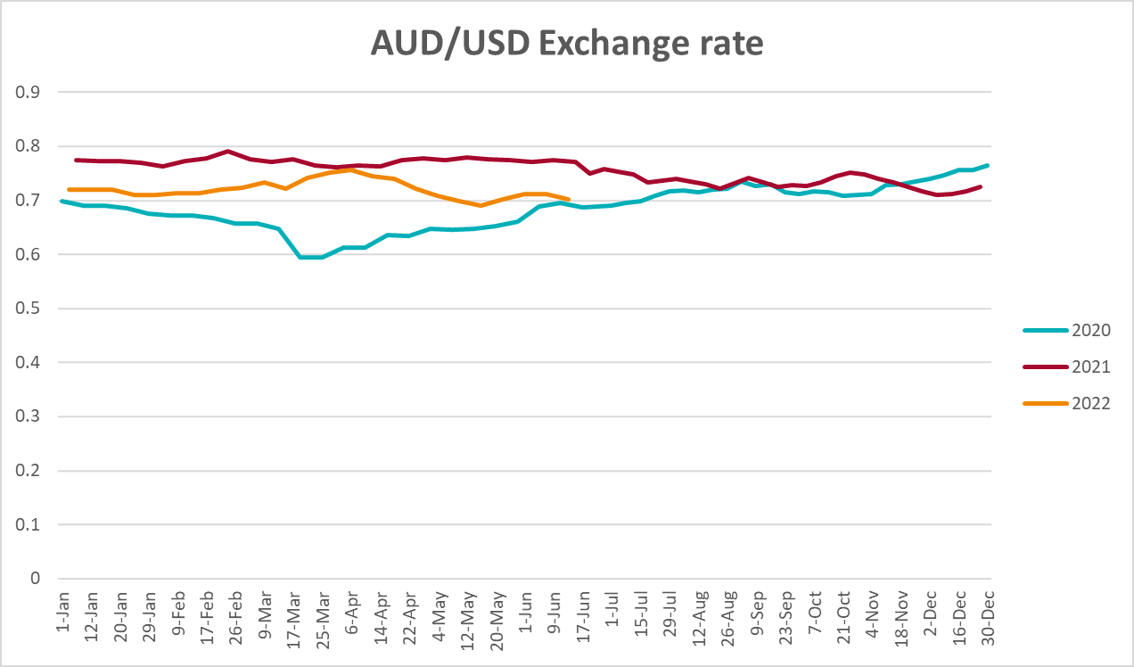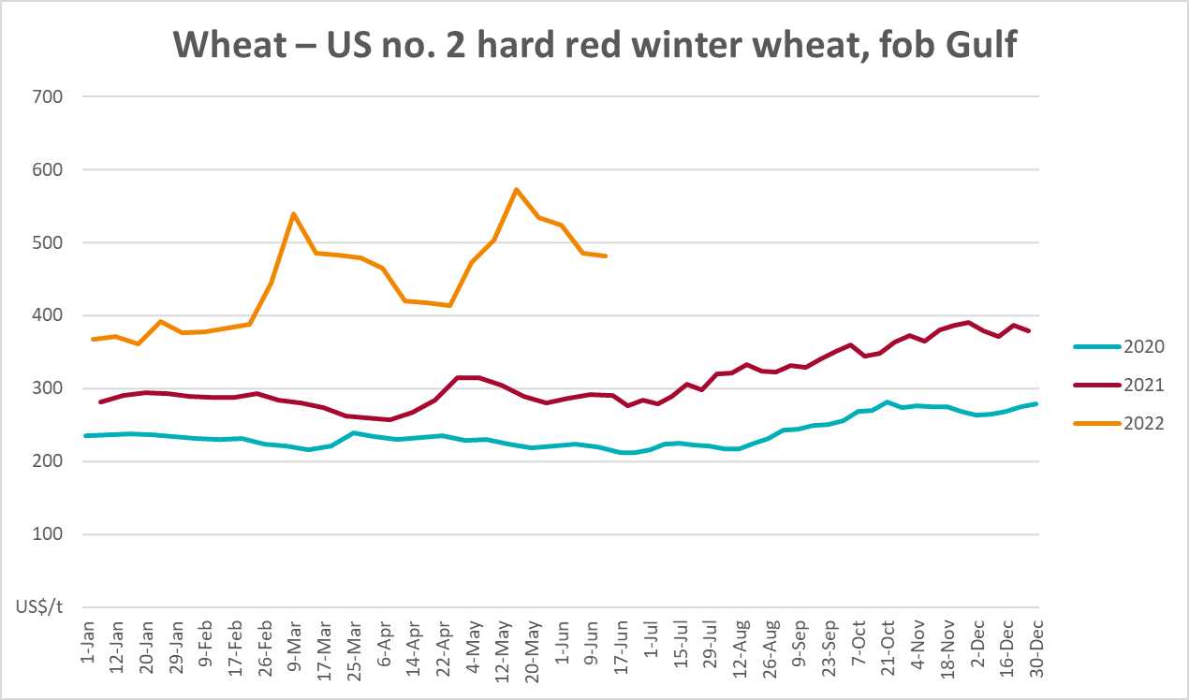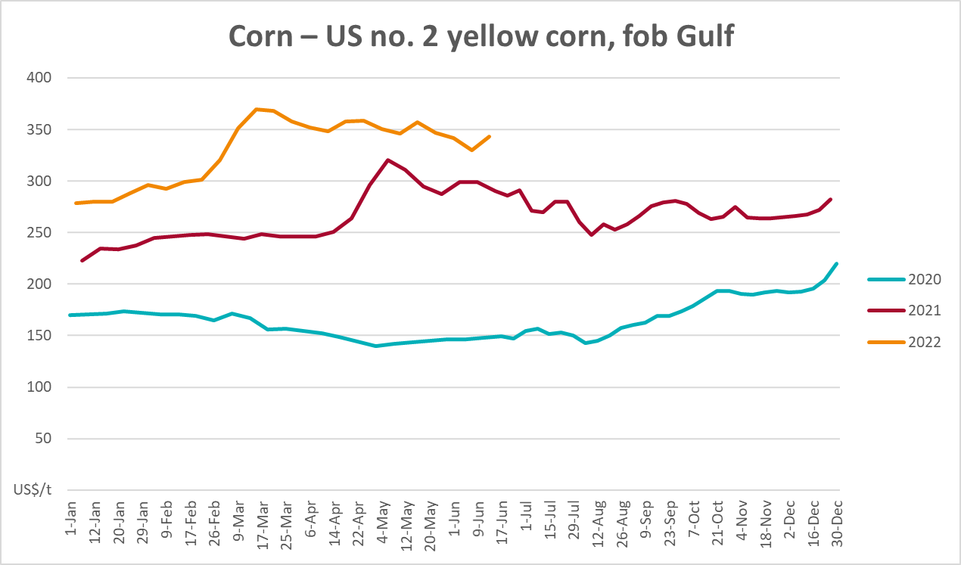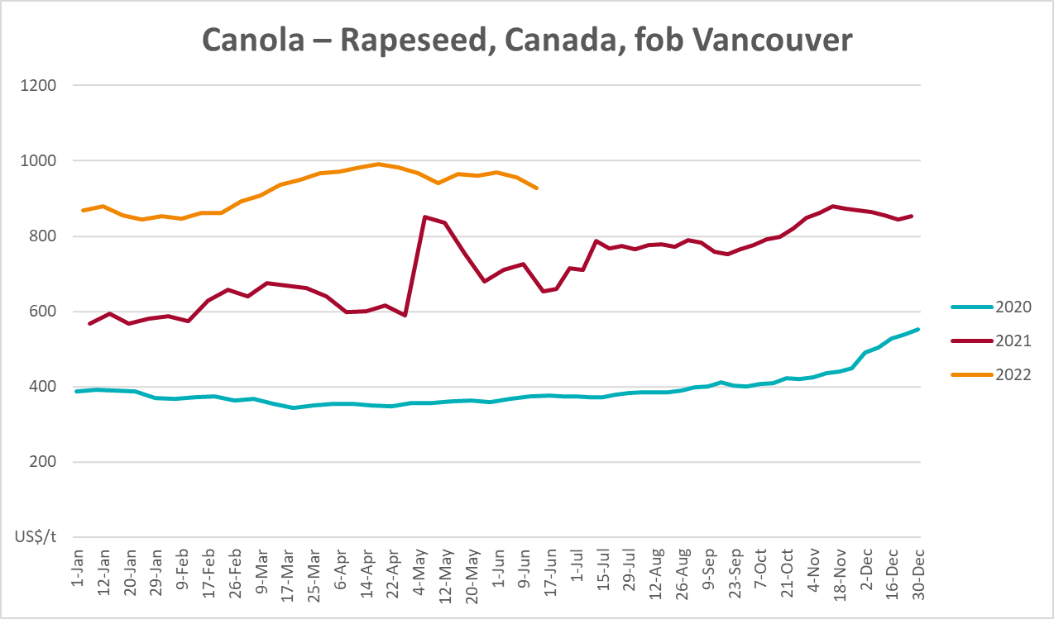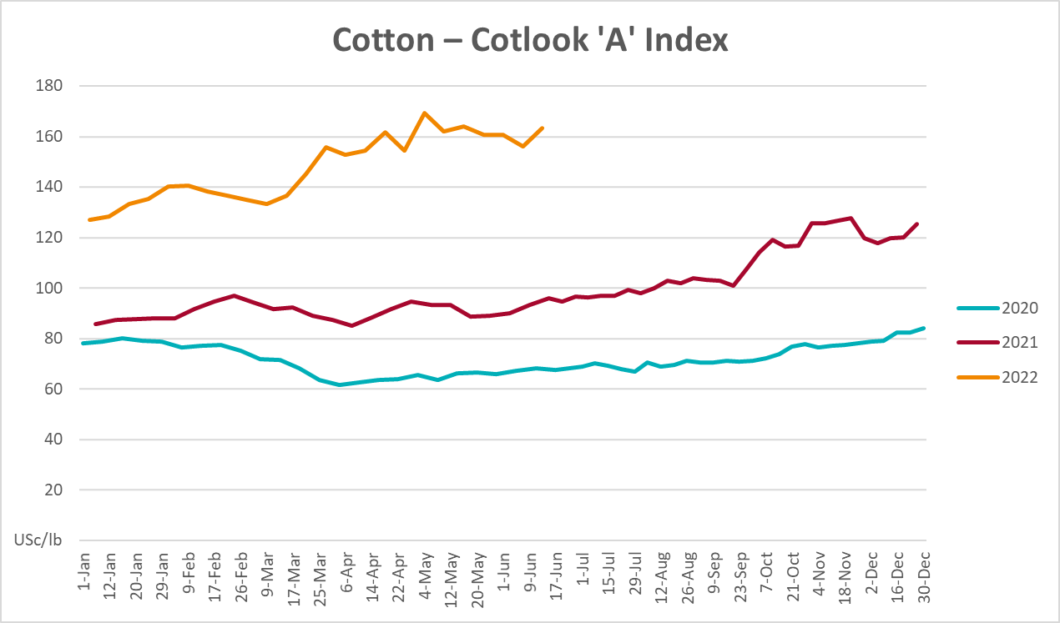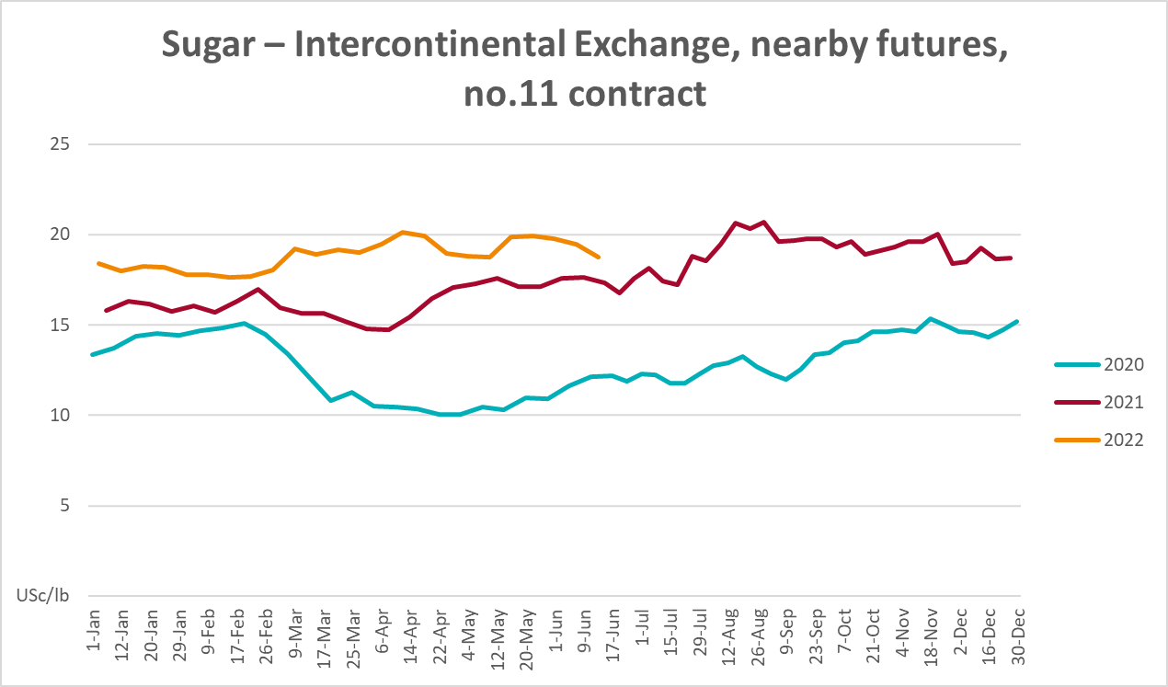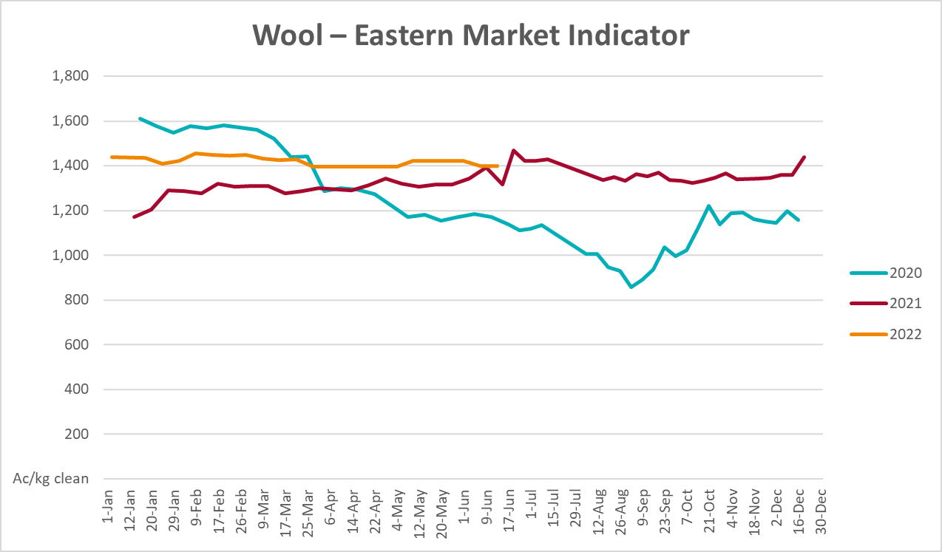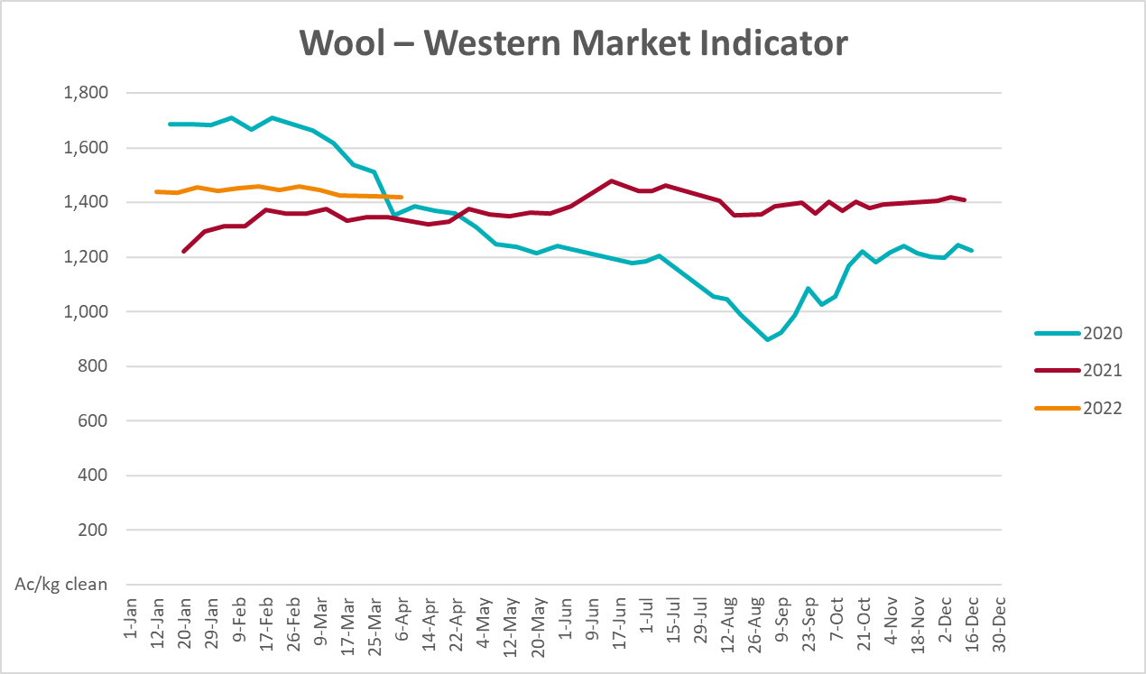

Selected domestic crop indicator prices

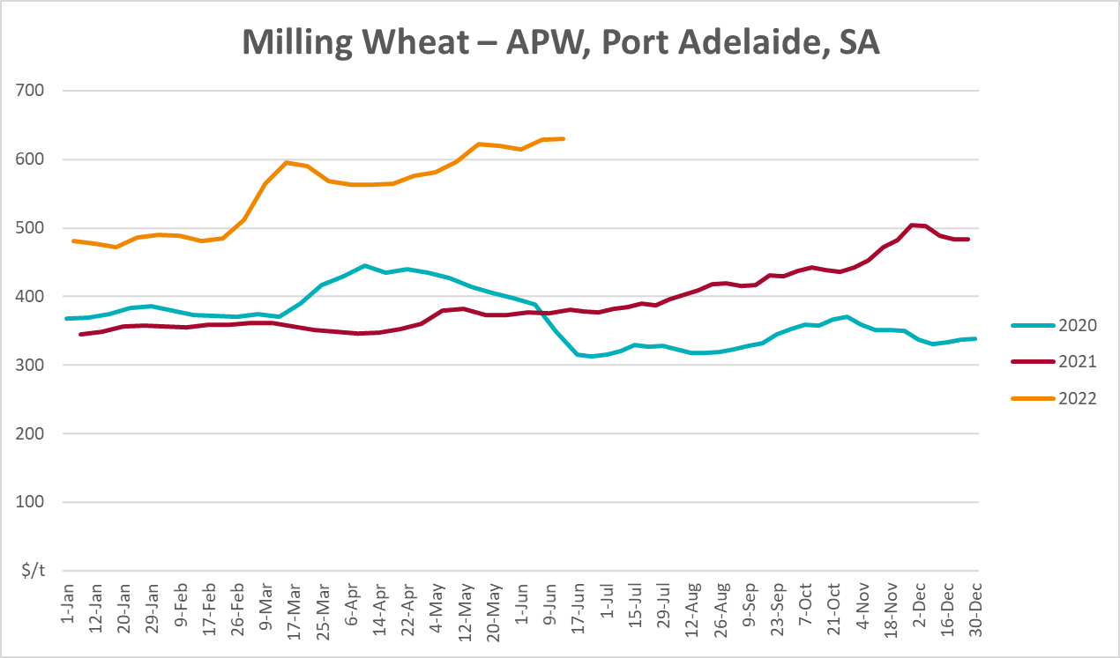
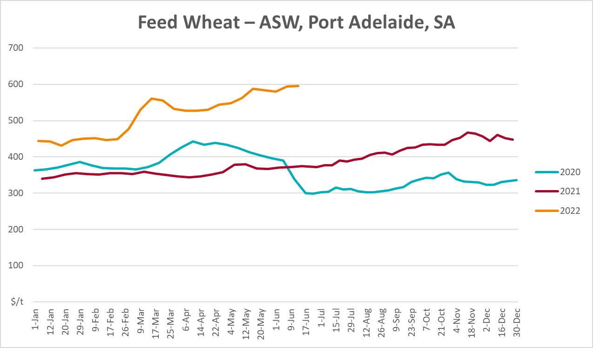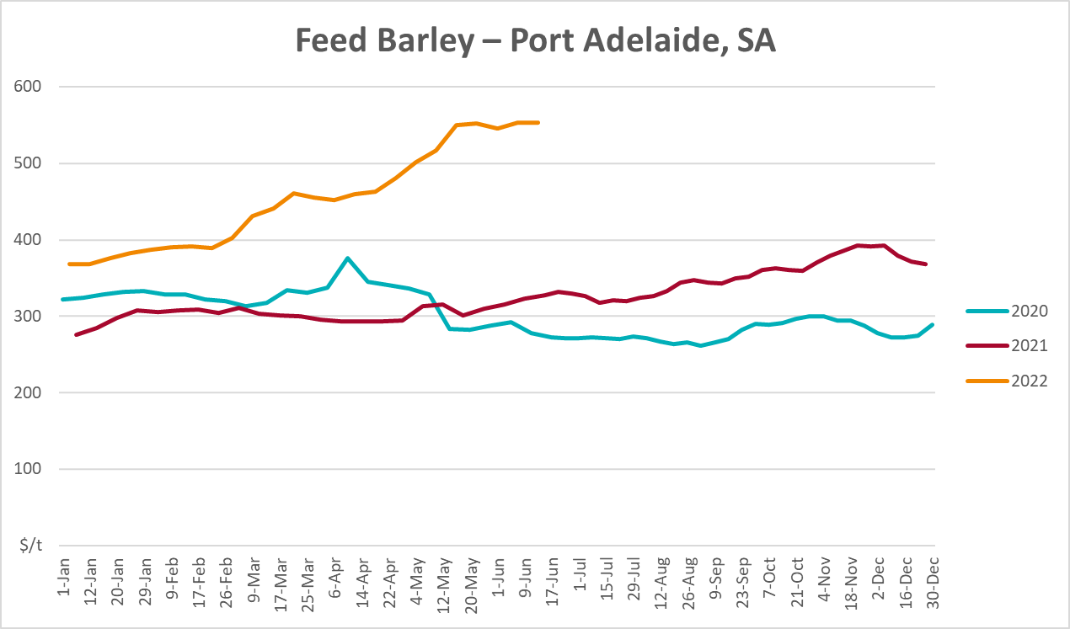
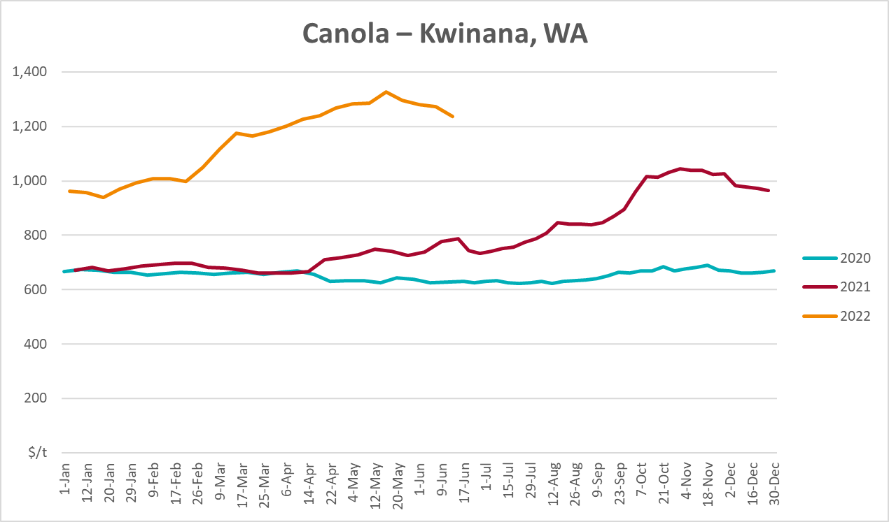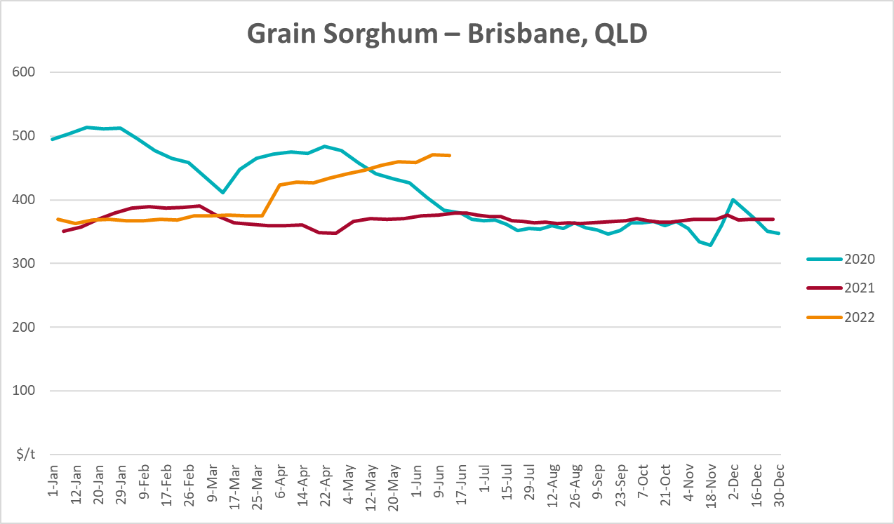

Selected domestic livestock indicator prices
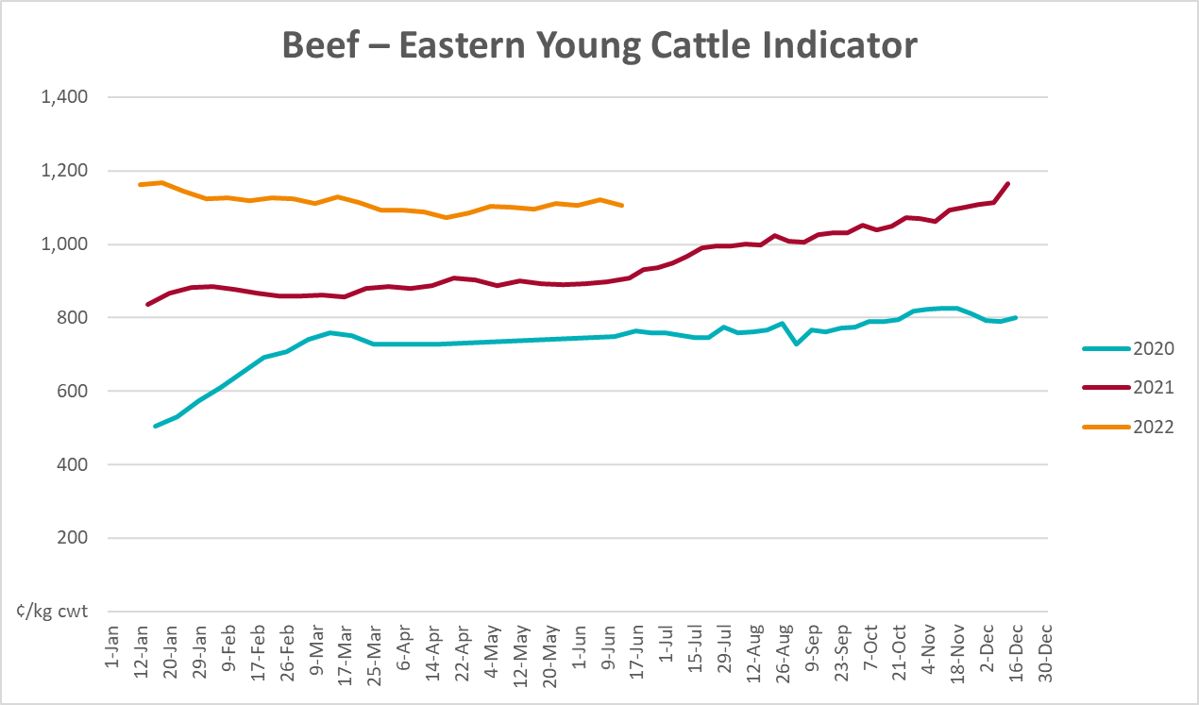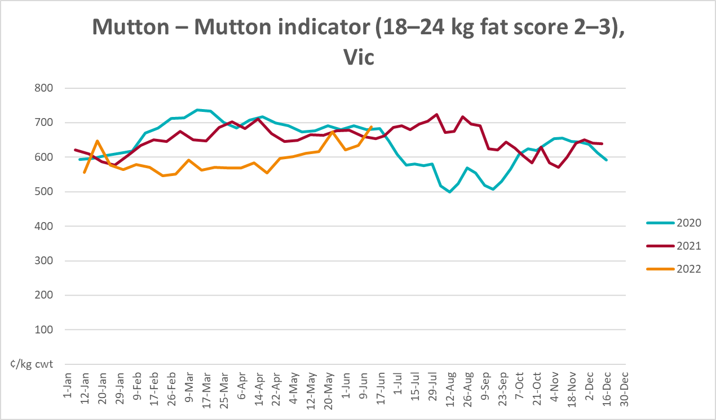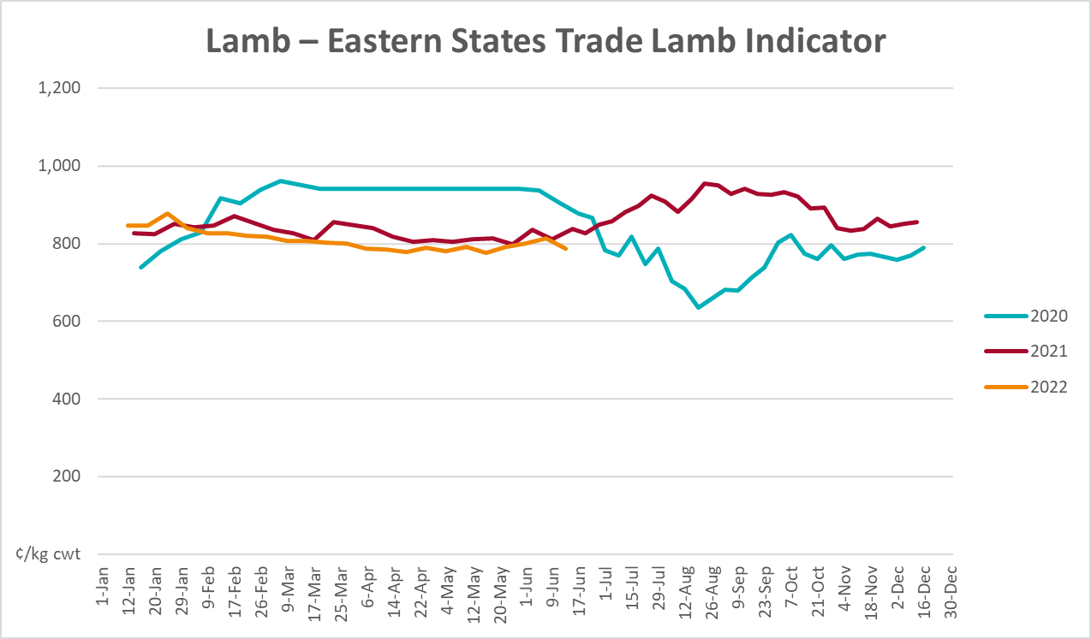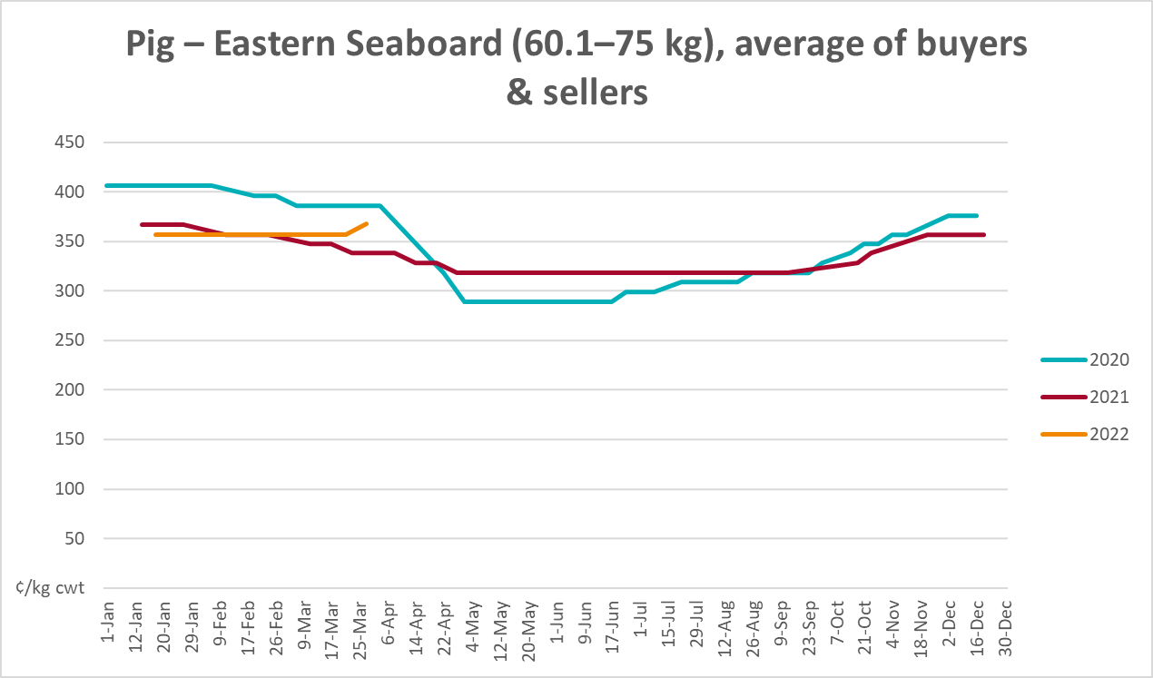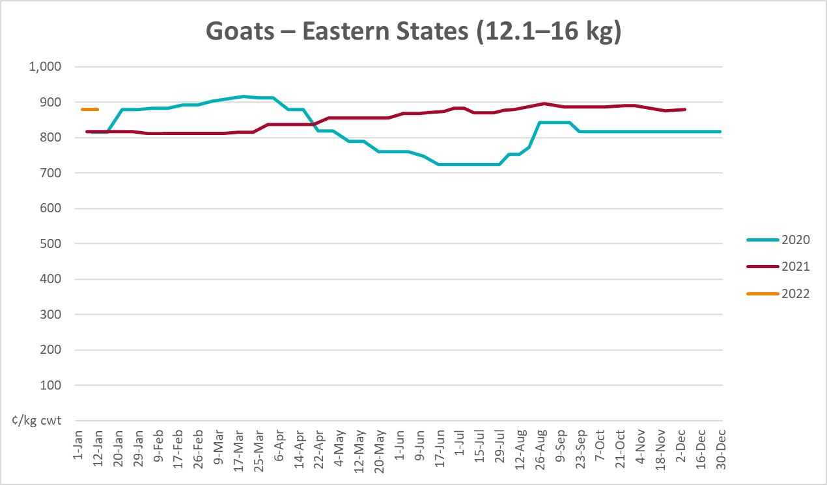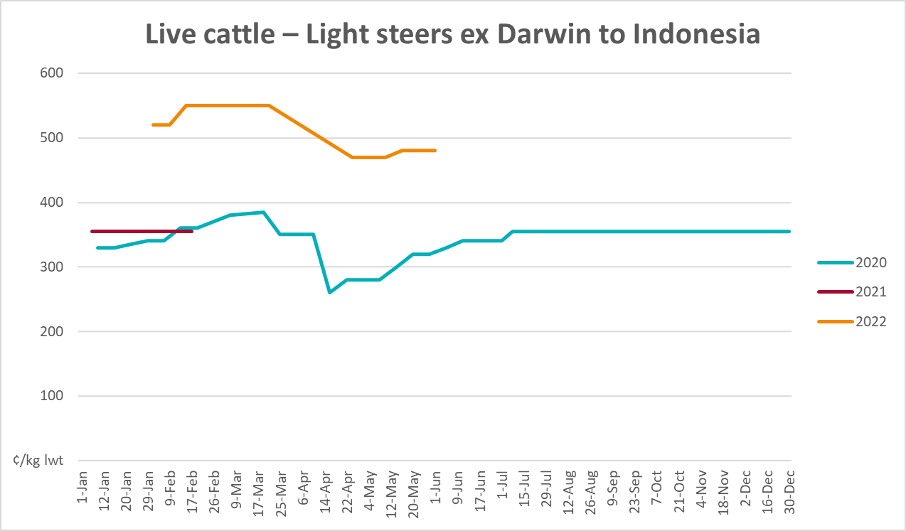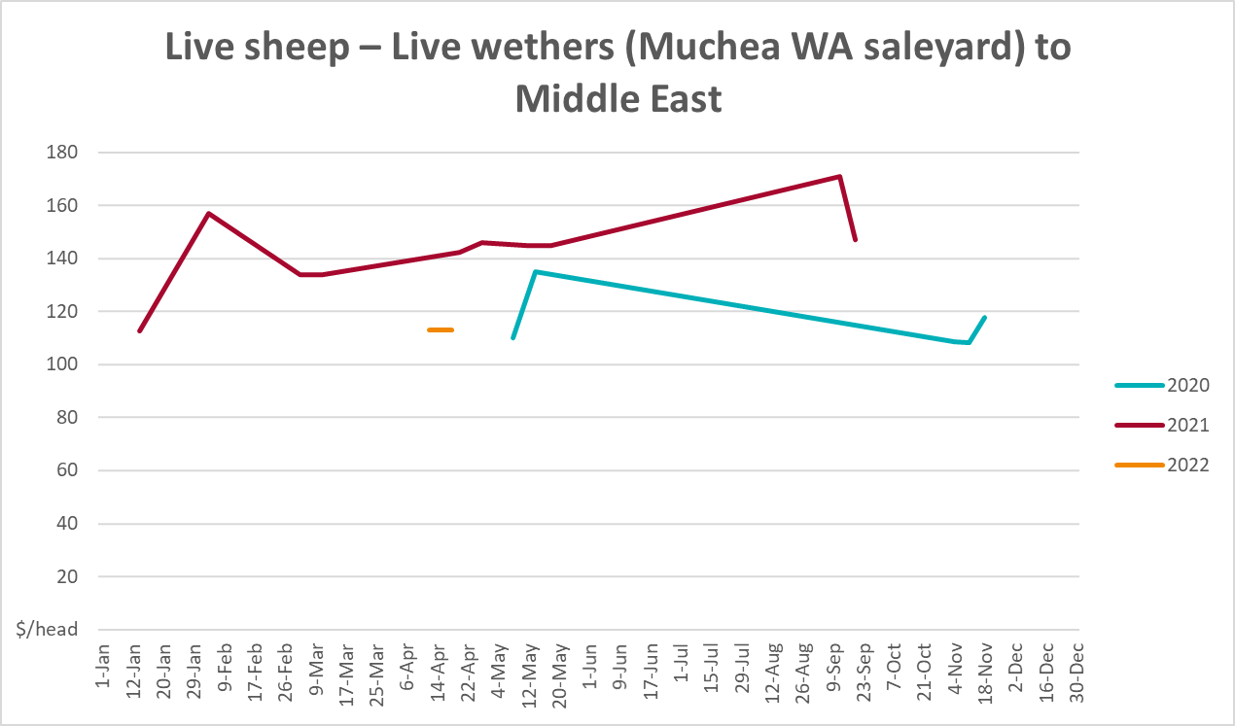

Global Dairy Trade (GDT) weighted average prices
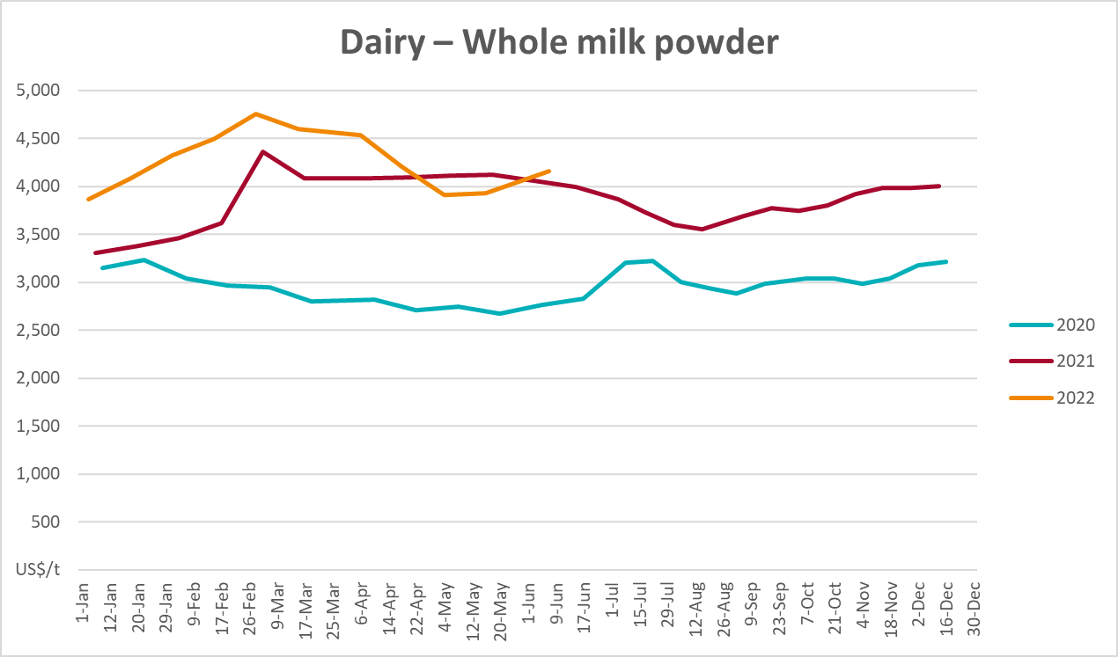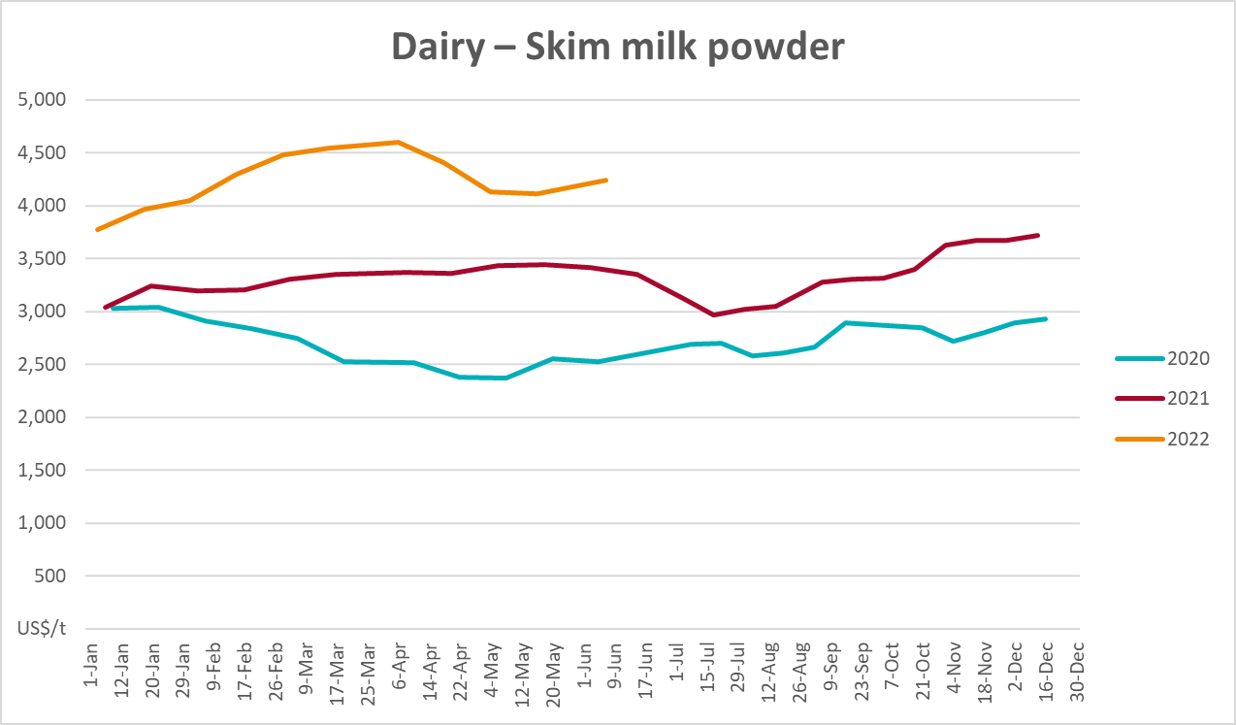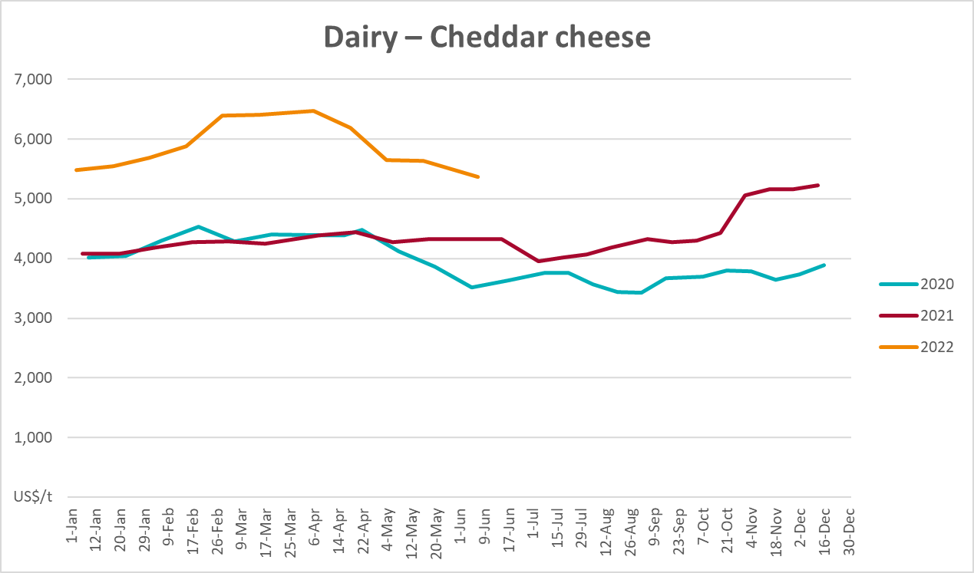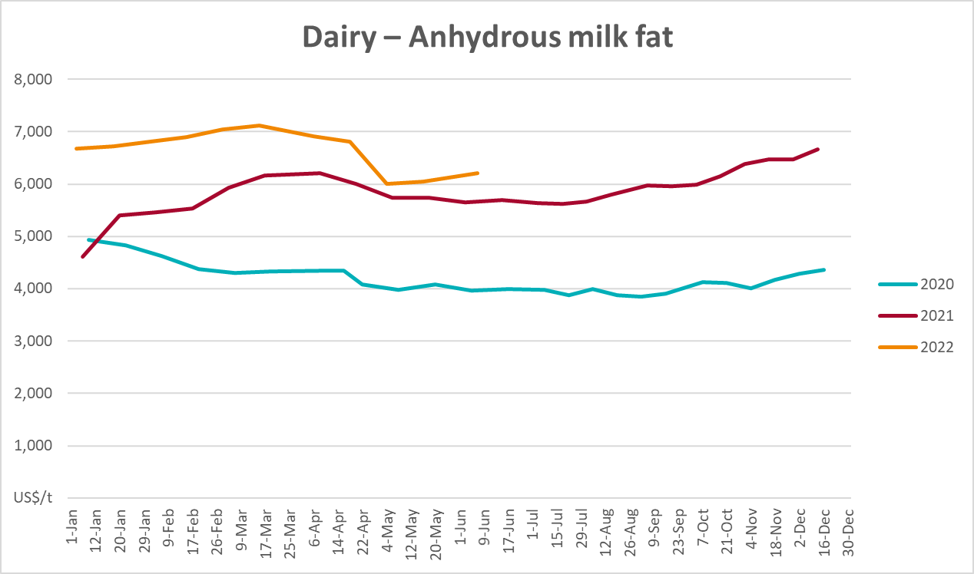

Selected fruit and vegetable prices
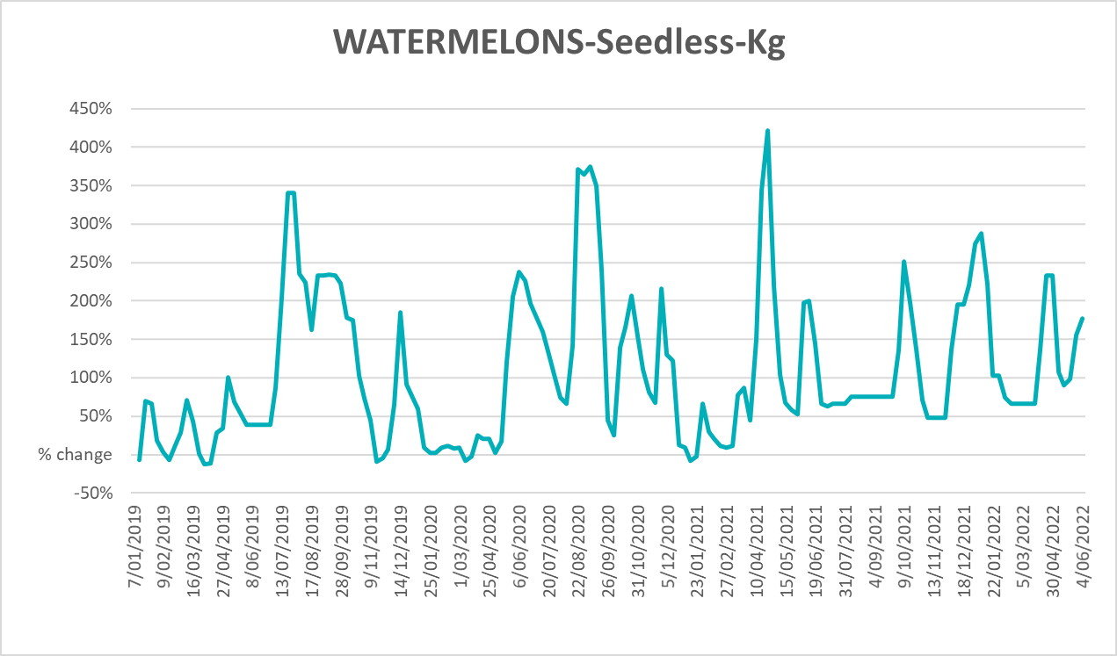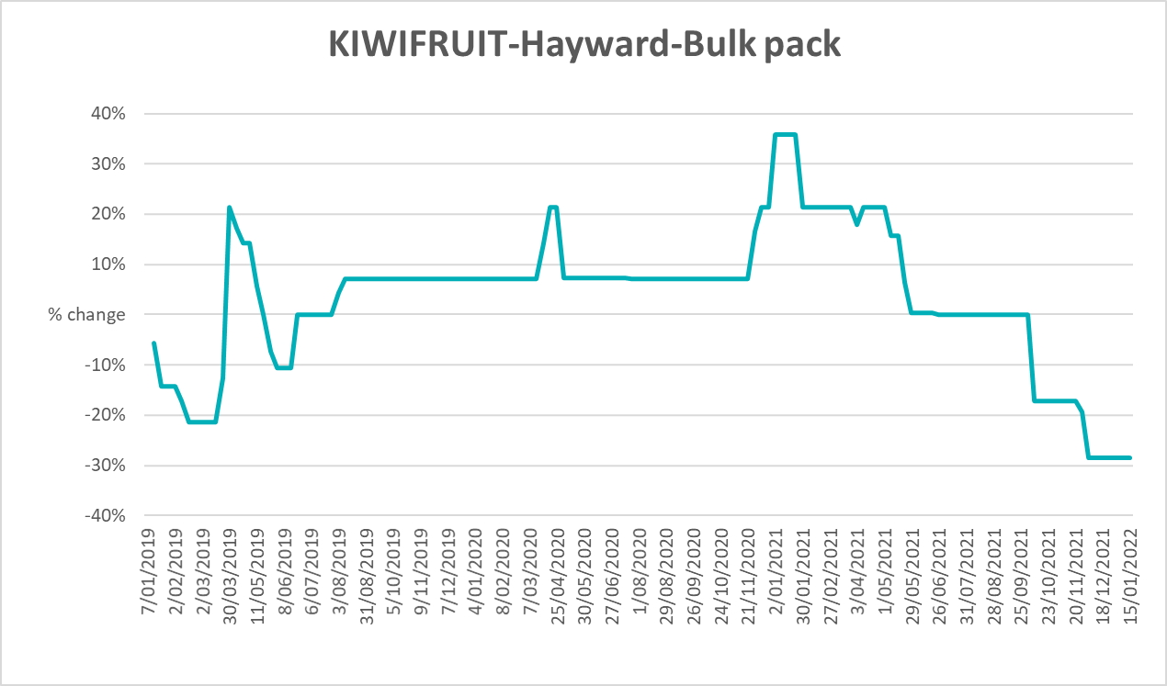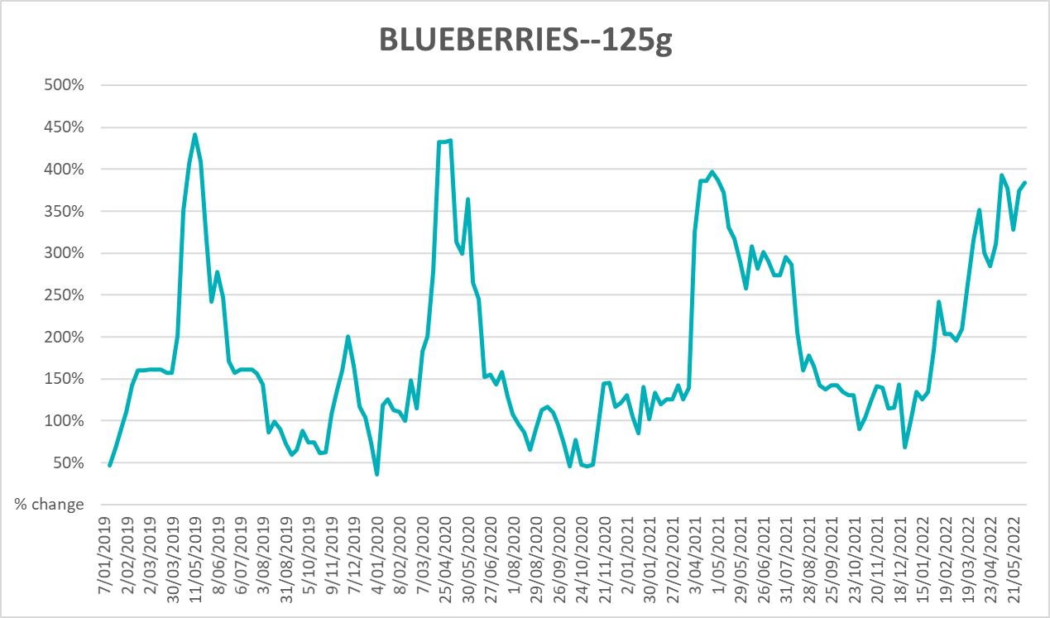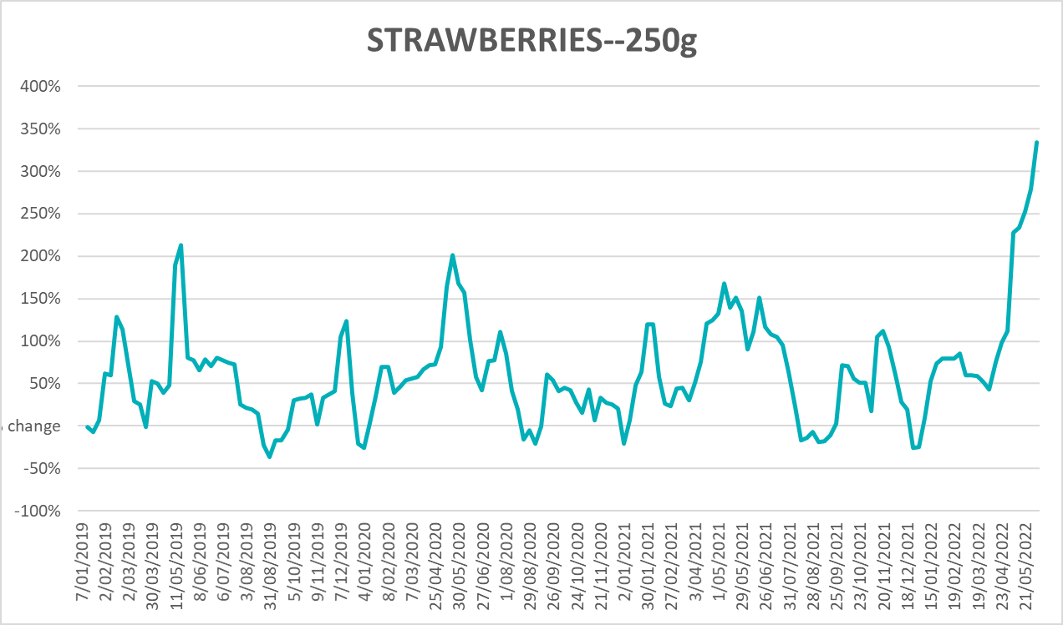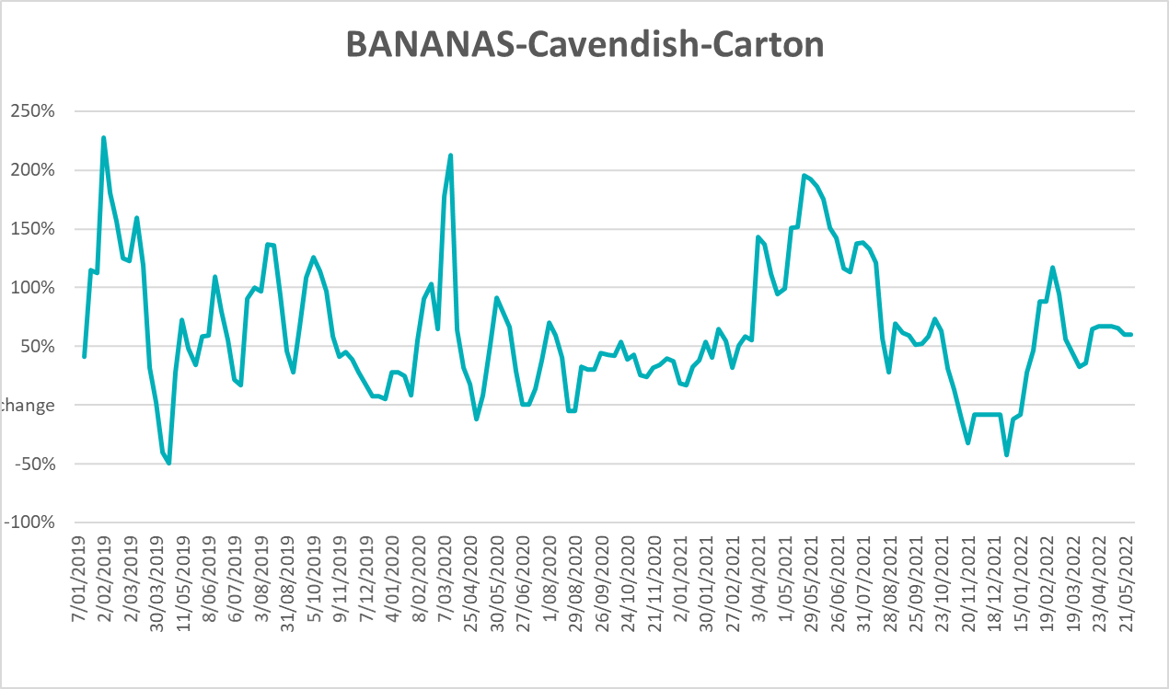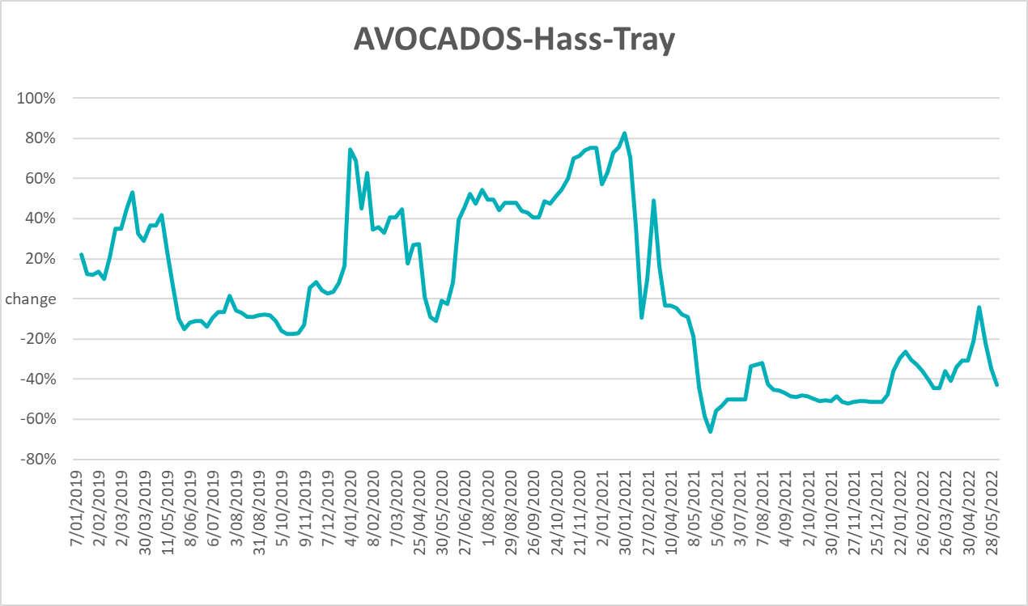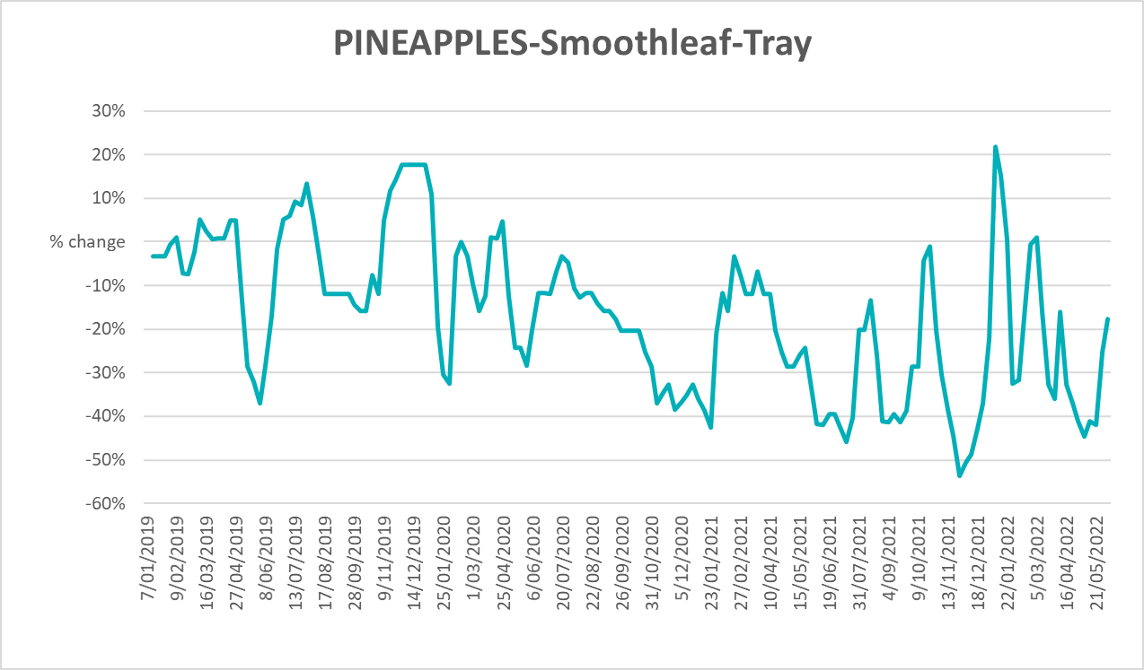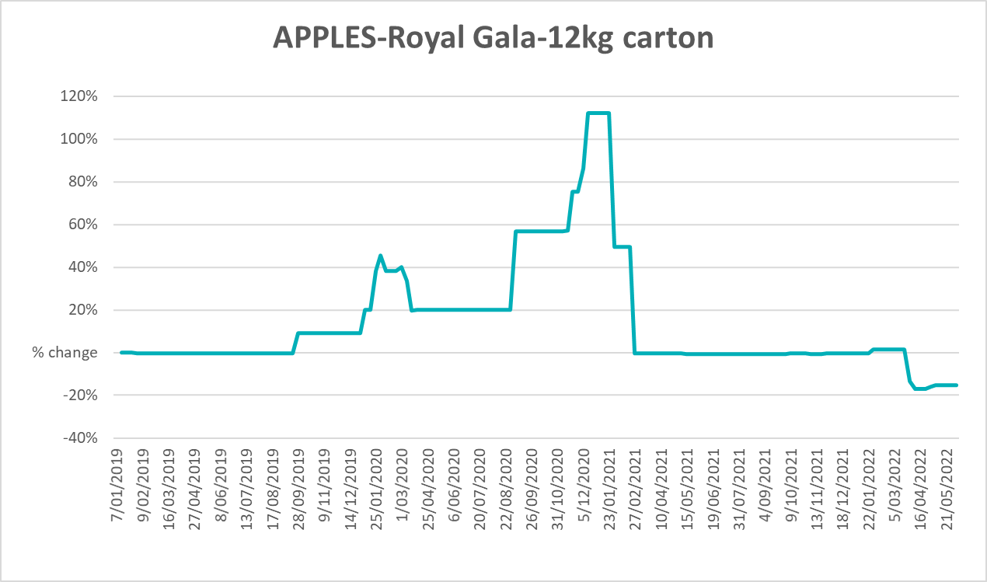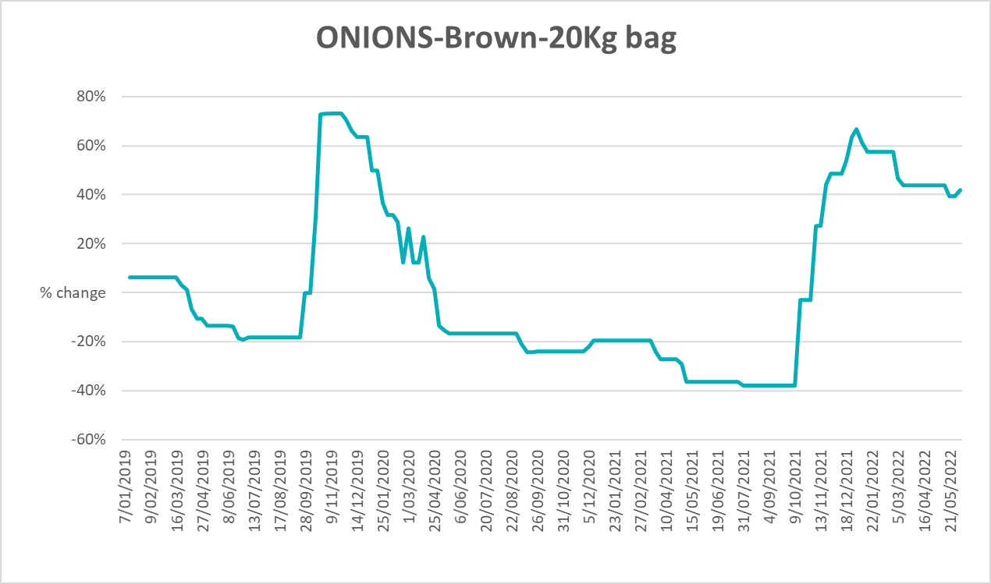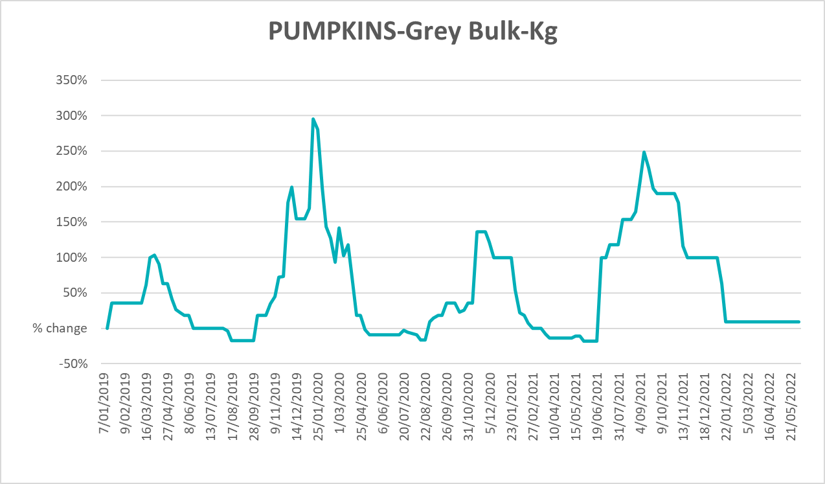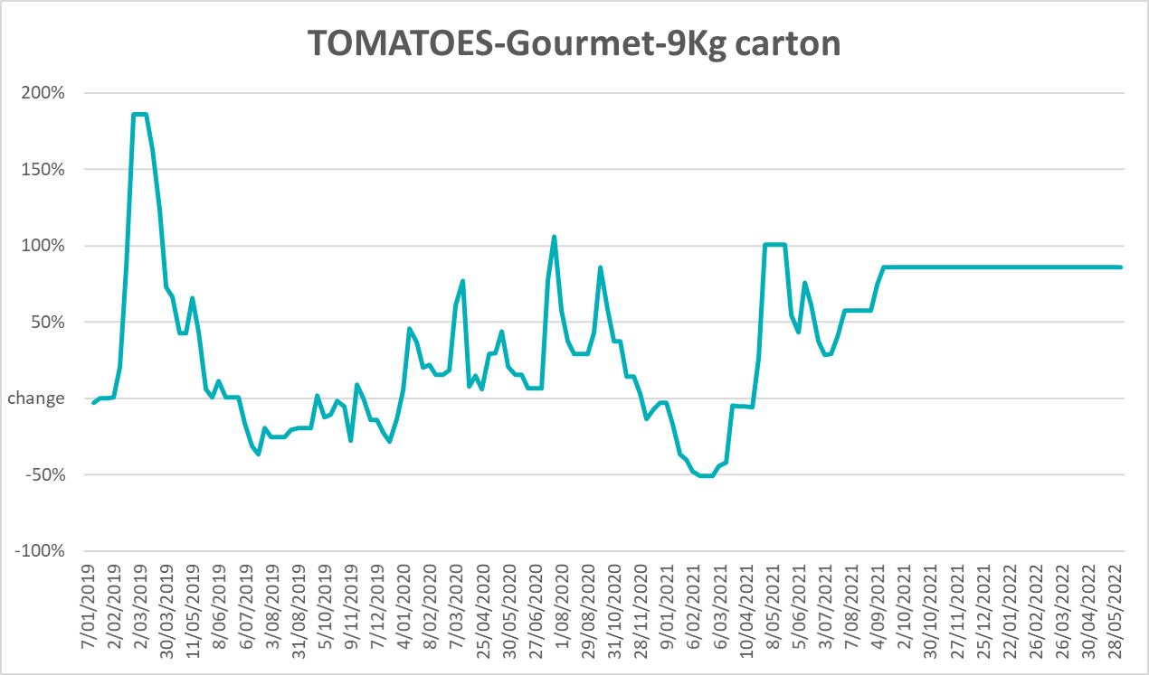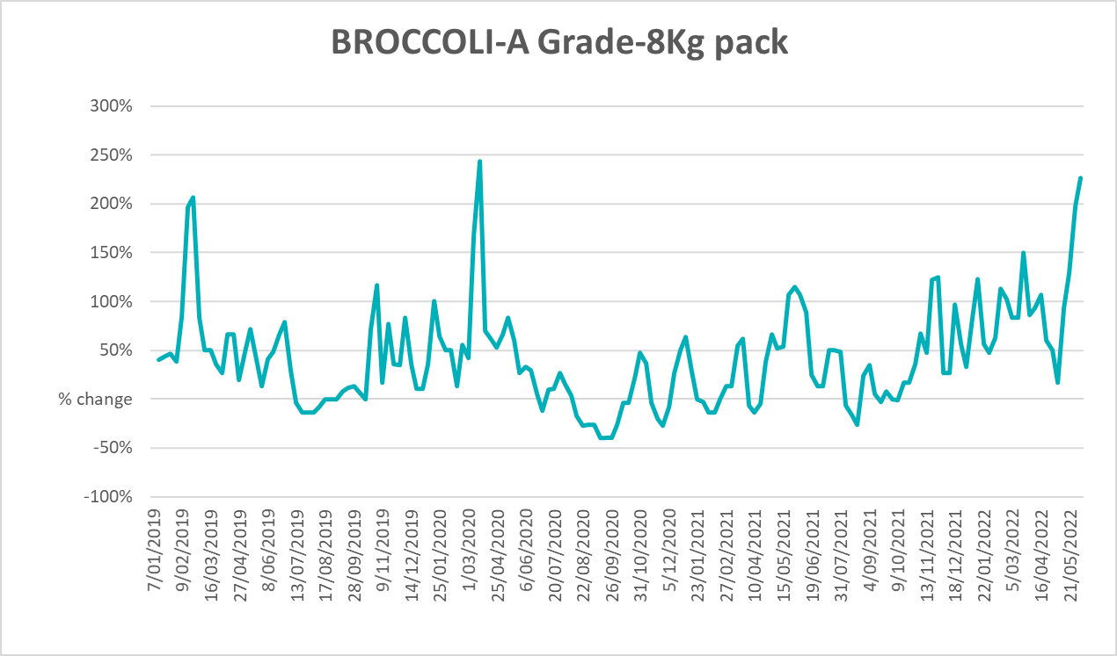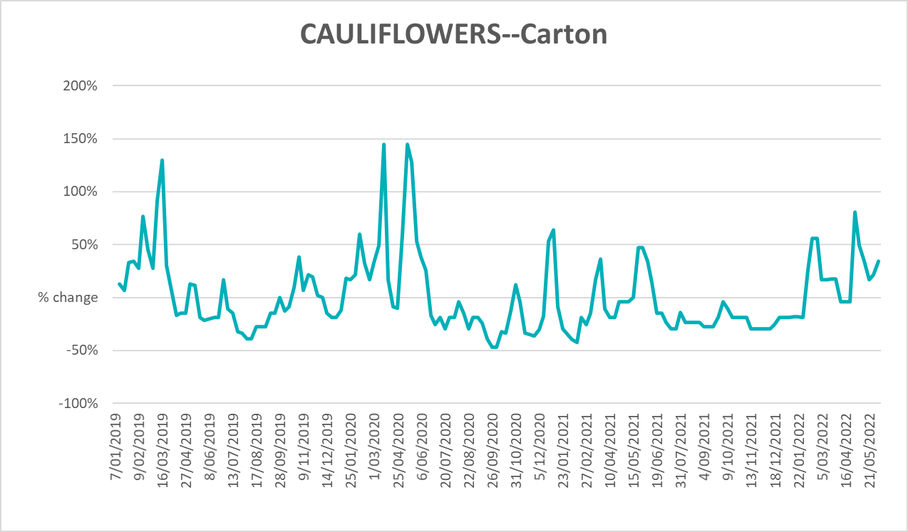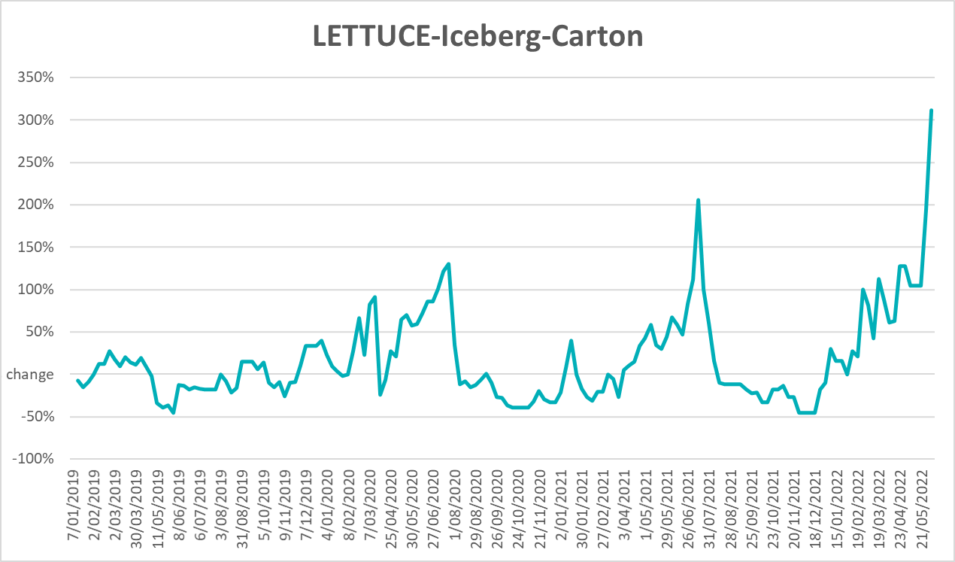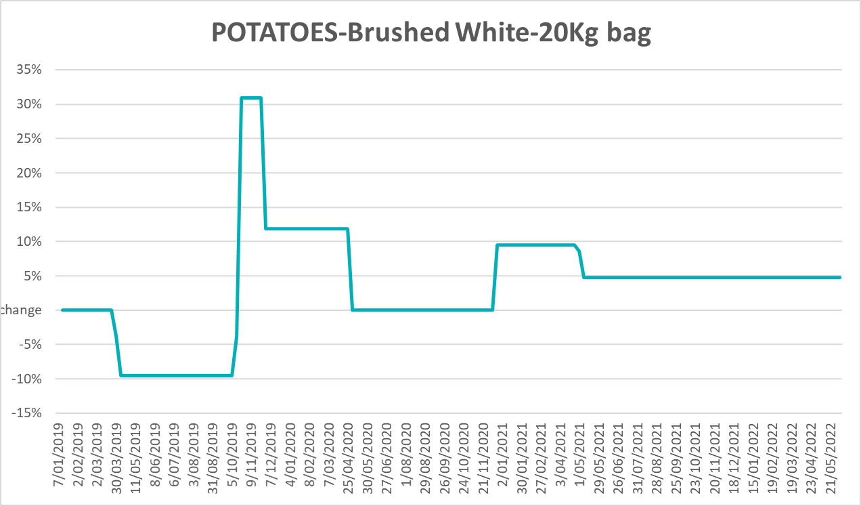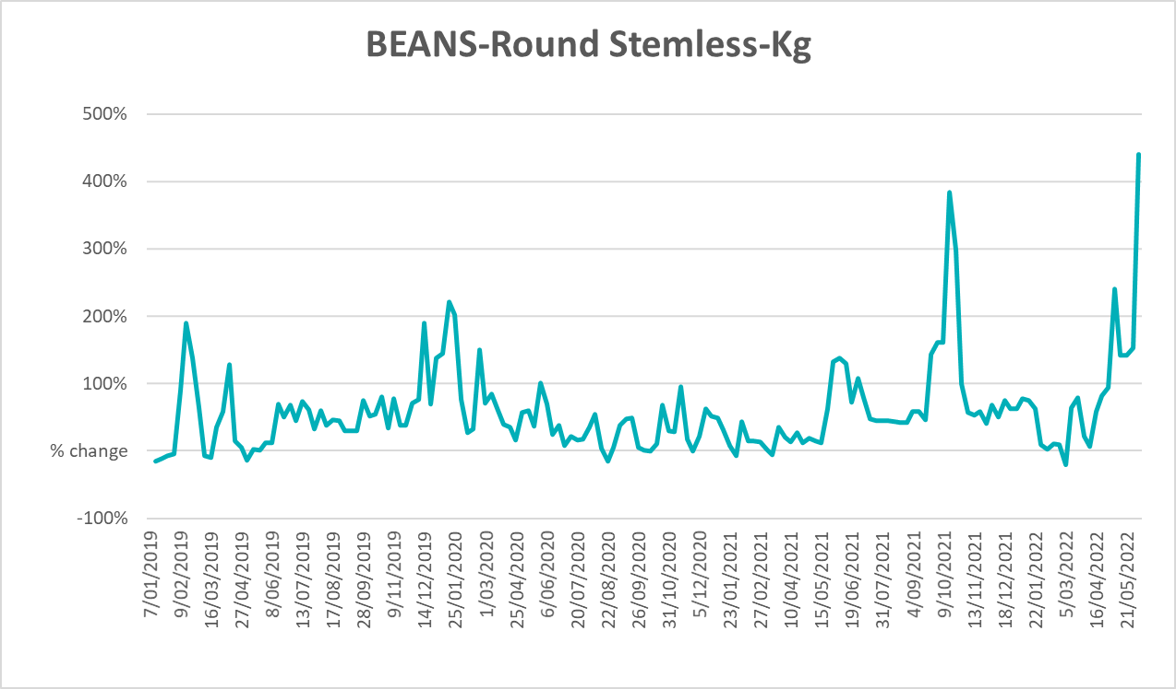

Selected domestic fodder indicator prices
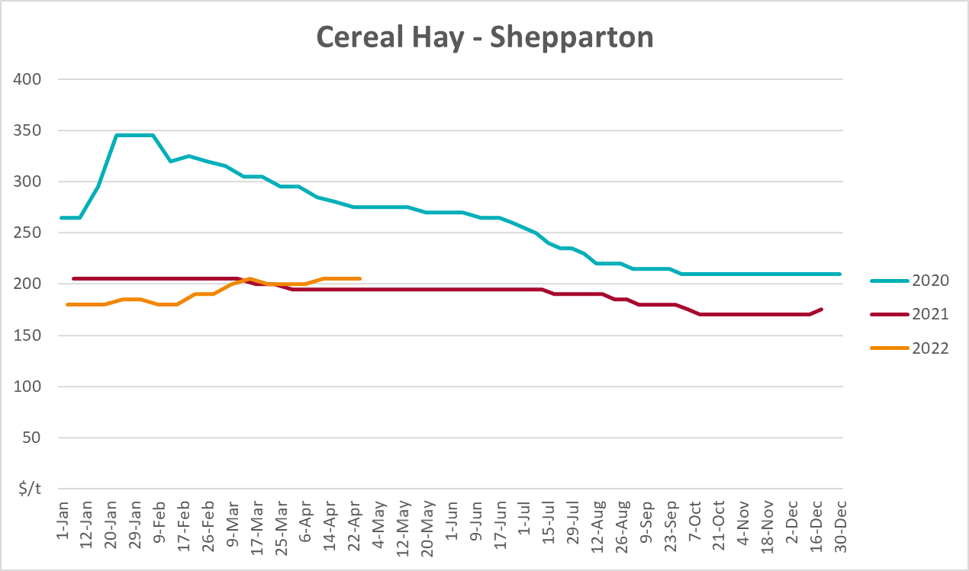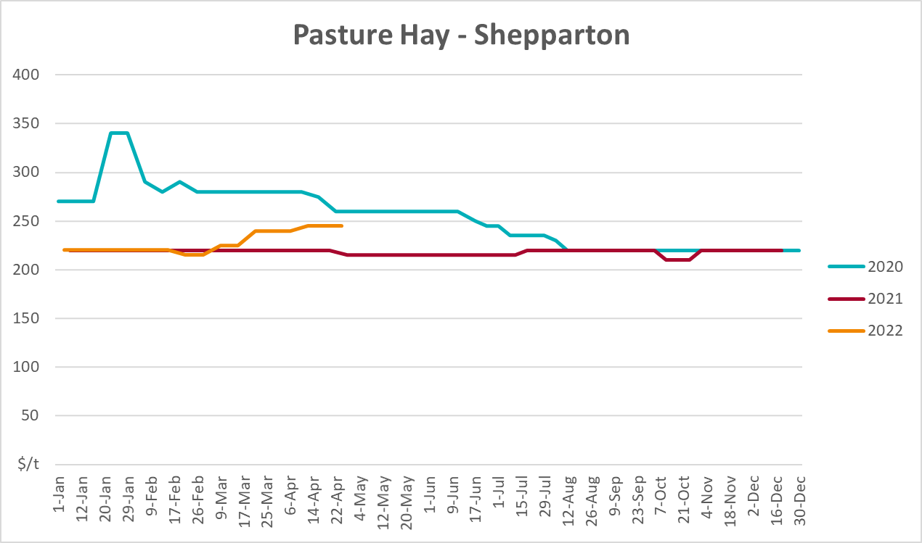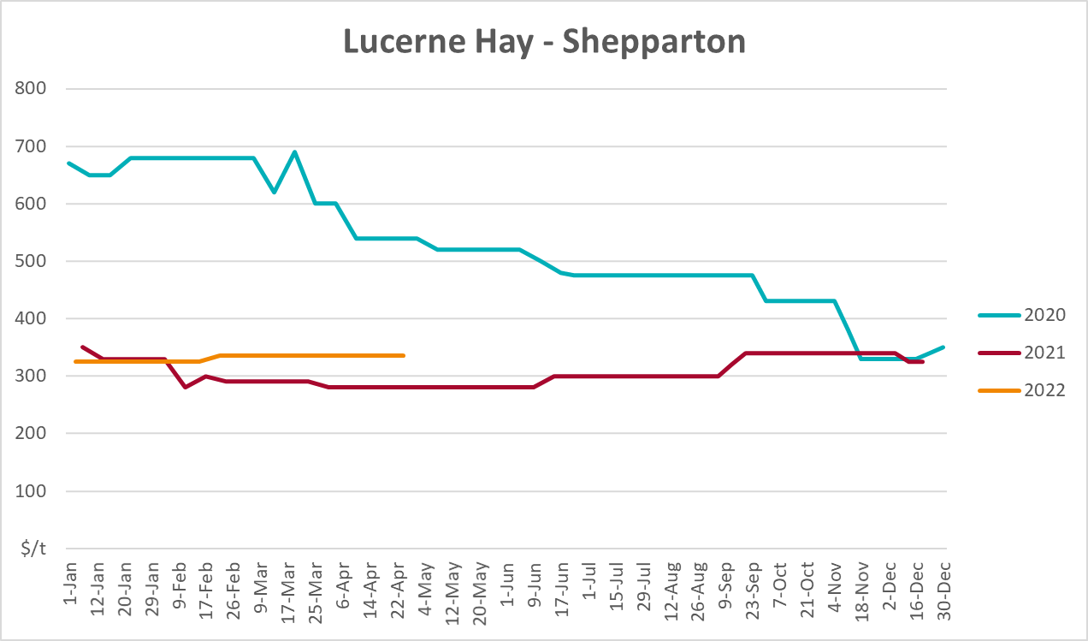

Data attribution

Climate
Bureau of Meteorology
- Weekly rainfall totals: www.bom.gov.au/climate/maps/rainfall/
- Monthly and last 3-month rainfall percentiles: www.bom.gov.au/water/landscape/
- Temperature anomalies: www.bom.gov.au/jsp/awap/temp/index.jsp
- Rainfall forecast: www.bom.gov.au/jsp/watl/rainfall/pme.jsp
- Seasonal outlook: www.bom.gov.au/climate/outlooks/#/overview/summary/
- Climate drivers: http://www.bom.gov.au/climate/enso/
- Soil moisture: www.bom.gov.au/water/landscape/
Other
- Pasture growth: www.longpaddock.qld.gov.au/aussiegrass/
- 3-month global outlooks: Environment and Climate Change Canada, NOAA Climate Prediction Center, EUROBRISA CPTEC/INPE, European Centre for Medium-Range Weather Forecasts, Hydrometcenter of Russia, National Climate Center Climate System Diagnosis and Prediction Room (NCC), International Research Institute for Climate and Society
- Global production: https://ipad.fas.usda.gov/ogamaps/cropmapsandcalendars.aspx
- Autumn break: Pook et al., 2009, https://rmets-onlinelibrary-wiley-com.virtual.anu.edu.au/doi/epdf/10.1002/joc.1833

Water
Prices
- Waterflow: https://www.waterflow.io/
- Ruralco: https://www.ruralcowater.com.au/
Bureau of Meteorology:
- Allocation trade: http://www.bom.gov.au/water/dashboards/#/water-markets/mdb/at
- Storage volumes: http://www.bom.gov.au/water/dashboards/#/water-storages/summary/drainage
Trade constraints:
- Water NSW: https://www.waternsw.com.au/customer-service/ordering-trading-and-pricing/trading/murrumbidgee
- Victorian Water Register: https://www.waterregister.vic.gov.au/TradingRules2019/

Commodities
Fruit and vegetables
- Datafresh: www.freshstate.com.au
Pigs
- Australian Pork Limited: www.australianpork.com.au
Dairy
- Global Dairy Trade: www.globaldairytrade.info/en/product-results/
World wheat, canola
- International Grains Council
World coarse grains
- United States Department of Agriculture
World cotton
- Cotlook: www.cotlook.com/
World sugar
- New York Stock Exchange - Intercontinental Exchange
Wool
- Australian Wool Exchange: www.awex.com.au/
Domestic wheat, barley, sorghum, canola and fodder
- Jumbuk Consulting Pty Ltd: http://www.jumbukag.com.au/
Cattle, beef, mutton, lamb, goat and live export
- Meat and Livestock Australia: www.mla.com.au/Prices-and-market
© Commonwealth of Australia 2022

Ownership of intellectual property rights
Unless otherwise noted, copyright (and any other intellectual property rights, if any) in this publication is owned by the Commonwealth of Australia (referred to as the Commonwealth).

Creative Commons licence
All material in this publication is licensed under a Creative Commons Attribution 4.0 International Licence except content supplied by third parties, logos and the Commonwealth Coat of Arms.
Inquiries about the licence and any use of this document should be emailed to copyright@awe.gov.au.


Cataloguing data
This publication (and any material sourced from it) should be attributed as:
ABARES 2022, Weekly Australian Climate, Water and Agricultural Update, Australian Bureau of Agricultural and Resource Economics and Sciences, Canberra, 16 June 2022. CC BY 4.0 DOI: https://doi.org/10.25814/5f3e04e7d2503
ISSN 2652-7561
This publication is available at https://www.awe.gov.au/abares/products/weekly_update
Department of Agriculture, Water and the Environment
GPO Box 858 Canberra ACT 2601
Telephone 1800 900 090
Web awe.gov.au/abares

Disclaimer
The Australian Government acting through the Department of Agriculture, Water and the Environment, represented by the Australian Bureau of Agricultural and Resource Economics and Sciences, has exercised due care and skill in preparing and compiling the information and data in this publication. Notwithstanding, the Department of Agriculture, Water and the Environment, ABARES, its employees and advisers disclaim all liability, including liability for negligence and for any loss, damage, injury, expense or cost incurred by any person as a result of accessing, using or relying on any of the information or data in this publication to the maximum extent permitted by law.

Statement of Professional Independence
The views and analysis presented in ABARES publications, including this one, reflect ABARES professionally independent findings, based on scientific and economic concepts, principles, information and data. These views, analysis and findings may not reflect or be consistent with the views or positions of the Australian Government, or of organisations or groups who have commissioned ABARES reports or analysis. More information on professional independence is provided on the ABARES website.

Acknowledgements
This report was prepared by Matthew Miller and Cameron Van-Lane.

