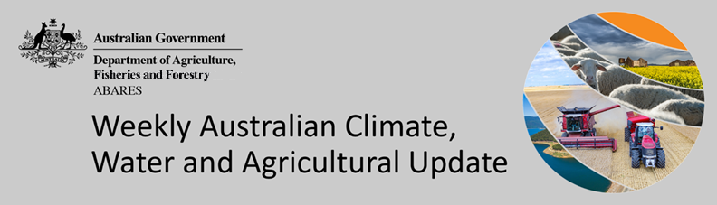
No. 29/2022

28 July 2022

Summary of key issues
- For the week ending 27 July 2022, a low-pressure system in the east and cold fronts across southern Australia brought moderate rainfall. Meanwhile, high-pressure systems dominated much of the country bringing clear, dry conditions (see Section 1.1).
- Rainfall across Queensland cropping regions over the past week has likely exacerbated waterlogging, where a wet start to the winter season limited field access and planting activity in the south. In Western Australian cropping regions, recent rainfall will support winter crop development over the coming weeks.
- According to oceanic and atmospheric indicators, ENSO conditions remain neutral, reducing its influence on Australia’s climate patterns. Most international climate models expect the ENSO to remain neutral throughout winter, although five of the seven models predict the development of a La Niña event in late spring. A negative IOD event continues to develop in the tropical Indian Ocean, and the SAM continues to remain positive. Given current and expected conditions, the IOD and SAM are likely to be the major influences on late winter and early spring rainfall across Australia (see Section 1.2).
- The outlook for August 2022 indicates that there is a 75% chance of rainfall totals between 10 and 50 millimetres across much of New South Wales, south-east and north-east Queensland, Victoria, southern South Australia, the south-west of Western Australia and Tasmania. Rainfall totals in excess of 100 millimetres are expected across alpine regions of New South Wales and Victoria, as well as the far south-west of Western Australia and western Tasmania (see Section 1.3).
- An early northern rainfall onset for 2022–23 season is more likely across Queensland and most of the Northern Territory, according to the latest northern rainfall onset outlook released by the Bureau of Meteorology. An early onset of the 2022–23 northern wet season is likely to boost soil moisture and water storages, and benefit summer crop production and northern pasture growth (see Section 1.4).
- Over the 8-days to 4 August 2022, low-pressure troughs and cold fronts are expected to bring light to moderate rainfall across large areas of southern Australia. Across southern New South Wales, Victoria and South Australia, soil moisture levels have steadily declined over recent weeks in the absence of significant rainfall. If this rainfall eventuates as forecast across southern Australia it will provide a welcome reprieve, but further rainfall will be required in the coming weeks to support yield potentials as we approach spring (see Section 1.5).
- Water storage in the Murray–Darling Basin (MDB) decreased by 16 gigalitres (GL) between 20 July 2022 and 27 July 2022. The current volume of water held in storage is 22,230 GL, which represents 88% of total capacity. This is 17% or 3,311 GL more than at the same time last year.
- Allocation prices in the Victorian Murray below the Barmah Choke decreased from $81 per ML on 15 July 2022 to $80 per ML on 22 July 2022. Prices are lower in the Goulburn-Broken due to the binding of the Goulburn intervalley trade limit.

Climate

Rainfall this week
For the week ending 27 July 2022, a low-pressure system in the east and cold fronts across southern Australia brought moderate rainfall. Meanwhile, high-pressure systems dominated much of the country bringing clear, dry conditions.
Rainfall totals of between 10 and 50 millimetres were recorded across scattered areas of eastern and northern New South Wales, south-east Queensland, large areas of Victoria, isolated southern parts of South Australia, the south-west of Western Australia, and northern and northern Tasmania. Rainfall totals in excess of 50 millimetres were recorded in parts of south-east Queensland and north-eastern New South Wales, and the south-west of Western Australia. Remaining parts of Australia received little to no rainfall.
In Australian cropping regions, rainfall totals of between 10 and 50 millimetres were recorded across much of Queensland and Western Australia, as well as southern Victoria and the south-west of South Australia. Little to no rainfall was recorded across remaining cropping regions for the week ending 27 July 2022.
Rainfall across Queensland cropping regions over the past week has likely exacerbated waterlogging, where a wet start to the winter season limited field access and planting activity in the south. A break in the rain in recent weeks allowed soil profiles to drain, however soil moisture levels remain above average to very much above average with saturated soils potentially hindering crop growth. In Western Australian cropping regions, recent rainfall will support winter crop development over the coming weeks. Following a favourable start to the cropping season, dry conditions had seen soil moisture levels drop to below average for this time of year, but recent rainfall will continue to support current yield potentials.

Rainfall for the week ending 27 July 2022
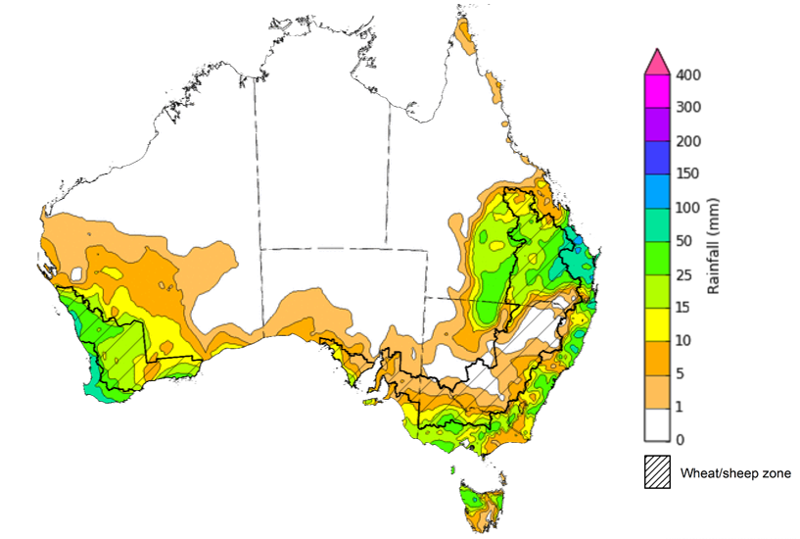
©Commonwealth of Australia 2022, Australian Bureau of Meteorology Issued:27/7/2022
Note: The rainfall analyses and associated maps utilise data contained in the Bureau of Meteorology climate database, the Australian Data Archive for Meteorology (ADAM). The analyses are initially produced automatically from real-time data with limited quality control. They are intended to provide a general overview of rainfall across Australia as quickly as possible after the observations are received. For further information go to http://www.bom.gov.au/climate/rainfall/

Climate Drivers
Throughout the late winter and early spring period the climate drivers with the largest potential impact on Australia’s climate patterns are the El Niño–Southern Oscillation (ENSO), the Indian Ocean Dipole (IOD) and the Southern Annular Mode (SAM). These climate drivers are likely to influence pasture growth across southern Australia and the growth and yield prospects for winter crops.
According to oceanic and atmospheric indicators, ENSO conditions remain neutral, reducing its influence on Australia’s climate patterns. Most international climate models expect the ENSO to remain neutral throughout winter, although five of the seven models predict the development of a La Niña event in late spring. A negative IOD event continues to develop in the tropical Indian Ocean, and the SAM continues to remain positive. Given current and expected conditions, the IOD and SAM are likely to be the major influences on late winter and early spring rainfall across Australia.
Sea surface temperature (SSTs) anomalies have largely been close to average in the tropical Pacific Ocean close to the equator over the previous week. However, cool anomalies were recorded along the equator in the western Pacific and small pockets of weak warm anomalies were present in parts of the eastern equatorial Pacific. SSTs were slightly cooler than average over much of the tropical central and eastern Pacific south of the equator. Neutral Pacific equatorial sea surface temperatures are associated with neutral ENSO conditions.
Warm sea surface temperature anomalies continue across the eastern Indian Ocean and the southern Maritime Continent, while cool anomalies are present in the north-west of the Indian Ocean basin. The warm anomalies in the eastern Indian Ocean and the ocean surrounding Australia underpin the ongoing development of a potential negative IOD.

Difference from average sea surface temperature observations 11 July to 17 July 2022
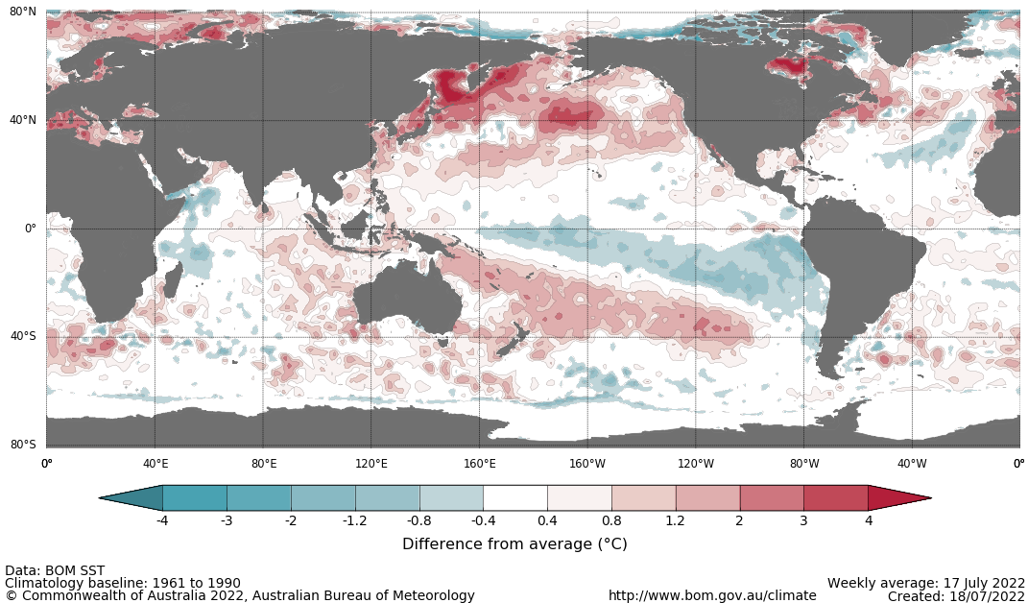

A negative IOD event is looking increasingly likely if current conditions in the Indian Ocean persist. Warmer than average water temperatures in the east of the Indian Ocean and cooler than average temperatures in the west are associated with above average rainfall across southern Australia throughout winter and spring, as well as the far north. It is also associated with the early onset of northern Australia rainfall.
As at 17 July 2022, the Indian Ocean Dipole (IOD) weekly value was -1.0°C, and recently reached its lowest value of -1.1°C since 2016. The IOD index has been below the negative IOD threshold (−0.4 °C) for six consecutive weeks. While a negative IOD event is not declared until the index has been below the threshold for at least 8 weeks, this pattern can still influence Australian rainfall as the event develops. All international climate models surveyed by the Bureau of Meteorology predict a negative IOD in August. All five models anticipating a negative IOD is likely to persist through to November.

International climate model outlooks for the IOD index in August 2022
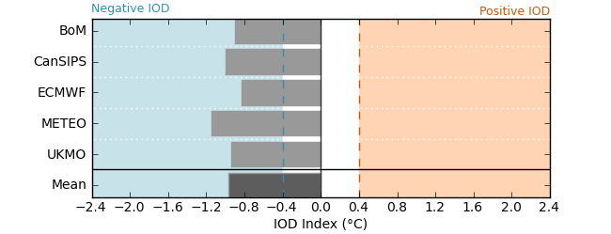
The Southern Annular Mode (SAM) is currently positive, with strongly positive values being recorded throughout much of June and July. SAM is expected to return to near-neutral values and remain neutral to positive over the coming weeks. The SAM refers to the north-south shift of the band of rain-bearing westerly winds and weather systems in the Southern Ocean compared to the usual position. A positive SAM in winter is associated with increased rainfall for parts of eastern Australia. It is also associated with decreased rainfall for western and central Victoria, the south-east of South Australia, the west of Western Australia and Tasmania.

Southern Annular Mode (SAM) daily index
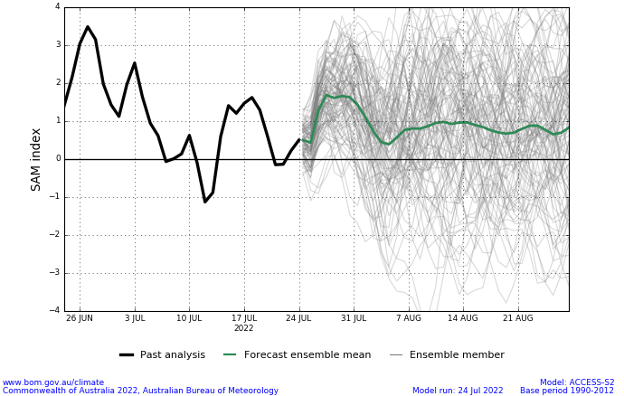

National Climate Outlook
These climate outlooks are generated by ACCESS–S (Australian Community Climate Earth-System Simulator–Seasonal). ACCESS–S is the Bureau of Meteorology's dynamic (physics-based) weather and climate model used for monthly, seasonal and longer-lead climate outlooks.
For further information, go to http://www.bom.gov.au/climate/ahead/about/
The Bureau of Meteorology’s latest rainfall outlook indicates wetter than average conditions are expected across south-eastern to north-western Australia during August. The ACCESS-S climate model suggests there is close to a 60% chance of exceeding median for parts of eastern, central and north-western Australia, with below median rainfall likely for western Tasmania, the far south-east of South Australia, parts of the tropical north coast, as well as part of south-western Victoria and Western Australia.
The outlook for August 2022 indicates that there is a 75% chance of rainfall totals between 10 and 50 millimetres across much of New South Wales, south-east and north-east Queensland, Victoria, southern South Australia, the south-west of Western Australia and Tasmania. Rainfall totals in excess of 100 millimetres are expected across alpine regions of New South Wales and Victoria, as well as the far south-west of Western Australia and western Tasmania.
Across cropping regions there is a 75% chance of rainfall totals of between 25 and 50 millimetres across eastern New South Wales, southern Victoria, western and central South Australia and parts of Western Australia. There is a 75% chance of rainfall less than 25 millimetres for northern and western New South Wales, the northwest of Victoria, parts of eastern South Australia, most of Queensland, and central and eastern cropping regions in Western Australia.
Rainfall totals that have a 75% chance of occurring August 2022
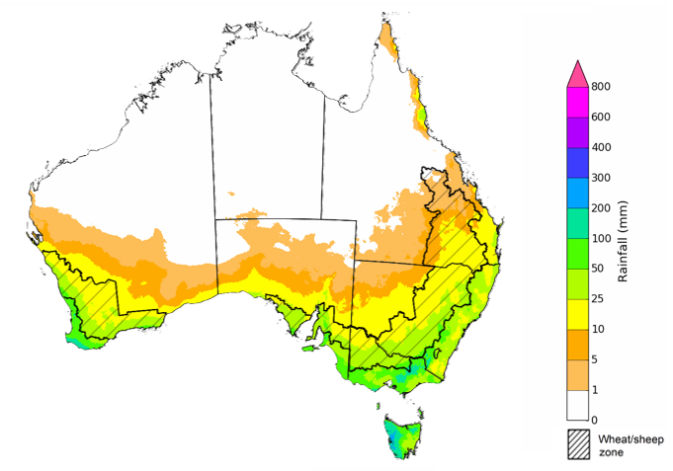
©Commonwealth of Australia 2022, Australian Bureau of Meteorology Issued: 21/07/2022

The rainfall outlook for August to October 2022 suggests there is a greater than 75% chance of exceeding median rainfall across most of New South Wales, Queensland, South Australia, northern Victoria, as well as the Northern Territory. For remaining regions of Australia, there is an increased chance of above median rainfall, except for parts of southwestern Western Australia and western Tasmania where below median rainfall is likely between August to October 2022 (Bureau of Meteorology ‘National Climate Outlook’, 21 July 2022).
Bureau of Meteorology rainfall outlooks for August to October have greater than 55% past accuracy across most of Australia. Outlook accuracy is greater than 65% across large areas of eastern Australia. Past accuracy is low (less than 50%) for parts of inland areas of Western Australia.
Chance of exceeding the median rainfall August to October 2022
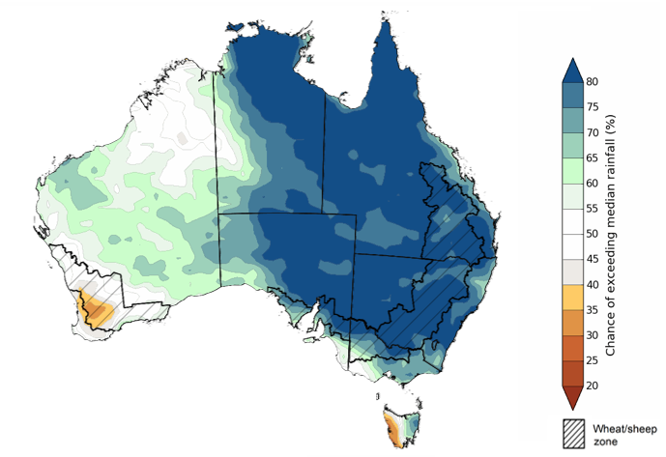
©Commonwealth of Australia 2022, Australian Bureau of Meteorology Issued: 21/07/2022

The outlook for August to October 2022 suggests there is a 75% chance of rainfall totals between 50 and 200 millimetres across much of New South Wales, south-eastern Queensland, Victoria, southern parts of South Australia, the south-west of Western Australia and Tasmania. Rainfall totals in excess of 200 millimetres are forecast for alpine regions of New South Wales and Victoria, far south-west Western Australia and western Tasmania.
Across cropping regions, there is a 75% chance of receiving between 50 and 100 millimetres across parts of western New South Wales, northern and western Queensland, north-western Victoria, parts of South Australia and much of Western Australia. Totals of between 100 and 200 millimetres are expected across much of eastern New South Wales and Queensland, southern Victoria, central South Australia and the far west and south of Western Australia.
Root zone soil moisture levels are average to above average across cropping regions in Queensland, with the expectation of above average rainfall over the next three months increasing the risk of prolonged waterlogging, and the potential to negatively impact crop growth and development. For cropping regions in south-eastern Australia, root zone soil moisture levels are below average to average. Following a favourable start to the winter cropping season, above average rainfall over the coming months is likely to support crops through critical development stages through spring, supporting strong yield potentials. Despite the below average rainfall expected in Western Australia, rainfall through August to October is likely to be sufficient to support ongoing crop growth and development.
Rainfall totals that have a 75% chance of occurring August to October 2022
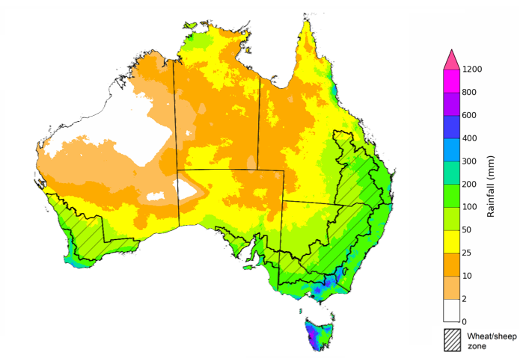
©Commonwealth of Australia 2022, Australian Bureau of Meteorology Issued: 21/07/2022

The temperature outlook for August to October 2022 indicates that maximum temperatures across most of Australia are likely to be close to the 1990-2012 average (the difference in the range of - 1°C to +1°C), with slightly higher than average temperatures across the tropical north. Minimum temperatures are expected to be slightly above average for much of the northern Australia, and close to average for the rest of Australia (Bureau of Meteorology ‘National Climate Outlook’, 21 July 2022).
Predicted maximum temperature anomaly for August to October 2022

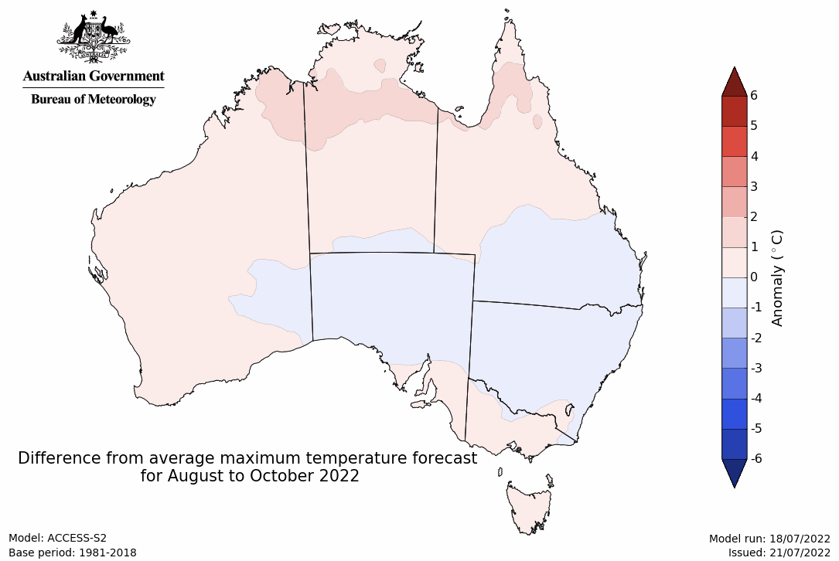
Predicted minimum temperature anomaly for August to October 2022
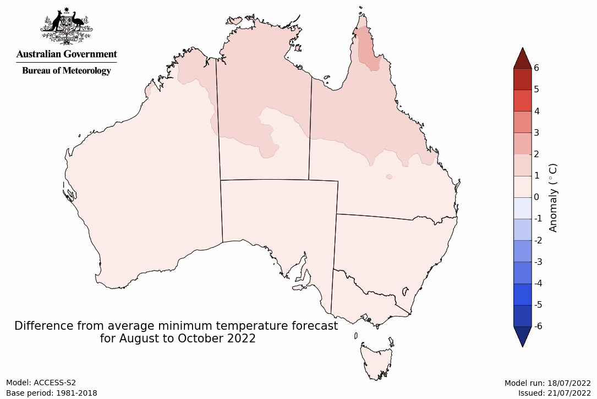

Northern rainfall onset outlook
The northern rainfall onset outlook provides an indication of whether the first significant rains after the dry season are likely to be earlier or later than normal. The onset occurs when the total rainfall after 1 September reaches 50 millimetres, this is considered approximately the amount of rainfall required to stimulate plant growth. Coastal parts of northern Australia usually accumulate 50 millimetres of rainfall by late October or early November, spreading to inland areas over subsequent weeks.
An early northern rainfall onset for 2022–23 season is more likely across Queensland and most of the Northern Territory, according to the latest northern rainfall onset outlook released by the Bureau of Meteorology. The chance of an early rainfall onset is greater than 65% for most of Queensland, the Northern Territory and parts of northern South Australia. Meanwhile, northern parts of Western Australia have less than a 40% chance of an early rainfall onset.
Northern Australia rainfall onset is significantly affected by the ENSO phase and the presence of a negative IOD. Earlier than normal northern rainfall onset is associated with the possible emergence of a La Niña conditions in late spring, which some international climate models are predicting. The La Niña event during spring-summer of 2020 also resulted in an early northern rainfall onset across much of northern Australia. In contrast, 2018 and 2019 had later than normal onsets, reducing the length of the dryland summer growing season and the recharge of water storages. In the Indian Ocean, negative Indian Ocean Dipole conditions are forecast out to November. This is also contributing to the higher likelihood of an earlier than normal northern rainfall onset. An early onset of the 2022–23 northern wet season is likely to boost soil moisture and water storages, and benefit summer crop production and northern pasture growth.
Chance of early northern rainfall onset
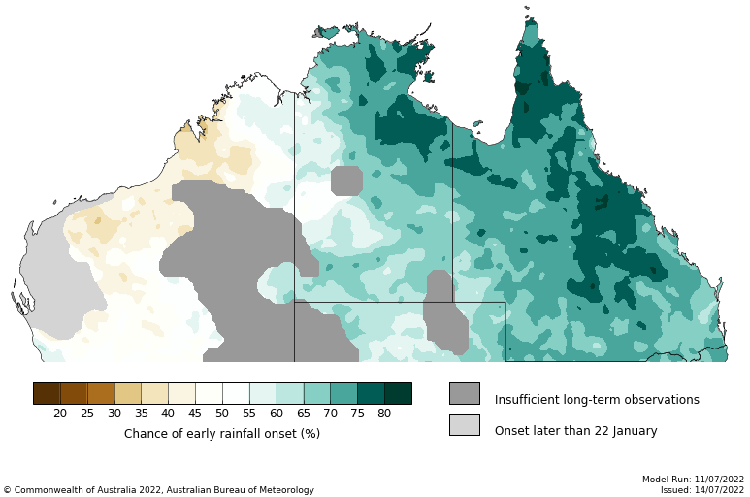

Rainfall forecast for the next eight days
Over the 8-days to 4 August 2022, low-pressure troughs and cold fronts are expected to bring light to moderate rainfall across large areas of southern Australia. However, high-pressure systems across much of the country are expected to result in clear, dry conditions.
Rainfall totals of between 10 and 50 millimetres are forecast for central areas of New South Wales, isolated parts of Queensland, much of Victoria, southern parts of South Australia and Western Australia, as well as much of Tasmania. Rainfall totals in excess of 50 millimetres are forecast for alpine regions of New South Wales and Victoria, the far south-west of Western Australia, and western and northern Tasmania. Little to no rainfall is forecast across remaining parts of Australia over the next 8-days.
In Australian cropping regions, rainfall totals of between 10 and 50 millimetres are expected across most of New South Wales, Victoria, South Australia and Western Australia, as well as isolated parts of south-west Queensland. Little to no rainfall is forecast for all remaining cropping regions during the next 8-days.
The dry conditions forecast for much of Queensland will allow soil profiles to drain, and if dry conditions persist, growers will be able to access fields again. Given the above average rainfall thus far this growing season, there is likely to be increased need for pest and disease management in winter crops. Forecast rainfall across most southern and western cropping regions over the coming week will be a welcome boost to soil moisture levels. The wet conditions will consolidate the rainfall received in western cropping regions over the past week and continue to support yield potentials. Across southern New South Wales, Victoria and South Australia, soil moisture levels have steadily declined over recent weeks in the absence of significant rainfall. The forecast rainfall will provide a welcome reprieve, but further rainfall will be required in the coming weeks to support yield potentials as we approach spring.

Total forecast rainfall (mm) for the period 28 July to 4 August 2022
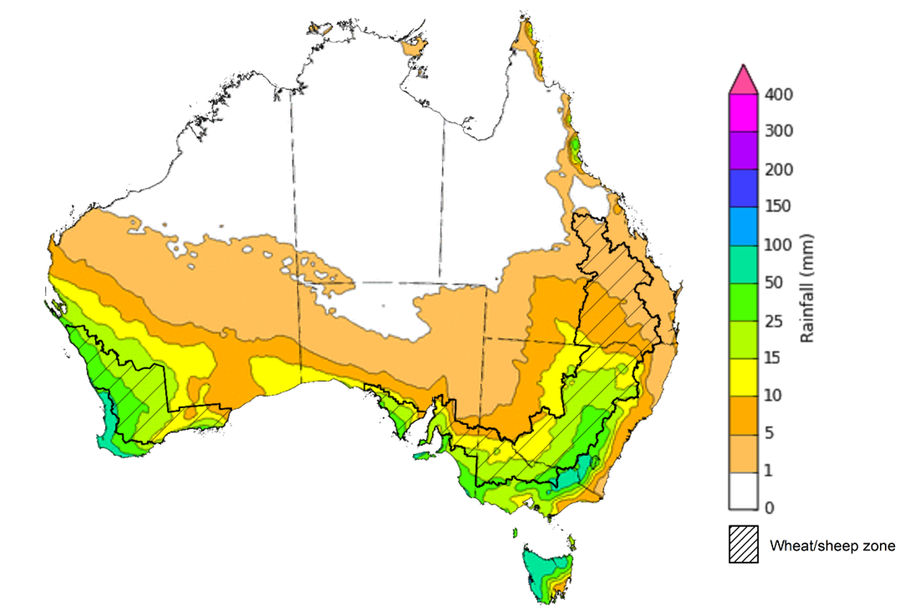
©Commonwealth of Australia 2022, Australian Bureau of Meteorology Issued:27/7/2022

Water
Note: This rainfall forecast is produced from computer models. As the model outputs are not altered by weather forecasters, it is important to check local forecasts and warnings issued by the Bureau of Meteorology.

Water markets – current week
Water storage in the Murray–Darling Basin (MDB) decreased by 16 gigalitres (GL) between 20 July 2022 and 27 July 2022. The current volume of water held in storage is 22,230 GL, which represents 88% of total capacity. This is 17% or 3,311 GL more than at the same time last year.

Water storages in the Murray-Darling Basin, 2013–2022
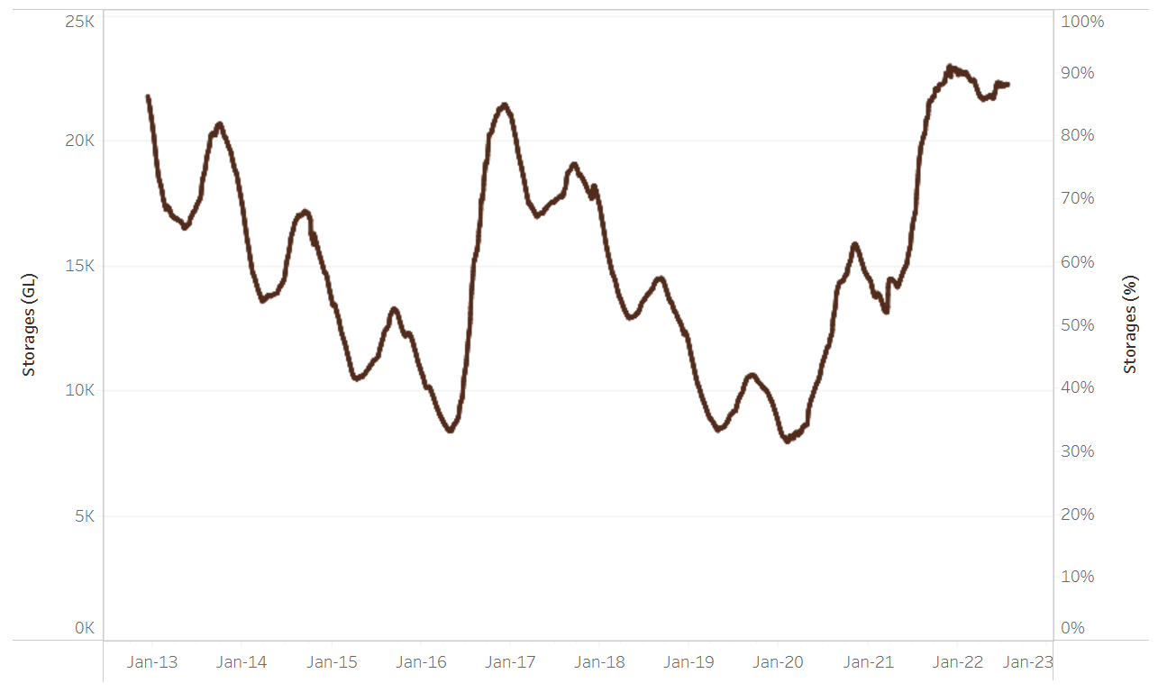
Allocation prices in the Victorian Murray below the Barmah Choke decreased from $81 per ML on 15 July 2022 to $80 per ML on 22 July 2022. Prices are lower in the Goulburn-Broken due to the binding of the Goulburn intervalley trade limit.
Water storage data is sourced from the Bureau of Meteorology.

Region | $/ML
NSW Murray Above | 51
NSW Murrumbidgee | 81
VIC Goulburn-Broken | 65
VIC Murray Below | 80

Surface water trade activity, Southern Murray–Darling Basin

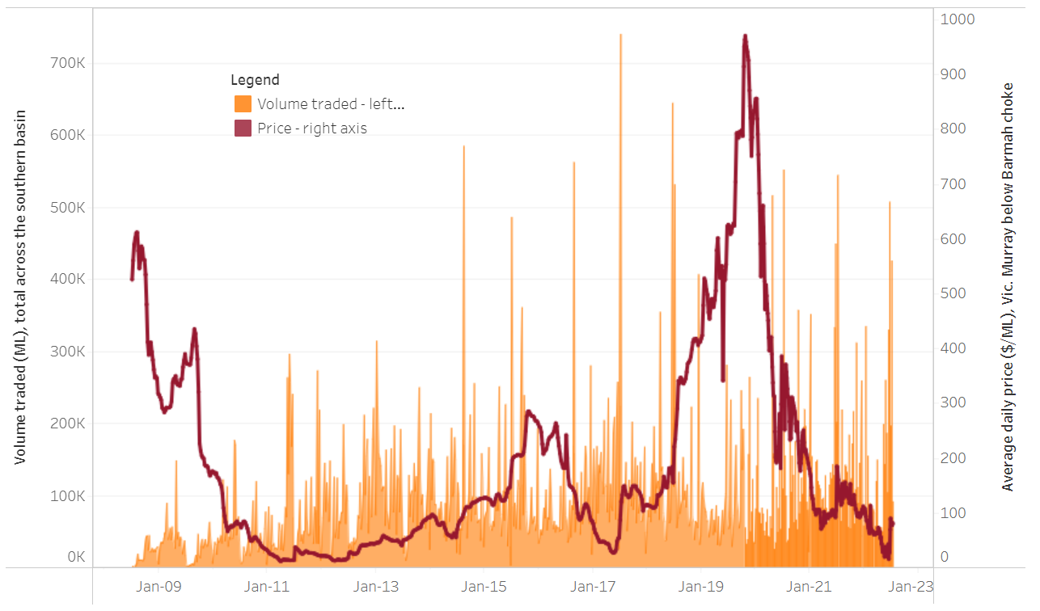
To access the full, interactive, weekly water dashboard, which contains the latest and historical water storage, water market and water allocation information, please visit http://www.agriculture.gov.au/abares/products/weekly_update/weekly-update-280722
The trades shown reflect estimated market activity and do not encompass all register trades. The price is shown for the VIC Murray below the Barmah choke. Historical prices (before 1 July 2019) are ABARES estimates after removing outliers from BOM water register data. Prices after 1 July 2019 and prior to the 30 October 2019 reflect recorded transaction prices as sourced from Ruralco. Prices after the 30 October 2019 are sourced from Waterflow. Data for volume traded is sourced from the BOM water register. Data shown is current at 28 July 2022.

Commodities

Indicator | Week ended | Unit | Latest price | Previous week | Weekly change | Price 12 months ago | Annual change
Selected world indicator prices
AUD/USD Exchange rate | 27-Jul | A$/US$ | 0.69 | 0.69 | 1% | 0.74 | -6%
Wheat – US no. 2 hard red winter wheat, fob Gulf | 27-Jul | US$/t | 378 | 384 | -2% | 320 | 18%
Corn – US no. 2 yellow corn, fob Gulf | 27-Jul | US$/t | 298 | 311 | -4% | 260 | 14%
Canola – Rapeseed, Canada, fob Vancouver | 27-Jul | US$/t | 700 | 722 | -3% | 765 | -8%
Cotton – Cotlook 'A' Index | 27-Jul | USc/lb | 127 | 128 | -1% | 98 | 30%
Sugar – Intercontinental Exchange, nearby futures, no.11 contract | 27-Jul | USc/lb | 17.7 | 19.3 | -8% | 19 | -5%
Wool – Eastern Market Indicator | 06-Jul | Ac/kg clean | 1,388 | 1,407 | -1% | 1,315 | 6%
Wool – Western Market Indicator | 06-Jul | Ac/kg clean | 1,473 | 1,486 | -1% | 1,333 | 11%
Selected Australian grain export prices
Milling Wheat – APW, Port Adelaide, SA | 27-Jul | A$/t | 583 | 602 | -3% | 396 | 47%
Feed Wheat – ASW, Port Adelaide, SA | 27-Jul | A$/t | 543 | 562 | -3% | 392 | 38%
Feed Barley – Port Adelaide, SA | 27-Jul | A$/t | 494 | 510 | -3% | 324 | 53%
Canola – Kwinana, WA | 27-Jul | A$/t | 1,097 | 1,133 | -3% | 788 | 39%
Grain Sorghum – Brisbane, QLD | 27-Jul | A$/t | 434 | 432 | 0% | 363 | 19%
Selected domestic livestock indicator prices
Beef – Eastern Young Cattle Indicator | 27-Jul | Ac/kg cwt | 936 | 973 | -4% | 968 | -3%
Mutton – Mutton indicator (18–24 kg fat score 2–3), Vic | 27-Jul | Ac/kg cwt | 585 | 592 | -1% | 680 | -14%
Lamb – Eastern States Trade Lamb Indicator | 27-Jul | Ac/kg cwt | 710 | 776 | -8% | 882 | -19%
Pig – Eastern Seaboard (60.1–75 kg), average of buyers & sellers | 29-Jun | Ac/kg cwt | 368 | 368 | 0% | 347 | 6%
Goats – Eastern States (12.1–16 kg) | 12-Jan | Ac/kg cwt | 879 | 879 | 0% | 818 | 8%
Live cattle – Light steers ex Darwin to Indonesia | 01-Jun | Ac/kg lwt | 480 | 480 | 0% | 320 | 50%
Live sheep – Live wethers (Muchea WA saleyard) to Middle East | 20-Apr | $/head | 113 | 113 | 0% | 122 | -7%

Indicator | Week ended | Unit | Latest price | Previous week | Weekly change | Price 12 months ago | Annual change
Global Dairy Trade (GDT) weighted average prices ª
Dairy – Whole milk powder | 20-Jul | US$/t | 3,757 | 3,961 | -5% | 2,761 | 36%
Dairy – Skim milk powder | 20-Jul | US$/t | 3,709 | 4,063 | -9% | 2,530 | 47%
Dairy – Cheddar cheese | 20-Jul | US$/t | 4,825 | 4,908 | -2% | 3,520 | 37%
Dairy – Anhydrous milk fat | 20-Jul | US$/t | 5,580 | 5,706 | -2% | 3,960 | 41%
a Global Dairy Trade prices are updated twice monthly on the first and third Tuesday of each month.

Selected world indicator prices
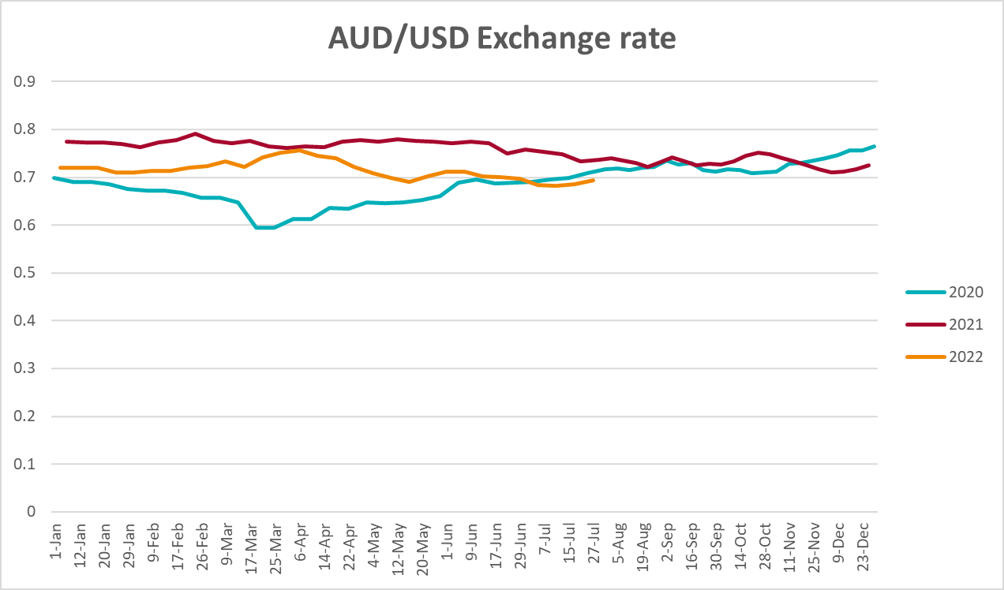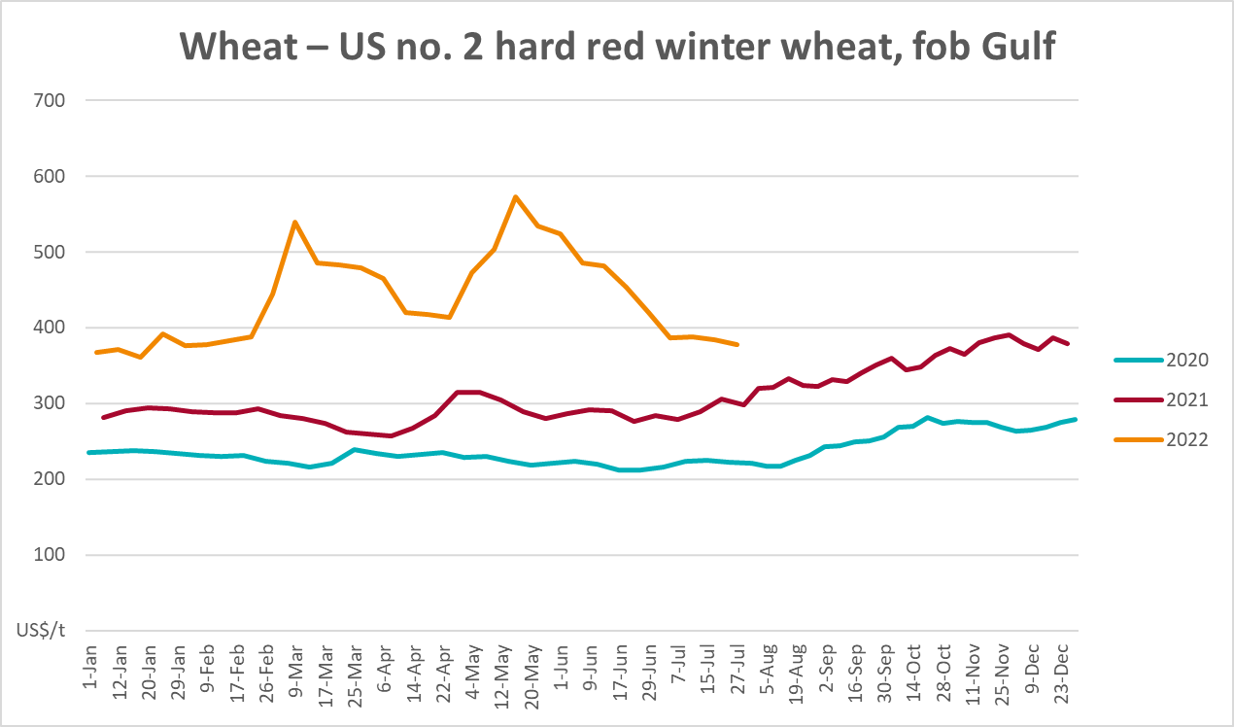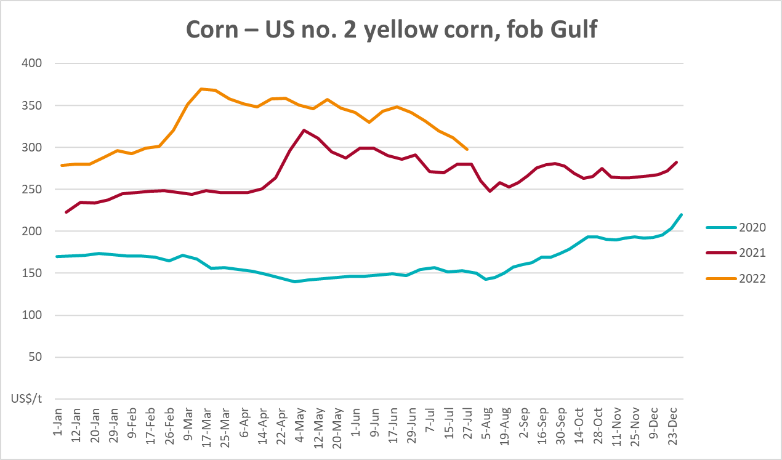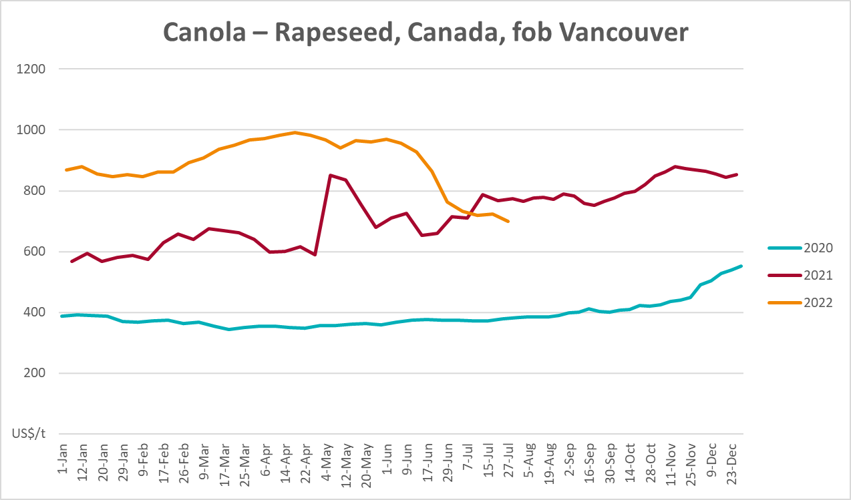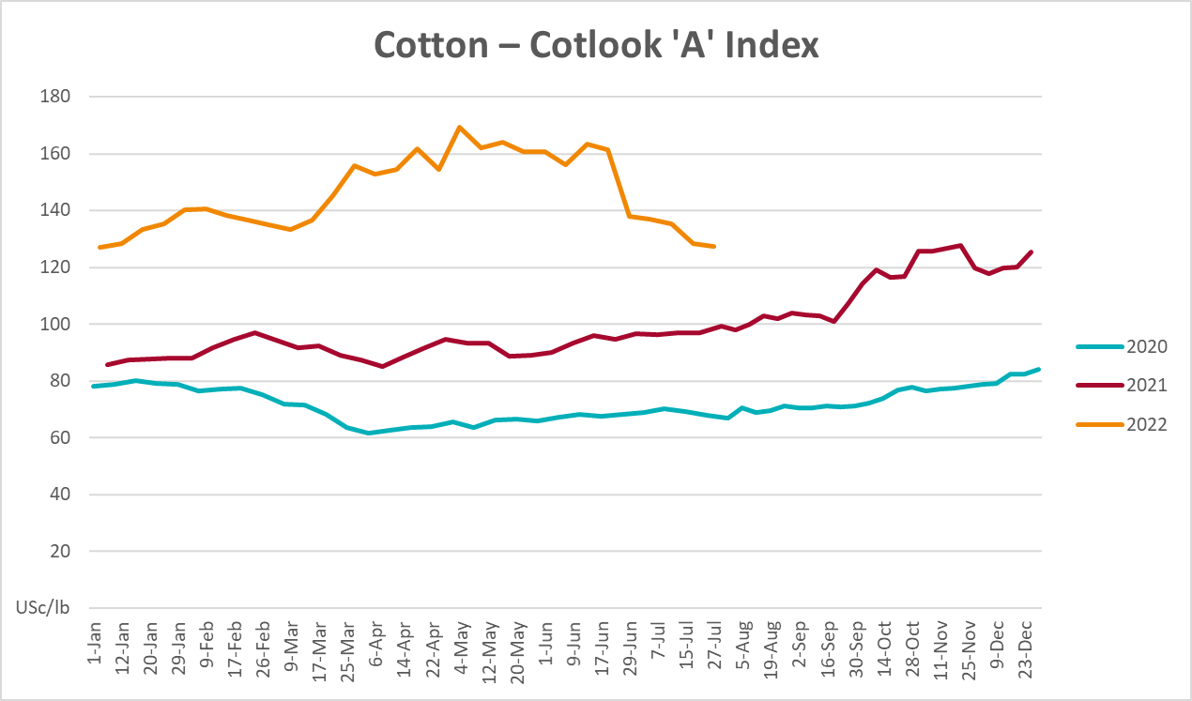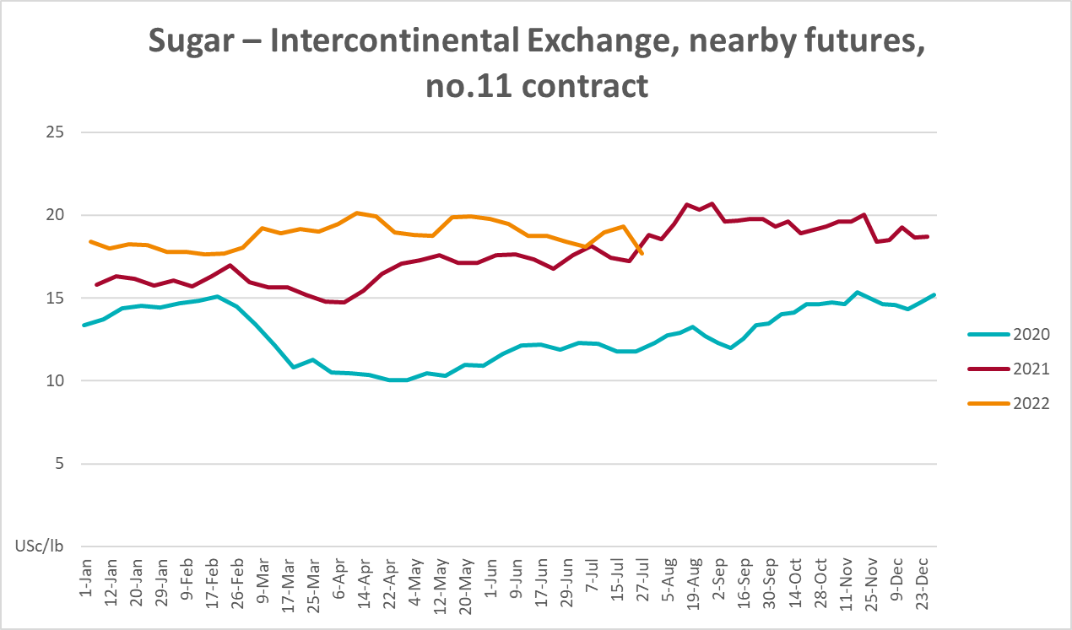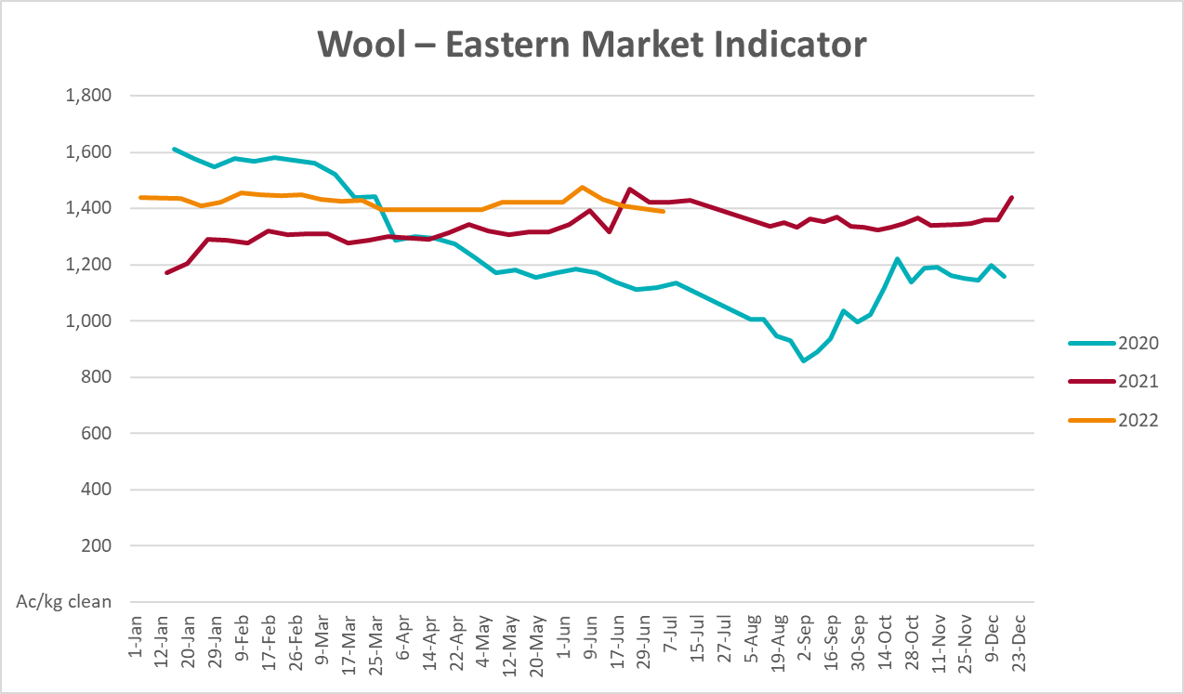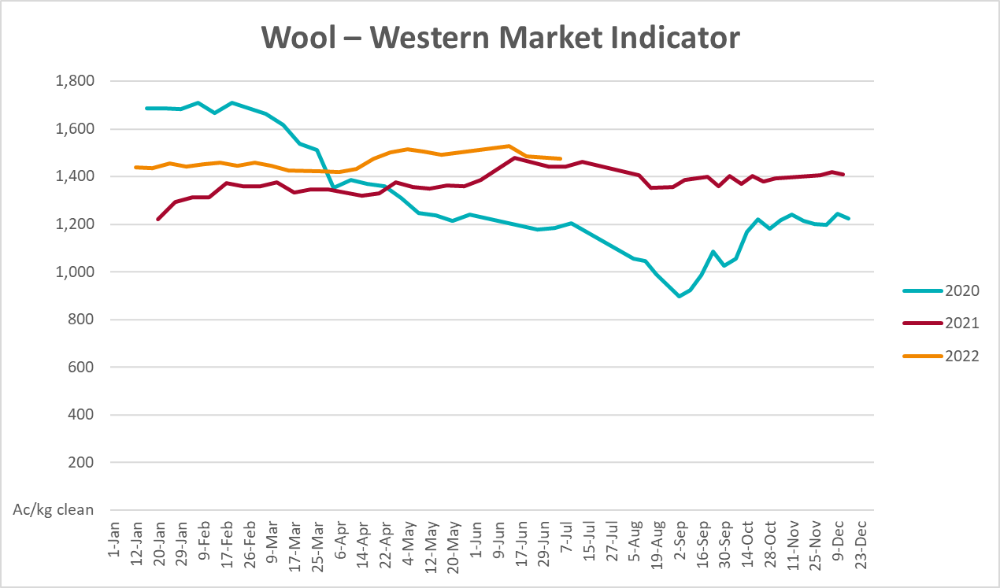

Selected domestic crop indicator prices
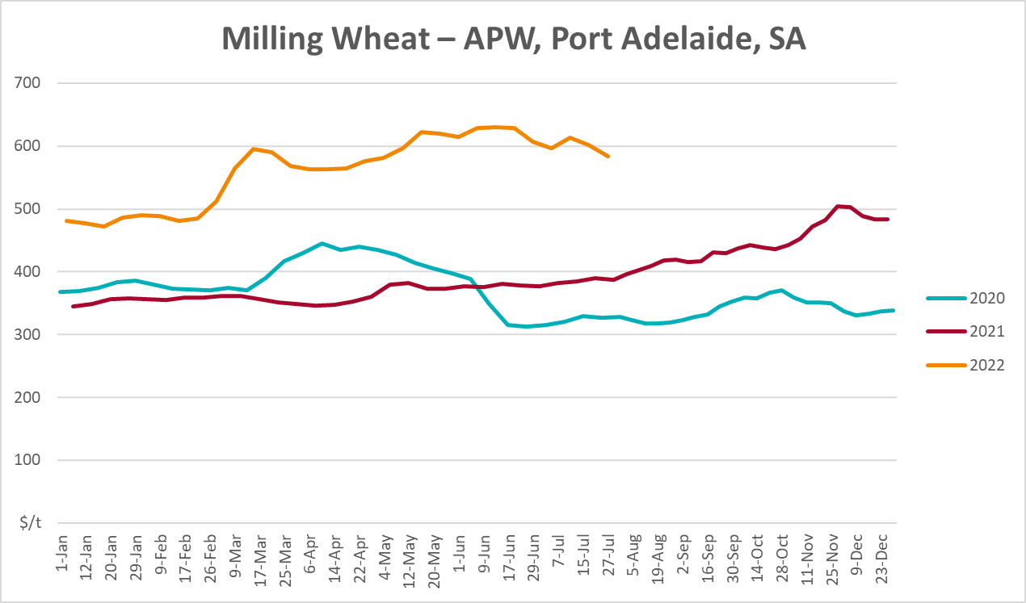
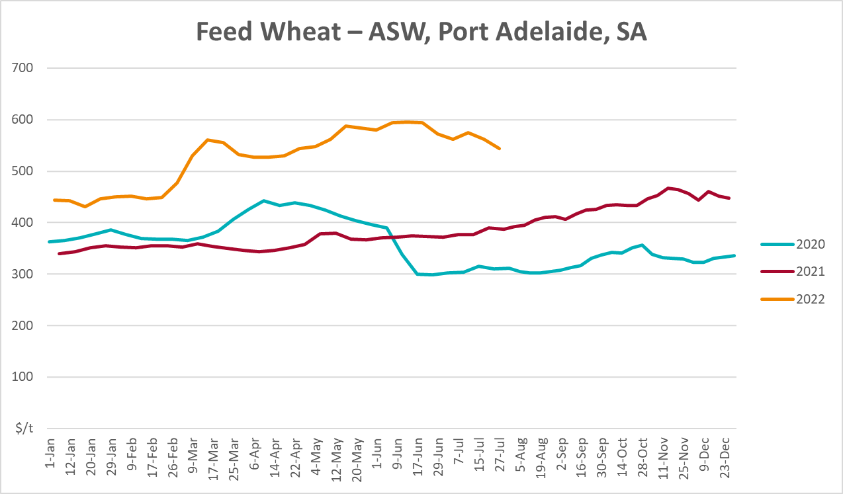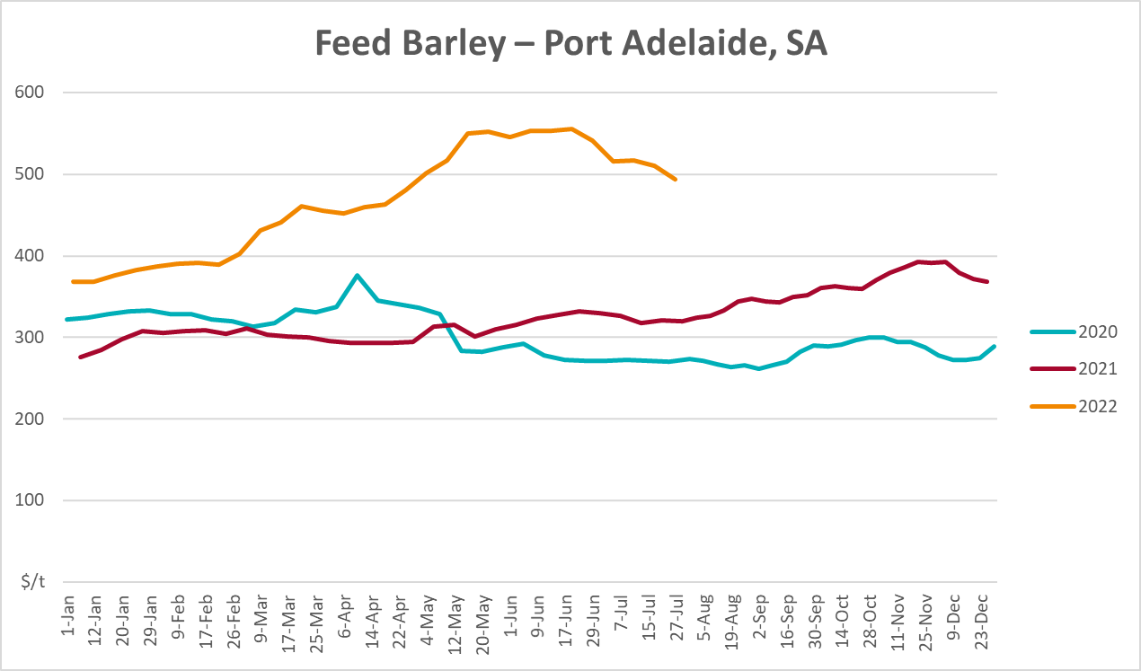
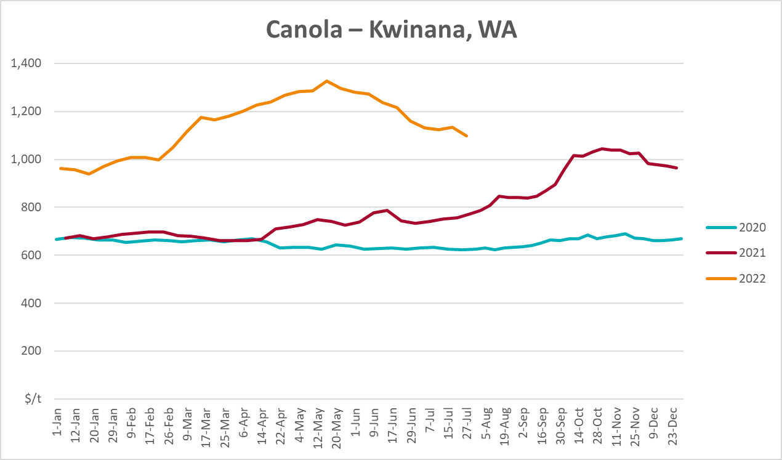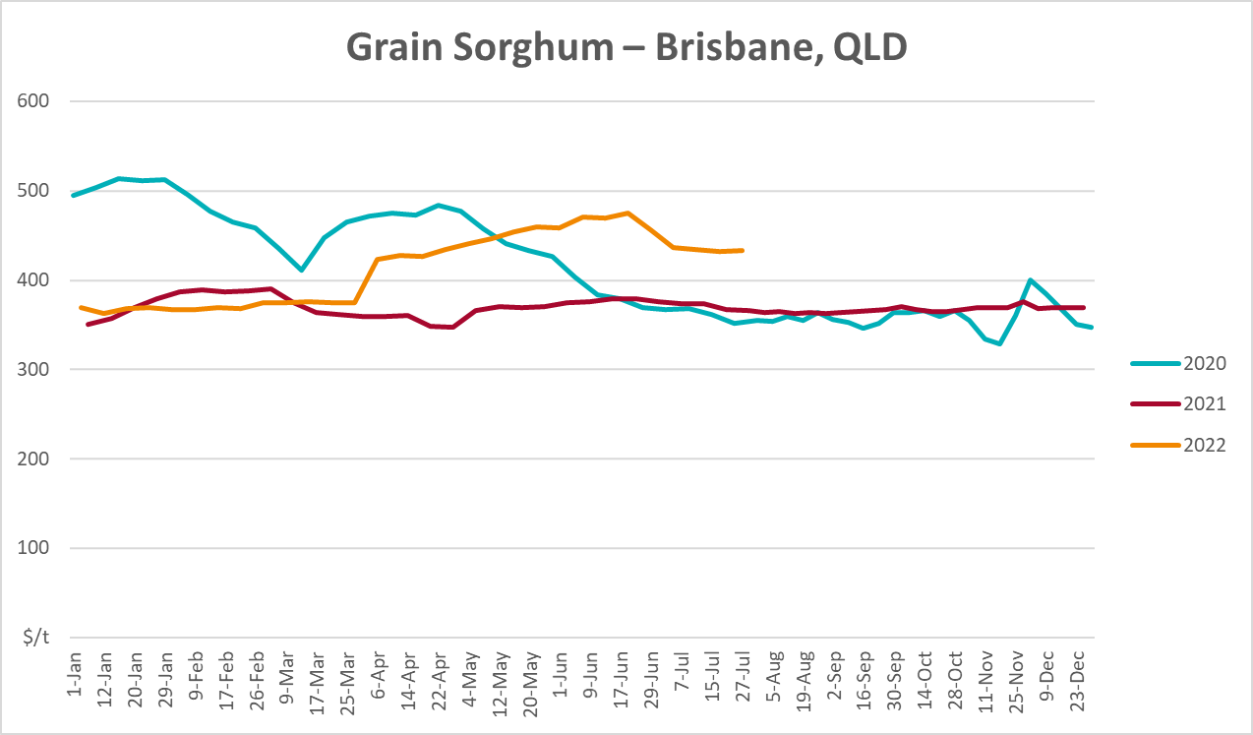

Selected domestic livestock indicator prices
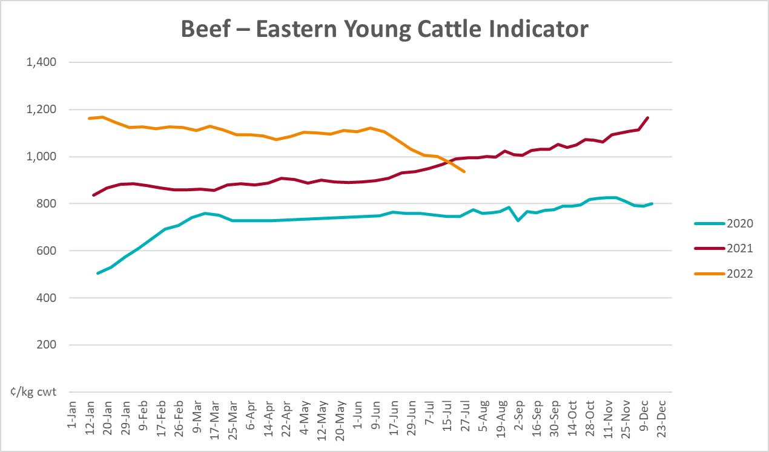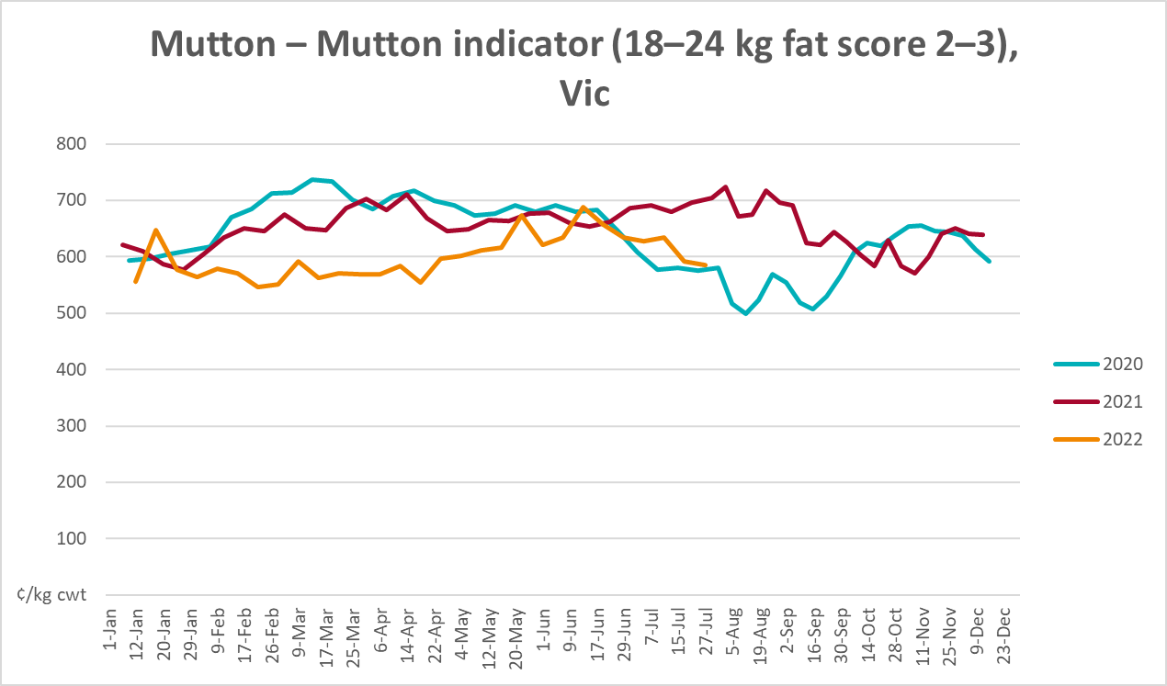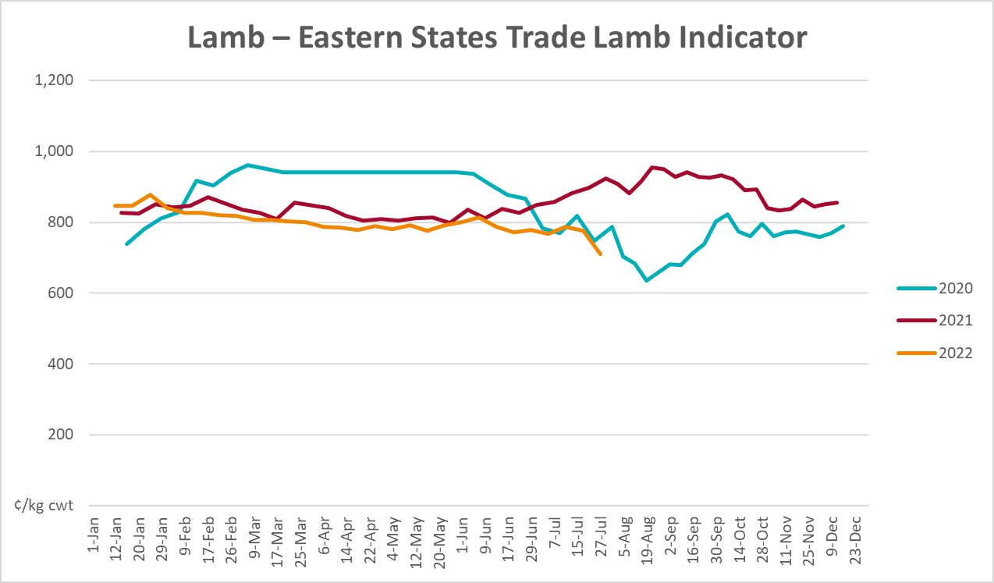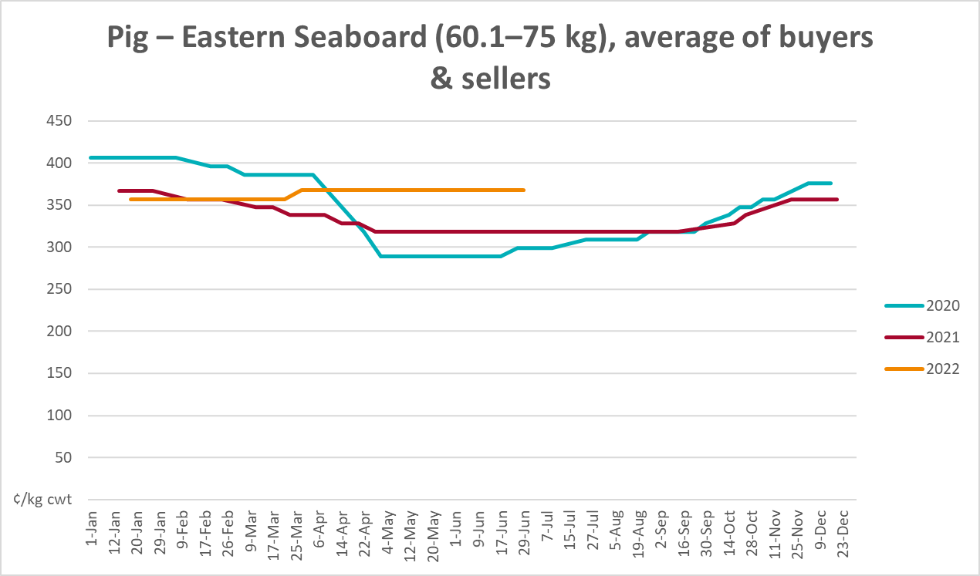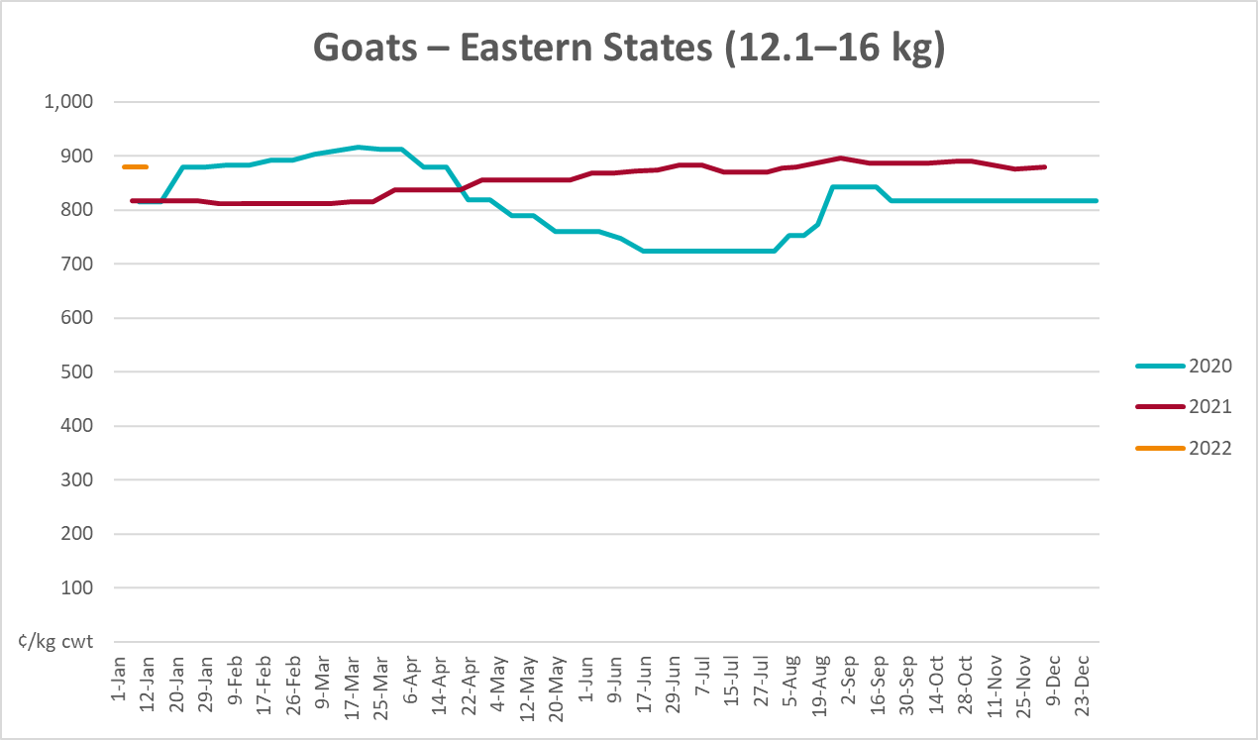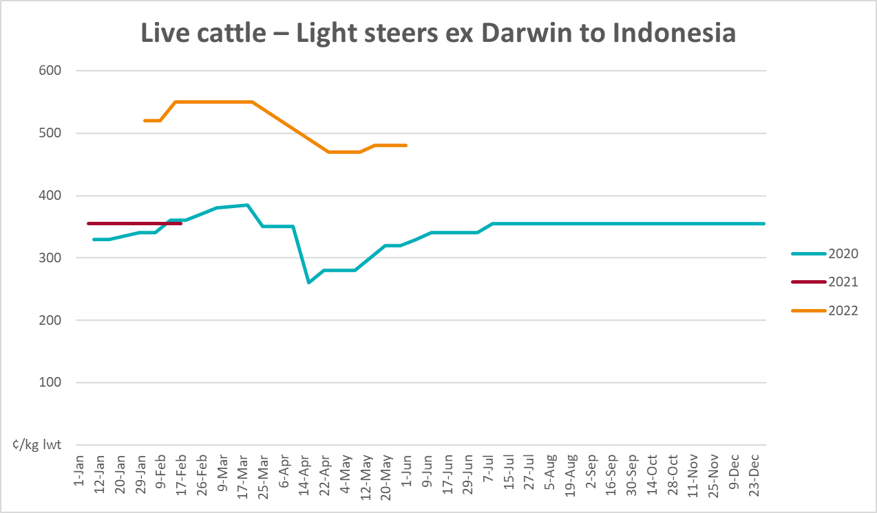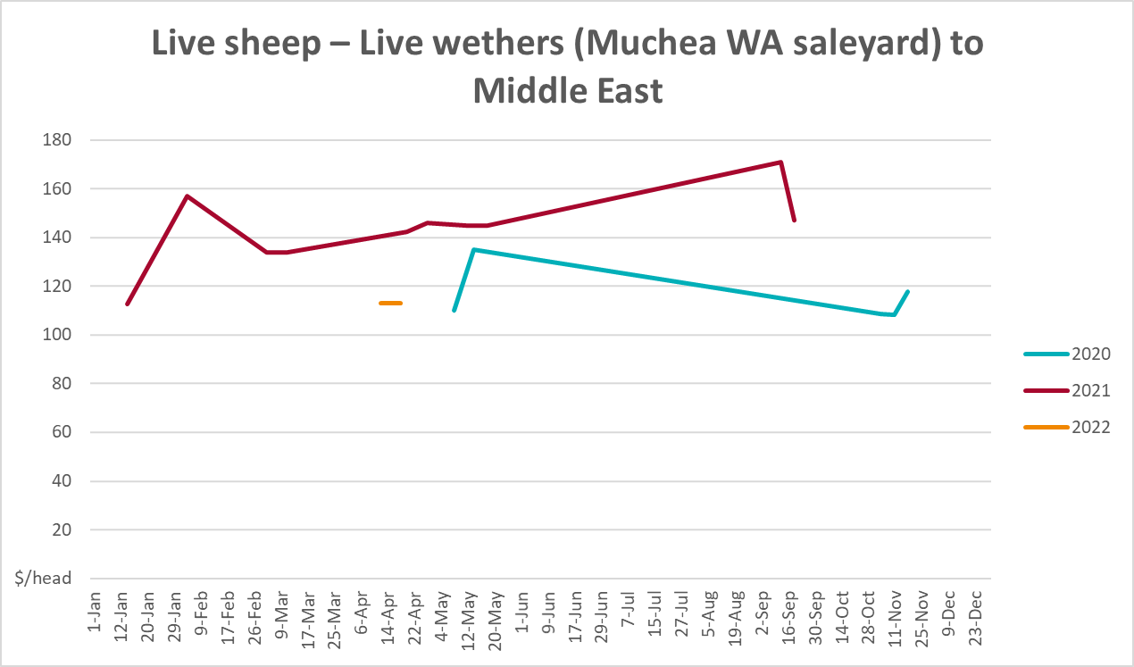

Global Dairy Trade (GDT) weighted average prices
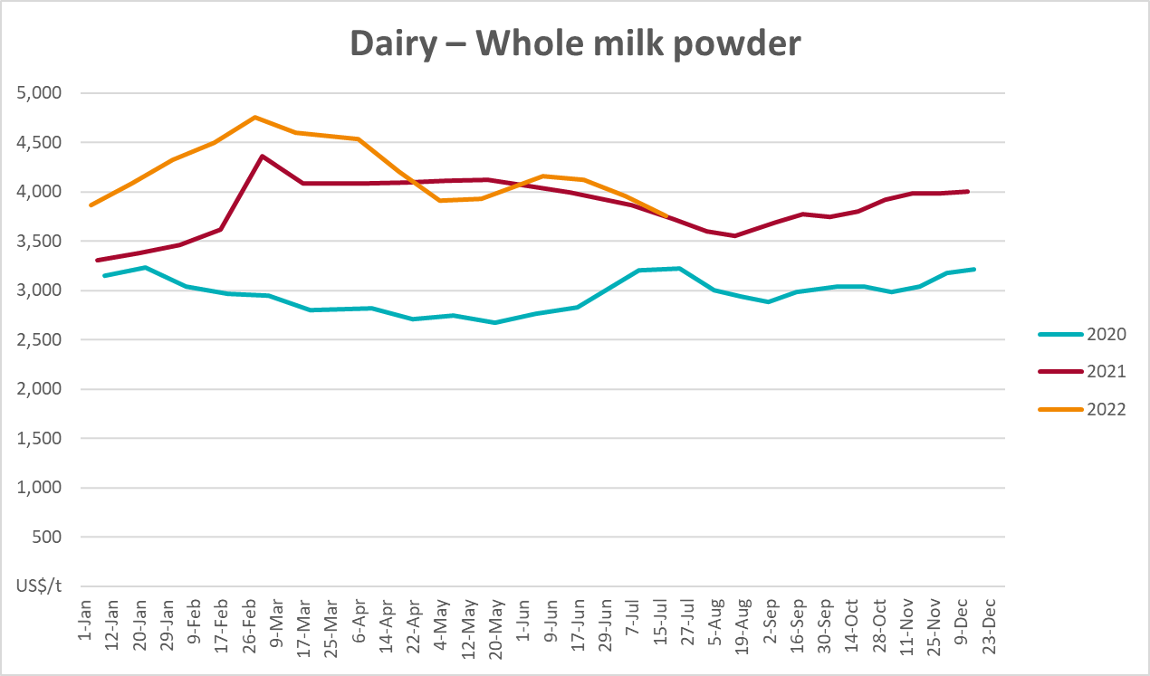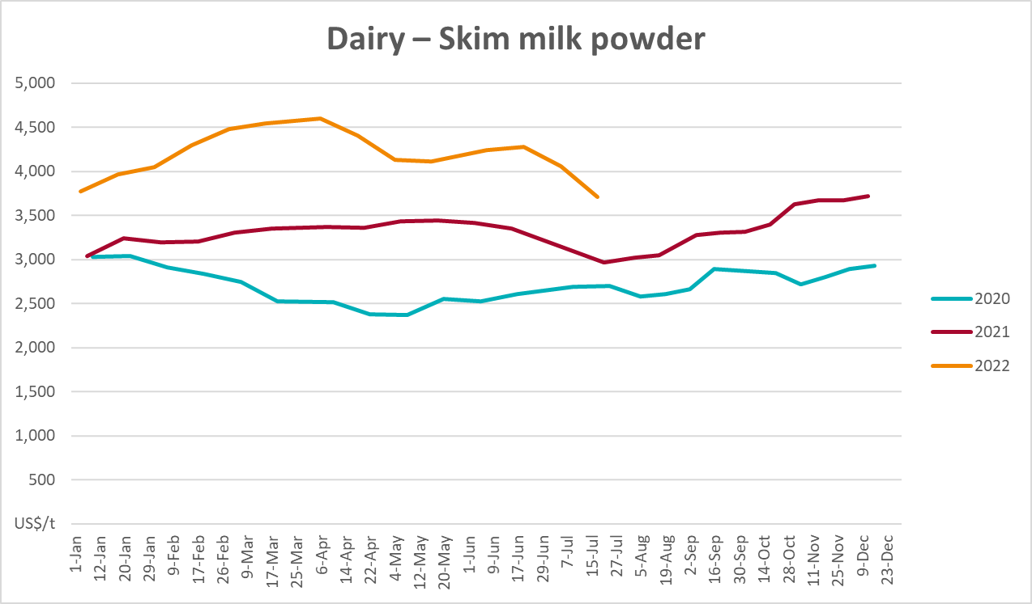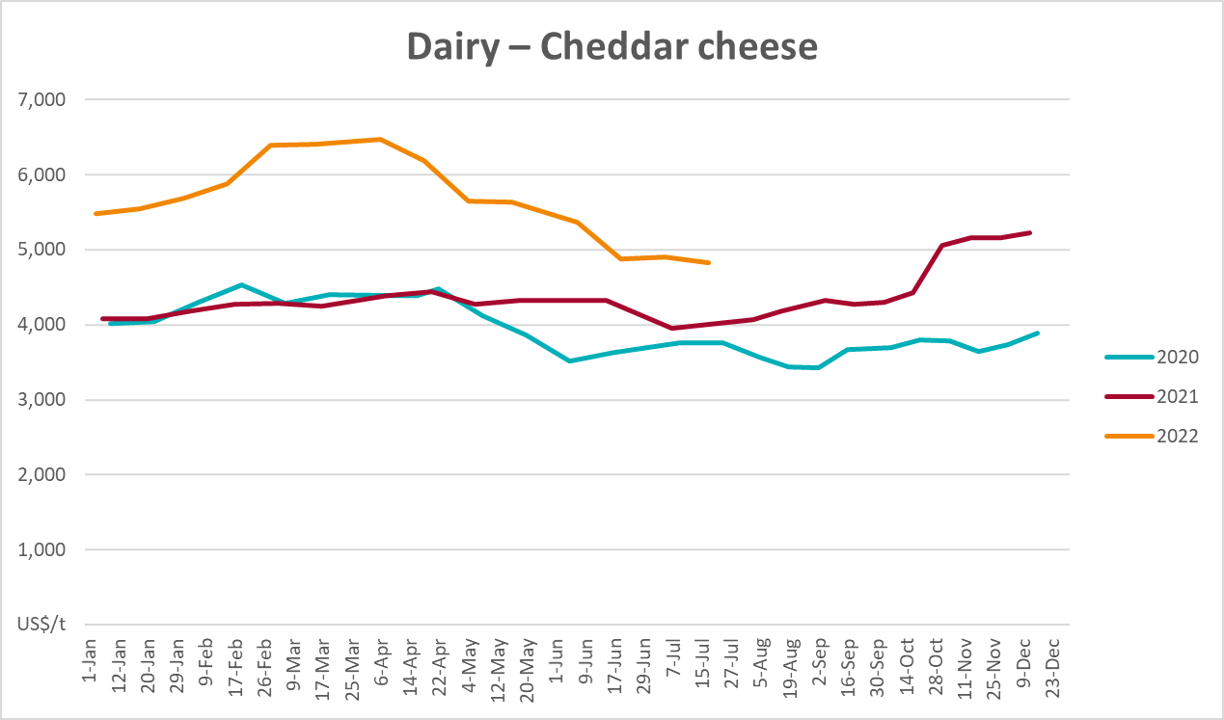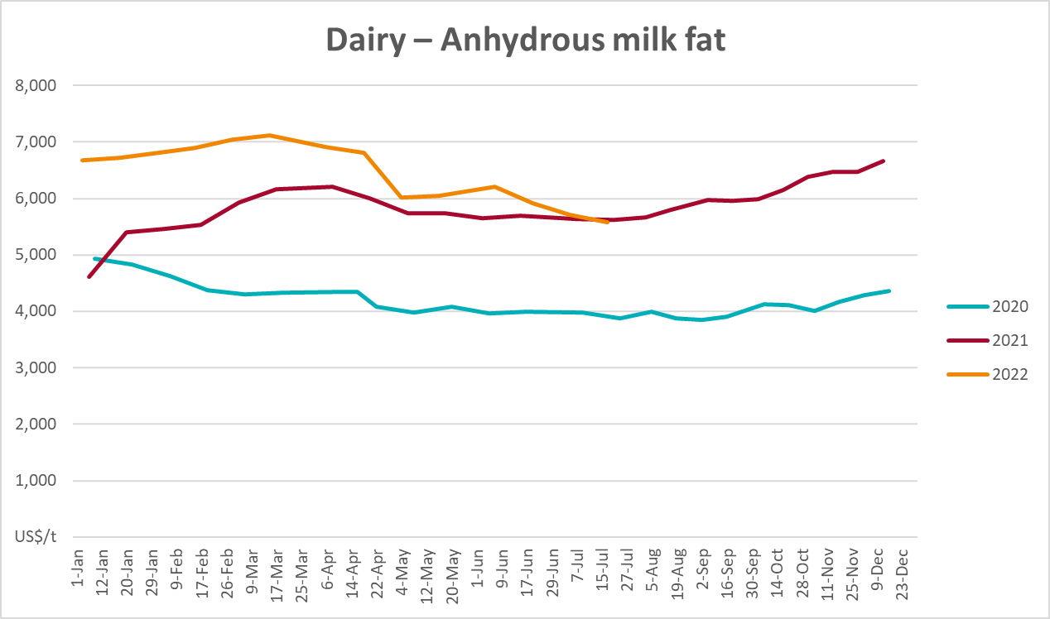

Selected fruit and vegetable prices
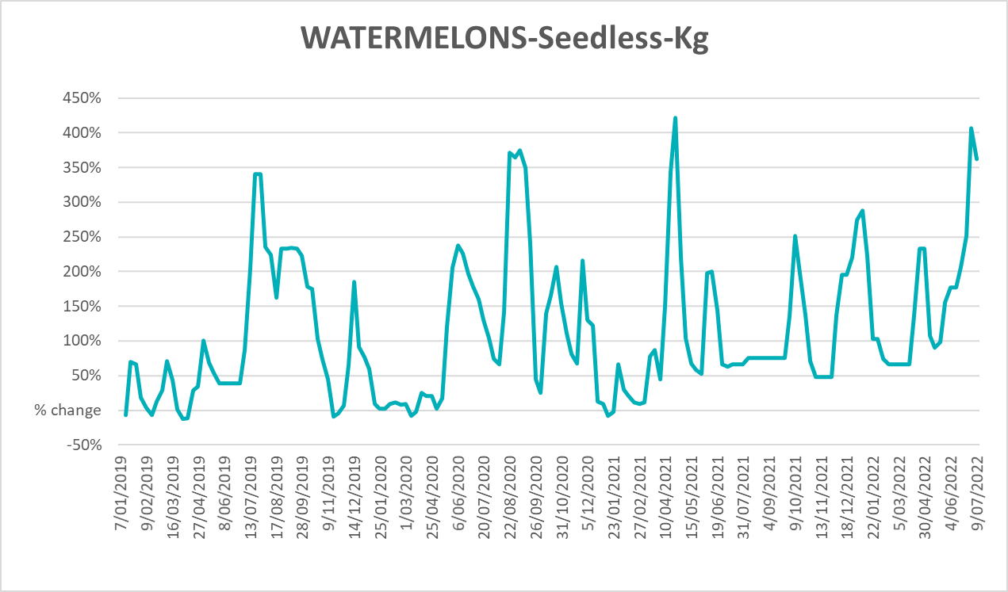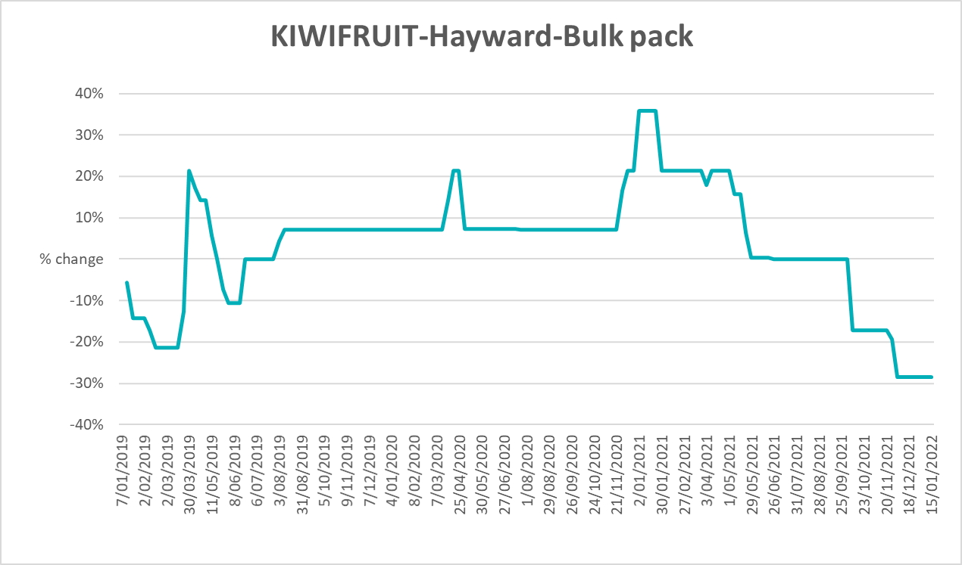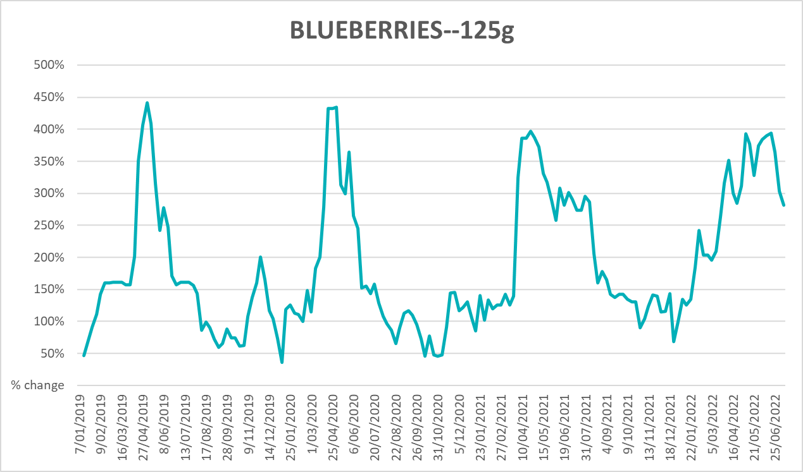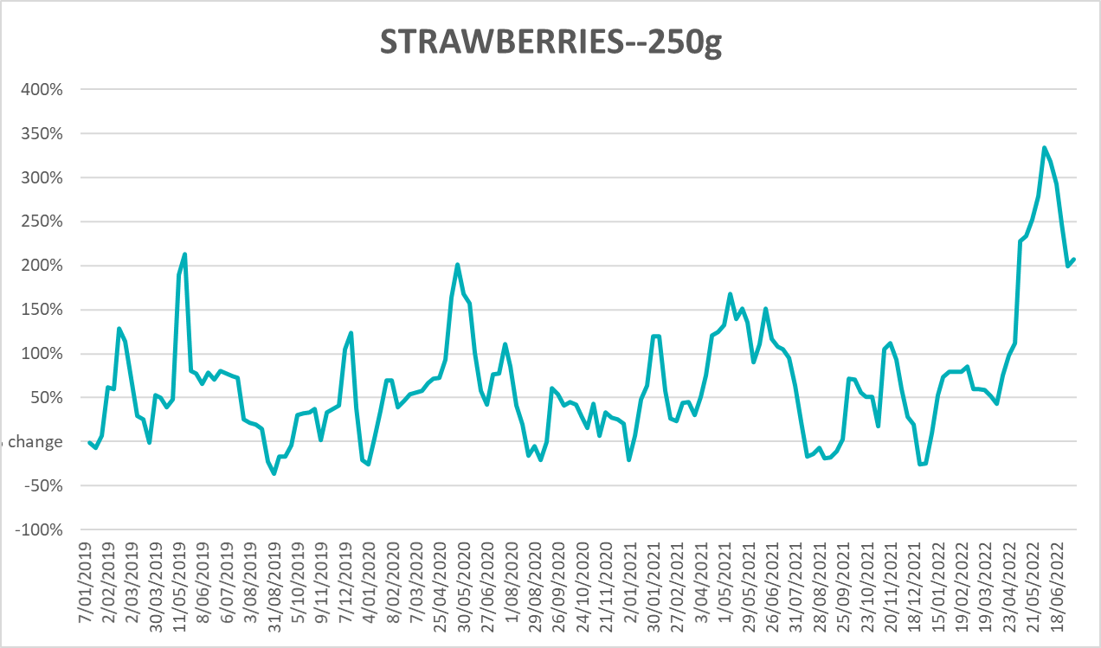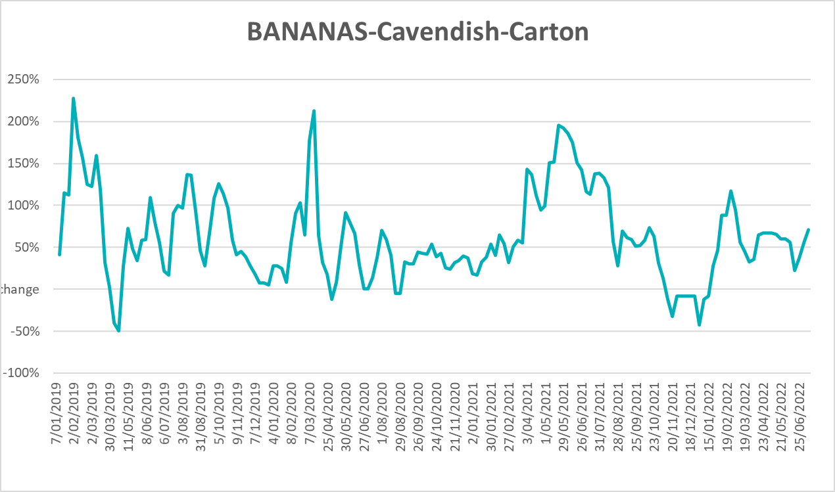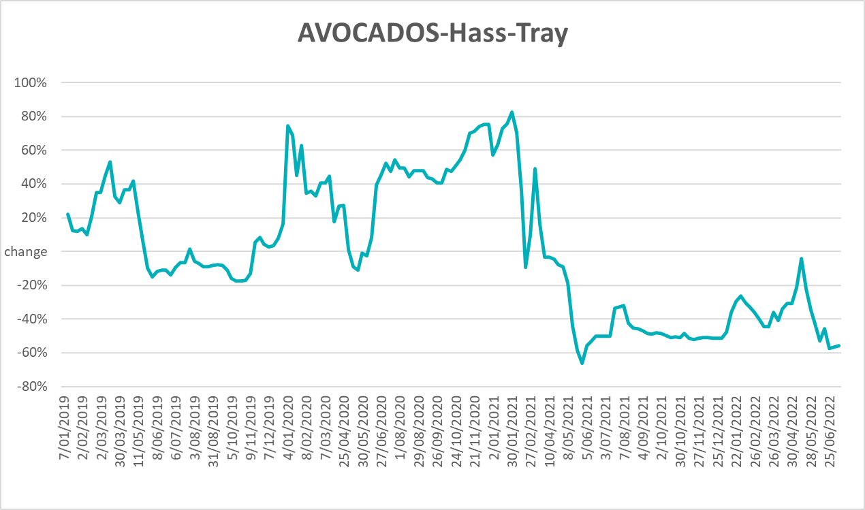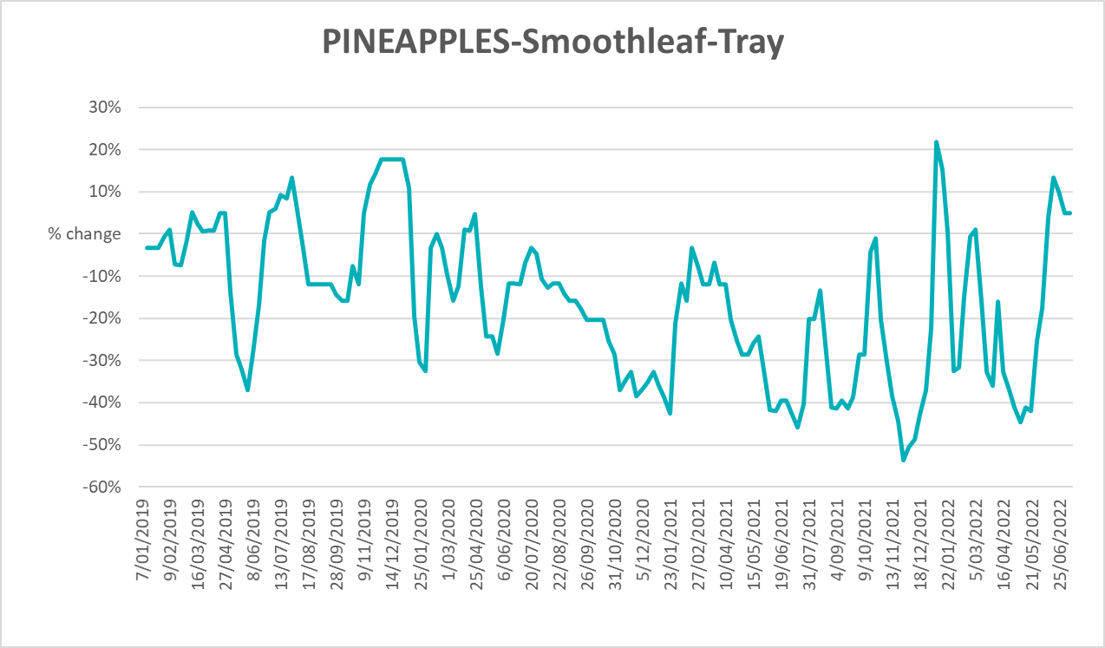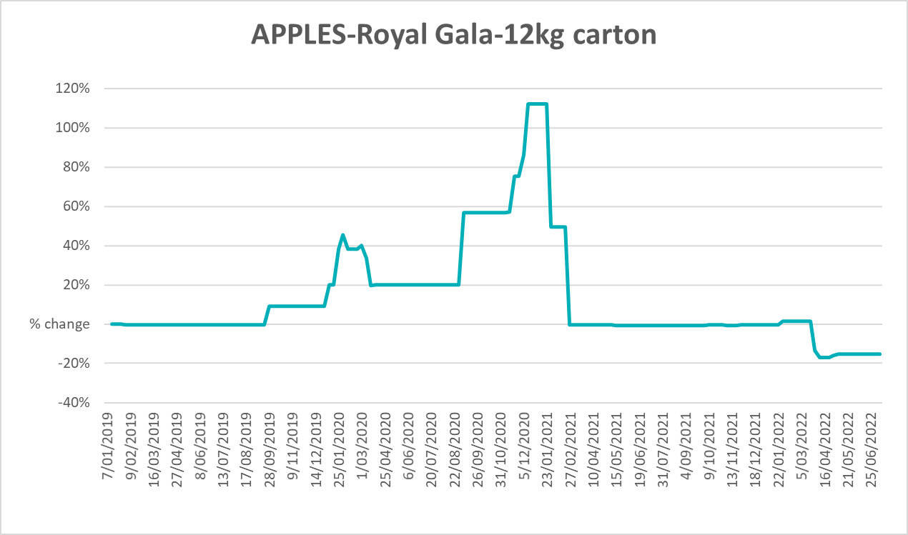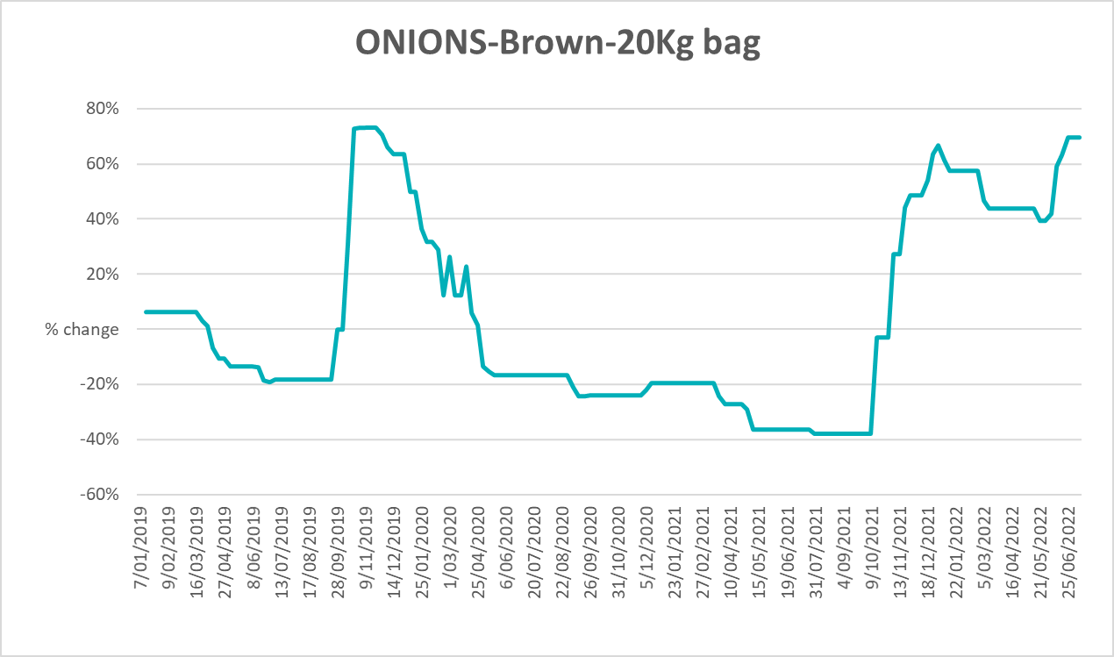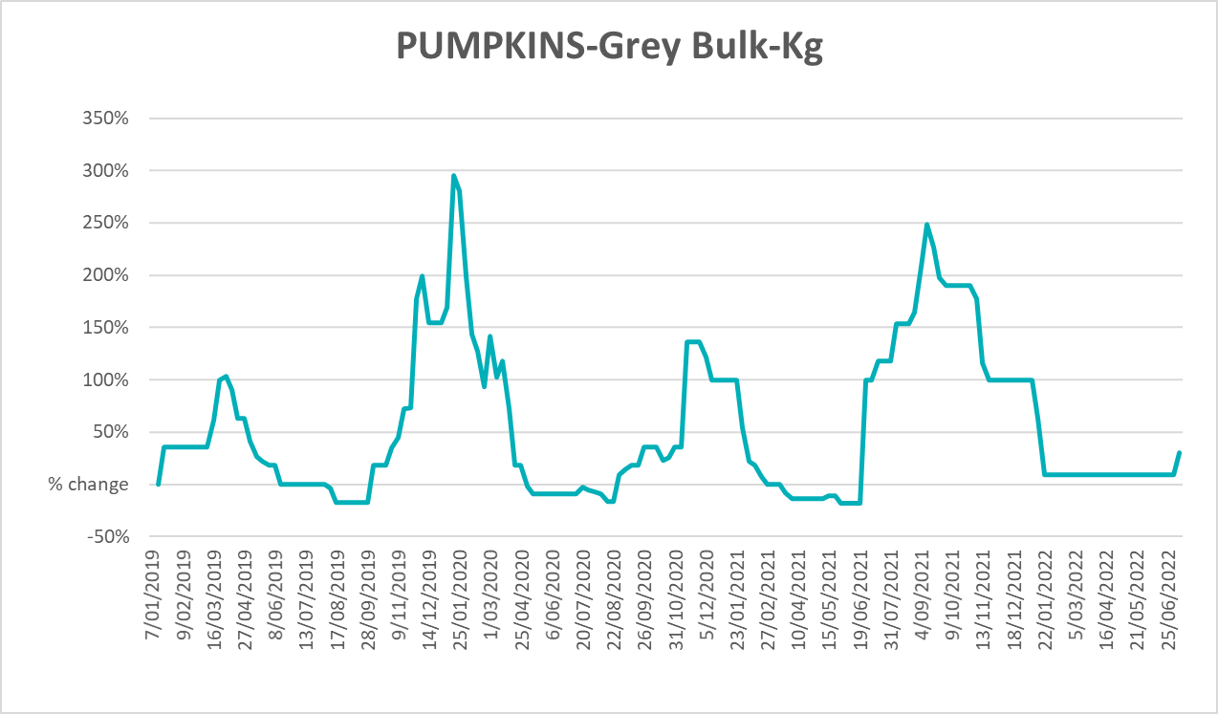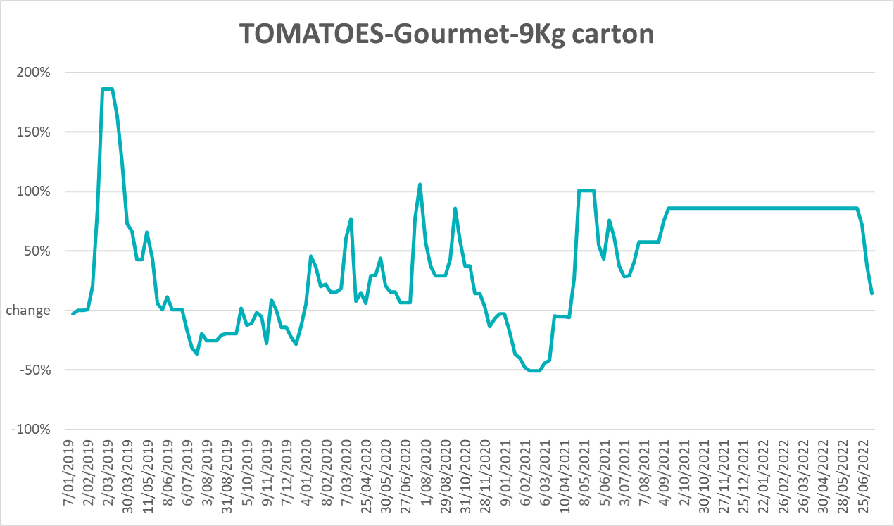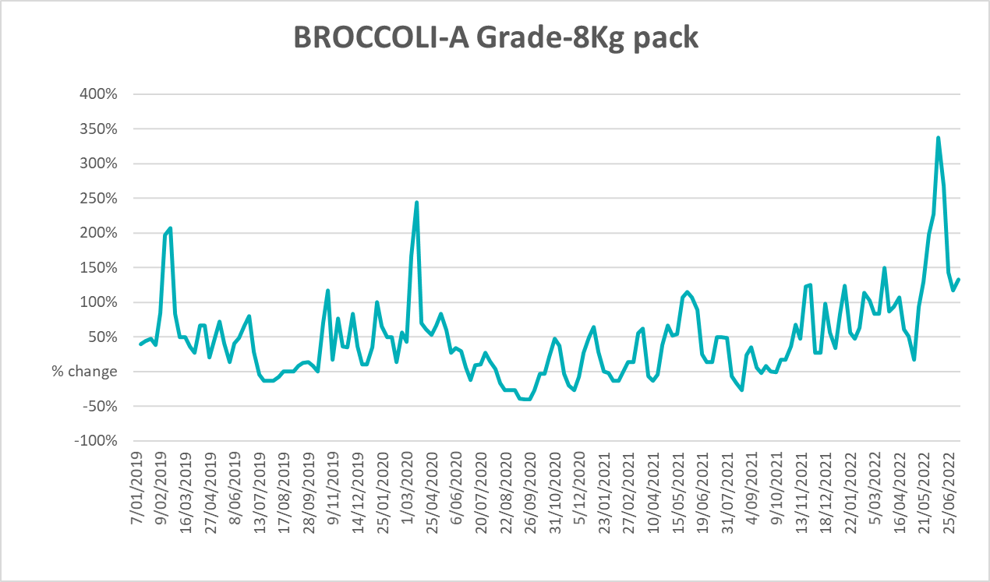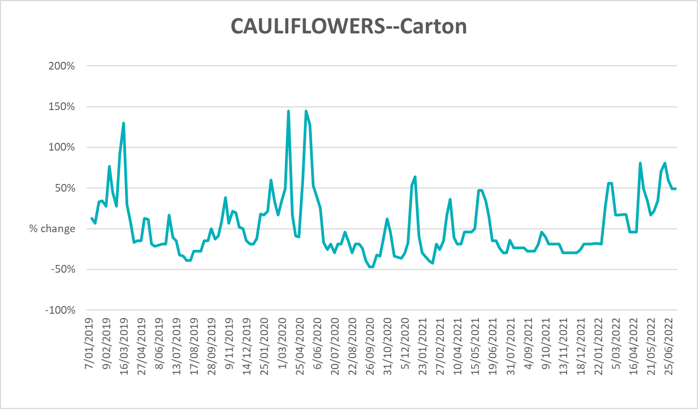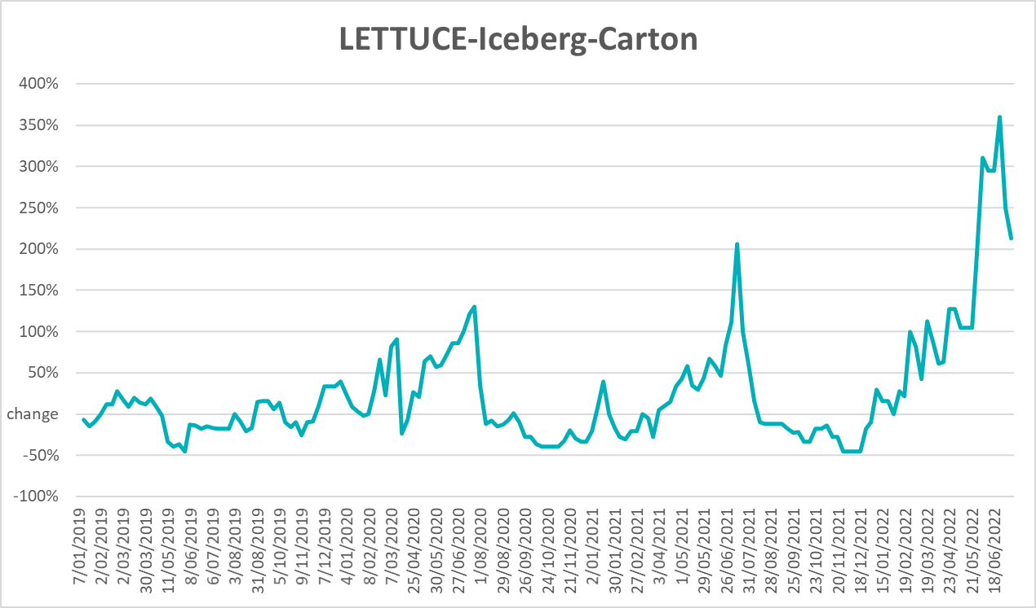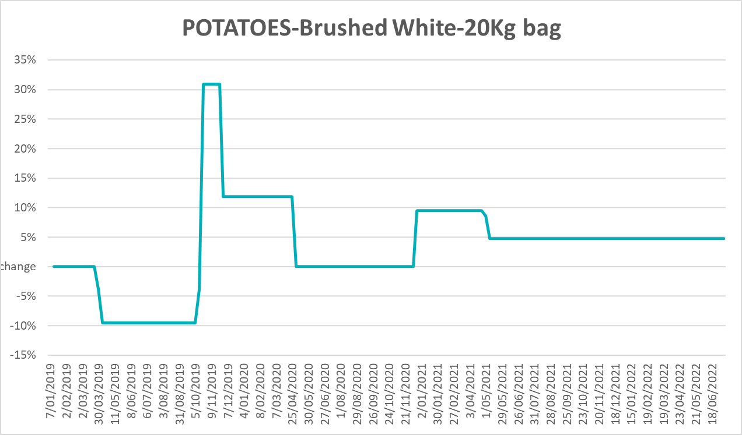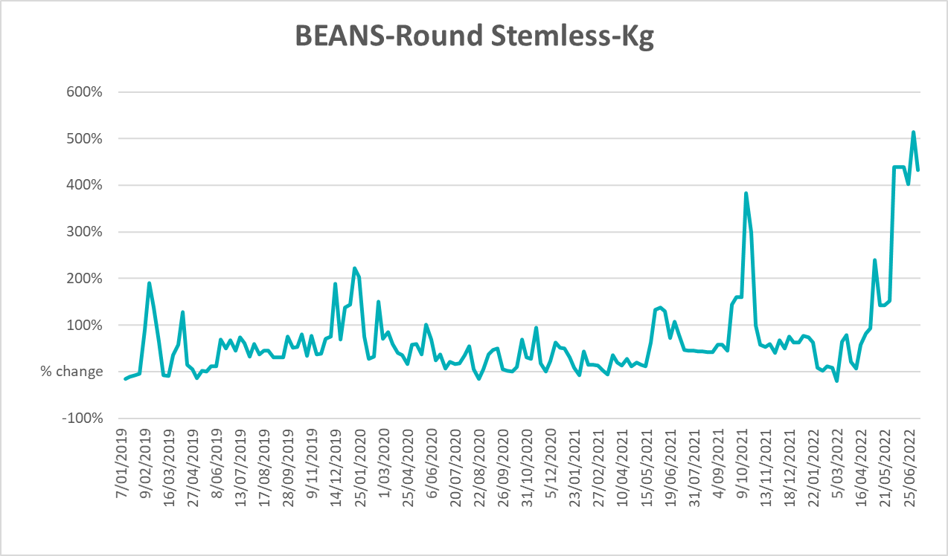

Selected domestic fodder indicator prices
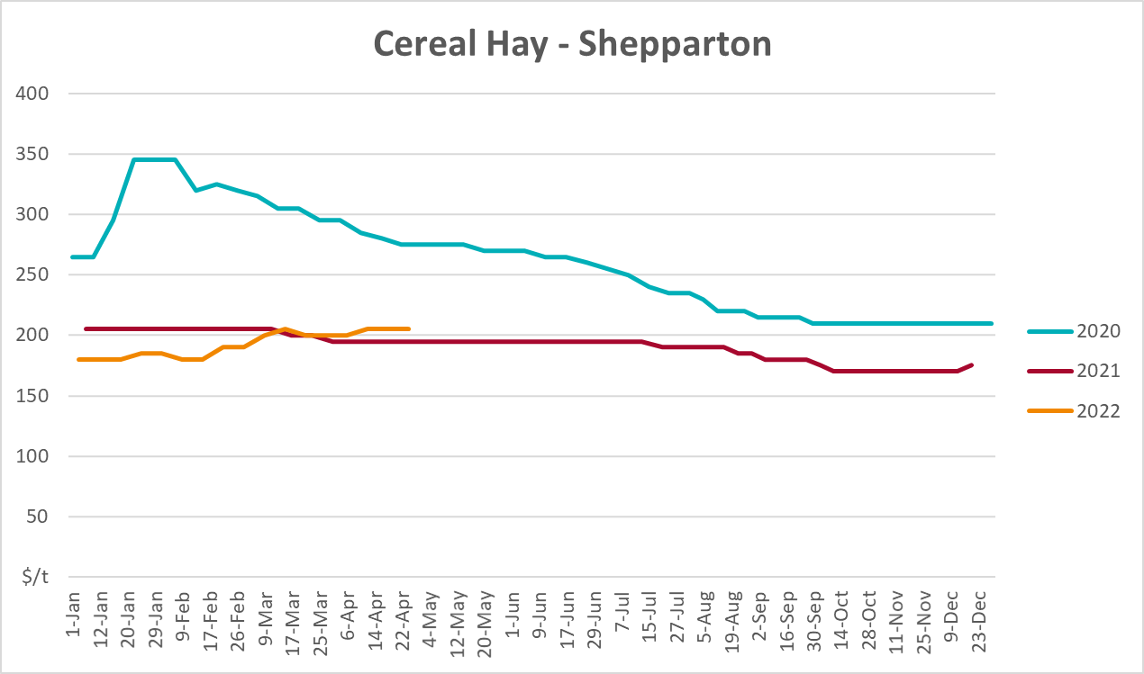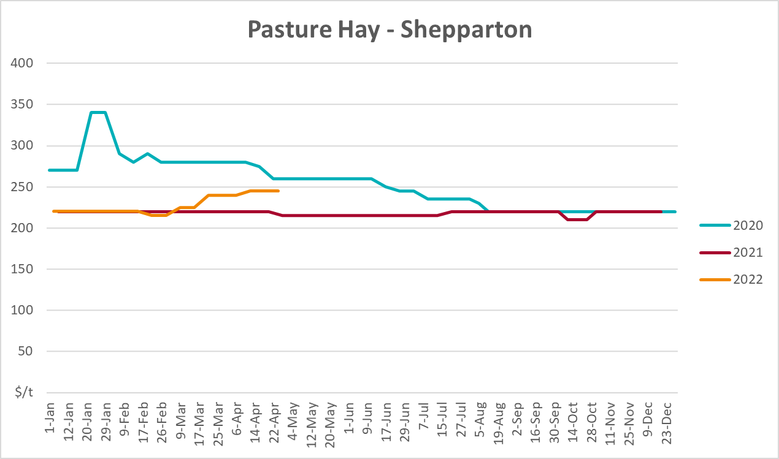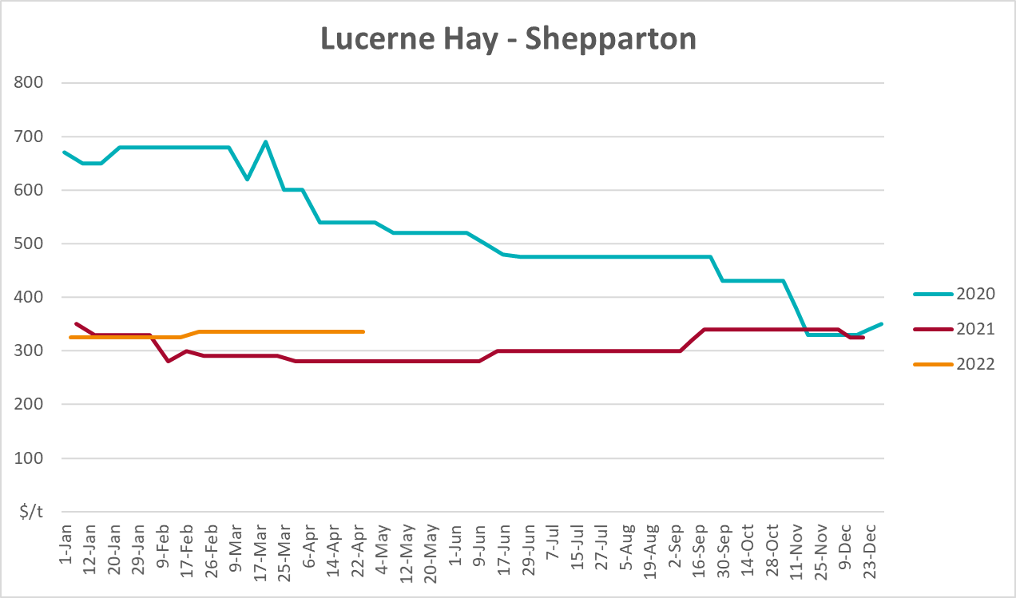

Data attribution

Climate
Bureau of Meteorology
- Weekly rainfall totals: www.bom.gov.au/climate/maps/rainfall/
- Monthly and last 3-month rainfall percentiles: www.bom.gov.au/water/landscape/
- Temperature anomalies: www.bom.gov.au/jsp/awap/temp/index.jsp
- Rainfall forecast: www.bom.gov.au/jsp/watl/rainfall/pme.jsp
- Seasonal outlook: www.bom.gov.au/climate/outlooks/#/overview/summary/
- Climate drivers: http://www.bom.gov.au/climate/enso/
- Soil moisture: www.bom.gov.au/water/landscape/
Other
- Pasture growth: www.longpaddock.qld.gov.au/aussiegrass/
- 3-month global outlooks: Environment and Climate Change Canada, NOAA Climate Prediction Center, EUROBRISA CPTEC/INPE, European Centre for Medium-Range Weather Forecasts, Hydrometcenter of Russia, National Climate Center Climate System Diagnosis and Prediction Room (NCC), International Research Institute for Climate and Society
- Global production: https://ipad.fas.usda.gov/ogamaps/cropmapsandcalendars.aspx
- Autumn break: Pook et al., 2009, https://rmets-onlinelibrary-wiley-com.virtual.anu.edu.au/doi/epdf/10.1002/joc.1833

Water
Prices
- Waterflow: https://www.waterflow.io/
- Ruralco: https://www.ruralcowater.com.au/
Bureau of Meteorology:
- Allocation trade: http://www.bom.gov.au/water/dashboards/#/water-markets/mdb/at
- Storage volumes: http://www.bom.gov.au/water/dashboards/#/water-storages/summary/drainage
Trade constraints:
- Water NSW: https://www.waternsw.com.au/customer-service/ordering-trading-and-pricing/trading/murrumbidgee
- Victorian Water Register: https://www.waterregister.vic.gov.au/TradingRules2019/

Commodities
Fruit and vegetables
- Datafresh: www.freshstate.com.au
Pigs
- Australian Pork Limited: www.australianpork.com.au
Dairy
- Global Dairy Trade: www.globaldairytrade.info/en/product-results/
World wheat, canola
- International Grains Council
World coarse grains
- United States Department of Agriculture
World cotton
- Cotlook: www.cotlook.com/
World sugar
- New York Stock Exchange - Intercontinental Exchange
Wool
- Australian Wool Exchange: www.awex.com.au/
Domestic wheat, barley, sorghum, canola and fodder
- Jumbuk Consulting Pty Ltd: http://www.jumbukag.com.au/
Cattle, beef, mutton, lamb, goat and live export
- Meat and Livestock Australia: www.mla.com.au/Prices-and-market
© Commonwealth of Australia 2022

Ownership of intellectual property rights
Unless otherwise noted, copyright (and any other intellectual property rights, if any) in this publication is owned by the Commonwealth of Australia (referred to as the Commonwealth).

Creative Commons licence
All material in this publication is licensed under a Creative Commons Attribution 4.0 International Licence except content supplied by third parties, logos and the Commonwealth Coat of Arms.
Inquiries about the licence and any use of this document should be emailed to copyright@awe.gov.au.


Cataloguing data
This publication (and any material sourced from it) should be attributed as:
ABARES 2022, Weekly Australian Climate, Water and Agricultural Update, Australian Bureau of Agricultural and Resource Economics and Sciences, Canberra, 28 July 2022. CC BY 4.0 DOI: https://doi.org/10.25814/5f3e04e7d2503
ISSN 2652-7561
This publication is available at https://www.agriculture.gov.au/abares/products/weekly_update
Department of Agriculture, Fisheries and Forestry
GPO Box 858 Canberra ACT 2601
Telephone 1800 900 090
Web agriculture.gov.au/abares

Disclaimer
The Australian Government acting through the Department of Agriculture, Fisheries and Forestry, represented by the Australian Bureau of Agricultural and Resource Economics and Sciences, has exercised due care and skill in preparing and compiling the information and data in this publication. Notwithstanding, the Department of Agriculture, Fisheries and Forestry, ABARES, its employees and advisers disclaim all liability, including liability for negligence and for any loss, damage, injury, expense or cost incurred by any person as a result of accessing, using or relying on any of the information or data in this publication to the maximum extent permitted by law.

Statement of Professional Independence
The views and analysis presented in ABARES publications, including this one, reflect ABARES professionally independent findings, based on scientific and economic concepts, principles, information and data. These views, analysis and findings may not reflect or be consistent with the views or positions of the Australian Government, or of organisations or groups who have commissioned ABARES reports or analysis. More information on professional independence is provided on the ABARES website.

Acknowledgements
This report was prepared by Matthew Miller and Cameron Van-Lane.

