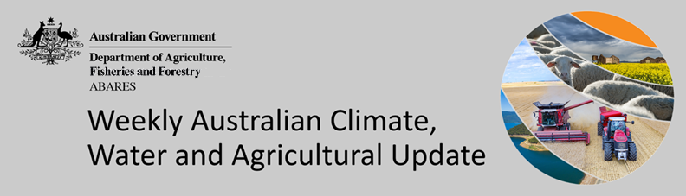
No. 32/2022

18 August 2022

Summary of key issues
- For the week ending 17 August 2022, low-pressure systems and cold fronts brought moderate to heavy rainfall across southern Australia. High-pressure systems over northern parts of the country resulted in clear, dry conditions (see Section 1.1).
- Another week of moderate rainfall across central New South Wales and parts of southern Queensland has potentially exacerbated waterlogging concerns in low lying areas, with soil moisture levels already well above average for this time of year. Western Australian cropping regions also received another week of moderate rainfall, with soil moisture levels above average to very much above average for this time of year. The rainfall will positively influence yield prospects across most cropping areas, but for areas where crops have been planted on heavy clay soils in Western Australia, there is increased risk of waterlogging.
- Below average rainfall globally during July is likely to result in lower-than-expected wheat production potential in Argentina, the European Union, and parts of Canada. Further, the conflict in Ukraine continues to generate uncertainty around wheat, corn and sunflower production for 2022. Below average rainfall and above average temperatures in recent months have also negatively affected corn production across parts of Argentina, Brazil, the European Union and the United States. Global production conditions have deteriorated compared to those used to formulate ABARES forecasts of global grain supplies and world prices in its June 2022 edition of the Agricultural Commodities Report. As a result, global grain and oilseed production is likely to be lower than that forecast in June (see Section 1.2).
- Over the 8-days to 25 August 2022, cold fronts are forecast to bring light to moderate rainfall to areas across south-eastern Australia. Across the remainder of the country, high-pressure systems will persist, providing clear, dry conditions. The light to moderate rainfall forecast for cropping regions in southern New South Wales, Victoria and South Australia will benefit winter crops where soil moisture levels are currently below average to average. The dry conditions expected across northern New South Wales, Queensland and Western Australia will be a welcome relief, allowing soil moisture levels and the risk of waterlogging to subside. Overall, yield prospects across major cropping regions look very favourable for this point in the season. However, the most sensitive periods for yield development (flowering and grain filling) are yet to come. A lack of plant available moisture and frost damage during these periods would negatively impact the production outlook (see Section 1.3).
- Water storage in the Murray–Darling Basin (MDB) increased by 143 gigalitres (GL) between 10 August 2022 and 17 August 2022. The current volume of water held in storage is 23,041 GL, which represents 91% of total capacity. This is 14% or 2,884 GL more than at the same time last year.
- Allocation prices in the Victorian Murray below the Barmah Choke decreased from $78 per ML on 5 August 2022 to $77 per ML on 12 August 2022. Prices are lower in the Goulburn-Broken and regions above the Barmah choke due to the binding of the Goulburn intervalley trade limit and Barmah choke trade constraint.

Climate

Rainfall this week
For the week ending 17 August 2022, low-pressure systems and cold fronts brought moderate to heavy rainfall across southern Australia. High-pressure systems over northern parts of the country resulted in clear, dry conditions.
Rainfall totals of between 10 and 50 millimetres were recorded across much of central New South Wales, southern Queensland, Victoria, the south of South Australia, the south-west and other isolated parts of Western Australia, and the south-west of the Northern Territory. Rainfall totals in excess of 50 millimetres were recorded in parts of eastern Victoria, the south-west of Western Australia and most of Tasmania. Remaining parts of Australia received little to no rainfall.
In Australian cropping regions, rainfall totals of between 10 and 50 millimetres were recorded across most of New South Wales, South Australia and Western Australia, as well as southern Queensland and Victoria. Rainfall totals in excess of 50 millimetres were recorded across western parts of cropping regions in Western Australia. Little to no rainfall was recorded across remaining cropping regions for the week ending 10 August 2022.
Another week of moderate rainfall across central New South Wales and parts of southern Queensland has potentially exacerbated waterlogging concerns in low lying areas, with soil moisture levels already well above average for this time of year. For winter crops not impacted by ongoing waterlogging, the recent rainfalls will have supported yield potentials and boosted soil moisture levels, which crops can draw on through critical plant and grain development periods in spring.
Western Australian cropping regions also received another week of moderate rainfall, with soil moisture levels above average to very much above average for this time of year. The rainfall will positively influence yield prospects across most cropping areas, but for areas where crops have been planted on heavy clay soils in Western Australia, there is increased risk of waterlogging. In central and northern cropping regions of South Australia, rainfall over the past week has provided much needed relief to winter crops, where plant available water had steadily declined over recent weeks.

Rainfall for the week ending 17 August 2022
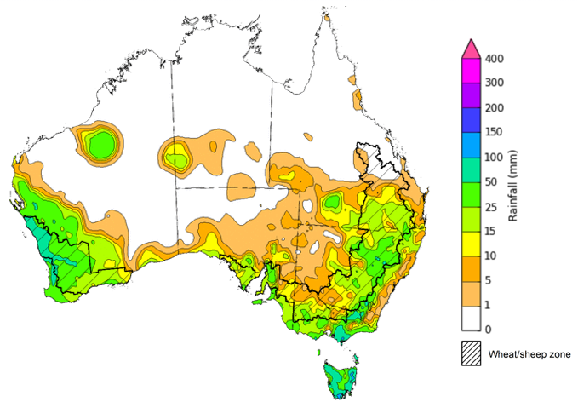
©Commonwealth of Australia 2022, Australian Bureau of Meteorology Issued:17/8/2022
Note: The rainfall analyses and associated maps utilise data contained in the Bureau of Meteorology climate database, the Australian Data Archive for Meteorology (ADAM). The analyses are initially produced automatically from real-time data with limited quality control. They are intended to provide a general overview of rainfall across Australia as quickly as possible after the observations are received. For further information go to http://www.bom.gov.au/climate/rainfall/

Global production conditions and climate outlook
Crop production is affected by long-term trends in average rainfall and temperature, interannual climate variability, shocks during specific growth stages, and extreme weather events (IPCC 2012). Some crops are more tolerant than others to certain types of stresses, and at each growth stage, different types of stresses affect each crop species in different ways.
The precipitation anomalies and outlooks presented here give an indication of the current and future state of production conditions for the major grain and oilseed producing countries which are responsible for over 80% of global production. This is an important input to assessing the global grain supply outlook.
July precipitation percentiles and current production conditions
As of the end of July 2022, rainfall was mixed for the world’s major grain-producing and oilseed-producing regions.
In the northern hemisphere, precipitation was below average across parts of southern United States, western areas of the European Union, central Canada and parts of southern and north-western China. Precipitation was above average for parts of eastern and south-western United States and north-eastern China. Precipitation was close to average across the remainder of the major grain-producing and oilseed-producing regions in the northern hemisphere.
In the southern hemisphere, July precipitation was below average for parts of northern Argentina, as well as parts of southern Brazil and southern Australia. Precipitation was above average for parts of eastern Australia and the northeast of Brazil. Precipitation was close to average across the remainder of major grain-producing and oilseed-producing regions in the southern hemisphere.

Global precipitation percentiles, July 2022

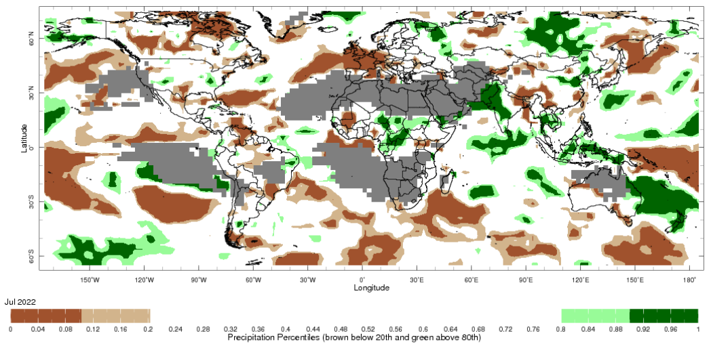
Note: The world precipitation percentiles indicate a ranking of precipitation for July, with the driest (0th percentile) being 0 on the scale and the wettest (100th percentile) being 1 on the scale. Percentiles are based on precipitation estimates from the NOAA Climate Prediction Center's Climate Anomaly Monitoring System Outgoing Precipitation Index dataset. Precipitation estimates for July 2022 are compared with rainfall recorded for that period during the 1981 to 2010 base period.
Source: International Research Institute for Climate and Society
As at 28 July 2022 global production conditions were generally favourable for rice and soybeans, but mixed for the production of wheat and corn.
In the northern hemisphere production conditions for wheat have been mixed. Climatic conditions have been favourable for wheat development in China, the Russian Federation, Turkey and the United Kingdom. Production conditions were variable for the European Union, Canada, Kazakhstan and the United States with dryness and excess heat in some areas and excessive moisture in others negatively affecting yield prospects. In the Ukraine, the ongoing war has reduced the area that can be harvested in and near the conflict zones. In the southern hemisphere, production conditions are favourable in Australia but in Argentina dry conditions continues to hamper sowing throughout the country, which is expected to reduce the total area sown compared to last year.
In Argentina, harvesting of late-planted corn crops is progressing well with some reduced yields due to earlier hot and dry weather. In Brazil, production conditions are variable as harvest continues for the summer-planted crop as a lack of rain in the south-east region negatively impacted yields. In Mexico, harvesting is wrapping up under favourable conditions. In the European Union, Canada and the United States, growing conditions are mixed, with hot and dry conditions negatively affecting yield prospects in some regions. In India sowing is progressing under favourable conditions. In China production conditions have improved across the Northern China Plain on the back of recent rainfall. In Ukraine, production conditions remain mixed due the ongoing war.
In China, hot and dry conditions in the south are reducing potential yields of late-season rice, while single-season rice is seeing favourable growing conditions. In the Philippines and Thailand, plant growth of wet-season rice is continuing under generally favourable conditions. In Thailand the total sown area is expected to increase compared to last year due to ample rainfall. In Vietnam, the harvest of winter-spring rice is ongoing in the north while the sowing of summer-autumn rice begins. In the south, the summer-autumn rice growth is proceeding under favourable conditions. In Indonesia, harvesting of wet-season rice is wrapping up under favourable conditions with an increase in the total harvested area compared to last year.
In the United States, growing conditions remain favourable for soybeans despite recent hot weather along the western and southern growing regions. There is a slight increase in total sown area compared to last year. In Canada, dry conditions have developed over the main producing province of Ontario, while conditions have improved in Manitoba. There is a reduction in the sown area compared to the 5-year average, most likely driven by a mixed beginning to the season in the Prairies. In China, conditions are favourable with the crop in the vegetative to reproductive stage of growth. In India, sowing is wrapping up under favourable conditions and an increase in total sown area compared to last year. In Ukraine, climatic conditions remain supportive of plant growth while the war continues to bring uncertainties.
Crop conditions, AMIS countries, 28 July 2022
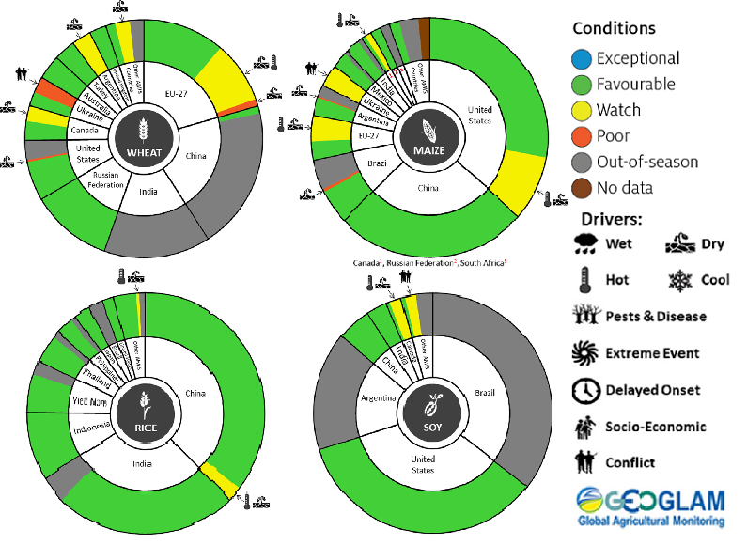
AMIS Agricultural Market Information System.
Source: AMIS
The global climate outlook for September 2022 to November 2022 indicates that variable rainfall conditions are expected for the world's major grain-producing and oilseed-producing regions. Outlooks and potential production impacts for the major grain and oilseed producing countries are presented in the table.
Rainfall outlook and potential impact on the future state of production conditions between September 2022 to November 2022
Region | September- November rainfall outlook | Potential impact on production
Argentina | Below average rainfall is expected across most of Argentina between September to November 2022. | Below average rainfall is likely to adversely affect the heading and filling of wheat and the planting of corn, cotton and soybeans through September and October. These conditions may also adversely impact early corn silking, and the planting of soybeans, sunflower, rice, sorghum and millet in November.
Black Sea Region | Kazakhstan, Ukraine and The Russian Federation - No strong tendency towards either above or below average rainfall between September to November 2022. | Average rainfall is likely to support spring wheat harvesting in the north-east of Russia and early cotton harvesting in southern regions. Average rainfall across Kazakhstan and Ukraine is likely to support winter wheat and rapeseed planting in September, and corn and sunflower filling in September and October.
Brazil | Above average rainfall is more likely in northern Brazil while below average rainfall is more likely across the south of Brazil. | Below average rainfall in parts of southern Brazil is likely to adversely affect wheat filling leading up to harvest in October, as well as corn and soybean planting and development in September and October. This may also affect the planting of groundnuts, sorghum, cotton, sunflower, rice and millet in November.
Canada | There is no strong tendency towards below or above average rainfall across much of Canada between September to November 2022. | Average rainfall is unlikely to be sufficient to increase the yield potential of corn, soybeans and sunflower at the grain filling and maturing stage through September and October.
China | Above average rainfall is likely across central China and below average across western, southern and north-eastern China between September to November 2022. | Below average rainfall is likely to adversely affect the development and harvest of cotton, corn, sorghum, soybean, sunflower, groundnuts and spring wheat across north-eastern, southern and western China. In central China, above average rainfall is likely to support the planting of winter wheat and rapeseed in October.
Europe | Below average rainfall more likely for western and central Europe between September to November 2022. | Below average rainfall may adversely impact the development and harvest of corn, cotton and sorghum in western and central Europe. Below average rainfall may also impact winter wheat and rapeseed planting in parts of western and central Europe during October and November.
South Asia (India) | Above average rainfall between September to November 2022 is likely across much of India. | Average to above average rainfall is likely to benefit cotton blooming in the south during September. It will also assist corn, sorghum, rice, millet, groundnuts and sunflower filling in September leading up to harvest in October and November, and winter wheat and rapeseed planting in November.
Southeast Asia (SEA) | Above average rainfall is likely for northern SEA, with a strong likelihood of above average rainfall for Indonesia between September to November 2022. | Above average rainfall in SEA is likely to support corn and rice maturing during September leading up to harvest in October.
The United States of America | Above average rainfall is more likely for parts of eastern US and below average rainfall is more likely across much of the centre and the western half of the US. | Below average rainfall is likely to adversely affect the filling and maturing of soybeans, sunflower, millet, cotton, rice, corn, sorghum and groundnuts in September leading up to harvest in October and November.

Rainfall forecast for the next eight days
Over the 8-days to 25 August 2022, cold fronts are forecast to bring light to moderate rainfall to areas across south-eastern Australia. Across the remainder of the country, high-pressure systems will persist, providing clear, dry conditions.
Rainfall totals of between 10 and 50 millimetres are forecast across southern and eastern New South Wales, Victoria, the south of South Australia and eastern Tasmania. Rainfall totals in excess of 50 millimetres are forecast for parts of eastern Victoria and western Tasmania. Little to no rainfall is forecast across remaining parts of Australia over the next 8-days.
In Australian cropping regions, rainfall totals of between 10 and 50 millimetres are expected across southern New South Wales, most of Victoria, as well as most of South Australia. Little to no rainfall is forecast for cropping regions in northern New South Wales, Queensland and Western Australia during the next 8-days.
The light to moderate rainfall forecast for cropping regions in southern New South Wales, Victoria and South Australia will benefit winter crops where soil moisture levels are currently below average to average. Across south-eastern cropping regions, the rainfall will consolidate falls received over the past week and improve yield potentials. However, further rainfall will be required as we enter spring.
The dry conditions expected across northern New South Wales, Queensland and Western Australia will be a welcome relief, allowing soil moisture levels and the risk of waterlogging to subside. Overall, yield prospects across major cropping regions look very favourable for this point in the season. However, the most sensitive periods for yield development (flowering and grain filling) are yet to come. A lack of plant available moisture and frost damage during these periods would negatively impact the production outlook. Growers in Queensland will also be looking to start field preparation over the coming weeks for planting of summer crops in September.

Total forecast rainfall (mm) for the period 18 August to 25 August 2022
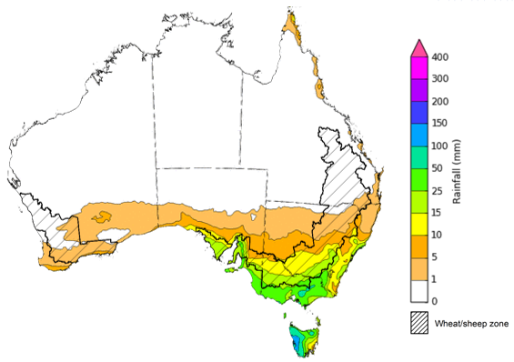
©Commonwealth of Australia 2022, Australian Bureau of Meteorology Issued:18/8/2022

Water
Note: This rainfall forecast is produced from computer models. As the model outputs are not altered by weather forecasters, it is important to check local forecasts and warnings issued by the Bureau of Meteorology.

Water markets – current week
Water storage in the Murray–Darling Basin (MDB) increased by 143 gigalitres (GL) between 10 August 2022 and 17 August 2022. The current volume of water held in storage is 23,041 GL, which represents 91% of total capacity. This is 14% or 2,884 GL more than at the same time last year.

Water storages in the Murray-Darling Basin, 2013–2022
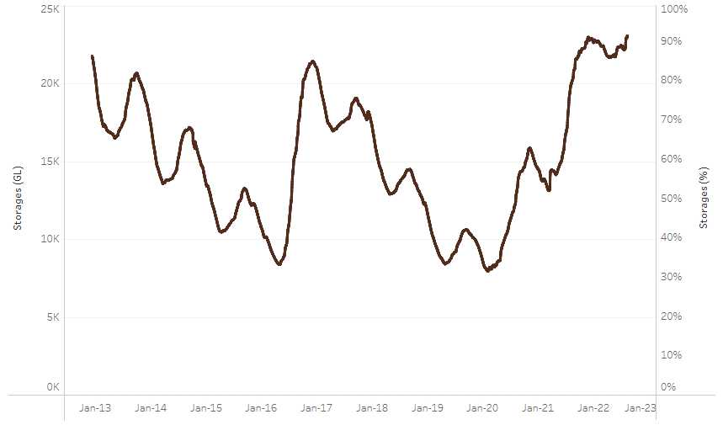
Allocation prices in the Victorian Murray below the Barmah Choke decreased from $78 per ML on 5 August 2022 to $77 per ML on 12 August 2022. Prices are lower in the Goulburn-Broken and regions above the Barmah choke due to the binding of the Goulburn intervalley trade limit and Barmah choke trade constraint.
Water storage data is sourced from the Bureau of Meteorology.

Region | $/ML
NSW Murray Above | 48
NSW Murrumbidgee | 90
VIC Goulburn-Broken | 63
VIC Murray Below | 77

Surface water trade activity, Southern Murray–Darling Basin

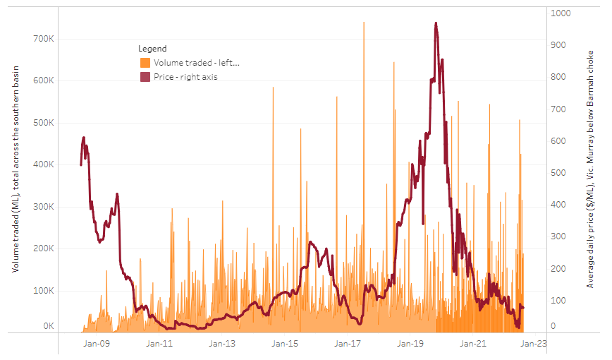
To access the full, interactive, weekly water dashboard, which contains the latest and historical water storage, water market and water allocation information, please visit http://www.agriculture.gov.au/abares/products/weekly_update/weekly-update-180822
The trades shown reflect estimated market activity and do not encompass all register trades. The price is shown for the VIC Murray below the Barmah choke. Historical prices (before 1 July 2019) are ABARES estimates after removing outliers from BOM water register data. Prices after 1 July 2019 and prior to the 30 October 2019 reflect recorded transaction prices as sourced from Ruralco. Prices after the 30 October 2019 are sourced from Waterflow. Data for volume traded is sourced from the BOM water register. Data shown is current at 18 August 2022.

Commodities

Indicator | Week ended | Unit | Latest price | Previous week | Weekly change | Price 12 months ago | Annual change
Selected world indicator prices
AUD/USD Exchange rate | 17-Aug | A$/US$ | 0.70 | 0.70 | 1% | 0.72 | -3%
Wheat – US no. 2 hard red winter wheat, fob Gulf | 17-Aug | US$/t | 386 | 373 | 3% | 323 | 19%
Corn – US no. 2 yellow corn, fob Gulf | 17-Aug | US$/t | 289 | 296 | -2% | 252 | 14%
Canola – Rapeseed, Canada, fob Vancouver | 17-Aug | US$/t | 691 | 712 | -3% | 771 | -10%
Cotton – Cotlook 'A' Index | 17-Aug | USc/lb | 131 | 115 | 14% | 102 | 29%
Sugar – Intercontinental Exchange, nearby futures, no.11 contract | 17-Aug | USc/lb | 18.4 | 18.0 | 2% | 20 | -9%
Wool – Eastern Market Indicator | 03-Aug | Ac/kg clean | 1,342 | 1,388 | -3% | 1,315 | 2%
Wool – Western Market Indicator | 03-Aug | Ac/kg clean | 1,449 | 1,473 | -2% | 1,346 | 8%
Selected Australian grain export prices
Milling Wheat – APW, Port Adelaide, SA | 17-Aug | A$/t | 552 | 561 | -2% | 418 | 32%
Feed Wheat – ASW, Port Adelaide, SA | 17-Aug | A$/t | 512 | 521 | -2% | 410 | 25%
Feed Barley – Port Adelaide, SA | 17-Aug | A$/t | 472 | 481 | -2% | 344 | 37%
Canola – Kwinana, WA | 17-Aug | A$/t | 1,089 | 1,107 | -2% | 841 | 30%
Grain Sorghum – Brisbane, QLD | 03-Aug | A$/t | 436 | 434 | 1% | 365 | 19%
Selected domestic livestock indicator prices
Beef – Eastern Young Cattle Indicator | 17-Aug | Ac/kg cwt | 994 | 935 | 6% | 995 | 0%
Mutton – Mutton indicator (18–24 kg fat score 2–3), Vic | 17-Aug | Ac/kg cwt | 517 | 517 | 0% | 723 | -29%
Lamb – Eastern States Trade Lamb Indicator | 17-Aug | Ac/kg cwt | 704 | 716 | -2% | 907 | -22%
Pig – Eastern Seaboard (60.1–75 kg), average of buyers & sellers | 03-Aug | Ac/kg cwt | 367 | 376 | -2% | 328 | 12%
Goats – Eastern States (12.1–16 kg) | 12-Jan | Ac/kg cwt | 879 | 879 | 0% | 818 | 8%
Live cattle – Light steers ex Darwin to Indonesia | 01-Jun | Ac/kg lwt | 480 | 480 | 0% | 320 | 50%
Live sheep – Live wethers (Muchea WA saleyard) to Middle East | 20-Apr | $/head | 113 | 113 | 0% | 122 | -7%

Indicator | Week ended | Unit | Latest price | Previous week | Weekly change | Price 12 months ago | Annual change
Global Dairy Trade (GDT) weighted average prices ª
Dairy – Whole milk powder | 17-Aug | US$/t | 3,417 | 3,544 | -4% | 3,208 | 7%
Dairy – Skim milk powder | 17-Aug | US$/t | 3,524 | 3,524 | 0% | 2,694 | 31%
Dairy – Cheddar cheese | 17-Aug | US$/t | 5,005 | 4,798 | 4% | 3,762 | 33%
Dairy – Anhydrous milk fat | 17-Aug | US$/t | 4,990 | 5,518 | -10% | 3,981 | 25%
a Global Dairy Trade prices are updated twice monthly on the first and third Tuesday of each month.

Selected world indicator prices
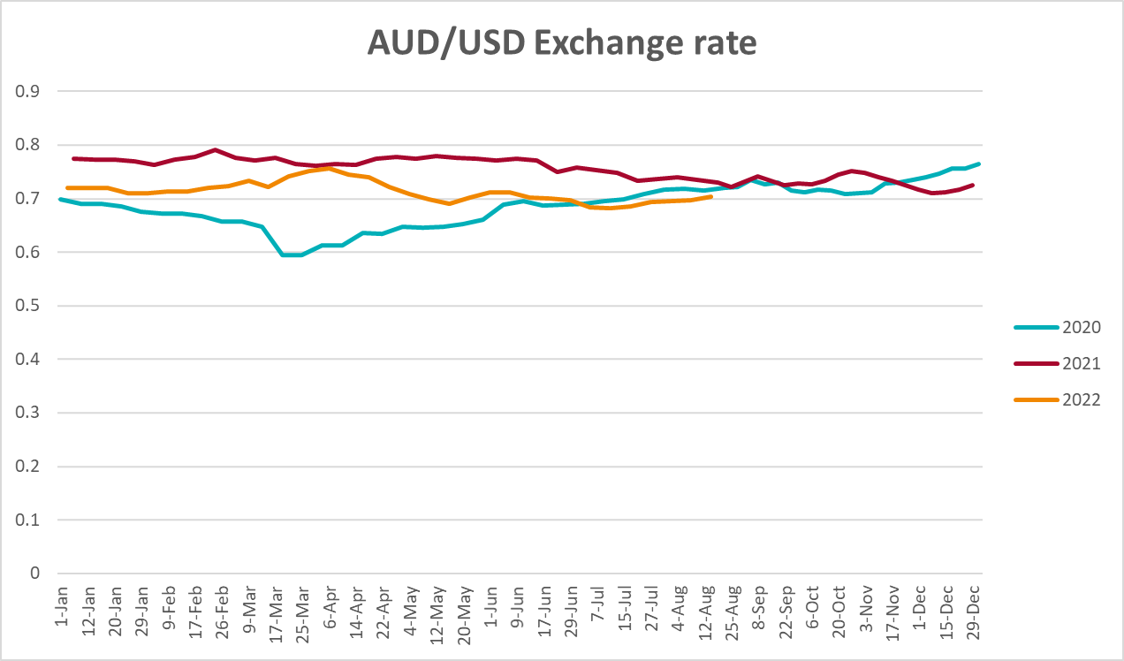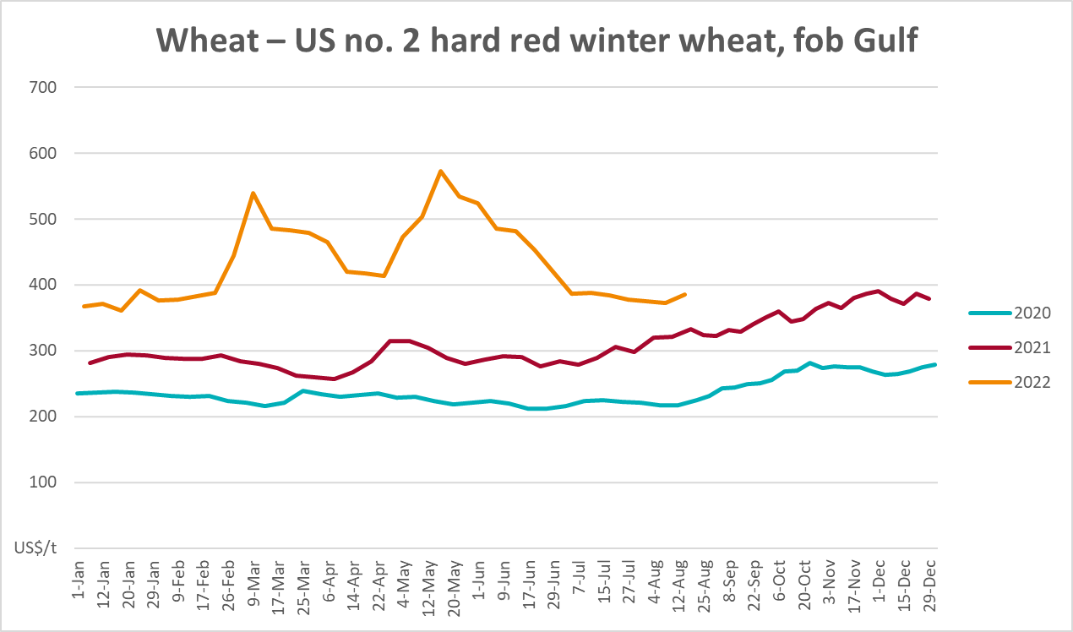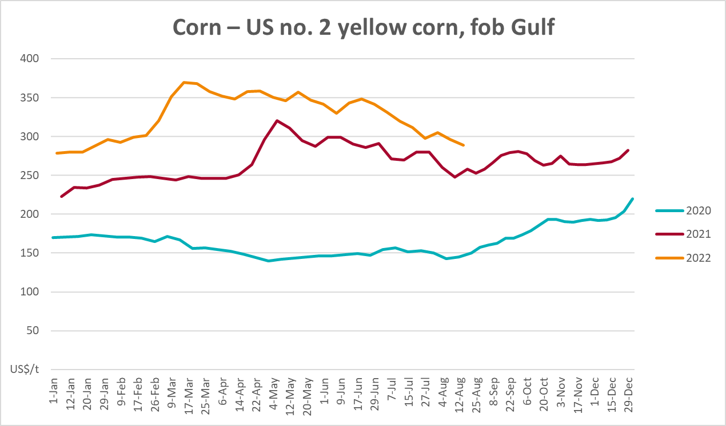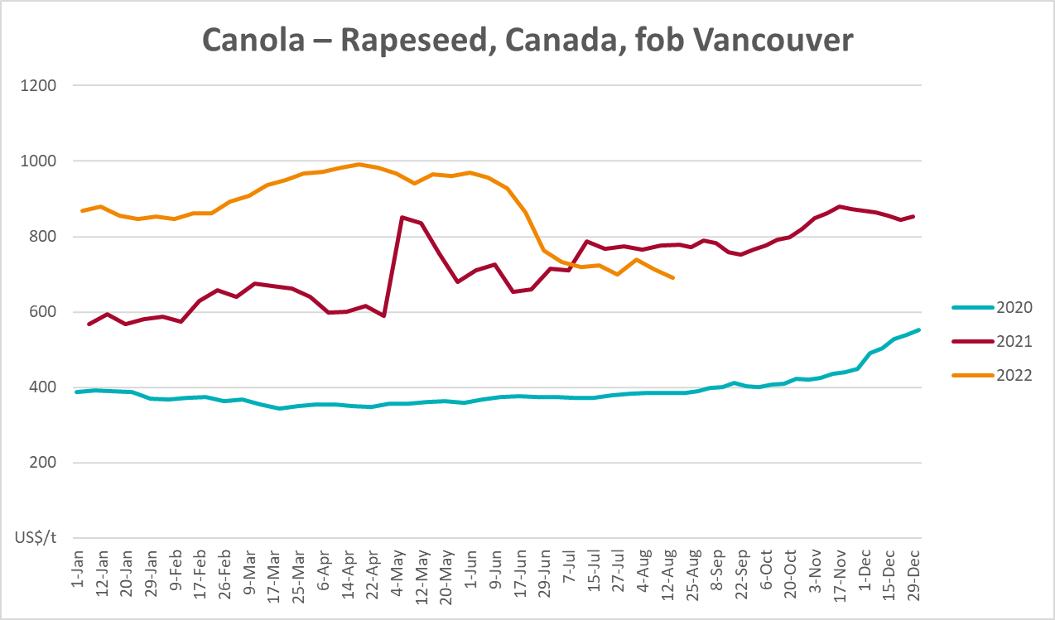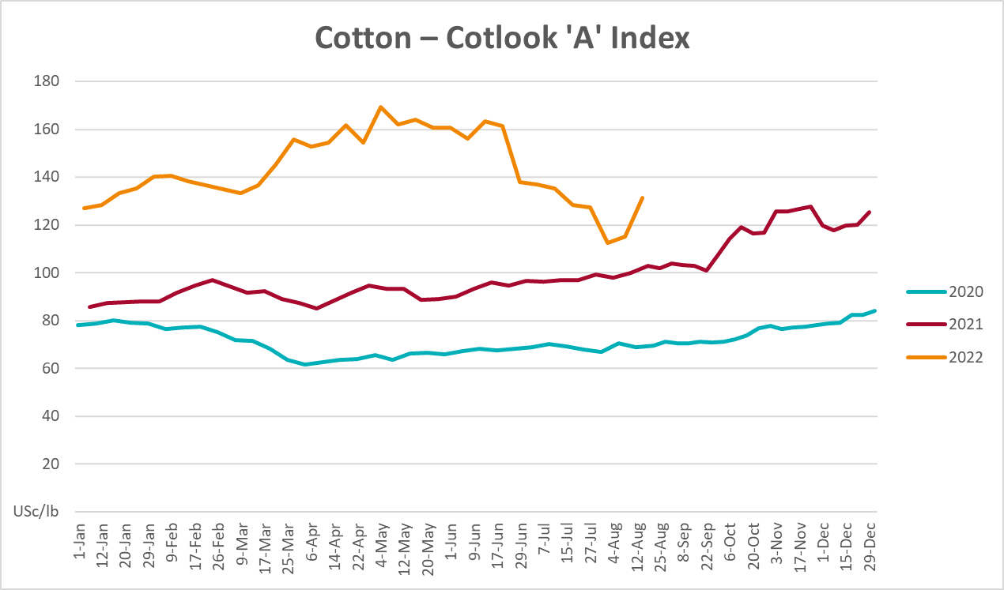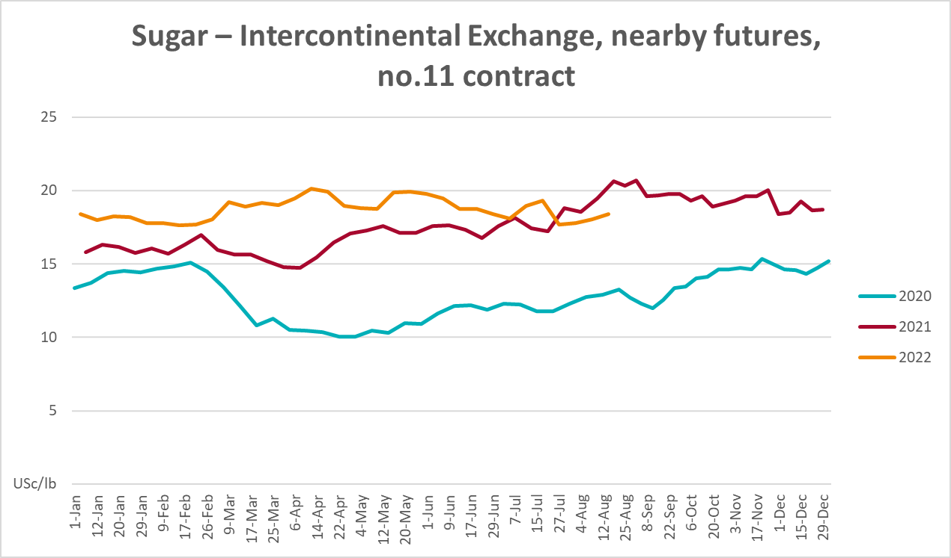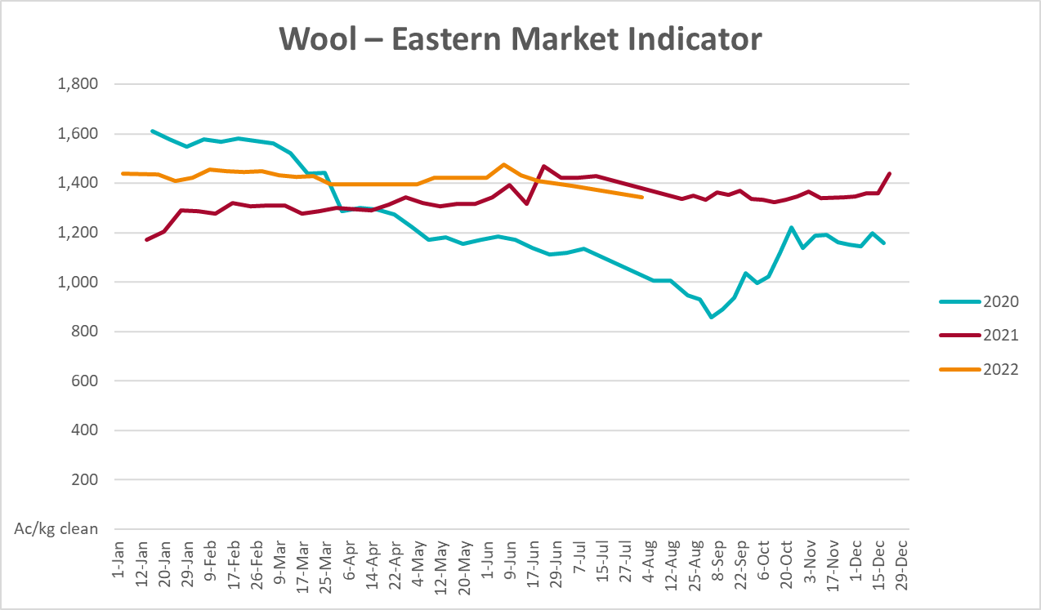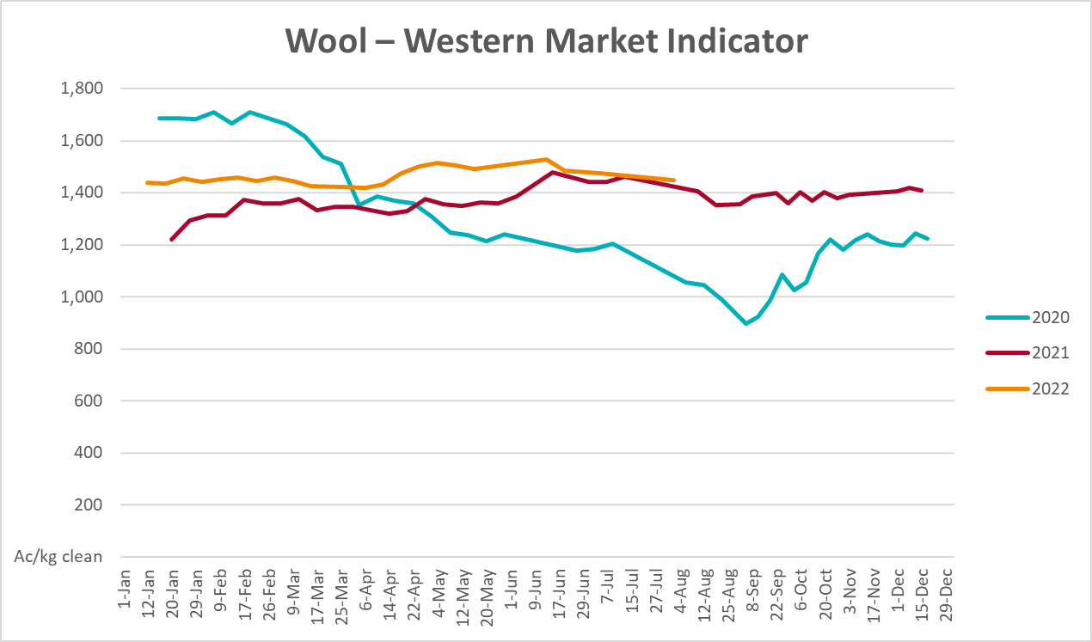

Selected domestic crop indicator prices
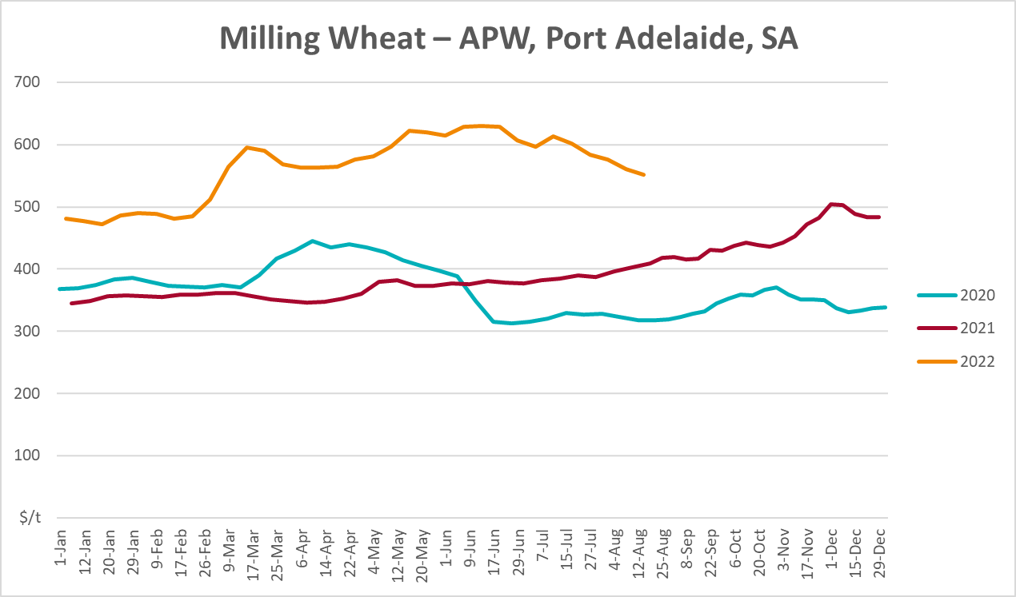
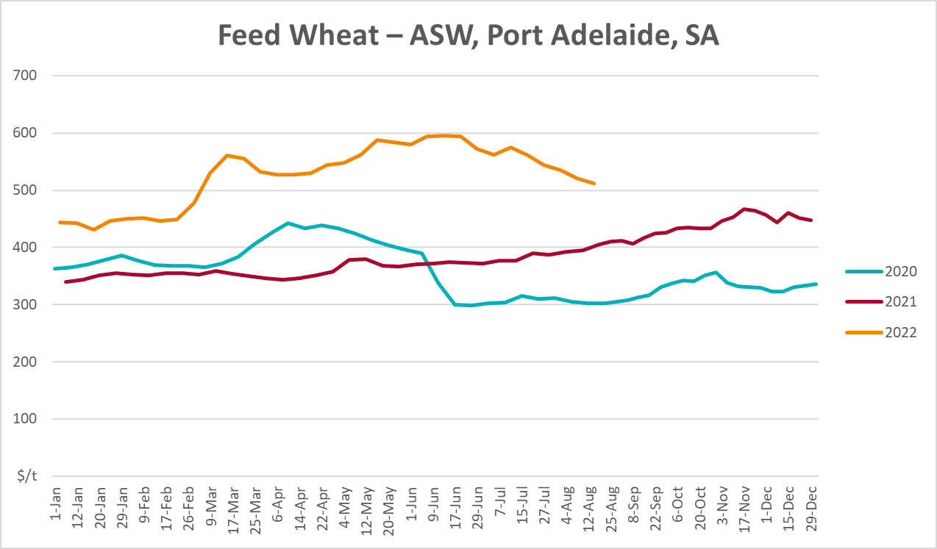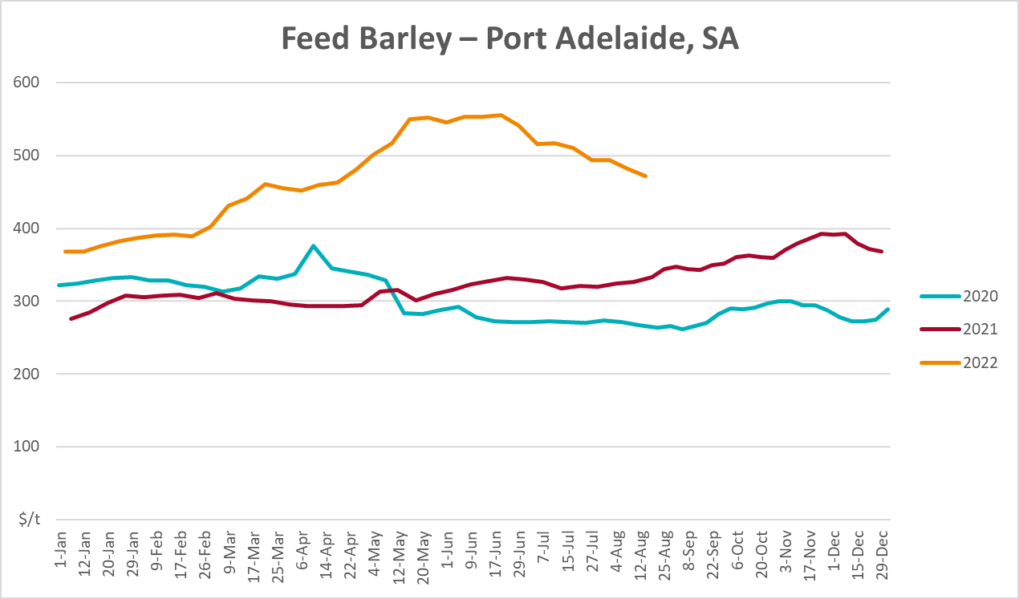
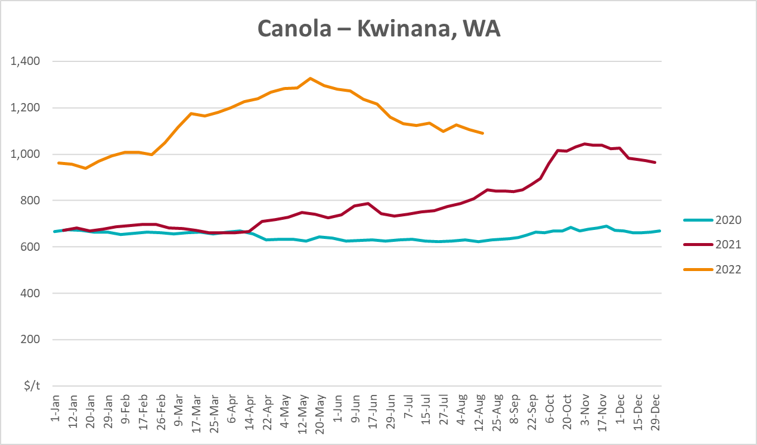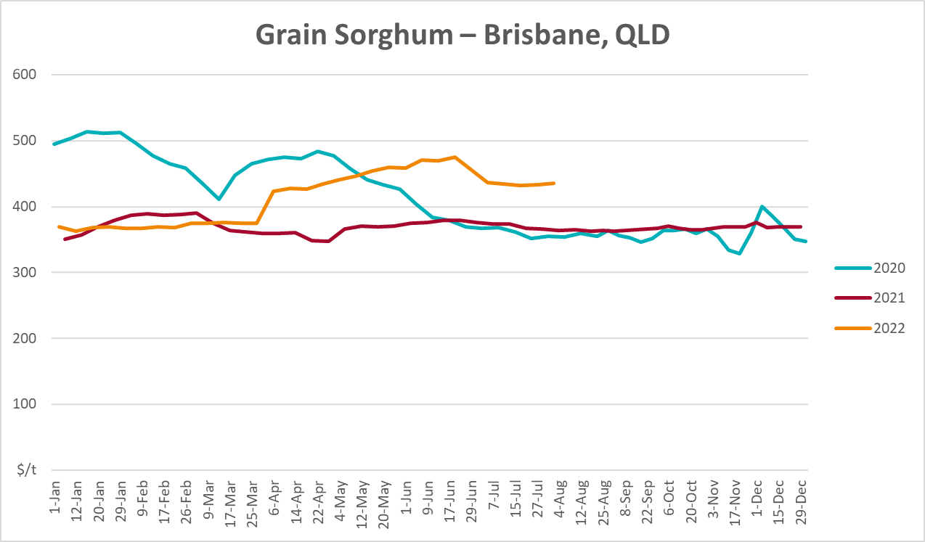

Selected domestic livestock indicator prices
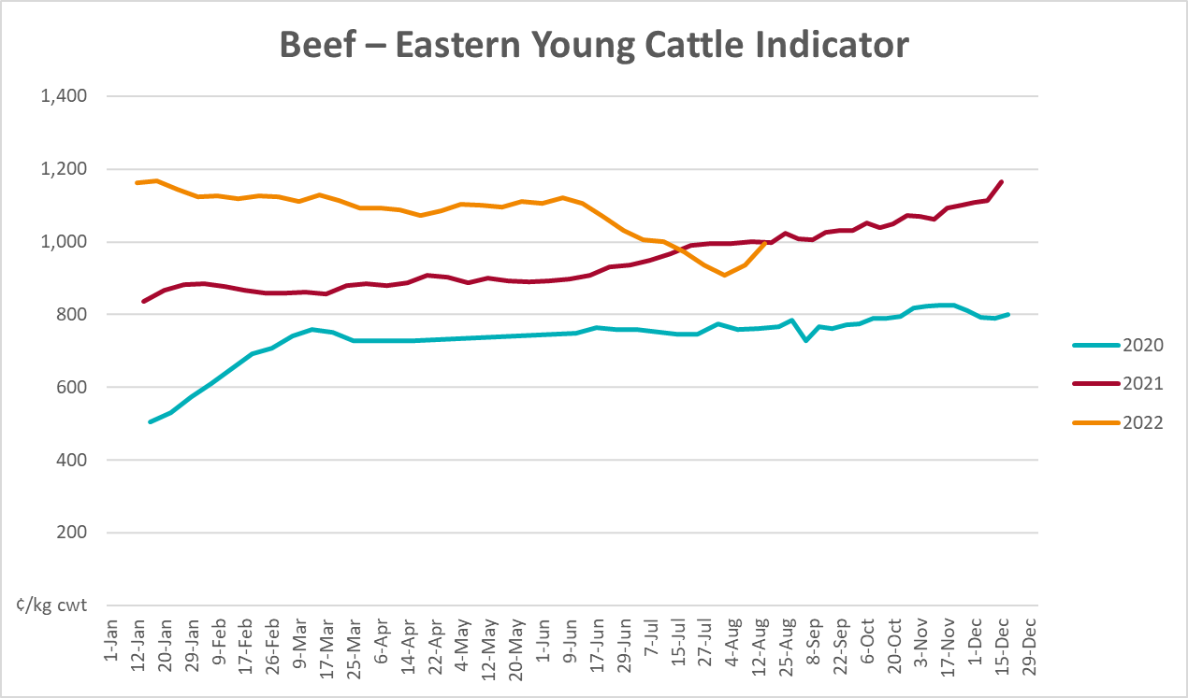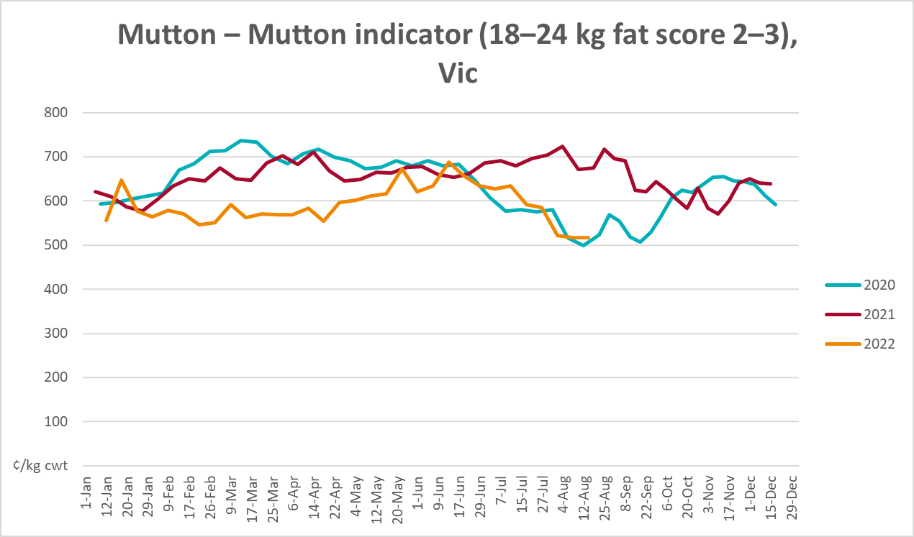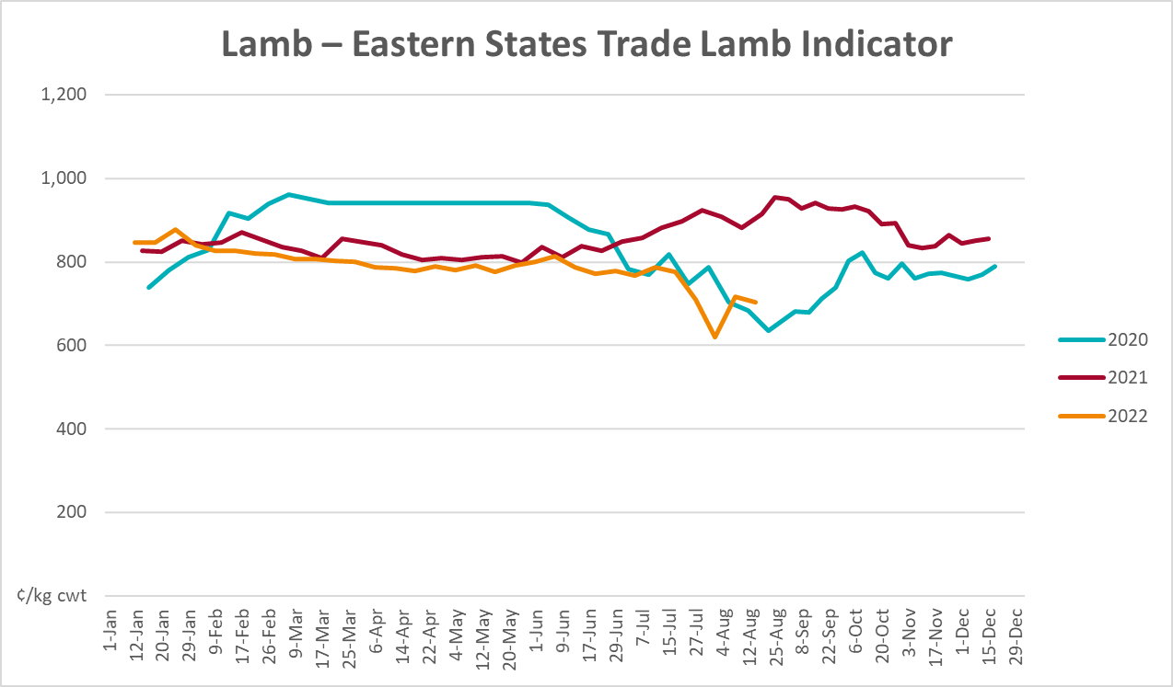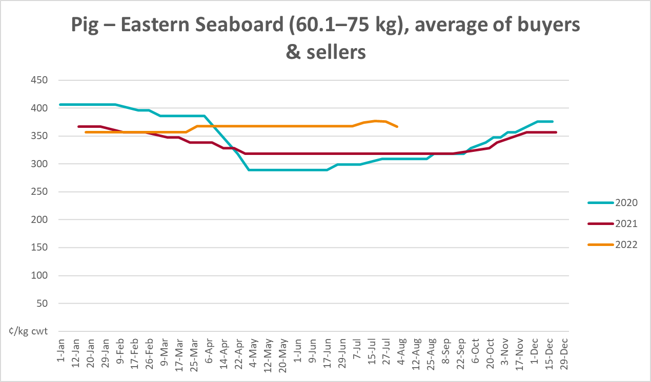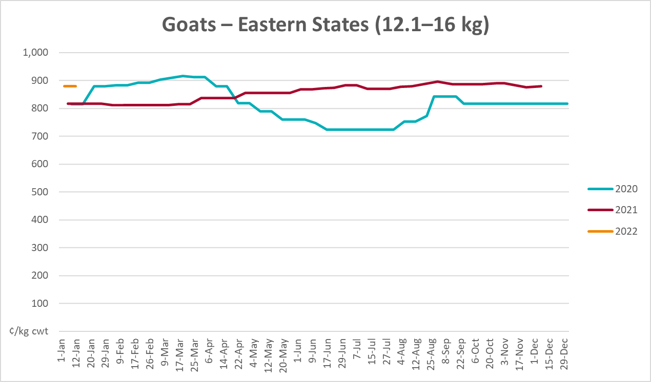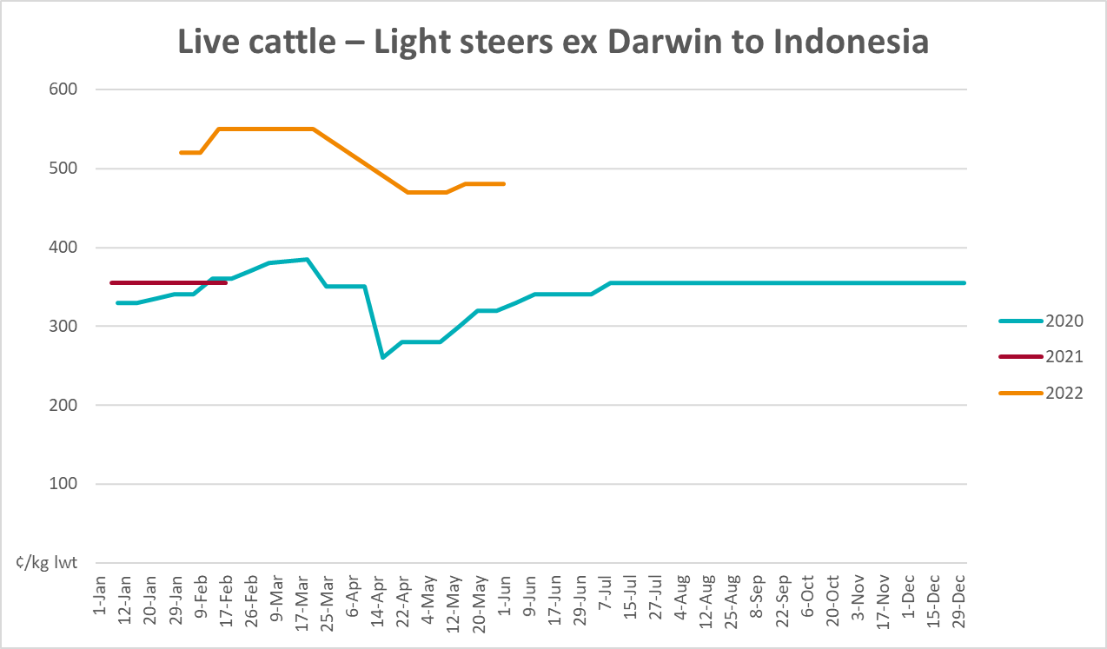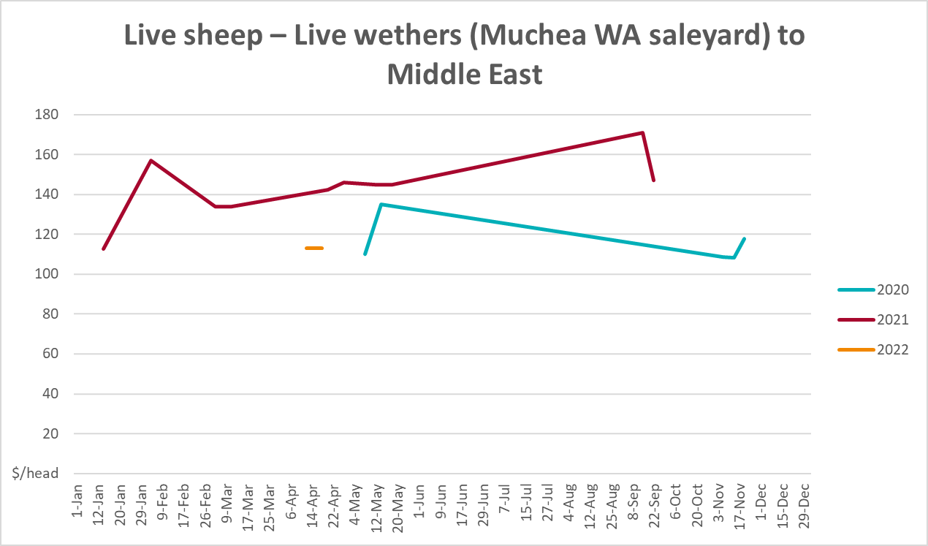

Global Dairy Trade (GDT) weighted average prices
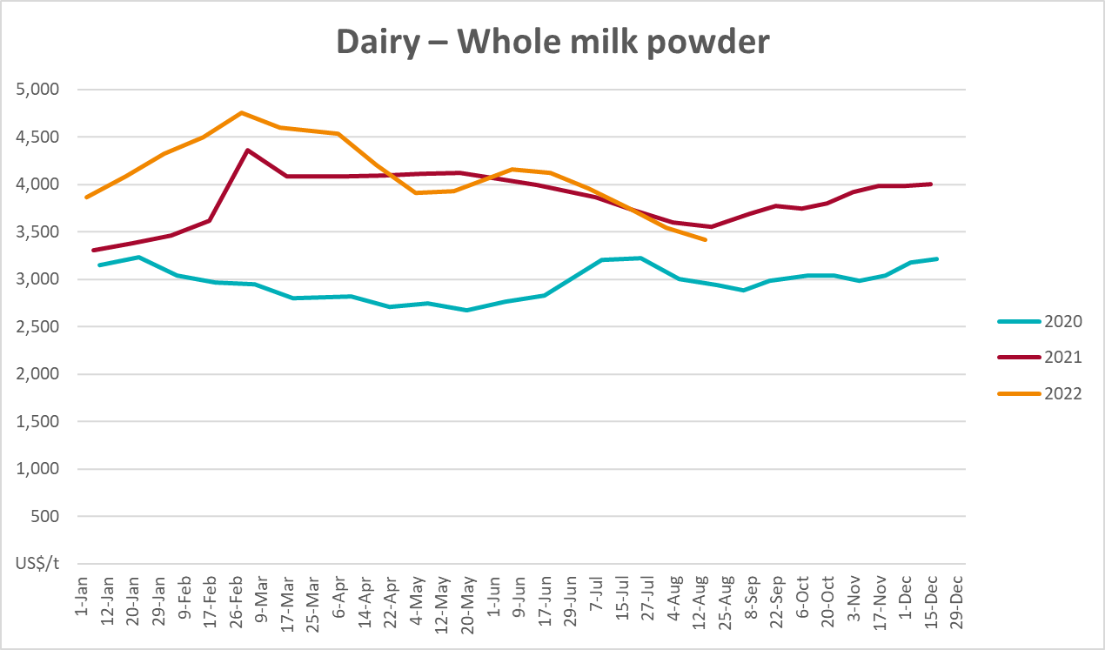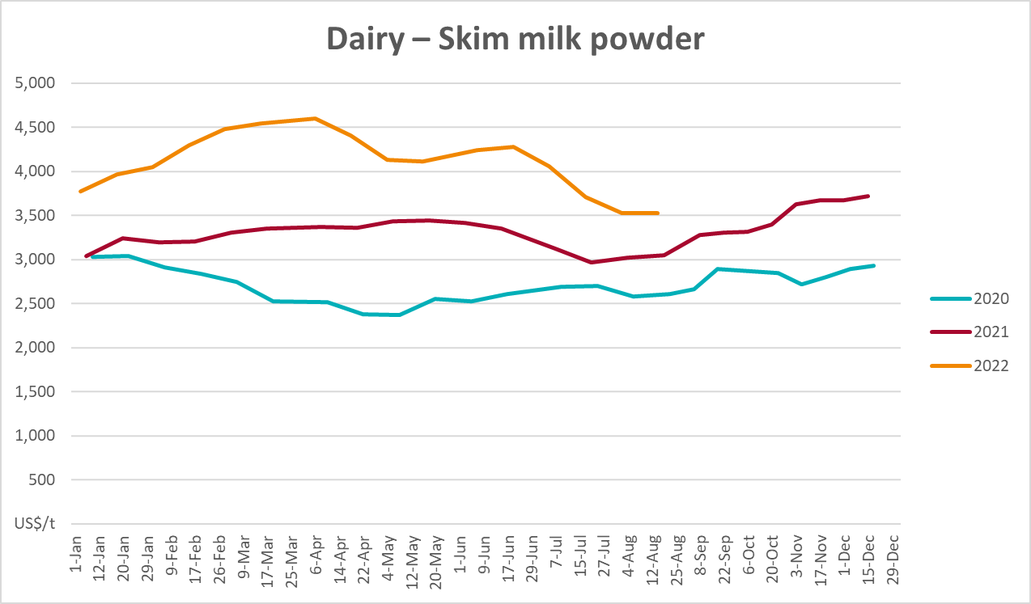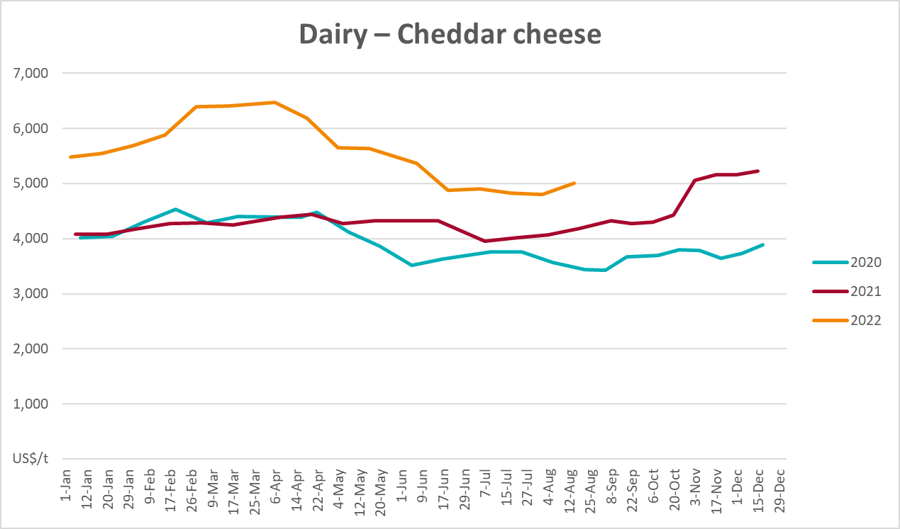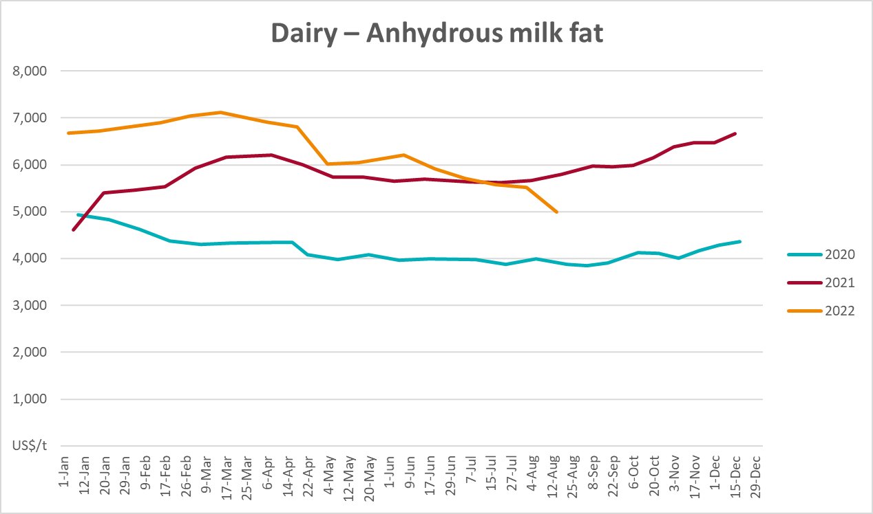

Selected fruit and vegetable prices
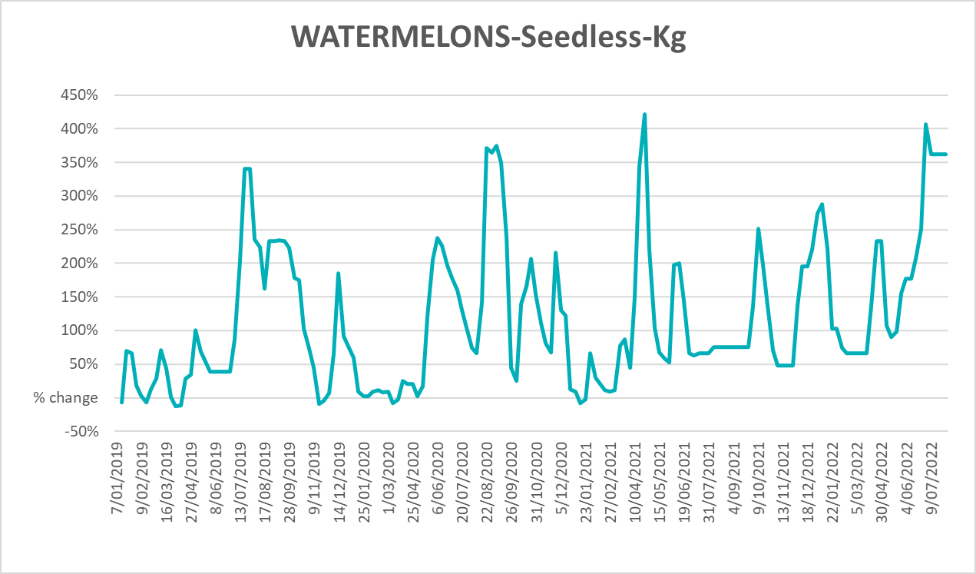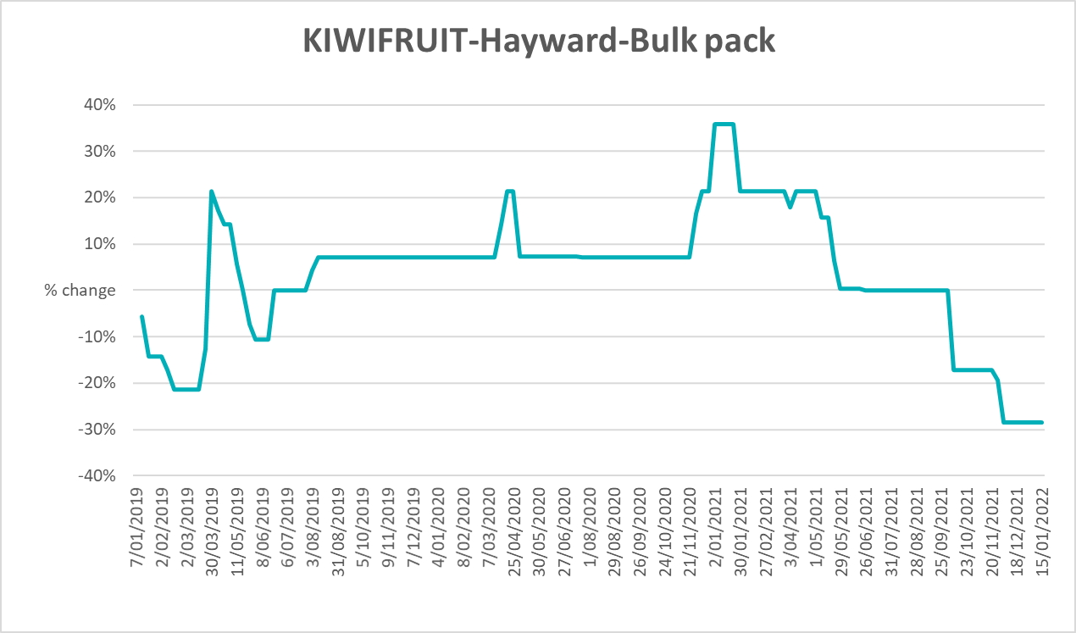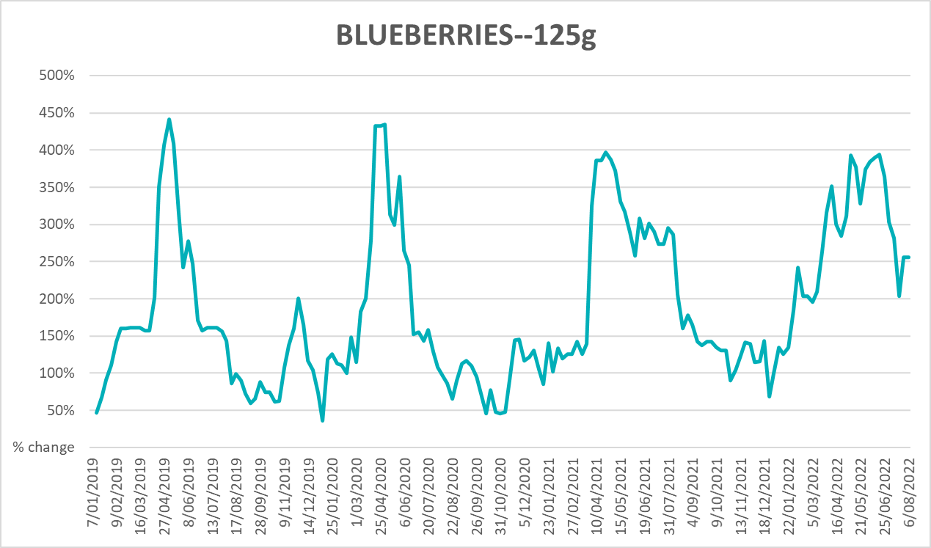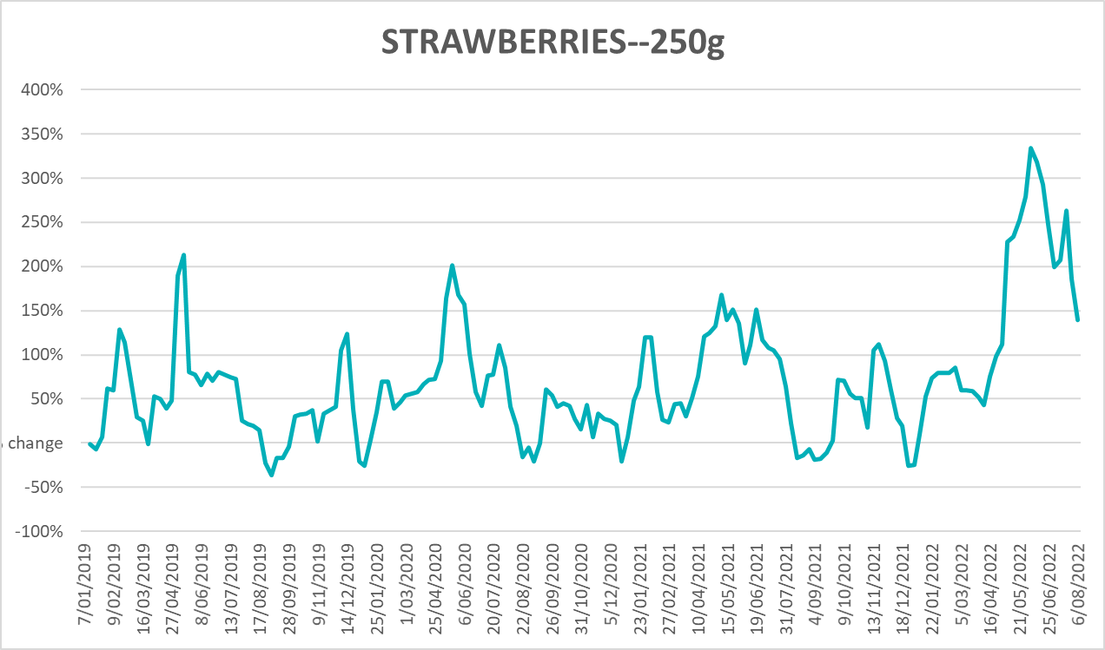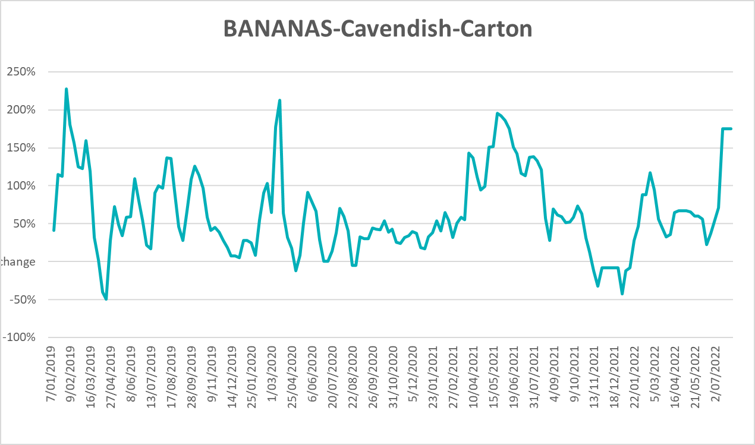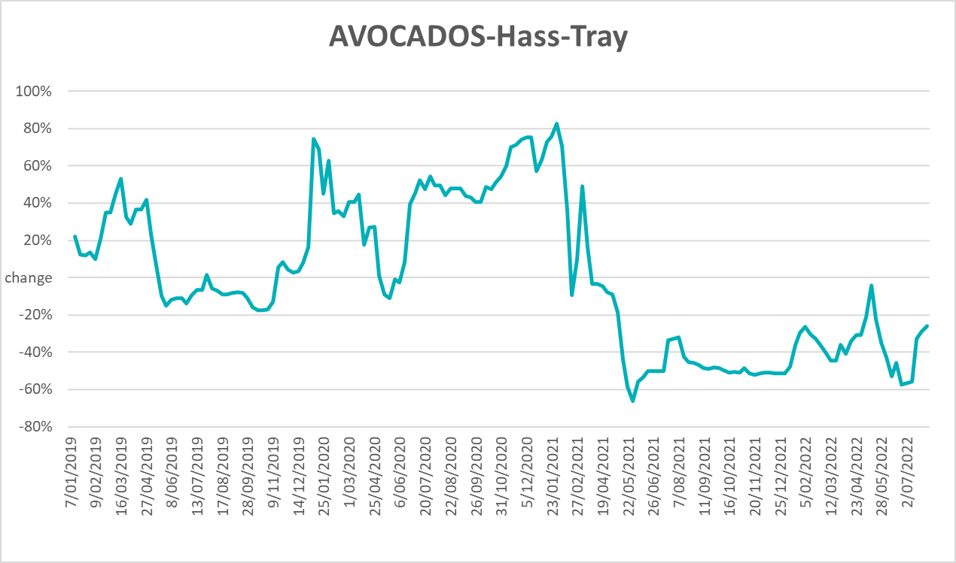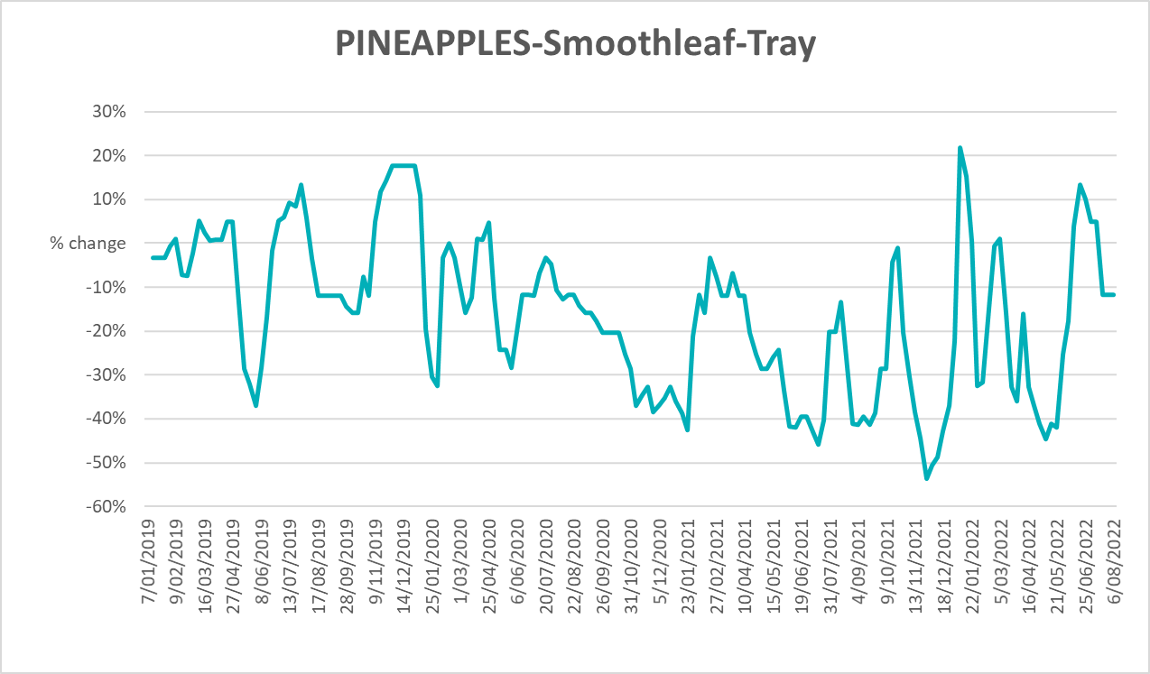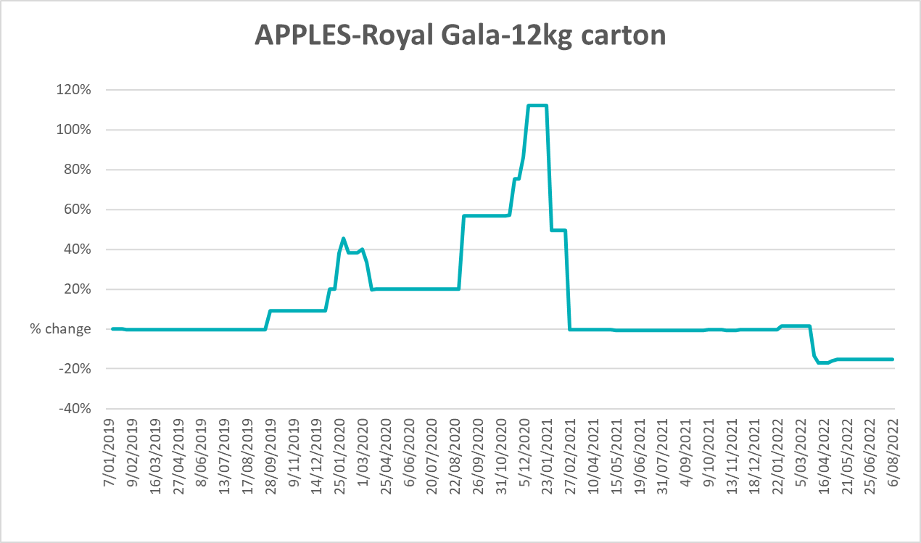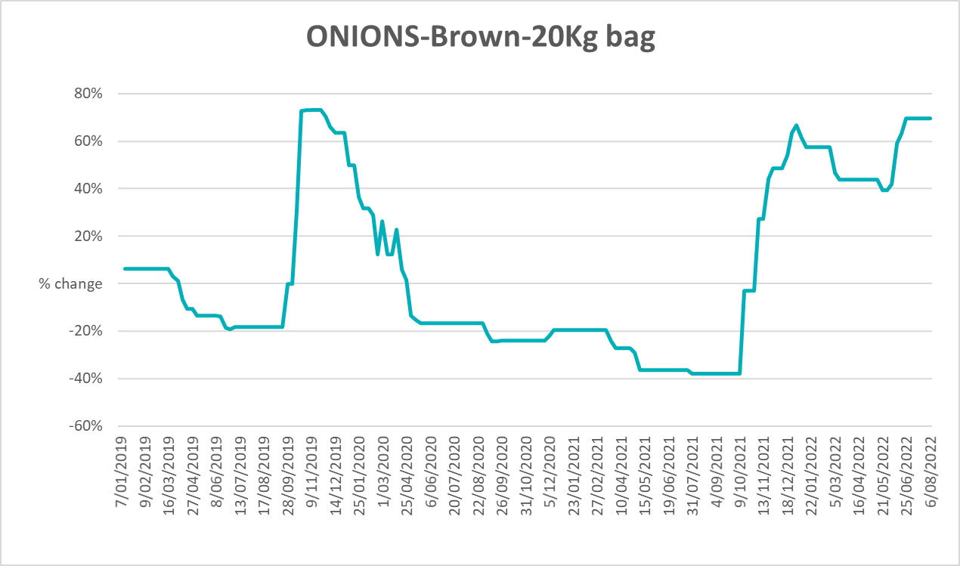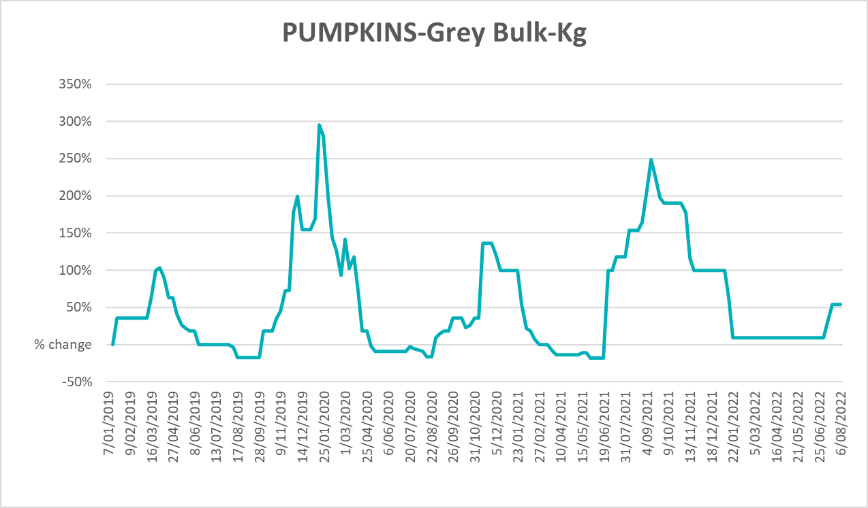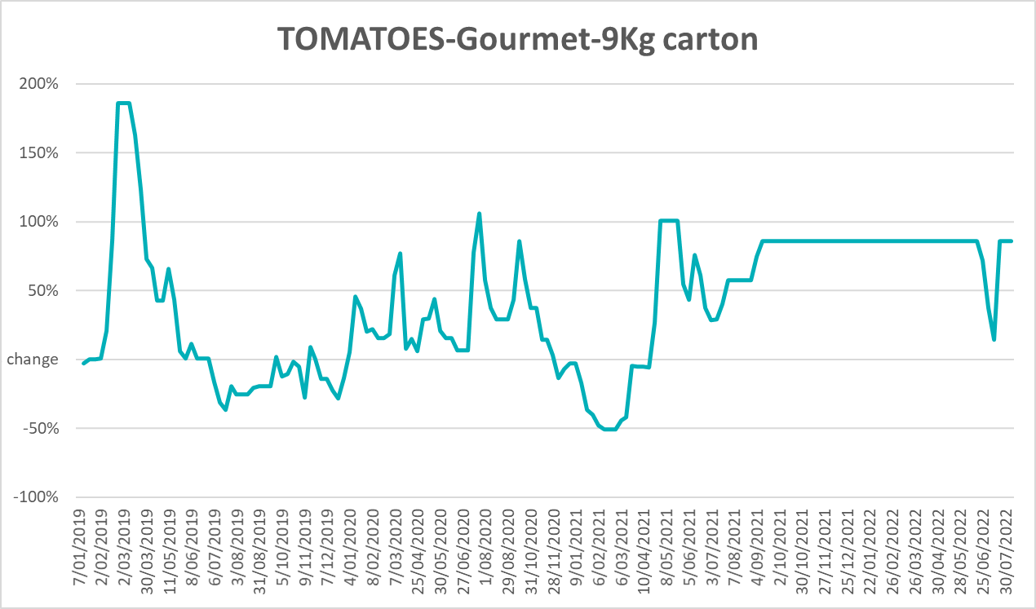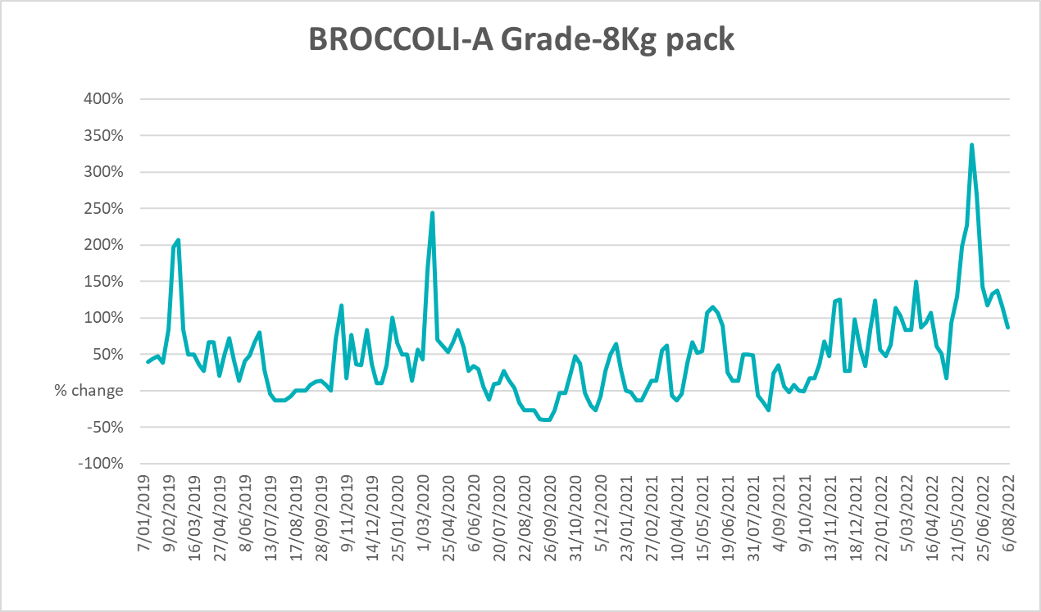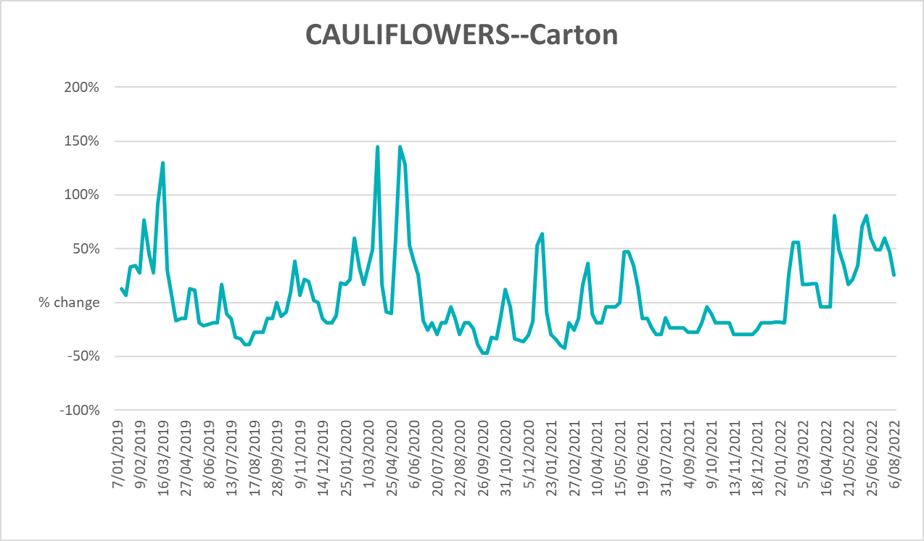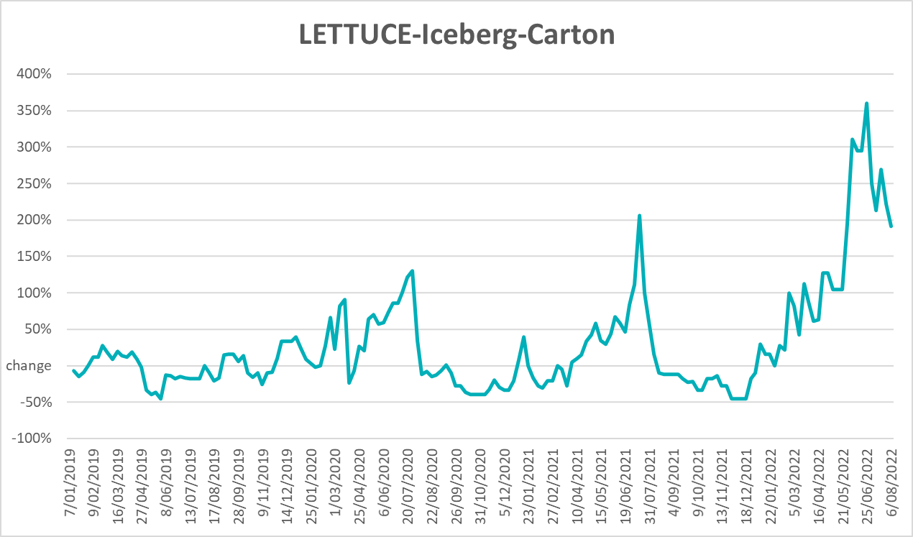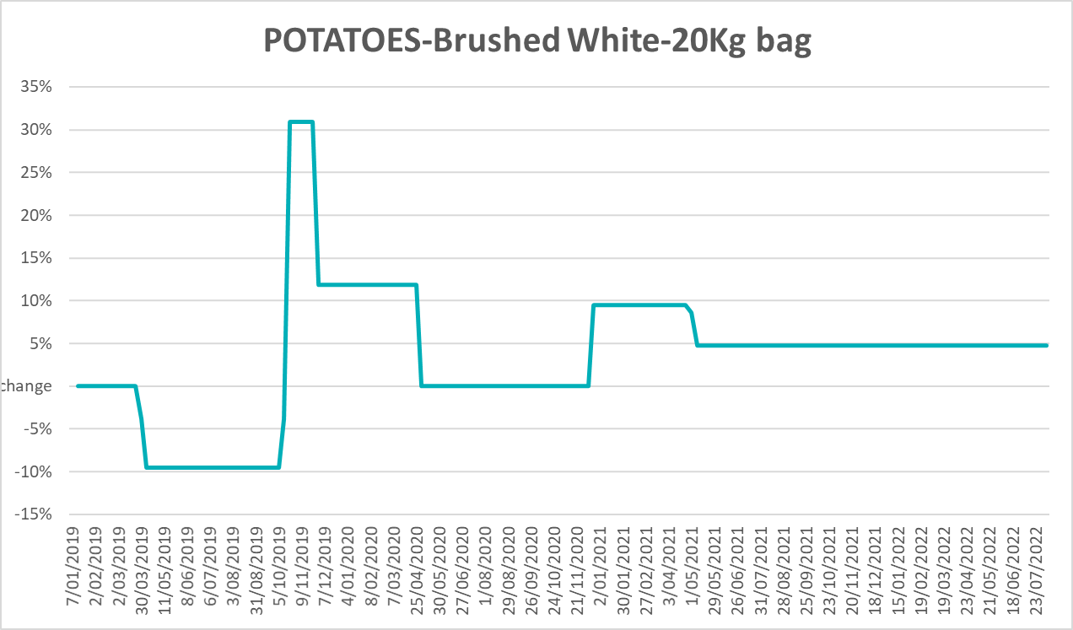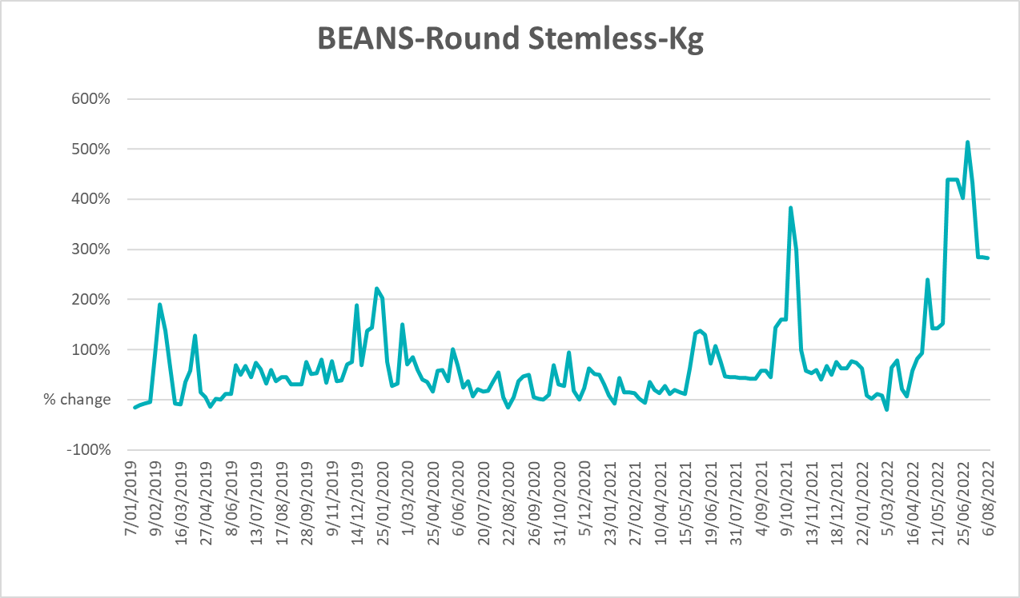

Selected domestic fodder indicator prices
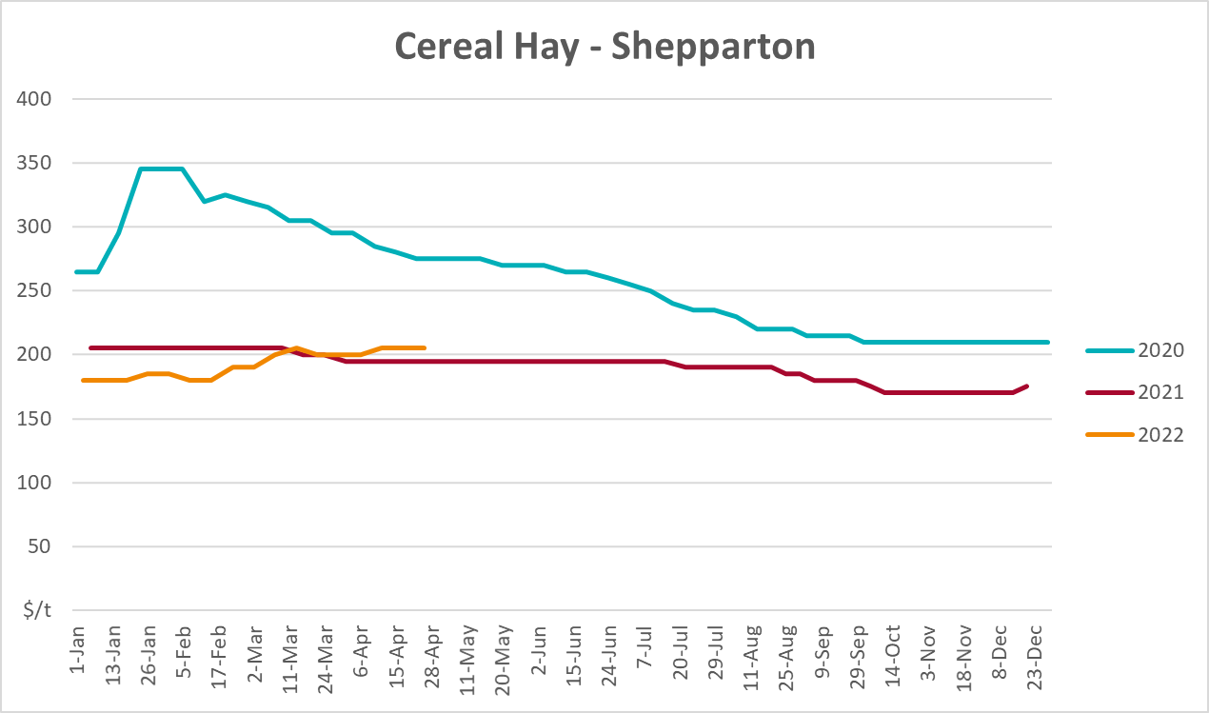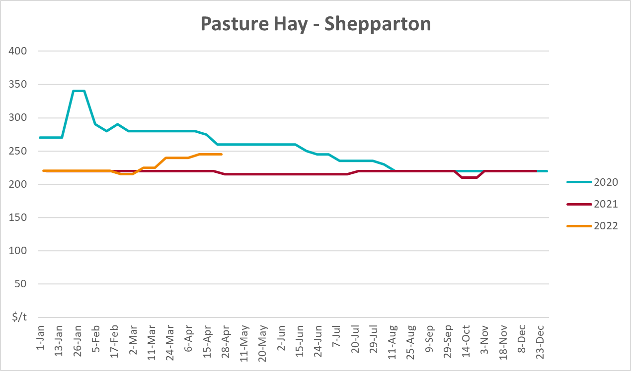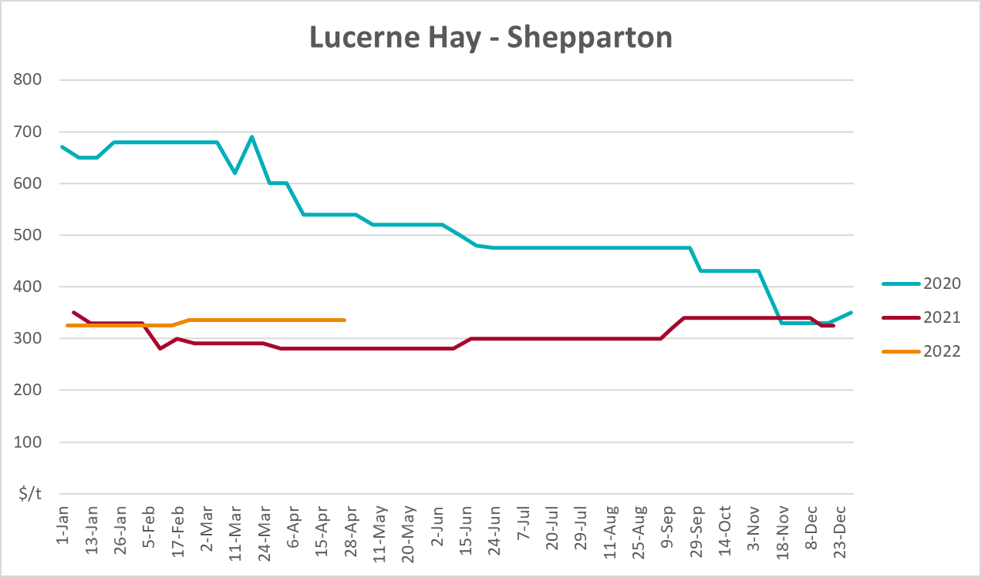

Data attribution

Climate
Bureau of Meteorology
- Weekly rainfall totals: www.bom.gov.au/climate/maps/rainfall/
- Monthly and last 3-month rainfall percentiles: www.bom.gov.au/water/landscape/
- Temperature anomalies: www.bom.gov.au/jsp/awap/temp/index.jsp
- Rainfall forecast: www.bom.gov.au/jsp/watl/rainfall/pme.jsp
- Seasonal outlook: www.bom.gov.au/climate/outlooks/#/overview/summary/
- Climate drivers: http://www.bom.gov.au/climate/enso/
- Soil moisture: www.bom.gov.au/water/landscape/
Other
- Pasture growth: www.longpaddock.qld.gov.au/aussiegrass/
- 3-month global outlooks: Environment and Climate Change Canada, NOAA Climate Prediction Center, EUROBRISA CPTEC/INPE, European Centre for Medium-Range Weather Forecasts, Hydrometcenter of Russia, National Climate Center Climate System Diagnosis and Prediction Room (NCC), International Research Institute for Climate and Society
- Global production: https://ipad.fas.usda.gov/ogamaps/cropmapsandcalendars.aspx
- Autumn break: Pook et al., 2009, https://rmets-onlinelibrary-wiley-com.virtual.anu.edu.au/doi/epdf/10.1002/joc.1833

Water
Prices
- Waterflow: https://www.waterflow.io/
- Ruralco: https://www.ruralcowater.com.au/
Bureau of Meteorology:
- Allocation trade: http://www.bom.gov.au/water/dashboards/#/water-markets/mdb/at
- Storage volumes: http://www.bom.gov.au/water/dashboards/#/water-storages/summary/drainage
Trade constraints:
- Water NSW: https://www.waternsw.com.au/customer-service/ordering-trading-and-pricing/trading/murrumbidgee
- Victorian Water Register: https://www.waterregister.vic.gov.au/TradingRules2019/

Commodities
Fruit and vegetables
- Datafresh: www.freshstate.com.au
Pigs
- Australian Pork Limited: www.australianpork.com.au
Dairy
- Global Dairy Trade: www.globaldairytrade.info/en/product-results/
World wheat, canola
- International Grains Council
World coarse grains
- United States Department of Agriculture
World cotton
- Cotlook: www.cotlook.com/
World sugar
- New York Stock Exchange - Intercontinental Exchange
Wool
- Australian Wool Exchange: www.awex.com.au/
Domestic wheat, barley, sorghum, canola and fodder
- Jumbuk Consulting Pty Ltd: http://www.jumbukag.com.au/
Cattle, beef, mutton, lamb, goat and live export
- Meat and Livestock Australia: www.mla.com.au/Prices-and-market
© Commonwealth of Australia 2022

Ownership of intellectual property rights
Unless otherwise noted, copyright (and any other intellectual property rights, if any) in this publication is owned by the Commonwealth of Australia (referred to as the Commonwealth).

Creative Commons licence
All material in this publication is licensed under a Creative Commons Attribution 4.0 International Licence except content supplied by third parties, logos and the Commonwealth Coat of Arms.
Inquiries about the licence and any use of this document should be emailed to copyright@awe.gov.au.


Cataloguing data
This publication (and any material sourced from it) should be attributed as:
ABARES 2022, Weekly Australian Climate, Water and Agricultural Update, Australian Bureau of Agricultural and Resource Economics and Sciences, Canberra, 18 August 2022. CC BY 4.0 DOI: https://doi.org/10.25814/5f3e04e7d2503
ISSN 2652-7561
This publication is available at https://www.agriculture.gov.au/abares/products/weekly_update
Department of Agriculture, Fisheries and Forestry
GPO Box 858 Canberra ACT 2601
Telephone 1800 900 090
Web agriculture.gov.au/abares

Disclaimer
The Australian Government acting through the Department of Agriculture, Fisheries and Forestry, represented by the Australian Bureau of Agricultural and Resource Economics and Sciences, has exercised due care and skill in preparing and compiling the information and data in this publication. Notwithstanding, the Department of Agriculture, Fisheries and Forestry, ABARES, its employees and advisers disclaim all liability, including liability for negligence and for any loss, damage, injury, expense or cost incurred by any person as a result of accessing, using or relying on any of the information or data in this publication to the maximum extent permitted by law.

Statement of Professional Independence
The views and analysis presented in ABARES publications, including this one, reflect ABARES professionally independent findings, based on scientific and economic concepts, principles, information and data. These views, analysis and findings may not reflect or be consistent with the views or positions of the Australian Government, or of organisations or groups who have commissioned ABARES reports or analysis. More information on professional independence is provided on the ABARES website.

Acknowledgements
This report was prepared by Matthew Miller and Cameron Van-Lane.

