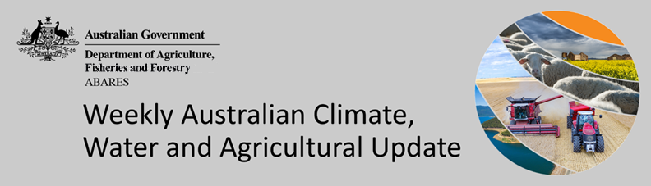
No. 34/2022

1 September 2022

Summary of key issues
- For the week ending 31 August 2022, onshore flow brought moderate rainfall to parts of Queensland, while a low-pressure system and associated cold fronts brought light to moderate rainfall to south-eastern Australia. Meanwhile, high-pressure systems over remaining parts of the country resulted in clear, dry conditions (see Section 1.1).
- Moderate rainfalls across central New South Wales over the past week has likely seen a continuation of waterlogging in low lying areas, given rootzone soil moisture levels are already well above average. Affected crops have already struggled due to exceptionally wet conditions thus far in the season. Moreover, the wet conditions across Australian cropping regions over recent weeks have limited field access for disease management and top dressing. The wet conditions have increased fungal disease pressure for winter crops, which may negatively impact yield potentials if not managed. Mouse populations will also start to increase, presenting a further risk of crop damage.
- Rainfall during August 2022 was above average for Australia as a whole. Rainfall was above average to extremely high for much of the eastern and northern Australia, the south-west of Western Australia, as well as parts of South Australia and much of Tasmania. However, rainfall was extremely low to below average for isolated parts of eastern Queensland, the south-east of Western Australia, and parts of the Northern Territory (see Section 1.2).
- Lower layer soil moisture for August 2022 was well above average to extremely high for this time of year across eastern and central New South Wales, large areas of eastern, central and northern Queensland, parts of northern and much of south-western Western Australia, and scattered areas of eastern Victoria and the north of the Northern Territory and South Australia. Average or better soil moisture levels in most cropping regions and pastoral districts, and the favourable rainfall outlook for spring, is likely to provide sufficient plant available water availability to achieve current winter and summer crop production forecasts for 2022–23 (see Section 1.3).
- Over the 8-days to 8 September 2022, troughs and low-pressure systems are forecast to draw down moist, tropical air, resulting in showers across central, western and eastern Australia. A cold front is expected to bring isolated rainfall to parts of southern Australia. The moderate rainfall forecast across cropping regions in northern New South Wales and southern and central Queensland will increase waterlogging risks across low-lying areas. These wet conditions will prolong the inability to access fields for disease management and top dressing (see Section 1.4).
- Water storage in the Murray–Darling Basin (MDB) increased by 124 gigalitres (GL) between 24 August 2022 and 31 August 2022. The current volume of water held in storage is 23,331 GL, which represents 92% of total capacity. This is 12% or 2,437 GL more than at the same time last year.
- Allocation prices in the Victorian Murray below the Barmah Choke decreased from $113 per ML on 25 August 2022 to $60 per ML on 1 September 2022. Prices are lower in the Goulburn-Broken and regions above the Barmah choke due to the binding of the Goulburn intervalley trade limit and Barmah choke trade constraint.

Climate

Rainfall this week
For the week ending 31 August 2022, onshore flow brought moderate rainfall to parts of Queensland, while a low-pressure system and associated cold fronts brought light to moderate rainfall to south-eastern Australia. Meanwhile, high-pressure systems over remaining parts of the country resulted in clear, dry conditions.
Rainfall totals of between 10 and 50 millimetres were recorded across parts of southern and central New South Wales, central, western and northern Queensland, much of Victoria, isolated parts of the south of South Australia and Western Australia, as well as isolated parts of central Northern Territory and western Tasmania. Rainfall totals in excess of 50 millimetres were recorded in alpine areas of Victoria, parts of central and north-eastern Queensland, and the east of the Northern Territory. Remaining parts of Australia received little to no rainfall.
In Australian cropping regions, rainfall totals of between 10 and 50 millimetres were recorded across southern and central New South Wales, parts of northern Queensland and most of Victoria. Little to no rainfall was recorded across remaining cropping regions for the week ending 31 August 2022.
Moderate rainfalls across central New South Wales over the past week has likely seen a continuation of waterlogging in low lying areas given rootzone soil moisture levels are already well above average. Affected crops have already struggled due to exceptionally wet conditions thus far in the season. Moreover, the wet conditions across some cropping regions over recent weeks have limited field access for disease management and top dressing. Mostly dry conditions across other Australian cropping regions over the past week will have allowed soil moisture levels to subside reducing the risk of waterlogging, with parts of New South Wales, Queensland and Western Australia having well above average soil moisture levels.
The wet conditions have increased fungal disease pressure for winter crops, which may negatively impact yield potentials if not managed. As we enter spring, mouse populations will also start to increase, presenting a further risk of crop damage. Following a large crop in 2021, an abundance of seed will support mouse populations through spring, necessitating baiting in high risk areas.

Rainfall for the week ending 31 August 2022
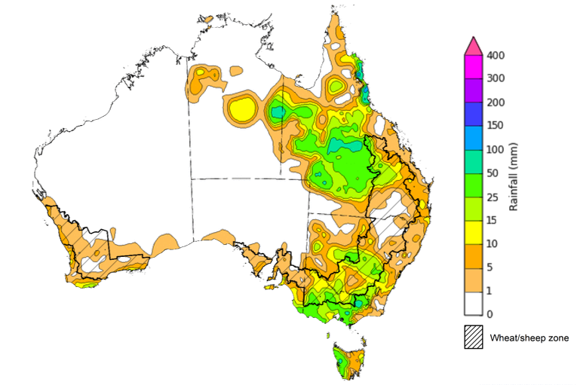
©Commonwealth of Australia 2022, Australian Bureau of Meteorology Issued:31/8/2022
Note: The rainfall analyses and associated maps utilise data contained in the Bureau of Meteorology climate database, the Australian Data Archive for Meteorology (ADAM). The analyses are initially produced automatically from real-time data with limited quality control. They are intended to provide a general overview of rainfall across Australia as quickly as possible after the observations are received. For further information go to http://www.bom.gov.au/climate/rainfall/

Monthly rainfall
Rainfall during August 2022 was above average for Australia as a whole. Rainfall was above average to extremely high for much of the eastern and northern Australia, the south-west of Western Australia, as well as parts of South Australia and much of Tasmania. However, rainfall was extremely low to below average for isolated parts of eastern Queensland, the south-east of Western Australia, and parts of the Northern Territory.
The main climate influences for August were a negative Indian Ocean Dipole (IOD) and a positive Southern Annular Mode (SAM). A negative IOD typically results in enhanced rainfall in a broad band extending from the north-west to the south-east of Australia, and a positive SAM is associated with increased rainfall across parts of eastern Australia but less rainfall for parts of southern Australia.
August 2022 rainfall was above average to extremely high across cropping regions of New South Wales and Western Australia, western, northern and south-eastern parts of Queensland, eastern and central Victoria, and central parts of South Australia. August rainfall was generally average for all remaining cropping regions
Extremely high rainfall across eastern Australia in August followed a wet start to the winter cropping season, with soil moisture levels above average across most cropping regions. Early sown crops not impacted by waterlogging are in excellent condition, especially across southern New South Wales and Victoria. However, the wet conditions have limited field access, with growers in some cases turning to aerial application of fungicides and urea. For parts of central and northern New South Wales and southern Queensland, the wet conditions have exacerbated waterlogging of winter crops, delaying crop development. The above average to extremely high rainfall received in Western Australia has continued to support winter crops, which have had a favourable start to the season, with above average crop biomass establishing strong yield potentials.

Rainfall percentiles for August 2022

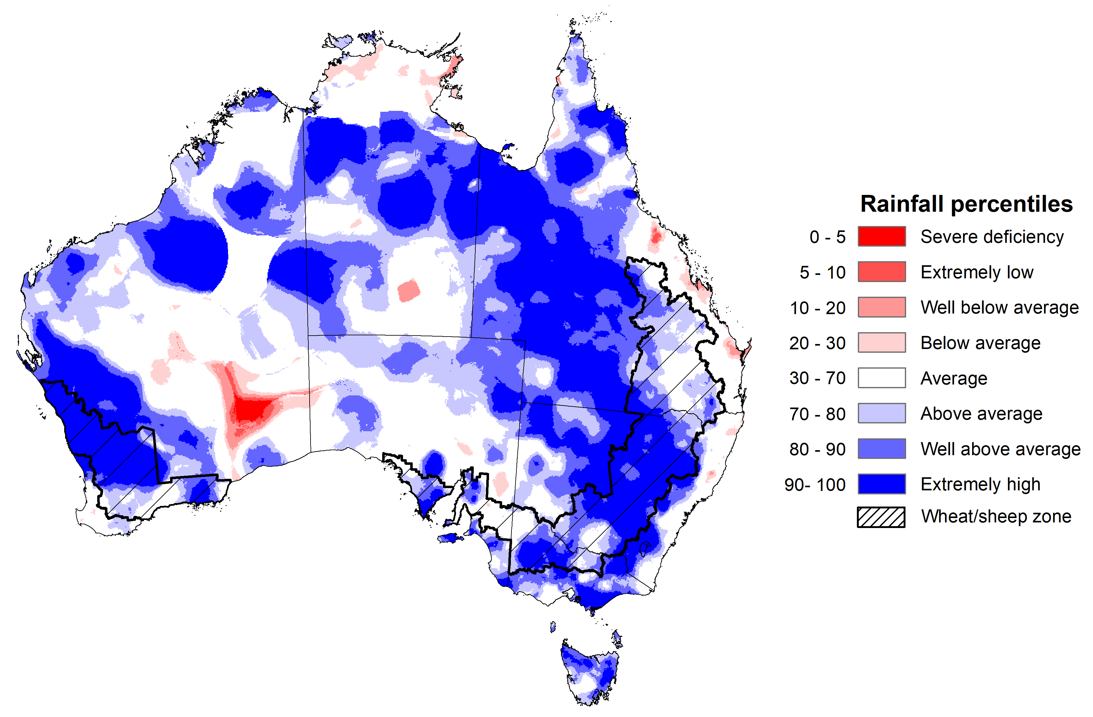
Note: Rainfall for August 2022 is compared with rainfall recorded for that period during the historical record (1900 to present). For further information, go to http://www.bom.gov.au/jsp/awap/
Source: Bureau of Meteorology

Monthly soil moisture
Upper layer soil moisture in August 2022 was extremely high for this time of year across much of New South Wales and Victoria, large areas of central and western Queensland, the north-west and south-west of Western Australia, the north-east and south of South Australia, isolated parts of the Northern Territory and Tasmania reflecting high monthly rainfall in these areas. Extremely low upper layer soil moisture was evident across scattered areas of eastern Queensland, the Northern Territory and central Western Australia. Modelled upper layer soil moisture was generally average to above average across the remainder of the country.
At this time of year, upper layer soil moisture is less critical for well-established winter crops. However, upper layer soil moisture will be critical for supporting the germination and establishment of summer crops in the coming months. Too much upper layer soil moisture at this time can also impede access paddocks to undertake the spraying of fungicide to counter disease pressure associated with the wet conditions and fertilizer top-dressing activities.
Upper layer soil moisture was average to above average for this time of year across cropping regions in Queensland and southern Western Australia. Upper layer soil moisture was well above average to extremely high for much of New South Wales, Victoria South Australia and central and northern Western Australia. Following extremely high upper layer soil moisture in previous months, the below average upper layer soil moisture conditions in August across Queensland would have allowed for improved field access.

Modelled upper layer soil moisture for August 2022

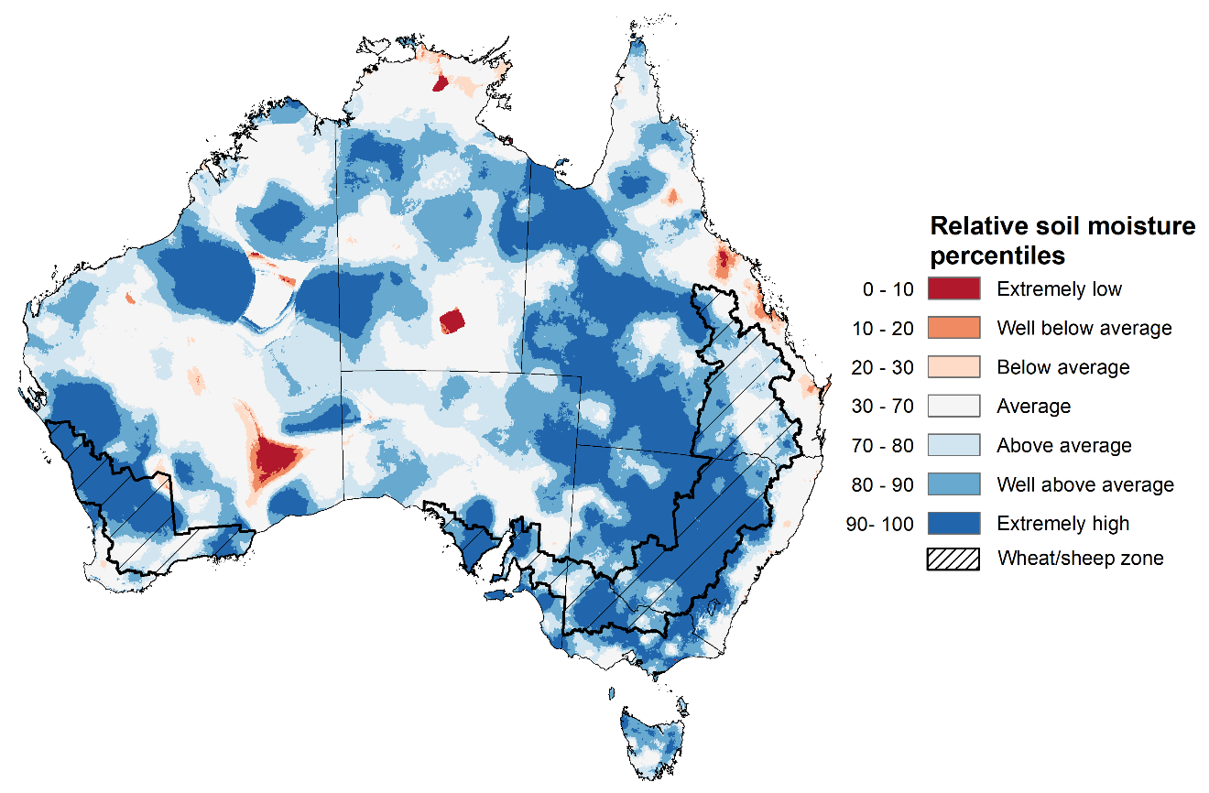
Note: This map shows the levels of modelled upper layer soil moisture (0 to 10 centimetres) during August 2022. This map shows how modelled soil conditions during August 2022 compare with August conditions modelled over the reference period (1911 to 2016). Dark blue areas on the maps were much wetter in August 2022 than during the reference period. The bulk of plant roots occur in the top 20 centimetres of the soil profile. Soil moisture in the upper layer of the soil profile is therefore useful indicator of the availability of water, particularly for germinating seed.
Source: Bureau of Meteorology (Australian Water Resources Assessment Landscape model)

Lower layer soil moisture for August 2022 was well above average to extremely high for this time of year across eastern and central New South Wales, large areas of eastern, central and northern Queensland, parts of northern and much of south-western Western Australia, and scattered areas of eastern Victoria and the north of the Northern Territory and South Australia. Lower layer soil moisture was well below average to below average in isolated parts of central South Australia, the north and south-east of Western Australia and large areas of the Northern Territory. Modelled lower layer soil moisture was generally average across the remainder of the country.
Lower layer soil moisture will be important for winter crops as they enter flowering and grain filling over the coming months and help support what is expected to be a very large spring and summer crop planting season and peak pasture growth period.
In cropping regions, lower layer soil moisture was well above average to extremely high across central New South Wales, much of Queensland and central and northern Western Australia. Lower layer soil moisture was below average for this time of year in isolated areas of southern New South Wales and central South Australia. Lower layer soil moisture was generally average across remaining areas of New South Wales, Victoria, South Australia, as well as southern areas of Western Australia.
Well above average to extremely high lower layer soil moisture levels across central New South Wales and much of Queensland does present a downside risk to yields. These areas are subject to increased chances of exceeding median rainfall over the next three months, increasing the potential of ongoing saturated soils and waterlogging and reducing potential yields.
Average or better soil moisture levels in most cropping regions and pastoral districts, and the favourable rainfall outlook for spring, is likely to provide sufficient plant available water availability to achieve current winter and summer crop production forecasts and drive strong pasture growth to support current livestock production and herd rebuilding projections for 2022–23.
Modelled lower layer soil moisture for August 2022
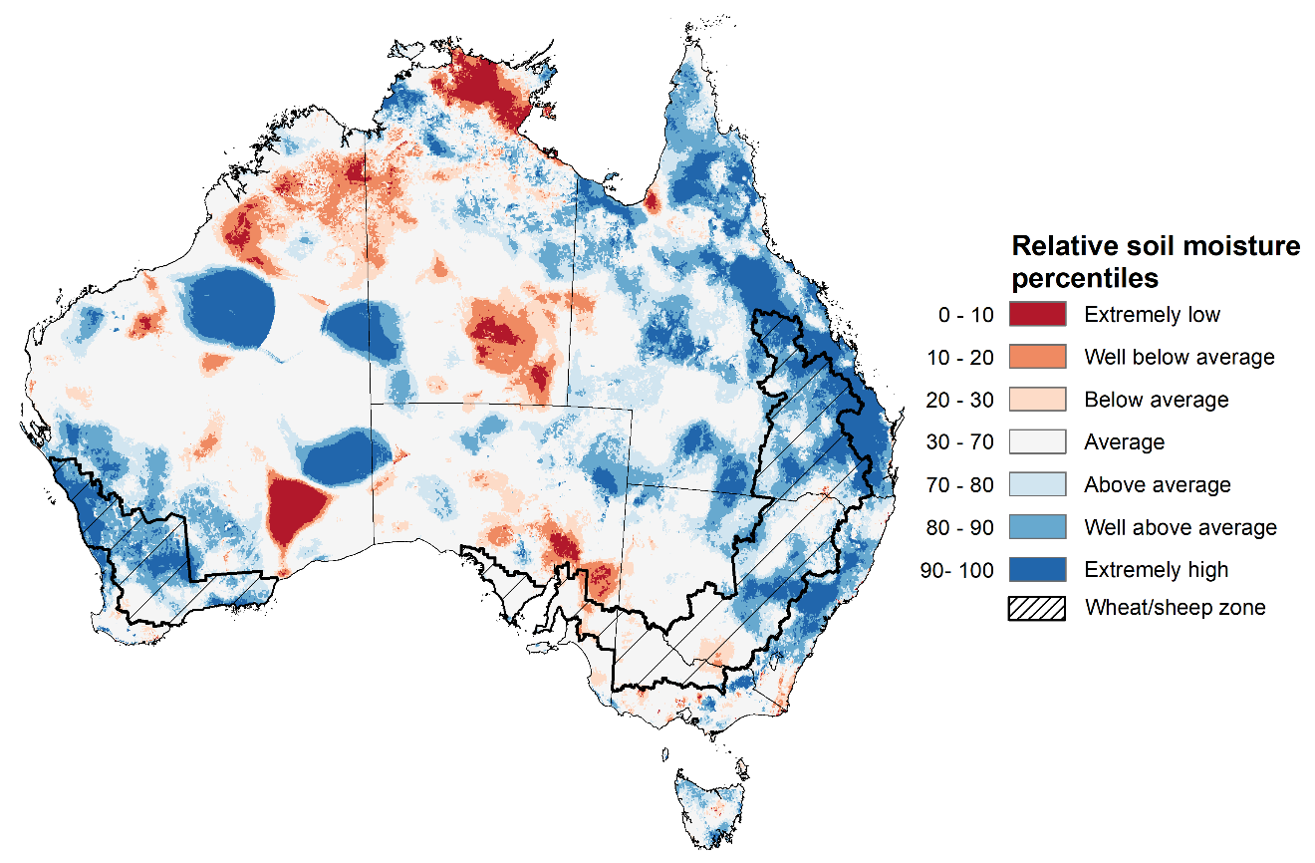
Note: This map shows the levels of modelled lower layer soil moisture (10 to 100 centimetres) during August 2022. This map shows how modelled soil conditions during August 2022 compare with August conditions modelled over the reference period (1911 to 2016). Dark blue areas on the maps were much wetter in August 2022 than during the reference period. The dark red areas were much drier than during the reference period. The bulk of plant roots occur in the top 20 centimetres of the soil profile. The lower layer soil moisture is a larger, deeper store that is slower to respond to rainfall and tends to reflect accumulated rainfall events over longer time periods.
Source: Bureau of Meteorology (Australian Water Resources Assessment Landscape model)

Rainfall forecast for the next eight days
Over the 8-days to 8 September 2022, troughs and low-pressure systems are forecast to draw down moist, tropical air, resulting in showers across central, western and eastern Australia. A cold front is expected to bring isolated rainfall to parts of southern Australia. High-pressure systems will provide clear, dry conditions across remaining parts of the country.
Rainfall totals of between 10 and 50 millimetres are forecast across most of New South Wales, southern and central Queensland, central and south-western Victoria, much of South Australia, and Tasmania, as well as southern and central parts of Western Australia and the Northern Territory. Rainfall totals in excess of 50 millimetres are forecast for parts of north-eastern New South Wales.
In Australian cropping regions, rainfall totals of between 10 and 50 millimetres are expected across New South Wales, Queensland, eastern Victoria, central and western regions of South Australia, as well as Western Australia. Little to no rainfall is forecast for cropping regions in western Victoria and the east of South Australia during the next 8-days.
The moderate rainfall forecast across cropping regions in northern New South Wales and southern and central Queensland will increase waterlogging risks across low-lying areas. These wet conditions will prolong the inability to access fields for disease management and top dressing. Limited access to aerial applications of pesticides and urea will be a major limiting factor in some growing regions. This may result in increased disease pressure and delays in the timely application of urea, presenting a potential downside risk to the current well above yield expectations in some growing regions.
Waterlogging and frost events remain the biggest potential downside risk to yields over the coming weeks. For the most part, above average soil moisture levels will support strong yield potentials, with crops flowering and grain filling as we enter spring. In Central Queensland, harvesting of winter crops and planting of long-season summer crops will get underway in the coming weeks. Central Queensland growers will be hoping for clear, dry conditions to facilitate timely planting and harvesting operations.

Total forecast rainfall (mm) for the period 1 September to 8 September 2022
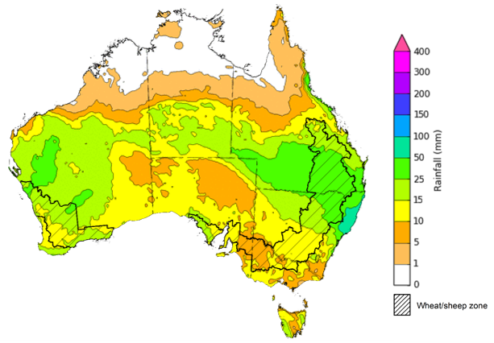
©Commonwealth of Australia 2022, Australian Bureau of Meteorology Issued:31/8/2022

Water
Note: This rainfall forecast is produced from computer models. As the model outputs are not altered by weather forecasters, it is important to check local forecasts and warnings issued by the Bureau of Meteorology.

Water markets – current week
Water storage in the Murray–Darling Basin (MDB) increased by 124 gigalitres (GL) between 24 August 2022 and 31 August 2022. The current volume of water held in storage is 23,331 GL, which represents 92% of total capacity. This is 12% or 2,437 GL more than at the same time last year.

Water storages in the Murray-Darling Basin, 2013–2022
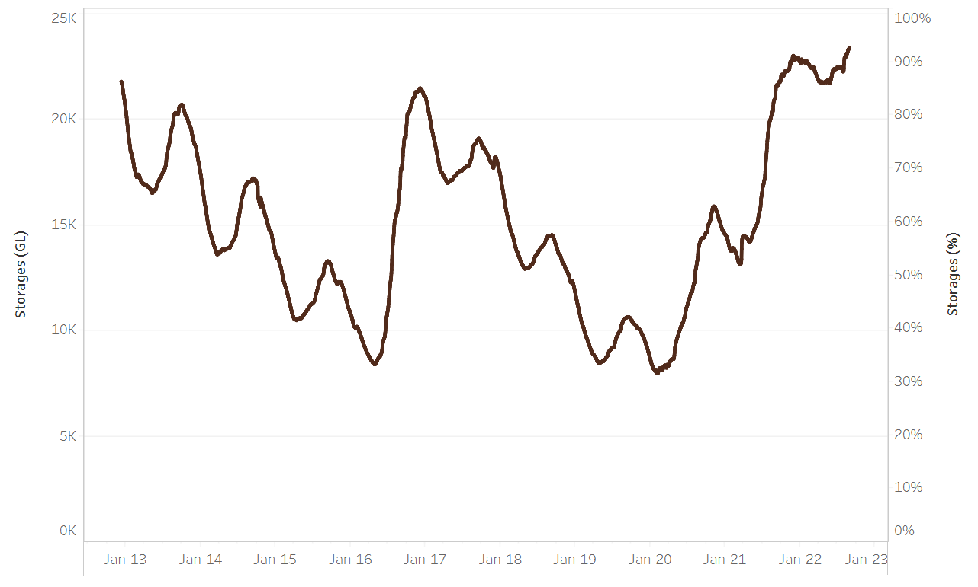
Allocation prices in the Victorian Murray below the Barmah Choke decreased from $113 per ML on 25 August 2022 to $60 per ML on 1 September 2022. Prices are lower in the Goulburn-Broken and regions above the Barmah choke due to the binding of the Goulburn intervalley trade limit and Barmah choke trade constraint.
Water storage data is sourced from the Bureau of Meteorology.

Region | $/ML
NSW Murray Above | 48
NSW Murrumbidgee | 46
VIC Goulburn-Broken | 45
VIC Murray Below | 60

Surface water trade activity, Southern Murray–Darling Basin

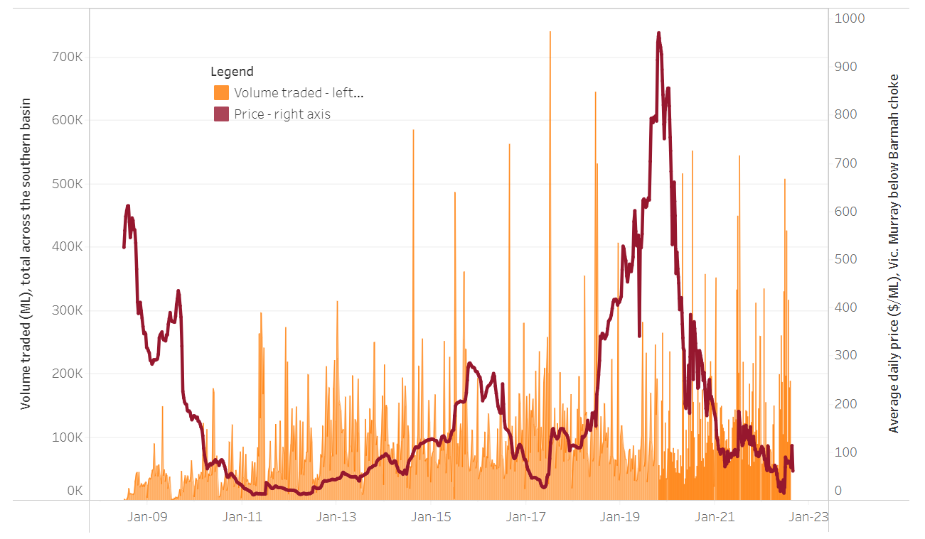
To access the full, interactive, weekly water dashboard, which contains the latest and historical water storage, water market and water allocation information, please visit http://www.agriculture.gov.au/abares/products/weekly_update/weekly-update-010922
The trades shown reflect estimated market activity and do not encompass all register trades. The price is shown for the VIC Murray below the Barmah choke. Historical prices (before 1 July 2019) are ABARES estimates after removing outliers from BOM water register data. Prices after 1 July 2019 and prior to the 30 October 2019 reflect recorded transaction prices as sourced from Ruralco. Prices after the 30 October 2019 are sourced from Waterflow. Data for volume traded is sourced from the BOM water register. Data shown is current at 1 September 2022.

Commodities

Indicator | Week ended | Unit | Latest price | Previous week | Weekly change | Price 12 months ago | Annual change
Selected world indicator prices
AUD/USD Exchange rate | 31-Aug | A$/US$ | 0.69154 | 0.69 | 0% | 0.74 | -6%
Wheat – US no. 2 hard red winter wheat, fob Gulf | 31-Aug | US$/t | 394.2 | 388 | 2% | 317 | 24%
Corn – US no. 2 yellow corn, fob Gulf | 31-Aug | US$/t | 321 | 301 | 7% | 266 | 21%
Canola – Rapeseed, Canada, fob Vancouver | 31-Aug | US$/t | 695 | 700 | -1% | 765 | -9%
Cotton – Cotlook 'A' Index | 31-Aug | USc/lb | 133 | 133 | 0% | 104 | 29%
Sugar – Intercontinental Exchange, nearby futures, no.11 contract | 31-Aug | USc/lb | 18.1 | 17.9 | 1% | 20 | -9%
Wool – Eastern Market Indicator | 31-Aug | Ac/kg clean | 1,330 | 1,342 | -1% | 1,468 | -9%
Wool – Western Market Indicator | 10-Aug | Ac/kg clean | 1,459 | 1,449 | 1% | 1,346 | 8%
Selected Australian grain export prices
Milling Wheat – APW, Port Adelaide, SA | 31-Aug | A$/t | 541 | 534 | 1% | 412 | 31%
Feed Wheat – ASW, Port Adelaide, SA | 31-Aug | A$/t | 510 | 494 | 3% | 426 | 20%
Feed Barley – Port Adelaide, SA | 31-Aug | A$/t | 468 | 459 | 2% | 344 | 36%
Canola – Kwinana, WA | 31-Aug | A$/t | 1,076 | 1,049 | 3% | 837 | 28%
Grain Sorghum – Brisbane, QLD | 31-Aug | A$/t | 431 | 420 | 3% | 363 | 19%
Selected domestic livestock indicator prices
Beef – Eastern Young Cattle Indicator | 31-Aug | Ac/kg cwt | 1,034 | 1,030 | 0% | 1,000 | 3%
Mutton – Mutton indicator (18–24 kg fat score 2–3), Vic | 31-Aug | Ac/kg cwt | 511 | 536 | -5% | 701 | -27%
Lamb – Eastern States Trade Lamb Indicator | 31-Aug | Ac/kg cwt | 685 | 732 | -6% | 900 | -24%
Pig – Eastern Seaboard (60.1–75 kg), average of buyers & sellers | 10-Aug | Ac/kg cwt | 378 | 378 | 0% | 318 | 19%
Goats – Eastern States (12.1–16 kg) | 29-Jun | Ac/kg cwt | 1,030 | 879 | 17% | 818 | 26%
Live cattle – Light steers ex Darwin to Indonesia | 17-Aug | Ac/kg lwt | 420 | 480 | -13% | 320 | 31%
Live sheep – Live wethers (Muchea WA saleyard) to Middle East | 20-Apr | $/head | 113 | 113 | 0% | 122 | -7%

Indicator | Week ended | Unit | Latest price | Previous week | Weekly change | Price 12 months ago | Annual change
Global Dairy Trade (GDT) weighted average prices ª
Dairy – Whole milk powder | 17-Aug | US$/t | 3,417 | 3,544 | -4% | 3,003 | 14%
Dairy – Skim milk powder | 17-Aug | US$/t | 3,524 | 3,524 | 0% | 2,583 | 36%
Dairy – Cheddar cheese | 17-Aug | US$/t | 5,005 | 4,798 | 4% | 3,568 | 40%
Dairy – Anhydrous milk fat | 17-Aug | US$/t | 4,990 | 5,518 | -10% | 3,994 | 25%
a Global Dairy Trade prices are updated twice monthly on the first and third Tuesday of each month.

Selected world indicator prices
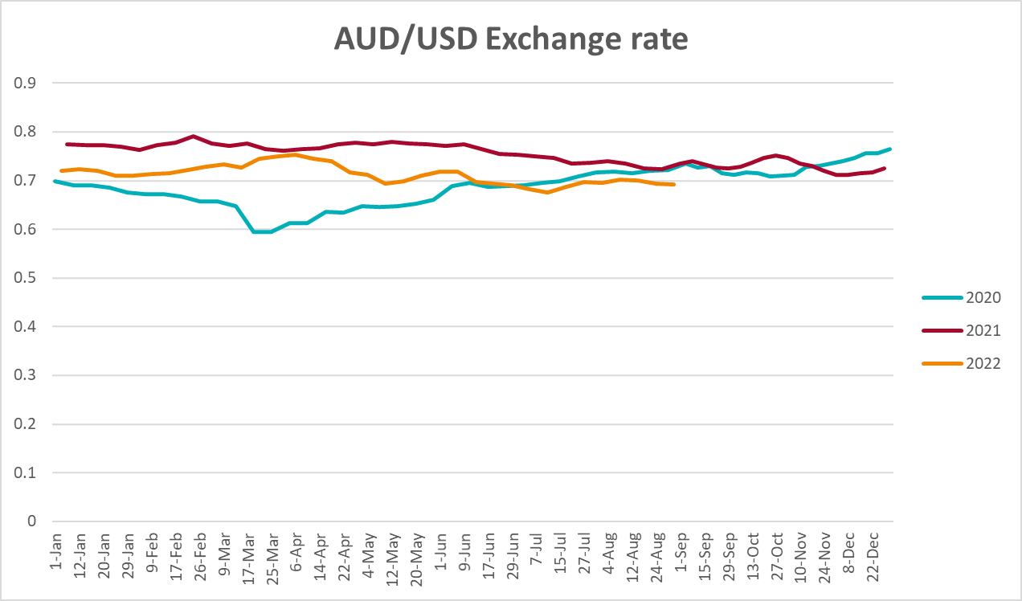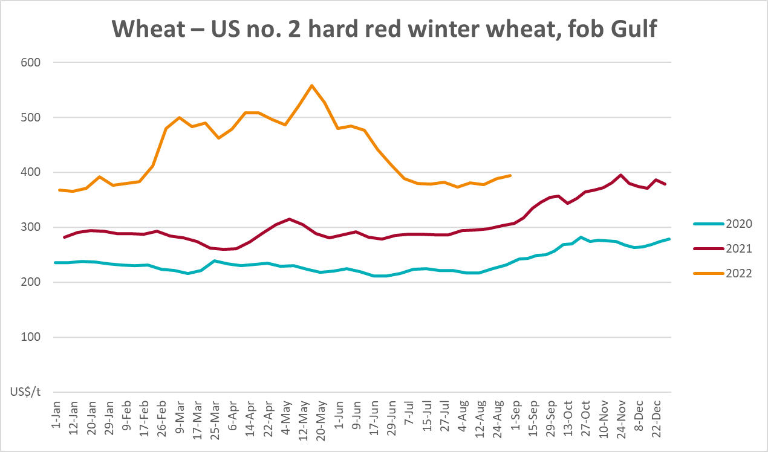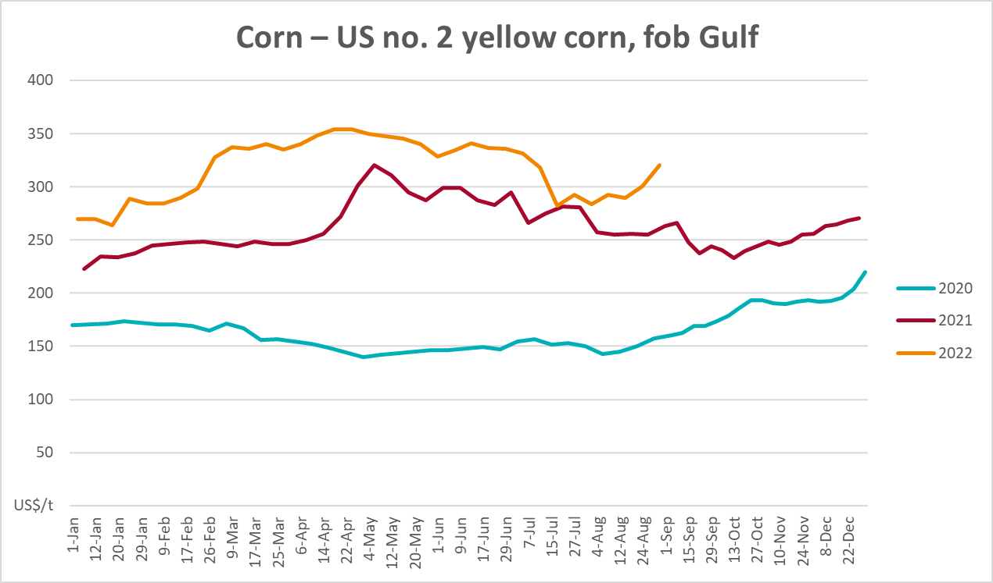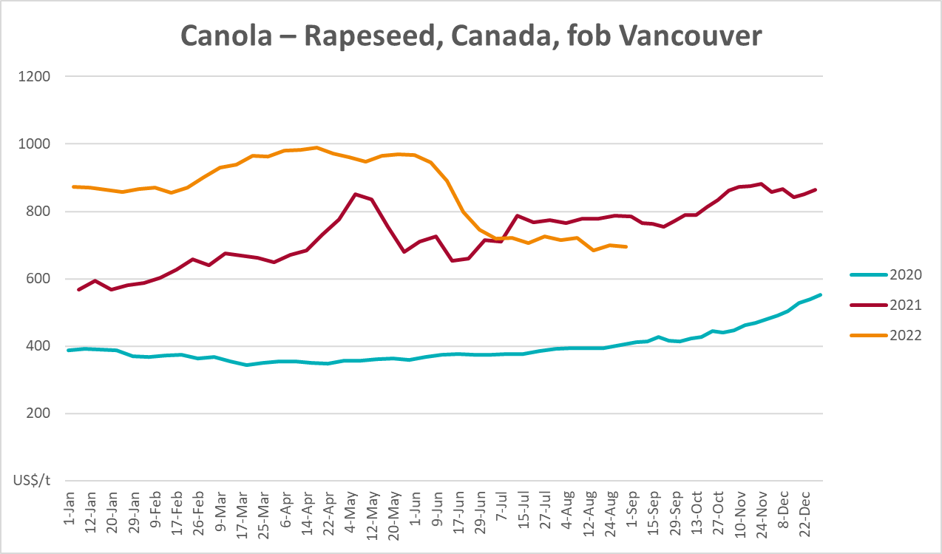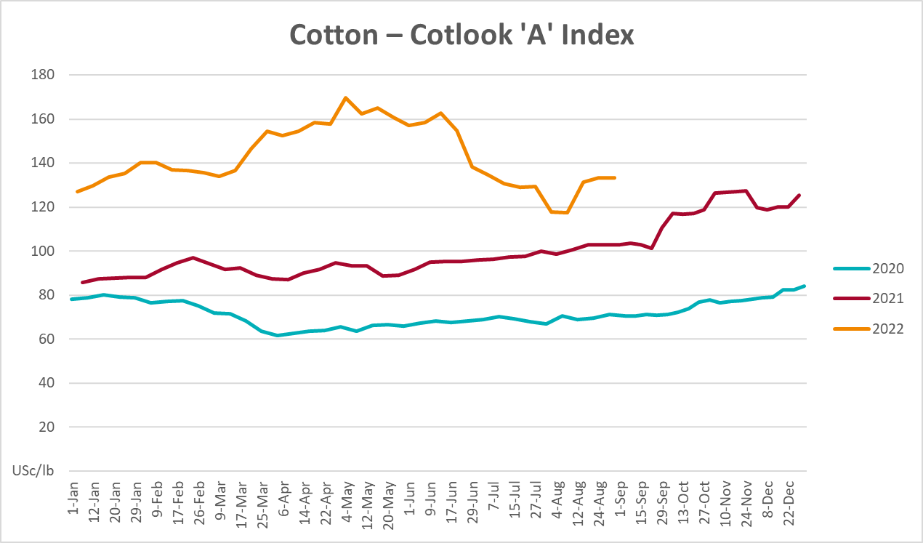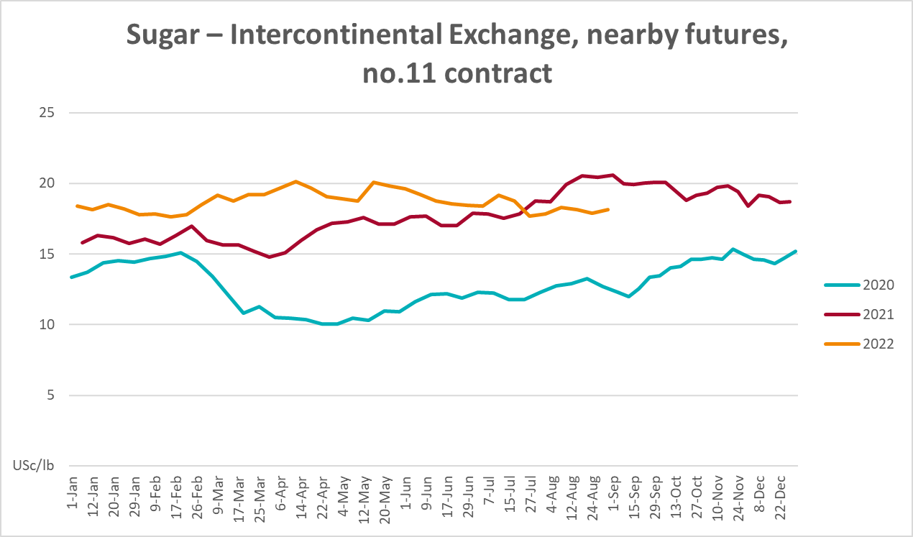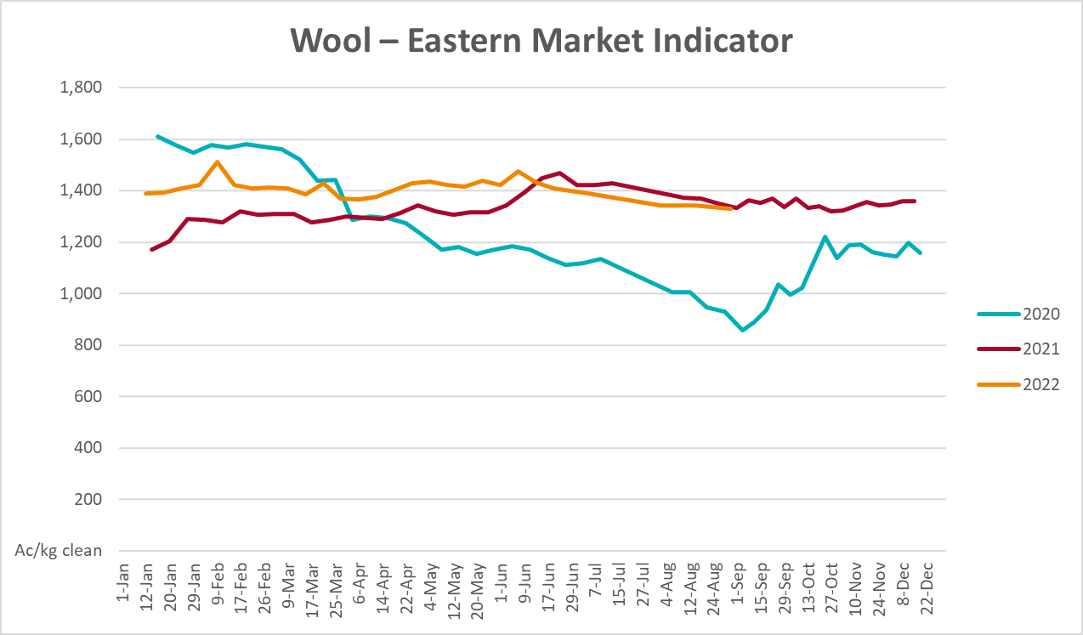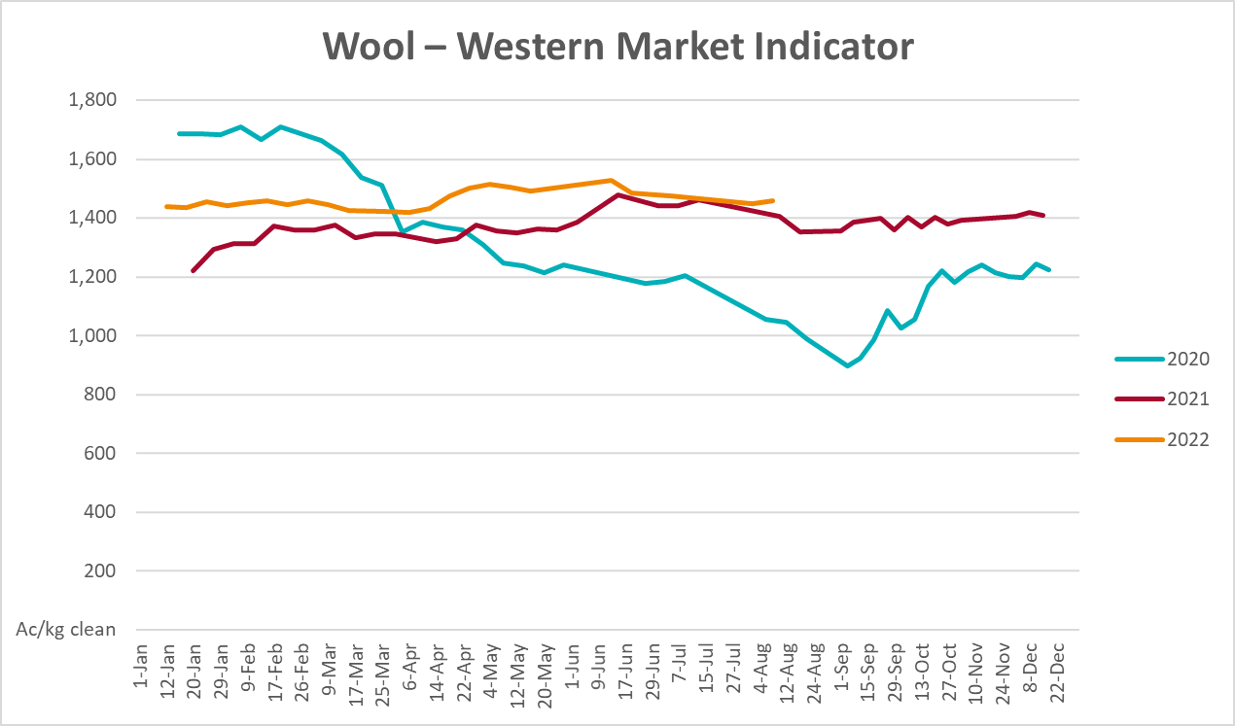

Selected domestic crop indicator prices
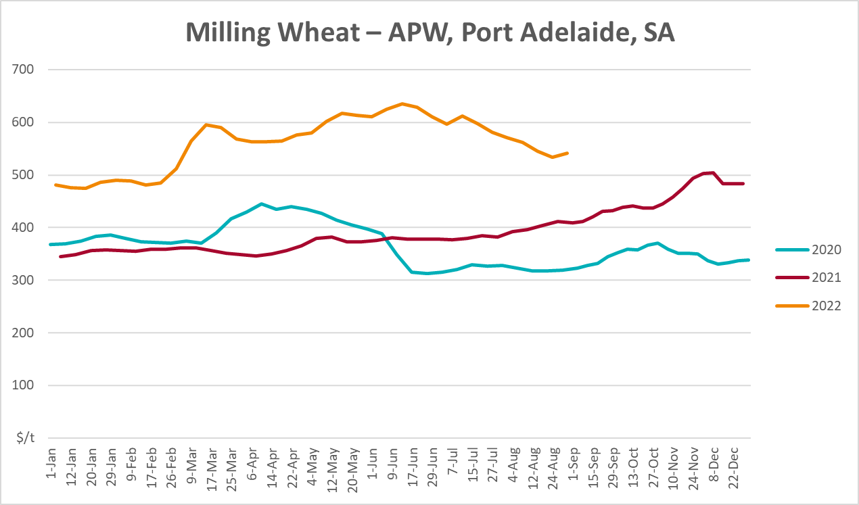
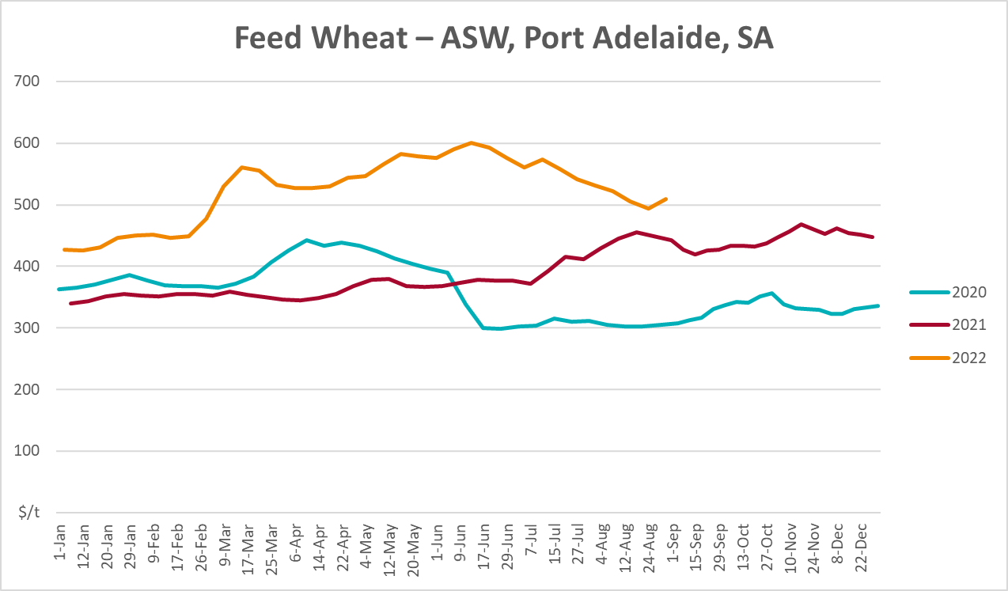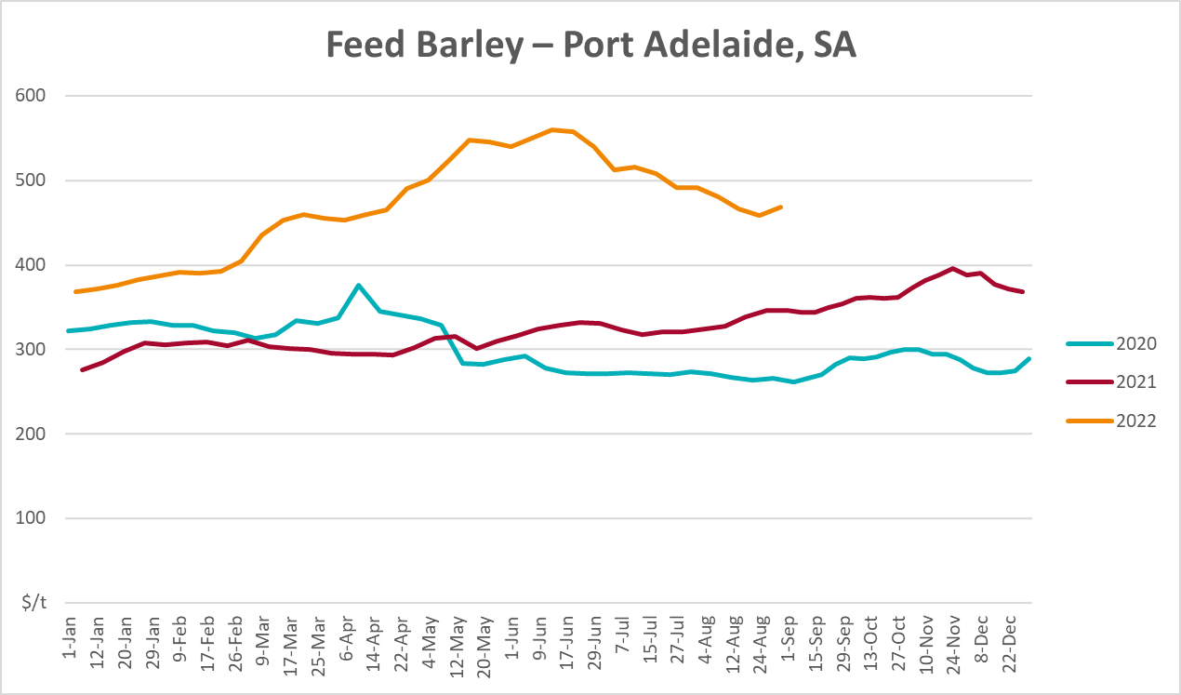
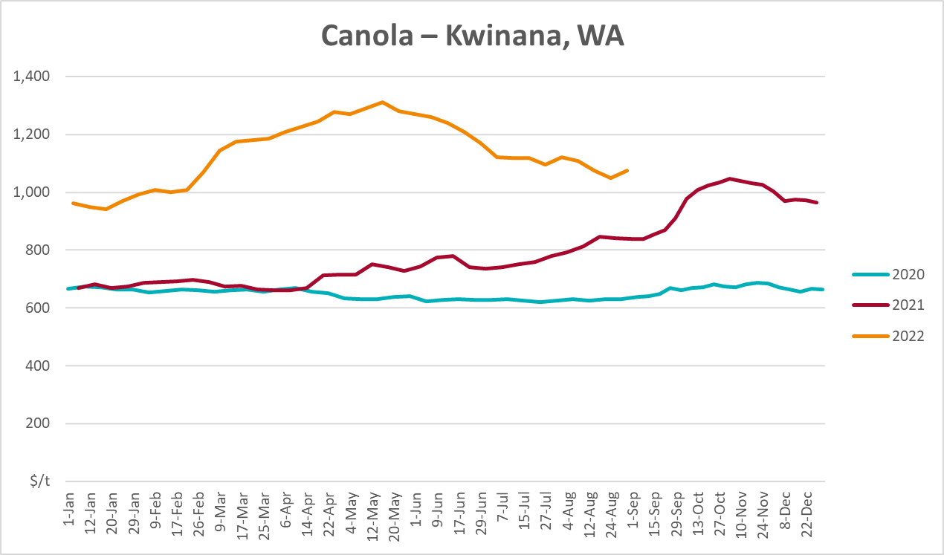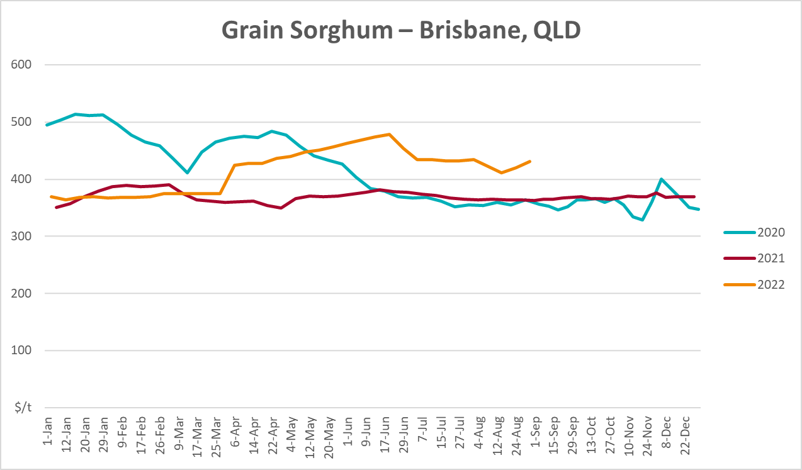

Selected domestic livestock indicator prices
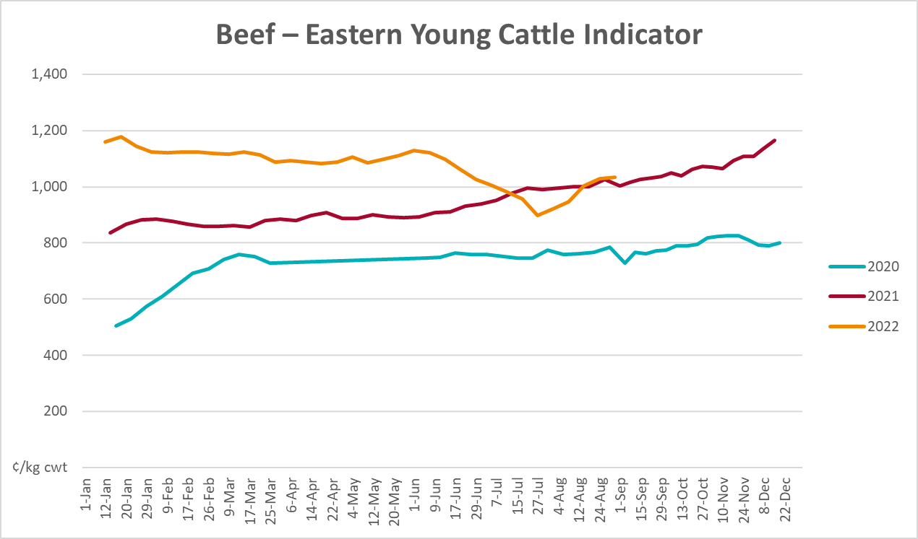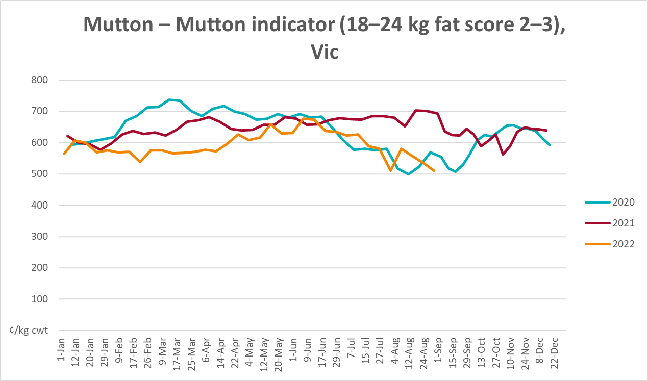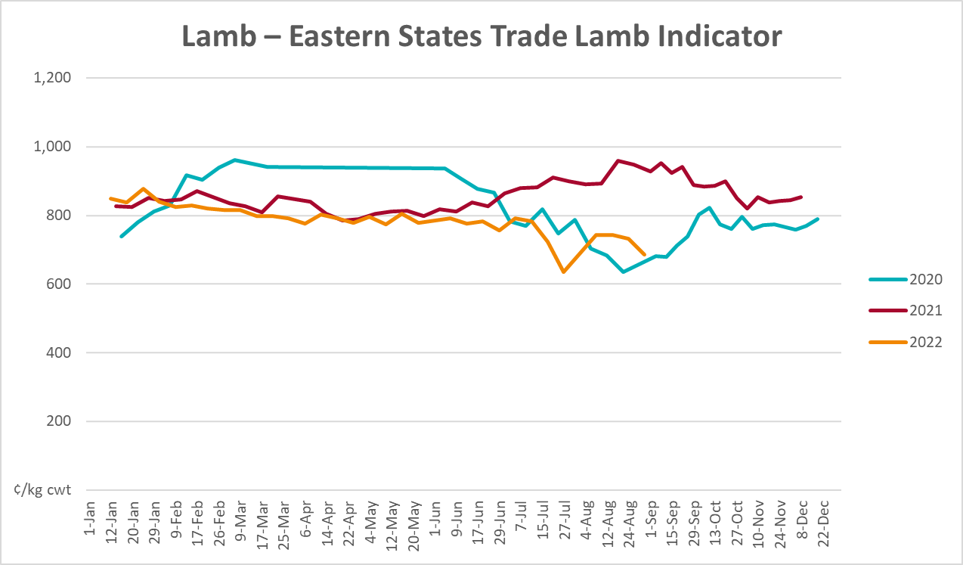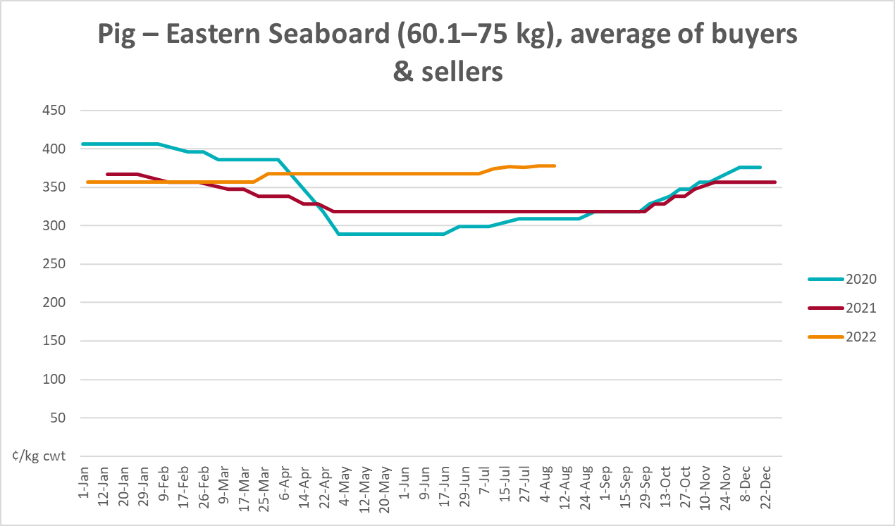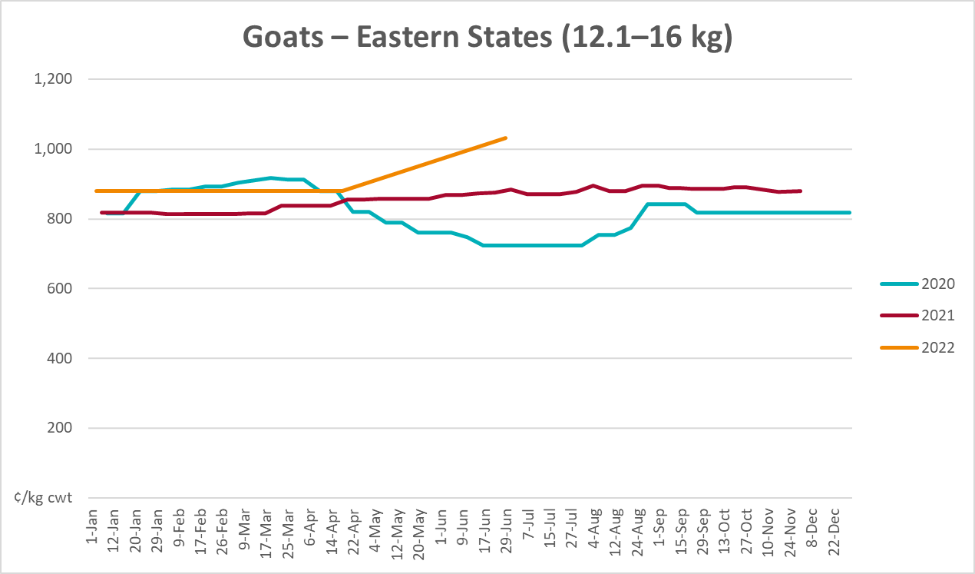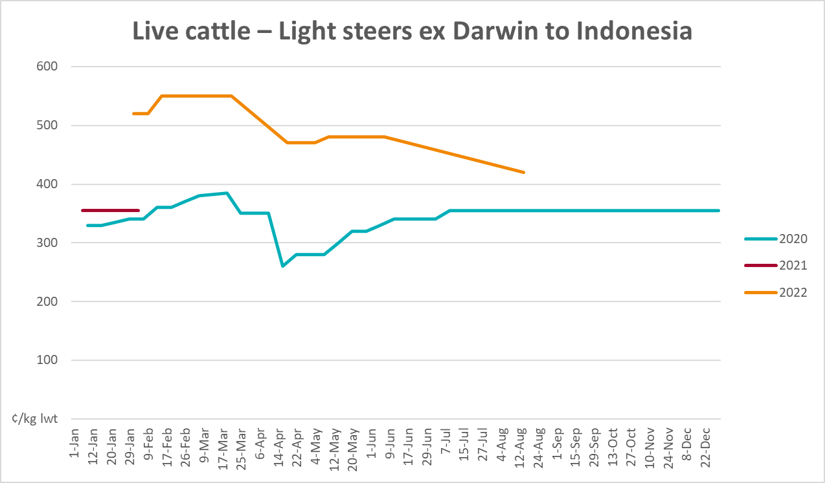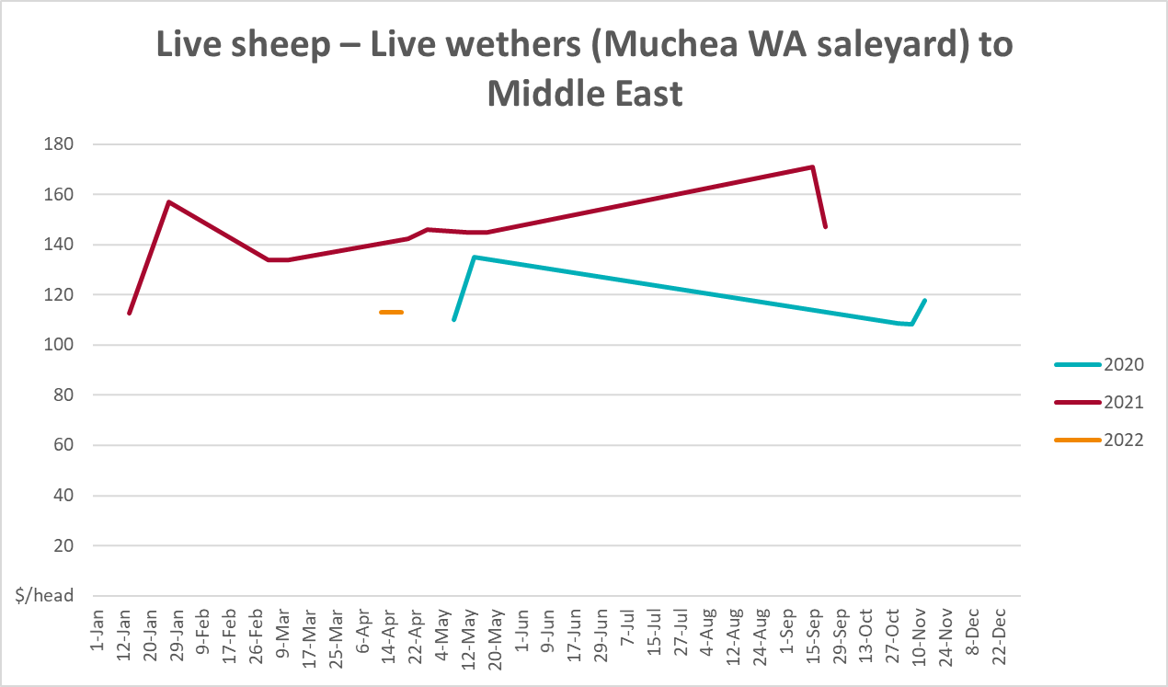

Global Dairy Trade (GDT) weighted average prices
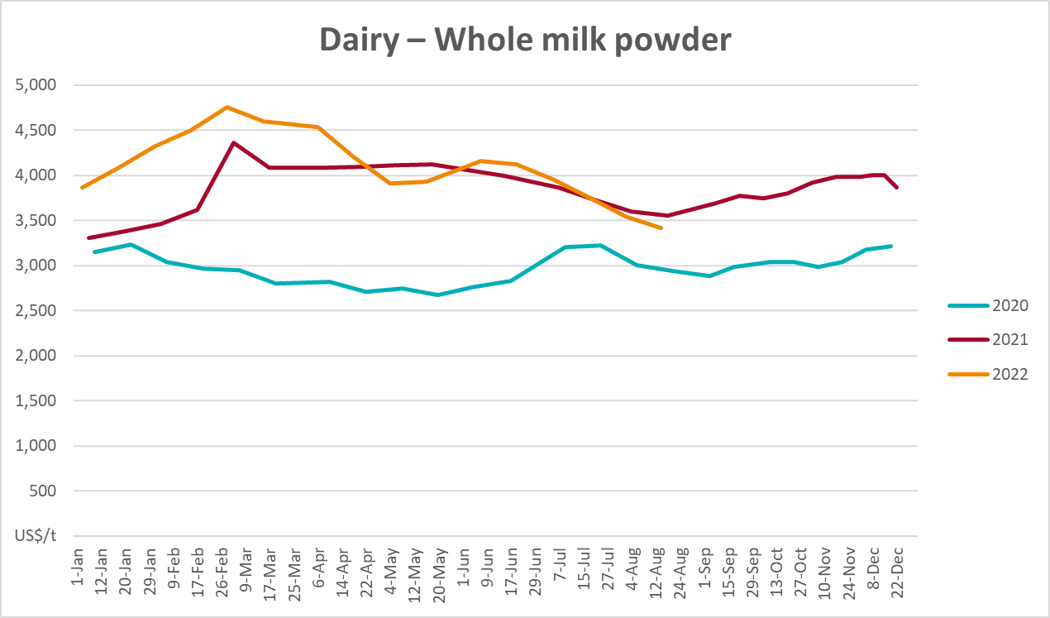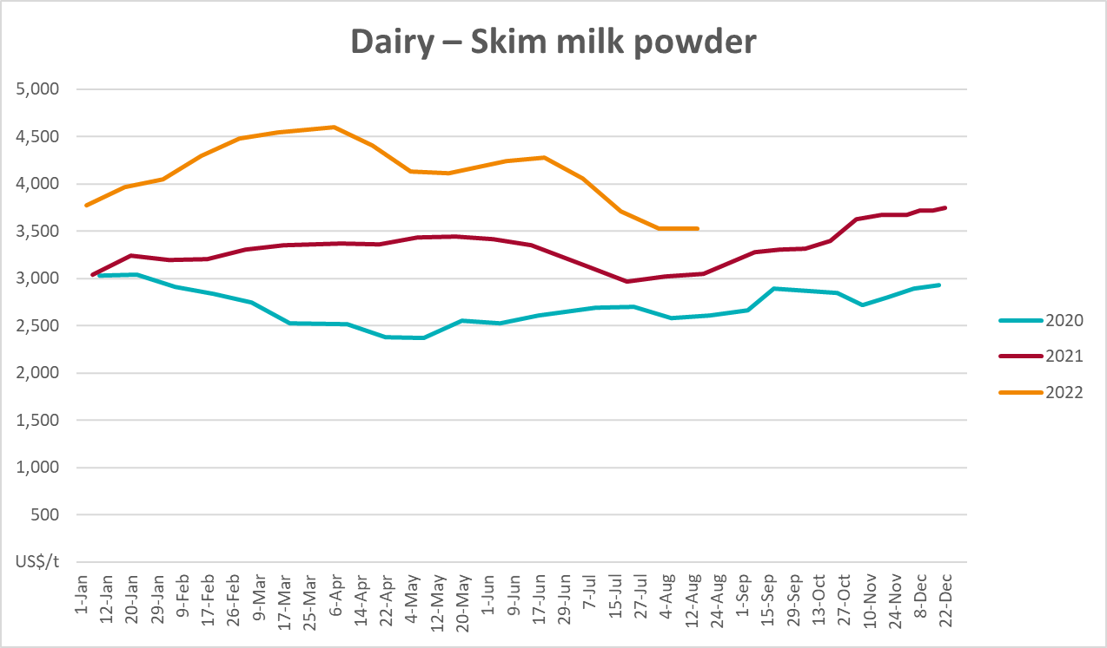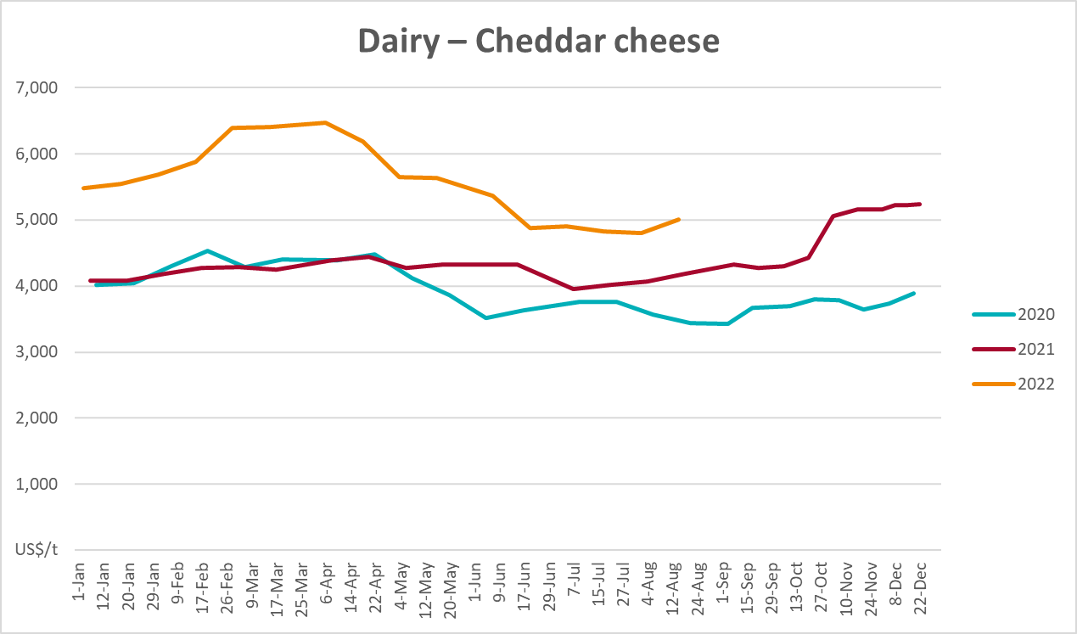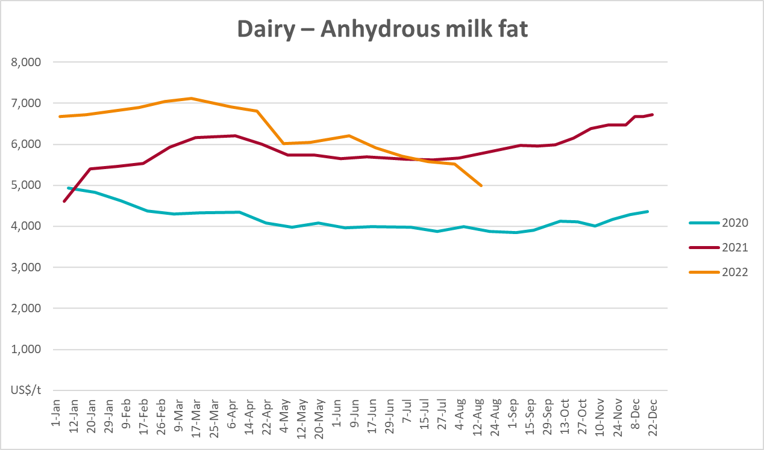

Selected fruit and vegetable prices
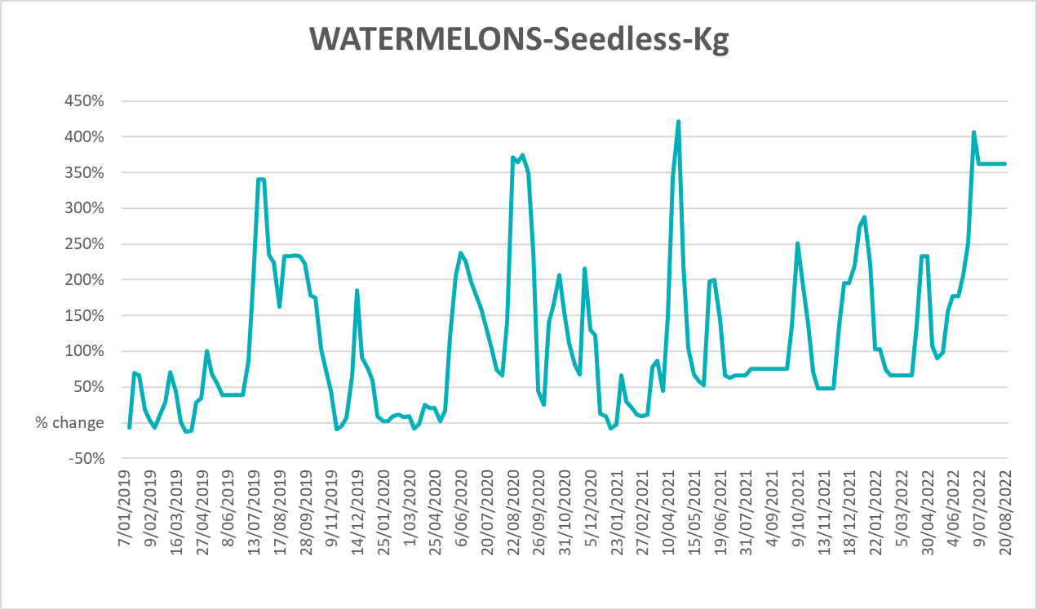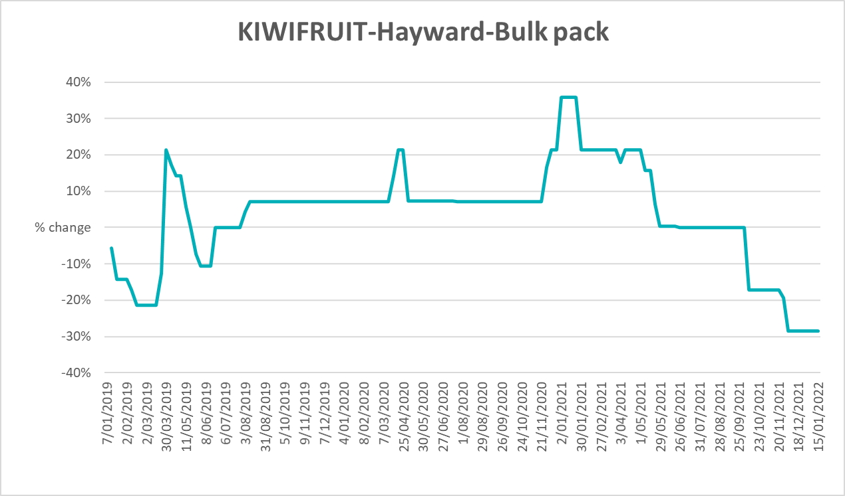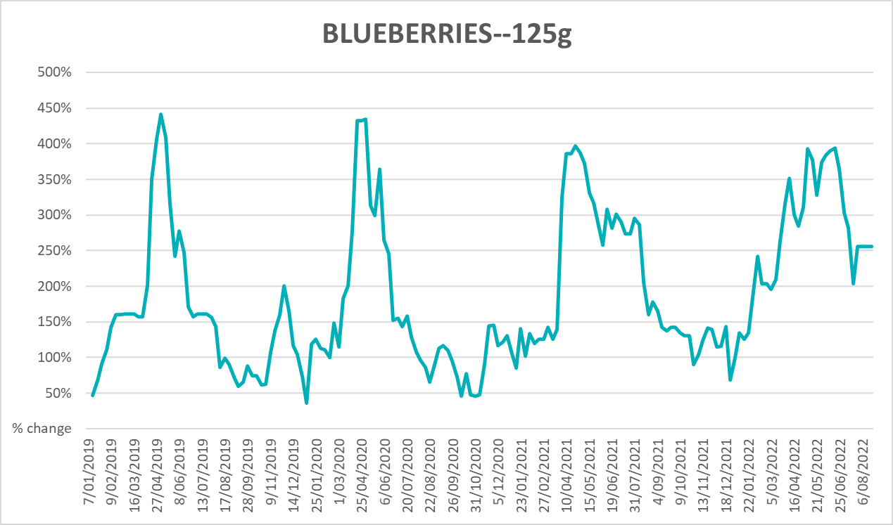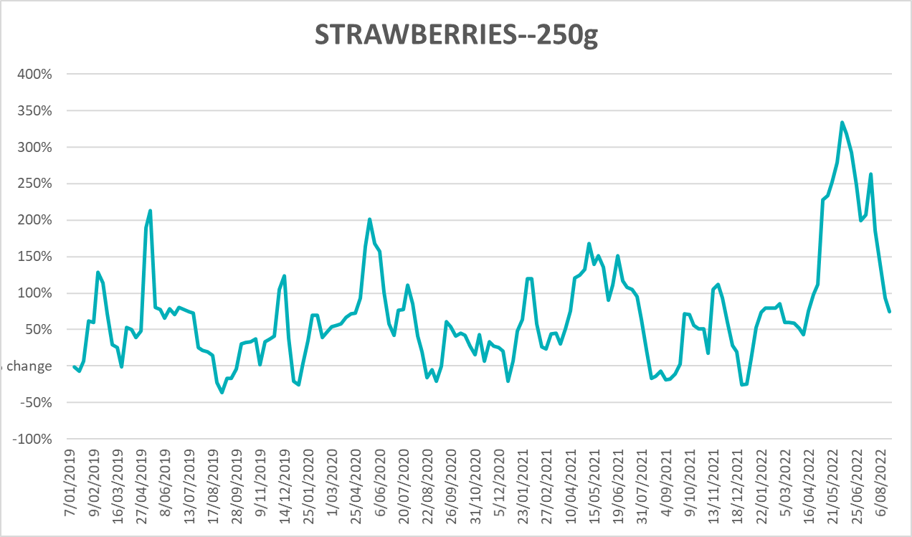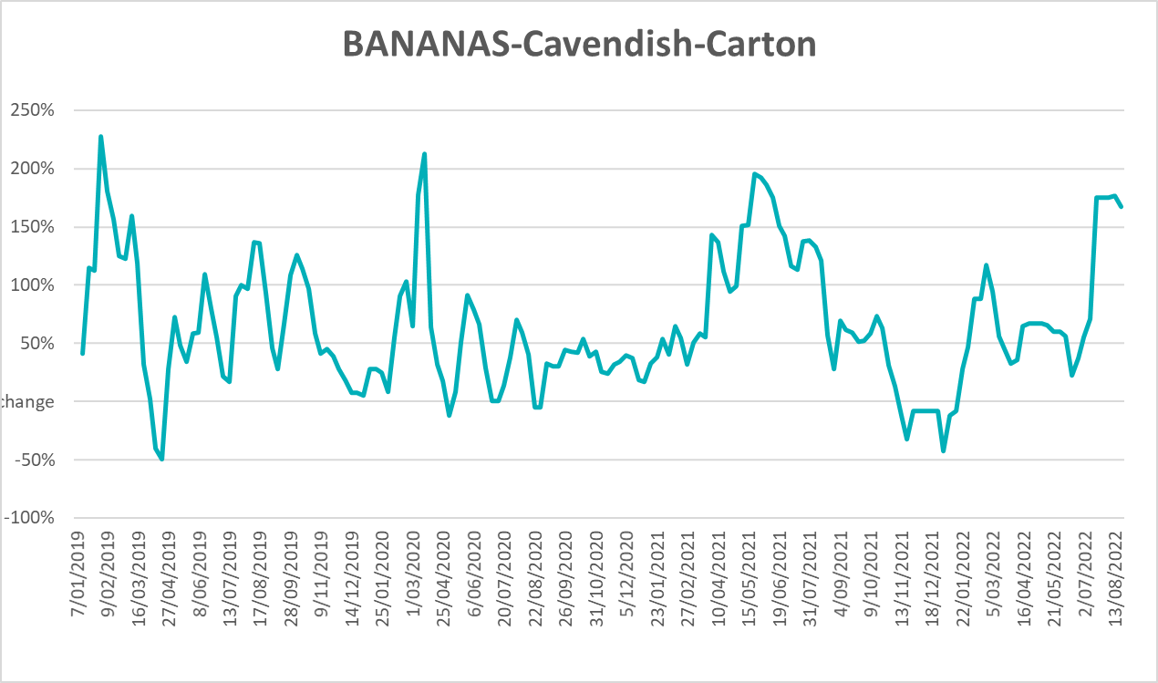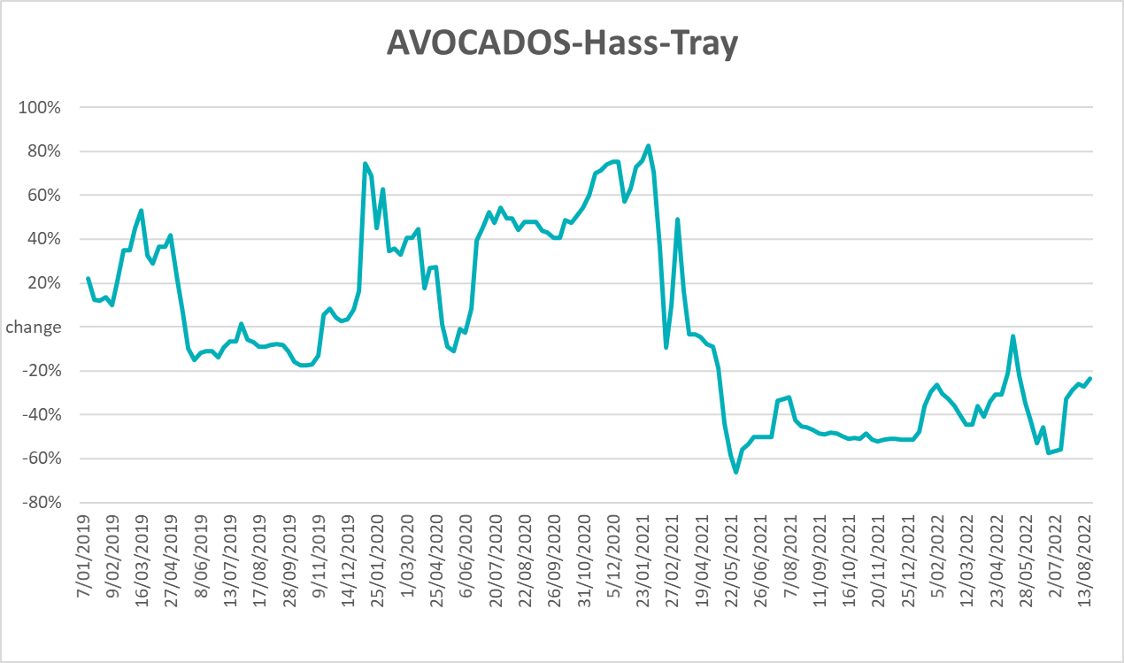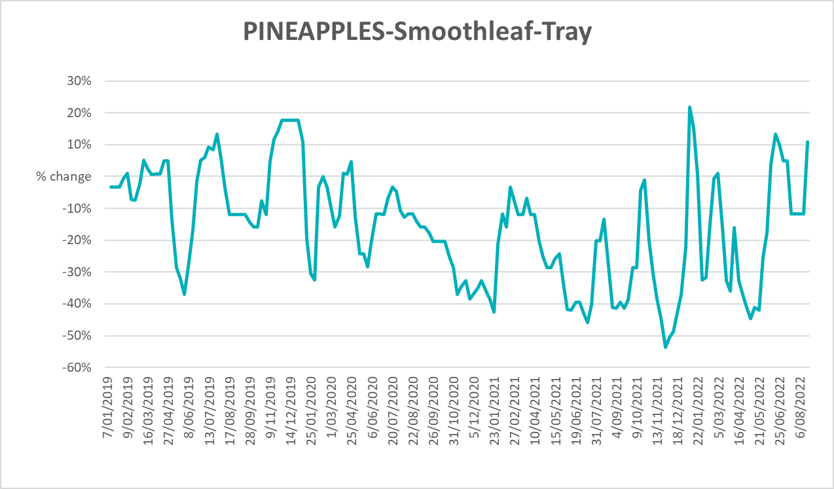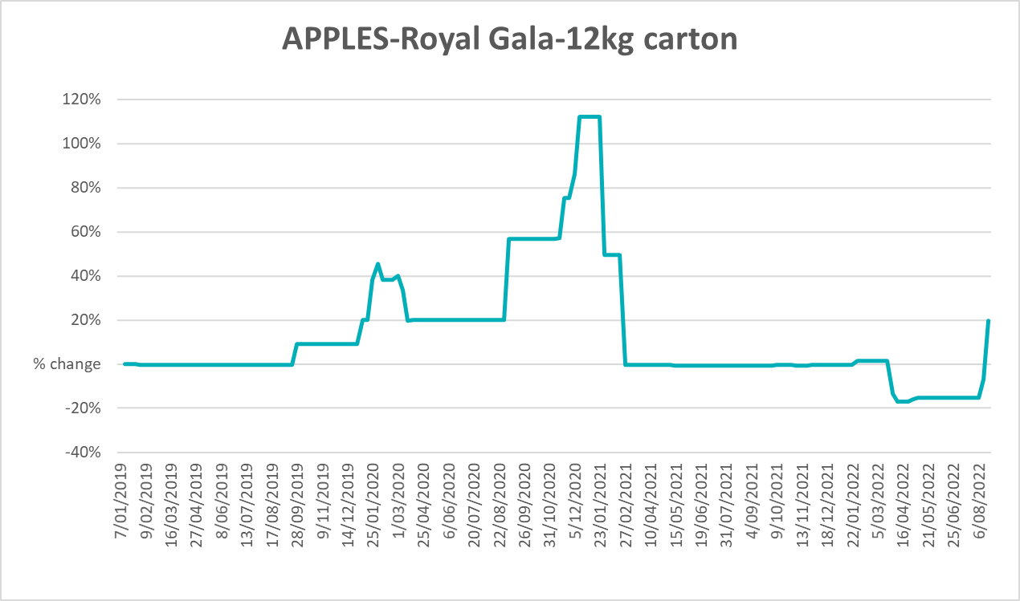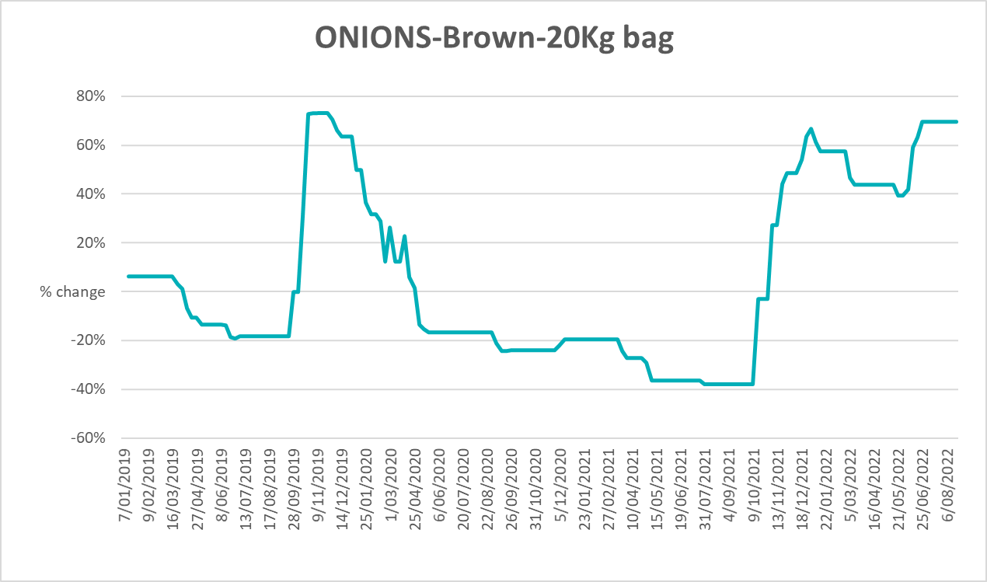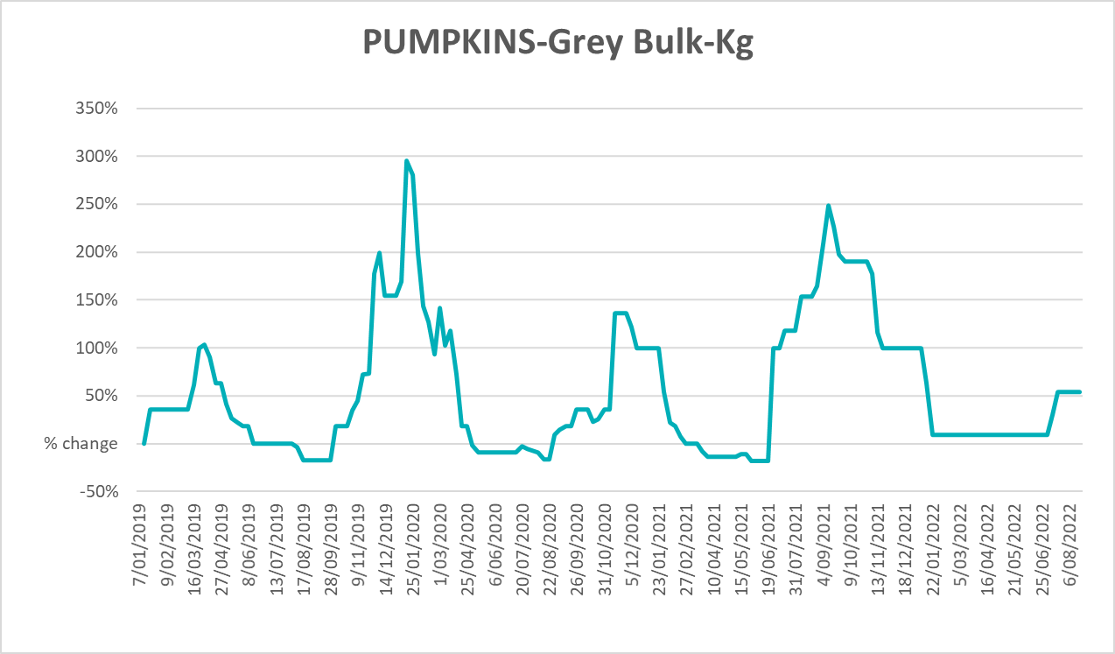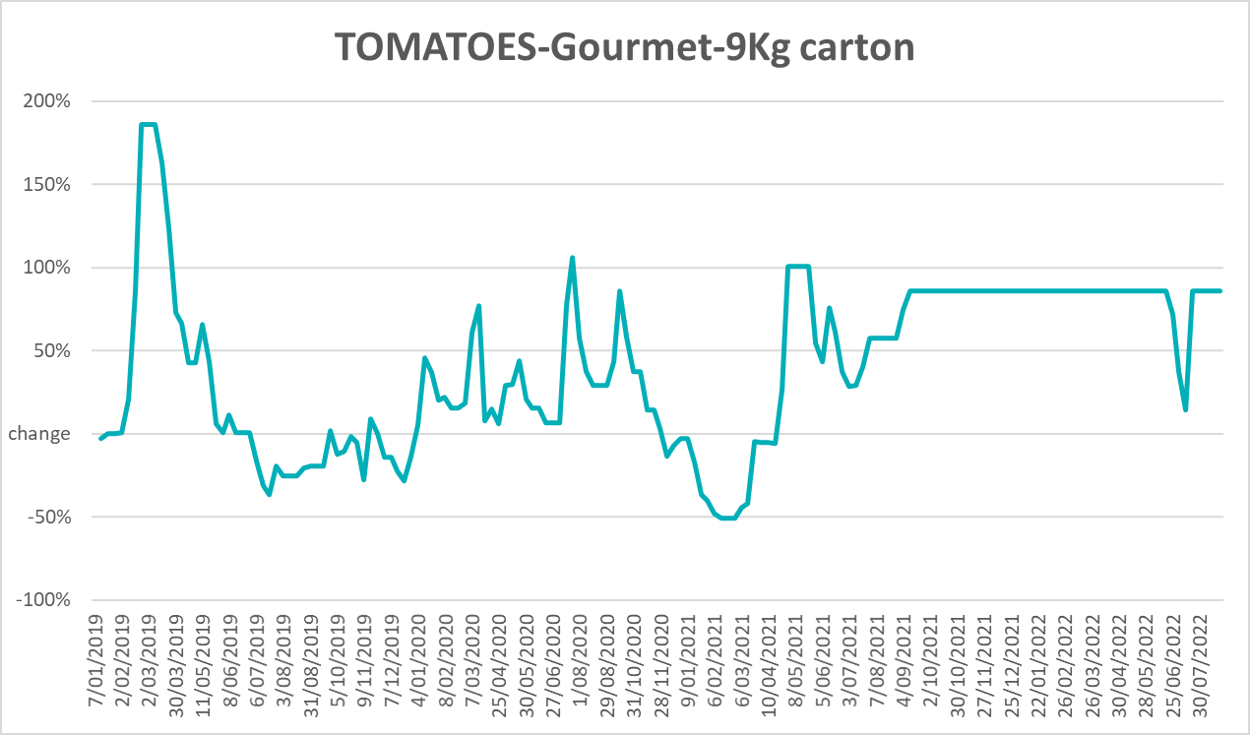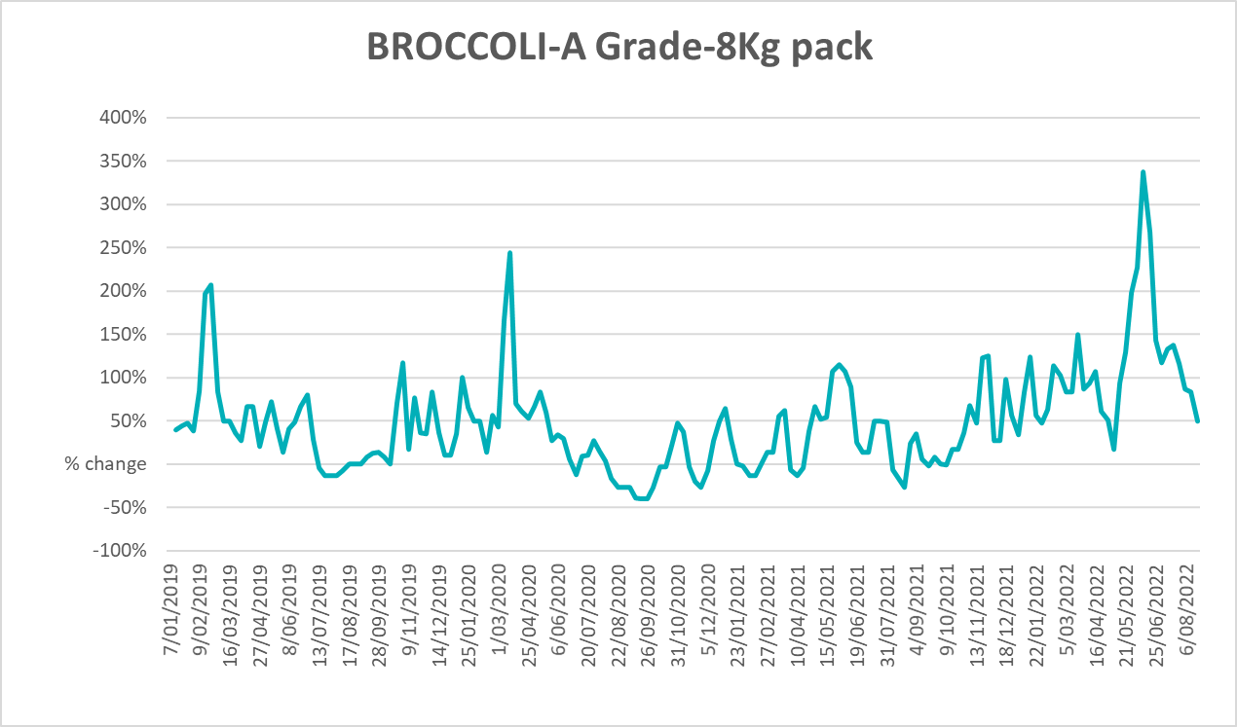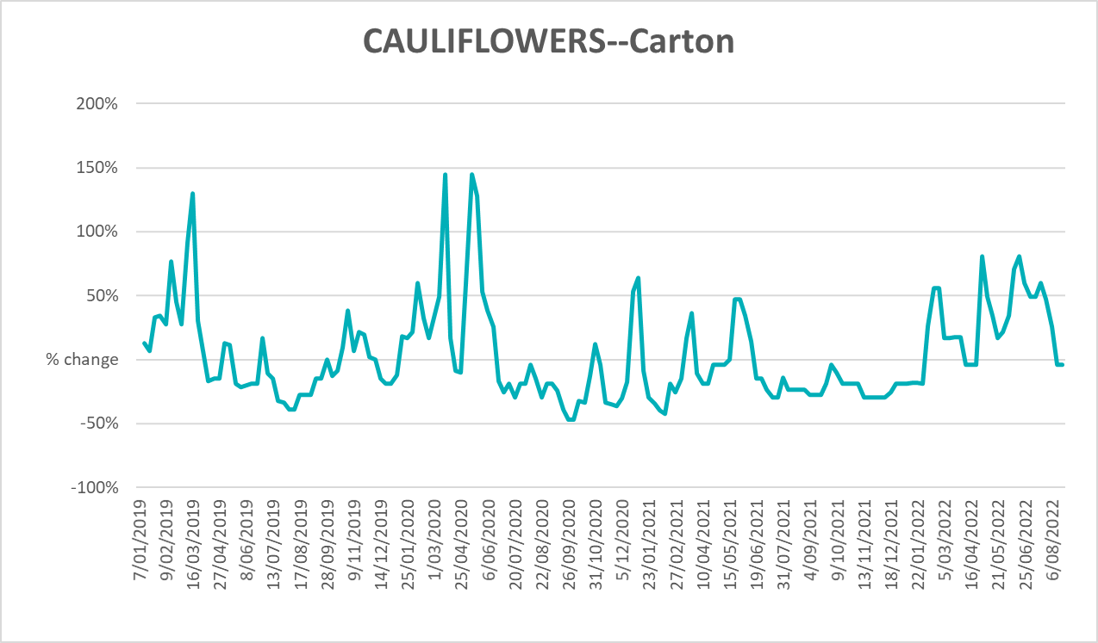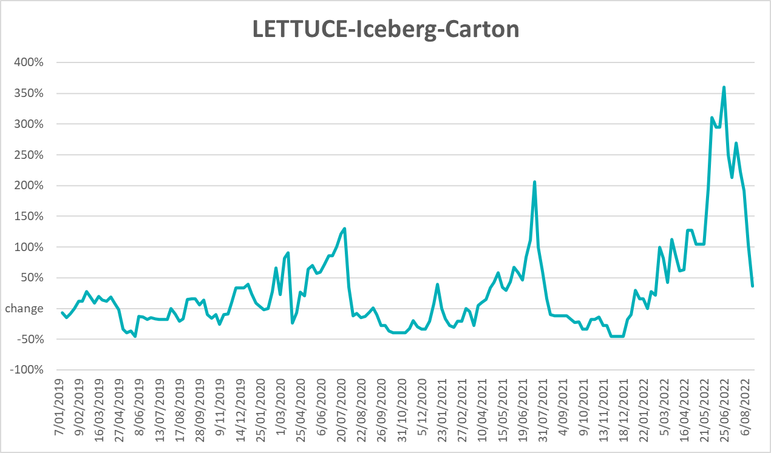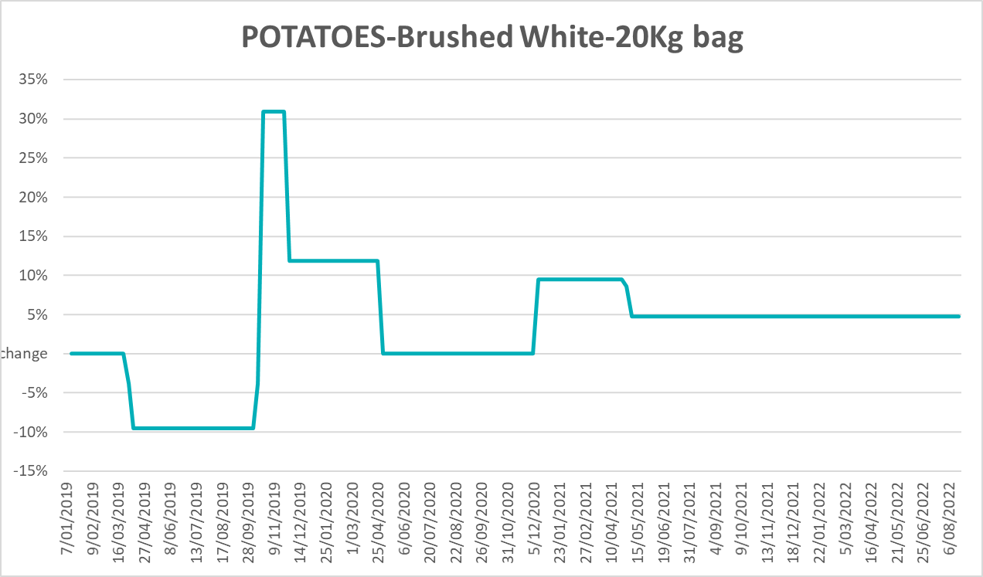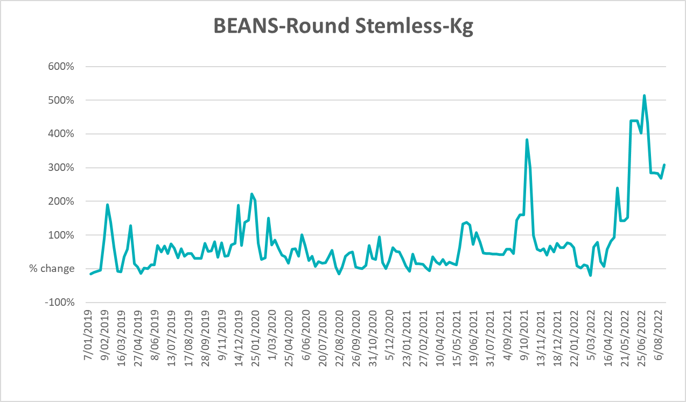

Selected domestic fodder indicator prices
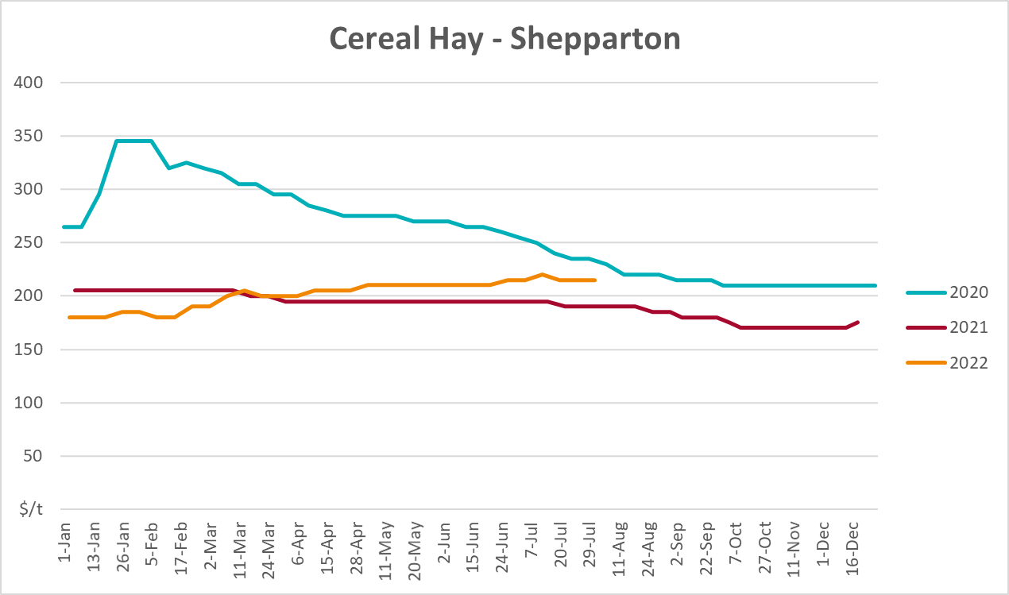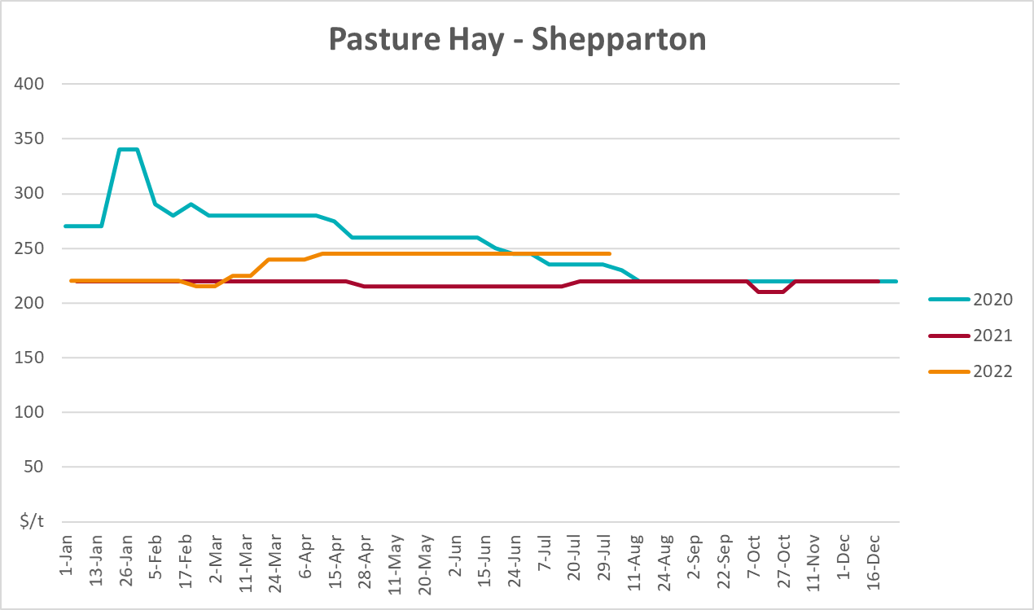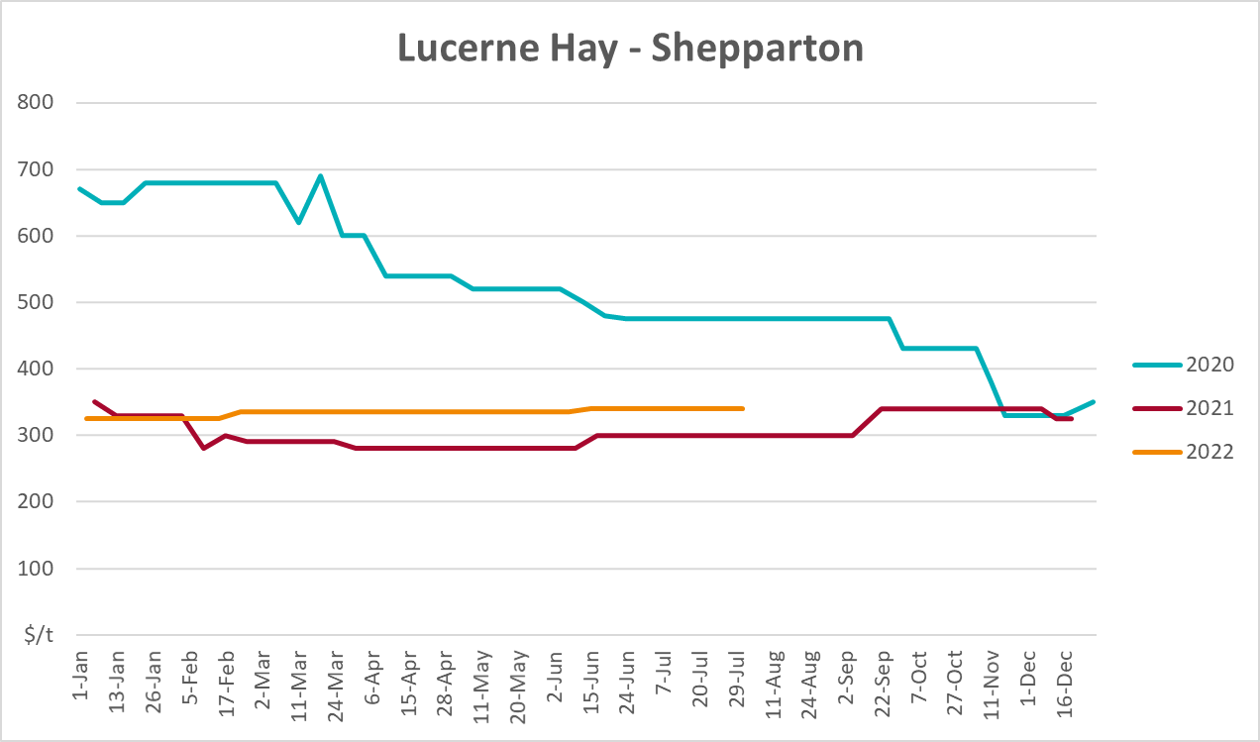

Data attribution

Climate
Bureau of Meteorology
- Weekly rainfall totals: www.bom.gov.au/climate/maps/rainfall/
- Monthly and last 3-month rainfall percentiles: www.bom.gov.au/water/landscape/
- Temperature anomalies: www.bom.gov.au/jsp/awap/temp/index.jsp
- Rainfall forecast: www.bom.gov.au/jsp/watl/rainfall/pme.jsp
- Seasonal outlook: www.bom.gov.au/climate/outlooks/#/overview/summary/
- Climate drivers: http://www.bom.gov.au/climate/enso/
- Soil moisture: www.bom.gov.au/water/landscape/
Other
- Pasture growth: www.longpaddock.qld.gov.au/aussiegrass/
- 3-month global outlooks: Environment and Climate Change Canada, NOAA Climate Prediction Center, EUROBRISA CPTEC/INPE, European Centre for Medium-Range Weather Forecasts, Hydrometcenter of Russia, National Climate Center Climate System Diagnosis and Prediction Room (NCC), International Research Institute for Climate and Society
- Global production: https://ipad.fas.usda.gov/ogamaps/cropmapsandcalendars.aspx
- Autumn break: Pook et al., 2009, https://rmets-onlinelibrary-wiley-com.virtual.anu.edu.au/doi/epdf/10.1002/joc.1833

Water
Prices
- Waterflow: https://www.waterflow.io/
- Ruralco: https://www.ruralcowater.com.au/
Bureau of Meteorology:
- Allocation trade: http://www.bom.gov.au/water/dashboards/#/water-markets/mdb/at
- Storage volumes: http://www.bom.gov.au/water/dashboards/#/water-storages/summary/drainage
Trade constraints:
- Water NSW: https://www.waternsw.com.au/customer-service/ordering-trading-and-pricing/trading/murrumbidgee
- Victorian Water Register: https://www.waterregister.vic.gov.au/TradingRules2019/

Commodities
Fruit and vegetables
- Datafresh: www.freshstate.com.au
Pigs
- Australian Pork Limited: www.australianpork.com.au
Dairy
- Global Dairy Trade: www.globaldairytrade.info/en/product-results/
World wheat, canola
- International Grains Council
World coarse grains
- United States Department of Agriculture
World cotton
- Cotlook: www.cotlook.com/
World sugar
- New York Stock Exchange - Intercontinental Exchange
Wool
- Australian Wool Exchange: www.awex.com.au/
Domestic wheat, barley, sorghum, canola and fodder
- Jumbuk Consulting Pty Ltd: http://www.jumbukag.com.au/
Cattle, beef, mutton, lamb, goat and live export
- Meat and Livestock Australia: www.mla.com.au/Prices-and-market
© Commonwealth of Australia 2022

Ownership of intellectual property rights
Unless otherwise noted, copyright (and any other intellectual property rights, if any) in this publication is owned by the Commonwealth of Australia (referred to as the Commonwealth).

Creative Commons licence
All material in this publication is licensed under a Creative Commons Attribution 4.0 International Licence except content supplied by third parties, logos and the Commonwealth Coat of Arms.
Inquiries about the licence and any use of this document should be emailed to copyright@awe.gov.au.


Cataloguing data
This publication (and any material sourced from it) should be attributed as:
ABARES 2022, Weekly Australian Climate, Water and Agricultural Update, Australian Bureau of Agricultural and Resource Economics and Sciences, Canberra, 1 September 2022. CC BY 4.0 DOI: https://doi.org/10.25814/5f3e04e7d2503
ISSN 2652-7561
This publication is available at https://www.agriculture.gov.au/abares/products/weekly_update
Department of Agriculture, Fisheries and Forestry
GPO Box 858 Canberra ACT 2601
Telephone 1800 900 090
Web agriculture.gov.au/abares

Disclaimer
The Australian Government acting through the Department of Agriculture, Fisheries and Forestry, represented by the Australian Bureau of Agricultural and Resource Economics and Sciences, has exercised due care and skill in preparing and compiling the information and data in this publication. Notwithstanding, the Department of Agriculture, Fisheries and Forestry, ABARES, its employees and advisers disclaim all liability, including liability for negligence and for any loss, damage, injury, expense or cost incurred by any person as a result of accessing, using or relying on any of the information or data in this publication to the maximum extent permitted by law.

Statement of Professional Independence
The views and analysis presented in ABARES publications, including this one, reflect ABARES professionally independent findings, based on scientific and economic concepts, principles, information and data. These views, analysis and findings may not reflect or be consistent with the views or positions of the Australian Government, or of organisations or groups who have commissioned ABARES reports or analysis. More information on professional independence is provided on the ABARES website.

Acknowledgements
This report was prepared by Matthew Miller and Cameron Van-Lane.

