Weeping Myall Woodlands

EPBC Act policy statement 3.17

Nationally threatened species and ecological communities guidelines

Department of the Environment, Water, Heritage and the Arts, September 2009

WHAT IS A NATIONALLY THREATENED ECOLOGICAL COMMUNITY?

An ecological community is a naturally occurring group of plants, animals and other organisms that are interacting in a unique habitat. Its structure, composition and distribution are determined by environmental factors such as soil type, position in the landscape, climate and water availability. Species within such communities interact and depend on each other – for example, for food or shelter. Examples of communities listed under Australia’s national environmental law include woodlands, grasslands, shrublands, forests, wetlands, ground springs and cave communities.

Together with threatened species, ecological communities listed under Australia’s national environmental law, the EPBC Act, are protected as one of several matters of National Environmental Signiﬁcance. Threatened ecological communities can be listed as critically endangered, endangered or vulnerable, categories which represent their decline and potential for extinction across their national extent. Protection through the EPBC Act is vital for some ecological communities because many patches often occur outside conservation reserves. National listing of an ecological community recognises that its long-term survival is under threat. The listing aims to prevent any further decline and to promote and assist recovery through landholder and community efforts.

As well as being important because of their unique biodiversity and place within the Australian landscape, ecological communities provide a range of ecosystem services, including the natural management of water, air and soil nutrients, the reduction of erosion and salinity and carbon storage. In addition to providing vital connections for wildlife corridors and habitat refuge for many threatened plant and animal species, they also contribute to tourism, recreation and the productivity of our farmlands. Beneﬁts to farmers include pollination of agricultural plants, healthy soils leading to improved crop yields, management of water tables, run-off and soil born microbes releasing minerals for plant uptake.

More information on nationally threatened ecological communities can be found at: http://www.environment.gov.au/biodiversity/threatened/index.html

WHAT IS THE WEEPING MYALL WOODLANDS ECOLOGICAL COMMUNITY?

The Weeping Myall Woodlands is an endangered ecological community listed under the EPBC Act.

Weeping Myall Woodlands occur in a range of forms from open woodlands to woodlands, in which weeping myall (Acacia pendula) trees are the sole or dominant overstorey species. Although weeping myall trees are often the only tree species in these woodlands, other trees can occur in the overstorey of the ecological community.

The understorey of Weeping Myall Woodlands often includes an open layer of shrubs above an open ground layer of grasses and herbs, though the ecological community can exist naturally as either a shrubby, or grassy woodland.

- The Weeping Myall Woodlands endangered ecological community only now exists as small remnants within its broad range.
- Travelling stock routes and reserves contain some of the best remaining patches of Weeping Myall Woodlands.
- Implementing favourable land use and management practices is essential at sites containing this ecological community.
- Setting aside this ecological community is encouraged, for long term protection for future generations to experience.

HOW DO I KNOW IF I AM STANDING IN A PATCH OF THE WEEPING MYALL WOODLANDS?

This guide is designed to help you determine if a native vegetation remnant could be part of the listed Weeping Myall Woodlands ecological community. The description and condition thresholds of the ecological community in the EPBC listing advice provide a deﬁnitive source of information for identifying a nationally threatened ecological community. The description in the listing advice is summarised in the following pages.
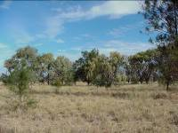
A patch of the listed ecological community is deﬁned as a discrete and continuous area that comprises the ecological community. It does not include substantial elements of other ecological communities, such as inland grasslands and other types of woodlands. However, a patch of the listed ecological community may include small-scale disturbances, such as tracks or breaks that do not alter its overall functionality, for instance, the easy movement of wildlife or dispersal of plant spores and seeds.

If a native vegetation remnant meets all of the criteria that follow, then you are likely to be standing in the nationally listed threatened ecological community. Assistance with identiﬁcation of species may be obtained from your local council, community Landcare group, Catchment Management Authority (see page 8), state agency or other vegetation expert.

Where should a woodlands patch be located?

- The Weeping Myall Woodlands occurs on the inland alluvial plains west of the Great Dividing Range in NSW and QLD. It occurs in the Riverina, NSW South Western Slopes, Darling Riverine Plains, Brigalow Belt South, Murray-Darling Depression, Nandewar and Cobar Peneplain Interim Biogeographic Regionalisation for Australia (IBRA) bioregions.
- The ecological community generally occurs on ﬂ at areas, shallow depressions or gilgais on raised alluvial plains. These areas are not associated with active drainage channels and are rarely, if ever, ﬂooded. The ecological community occurs on black, brown, red-brown or grey clay or clay loam soils.
- Most areas remaining in the best condition are in lightly-grazed, uncropped sites such as road reserves and Travelling Stock Routes and Reserves. There may be considerable variation in the composition of individual stands of the listed community within any given bioregion. IBRA is the National Reserve System’s planning framework. Gilgai microrelief is formed due to clay horizons shrinking and swelling with alternate drying and wetting cycles. Each cycle of swelling, shrinkage and cracking becomes more exaggerated and the landscape eventually becomes covered by a repeated pattern of mounds and depressions. The depressions are gilgais which become ﬁlled with water during the wet seasons. (Vic DPI/CSIRO/QLD EPA)

What is the native vegetation like?

- The Weeping Myall Woodlands range from open woodlands to woodlands, generally 4 to 12m high. The overstorey is dominated by weeping myall (Acacia pendula) trees and in some cases this species may be the only tree canopy species. Other common names for weeping myall include myall, boree, balaar, nilyah, bastard gidgee, and silver leaf boree.
- Other woodland species may also form part of the overstorey of the ecological community. These include: western rosewood (Alectryon oleifolius subsp. elongatus); poplar box (Eucalyptus populnea); or black box (Eucalyptus largiﬂ orens). Grey mistletoe (Amyema quandang) commonly occurs on the branches of weeping myall trees throughout the ecological community’s range.
- The Weeping Myall Woodlands ecological community can naturally occur either as a grassy or a shrubby woodland. However, the understorey often includes an open layer of shrubs over a ground layer which includes a diversity of grasses and forbs. The ground layers can vary in species composition and cover depending on past and current grazing regimes, and the occurrence of recent rain.
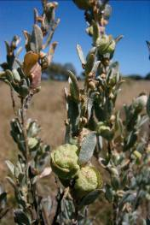
- There are more than 80 species of plants that could be part of the ecological community. A list of species typically found in the ecological community can be found in the listing advice on SPRAT. Go to the Weeping Myall Woodlands ‘Details’ link, then view ‘Further Information’:www.environment.gov.au/cgi-bin/sprat/public/publiclookupcommunities.pl
- Weeping Myall Woodlands can vary in structure throughout its range. In higher rainfall areas it typically forms an open woodland. As rainfall decreases the ecological community becomes increasingly restricted, tending to sparse or scattered stands of woodland occurring in discrete bands fringing better-watered country. It can also occur as relatively narrow strips on the margins of ﬂoodplain woodland and on minor depressions or run-on areas adjacent to sandhills.

Condition thresholds
- the patch of woodland must be at least 0.5 ha (5000 m²) in size
- the overstorey must have at least 5 per cent tree canopy cover or at least 25 dead or defoliated mature weeping myall trees per hectare
- the tree canopy must be dominated (at least 50 per cent of trees present) by living, dead or defoliated weeping myall trees, and
- the patch has more than two layers of regenerating weeping myall present, or
- the tallest layer of living, dead or defoliated weeping myall trees is at least 4 m tall and of the vegetative cover (shrub and ground layers) present, 50 per cent is comprised of native species, and
- areas of leaf litter and cryptogams (e.g. lichens, mosses) or soil crusts may be evident and acceptable as part of the ground layer of this ecological community.

Areas that have a total absence of native species in the understorey are considered to be so highly degraded that they cannot be returned to a state in which they could be considered part of the listed ecological community. Patches that consist of single paddock trees with no native understorey are generally excluded (where the above condition thresholds have not been met).

Although these trees are excluded from the listed ecological community, they retain their importance as habitat for many species, and could be managed with the goal of improving fauna habitat. Therefore, patches that do not meet the condition thresholds should be conserved, taking into account their context within the surrounding environment. For example: patches that link native vegetation remnants in the landscape are particularly important as wildlife habitat and to the viability of listed patches of the ecological community. Both patches that meet the condition thresholds and those that do not should also be considered in recovery and other management actions, including through the Australian Government’s Caring for Our Country initiative (see page 18).

Assessment considerations

The Weeping Myall Woodlands ecological community can be variable in its appearance because it mostly occurs in semi-arid environments. Therefore the ﬂowering of the species present is driven more by rainfall events than by the time of year. The result is that some species may not ﬂower every year whereas others may ﬂower twice in the one year. The woodland may vary from site to site, depending on land management practices and the history of disturbances.

Assessment of a patch should be done wherever possible when 10 per cent or more of the area is covered with either native or exotic vegetation, whether dead or alive (this accounts for situations such as drought). Ideally, the minimum plot size for determining the presence of the ecological community should be 0.04 ha (i.e. 20 m x 20 m). The number of plots (or transects) per patch should take into consideration the size, shape and quality across the site.

Assessment timing should be related to rainfall patterns so that it coincides with ﬂowering of the understorey species wherever possible. For example; in areas such as the southern extent of the community (south of the mid-Lachlan region), sufficient rainfall to stimulate ﬂowering is more likely in winter. This is because the southern extent is dominated by winter growing grass species (wallaby grasses – Austrodanthonia species) and chenopods (saltbushes, native cotton bushes, bluebushes and goosefoots) that respond to winter rainfall. However, in the northern extent of the community, the understorey is dominated by grass species such as Mitchell grass – Astrebla spp. and Queensland blue grass – Dichanthium sericeum which respond to summer rainfall.

Decision flowchart

The ﬂowchart on page 7 represents the lowest condition at which patches are included in the listed ecological community. This is not the ideal state of the ecological community. Large patches, those that link remnants in the landscape, those that occur in highly cleared areas, those that contain rare, declining or threatened species, and those that represent the entire range of the ecological community, are important for the long-term future of the ecological community.

Weeping Myall Woodlands – Decision Flowchart

Are there Weeping Myall trees on the property? | NO | Not the listed ecological community
YES
Does the patch* have a native understorey? | NO | Not the listed ecological community
YES
Does the patch* have at least 5% tree canopy cover or at least 25 dead or defoliated mature Weeping Myall trees per hectare? | NO | Not the listed ecological community
YES
Is the tree canopy dominated (at least 50%) by living, dead or defoliated Weeping Myall trees? | NO | Not the listed ecological community
YES
Is the patch* 0.5 hectares or greater in size? | NO | Not the listed ecological community
YES
Does the patch have more than two layers of regenerating Weeping Myall present? | NO | Is the tallest layer of living, dead or defoliated Weeping Myall trees at least 4 metres tall and of the vegetative cover present (shrub layer and ground cover), is at least 50% composed of native species?
YES |  | NO | YES
The listed ecological community |  | Not the listed ecological community | The listed ecological community

Definitions
* A patch is defined as a continuous area that entirely consists of an ecological community. Substantial areas of other ecological communities such as woodlands dominated by other species are not included in a patch. The patch extends over the area up to 10 m beyond the drip line (the edge of the foliage canopy) of the outermost trees where the understorey criteria are satisfied. Assessment of a patch should be done wherever possible when 10 per cent or more of the area is covered with either native or exotic vegetation, whether dead or alive, (this accounts for situations such as drought). Assessment timing must also consider the flowering of the understorey species to aid identification. For example; in areas where winter rainfall is more likely, such as the southern extent of the community, sampling should be performed following these rainfall events. However, in areas where summer rainfall is more likely, such as the northern extent of the community, sampling should be planned for late summer.
† Areas of leaf litter cryptogams and biological soil crusts may be evident and acceptable as part of the native understorey of this ecological community.
Where is the ecological community found?

The Weeping Myall Woodlands generally occurs on the inland alluvial plains west of the Great Dividing Range in NSW and QLD. It occurs on ﬂat areas, shallow depressions or gilgais on raised (relict) alluvial plains. These areas are not associated with active drainage channels and are rarely if ever ﬂooded. The ecological community occurs on black, brown, red-brown or grey clay or clay loam soils.
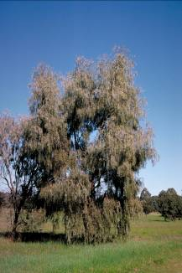
Weeping Myall Woodlands are found in the following Natural Resource Management/Catchment Management Authority Regions:
Murray CMA, NSW
Murrumbidgee CMA, NSW
Lachlan CMA, NSW
Central West CMA, NSW
Namoi CMA, NSW
Border-Rivers-Gwydir CMA, NSW
Queensland Murray Darling Committee NRM, QLD (Border Rivers & Maranoa Balonne)
Condamine NRM, QLD
Fitzroy Basin Committee NRM, QLD
South West QLD NRM, QLD
Burnett Mary NRM, QLD

A high resolution map shows the range over which the Weeping Myall Woodlands may occur. It is not possible to prepare a precise map which shows all remnants of the woodlands. This is because many remnants are now limited to very small, disparate and fragmented patches that cannot be shown on a map at this scale.

High resolution map - www.environment.gov.au/cgi-bin/sprat/public/publicshowcommunity.pl?id=98

The description and condition thresholds of the ecological community in the listing advice are always the deﬁnitive source of information for identifying a nationally threatened ecological community at a particular site and any mapped vegetation units should only be used as a guide.

The ecological community is highly fragmented and estimated to have reduced by more than 90% from its pre-European extent.

Some Key Flora Species

Acacia pendula (weeping myall) trees are the dominant overstorey species in the Weeping Myall Woodlands ecological community. As weeping myall trees are often the only tree species present in the ecological community, this makes it a strong indicator of community integrity. This tree species goes through regular cycles of senescence (aging and death) and regeneration. Therefore, the ecological community can be dominated by weeping myall trees that are in a living, defoliated or dead state (not considered to be an indicator of poor condition).

In the southern part of the distribution of Weeping Myall Woodlands (south of the mid-Lachlan region), chenopods, such as saltbushes, native cotton bushes, bluebushes, goosefoots and copperburrs, were originally an important component of the understorey. As chenopods are generally highly palatable, they have largely disappeared in areas that have been grazed for substantial periods of time.
In the northern parts of the ecological community, chenopods are a less prominent component of the understorey and winter-growing grasses, such as wallaby grasses (Austrodanthonia species), are also less common. Summer-growing grasses, such as Mitchell grass (Astrebla spp.) and Queensland blue grass (Dichanthium sericeum), are more abundant than in the south.

The following photos are a guide for identifying some of the key species of the Weeping Myall Woodlands and show the different forms of the ecological community.

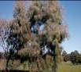  Acacia pendula Weeping Myall | 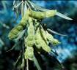  Acacia pendula Weeping Myall | 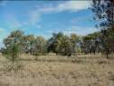  Weeping Myall Woodlands
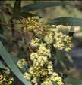  Eucalyptus largiflorens Black Box | 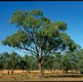  Eucalyptus largiflorens Black Box | 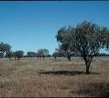  Weeping Myall Woodlands
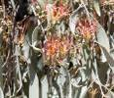  Amyema quandang Greay mistletoe | 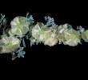  Maireana aphylla Bluebush | 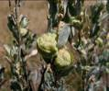  Atriplex vesicaria spp. Macrocystidia Bladder Saltbush
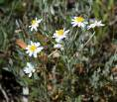  Rhodanthe corymbiflora | 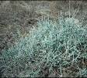  Sclerolaena stelligera Copperburr | 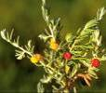  Enchylaena tomentosa

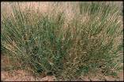  Dichanthium sericeum Queensland Blue Grass | 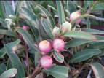  Eremophila debilis | 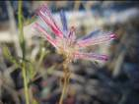  Ptilotus spp.
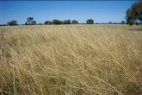  Themeda avenacea | 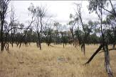  Weeping Myall Woodlands | 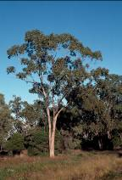  Eucalyptus populnea Poplar Box
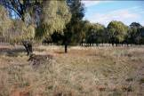  Weeping Myall Woodlands | 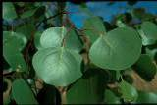  Eucalyptus populnea Poplar Box

State and other equivalents to the listed community?

The states in which the listed ecological community occurs, QLD and NSW, have equivalent vegetation types for Weeping Myall Woodlands and these are listed below. This list may enable land managers who are familiar with their own state’s vegetation classiﬁcation to identify whether the EPBC listed community may occur at a particular site.

Queensland:

Although the species Acacia pendula occurs widely in QLD, the Weeping Myall Woodlands ecological community is typically restricted to small patches that occur within two regional ecosystems in QLD:

11.3.2 Eucalyptus populnea woodland on alluvial plains, and

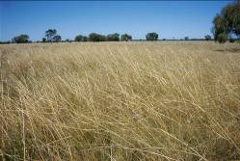
11.3.28 Casuarina cristata⁵ ± Eucalyptus coolabah open woodland on alluvial plains.

Both are categorised as ‘Of Concern’ under the Queensland Vegetation Management Act 1995. A description for each of the Regional Ecosystems is found at: http://www.epa.qld.gov.au/nature_conservation/biodiversity/regional_ecosystems

New South Wales:

The core distribution of the ecological community in NSW is thought to have been the Riverina bioregion. Weeping Myall Woodlands has been identiﬁ ed as two vegetation communities. These are:

- Vegetation Community ID 26: Weeping Myall open woodland of the Riverina and NSW South Western Slopes Bioregions, and

- Vegetation Community ID 27: Weeping Myall open woodland of the Darling Riverine Plains and Brigalow Belt South Bioregions.

The ecological community is listed as endangered under the NSW Threatened Species Conservation Act 1995 as ‘Myall Woodland in the Darling Riverine Plains, Brigalow Belt South, Cobar Peneplain, Murray-Darling Depression, Riverina and NSW South Western Slopes bioregions.’

A description can be found at: http://www.threatenedspecies.environment.nsw.gov.au/tsproﬁ le/proﬁ le.aspx?id=10973
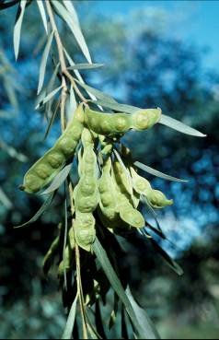
The Weeping Myall – Coobah – Scrub Wilga Shrubland of the Hunter Valley ecological community has been listed as critically endangered under the EPBC Act since 2005. This ecological community applies to one, two hectare patch at Jerry’s Plain, NSW. The Jerry’s Plain Weeping Myall community differs from the more widely spread Weeping Myall Woodlands ecological community as it is a naturally rare relict from a previous climate regime.

The co-dominance of wilga (Geijera spp.) in Weeping Myall – Coobah – Scrub Wilga Shrubland of the Hunter Valley as well as the presence of other species differentiates this community from Weeping Myall Woodlands ecological community.

Specific exemptions

Queensland:

Small patches of weeping myall trees may occur in Regional Ecosystems 11.9.3a and 4.9.6. However, these occurrences are on different landscape and soil types (undulating country on ﬁ ne grained sedimentary rocks) than regional ecosystems 11.3.2 and 11.3.28, which occur on alluvial plains. Accordingly, 11.9.3a and 4.9.6 are not considered to be part of the EPBC listed ecological community.

Victoria:

Acacia pendula is listed as a threatened species under the Victorian Flora and Fauna Guarantee Act 1988. Only three small natural stands remain. The current extent covers only a few hectares with the main stand being represented by only three mature trees and a small number of regenerating trees. As the Victorian occurrences of Weeping Myall Woodlands were very limited in extent and are presently degraded, they have been excluded from the Weeping Myall Woodlands ecological community at this point in time.

Fauna Species of Special Importance

The Weeping Myall Woodlands ecological community constitute a signiﬁcant habitat for native birds, mammals and invertebrates. The ecological community provides foraging, nesting and/or breeding habitat for a variety of these fauna species. The geographic position in the landscape of Weeping Myall Woodlands, places it at the interface of the semi-arid, sub-tropical and temperate zones. At least 123 terrestrial bird species are known to be found within this habitat type, either as residents, nomads or migrants.

Three prominent functional groupings can be recognised among the Weeping Myall Woodlands bird fauna:

- ground-dwelling species that forage and/or nest on the ground and rely on native grasses, herbs and woody debris (approximately 47 species)

- species that depend on tree-hollows for shelter or breeding (approximately 20 species), and

- insectivores that forage in the shrub layer • (approximately 23 species).

Some species, such as Superb Parrot, Black-faced Woodswallow, Painted Honeyeater, Mistletoebird and Singing Honeyeater may be considered iconic of the Weeping Myall Woodlands ecological community. Various other woodland specialists are catered for but their distribution also extends heavily into neighbouring vegetated communities.

Weeping Myall Woodlands also support species representative of relatively moister woodland environments located to the east, and drier arid environments to the west and north. Autumn-winter is a period where the bird fauna of this ecosystem is relatively stable, but in spring to summer, a number of migrants and nomads from northern or inland Australia move south into these open woodlands. Examples include the Red-backed Kingﬁsher, Pallid Cuckoo, White-browed Woodswallow, Rufous Whistler, White-winged Triller, Painted Honeyeater and Rufous Songlark. The abundance of these bird species varies annually, depending on climatic conditions in any given year. A number of inland species have ‘irruptive’ movements into Weeping Myall Woodlands when conditions are optimal, such as Black Honeyeater, Crimson Chat, Budgerigar and Letter-winged Kite. Weeping Myall is commonly used as a nest site for a wide variety of birds – its dense foliage providing good cover especially for species vulnerable to predation. The Painted Honeyeater is known to consistently nest in weeping myall.

Two species are listed under the Commonwealth Environment Protection and Biodiversity Conservation Act 1999.

Key to abbreviations used in the following image captions:
R – Rare (Queensland listing category)
V – Vulnerable
E – Endangered

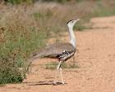  Australian Bustard  Ardeotis australis.  Uncommon nomad NSW - E | 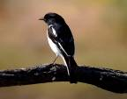  Hooded Robin  Melanodryas cucullata  Uncommon resident NSW - V | 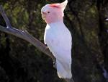  Major Mitchell’s Cockatoo  Lophochroa leadbeateri  Occasional use QLD – V, NSW - V
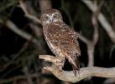  Southern Boobook  Ninox novaeseelandiae  Widespread resident | 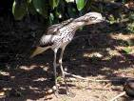  Bush Stone-curlew  Burhinus grallarius  Uncommon resident NSW - E | 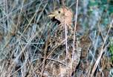  Plains-wanderer  Pedionomus torquatus  Restricted nomad QLD – V, NSW – V, EPBC - V
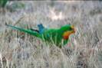  Superb Parrot  Polytelis swainsonii  Restricted resident NSW – V, EPBC - V | 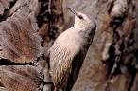  Brown Treecreeper  Climacteris picumnus  Widespread resident NSW - V | 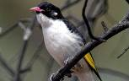  Painted Honeyeater  Grantiella picta  Uncommon resident QLD – R, NSW - V
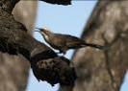  Grey-crowned Babbler  Pomatostomus temporalis  Uncommon resident NSW - V | 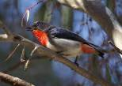  Mistletoe Bird  Dicaeum hirundinaceum  Widespread resident | 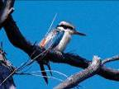  Red-backed Kingfisher  Todiramphus pyrrhopygius  Summer nomad
Why is the ecological community listed as endangered?

The decision to list the ecological community was made by the Australian Minister for the Environment, Heritage and the Arts after a rigorous process that involved consultation with stakeholders and advice from the Threatened Species Scientiﬁc Committee – an independent scientiﬁc body that advises the Minister on the conservation status of native species and ecological communities.

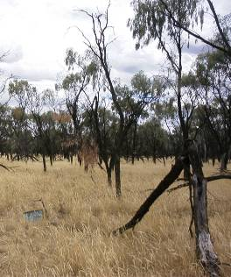
The Weeping Myall Woodlands ecological community has been listed under the EPBC Act because of its severe decline in extent. The central Riverina district once supported extensive stands of Weeping Myall Woodlands. It was also found near the Lachlan, Macquarie, Gwydir and McIntyre rivers as well as the upper Darling tributaries in Queensland. Due to the occurrence of the woodland on highly fertile and arable soils most of the former extent of the ecological community has been lost to clearing and farming.

The ecological community provides habitat for numerous species including fauna such as the Superb Parrot (Polytelis swainsonii), Painted Honeyeater (Grantiella picta) and Bush-Stone curlew (Burhinus grallarius).

Listing can also lead to funding opportunities, such as through Caring for Our Country, to help with recovery and conservation efforts. See page 18 for information on funding opportunities or visit www.nrm.gov.au/funding/index.html for further details.

Long-term protection of native biodiversity can provide additional ecological and on farm beneﬁts. Native vegetation remnants, such as the Weeping Myall Woodlands ecological community, provide a range of ecosystem services across an area of Australia regularly impacted by drought, including shade and shelter, reducing the need for bioremediation of acid sulphate soils and salinity, the maintenance of soil fertility, clean water and micro-climate regulation.

What does the listing of the ecological community mean for land managers or developers?

If a patch of the listed ecological community is present, then continuation of supportive land use and practices is vitally important if it is to persist for the beneﬁt of future generations.

The listing of the Weeping Myall Woodlands under the EPBC Act will not prevent land managers from continuing to use land in the same way they were before, providing that they do not signiﬁcantly change or intensify their activities (and the activity is lawful).

National protection means any new or intensiﬁed activities that may have a signiﬁcant impact upon one or more patches of the listed ecological community should be referred to the Australian Minister for the Environment for possible assessment and approval.

Those activities likely to require referral under the EPBC Act include, but are not restricted to, clearing remnants of native vegetation in or near the listed community, changes to drainage, signiﬁcant and adverse changes in grazing or management regimes (such as changing the ﬁ re regime), or introducing exotic species (such as plantations) in or near to remnants. Also note that even if your remnant vegetation does not meet the criteria for the listed ecological community some plants or animal species that occur within the remnant may be individually protected under the EPBC Act.

The EPBC Act allows for some exemptions to the requirement for assessment and approval. This means that some activities may not need to be referred for an assessment or approval under certain conditions. However, failure to refer an action that has a signiﬁcant impact on the listed ecological community may have legal consequences such as ﬁnancial penalties or remediation orders.

If you are considering an action that will have an impact on the ecological community, you are encouraged to contact the department about your management options. Enquiries may be directed to 1800 803 772. Further information is available on:

Exemptions:
www.environment.gov.au/epbc/about/exemptions.html
Referrals:
www.environment.gov.au/epbc/assessments/referral-form.html
Approvals:
www.environment.gov.au/epbc/approval.html
You should also check that no state or Local Government approvals are required in addition to EPBC Act requirements.

If you have the listed ecological community on your property and are a farmer, then you are encouraged to seek advice from the Environment Liaison Ofﬁcer at the National Farmers’ Federation. The ofﬁcer can be contacted by phone 1800 704 520 or email: environment@nff.org.au

Alternatively contact your local council, community Landcare group, or Catchment Management Authority (see page 8).

GUIDE TO MANAGING THREATS AND SUGGESTED CONSERVATION ACTIONS

The Weeping Myall Woodlands occur on highly fertile and arable soils. Much of the former Weeping Myall Woodlands ecological community has been cleared for dryland or irrigated cropping or has been signiﬁcantly modiﬁed by grazing.

Clearing and lopping for drought fodder has removed weeping myall (Acacia pendula) trees, and grazing combined with drought and changed ﬁ re regimes has eliminated many chenopod shrubs (e.g. saltbushes and native cotton bushes). These threatening processes remove the vegetation and seedbank, further fragmenting the listed community. This has a signiﬁcant negative impact on the biodiversity of the region.

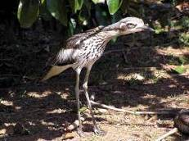
Both chenopod shrubs and weeping myall trees (Acacia pendula) are functionally important to this ecological community and both have undergone substantial loss and decline. Weeping myall is also highly susceptible to attack by the bag-shelter moth (Ochrogaster lunifer) which can defoliate large trees to such an extent that they do not recover.

Weeds have the ability to structurally change and transform the composition of the understorey species of the Weeping Myall Woodlands. Most of the riparian/ﬂoodplain remnants of the ecological community have shown high levels of site disturbance and the understorey tends to be heavily impacted by exotic species. The lack of ability of important species like the chenopods to recover due to limited seed longevity and low competitive abilities against weeds and grazing, reduces the complexity of the ecological community. For information on the management of weeds, visit the Weeds of National Signiﬁcance site: http://www.weeds.org.au/WoNS

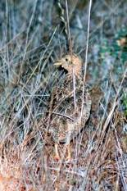
Most areas remaining in good condition are on lightly-grazed, uncropped sites such as areas conserved by farmers, road reserves and Travelling Stock Routes and Reserves. These remaining areas of structurally intact woodland tend to be relatively small and fragmented due to clearing, thinning, cropping, grazing and associated soil erosion and changes to ﬁ re regimes in the surrounding landscape. The increasing trend of converting intermittent grazing regimes to more intense or set stocking regimes of these areas is of particular concern.

Protecting Weeping Myall Woodlands can provide beneﬁts to the long-term protection of biodiversity. Farmers are encouraged to investigate techniques such as strategic grazing that allows regeneration and minimise impacts to biodiversity.
Below is a table showing some other potential threats for the Weeping Myall Woodlands listed ecological community as well as possible actions that land managers may take to beneﬁt the conservation of the listed ecological community and their land. This list is not exhaustive but highlights conservation actions of high priority. Conservation advice for this ecological community has been prepared. It highlights conservation actions of high priority at the time of listing and provides additional guidance. The conservation advice is available on SPRAT: www.environment.gov.au/cgi-bin/sprat/public/publiclookupcommunities.pl

Threat | Impact | Management Actions/Outcomes
Clearing and modiﬁcation | - Clearing for cropping leads to permanent destruction of the ecological community  - Removal, damage, thinning or fragmentation of the community  - Exacerbates soil erosion and salinity | - Identify high conservation sites and implement conservation mechanisms  - Protect remnants  - Repair and expand and connect remnants  - Collect and store seeds for future plantings  - Replanting of understorey species where they have been depleted
Heavy grazing | - Continuous grazing excludes regeneration of weeping myall (Acacia pendula) and other key native species  - Promotes weed invasion  - Soil compaction and erosion | - Prevent trampling and excessive grazing pressure at known Weeping Myall Woodlands sites  - Develop strategic grazing that allows regeneration  - Promoting native vegetation may lead to healthier soils and improve water retention in the long term  - Keep stock away from known nesting sites for ground dwelling birds
Lopping for drought fodder | - Leads to degradation of the ecological community  - Changes to structure and function of key species  - Tree mortality  - Reduction in regeneration capacity of weeping myall (Acacia pendula) seed stock | - Develop and implement lopping methods that do not result in the death of, or severe impacts on, the dominant tree species  - Replant with local understorey species such as chenopods

Threat | Impact | Management Actions/Outcomes
Invasive plant species (weeds) | - Invasive plant species compete with native plants for space, water and nutrients  - May lead to structural changes as some invasive plant species proliferate | - Manage sites to prevent introduction of invasive plant species  - Speedy eradication of any new invasive plant species  - Replant with local understorey species such as chenopods  - Develop and use long-term management plans for controlling key invasive plant species
Fertiliser and herbicide application | - Fertilisers can kill some native plant species | - Avoid the application of fertilisers and herbicides in or near remnants  - Promote native species to save on fertiliser application
Loss of fauna from the ecological community | - Loss of functionality | - Avoid ﬁrewood collection (dead and fallen trees)  - Allow fallen branches and bark to remain on ground to provide fauna habitat  - Control introduced pest animals at known sites

Funding to protect the Weeping Myall Woodlands ecological community?

If you have the ecological community on your property, on council land or public land, you may be eligible for funding to help preserve or restore remnants.

Funding through the Australian Government’s Caring for Our Country initiative may be available for activities that are undertaken which have an environmental beneﬁt.

The National Reserve System (NRS) has an important role in protecting biodiversity values. Building the NRS is one of the priorities under Caring for Our Country. Funding is open to landholders who seek ﬁnancial support to either purchase land or establish protected areas on private land for inclusion in the NRS.

For more details:
www.nrm.gov.au/funding/index.htmlwww.environment.gov.au/parks/nrs

Or contact 1800 552 008 to request further information.

Regional ofﬁces at either the Department of Environment and Resource Management of QLD, or the Department of Environment, Climate Change and Water of NSW, or your local Catchment Management Authority, Regional Natural Resource Management Group, or local council can provide you with information about current programs in place to support conservation efforts on private property.

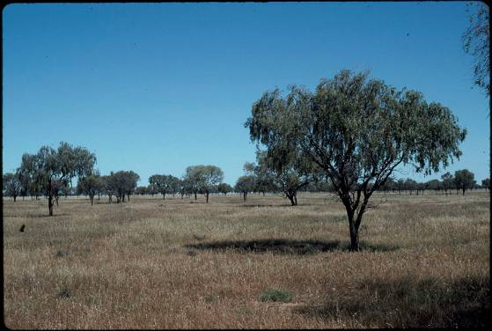
Where can I go for further information?

Listing Advice and Conservation Advice for the Weeping Myall Woodlands. Go to the ecological community on SPRAT and view the advices:
www.environment.gov.au/cgi-bin/sprat/public/publiclookupcommunities.pl

The NSW Department of Environment, Climate Change and Water (NSW listed ecological community). Myall Woodland in the Darling Riverine Plains, Brigalow Belt South, Cobar Peneplain, Murray-Darling Depression, Riverina and NSW South western Slopes bioregions ecological community proﬁle:
www.threatenedspecies.environment.nsw.gov.au

The Queensland Department of Environment and Resource Management. Search the regional ecosystems database:
http://www.epa.qld.gov.au/nature_conservation/biodiversity/regional_ecosystems

Useful websites

EPBC Act web site: www.environment.gov.au/epbc
EPBC Act Administrative Guidelines on Signiﬁcance:
www.environment.gov.au/epbc/assessmentsapprovals/guidelines/index.html
Information about nationally threatened ecological communities and species: www.environment.gov.au/cgi-bin/sprat/public/sprat.pl
Caring for Our Country – What can I do?
www.nrm.gov.au/do/landholders/index.html
National Farmers’ Federation:
www.nff.org.au/ or
www.nff.org.au/policy/nrm.html
Department of Climate Change: http://www.climatechange.gov.au/publications/index.html#impacts

Additional Copies

If you would like extra copies of this brochure please contact the Community Information Unit of the Department of the Environment, Water, Heritage and the Arts.

Email: ciu@environment.gov.au

Freecall 1800 803 772

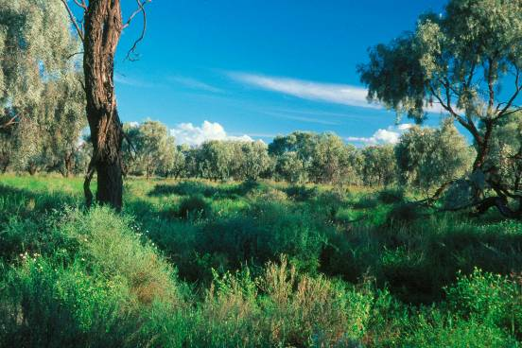

Explorer and botanist Allan Cunningham wrote about the John Oxley expedition in his 1817 journal Journey over the Western or Blue Mountains (Lee, 1925)

May 18th. Sunday. Having passed the heads of some lagoons the country becomes exceeding brushy, and assumes a greyish gloominess in consequence of the great numbers of Acacia pendula and Rhagodia dilatata, which are the two predominant shrubs.

May 18th. Sunday. In an open space having marks of inundation the holes were very dry, and gave us but little encouragement to hope for water at any resting place where we might halt at night. Acacia pendula [Myall], is common with another species.

May 23rd. Friday. It was well advanced in the day before we were able and ready to proceed forward on our journey, occasioned by the distances we are obliged to fetch water. At about two miles on our route, arriving at a small opening, we could distinguish some high mountains to the northward and westward of us. Passing through a country covered with the melancholy Acacia pendula we came to a gentle rising...

Allan Cunningham 1817

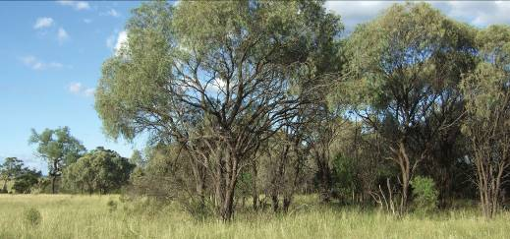

This brochure is designed to assist land managers, owners and occupiers as well as
consultants, environment assessment officers and other stakeholders to identify, assess
and manage the Weeping Myall Woodlands, an ecological community listed under Australia’s
national environmental law, the Environment Protection and Biodiversity Conservation
Act 1999 (EPBC Act). The brochure is a companion document for the listing advice which can
be found at the Australian Government’s species profile and threats database (SPRAT).
Please go to the Weeping Myall Woodlands profile in SPRAT, then click on the Details link:
www.environment.gov.au/cgi-bin/sprat/public/publiclookupcommunities.pl

Disclaimer
The contents of this document have been compiled using a range of source materials and is valid as at August 2009.
The Australian Government is not liable for any loss or damage that may be occasioned directly or indirectly through
the use of or reliance on the contents of the document.
© Commonwealth of Australia 2009
This work is copyright. You may download, display, print and reproduce this material in unaltered form only (retaining this notice) for
your personal, non-commercial use or use within your organisation. Apart from any use as permitted under the Copyright Act 1968,
all other rights are reserved. Requests and inquiries concerning reproduction and rights should be addressed to Commonwealth
Copyright Administration, Attorney General’s Department, Robert Garran Offices, National Circuit, Barton ACT 2600 or posted at
http://www.ag.gov.au/cca.

INTERNAL IMAGES (left to right, top to bottom)

1 Superb Parrot Polytelis swainsonii © Lindsay Hansch
2 Weeping Myall Woodlands Bogan River floodplain, Central NSW © Steve Lewer, NSW Department of Environment &
Climate Change
3 Ptilotus spp. © Department of the Environment, Heritage, Water & the Arts
3 Weeping Myall Woodlands © R. Armstrong, NSW Department of Environment & Climate Change
5 Atriplex vesicaria spp. macrocystidia Bladder saltbush © Steve Lewer, NSW Department of Environment & Climate Change
8 Acacia pendula Weeping Myall © M. Fagg, Australian National Botanic Gardens
10 Acacia pendula Weeping Myall © M. Fagg, Australian National Botanic Gardens
10 Acacia pendula Weeping Myall © M. Fagg, Australian National Botanic Gardens
10 Weeping Myall Woodlands © R. Armstrong, NSW Department of Environment & Climate Change
10 Eucalyptus largifl orens Black Box © M. Fagg, Australian National Botanic Gardens
10 Eucalyptus largifl orens Black Box © M. Fagg, Australian National Botanic Gardens
10 Weeping Myall Woodlands © R. Armstrong, NSW Department of Environment & Climate Change
11 Amyema quandang Grey mistletoe © M. Fagg, Australian National Botanic Gardens
11 Maireana aphylla Bluebush K. Thiele © Australian National Botanic Gardens
11 Atriplex vesicaria spp. macrocystidia Bladder saltbush © Steve Lewer, NSW Department of Environment & Climate Change
11 Rhodanthe corymbifl ora © M. Fagg, Australian National Botanic Gardens
11 Sclerolaena stelligera Copperburr S. Donaldson © Australian National Botanic Gardens
11 Enchylaena tomentosa © M. Fagg, Australian National Botanic Gardens
11 Dichanthium sericeum Queensland Blue Grass D. Greig © Australian National Botanic Gardens
11 Eremophila debilis © Department of the Environment, Heritage, Water & the Arts
11 Ptilotus spp. © Department of the Environment, Heritage, Water & the Arts
11 Themeda avenacea © Department of the Environment, Heritage, Water & the Arts
11 Weeping Myall Woodlands © Steve Lewer, NSW Department of Environment & Climate Change
11 Eucalyptus populnea Poplar Box Brooker & Kleinig © Australian National Botanic Gardens
11 Weeping Myall Woodlands © Steve Lewer, NSW Department of Environment & Climate Change
11 Eucalyptus populnea Poplar Box Brooker & Kleinig © Australian National Botanic Gardens
12 Themeda avenacea near Warren NSW, © Department of the Environment, Heritage, Water & the Arts
13 Acacia pendula Weeping Myall © M. Fagg, Australian National Botanic Gardens
15 Australian Bustard Ardeotis australis. Uncommon nomad NSW – E © David Cook
15 Hooded Robin Melanodryas cucullata. Uncommon resident NSW – V © Stuart Harris
15 Major Mitchell’s Cockatoo Lophochroa leadbeateri. Occasional use QLD – V, NSW – V © David Cook
15 Southern Boobook Ninox novaeseelandiae. Widespread resident © David Cook
15 Bush Stone-curlew Burhinus grallarius. Uncommon resident NSW – E © David Cook
15 Plains-wanderer Pedionomus torquatus. Restricted nomad QLD – V, NSW – V, EPBC – V © Lindsay Hansch
15 Superb Parrot Polytelis swainsonii. Restricted resident NSW – V, EPBC – V © Lindsay Hansch
15 Brown Treecreeper Climacteris picumnus. Widespread resident NSW – V © Graham Stephinson
15 Painted Honeyeater Grantiella picta. Uncommon migrant QLD – R, NSW – V © Geofrey Dabb
15 Grey-crowned Babbler Pomatostomus temporalis. Uncommon resident NSW – V © David Cook
15 Mistletoebird Dicaeum hirundinaceum. Widespread resident © David Cook
15 Red-backed Kingfi sher Todiramphus pyrrhopygius. Summer nomad © Stuart Harris
16 Weeping Myall Woodlands near Dandaloo, Central NSW © Steve Lewer, NSW Department of Environment & Climate Change
18 Eremophila debilis © Department of the Environment, Heritage, Water & the Arts
18 Bush Stone-curlew Burhinus grallarius. Uncommon resident NSW – E © David Cook
19 Enchylaena tomentosa © M. Fagg, Australian National Botanic Gardens
19 Plains-wanderer Pedionomus torquatus. Restricted nomad QLD – V, NSW – V, EPBC – V © Lindsay Hansch
21 Weeping Myall Woodlands © M. Fagg, Australian National Botanic Gardens
23 Weeping Myall Woodlands © R. Armstrong, NSW Department of Environment & Climate Change
24 Weeping Myall Woodlands Gravesend, NSW © W. Hawes

R = Rare
V = Vulnerable
E = Endangered

Woodlands are distinguished by the height of trees and their foliage cover e.g. “woodlands” have 10 to 30% foliage cover, while “open woodlands” have less than 10% foliage cover.
IBRA is the National Reserve System’s planning framework.
Gilgai microrelief is formed due to clay horizons shrinking and swelling with alternate drying and wetting cycles. Each cycle of swelling, shrinkage and crackling becomes more exaggerated and the landscape eventually becomes covered by a repeated pattern of mounds and depressions. The depressions are gilgais which become filled with water during the wet season. (Vic DPI/CSIRO/QLD EPA)
Run-on refers both to the process whereby surface runoff infiltrates the ground as it flows, and to the portion of runoff that infiltrates.
Weeping Myall trees go through regular cycles of ageing, death and regulation. Weeping Myall trees are also susceptible to defoliation by Bag–shelter Moth (Ochrogaster lunifer) capertillas and are often lopped for domestic stock fodder. Dead trees can contain viable seed for generation and provide habitat for fauna and bird species.

