

Western Sydney Dry Rainforest and Moist Woodland on Shale: a nationally-protected ecological community

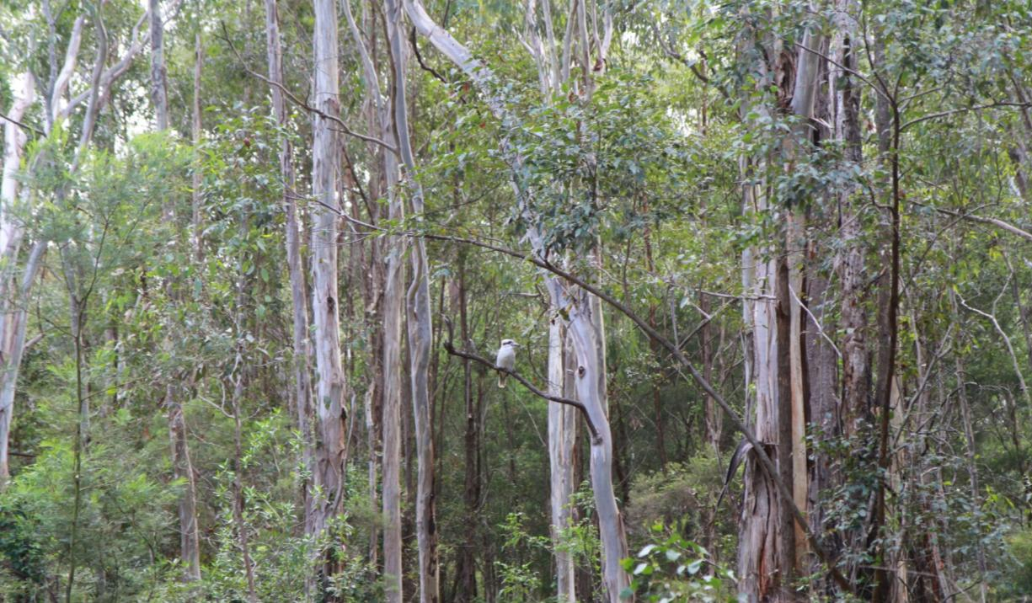This factsheet is designed to assist land managers, owners and occupiers as well as environmental assessment officers and consultants to identify, assess and manage the Western Sydney Dry Rainforest and Moist Woodland on Shale ecological community. This is a threatened ecological community listed under the Environmental Protection and Biodiversity Conservation Act 1999 (EPBC Act)—Australia’s national environmental law.

The factsheet is a companion document for the Listing Advice and Conservation Advice, which can be found in the Australian Government’s species profile and threats database (SPRAT) at: [www.environment.gov.au/cgi-bin/sprat/public/publiclookupcommunities.pl](http://www.environment.gov.au/cgi-bin/sprat/public/publiclookupcommunities.pl)

At this website, click on the details link to download the documents and map for the ecological community.

© Commonwealth of Australia, 2015.

*Western Sydney Dry Rainforest and Moist Woodland on Shale: a nationally-protected ecological community* is licensed by the Commonwealth of Australia for use under a Creative Commons By Attribution 4.0 Australia licence with the exception of the Coat of Arms of the Commonwealth of Australia, the logo of the agency responsible for publishing the report, content supplied by third parties, and any images depicting people. For licence conditions see: http://creativecommons.org/licenses/by/4.0/

This report should be attributed as ‘*Western Sydney Dry Rainforest and Moist Woodland on Shale: a nationally-protected ecological community*, Commonwealth of Australia 2015’.

The Commonwealth of Australia has made all reasonable efforts to identify content supplied by third parties using the following format ‘© [name of third party] ’.

**Disclaimer**

The views and opinions expressed in this publication are those of the authors and do not necessarily reflect those of the Australian Government or the Minister for the Environment.

**Images**

Front cover: Moist Woodland on Shale with a perched Kookaburra © Peter Ridgeway.  
Back cover: Western Sydney Dry Rainforest © Robin Woods.

This guide is intended to assist the public to understand the national listing of the Western Sydney Dry Rainforest and Moist Woodland ecological community—what it is, why it is threatened and what national protection means for people in the region.

In summary:

* The Western Sydney Dry Rainforest and Moist Woodland ecological community is listed as critically endangered under Australia’s national environment law, the Environment Protection and Biodiversity Conservation Act 1999 (EPBC Act).
* The national Threatened Species Scientific Committee found that the ecological community is highly threatened. Like much of the bush on and around the plains of Western Sydney, its extent has declined severely—by more than 70 per cent—resulting in a highly fragmented and restricted geographic distribution and loss of some animals and ecosystem function.
* National listing aims to secure the future of the species and ecosystem functions within Australia’s most threatened ecological communities by taking them into account during approval processes for major new developments.
* It also aims to encourage conservation and recovery efforts, particularly those delivered through Australian Government funding, to consider listed species and/or ecological communities as priority areas for support.
* National listing raises awareness about ecological communities and priority actions to combat threats.
* The ecological community is restricted to sheltered slopes and gullies of the Cumberland Plain, part of the Sydney Basin Bioregion. Core areas occur near Picton, Camden, Cattai, Campbelltown, Richmond and Baulkham Hills.
* The ecological community provides vital habitat for a number of nationally threatened species such as the spotted-tail quoll, as well as being a refuge for locally-rare species such as the superb lyrebird and satin bowerbird.
* It also contributes to the health and wellbeing of local residents. For example, the ecological community helps to cool temperatures and filter water in its surrounding area, and provides scenic areas for bushwalking.
* The ecological community is made up of two vegetation units or sub-communities. It transitions from a dry rainforest with a closed non-eucalypt canopy into moist woodland with a more open canopy dominated by eucalypts. These two variations have been combined into a single nationally significant community or ecosystem because the two units are often adjacent and hence share flora and fauna and key threats that benefit from complementary management.
* The national definition promotes a co-ordinated, ecosystem-scale approach to threat abatement and recovery. The Threatened Species Scientific Committee’s Conservation Advice outlines a range of priority research and management actions that provide guidance on how to protect, manage and restore the ecological community.
* Routine property maintenance and land management practices—including most farming activities and management fire breaks—carried out in line with local laws, and guidelines covering native vegetation, are typically unlikely to require referral under national environment law.
* Only activities that are likely to have a significant adverse impact on a listed ecological community need to be considered under Australia’s national environment law—activities such as large new developments, works or infrastructure. For example, activities which involve permanently clearing large areas of intact and high-quality native vegetation.

National 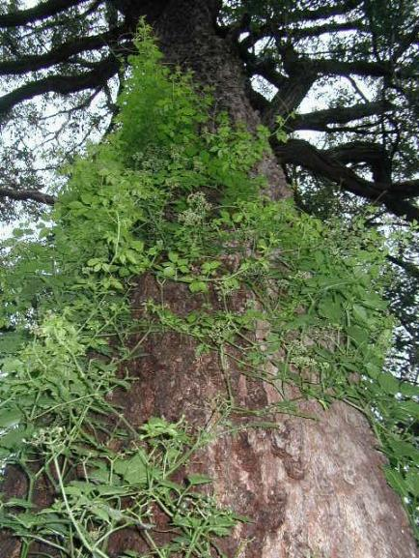ecological communities

Australia’s national environmental law, the EPBC Act, provides a legal framework to protect and manage Matters of National Environmental Significance (MNES), which include nationally threatened species and ecological communities.

The EPBC Act defines an ecological community as an assemblage of native species which inhabit a particular area in nature. In other words, ecological communities are groups of native plants, animals and other organisms that naturally occur together and interact in a unique habitat. Listed ecological communities include forests, grasslands, shrublands, wetlands, woodlands, marine, ground springs and cave communities.

The native plants and animals within an ecological community have different roles and relationships that, together, contribute to the healthy functioning of the environment. Protecting native communities also protects ecosystem services such as clean air, clean land and clean water—which, in turn, benefits individuals and communities within and beyond the local areas, and contributes to our land and water becoming more productive.

*Cayratia clematidea* (native grape) © Robin Woods

*Cayratia clematidea* © Robin Woods

Why is the Western Sydney Dry Rainforest and Moist Woodland on Shale ecological community important?

Many of the areas where the ecological community is found are the most highly-developed areas of the Sydney Basin Bioregion. Since European settlement, substantial areas of the Western Sydney Dry Rainforest and Moist Woodland ecological community has been lost or otherwise degraded as a result of clearing, logging, weed invasion, heavy grazing and/or altered fire regimes. It is important to help prevent further decline by promoting recovery through landholder and community efforts. Listing this ecological community reduces the risk of this unique and important part of the western Sydney environment being lost for future generations.

The Western Sydney Dry Rainforest and Moist Woodland ecological community provides habitat for a range of native plants, birds, mammals, reptiles, and other animals. By listing the ecological community, protection is also given to the native animals and plants which help make up the ecological community. These include seven nationally listed fauna species such as the giant barred frog (*Mixophyes iteratus*) and regent honeyeater (*Anthochaera phrygia*). It also contributes toward the area’s water quality and helps to prevent erosion around gullies and slopes.

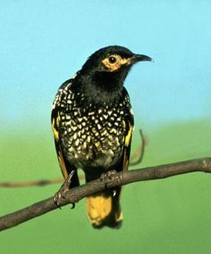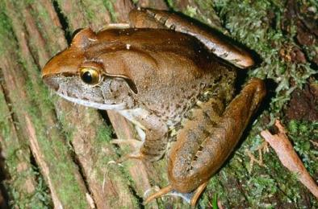A large portion of the ecological community has already been lost and remaining areas are fragmented and vulnerable to the impacts of threats. Protection will contribute to the future survival and recovery of the ecological community.

Giant barred frog © H B Hines Regent honeyeater © Graeme Chapman

**Where does the Western Sydney Dry Rainforest and Moist Woodland on Shale ecological community occur?**

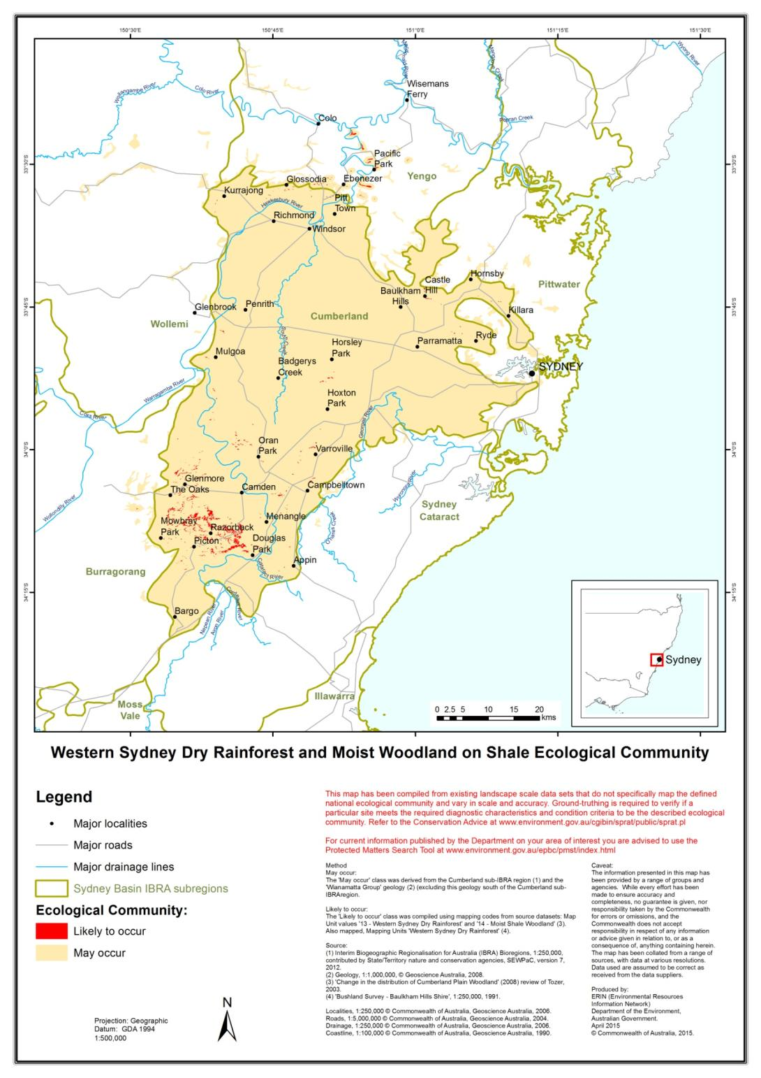

What is the Western Sydney Dry Rainforest and Moist Woodland on Shale ecological community?

The ***Western Sydney Dry Rainforest and Moist Woodland on Shale*** ecological community is a type of dry rainforest that grades into moist woodland. It is found in gullies and slopes around western Sydney and its vegetation occurs in a number of forms, depending on the landscape position, climate or land use history.

The ecological community can be identified by these general features.

*Landscape and soils*

* Generally occurs in higher rainfall areas (relative to surrounding areas on the western Sydney plains) at elevations up to 300m above sea level.
* Often found in steeper, more rugged terrain.
* The dry rainforest form typically occupies gully bottoms and lower slopes.
* The moist woodland form typically occurs upslope from gullies, with some patches extending onto gentler, undulating terrain. From there, it may intergrade with the critically endangered Cumberland Plain Shale Woodlands and Shale-Gravel Transition Forest ecological community. Moist woodland may also develop where partial clearance or fire has disturbed the dry rainforest vegetation.
* Typically occurs on clay soils derived from Wianamatta Group shale geology.

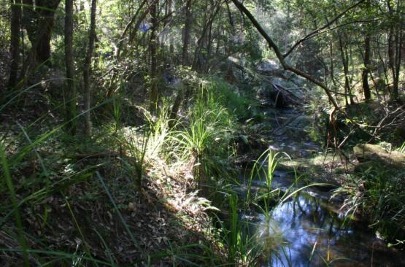

*Vegetation*

* The dry rainforest form is a low, closed forest dominated by non-eucalypts—notably prickly-leaved paperbark (*Melaleuca styphelioides*), hickory wattle (*Acacia implexa*) and native quince (*Alectryon subcinereus*), while white euodia (*Melicope micrococca*) may also be common.
* The moist woodland form has a more open canopy dominated by eucalypts, notably forest red gum (*Eucalyptus tereticornis*) and coastal grey box (*E. moluccana*).

Western Sydney Dry Rainforest stream © Robin Woods

* The vegetation underneath the canopy includes a variable presence of shrubs, and a generally sparse cover of grasses, ferns and other herbs. Vines and scramblers are typically present, though are most common in the dry rainforest form. The ecological community is characterised by a good representation of moisture-dependent species, such as broad-leaved shrubs and ferns.
* 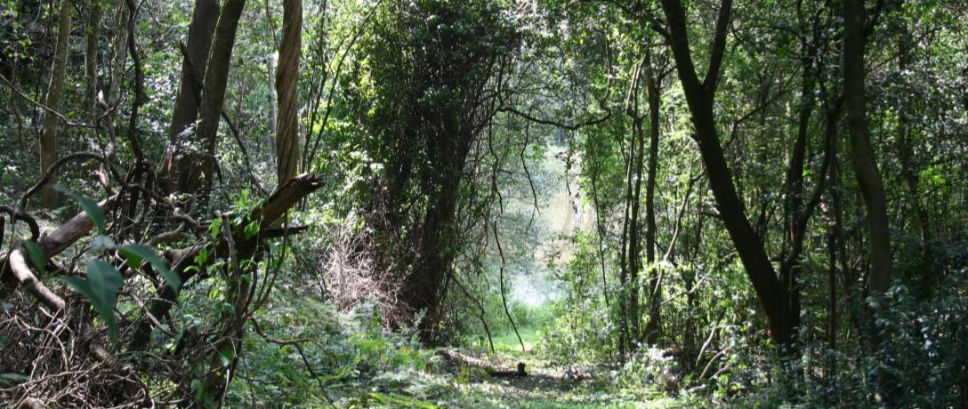Some plants that often occur in other types of rainforest/moist woodland in New South Wales are usually absent or uncommon in this ecological community. For instance, palms, figs, vascular epiphytes, mosses and grey myrtle (*Backhousia myrtifolia*) are not a common feature of this ecological community.

Western Sydney Dry Rainforest © Robin Woods

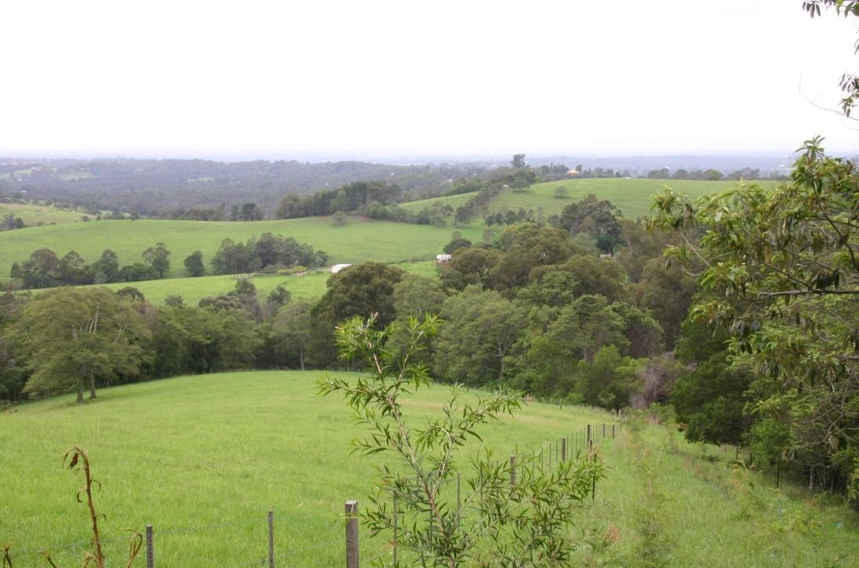Why does the ecological community need national protection?

Fragmentation of the ecological community throughout agricultural land © Robin Woods

In February 2013, the Australian Government Minister for the Environment listed the Western Sydney Dry Rainforest and Moist Woodland ecological community after considering the advice of the Threatened Species Scientific Committee. A rigorous assessment of the scientific evidence supported listing as critically endangered as it met the eligibility criteria under national environment law. The Committee found that:

* the ecological community had undergone a decline of more than 70 per cent in its extent
* about 950 hectares now remains, almost all of which occurs as highly fragmented patches under 10 ha in size
* it has experienced a very severe reduction in its community integrity due the combined effects of fragmentation, weed infestations, loss of fauna, heavy grazing and changes to natural fire regimes.

The overall aim of listing the ecological community is to prevent its decline and to provide support to on-ground efforts that ensure its long-term survival. The Conservation Advice outlines a range of priority research and management actions that provide guidance on how to manage, restore and protect the ecological community.

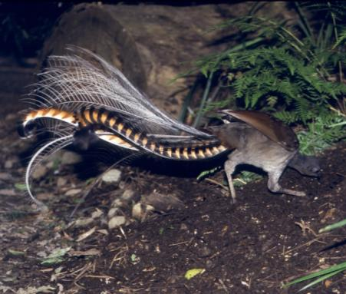

Superb lyrebird © Brian Furby

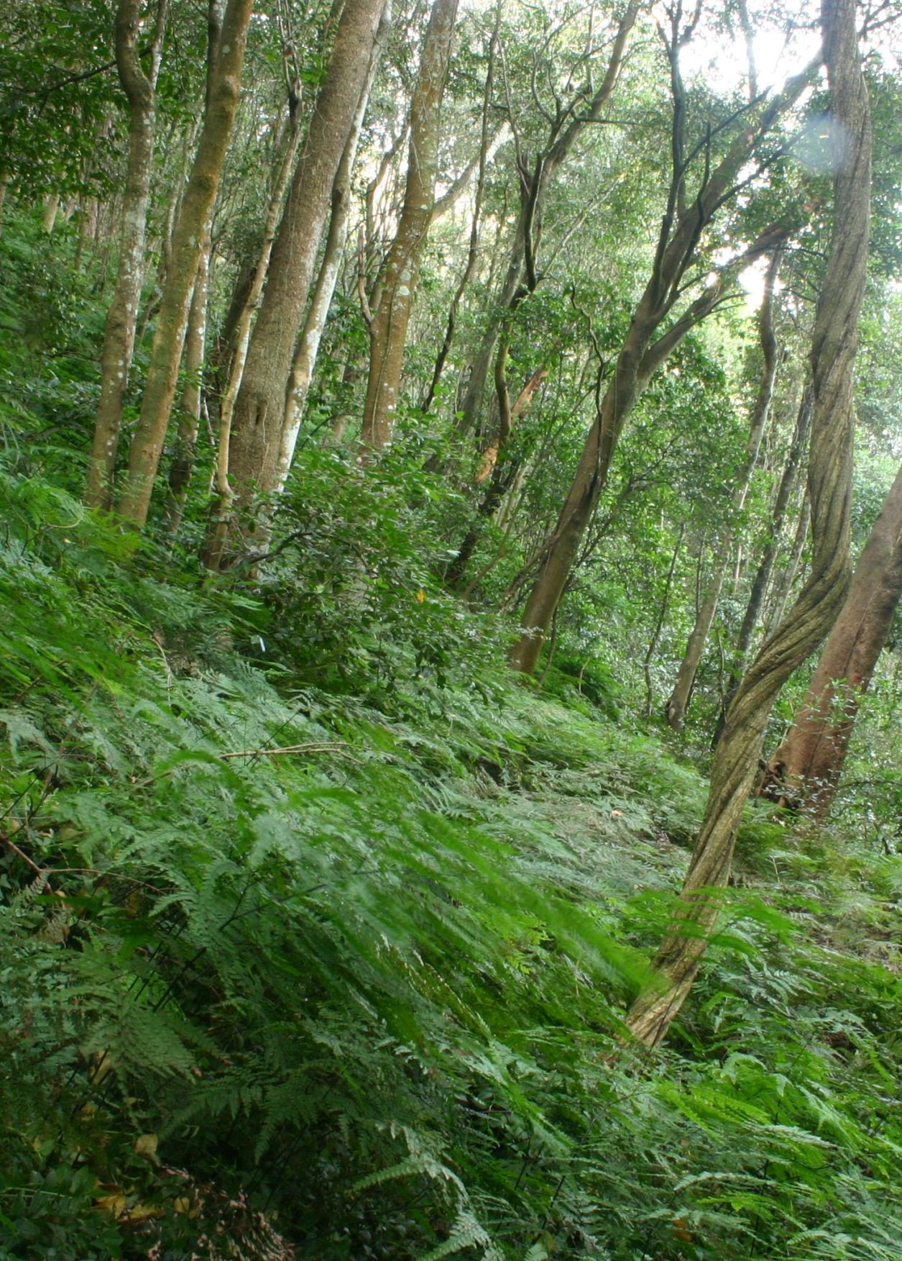

Western Sydney Dry Rainforest © Robin Woods

Are all patches protected under the listing?

No. National listings of ecological communities specify condition thresholds that help to identify patches that are too degraded for the purposes of protection under national environment law. This allows national protection to focus on the best and most intact patches that remain of a listed ecological community.

The condition thresholds effectively mean that small, degraded patches—such as individual paddock trees, narrow patches, or remnants where the understorey has been largely replaced by weeds—are excluded from a listed ecological community and any actions do not need to be considered under the national environmental law.

*Condition thresholds*

The Western Sydney Dry Rainforest and Moist Woodland ecological community is only protected under national environment law when it remains in relatively good condition.

A patch should first be identified as being the ecological community (using the features listed on page 6, or by referring to the Listing Advice document). Then it may be identified as being in relatively good condition if it meets **all** criteria depicted in the flowchart.

The condition of an ecological community is best assessed when:

* many species are flowering or fruiting (to aid their identification), which usually occurs in November to December
* there has been no recent disturbances—which means to allow two months or more to recover after any substantial disturbance.

In the flowchart below, a patch that registers ‘NO’ against any of the criteria is considered to be degraded and not part of the national ecological community. Although not part of the ecological community as listed under the EPBC Act, it is recognised that patches which do not meet the condition thresholds may still retain important natural values, particularly if adjacent to patches which do meet the condition thresholds. As such, these patches should not be excluded from recovery and other management actions.

For further information on how to determine whether a patch of vegetation meets the definition and condition thresholds for the national ecological community see the **Listing Advice and Conservation Advice.**

[www.environment.gov.au/cgi-bin/sprat/public/publicshowcommunity.pl?id=106&status=Critically+Endangered](http://www.environment.gov.au/cgi-bin/sprat/public/publicshowcommunity.pl?id=106&status=Critically+Endangered)

Is the patch 0.1 ha or greater in size?

YES

If NO – the patch is too small

YES

Are at least 20 native species present in a 0.04ha sample plot?

If NO – the patch seems to lack native diversity

Do non-native perennial plants account for no more than 50% of the total vegetation cover in the patch?

YES

If NO – the patch is too weedy

**The patch is part of the national ecological community**

**What are the benefits of listing an ecological community as nationally threatened?**

There are a number of benefits to listing ecological communities under Australia’s national environment law:

* Listing an ecological community can help to protect the landscapes that provide connectivity, corridors and refuge essential to protect and improve the ecological function, health and biodiversity of the region. It can protect habitat critical for refuge and recruitment of threatened species and for other species that are under pressure in the region. In turn, this helps foster the ecosystem services associated with an ecological community.
* 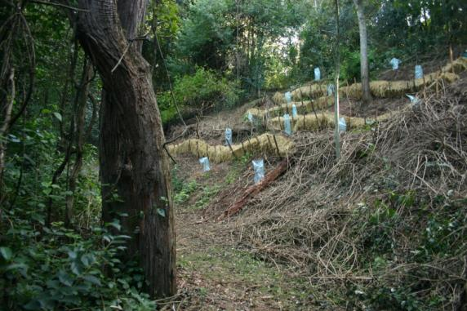National listing helps protect threatened ecological communities from future significant human impacts that may cause further decline. The aim of the national environment law is to ensure the matters of national environmental significance are given due consideration, along with broader economic, social and other issues in the planning of any large projects. Where possible, significant adverse impacts to the environment should be avoided. However, if the impacts are unavoidable, then they must be mitigated, reduced or offset.
* It encourages agencies and community groups to apply for environmental funding opportunities for conservation and recovery works. The Australian Government has a variety of funding programmes to encourage land managers to conserve biodiversity and ecosystem services.
* A Conservation Advice, published at the time of listing, provides guidance and options for environmental decision-making, including priority rehabilitation and conservation initiatives.
* In the case of the Western Sydney Dry Rainforest and Moist Woodland ecological community, the listing will:

Remediation efforts for the ecological community © Robin Woods

* provide landscape-scale protection that complements existing national protection for threatened species that are found within the ecological community
* protect the environmental values, including the ecosystem functions and services associated with the ecological community, which contributes to the long-term productivity of the landscape
* raise awareness about the ecological community and its threats.

What does the listing mean for landholders?

*Business as usual for most routine activities*

It is important to note that the EPBC Act is only triggered if a particular activity has, or will have, a significant impact on a MNES—or a threatened ecological community, in this instance.

The normal activities of individual landholders, residents and councils will typically not be affected by a listing. Routine property maintenance, land management and other established practices, such as ongoing road maintenance works, are unlikely to have a significant impact and so do not typically require referral or other consideration under national environment law—particularly if carried out in line with other national and state laws covering native vegetation.

For instance, the following actions are unlikely to trigger national environment law:

* ongoing grazing, horticultural or cropping activities
* maintaining existing roads, fences, access tracks and firebreaks
* maintaining existing gardens and orchards
* maintaining existing dams or water storages
* maintaining existing pumps and clearing drainage lines
* replacing and maintaining sheds, yards and other buildings
* controlling weeds and spraying for pests on individual properties or roadside verges.

In all these cases, impacts on important patches—such as high-quality, important corridor for wildlife—of the ecological community should be avoided.

It also must be noted that human settlements and infrastructures where an ecological community formerly occurred do not form part of the natural environment and are therefore not considered to be part of the protected ecological community. This also applies to sites that have been replaced by crops and exotic pastures, or where the ecological community exists in a highly-degraded or unnatural state.

Whether or not an action is likely to have a significant impact depends upon the sensitivity, value and quality of the environment which is impacted, and upon the intensity, duration, magnitude and geographic extent of the impacts.

*Referral required for actions likely to have a significant impact*

The EPBC Act is triggered if an action is likely to have a significant impact on the Western Sydney Dry Rainforest and Moist Woodland ecological community. If a proposed action is likely to have such an impact, it would require:

* determining if the action may have a significant impact on the ecological community (referral)
* assessment (the scope of the assessment depends on the complexity of the proposed action and impacts)
* a decision on approval from the Minister (who considers all the environmental, social and economic factors).

Social and economic matters may also be taken into account for individual projects that may have a significant impact on the ecological community, through the EPBC Act approvals process. Strict timeframes apply to assessments to ensure decisions are made as quickly as possible.

The key diagnostics and condition thresholds outlined above for the ecological community exclude many patches on properties or along roadside verges that are considered too degraded for protection. In addition, the EPBC Act provides exemptions for continuing (routine) use or where legal permission has previously been given.

The major activity that is likely to have a significant impact on the ecological community is permanently clearing large or otherwise important areas of intact or high-quality native vegetation. Examples of this may include:

* major mining, residential, commercial or other industrial development
* building new roads or widening existing roads
* converting large areas into new pastures or cropping fields.

To help reduce the significance of actions, the EPBC Act promotes the avoidance and mitigation of impacts from the early planning stage, wherever that is possible.

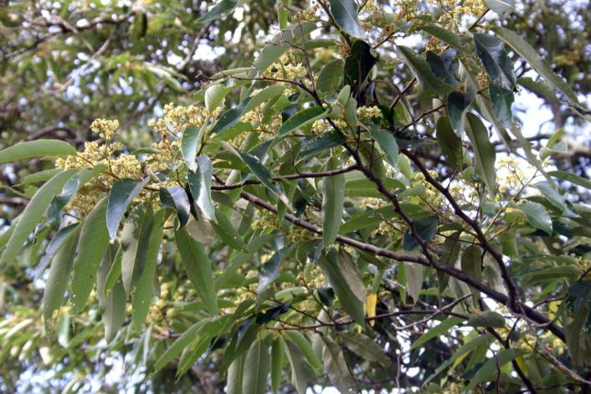

Flowering *Alphitonia excelsa* **©** Robin Woods

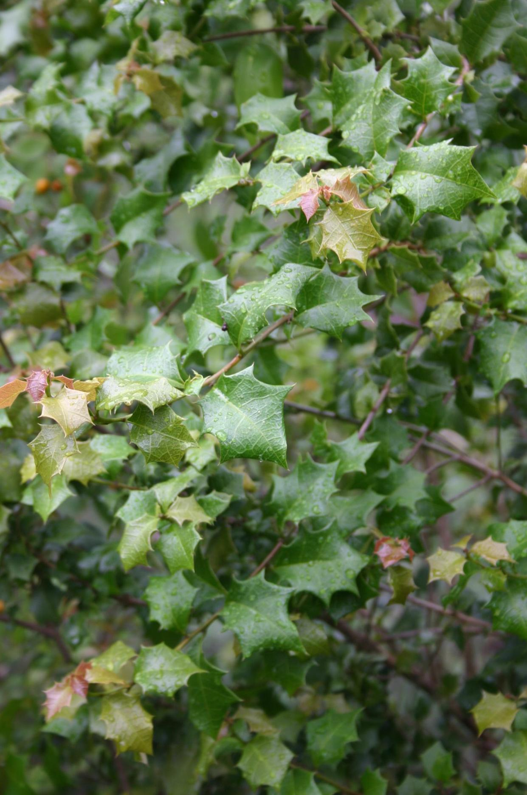

Alchornea ilicifolia (native holly) © Robin Woods

**What can you do to help?**

There are a range of things you can do to help bush remnants in your area, these include:

* practising environmentally safe bushwalking by keeping to paths, avoiding the removal or trampling of plants, keeping pets on a leash and by taking your rubbish home with you
* not collecting firewood, such as fallen timber, or bush rocks as they provide important habitat for fauna, particularly as refuge from predators and fire
* planting local species in your garden, including from the threatened ecological communities, and avoiding potential environmental weeds
* reporting illegal or damaging behaviour to your council
* participating in special conservation events, including information nights, tree planting days, rubbish removal and weed removal projects in your area
* joining local organisations such as Landcare or ‘friends of’ groups, and volunteering to help conserve native vegetation and wildlife. These can provide you with a rewarding experience and an opportunity to meet people and explore nature, including nationally significant ecosystems in your region.

Are there other nationally protected ecological communities within this area?

Within the Cumberland Plain and greater area of Sydney, there are a number of other ecological communities protected under national environmental law and these include the:

* Blue Gum High Forest of the Sydney Basin Bioregion
* Castlereagh Scribbly Gum and Agnes Banks Woodlands
* Coastal Upland Swamps in the Sydney Basin Bioregion
* Cooks River and Castlereagh Ironbark Forest
* Cumberland Plain Shale Woodlands and Shale-Gravel Transition Forest
* Shale Sandstone Transition Forest of the Sydney Basin Bioregion
* Turpentine-Ironbark Forest in the Sydney Basin Bioregion.

For more information regarding these ecological communities visit:   
[www.environment.gov.au/cgi-bin/sprat/public/publiclookupcommunities.pl](http://www.environment.gov.au/cgi-bin/sprat/public/publiclookupcommunities.pl)

Do state or local environment laws also apply?

Yes, however such state and local laws do not replace or stop the operation of the national environmental law. Information about state-listed communities and vegetation management laws are available from these New South Wales agencies:

* NSW Office of Environment and Heritage:   
  [www.environment.nsw.gov.au/threatenedspecies/](http://www.environment.nsw.gov.au/threatenedspecies/)  
  [www.environment.nsw.gov.au/vegetation/](http://www.environment.nsw.gov.au/vegetation/)
* Greater Sydney Local Land Services:   
  [www.greatersydney.lls.nsw.gov.au/land-and-water/native-vegetation](http://www.greatersydney.lls.nsw.gov.au/land-and-water/native-vegetation)

Where can I get further information?

The Listing Advice and Conservation Advice for the Western Sydney Dry Rainforest and Moist Woodland on Shale ecological community are the definitive source of information on the listing of this ecological community. That information and more regarding the EPBC Act is available on the Department of the Environment website:

* + - * Comprehensive Listing Advice and Conservation Advice for the ecological community on the department’s Species Profile and Threats (SPRAT) database: [www.environment.gov.au/cgi-bin/sprat/public/publicshowcommunity.pl?id=106&status=Critically+Endangered](http://www.environment.gov.au/cgi-bin/sprat/public/publicshowcommunity.pl?id=106&status=Critically+Endangered)
* EPBC listing process: [www.environment.gov.au/topics/threatened-species-ecological-communities](http://www.environment.gov.au/topics/threatened-species-ecological-communities)
* EPBC referral and approval process:   
  [www.environment.gov.au/topics/environment-protection](http://www.environment.gov.au/topics/environment-protection)
* Australian Government natural resource management initiatives: [www.nrm.gov.au](http://www.nrm.gov.au).

Enquiries can also be made through the Department’s Community Information Unit by phone on **1800 803 772** (freecall), or email at <mailto:ciu@environment.gov.au>

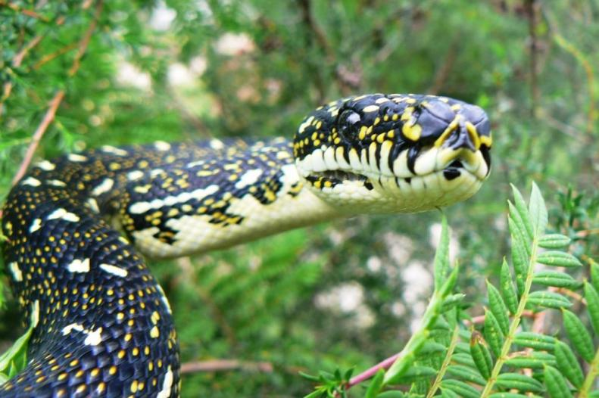

Diamondback python in Moist Woodland on Shale **©** Peter Ridgeway

**environment**.gov.au

