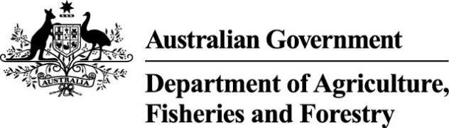

Exports work instruction

Requesting an Instrument of Appointment using the Plant Exports Management System
Direction to authorised officers
This is official instructional material of the Department of Agriculture, Fisheries and Forestry (the department). Failure to comply with it may result in a breach of relevant legislation and/or the code of conduct under section 13(5) of the Public Service Act 1999.

Purpose of this document
This document details the procedure to request an Authorised Officer (AO) Instrument of Appointment using the Plant Exports Management System (PEMS).
__________________________________________________________________________________
In this document
This document contains the following topics:
Purpose of this document 1
Policy statement 2
Roles and responsibilities 2
How do I request an Instrument of Appointment? 2
Create an Instrument of Appointment 3
Pay the approval fee 8
Download the Instrument of Appointment 14
Contact 16
Related material 16
Document information 16
Version history 17

Policy statement
The policy, definitions and legislation related to this work instruction can be found in the Exports Policy: Management of third party plant exports authorised officers.

Roles and responsibilities
The following table outlines the roles and responsibilities undertaken when requesting an Instrument of Appointment.
Role | Responsibility
Applicant | - Requesting an Instrument of Appointment.  - Paying all applicable fees and charges.

How do I request an Instrument of Appointment?
Persons wanting to receive their AO Instrument of Appointment must lodge a request online through PEMS following the procedure described in this work instruction.
Note: Instruments of Appointment are only available to candidates who received a ‘Competent’ result at assessment.

Create an Instrument of Appointment
This procedure initiates when an AO candidate receives a ‘Competent’ result at assessment.
The following table outlines how to create an Instrument of Appointment.
Step | Action | Graphic
1. | Go to https://online.agriculture.gov.au/selfservice  Note: The log in page will display.
2. | - Enter your User Login and Password.  Note: This information will have been circulated to you via email following registration.  - Check the ‘I accept the terms of use’ box.  - Click ‘Log in’.
3. | Click the ‘PEMS’ button to enter the PEMS home page.  Note: You will not be able to complete this step until your access has been approved by the department. | 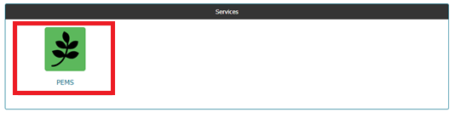
4. | Click on ‘Open’.
5. | Select the Appointment tab. | 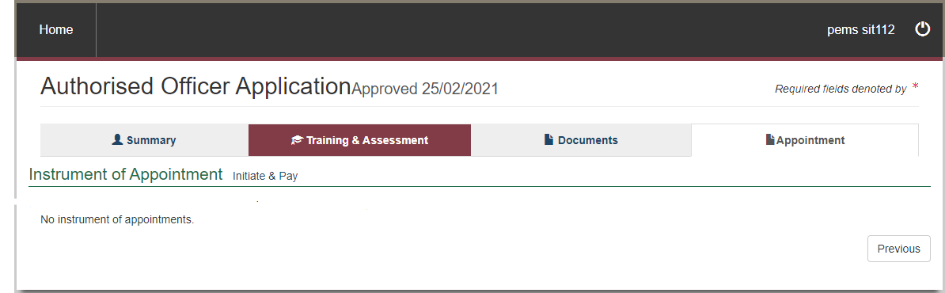
6. | Click on ‘Initiate & Pay’.
7. | - Read through the Instrument of Appointment information.  - Tick the box to indicate that you have read and agree to the terms.  Important: If you do not agree to the terms, you will not be appointed as an AO.  - Click ‘Save’.  - Go to ‘Pay the approval fee’. | 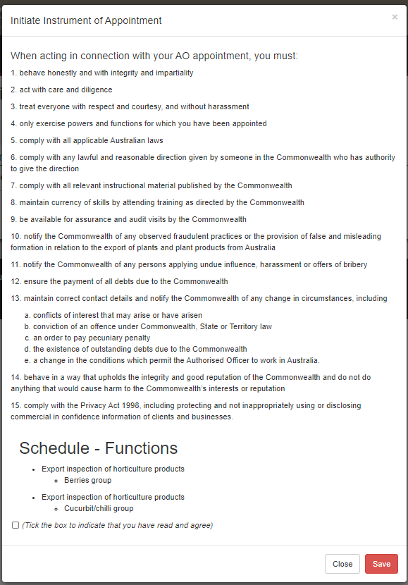

Pay the approval fee
The following table outlines how to pay the approval fee.
Step | Action | Graphic
1. | - Note the status of ‘Awaiting Payment’.  - Click ‘Pay Now’. | 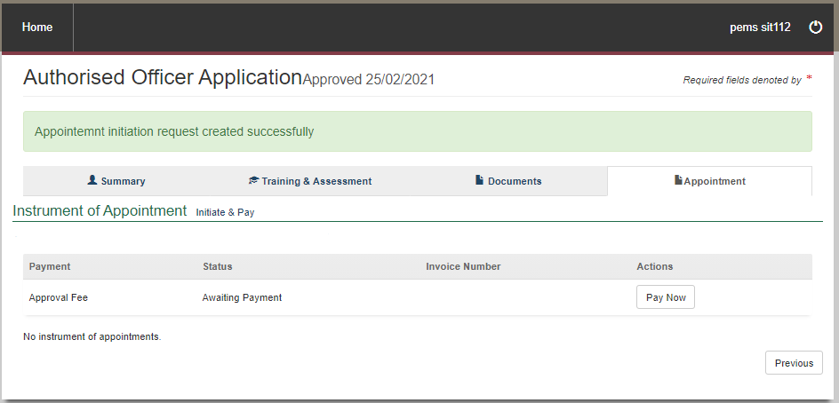
2. | - Review the details of the Service Summary.  - Click ‘Next’. | 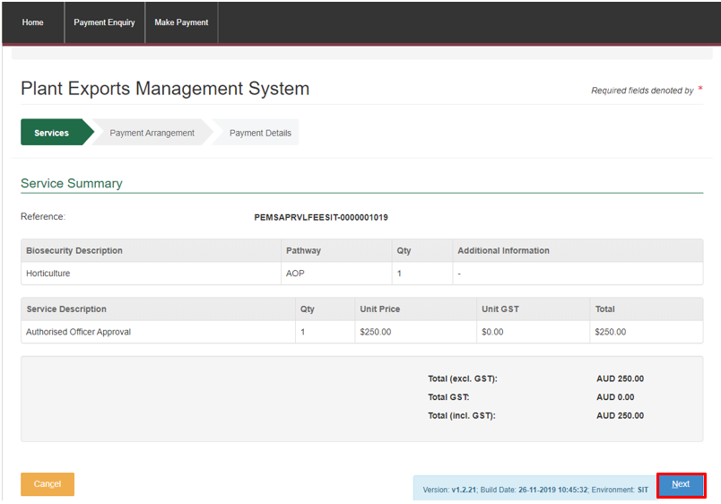
3. | - Select ‘No’ to the question Do you have an Account Number?  - Click ‘Continue to Payment’.
4. | Enter your credit/debit card details. | 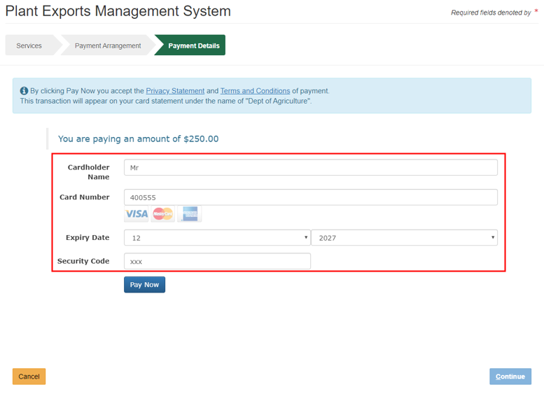
5. | Click ‘Pay Now’. | 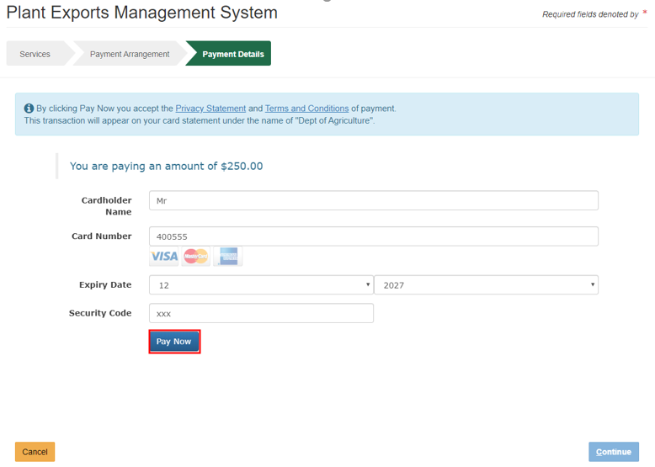
6. | - Note the Payment Confirmation screen.  - Click ‘Continue’.  - Go to ‘Download the Instrument of Appointment’ | 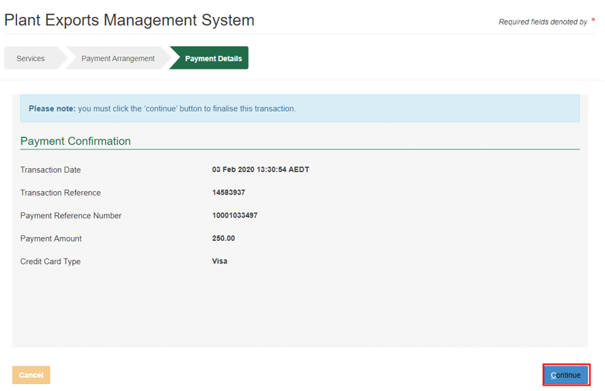

Download the Instrument of Appointment
The following table outlines how to download the instrument of appointment.
Step | Action | Graphic
1. | From the PEMS home screen, click ‘Open’ to open your application. | 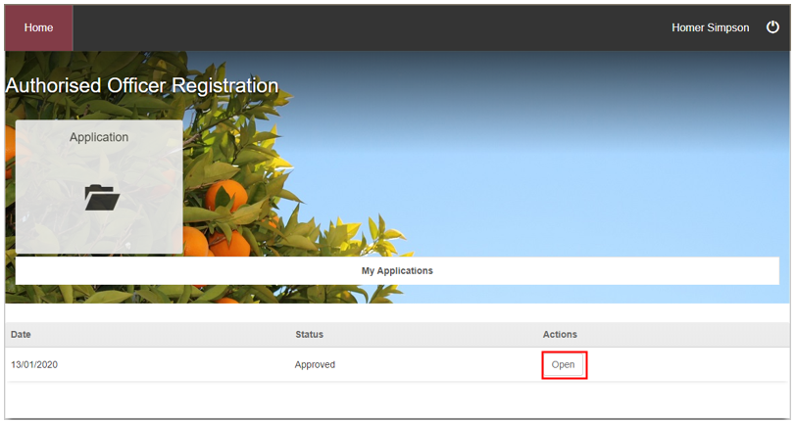
2 | - Click on ‘Download’.  - Note your Instrument of Appointment. | 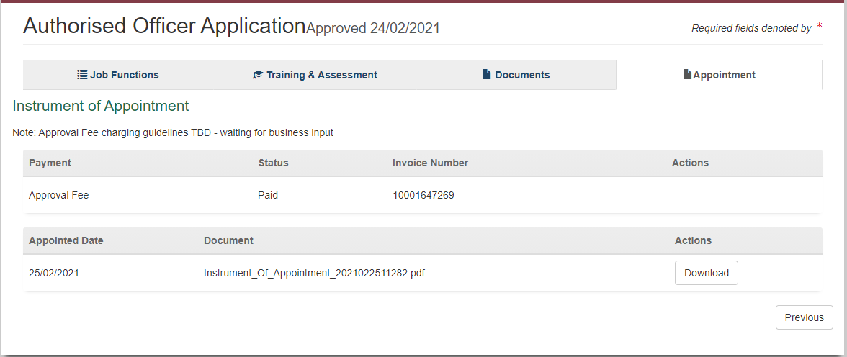

Contact
- Authorised Officer Program: PlantExportTraining@aff.gov.au
- Authorised Officer Hotline: 1800851305

Related material
The following related material is available online:
- Authorised Officer webpage
- Exports Policy: Management of third-party plant exports authorised officers
- Exports work instruction: Applying to become an Authorised Officer using the Plant Exports Management System
- Exports work instruction: Requesting Authorised Officer training using the Plant Exports Management System
- Exports work instruction: Requesting Authorised Officer assessment using the Plant Exports Management System
- Exports reference: Requesting additional job functions in the Plant Exports Management System
- Plant Exports Management System
- Plant Export Operations Manual
- Exports reference: Plant Exports Management System Authorised officer user guide
- Exports reference: Table of authorised officer job functions
- Fees and charges
- Privacy Policy

Document information
The following table contains administrative metadata.
Instructional Material Library document ID | IMLS-9-7557
Instructional material owner | Director, Authorised Officer Program
Risk rating | Low
Review period | Due for review within 4 years of the most recent approved date.

Version history
The following table details the published date and amendment details for this document.
Version | Date published | Date last approved | Review type | Summary of review
1.0 | 6/07/2020 | 6/07/2020 | New Document | First publication of this work instruction.
2.0 | 6/08/2020 | 6/08/2020 | Major Change | Re-title of the WI: Requesting Authorised Officer training using the Plant Export Management System
3.0 | 22/04/2021 | 22/04/2021 | Major Change | Updates for the commencement of the Export Control Act 2020 and associated Export Control (Plants and Plant Products) Rules 2021.
4.0 | 28/02/2024 | 28/02/2024 | Major Change | - Updated department branding and contact information.  - Converted to new exports templates.
5.0 | 19/04/2024 | 19/04/2024 | Major Change | Updated screengrabs.

