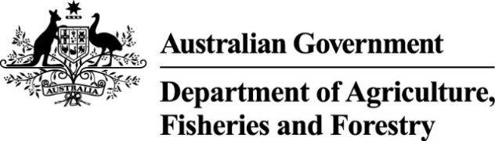

Exports work instruction

Requesting Authorised Officer assessment using the Plant Exports Management System
Direction to authorised officers
This is official instructional material of the Department of Agriculture, Fisheries and Forestry (the department). Failure to comply with it may result in a breach of relevant legislation and/or the code of conduct under section 13(5) of the Public Service Act 1999.

Purpose of this document
This document details the procedure to request Authorised Officer (AO) assessment using the Plant Exports Management System (PEMS).
__________________________________________________________________________________
In this document
This document contains the following topics:
Purpose of this document 1
Policy statement 2
Roles and responsibilities 2
How do I request AO assessment? 3
Request assessment 3
Viewing my progress 14
Contact 17
Related material 17
Document information 17
Version history 18

Policy statement
The policy, definitions and legislation related to this work instruction can be found in the Exports Policy: Management of third party plant exports authorised officers.

Roles and responsibilities
The following table outlines the roles and responsibilities undertaken when requesting AO assessment.
Role | Responsibility
Applicant | Requesting assessment through PEMS.

How do I request AO assessment?
Persons wanting to be assessed in their chosen AO job function/s must lodge their request online through PEMS.
Important: Only complete the assessment request if you are ready to be assessed.

Request assessment
The following table outlines how to request assessment.
Step | Action | Graphic
1. | Go to https://online.agriculture.gov.au/selfservice  Note: The log in page will display. | 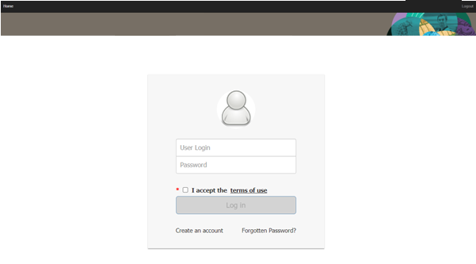
2. | - Enter your User Login and Password.  Note: This information will have been circulated to you via email following registration.  - Check the ‘I accept the terms of use’ box.  - Click ‘Log in’.
3. | Click the ‘PEMS’ button to enter the PEMS home page.  Note: You will not be able to complete this step until your access has been approved by the department.
4. | Click on ‘Open’.
5. | Select the Training & Assessment tab.
6. | Click on ‘Request’. | 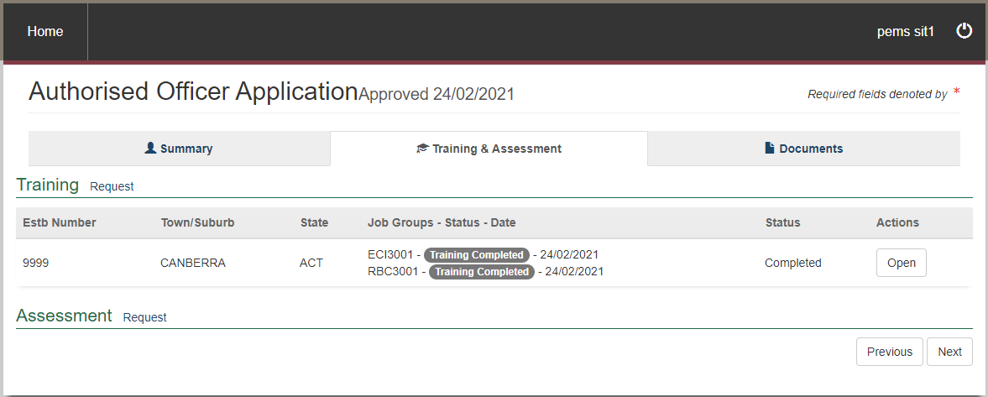
7. | Do you have an Establishment Number?  If… Then…  yes - enter the number - click ‘Search’ - note the information that pre-populates - continue to Step 8.  no go to Step 10. | 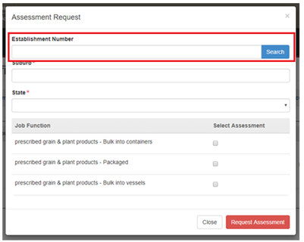
8. | Enter your suburb and state.
9. | Check the boxes for the assessment you want to request. | 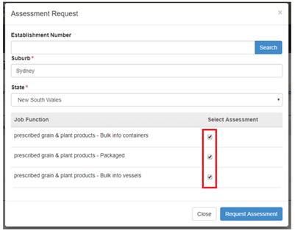
10. | Click ‘Request Assessment’. | 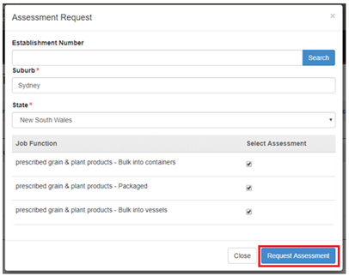
11. | - Note the confirmation of assessment request.  - Go to ‘Viewing my progress’ | 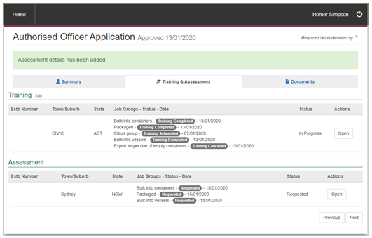

Viewing my progress
The following table outlines how to view your progress.
Step | Action | Graphic
1. | Click ‘Open’.
2. | Note the information displayed in the Assessment Request window:  - where the assessment will take place¹  - what Job Function² will be assessed  - what the Assessment Status³ is  - the Schedule Date⁴, that is, the date assessment has been scheduled for  - the Completion Date⁵  - Assessment Outcome⁶  If your assessment outcome is… Then…  blank - you have not yet been assessed - no further action.  competent refer to Exports work Instruction: Requesting an Instrument of Appointment using the Plant Export Management System.  not yet competent (Level 1) - you will require re-training before you can be re-assessed - refer to Exports work Instruction: Requesting for Authorised Officer training using the Plant Export Management System Note: There is an additional fee for re-training.  not yet competent (Level 2) - you will require re-assessment Note: A request for re-assessment will populate automatically. | 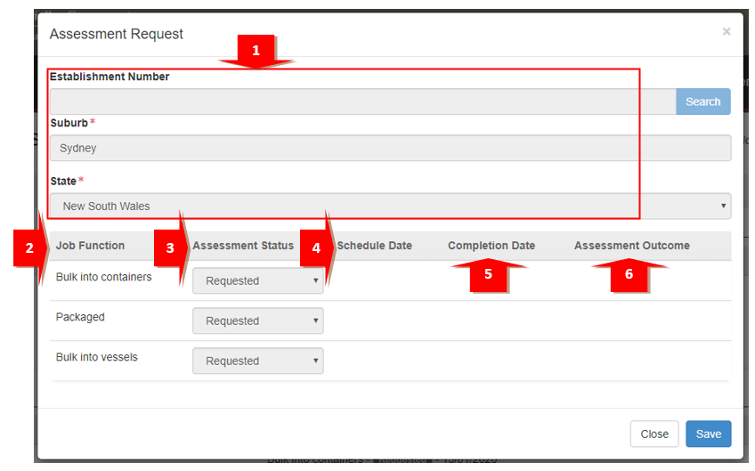

Contact
- Authorised Officer Program: PlantExportTraining@aff.gov.au
- Authorised Officer Hotline: 1800851305

Related material
The following related material is available online:
- Authorised Officer webpage
- Exports Policy: Management of third party plant exports authorised officers
- Exports work instruction: Applying to become an Authorised Officer using the Plant Exports Management System
- Exports work instruction: Requesting Authorised Officer training using the Plant Exports Management System
- Exports work instruction: Requesting an Authorised Officer Instrument of Appointment using the Plant Exports Management System
- Exports reference: Requesting additional job functions in the Plant Exports Management System
- Plant Exports Management System
- Plant Export Operations Manual
- Exports reference: Plant Exports Management System Authorised officer user guide
- Exports reference: Table of authorised officer job functions
- Fees and charges
- Privacy Policy

Document information
The following table contains administrative metadata.
Instructional Material Library document ID | IMLS-9-7545
Instructional material owner | Director, Authorised Officer Program
Risk rating | Low
Review period | Due for review within 4 years of the most recent approved date.

Version history
The following table details the published date and amendment details for this document.
Version | Date published | Date last approved | Review type | Summary of review
1.0 | 6/07/2020 | 6/07/2020 | New document | First publication of this work instruction.
2.0 | 6/08/2020 | 6/08/2020 | Minor change | Re-title of the WI: Requesting Authorised Officer training using the Plant Export Management System.
3.0 | 22/04/2021 | 22/04/2021 | Major change | Updates for the commencement of the Export Control Act 2020 and associated Export Control (Plants and Plant Products) Rules 2021.
4 | 6/05/2024 | 6/05/2024 | Minor change | Updated department logo, IM template and screengrabs.

