

Wildlife Conservation Plan for Migratory Shorebirds

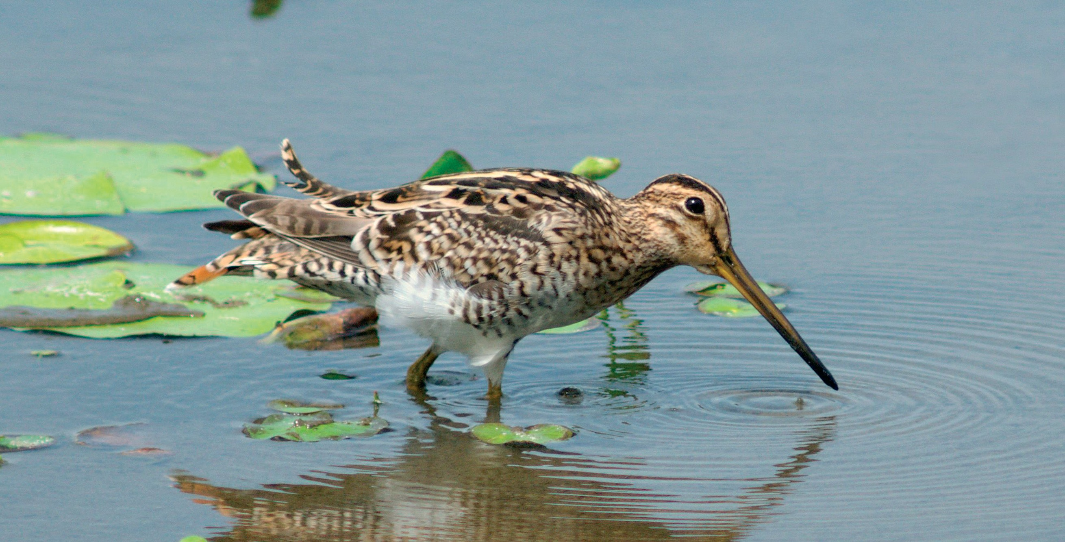

### August 2015

2 / Wildlife Conservation Plan for Migratory Shorebirds

**© Copyright Commonwealth of Australia, 2015.**

The *Wildlife Conservation Plan for Migratory Shorebirds* is licensed by the Commonwealth of Australia for use under a Creative Commons Attribution 4.0 Australia licence with the exception of the Coat of Arms of the Commonwealth of Australia, the logo of the agency responsible for publishing the report, content supplied by third parties, and any images depicting people. F[or licence conditions see: http://creativecommons.org/licenses/](http://creativecommons.org/licenses/) by/4.0/au/

This report should be attributed as ‘*Wildlife Conservation Plan for Migratory Shorebirds*, Commonwealth of Australia 2015’.

The Commonwealth of Australia has made all reasonable efforts to identify content supplied by third parties using the following format ‘© Copyright, [*name of third party*] ’.

The views and opinions expressed in this publication are those of the authors and do not necessarily reflect those of the Australian Government or the Minister for the Environment.

While reasonable efforts have been made to ensure that the contents of this publication are factually correct, the Commonwealth does not accept responsibility for the accuracy or completeness of the contents, and shall not be liable for any loss or damage that may be occasioned directly or indirectly through the use of, or reliance on, the contents of this publication.

Front cover: Latham’s snipe feeding on Bribie Island (Graeme Chapman) Back cover: Sharp-tailed sandpiper (Brian Furby Collection)

Table of Contents

1. Summary 4
2. Introduction 5
   1. Review of the 2006–2011 Wildlife Conservation Plan 6
3. Species covered under the Wildlife Conservation Plan 7
4. Vision 7
5. Objectives 7
6. Legal Framework 8
   1. Statutory commitments relevant to migratory birds 8
   2. Other Australian commitments relevant to migratory shorebirds 9
7. Important habitat for migratory shorebirds in Australia 11
8. Threats 14
   1. Habitat loss 14
   2. Habitat modification 15
   3. Anthropogenic disturbance 16
   4. Climate variability and change 16
   5. Harvesting of shorebird prey 17
   6. Fisheries by-catch 17
   7. Hunting 17
   8. Threat prioritisation 18
9. Actions to achieve the Specific Objectives 20
10. Affected interests 25
11. Organisations/persons involved in evaluating the performance of the plan 25
12. Major benefits to other migratory species, marine species, species of cetacean or conservation dependent species 27
13. References 28
14. Appendix A 30

# 1 Summary

Migratory species which visit Australia such as shorebirds and seabirds received national protection as a matter of national environmental significance when the *Environment Protection and Biodiversity Conservation Act 1999* (EPBC Act) took effect in

July 2000. Under the EPBC Act, wildlife conservation plans may be prepared for the purposes of protection, conservation and management of listed migratory, marine, cetacean or conservation dependant species.

This Wildlife Conservation Plan for Migratory Shorebirds provides a framework to guide the conservation of migratory shorebirds and their habitat in Australia and, in recognition of their migratory habits, outlines national activities to support their appreciation and conservation throughout the East Asian-Australasian Flyway (EAAF). The previous Wildlife Conservation Plan

for Migratory Shorebirds came into effect in February 2006, and was the first wildlife conservation plan developed under the EPBC Act.

Based on expert opinion and new information, a review of the previous wildlife conservation plan recommended that Little ringed plover (*Charadrius dubius*) should be added to the revised list of species covered by the plan. The species is a known regular visitor to northern Australia in low numbers (Geering et al. 2007).

This revised plan contains clarification of statutory elements of the EPBC Act by addressing topics relevant to the conservation of migratory shorebirds, including a summary of Australia’s commitments under international conventions and agreements, and identification of important habitat. It outlines national actions to support EAAF shorebird conservation, and should be used to ensure these activities are integrated and remain focused on the long-term survival of migratory shorebird populations and their habitats.

The Wildlife Conservation Plan for Migratory Shorebirds will remain in place until such time that the shorebird populations that visit Australia have improved to the point where they do not need research or management actions to support their survival. This plan will be in place for five years and will be reviewed in 2020. It is available for download from the Department’s website at:

[www.environment.gov.au/resource/wildlife-conservat](http://www.environment.gov.au/resource/wildlife-conservat)ion-plan-migratory-shorebirds

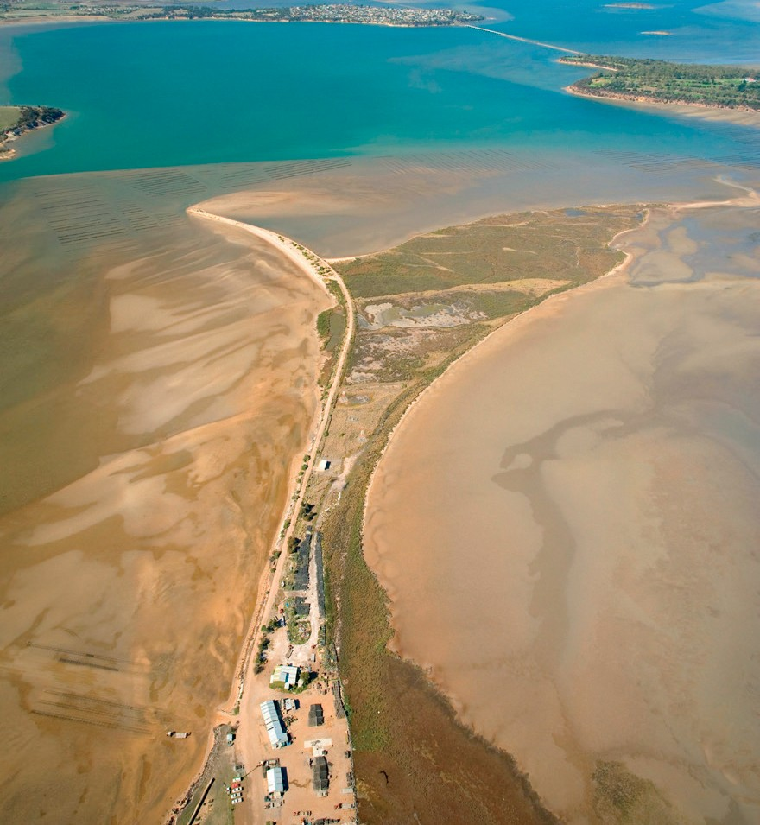

Photo: Aerial view of the Oyster Farms and coastal area of Barilla Bay (Nick Rains)

# Introduction

Most migratory shorebirds make an annual return journey of many thousands of kilometres between their breeding grounds in the northern hemisphere and their non-breeding grounds in the southern hemisphere. The EAAF extends from breeding grounds in the Russian tundra, Mongolia and Alaska southwards through east and south-east Asia, to non-breeding areas in Indonesia, Papua New Guinea, Australia and New Zealand. One species, the Double-banded plover (*Charadrius bicinctus*), breeds in New Zealand and migrates to

south-eastern Australia.

#### Figure 1. East Asian—Australasian Flyway

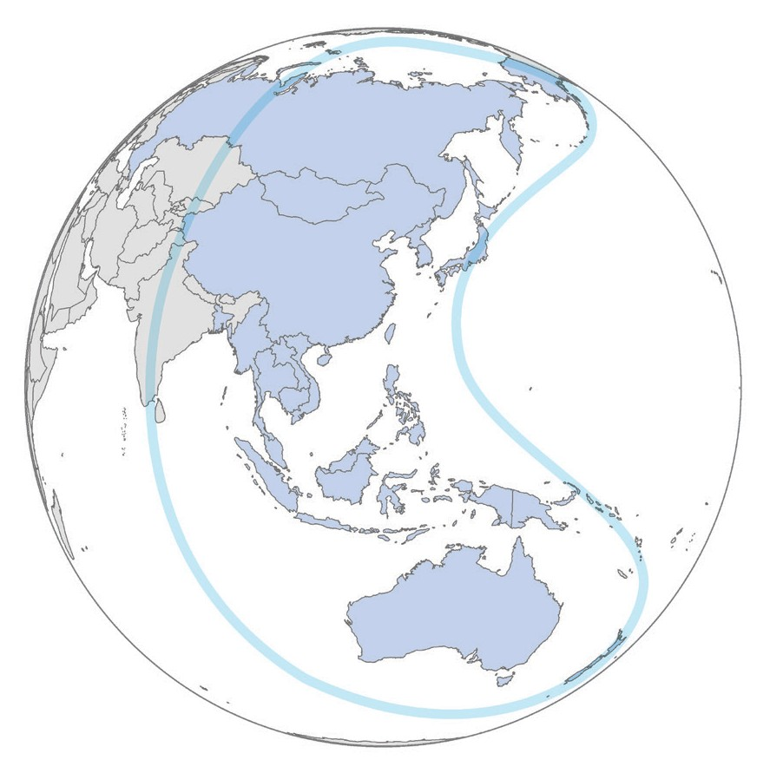

Thirty-seven species of migratory shorebird regularly and predictably visit Australia during their non-breeding season, from the Austral spring to autumn. Australia’s coastal and freshwater wetlands are important habitat during the non-breeding season as places for these migratory shorebirds to rest and feed, accumulating energy reserves to travel the long distance (up to 13 000 kilometres) back to their breeding grounds. In the month or two before migrating, migratory shorebirds need to increase their body mass by up to 70 per cent to sustain their journey.

Shorebirds that migrate from the northern hemisphere reach ‘staging areas’, such as Roebuck Bay and Eighty-mile Beach in north-western Western Australia and the Gulf of Carpentaria in Queensland, by September. From these staging areas, the birds disperse across Australia, reaching the south-eastern states by October. Smaller flocks—cumulatively numbering thousands of birds—take advantage of ephemeral wetlands across inland Australia, while others spread along the coastline. Migratory shorebirds are often gregarious, gathering in mixed flocks, but also occur in single-species flocks or feed and roost with resident shorebird species such as stilts, avocets, oystercatchers and plovers. The picture is further complicated because flocks or individuals of some migratory species remain in Australia during the winter months, such as first-year birds that lack the experience or physical condition to return to their natal sites but often do so in their second year. By March, the birds that have previously dispersed across the country begin to gather at staging areas, once again forming large flocks and feeding virtually round the clock to accumulate energy reserves for their northward migration.

The ecology of migratory shorebirds is complex, especially in Australia where investigations are continuing to unravel their patterns of movement, roosting and dispersal behaviours through targeted research programs. To be effective, shorebird conservation and management initiatives in Australia must take into account the unique distributions and ecology of shorebirds–and the critical importance of international migratory pathways and staging areas, particularly the Yellow Sea region (Barter 2002; MacKinnon et al. 2012; Iwamura et al. 2013; Murray et al. 2014).

As some migratory shorebird populations decrease there is a growing need to minimise threats to the remaining habitats that are critical for their ongoing survival (MacKinnon et al. 2012). This need is occurring in the face of ever-increasing human development and loss of habitat. Efforts to conserve migratory shorebirds in one country can only be effective with cooperation and complementary actions in all countries that shorebirds visit.

Australia is therefore well positioned to lead conservation and research action for migratory shorebirds in the EAAF that would otherwise be difficult to achieve. As migratory shorebird

populations in Australia remain stable for about three months of the year (December to February), Australia plays an important role in monitoring population changes in the species that regularly visit here.

Australia’s national shorebird monitoring programme, Shorebirds 2020– coordinated by BirdLife Australia–has expanded its monitoring coverage to include remote and sparsely populated areas in northern Australia, particularly in the Gulf of Carpentaria region. The Gulf of Carpentaria contains internationally and nationally important habitat for migrating and wintering shorebirds, with extensive and largely pristine wetlands and beach habitats.

Accurate information on shorebird abundance and distribution is urgently required from this region, particularly in light of recent steep declines in southern Australia. Whether these declines are

mirrored in northern Australia will have implications for the management of important habitat in

the region.

The growing and skilled workforce of Indigenous land and sea management organisations (including ranger programmes based in remote areas with management authority for extensive beach and wetland habitats) presents a valuable opportunity to improve information about migratory shorebirds in northern Australia. Partnerships between BirdLife Australia and the North Australian Indigenous Land and Sea Management Alliance (NAILSMA) are already developing to achieve this aim. There are likely to be many unidentified migratory shorebird areas, particularly in northern Australia, that meet the criteria of important habitat (Section 7).

Monitoring and research projects undertaken by governments, academic institutions and conservation groups in Australia and other parts of the EAAF continue to indicate decreasing migratory shorebird populations, largely attributed to ongoing loss of critical intertidal habitat in east Asia (MacKinnon

et al. 2012; Murray et al. 2014). For the migratory shorebird populations that visit Australia to have a reasonable chance of survival through this century, increased levels of habitat protection, and in some cases restoration, are needed throughout the EAAF.

2.1 Review of the

2006–2011 Wildlife

Conservation Plan

After reviewing progress made in the conservation of Australia’s migratory shorebirds since 2006, some fundamental problems with the previous wildlife conservation plan were identified. Specifically, only moderate progress was made against the objectives and actions in the original plan. Of the 31 actions listed, four were completed comprehensively. While progress was made on a further 20 actions, these were mostly considered to be on-going. Little or no progress was made on the remaining seven actions. In a holistic sense the wildlife conservation plan failed to meet its objectives, because it had apparently not reduced the rate of decrease of any of the listed species, nor did it have any measurable influence on the known core impacts in East Asia.

The review recommended that given the contemporary and likely future threats to migratory shorebirds in Australia and the EAAF, there was a need to retain a wildlife conservation plan for the 36 listed species to maintain a national framework identifying research and management actions. It recommended that, based on expert opinion and new information, the Little ringed plover (*Charadrius dubius*) should be considered as an addition to the revised Appendix A. This species is a known regular visitor to northern Australia in low numbers (Geering et al. 2007). The review further recommended that the plan should be updated to remove the completed actions and include new, focused conservation priorities.

This revised wildlife conservation plan builds upon the previous plan’s achievements and was made in consultation with representatives from the Australian, state and territory governments, NGOs, industry and research organisations. The revised plan provides for the research and management actions necessary to support the survival of the listed migratory shorebirds.

# Species covered under the Wildlife Conservation Plan

This Wildlife Conservation Plan includes 35 species of migratory shorebird that regularly visit Australia (Appendix A). Little ringed plover has been added to the revised list based on expert opinion and new information. This species is a regular visitor to northern Australia in low numbers (Geering et al. 2007). The plan will cease to apply to any of these species should they become a listed threatened species under the EPBC Act. Instead, threatened species receive separate, approved conservation advice and in some cases a recovery plan which sets out what could appropriately be done to stop the decline or support the recovery of the species. On 26 May 2015, Eastern curlew and Curlew sandpiper were listed as critically endangered under the EPBC Act. This decision made them ineligible to be included in the revised Wildlife Conservation Plan for Migratory Shorebirds. Both species have approved Conservation Advice which sets out species specific actions to support the recovery of these species.

If any additional migratory shorebird species that are currently considered to be vagrant were to be recorded on a regular basis, monitoring programmes for the species should be supported to determine whether inclusion under the plan is appropriate.

# Vision

Ecologically sustainable populations of migratory shorebirds remain distributed across their range and diversity of habitats in Australia, and throughout the East Asian-Australasian Flyway.

# Objectives

1. Protection of important habitats for migratory shorebirds has occurred throughout the EAAF.
2. Wetland habitats in Australia, on which migratory shorebirds depend, are protected and conserved.
3. Anthropogenic threats to migratory shorebirds in Australia are minimised or, where possible, eliminated.
4. Knowledge gaps in migratory shorebird ecology in Australia are identified and addressed to inform decision makers, land managers and the public.

# Legal Framework

* 1. Statutory commitments relevant to

migratory birds

The EPBC Act is the Australian Government’s key piece of environmental legislation. Under the Act approval is required for any proposed action, including projects, developments, activities, or alteration of

these things, likely to have a significant impact on any of the identified matters of national environmental significance. One of these matters protected by the Act is migratory species; specifically those migratory species listed under the *Convention on Conservation*

*of Migratory Species of Wild Animals* (also known as the CMS or the Bonn Convention; [www.cms.int/)](http://www.cms.int/)) and bilateral migratory bird agreements with Japan (JAMBA), China (CAMBA) and the Republic of Korea (ROKAMBA).

Australia’s list of migratory species is established under Section 209 of the EPBC Act and must include:

*“(a) all migratory species that are:*

* + 1. *native species; and*
    2. *from time to time included in the appendices to the Bonn Convention; and*

1. *all migratory species from time to time included in annexes established under JAMBA and CAMBA; and*
2. *all native species from time to time identified in a list established under, or an instrument made under, an international agreement approved*

*by the Minister under subsection (4).* [Which includes ROKAMBA]

*The list must not include any other species.”*

The migratory species list established under the EPBC Act is available at: [www.environment.gov.au/topics/](http://www.environment.gov.au/topics/) biodiversity/migratory-species

Section 211(A to E) of the EPBC Act prohibits the killing, injuring, taking, trading, keeping or moving of any migratory species in or on a Commonwealth area, although certain exemptions are allowed for in Section 212. For places outside of Commonwealth areas, the EPBC Act prevents actions (Section 140) or approvals under Strategic Assessments (Section 146L) being inconsistent with Australia’s migratory species’ obligations under the Bonn Convention or JAMBA, CAMBA or ROKAMBA.

Under the Bonn Convention, species are listed on Appendix I or Appendix II (or both), with Appendix I species recognised as endangered. Appendix II species are those which have an unfavourable conservation status and which require international agreements

for their conservation and management, as well as those which would significantly benefit from the international cooperation that could be achieved by an international agreement. All of Australia’s migratory shorebird species are listed on Appendix II, Eastern curlew (*Numenius madagascariensis*) and Great knot (*Calidris tenuirostris*) are also listed on Appendix I. Endangered migratory species included in Appendix

I, in addition to enjoying strict legal protection by Parties, can benefit from the development of Concerted Actions. These range from field research and conservation projects to the establishment of technical and institutional frameworks for action. International Single Species Action Plans are an important instrument to promote and coordinate activities that seek to protect and restore habitat, mitigating obstacles to migration and other controlling factors that might endanger species.

Parties to the Convention that are Range States of a migratory species commit to prohibiting the taking of animals listed in Appendix I, and endeavour:

* to conserve and, where feasible and appropriate, restore those habitats of the species which are of importance in removing the species from danger of extinction
* to prevent, remove, compensate for or minimize, as appropriate, the adverse effects of activities or obstacles that seriously impede or prevent the migration of the species
* to the extent feasible and appropriate, prevent, reduce or control factors that are endangering or are likely to further endanger the species,

including strictly controlling the introduction of, or controlling or eliminating, already introduced exotic species.

Signatories to JAMBA, CAMBA and ROKAMBA are committed to taking appropriate measures to preserve and enhance the environment of migratory birds, in particular, by seeking means to prevent damage to such birds and their environment. These agreements also commit the governments to exchange research data and publications, to encourage formulation of joint research programs, and to encourage the conservation of migratory birds.

Australia’s obligations under the Bonn Convention and JAMBA, CAMBA and ROKAMBA amount to ensuring adverse effects on listed migratory species and their habitats in Australia do not occur. The EPBC Act seeks to prevent such adverse impacts

by imposing civil penalties (Section 20) to persons who take actions that have, or are likely to have,

a significant impact on a listed migratory species. *EPBC Act Policy Statement 3.21—Industry Guidelines for avoiding, assessing and mitigating impacts on EPBC Act listed migratory shorebird species* provides assistance in determining the likelihood of a significant impact on migratory shorebirds.

This wildlife conservation plan gives clarification to the concept of ‘important habitat’ in relation to migratory shorebirds (Section 9). It also identifies

other actions to assist Australia’s commitments under both the Bonn Convention and the bilateral migratory bird agreements.

## Other Australian commitments relevant to migratory shorebirds

While the Bonn Convention, JAMBA, CAMBA and ROKAMBA provide mechanisms for pursuing conservation outcomes for migratory birds, they do not encompass all migratory birds and are binding only on a limited number of countries. As Australia

became increasingly concerned about the conservation status of migratory waterbirds, additional mechanisms have been developed for multilateral cooperation on waterbird conservation throughout the EAAF.

### Ramsar Convention on Wetlands

Australia is a signatory to the *Convention on Wetlands of International Importance* (see www.ramsar.org). The Ramsar Convention, as it is commonly known, is an intergovernmental treaty dedicated to the conservation and ‘wise use’ of wetlands.

The Ramsar Convention focuses on conservation of important habitats rather than species. Parties are committed to identifying wetlands that qualify as internationally significant against a set of criteria, nominating these wetlands to the List of Wetlands of International Importance (the Ramsar List) and ensuring the maintenance of the ecological character of each listed Ramsar site.

As at July 2015, Australia has 65 Wetlands of International Importance that cover a total of approximately 8.1 million hectares. Many of Australia’s Ramsar sites were nominated and listed using waterbird-based criteria, and in some of these cases migratory shorebirds are a major component of the waterbird numbers (e.g. Roebuck Bay and Eighty-mile Beach Ramsar Sites in Western Australia).

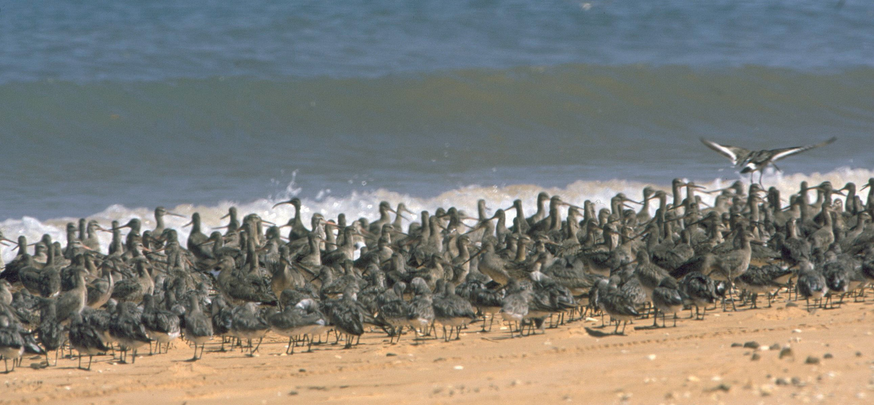

Photo: Black-tailed godwits (Brian Furby Collection)

### East Asian—Australasian Flyway Partnership

The Partnership for the Conservation of Migratory Waterbirds and the Sustainable Use of their Habitats in the East Asian–Australasian Flyway (East Asian— Australasian Flyway Partnership) was launched on 6 November 2006. A Ramsar regional initiative, the partnership is an informal and voluntary collaboration of effort focusing on protecting migratory waterbirds, their habitat and the livelihoods of people dependant on them.

The EAAF is one of nine major migratory waterbird flyways around the globe. It extends from within the Arctic Circle in Russia and Alaska, southwards through East and South-east Asia, to Australia and New Zealand in the south, encompassing 22 countries. Migratory waterbirds share this flyway with 45 per cent of the world’s human population. The EAAF is home to over 50 million migratory waterbirds—including shorebirds, Anatidae (ducks, geese and swans), seabirds and cranes—from 207 species, including 33 globally threatened and 13 near threatened species.

Flyway partners include countries, intergovernmental agencies, international non-government organisations and the international business sector. A cornerstone of the partnership is the establishment of a network of internationally important sites for migratory waterbirds throughout the EAAF. The partnership operates via working groups and task forces, one working group and a number of task forces focus on migratory shorebirds. More information about the Partnership is available at: [www.eaaflyway.net](http://www.eaaflyway.net/)

# 7 Important habitat for migratory shorebirds in Australia

Under the EPBC Act, ‘important habitat’ is a key concept for migratory species, as identified in *EPBC Act Policy Statement 1.1 Significant Impact Guidelines—Matters of National Environmental*

*Significance 2009*. Defining this term for migratory shorebirds in Australia is important to ensure that habitat necessary for the ongoing survival of the

37 species is appropriately managed.

Important habitats in Australia for migratory shorebirds under the EPBC Act include those recognised as nationally or internationally important (see below). The widely accepted and applied approach to identifying internationally important shorebird habitat throughout the world has been through the use of criteria adopted under the Ramsar Convention. Further assistance in identifying important habitats and survey guidelines for migratory shorebirds is available in *EPBC Act Policy Statement 3.21—Industry Guidelines for avoiding, assessing and mitigating impacts on EPBC Act listed migratory shorebird species*.

According to this approach, wetland habitat should be considered **internationally important** if it regularly supports:

* 1 per cent of the individuals in a population of one species or subspecies of waterbird or
* a total abundance of at least 20 000 waterbirds.

**Nationally important** habitat for migratory shorebirds can be defined using a similar approach to these international criteria, i.e. if it regularly supports:

* 0.1 per cent of the flyway population of a single species of migratory shorebird or
* 2000 migratory shorebirds or
* 15 migratory shorebird species.

Photo: Black-tailed Godwit (Graeme Chapman) Photo: Long view northwards of the restored area of dunes behind Merewether Beach (John Baker)

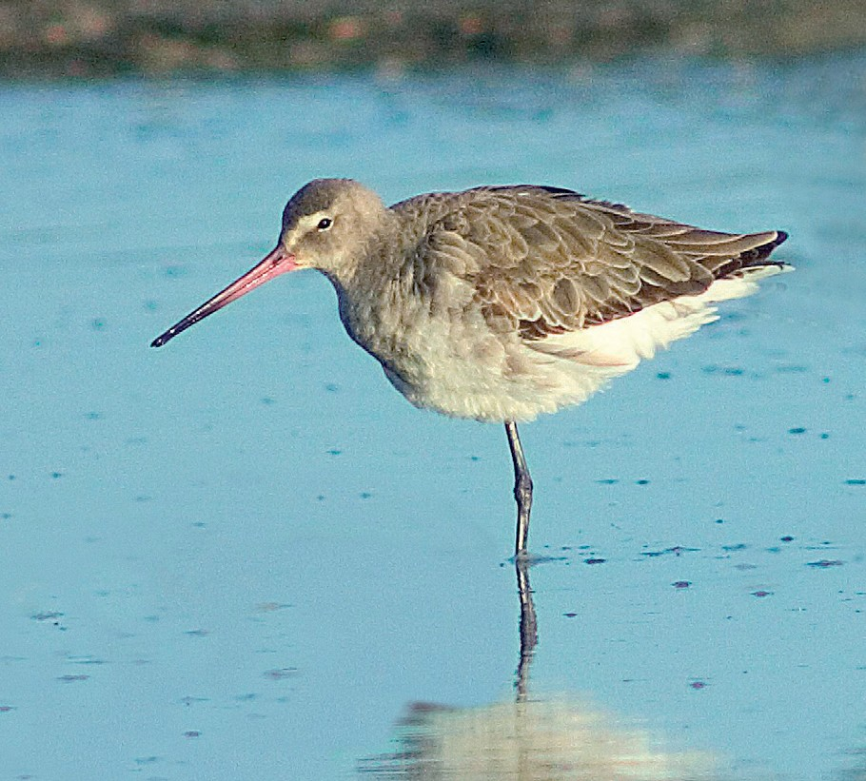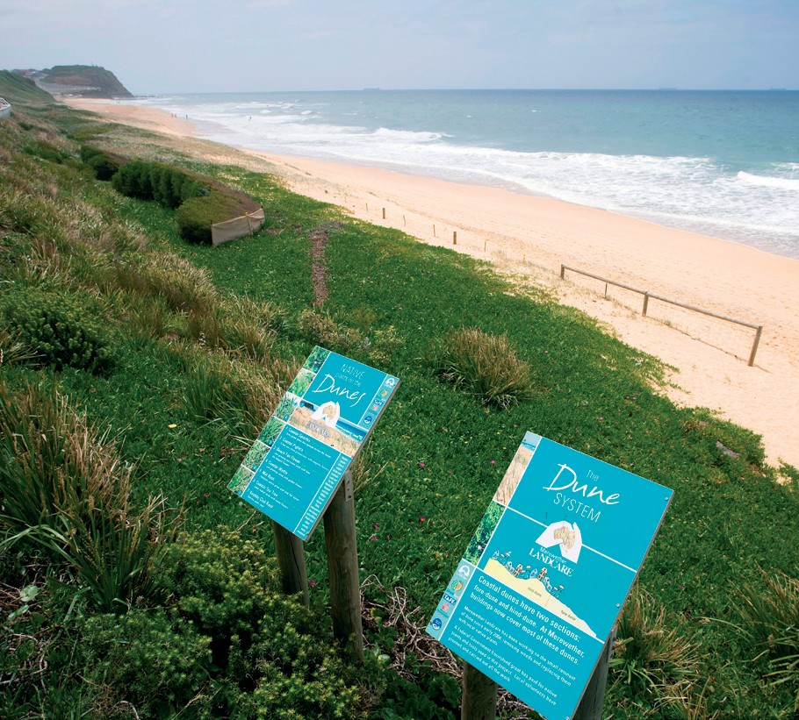

Figure 2 illustrates the process for identifying important habitat for migratory shorebirds under the EPBC Act. This process applies to each of the migratory shorebird species with the exception of Latham’s snipe (*Gallinago hardwickii*) which is treated differently, reflecting its cryptic lifestyle (see below).

#### Figure 2. Process for identifying important habitat for migratory shorebirds (excluding Latham’s snipe) within Australia.

Is the shorebird area**1** already identified as internationally**2** important?

YES

Important habitat

NO

Does the shorebird area support**3**:

1. at least 0.1 per cent of the flyway population**2** of a single migratory shorebird species, or
2. at least 2000 migratory shorebirds, or
3. at least 15 migratory shorebird species.

YES Important habitat

NO

Not important habitat

1. Following Clemens *et al*. (2010) a shorebird area is defined as: *the geographic area that has been used by the same group of shorebirds over the main non-breeding period*. This is effectively the home range of the local population when present.

Shorebird areas may include multiple roosting and feeding habitats. While most migratory shorebird areas will represent contiguous habitat, non-contiguous habitats may be included as part of the same area where there is evidence of regular bird movement between them. Migratory shorebird areas may therefore extend beyond the boundaries of a property or project area, and may also extend beyond Ramsar boundaries for internationally important areas. Existing information and/or appropriate surveys can determine the extent of a migratory shorebird area.

1. Bamford et al. (2008) detailed a list of internationally important areas within the EAAF and is available at:

[www.environment.gov.au/biodiversity/migratory/publications/shorebirds-east-asia.html](http://www.environment.gov.au/biodiversity/migratory/publications/shorebirds-east-asia.html)

Shorebird population estimates may from time-to-time be updated as new information is published. Further information can be found on the Department’s website.

1. ‘Support’ is defined differently depending on whether the habitat is considered permanent or ephemeral.
   * For permanent wetlands, ‘support’ is defined as: *migratory shorebirds are recorded during surveys and/or known to have occurred within the area during the previous five years*.
   * For ephemeral wetlands, ‘support’ is defined as: *habitat that migratory shorebirds have ever been recorded in, and where that habitat has not been lost permanently due to previous actions*.

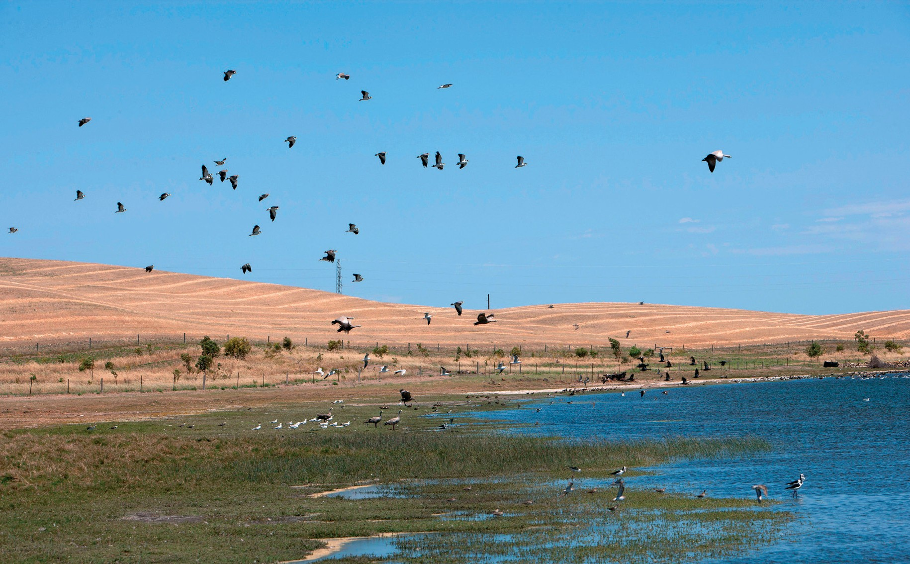

Photo: Birdlife of the Little Swamp Wetland in Port Lincoln (Dragi Markovic)

Another issue regarding important habitat is the degree of importance of habitat components within complexes or areas. For example, a large area may be considered internationally or nationally important, but within that area there may be particular habitats that are more valuable than others, such as those used most regularly for roosting and feeding. In promoting the wise use of wetlands, it may be pertinent to strongly protect such habitat from development and recreational activities that may disturb shorebirds, but consider allowing these activities within parts of the broader area.

Latham’s snipe (*Gallinago hardwickii*)

Latham’s snipe does not commonly aggregate in large flocks or use the same habitats as other migratory shorebird species. Consequently, habitat important to Latham’s snipe cannot be identified using the process outlined in Figure 2 and different criteria are necessary. Threshold criteria are still considered the best way to identify important sites in the absence of data sufficient for more rigorous methods. For the purposes of this plan, important habitat for Latham’s snipe is described as areas that have previously been identified as internationally important for the species, or areas that support at least 18 individuals of the species. Definitions for shorebird ‘area’ and ‘support’ are as above.

# Threats

In a global review, Sutherland et al. (2012) identify 45 threats facing shorebird populations that can

be divided into three categories: natural, current anthropogenic and future issues. The natural issues include volcanoes and cyclones, while current anthropogenic threats encompass climate change, abandonment of rice fields and human disturbance. Likely future issues that could affect shorebird population include microplastics, global hydro-security and changes in sedimentation rates.

The review demonstrates the breadth of issues facing shorebirds, ranging from ‘likely but with minor effects’ to ‘unlikely but catastrophic effects causing species extinction’.

In Australia and the EAAF, many of the current threats are linked to the changing availability of wintering, stop-over and breeding habitats (MacKinnon et al. 2012). The loss of key locations

at any point on the migratory pathway will have significant consequences for a number of species.

Key threats to the migration and survival of

Australian migratory shorebirds are identified in

this section. The list is no by means exhaustive, but identifies the main threats that are likely to significantly affect shorebird populations adversely.

## Habitat loss

### Infrastructure / coastal development in Australia

Habitat loss occurring as a result of development is the most significant threat currently affecting Australian migratory shorebirds, both in Australia and along the EAAF. It is estimated that since European settlement approximately 50 per cent of Australia’s non-tidal wetlands have been converted to other uses. In some regions the rate of loss has been even higher. On the Swan Coastal Plain of Western Australia 75 per cent of wetlands have been filled or drained. In south-east South Australia 89 per cent has been lost. Urban development in Australia has often involved the draining and filling of wetlands for industrial or

commercial use and waste disposal (Lee et al. 2006). Many watercourses in urban areas have been converted to concrete-lined drains resulting in loss of in-stream habitats, fringing wetlands and streamside vegetation.

In Australia, due to the nature of the environment and the distribution of the human population, estuaries and permanent wetlands of the coastal lowlands have experienced most losses, especially in the southern parts of the continent (Lee et al. 2006). Agricultural development and infrastructure has been attributed

to the substantial loss of wetlands on the floodplains of inland and coastal rivers. Drainage and conversion of wetlands for agricultural activities has been a major cause of wetland loss worldwide.

### Infrastructure /coastal development in staging and stop-over areas, particularly the Yellow Sea

Of particular concern in the EAAF is coastal development and intertidal mudflat ‘reclamation’ in the Yellow Sea region, which is bordered by China, the Democratic People’s Republic of Korea and the Republic of Korea (Murray et al. 2014). A migratory shorebird’s ability to complete long migration flights depends on the availability of suitable habitat at sites throughout the EAAF that provide adequate food and roosting opportunities to build sufficient energy reserves. The Yellow Sea region is a major staging area for several species of shorebird, including significant populations of Great knot (*Calidris tenuirostris*), which fly between Australia and the east coast of Asia on migration (Barter 2002; Bamford et al. 2008; Iwamura et al. 2013). In a recent study using historical topographical maps, remote sensing and geographical information system (GIS) analysis, Murray et al. (2014) suggest that up to two-thirds (65 per cent) of the tidal flats existing in the Yellow Sea in the 1950s have been lost to development. Losses of such magnitude are likely the key drivers of decreases in biodiversity and ecosystem services in the intertidal zone of the region (MacKinnon et al. 2012). Further reclamation projects are occurring or are in the planning stage in the Yellow Sea region.

## Habitat modification

Modification of wetland habitats can arise from a range of different activities including fishing or aquaculture, forestry and agricultural practices,

mining, changes to hydrology and development near wetlands for housing or industry (Lee et al. 2006; Sutherland et al. 2012). Such activities may result in increased siltation, pollution, weed and pest invasion, all of which can change the ecological character of a shorebird area, potentially leading to deterioration of the quantity and quality of food and other resources available to support migratory shorebirds (Sutherland et al. 2012 and references therein). The notion that migratory shorebirds can continue indefinitely to move to other important habitats as their normal feeding, staging or roosting areas become unusable

is erroneous. As areas become unsuitable to support migratory shorebirds, remaining habitats will attract more birds, in turn creating overcrowding, competition for food and depletion of food resources, and increased risk of disease transmission.

### Chronic pollution

Shorebird habitats are threatened by the chronic accumulation and concentration of pollutants. Chronic pollution may arise from both local and widespread sources. Migratory shorebirds may be exposed to chronic pollution during their time in Australia and along their migration routes, although the extent and implications of this exposure remains largely unknown. In their feeding areas, shorebirds are most at risk from bioaccumulation of human-made chemicals such as organochlorines from herbicides and pesticides and industrial waste. Agricultural, residential and catchment run-off carries excess nutrients, heavy metals, sediments and other pollutants into waterways, and eventually wetlands.

### Acute pollution

Wetlands and intertidal habitats are threatened by acute pollution caused by, for example, oil or chemical spillage. Acute pollution generally arises from accidents, such as chemical spills from shipping, road or industrial accidents. Generally, migratory shorebirds are not directly affected by oil spills, but important habitat may be affected for many years through catastrophic loss of marine benthic food sources.

### Invasive species

Introduced plant species such as Water hyacinth (*Eichhornia crassipes*), *Ludwigia peruviana, Salvinia* sp. and *Mimosa pigra* have adversely affected the ecological character and biodiversity of wetlands across Australia; introduced animals such as pigs (*Sus* sp.), cane toads (*Rhinella marina*) and European carp (*Cyprinus carpio*) are also well known for their destructive impacts on wetland areas. There is also a constant risk of new introductions of exotic pasture, aquarium and garden species, such as Sea spurge (*Euphorbia paralias*), and exotic marine pests from ballast water and hull transport. Of specific concern for migratory shorebirds is the introduction of exotic marine pests resulting in loss of benthic food sources at important intertidal habitat (Neira et al. 2006). Predation by invasive animals, such as cats (*Felix catus*) and foxes (*Vulpes vulpes*) in Australia has not been quantified, but anecdotal evidence suggests some individuals are taken as prey.

Outside Australia, invasive species are negatively affecting coastal habitat, causing local species to be displaced by species accidentally or deliberately introduced from other areas. With an increase in global shipping trade the influx of such species is increasing, especially in the coastal zone. Examples include *Spartina* grass in China, Zebra mussels (*Dreissena polymorpha*), and Tilapia (*Tilapia* spp.) in wetlands and estuaries and along coasts (MacKinnon et al. 2012).

### Altered hydrological regimes

Altered hydrological regimes can directly and indirectly threaten migratory shorebird habitats. Water regulation, including extraction of surface and ground water (for example, diversions upstream for consumptive or agricultural use), can lead to significant changes to flow regime, water depth and water temperature. Changes to flows can lead to permanent inundation or drying down of connected wetlands, and changes to the timing, frequency

and duration of floods. These changes affect both habitat availability and type (for example, loss of access to mudflats through permanent higher water levels, or a shift from freshwater to salt-tolerant vegetation communities), and the disruption of lifecycles of plants and animals in the food chain for migratory shorebirds.

Reduced recharge of local groundwater that occurs when floodplains are inundated can change the vegetation that occurs at wetland sites, again affecting habitat and food sources.

Water regulation can alter the chemical make-up of wetlands. For example, reduced flushing flows can cause saltwater intrusion or create hyper-saline conditions. Permanent inundation behind locks and weirs can cause freshwater flooding of formerly saline wetlands, as well as pushing salt to the surface through rising groundwater.

## Anthropogenic disturbance

Research suggests that disturbance from human activities has a high energetic cost to shorebirds and may compromise their capacity to build sufficient energy reserves to undertake migration (Goss-Custard et al. 2006; Weston et al. 2012). Disturbance which renders an area unusable is equivalent to habitat loss and can exacerbate population declines. Disturbance is greatest where increasing human populations and development pressures may have an impact on important habitats. Migratory shorebirds are most susceptible to disturbance during daytime roosting and foraging periods. As an example, disturbance of migratory shorebirds in Australia is known to result from aircraft over-flights, industrial operations and construction, artificial lighting, and recreational activities such as fishing, off-road driving on beaches, unleashed dogs and jet-skiing (Weston et al. 2012).

A recent study by Martin et al. (2014) examined the responses to human presence of an abundant shorebird species in an important coastal migration staging area. Long-term census data were used to assess the relationship between bird abundances and human densities and to determine population trends. In addition, changes in individual bird behaviour in relation to human presence were evaluated by direct observation of a shorebird resident species. The results showed that a rapid increase in the recreational use of the study area in summer dramatically reduced

the number of shorebirds and gulls which occurred, limiting the capacity of the site as a post-breeding stop-over area. In addition, the presence of people at the beach significantly reduced the time that resident species spent consuming prey. The study found negative effects of human presence on bird abundance remained constant over the research period, indicating no habituation to human disturbance in any of the studied species. Moreover, although intense human disturbance occurred mainly in summer, the human presence observed was sufficient to have a negative impact on the long-term trends of a resident shorebird species. The authors suggested that the impacts of disturbance detected on shorebirds and gulls may be reversible through management actions that decrease human presence. They suggest minimum distances

for any track or walkway from those areas where shorebirds are usually present, particularly during spring and summer, as well as an appropriate fencing in the most sensitive areas.

## Climate variability and change

There is strong scientific evidence that anthropogenic greenhouse gas emissions are causing changes to the world’s climate (Fifth Assessment Report of the Intergovernmental Panel on Climate Change 2013). As such, ‘*Loss of habitat caused by anthropogenic emissions of greenhouse gases’* has been declared a Key Threatening Process under the EPBC Act. Such changes have the potential to affect migratory shorebirds and their habitats by reducing the extent of coastal and inland wetlands or through a poleward shift in the range of many species (Chambers et al. 2005; Iwamura et al. 2013). Climate change projections for Australia suggest likely increased temperatures, rising sea levels and an overall drying trend for much of the continent, together with more frequent and/or intense extreme climate events resulting in likely species loss and habitat degradation (Chambers et al. 2005, 2011; Iwamura et al. 2013).

* 1. Harvesting of

shorebird prey

Overharvesting of intertidal resources, including fish, molluscs, annelids, sea-cucumber, sea-urchins and seaweeds can lead to decreased productivity and changes in prey distribution and availability (MacKinnon et al 2012). The recent industrialisation of harvesting methods in China has resulted in greater harvests of intertidal flora and fauna with less manual labour required, which is affecting ecosystem processes throughout the intertidal zone. In many important shorebirds areas, the intertidal zone is a maze of fishing platforms, traps and nets that not only add to overfishing, but prevent access to shorebird feeding areas by causing human disturbance.

## Fisheries by-catch

Competition for food by human fishers together with associated disturbance by humans and boats has continued to put pressure on waterbirds along the EAAF (MacKinnon et al. 2012). Fishing nets, set for shrimp or fish species, accidentally kill shorebirds if left on intertidal flats at low tide. Birds caught in the nets drown when the tide rises. The significance of this threat is presently not quantified and requires further investigation.

## Hunting

Hunting of migratory shorebirds in Australia has been prohibited for a number of decades. It is unclear if illegal hunting occurs during the annual duck hunting season in certain states. Historically, Latham’s snipe was particularly vulnerable to hunting. The species was formerly hunted, legally, in all states in eastern Australia. It has been estimated that up to

10 000 birds (including 6000 birds in Victoria and 1000 birds in Tasmania) were killed annually by hunters before bans on shooting were introduced in 1976 (New South Wales), 1983 (Tasmania) and 1984 (Victoria). Shooting is also banned in Queensland

and South Australia, but the dates at which bans were introduced are unknown (Naarding 1981, 1983, 1985, 1986). Eastern curlews were also shot for food in Tasmania (Park 1983; Marchant & Higgins 1993) and have been hunted intensively on their breeding grounds in Russia and at stopover points while on migration (Marchant & Higgins 1993).

There have been a number of investigations into hunting activity at international sites, including in the Chang Jiang Estuary, China (Tang & Wang 1991, 1992, 1995; Barter et al. 1997; Ma et al. 1998).

Tang and Wang (1992) estimated that approximately 30 000 shorebirds in 1991 and 9 000 shorebirds in 1992 were captured with clap nets during northward migrations. They suggested that the decrease between the two years was due to decreasing hunter numbers, increasing incomes from alternative activities and/or reduction in shorebird habitat due to reclamation. However, a study during the 1996 northward migration showed that hunter numbers had not decreased since 1991 and that the number of shorebirds caught was similar (Barter et al. 1997). Studies during the 2000-2001 period indicate that hunting activity had declined at Chongming Dao, China (Ma et al. 2002).

Wang et al. (1991, 1992) also reported hunting activity in the Yellow River Delta, estimating that 18 000 to 20 000 shorebirds were caught with clap nets during northward migration in

1992 and probably a higher number during southward migration in 1991. However, no hunting was observed in the Delta during surveys in the 1997, 1998 and 1999 northward migrations (Barter 2002). With the exception of the Chang Jiang Estuary, no hunting activity has been detected in China during recent shorebird surveys that covered about one-third of Chinese intertidal areas between 1996 and 2001 (Barter 2002). Hunting also appears to be decreasing in South Korea, with the only reported instance being minor hunting activity in Mangyeung Gang Hagu (Barter 2002).

## Threat prioritisation

Each of the threats outlined above has been assessed to determine the risk posed to migratory shorebird populations using a risk matrix. This determines the priority for actions outlined in Section 9. The risk matrix considers the likelihood of an incident occurring and the consequences of that incident. Threats may act differently on different species and populations at different times of year, but the precautionary principle dictates that the threat category is determined by the group at highest risk. Population-wide threats are generally considered to present a higher risk.

The risk matrix uses a qualitative assessment drawing on peer reviewed literature and expert opinion.

In some cases the consequences of activities are unknown. In these cases, the precautionary principle has been applied. Levels of risk and the associated priority for action are defined as follows:

**Very High**—immediate mitigation action required

**High**—mitigation action and an adaptive management plan required, the precautionary principle should be applied

**Moderate**—obtain additional information and develop mitigation action if required

**Low**—monitor the threat occurrence and reassess threat level if likelihood or consequences change

**Figure 3. Risk Prioritisation**

|  |  |  |  |  |  |
| --- | --- | --- | --- | --- | --- |
| **Likelihood** | **Consequences** | | | | |
|  | **Not significant** | **Minor** | **Moderate** | **Major** | **Catastrophic** |
| Almost certain | Low | Moderate | Very High | Very High | Very High |
| Likely | Low | Moderate | High | Very High | Very High |
| Possible | Low | Moderate | High | Very High | Very High |
| Unlikely | Low | Low | Moderate | High | Very High |
| Rare or Unknown | Low | Low | Moderate | High | Very High |

**Categories for likelihood are defined as follows:**

Almost certain—expected to occur every year Likely—expected to occur at least once every five years Possible—might occur at some time

Unlikely—such events are known to have occurred on

a worldwide basis but only a few times

Rare or Unknown—may occur only in exceptional circumstances; OR it is currently unknown how often the incident will occur

#### Categories for consequences are defined as follows:

Not significant—no long-term effect on individuals or populations

Minor—individuals are adversely affected but no effect at population level

Moderate—population recovery stalls or reduces Major—population decreases Catastrophic—population extinction

19

#### Figure 4. Migratory Shorebird Population Residual Risk Matrix

|  |  |  |  |  |  |
| --- | --- | --- | --- | --- | --- |
| **Likelihood of occurrence** | **Consequences** | | | | |
|  | **Not significant** | **Minor** | **Moderate** | **Major** | **Catastrophic** |
| Almost certain |  | * Harvesting of shorebird prey | * Coastal development in Australia |  | * Coastal development, particularly in the Yellow Sea* |
| Likely |  | * Hunting* * Fisheries by-catch* | * Anthropogenic disturbance * Altered hydrological regimes * Invasive species | * Climate variability and change |  |
| Possible |  |  |  |  |  |
| Unlikely |  | * Chronic pollution |  |  |  |
| Rare or Unknown |  | * Acute pollution |  |  |  |

* threat occurs mostly outside Australia.

# Actions to achieve the Specific Objectives

Actions identified for the protection, conservation and management of the species covered by this plan are described below. Some of the objectives are long-term and may not be fully achieved during the lifetime of this wildlife conservation plan.1 Lead organisations are identified in bold type.

***Objective 1:*** *Protection of important habitats for migratory shorebirds has occurred throughout the EAAF*.

**Action Priority Performance Criteria Threat to be mitigated Responsible**

**agencies**1 **and potential partners**

1a Maintain, and where possible, improve existing international obligations that concern migratory shorebird conservation.

Very High

Continue or improve existing international obligations to minimise threats.

Coastal development, particularly in the Yellow Sea

Climate variability and change

Altered hydrological regimes

Hunting

**Australian Government**

1b Seek the support of the Chinese and South Korean governments to protect remaining tidal flats in the Yellow Sea.

Very High

Undertake negotiations with the Chinese and South Korean

governments through multilateral environmental agreements

and biennial migratory bird consultative meetings.

Coastal development, particularly in the Yellow Sea

Altered hydrological regimes

Invasive species

**Australian Government**

East Asian— Australasian Flyway Partnership

1c Make available, via the EAAFP website, Australian Government standards and case studies for assessing development proposals that may impact on important migratory shorebird habitats.

Medium Development assessment standards relevant to important migratory shorebird habitat are discussed

and considered by national governments across the flyway.

Coastal development, particularly in the Yellow Sea

**Australian Government East Asian—**

**Australasian Flyway Partnership**

1d Support the East Asian— Australasian Flyway Partnership Implementation Strategy.

Medium Progress with Implementation

Strategy objectives can be demonstrated by 2016.

Coastal development, particularly in the Yellow Sea

**Australian Government**

***Objective 2:*** *Wetland habitats in Australia, on which migratory shorebirds depend, are protected and conserved.*

|  |  |  |  |  |  |
| --- | --- | --- | --- | --- | --- |
|  | **Action** | **Priority** | **Performance Criteria** | **Threat to be mitigated** | **Responsible** |
|  |  |  |  |  | **agencies**1 **and** |
|  |  |  |  |  | **potential partners** |
| 2a | Identify key areas for | Very | An increased number of important | Coastal development in | **Australian Government** |

shorebird species and

improve legal site protection and management using international, national and state mechanisms.

High

sites for migratory shorebirds in

Australia are formally recognised as new protected areas by 2020.

Australia

Climate variability and change

Harvesting of shorebird prey

Anthropogenic disturbance

**State and Territory governments**

Relevant NGOs

Relevant Indigenous land and sea management organisations

Update a directory of 2b important habitat for migratory shorebirds.

High A review of internationally and

nationally important habitat is completed and published by 2018.

Coastal development in Australia

Altered hydrological regimes

Anthropogenic disturbance

**Australian Government State and territory**

**governments Relevant NGOs**

***Objective 3:*** *Anthropogenic threats to migratory shorebirds in Australia are minimised or, where possible, eliminated.*

|  |  |  |  |  |  |
| --- | --- | --- | --- | --- | --- |
|  | **Action** | **Priority** | **Performance Criteria** | **Threat to be mitigated** | **Responsible agencies**1 **and potential partners** |
| 3a | Develop and implement a community education and awareness program to reduce the effects of  recreational disturbance on | High | A reduction of disturbance can be demonstrated through  observational data, particularly in areas where disturbance is high. | Anthropogenic disturbance | **Australian Government**  **State and territory governments**  **Relevant NGOs including their State** |
|  | migratory shorebirds. |  |  |  | **and regional groups** |
|  |  |  |  |  | Relevant Indigenous land and sea management organisations |
| 3b | Investigate the impacts of climate change on migratory shorebird  habitat and populations in Australia. | Very High | An improved understanding of the effects of climate change on migratory shorebirds and their habitat can be demonstrated. | Climate variability and change | **Academic institutions**  Australian Government Relevant Indigenous  land and sea management organisations |
| 3c | Investigate the significance of cumulative impacts  on migratory shorebird habitat and populations in Australia. | Very High | An improved understanding of the cumulative impacts of development on migratory shorebird habitat can be demonstrated by 2020. | Coastal development in Australia | **Academic institutions**  Australian Government Industry and  commercial bodies |
| 3d | Investigate the impacts of hunting and shorebird prey harvesting on migratory shorebirds in Australia and | Medium | An improved understanding of the effects of hunting on migratory shorebirds populations can be demonstrated by 2020. | Hunting Fisheries by-catch Harvesting of | **Academic institutions**  Australian Government |

the EAAF.

shorebird prey

3e Develop guidelines for wetland rehabilitation and the creation of artificial wetlands to support populations of migratory shorebirds.

High Guidelines developed to support land managers rehabilitate degraded wetlands are published by 2018.

Altered hydrological regimes

Invasive species Chronic pollution Acute pollution

**Australian Government**

**State and territory governments**

**Relevant NGOs**

Relevant Indigenous land and sea management organisations

Industry and commercial bodies

3f Ensure all areas important to migratory shorebirds in Australia continue to be considered in development assessment processes.

Very High

All assessments of future developments are undertaken in accordance with the EPBC Act and the associated guidelines and policy documents and take account of information included in the wildlife conservation plan

for migratory shorebirds and other sources of information.

Coastal development in Australia

**Australian Government**

**State and territory**

**governments**

Industry and commercial bodies

***Objective 4:*** *Knowledge gaps in migratory shorebird ecology in Australia are identified and addressed to inform decision makers, land managers and the public.*

**Action Priority Performance Criteria Threat to be mitigated Responsible agencies**1 **and potential partners**

4a Identify and prioritise knowledge gaps that are required to support the conservation

and management of migratory shorebirds and their habitats.

High Priority knowledge gaps are identified, and responses are agreed and implemented for migratory shorebirds in Australia by 2018.

Coastal development, particularly in the Yellow Sea

Coastal development in Australia

Climate variability and change

Anthropogenic disturbance

Altered hydrological regimes

Invasive species Hunting

Harvesting of shorebird prey

**Australian Government State and territory**

**governments Academic institutions Relevant NGOs**

**Relevant Indigenous land and sea management organisations**

4b Identify important

stop-over and staging areas for migratory shorebirds in the East Asian— Australasian Flyway.

Very High

Important stop-over and staging areas are identified and published by 2018.

Coastal development, particularly in the Yellow Sea

Coastal development in Australia

Climate variability and change

**Australian Government East Asian—**

**Australasian Flyway Partnership**

Relevant NGOs

Relevant Indigenous land and sea management organisations

**Action Priority Performance Criteria Threat to be mitigated Responsible agencies**1 **and potential partners**

4c Survey northern and inland Australia for migratory shorebird populations and identify important habitats.

Very High

Priority areas have been identified and surveyed for migratory shorebird populations by 2018.

Coastal development in Australia

Climate variability and change

Altered hydrological regimes

Invasive species

**Australian Government State and territory**

**governments Academic institutions Relevant NGOs**

**North Australian Indigenous Land and Sea Management Alliance**

**Relevant Indigenous land and sea management organisations, including ranger programs**

4d Maintain Shorebirds

2020 as Australia’s national shorebird monitoring programme.

High The Shorebirds 2020 program

remains active and relevant over the duration of this plan.

Coastal development in Australia

Climate variability and change

Anthropogenic disturbance

Altered hydrological regimes

Invasive species

**BirdLife Australia** Relevant NGOs Australian Government

4e Complete a review of the conservation status of all migratory shorebirds in Australia.

Very High

The conservation status, including revised EAAF population estimates, of all migratory shorebirds is reviewed and published by 2017.

Coastal development, particularly in the Yellow Sea

Coastal development in Australia

Climate variability and change

Anthropogenic disturbance

Altered hydrological regimes

Invasive species

**Academic institutions Birdlife Australia**

East Asian—

Australasian Flyway Partnership

Australian Government

|  |  |  |  |  |  |
| --- | --- | --- | --- | --- | --- |
| 4f | Promote conservation | High | Knowledge of shorebirds and their | Coastal development, | **Australian Government** |
|  | of migratory shorebirds |  | conservation needs is widespread | particularly in the | **Relevant NGOs** |
|  | through strategic |  | amongst decision makers and | Yellow Sea |  |
|  | programmes and |  | within the community by 2020. | Coastal development in | **State and territory** |
|  | educational products. |  |  | Australia | **governments** |

Climate variability and change

Anthropogenic disturbance

Altered hydrological regimes

Invasive species

Harvesting of shorebird prey

East Asian—

Australasian Flyway Partnership

North Australian Indigenous Land and Sea Management Alliance

Relevant Indigenous land and sea management organisations, including ranger programs

4g Promote exchange of shorebird conservation information between governments, NGOs and communities through use of networks, publications and web sites.

High Information on shorebird conservation is available in a form useful to governments, NGOs, land managers and the community by 2020.

Coastal development, particularly in the Yellow Sea

Coastal development in Australia

Climate variability and change

Anthropogenic disturbance

Altered hydrological regimes

Invasive species

**Australian Government**

**State and territory**

**governments Relevant NGOs**

East Asian—

Australasian Flyway Partnership

North Australian Indigenous Land and Sea Management Alliance

Relevant Indigenous land and sea management organisations, including ranger programs

# Affected interests

Organisations likely to be affected by the actions proposed in this plan include: government agencies (Commonwealth, state and territory, local), particularly those involved with coastal environments and wetland conservation; Indigenous land and sea management groups (including ranger programmes); researchers; bird watching groups; conservation groups; wildlife interest groups; 4WD and fishing

groups; environmental consulting companies; Industry and commercial bodies; and, proponents of coastal development in the vicinity of important habitat. This list however should not be considered exhaustive, as there may be other interest groups that would like to be included in the future or need to be considered when specialised tasks are required.

# Organisations/persons involved in evaluating the performance of the plan

This plan must be formally reviewed no later than five years from when it was endorsed and made publicly available. The review will determine the performance of the plan; whether the plan continues unchanged; whether the plan is varied to remove completed actions and include new conservation priorities; or whether a wildlife conservation plan is no longer necessary for the species.

The review will be coordinated by the Department of the Environment in association with relevant state and territory agencies and key stakeholder groups including scientific research organisations.

Key stakeholders who may be involved in reviewing the performance of this Wildlife Conservation Plan:

Australian Government

Department of Agriculture

Department of Defence

Department of Foreign Affairs and Trade

Department of Industry

Great Barrier Reef Marine Park Authority Indigenous Land Corporation

State / Territory Governments Department of Environment and Conservation, WA Department of Environment and Heritage

Protection, Qld

Department of Lands, Planning and the Environment, NT

Department of Environment, Water and Natural Resources, SA

Office of Environment and Heritage, NSW Department of Environment, Land, Water and

Planning, Vic

Department of Primary Industries, Parks, Water and Environment, Tas

Environment and Sustainable Development Directorate, ACT

Museums

Natural Resource Management Bodies/ Catchment Management Authorities

Shipping, oil and gas exploration and development agencies

Local Governments

Industry and Non-Government Organisations

Conservation groups

Indigenous Land Councils and communities Indigenous land and sea management organisations Local communities, ‘care’ and ‘Friends of ’ groups Nature-based tourism industry

Oil and gas exploration and production industry Salt works, land developers and port authorities Universities and other research organisations Recreational boating and four-wheel driving groups

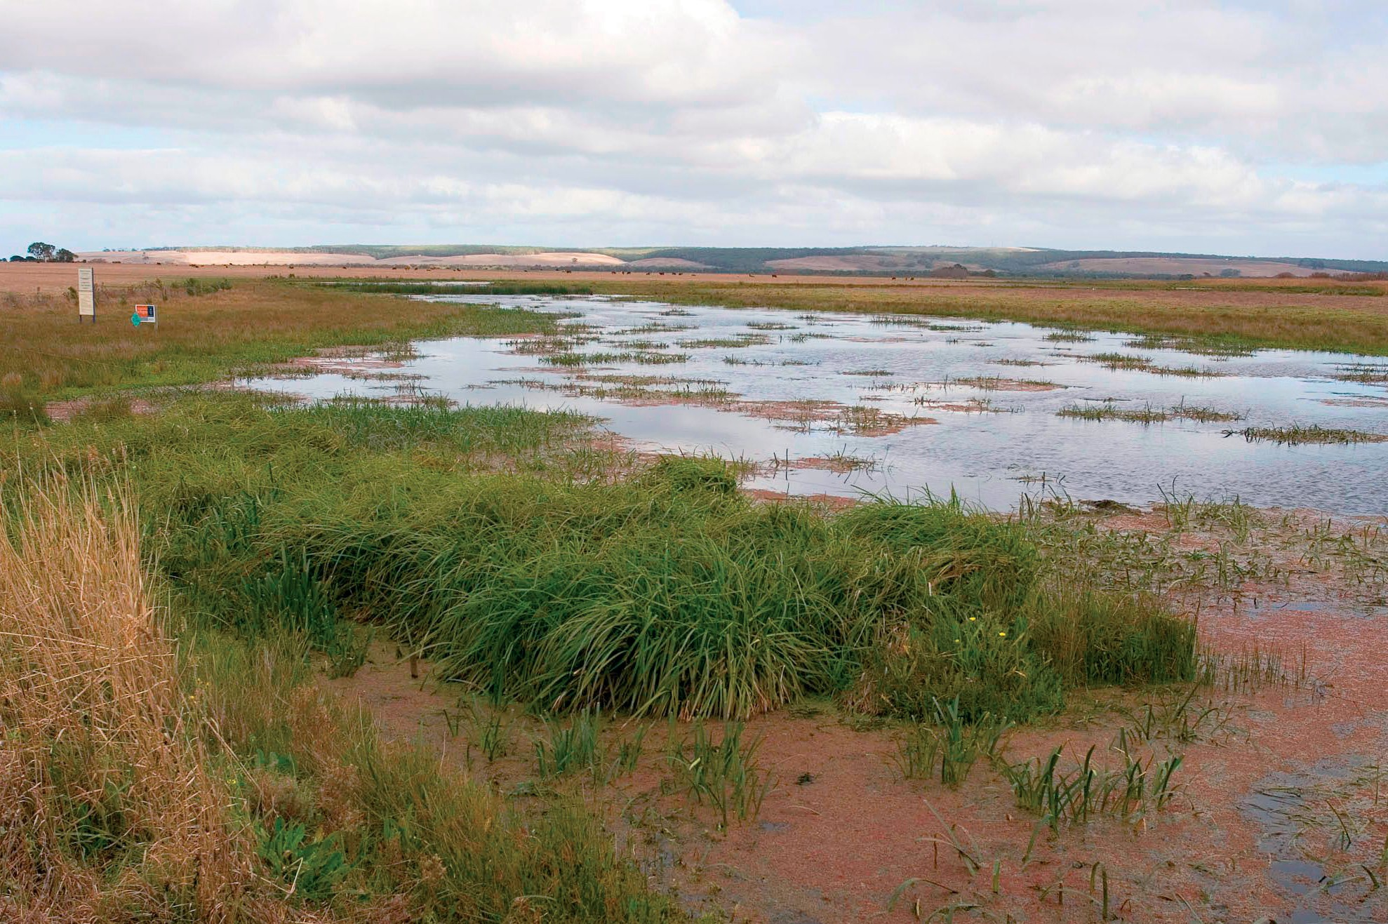

Photo: Wetland (John Baker)

# Major benefits to other migratory species, marine species, species of cetacean or conservation dependent species

On 26 May 2015, Eastern curlew and Curlew sandpiper were listed as critically endangered under the EPBC Act. This decision makes them ineligible to be included in the revised wildlife conservation plan. However, both species have approved Conservation Advice which outlines specific conservation and management actions, monitoring priorities, information and research priorities. Actions in this wildlife conservation plan will have major cross-cutting benefits for Eastern curlew and Curlew sandpiper conservation action.

There are a number of major benefits to species other than migratory shorebirds that will result from implementation of the wildlife conservation plan. Some migratory and threatened seabirds may benefit from the implementation of a Wildlife Conservation Plan for Migratory Shorebirds. For example, Fairy tern (*Sternula nereis nereis*) is listed as vulnerable under the EPBC Act and the Little tern (*Sternula*

*albifrons*), listed as endangered under state threatened species legislation in Qld, NSW and Tas and listed threatened in Vic, share similar habitat requirements with migratory shorebirds and would therefore benefit from habitat management actions. Marine turtles in WA, NT and Qld share nesting habitat with migratory shorebirds and may benefit from habitat management actions. Coastal and freshwater

wetlands serve as nurseries for many species of fish and aquatic invertebrates.

As much of the wildlife conservation plan focuses on identifying and developing effective management strategies for important habitats, there will also be major conservation benefits for those species that share habitats with migratory shorebirds. Although it is not a legislative requirement to specify benefits to non-migratory shorebirds, there are at least 18 species of resident shorebirds including the Banded stilt (*Cladorhynchus leucocephalus*), Hooded plover (*Thinornis rubricollis*) and Australian pied oystercatcher (*Haematopus longirostris*) that share many habitat requirements and characteristics with their migratory relatives and would also gain major benefits from the plan’s implementation.

# References

Bamford, M., Watkins, D., Bancroft, W., Tischler, G.,

& Wahl, J. (2008) Migratory Shorebirds of the East Asian—Australasian Flyway; Population Estimates and Internationally Important Sites. Wetlands International—Oceania. Canberra, Australia.

Barter, M.A., Qian, F.W., Tang, S.X., Yuan, X. & Tonkinson, D. (1997a) Hunting of waders on Chongming Dao; a declining occupation? *Stilt* 31: 18-22.

Barter, M.A., Tonkinson, D., Tang, S.X., Yuan, X.

& Qian, F.W. (1997b) Wader numbers on Chongming Dao, Yangtze Estuary, China, during early northward migration and the conservation implications. *Stilt* 30: 7-13.

Barter, M. (2002) Shorebirds of the Yellow Sea: Importance, threats and conservation status. Wetlands International Global Series 9, International Wader Studies 12. Canberra, Australia

Chamber, L.E., Hughes, L., & Weston M.A. (2005) Climate change and its impact on Australia’s avifauna. *Emu* 105: 1-20.

Chambers. L.E., Deveny, C.A., Congdon, B.C., Dunlop, N., Woehler, E.J., & Dann, P. (2011) Observed and predicted effects of climate on Australian seabirds. *Emu* 111: 235-257.

Clemens, R. S., Weston, M. A., Haslem, A., Silcocks, A., & Ferris, J. (2010). Identification of significant shorebird areas: thresholds and criteria. *Diversity and Distributions* 16:

229-242.

Geering, A., Agnew, L., & Harding, S. (2007) Shorebirds of Australia. CSIRO Publishing. Collingwood, Australia.

Goss-Custard, J.D., Triplet, P., Sueur, F., West, A.D., (2006) Critical thresholds of disturbance by people and raptors in foraging wading birds. *Biological Conservation* 127: 88-97.

Iwamura, T., Possingham, H.P., Chadès, I., Minton, C., Murray, N.J., Rogers, D.I., Treml, E.A., & Fuller, R.A. (2013) Migratory connectivity magnifies the consequences of habitat loss from sea-level rise for shorebird populations. *Proceedings of the Royal Society Biological Sciences* 280: 20130325.

Lee, S.Y., Dunn, R.J.K., Young, R.A., Connolly,

R.M., Dale, P.E.R., Dehayr, R., Lemckert,

C.J., McKinnon, S., Powell, B., Teasdale, P.R.,

& Welsh, D.T. (2006) Impact of urbanization on coastal wetland structure and function. *Austral Ecology* 31: 149-163.

Ma, M., Lu, J.J., Tang, C.J., Sun, P.Y. & Hu, W.

(1998) The contribution of shorebirds to the catches of hunters in the Shanghai area, China, during 1997-1998. *Stilt* 33: 32-36.

Ma, Z.J., Jing, K, Tang, S.M. & Chen, J.K. (2002) Shorebirds in the Eastern Intertidal Areas of Chongming Island during the 2001 Northward Migration. *Stilt* 41: 6-10.

MacKinnon, J., Verkuil, Y.I. & Murray, N. (2012) IUCN situation analysis on East and Southeast Asian intertidal habitats, with particular reference to the Yellow Sea (including the Bohai Sea). Occasional Paper of the IUCN Species Survival Commission No. 47. IUCN, Gland, Switzerland and Cambridge, UK. ii + 70 pp.

Marchant, S. & P.J. Higgins, eds. (1993) Handbook of Australian, New Zealand and Antarctic Birds. Volume 2—Raptors to Lapwings. Oxford University Press. Melbourne, Victoria.

Martin, B., Delgado, S., de la Cruz, A., Tirado,

S., & Ferrer, M. (2014) Effects of human presence on the long-term trends of migrant and resident shorebirds: evidence of local population declines. *Animal Conservation* 18: 73-81.

Murray, M.J., Clemens, R.S., Phinn, S.R., Possingham, H.P. & Fuller, R.A. (2014) Tracking the rapid loss of tidal wetlands in the Yellow Sea. *Frontiers in Ecology and the Environment*

Naarding, J.A. (1981). Latham’s Snipe (*Gallinago hardwickii*) in Tasmania. Wildlife Division Technical Report. 81/2. Tasmania: National Parks and Wildlife Service.

Naarding, J.A. (1983). Latham’s Snipe (*Gallinago hardwickii*) in Southern Australia. Wildlife Division Technical Report. 83/01. Tasmania: National Parks and Wildlife Service.

Naarding, J.A. (1985). Latham’s Snipe (*Gallinago hardwickii*) in Australia and Japan. Wildlife Division Technical Report. 85/2. Tasmania: National Parks and Wildlife Service.

Naarding, J.A. (1986). Latham’s Snipe, *Gallinago hardwickii*, in Australia and Japan. RAOU Report Series. 24:1-74.

Neira, C., Grosholz, E.D., Levin, L.A., & Blake, R. (2006) Mechanisms generating modification of benthos following tidal flat invasion by a *Spartina* hybrid. *Ecological Applications* 16: 1391-1404.

Park, P. (1983) Orielton Lagoon and Sorell wader areas. *An Occasional Stint* 2: 15-33.

Smit, C.J., & Visser, G.J.M. (1993) Effects of disturbance on shorebirds: a summary of existing knowledge from the Dutch Wadden Sea and Delta area. *Wader Study Group Bulletin* 68: 6-19.

Sutherland, W.J., Alves, J.A., Amano, T., Chang, C.H., Davidson, N.C., Finlayson, C.M., Gill, J.A., Gill, R.E., González, P.M., Gunnarsson, T.G., Kleijn, D., Spray, C.J., Székely, T.,

& Thompson, D.B.A. (2012) A horizon assessment of current and potential future threats to migratory shorebirds. *Ibis* 54: 663-679.

Tang S.X. & Wang T.H. (1991) A Survey of Hunting Pressure on Waterbirds near Shanghai,

March-May 1991. East China Waterbirds Ecology Group Report, June 1991. East China Normal University, Shanghai.

Tang S.X. & Wang T.H. (1992) Assessment of Hunting Pressure on Shorebirds near Shanghai, Phase II (Socio-economic Analysis). East China Waterbirds Ecology Group Report, December 1992. East China Normal University, Shanghai.

Tang, S.X. & Wang, T.H. (1995) Waterbird hunting in East China. Asian Wetland Bureau Publication No. 114, Kuala Lumpur.

Wang, T.H., Tang, S.X. & Ma, J.S. (1991) Survey of shorebirds and coastal wetlands in the Yellow River Delta, Shandong Province. Autumn 1991. East China Waterbird Ecology Group, East China Normal University, Shanghai.

Wang, T.H., Tang, S.X., Sai, D.J. & Fu, R.S. (1992) A

survey of coastal wetlands and shorebirds in the Yellow River Delta, Shandong Province. Spring 1992. East China Waterbird Ecology Group, East China Normal University, Shanghai.

Weston, M.A., McLeod, E.M., Blumstein, D.T., & Guay, P.-J. (2012) A review of flight-initiation distances and their application to managing disturbance to Australian birds. *Emu* 112: 269-286.

# Appendix A

Migratory shorebird species included under the wildlife conservation plan:

#### Scientific Name Common Name

#### Charadriidae Plovers and Lapwings

*Pluvialis fulva* Pacific golden plover

*Pluvialis squatarola* Grey plover

*Charadrius dubius* Little ringed plover

*Charadrius bicinctus* Double-banded plover

*Charadrius mongolus* Lesser sand plover

*Charadrius leschenaultii* Greater sand plover

*Charadrius veredus* Oriental plover

#### Scolopacidae Sandpipers

*Gallinago hardwickii* Latham’s snipe

*Gallinago stenura* Pin-tailed snipe

*Gallinago megala* Swinhoe’s snipe

*Limosa limosa* Black-tailed godwit

*Limosa lapponica* Bar-tailed godwit

*Numenius minutus* Little curlew

*Numenius phaeopus* Whimbrel

*Xenus cinereus* Terek sandpiper

*Actitis hypoleucos* Common sandpiper

*Tringa brevipes* Grey-tailed tattler

*Tringa incana* Wandering tattler

*Tringa nebularia* Common greenshank

*Tringa stagnatilis* Marsh sandpiper

*Tringa totanus* Common redshank

*Tringa glareola* Wood sandpiper

*Arenaria interpres* Ruddy turnstone

*Limnodromus semipalmatus* Asian dowitcher

*Calidris tenuirostris* Great knot

*Calidris canutus* Red knot

*Calidris alba* Sanderling

*Calidris ruficollis* Red-necked stint

*Calidris subminuta* Long-toed stint

*Calidris melanotos* Pectoral sandpiper

*Calidris acuminata* Sharp-tailed sandpiper

*Limicola falcinellus* Broad-billed sandpiper

*Philomachus pugnax* Ruff

*Phalaropus lobatus* Red-necked phalarope

#### Glareolidae Pratincoles

*Glareola maldivarum* Oriental pratincole

BIO442.0715

**environment**.gov.au

