

DEPARTMENT OF PLANNING, INDUSTRY & ENVIRONMENT

Wildlife Trade Management Plan for the Commercial Harvest of Kangaroos in New South Wales 2022–26

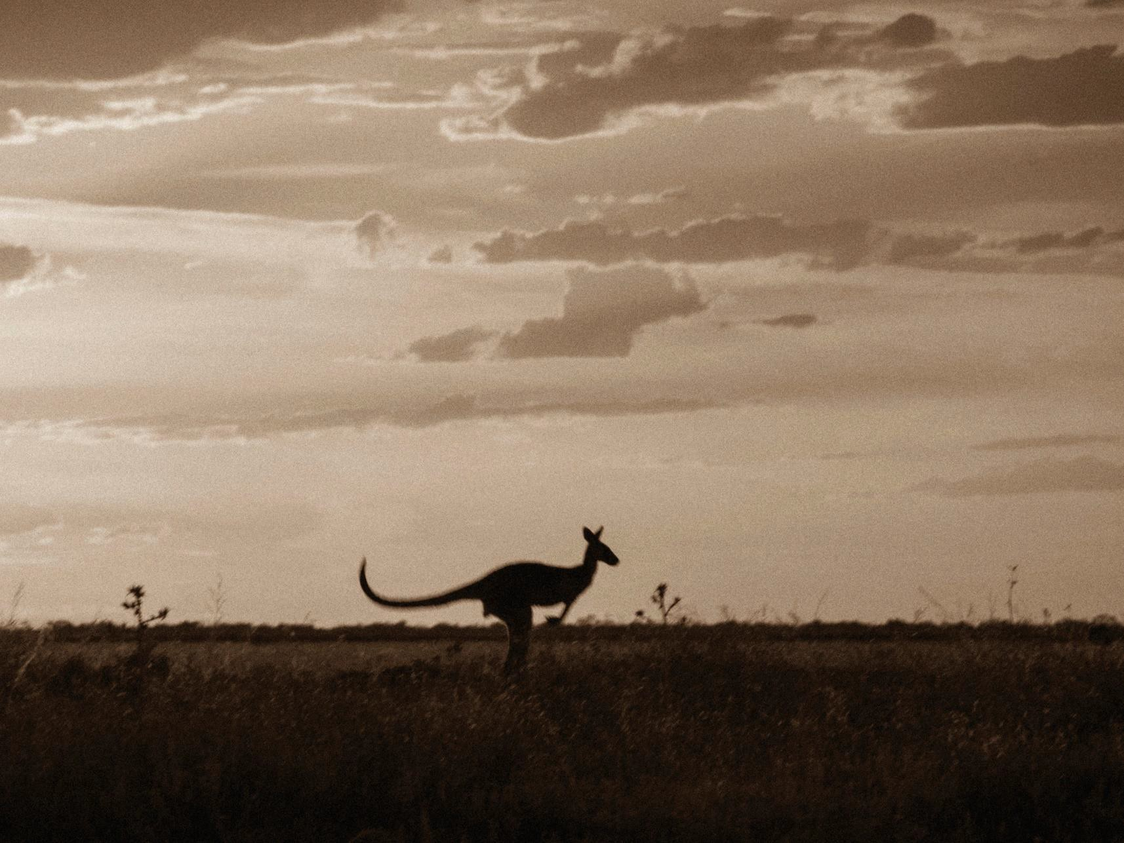

environment.nsw.gov.au

© 2021 State of NSW and Department of Planning, Industry and Environment
With the exception of photographs, the State of NSW and Department of Planning, Industry and Environment are pleased to allow this material to be reproduced in whole or in part for educational and non-commercial use, provided the meaning is unchanged and its source, publisher and authorship are acknowledged. Specific permission is required for the reproduction of photographs.
The Department of Planning, Industry and Environment (DPIE) has compiled this report in good faith, exercising all due care and attention. No representation is made about the accuracy, completeness or suitability of the information in this publication for any particular purpose. DPIE shall not be liable for any damage which may occur to any person or organisation taking action or not on the basis of this publication. Readers should seek appropriate advice when applying the information to their specific needs.
All content in this publication is owned by DPIE and is protected by Crown Copyright, unless credited otherwise. It is licensed under the Creative Commons Attribution 4.0 International (CC BY 4.0), subject to the exemptions contained in the licence. The legal code for the licence is available at Creative Commons.
DPIE asserts the right to be attributed as author of the original material in the following manner: © State of New South Wales and Department of Planning, Industry and Environment 2021.
Cover photo: Kangaroo silhouette. Terry Cooke/DPIE

Published by:
Environment, Energy and Science
Department of Planning, Industry and Environment Locked Bag 5022, Parramatta NSW 2124
Phone: +61 2 9995 5000 (switchboard)
Phone: 1300 361 967 (Environment, Energy and Science enquiries)
TTY users: phone 133 677, then ask for 1300 361 967
Speak and listen users: phone 1300 555 727, then ask for 1300 361 967 Email: info@environment.nsw.gov.au
Website: www.environment.nsw.gov.au
Report pollution and environmental incidents
Environment Line: 131 555 (NSW only) or info@environment.nsw.gov.au See also www.environment.nsw.gov.au
ISBN 978-1-922558-89-3 EES 2021/0217
September 2021

Find out more about your environment at:

www.environment.nsw.gov.au

Contents
Acknowledgment of Aboriginal people and Connection to Country 5
Definitions 6
Acronyms 7
Introduction 8
Purpose 8
Context 9
Scope 9
Legislative framework 10
Commonwealth 10
New South Wales 10
Goals and aims 11
Goal 11
Aims 11
Management actions and performance indicators 12
Aim 1: Ensure commercial harvest of kangaroos in New South Wales is humane 12
Aim 2: Ensure commercial harvest of kangaroos in New South Wales is ecologically sustainable 13
Aim 3: Be open, accountable and transparent 18
Aim 4: Implement effective and efficient regulation and administration 19
Aim 5: Effectively promote, monitor and enforce compliance 21
Aim 6: Facilitate adaptive management and research 23
Aim 7: Undertake program reporting and review 24
Appendices 26
Appendix 1: Setting and applying harvest thresholds 26
Appendix 2: Biology, ecology and conservation status of commercially harvested macropods in New South Wales 31
References 45

List of tables

Table 1 | Conservation status of the kangaroo species available for
 | commercial harvest | 36
Table 2 | Anthropogenic threats to kangaroos | 36
Table 3 | Biological threats to kangaroos | 38

List of figures

Figure 1 Fluctuation in kangaroo populations in western plains of New South Wales over time 14

Figure 2 Fluctuation in kangaroo populations in the Northern, Central and South East Tablelands zones in New South Wales over time 15

Figure 3 NSW commercial kangaroo management zones 16

Figure 4 Histogram of a theoretical population of kangaroos 27

Figure 5 A theoretical distribution after z-score transformation 27

Figure 6 Example of setting harvest thresholds for red kangaroos in Zone 2 28 Figure 7 10,000 simulations for a population fluctuating over 20 years 30

Figure 8 Simulated population as described for Figure 7 30

Figure 9 Red kangaroo (O. rufus) distribution in New South Wales 32

Figure 10 Western grey kangaroo (M. fuliginosus) distribution in New South Wales 33

Figure 11 Eastern grey kangaroo (M. giganteus) distribution in New South Wales 34

Figure 12 Common wallaroo (O. robustus) distribution in New South Wales 35

Figure 13 Fluctuation in kangaroo populations in western plains of New South Wales over time 40

Figure 14 Fluctuation in kangaroo populations in the Northern, Central and South East Tablelands zones in New South Wales over time 41

Acknowledgment of Aboriginal people and Connection to Country
The Department of Planning, Industry and Environment acknowledges the Traditional Owners of the lands across New South Wales, their ongoing stewardship and connection to Country.
The Department’s vision is to advance the aspirations of Aboriginal people of New South Wales through its work. We recognise that Country is at the core of every Aboriginal person’s identity and sense of belonging, and will strive to acknowledge, value and embed cultural knowledge in program delivery and business.
New South Wales is Aboriginal land; always was, always will be.
In preparing this plan, the Department pays respect to Elders past, present and emerging, and further acknowledges Aboriginal people’s rights, obligations and roles as Traditional Custodians of the land, sea and waterways.

Kangaroos and culture
The cultural significance of kangaroos, wallaroos and wallabies (kangaroos) to Aboriginal people cannot be measured in regard to numbers. The very presence of kangaroos in the landscape recalls deep spiritual associations through self-reflection of one’s livelihood, personal and family connection to Country, creation and being.
An Aboriginal person may have a close totemic link to kangaroos. Many Aboriginal people will dance and sing in ceremony to continue to preserve strength, health and cultural connections to their Country as they have been taught in the beginning (the Dream Time).
An Uncle once quizzed me with, ‘Who owns kangaroos?’
He said non-Aboriginal people have pigs, goats, sheep and cattle. We don’t have ownership of great swaths of land in western New South Wales. Access to kangaroos is important to Aboriginal people. It’s important that cultural practice continues and relationships with non-Aboriginal landholders are fostered and understood.
Kangaroos are a vital part of the Aboriginal diet, eaten for thousands of years, and the health benefits are proven. Kangaroo skins, sinews, teeth and bones have all been used for trade and many cultural purposes, clothes and food being the most important.
Decision-making bodies like the Kangaroo Management Program in New South Wales are a strong vehicle for change – a safe place to advocate and to keep Aboriginal people’s issues on the table. The department must continue to provide opportunities for Aboriginal people through facilitating government, landholders and industries to keep the cycle of Aboriginal cultural responsibilities thriving.
Mr Jason Wilson Aboriginal man (Murri)
NSW Kangaroo Management Advisory Panel 2021

Definitions
Biodiversity conservation licence has the same meaning as in section 1.6 of the NSW Biodiversity Conservation Act 2016 (BC Act). At the time of drafting this is, ‘a biodiversity conservation licence issued under Division 3 of Part 2 [of the BC Act] and in force.’
Carcass means the physical structure of the kangaroo, including the bones, flesh and organs, whether or not any body parts are removed.
Carcass tag means a tag issued to the licensee by the department for affixing to kangaroo carcasses.
Chiller means a cooling room, or a number of cooling rooms sitting directly next to one another, used for the temporary storage of kangaroo carcasses.
Commercial tag advice means a notice in writing issued by the department to the licensee when carcass tags are supplied to the licensee by the department.
Department means the NSW Department of Planning, Industry and Environment.
Ecologically sustainable development refers to the definition contained in section 3A of the Commonwealth Environment Protection and Biodiversity Conservation Act 1999 (EPBC Act). In general, this definition includes the precautionary principle, intergenerational equity, conservation of biological diversity and ecological integrity, and improved valuation of environmental factors.
Ecologically sustainable use of natural resources has the same meaning as in section 528 of the EPBC Act. At the time of drafting this means, ‘use of the natural resources within their capacity to sustain natural processes while maintaining the life-support systems of nature and ensuring that the benefit of the use to the present generation does not diminish the potential to meet the needs and aspirations of future generations.’
Harm has the same meaning as in section 1.6 of the BC Act. At the time of drafting this is, ‘… includes kill, injure or capture the animal, but does not include harm by changing the habitat of the animal.’
Harvest means to harm a kangaroo by shooting in accordance with the most recent version of the National Code of Practice for the Humane Shooting of Kangaroos and Wallabies for Commercial Purposes (AgriFutures Australia 2020). Also referred to as ‘take’ in section 528 of the EPBC Act.
Harvester means a person registered with, licensed and authorised by the Kangaroo Management Program within the NSW Department of Planning, Industry and Environment to harvest kangaroos for commercial purposes.
Kangaroo means the macropod species that can be used in accordance with this plan: the red kangaroo (Osphranter rufus), western grey kangaroo (Macropus fuliginosus), eastern grey kangaroo (Macropus giganteus) and common wallaroo (Osphranter robustus), and other species as per any relevant licence issued under the BC Act subsequent to the commencement of this plan.
Kangaroo Management Program refers to the program within the Department of Planning, Industry and Environment responsible for regulating and managing activities associated with the commercial harvest of kangaroos in New South Wales. This does not include non- commercial culling or other kangaroo population or damage mitigation actions or functions.
Landholder has the same meaning as in section 1.6 of the BC Act. At the time of drafting this means, ‘a person who is the owner of land or who, whether by reason of ownership or otherwise, is in lawful occupation or possession, or has lawful management or control, of land.’

National Code of Practice for the Humane Shooting of Kangaroos and Wallabies for Commercial Purposes (the National Code) is a nationally endorsed document that guides regulation and sets criteria to ensure the shooting of kangaroos or wallabies for commercial purposes is carried out in a manner to minimise, to the fullest extent possible, pain, distress and suffering.
Population has the same meaning as in section 528 of the EPBC Act. At the time of drafting this refers to ‘a species or ecological community’ and means ‘an occurrence of the species or community in a particular area.’
Precautionary principle has the same meaning as in subsection 391(2) of the EPBC Act. At the time of drafting this means that ‘lack of full scientific certainty should not be used as a reason for postponing a measure to prevent degradation of the environment where there are threats of serious or irreversible environmental damage.’
Premises means a location registered with the department for the purpose of locating one chiller for storage of and dealing in protected animals in accordance with licence conditions.
Quota refers to the maximum number of individual kangaroos that can be harvested annually, per species, per zone. Quota is set for commencement 1 January each year based on the population survey data of the year prior. Detailed explanation is provided under Action
2.2 Proportional commercial harvest quotas.
Registered training organisation has the same meaning as in the Commonwealth National Vocational Education and Training Regulator Act 2011. At the time of drafting this is, ‘a training organisation listed on the National Register as a registered training organisation.’
Viable population refers to the survival of a population in a state that maintains its vigour and its potential for evolutionary adaptation (Soulé 1987).
Zone means a commercial kangaroo management zone as set out in Figure 3 of this plan or as updated on the kangaroo management webpages of the NSW Government website.

Acronyms
BC Act Biodiversity Conservation Act 2016 (NSW)
CITES Convention on International Trade in Endangered Species of Wild Fauna and Flora
DPI NSW Department of Primary Industries
EES Environment, Energy and Science Group of the Department of Planning, Industry and Environment
EPBC Act Environment Protection and Biodiversity Conservation Act 1999
(Commonwealth)
IUCN International Union for Conservation of Nature
KMAP Kangaroo Management Advisory Panel
NSC NSW Scientific Committee
RSPCA Royal Society for the Prevention of Cruelty to Animals
SD standard deviation
TGP total grazing pressure

Introduction
Kangaroos are unique wild animals that live across the Australian landscape. Both the NSW Government and Australian Government are committed to protecting and conserving all native species. While state and territory governments have primary responsibility for wildlife management, the Australian Government regulates international wildlife trade.
Australia’s largest kangaroo species are harvested for commercial use under principles of sustainable management. This includes meat for human consumption and pet food, and skins and furs for domestic and international markets.
Harvesting of kangaroos for commercial purposes started in New South Wales during the early 1970s after population size had been estimated, and a quota could be set in proportion to population size. Similar harvesting strategies are used in Queensland, South Australia, Western Australia, Tasmania and, most recently, Victoria.
No adverse long-term impacts on kangaroo populations have been identified after more than 45 years of harvesting under commercial harvest management plans. This time frame has included several periods of severe drought.
Continuing this success into the future is a fundamental objective of this plan. The plan outlines the framework to manage and regulate the commercial harvest of kangaroos in accordance with Commonwealth and New South Wales legislation and regulations. It reviews environmental factors associated with commercial harvesting activities and sets out management tools, regulatory activities and performance indicators to monitor and maintain viable kangaroo populations amongst those subject to commercial harvesting activities.
A comprehensive impact assessment of the commercial harvest of kangaroos, on both kangaroo populations and related habitats and ecosystems, is provided under Threats and assessment of impacts in Appendix 2.

Purpose
In Australia, the export of kangaroo products requires Australian Government approval under the Environment Protection and Biodiversity Conservation Act 1999 (EPBC Act). The EPBC Act provides for the Australian Government Minister responsible for the environment to approve a wildlife trade management plan, for up to five years, if the Minister is satisfied the plan is consistent with the objects of section 303FO of the EPBC Act.
The plan must include an assessment of the environmental impact of the activities covered by the plan, in this case, the commercial harvest of kangaroos. It also includes management controls to ensure these activities are ecologically sustainable and will not be detrimental to the conservation status of taxa covered by the plan or any relevant ecosystem, as well as measures to mitigate, monitor and respond to any environmental impacts.
The Wildlife Trade Management Plan for the Commercial Harvest of Kangaroos in New South Wales 2022–26 has been prepared by the NSW Department of Planning, Industry and Environment to satisfy the requirements of the EPBC Act. It provides a management framework for the sustainable, ethical and humane commercial harvest of kangaroos in New South Wales and demonstrates how commercial harvest activities will be undertaken in accordance with objects of the EPBC Act and principles of ecologically sustainable development, defined by Section 3A of this Act as:
- decision-making processes should effectively integrate both long-term and short-term economic, environmental, social and equitable considerations
- if there are threats of serious or irreversible environmental damage, lack of full scientific certainty should not be used as a reason for postponing measures to prevent environmental degradation

- the principle of intergenerational equity – that the present generation should ensure that the health, diversity and productivity of the environment is maintained or enhanced for the benefit of future generations
- the conservation of biological diversity and ecological integrity should be a fundamental consideration in decision-making
- improved valuation, pricing and incentive mechanisms should be promoted.

Context
Kangaroos are protected in New South Wales under the Biodiversity Conservation Act 2016 (BC Act). The use of kangaroos is regulated under the BC Act and the Biodiversity Conservation Regulation 2017. The commercial kangaroo harvest management program is administered by the Environment, Energy and Science (EES) group of the NSW Department of Planning, Industry and Environment in accordance with the BC Act and Regulation.
This plan is consistent with International Union for Conservation of Nature (IUCN) recommendation 18.24 on conservation of wildlife through wise use as a renewable natural resource, which states that ‘the ethical, wise and sustainable use of some wildlife can provide an alternative or supplementary means of productive land use, and can be consistent with and encourage conservation, where such use is in accordance with the appropriate safeguards’ (IUCN 1990).

Scope
This plan applies to the commercial harvest of four large and abundant kangaroo species:
- red kangaroo (Osphranter rufus, previously known as Macropus rufus)
- western grey kangaroo (Macropus fuliginosus)
- eastern grey kangaroo (M. giganteus)
- common wallaroo (O. robustus, previously known as Macropus robustus)
- other species as per any relevant licence issued under the BC Act subsequent to the commencement of this plan.
Where the term ‘kangaroo’ is used in this document, it refers collectively to these species. Each is protected as native fauna and declared common throughout its range. No commercially harvested kangaroo species in New South Wales are listed as threatened or endangered under State or Commonwealth legislation or international listings (Appendix 2).
This plan relates to the commercial harvest of kangaroos only on:
- privately owned land, and
- publicly owned land for which the primary purpose is not conservation.
The plan does not provide a framework for managing kangaroos within protected areas such as national parks, nature reserves and world heritage areas.
This plan does not regulate the non-commercial culling of kangaroos in New South Wales for damage mitigation.
Harvesting kangaroos for their skin only is currently prohibited under this plan. Applications to introduce skin-only shooting, since its prohibition in June 1996, have not been supported.
With the approval of the Australian Government Minister for the Environment, this plan is current for a maximum five-year period from 1 January 2022 to 31 December 2026.

Legislative framework

Commonwealth
The Commonwealth Environment Protection and Biodiversity Conservation Act 1999 (EPBC Act) Part 13A provides for the development and approval of wildlife trade management plans in order for permits to be issued for the commercial export of wildlife products. Section 303BA of the EPBC Act lists the objects of Part 13A as:
- to ensure that Australia complies with its obligations under CITES [Convention on International Trade in Endangered Species] and the Biodiversity Convention
- to protect wildlife that may be adversely affected by trade
- to promote the conservation of biodiversity in Australia and other countries
- to ensure that any commercial utilisation of Australian native wildlife for the purposes of export is managed in an ecologically sustainable way
- to promote the humane treatment of wildlife
- to ensure ethical conduct during any research associated with the utilisation of wildlife
h. to ensure that the precautionary principle is taken into account in making decisions relating to the utilisation of wildlife.
In addition, section 303FO of the EPBC Act specifies approval of a wildlife trade management plan must be given only if the Minister is satisfied that:
- the plan is consistent with the objects of Part 13A of the EPBC Act (above)
- an assessment of the environmental impacts of the activities in the plan has been undertaken
- the plan includes management controls directed towards ensuring the impacts of the activities covered by the plan are ecologically sustainable
- the activities in the plan are not detrimental to the species to which the plan relates or any relevant ecosystem
- the plan includes measures to mitigate, monitor and respond to the environmental impacts of the activity covered by the plan.
In deciding whether to declare a plan, the Minister must also have regard to whether:
- legislation relating to the protection, conservation or management of the species to which the plan relates is in force in the state or territory concerned
- the legislation applies throughout the state or territory concerned
- in the opinion of the Minister, the legislation is effective.

New South Wales
Kangaroos are protected in New South Wales by the Biodiversity Conservation Act 2016 (BC Act). It is an offence to harm (including kill, injure or capture), attempt to harm a kangaroo (including hunt, pursue or use anything for the purpose of harming) or to buy or sell kangaroos without a licence (section 2.1 of the BC Act).
The BC Act makes provision to grant a licence to a person that authorises the doing of an act that would otherwise constitute an offence under the BC Act (section 2.11). This includes activities relating to the commercial harvest of and dealing in kangaroos in New South Wales.

The regulatory regime for commercial kangaroo harvest management in New South Wales ensures kangaroos are taken only in accordance with this plan. Licence conditions may be applied to licences to regulate and limit the licensed activities. These conditions may include (but are not limited to) minimum standards relating to the humane treatment of animals, tagging of carcasses, weight limits, record keeping and reporting.
The Prevention of Cruelty to Animals Act 1979 is the primary piece of legislation protecting animals from cruelty in New South Wales. This legislation also applies to the harming of kangaroos, section 24 of the Act requiring that this be carried out in a manner that inflicts no unnecessary pain upon the animal. Compliance with this Act is monitored and enforced by NSW Police Force, the Royal Society for the Prevention of Cruelty to Animals NSW (RSPCA) and the Animal Welfare League NSW.
NSW Police Force also monitors and investigates breaches of the NSW Firearms Act 1996, firearm safety laws and non-compliance with firearm licences.

Goals and aims

Goal
This plan aims to provide for the sustainable, ethical and humane commercial harvest of kangaroos in New South Wales, in accordance with the objects of the EPBC Act and principles of ecologically sustainable development through conservation and ecologically sustainable use of a natural resource.

Aims
The plan sets out seven strategic aims to deliver this goal. Each aim comprises actions detailing how the aim will be delivered operationally and performance indicators for measuring delivery success. These aims, actions and performance indicators provide the framework for regular monitoring, annual audit and reporting throughout the life of the plan.
The aims of this plan are to:
- ensure commercial harvest of kangaroos in New South Wales is humane
- ensure commercial harvest of kangaroos in New South Wales is ecologically sustainable
- be open, accountable and transparent
- implement effective and efficient regulation and administration
- effectively promote, monitor and enforce compliance
- facilitate adaptive management and research
- undertake program reporting and review.

Management actions and performance indicators
As required under section 303FO of the EPBC Act, the department has identified management actions directed towards ensuring the plan’s aims are achieved, and activities covered by the plan are ecologically sustainable and not detrimental to the kangaroo species or relevant ecosystems. These include measures to mitigate, monitor and respond to changes in the environmental impact of the activities covered by the plan.
Performance indicators are identified to monitor progress against the plan's aims and measure the success of the plan as an adaptive wildlife management program. These will be included in annual reports to the Australian Government and for publication online.

Aim 1: Ensure commercial harvest of kangaroos in New South Wales is humane
The National Code of Practice for the Humane Shooting of Kangaroos and Wallabies for Commercial Purposes (the National Code), revised in 2020, sets evidence-based minimum standards that must be met to achieve an acceptable level of animal welfare during commercial harvesting. The National Code sets a benchmark for kangaroo harvesters to follow and provides a basis for developing and enhancing their knowledge and skills.
Compliance with the National Code is a requirement of all state kangaroo management plans approved under the EPBC Act.
To ensure humane practice and acceptable animal welfare standards are met, all commercial kangaroo harvesters operating in New South Wales must comply with the National Code, and any subsequent revisions, as part of their licence conditions. Monitoring and enforcement of compliance with licence conditions, and delivering education and engagement activities to licensees, ensures participants have the knowledge and skills required to implement best practice operational procedures.

Action 1.1: Implement and enforce the National Code of Practice for the Humane Shooting of Kangaroos and Wallabies for Commercial Purposes across all commercial harvesting activity in New South Wales
Licensed harvesters are required to be accredited shooters. Accreditation must be renewed every five years with a registered training organisation authorised to deliver such training.
This demonstrates kangaroo harvesters have met minimum standards and can shoot with the accuracy required by the National Code, using the firearms and ammunition specified.
The National Code identifies 23 requirements for complying with the humane harvesting method described, as summarised in Appendix 10 of the Code. Licence conditions specify the commercial harvesting of kangaroos in New South Wales must be done in accordance with the National Code, enabling the department to regulate compliance.

Performance indicators
- Licence conditions specify the commercial harvesting of kangaroos in New South Wales must be done in accordance with the National Code.
- All identified incidences of non-compliance with licence conditions related to inhumane harvesting are investigated, and appropriate compliance action is taken.

- Harvester licences are issued only to applicants who have completed the game harvester statement of attainment or equivalent, have met shooter competency standards, and hold a current firearms licence.

Action 1.2: Facilitate capacity building and engagement opportunities to maintain harvester competency to meet National Code requirements
In accordance with the National Code, harvesters must understand their responsibilities for the humane treatment of kangaroos and wallabies and be familiar with the requirements and standard operating procedures outlined in the Code.
The department will work with industry and training providers to review, develop and facilitate education and training. This is to ensure harvesters maintain the knowledge, skills, attitude and behaviour required to fulfil the requirements of the National Code and perform their tasks competently.

Performance indicators
- Copies of the National Code and education materials are provided to all licensees and made available through the department’s website.
- A capacity building program to improve and maintain harvester competency, and increase voluntary compliance with licence conditions, is developed and implemented within the life of this plan.

Aim 2: Ensure commercial harvest of kangaroos in New South Wales is ecologically sustainable
The department is responsible for protecting, conserving and managing kangaroos as protected species under the BC Act. Ensuring the harvest does not negatively impact the ecological viability of those kangaroo species covered by the plan is a central tenet of the NSW Kangaroo Management Program’s design.
The department monitors kangaroo populations in New South Wales using best practice survey methods for the terrain (Payne 2008). These population estimates are used to monitor population health, set quotas and determine if thresholds for population management, such as reducing or suspending harvest activities, are required to support kangaroo population viability.
Data collected by the department shows kangaroo numbers fluctuate widely (Figures 1 and 2). These fluctuations are mostly driven by seasonal conditions with the major population declines usually associated with dryer periods and reduced feed availability. Harvesting has little effect on the populations. Commercial harvesting has not adversely impacted population viability.
Survey methods to estimate population size have varied over time from monitoring seven sample blocks (yellow line) to 200-metre (blue line) and 100-metre strip transects (green line). Aerial survey methods were changed in 2017 to mark-recapture-distance-sampling (MRDS) (orange line).
After over 45 years of commercial harvesting in New South Wales, the four kangaroo species available for harvest are abundant. Ecologically viable populations of each species have been maintained across their range, and the management techniques used by the program have proven successful for 45 years.
Continuing this success into the future is a fundamental objective of this plan. Management actions and performance indicators to ensure the ongoing sustainable setting of harvest quotas are of critical importance and explained below. A more comprehensive impact

assessment of the commercial harvest of kangaroos, on both kangaroo populations and related habitats and ecosystems, is provided under Threats and assessment of impacts (Appendix 2).
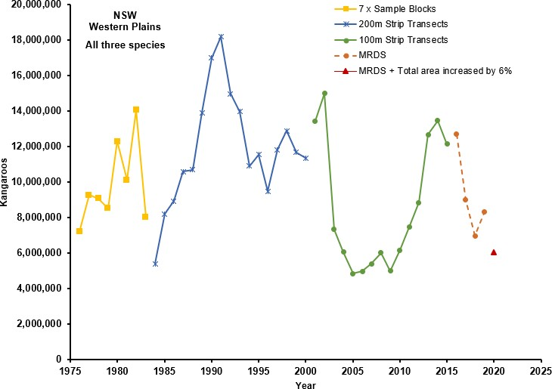

Figure 1 Fluctuation in kangaroo populations in western plains of New South Wales over time

Figure 1 is adapted from Lunney et al. (2018) and Pople et al. (2018). It has also been extended to include more recent population estimates made using mark-recapture-distance-sampling methods. The graph shows temporal variation of kangaroo populations on the western plains of NSW. Survey methods to estimate population size have varied over time from monitoring seven sample blocks (yellow line) to 200-metre (blue line) and 100-metre strip transects (green line) and more recently mark-recapture-distance-sampling (MRDS) (orange dotted line). Strip count data has been adjusted as described in Pople (2006).

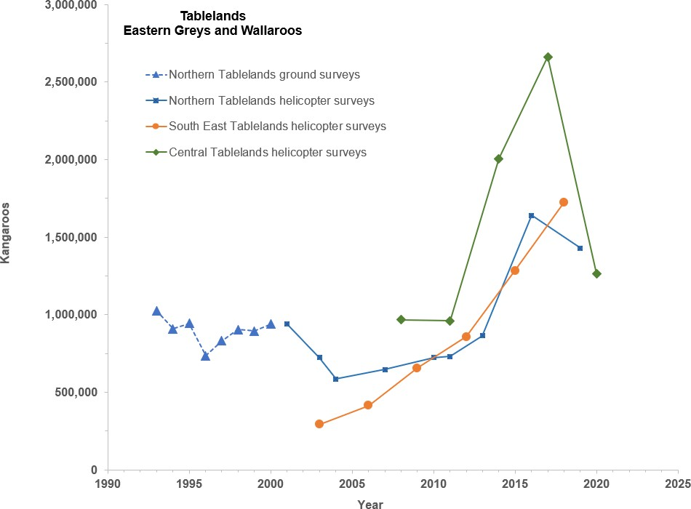

Figure 2 Fluctuation in kangaroo populations in the Northern, Central and South East Tablelands zones in New South Wales over time

Population thresholds were introduced in 2008 as part of previous program reviews, as a method to monitor variation in long-term average population sizes. Thresholds are reference points used to trigger a different management action. They are used to determine whether changes to commercial harvesting quotas are necessary to conserve viable populations of kangaroos. If populations deviate below certain population sizes during estimates, harvesting quotas for that species may be reduced or suspended until the population estimates increase to acceptable levels. The use of thresholds is described in detail in Appendix 1.
Commercial harvesting of kangaroos in New South Wales is restricted to the commercial kangaroo management zones (Figure 3). The zone-based system has proven to be an effective management tool for New South Wales, allowing quotas to be managed strategically and thresholds applied in response to fluctuating population densities.
New commercial kangaroo management zones may be opened, or zone boundaries adjusted, within the life of the plan. The decision to open new areas or adjust boundaries will have regard for any conservation risks the adjustment may pose to achieving the plan objectives. Any new areas opened will be included in subsequent population surveys in line with best practice survey design. The department’s website will be used to publish and share the current commercial management zones.

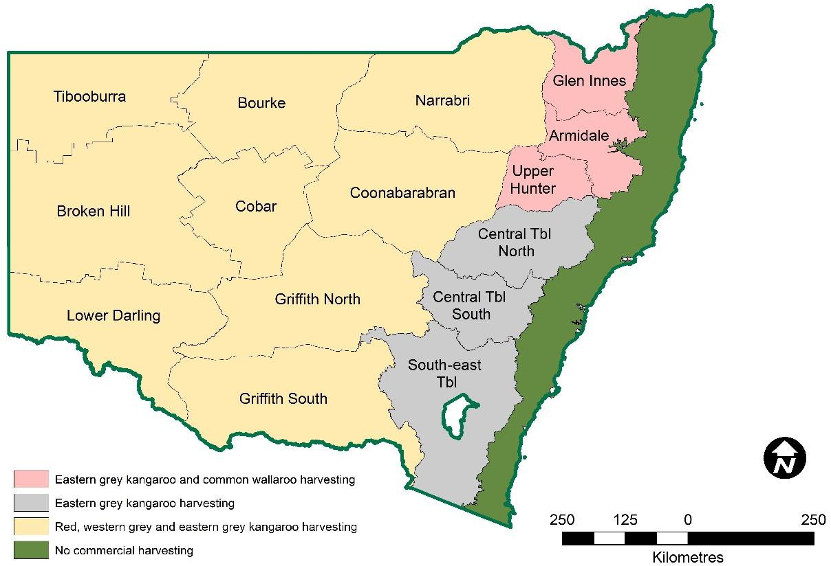

Figure 3 NSW commercial kangaroo management zones

Action 2.1: Kangaroo population estimates are determined using scientifically rigorous population surveys
Kangaroo populations are monitored using scientifically robust and peer-reviewed methods of aerial wildlife population surveying (Barker 2008; Fewster & Pople 2008; Fleming & Tracey 2008; Hone 2008; Laake et al. 2008; Pople 2008).
Kangaroo populations are currently surveyed annually on the Western Plains using fixed- wing aircraft and triennially in tablelands areas using helicopters. Population data for the western plains and tablelands are shown in Figures 1 and 2 respectively. The methods and frequencies used to survey populations are adapted to the terrain and are relative to observed and expected population variation. A full description of methods for surveying populations is available on the department’s kangaroo management webpage.

Performance indicators
- Fixed-wing aircraft surveys are conducted annually on the inland plains during winter. Population estimates are calculated for each inland plains commercial kangaroo management zone by 30 November each year.
- Helicopter surveys are completed in one region annually, and tableland regions are surveyed triennially. Population estimates are calculated by 30 November in the year of survey.

Action 2.2: Proportional commercial harvest quotas are set and reported annually for each commercial kangaroo management zone
Kangaroos are permitted to be harvested on privately owned land or other lands for which the primary purpose of that land is not conservation, located in commercial kangaroo

management zones (Figure 3). Licence conditions are used to restrict harvest activities to specific species and zones for which commercial tags are issued. Landholder consent must be obtained to harvest kangaroos on a property.
Following each survey, conservative proportional quotas are set per species for each commercial kangaroo management zone. Quotas are determined in line with the precautionary principle using scientifically based and long-term population thresholds. This method ensures populations are not adversely affected by harvesting (Appendix 1).
If populations fall below set thresholds, quotas are reduced or harvesting suspended for that species in affected zones to allow the population to recover.

Special quotas
The department may consider releasing a special quota where the annual commercial quota for a species in a commercial kangaroo management zone has been fully issued. This is not an automatic decision. The special quota aims to minimise the number of kangaroos shot under non-commercial licences by allowing increased commercial use of kangaroos that would otherwise be shot and left in the field. In deciding whether to release a special quota, the department will consult the Kangaroo Management Advisory Panel and consider local conditions, climatic trends, population trends and Western Lands de-stocking orders to ensure populations can remain viable with increased harvest.
When used, special quotas will be set at a maximum of 5% of the population estimate of each kangaroo species in any one zone, and a maximum of 1.5% of the population of each species across all zones.
Special quotas will not be allocated where the commercial harvest is reduced or suspended due to low populations.

Performance indicators
- Quota reports are submitted to the relevant Australian Government department and published on the NSW Department of Planning, Industry and Environment website by 1 December each year.
- Annual commercial harvest quotas are set for each species and commercial kangaroo management zone for harvesting to commence 1 January each year.
- Maximum harvest quotas are set at 15% of the population for eastern grey kangaroos, western grey kangaroos and common wallaroos, and 17% of the population for red kangaroos.
- Quotas on populations that are between 1.5 and 2 standard deviations below their long- term averages are calculated at a reduced rate of 10% of the population.
- Quotas on populations that are two or more standard deviations below their long-term averages are suspended.

Action 2.3: Harvest data are monitored to ensure quotas are not exceeded
The percentage of quota harvested of each kangaroo species is monitored and reported regularly. Monthly harvester returns data are monitored and analysed throughout species’ ranges to identify any unexplained or potentially adverse trends. This allows the department to adapt its management program as required to maintain ecologically viable kangaroo populations in relevant zones.

Performance indicators
- Proportion of monthly harvester returns submitted on time.
- Proportion of monthly harvester returns submitted accurately.
- Monthly tag allocations and harvester returns analysed and published online within 14 days of the end of the month.

Action 2.4: Identify any potential threats to population health
Kangaroo carcasses are examined in processing plants by veterinarians who can identify abnormalities. Diseased animals and any abnormalities can be traced to their origin through the tagging system and investigated. In addition, harvesters are encouraged to report any observed abnormalities relating to kangaroo health or behaviour to better understand potential threats to the kangaroo species covered by the plan and ensure populations remain healthy.

Performance indicators
1. Any reports received relating to kangaroo health or mortality events are recorded and referred to the appropriate authorities.

Aim 3: Be open, accountable and transparent
The department is committed to engaging with industry and the community to ensure the objectives of the plan are met. Industry stakeholders are consulted and kept up to date with program developments through regular communication via email and newsletters. General program information and regular reports are published on the department’s public website, and other relevant information is provided upon request.
The department convenes a Kangaroo Management Advisory Panel (KMAP) to provide advice on the operation of the Kangaroo Management Program. KMAP includes nominated representatives from industry, animal welfare interest groups, Aboriginal communities, farmers, scientific community and government.

Action 3.1: Maintain public website with relevant documents and current information
The department is committed to open access and transparency in its decision-making. In accordance with the Government Information (Public Access) Act 2009, the department will ensure public access to relevant documents and make its information freely available through its website, libraries, offices or upon request, unless there is an overriding public interest against its release.

Performance indicators
- The following information, as a minimum, is regularly reviewed and kept current on the Kangaroo Management Program webpages:
  - a statement of the reasons commercial harvest is undertaken in this State
  - current versions of the NSW Commercial Kangaroo Harvest Management Plan, annual report and quota report
  - annual reports and quota reports from the past five years
  - commercial harvest and tag allocation reports from at least the past 12 months
  - current licence conditions for kangaroo harvesters, kangaroo dealers and kangaroo skin dealers

  - National Code of Practice for the Humane Shooting of Kangaroos and Wallabies for Commercial Purposes
  - contact information for the NSW Kangaroo Management Program.

Action 3.2: Engage a Kangaroo Management Advisory Panel to provide expert advice on relevant kangaroo management issues
The KMAP, comprising representatives from relevant stakeholder groups, is appointed to provide guidance on the plan's management activities to ensure kangaroo populations in New South Wales remain ecologically viable, the program is ecologically sustainable, and the methods of harvesting kangaroos for commercial use are in accordance with the National Code. KMAP also acts as a conduit for information exchange between the program and key stakeholders.

Performance indicators
- KMAP meets at least twice per year to review progress and provide advice on implementation and review of the management plan.
- The department provides KMAP with timely and relevant information and reports to perform its functions throughout the life of the plan.

Action 3.3: Respond to information requests
The department recognises there is strong public interest in the operation and management of the commercial kangaroo harvest program in New South Wales. The department will provide timely and transparent information where appropriate, in line with a kangaroo management stakeholder communication and engagement strategy.

Performance indicators
- A stakeholder communication and engagement strategy is developed in the first 12 months and implemented throughout the life of this plan.
- Media releases on issues of interest to the community are prepared for approval by the NSW Minister when appropriate.
- Responses to all media enquiries are provided in a timely way.
- Approved relevant departmental staff will participate in relevant interviews with the media upon request.
- Enquiries received will be responded to within two working days for simple requests and within 28 working days for more complex responses.

Aim 4: Implement effective and efficient regulation and administration
The department manages and regulates the Kangaroo Management Program in New South Wales through the issue of licences for commercial harvesting and dealing in kangaroos in accordance with the BC Act, its Regulation and the National Code of Practice.
The legislative basis for licensing and licensing procedures are described in the Legislative framework section on pages 10 and 11 of this plan.
Licensees must comply with licence conditions that include administrative and reporting requirements such as tagging procedures and the submission of activity reports (returns) to the Kangaroo Management Program. Through these processes the department can maintain

viable populations of macropods throughout their ranges and regulate harvesting activities so they are carried out according to the National Code of Practice.

Action 4.1: All activities relating to the commercial harvest of kangaroos in New South Wales are licensed in accordance with BC Act, Regulation and policy
The BC Act sets the framework for issuing licences to harvest and deal in kangaroos in New South Wales. Only people who are licensed and registered by the department with a Kangaroo Harvester Licence granted under the BC Act may harvest kangaroos and sell the carcasses. An Animal Dealer (Kangaroo) Licence holder can buy kangaroo carcasses from commercial harvesters and process them for sale if they have approved registration and certifications. To buy and process kangaroo skins requires an Animal Dealer (Kangaroo Skin) Licence.
All licence applications under the NSW Kangaroo Management Program will be assessed, processed and issued according to the provisions of the BC Act and Regulation. Licensee and registration data will be collected, used and stored according to the department’s Privacy Plan and the NSW Privacy and Personal Information Protection Act 1998.

Performance indicators
- Databases of licensee and registration information are accurate, complete and up to date.
- A sample of licences is assessed annually to confirm they are being processed and issued in accordance with relevant legislation and departmental policy.

Action 4.2: Licence conditions are effectively applied
Licence conditions are the primary instrument for regulating kangaroo harvester and dealer activity in New South Wales. Clear and concise licence conditions that are well-understood by licence holders are important for effective regulation of the Kangaroo Management Program. Promoting a high level of voluntary compliance and ensuring licence conditions are enforceable work together for effective application of licence conditions.

Performance indicators
- Licence conditions are reviewed biennially.
- Licensees are advised of changes to licence conditions in writing within 7 days of the changes taking effect.
- Advisory materials to explain changes to licence conditions are developed and distributed with the notification of change.

Action 4.3: Tagging, landholder consent and reporting processes enable program accountability and compliance
Licensees apply for commercial tags to harvest specific kangaroo species in a stated commercial harvest zone. The quantity of tags allocated depends on the number of species, the available quota and the number of hectares available to the harvester within the zone.
Available hectares for harvesters are determined by the size of the properties within that zone for which the harvester has obtained landholder consent.
The requirement for licensed harvesters to obtain landholder consent before undertaking harvest activities on a property helps to provide safeguards for tracking biosecurity and other issues and improves program accountability and compliance.

All kangaroos harvested must have a carcass tag fitted at the time of harvest. Each tag is uniquely numbered according to the harvesting year, colour-coded to the species, and registered to a zone and harvester. This tag must not be removed until immediately before processing the skin. This ensures traceability of carcasses back to the harvester, zone and property where they were harvested.
Combined with compulsory reporting, these processes underpin the regulation of quotas and ensure kangaroo populations are not harvested beyond available quota.
There are opportunities to achieve greater utility from the current tagging and reporting system. Opportunities to automate systems to monitor carcass consignments and transportation, for example, will be investigated where available. Challenges include different reception of mobile phone networks across New South Wales in remote locations, system disruptions and maintenance. If innovations arise, costs and benefits to the program will be assessed, systems will be trialled, and efficacy tested.

Performance indicators
1. Opportunities to improve carcass traceability, compliance, data accuracy and utility will be evaluated when available.

Aim 5: Effectively promote, monitor and enforce compliance
The compliance program for commercial kangaroo harvesting aims to encourage and enforce adherence to the law. An array of strategies and tools are used by the department and compliance teams, including engagement and education, clearly communicated licence conditions and standards, monitoring and auditing programs, targeted investigations informed by intelligence, and taking appropriate enforcement action.
A risk-based approach is used to identify the highest compliance priorities, such as non- head-shot carcasses and matters where proactive compliance activity is most likely to have measurable outcomes. The department escalates its response according to the seriousness of the breach.

Action 5.1: Develop and implement a kangaroo management compliance strategy and annual action plan
The development of a specific compliance strategy for commercial kangaroo harvest management provides a framework for a consistent risk-based approach to compliance and enforcement activities and set minimum standards for regular compliance activities such as investigations, inspections and audits to ensure the Kangaroo Management Program meets its regulatory obligations.
An annual action plan will be used to prioritise activities to continually improve and deliver an effective and efficient compliance program for commercial kangaroo harvest management.

Performance indicators
1. Annual review and prioritisation of compliance and enforcement focus areas that respond to current risks and trends in the industry.

Action 5.2: Regular and opportunistic monitoring of licensees for compliance with licence conditions and legislation
The department recognises the need for an agile approach to monitoring compliance. To remain equitable and to meet its goal of humane harvesting practices and viable kangaroo populations, compliance requires transparent, effective monitoring processes and reporting systems. Opportunistic, random and targeted inspections of carcasses, harvesters, chiller premises and processing works are completed in response to gathered intelligence or to substantiate evidence of reported breaches. Inspections may include, but are not limited to, monitoring for non-head-shot kangaroos, underweight carcasses, valid and correctly affixed tags, untagged kangaroos, and correct display of registration information and certificates on vehicles and chiller premises.

Performance indicators
- Chiller premises and processing works (kangaroo carcasses and skins) are inspected on average a minimum of 1.5 times per year to ensure compliance with NSW legislation and licence conditions.
- At least 0.5% of carcasses are inspected each year for signs of unlicensed activities, breaches of licence conditions and other evidence contrary to the program’s objectives for a humane and sustainable harvest.

Action 5.3: Investigation of and appropriate response to non-compliance
Compliance officers will follow up all reports of non-compliance and will actively investigate those that present the greatest risk, according to the risk analysis framework described in the department’s Compliance Policy.

Performance indicators
1. All reports of unauthorised activities and activities in breach of licence conditions are submitted to relevant compliance teams. Compliance teams may impose enforcement actions such as issue of verbal cautions, written warnings or infringement notices, and prosecution or revocation of licences and registrations in accordance with the department’s Compliance Policy and Prosecution Guidelines.

Action 5.4: A collaborative approach to compliance
The department has strong working relationships with regulatory partners, including NSW Food Authority, Department of Primary Industries Game Licensing Unit, NSW Police Force and interstate agencies responsible for commercial kangaroo management. Formal agreements with partner agencies facilitate information sharing, joint investigations and reporting of evidence of non-compliance found during regulatory inspections. These formal agreements ensure intelligence is available to appropriate agencies, enhancing the monitoring and enforcement of non-compliance.

Performance indicators
1. Review and establish formal agreements with other New South Wales and cross-border agencies to develop collaborative approaches, establish cross-authorisation and share intelligence and information that leads to improved compliance.

Aim 6: Facilitate adaptive management and research
The department proactively seeks and applies the best available science to improve its management approach and outcomes. Opportunities for research may help build our understanding of adaptive management and population dynamics, improve animal welfare, and increase compliance.
General ecology of kangaroo populations is well-documented, as are kangaroo biology and genetics (Appendix 2). More research on movement ecology, impacts to population ecology during droughts and floods, triggers of population decline, natural mortality and reproduction rates will provide greater confidence and certainty to apply adaptive management actions when managing populations under different climatic and other scenarios.

Action 6.1: Foster and support research to improve animal welfare outcomes
The department will work to identify and investigate animal welfare issues relevant to the commercial harvest of kangaroos. This may include working with external research institutions, animal welfare and conservation organisations, industry and other agencies to undertake research to better understand and mitigate animal welfare impacts as they relate to commercial harvest procedures.

Performance indicators
- Contribute to any review of the National Code of Practice for the Humane Shooting of Kangaroos and Wallabies for Commercial Purposes during the life of this plan.
- Assess all research proposals for opportunities to facilitate improvements to animal welfare outcomes in the Kangaroo Management Program.
- All research led by the department involving animals will be conducted in accordance with approval from the department’s Animal Ethics Committee and the Australian code for the care and use of animals for scientific purposes (National Health and Medical Research Council, 2013).

Action 6.2: Foster and support research to improve kangaroo census and population modelling
The department will work to improve population monitoring and modelling by partnering with external research organisations, industry and other agencies to identify areas for appropriate research. While aerial surveys using trained observers is the most accurate and least expensive method currently available, research may look at alternative monitoring techniques and technology, census platforms and new more robust models.
The department encourages research proposals that advance knowledge in areas such as population ecology, movement patterns and triggers, and reproduction and mortality rates.

Performance indicators
- All research proposals are assessed for opportunities to identify improvements in kangaroo census and population modelling techniques.
- All research led by the department involving animals will be conducted in accordance with approval from the department’s Animal Ethics Committee and the Australia code for the care and use of animal for scientific purposes.

Action 6.3: Facilitate adaptive management experiments to test deliberate management interventions where practicable
The department’s adaptive management position statement defines adaptive management as a procedure for implementing management while learning about which management actions are most effective at achieving specified objectives.
The department is committed to using adaptive management, combined with monitoring, evaluation and reporting, to support continuous improvement of on-ground management decisions and improved capacity for data management and reporting for ecological, social and economic outcomes.

Performance indicators
- Any proposals to undertake active adaptive management experiments are reviewed and assessed by the department in accordance with the criteria outlined in this plan.
- All adaptive management experiments undertaken by, or in partnership with, the department are monitored and conducted according to approved conditions, including any animal welfare and ethics approvals.

Action 6.4: Share historical survey and harvest data
Over the 45 years of its operation, the NSW Kangaroo Management Program has accumulated a rich bank of historical data that underpins its decision-making. The department will make this data publicly accessible for researchers, interest groups and the community.
Performance indicators
- A strategy, data structure and suitable platform to make historical survey and harvest data available to the public is investigated within the first two years of this plan.
- Subject to the plausibility of this strategy (as above), historical data are released by the end of year four of this plan.

Aim 7: Undertake program reporting and review
The Wildlife Trade Management Plan for the Commercial Harvest of Kangaroos in New South Wales 2022–26 is evaluated against its aims and performance measures annually. An annual report is published on the department’s website and provided to the Australian Government to show how the plan has met identified performance indicators.
Other reviews and reports completed for or as part of the program, such as monthly allocation and take data, are published on the department’s website for better accountability and transparency.

Action 7.1: Produce and publish regular reports
Regular reports, including quota, allocation and harvest reports and an annual report are published on the department’s website. Annual reports will also be submitted to the Australian Government Department of Agriculture, Water and the Environment to comply with obligations under the EPBC Act 1999.

Performance indicators
- The following reports will be produced and published on the department’s kangaroo management website:

  - monthly tag allocation report by the fifth day of the month for the preceding month
  - monthly harvest report by the 15th day of the month for the preceding month.
- The following reports will be produced and published on the department’s kangaroo management website and provided to the Australian Government on time:
  - annual allocation and harvest reports by the end of February each year for the preceding year
  - annual report on the operation of the plan by the end of March each year for the preceding year
  - quota report, stating population size and quota allocated for the following year, by 1 December each year.
- The annual report on the operation of the plan will include as a minimum the following information:
  - actual harvest, by commercial harvest zone and species, compared with available quotas
  - any special quota used
  - gender bias and average weights for each species in each commercial harvest zone
  - non-commercial cull allocation statistics within the commercial harvest zones
  - compliance statistics including:
    - premises inspected
    - penalty infringement notices issued and reasons for the issue
    - prosecutions
  - any unusual situations affecting the commercial harvest (e.g. disease outbreaks, drought conditions, market factors)
  - any research on kangaroos supported by the department
  - progress against performance indicators.

Action 7.2: Review of the Wildlife Trade Management Plan for the Commercial Harvest of Kangaroos in New South Wales 2022–26
An end-of-plan review will seek to identify areas where management actions and strategy can be improved, to inform preparation of subsequent commercial harvest management plans.

Performance indicators
1. The department will commence review of this plan at least 12 months before its expiry and resubmit for public exhibition and assessment by the Australian Government before approval by the Commonwealth Minister for the Environment in the timeframe prescribed by the Commonwealth department.

Appendices

Appendix 1: Setting and applying harvest thresholds

SR McLeod and AR Pople

Setting thresholds for proportional threshold harvest strategies
When populations fluctuate widely, harvest strategies that track changes in population size have been found to reduce the likelihood of overharvest (Lande et. al. 1995). A proportional harvest strategy is currently used to set quotas for the commercial harvest of kangaroos in Australia (Pople & Grigg 1999). This harvest strategy tracks fluctuations in population abundance and adjusts quotas accordingly. It has been found to have a low risk of overharvest (Engen et al. 1997). Proportional threshold harvesting is a modification of proportional harvesting and sets a threshold in population abundance, below which the proportion of the population that can be harvested is reduced eventually to zero. Harvest thresholds thus lower the risk of overharvesting by reducing harvest mortality at times of low population size.
Harvest strategies that use thresholds will not necessarily result in substantially lower yields. Research on proportional threshold harvesting (Lande et al. 1997) indicated that average yield may even be increased if thresholds are set optimally. However, a drawback of threshold harvesting is that it may increase variance in annual yield since there may be some years when no harvesting is allowed if the population remains below the lowest threshold. Nevertheless, proportional threshold harvesting has been shown to be superior in reducing depletion and extinction while maintaining yield, to other harvesting strategies including proportional harvesting.
Threshold abundance levels can be set in a number of ways. Using a time series of abundance data, the threshold can be set at the minimum observed abundance (Deroba & Bence 2008). A potential disadvantage of this method is that the time series needs to be sufficiently long to represent the conditions (environmental and anthropogenic) that influence a population’s abundance and establish a reliable threshold. For example, if a rare event caused abundance to fall to a historically low level that is unlikely to occur again, the threshold might be set too low. Furthermore, if abundance falls below the threshold, which can happen even in the absence of harvesting, should the threshold be adjusted to the new low abundance or not? The somewhat arbitrary nature of the threshold can make management actions unclear when abundance falls below the threshold.
Alternatively, the threshold can be based on statistical properties of a time series of the population’s abundance. For example, a time series of abundance estimates can be plotted as a histogram (Figure 4). In this example, the distribution of abundance follows an approximately lognormal distribution with a mean of 15.2 kangaroos per square kilometre and a standard deviation of 5.8 kangaroos per square kilometre. In the long term, kangaroo density is expected to follow a lognormal distribution. This distribution can also be represented using z-scores. The z-score transformation quantifies the variables in terms of standard deviations from the mean. The z-score transformation also standardises the variables so the mean of the distribution is 0 and the standard deviation is 1. The area under the curve between two z-scores represents the probability that an element of the distribution is the specified number of standard deviations from the mean (Figure 5). In terms of setting harvesting thresholds, a threshold set at a z-score of −1.5 would represent the lowest 6.7% of the distribution, while a z-score of 2 represents the lowest 2.3% of the distribution.

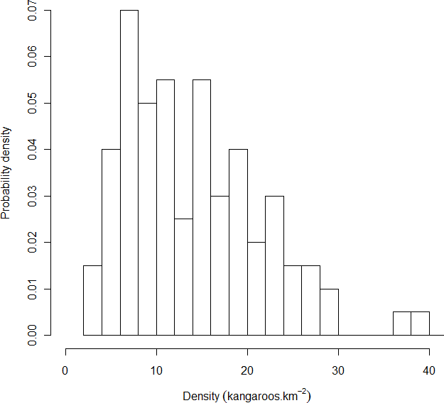
Figure 4 Histogram of a theoretical population of kangaroos

Density is estimated by aerial survey, and the frequency of estimated densities is converted to probability densities. The distribution of kangaroo densities is approximately lognormal.
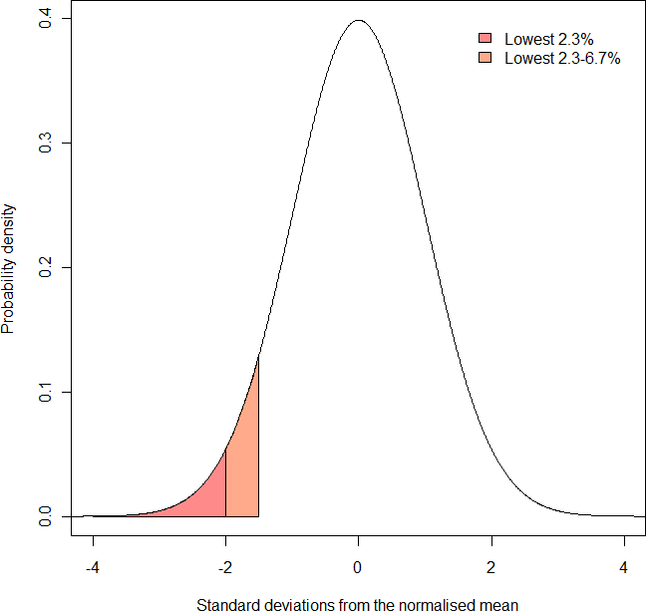
Figure 5 A theoretical distribution after z-score transformation

The mean of the distribution is 0 and the standard deviation is 1. Areas under the distribution represent probabilities. The orange-shaded region represents the probability that a sample is between 1.5 and 2 standard deviations below the mean (and represents 4.4% of the area). The red-shaded region represents the probability that a sample is more than 2 standard deviations below the mean (and represents 2.3% of the area).

The advantage of this method of setting the threshold over a more arbitrary method is the threshold is unlikely to be biased by a single low abundance. Additionally, as more survey data are added to the time series of abundance for a population, the estimates of the population’s mean and standard deviation become more robust.
Applying this method of setting thresholds to red kangaroos in Zone 2 (Figure 6) indicates an initial threshold of 7.8 red kangaroos per square kilometre and a lower threshold of 6.4 red kangaroos per square kilometre. If the annual aerial survey indicates the population of red kangaroos is below 7.8 kangaroos per square kilometre, the annual quota is reduced from 17 to 10% of the estimated population size. If the survey indicates the population abundance of red kangaroos is below 6.4 kangaroos per square kilometre, then all harvesting in the zone will cease until at least the next survey when the annual harvest quota is reappraised. Thus, thresholds allow the population to fluctuate within its normal range in abundance but prevent harvest mortality from depleting the population when it is at low abundance.

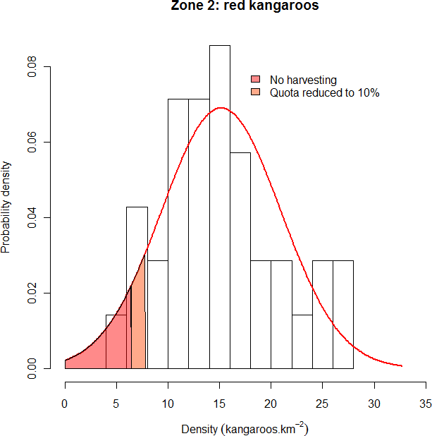
Figure 6 Example of setting harvest thresholds for red kangaroos in Zone 2

The red line represents a normal probability distribution of the observed data with a mean of 15.2 kangaroos per square kilometre and a standard deviation of 5.8 kangaroos per square kilometre. The upper range of the orange region (7.8 kangaroos per square kilometre) represents the threshold within which harvest rate is reduced from 17 to 10%. This lower rate is maintained unless density falls below 6.4 kangaroos per square kilometre, at which point harvesting ceases (red region). The thresholds were calculated after log transforming the data.
The following section shows how model simulations can be used to examine the relative effects of different thresholds applied to harvesting a theoretical population of red kangaroos.

Reducing the risk of overharvesting: an example using red kangaroos
The recommended strategy to minimise the risk of overharvest is to reduce harvest rate as density declines, with changes in harvest rate triggered at predetermined density thresholds. Appropriate thresholds can be considered by harvesting a simulated population of kangaroos (cf. Milner-Gulland et al. 2001). An appropriate population model for red kangaroos was developed by Caughley et al. (1987) and various forms of the model have

continued to be used for assessing strategies for managing the kangaroo harvest (see Hacker et al. 2004; Pople 2003, 2008).
Briefly, changes in kangaroo numbers are modelled as a function of pasture biomass which, in turn, is determined by recent rainfall, past pasture biomass and the density of kangaroos (and livestock) consuming the pasture. Harvesting obviously reduces kangaroo numbers, but the reduced density results in higher pasture biomass and therefore higher rates of increase of kangaroos. This improvement in environmental conditions for a population, which without harvesting has no long-term trend, is a basic requirement for the sustainability of a harvest. The population can be simulated 10,000 times over a 20-year period. Each run is different as, every three months, rainfall is drawn from a probability distribution using the average and standard deviation for rainfall in western New South Wales and thus reflects the uncertain food supply in this arid environment. Population size is also estimated with uncertainty by aerial surveys, and so this too was drawn from a probability distribution using the average and standard deviation associated with aerial surveys (Pople 2008). The population was harvested at an annual rate of 15% or less if it was below a particular threshold.
Extinction is highly unlikely for this simulated population unless there is some combination of low numbers, catastrophic weather and unsustainable harvesting (i.e. much greater than 15%). A more useful measure of threshold performance is the probability of the population dropping to a relatively low density. This can be calculated as the proportion of the 10,000 simulation runs where the population falls below particular densities. Thresholds can be expressed in terms of standard deviations (SDs) below long-term average density for a kangaroo management zone. That way, the aim of the threshold harvest strategy is to keep the harvested population above historically low density.
The effect of reducing harvest rate at varying SDs below the long-term average density for the simulated kangaroo population is shown in Figure 7. Reducing the threshold not surprisingly reduces the probability of very low density, but the decline in probability from no threshold (15% harvest) to no harvest is smooth. There is therefore no obvious optimum with the choice being somewhat arbitrary. Notably, even an unharvested population has some chance of declining to very low density.
Other factors that could be considered in setting thresholds are the time spent below some relatively low density (Figure 8), and the long-term average and variability in harvest offtake (including years with zero offtake) (Pople 2003). For these simulations, average harvest offtake was similar among the thresholds shown in Figures 7 and 8, but variability in the annual harvest increased slightly as the threshold was reduced.

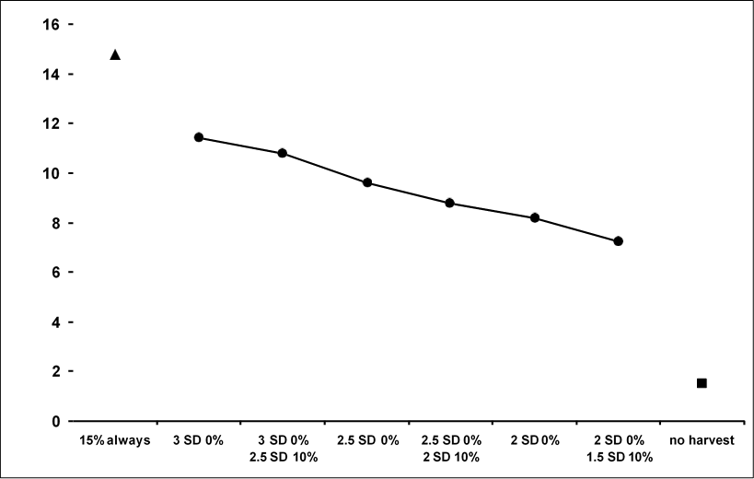
Figure 7 10,000 simulations for a population fluctuating over 20 years
%time < 2 SD below mean

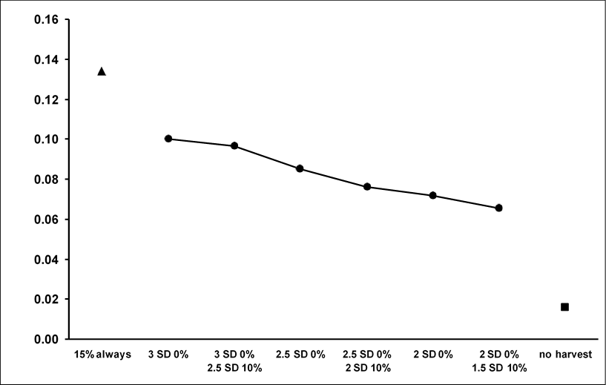
Standard deviation (over time) was calculated from a lognormal distribution. Mean population size was about eight kangaroos per square kilometre. Density was about four kangaroos per square kilometre at 2 standard deviations below the mean.
Prob. < 4.5 SD below mean

Figure 8 Simulated population as described for Figure 7

Density was about two kangaroos per square kilometre at 4.5 standard deviations below the mean.

Appendix 2: Biology, ecology and conservation status of commercially harvested macropods in New South Wales

Introduction
Indigenous Australians have a long history of stable interactions with the environment, and a central component of those interactions has been the kangaroo (Kohen 1995; Pascoe 2014). Realistic depictions of kangaroos and their extinct megafaunal cousins, such as the subfamily Sthenurinae, exist in many rock paintings across the continent (Cane 2013).
Kangaroos are depicted in Indigenous Australian creation stories (Reed 1982; Mountford 1973) and are valued as an important source of protein (Thomsen et al. 2006; Gammage 2012; Pascoe 2014). Different Indigenous groups holistically use all parts of kangaroos including meat, skins, bones, organs, teeth, blood and sinew for aural, ornamental and consumptive purposes (Langley et al. 2016; Akerman 2018; Dart 1958). Indigenous Australians historically, and many still, have a culturally embedded sustainable relationship with kangaroos from which much can be learned.
Empirical evidence of population dynamics before European arrival is negligible. Regulation of kangaroo populations can be attributed to people (Codding et al. 2014) and predators (Caughley et al. 1980; Pople et al. 2000; Letnic & Koch 2010). With the introduction of European farming practices and understandings of land ownership, widespread land clearing, exclusion of predators and creation of watering points to sustain livestock occurred throughout much of New South Wales. It’s believed these factors dramatically altered the ecodynamics of kangaroo populations and enabled them to sustain high numbers (Newsome 1965). Recent research, however, has found no evidence of a positive relationship between artificial watering points and kangaroo densities (Letnic & Crowther 2013; Lavery et al.
2018). On the other hand, dingos have been shown to regulate population numbers (Pople et al. 2000; Letnic et al. 2012) and grazing by ruminants is positively correlated with kangaroo abundance (Newsome 1975; Jonzén et al. 2005). With the removal of dingos with exclusion fencing, fluctuations in kangaroo populations are largely driven by the occurrence of rainfall and the availability of food resources.
Kangaroo management activities can occur for several reasons, including reducing grazing pressure, reducing animal-car collisions, conserving water or conserving flora (Pople 2003; Descovich et al. 2015; Mills et al. 2020). The NSW Kangaroo Management Program provides landholders an alternative avenue through which kangaroo populations can be managed by professional kangaroo harvesters, in line with localised quotas and rigorously determined population estimates. This reduces the need for landholders to use other forms of population management such as culling, fertility control, watering point control or re- introduction of predators (Wilson & Edwards 2019; Olsen & Braysher 2000; Olsen & Low 2006).
The department is responsible for protecting, conserving and managing kangaroos as protected species under the BC Act. Ensuring the harvest does not negatively affect the ecological viability of those kangaroo species covered by the plan is a central tenet of the EPBC Act authorising these types of wildlife trade management programs. The following paragraphs provide an overview of the ecology of kangaroo species affected by the plan. In addition, biological and anthropogenic threats to kangaroos are summarised, and threats to habitats and ecosystems as a result of commercial harvesting are reviewed.

Systematics
Kangaroos, particularly those within the genera Macropus and Osphranter (formerly in the genus Macropus), are the largest marsupials and members of the family Macropodidae.
These are generally united as a group and distinct from some wallabies, such as Wallabia

and Petrogale spp., due to a preference for grazing rather than browsing for food. They are anatomically and physiologically specialised so that widely available grasses can be consumed, digested and efficiently converted to energy as a central component of their diet (Dawson 2012).
Four macropod species are the subject of this plan: Osphranter rufus, Macropus fuliginosus, Macropus giganteus and Osphranter robustus.

Red kangaroo (Osphranter rufus)
Red kangaroos are the largest of the Macropodidae family. Sexually dimorphic, mature males can reach over 90 kilograms and females up to 40 kilograms. Males are mostly a dusky red-brown and females usually blue-grey although there is colour variation within sexes. Both sexes have a pale underbelly and tail tip, which provides a good distinguishing feature from the dark tail tip of grey kangaroos.
The distribution of the red kangaroo is generally continuous throughout lightly wooded and open areas of inland Australia where there is less than 500 millimetres annual rainfall, with highest densities found to occur in the rangelands of western New South Wales (Dawson 2012). The western New South Wales concentration of red kangaroos appears to be a population centre for New South Wales but may be a flow-on effect of efforts to protect and support grazing stock using exclusion fencing and increased watering points in the rangelands (Figure 9).
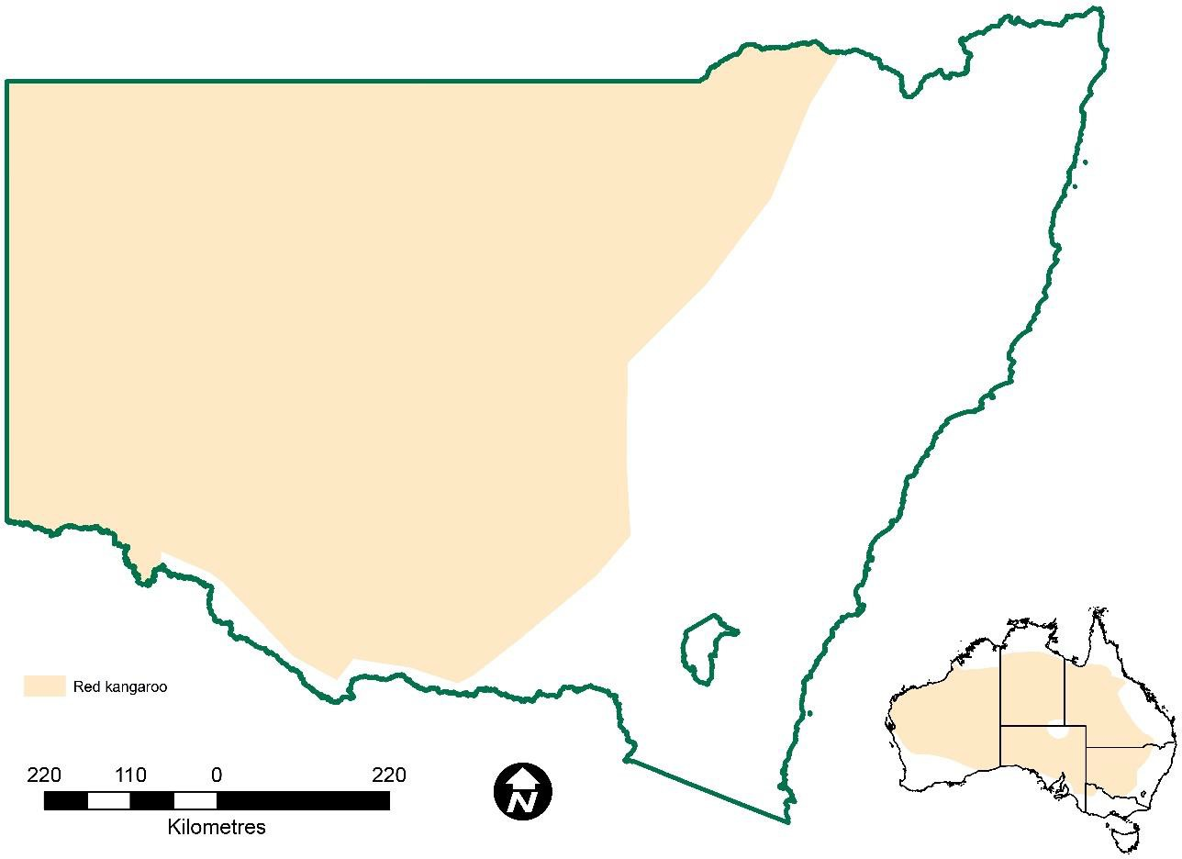
Figure 9 Red kangaroo (O. rufus) distribution in New South Wales

After about one year and before reaching sexual maturity, red kangaroos become transient in search of a home range. It is during this period many young males may die through starvation, thirst or mishap. They may wander 10 to 15 kilometres from their mother’s home range before establishing a much tighter home range of 2 to 3 kilometres in diameter.
Mature red kangaroos are known to travel much larger distances. Long-distance movements

(10–100 kilometres) may be prompted by displacement or the smell of rain during droughts. There is evidence of a mature female dispersing over 250 kilometres (Dawson 2012).
Female red kangaroos may enter oestrus at any time throughout the year. There is no breeding ‘season’. It takes around 235 days from when the joey appears in the pouch for it to permanently exit.

Western grey kangaroo (Macropus fuliginosus)
Western grey kangaroo distribution extends from the south-western corner of Western Australia, through southern South Australia and Kangaroo Island, into western Victoria and up into south-western New South Wales, where it overlaps with the eastern grey kangaroo (Kirsch & Poole 1972). Western greys’ northern distribution appears to be limited by the southern Australian winter rainfall band (Dawson 2012). Within New South Wales, they are mostly restricted to the floodplain soils of the Murray-Darling Basin (Figure 10). They are more sedentary than reds although a small proportion (< 10%) has been observed to move further than 10 kilometres.
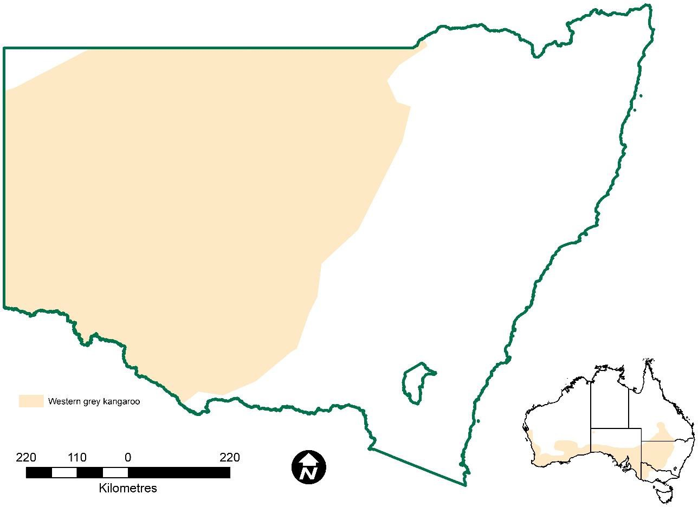
Figure 10 Western grey kangaroo (M. fuliginosus) distribution in New South Wales

Western grey kangaroos are genetically distinct from eastern greys and believed to have originated from south-west Western Australia due to increased tolerance to the plant toxin fluoroacetate (the toxic compound found in 1080 baits) which naturally occurs in plant genera native to the region (Twigg & King 1991). Western greys are most often found in shrub and woodland habitats. Western grey kangaroos have been shown to avoid herbivory on Myrtaceae to the point where kangaroos avoided herbivory on palatable legumes co- planted with Myrtaceae (Jones et al. 2003)
The oestrus cycle and gestational period for western greys was found to repeat on average every 34.9 and 30.6 days respectively (Kirsch & Poole 1972). When there is insufficient food resource, females cease breeding (Dawson 2012). Western greys have also been found to

have a breeding regime restricted to the months from November to February, with 78% of pouch young found to be conceived between December and February (Mayberry et al.
2010).
Western and eastern grey kangaroos are morphologically distinct from one another based on minor differences in colouring. Western greys have a brown–grey coat with dark patches on the elbows and around the face, whereas eastern greys have a grey coat with a lighter coloured face (Dawson 2012). Hybridisation infrequently occurs between western and eastern grey kangaroos (Neaves et al. 2010).

Eastern grey kangaroo (Macropus giganteus)
The eastern grey kangaroo is a large kangaroo with grey, grey–brown fur and a lighter belly. Mature females can reach up to 35 kilograms and males 70 kilograms (Dawson 2012).
Eastern grey kangaroos occur in all eastern states from Cape York to Victoria, as well as eastern Tasmania. They are also found in south-east South Australia (Kirsch & Poole 1972). Eastern greys are found throughout New South Wales but become scarcer in the far north- west. The population is generally restricted to areas subject to > 250 millimetres annual rainfall, although they’re able to traverse more arid zones along major drainage lines supported by inland riparian forests and woodlands (Dawson 2012) (Figure 11).
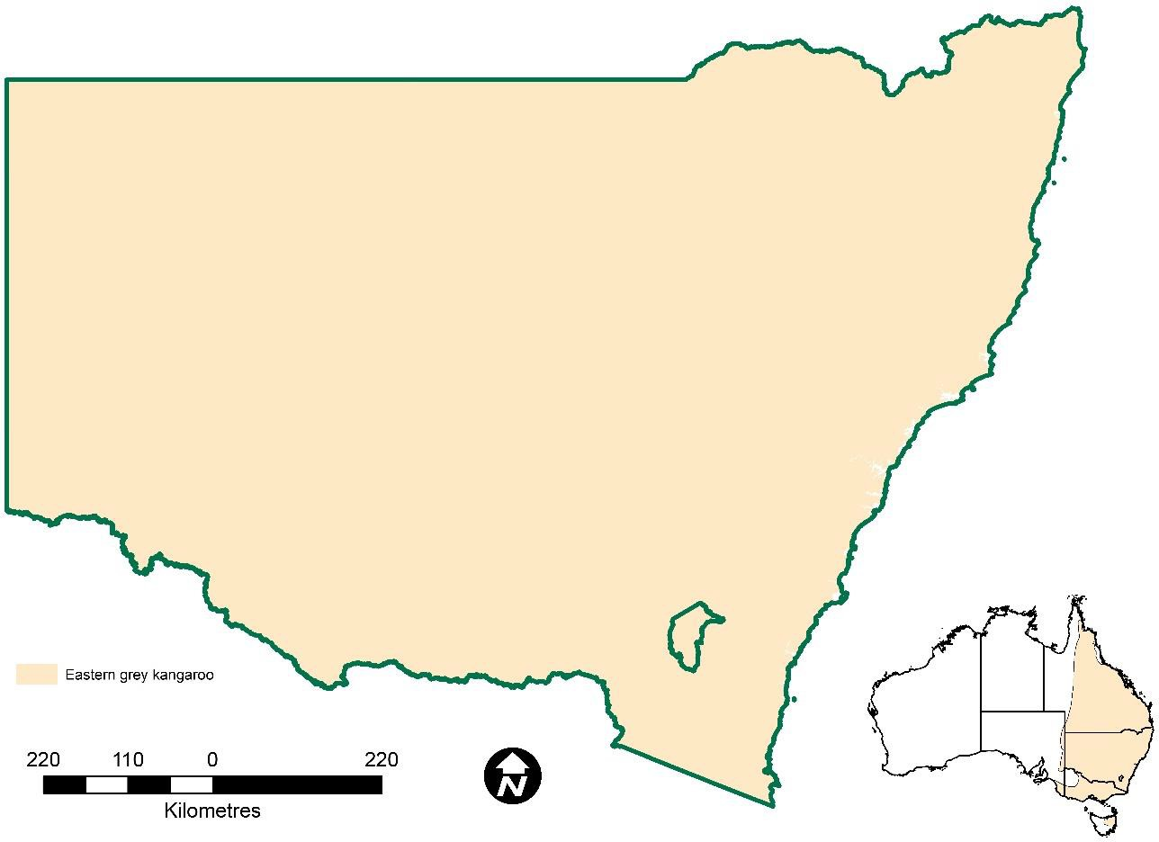
Figure 11 Eastern grey kangaroo (M. giganteus) distribution in New South Wales

An artefact of their preference for mesic habitats is that eastern greys are relatively sedentary, although females have been radio-tracked moving along drainage lines for up to 10 kilometres (Dawson 2012).
The average oestrus cycle and gestational period of eastern greys was found to be 45.6 days and 36.4 days respectively (Kirsch & Poole 1972). This allows populations to respond quickly to increases in resource availability. In south-east Australia, eastern greys give birth in summer before pouch young are weaned in late winter or early spring the following year.

Studies on eastern greys have found that reduced sociability leads to higher reproductive success. This may seem counterintuitive, and studies remark on this, however, it is a stark illustration of the importance of the mother–offspring relationship (Menz et al. 2020; King et al. 2017). It is believed the inverse correlation between sociability and reproductive success may occur in all four large kangaroos.

Common wallaroo (Osphranter robustus)
Common wallaroos (Osphranter robustus) occur throughout most of New South Wales (Figure 12). Two subspecies are recognised in New South Wales, with each predominant in different geographic areas (Richardson 2019). Morphological, physiological and behavioural differences between the subspecies relate to responses to their specific environments.
Eastern wallaroos (O. robustus subsp. robustus) occur mainly along the eastern and western slopes of the Great Dividing Range where there is sufficient water and rocky habitat. The euro (O. robustus subsp. erubescens) is found in suitably rocky habitat across arid Australia (Dawson 2012). The euro is not currently commercially harvested in New South Wales.
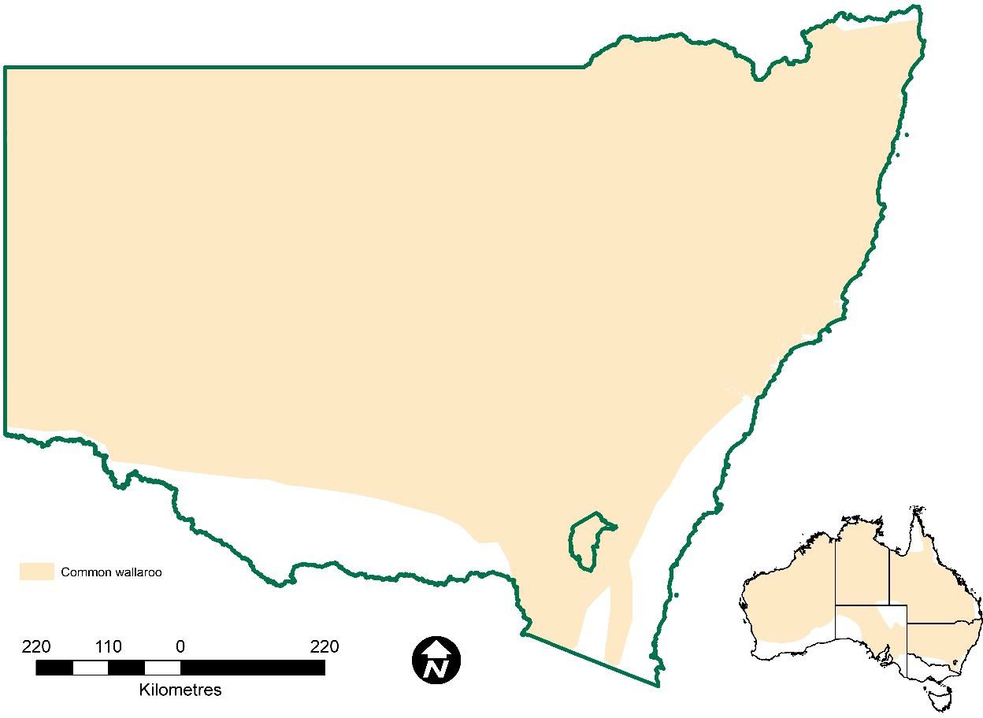
Figure 12 Common wallaroo (O. robustus) distribution in New South Wales

Common wallaroos can be distinguished from other kangaroos by their robust build and dark grey fur. Both sexes have shorter limbs than other kangaroos. Males have very solid shoulders and forearms, and rarely weigh more than 50 kilograms. Females are less than half this size, lighter in colour and tend to have blue–grey fur (Dawson 2012). Common wallaroos are mostly sedentary, but some do disperse (Dawson 2012).

Conservation status
The four species to which this plan relates (O. robustus, M. fuliginosus, O. rufus and M. giganteus) are listed as species of least concern with stable or increasing populations by the IUCN (iucnredlist.org, accessed 18 January 2021). The IUCN listing is supported by the

NSW Threatened Species Scientific Committee’s decision to reject calls for the conservation status of the four large macropods species to be upgraded to ‘vulnerable’ in 2015 (NSC 2015 a–d). None of the species to which this plan relates are listed under the Convention on International Trade in Endangered Species of Wild Fauna and Flora (CITES) (https://speciesplus.net). These species are widespread, and none are listed as threatened at state, national or international levels of governance (Table 1).

Table 1 Conservation status of the kangaroo species available for commercial harvest

Species | NSW legislated status¹ | IUCN Red List status²
Eastern grey kangaroo (M. giganteus) | Protected | Stable
Western grey kangaroo (M. fuliginosus) | Protected | Increasing
Red kangaroo (O. rufus) | Protected | Stable
Common wallaroo (O. robustus) | Protected | Stable
- Biodiversity Conservation Act 2016, Schedule 5, accessed 19 April 2021
- The IUCN Red List of Threatened Species 2020–3, accessed 19 April 2021

Threats and assessment of impacts
While the kangaroo species covered by this plan are not listed for conservation status, they still face several threats, both biological and anthropogenic in nature. These threats are detailed in Tables 2 and 3.

Anthropogenic threats
Anthropogenic threats are threats caused by human activity. In land management decisions, whether the desired outcome is to maintain economic viability or to conserve rangeland resources, total grazing pressure (TGP) is a fundamental consideration (Hacker et al. 2019). This is a critical point in rainfall-limited ecosystems, and while less so in higher rainfall regions, TGP and overgrazing remain important for landholders in these regions. It is important to recognise that kangaroos contribute to TGP. Wilson & Edwards (2019) demonstrate the comparative monetary value of kangaroos ($/kg) is considerably lower than that of cattle, sheep and goats. Kangaroos are thus more likely to be removed where there is a need to reduce TGP, often by culling (Sinclair et al. 2019). Such decisions are socially, economically and environmentally driven with the need to respond to climatic drivers such as any onset of drying conditions or drought as a catalyst.

Table 2 Anthropogenic threats to kangaroos

Threat | Description | Reference
Culling | Culling is a lethal control measure practised to effectively reduce populations and alleviate grazing pressure. Shooting is the most common method.  In New South Wales, kangaroos are protected under the BC Act. Culling by landholders is permitted under licence. These non-commercial licences are based on kangaroos being perceived as pests or over abundant and permit a pre-determined number of kangaroos to be culled based on property size and population estimates.  Concerns remain around the efficacy of non- professional shooters and their ability to meet animal welfare standards. However, if carried out in line with | Descovich et al. 2015; Lunney 2010; McLeod & Hacker 2020; Olsen & Braysher 2000; Olsen & Low 2006; Sinclair et al. 2019

Threat | Description | Reference
 | the National Code of Practice, shooting remains the most humane and cost-effective way of relieving population pressure.
Fencing | Wildlife-proof fencing may be used by graziers to exclude predators and competitors. When applied across a group of neighbouring properties this is termed ‘cluster fencing’. The impacts of cluster fencing on kangaroos are poorly understood, but there is evidence it may have knock-on effects on kangaroos.  Kangaroos have few natural predators, and sufficient food and water supply allows them to multiply and compete with stock or graze in spelled pastures. This may be exacerbated when kangaroos are enclosed by cluster fencing, such that high densities in a confined area are perceived as pests and subsequently controlled through culling.  Cluster fencing may also prevent local dispersal, although research on this and impacts on genetic diversity, and hence population viability, is scarce. | Clark et al. 2018; Smith et al. 2020; Wilson & Edwards 2019
Fertility control | Anti-fertility control, immunocontraception and contraceptive implants are methods which may help control overabundant kangaroo populations.  These types of control measures are often too expensive and impractical to apply as a broadscale management tool, but in some cases have been used in small-scale population control. The choice of method depends upon several factors including contraceptive duration, reversibility and predictability. | Cope et al. 2018; Coulson et al. 2008; Hampton et al. 2015; Olsen & Braysher 2000; Olsen & Low 2006; Poiani et al. 2002; Woodward et al. 2006
 | While there is a large body of literature around the efficacy and suitability of fertility controls, peer- reviewed studies investigating animal welfare impacts of fertility control are scarce.
Watering point control | Artificial watering points are often cited as a factor sustaining increased numbers of herbivores in Australia’s rangelands. Controlling access to these watering points may either attract or repel both welcome and unwelcome grazers.  While it may be an effective means of controlling grazing by livestock, its applicability to kangaroos is debatable. Research on artificial watering points recognises that kangaroos require less water and are more mobile than livestock, allowing them to travel further between drinks. Several studies have found controlling watering points to be largely ineffective in controlling kangaroo populations. | Blayney et al. 2000; Dawson et al. 2004; Fukuda et al. 2009; Landsberg et al. 1997; Landsberg et al. 2002; Lavery et al. 2018; Letnic et al. 2015; Montague-Drake & Croft 2004
 | Further research is required to better understand the effects of watering point control on kangaroo populations.

Biological threats
Non-anthropogenic kangaroo mortality is often due to multiple causes with the catalyst often being an environmental event. Biological threats are often centred around climate-driven fluctuations of a contested resource (e.g. food, habitat, water) but also by competitive and survival strategies of other organisms.

Table 3 Biological threats to kangaroos

Threat | Description | Reference
Climate change | Macropod populations are closely tied to climatic drivers in inland Australia. Climate change is anticipated to affect kangaroo populations, particularly in response to variability in rainfall. The proportional threshold harvesting strategy (Appendix 1) employed by this plan accounts for these impacts.  The details and extent of such impacts are poorly understood and difficult to predict. Where possible, this program will contribute to the review of forage composition, seasonal weather events, fecundity, survival and behaviour of kangaroos during climatic change. Species compositions, distribution and genetics may also be affected and more research into population change can be included when proposed. | Dunlop & Brown 2008; Jonzén et al. 2010; OEH 2014 a–d; Ritchie & Bolitho 2008; Saintilan et al. 2021
Drought | Reduced availability of water and feed during drought may lead to poor nutritional health in macropods. Macropods with poor nutrition are vulnerable to both predation and disease. Pouch and weaning young are particularly susceptible to poor nutrition through lack of feed, as are fast- growing males about to reach sexual maturity.  Older macropods with reduced foraging capacity are also susceptible to poor nutrition.  Reproductive strategies allow kangaroo populations to affect group size in response to availability of water. Some may disperse and older age cohorts may die off earlier than younger kangaroos, allowing populations to recover quickly from drought periods. | Bayliss 1985; Bayliss  1987; Cairns et al. 2000; Cairns & Grigg 1993; Caughley et al. 1985; Dawson et al. 2007; Dawson 2012; McCarthy  1996; Pople 2003
Flood | Floods generally lead to reduced availability of nutritional resources either directly by rendering food resources unavailable or indirectly by isolating populations. This can lead to poor health and increase susceptibility to disease, particularly in the context of a higher prevalence of waterborne diseases.  Eastern and western grey kangaroos, however, are found in intermittently flooded forests throughout the Murray-Darling Basin where they play a key role in ecosystem function as localised seed and nutrient dispersers. Low-lying parts of the inland floodplain forests are highly productive ecosystems where intermittent flooding likely supports the presence of kangaroos. | Dawson 2012; Hale 2004; Iles et al. 2010; Kobayashi et al. 2011

Threat | Description | Reference
Disease and parasitism | Many studies on the relationships between macropods and diseases were completed on animals in captivity. Disease-related mortality in wild kangaroo populations is poorly understood and requires more research.  The effects of disease and parasites are often exacerbated when food resources become restricted and malnourishment occurs and may be primary contributors to mortality. Disease occurrence in macropod species is often related to broader environmental factors such as drought.  Large mortality events in wild populations have been associated with anomalous rainfall and abundant forage, with increased insect activity as suspected possible vectors.  There have been several spatially heterogenous mortality events in recent years where Globocephaloides sp. is a common factor.  Parasitism, particularly in relation to Globocephaloides sp. but also Babesia spp. spread via tick bite, occurs in macropods of south-east Australia.  Blood sucking midges (Culicoides dycei) are a vector for Wallal virus which can lead to blindness and mortality in kangaroos and reached epidemic levels in the mid-1990s.  The bacteria Fusobacterium necroforum infects kangaroos jaw bones causing lumpy jaw disease and can eventually lead to death. | Curran 2011; Curran et al. 1999; Dawson 2012; DPI 2015; Grillo et al.  2014a; Grillo et al. 2014b; Kido et al. 2018; Obendorf et al. 1991; Sotohira et al. 2017; Stern 2010
Fire | The predator–prey dynamic between foxes and eastern grey kangaroos is altered in recently burnt areas. Changed habitat helps predators locate vulnerable prey who do not have protective cover and are affected by availability of food and water. This relationship is less pronounced adjacent to agricultural areas, possibly due to the availability of such resources and open habitat.  On the other hand, high-quality food resources often increase following fires, promoting population growth. Presence of large herbivores, such as feral cattle, has been found to deter kangaroos from grazing high-quality, post-fire forage. | Caughley et al. 1985; Geary et al. 2020; Hrdasky 2020; Reid 2018
Plant toxicity | There are several recently recorded mortality events that have been attributed to plant toxicity. Reported instances suggest poisoning in response to ingestion of Lantana camara, Panicum sp., Phalaris sp. and Tribulus terrestris. | Alden et al. 2014; Grillo et al. 2014a; Grillo et al.  2014b; Twigg & King 1991
Predation | Kangaroos will be preyed upon by dingos, foxes and cats. Purcell (2010) showed dingo dietary preference changes dependent on biological seasons of dingos. An early study on dingo stomach contents found that kangaroos made up a minute part of a dingo’s diet in good seasons, but during droughts they made up a disproportionately  large part of a dingo’s diet. More research is | Banks et al. 2000; Corbett & Newsome1987; Dawson 2012; Hradsky 2020; Letnic & Crowther 2013; Purcell 2010

Threat | Description | Reference
required to understand the effects of low predation rates on kangaroo populations.
Banks et al. (2000) compared mother:young ratios in eastern grey kangaroos in south-east New South Wales in response to the level of fox control, and found 25–40% more females retained juveniles when fox numbers were reduced by means of long- term 1080 baiting.

Threats to kangaroos related to commercial harvest
The commercial harvest has been administered in New South Wales for 45 years. Data collected by the department shows kangaroo numbers fluctuate widely (Figures 13 and 14). These fluctuations are mostly driven by seasonal conditions with the major population declines usually associated with dryer periods and reduced feed availability. Harvesting has little effect on the populations. Commercial harvesting has not adversely impacted population viability. The department recognises the potential threats to kangaroos related to the commercial harvest, which this management plan addresses and mitigates through rigorous regulation and the described aims and actions in the plan.

Figure 13 Fluctuation in kangaroo populations in western plains of New South Wales over time

Figure 13 is adapted from Lunney et al. (2018) and Pople et al. (2018). It has also been extended to include more recent population estimates made using mark-recapture-distance-sampling methods. The graph shows temporal variation of kangaroo populations on the western plains of NSW. Survey methods to estimate population size have varied over time from monitoring seven sample blocks (yellow line), to 200-metre (blue

line) and 100-metre strip transects (green line) and more recently mark-recapture-distance-sampling (MRDS) (orange dotted line). Strip count data has been adjusted as described in Pople (2006).

Figure 14 Fluctuation in kangaroo populations in the Northern, Central and South East Tablelands zones in New South Wales over time

Fitness trait and genetic effects
Harvesters tend towards a male bias when harvesting because of their greater size and hence financial return as they are paid per kilogram of carcass weight. This has led to past concerns around the effects such a bias might have on population genetics (Croft 2000).
However, Hale (2004) showed that the likelihood of male-biased harvesting influencing population genetics is negligible for reasons including:
- populations are larger than the quantity harvested, thus size-related traits and genetic diversity are replaced through immigration or emigration
- while there may be a bias toward large males, not all large males in a population are harvested
- the variability of food resources means the largest kangaroos are not necessarily the fittest – increased energy use associated with increased size may in fact be a disadvantage when food resources are scarce.
Hale further solidified his findings by demonstrating no loss in gene diversity between harvested and unharvested populations. Allendorf et al. (2008) also state the key role of refuges throughout the harvest zones in protecting against loss of genetic diversity.
Tenhumberg et al. (2004) came to a similar conclusion when modelling the realistic scenario of harvest refuges dispersed throughout the commercial harvesting zone.

Mitigating actions
Action 2.1: Kangaroo population estimates are determined using scientifically rigorous population surveys.
Action 2.2: Proportional commercial harvest quotas are set and reported annually for each commercial kangaroo management zone.
Action 2.3: Harvest data are monitored to ensure quotas are not exceeded.
Action 4.3: Tagging, landholder consent and reporting processes enable program accountability and compliance.
Action 6.2: Foster and support research to improve kangaroo census and population modelling.
Action 6.3: Facilitate adaptive management experiments to test deliberate management interventions where practicable.

Humane harvesting
The department recognises the animal welfare concerns that exist around the commercial harvest (Hampton et al. 2020; Sinclair et al. 2019), be it the welfare of the targeted individuals or the implications on dependent young (Sharp 2015). The department advocates for humane harvesting and strives to ensure that humane harvesting is practised in the field. The department supports only tried, tested and determined methods resulting in least possible harm to individuals and populations as the most appropriate method of harvesting for commercial purposes (Olsen & Braysher 2000; Olsen & Low 2006; Descovitch et al.
2015).
Mitigating actions
Action 1.1: Implement and enforce the National Code of Practice for the Humane Shooting of Kangaroos and Wallabies for Commercial Purposes across all commercial harvesting activity in New South Wales.
Action 1.2: Facilitate capacity building and engagement opportunities to maintain harvester competency to meet National Code requirements.
Action 4.1: All activities relating to the commercial harvest of kangaroos in New South Wales are licensed in accordance with BC Act, Regulation and policy.
Action 4.2: Licence conditions are effectively applied.
Action 5.2: Regular and opportunistic monitoring of licensees for compliance with licence conditions and legislation.
Action 5.3: Investigation of and appropriate response to non-compliance. Action 5.4: A collaborative approach to compliance.
Action 6.1: Foster and support research to improve animal welfare outcomes.
Action 6.3: Facilitate adaptive management experiments to test deliberate management interventions where practicable.

Perceived risk of ‘overharvest’
The NSW Government has a statutory obligation under the BC Act to ensure ecologically viable populations of kangaroos in New South Wales. The likelihood of ‘overharvest’ or even possible extinction of any kangaroo species available for commercial harvest under this plan are very low. This risk is successfully mitigated by the implementation of the proportional harvesting strategy; reducing harvest rate as density declines, triggered at predetermined thresholds (Appendix 1).

The commercial kangaroo harvest has been administered in New South Wales for 45 years. Populations are monitored on an annual basis. Objective analysis of long-term population variance, including fluctuations in relation to wet and dry periods, has demonstrated the sustainability of the harvest during this time (Figure 13).
Mitigating actions
Action 2.1: Kangaroo population estimates are determined using scientifically rigorous population surveys.
Action 2.2: Proportional commercial harvest quotas are set and reported annually for each commercial kangaroo management zone.
Action 2.3: Harvest data are monitored to ensure quotas are not exceeded. Action 2.4: Identify any potential threats to population health.
Action 3.1: Maintain public website with relevant documents and current information.
Action 3.2: Engage a Kangaroo Management Advisory Panel to provide expert advice on relevant kangaroo management issues.
Action 3.3: Respond to information requests.
Action 6.2: Foster and support research to improve kangaroo census and population modelling.
Action 6.4: Share historical survey and harvest data. Action 7.1: Produce and publish regular reports.

Threats to habitats and ecosystems related to commercial harvest
There are no direct threats to habitats and ecosystems that result from the activities outlined in this plan. Harvesting is authorised only on private properties or areas which are not reserved for conservation. Private properties with active conservation agreements are likely to have a macropod management plan to reduce the impacts of kangaroos on the conserved habitats and ecosystems. Such plans may include using a professional kangaroo harvester to harvest animals and remove carcasses for the benefit of the conserved area.

Threats from harvesting
Harvesters are required to field dress carcasses and will leave offcuts, which may attract scavengers. Scavengers may also prey upon protected species or damage habitat and ecosystems, but these are not directly related to activities of the commercial harvesting program. Kangaroo offcuts can return a proportion of nutrients to the ecosystem via decomposition in soil (Wilson & Read 2003; Macdonald et al. 2014). Recent research also highlights that failing to effectively manage kangaroo populations can lead to detrimental outcomes for habitats and ecosystems through overgrazing (Mills et al. 2020).
Mitigating actions
Action 2.1: Kangaroo population estimates are determined using scientifically rigorous population surveys.
Action 2.2: Proportional commercial harvest quotas are set and reported annually for each commercial kangaroo management zone.
Action 2.4: Identify any potential threats to population health.
Action 6.1: Foster and support research to improve animal welfare outcomes.
Action 6.2: Foster and support research to improve kangaroo census and population modelling.

Action 6.3: Facilitate adaptive management experiments to test deliberate management interventions where practicable.

References
AgriFutures Australia 2020, National Code of Practice for the Humane Shooting of Kangaroos and Wallabies for Commercial Purposes, AgriFutures Australia Publication No. 20–126.
Akerman K 2018, The esoteric and decorative use of bone, shell and teeth in Australia, in Langley MC, Wright D, Litster M & May SK (eds), The Archaeology of Portable Art: Southeast Asian, Pacific and Australian Perspectives, Routledge.
Alden R, Hackney B, Weston L & Quinn JC 2014, Phalaris toxicoses in Australian livestock production systems: prevalence, aetiology and toxicology, Journal of Toxins 1(1): 7.
Allendorf FW, England PR, Luikart G, Ritchie PA & Ryman N 2008, Genetic effects of harvest on wild animal populations, Trends in ecology and evolution 23(6): 327–337.
Banks PB, Newsome AE & Dickman CR 2000, Predation by red foxes limits recruitment in populations of eastern grey kangaroos, Austral Ecology 25(3): 283–291.
Barker R 2008, ‘Theory and application of mark – recapture and related techniques to aerial surveys of wildlife, Wildlife Research 35: 268–274.
Bayliss P 1985, The population dynamics of red and western grey kangaroos in arid New South Wales, Australia, 1: Population dynamics and rainfall, Journal of Animal Ecology 54: 111–125.
Bayliss P 1987, Kangaroo Dynamics, in Caughley G, Shepherd N & Short J (eds), Kangaroos: their Ecology and Management in the Sheep Rangelands of Australia, Cambridge University Press, Cambridge.
Blaney CE, Dawson TJ, McCarron HCK, Buffenstein R & Krockenberger AK 2000, Water metabolism and renal function and structure in Eastern Grey Kangaroos (Macropus giganteus): Responses to water deprivation, Australian Journal of Zoology 48(4): 335–345.
Cairns SC & Grigg GC 1993, Population dynamics of red kangaroos (Macropus rufus) in relation to rainfall in the South Australian Pastoral Zone, Journal of Applied Ecology 30: 444– 458.
Cairns SC, Grigg GC, Beard LA, Pople AR & Alexander P 2000, Western grey kangaroos, Macropus fuliginosus, in the South Australian pastoral zone: populations at the edge of their range, Wildlife Research 27: 309–318.
Cane S 2013, First footprints: The epic story of the First Australians, Allen and Unwin, Crows Nest, New South Wales.
Caughley G, Grigg GC, Caughley J & Hill GJ 1980, Does dingo predation control the densities of kangaroos and emus?, Wildlife Research 7(1): 1–12.
Caughley G, Grigg GC & Smith L 1985, The effect of drought on kangaroo populations,
Journal of Wildlife Management 49: 679–685.
Caughley G, Shepherd N & Short J 1987, Kangaroos: their ecology and management in the sheep rangelands of Australia, Cambridge University Press, Cambridge.
Clark P, Clark E & Allen BL 2018, Sheep, dingoes and kangaroos: new challenges and a change of direction 20 years on, in Advances in conservation through sustainable use of wildlife, University of Queensland, Gatton, Australia, 173–178, ISBN 978-0-646-99219-8.
Codding BF, Bird RB, Kauhanen PG & Bird DW 2014, Conservation or co-evolution? Intermediate levels of aboriginal burning and hunting have positive effects on kangaroo populations in Western Australia, Human Ecology 42(5): 659–669.

Cope HR, Hogg CJ, White PJ & Herbert CA 2018, A role for selective contraception of individuals in conservation, Conservation Biology 32(3): 546–558.
Corbett LK & Newsome AE 1987, The feeding ecology of the dingo, Oecologia 74: 215–227, doi.org/10.1007/BF00379362.
Coulson G, Nave CD, Shaw G & Renfree MB 2008, Long-term efficacy of levonorgestrel implants for fertility control of eastern grey kangaroos (Macropus giganteus), Wildlife Research 35(6): 520–524.
Croft DB 2000, Sustainable use of wildlife in western New South Wales: Possibilities and problems’, The Rangeland Journal 22(1): 88–104.
Curran G 2011, Field investigation of kangaroo deaths in Sturt National Park and areas near Tibooburra in early 2010, Industry and Investment NSW, Broken Hill, accessed 7 October 2020.
Curran G, Gay E & Gilroy J 1999, Investigations of a major epidemic mortality of macropods in the northern part of far western NSW in October 1998, NSW Kangaroo Management Committee, NSW.
Dart RA 1958, Bone tools and porcupine gnawing, American Anthropologist 60(4): 715–724. Dawson TJ 2012, Kangaroos, 2nd edition, CSIRO Publishing, Collingwood, Victoria.
Dawson TJ, McTavish KJ & Ellis BA 2004, Diets and foraging behaviour of red and Eastern Grey Kangaroos in arid shrub land: Is feeding behaviour involved in the range expansion of the Eastern Grey Kangaroo into the arid zone?, Australian Mammalogy 26(2): 169–178.
Dawson TJ, Blaney CE, McCarron HC & Maloney SK 2007, Dehydration, with and without heat, in kangaroos from mesic and arid habitats: different thermal responses including varying patterns in heterothermy in the field and laboratory, Journal of Comparative Physiology B 177(7): 797–807.
Deroba JJ & Bence JR 2008, A review of harvest policies: Understanding relative performance of control rules, Fisheries Research 94: 210–223.
DPI 2015, CVO Bulletin to Veterinarians: Eastern Grey Kangaroo Mortalities in NSW, ACT and Victoria, July-September 2015, NSW Department of Primary Industries, accessed
6 October 2020.
Descovich K, McDonald I, Tribe A & Phillips CA 2015, Welfare assessment of methods used for harvesting, hunting and population control of kangaroos and wallabies, Animal Welfare 24: 255–265.
Dunlop M & Brown PR 2008, Implications of Climate Change for Australia’s National Reserve System. A Preliminary Assessment, report to the Department of Climate Change, Canberra.
Engen S, Lande R & Saether B-E 1997, Harvesting strategies for fluctuating populations based on uncertain population estimates, Journal of Theoretical Biology 186: 201–212.
Fewster RM & Pople AR 2008, A comparison of mark–recapture distance-sampling methods applied to aerial surveys of eastern grey kangaroos, Wildlife Research 35: 320–330.
Fleming PJS & Tracey JP 2008, Some human, aircraft and animal factors affecting aerial surveys: how to enumerate animals from the air, Wildlife Research 35: 258–267.
Fukuda Y, McCallum HI, Grigg GC & Pople AR 2009, Fencing artificial waterpoints failed to influence density and distribution of red kangaroos (Macropus rufus), Wildlife Research 36(6): 457–465.
Gammage, B 2011, The biggest estate on earth: how Aborigines made Australia, Allen & Unwin, Crows Nest, NSW.

Geary WL, Hradsky BA, Robley A & Wintle BA 2020, Predators, fire or resources: What drives the distribution of herbivores in fragmented mesic forests?, Austral Ecology, 45(3): 329–339.
Grillo T, Cox-Witton K & Wicks R 2014a, Animal Health Surveillance Quarterly Report
19(3): 3–6, Wildlife Health Australia.
Grillo T, Cox-Witton K & Wicks R 2014b, Animal Health Surveillance Quarterly Report 19(2): 6–7, Wildlife Health Australia.
Hacker R, McLeod S, Druhan J, Tenhumberg B & Pradhan U 2004, Kangaroo management options in the Murray-Darling Basin, report to Murray-Darling Basin Commission, Canberra.
Hacker RB, Sinclair K & Waters CM 2019, Total grazing pressure – a defining concept for extensive pastoral systems in the southern rangelands of Australia, The Rangelands Journal 41: 457–460, doi:10.1071/RJ19026.
Hale PT 2004, Genetic effects of kangaroo harvesting, Australian Mammalogy 26(1): 75–86.
Hampton JO, Hyndman TH, Barnes A & Collins T 2015, Is wildlife fertility control always humane?, Animals 5(4): 1047–1071.
Hampton JO, Jones B & McGreevy PD 2020, Social License and Animal Welfare: Developments from the Past Decade in Australia, Animals 10(12): 2237.
Hone J 2008, On bias, precision and accuracy in wildlife aerial surveys, Wildlife Research
35: 253– 257.
Hradsky BA 2020, Conserving Australia’s threatened native mammals in predator-invaded, fire-prone landscapes, Wildlife Research 47(1): 1–15.
Iles J, Kelleway J, Kobayashi T, Mazumder D, Knowles L, Priddel D & Saintilan N 2010, Grazing kangaroos act as local recyclers of energy on semiarid floodplains, Australian Journal of Zoology 58(3): 145–149.
IUCN 1990, Proceedings: 18th session of the General Assembly of IUCN – the World Conservation Union, Perth, Australia, 28 November – 5 December 1990, International Union for Conservation of Nature, accessed: 11 May 2021.
IUCNNR 2021, The IUCN Red List of Threatened Species 2020–3, International Union for Conservation of Nature and Natural Resources, accessed 18 January 2021.
Jones AS, Lamont BB, Fairbanks MM & Rafferty CM 2003, Kangaroos avoid eating seedlings with or near others with volatile essential oils, Journal of Chemical Ecology 29: 2621–2635, doi.org/10.1023/B:JOEC.0000008008.91498.62.
Jonzén N, Pople AR, Grigg GC & Possingham HP 2005, Of sheep and rain: large‐scale population dynamics of the red kangaroo, Journal of Animal Ecology 74(1): 22–30.
Jonzén N, Pople AR, Knape J & Sköld M 2010, Stochastic demography and population dynamics in the red kangaroo Macropus rufus, Journal of Animal Ecology 79: 109–116, doi.org/10.1111/j.1365-2656.2009.01601.x.
Kido N, Tanaka S, Wada Y & Sato S 2018, Factors affecting the occurrence of enteritis in 10 to 12‐month‐old eastern grey kangaroos (Macropus giganteus), Zoo Biology 37(2): 115–118.
King WJ, Fest-Bianchet M, Coulson G & Goldizen AW 2017, Long-term consequences of mother-offspring associations in eastern grey kangaroos, Behavioral Ecology and Sociobiology 71: 77, doi:10.1007/s00265-017-2297-1.
Kirsch JAW & Poole WE 1972, Taxonomy and distribution of the grey kangaroos, Macropus giganteus Shaw and Macropus Fuliginosus (Desmarest), and their subspecies (Marsupialia : Macropodidae), Australian Journal of Zoology, 20: 315–339, doi.org/10.1071/ZO9720315

Kobayashi T, Iles J & Knowles L 2011, Are the faecal pellets of kangaroos (Macropus spp.) a source of nutrients and carbon in an inland floodplain wetland during flooding? A preliminary experimental inundation study in the Macquarie Marshes, New South Wales, Australian Zoologist 35(3): 458–462.
Kohen JL 1995, Aboriginal environmental impacts, UNSW Press, Sydney.
Laake J, Dawson MJ & Hone J 2008, Visibility bias in aerial survey: mark–recapture, line transect or both?, Wildlife Research 35: 299–309.
Lande R, Engen S & Saether B-E 1995, Optimal harvesting of fluctuating populations with a risk of extinction, American Naturalist 145: 728–745.
Lande R, Saether B-E & Engen S 1997, Threshold harvesting for sustainability of fluctuating resources, Ecology 78: 1341–1350.
Landsberg J, James CD, Maconochie J, Nicholls AO, Stol J & Tynan R 2002, Scale‐related effects of grazing on native plant communities in an arid rangeland region of South Australia, Journal of Applied Ecology 39(3): 427–444.
Landsberg J, James CD, Morton SR, Hobbs TJ, Stol J, Drew A & Tongway H 1997, The effect of artificial sources of water on rangeland biodiversity: Final report to the Biodiversity Convention and Strategy Section of the Biodiversity Group, Environment Australia, CSIRO Division of Wildlife Ecology.
Langley MC, O’Connor S & Aplin K 2016, A >46,000-year-old macropod bone implement from Carpenters Gap 1 (Kimberley, northwest Australia), Quaternary Science Reviews 154: 199–213.
Lavery TH, Pople AR & McCallum HI 2018, Going the distance on kangaroos and water: a review and test of artificial water point closures in Australia, Journal of Arid Environments 151: 31–40.
Letnic M & Crowther MS 2013, Patterns in the abundance of kangaroo populations in arid Australia are consistent with the exploitation ecosystems hypothesis, Oikos 122(5): 761– 769.
Letnic M & Koch F 2010, Are dingoes a trophic regulator in arid Australia? A comparison of mammal communities on either side of the dingo fence, Austral Ecology 35(2): 167–175.
Letnic M, Laffan SW, Greenville AC, Russell BG, Mitchell B & Fleming PJ 2015, Artificial watering points are focal points for activity by an invasive herbivore but not native herbivores in conservation reserves in arid Australia, Biodiversity and Conservation 24(1): 1–16.
Letnic M, Ritchie EG & Dickman CR 2012, Top predators as biodiversity regulators: the dingo Canis lupus dingo as a case study, Biological Reviews, 87: 390–413, doi.org/10.1111/j.1469-185X.2011.00203.x.
Lunney D 2010, A history of the debate (1948–2009) on the commercial harvesting of kangaroos, with particular reference to New South Wales and the role of Gordon Grigg, Australian Zoologist 35(2): 383–430.
Lunney D, Purcell B, McLeod S, Grigg G, Pople T & Wolter S 2018, Four decades of research and monitoring the populations of kangaroos in New South Wales: one of the best long-term datasets in Australia, Australian Zoologist, 39: 784–800.
Macdonald BC, Farrell M, Tuomi S, Barton PS, Cunningham SA & Manning AD 2014, Carrion decomposition causes large and lasting effects on soil amino acid and peptide flux, Soil Biology and Biochemistry 69: 132–140.
Mayberry C, Maloney SK, Mawson P & Bencini R 2010, Seasonal anoestrus in western grey kangaroos (Macropus fuliginosus ocydromus) in south-western Australia. Australian Mammalogy 32: 189–196, doi.org/10.1071/AM09029.

McCarthy MA 1996, Red kangaroo (Macropus rufus) dynamics: effects of rainfall. Density dependence, harvesting and environmental stochasticity, Journal of Applied Ecology 33: 45– 53.
McLeod SR & Hacker RB 2020, Balancing stakeholder interests in kangaroo management – historical perspectives and future prospects, The Rangeland Journal 41: 567–579, doi.org/10.1071/RJ19055.
Menz CS, Carter AJ, Best EC, Freeman NJ, Dwyer RG, Blomberg SP & Goldizen AW 2020, Higher sociability leads to lower reproductive success in female kangaroos, Royal Society Open Science 7: 200950, doi: 10.1098/rsos.200950.
Mills CH, Waudby H, Finlayson G, Parker D, Cameron M & Letnic M 2020, Grazing by over- abundant native herbivores jeopardizes conservation goals in semi-arid reserves, Global Ecology and Conservation 24: e01384, doi.org/10.1016/j.gecco.2020.e01384.
Milner-Gulland EJ, Shea K, Possingham H, Coulson T & Wilcox C 2001, Competing harvesting strategies in a simulated population under uncertainty, Animal Conservation 4: 157–167.
Montague-Drake R & Croft DB 2004, Do kangaroos exhibit water-focused grazing patterns in arid New South Wales? A case study in Sturt National Park, Australian Mammalogy
26(1): 87–100.
Mountford CP 1973, The Dreamtime Book: Australian Aboriginal Myths in Paintings by Ainslie Roberts, Rigby, Australia.
National Health and Medical Research Council 2013, Australian code for the care and use of animals for scientific purposes, 8th edition. National Health and Medical Research Council, Canberra.
Neaves LE, Zenger KR, Cooper DW & Eldridge MDB 2010, Molecular detection of hybridization between sympatric kangaroo species in south-eastern Australia, Heredity, 104: 502–512, doi.org/10.1038/hdy.2009.137.
Newsome AE 1965, The distribution of red kangaroos, Megaleia rufa (Desmarest), about sources of persistent food and water in central Australia, Australian Journal of Zoology, 13(2): 289–300.
Newsome AE 1975, An ecological comparison of the two arid zone kangaroos of Australia, and their anomalous prosperity since introduction of ruminant stock to their environment, Quarterly Review of Biology 50: 389–424.
OEH 2014a, Far West Climate change snapshot, AdaptNSW, Office of Environment and Heritage, accessed 19 January 2021.
—— 2014b, New England North West Climate change snapshot, AdaptNSW, Office of Environment and Heritage, accessed 19 January 2021.
—— 2014c, Central West and Orana Climate change snapshot, AdaptNSW, Office of Environment and Heritage, accessed 19 January 2021.
—— 2014d, Murray Murrumbidgee Climate change snapshot, AdaptNSW, Office of Environment and Heritage, accessed 19 January 2021.
NSC 2015a, Eastern Grey Kangaroo Macropus giganteus – Final Determination, NSW Scientific Committee, Office of Environment and Heritage, accessed 18 January 2021.
—— 2015b, Western Grey Kangaroo Macropus fuliginosus – Final Determination, NSW Scientific Committee, Office of Environment and Heritage, accessed 18 January 2021.
—— 2015c, Red Kangaroo Macropus rufus – Final Determination, NSW Scientific Committee, Office of Environment and Heritage, accessed 18 January 2021.

—— 2015d, Common Wallaroo Macropus robustus robustus – Final Determination, NSW Scientific Committee, Office of Environment and Heritage, accessed 18 January 2021.
Obendorf DL, Beveridge I & Andrews RH 1991, Cryptic species in populations of Globocephaloides trifidospicularis Kung (Nematoda: Trichostrongyloidea), parasitic in macropodid marsupials, Transactions of the Royal Society of South Australia 115(3–4): 213– 216.
Olsen P & Braysher M 2000, Situation Analysis Report: Current state of scientific knowledge on kangaroos in the environment, including ecological and economic impact and effect of culling, report to the NSW Kangaroo Management Advisory Committee.
Olsen P & Low T 2006, Update on Current State of Scientific Knowledge on Kangaroos in the Environment, Including Ecological and Economic Impact and Effect of Culling, report to the NSW Kangaroo Management Advisory Panel.
Pascoe B 2014, Dark Emu, Scribe Publications, London.
Payne N 2008, Population monitoring methods for the NSW kangaroo management program, Department of Environment and Climate Change NSW, Hurstville.
Poiani A, Coulson G, Salamon D, Holland S & Nave CD 2002, Fertility control of eastern grey kangaroos: do levonorgestrel implants affect behavior? The Journal of Wildlife Management 66(1): 59–66, doi: 10.2307/3802871.
Pople AR 2003, Harvest Management of Kangaroos During Drought, report to the NSW National Parks and Wildlife Service, accessed 25 February 2021.
Pople AR 2008, Frequency and precision of aerial surveys for kangaroo management,
Wildlife Research 35: 340–348.
Pople A, Gentle M, & Brennan M 2018, Achieving pest control through sustainable wildlife use, in Baxter G, Finch N & Murray P (eds), Advances in conservation through sustainable use of wildlife, The University of Queensland, Gatton: Brisbane, Queensland,151–161.
Purcell B 2010, Dingo – Australian Natural History Series, CSIRO Publishing, Collingwood.
Pople T & Grigg G 1999, Commercial harvesting of kangaroos in Australia, accessed 22 March 2015.
Pople AR, Grigg GC, Cairns SC, Beard LA & Alexander P 2000, Trends in the numbers of red kangaroos and emus on either side of the South Australian dingo fence: evidence for predator regulation?, Wildlife Research 27(3): 269–276.
Reed AW 1982, Aboriginal Myths, Legends and Fables, Reed, Sydney, NSW.
Reid N, Vernes K, Fleming P, Ballard G, Hunter J & Morgan H 2018, Management of wild canids and trophic cascades: How is vegetation influenced by top-order predators? (unpublished thesis), University of New England, https: //hdl.handle.net/1959.11/215399.
Richardson BJ 2019, Subspecies definitions and legislation: from eastern wallaroo (Osphranter robustus robustus) to euro (Osphranter robustus erubescens), Australian Mammalogy 41: 65–75.
Ritchie EG & Bolitho EE 2008, Australia’s savanna herbivores: bioclimatic distributions and an assessment of the potential impact of regional climate change, Physiological and Biochemical Zoology 81(6): 880–890, doi.org/10.1086/588171.
Saintilan N, Bowen S, Maguire O, Karimi SS, Wen L, Powell M, Colloff MJ, Sandi S, Saco P & Rodriguez J 2021, Resilience of trees and the vulnerability of grasslands to climate change in temperate Australian wetlands, Landscape Ecology 36: 803–814, doi.org/10.1007/s10980-020-01176-5.
Sharp TM 2015, Commercial kangaroo harvesting: the animal welfare implications for dependent young (unpublished PhD thesis), University of New South Wales.

Sinclair K, Curtis AL, Atkinson T & Hacker RB 2019, Public attitudes to animal welfare and landholder resource limitations: implications for total grazing pressure management in the southern rangelands of Australia, The Rangeland Journal 41(6): 477–484.
Smith D, Waddell K & Allen BL 2020, Expansion of Vertebrate Pest Exclusion Fencing and its Potential Benefits for Threatened Fauna Recovery in Australia, Animals 10: 1550–1565, doi:10.3390/ani10091550.
Sotohira Y, Suzuki K, Sano T, Arai C, Asakawa M & Hayashi H 2017, Stress assessment using hair cortisol of kangaroos affected by the lumpy jaw disease, Journal of Veterinary Medical Science 79(5): 852–854, doi: 10.1292/jvms.16-0633.
Soulé ME (ed.) 1987, Viable populations for conservation, Cambridge University Press, Cambridge, doi.org/10.1017/CBO9780511623400.
Stern AW 2010, A retrospective study of disease in captive kangaroos from Oklahoma State University, 1995–2009, Journal of Veterinary Diagnostic Investigation 22(2): 324–326.
Tenhumberg B, Tyre AJ, Pople AR & Possingham HP 2004, Do harvest refuges buffer kangaroos against evolutionary responses to selective harvesting?, Ecology 85(7): 2003– 2017.
Thomsen DA, Muir K & Davies J 2006, Aboriginal perspectives on kangaroo management in South Australia, The Rangeland Journal, 28: 127–137, doi.org/10.1071/RJ05028.
Twigg LE & King DR 1991, The Impact of Fluoroacetate-Bearing Vegetation on Native Australian Fauna: A Review, Oikos 61(3): 412–430, doi:10.2307/3545249.
Wilson D & Read J 2003, Kangaroo harvesters: fertilising the rangelands, The Rangeland Journal 25(1): 47–55.
Wilson GR & Edwards M 2019, Professional kangaroo population control leads to better animal welfare, conservation outcomes and avoids waste, Australian Zoologist 40(1): 181.
Woodward R, Herberstein ME & Herbert CA 2006, Fertility control in female eastern grey kangaroos using the GnRH agonist deslorelin. 2. Effects on behaviour, Wildlife Research 33(1): 47–55.

