

Photo credits L-R: Alpine Bogs and Associated Fens (R.Good), Lake Clifton Thrombolites (A.Hoffman), Giant Kelp Forest (N.Barrett), Grey Box Grassy Woodland (R.Purdie), Arnhem Plateau Sandstone Heath (H. Mills), Natural Temperate Grassland of the Victorian Volcanic Plains (T. Allen).

March 8th & 9th 2012

Canberra

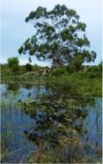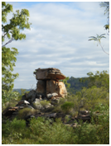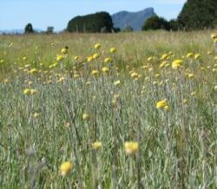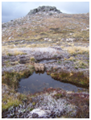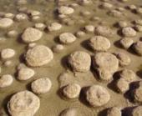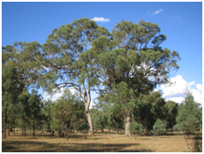

National Threatened Ecological Communities

Strategic Workshop

*8 & 9 March 2012,* Canberra

Threatened Species Scientific Committee &

Ecological Communities Section (DSEWPaC)

Report - November 2012

|  |
| --- |
| ***How to cite this report***  Threatened Species Scientific Committee (2012). National Threatened Ecological Community Strategic Workshop, 8 – 9 March 2012, Canberra.  ***Disclaimer***  This report was compiled based on the outcomes of a national workshop. Although the workshop was attended by members of the Threatened Species Scientific Committee, officers of the Department, and other experts and agency representatives, release of this report does not imply endorsement of all of its contents by the Commonwealth, the Committee, or workshop participants. |

**Table of Contents**

**____________________________________________­­­_­­­_­­­_­­­**

|  |  |  |  |
| --- | --- | --- | --- |
| **Executive Summary** | |  | **5** |
| **Background** | |  | **7** |
| **Aims of National Strategic Workshop** | | | **10** |
| **Setting the Scene** | |  | **11** |
|  | **Introduction to the EPBC Act**  **Threatened Species Scientific Committee**  **How matters of NES are protected under the EPBC Act**  **The listing process for ecological communities**  **The assessment process for ecological communities**  **Benefits of protecting TECs under the EPBC Act**  **Informing priorities for listing TECs – preliminary considerations** | | **11**  **12**  **12**  **14**  **15**  **18**  **19** |
| **Framework for Prioritisation of Ecological Community Nominations** | | | **29** |
| **Gaps in the National Ecological Community List** | | | **39** |
|  | **Terrestrial North/West** | | **39** |
|  | **Terrestrial East** | | **42** |
|  | **Terrestrial Southeast** | | **46** |
|  | **Aquatic**  **Additional Rainforests & Vine Thickets Study** | | **50**  **54** |
| **The Way Forward** | |  | **56** |
| **Appendices** | |  | **60** |
|  | **1. Strategic Workshop Agenda**  **2. Broad Groupings of ECs - Listed/Under Assessment**  **3. Maps**  **Interim Biogeographic Regionalisation for Australia (IBRA V6.1) Map & Codes**  **All Ecological Communities Currently Under Assessment**  **Listed Ecological Communities by State/Territory**  **Remaining Native Vegetation (% of pre-1750 extent by IBRA region)**  **Biodiversity Hotspots Map**  **Parks and Reserves by Bioregion**  **Ramsar Wetlands of Australia**  **4. Strategic Workshop Participants List** | | **61**  **63**  **74**  **89** |

**Executive Summary**

**_____________________________________________**

An inaugural *National Threatened Ecological Communities Strategic Workshop* (*National Strategic Workshop*) was held on 8-9th March 2012. The workshop brought together some 50 participants, including technical experts and representatives from State and Territory agencies and scientific committees, NGOs, the Department and the Threatened Species Scientific Committee (the Committee). The workshop sought to identify gaps in the National List of terrestrial and aquatic threatened ecological communities (marine ecological communities were excluded due to a separate workshop in 2009). The workshop also aimed to seek feedback on the key principles (*Prioritisation Framework*) used by the Committee and the Department when prioritising ecological community nominations.

Threatened ecological communities (TECs) are listed under Australia's premier environmental law, the *Environment Protection and Biodiversity Conservation Act* (EPBC Act), as ‘matters of national environmental significance’. As such they are protected under the EPBC Act and actions likely to result in a detrimental significant impact must be referred to the Commonwealth Minister for the Environment. The process for nomination, listing and assessment of ecological communities, and the benefits of listing were covered by the workshop, and are outlined in this report.

To date 58 TECs are listed under the EPBC Act with 38 listed since the start of the Act in July 2000 (20 were carried over from previous legislation), including 24 listed since the Act was last amended in February 2007. Another 19 are currently under various stages of assessment. TECs can represent a form of landscape or systems-level protection. Importantly, the current National List of TECs represents more than 150 ECs (or equivalent) recognised as threatened by States and Territories; and over   
4.6 million ha of ‘protected’ environment (which had a former extent of 29 million ha).

There was strong support from the *National Strategic Workshop* for the principles that make up the *Framework for Prioritisation for Ecological Community Nominations* (*Prioritisation Framework*) used by the Committee and the Department for assessing EC nominations. Although there were differing views of which parts of the framework are most important, it was acknowledged that overall, the *Prioritisation Framework* confers rigour and consistency to the nomination prioritisation process. Some refinements and new ideas were also explored.

Each of three workshop breakout groups undertook a gaps analysis of terrestrial ecological communities (ECs) in three specific regions of Australia, (the North/West, East and Southeast) and another group looked at Aquatic ECs. Overall the workshop suggested 76 ECs or broader landscape entities or groupings across Australia that would benefit from national protection and should inform future nominations for TECs. Thirty-three of these were grouped together further and/or ranked as a higher priority (i.e. North/West suggested 17 ECs (with 6 given highest priority); East 20 (11), Southeast 21 (6), and 18 (10) for Aquatic). A study concurrent to the workshop also identified 6 potential rainforest and vine thicket TECs for priority assessment.

The *National Strategic Workshop* also discussed the way forward. Overall, workshop outcomes provide guidance for a strategic approach to future EC nominations for both the Committee and for potential nominators. It was agreed that the workshop report should be made available to support future nomination rounds. However, some of the suggested priorities, as broadly defined, may not meet the definition or criteria for a TEC. The Committee note that in some instances, the gaps or priorities for national protection are broad groupings or complexes and further work is needed to identify discrete ecological communities for nomination and potential assessment as threatened. In addition, rather than nominating as TECs, some of the entities identified by the workshop may be better addressed through other types of national protection, either as new protection or as an expansion of existing protection.

****The Committee note that nominations for ECs considered to be threatened are not limited to those identified in this report and that all new nominations are given equal consideration. The Committee’s *Guidelines for nominating and assessing ecological communities*, and associated nomination form, remain the key documents for preparing nominations. However, development of a pre-nomination step in the process of nominating was raised by the workshop as a possible approach to focus resources on the highest priorities for future national assessment and listing. As an interim step, the *Prioritisation Framework* will be updated in line with the workshop and published on the Department’s website for use in pre-nomination analysis by nominators prior to the next call for public nominations.

In conclusion:

(i) The listing of TECs under the EPBC Act is an important environment protection and conservation tool that is robust, adaptable and efficient. Protecting TECs also protects native species, natural landscapes and ecosystem services on all land/sea tenures. As ‘matters of national environment significance’ under the EPBC Act, TECs complement and guide a range of other conservation initiatives. For example, national TECs are effective conservation targets for guiding biodiversity management and recovery actions for particular areas or habitat types, as well as for building the representativeness of the National Reserve System.

(ii) This report highlights the value of developing a strategic approach to listing under the EPBC Act through identifying and assessing high priority TECs that are not yet nationally protected. As demonstrated through the *Prioritisation Framework*, priority TECs for assessment include those: in areas where biodiversity has been depleted (e.g. by land clearing) and/or facing substantial threats (e.g. rapid development); that represent habitat types or regions under-represented within the National Reserve System or through other protection mechanisms; and/or, in areas where TEC protection and recovery will connect existing conservation areas or enhance ecological resilience through maintaining or restoring ecological function, critical habitat, wildlife corridors and/or refugia.

**Background**

**_____________________________________________**

Australia's national environment law is the *Environment Protection and Biodiversity Act* (EPBC Act). It provides a legal framework to protect and manage nationally and internationally important plants, animals, ecological communities, and natural heritage places. These are defined by the Act as matters of 'national environmental significance'.

To date 58 threatened ecological communities (TECs) are listed under the EPBC Act as matters of national environmental significance. Of these, 38 have been listed since the start of the Act in July 2000 (the other 20 were carried over from previous legislation), including 24 listed since the Act was last amended in 2007. The full list of TECs is at: [www.environment.gov.au/cgi-bin/sprat/public/publiclookupcommunities.pl](http://www.environment.gov.au/cgi-bin/sprat/public/publiclookupcommunities.pl)  The types of TECs listed to date include:

|  |  |
| --- | --- |
| * Grassy woodlands | * Shrublands and heathlands |
| * Tussock grasslands | * Rain forests and vine thickets |
| * Swamps and bogs | * Microbial-based communities (thrombolites) |
| * Seasonal wetlands and clay pans | * Cave communities |

Importantly, this National List of threatened ecological communities represents:

* More than 150 ecological communities or their equivalent (e.g. Queensland uses regional ecosystems) recognised as threatened by States and Territories;
* 4.6 million hectares protected under the EPBC Act, regardless of land tenure (i.e. Crown land; private land). This represents an 85% decline in their collective geographic distributions from a former extent of around 29 million hectares.

Ecological communities are often complex to define and describe (for EPBC Act definition see p.14). In defining an ecological community for EPBC Act protection, the traditional scientific approach is built upon conceptually to achieve practical conservation outcomes for species and ecological functions. Each ecological community description is developed on a case-by-case basis to be ecologically (scientifically) rigorous, while at the same time being legally clear and understandable to people on the ground. There are also a range of scales at which an ecological community can be defined and determining the appropriate scale that represents national extent for EPBC Act protection is important.

The Threatened Species Scientific Committee (the Committee), which provides advice to the Minister on prioritising and assessing TECs, has been increasingly moving to a systems-based approach to defining and protecting TECs under the Act. Thus the listing of TECs under the EPBC Act can provide the opportunity for a form of landscape or ecosystem level protection. Examples include the broad-scale listings of woodlands such as *White Box-Yellow Box-Blakely's Red Gum Grassy Woodland, Grey Box (Eucalyptus microcarpa) Grassy Woodlands of South-eastern Australia*, and *Coolibah-Black Box Woodlands* *of the Darling Riverine Plains and the Brigalow Belt South Bioregions*, which cover vast areas and ecological systems of inland Australia across several State borders[1]. Assessment for potential listing of a major river system for the first time, the *River Murray and associated wetlands, floodplains and groundwater systems, from the junction with the Darling River to the sea* ecological community, is also based on such a landscape/systems-based approach.

Listing at the broader, landscape-scale can provide for a more efficient and effective approach and complements the listing of single threatened species and other environmental conservation measures such as the National Reserve System. It allows for protection of both the biotic components and the ecological functions and services that the TECs provide (for example: shelter for stock, natural management of water and air, habitat for pollinators, carbon storage, etc.). TEC protection can also promote connectivity and wildlife corridors, including within and between National Reserve System properties.

In addition to the 58 TECs on the National List, a further 19 nominations for ecological communities are currently at various stages of listing assessment. The bulk of TECs listed or under assessment are terrestrial, vegetation-based communities. However, the nominations currently under assessment also include the first marine communities to be considered for national listing in Australia:

* *Giant Kelp Marine Forests of South East Australia* (since listed in August 2012)
* *Posidonia Seagrass Meadows*
* *Subtropical and Temperate Coastal Saltmarsh.*

They also include assessments of large, complex riverine/wetland communities:

* *River Murray and associated wetlands, floodplains and groundwater systems, from the junction with the Darling River to the Sea (River Murray - Darling to Sea)*
* *Long Lowland Floodplain Rivers of southeast QLD and northern NSW*
* *Macquarie Marshes*.

Some key challenges remain for the description and listing assessment of TECs. These generally relate to a lack of data; e.g. on the current and past extent of communities, or patch size distributions for highly fragmented systems; or knowing where to determine clear boundaries for a TEC, particularly in light of natural or disturbance-induced variation that TECs may show across their range. Lack of data also affects the ability to comprehensively map where a TEC occurs. From an ecological perspective, for many ecological communities there also remains a lack of information on species interactions and their roles, and on ecological function.

Despite these challenges and limitations, the listing assessment of national TECs results in comprehensive and rigorous *Listing* and/or *Conservation Advices.* These documents provide robust information for environmental decision-making, research and conservation management/recovery, which is crucial for stakeholders such as land managers and developers, as well as for EPBC assessment and compliance officers. Listing assessments usually take between one to two years to complete. More complex nominations may take longer, however the EPBC Act places a limit of five years from placement on the Finalised Priority Assessment List (FPAL) for Committee assessment timeframes.

Currently, there is a heavy reliance on public nominations for ecological communities. While this has resulted in a strong foundation for the National List of TECs, it is also timely to take stock. It is known that there are certain gaps in the National List, particularly some types of TECs and in some regions. A preliminary gaps analysis has been undertaken by the Department to help identify priority vegetation-based and aquatic ecological communities (see *Informing priorities* section of report, p.19).

Undertaking a gap analysis and developing a prioritisation process in consultation with experts at this juncture provides the opportunity for a more strategic approach to future listings and to facilitating a comprehensive and representative National List. This is also prudent given resource constraints in the conservation sector.

Improved alignment with State/Territory classification and listing processes is an important component of an effective strategic approach and work is underway to facilitate bilateral cooperation. In 2009, 2010 and 2011 State scientific committees and agencies have worked with the Threatened Species Scientific Committee to identify state-endemic TECs that are high priorities for national assessment (resulting in two EPBC listings so far, with various other assessments underway). Other complementary policy processes are also underway to align State/Territory and Commonwealth legislative frameworks for listing ecological communities.

This *National Strategic Workshop* enabled a broad range of technical experts, government agencies, NGOs, and other stakeholders to share knowledge and contribute to a national-scale analysis of priorities for the future of the National List of threatened ecological communities.

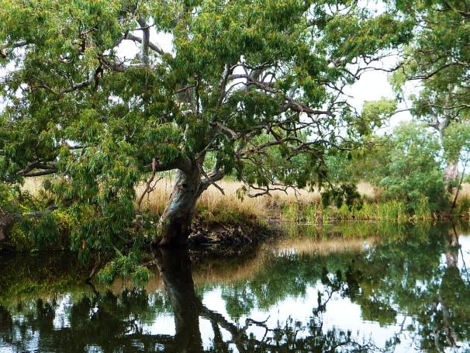

*River Murray - Darling to Sea EC - under assessment*

*(Red gum at Finnis Creek: Source Matt White)*

**Aims of the 2012 Strategic Workshop**

**_____________________________________________**

The 2012 *National Threatened Ecological Communities Strategic Workshop* is the first national-scale workshop held to identify gaps and determine priorities for the National List of threatened ecological communities. The workshop focussed on terrestrial and freshwater ecological communities because priorities for marine communities were investigated as part of a national workshop on *Marine Ecological Communities* held in 2009[2].

The aims of the 2012 *National Threatened Ecological Communities Strategic Workshop* were to:

1. **Identify key gaps in the National List of threatened ecological communities, by type (including terrestrial and aquatic) or region, and identify which specific ecological communities should be prioritised for listing.**
2. **Review the guiding principles of the *Framework for Prioritisation of Ecological Community Nominations*.** These are the current factors used for determining the value and benefits of national listing and hence prioritising assessment of a TEC as a matter of national environmental significance.
3. **Determine options for nomination and assessment of identified priorities, i.e. the way forward.**

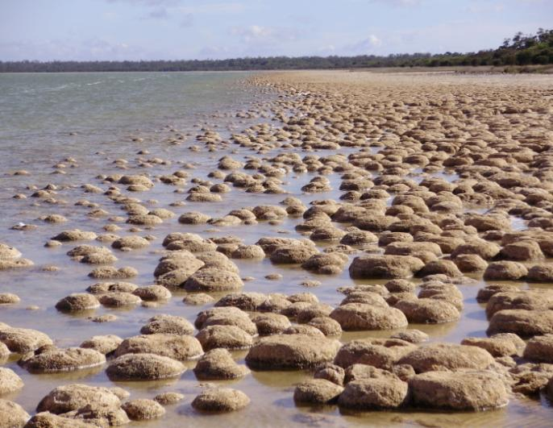

*Lake Clifton Thrombolites EC (Source: Anthony Hoffman)*

**Setting the Scene**

**_____________________________________________**

**Introduction to the EPBC Act**

The *Environment Protection and Biodiversity Conservation Act 1999* (EPBC Act) is the premier Commonwealth environmental legislation and came into effect on 16 July 2000. It improved on and reformed the Australian Government's environmental legislation of the 1970s to 1990s. The EPBC Act defines the Commonwealth's role in protecting the environment, and provides for direct powers of approval by the Environment Minister. It sets the processes and timeframes for assessing 'significant' impacts on the environment and focuses on 'matters of national environmental significance' (NES).

There are eight matters of national environmental significance:

|  |  |
| --- | --- |
| Glenelg Stephen Platt DSE.JPG*Natural Temperate Grassland of the Vic. Volcanic Plain EC (Source: Stephen Platt)* | * Listed threatened species and ecological communities * Migratory species listed under international agreements * Ramsar wetlands * Commonwealth marine areas * National heritage places * World heritage properties * Great Barrier Reef Marine Park * Nuclear actions. |

The EPBC Act recently underwent a ten year review (the Hawke review) which has culminated in a package of reforms. Amended legislation is planned to be enacted in 2013. Several intended changes are relevant to threatened ecological communities (TECs). Most importantly, the reform aims to enable TECs listed as 'vulnerable' to trigger the full protection provisions of the Act. Currently, only TECs listed as 'endangered' or 'critically endangered' are matters of NES.

The EPBC Act promotes conservation of biodiversity in a number of ways, for example:

* Listing of threatened species and ecological communities, natural heritage values, Ramsar wetlands, and key threatening processes (KTPs); which helps to identify and raise awareness of nationally significant natural assets and the threats to them.
  + Listings are accompanied by important documentation such as *Listing* and/or *Conservation Advices*, descriptions of key heritage values and wetland characters, and recovery, threat abatement, or management plans.
* Managing all environment assets in Commonwealth owned land/marine area/parks, e.g. Kakadu; Christmas Island; Marine Protected Areas; Defence owned land.
* Allowing for the development of Bioregional Plans, e.g. in Commonwealth marine areas.
* Meeting Australia's roles/obligations in international biodiversity agreements and conventions (e.g. threatened and migratory species; wildlife trade).
* Consideration of Indigenous interests and knowledge in caring for the environment.

**Threatened Species Scientific Committee**

The Threatened Species Scientific Committee (the Committee) is an independent committee of scientists, ecologists and other experts that advises the Federal Minister for the Environment on amendments to the national lists for threatened species, threatened ecological communities, and key threatening processes, and the development and adoption of recovery and threat abatement plans. The Committee’s establishment and function are set out under the EPBC Act. The Minister is required to consult the Committee on these listing matters and the Committee presents advice to the Minister chiefly through its *Listing* and/or *Conservation Advices* for each species and ecological community assessed. The Committee also reviews recovery and threat abatement plans prior to their presentation to the Minister for approval.

**How matters of NES are protected under the EPBC Act**

Under the EPBC Act, an 'action' that is likely to have a significant detrimental impact on a matter of NES requires the approval of the Federal Minister for the Environment. A 'referral' to the Minister is therefore needed for such actions. This may be followed by an environmental assessment that may require further documentation of likely impacts (e.g. environment impact statement) and decisions about how to avoid or mitigate significant impacts.

For the purposes of the Act, an action is a new or intensified activity that may have, will have, or has had a significant detrimental impact on a matter of NES. Such actions are often associated with a project or development activity (e.g. new mine, dam, road, infrastructure, etc.). An action must involve a physical interaction or material change to the environment (e.g. capital works, bulldozing native vegetation, obvious change in land use, significant diversion of water, etc.). Administrative decisions such as changes to zoning laws or boundaries, or failure to do something such as not controlling weeds already on a property, are not considered actions under the EPBC Act.

Application of a 'significant impact test' means that the Commonwealth does not become involved in developments/actions where those risks have clearly been eliminated (e.g. by project design or by State/Local government regulation or planning). To assist in determining significance, the Department publishes on its website related resources such as: *Significant Impact Guidelines*; *Listing* and/or *Conservation Advices* for each listed species or TEC (<http://www.environment.gov.au/sprat>); *Recovery Plans*; and other publications such as information guides on ecological communities. Precedent court findings may also be relevant.

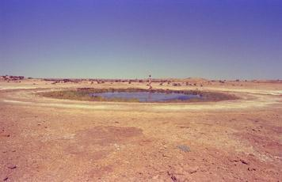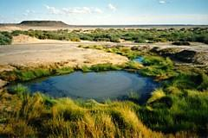

*The community of native species dependent on natural discharge of groundwater from the Great Artesian Basin EC (Source: SEWPaC)*

The intent of referring under the Act is to avoid significant impact to the TEC where possible, or mitigate/reduce significant impacts, or offset adverse impacts when unavoidable. There are also strong compliance measures in place, so failure to refer may lead to EPBC compliance actions.

Compliance and enforcement are important operational elements of protection under the EPBC Act and have had an increased role since 2007. Strong penalties may apply, for example, civil fines of up to $5.5 million; sentencing for criminal actions of up to seven years gaol. ‘Remediation orders’ are the most common penalty. Around 500 incidents are reported each year. These are identified by departmental monitoring and auditing finding breaches of conditions, and via the media, public, local councils, State agencies, and the *Compliance Hotline* (1800 110 395). An important case example is that where long-wall mining was undertaken on the Newnes Plateau that resulted in significant impacts to the *Temperate Highland Peat Swamps on Sandstone* TEC. The resulting legal judgement required the company to pay $1.45 million towards a research program to better understand and protect the swamps. This is the largest ‘enforceable undertaking’ under the EPBC Act to date.

It is important to recognise that there are also exemptions under the EPBC Act regarding the need to refer or seek approval of proposed actions. These exemptions allow for the continuation of activities that were fully approved before the EPBC Act came into force ('prior authorisation'), or otherwise lawful activities which commenced before the EPBC Act came into force, and which have continued without substantial interruption, change or intensification ('continuing uses'). The EPBC Act is not about regulating day to day farming or property management activities, for example, routine activities such as farm maintenance, seasonal grazing and cropping, licensed irrigation activities, etc.

**The listing process for ecological communities**

Listing indicates that if the threats are not managed, there is a risk that the ecological community will suffer an irreversible loss of its species composition and inherent ecological functionality that may lead to its extinction.

An ecological community is defined under the EPBC Act (Section 528) as (see also discussion on definition/description, p. 7):

* *The extent in nature in the Australian jurisdiction of an assemblage of native species that a) inhabits a particular area in nature; and b) meets the additional criteria specified in the regulations made for the purposes of this definition.*

(Note: at present the only additional criteria in the Regulations relating to ecological communities are the criteria for each listing category).

* *Under the EPBC Regulations 2000 there are six prescribed Criteria for determining the conservation status of TECs. A TEC may be listed as Vulnerable, Endangered or Critically Endangered. Only the latter two categories currently trigger full protection under the EPBC Act.*

Under the EPBC Act public nomination rounds occur each year, usually from November to the following March. The Committee, in consultation with the Department, undergoes a prioritisation process of the nominations received. This results in a Proposed Priority Assessment List (PPAL) that is forwarded to the Federal Environment Minister. The Minister then has 20 business days to consider the PPAL and make any changes. After this time, the PPAL becomes the Finalised Priority Assessment List (FPAL), which is published on the Department’s website. An overview of the listing process for an EC on the FPAL is shown at Figure 1.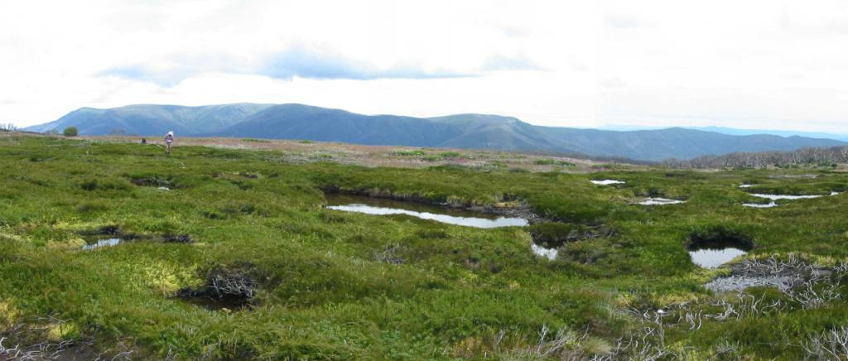

*Alpine Sphagnum Bogs and Associated Fens EC (Bogong High Plains of Victoria, Source: Arn Tolsma)*

Public Nomination (prioritised by TSSC/Minister for assessment)

|  |
| --- |
| Listing Assessment (including defining EC & threats)  Expert & Public  Consultation  Review available literature & data    Final *Listing* and *Conservation Advice* finalised by TSSC  Decision by Federal Minister for the Environment  Publish, table in Parliament, & other information to public |

**Figure 1:** *Overview flowchart of listing process for an ecological community (TSSC = Threatened Species Scientific Committee).*

**The assessment process for ecological communities**

The protection of threatened ecological communities and species, and amelioration of key threatening processes (KTPs), under the EPBC Act are based on various advice provided by the Committee to the Minister:

* *Listing and/or Conservation Advices* (published online at the time of listing)
* *Recovery Plans* (developed post-listing for some single species/TECs; or multi-species/TECs; or regions)
* *Threat Abatement Plans* (developed post-listing of some KTPs).

*Listing and/or Conservation Advices* represent the documented scientific assessment of the conservation status of a TEC by the Committee. These contain information about the ecological community such as a description, boundaries, key diagnostic characteristics, and threats. Advice includes the ‘national extent’ (or distribution) of the TEC – with the overall structure, function, keystone species (and sometimes species composition) remaining the same across its full range. National extent can range from small-scale to broad-scale where vegetation units or sub-communities are grouped together, and may cross jurisdictional or regional boundaries. ‘Condition thresholds’ are usually incorporated, which determine how different levels/qualities of condition of the ecological community affect the defined entity, including taking into account natural variation versus anthropogenic-induced degradation.

The description of the ecological community assists stakeholders to determine if the listed TEC is present at a site. The *Listing and/or Conservation Advices* also recommend priority conservation actions that assist managers and landholders to protect and restore the ecological community. These act in lieu of any recovery plan that may be developed at a later stage.

Importantly the *Listing and/or Conservation Advices* also contain the scientifically based justification for listing against the listing criteria. This component of the assessment includes analysis against the six criteria that are outlined in the EPBC *Regulations*, with different requirements (thresholds) to be met for each listing conservation category (see Table 1). Supporting *Guidelines[3]* have been developed by the Committee to determine eligibility for listing and conservation status based on thresholds. Only one of the six criteria needs to be met for a TEC to merit listing as threatened. If more than one criterion is met, then the highest conservation category is used for the status of the listing.

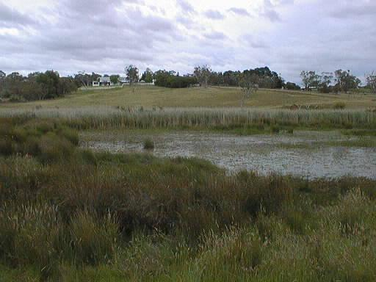

*Swamps of the Fleurieu Peninsula EC (Source: SEWPaC)*

**Table 1:** *Summary of EPBC Act Listing Criteria for assessing TECs.*

|  |  |  |  |  |
| --- | --- | --- | --- | --- |
|  | **Criterion** | **Category** |  |  |
| **Critically Endangered** | **Endangered** | **Vulnerable** |
| **1** | **Its decline in geographic distribution is:** | **very severe**  **(≥95%)** | **severe**  **(≥90%)** | **substantial**  **(≥70%)** |
| **2** | **Its geographic distribution is:**  **and**  **the nature of its distribution makes it likely that the action of a threatening process could cause it to be lost in:** | **very restricted** | **restricted** | **limited** |
| **the immediate future** | **the near future** | **the medium-term future** |
| **3** | **For a population of a native species that is likely to play a major role in the community, there is a:**    **to the extent that restoration of the community is not likely to be possible in:** | **very severe decline** | **severe decline** | **substantial decline** |
| **the immediate future** | **the near future** | **the medium-term future** |
| **4** | **The reduction in its integrity across most of its geographic distribution is:**    **as indicated by degradation of the community or its habitat, or disruption of important community processes, that is:** | **very severe** | **severe** | **substantial** |
| **very severe** | **severe** | **substantial** |
| **5** | **Its rate of continuing detrimental change is:**  **as indicated by:**  **(a) rate of continuing decline in its geographic distribution, or a population of a native species that is believed to play a major role in the community, that is:**  **or**  **(b) intensification, across most of its geographic distribution, in degradation, or disruption of important community processes, that is:** | **very severe** | **severe** | **substantial** |
| **very severe** | **severe** | **serious** |
|  | **very severe** | **severe** | **serious** |
| **6** | **A quantitative analysis shows that its probability of extinction, or extreme degradation over all of its geographic distribution, is:** | **at least 50% in the immediate future** | **at least 20% in the near future** | **at least 10% in the medium-term future** |

**Benefits of protecting TECs under the EPBC Act**

The listing of a threatened ecological community (TEC) under national environment law recognises that its long-term survival is under threat. The aim of listing is to prevent further decline and to promote and assist recovery through conservation advice, recovery plans and other landholder, agency, and community efforts. Listing provides legislative protection and national recognition – i.e. the ecological community becomes a ‘matter of national environmental significance’.

There are many benefits from listing under the EPBC Act. For example, listing leads to improved awareness, information and education about the threatened ecological community and the threats that may impact on it. A range of associated publications become available through the Departmental website, e.g. *Listing and/or Conservation Advices*; *Recovery Plans*; fact sheets, brochures, and the online SPRAT[4] database and EPBC search tools.

TECs provide vital habitat, refuge, and wildlife corridors for many plants and animal species (including for threatened species and those in decline but not yet listed). As such, they facilitate resilience of Australia’s unique biodiversity, particularly in light of a changing climate. Listing of TECs can be likened to a form of landscape or systems level protection which can sometimes be more proactive or effective and efficient than the listing of individual species. Also, TECs have their own unique place in the Australian landscape with natural, cultural/social and economic values. They provide a range of ecosystem services such as: the natural management of air, water and soil nutrients; the reduction or control of erosion, salinity and acid sulfate soils; and, the storage of carbon. They can also provide a focus for tourism and recreation, have cultural significance, and enhance the productivity of our farmlands.

Importantly, listing of TECs may also stimulate opportunities for research and improved management, and for threat abatement and restoration – in particular, through government initiatives, such as the Australian Government’s *Caring for our Country* initiative or the National Reserve System (see [www.nrm.gov.au](http://www.nrm.gov.au) and [www.environment.gov.au](http://www.environment.gov.au)/parks for more information). For example, the *Environmental Stewardships Program* provides funding to land managers to protect and rehabilitate targeted matters of NES on private land and to date listed TECs have been a major target of the program.

TECs have also been the key driver of large scale *Strategic Assessments* [5] under the EPBC Act (i.e. such as those undertaken for Melbourne, Western Sydney and ACT urban growth; and the Tasmanian Midlands water scheme).

**Informing priorities for listing TECs - preliminary considerations**

To date, the majority of listed threatened ecological communities are vegetation based, on fertile soils in south-east Australia and/or in coastal areas. This is partly due to the fact that vegetation clearance was so prolific following European settlement and that detailed information is available on current and historical vegetation distribution and ecology in these areas. Natural systems continue to be pressured by vegetation clearance related to increasing population and development as well as by other key threats such as inappropriate fire regimes and invasive species. To determine future priorities for listing TECs, four key sources are:

1. Pressure hotspots (recent and current threats operating);
2. Available national vegetation data sets (vegetative loss by type and bioregion);
3. Available state vegetation data sets (vegetative loss and fragmentation); and
4. State/territory alignment and prioritisation (TECs identified by states/territories).

***Pressure Hotspots***

An indication of where the major areas for development (or ‘pressure hotspots’) are in the past decade can be gained by examining the density of EPBC referrals for all triggers. As demonstrated by Figure 2, more referrals occur in the following areas:

* Close to major urban centres
* East coast to inland of ranges from Cairns to Adelaide, and
* West on the Swan Coastal Plain, Geraldton and Exmouth-Pilbara.

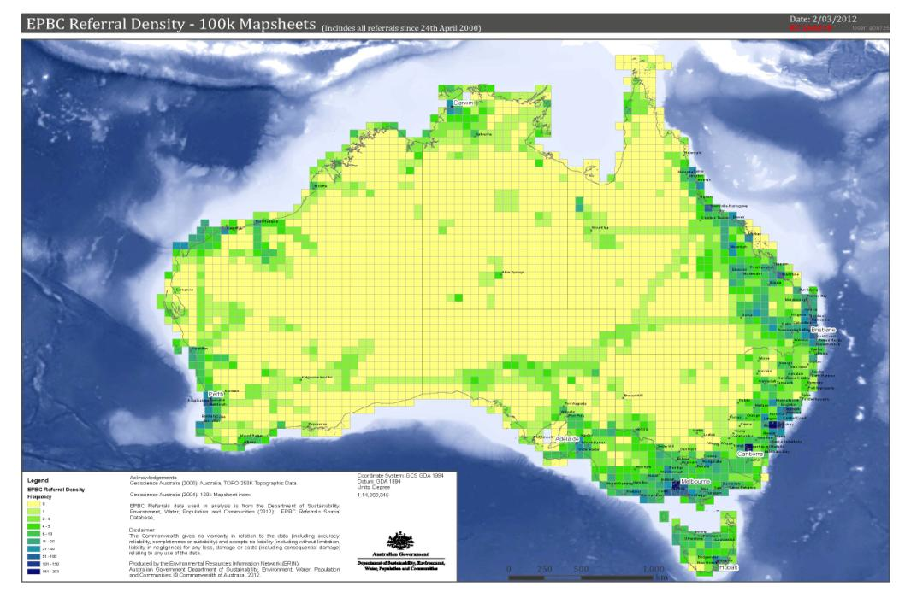

**Figure 2***: EPBC Act referral density by all triggers – 100 k map sheet (produced by ERIN).*

***Available national vegetation data sets***

National vegetation data sets are available via the National Vegetation Information System (NVIS), which is a comprehensive data system about the types, extent and distribution of vegetation across Australia. NVIS has a range of data products showing the variety and distribution of Australia’s native vegetation and is updated as new information becomes available. The products are suited to many applications and can be used at various scales in a geographic information system. Highly detailed data received from state and territory custodians with standard NVIS attributes are compiled into the NVIS database. The resultant data sets are suitable to interpret vegetation at the national or regional scale.

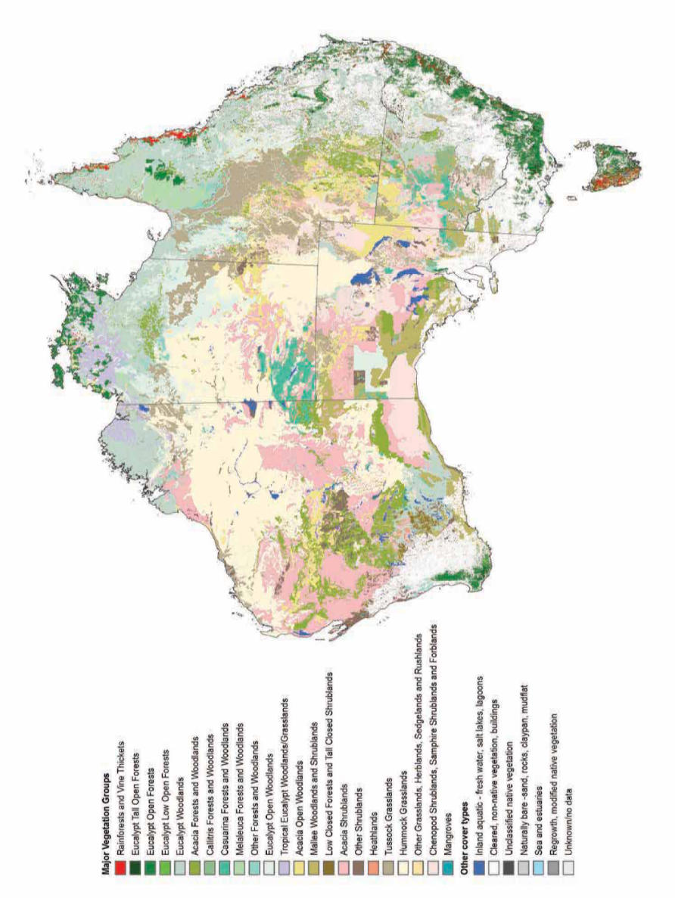At the national scale, NVIS provides information about the distribution and change in extent of 23 Major Vegetation Groups (MVG) (Figure 3) and a larger number of Major Vegetation Subgroups (MVS). This information is available on the Department’s website.

**Figure 3:** *NVIS Major Vegetation Groups. Current extent of the 23 MVGs across Australia (Source: ERIN).***Table 2:** *IBRA bioregions in which a Major Vegetation Group has declined by >70% within that bioregion. The original extent of the MVG within that bioregion is also indicated to distinguish substantial declines from smaller occurrences. An index to IBRA bioregional codes is given in Appendix 3a. (Note: IBRA version 6.1 was used for the analysis).*

|  |  |  |  |
| --- | --- | --- | --- |
| **Major Vegetation Group** | **Pre-1750 bioregional extent (ha)** | | |
| **>100,000** | **10,000 – 100,000** | **< 10,000** |
| **1. Rainforests & Vine Thickets** | BBS |  | SCP |
| **2. *Eucalyptus* Tall Open Forests** |  | FLI |  |
| **3. *Eucalyptus* Open Forests** | NSS, SCP, VVP, SWA | NCP, KAN |  |
| **4. *Eucalyptus* Low Open Forests** |  |  | SEH, KIN |
| **5. *Eucalyptus* Woodlands** | NNC, NAN, NET, MDD, RIV, NCP, VM NSS, VVP, SCP, AW, SWA, FLB, KAN, EYB | TSE, FLI, TNM, TNS, KIN. BEL, TSR, GS | TCH |
| **6. *Acacia* Forests & Woodlands** | BBN, BBS, RIV | SEQ, NSS, GS | VM, VVP, AW |
| **7. *Callitris* Forests & Woodlands** |  |  | SWA |
| **8. *Casuarina* Forests & Woodland** | VVP | SEC, SB. AW | VM, SWA, MAL |
| **9. *Melaleuca* Forests & Woodland** | EYB | NCP, SWA | BBS, VVP, AW |
| **10. Other Forests & Woodlands** | SCP | VVP, AW | BBN, DRP, JF, MAL |
| **11. *Eucalyptus* Open Woodlands** | DRP, FLB | EYB, FLI, MAL | TCH, GS |
| **12. Tropical *Eucalyptus* Woodlands/Grasslands** |  |  |  |
| **13. *Acacia* Open Woodlands** |  | BBN | EYB |
| **14. Mallee Woodlands & Shrublands** | RIV, NCP, AW |  | SEC, SEH, JF |
| **15. Low Closed Forests & Tall Closed Shrublands** | AW | TNS | TNM, SWA. JF |
| **16. *Acacia* Shrublands** | AW, GS |  | NNC, SEQ |
| **17. Other Shrublands** | AW | SCP |  |
| **18. Heathlands** |  | SCP, AW | VVP |
| **19. Tussock Grasslands** | VVP, NCP | SCP | AA, SEC, VM |
| **20. Hummock Grasslands** |  |  |  |
| **21. Other Grasslands, Herblands, Sedgelands & Rushlands** |  | SEH, VVP |  |
| **22. Chenopod Shrublands, Samphire Shrublands & Forblands** |  | TCH, FLI, TMN, MAL | KIN, TSR, BEL, TNS, TWE, TSE, GS, SWA, ESP |
| **23. Mangroves** |  |  | VVP |

The distribution and decline of MVGs within each IBRA bioregion (IBRA version 6.1) has been analysed to determine if there were any patterns of decline (Table 2; Figures 3 and 4). A large number of MVGs experience bioregional declines of >70%. In some cases, the original (pre-European settlement) bioregional extent of an MVG is low (<10 000 ha) but in other cases the original extent was large (>100 000 ha), so that declines of >70% represent a considerable loss of cover for that vegetation type.

Some MVGs declined by >70% in a large proportion of bioregions where they naturally occurred, indicating substantial national decline. The MVGs that declined in more than 15% of bioregions where originally present include: *Eucalyptus* woodlands; Mallee woodlands and shrublands; Low closed forests and tall closed shrublands; and Chenopod shrublands, samphire shrublands and forblands (Figure 4). Where declines occurred, the original bioregional extent was low for most of these MVGs; a notable exception was *Eucalyptus* woodlands where >70% decline occurred in bioregions where the MVG was originally prevalent, covering more than 100 000 ha.

**Figure 4:** *Number of IBRA bioregions in which each MGV occurs and is declining. The ellipse indicates that the MVG declined in >15% of bioregions where present.*

Further analysis highlights which IBRA bioregions experienced >70% decline for multiple MVGs (Figure 5). Two bioregions show marked decline for ten MVGs. These were the Avon Wheatbelt of Western Australia and the Victorian Volcanic Plain of Victoria. Not surprisingly, these two bioregions are the most heavily cleared of all 89 IBRA bioregions. Another seven bioregions show >70% decline for four or more MVGs. Many of these are adjacent or near to the Avon Wheatbelt and Victorian Volcanic Plain bioregions indicating that similar patterns of vegetation clearance extend across broader regions of south-western WA and southern Victoria/SA.

**Figure 5**: *IBRA Bioregion in which four or more MVGs declined by >70%.*

***Available State vegetation data sets***

The availability and comparability of State vegetation data sets varies across jurisdictions. Each State/Territory has classified its vegetation based on its own separate system or set(s) of past vegetation surveys. It can be problematic to apply these to national studies because many classifications stop at State or regional boundaries or are determined using different scales or parameters. This makes it difficult to correspond vegetation types where two or more surveys met at jurisdictional boundaries. However, it is possible to draw conclusions about vegetation composition and decline within State borders where a consistent classification system has been applied for that jurisdiction.

Victoria is one example where a state-wide vegetation classification scheme (Ecological Vegetation Classes or EVCs) has been developed to determine the original pre-European vegetation and its current extent. Each EVC has been accorded a bioregional conservation status based on its decline within each Victorian bioregion[6]. The EVC system is complex and involves hundreds of EVCs. However, they are grouped into broad EVC groups and subgroups that are more amenable to analysis[7].

The bioregional conservation status was examined for all component EVCs within each EVC group/subgroup. The proportion of EVCs that had a bioregional conservation status of 'Possibly extinct', 'Endangered' or 'Vulnerable' was calculated to highlight the threatened status of the EVC group. It is presumed that a higher proportion of threatened EVCs indicates that the EVC group is more likely to be threatened as a whole. Table 3 shows those EVC groups/subgroups in which more than 60% of component EVCs were rated as threatened. There were ten EVC groups/subgroups where most (80% or more) EVCs had a threatened bioregional conservation status. Many of these cover grassy woodlands and grasslands that would already be on the EPBC list of TECs. However, the study highlighted potential gaps on the National List that merit further consideration, such as mallee on clay pans and herb-rich woodlands.

**Table 3:** *Proportion of EVC Group/Subgroups in which component EVCs had a threatened bioregional conservation status. Bioregional conservation status is explained in footnote 6. Only groups where the proportion of threatened EVCs is 60% or more are shown.*

|  |  |
| --- | --- |
| **EVC GROUP / SUBGROUP** | **%X/E/V** |
| Mallee / Clay plains | 100.00 |
| Plains Woodlands or Forests / Freely-draining | 98.84 |
| Plains Woodlands or Forests / Lunettes or beach ridges or shallow sands | 97.06 |
| Plains Woodlands or Forests / Poorly-draining | 94.12 |
| Lower Slopes or Hills Woodlands / Grassy | 90.57 |
| Plains Woodlands or Forests / Semi-arid (non-Eucalypt) | 90.00 |
| Plains Grasslands and Chenopod Shrublands / Clay soils | 86.05 |
| Wetlands / Brackish/estuarine | 85.71 |
| Wetlands / Freshwater | 82.57 |
| Herb-rich Woodlands / Damp Sands | 81.69 |
| Herb-rich Woodlands / Alluvial terraces and/or creeklines | 77.36 |
| Riparian Scrubs or Swampy Scrubs and Woodlands | 71.52 |
| Riverine Grassy Woodlands or Forests / Creekline and/or swampy | 67.61 |
| Riverine Grassy Woodlands or Forests / Broader plain | 66.67 |
| Rainforests | 64.52 |
| Mallee / Sandstone ridges and rises | 62.50 |
| Salt-tolerant and/or succulent Shrublands / Coastal | 62.50 |
| Heathlands / Sub-alpine | 60.00 |

Another example of a State vegetation data set is the New South Wales Vegetation Classification and Assessment database (NSWVCA)[8]. The NSWVCA aims to classify the entire native vegetation of NSW within a single scheme. It is presently incomplete but covers the bulk of the State except for the southern tablelands, alps, coastal ranges and coast. As with EVCs, there are numerous communities identified that have been grouped into broader formations. Therefore, a similar approach has been taken as for the EVC data. Table 4 shows those NSWVCA formation groups in which more than 60% of component communities were rated as threatened. Many of these would cover grassy woodland, vine thicket and swamp communities that are represented on the National List of TECs. However, once again the table highlights potential gaps for further consideration, such as riparian and coastal ironbark woodland communities.

**Table 4:** *Proportion of NSWVCA Formation Groups in which component vegetation communities had a threatened conservation status of critically endangered (C), endangered (E) or vulnerable (V). Only formation groups where the proportion of threatened communities is 60% or more are shown.*

|  |  |
| --- | --- |
| **NSWVCA Formation Group** | **%C/E/V** |
| *Eucalyptus* (mostly Grassy) Box Woodlands of the East Coast Valleys | 100.00 |
| Eucalyptus Swamp Communities of the Eastern Coast and Tablelands | 100.00 |
| Freshwater Wetlands: Montane and Alpine Freshwater Lakes | 100.00 |
| Rainforest: Semi-Evergreen Vine Forests and Ooline (*Cadellia pentastylis*) | 100.00 |
| Riparian mostly Myrtaceous Shrublands of the Western Slopes, Tablelands and Coast (non-rainforest) | 83.33 |
| *Eucalyptus* (mostly Grassy) Box Woodlands of the Tablelands and Western Slopes | 78.75 |
| Freshwater Wetlands: Coast, Tablelands and Slopes Sedgeland Swamps | 66.67 |
| *Eucalyptus* Communities of Inland Watercourses and Inner Floodplains | 65.79 |
| *Eucalyptus* (mostly Grassy) Box Woodlands of the Inland Plains | 60.00 |
| *Eucalyptus* Ironbark Woodlands and Forests of the East Coast and Tablelands | 60.00 |
| Grasslands of Freshwater Aquatic Habitats of Periodically Flooded Soils | 60.00 |

***State alignment and prioritisation***

In order to foster the alignment of the EPBC National List and State/Territory lists of TECs (or equivalent), the Committee and the Department in recent years have actively discussed priorities for assessment with State/Territory agencies and scientific committees. These groups were asked each year since 2010 to provide their priority ecological communities for listing from existing State/Territory lists, or databases where a formal list is not available. This approach aimed to facilitate greater consistency between State/Territory and National Lists and focus EPBC assessments on TECs that would benefit the most from national protection.

Two priority items have already been assessed and listed under the EPBC Act through this approach:

* Claypans of the Swan Coastal Plan, WA (listed as critically endangered); and
* Broad leaf tea-tree *(Melaleuca viridiflora)* woodlands in high rainfall coastal north Queensland (listed as endangered).

A number of other State/Territory priority items are under assessment either as State-nominated entities and/or because they coincide with public nominations (nominations for those marked with an asterisk were received after the workshop). These include:

* Eyre Peninsula blue gum grassy woodland, SA
* Plant communities on ferricrete/ironstone, WA
* Hunter Valley ironbark/spotted gum/coastal grey box forests and woodlands, NSW*
* Cooks River/Castlereagh ironbark forest in the Sydney Basin Bioregion, NSW*
* 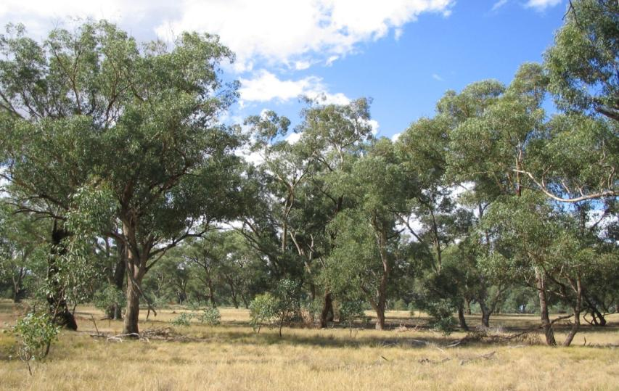Natural grasslands of the South Gippsland plains, Victoria.

*Grey box (Eucalyptus microcarpa) grassy woodland of South-Eastern Australia EC (Source: Rosemary Purdie)*

***Suggested priorities to stimulate workshop discussion***

Some further ideas on potential gaps in the National List were provided to workshop participants to stimulate discussion prior to the Breakout Group session (see Table 5). These priorities are based on a range of information/sources such as: previous nominations that were not prioritised at the time, the vegetation priorities analysis (see *Informing priorities* section, p.19), the state prioritisation process, other internal knowledge, and external expert advice. For these, discrete ECs would still need to be defined and prioritised (see next section of report - *Framework for Prioritisation*).

**Table 5:** *Suggested options for potential priority ecological communities proposed to stimulate discussion at the National Strategic Workshop.*

|  |  |
| --- | --- |
| **Potential Terrestrial ECs** | **Potential Aquatic ECs** |
| * NSW Southern Highlands shale woodlands * Bangalay sand forest (NSW south coast) * Poplar box/Bimble box woodlands of NSW/QLD * River flat forests of east coast * Coastal Moonah woodlands of SE Australia * *Themeda* grasslands on coastal headlands of SE Australia * Mallee *Eucalyptus* woodlands e.g. WA Goldfields | * Terminal wetlands of Lachlan River * Snowy River * Lowland Rivers entering Port Phillip Bay * South East Montane Swamps * Kimberly Ground Springs * Wetlands of the Swan Coastal Plain * Top End Lowland Rivers |

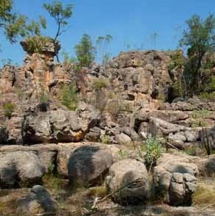

*Arnhem Plateau Sandstone Shrubland Complex EC (Source: Helena Mills)*

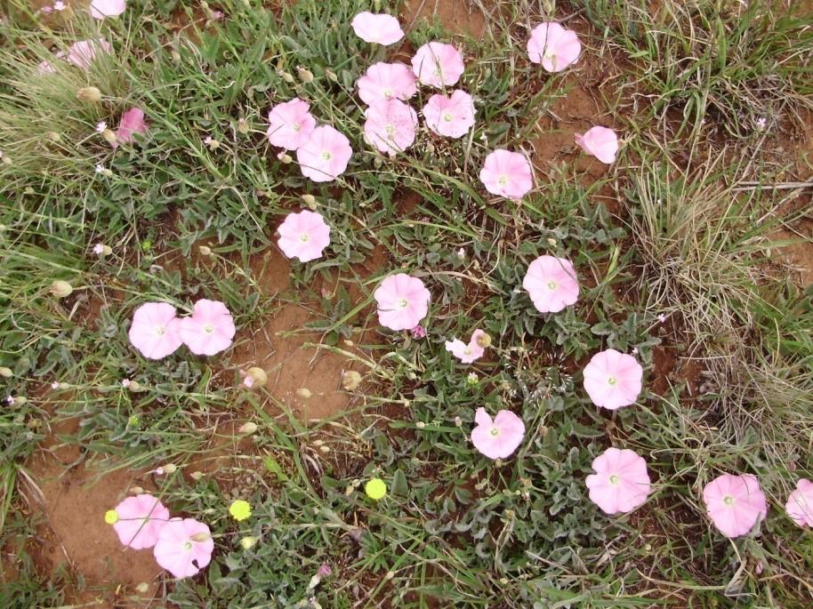

*Lowland Tasmanian Grasslands EC (Source: Tori Wright)*

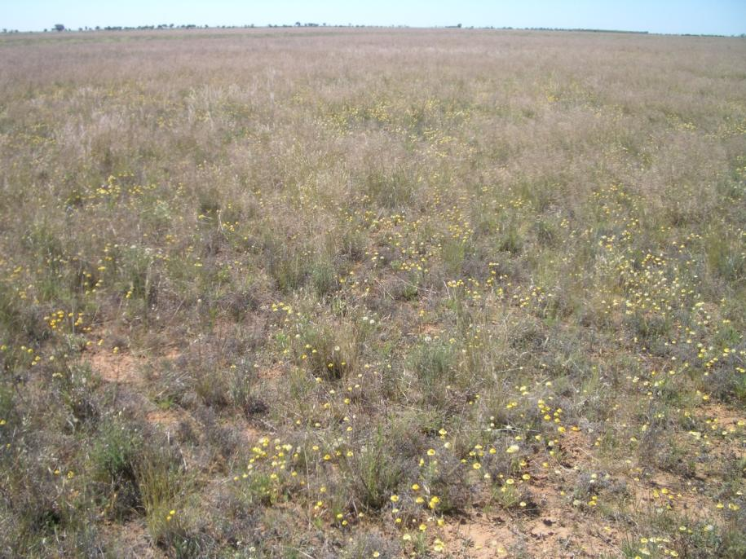

*Natural Grasslands of the Murray Valley Plains EC (Source: Mark Bourne)*

**Framework for Prioritisation of EC Nominations**

**_____________________________________________**

Each year there are typically five to ten new ecological community nominations received through the open public nomination round. Under the EPBC Act, each nomination has two opportunities (over 2 years) to be considered for prioritisation by the Committee. There are typically up to fifteen nominations assessed for priority each year – with a selection of these undergoing a full assessment.

The Committee publishes *Guidelines for nominating and assessing threatened ecological communities*, and an associated nomination form, on the Department’s website. Over the past three years the Ecological Communities section of the Department, in conjunction with the Committee, has significantly evolved the assessment and prioritisation process for ecological community nominations. The principles taken into account during this prioritisation process have, for the purposes of this workshop, been put into a *Framework for Prioritisation of Ecological Community Nominations* (*Prioritisation Framework*, see Table 6). The *Prioritisation Framework* consists of a series of ‘primary’ or ‘other’ considerations (or principles).

Each guiding principle focuses on a particular aspect or issue to be considered as part of the comparative prioritisation process for a pool of nominations. Participants at the *National Strategic Workshop* were asked to comment on the *Prioritisation Framework*, and in particular on each guiding principle and its supporting explanation. These comments were then collated and analysed. Results of this process are summarised below and shown in Table 7.

***Feedback from workshop participants***

Overall there was general agreement with the *Prioritisation Framework*, particularly for the primary considerations. This provided a degree of assurance that the approach taken is one of rigour and consistency across the various ecological community nominations received.

The strongest objection against a principle in the framework related to the ‘other consideration’ of whether or not an ecological community occurs within an area covered by a Regional Forest Agreement (RFA). It was suggested that even though the EPBC referral mechanisms do not apply to forestry operations in RFA areas, there would still be benefits from national listing (particularly for aquatic ECs). Some feedback also suggested that various threatened species listings coinciding with an ecological community should not preclude the ecological community from a separate listing. A complementary approach to both species and TEC listing was seen as beneficial.

In summary, feedback on the various prioritisation principles was as follows:

*Primary considerations*

* Conservation status: a top priority;
* Threats (demonstrable): a top priority (e.g. heavily depleted plus threats causing rapid detrimental change);
* Data/information: important to determine whether to allocate resources to an assessment, but noted should be 'case by case' and need to also take into account availability of data not presented in nomination;
* National extent: agreed a high priority, noting State/Territory-endemic extent is just as worthy of protection as cross-jurisdictional;
* Protection in reserve: agreed important to consider benefits of listing EC that is already well protected in reserves versus an EC that is poorly protected in reserves; but depends on amount (e.g. how much EC within reserve), reserve type (e.g. perpetual) and effectiveness of reserve (relates to threat);
* State/Territory protection: high priority for national EC listings where there are gaps or alignment potential;
* Ramsar protection: lower priority if duplication, but depends on degree of protection (i.e. most of EC included and effectively protected in Ramsar protection versus partial inclusion);
* Heritage EPBC listing: lower priority if duplication, but depends on prescribed values and degree of protection (i.e. most of EC included in heritage site versus partial inclusion).

*Other considerations*

* Overall conservation benefits from national listing: important to consider the difference national listing will make to conservation;
* Enhanced ecological resilience/functionality on a national scale: important for terrestrial and aquatic ECs;
* Increased national recognition: intrinsic benefit;
* Regional Forest Agreement: should not preclude assessment;
* Threatened Species: a complementary landscape-scale approach is worthwhile, so species protection should not preclude assessment of ECs.

Some minor enhancements and new ideas were also suggested. For instance, there was a model put forward that includes national 'uniqueness' of the EC as a consideration in prioritisation (i.e. a nomination for a type of EC that is not well represented on the national EC list may be given a higher priority). In addition, there was a suggestion that there are ‘flow-on’ conservation benefits if the National EC List represents key threatening processes across Australia (i.e. a nomination for an EC that is predominantly threatened by a KTP that is not well represented by national EC, KTP or species lists could be given extra priority). The Department and the Committee will take all feedback and new ideas into account in refining the prioritisation principlesand in making future nomination decisions.

The *Prioritisation Framework* will be updated in line with the workshop feedback and published on the Department’s website for use in pre-nomination analysis by nominators. The Committee’s *Guidelines for nominating and assessing ecological communities*, and associated nomination form, also remain the key documents for preparing nominations.

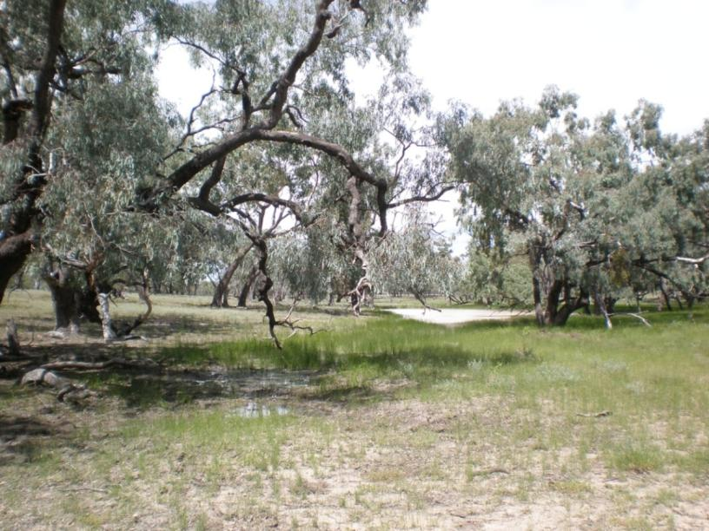

*Coolibah - Black Box Woodlands of the Darling Riverine Plains and the Brigalow Belt South Bioregions EC (Source: Megan Good)*

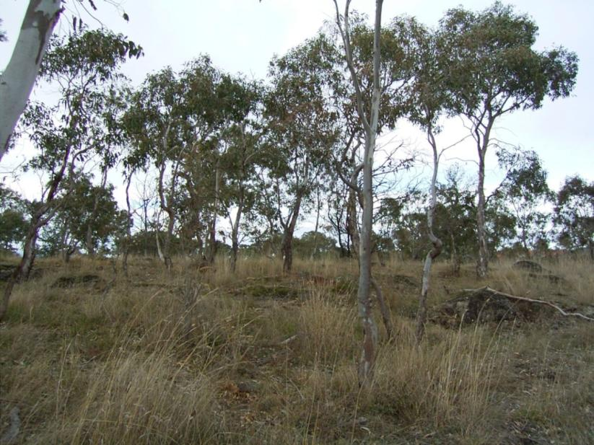

*Grassy Eucalypt Woodlands of the Victorian Volcanic Plain EC (Source: John Vranjic)*

**Table 6:** *Framework for Prioritisation of Ecological Community (EC) Nominations. (Note: points are in no particular order).*

|  |  |
| --- | --- |
| Prioritisation guideline | Issues for prioritisation |
| Primary considerations |  |
| Conservation status and listing criteria the EC will likely meet | Should ECs that meet criteria for a higher listing status (i.e. endangered and critically endangered) be considered a higher priority? Should an EC that meets more listing criteria be a higher priority than those that meet only one? |
| Nature, degree and timeframe of threats operating on the EC | This takes into account how severe the threat(s) are, the number of threats operating, whether they are actual/potential or past/current, and the degree to which threats are manageable. From this, an EC that is more likely to benefit from protection, therefore may be considered a higher priority. |
| Consideration of amount and quality of data and information available to adequately describe and assess against listing criteria | Nominations that lack information and data to describe an EC and assess it against listing criteria are harder to properly assess. Therefore they may be considered a lower priority in comparison to better known items in the nomination pool*. |
| Consideration of national extent | The extent of the EC needs to properly reflect its national distribution (i.e. irrespective of jurisdictional boundaries). If national extent is difficult to determine, then assessment may take longer and therefore the EC may be considered a lower priority. |
| Consideration of amount of protection already provided by areas in reserves | ECs may be already wholly or largely protected in reserves. Depending on the effectiveness of this protection, the EC may be a lower priority as listing may not provide additional protection. However, if the level of protection is insufficient to protect it from threats, then the EC may have a higher priority. |
| Consideration of existing level of protection by State/Territory legislation | ECs that are already fully protected under state/territory legislation may be a lower priority. In some cases, there may be gaps in local protection that could be addressed by national listing. Where this is the case, the EC may be considered a higher priority. |
| Consideration of existing level of protection through Ramsar listing | ECs wholly or largely corresponding to a Ramsar wetland are already afforded some protection under the EPBC Act as a matter of National Environmental Significance. Therefore they may be considered a lower priority, depending on the effectiveness of the protection compared to the level of threat. |
| Consideration of existing level of protection through Heritage listing | ECs wholly or largely corresponding to a World or National Heritage area are already afforded some protection under the EPBC Act as a matter of National Environmental Significance. Therefore they may be considered a lower priority, depending on the effectiveness of the protection compared to the level of threat. |

|  |  |
| --- | --- |
| Other considerations |  |
| Overall conservation benefit contributes to/reinforces the national context | Consider benefits of listing that reinforce protection in the national context. For example: does the EC take a landscape/seascape approach, **or** contribute to a comprehensive, adequate and representative national list of ECs (e.g. range of bioregions on list) **or** is it of a unique nature (including high-value remnants) that is poorly represented? Such ECs would benefit from protection, which may make them a higher priority when considered against the nomination pool. |
| Provides additional conservation benefit through enhanced ecological functionality at a regional or national scale | Does the EC: provide connectivity between other protected areas or threatened systems, **or** create a corridor effect for wildlife movement, **or** protect important regional/national refugia. Such ECs would benefit from protection, which may make them a higher priority when considered against the nomination pool. |
| Enhanced opportunity for conservation through increased national recognition | Would listing the EC raise awareness/recognition, leading to more opportunities for increased/improved: research, management, threat abatement, recovery, or restoration. As such, the EC may be of a higher priority when considered against the nomination pool. |
| Regional Forest Agreements (RFAs) | The EPBC Act, and hence listings, do not apply to forestry operations in areas covered by RFAs. Should EC listings in these areas be a lower priority? This is more complicated under the Tasmania RFA. In addition, although the EPBC Act can 'switch off' in RFA areas, listing can still add value in other ways such as management/recovery. |
| Threatened Species | Should ECs that provide critical habitat to a high number of threatened species be a higher priority? This is because an EC can help protect habitat for threatened species (complementing species protection). Should ECs that contain a high diversity of species or a high number of “near-threatened” or “declining” species be given a higher priority? (where data are available to demonstrate such decline).  Alternatively, should ECs that contain EPBC Act listed species with distributions/habitat that are identical to the EC be a lower priority? This is because these ECs should already be afforded protection as habitat for threatened and/or migratory species under the EPBC Act. |

**\*** *nomination pool refers to the set of nominations received in any particular year for that year's Priority Assessment List plus any nominations from the previous year's nominations (i.e. under the provisions of the EPBC Act nominations can only be considered for two consecutive annual assessment lists).*

**Table 7:** *Feedback from workshop discussions on Prioritisation Framework*.

|  |  |
| --- | --- |
| Prioritisation Guideline | Feedback from Workshop participants |
| **1. Conservation status and listing criteria the EC will likely meet** | * Many acknowledged whether or not an EC is likely to meet listing criteria as a high priority; some noted it was the number one priority for undertaking a listing assessment; and others putting it in the top 5. * Several see higher listing status (i.e. critically endangered) as a higher priority for EPBC assessment/listing as TEC listing should focus on protecting the most threatened. One person thought that a vulnerable listing status was a higher priority to protect an EC (and associated species) before it is more threatened. Others said it doesn’t matter as long as criteria are met - all listing categories are relevant and a balance of listings in all three categories is good. * It was noted that there were definite benefits to giving vulnerable ECs full protection under the EPBC Act in the future and that there should be a diligent process for prioritising vulnerable ECs for assessment if the Government implements the EPBC Review proposal for vulnerable ECs to be given full protection. * Some responded directly with a “no” to the question as to whether it matters how many criteria are met (hence, likely to meet one criteria for listing would be sufficient reason for prioritising for assessment). No “yes” response, but one person questioned whether some criteria should be more important than others (a weighting system). Someone noted the importance of rate of change (Criteria 5). * Some noted that a robust decision support system is important. * A ‘pre-assessment’ was suggested, to determine whether criteria are likely to be met may be worthwhile before proceeding to full assessment. |
| **2. Nature, degree and timeframe of threats operating on the EC** | * Many acknowledged that the nature, degree and timeframe of threats operating on an EC are a high priority consideration for deciding whether to prioritise an EC for a national listing assessment. Some noted it was the number one or two highest priority. Others thought it was a top 5 priority. Some noted that an EC with current/active threats is more of a priority than one with future or past threats only. However, others noted that an EC can be so damaged by past threats (e.g. 98% cleared) so would be very worthy of protection against future threats (even if threats are not currently active/demonstrable). * It was noted that meeting listing criteria (as above) should align with threats (i.e. together they are the highest priority). * A couple of people suggested undertaking a risk analysis to balance values/benefits of listing versus cost of threats. Importantly, strong threats are a high priority for prioritising a listing assessment, but only if listing will help to abate the threats. Many people noted it was important that the capacity to reduce threats and hence manage/ recover the EC is considered. Although others noted that some threats are difficult to mitigate (e.g. climate change) and/or require political will and resources which national listing can highlight. * It was noted that the immediacy and severity of threats, as well as the particular susceptibility of each ecological community, should be considered in prioritising. Identification of (type of) threat is important,  e.g. past/present/impending; spatial extent; pulse/pressure/ramp. * In some cases emergency listing should be considered. * It was noted that Key Threatening Processes (by any jurisdiction) and Threat Abatement Plans should be considered. There was a suggestion that there are ‘flow-on’ conservation benefits if the national EC list represents key threatening processes across Australia (i.e. a nomination for an EC that is predominantly threatened by a KTP may be given a higher priority). * As above, a decision to prioritise based on threats should be based on a clear and detailed weighting [decision support] system. One conceptual model was provided as an example, noting ‘uniqueness of biodiversity’ also as important, as follows:   Weighting Model Example  Priority = BxU  C  B = differential benefit to EC of listing; U = uniqueness of biodiversity that may be lost from EC; C = cost of assessment process (e.g. time taken). Differential benefit of listing ("B") includes risk/asset/abatement via: raised awareness (e.g. private conservation efforts); legislative protection; promotes/assists recovery (e.g. recovery plans); attracts funding for actions (e.g. Commonwealth programs). |
| **3. Consideration of amount and quality of data and information available to adequately describe and assess against listing criteria** | * Some suggested this was a secondary pragmatic consideration or an administration issue rather than a ‘worthy of protection’ issue. Some did not rate it as a top 5 priority. Others noted that knowing there is adequate data was critical to prioritising an assessment and the cost/time of undertaking an assessment must be considered, otherwise there would be wasted resources if data was insufficient to complete an assessment. Some emphasised that adequate data was critical for an accurate description of an EC. * Data must be of the right type (‘fit-for-purpose’), amount and quality, as well as accessible. * It was noted that data on the values of ecological communities (e.g. habitat) is also beneficial to deciding whether or not to assess/list. * A few people noted that there was a risk that some ecological communities may be put in the “too-hard basket” if data is not well covered in nominations and that this is a problem for poorer studied biodiversity (e.g. some invertebrates). However, if threats are known to be operating and the EC is susceptible (e.g. known to be cleared/fragmented) then a nomination should be investigated further (i.e. irrespective of data provided by nomination). * It was suggested that the Department/TSSC should investigate whether data are readily available that hasn’t been included in nominations before making a decision to prioritise. * One person was concerned that nominators be given an opportunity to resubmit a nomination if extra data become available (Note: this has happened several times for EC nominations). * More research should also be supported to fill data gaps for ECs that are likely to be threatened. * Quality of data may worsen as a lot of expert ecologists near retirement age. |
| **4. Consideration of national extent** | * Several people identified this as a top 5 priority. Others thought this wasn’t an important criterion. * Some agreed that an EC with a broad or poorly-defined national extent has cost implications as it may take longer to assess. It was noted that there is no useful national hierarchical system, including for ‘splitting/lumping’ ECs. * Some noted that we shouldn’t be looking unnecessarily for cross-jurisdictional national listing, as plenty of ecological communities could be defined within a particular State - often more easily. It was acknowledged that threatened ECs are also still ‘national assets’ regardless of how extensive they are. * In contrast, one person noted determining national extent is more of a resourcing issue and should be a lower level consideration compared to more ‘conservation-focussed’ reasons for assessing/listing. However, they also noted that it was very important that the National List is reflective of national scale priorities. * A few noted that the Department should have more resources to adequately map extent of ecological communities at the national scale. Help from various State bodies is important. |
| **5. Consideration of amount of protection already provided by areas in reserves** | * Some people noted that this should be a low priority, with one group not rating it as a top 5 priority, but rather as a secondary pragmatic consideration. * It was acknowledged that although reserves may reduce some threats, the area in reserve is inconsequential if the threats operate regardless of location (land tenure) e.g. impacts to hydrology, die-back. It was even noted that this could bias some threats over others and that some threats may even increase within reserves (including recreation/tourism activities in National Parks, which can be poorly managed). One person suggested that the CAR (Comprehensive Adequate and Representative) principle for reserves was too focussed on R (representative). Another thought it was difficult to measure the effectiveness of reserve protection. * Someone noted there is a need to weigh up the effectiveness/credibility of statutory and other (conservation) measures currently in the area of the proposed EC. * Some people noted it was important to keep a ‘watching brief’/monitor whether assets such as threatened ECs are being effectively protected/managed in reserves as things can change. * Some noted that it depended on the level of reservation and criteria used (e.g. IUCN levels; institutional arrangements) and that land tenure can change quickly. While it was noted that ‘formal’ and higher IUCN classification may be more likely to provide protection, some private tenure is very effective at protection and managing threats. * Someone recommended a gap analysis be undertaken of what threatened ecological communities are not adequately protected in reserves. * It was noted that most State protection goes to terrestrial systems (cf. aquatic/marine assets). * One person suggested this prioritisation criterion could even act against alignment with State listings (as some jurisdictions have several TECs with large extents within reserves). |
| **6. Consideration of existing level of protection by State/Territory legislation** | * Some people noted that this should be a low priority with one group not rating it as a top 5 priority and noting it is a secondary pragmatic consideration. * Others thought it was important to consider effectiveness of State/Territory legislation and ask the question “what is not currently protected by State/Territory legislation?” If it is effective at reducing threats, then listing under EPBC should be a lower priority. If a TEC is not protected at the state level (many aren’t) then it is an obvious candidate for EPBC protection. * It was suggested that a gap analysis should be undertaken for TECs not protected by State/Territory listings. * Several noted that some States provide specific/formal legislative protection for TECs and some don’t and so this it is important to properly assess existing protection. Others noted that state legislative protection could change rapidly. * Someone noted that the current process of considering state/territory protection before and during national TEC listing was working properly at the moment (i.e. it is considered in prioritisation and assessment phases). * Others noted (similar to national extent) that TECs go beyond jurisdictional boundaries and State/Territory protection may vary. It is important that researchers (and recovery actions) are not limited to state concerns/boundaries. |
| **7. Consideration of existing level of protection through Ramsar listing** | * Some people noted that this should be a low priority with one group not rating it as a top 5 priority and noting it is a secondary pragmatic consideration. * Others thought it was important to consider duplication of protection but that it is important to consider whether Ramsar listing covers the full extent of the TEC (i.e. how much of the EC is protected by a Ramsar site). * As per other criteria above, some people noted it was important to consider how effective Ramsar protection is in general for the particular ecological community (e.g. outer floodplain woodland versus core wetland). * One person noted it is very difficult to measure effectiveness of protection but others noted it was important to consider whether Ramsar protection is effective from both a legislative (e.g. EPBC Act) and management perspective (e.g. management actions may not be acted on or working). Therefore, it is not always a question of whether legislative protection is operating for a Ramsar site (e.g. EPBC referral) but whether the condition of the site is deteriorating; if so, there is a need to consider additional protection measures, statutory and non-statutory. |
| **8. Consideration of existing level of protection through Heritage listing** | * Opinion ranged from this being a high to a low priority, with one group not rating it as a top 5 priority and noting it is a secondary pragmatic consideration. * Some noted it was a lower priority if duplication, but depends on effectiveness and degree of protection (i.e. most of EC included in heritage site versus partial). * Some suggested comparing how well threats are addressed under the two types of protection (i.e. comparatively between eritHeHHeritage and EC listing). |
| Other considerations | Feedback from Workshop participants |
| **9. Overall conservation benefit contributes to/reinforces the national context** | * Several people identified this as a top 5 priority. * Some felt this linked to conservation status of listing (i.e. CE, E, V) and the need to consider long-term resilience and the capacity to manage threats. * There was a suggestion that the ecological values and benefits should be defined and documented in listing. * The issue of representatives was raised. |
| **10. Provides additional conservation benefit through enhanced ecological functionality at a regional** **or national scale** | * Several people identified this as a top 5 priority and considered it a strategic approach to protection. * In particular the elements of increased 'connectivity' and 'corridors' were seen as important, particularly in light of climate change and to help overcome fragmentation. * It was noted as an important consideration for both terrestrial and aquatic ECs. |
| **11. Enhanced opportunity for conservation through increased national recognition** | * Many felt this to be an intrinsic component of the listing process. * Some people noted that this should be a low priority (one group noting it is a secondary pragmatic consideration). * Benefits of increased recognition and 'spreading the message' via listings was generally acknowledged. * Some felt the potential flow-on effects for research were important (with more recognition of ECs at an earlier stage suggested). * Others felt this was a lower consideration due to funding limitations to States for research/recovery. * It was noted that potential benefits could come through compliance/enforcement regarding recognition and conservation outcomes. |
| **12. Regional Forest Agreements (RFAs)** | * Some people noted that this should be a low priority with one group not rating it as a top 5 priority and noting it is a secondary pragmatic consideration. It was noted it does not apply to WA ECs. * Some considered that this was not a reason to prioritise as ECs in RFAs should still be listed and that distribution of the wider community outside the RFA is relevant. * Others noted it should be considered in a similar way to other protection mechanisms – is it effective? * The terms of the RFA need consideration for each case. It was suggested that future reviews of RFAs should be investigated and consider whether TECs are adequately protected. |
| **13. Threatened Species** | * Some people noted that this should be a low priority with one group not rating it as a top 5 priority and noting it is a secondary pragmatic consideration. * Others felt that if there were many threatened species, then this should be given higher priority. * Others thought it was very important to consider landscape-scale threats (as these not always considered for threatened species) and to protect a wider area/habitat of threatened species and other species (i.e. as for ECs). |

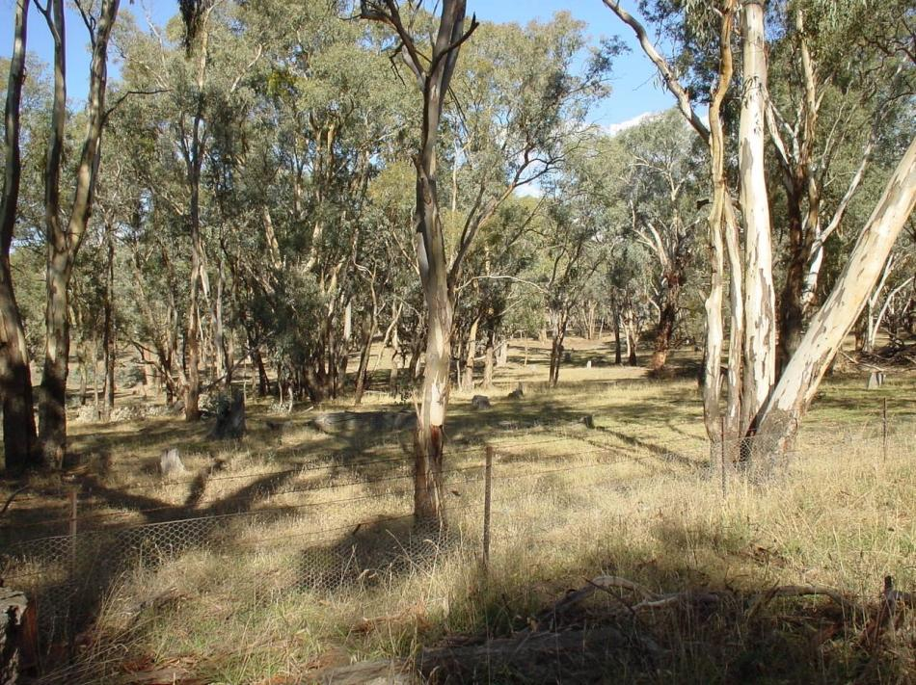 *White Box-Yellow Box-Blakely's Red Gum Grassy Woodland and Derived Native Grassland EC (Source: Helena Mills)*

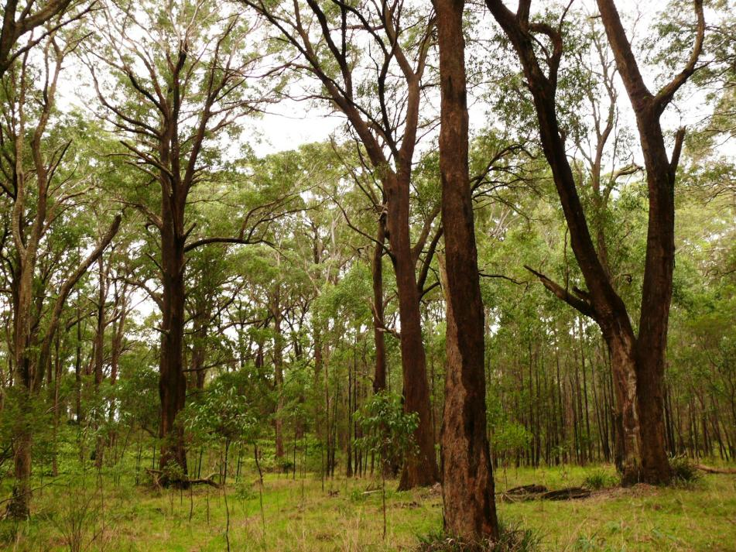

*Upland Basalt Eucalypt Forest of the Sydney Basin Bioregion EC (Source: Vanessa Keyzer)*

**Gaps in the National EC List**

**_____________________________________________**

Participants of the *National Strategic Workshop* were divided into four Breakout Groups, which consisted of a range of experts and agency representatives. Three groups each considered a particular region of Australia and the fourth group specifically considered aquatic ecosystems/ECs. The groups were asked to undertake a gaps analysis of their area and nominate potential threatened ecological communities and priorities for protection. The broader list of ECs put forward was then further discussed to determine the highest priorities.

It should be noted that the outcomes of the workshop, while providing excellent guidance on gaps and areas in need of national protection, are considered by the Committee and the Department as indicative options for threatened ecological communities. This prioritisation process does not preclude any ecological community considered to be threatened being nominated. Further, all nominations should be considered against the guiding principles of the *Prioritisation Framework*.

It is also worthwhile noting, when considering the priorities identified in the tables below, that some items are very broadly defined and may represent groupings of several similar ecological communities. Any nomination and subsequent assessment based on any of the entities identified would need to carefully consider what threatened ecological communities are encompassed within them.

A separate study to investigate potential gaps in the suite of rainforest and vine-thicket vegetation communities on the national list of TECs was undertaken in conjunction with the workshop. The results are summarised on page 55.

***Terrestrial North/West***

The Terrestrial North/West Group discussed a range of issues and options prior to determining gaps and priority entities for national protection in these regions – i.e. for northern Queensland, all of the Northern Territory and Western Australia. A subset of six gaps or broad ecological community groupings was recommended by the Group (Table 8a) from a larger list of 17 gaps or potential priority entities (Table 8b). Issues and questions raised during the discussions included:

* There are differing key ongoing pressures across this broad section of Australia, for example:
  + south-west WA – urban and associated development, fire regimes
  + north WA, NT, north QLD – fire, invasive species, mining and associated development.
* Generally, apart from south-west Western Australia, ecological communities in these regions are not as highly cleared but are suffering decline in their integrity or face foreseeable threats.
* Characteristic fauna are being lost from many northern Australian ecological communities.
* Tropical ecological communities are less represented in the current National List. This is likely a consequence that impacts in the region to date have resulted in degradation rather than outright clearing and loss.
* Varying approaches and lack of data may present a challenge for defining some of the ecological communities and assessing them against listing criteria. As comparative examples:
  + Northern Territory does not list ecological communities.
  + Western Australia does not have a specific legislated list for TECs but has threatened ecological community (TEC) and priority ecological community (PEC) lists to work from, many with complimentary spatial data. Thus, national listing would contribute to alignment with Western Australia’s TEC and PEC lists. However, TEC and PEC lists are not complete in WA and there is less data on these. Little information exists for some ecological communities in WA (e.g. mallee in mid-west Goldfields), despite being under-represented on the National List.

**Table 8a:** *Gaps and higher priority entities for national protection, as recommended by the North/West Breakout Group at the National Strategic Workshop.*

|  |  |  |
| --- | --- | --- |
| **No.** | **Terrestrial North/West Gap** | **Comments/Rationale** |
| 1 | *Banded Ironstone* (WA) | * about 35 WA PECs/TECs * threats – mining and associated devlt. |
| 2 | *Banksia Woodland* *of Southern Swan Coastal Plain*\* (WA) | * about 8 WA PECs/TECs * threats – urban devlt., dieback, weeds |
| 3 | *Pilbara Grasslands and Claypans* (WA) | * about 9 WA PECs/TECs * threats – mining and associated development (e.g. expansion of towns) |
| 4 | *Lowland Floodplains* (WA, NT, QLD) | * a very broad grouping (if narrower definition, Arafura swamp is most threatened) * threats – climate change-induced salt water intrusion, invasive flora and fauna, agricultural intensification |
| 5 | *Mitchell Grasslands* (QLD, NT, possibly WA) | * threats – agricultural intensification; invasive species |
| 6 | *Christmas Island* | * the island contains rainforest and other forest types * threats - invasive species, increasing development |

* nomination subsequently received and placed on the 2012 FPAL.

**Table 8b:** *Gaps and priority entities for national protection recommended by the Terrestrial North/West Breakout Group at the National Strategic Workshop - by jurisdiction and unranked.*

|  |  |  |
| --- | --- | --- |
|  | **Terrestrial North/West Gap** | **Comments/Rationale** |
| **WA** |  |  |
|  | *Wheatbelt hills* | * threats – grazing |
|  | *Pisolite hills/mesas* | * assemblage of unusual geologies * threats – mining |
|  | *Banded ironstone formations* | * threats – mining and associated development |
|  | *Stygofauna/troglofauna of groundwater calcretes* | * threats – mining and groundwater management issues |
|  | *Mound springs & rainforest swamps of Kimberley* | * threats – grazing, altered fire regimes |
|  | *Pilbara grasslands and claypans* | * threats – mining and associated development (e.g. expansion of towns) |
|  | *Whicher sands (hills south of Swan Coastal Plains)* | * threats – mining |
|  | *Banksia woodlands of southern Swan Coastal Plain* | * threats – urban expansion, dieback |
|  | *Assemblages on Greenstones* | * threats – mining |
| **NT** |  |  |
|  | *Lowland floodplains* | * broad group, also in WA and QLD * includes Arafura swamp (narrower definition, most threatened) * threats – climate change-induced salt water intrusion, invasive flora and fauna, agricultural intensification |
|  | *Heathlands (other than Arnhem)* | * smaller and more restricted on rock areas * fire regimes the key threat |
|  | *Mitchell grassland of northern Australia* | * also extending into QLD and possibly WA * agricultural intensification and invasive species |
|  | *Relictual communities on ranges in Northern Australia* |  |
| **QLD** |  |  |
|  | *Riparian vegetation in northwest of Queensland* | * broad grouping * threats - grazing intensification, mining, invasives * threatened on condition not reduction in extent * data available (e.g. Regional Ecosystems) |
|  | *Cape York* | * Being assessed for World Heritage listing. |
|  | *Tall open forests* | * World Heritage protection |

***Terrestrial East***

The Terrestrial East Group discussed a range of issues and options prior to determining a broad list of 20 gaps and potential priority ecological communities for national protection in these regions - i.e. for NSW, Queensland, and eastern Victoria (Table 9). Of these 20, a subset of 11 higher priority entities was also determined (as per Table 9). Issues and questions raised during the discussions include:

* Current listings focus on loss of extent rather than loss of function of an ecological community. This has led to gaps in the west (i.e. semi-arid to arid regions of eastern states). An ecological community has tended to be described using co-occurrence of species rather than inter-relationships of species. There is often a knowledge gap around how specific species interrelate, although functional roles can often be assumed.
* Terrestrial ecological communities are focused around vegetation. Therefore is the current process missing:
  + faunal communities that may cut across a range of vegetation types/ important habitat types?
  + functional aspects that might involve fauna or physical aspects (e.g. soil) which may not have been captured because of focus on spatial vegetation data? There are data on function available (e.g. effects of rabbits) but it's difficult to apply to ecological community listing criteria.
  + local scale and local concepts – and how does this apply across the landscape?
  + the functional relationships between vegetation and fauna that are not well defined (in science) – and how do we overcome this?
* Should expanded extent reviews for existing ecological community listings be prioritised? (e.g. New South Wales *Natural Temperate Grasslands* into surrounding regions; *Victorian Volcanic Plains* into South Australia).
* What data exists regarding 'condition benchmarks' and should be considered?
  + Queensland - has condition assessment, starting to map further
  + NSW – VAST (Vegetation Assets States and Transitions) system, catchment reports, broad tenure as a surrogate
  + Victoria – Ecological Vegetation Classes have condition categories.

It is noteworthy that some of the issues and gaps identified by this group overlap with those of the ‘Terrestrial Southeast’ group (see pages 46-49).

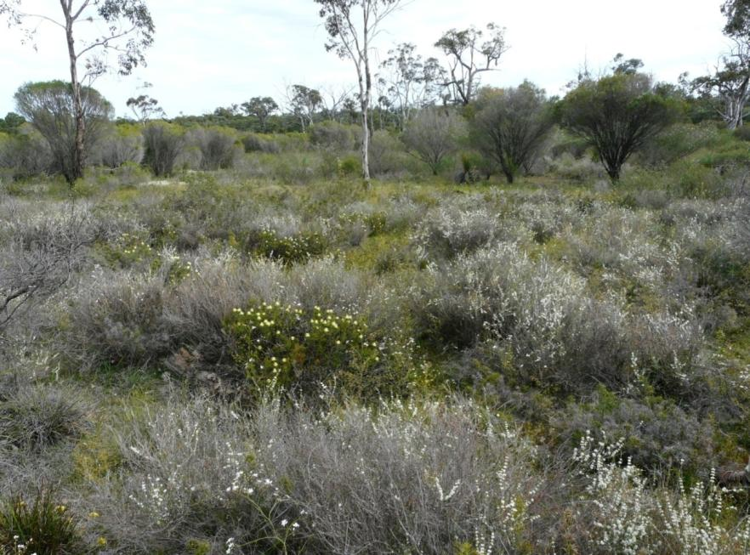

*Claypans of the Swan Coastal Plain EC (Source: Trish MacDonald)*

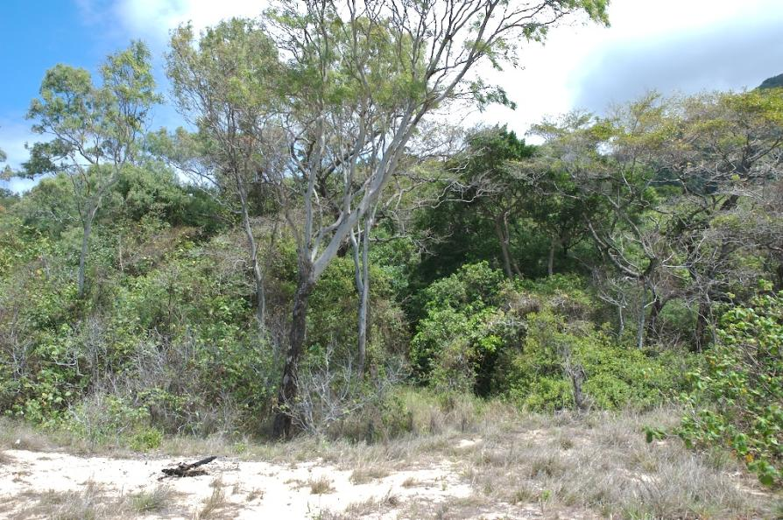

*Littoral rainforest and coastal vine thickets EC (Source: Gary Wilson)*

**Table 9:** *Gaps and priority entities for national protection, as recommended by Terrestrial East Breakout Group at the National Strategic Workshop (Note: 1-11 are highest priorities).*

|  |  |  |
| --- | --- | --- |
| **No.** | **Terrestrial East Gap** | **Comments/Rationale** |
| **1** | *East Coast Floodplain Complex* | * equates to approximately 6 NSW coastal listings (state alignment potential) and likely to occur in Qld and Vic. * efficient assessment if broad grouping * functional commonalities (between 6 NSW listings), but structural differences (rainforest, swamp paperbark forest, swamp oak woodland, eucalypt forests) |
| **2** | *Hunter Valley Woodlands*\* | * no effective EPBC Act triggers in the region * equates to around 4 NSW listings * threat – mining and associated development |
| **3** | *Woodlands of the Outer Floodplains of Inland Flowing Rivers (Black box)* | * recent decline (20% mortality of trees) * threats - water regulation, weeds, climate change * grades into Coolibah as it goes north (overlaps with current EPBC-listed Coolibah-Black Box TEC). |
| **4** | *Non-Eucalypt Arid/Semi-Arid Woodland* | * intense grazing pressure - e.g. goats * not threatened by direct clearing - a ‘sleeper’ |
| **5** | *Bimble Box/ Poplar Box* | * in NSW and Queensland * extensive, backbone of the region * threats – past clearance, mining, weeds and ferals |
| **6** | *Gidgee Woodland* | * heavily cleared * ecologically different to what is further west |
| **7** | *Sand Plain Forest of NSW Coast and Gippsland* | * threats change throughout its range * southern extent has threat of peri-urban development and fire * north of Sydney has different composition, threat and reservation status |
| **8** | *Remnant Sandhill Fossil Streams* | * may be none left in Victoria but some remain in NSW * not large areas * often under vineyards * threats - ferals (goats, rabbits), fire regimes |
| **9** | *Open Forests and Woodlands of Coastal Valleys on Fine Grained Soils* | * broad EC or several ECs in coastal rainshadow/fertile coastal valley grassy woodlands - e.g. Hunter Valley, Cumberland Plain, Bega, East Gippsland, Clarence River (some already covered by listings or current assessments) |
| **10** | *Old Floodplain Chenopod Communities* | * gradual loss of integrity due to grazing, invasive species and clearance e.g. Hay Plain |
| **11** | *Sub-Alpine Frost Hollows* | * threats - horses, deer, livestock * small areas * overlap with other protection measures needs to be considered (e.g. reserves; alpine heritage) |
| **12** | *Tropical coastal freshwater floodplains* | * threats - weed invasion, pigs, cane toads, buffalo, sea level rise * EC or ECs need to be defined |
| **13** | *Coastal Saltmarsh* | * current nomination – being assessed on 2010 FPAL |
| **14** | *Floodplain wetlands of Brigalow Belt* | * EC or ECs need to be defined |
| **15** | *Tablelands/Slopes dry Sclerophyll Forest* | * threats – past clearance, increasing development, weeds and ferals * EC or ECs need to be defined |
| **16** | *Riverine Mulga Lands* | * threat - ongoing grazing and invasive scrub * broad landscape concept - EC or ECs need to be defined |
| **17** | *Remaining Wheatland Woodlands* | * threats - past clearance, loss of integrity due to grazing and invasive species * EC or ECs need to be defined |
| **18** | *Acacia Communities that are not Mulga or Brigalow related* | * gradual loss of integrity due to grazing and invasive species * EC or ECs need to be defined |
| **19** | *Mangroves* | * threat level different north and south * species also vary north and south |
| **20** | *Other Riparian Vegetation* | * EC or ECs need to be defined |

* nomination subsequently received and placed on the 2012 FPAL.

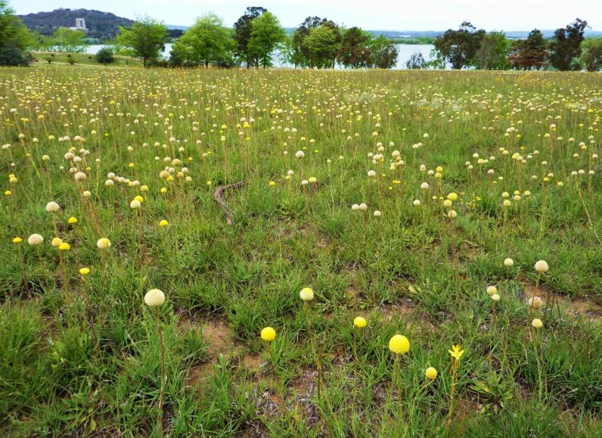

*Natural Grasslands of the ACT & NSW Sth Tablelands EC (St Marks Canberra, Source: Matt White)*

***Terrestrial Southeast***

The Terrestrial Southeast Group discussed a range of issues and options prior to determining gaps and potential priority ecological communities for national protection in these regions - i.e. for Southern NSW and ACT, Victoria, Tasmania and South Australia.

Discussions within the Group initially covered a range of issues:

* Climate change refugia, connectivity of remnants and ecological resilience were noted as important considerations for future management of landscapes. These have roles in providing opportunities for species to disperse and relocate into suitable habitat, especially where other habitats have declined, as well as for maintaining key ecological processes.
* However, it was also noted that these can be difficult to recognise within the landscape or to characterise as a threatened entity. Consequently these issues may be more a management priority than a priority for identifying threatened ecological communities.
* The focus to date on terrestrial ecological communities in this region has been on loss of area extent due to historical (and sometimes ongoing) clearing. These are relatively easier to assess as the threats are readily evident and there are often reliable data on past and current extent to demonstrate a significant decline.
* There is a need to shift towards consideration of ecological communities impacted primarily by degradation. However, there are gaps in our knowledge of functional decline and how to assess these systems to demonstrate that they merit listing as threatened.
* Therefore, it is likely that listings will continue to focus on ecological communities that have tangible, manageable threats, at least into the near future

Representatives from each jurisdiction identified ‘regional’ gaps or priority entities for further consideration. It is noted that any ecological communities associated with these are not necessarily restricted to a particular jurisdiction. They may be more widespread and the threats are likely to extend across their range. A list of 21 ecological communities was suggested (Table 10b) from which a subset of 6 broad groupings that are considered the highest priority for national protection were determined (Table 10a).

It is noteworthy that several of the issues and gaps identified by this group overlap with those of the ‘Terrestrial East’ group (see pages 42-45).

**Table 10a:** *Broad gaps and higher priority entities for national protection, as recommended by the Southeast Breakout Group at the National Strategic Workshop*.

|  |  |  |
| --- | --- | --- |
| **No.** | **Terrestrial Southeast Gap** | **Comments/Rational** |
| 1 | *Coastal Forests and Woodlands*  (temperate) | * southern QLD to eastern VIC * threats – coastal development; invasive species * EC or ECs need to be defined (some already listed) |
| 2 | *Cool Temperate Rainforest Communities* (southern NSW, VIC, TAS?) | * threats – fire regimes (greater on the mainland than Tasmania) * EC or ECs need to be defined |
| 3 | *'Infill' Woodlands of the Wheat-Sheep Belt* (NSW, ACT, VIC) | * threats – conversion to cropping and pasture; past clearance/fragmentation exacerbating other threats * EC or ECs need to be defined (some already listed) |
| 4 | *Mallee Woodlands*  (SW NSW, NW VIC, SA) | * threats – conversion to cropping; invasive species; fire regimes. * EC or ECs need to be defined |
| 5 | *Eucalyptus ovata Woodlands & Forests*  (southern VIC, TAS) | * may overlap with existing EPBC listing in Tasmania but Flinders Island and Victorian occurrences also need protection |
| 6 | *Rocky Range Mulga Communities* | * gradual loss of integrity due to grazing (e.g. goats) |

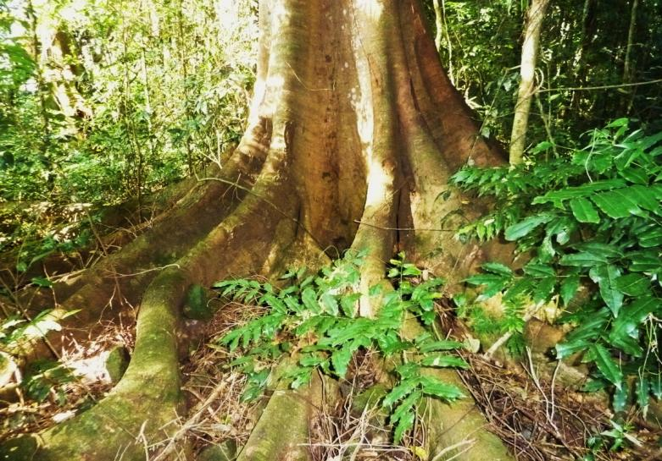

*Lowland Rainforest of Subtropical Australia (nr Lismore NSW, Source: Matt White)*

**Table 10b :** *Gaps and priority entities for national protection recommended by the Terrestrial Southeast Breakout Group at the National Strategic Workshop – divided into functionally degraded (****FD****) ecological communities and by jurisdiction. Note: all are unranked.*

|  |  |  |
| --- | --- | --- |
|  | **Terrestrial Southeast Gap** | **Comments/Rationale** |
| **FD** |  |  |
|  | *Rocky ranges Mulga and western rosewood communities* | * NSW, SA, possibly QLD * degradation from goat grazing * lack of regeneration of mulga, a key functional component (loss of key functional species) |
|  | *Cool temperate non-littoral rainforest communities* | * TAS and southern VIC (e.g. Flinders bioregion) * inappropriate fire regimes a key threat |
|  | *Semi-arid Chenopod shrublands* | * declining in certain areas in pastoral zone of southern SA, central NSW, northwest VIC * distinct from arid shrublands |
|  | *Mallee communities (various)* | * southern SA, western NSW, western VIC * threats - fire regimes, clearing, grazing |
|  | *Wheat-sheep belt/western slopes Communities* | * apple box (*E. bridgesiana*)grassy woodlands in ACT/NSW/VIC * grassy poplar/bimble box woodlands of Darling Riverine Plains * belahwoodlands in QLD, NSW, SA and VIC * eucalypt ECs of restricted distribution (e.g. Bendamere woodlands) |
| **VIC** |  |  |
|  | *Plains Grassland of south Gippsland\** | * localised - distinct from Gippsland red gum grassy woodlands and associated grasslands |
|  | *Semi-arid belah woodland* | * in other jurisdictions; under-represented veg-type |
|  | *Semi-arid Callitris woodland* | * in other jurisdictions; under-represented veg-type |
|  | *Mallee woodland* | * in other jurisdictions; under-represented veg-type |
|  | *Black box woodland in Victorian Midlands bioregion* | * distinctive regional dryland outlier of Black box woodland |
|  | *‘Lowland’ Snowgum woodland* | * unique non-alpine; may be in other jurisdictions |
|  | *Rocky Chenopod open-scrublands* | * outlier away from Mallee zone; listed in Vic |
| **TAS** |  |  |
|  | *Eucalyptus ovata forest and woodland* | * overlaps with current EPBC listing in Tasmania * types on Flinders Island and on alkaline sands of Victoria that may be distinct |
|  | *Coastal heathlands* | * impacted by coastal development and *Phytophthora* dieback * possibly also in other states |

* *subsequently placed on the 2012 FPAL.*

|  |  |  |
| --- | --- | --- |
| **ACT** |  |  |
|  | *Tablelands Snowgum/Black sallee community* | * just listed in NSW as TEC. |
|  | *Eucalyptus macrorhyncha (red stringybark) with Eucalyptus polyanthemos (red box) forest* | * becoming restricted locally. Also in NSW. * urban development, rabbits and inappropriate fire are key drivers of loss of integrity. |
|  | *Eucalytpus viminalis woodland on granites and basalts in the southern tablelands* | * dieback due to drought and herbivory. Also in NSW (possibly inc. northern tablelands). |
| **NSW** |  |  |
|  | *Grassy woodlands in eastern coastal valleys* | * from QLD through NSW to VIC * explicit EC or ECs need to be defined (some are already listed) * e.g. *E. tereticornis* dominated remnants |
|  | *Coastal flooded Melaleuca forests* | * NSW to QLD (TEC already listed in Nth Qld) * EC or ECs need to be defined |
|  | *Subtropical Mangroves* | * in parts of northern NSW and southern QLD |
| **SA** |  |  |
|  | *Various* | * State is undertaking a prioritisation process to be completed in 2012-13 * buffel grass a major concern in northeast * inappropriate fire regimes a key threat |

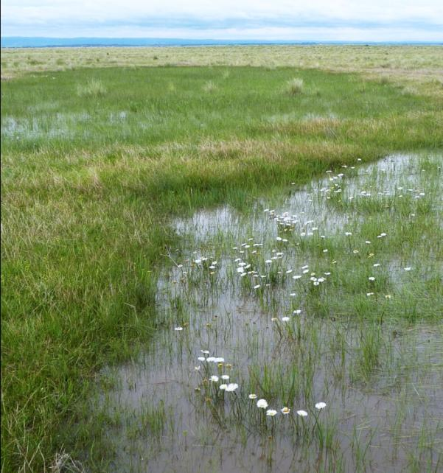

*Seasonal Herbaceous Wetlands of Temperate Lowland Plains*

*(Victorian Volcanic Plains, Source: Matt White)*

***Aquatic Ecological Communities***

After discussions, the Aquatic Breakout Group suggested eighteen gaps and priority entities for national protection, which included a top ten list.

Results are shown in Table 11. Issues raised during the discussions included:

* The Group felt strongly that estuaries should be considered a priority pressured aquatic ecosystem, but they were excluded from the voting (i.e. as not freshwater). Some members felt similarly about mangroves due to the rate of clearance and the unique high diversity in the tropics.
* A clear definition of wetlands is needed for ecological communities and it would be useful to consider the High Ecological Value Aquatic Ecosystem (HEVAE) process to assist with definitions.
* It is important to consider whether aquatic ecological communities are EPBC protected in areas where Regional Forest Agreements are in place (i.e. forestry practices in RFA areas are exempt from triggering the EPBC Act).
* Principles for representativeness of aquatic ecological communities need to be investigated.
* The Group suggested that drainage divisions are a useful bioregional framework for aquatic ecological communities considered for the National List.
* Professor Peter Cullen's call for the Ovens River (and associated floodplain) to be protected (nominated for National Heritage values) was reiterated. It was considered that this is an information rich, cogent case for protection and a rare example of a relatively intact, snow-fed montane river. It is the last essentially unregulated river in the southern Murray Darling Basin but is currently under threat from agriculture and the building of new dams. The lower floodplain has immense scientific value as a reference site to gauge the impact of river regulation on aquatic ecosystems.
* It was noted that within Australia there is little information on wetlands that are predominantly rain-filled (despite recent (2002) recognition by the Ramsar Convention on Wetlands). Worldwide rain-filled wetlands are among the fastest disappearing wetlands. Disappearance from the landscape may result in a weakening of the biological connections between pools due to increasing isolation and the impoverishment of their communities as well as loss of biodiversity at a regional level. Major threats to rain-filled wetlands are altered hydroperiods (damming and draining), and intensive agriculture (grazing, cropping, pesticides and fertilizers).

It is noteworthy that some of the issues and priority ECs identified by this group overlap with those identified by the terrestrial regional groups (e.g. non-alpine peats and fens).

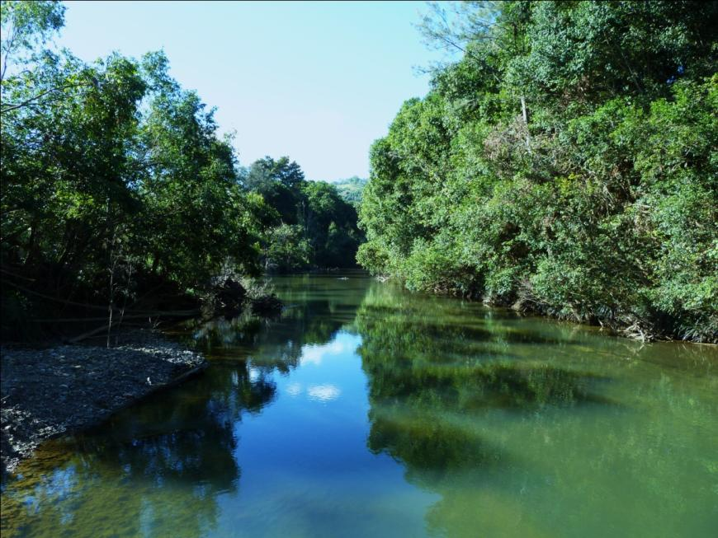

*Long Lowland Floodplain Rivers of southeast QLD and northern NSW EC; currently*

*under assessment (Mary River, Source: Matt White)*

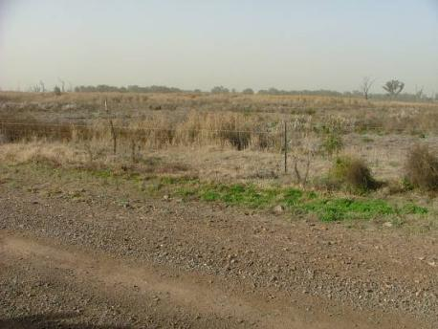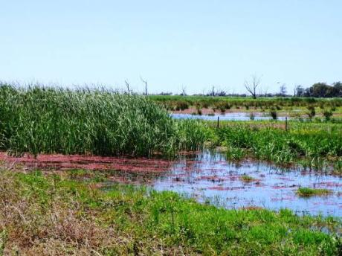

*Macquarie Marshes EC, currently under assessment,*

*Monkeygar Swamp June 2009 (at peak of long drought, left) and*

*October 2010 (after drought broke, right)*

*(Source: Tim Hosking)*

**Table 11:** *Gaps and priority entities for national protection, as recommended by Aquatic Breakout Group at the National Strategic Workshop (Note: 11 - 18 are unranked).*

|  |  |  |
| --- | --- | --- |
| **No.** | **Aquatic Gap** | **Comments/Rationale** |
| **1** | *Lake Eyre Basin Aquatic Systems* | * rivers, lakes, floodplain, wetlands, springs (not GAB) * threats: coal seam gas mining, alien species, rangeland agriculture, eco-tourism, altered flow regimes, climate change * high endemic flora and fauna, extreme boom and bust ecological dynamics, large range of ecosystem types (50), uniquely variable flow regimes on national and global scale, largely unregulated * information base patchy but good data on birds, fish |
| **2** | *Inland Saline Lakes of Victorian Volcanic Plain* | * intensification of agriculture, water diversion, urban settlement * globally unique group of lakes from freshwater to crystallising brine * highly distinctive flora and fauna * intensively studied in 1960-1980 |
| **3** | *Top End Rivers-Floodplains* | * WA/NT/QLD Kimberley to Cooktown (into Gulf) * threats: cattle grazing/trampling, ferals/weeds, changed fire regime, changed flow regime, future development * unique processes, mostly free flowing rivers (natural), endemic and threatened species, annual boom-bust cycle, * information good – TRACK and other research, indigenous knowledge |
| **4** | *Groundwater Calcrete Aquifer Communities of Arid Australia (Calcrete Stygofauna)* | * 80 areas mapped * common community composition but each comprising endemic suite of species * threatened by water extraction and removal |
| **5** | *Snowy River* | * from source to mouth – alpine to coastal – upland and lowland * fish and invertebrates plus threatened species * information on hydrology, vegetation, fish, invertebrates good * threats: river regulation, 3 dams, water extraction, barriers, sedimentation, grazing, clearing * NSW protected but not VIC (jurisdictional issues) |
| **6** | *Non-Alpine Peat and Fens* | * wetlands with peat soils * globally threatened – priority habitat * high species diversity and high number of rare species * geographically restricted but widespread (VIC, SA, WA, NSW, QLD, TAS) * threats: drainage, groundwater extraction, grazing |
| **7** | *Lowland Floodplain Murray/Murrumbidgee* | * (Lake Hume to Darling junction) Burrinjuck Dam to Murray junction) Edward/Wakool * floodplains lost significant connectivity with river channel resulting in substantial declines (especially black box and lignum communities) * riverine floodplain interactions important for the functioning of the river system * decline in riverine conditions - lack of lateral interactions |
| **8** | *Montane Lakes (Victoria to Tasmania)* | * intensity of tourism, grazing, climate change, invasives (trout) * above 600 m * unique glacial relict fauna and flora (old) * undetectable conductivity * are they excluded from EPBC protection within regional Forest Agreement areas? |
| **9** | *Ovens River-Floodplain* | * one of the last essentially unregulated rivers in south Murray-Darling Basin * has natural flooding and drying cycles (unique reference site) * threat from expansion of river regulation (e.g. dam on major tributary Buffalo River) |
| **10** | *Coastal (Wallum) Sand Dune Lakes of Eastern Australia* | * threats from invasive species, erosion, sea level rise, clearing, development * should wallum tributaries be included? |
| **11** | SW WA Mediterranean Rivers | * threats from dams, salinisation, invasive fish |
| **12** | Lower Lachlan River Floodplain wetlands (Great Cumbung) | * Great Cumbung Swamp a terminal wetland on the Lachlan River - largest stands of river red gum in NSW; also Booligal Wetlands * notable sites and habitat for waterbirds when flooded (e.g. 80,000 breeding pairs of ibis). |
| **13** | Karst systems of Ewen and Piccaninnie Ponds (SA) | * threats from groundwater extraction, diving disturbance, altered hydrology * unique submerged veg.; RAMSAR nominated. |
| **14** | Teatree swamps of southeast | * several jurisdictions; are watercourses included? |
| **15** | Freshwater wetland systems of Great Barrier Reef catchments | * consider whether overlap with existing Great Barrier Reef protection measures |
| **16** | NE Australian Tropical Rivers | * consider whether overlap with existing Heritage and Great Barrier Reef protection measures |
| **17** | Rain-filled wetlands of Murrumbidgee | * Ramsar recognition (2002) - fastest disappearing wetlands worldwide (loss of connectivity) |
| **18** | Western lakes of central Tasmania | * alpine; consider Heritage overlap |

***Additional Rainforests and Vine-Thickets Study***

Concurrent to the work of the breakout groups at the *National Strategic Workshop*, a separate project was commissioned by the Department to investigate potential gaps in the suite of rainforest and vine-thicket vegetation communities on the national list of TECs. The study was undertaken through the University of Tasmania.

The consultancy acknowledged that many rainforest and vine thicket ECs that may be considered threatened are already included on the national list, or are currently being assessed for their inclusion. Additionally these vegetation types are generally well covered by other forms of protection in many cases (e.g. national parks, heritage), at a broad scale. However, even though there is relatively good coverage by the national TEC list or other forms of protection, some rainforest and vine thicket ECs (which may be defined at various scales) warrant further consideration for potential nomination. These are outlined in Table 12 and include: ECs that are not on the list (e.g. geographically fragmented drier types); ECs where the majority of their distribution falls outside the National Reserve System, Heritage listing or other forms of protection; and/or ECs that continue to be subject to substantial threatening processes despite other forms of protection.

As with other potential TECs outlined in this report, data gaps exist that may hinder the assessment of national extent and status against listing criteria. Therefore, these potential priorities for nomination should also be considered in the context of the *Prioritisation Framework*.

**Table 12: *Rainforest and vine thicket communities initially identified as potentially threatened, or requiring additional data to determine this.***

|  |  |  |
| --- | --- | --- |
| **Suggested ecological community groupings** | **State inclusions/equivalents [Regional Ecosystem Codes (RE) for Queensland, Ecological Vegetation Classes (EVC) for Victoria and TASVEG codes stated].** | **Comments/Rationale** |
| North Kimberley lowland springs and floodplain rainforest | WA (McKenzie *et al.* 1991)  Walcott Inlet rainforest  Theda Soak rainforest  Point Spring & Long Swamp rainforests  Roe River rainforest | These monsoonal rainforests occupy soaks and floodplains and are deemed to have a similar environmental envelope. They are also physiognomically similar, being of the complex mesophyll structure, and are hence segregated from the more widespread vine thicket rainforest types in the Kimberley region. |
| Vine Thickets and Dry rainforest of South East Australia | NSW (Keith & Bedward 1999; Tozer et al. 2010)  Hunter Valley Vine Thickets (NSW) Dry rainforest of the South-east Bioregion (NSW)  VIC (Peel 1999)  EVC 34: Dry Rainforests | This EC may be grouped on the basis of its structure and physiognomy as well as shared floristic and fauna elements. |
| Tasmanian Dry Rainforest | TAS (Harris & Kitchener 2005; Pollard 2006)  Dry rainforest of Eastern Tasmania  TASVEG code NNP: *Notelaea*-*Pomaderris*-*Beyeria* forest (in part) | This temperate rainforest derivative is typically only found in fire –protected areas like valleys where there is a consistent water supply. The EC is unified by the presence or dominance of *Notelaea lingustrina*, *Pomaderris apetala* and *Beyeria viscosa*. |
| Eastern Tasmania relict cool temperate rainforest | TAS (Harris & Kitchener 2005; Neyland 1991)  TASVEG code RMT: *Nothofagus*-*Atherosperma* rainforest (in part)  TASVEG code RMS: *Nothofagus*-*Phyllocladus* short rainforest (in part) | These rainforests are highly fragmented relict patches of rainforest on the Tasmanian east coast and are distinguished by their significance as refugia sites. |
| Tasmanian endemic cool temperate rainforest | TAS (Harris & Kitchener 2005)  Various montane rainforest communities dominated by *Athrotaxis* conifers and *Nothofagus gunnii*.  Implicate rainforest types. | This EC is found only in temperate montane habitats of Tasmania and is defined by the presence of Tasmanian endemic trees *Athrotaxis* or *Nothofagus gunnii* as dominants. A rich component of endemic montane shrubs is also a distinguishing feature. |
| Semi-deciduous to Deciduous Vine forests and Thickets | QLD Regional Ecosystems (Sattler & Williams, 1999)  RE 3.2.2: Semi-deciduous vine thicket on western coastal dunes and beach ridges  RE 3.3.2: Semi-deciduous mesophyll/notophyll vine forest on alluvia  RE 3.3.3: Semi-deciduous notophyll/microphyll vine thicket on slopes of Melville Range  RE 3.3.7: Tall semi-deciduous notophyll/microphyll vine thicket  RE 3.3.38: Deciduous microphyll vine thicket ± *Lagerstroemia archeriana* on heavy clay alluvium  RE 3.3.39: Semi-deciduous microphyll vine forest  RE 3.5.3: Semi-deciduous notophyll vine forest. Restricted to lateritic Carnegie Tableland RE 3.5.4: Semi-deciduous notophyll vine forest on Northern Plateaus  RE 3.7.1: Semi-deciduous notophyll/microphyll vine thicket  RE 3.8.2: Semi-deciduous notophyll/microphyll vine forest on Mt Webb  RE 3.10.5: Deciduous notophyll/microphyll vine thicket ± *Gyrocarpus americanus*  RE 3.11.1: Semi-deciduous mesophyll vine forest on coastal ranges  RE 3.11.2: Semi-deciduous mesophyll vine forest on metamorphic ranges  RE 3.12.1: Semi-deciduous mesophyll/notophyll vine forest on granitic slopes  RE 3.12.21: Deciduous vine thicket on granite slopes  RE 3.12.22: Deciduous vine thicket ± *Wodyetia bifurcata* on granite slopes  RE 7.8.6: Semi-deciduous mesophyll vine forest on moist basaltic foothills  RE 7.12.6: Semi-deciduous mesophyll vine forest on moist granite lowlands and foothills  RE 7.12.36: Deciduous microphyll vine thicket on fire protected dry granite lowlands  RE 8.12.11 Semi-deciduous microphyll rainforest of steep fry rocky slopes  Semi-deciduous Complex mesophyll vine forest of Lockerbie Scrub (Lavarack & Godwin 1987; Fell *et al.* 2009) | These rainforest patches are largely subtropical, with a few tropical variants. While many specific types have been mapped, they are unified by their semi-deciduous to deciduous habit. Full national extent (outside of Queensland) needs further exploration. |

**The Way Forward**

**_____________________________________________**

One major goal of the *National Strategic Workshop* is to have the workshop report available to support future annual calls for nominations under the EPBC Act, starting with the next call for public nominations (due to begin in November 2012 and close around March 2013).

The outcomes from this workshop will also complement the Committee’s annual process for aligning with State/Territory TEC (or equivalent) lists. This has been done with various jurisdictions since 2010 through identifying the highest priority endemic State/Territory TECs that are not yet listed under the EPBC Act and would benefit from additional national protection. The previous workshop on marine TECs should also be considered alongside the outcomes of this workshop. The marine TECs report is available on the Department’s website at: http://www.environment.gov.au/biodiversity/threatened/publications/workshop-marine-communities.html

The *Prioritisation Framework* outlined in this report will help with prioritisation of both public nominations and State alignment (i.e. help inform nominators as well as State/Territory and Commonwealth committees and agencies).

Feedback was sought from various representatives at the workshop on the way forward for priority listing of ecological communities and this discussion is summarised in Table 13. Some key points raised were:

* Workshop participants were supportive: of the national listing of TECs; that the TECs identified at the workshop are a good starting point for future nominations; and that the *Prioritisation Framework* is sound, subject to some fine-tuning consistent with feedback received at this workshop.
* Aligning State/Territory and Commonwealth listings, data, monitoring and converting listing into recovery actions were noted as ongoing challenges. Several delegates were also concerned at the lack of resourcing available to ensure a comprehensive and representative National List of TECs given the benefits of this type of larger scale ecological conservation.
* There was a strong interest from workshop participants to be involved in future nominations and assessment processes. It was suggested that preliminary nominations be prepared for ECs where possible. This can be likened to an 'expression of interest' process and would require a 'fit-for-purpose' pro-forma to be developed. Such a pre-nomination would work best as an administrative step outside of the formal nomination round as per the *Regulations* of the EPBC Act. Pre-nominations would be assessed before deciding whether or not to pursue investment in a full nomination.

Importantly, the Committee will consider the report from the *National Strategic Workshop* and consider if it should progress any suggested gaps as a Committee nomination (i.e. the Act allows prioritisation of Committee nominations as well as public nominations). The Committee will also continue to work towards harmonising jurisdictional alignment processes and facilitating cooperation between itself, State scientific committees, and State/Territory agencies. However, some of the suggested entities, particularly those that are broadly defined, may not meet the definition or criteria for a TEC. Therefore, ****discrete ecological communities may need to be identified or other protection mechanisms considered.

In relation to development of a pre-nomination step, the *Prioritisation Framework* will be updated in line with the workshop and published on the Department’s website for use in pre-nomination analysis by nominators. The Committee’s *Guidelines for nominating and assessing ecological communities*, and associated nomination form, also remain the key documents for preparing nominations.

**Table 13:** *Comments from various representative groups at the National Strategic Workshop when considering the way forward.*

|  |  |
| --- | --- |
| **Representative** | **Comments** |
| **WA** | * Currently appears to be a focus on broad scale communities from the eastern states (i.e.in current list and priorities identified at the workshop). * There are plenty of TECs in WA that are not on National List and it’s worth addressing this. Those identified at this workshop are a reasonable start. * There are a number of discrete ECs in WA and it’s worthwhile further considering issues around prioritisation of distinctive and unique ECs that are highly threatened. * WA Department is not well placed to produce nominations, but does have a good database to support assessments. |
| **SA** | * SA cannot list ECs at present (no specific legislation) but investigating options - undertaking a review of processes and underpinning science for listing (e.g. IUCN criteria, engaging with NRM bodies). Review findings should be out in 2013. * To progress a parcel of nominations would need financial support. Is it possible to establish a public fund and invite donations or sponsors? |
| **VIC** | * Resources are a limiting factor for progressing nominations. * The Victorian Scientific Advisory Committee has recently improved their guidance on defining ecological communities. * Need to scope out priorities - perhaps a 2-3 page pre-proposal format for the ECs identified at this workshop as a next step - but Vic Department do not have resources so would need volunteers. * Difficulty aligning with national listing as Vic doesn’t have same threat categories (only ‘threatened’). |
| **TAS** | * Similar situation to SA, with no listings since 2002, and currently doing a review of processes around state listings. * Can't contribute much from Tasmanian perspective until state review is completed but a report will be out before the end of 2012. |
| **NSW** | * NSW Scientific Committee makes regular listings. There are only minor differences to EPBC TEC listing. Similar criteria are used. * Driven by public nominations. Nominations vary in standard which affects resourcing for assessments. * Lack of resources requires more strategic approach for building the list of NSW TECs. * Potential for fast tracking 1-2 of the priorities identified at this workshop by working together with Commonwealth. Some overlap with recent NSW listings/assessments. * Important the Commonwealth nomination form is not too onerous while also important to meet criteria and not make requirements too simple. * NSW also has a Fisheries Scientific Committee - good process for listing aquatic fauna and freshwater ECs, particularly in river systems (especially based on river channels and changes in fauna rather than flora - so riparian vegetation is excluded). But lack of baseline data remains a problem for marine systems. |
| **QLD** | * In QLD Regional Ecosystems rather than ECs are listed – but have similar criteria to Commonwealth ECs, especially around change in extent. * It is a challenge to deal with ECs that don’t just occur in Queensland (‘non- State endemics’). * No formal nomination process - but informal one where Bioregional panels assist with nomination and assessment. |
| **NT** | * NT has no Committee or EC list or detailed mapping or legislation (but does have a threatened species list that is reviewed every 5 years). * Most threats are pervasive leading to a gradual decline in biodiversity. * Federal TEC listing is good for NT (e.g. recent Arnhem listing was a good outcome with major Indigenous involvement). |
| **Australian Heritage Council** | * Australian Heritage Council currently under resource constraints. Won't be able to list as many places at a national level. * Therefore, it’s timely to look at prioritisation methods for heritage items in a similar way to this workshop. * The Council recently decided to develop more extensive/clearer definitions for heritage values in listing advices, to support decision-making. * Any overlap between heritage listing and ECs needs to be considered. * Data availability is an issue. * Need to involve industry more and NRM groups. |
| **Nominators/ NGOs** | * Keen to see a strong, credible National List of TECs as soon as possible. * NGOs have significant involvement in the nomination process. Nomination is an onerous process but consider TEC listing is one of the best value ways to achieve habitat-scale protection. * Some NGOs are willing and able to develop EC nominations associated with this workshop but there is a problem of funding to get nominations prepared. NGOs can, and do, outsource nominations but costs are restrictive. May be able to do up to 4 per year based on the Department’s assessment capacity. * The outcomes of this workshop help build the business case to emphasise the importance of listing and seek funding. |
| **Other** | * TSSC would like to continue building co-operation with state scientific committees. * There are efficiencies in harmonising state and Commonwealth processes but it may be impractical to try and align everything. It is reasonable to consider different scales for national and jurisdictional ECs and timing of assessments also will not always align. * This workshop has come up with good priorities for aquatic ecosystems (ECs) that would benefit from more protection through EPBC listing. * More work needs to be done on defining aquatic ECs - how to deal with variability, river, floodplain, spatial scale, etc. Don't stop at edge of stream. Threatening processes are on land and water. * Quality of information and data are important for EC definition and assessment. Also important to have data and mapping of condition. Problems include resources and licensing regimes between jurisdictions. Need to make data more publicly assessable for nominations, assessments and so land managers can recover TECs. * No uniform hierarchical classification scheme exists for ECs in Australia, e.g. as for USA, that could better inform EC nominations and assessments. There is a world scale starting, but high level i.e. IUCN is looking at developing a Red List of ecosystems. * Ongoing issue of lack of monitoring - an essential part of the story for effective environmental protection. |

**Appendices**

**_____________________________________________**

1. **Strategic workshop agenda**
2. **Broad Groupings of Ecological Communities –**

**a) Listed**

**b) Under Assessment**

1. **Maps**
2. **Interim Biogeographic Regionalisation for Australia (IBRA) Version 6.1 map and codes**
3. **All Ecological Communities Currently Under Assessment**
4. **Listed Ecological Communities by State**
5. **Remaining Native Vegetation (% of pre-1750 extent by IBRA region)**
6. **Biodiversity Hotspots Map**
7. **Parks and Reserves by Bioregion**
8. **Ramsar Wetlands of Australia**
9. **Strategic Workshop Participants List**

**Appendix 1: Agenda - National Threatened Ecological Communities Strategic Workshop**

***Hosted by the Threatened Species Scientific Committee and the Department of Sustainability, Environment, Water, Population and Communities, 8-9 March 2012, Canberra.***

***Day One: Thursday 8 March 2011***

***__________________________________________________________***

2.20 to 2.50 Arrival and AFTERNOON TEA

**Workshop Session One: Prelude and Process**

**Chair:** *Professor Helene Marsh*

2.50 Welcome and housekeeping

*Professor Helene Marsh*

3.10 National listing and protection for threatened ecological communities – Intro to the EPBC Act; how do we list?; and, why do we list?

*Matt White*

*Including Group discussion/first impressions from delegates on “why nationally list threatened ecological communities?”; “what more can be done?”; “what could we change?”*

4.15 What next for national listing ? – where is the national list at and what next?; outcomes sought from this workshop; and, how we would like you to contribute.   
*Matt White/Members of the Threatened Species Scientific Committee*

4.30 Questions and Discussion

5.00 Close of Session One

(6.15 Optional Workshop Dinner: to be confirmed)

***Day Two: Friday 9 March 2011***

**Workshop Session Two: How should we prioritise ECs for national listing?**

***Chair: Professor Helene Marsh***

9.00 Short recap of session one

9.10 Overview of existing prioritisation principles and methods

*Matt White/Gina Newton*

9.30 Questions and Group Discussion – how can we further refine our prioritisation methods and what other prioritisation considerations should be considered?

10.15 to 10.40 MORNING TEA

**Workshop Session Three: Identifying gaps on the national list A**

10.40 What we think some of the gaps might be – Introduction to gaps on the national list

*Matt White/John Vranjic*

11.00 **Breakout groups** – identifying other gaps and priority ECs/regions for listing

12.30 to 1.20 LUNCH

[Rapporteurs prepare reports via PowerPoint]

**Workshop Session Four: Identifying gaps on the national list B – Report Back and Discussion**

[Rapporteurs report back with PP presentations: 10 mins each + 5 mins for questions]

1.20     **Group 1: Terrestrial South-East 1 Ecological Communities**

*Chair: Rosemary Purdie                        Rapporteur: John Vranjic*

1.35     **Group 2: Terrestrial North & West Ecological Communities**

*Chair: Gordon Guymer                Rapporteur: Mark Bourne*

1.50     **Group 3: Terrestrial South-East 2 Ecological Communities**

*Chair: Peter Harrison Rapporteur: Karina Richards*

2.05     **Group 4: Aquatic (non-marine) Ecological Communities**

*Chair: Keith Walker                         Rapporteur: Gina Newton*

2.20 **General Discussion: Finalising the gaps list**

*Chair: Professor Helene Marsh*

3.15 – 3.30 AFTERNOON TEA

3.30 **Workshop Session Five:** **How do we make it happen?**

How do we progress this list of gaps/potential nationally threatened ecological communities to the nomination and assessment stage?  
*Facilitator: Matt White/Professor Helene Marsh*

4.15 - 4.30 Workshop Wrap Up by Chair and Workshop Close.

**Appendix 2: Broad Groupings of Ecological Communities – a. Listed / b. Under Assessment**

|  |  |  |  |  |  |  |  |  |
| --- | --- | --- | --- | --- | --- | --- | --- | --- |
| **a) EPBC-listed National Ecological Communities, sorted by 'broad EC group' (as at 31 October 2012): Notes:** | | | | | | | | |
| - Major vegetation group is from the National Vegetation Information System (NVIS); | | | | | | | | |
| - ECs that are highlighted in grey fit into 2 or more 'Broad EC Groups' | | | | | | | |  |
| (if this is the case, additional groups are detailed under 'Major Veg. Group name'). | | | | | | | | |
|  |  |  | |  | |  | |  |
| **'Broad EC Group'** | **Name of Ecological Community** | | **Status** | | **Distribution** | | **Major Veg. Group No.** | **Major Veg. Group Name** |
|  |  | |  | |  | |  |  |
| **Rainforest and Vine Thickets** | Littoral Rainforest and Coastal Vine Thickets of Eastern Australia | | CR | | Qld, NSW, Vic | | 1 | Rainforest and vine thickets |
|  | Lowland Rainforest of Subtropical Australia | | CR | | NSW, Qld | | 1 | Rainforest and vine thickets |
|  | Mabi Forest (Complex Notophyll Vine Forest 5b) | | CR | | Qld | | 1 | Rainforest and vine thickets |
|  | Semi-evergreen Vine Thickets of the Brigalow Belt (North and South) and Nandewar Bioregions | | EN | | Qld, NSW | | 1 | Rainforest and vine thickets |
| **Forests** | Blue Gum High Forest of the Sydney Basin Bioregion | | CR | | NSW | | 2 | Eucalypt tall open forests |
|  | *Eucalyptus ovata* - *Callitris oblonga* Forest | | VUL | | Tas | | 3 | Eucalypt open forest |
|  | Shale/ Sandstone Transition Forest | | EN | | NSW | | 3 | Eucalypt open forest |
|  | Swamp Tea-tree *(Melaleuca irbyana)* Forest of South-east Queensland | | CR | | Qld | | 9 | Melaleuca forests and woodlands |

|  |  |  |  |  |  |
| --- | --- | --- | --- | --- | --- |
| **'Broad EC Group'** | **Name of Ecological Community** | **Status** | **Distribution** | **Major Veg. Group No.** | **Major Veg. Group Name** |
| **Forests cont.** | Turpentine-Ironbark Forest in the Sydney Basin Bioregion | CR | NSW | 3 | Eucalypt open forest |
|  | Upland Basalt Eucalypt Forests of the Sydney Basin Bioregion | EN | NSW | 3 | Eucalypt open forest |
| **Woodlands** | Brigalow (*Acacia harpophylla* dominant and co-dominant) | EN | Qld, NSW | 6 | Acacia forests and woodlands |
|  | Buloke Woodlands of the Riverina and Murray-Darling Depression Bioregions | EN | NSW, Vic, SA | 8 | Casuarina forests and woodlands |
|  | Coolibah - Black Box Woodlands of the Darling Riverine Plains and the Brigalow Belt South Bioregions | EN | Qld, NSW | 5, 11 | Eucalypt woodlands; Eucalypt open woodlands |
|  | *Corymbia calophylla* - *Kingia australis* woodlands on heavy soils of the Swan Coastal Plain | EN | WA | 5 | Eucalypt woodlands |
|  | *Corymbia calophylla* - *Xanthorrhoea preissii* woodlands and shrublands of the Swan Coastal Plain | EN | WA | 5 | Eucalypt woodlands |
|  | Cumberland Plain Shale Woodland and Shale Gravel Transition Forest | CR | NSW | 5 | Eucalypt woodlands; Eucalypt open forest |

|  |  |  |  |  |  |
| --- | --- | --- | --- | --- | --- |
| **'Broad EC Group'** | **Name of Ecological Community** | **Status** | **Distribution** | **Major Veg. Group No.** | **Major Veg. Group Name** |
| **Woodlands cont.** | Gippsland Red Gum (*Eucalyptus tereticornis* subsp*. mediana*) Grassy Woodland and Associated Native Grassland | CR | Vic | 5, 19 | Eucalypt woodlands; Tussock grasslands |
|  | Grassy Eucalypt Woodland of the Victorian Volcanic Plain | CR | Vic | 5, 19 | Eucalypt woodlands; Tussock grasslands |
|  | Grey Box (*Eucalyptus microcarpa*) Grassy Woodlands and Derived Native Grasslands of South-eastern Australia | EN | NSW, Vic, SA | 5, 19 | Eucalypt woodlands; Tussock grasslands |
|  | New England Peppermint (*Eucalyptus nova-anglica*) Grassy Woodlands | CR | Qld, NSW | 5 | Eucalypt woodlands |
|  | Peppermint Box (*Eucalyptus odorata*) Grassy Woodland of South Australia | CR | SA | 5 | Eucalypt woodlands |
|  | Shrublands and Woodlands of the Eastern Swan Coastal Plain | EN | WA | 5, 17 | Eucalypt woodlands; Other Shrublands |
|  | Shrublands and Woodlands on Muchea Limestone of the Swan Coastal Plain | EN | WA | 5, 17 | Eucalyptus woodlands; Other Shrublands |
|  | Shrublands and Woodlands on Perth to Gingin Ironstone (Perth to Gingin Ironstone Association) of the Swan Coastal Plain | EN | WA | 5, 17 | Eucalypt woodlands; Other Shrublands |
| **'Broad EC Group'** | **Name of Ecological Community** | **Status** | **Distribution** | **Major Veg. Group No.** | **Major Veg. Group Name** |
| **Woodlands cont.** | Weeping Myall Woodlands | EN | Qld, NSW | 6 | Acacia forests and woodlands |
|  | White Box-Yellow Box-Blakely's Red Gum Grassy Woodland and Derived Native Grassland | CR | Qld, NSW, ACT, Vic | 5, 19 | Eucalypt woodlands; Tussock grasslands |
| **Grasslands, herblands, sedgelands and rushlands** | Iron-grass Natural Temperate Grassland of South Australia | CR | SA | 19 | Tussock grasslands |
|  | Lowland Native Grasslands of Tasmania | CR | Tas | 19 | Tussock grasslands |
|  | Natural Grasslands of the Murray Valley | CR | Vic, NSW, SA | 19 | Tussock grasslands |
|  | Natural Grasslands of the Queensland Central Highlands and the northern Fitzroy Basin | EN | Qld | 19 | Tussock grasslands |
|  | Natural Grasslands on Basalt and Fine-textured Alluvial Plains of Northern New South Wales and Southern Queensland | CR | Qld, NSW | 19 | Tussock grasslands |
|  | Natural Temperate Grassland of the Southern Tablelands of NSW and the Australian Capital Territory | EN | ACT, NSW | 19 | Tussock grasslands |
|  | Natural Temperate Grassland of the Victorian Volcanic Plain | CR | Vic | 19 | Tussock grasslands |
| **'Broad EC Group'** | **Name of Ecological Community** | **Status** | **Distribution** | **Major Veg. Group No.** | **Major Veg. Group Name** |
| **Grasslands, herblands, sedgelands and rushlands cont.** | Sedgelands in Holocene Dune Swales of the Southern Swan Coastal Plain | EN | WA | 21 | Other grasslands, herblands, sedgelands and rushlands |
|  | Seasonal Herbaceous Wetlands (Freshwater) of the Temperate Lowland Plains | CR | Vic, SA, NSW | 21, 24 | Other grasslands, herblands, sedgelands and rushlands; Inland aquatic – freshwater, salt lakes, lagoons |
| **Shrublands and heath** | Arnhem Plateau Sandstone Shrubland Complex | EN | NT | 18 | Heath |
|  | Claypans of the Swan Coastal Plain | CR | WA | 17, 21 | Other Shrublands; Other grasslands, herblands, sedgelands and rushlands |
|  | Eastern Stirling Range Montane Heath and Thicket | EN | WA | 17, 18 | Other Shrublands; Heath |
|  | Eastern Suburbs *Banksia* Scrub of the Sydney Region | EN | NSW | 18 | Heath |
|  | Shrublands on Southern Swan Coastal Plain Ironstones | EN | WA | 17 | Other Shrublands |
|  | Silurian Limestone *Pomaderris* Shrubland of the South East Corner and Australian Alps Bioregions | EN | Vic | 17 | Other Shrublands |
|  | Weeping Myall - Coobah - Scrub Wilga Shrubland of the Hunter Valley | CR | NSW | 16 | Acacia shrublands |

|  |  |  |  |  |  |
| --- | --- | --- | --- | --- | --- |
| **'Broad EC Group'** | **Name of Ecological Community** | **Status** | **Distribution** | **Major Veg. Group No.** | **Major Veg. Group Name** |
| **Freshwater aquatic** | Alpine *Sphagnum* Bogs and Associated Fens | EN | ACT, NSW, Vic, Tas | 17, 21, 24 | Other Shrublands; Other grasslands, herblands, sedgelands and rushlands; Inland aquatic – freshwater, salt lakes, lagoons |
|  | Assemblages of plants and invertebrate animals of tumulus (organic mound) springs of the Swan Coastal Plain | EN | WA | 24 | Inland aquatic – freshwater, salt lakes, lagoons |
|  | Perched Wetlands of the Wheatbelt Region with Extensive Stands of Living Sheoak and Paperbark across the Lake Floor (Toolibin Lake) | EN | WA | 24 | Inland aquatic – freshwater, salt lakes, lagoons |
|  | Swamps of the Fleurieu Peninsula | CR | SA | 18, 21, 24 | Heath; Other grasslands, herblands, sedgelands and rushlands; Inland aquatic – freshwater, salt lakes, lagoons |
|  | Temperate Highland Peat Swamps on Sandstone | EN | NSW | 18, 21, 24 | Heath; Other grasslands, herblands, sedgelands and rushlands; Inland aquatic – freshwater, salt lakes, lagoons |
| **'Broad EC Group'** | **Name of Ecological Community** | **Status** | **Distribution** | **Major Veg. Group No.** | **Major Veg. Group Name** |
| **Freshwater aquatic cont.** | The Community of Native Species Dependent on Natural Discharge of Groundwater from the Great Artesian Basin | EN | Qld, NSW, SA | 24 | Inland aquatic – freshwater, salt lakes, lagoons |
|  | Upland Wetlands of the New England Tablelands and the Monaro Plateau | EN | NSW | 21, 24 | Other grasslands, herblands, sedgelands and rushlands; Inland aquatic – freshwater, salt lakes, lagoons |
| **Cave- invertebrate communities** | Aquatic Root Mat Community 1 in Caves of the Leeuwin Naturaliste Ridge | EN | WA | - |  |
|  | Aquatic Root Mat Community 2 in Caves of the Leeuwin Naturaliste Ridge | EN | WA | - |  |
|  | Aquatic Root Mat Community 3 in Caves of the Leeuwin Naturaliste Ridge | EN | WA | - |  |
|  | Aquatic Root Mat Community 4 in Caves of the Leeuwin Naturaliste Ridge | EN | WA | - |  |
|  | Aquatic Root Mat Community in Caves of the Swan Coastal Plain | EN | WA | - |  |

|  |  |  |  |  |  |
| --- | --- | --- | --- | --- | --- |
| **'Broad EC Group'** | **Name of Ecological Community** | **Status** | **Distribution** | **Major Veg. Group No.** | **Major Veg. Group Name** |
| **Microbial** | Thrombolite (Microbiolite) Community of a Coastal Brackish Lake (Lake Clifton) | CR | WA | - |  |
|  | Thrombolite (Microbial) Community of Coastal Freshwater Lakes of the Swan Coastal Plain (Lake Richmond) | EN | WA | - |  |
| **Marine** | Giant Kelp Forests of the East and South Coasts of Tasmania | EN | Tas, Vic, SA | 28 | Sea, estuaries (includes seagrass) |

|  |  |  |  |  |  |  |  |  |
| --- | --- | --- | --- | --- | --- | --- | --- | --- |
| **b) Ecological communities under assessment (i.e. on FPAL), sorted by 'broad EC group' (as at 31 October 2012):**  **Notes:** | | | | | | | | |
| - Major vegetation group is from the National Vegetation Information System (NVIS); | | | | | | | | |
| - ECs that are highlighted in grey fit into 2 or more 'Broad EC Groups' | | | | | | | | |
| (if this is the case, additional groups are detailed under 'Major Veg. Group name'). | | | | | | | | |
|  | |  | |  | |  |  |  |
| **'Broad EC Group'** | **Name of Ecological Community** | | **Status** | | **Likely Distribution** | | **Major Veg. Group No.** | **Major Veg. Group Name** |
|  |  | |  | |  | |  |  |
| **Rainforest and vine thickets** | Monsoon Vine Thickets on the Coastal Sand Dunes of the Dampier Peninsula | | Pending | | WA | | 1 | Rainforest and vine thickets |
|  | Western Sydney Dry Rainforest and Moist Shale Woodland in the Sydney Basin Bioregion | | Pending | | NSW | | 1, 5 | Rainforest and vine thickets; Eucalypt woodlands |
| **Forests** | Cooks River and Castlereagh Ironbark Forest of the Sydney Basin | | Pending | | NSW | | 3 | Eucalypt open forest |
| **Woodlands** | Banksia Dominated Woodlands of the Swan Coastal Plain Bioregion | | Pending | | WA | | 10 | Other forests and woodlands |
|  | Eucalypt Woodlands of the Western Australian Wheatbelt | | Pending | | WA | | 5 | Eucalypt woodlands |
|  | Eyre Peninsula Blue Gum (*Eucalyptus petiolaris*) Grassy Woodland | | Pending | | SA | | 5 | Eucalypt woodlands |
|  | Hinterland Sand Flats Forests and Woodlands of the Sydney Basin Bioregion | | Pending | | NSW | | 5 | Eucalypt woodlands |
|  | Hunter Valley Remnant Woodlands and Open Forests | | Pending | | NSW | | 3, 5 | Eucalypt woodlands, Eucalypt open forest |
|  | Kangaroo Island Narrow-leaved Mallee *(Eucalyptus cneorifolia)* Eastern Plains Complex | | Pending | | SA | | 14 | Mallee woodlands and shrublands |
|  | Lowland Grassy Woodland and Forest of the South-East Corner Bioregion | | Pending | | NSW | | 5 | Eucalypt woodlands |

|  |  |  |  |  |  |  |
| --- | --- | --- | --- | --- | --- | --- |
| **'Broad EC Group'** | **Name of Ecological Community** | **Status** | **Likely Distribution** | **Major Veg. Group No.** | | **Major Veg. Group Name** |
| **Grasslands, herblands, sedgelands and rushlands** | Natural Grasslands of the South Gippsland Plains | Pending | VIC | 19 | Tussock grasslands | |
| **Shrublands and Heath** | Obligate Seeding Proteaceae and Kwongan of the Esperance Sandplains | Pending | WA | 18 | | Heath |
|  | Plant Communities on Ferricrete in South-West Western Australia | Pending | WA | 17 | | Other Shrublands |
| **Freshwater aquatic** | Lower Murray River and Associated Wetlands, Floodplains and Groundwater Systems from the Junction of the Darling River to the Sea | Pending | NSW, Vic, SA | 5, 8, 14, 21, 22, 24 | | Eucalypt woodlands; Casuarina forests and woodlands; Acacia open woodlands; Other grasslands, herblands, sedgelands and rushlands; Chenopod shrub, samphire shrub and forblands; Inland aquatic – freshwater, salt lakes, lagoons |

|  |  |  |  |  |  |
| --- | --- | --- | --- | --- | --- |
| **'Broad EC Group'** | **Name of Ecological Community** | **Status** | **Likely Distribution** | **Major Veg. Group No.** | **Major Veg. Group Name** |
| **Freshwater aquatic cont.** | Riffle/Pool/Bar River Community of the South Eastern Queensland Bioregion | Pending | NSW, Qld | 1, 2, 3, 24 | Rainforest and vine thickets; Eucalypt tall open forests; Eucalypt open forest; Inland aquatic – freshwater, salt lakes, lagoons |
|  | Wetlands of the Darling Basin (Macquarie Marshes) | Pending | NSW | 5, 11, 21, 22, 24 | Eucalypt woodlands; Eucalypt open woodlands; Other grasslands, herblands, sedgelands and rushlands; Chenopod shrub, samphire shrub and forblands; Inland aquatic – freshwater, salt lakes, lagoons |
| **Marine** | *Posidonia* Seagrass Meadows | Pending | NSW, Vic, SA, WA, Tas | 28 | Sea, estuaries (includes seagrass) |
|  | Subtropical and Temperate Coastal Saltmarsh | Pending | Qld, NSW, Vic, SA, Tas, WA | 22, 23 | Chenopod shrub, samphire shrub and forblands; Mangroves |
|  | The community of estuarine species dependent on salt-wedge estuaries of southern Australia | Pending | Vic, SA, Tas, WA | 28 | Sea, estuaries (includes seagrass) |

**Appendix 3: Maps**

1. **Interim Biogeographic Regionalisation for Australia (IBRA) Version 6.1 map and codes**
2. **All Ecological Communities Currently Under Assessment**
3. **Listed Ecological Communities by State/Territory**
4. **Remaining Native Vegetation (% of pre-1750 extent by IBRA region)**
5. **Biodiversity Hotspots Map**
6. **Parks and Reserves by Bioregion**
7. **Ramsar Wetlands of Australia**

**3 a) Interim Biogeographic Regionalisation for Australia (IBRA) Version 6.1 map and codes**(available at: http://www.environment.gov.au/parks/nrs/science/bioregion-framework/ibra/index.html)

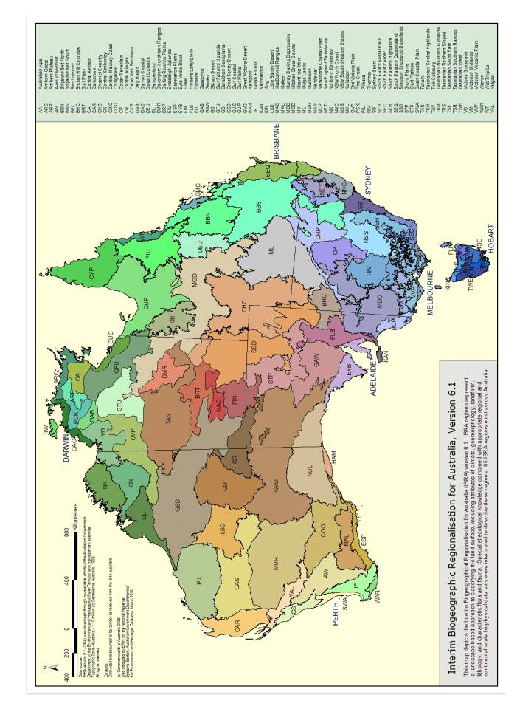

**3 b) All Ecological Communities Currently Under Assessment**

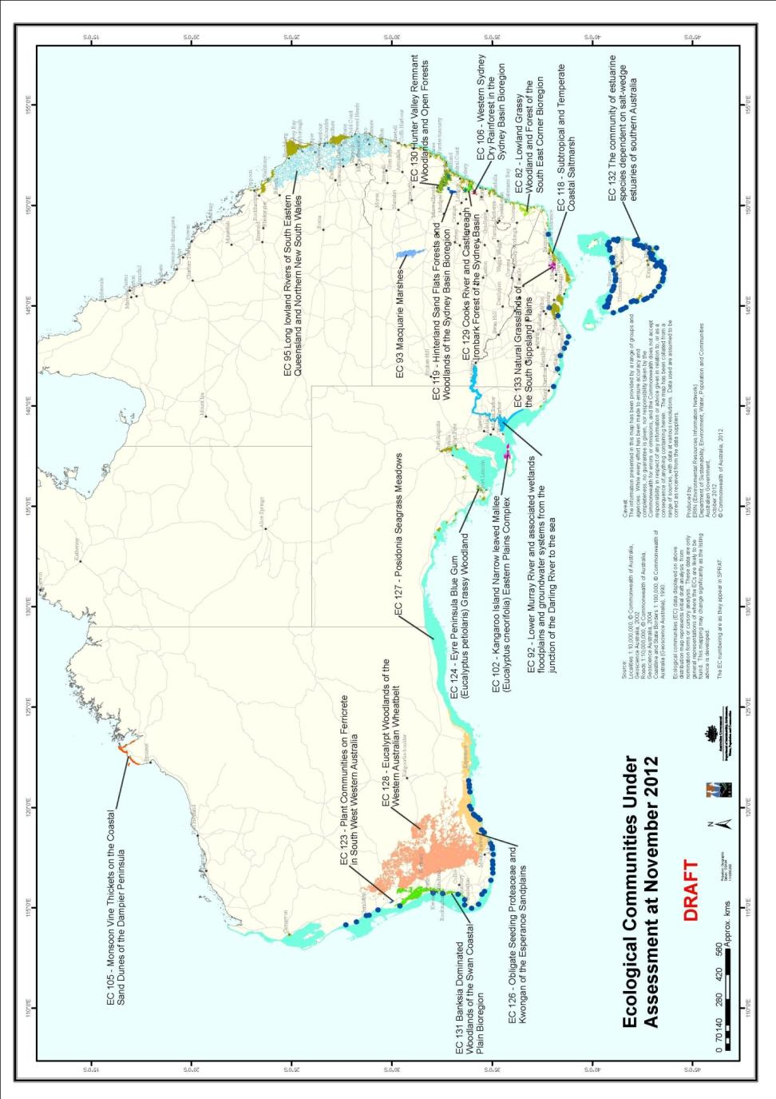

**3 c) Listed Ecological Communities by State/Territory**

**Queensland:**

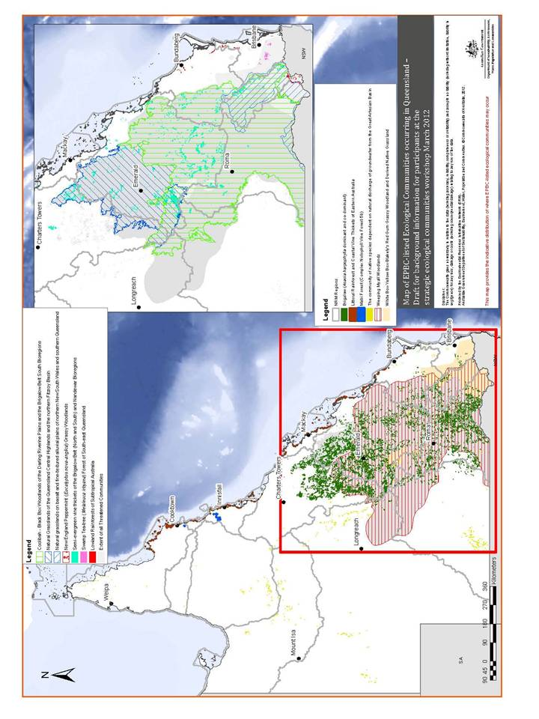

**NSW/ACT (map 1 of 2):**

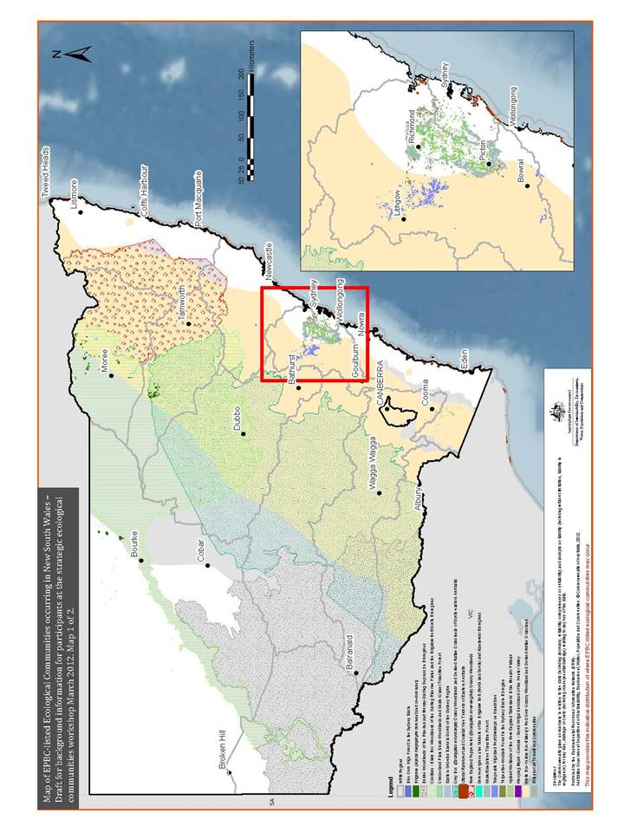

**NSW/ACT (map 2 of 2):**

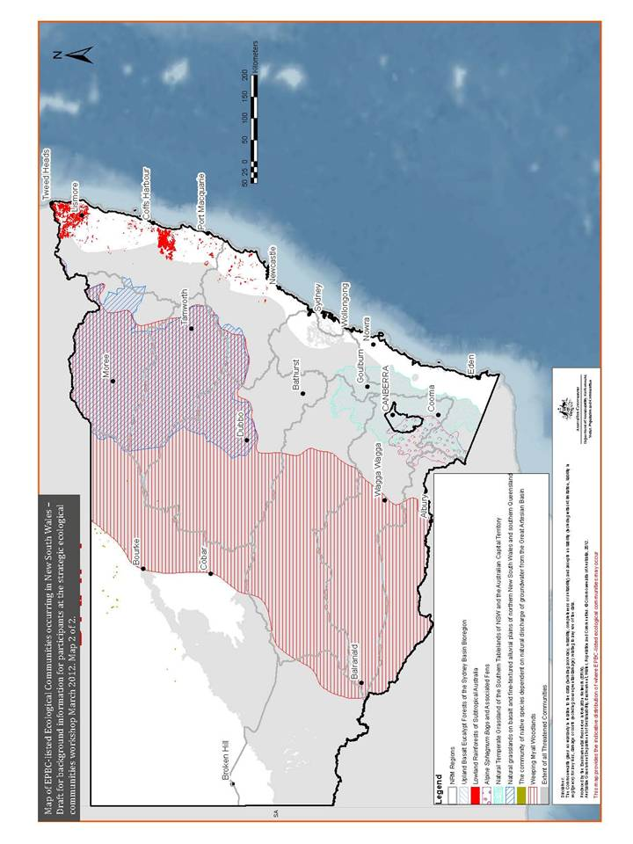

**Victoria:**

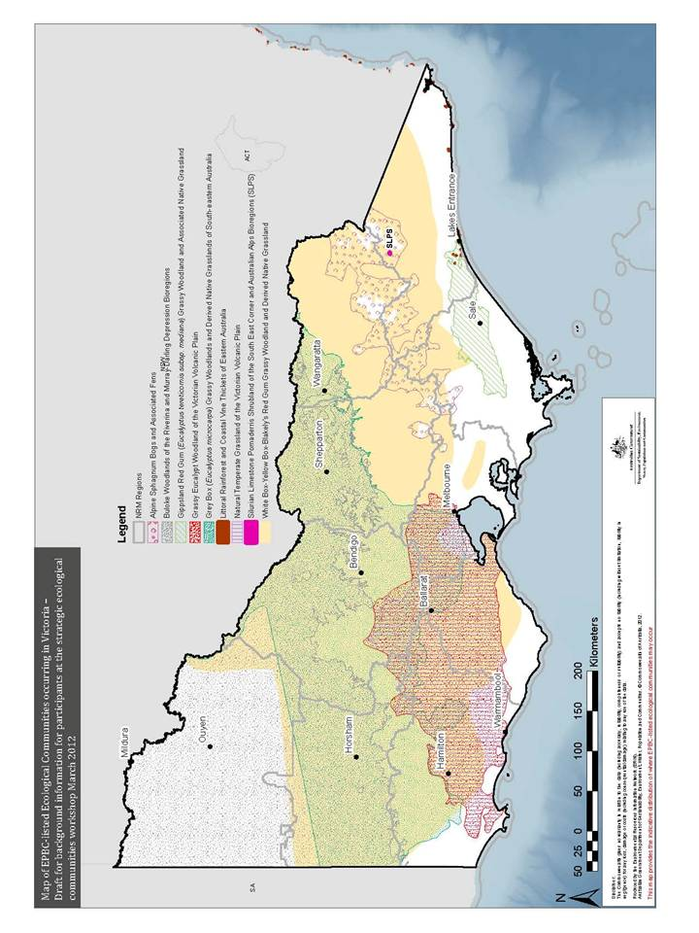

**Tasmania:**

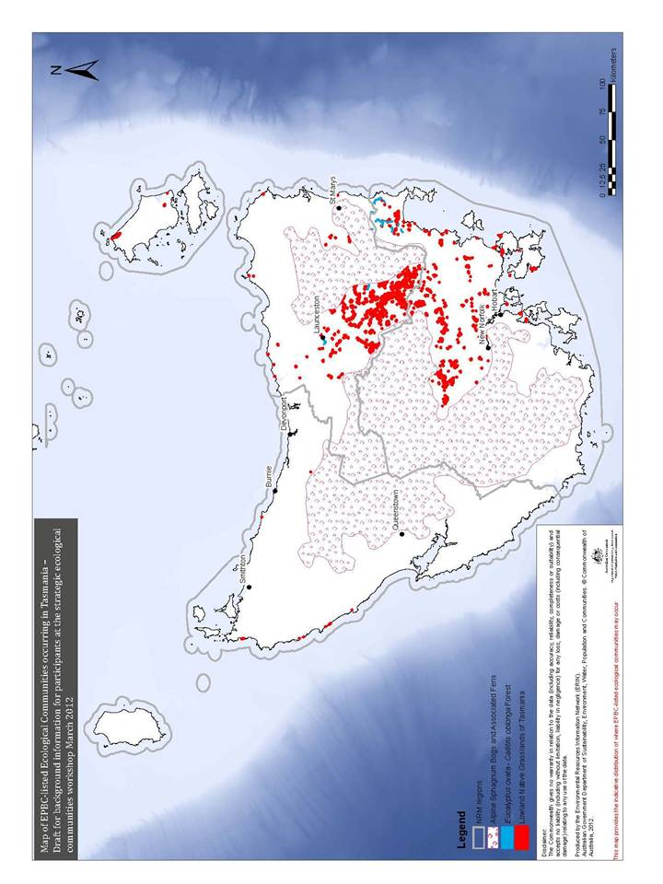

**South Australia:**

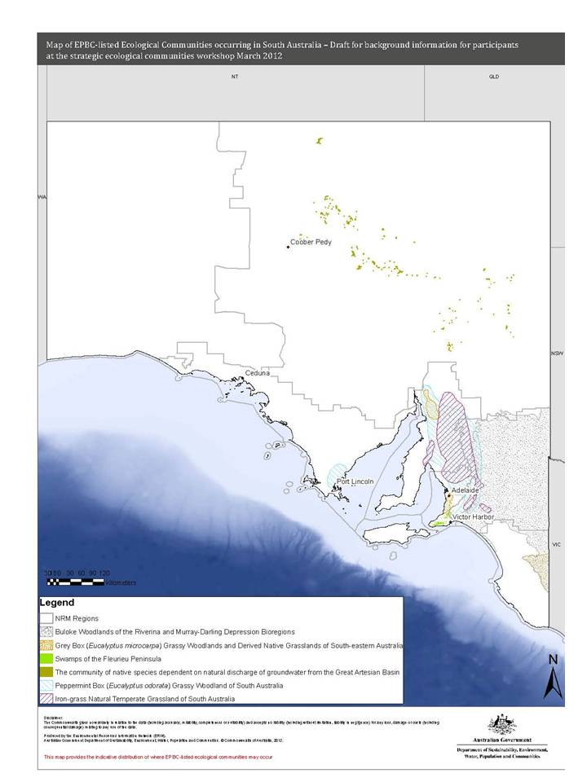

**Western Australia:**

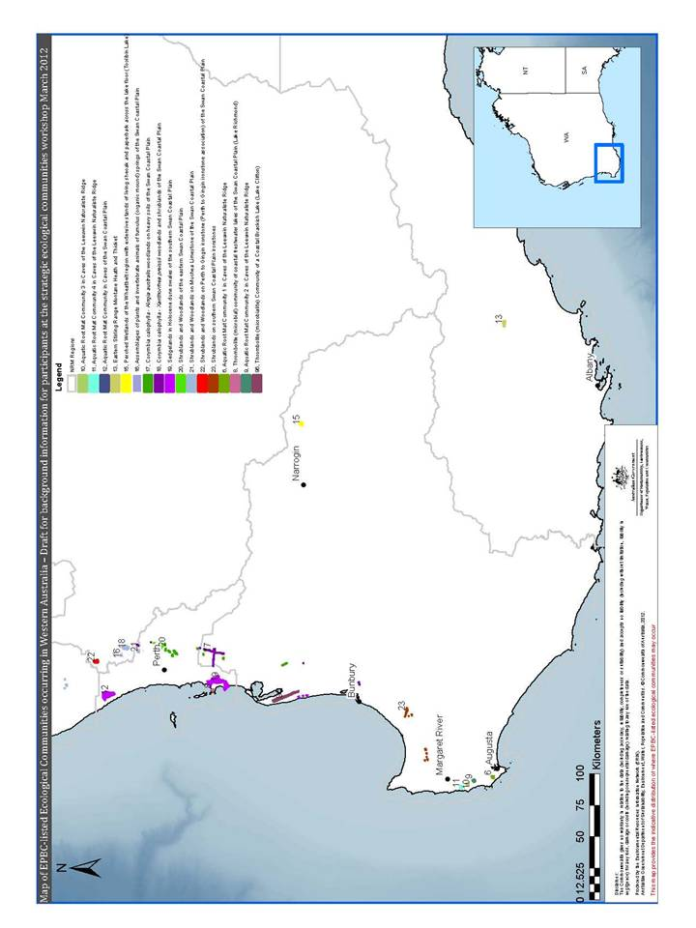

**Northern Territory:**

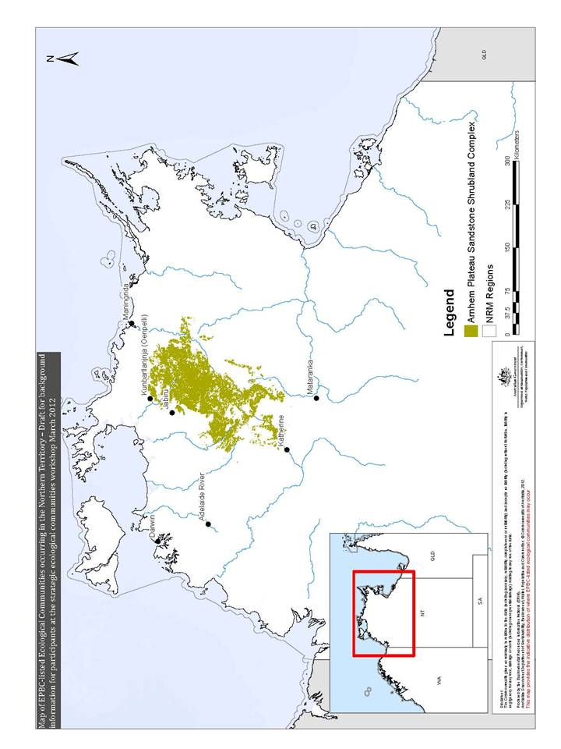

**3 d)** **Remaining Native Vegetation (% of pre-1750 extent by IBRA region)**

(from State of the Environment 2011; available at: http://www.environment.gov.au/soe/2011/report/coasts/2-3-coastal-land.html)

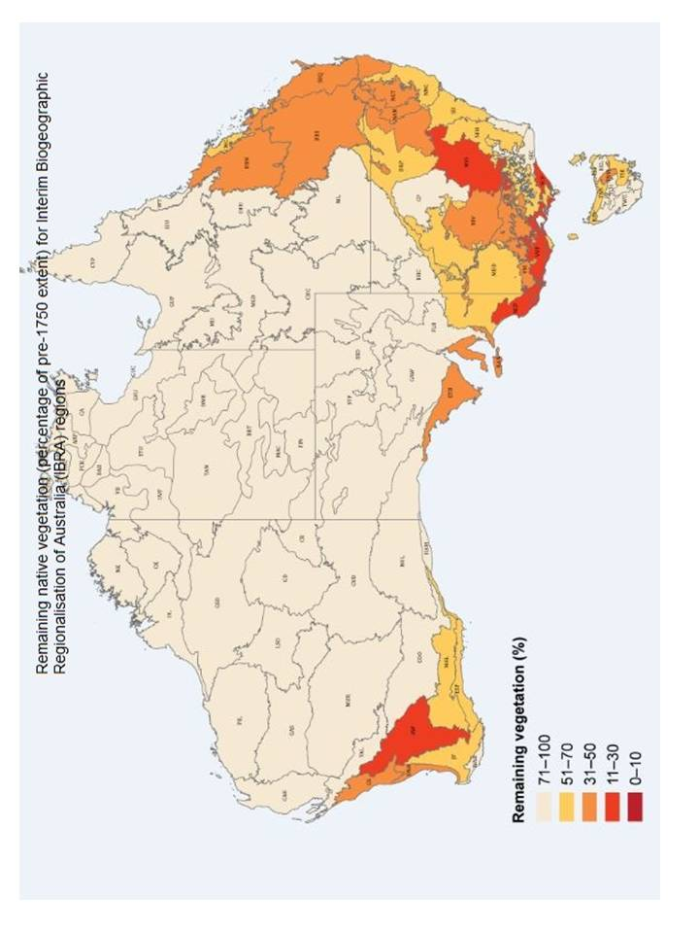

**3 e)** **Biodiversity Hotspots Map**

(available at: http://www.environment.gov.au/biodiversity/hotspots/national-hotspots.html)

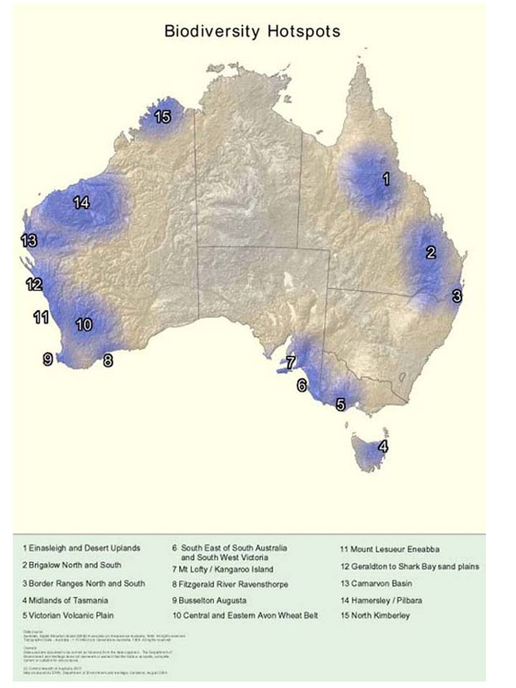

**3 f)** **Parks and Reserves by Bioregion**(available at: http://www.environment.gov.au/parks/nrs/science/maps.html)

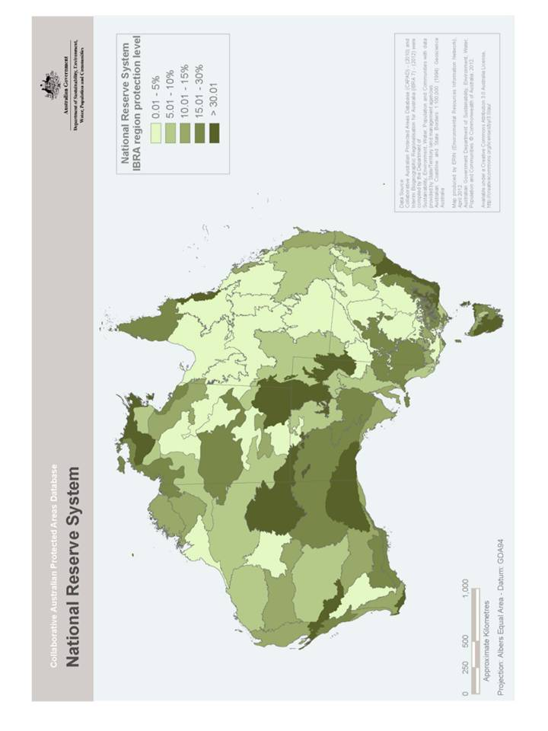

**3 g)** **Ramsar Wetlands of Australia**(available at: http://www.environment.gov.au/cgi-bin/wetlands/alphablist.pl)

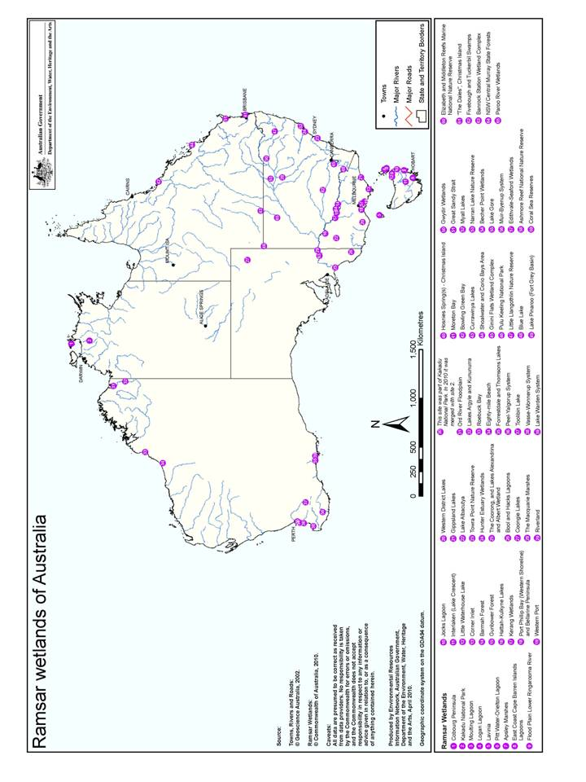

**Appendix 4: Strategic Workshop Participants List**

|  |  |  |
| --- | --- | --- |
| **Surname** | **First name** | **Organisation** |
| Arthington | Angela | Australian Rivers Institute, Griffith University |
| Auld | Tony | NSW Scientific Committee |
| Baldwin | Darren | CSIRO Land and Water |
| Barraclough | Paul | Ecological Communities Section, DSEWPaC |
| Barton | Collette | Ecological Communities Section, DSEWPaC |
| Benson | John | Royal Botanic Gardens, Sydney |
| Bisset | Ramone | Ecological Communities Section, DSEWPaC |
| Bolton | Matt | ERIN, DSEWPaC |
| Bourne | Mark | Ecological Communities Section, DSEWPaC |
| Burton | Neisha | Ecological Communities Section, DSEWPaC |
| Butcher | Rhonda | Victorian Scientific Advisory Committee |
| Callister | Deb | Assistant Secretary, Wildlife Branch, DSEWPaC |
| Cheal | David | Arthur Rylah Institute, Vic Dept of Sustainability and Environment |
| Conrick | Di | Aquatic Ecosystems Policy, DSEWPaC |
| Craigie | Vanessa | Vic Dept of Sustainability and Environment |
| English | Val | WA Dept of Environment and Conservation |
| Fitzhardinge | Guy | Threatened Species Scientific Committee |
| Guymer | Gordon | Threatened Species Scientific Committee |
| Harris | Stephen | Tas Dept of Primary Industries, Parks, Water and Environment |
| Harrison | Peter | Threatened Species Scientific Committee |
| Heupel | Michelle | Threatened Species Scientific Committee |
| Hoffman | Anthony | Ecological Communities Section, DSEWPaC |
| Humphreys | Bill | Threatened Species Scientific Committee |
| Keith | David | NSW Office of Environment and Heritage |
| Kitchin | Margaret | ACT TAMS |
| Kroon | Frederieke | Ecosystem Sciences, CSIRO |
| Lake | Sam | Emeritus Professor, Monash University |
| Latch | Peter | Recovery Planning, DSEWPaC |
| Marsh | Helene | Chair, Threatened Species Scientific Committee |
| Mattiske | Libby | Australian Heritage Council |
| Meakin | Chris | ERIN, DSEWPaC |
| Newton | Gina | Ecological Communities Section, DSEWPaC |
| Pisanu | Phil | SA Dept of Environment and Natural Resources |
| Purdie | Rosemary | Threatened Species Scientific Committee |
| Quartermain | Evan | Humane Society International |
| Richards | Karina | Ecological Communities Section, DSEWPaC |
| Ritchie | Veronica | Strategic Approvals West, DSEWPaC |
| Sinclair | Paul | Australian Conservation Foundation (Healthy Ecosystems) |
| Sinclair | Steve | Arthur Rylah Institute, Vic Dept of Sustainability and Environment |
| Stacpoole | Tanya | Environmental Stewardship Program, DSEWPaC |
| Tng | David | School of Plant Science, University of Tasmania |
| Vranjic | John | Ecological Communities Section, DSEWPaC |
| Walker | Keith | Threatened Species Scientific Committee |
| Wardrop | Martin | Conservation Policy, DSEWPaC |
| White | Matt | Director, Ecological Communities Section, DSEWPaC |
| Williamson | Jane | Chair, NSW Fisheries Scientific Committee |
| Wilson | Bruce | Qld Dept Environment & Resource Management |
| Woinarski | John | Threatened Species Scientific Committee |
| Wright | Tori | Species Listing (& Key Threatening Processes), DSEWPaC |

1. From central Queensland, through New South Wales west of the Dividing Range, across northern Victoria and into eastern South Australia; and noting that although these are key native vegetation remnants in these regions, they are highly fragmented across the landscape.
2. For marine workshop report see: http://www.environment.gov.au/biodiversity/threatened/publications/workshop-marine-communities.html
3. Guidelines prepared by the TSSC are available at: http://www.environment.gov.au/biodiversity/threatened/pubs/guidelines-ecological-communities.pdf
4. SPRAT is the Species Profile and Threats Database provides information on threatened species and ecological communities listed under the EPBC Act., see: http://www.environment.gov.au/cgi-bin/sprat/public/sprat.pl.
5. Strategic Assessments are landscape scale assessments that can consider a broader set of actions, for example as large urban growth area developed over many years, or a fire management policy over a broad landscape, regional scale development plans and policies. See: http://www.environment.gov.au/epbc/assessments/strategic.html
6. Victorian bioregions are broadly equivalent to IBRA subregions that occur within Victoria. EVCs may have a bioregional conservation status of Possibly extinct (X), Endangered (E), Vulnerable (V), Depleted (D), Rare (R) or Least concern (LC).
7. More information about the EVC system is available from the Victorian Department of Sustainability and Environment:

   <http://www.dse.vic.gov.au/conservation-and-environment/native-vegetation-groups-for-victoria/ecological-vegetation-class-evc-benchmarks-by-bioregion>.
8. Benson J.S. (2006). New South Wales Vegetation Classification and Assessment: Introduction — the classification, database, assessment of protected areas and threat status of plant communities. See: <http://www.rbgsyd.nsw.gov.au/__data/assets/pdf_file/0008/110060/Cun9Ben331.pdf>