

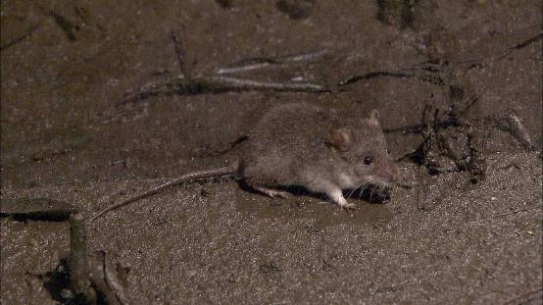

Significant impact guidelines for the vulnerable water mouse (Xeromys myoides)

Nationally threatened species and ecological communities

Background paper to EPBC Act policy statement 3.20

Contents
Acknowledgments 3
Introduction 4
Conservation status 4
About the water mouse 4
Description 4
Distribution 4
Abundance 5
Habitat 5
Northern Territory 5
Central south Queensland 6
South-east Queensland 6
Diet 13
Nesting 14
Reproductive biology 16
Movement 16
Key threats 17
Habitat removal 17
Alteration of natural hydrology 18
Fragmentation 18
Acid sulfate exposure 18
Weeds 18
Predation 19
Herbicides, pesticides and oil pollution 19
Other threats 19
Recovery priorities 20
Significant impact assessment 21
Significant impact threshold 21
Important populations 21
Regional considerations for an important population 21
Habitat critical to the survival of the species 22
Mitigation measures 22
Experimental mitigation measures 23
Translocation 23
Survey guidelines 23
References 28

Acknowledgments
The Department of the Environment Water Heritage and the Arts would like to thank the following people for their participation at the workshop in Brisbane and for their valued expert advice in the development of the policy statement and background paper: Steve Van Dyck, Heather Janetzki, Ian Gynther, Derek Ball, Tina Ball, Simon Ward, Rod Hobson and Mark Breitfuss.

© Commonwealth of Australia 2009
This work is copyright. You may download, display, print and reproduce this material in unaltered form only (retaining this notice) for your personal, non-commercial use or use within your organisation. Apart from any use as permitted under the Copyright Act 1968, all other rights are reserved. Requests and inquiries concerning reproduction and rights should be addressed to Commonwealth Copyright Administration, Attorney General’s Department, Robert Garran Offices, National Circuit, Barton ACT 2600 or posted at www.ag.gov.au/cca.

Disclaimer
The contents of this document have been compiled using a range of source materials and is valid as at November 2009. The Australian Government is not liable for any loss or damage that may be occasioned directly or indirectly through the use of reliance on the contents of the document.
Front page photograph: The water mouse Xeromys myoides (photo taken by Totally Wild, Channel Ten)

Introduction
This paper provides background to EPBC Act policy statement 3.20 – Significant impact guidelines for the water mouse (Xeromys myoides) hereafter referred to as the policy statement. This background paper provides the biological and ecological context for the habitat areas, significant impact thresholds, and mitigation measures defined for the water mouse in the policy statement. The information provided in this paper has been prepared on the best available information gathered from scientific literature, consultation with experts and an understanding of the application of the Australian Government Environment Protection and Biodiversity Conservation Act 1999 (EPBC Act). Increases in knowledge will be accounted for in future policy revisions.

Conservation status
The water mouse is listed as vulnerable under the EPBC Act. Listed threatened species and ecological communities are a matter of national environmental significance recognising the importance from a national perspective. Under the EPBC Act an action will require approval from the federal environment minister if the action has, will have, or is likely to have a ‘significant impact’ on a matter of national environmental significance.
The water mouse is also listed as vulnerable in Queensland under the Queensland Nature Conservation Act 1992 and as data deficient in the Northern Territory under the Territory Parks and Wildlife Conservation Act 2000. The listing of a species, subspecies or ecological community listed as threatened under the EPBC Act recognises the conservation status of the entity from a national perspective and does not replace listing under state, regional or local legislation or regulations.
Judgements may differ between Australian, state and local decision making processes, due to the different scales of consideration. If your activity could affect the species or individual animals you should contact the relevant State and local authorities regarding your obligations.

About the water mouse

Description
The water mouse is of unmistakeable appearance (Woinarski et al 2007). It is a small rodent which has a maximum head and body length of 126mm and maximum weight of 64g. It has short, very dense and silky fur that is dark slate-grey above and pure white below. The species has a strong musty odour. Very old individuals are grizzled all over and have a rufous wash to the flanks. Adults are usually white-spotted dorsally (Queensland). The ears are rounded and short and the eyes are very small. The hindfeet are not webbed. The tail is slender, thinly haired and very finely ringed (smooth). The water mouse has only two molars in each of the upper and lower rows (Gynther and Janetzki 2008). The water mouse appears to be totally nocturnal.

Distribution
The water mouse occurs in three discrete populations on the eastern and northern Australian coastline (refer to figures 1-3).
In the Northern Territory, the species has been recorded between the Glyde River in eastern Arnhem Land and the Daly River floodplain (Woinarski et al 2007). One Northern Territory population is known from Kakadu National Park, but there is no knowledge of this population other than a broad location described as South Alligator at the time of its discovery in 1903 (Woinarski 2004). The close proximity of records to the Western Australia/Northern Territory border suggests that it is possible that the species may occur in coastal parts of the Kimberley region of Western Australia (Morris 2000).
In central south Queensland, the water mouse occurs between Agnes Water and Cannonvale and Mackay is the type locality for the species. In south-east Queensland the water mouse occurs between the Coomera River (50km southeast of Brisbane) and Hervey Bay; the islands of Moreton Bay and Pumicestone Passage, including the lee of North and South Stradbroke and Bribie Islands; and Fraser Island. The species has also been recorded as far inland as Beerwah (Dwyer et al. 1979).
The water mouse is also known to occur outside of Australia from the middle of the Torassi (Bensbach) River in south west Papua New Guinea (Hitchcock 1998).

Abundance
The population size of water mouse in Queensland has been estimated at between 1001 to 10000 individuals occupying an area of between 101 to 1000 km² (Dickman et al 2000). No abundance estimates have been made for the Northern Territory population as few records exist and there has been relatively little survey of the species mangrove and adjacent sedgeland-grassland habitats (Woinarski 2000).

Habitat
The water mouse requires mangrove communities and associated saltmarsh, sedgelands, clay pans, heathlands and freshwater wetlands with intact hydrology that provide adequate nest sites and prey resources. Habitat suitability mapping for the water mouse is presented in Figures 1, 2 and 3. The water mouse’s habitat varies across the three disjunct regional populations. Littoral, supralittoral and terrestrial vegetation differs in structure and composition between the three populations and in turn dictates water mouse nesting behaviour (see Figure 4 and ‘nesting’ section).

Northern Territory
In the Northern Territory, water mouse habitat preferences are not as well/less poorly known but appear to utilise both intertidal and freshwater habitats. Most records have been from mangrove forests, saltmarsh, sedgelands, clay pans and freshwater melaleuca wetlands (Redhead and McKean 1975; Magnusson et al 1976; Woinarski et al 2000). Initial capture sites in the Northern Territory along the Daly River were from moist regions at the edges of freshwater lagoons which during the dry season had receded from an outer margin of paperbark Melaleuca nervosa and freshwater mangrove Barringtonia acutangula, leaving an exposed plain of dry cracked earth covered with grasses and sedges (Redhead and McKean 1975).
A specimen recorded from mangroves along the Tomkinson River in Arnhem Land was captured beneath corrugated iron three metres from the river’s edge in a small patch of saltmarsh Sporobolus virginicus grassland, surrounded on three sides by mangrove forest comprised of Avicennia eucalyptifolia, Lumnitzera racemosa, Exoecaria agallocha and Ceriops tagal var. australis (Magnusson et al 1976). On Melville Island from the banks of Andranangoo Creek, water mice were found nesting within a mound of black friable mud within a tall Bruguiera parviflora mangrove forest with a few Ceriops tagal (Magnusson et al 1976).
Habitat information from more recent captures in the Northern Territory on the floodplain of the Glyde River (Woinarski et al 2000) included an extensively inundated saline light clay plain, with scattered low chenier ridges and patches of low chenopod shrubland intergrading with the saline grassland. This grassland was sparsely vegetated with Sporobolus virginicus, Cyperus scariosus and Cressa cretica and lacked any water in the immediate vicinity.

Central south Queensland
In central south Queensland, the water mouse has only been captured in the high inter-tidal zone in tall, closed fringing mangrove forest containing only Ceriops tagal and/or Bruguiera sp (Ball 2004). Although not considered core habitat, the water mouse has also been captured in saline grassland adjacent to a closed forest of Ceriops tagal and Bruguiera sp and in closed forest of Avicennia marina (Ball 2004). A supralittoral bank is usually absent in this subregion.
The type specimen from near Mackay was caught in a permanent reed swamp, covered with tall grass, shrubs and Pandanus, one mile from a beach near Mackay (Troughton 1943). The moist wallum, heath, sedgeland and freshwater influences along mangrove ecotones as described by Van Dyck (1996) were not present to any large degree at the capture sites in south central Queensland and more typically comprised distinct ecotones between mangroves and dry sclerophyll woodlands and/or saltpan (Ball 2004).

South-east Queensland
In south-east Queensland, water mouse habitat includes mangrove communities and adjacent sedgelands, grasslands and freshwater wetlands. Mangrove communities in this region are typically comprised of Avicenna marina var. australasica, Rhizophora stylosa, Bruguiera gymnorrhiza, Aegiceras corniculatum and Ceriops tagal var. australis (Van Dyck and Durbidge 1992; Van Dyck 1996; Van Dyck and Gynther 2003; see Photos 1& 2).
In south-east Queensland the upper tidal areas on the shoreward side of the mangrove zone often support sedgelands or salt meadows, comprised of Juncus kraussii, Baumea juncea, B. rubiginosa, Fimbristylis ferruginea and Sporobolus virginicus. The adjacent terrestrial communities are typically freshwater wetland, coastal woodland or wet heathland dominated variously by species such as Melaleuca quinquenervia, Corymbia intermedia, Casuarina glauca, Eucalyptus robusta, Leptospermum liversidgei, Gahnia sieberiana and Caustis blakei. A supralittoral bank may also be present and be utilised by the water mouse for nesting (Van Dyck and Durbidge 1992; Van Dyck 1996; Van Dyck and Gynther 2003).
Studies on North Stradbroke Island suggested that the most productive zone for the water mouse lies between nests at the supralittoral bank and the first 100 metres into the mangroves (Van Dyck 1996). The floor of mangrove habitats provide a variety of microhabitat features important to the water mouse including tidal pools, channels, crab holes, pneumatophores, crevices in bark and around roots, hollows in standing and fallen timber, suspended drifts of twigs and leaves and driftwood. These microhabitats vary according to the structure of the community (Van Dyck 1996).
The water mouse has also been captured from a variety of freshwater wetland/ wet heath habitats in South-east Queensland. The water mouse was captured in a dry creekbed of the Beerwah scientific area which comprised dense Persoonia, Banksia robur, Gahnia and grass inside a five-year old slash pine plantation, 25m from a stream fringed with Casuarina and Callitris, and 30m from a sedge swamp fringed by Melaleuca (Dwyer et al 1979). In Cooloola, South-east Queensland, the water mouse was captured in dense restiad swamp with some Gahnia and shallow surface water, within 300m of Noosa River (Dwyer et al 1979). On Fraser Island, the water mouse was recorded near Garry’s Anchorage in an ecotone of reedy (Lepironia articulata) swampland and wet heathland (Pers. comm. Rob Hodson. DERM).
The Queensland Department of Environment and Resource Management maps ‘Essential Habitat’ for endangered, vulnerable, rare or near threatened species in Queensland. This mapping is based on the buffering of known water mouse records. Essential habitat for the water mouse is currently only mapped for the Central Queensland Coast bioregion however there are plans to extend this into the Brigalow Belt and South-east Queensland bioregions in the near future (David McFarland, DERM. pers.comm, 2009).

Essential habitat for the water mouse in the Central Queensland Coast bioregion includes Regional Ecosystem (RE) 8.1.1, whilst REs likely to be considered habitat in the Brigalow Belt and Southeast Queensland bioregions represent similar mangrove habitats (REs 11.1.4 and 12.1.3, respectively), with possibly the addition of adjacent patches of other saline communities (REs 11.1.1 and 11.1.2 except 11.1.2a, 11.1.3 and 12.1.2) (pers.comm. David McFarland, DERM, 2009). No freshwater wetland RE’s are considered essential habitat for the water mouse. A description of these REs considered or likely to be considered Essential Habitat is presented in Table 1.
Table 1 Regional Ecosystems considered essential habitat in Queensland or considered likely to be essential habitat in the near future.
Bioregion (Sattler and Williams 1999) | RE code | Description (EPA 2007) | Essential Habitat
Central Queensland Coast | 8.1.1 | Mangrove vegetation of marine clay plains and estuaries. | Yes
Brigalow Belt | 11.1.1 | Sporobolus virginicus grassland on marine clay plains. | Likely
Brigalow Belt | 11.1.2 | Samphire forbland or bare mud-flats on Quaternary estuarine deposits. | Likely
Brigalow Belt | 11.1.4 | Mangrove low forest on Quaternary estuarine deposits. | Likely
Southeast Queensland | 12.1.3 | Mangrove shrubland to low closed forest on marine clay plains and estuaries. | Likely

Figure 1 - habitat mapping for the water mouse in the Northern Territory
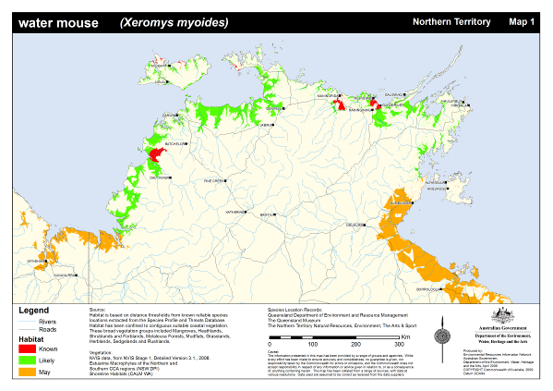

Figure 2 Known, likely and may occur habitat mapping for the water mouse in south central Queensland
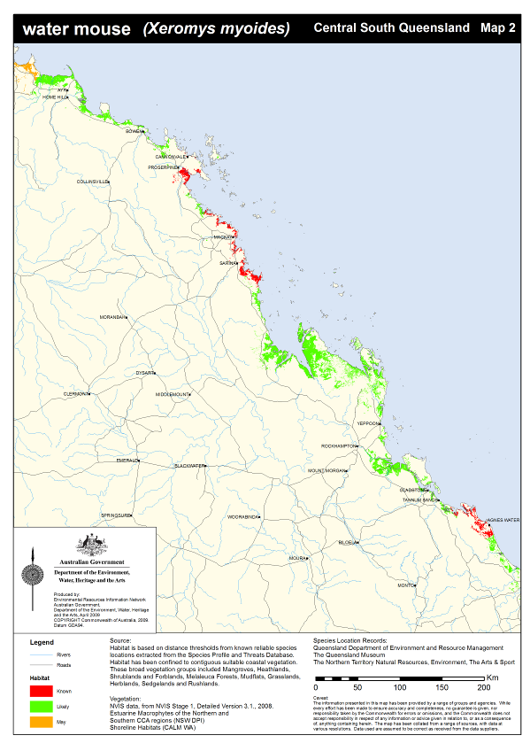

Figure 3 Known, likely and may occur habitat mapping for the water mouse in south-east Queensland.
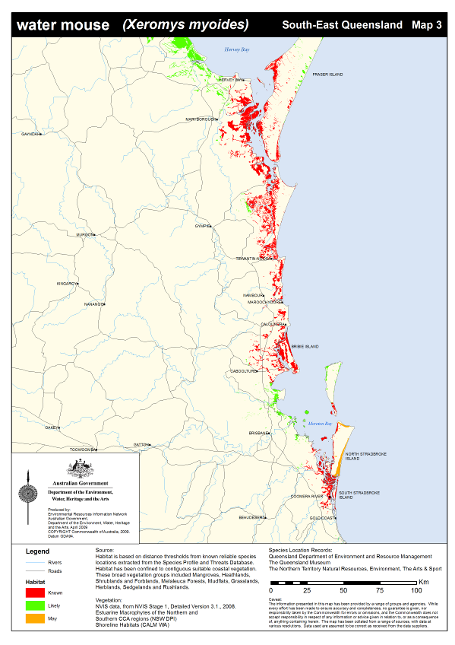

Figure 4 - Habitat profile of the water mouse

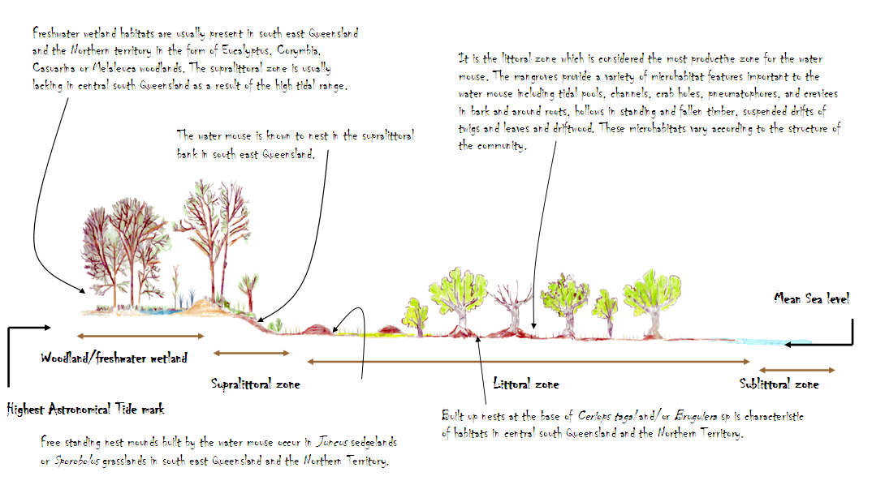
Photo 1 Mangrove habitat in south-east Queensland (photo taken by David Jackson, DEWHA)
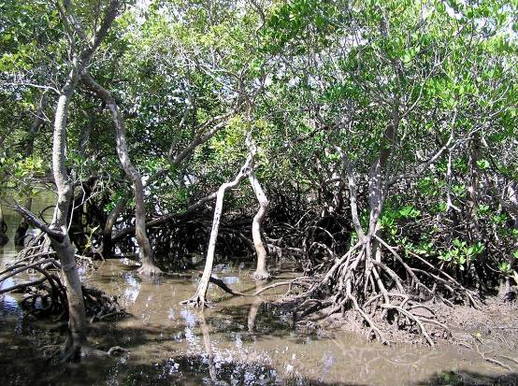
Photo 2 Supralittoral and littoral habitat in south-east Queensland (photo taken by David Jackson, DEWHA)
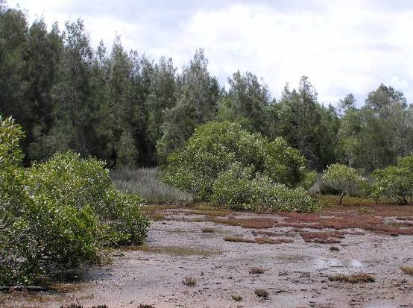

Diet
Van Dyck (1996) investigated the diet of the water mouse on North Stradbroke Island in south-east Queensland. These observations were made directly and revealed a variety of crustaceans (Parasesarma erythrodactyla, Helice leachi and Australoplax tridentata), marine polyclads, marine pulmonates (Salinator solida, Ophicardelus quoyi and Ochidina australis) and marine bivalves (Glauconome sp.). Investigations of middens within and outside tree hollows also revealed the remains of the mud lobster Laomedia healyi and mottled shore crab Peragrapsis laevis (Van Dyck 1996). This suite of species is common on intertidal saltmarsh habitats in south-east Queensland (Breitfuss et al 2004).

The dietary preferences in central south Queensland appear to be similar and include grapsid crabs (Ball 2004; Photo 3). Whilst limited information exists on the diet of the water mouse in the Northern Territory, the remains of a grapsid crab, Neoepisesarma mederi were discovered within and outside a mound nest on Melville Island (Magnusson et al 1976). Plant foods to date have not been reported in the diet of the water mouse, however gut morphology suggests that the diet of the water mouse should not be totally carnivorous (Van Dyck 1996).

Photo 3 Grapsid crabs – an important component of the water mouse diet (photo taken by David Jackson, DEWHA)
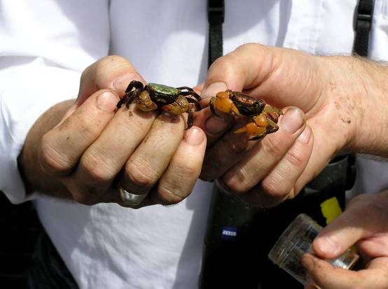

Nesting
The water mouse creates nests which are important for breeding and refuge from high tide and predators. The water mouse constructs five types of nests: free-standing, termitarium-like mound nests or mounds at the base of mangrove trees, mound nests on small elevated ‘islands’ within the tidal zone, mound nests or holes in supralittoral banks; nests inside hollow tree trunks, and nests in spoil heaps created as a result of human activity (Van Dyck and Gynther 2003; Van Dyck et al 2003; Photos 4-6).
Nest mounds are usually 20 to 60cm in height with a basal circumference of 1.6 to 4.8m, with one to three entrance holes, although other entrances may be hidden (Magnusson et al 1976; Van Dyck 1992; Van Dyck and Gynther 2003). Burrow entrances can be at the top, sides or bottom, or in adjoining banks or fallen timber (Van Dyck and Gynther 2003).
Fresh mud plastering on the top of nest mounds can indicate that a mound has been built up to maintain its height above high tide level (Van Dyck and Gynther 2003). Mud pathways also may be present on the side of mounds where the water mouse has excavated mud from a tunnel and spread it along a track. These mud plastering’s may include bits of vegetation, dried leaves, sedges and crab shells (Van Dyck and Gynther 2003). The nests recorded in sites adapted from spoil heaps include materials such as excavated or bulldozed sand, rocks and earth, and tree-stump waste (Van Dyck and Gynther 2003). A distinctive odour may indicate whether the water mouse is nesting in a mound (Van Dyck and Gynther 2003).
Nesting in central south Queensland does not appear to include free standing nests ascribed to the species elsewhere but seem restricted to mud ramps constructed between the buttress roots of Ceriops tagal or more commonly Bruguiera parviflora or B. gymnorrhiza (Ball 2004). Magnusson et al (1976) however discovered similar free standing nests to that in south-east Queensland on Melville Island in the Northern Territory. The nest was described as a mound of black friable mud, 60cm in height and semi circular at the base, against and interlocked within the buttress trunk of a B. parviflora.
It is assumed the water mouse does not need to build mounds or obvious nest structures in non-tidal environments.

Photo 4 A water mouse nest near the base of a Casuarina glauca on a small elevated ‘island’ within the littoral zone in south-east Queensland (photo taken by Tim McGrath, DEWHA).
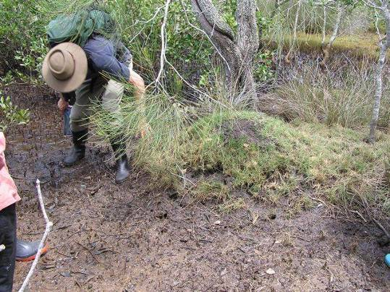
Photo 5 Free standing nest mound within sedgeland supporting Juncus kraussii and Baumea juncea (photo taken by Tim McGrath, DEWHA).
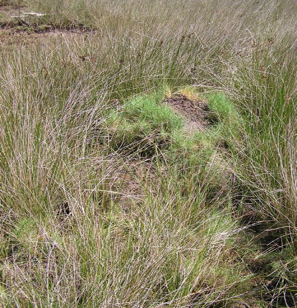
Photo 6 A nest mound at the base of a tree in the supralittoral bank supporting Casuarina glauca and Melaleuca quinquenervia (photo taken by Dr Ian Gynther, DERM).
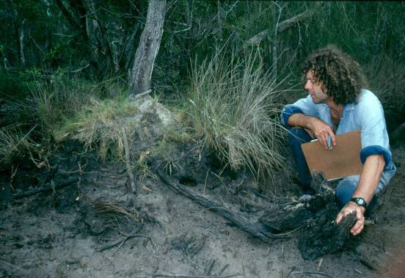

Reproductive biology
Little is known about the reproductive biology of the water mouse however the benchmark research undertaken by Van Dyck (1996) on North Stradbroke Island has given some insight into the reproductive biology of the species in south-east Queensland. Van Dyck (1996) found that up to eight individuals of both sexes can share a nest mound, however there is generally only one sexually active male present. The nest may also be used by successive generations over a number of years. Scrotal males were recorded in all months except January, February and April.
Females in this population were presumed to be pregnant if they showed a swollen appearance and increased weights, and such females were recorded in the months of January, May, August, September and October, and females with enlarged nipples were recorded from July through to December. Juveniles were recorded in the months of May, July, August and November. Endoscopic examination of a nesting chamber on North Stradbroke Island revealed a litter of four dark-skinned but hairless young which the adult—upon detection of the endoscope—removed one by one to another location in the nesting mound (Van Dyck 1996). Van Dyck (1996) commented that in the absence of further information on breeding it would appear that the water mouse is capable of breeding throughout the year.

Movement
The water mouse has been observed to travel relatively large distances of up to 3km a night while criss-crossing home ranges averaging 0.7ha (Gynther and Janetzki 2008). Home range estimates by Van Dyck (1996) at Rainbow Channel on North Stradbroke Island suggested animals had an average home range of 0.64ha. Data from animals radio tracked by Van Dyck (1996) also indicated that males had a larger home than females (male average 0.77ha; female 0.53ha). Home range estimates differed greatly between sites with animal’s radio tracked further south at Canalpin Creek having a much larger home range estimate of 3.42ha. Larger home ranges are thought to be a result of microhabitat complexity and width of the mangrove zone at a site (Van Dyck 1996). Nothing is known about dispersal movements in this species.

Key threats
The removal and degradation of habitat as a result of development actions is the principal threat to the survival of the water mouse. Development actions likely to impact on the water mouse include sand mining, urban residential development, resorts and marina development, bund walling, aquaculture projects and creation or upgrading of easements for energy distribution or infrastructure for example electricity, gas or water pipelines.
Habitats used in central south Queensland are often directly adjacent to terrestrial areas that are subject to ongoing disturbance, modification and clearing, aquaculture and housing (Ball 2004) and important populations in south-east Queensland on North Stradbroke Island are continually threatened by expansion of mining activities (Van Dyck 1996). In the Northern Territory there is a paucity of information to determine what the actual key threatening processes are (Woinarski et al 2000). Development actions such as, but not limited to, those described above have the potential to introduce threatening processes to water mouse habitat, or contribute to or increase the intensity and magnitude of existing threats to the water mouse. Threats and threatening processes to the water mouse are discussed in more detail below.

Habitat removal
Regional Ecosystem (RE) data (EPA 2007) estimates the area of water mouse habitat cleared in Queensland since pre-clearing times. Using regional ecosystems considered or likely to be considered essential habitat in Queensland resulted in an estimate that 31,213ha of water mouse habitat had been cleared between pre-clearing times and 2005 (see Table 2).
Table 2 Extent of water mouse habitat cleared in Queensland. Estimate taken from pre clearing to 2005 (EPA 2007)
RE code | Description (EPA 2007) | Pre clearing extent (ha) | Extent remaining in 2005 (ha) | Estimate of clearing (pre clearing to 2005)  (ha)
8.1.1 | Mangrove vegetation of marine clay plains and estuaries. | 41,024 | 40,248 | 776
11.1.1 | Sporobolus virginicus grassland on marine clay plains. | 35,008 | 17,633 | 17,375
11.1.2 | Samphire forbland or bare mud-flats on Quaternary estuarine deposits. | 11,3110 | 104,073 | 9037
11.1.4 | Mangrove low forest on Quaternary estuarine deposits. | 85,291 | 84,282 | 1009
12.1.3 | Mangrove shrubland to low closed forest on marine clay plains and estuaries. | 53,499 | 50,483 | 3016
Note: This data refers only to intertidal habitats. It does not consider freshwater habitat that has been lost and is likely to be an underestimate.

Alteration of natural hydrology
The draft national recovery plan for the water mouse (DERM 2009a) lists the following alterations to hydrology as threats to the water mouse:
- changes in natural hydrology including increased freshwater inflows and sedimentation from storm water run-off as a result of adjacent development
- physical changes to saltmarsh such as runnelling or bundwall construction that modify tidal amplitude and frequency of inundation
- modified water levels and salinity in tidal waterways resulting from installation of flow control gates for flood mitigation, and
- drainage of coastal and terrestrial wetlands for urban and industrial developments.
These threats can affect natural, disturbed or created water mouse habitat. The alteration of overland water flows such as the concentration of stormwater run-off from adjacent urban areas has been observed in central south Queensland (Ball 2004). Such artificial physical processes may impact on the water mouse indirectly. For example, increased stormwater runoff from expanding urbanisation causes changes to salinity and sediment loads which are detrimental to populations of grapsid crabs, a major food source of the water mouse (Ball et al. 2006).

Fragmentation
The fragmentation of freshwater and intertidal wetland communities is considered one of the most important issues to the water mouse as it can reduce potential feeding resources and nesting opportunities, extend edge effects, promote weed invasion and increase feral pest densities or their impacts on native fauna (DERM 2009a). Fragmented populations of water mouse are thought to be at high risk of local extinction through fox and possibly cat predation (DERM 2009a) and habitat fragmentation probably exacerbates feral predator impacts and restricts recruitment or recolonisation from adjacent areas (Gynther and Janetzki 2008).
Development actions such as residential development are the main cause of fragmentation whilst the creation of easements for power, water and gas pipelines can also result in the fragmentation of habitat. Clearing to the edges of mangrove habitat is evident in central south Queensland (Ball 2004) and is likely to have impacts on local water mouse populations.

Acid sulfate exposure
An estimated 2.3 million hectares of acid sulfate soils occur along 6500km of the Queensland coastline (DERM 2009b), coinciding with known and likely water mouse habitat (see Figures 1-3). Without appropriate management, development activities in coastal habitats have the potential to disturb acid sulfate soils which can release sulphuric acid and often toxic quantities of iron, aluminium and heavy metals. Acid sulfate soils can have a number of negative implications for the water mouse relating to habitat degradation and poor plant productivity and, most significantly, can impact negatively upon crustaceans, marine pulmonates and molluscs which are important food resources.

Weeds
Although there is insufficient information available to assess the impacts of possible threatening process in the Northern Territory, the most plausible threatening processes relate to broadscale habitat changes, especially the spread of weeds (Woinarski et al 2007). Much of the lowland wetland communities in the Northern Territory likely to support the water mouse are being transformed by the spread of exotic plants including Mimosa pigra and exotic pasture grasses such as para grass and olive hymenachne (DERM 2009a).

Predation
Direct biological impacts on the water mouse include predation pressures from native and introduced fauna (DERM 2009a). Predation pressures from feral and domestic dogs, foxes and feral and domestic cats are likely to pose significant threats to populations of the water mouse; particularly those located close to urban environments in parts of coastal Queensland. However, these pressures have not been quantified for isolated populations (DERM 2009a). Feral pigs, foxes and both feral and domestic cats are common throughout the central Queensland coast and their impact as predators on the water mouse are likely to be significant (Ball 2004).
Remains of the water mouse have been detected in dingo scats on Fraser Island (K.Twyford pers. comm.), although the population-level significance of predation of water mouse by dingoes is unknown (DERM 2009a). The remains of a water mouse have also been discovered in a crocodile in the Northern Territory (Magnusson et al 1976) however the degree to which this predation occurs is unknown. Van Dyck (1996) noted the presence of the carpet python (Morelia spilota), the rough scaled snake (Tropidechis carinatus), and tawny frogmouth (Podargus strigoides) in water mouse habitat in south-east Queensland. Although no evidence of actual predation exists, the presence of these species in this habitat and their life history suggests the water mouse may be a potential prey item. It is also possible that the water mouse represents a prey item for the water rat (Hydromys chrysogaster) (Van Dyck 1996).

Herbicides, pesticides and oil pollution
In south-east and central Queensland, saltmarsh and mangrove habitats occur adjacent to agriculture (for example sugar cane lands) and urban development. Herbicides and pesticides are employed for pest management, but may also persist in natural environments (Zimmerman et al. 2000), possibly impacting non-target populations and potentially affecting the water mouse and/or its prey and habitat (DERM 2009a).
Off-shore pollution events such as oil spills (from tankers or pipelines) have the potential to negatively influence the function and health of mangrove communities. As a result, the cumulative impacts from these activities may result in secondary effects on populations of the water mouse and/or its primary food sources (DERM 2009a). Researchers in North Queensland have recently discovered that a common agricultural herbicide, diuron, is correlated with the severe dieback of common grey mangroves Avicennia marina (Shearer 2004). The use of insecticides for mosquito control is also a process that may directly or indirectly affect water mouse populations as this process has been observed to take place in south-east Queensland where a once-known population is now considered extinct (Queensland Museum 2009).

Other threats
The use of recreational vehicles in intertidal areas is considered a threat to the water mouse (DERM 2009a). The creation of wheel ruts has the potential to cause saltwater incursion and supralittoral dieback. Any prolonged or intensive wave action from recreational vessels (for example jet skis, motorboats) could result in the erosion of supralittoral banks or the washing away of mound nests.
The discovery of a nest mound exposed by fire on an island in the supralittoral zone in Donnybrook, south-east Queensland (Van Dyck and Gynther 2003) suggests that fire in the supralittoral zone, whether as a result of development actions, natural or recreational activities or arson events, poses a threat to the water mouse.
The destruction or degradation of habitat by feral and hard-hoofed animals (for example pigs) has been recorded from a number of populations of the water mouse (DERM 2009a). Cattle grazing in the supralittoral zone may pose a threat to water mouse habitat through trampling and denudation of intertidal habitats, altering hydrology, removing vegetative cover protecting animals from predation and potentially allowing for acid sulfate soil incursions.

Recovery priorities
When deciding whether or not to grant consent or impose conditions on an action the minister must not act inconsistently with a recovery plan made or adopted under the EPBC Act. Recovery plans define the actions needed to protect and promote the recovery of the species, and provide the primary context for any determination on the likely significance of impacts and the acceptability of actions. This policy statement had been formulated to be consistent with the draft recovery plan relevant to this species and should be read in conjunction with the recovery plan. The key recovery actions identified in the draft recovery plan for the water mouse (DERM 2009a) are consistent with key threats associated with the decline of the species and include:

Specific objective 1: Identify habitats supporting populations of the water mouse and map the current distribution.
- Confirm current distribution of the water mouse.
- Consolidate data of all water mouse records and survey results.
- Produce GIS mapping and undertaken spatial analysis of water mouse habitat.
- Conduct surveys and ecological assessments of potential water mouse habitat.

Specific objective 2: Describe key biological and ecological features of the water mouse and its habitat.
- Determine whether genetic variation exists across populations of the water mouse.
- Understand the reproductive biology of the water mouse.
- Monitor sentinel field populations of the water mouse.

Specific objective 3: Identify and manage threats to species’ survival.
- Monitor representative populations.
- Assess impact of known threats to species’ survival.
- Investigate relative impact of threats to species’ survival.
- Develop and implement threat management plan.
Specific objective 4: Rehabilitate habitat to expand extant populations.
- Regenerate habitat corridors at five sites.
- Evaluate the potential for artificial nesting structures to encourage re-colonisation of suitable habitat for the water mouse.

Specific objective 5: Increase public awareness of, and involvement in, water mouse conservation.
- Collaborate with Indigenous landowners to exchange knowledge about the water mouse, its environment, threats to species’ survival and management.
- Investigate opportunities for protecting the habitat of extant populations through voluntary conservation agreements.
- Develop and implement management plans for populations of water mouse occurring on land that is subject to voluntary conservation agreements.
- Develop and implement a community awareness and education program focusing on the water mouse.

Significant impact assessment
Whether or not an action is likely to have a significant impact depends upon the sensitivity, value and quality of the environment that is impacted and upon the intensity, duration, magnitude and geographic extent of the impacts. The potential for an action to have a significant impact will therefore vary from case to case. The following threshold has have been developed to provide guidance in determining the likely significance of impacts on the water mouse.

Significant impact threshold
There is a real chance or possibility of a significant impact on the water mouse if the action impacts breeding of an important population and/or reduces dispersal across habitat patches, or removes habitat critical to the survival of the species.

Important populations
A water mouse population is regarded as an ‘important population’ if it:
- shows evidence of recent activity for example nest mounds, plastering, middens
- occurs in habitat critical to the survival of the species
- occurs in a protected area for example Great Sandy National Park
- occurs at or near the limits of the range of one of the regional populations (see Figures 1–3)
- occurs at or near the limits of the species’ range (see Figures 1–3)
- has been the subject of long-term monitoring, or
- preserves high genetic diversity for the species.

Regional considerations for an important population

Northern Territory
The Daly River floodplain and Glyde River are at the extremities of the species’ range in the Northern Territory (see Figure 1).

South central Queensland
Agnes Water and Cannonvale are at the extremities of the species’ range. There are long-term study sites at Eimeo, Bucasia, Freshwater Point and Cape Palmerston (see Figure 2).

South-east Queensland
The Coomera River and Hervey Bay/Fraser Island areas are at the extremities of the species’ range. In addition, the populations at Myora Springs (North Stradbroke Island) and Coomera River have been the subject of long-term study and are considered important populations because of their value to understanding of the species (see Figure 3).

Habitat critical to the survival of the species
Habitat critical to the survival of the species includes mangrove communities and other intertidal communities or coastal freshwater wetlands with intact hydrology, prey resources, nest mounds and/or natural features such as a supralittoral bank to enable the construction of nests.

Mitigation measures
Mitigation activities are generally undertaken on the site of a development to avoid or reduce impacts. Ideally, mitigation measures should be incorporated into the design of a development so that significant impacts are unlikely to occur.
Care should be taken to ensure that any mitigation and/or management actions implemented for the water mouse do not have a negative impact on other matters of national environmental significance present at a site. The mitigation and management proposed at a site needs to take into account the needs of all matters of national environmental significance in a project area.
The following measures may assist in minimising impacts on the water mouse. They should be used with the aim of reducing the impact of an action to below the thresholds laid out in this document. Avoidance measures should be considered the priority.
The following measures may help to avoid impacts on the water mouse.
- Retain habitat known or likely to contain water mouse, and manage for the species.
- Maintain existing hydrology (including any appropriate flood regime, as well as water flow and quality).
- Avoid habitat fragmentation.
- Retain supralittoral and intertidal habitat corridors.
- Maintain current site conditions (for example disturbance regimes, stock grazing, etc) until impacts or benefits of disturbance are evaluated.
If impacts are unavoidable they can be minimised by:
- establishing a buffer of natural vegetation of at least 30m around areas identified as containing or linking likely water mouse habitat
- actively monitoring water mouse populations and using results to update management actions
- capturing and reducing development-related fresh water run-off that may reduce salinity and affect water mouse habitat and prey abundance
- erecting fencing to exclude livestock such as cattle, horses, feral pigs, foxes, as well as domestic dogs and cats
- appropriately managing and treating noxious weeds for example mimosa, and
- adopting sensitive urban water design guidelines to avoid indirect impacts from adjacent urban development.

Experimental mitigation measures
The water mouse has been recorded as occupying and adapting to experimentally constructed artificial nest mounds (Van Dyck et al 2003). Their use may expand the amount of habitat available to the water mouse and afford some degree of protection from feral and domestic animals.
However, there is not yet sufficient evidence (for example through demonstrated application, studies or surveys) of the success of these experimental techniques to consider them effective mitigation. Until such information is available and accepted, such measures should be considered experimental and undertaken only in conjunction with accepted mitigation such as those measures listed above. Applications to carry out experimental measures must be accompanied by a fully costed and funded adaptive management strategy which clearly specifies the criteria for identifying success and identifies thresholds at which management intervention will occur. Ongoing monitoring should collect data which allow the reason behind any decline to be identified and to inform any adaptive management undertaken.

Translocation
Translocation does not reduce the impact of an action below the significance threshold. Translocation of the water mouse is not considered to mitigate or offset the impact of an action, since the loss of habitat and any translocation, no matter how successful, cannot lessen the loss of habitat..
In limited circumstances, where a very small numbers of individuals of a species are proposed for translocation and the proposal is consistent with best practice, then translocation may be considered as compensation, in addition to appropriate mitigating measures. Such translocation may be trialled as an experiment and must be undertaken in association with a fully costed and funded monitoring program and adaptive management strategy with clearly stated criteria for identifying success. Additional permits will be required to undertake salvage translocation.

Survey guidelines

Consideration should be given to the timing, effort, methods and area to be covered in the context of the proposed action. If surveys are conducted outside recommended periods or conditions, survey methods and effort should be adjusted to compensate for the decreased likelihood of detecting the species.
Primary survey techniques
Habitat assessment, daytime searches and night-time Elliott trapping are the three most reliable methods for detecting the presence of the water mouse. Before commencing a habitat assessment or trapping program, surveyors should examine aerial photos and topographical maps to better understand the study area for example identify elevated, dry supralittoral areas within mangrove communities which may support active nest mounds to target during habitat assessment and trapping programs.

Habitat assessment
A habitat assessment should be undertaken with the aim of recording all notable habitat features in the study area including vegetation types and species, presence of prey species and prey middens, hollow-bearing trees etc. Habitat assessments should be done in conjunction with daytime searching.
Habitat descriptions should include photos and GPS reference. Habitat assessment in conjunction with daytime searching should consider the following corroborative, but not conclusive, evidence of water mouse presence.
- Predator scats, owl casts or remains in nests and dens of predatory mammals and birds can help identify predatory pressure indices, although the age of remains should be taken into account.
- The presence and abundance of prey species such as grapsid crabs (for example Parasesarma erythrodactyla, Neosarmatium trispinosum and Helice leachi), mud-lobsters, green sea mussels Glauconome sp., polyclad worms, pulmonate molluscs (for example Salinator solida, Ophicardelus quoyi) and sea slugs. Published data are available for southeast Queensland, but prey composition and density will vary between subregions, and are undescribed in the Northern Territory.
- Prey middens primarily comprised of grapsid crab remains. These are usually found on the floor of the littoral zone, especially in hollows at the base of mangrove trees. However, they can be confused with middens of other littoral species such as Water Rat Hydromys chrysogaster.
- Rodent tracks, although these are not a reliable indication owing to potential confusion with other littoral rodents (for example Rattus spp. and Melomys spp.).

A habitat assessment can include opportunistic sampling for prey species using 25cm X 25cm quadrats allowing for vagaries of prey, for example crab burrows at base of mangrove trees as well as in more open areas. Small pitfall traps such as plastic drinking cups may be used to sample prey within these quadrats.

Daytime searching
Daytime searches should include transect style searches spaced at 50-100 m intervals, or in quadrats and involve one to two hours looking for nesting structures for every one hectare of intertidal an/or supralittoral water mouse habitat. Special attention should be paid to supralittoral banks, where present. Even low supralittoral banks may support nests, although they are also used by burrowing crustaceans and water mouse burrow entrances can be difficult to reliably detect.

Useful features that can aid with the recognition of active mound nests include:
- mounds usually 20–60cm in height with a basal circumference of 1.6–4.8m, with one to three entrance holes, although other entrances may be hidden. Burrow entrances can be at the top, sides or bottom, or in adjoining banks or fallen timber
- fresh mud plastering on the top may indicate that a mound has been built up to maintain its height above high tide level. Mud pathways also may be present on the side of mounds where the water mouse has excavated mud from a tunnel and spread it along a track. Mud plastering’s may include bits of vegetation, dried leaves, sedges and crab shells
- a distinctive musty odour indicating animals are present in the mound
- mounds overgrown with sedges or incorporated into the roots or trunk of emergent trees such as casuarinas may be active, and
- mound nests in good indication that other, cryptic nests may also be present in mangrove trees and supralittoral banks. Water mouse nests have also been recorded in sites adapted from spoil heaps, such as excavated or bulldozed sand, rocks and earth, and tree-stump waste.

Regional considerations should be taken into account:

South-east Queensland
- Because nest mounds usually break down quickly if unoccupied, their presence is the most reliable indicator of Water Mouse populations.
- Tree nests may also be present in the base of mangrove tree hollows in the intertidal zone.
South central Queensland
- The supralittoral zone may be too narrow to support nest mounds or be absent altogether; supralittoral banks may also be absent.
- Searches should concentrate on nests at the base of trees with buttress roots using transects or quadrats in the littoral zone where mature mangrove trees.
Northern Territory
- Most water mouse records have been from saltmarsh, sedgelands, clay pans and freshwater wetlands, although nests in mangrove trees have been recorded.

Elliott trapping
Trapping can only be carried out under a permit from the relevant State/Territory authority. Elliot trapping (Size A) must be carried out at night and transect layout informed by information gathered from daytime searches for nesting structures. Elliott trapping is the only reliable method for estimating water mouse population density. Trapping can only be carried out under a permit from the relevant State/Territory authority and must consider the following.

- Place 20 Elliott A traps (medium sized, 330 mm X 100 mm X 90 mm) at 10 m intervals per transect.
- A minimum of four transects per five ha of potential water mouse habitat is recommended.
- Elliott traps should be placed in a line at the top edge of the supralittoral zone; and perpendicular to the supralittoral zone through the adjacent mangroves, in a zigzag or sinusoidal curve through the intertidal zone to the low-water edge of the mangroves (see diagram).
- Elliot traps should be set for a minimum of four nights.
- Pay strict adherence to tide tables to prevent traps being inundated by tidal movement.
- Elliot trapping must be undertaken during night hours.
- Place traps on littoral substrate (not in trees as water mouse does not climb well), making use of existing features, for example the base of hollow bearing trees, near nest mounds.
- Place traps on a falling tide and bait with pilchards cut in half, mullet pieces or commercial cat food.
- The location of each trap should be clearly flagged with fluorescent tape for ease of recovery and to avoid animal drownings. A continuous cotton line should be used to mark the location of the trapline.
- Pay attention to storm surges, wind and wave action, and creek crossings, which may fill up sooner than flat areas of the intertidal zone.
- Release animals in the vicinity of capture, but not where the site is inundated; if the entire site is inundated release captured animals in sloping tree hollows, not vertical trunks as they have difficulty in climbing vertical trunks.
- Exercise minimal impact on the ecosystem, that is, two people should be adequate to set and recover traps.

The minimum recommended trap effort is 320 trap nights per five ha of potential water mouse habitat

Supplementary survey techniques
Pitfall trapping, spotlighting and hair tubing can be used to increase the probability of detecting the water mouse however these techniques are not required where primary techniques are implemented.

Pitfall trapping
Owing to the risk of drowning, pitfall trapping should not be used in littoral zones. Pitfall trapping is however considered a useful technique on seasonally dry floodplains and freshwater wetland habitats in the Northern Territory or south east Queensland. Seasonal flooding regimes and heavy rainfall should be taken into account when setting and checking pitfall traps.

Spotlight surveys
Spotlight surveys are not a useful survey technique for the water mouse. At best they can only determine the species’ presence and there is a high probability of confusion with other rodents (for example Rattus spp and Melomys spp.).

Hair tubes
Hair sampling can indicate water mouse presence, but is superfluous where daytime searches and Elliott trapping are carried out.

Figure 5 - Elliott trapping methodology for presence/absence surveys of the water mouse
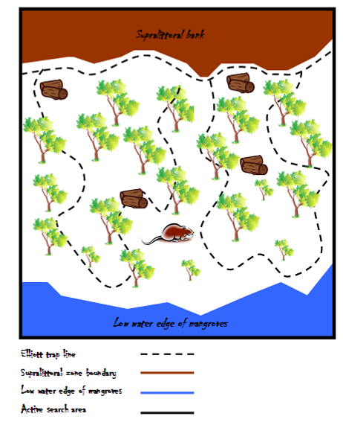

References

Ball, D (2004). Distribution and Habitat of the Water Mouse, Xeromys myoides Thomas, 1889 (Rodentia: Muridae) in Intertidal Areas of Central Eastern Queensland. Memoirs of the Queensland Museum. 49 part 2. Brisbane.
Ball, D., Wake, J. and McKillup, S (2006.). Point discharge of storm water runoff into a landward mangrove community: initial investigations indicate a negative effect on keystone species (mangrove crabs, Family: Grapsidae), p25 in McLeod, L. (ed.) New Zealand Marine Sciences Society Review 47, NZMSS, Wellington, NZ.
Breitfuss, M., Connolly, R. and Dale, P (2004). Densities and aperture sizes of burrows constructed by Helograpsus haswellianus (Decapoda: Varunidae) in saltmarshes with and without mosquito control runnels. Wetlands 24:14-22.
Department of Environment and Resource Management (2009a). National recovery plan for the water mouse (false water rat) Xeromys myoides. Report to Department of the Environment, Water, Heritage and the Arts, Canberra. Department of the Environment and Resource Management, Brisbane.
Department of the Environment and Resource Management (2009b). Acid Sulphate Soils. www.nrw.qld.gov.au/land/ass/index.html
Dickman, C.R., L.K-P. Leung & S.M. Van Dyck (2000). Status, ecological attributes and conservation of native rodents in Queensland. Wildlife Research 27:333-346.
Dwyer, P.D., M. Hockings & J. Willmer (1979). Mammals of Cooloola and Beerwah. Proceedings of the Royal Society of Queensland 90:65-84.
Environmental Protection Agency (2007). Regional Ecosystem Description Database (REDD). Version 5.2. Updated November 2007.
Gynther, I.C. and Janetzki, H (2008). Water mouse Xeromys myoides, pp 664-666 in Van Dyck, S. and Strahan, R. (eds) The Mammals of Australia (3rd ed.), Reed New Holland, Sydney, NSW.
Hitchcock, G (1998). First record of the false water-rat, Xeromys myoides (Rodentia: Muridae), in New Guinea. Science in New Guinea 23:141-144.
Magnusson, W.E., G.J.W. Webb & J.A. Taylor (1976). Two new locality records, a new habitat and a nest description for Xeromys myoides Thomas (Rodentia:Muridae). Australian Wildlife Research 3:153-157.
Morris, K (2000). The status and conservation of Native Rodents in Western Australia. Wildlife Research 27:405–419
Redhead, T.D. & J.L. McKean (1975). A new record of the False Water-rat, Xeromys myoides, from the Northern Territory. Australian Mammalogy 1:347-354.
Shearer, H (2004). Herbicides threaten North Queensland’s coastal mangroves. ECOS 119:32-33.
Troughton, E (1943). Furred animals of Australia. Angus and Robertson, Sydney, New South Wales, Australia
Van Dyck, S. & E. Durbidge (1992). A nesting community of false water rats (Xeromys myoides on the Myora sedgelands, North Stradbroke Island. Memoirs of the Queensland Museum. 32:374.
Van Dyck, S. (1996). Xeromys myoides Thomas, 1889 (Rodentia: Muridae) in mangrove communities of North Stradbroke Island, southeast Queensland. Memoirs of the Queensland Museum. 42:337-366.
Van Dyck, S. & I. Gynther (2003). Nesting strategies of the Water Mouse Xeromys myoides in southeast Queensland. In: Memoirs of the Queensland Museum 49(1):453-479.
Van Dyck, S., S. Janetzki & I. Gynther (2003). Artificial Nesting Mounds for the Water Mouse, Xeromys myoides. Memoirs of the Queensland Museum 49(1):480.
Woinarski, J.C.Z (2000). The conservation of rodents in the monsoonal tropics of the Northern Territory. Wildlife Research 27(4):421-435.
Woinarski, J (2004). Threatened Plants and Animals in Kakadu National Park: a review and recommendations for management, Report to Parks Australia North, Parks and Wildlife Commission of the Northern Territory, Darwin, NT.
Woinarski, J.C.Z., K. Brennan, A. Dee, J. Njudumul, P. Guthayguthay & P. Horner (2000). Further records of the false water-rat Xeromys myoides from coastal Northern Territory. Australian Mammalogy 21:245-247.
Woinarski, J., Pavey, C., Kerrigan, R., Cowie, I., and Ward, S (2007). Lost from our Landscape: Threatened Species of the Northern Territory, NT Government Printer, Darwin, NT.
Zimmerman, L., Thurman, E. and Bastian, K (2000). Detection of persistent organic pollutants in the Mississippi Delta using semi-permeable membrane devices. The Science of the Total Environment 248:169-179.

Figures
Figure 1 - habitat mapping for the water mouse in the Northern Territory 8
Figure 2 Known, likely and may occur habitat mapping for the water mouse in south central Queensland 9
Figure 3 Known, likely and may occur habitat mapping for the water mouse in south-east Queensland. 10
Figure 4 - Habitat profile of the water mouse 11
Figure 5 - Elliott trapping methodology for presence/absence surveys of the water mouse 27

Photographs
Photo 1 Mangrove habitat in south-east Queensland (photo taken by David Jackson, DEWHA) 12
Photo 2 Supralittoral and littoral habitat in south-east Queensland (photo taken by David Jackson, DEWHA) 12
Photo 3 Grapsid crabs – an important component of the water mouse diet (photo taken by David Jackson, DEWHA) 13
Photo 4 A water mouse nest near the base of a Casuarina glauca on a small elevated ‘island’ within the littoral zone in south-east Queensland (photo taken by Tim McGrath, DEWHA). 15
Photo 5 Free standing nest mound within sedgeland supporting Juncus kraussii and Baumea juncea (photo taken by Tim McGrath, DEWHA). 15
Photo 6 A nest mound at the base of a tree in the supralittoral bank supporting Casuarina glauca and Melaleuca quinquenervia (photo taken by Dr Ian Gynther, DERM). 16

