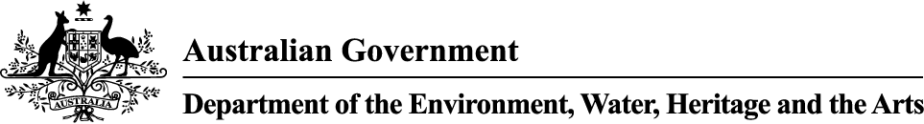

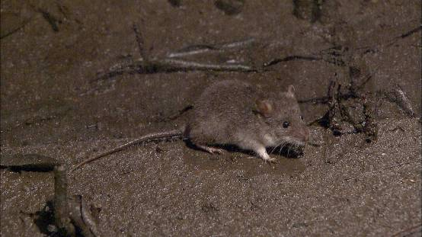

Significant impact guidelines for the vulnerable water mouse Xeromys myoides
Nationally threatened species and ecological communities
EPBC Act policy statement 3.20

© Commonwealth of Australia 2009
This work is copyright. You may download, display, print and reproduce this material in unaltered form only (retaining this notice) for your personal, non-commercial use or use within your organisation. Apart from any use as permitted under the Copyright Act 1968, all other rights are reserved. Requests and inquiries concerning reproduction and rights should be addressed to Commonwealth Copyright Administration, Attorney General’s Department, Robert Garran Offices, National Circuit, Barton ACT 2600 or posted at www.ag.gov.au/cca.

Disclaimer
The contents of this document have been compiled using a range of source materials and is valid as at November 2009. The Australian Government is not liable for any loss or damage that may be occasioned directly or indirectly through the use of reliance on the contents of the document.
Front page photograph: The water mouse Xeromys myoides (photo taken by Totally Wild, Channel Ten)

Introduction
The water mouse Xeromys myoides is listed as vulnerable under the Australian Government Environment Protection and Biodiversity Conservation Act 1999 (EPBC Act). Listed threatened species and ecological communities are a matter of national environmental significance. Under the EPBC Act an action will require approval from the federal environment minister if the action has, will have, or is likely to have a ‘significant impact’ on a matter of national environmental significance.
A ‘significant impact’ is an impact which is important, notable, or of consequence, having regard to its context or intensity. Whether or not an action is likely to have a significant impact depends upon the sensitivity, value, and quality of the environment which is impacted, and upon the intensity, duration, magnitude and geographic extent of the impacts. You should consider all of these factors when determining whether an action is likely to have a significant impact on matters of national environmental significance.
This policy statement is designed to help determine whether a proposed action may have a significant impact on the water mouse. The policy statement applies to mangrove communities and associated saltmarsh, sedgelands, clay pans, floodplains, heathlands and coastal freshwater wetlands within the known and potential range of the water mouse in south east Queensland, central south Queensland and Northern Territory (see Figure 1).
This policy statement is based on the best available information, including:
- scientific literature
- consultation with species experts, and
- application of the national environmental legislation (EPBC Act).
This policy statement builds on the information and explanations in EPBC Act policy statement 1.1 Significant impact guidelines – Matters of national environmental significance.

Figure 1 Habitat mapping for the water mouse

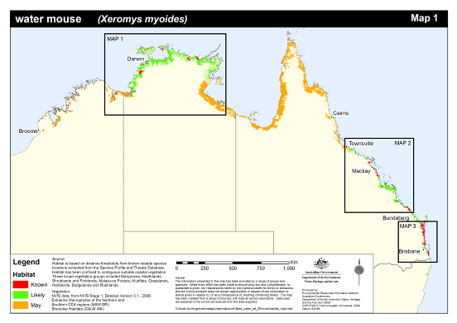

How to interpret and apply these guidelines
The significance thresholds outlined in this policy statement are not designed to be prescriptive, but rather to clarify the level and types of impact likely to be significant at a national level, having regard for the biology and ecology of and threats to the species. If you are planning an action in any areas in Figure 1 you should consider the following:
- Does my site support the water mouse (see section 4 & 6)?
- What impacts, both direct and indirect, could result from my action (see section 5)?
- Could any of these impacts exceed the significance thresholds (see section 7)?
- What measures could be taken to reduce the level of impact (see section 9)?
If you think that your action may have a significant impact on a matter of national environmental significance, or if you are unsure, you should refer the action to the federal environment minister. The minister will make a decision within 20 business days on whether approval is required under the EPBC Act. Substantial penalties apply for taking an action that has, will have or is likely to have a significant impact without approval.

What other laws protect the water mouse?
The water mouse is listed as vulnerable under the EPBC Act. Listed threatened species and ecological communities are a matter of national protected matter that recognises the importance from a national perspective. Under the EPBC Act an action will require approval from the federal environment minister if the action has, will have, or is likely to have a significant impact on a matter of national environmental significance..
The water mouse is also listed as ‘vulnerable’ in Queensland under the Queensland Nature Conservation Act 1992 and as ‘data deficient’ in the Northern Territory under the Territory Parks and Wildlife Conservation Act 2000. The listing of a species, subspecies or ecological community listed as threatened under the EPBC Act recognises the conservation status of the entity from a National perspective and does not replace listing under state/territory, regional or local legislation or regulations.
Judgements may differ between Australian, state and local decision-making processes, due to the different scales of consideration. If your activity could affect the species or individual animals you should contact the relevant state/territory and local authorities to find out your obligations.

Ecology of the water mouse
Description of the species
The water mouse is a small rodent which has a maximum head and body length of 126mm and maximum weight of 64g. It has short, very dense and silky fur that is dark slate-grey above and pure white below. The species has a strong musty odour. Very old individuals are grizzled all over and have a rufous wash to the flanks. Adults are usually white-spotted dorsally (Queensland). The ears are rounded and short and the eyes are very small. The hindfeet are not webbed. The tail is slender, thinly haired and very finely ringed (smooth). The water mouse has only two molars in each of the upper and lower rows. The water mouse appears to be totally nocturnal.
Distribution
The water mouse occurs in three discrete populations on the eastern and northern Australian coastline. In south-east Queensland the water mouse occurs between the Coomera River (50km southeast of Brisbane) and Hervey Bay; the islands of Moreton Bay and Pumicestone Passage, including the lee of north and south Stradbroke and Bribie Islands; and Fraser Island. In central south Queensland the water mouse occurs between Agnes Water and Cannonvale and in the Northern Territory it has been recorded between the Glyde River in eastern Arnhem Land and the Daly River floodplain.
Habitat
The water mouse requires mangrove communities and associated saltmarsh, sedgelands, clay pans, heathlands and freshwater wetlands with intact hydrology that provide adequate nest sites and prey resources. Where present, it may also use a supralittoral zone (with or without a supralittoral bank) for the construction of nest mounds. Water mouse habitat varies across the three disjunct populations (refer to the background paper).
Nesting
The water mouse creates nests which are important for breeding and refuge from high tides and predators. The water mouse constructs five types of nests: free-standing mound nests or mounds at the base of mangrove trees, mound nests on small elevated ‘islands’ within the tidal zone, mound nests or holes in supralittoral banks; nests inside hollow tree trunks, and nests in spoil heaps created as a result of human activity. It is assumed the species does not need to build mounds or obvious nest structures in non-tidal environments.
Reproductive biology
Little is known about the reproductive biology of the water mouse. Research undertaken on North Stradbroke Island found that up to eight individuals of both sexes can share a nest mound, however, there was generally only one sexually active male present. The nest may also be used by successive generations over a number of years. It is possible that the water mouse is capable of breeding throughout the year.
Movements
The water mouse generally exhibits frenetic activity; travelling relatively large distances of up to 2.9km a night while criss-crossing home ranges averaging 0.7ha. In south-east Queensland the water mouse has been observed following the receding tide out through sedgelands and into the mangroves where it foraged at night over a home range estimated at approximately 0.8ha for males and 0.6ha for females. There is no available information about dispersal movements in this species.
Further detail on the ecology of the water mouse including habitat suitability mapping is provided in the background paper.

Principal threats to the water mouse
Principal threats most relevant to judgements on significance of impacts to the water mouse include:
- habitat removal as a result of development actions for example vegetation clearing to extract minerals
- habitat degradation as a result of development actions:
- alteration of natural hydrology for example increased freshwater inflows to mangroves and acidic heathlands, or increased sedimentation from storm-water runoff
- fragmentation e.g. through powerlines and water pipeline easements
- acid sulphate exposure
- oil pollution
- introduction of weeds e.g. mimosa in the Northern Territory
- habitat degradation and disturbance from recreational activities:
- vehicle damage in supralittoral habitat
- prolonged or intensive wave action from recreational vessels (for example jet skis, motorboats) eroding or washing away mound nests and damaging banks
- chemical control of insects and weeds for example mosquitocides and herbicides.
- fire in the supralittoral zone (resulting from development actions, natural, recreational or arson)
- feral predators (increased risk from habitat fragmentation and urban encroachment, namely cats as habitat fragmentation may provide them with easier access to water mouse habitat), and
- grazing by cattle for example trampling or denudation of intertidal habitats.

Survey guidelines for the water mouse
A guide to conducting surveys for the water mouse is outlined below. Surveys should:
- be conducted by a suitably qualified person with experience in mammal surveys
- maximise the chance of detecting the species
- determine the context of the site within the broader landscape, and
- account for uncertainty and error.


Consideration should be given to the timing, effort, methods and area to be covered in the context of the proposed action. If surveys are conducted outside recommended periods or conditions, survey methods and effort should be adjusted to compensate for the decreased likelihood of detecting the species.

Survey recommendations
Best practice surveys for the water mouse include implementation of all primary survey techniques either with or without the use of supplementary survey techniques.
Primary survey techniques
Habitat assessment, daytime searches and Elliott trapping are the three most reliable methods for detecting the presence of the water mouse. Surveyors should examine aerial photos and topographical maps before commencing a habitat assessment or trapping program. This will target and identify elevated, dry supralittoral areas within mangrove communities which may support active nest mounds.
Habitat assessment
A habitat assessment should record all notable habitat features in the study area including vegetation types and species, presence of prey species and prey middens, trees with hollow trunks etc.
Daytime searching
Daytime searches should include transect style searches spaced at 50-100m intervals, or in quadrats, and involve one to two hours spent looking for nesting structures for every one hectare of intertidal or supralittoral water mouse habitat.
Elliott trapping
Elliott trapping (Size A) must be carried out at night. Elliott trapping is the only reliable method for estimating water mouse population density. Elliott traps should be baited with pilchards cut in half, mullet pieces or commercial cat food. The minimum survey effort required to trap the water mouse is 400 trap nights per four to five hectares of potential water mouse habitat.

Supplementary survey techniques
Pitfall trapping, spotlighting and hair tubing can be used to increase the probability of detecting the water mouse. However these techniques are not required where primary techniques are implemented.
Please refer to the background paper for additional details for example primary and secondary survey guidelines, including trap effort, and regional considerations for the various survey techniques.

What sorts of actions are likely to have a significant impact on the species?
Significant impact judgements must be made on a case-by-case basis and with consideration for the context of the action. The potential for a significant impact on a listed threatened species will depend on:
- the intensity, duration, magnitude and geographic extent of the impact
- the sensitivity, value and quality of the environment on and around the site
- the cumulative effect of on-site, off-site, direct and indirect impacts, and
- the presence of this and other matters of national environmental significance.

Development actions that may impact on the water mouse include sand mining, urban residential development, resorts and marina development, bund walling, aquaculture projects and creation or upgrade of easements for energy distribution for example electricity, gas or water pipelines.
Significant impact threshold
There is a possibility of a significant impact on the water mouse if the action impacts breeding of an important population and/or reduces dispersal across habitat patches, or removes habitat critical to the survival of the species.

Important populations
A water mouse population is regarded as an ‘important population’ if it:
- shows evidence of recent activity for example nest mounds, plastering, middens
- occurs in habitat critical to the survival of the species
- occurs in a protected area for example Great Sandy National Park
- occurs at or near the limits of the range of one of the regional populations (see Figure 1)
- occurs at or near the limits of the species’ range (see Figure 1)
- has been the subject of long-term monitoring, or
- preserves high genetic diversity for the species.
Specific regional considerations for determining an important population are listed in the background paper.

Habitat critical to the survival of the species
Habitat critical to the survival of the species includes mangrove communities and other intertidal communities or coastal freshwater wetlands with intact hydrology, prey resources, nest mounds and/or natural features such as a supralittoral bank to enable the construction of nests..

What does this mean for actions in water mouse habitat?
If you plan an action that may have a significant impact then you should refer the proposal to the minister before commencing the action. The minister will decide, within 20 business days, whether assessment and approval is required under the EPBC Act. More information on referral and assessment is available at www.environment.gov.au/epbc/assessments/process.html.

How can my action avoid having a significant impact on the water mouse?
Mitigation are all measures taken on the site of the action, to avoid or reduce impacts. Measures should be incorporated into the design of the action at the conceptual and planning stage(s) to:
- reduce the level of the impact to below the significant impact threshold outlined in this policy statement
- monitor the performance of the mitigation measures (specify the timeframe for example by using performance indicators measured at seasonally/annually nominated times), and
- feedback into an adaptive management plan, to quickly react to any changes in performance.
Mitigation and management actions must:
- prioritise impact avoidance over impact reduction measures
- avoid negative impacts on other matters of national environmental significance, and
- be consistent with relevant recovery, conservation and action plans.
The following measures may assist in avoiding impacts on the water mouse:
- retain habitat known or likely to contain water mouse, and manage for the species
- maintain existing hydrology (including any appropriate flood regime, as well as water flow and quality)
- avoid habitat fragmentation
- retain supralittoral and intertidal habitat corridors
- maintain current site conditions (for example disturbance regimes, stock grazing, etc) until impacts or benefits of disturbance are evaluated.
If impacts are unavoidable they can be minimised by:
- establishing a buffer of natural vegetation of at least 30 m around areas identified as containing or linking likely water mouse habitat
- actively monitoring water mouse populations and using results to update management actions
- capturing and reducing fresh water run-off (for example by recycling) that may reduce salinity and affect water mouse habitat and prey abundance
- erecting fencing to exclude livestock such as cattle, horses, feral pigs, dogs, foxes, and cats
- appropriately managing and treating noxious weeds for example groundsel.
Further information on managing impacts and experimental mitigation measures can be found in the background paper.

Translocation
Translocation does not reduce the impact of an action. Translocation of the water mouse is not considered to mitigate or offset the impact of an action, since any translocation, no matter how successful, cannot lessen the loss of habitat.

Where can I get more information?
The background paper for this policy statement provides a biological and ecological context for survey guidelines, significant impact thresholds, and mitigation measures.
Other EPBC Act policy statements are available to help you to understand the EPBC Act and your obligations. They are available from the department’s website at: www.environment.gov.au/epbc/guidelines-policies.html, or by contacting the community information unit by email: ciu@environment.gov.au or by phone: 1800 803 772.
The Protected Matters Search Tool can provide a good starting point for determining the likelihood of having matters of national environmental significance in your area. State and territory government agencies may also hold relevant information including habitat and species distribution information.
Further information on this and other listed threatened species and ecological communities is at the department’s species profiles and threats database (SPRAT) at: www.environment.gov.au/cgi-bin/sprat/public/sprat.pl.

