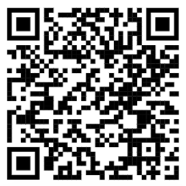
November 2025

Zebra mussel (Dreissena polymorpha)
Zebra mussel is a small freshwater mollusc native to Eastern Europe and Western Russia which has spread widely across North America and parts of Europe.
Zebra mussel is not currently established in Australia and is listed as a higher-risk species on the Exotic Environmental Pest List.
Keeping Australia free of zebra mussel is vital to protecting our aquatic ecosystems, infrastructure and way of life.

How it could impact Australia
If zebra mussel becomes established in Australia, there could be severe consequences.
Zebra mussel could:
- alter aquatic ecosystems by outcompeting native aquatic species
- disrupt food chains and nutrient cycles, impacting fisheries
- clog water infrastructure, including irrigation, hydroelectric and water treatment systems

What it looks like
Zebra mussels are:
- small and fingernail-sized, but can be as small as 1mm and grow up to 50mm long
- usually marked by distinctive brown or black zigzag stripes across the pale shells.
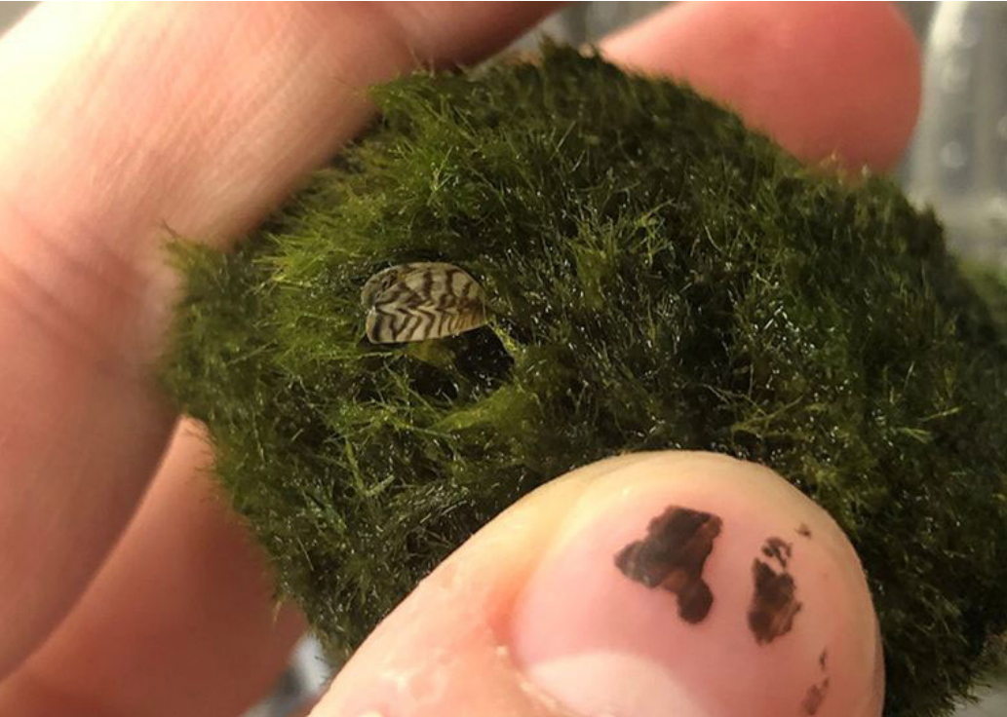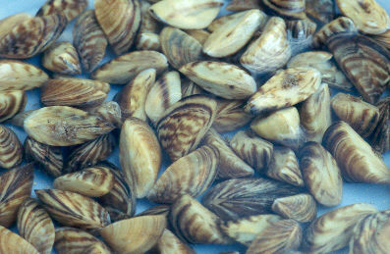
LEFT: Zebra mussel on a marimo moss ball. RIGHT: Adult zebra mussels. (Images: US Geological Survey)

Where it might be found
Zebra mussel can establish in freshwater to brackish environments, including slow-moving rivers, lakes, reservoirs, estuaries, canals, irrigation systems, aquariums and ornamental ponds. Zebra mussel reproduces rapidly and releases microscopic larvae, and forms dense clusters or colonies on hard surfaces.
Zebra mussel is not found in Australian waterways, however adults and larvae could spread through movement of:
- aquarium and pond tank water, substrates, decorations, aquatic plants and disposal or dumping of these materials
- watercraft and fishing gear, including boat hulls, trailers, motors and nets
- ballast water.

What to do if you see it
If you think you’ve spotted zebra mussel:
- Do not move it
- Take a photo if safe to do so
- Report it immediately to your local state or territory aquatic biosecurity team. List of state and territory contacts available at agriculture.gov.au/zebra-mussel
- Alternatively, call the See. Secure. Report hotline on 1800 798 636 or report online at www.agriculture.gov.au/biosecurity-trade/pests-diseases-weeds/report
Your vigilance and support are vital in preventing the spread of invasive species. Thank you for helping us to protect Australia’s environment and way of life.

More information
- Zebra mussel agriculture.gov.au/zebra-mussel
- Exotic Environmental Pest List agriculture.gov.au/biosecurity-trade/policy/environmental/priority-list
- Email ACEBO@aff.gov.au
Acknowledgement of Country
We acknowledge the continuous connection of First Nations Traditional Owners and Custodians to the lands, seas and waters of Australia. We recognise their care for and cultivation of Country. We pay respect to Elders past and present, and recognise their knowledge and contribution to the productivity, innovation and sustainability of Australia’s agriculture, fisheries and forestry industries.
© Commonwealth of Australia 2025
Unless otherwise noted, copyright (and any other intellectual property rights) in this publication is owned by the Commonwealth of Australia (referred to as the Commonwealth).
All material in this publication is licensed under a Creative Commons Attribution 4.0 International Licence except content supplied by third parties, logos and the Commonwealth Coat of Arms.
The Australian Government acting through the Department of Agriculture, Fisheries and Forestry has exercised due care and skill in preparing and compiling the information and data in this publication. Notwithstanding, the Department of Agriculture, Fisheries and Forestry, its employees and advisers disclaim all liability, including liability for negligence and for any loss, damage, injury, expense or cost incurred by any person as a result of accessing, using or relying on any of the information or data in this publication to the maximum extent permitted by law.

