

Zooplankton response to a multi-site environmental watering event during spring 2019 in the River Murray

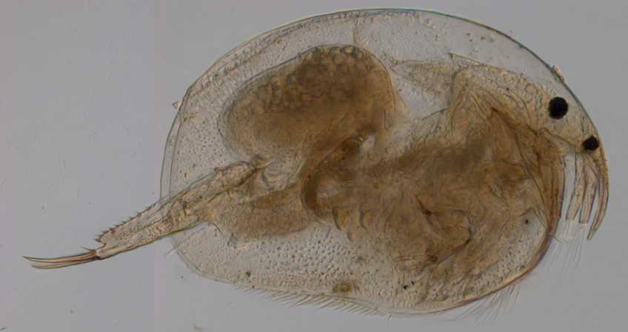

A report to the Commonwealth Environmental Water Office

Deborah Furst1, Qifeng Ye1, 2, Chris Bice1, 2, Paul McInerny3,Tapas Biswas3, Gavin Rees3 and Robyn Watts4

1School of Biological Sciences, University of Adelaide

2South Australian Research and Development Institute

3The Commonwealth Scientific and Industrial Research Organisation

4Charles Sturt University

Project number: CEWO- 2000007157

May 2020

   

Disclaimer:

The results and comments contained in this report have been provided on the basis that the recipient assumes the sole responsibility for the interpretation and application of them. The authors give no warranty, expressed or implied, or assumes any legal liability or responsibility for the accuracy, completeness or use of the results and comments contained in this report by the recipient or any third party.

The views and opinions expressed in this publication are those of the authors and do not necessarily reflect those of the Australian Government or the Minister of the Environment. While reasonable efforts have been made to ensure that the contents of this publication are factually correct, the Commonwealth does not accept responsibility for the accuracy or completeness of the contents, and shall not be liable for any loss or damage that may be occasioned directly or indirectly through the use of, or reliance on, the contents of this publication.

Cite as: Furst, D., Ye, Q., Bice, C., McInerny, P., Biswas, T., Rees, G. and Watts, R. (2020). *Zooplankton response to a multi-site environmental watering event during spring 2019 in the River Murray*. A report to the Commonwealth Environmental Water Office, Canberra. Project number: CEWO- 2000007157.

# Acknowledgments

Funding of this project was provided by the Commonwealth Environmental Water Office (CEWO). The authors would like to thank the University of Adelaide staff members Christopher Keneally, Tyler Dornan, Dhani Riehl and Ned Ryan-Schofield, the South Australian Research and Development (SARDI) staff members David Short, David Fleer and Zygmunt Lorenz, the Commonwealth Scientific and Industrial Research Organisation (CSIRO) staff members Daryl Nielsen, Garth Watson and John Pengelly and Charles Sturt University (CSU) staff member Xiaoying Liu for assistance with field sampling and Dr Russell Shiel for assistance with zooplankton identifications. Thanks to Sean Kelly (CEWO) for project management and support to this work. Thanks to the Murray-Darling Basin Authority (MDBA) staff members Gill Whiting, Anil Dhir and Adam Sluggett for providing flow and environmental water volume information and data. Thanks to Sean Kelly (CEWO), Gill Whiting (MDBA), Andrew Sharpe (Victorian Environmental Water Holder), Tracey Steggles (South Australian Department for Environment and Water), Paul Childs (New South Wales Department of Planning, Industry and Environment), Elizabeth Blake (CEWO), Jenessa Albert (MDBA) and Benjamin Wolfenden (New South Wales Department of Planning, Industry and Environment) for reviewing this report and providing most welcome and constructive feedback.

Contents

Acknowledgments 4

Executive summary 6

Terminology, definitions and abbreviations 9

Introduction 10

Study area 13

River Murray broad region 13

Barmah-Millewa Forest 15

Methods 18

Field sampling 18

Laboratory analysis and calculations 18

Statistical analysis 19

Results 20

General trends 20

Hydrology 20

Water quality 20

Zooplankton 23

Sampling trips 27

Trip 1: 9 September 2019 27

Trip 2: 23 September 2019 27

Trip 3: 8 October 2019 28

Trip 4: 21 October 2019 29

Trip 5: 5 November 2019 30

Trip 6: 18 November 2019 31

Trip 7: 2 December 2019 32

Discussion 34

Changes in microcrustacean density and community structure 34

Changes in zooplankton density and community structure: Mid-Murray 36

Changes in zooplankton density and community structure: Lower-Murray 38

Conclusion and recommendations 39

Appendix 42

References 49

# Executive summary

Hydrology and seasonality are principal drivers of ecological processes in river systems. Two critical facets of river flow regimes are lateral and longitudinal hydrological connectivity, which play important roles in energy transportation (spatially) and transferal (between trophic levels). In concert with changes in flow and connectivity, seasonality influences a range of processes such as photosynthetic and metabolic rates, as well as biological activity and behaviour. Thus, changes to the natural timing of flows and associated patterns of connectivity are among the most severe and ongoing threats to the ecological integrity of regulated rivers. In the River Murray, the natural flow regime was characterised by inter-annual variability, but with consistent intra-annual (seasonal) patterns that included high flows occurring in winter/spring, even during times of drought. This provided a degree of predictability in resource availability, in which native biota evolved. Now, a large proportion of winter/spring flows are stored in reservoirs, and later released for irrigation and consumptive purposes. Further compounding these hydrological impacts, 13 weirs throughout the system diminish the relationship between discharge, and water level and instream hydraulics (i.e. water velocity and turbulence). These alterations are likely to have resulted in diminished and temporally fragmented responses between organisms and their food resources, with significant impacts on the function of the aquatic food web.

Zooplankton are a key group of organisms influenced by hydrological connectivity and seasonality. Within aquatic food webs, zooplankton are primary consumers of basal resources (e.g. bacteria, phytoplankton and detritus) and are in turn preyed upon by higher trophic organisms such as macroinvertebrates and fish. Zooplankton respond rapidly to changes in discharge and river stage, as the inundation of dried sediment induces hatching from diapause eggs in the sediment, and slow-flowing habitats such as littoral zones, backwaters and floodplains play an important role in supporting the development of highly abundant communities. During periods of high discharge, organisms may be washed from these habitats into the main river channel and transported downstream, where they are then influenced by instream hydraulics. An important physicochemical factor that influences both hatching and community dynamics across all habitats throughout the River Murray is seasonal changes in water temperature. Therefore, the timing of inundation events plays a major role in determining the community structure that develops throughout the system.

Commencing in September, the 2019 spring flow pulse comprised coordinated releases from the Hume Dam and Lake Eildon via the mid-River Murray and Goulburn River. The Hume Dam releases combined with unregulated flows from the Kiewa and Ovens rivers resulted in cumulative flow at Yarrawonga Weir that peaked at ~ 15,000 ML/day and was estimated to inundate approximately 25 per cent of the Barmah-Millewa floodplain before returning to the river. The pulse was then supported by releases from the Goulburn River, and flowed unimpeded through the mid and lower-Murray to the end of the system approximately three weeks later. The spring 2019 flow pulse provided an opportunity to monitor the response of in-stream productivity along the River Murray between the township of Tocumwal (upstream from the Barmah-Millewa Forest) and Lock 3 in South Australia. A Murray−Darling Basin Authority (MDBA) funded project focused on investigating the influence of longitudinal and lateral connectivity on carbon and nutrients during the 2019 spring flow pulse, and this complementary project, funded by the Commonwealth Environmental Water Office, focused on the response of the zooplankton community. Key objectives were to:

1. Investigate the influence of the partial inundation of the Barmah-Millewa Forest on the zooplankton community within the main river channel, and
2. Investigate the influence of the spring flow pulse on downstream zooplankton communities.

Results suggest that the Barmah-Millewa Forest contributed to higher densities of microcrustaceans at locations immediately downstream (approximate 35 kms). Higher densities of microcrustaceans were measured at Four Posts in the Edward River (20±5.1 ind.L-1, significant), at Barmah (17±9.7 ind.L-1) and Echuca (25±6.7 ind.L-1, significant) in the River Murray in comparison to the site upstream of Barmah-Millewa Forest at Tocumwal (2.5±1.4 ind.L-1) in late-September. The microcrustacean communities detected downstream at this time were comprised largely of Chydoridae, Macrothricidae and copepod nauplii, all taxa that are important food resources for the larvae of large-bodied native fish (e.g. Murray cod, *Maccullochella peelii*). The inundation of the floodplain and lateral connectivity promoted by the spring flow pulse created conditions favourable for off-channel community development and transferral to the main river channel. The timing of the delivery also likely played a role, as spring is known to provide favourable conditions for microcrustacean development.

In the lower-Murray (sites Lock 6 and Lock 4), high zooplankton densities and communities characterised by flow responsive species suggested positive responses related to timing of flow and longitudinal connectivity. Very high zooplankton densities (up to ~2,000 ind.L-1 and significantly greater than all other sites) were measured at the peak of the spring flow pulse in mid-October 2019, considerably greater than those measured in the lower River Murray as part of the Long-Term Intervention Monitoring Project at the same time of year from 2014 to 2017 where densities in late-October to early-November fell between ~200 and 750 ind.L-1. The community in 2019 was primarily comprised of taxa from the rotifer genus *Trichocerca*,which have been found to be an important food resource for both shrimp and fish, and positively associated with longitudinal connectivity, water velocity and increased discharge in spring within the main channel of the lower River Murray. It is possible, that under such conditions these organisms are swept from their preferred littoral habitat, entrained within the flowing water and transported downstream. Densities may then increase due to in-channel reproduction and/or the continual entrainment of these organisms within an envelope of water as it moves along the river channel. Therefore, increased discharge and associated promotion of longitudinal connectivity and water velocities, and the timing of the delivery of this spring flow event, are likely to have contributed to the substantially increased densities of these taxa.

Overall, the results demonstrate a number of positive outcomes in relation to zooplankton responses to the delivery of environmental water along the length of the River Murray in spring 2019. In conjunction with understanding of carbon and nutrient dynamics during this flow event from an allied project undertaken by the CSIRO, this data will inform future environmental water delivery with regard to improving riverine productivity and the transfer of energy between lower and higher trophic levels.

# Terminology, definitions and abbreviations

**Barmah-Millewa Forest (BMF): Covering approximately 650 square kilometres between Tocumwal, Deniliquin and Echuca, the BMF is Australia’s largest river red gum forest. The forest is adjacent to the main channel of the River Murray** and experiences relatively frequent flooding**.**

**Facultative:** Optional or discretionary.

**In-channel habitats: The main river channel of the River Murray and adjoining littoral and backwater habitats that are inundated under typical regulated conditions.**

**Lentic habitats: still fresh water habitats**

**Littoral organisms: Organisms that prefer and are adapted to the region of the sublittoral zone up to the shore.**

**Littoral (facultatively pelagic (f/p)) organisms: Organisms that prefer and are adapted to the region of the sublittoral zone up to the shore however at times may migrate into the adjacent still open water environment. Many of these organisms can also aptly survive if washed into lotic habitats however reproduction is commonly inhibited.**

**Lotic habitats: habitats with rapidly moving water.**

**Microcrustaceans: Small crustaceans including cladocerans, copepods and ostracods which are important food resources for a range of fish species including juvenile silver perch, golden perch and Murray cod.**

**Off-channel habitats: Ephemeral habitats that become inundated when flows greater than the channel occurs and commonly includes anabranches, flood runners, wetlands, lakes, billabongs and floodplains.**

**Pelagic organisms: Organisms that prefer still (lentic), open water (pelagic) environments. For example, the pelagic zone of lakes, billabongs, wetlands and slackwaters.** **Many of these organisms can also aptly survive if washed into lotic habitats however reproduction is commonly inhibited.**

**Rotifers: A phylum of microscopic animals that are commonly the smallest in size, most diverse and most abundant group of zooplankton within in-channel habitats (in comparison to cladocerans, copepods and ostracods). Rotifers are important food for other zooplankton, macroinvertebrates and fish.**

**Water residence time (WRT): The amount of time water spends within a particular habitat/environment.**

**Zooplankton: Planktonic microinvertebrates including rotifers, cladocerans, copepods and ostracods.**

**Zooplankton community structure: The taxa and their densities that make up the zooplankton community including rotifers, cladocerans, copepods and ostracods.**

# Introduction

Hydrology is a key driver of ecological processes throughout river systems. Two important aspects of riverine flow regimes are lateral and longitudinal hydrological connectivity, both of which play an important role in energy transportation (spatially) and transferal (between trophic levels) (e.g. Junk *et al.* 1989; Gigney *et al.* 2006; Aldridge *et al.* 2012; Furst *et al.* 2017). Lateral connectivity increases with river height as a result of inundation of littoral zones (in and off channel), backwaters and floodplains, all of which can act as sources, sinks or transformers of resources. Areas that experience wetting-drying cycles can develop into biogeochemical “hotspots” (McClain *et al.* 2003), as nutrients are mobilised from sediments and carbon is released from organic material when inundated. Longer water residence times (WRT) and elevated nutrients in these areas can promote primary production (e.g. Glazebrook and Robertson 1999) and microbial activity (bacteria), which may then be assimilated into the food web by both the emerging (from the seed and egg bank) and colonising aquatic biota including zooplankton (Bunn *et al.* 2003; Balcombe *et al.* 2005). Resources liberated from the floodplain can be transported into the main river channel via lateral connectivity (e.g. Tockner *et al.* 1999; Gigney *et al.* 2006), where they are then transported downstream.

In addition to hydrology, seasonality plays a major role in regulating ecological processes within aquatic ecosystems. Throughout the seasons, predictable changes in temperature, light intensity and photoperiod influence a range of processes and functions such as photosynthetic and metabolic rates, and biological activity and behaviour (e.g. Bartolini *et al.* 2015; Nalley *et al.* 2018; Pilakouta *et al.* 2019). These changes act in concert with changes in flow and connectivity. Thus, changes to the timing of flows and associated patterns of connectivity are among the most severe and ongoing threats to the ecological integrity of regulated rivers, including the River Murray in Australia (Naiman *et al.* 1995; Poff *et al.* 1997; Bunn and Arthington 2002; Olden and Naiman 2010). Within the River Murray, the natural flow regime was once characterised by inter-annual variability, but exhibited consistent and predictable intra-annual (seasonal) patterns, with high flows occurring annually in winter/spring, even during times of drought (Maheshwari *et al.* 1995; Mallen‐Cooper and Zampatti 2018). This consistent flow pattern provided a degree of predictability in resource availability, in which native biota evolved. Indeed, higher flows in spring have been linked to a range of important ecological responses. For example, the spawning of golden perch (*Macquaria ambigua*)and silver perch (*Bidyanus bidyanus*)and the development of diverse communities of microcrustaceans, an important food resource for these fish species as juveniles (Shiel *et al.* 1982; Puckridge and Walker 1990; Rowland 1998; Humphries 2005; King *et al.* 2009; Zampatti and Leigh 2013). Now, a large proportion of winter/spring flows are captured in large storages such as Hume and Dartmouth dams, and later released for irrigation and consumptive purposes (Maheshwari *et al.* 1995; Mallen‐Cooper and Zampatti 2018). These alterations are likely to have produced diminished and temporally fragmented responses between organisms and their food resources, with significant impacts on the integrity of the aquatic food web.

A key group of organisms influenced by hydrological connectivity and the timing of flows in rivers are zooplankton. Zooplankton provide a pivotal link within the aquatic food web as they consume bacteria, phytoplankton and detritus (e.g. Boon and Shiel 1990; Kim *et al.* 2000) and are preyed upon by higher trophic organisms such as fish (e.g. Arumugam and Geddes 1988; Arumugam and Geddes 1996; Tonkin *et al.* 2006). They respond rapidly to changes in discharge as they hatch from diapause eggs in the sediment when wet, and in the presence of appropriate hatching conditions (e.g. physicochemical factors). Different habitat types, physicochemical factors and WRT then promote the development of specific zooplankton communities (e.g. Reckendorfer *et al.* 1999; Nielsen *et al.* 2003). WRT has a strong positive relationship with zooplankton density and biomass as well as a shift from rotifer to microcrustacean dominance due to microcrustaceans longer reproductive cycles (Obertegger *et al.* 2007). Therefore, habitats such as littoral zones, backwaters and floodplains that have longer WRT’s, promote the development of more abundant and microcrustacean dominated communities. During periods of higher discharge, organisms are washed from these habitats into the main river channel (Furst *et al.* 2014; Nielsen *et al.* 2016), where they are then influenced by factors such as hydrodynamics (e.g. water velocity), physicochemical factors and longitudinal connectivity (e.g Czerniawski and Sługocki 2017; Furst *et al.* 2018). One of the most dominant physicochemical factors that influences both hatching and community dynamics within the River Murray is water temperature (e.g. van Dijk and van Zanten 1995; Jones and Gilbert 2016). Therefore, the timing of inundation events plays a major role in determining the community structure that develops throughout the system. Thus, improving our understanding of how discharge and temperature regimes influence the zooplankton community throughout the River Murray will provide valuable insights for the ongoing management of the system.

A system scale environmental flow event, in which spatial and temporal aspects were guided by that of a small natural flow, consistent with the dry conditions, was carried out in spring 2019 along the River Murray channel. This event involved the delivery of a spring flow pulse through coordinated releases from the Hume Dam via the River Murray and Lake Eildon via the Goulburn River (the Goulburn flows were released for local outcomes in the Goulburn and to contribute to the River Murray). It was estimated to inundate up to approximately 25 per cent of the Barmah-Millewa Forest (BMF) before travelling down the length of the River Murray to the end of the system. Environmental water managers queried whether this flow would result in an increase in whole of river in-stream productivity including an increase in the mobilisation of nutrients available to fuel primary production, and a subsequent increase in zooplankton biomass. A separate Murray−Darling Basin Authority (MDBA) funded project focused on investigating the influence of longitudinal and lateral connectivity on carbon and nutrients during this spring flow pulse (Rees *et al.* 2020a), this complementary project, funded by the Commonwealth Environmental Water Office, focused on the response of the zooplankton community, where the key objectives were to:

1. Investigate the influence of the partial inundation of the Barmah-Millewa Forest on the zooplankton community within the main river channel, and
2. Investigate the influence of the spring flow pulse on downstream zooplankton communities.

Expected outcomes include:

1. Greater densities of zooplankton downstream in comparison to upstream of the BMF while floodplain connectivity to the main river channel is maintained. Densities of rotifers are expected to increase earlier, and be maintained for a more extended period of time than microcrustaceans, as they respond more rapidly to the inundation of off-channel habitats and have much shorter generation times than microcrustaceans. This allows them to rapidly develop into, and maintain, highly dense communities while increasing densities downstream.
2. An increase in the density of littoral and/or littoral (f/p) zooplankton during the spring flow pulse, as littoral zones adjoining the river become inundated, and higher velocities and/or turbulence promote entrainment and downstream transportation. This response is expected to be more distinct in the rotifer community, as they occur in much greater densities within in-channel littoral zones, and are more apt to flowing water than microcrustaceans.

# Study area

## River Murray broad region

The Murray–Darling Basin is the longest river system in Australia, containing both the Murray and Darling rivers. The main contributor to end-of-system flow, the River Murray, begins in the Snowy Mountains and flows to the Southern Ocean in South Australia, covering a total length of approximately 2,530 km (MDBA 2013). This project focusses on the River Murray between Tocumwal (New South Wales) (1,886 km upstream of the Murray Mouth) and Lock 3 in South Australia (500 km upstream of the Murray Mouth) (Figure 1). The River Murray is heavily regulated, with key features that influence the flow regime including large storage dams in the river’s headwaters (the Dartmouth and Hume dams); a weir at Lake Mulwala, Yarrawonga; and a large off-stream storage lake approximately 60 km’s downstream of the Murray-Darling junction (Lake Victoria). Additionally, 13 weirs between Torrumbarry and Blanchetown compound these hydrological impacts through alteration of the relationships between discharge, and water level and instream hydraulics (i.e. water velocity and turbulence) (Bice *et al.* 2017).

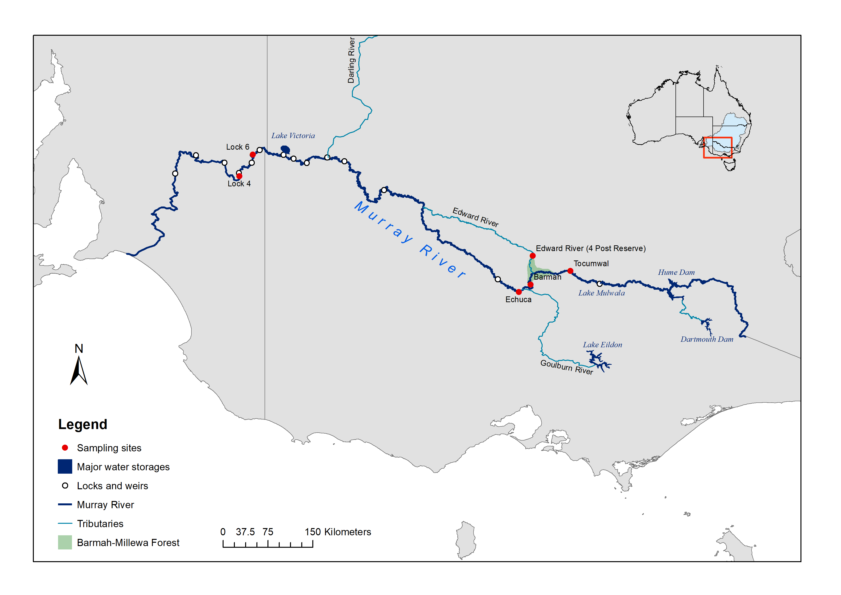

***Figure 1: Map of the study area. Inset: map of Australia with the location of the study area indicated by the red square.***

## Barmah-Millewa Forest

The Barmah-Millewa Forest (BMF) is the largest river red gum forest in Australia, covering approximately 65,000 hectares between Tocumwal, Deniliquin and Echuca (Jones 2006) (Figure 2). It is one of six icon sites identified as part of the country’s largest river restoration program, The Living Murray, and is listed as a Wetland of International Importance under the Ramsar Convention. The forest comprises a complex system of creeks, ephemeral anabranches, wetlands and floodplain that supports a diversity of native flora and fauna. This floodplain experiences relatively frequent inundation due to its unusually low and narrow banks where discharge is limited to around 8,900 ML.day-1 (measured downstream of the Yarrawonga Weir) before floodplain inundation occurs. This frequent inundation, assists with the reduction of carbon (primarily in the form of leaf litter) on the floodplain and the transferral of carbon and nutrients to the main river channel.

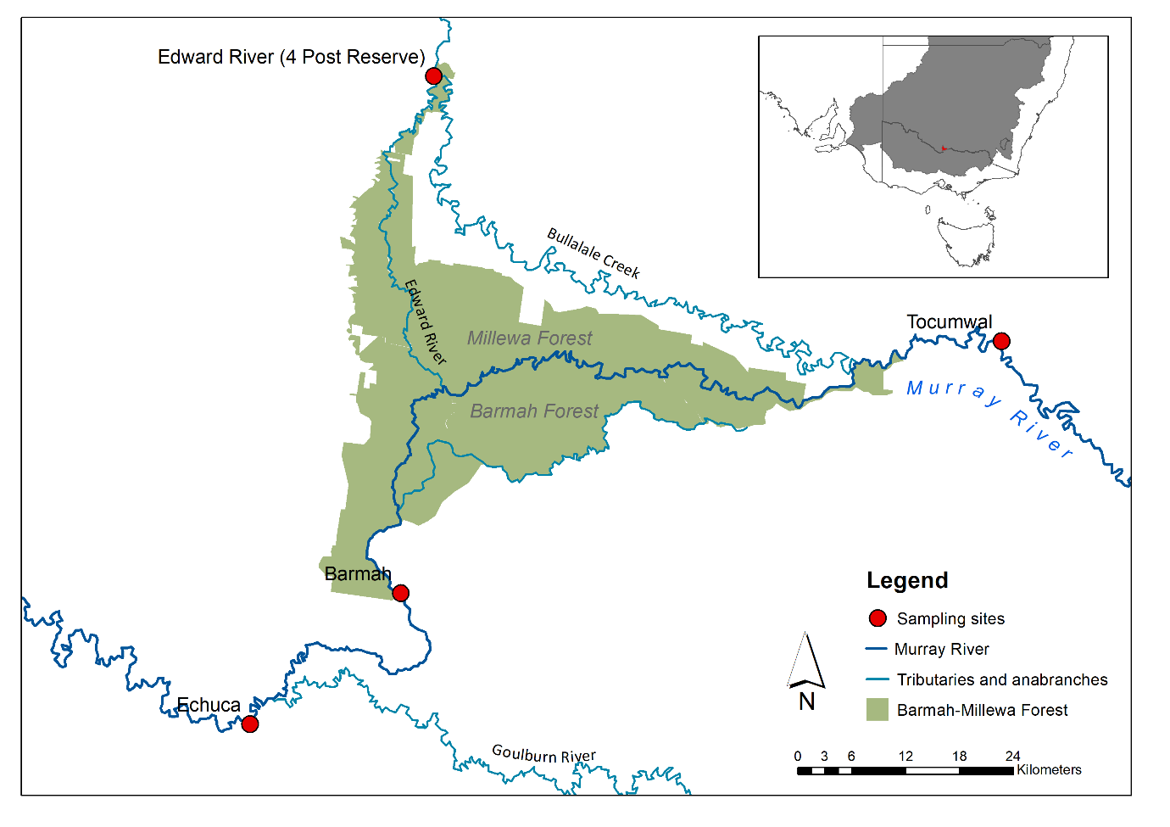

Figure 2: Map of the mid-Murray study area. Inset map of south eastern Australia with the location of the mid-Murray study area indicated by the red square.

To investigate productivity contributions from the Barmah-Millewa Forest (BMF) floodplain (objective 1) as well as downstream zooplankton communities (objective 2), the River Murray will be discussed in relation to two regions: 1) the mid-Murray, between Tocumwal and Echuca; and 2) the lower-Murray, from Lock 6 to Lock 3 (Figure 1 and Figure 2). Within the mid-Murray, four sites were sampled including: 1) the River Murray at Tocumwal, to assess the community upstream of the BMF (the influence of Lake Mulwala may also be detected at this site); 2) the Edward River at 4 Post reserve (located immediately upstream from Deniliquin township), to assess changes downstream of the BMF (hereafter referred to as Edward River); 3) the River Murray at the Barmah township, to assess the influence of return flows from the BMF (hereafter referred to as Barmah); and 4) upstream of the township of Echuca, to assess downstream transportation and the influence of discharge from the Goulburn River (hereafter referred to as Echuca) (Figure 2 and Table 1). In the lower-Murray, two sites were sampled including: 1) downstream of Lock 6 (hereafter referred to as Lock 6); and 2) downstream of Lock 4 (hereafter referred to as Lock 4) (Figure 1 and Table 1), both to investigate the influence of longitudinal hydrological connectivity. See Figure 3 for the major features surrounding each of the sample sites, how these features may influence the results observed. See Table 4 in the Appendix for additional information on how these features influence primary and secondary production and how these results may vary in relation to discharge.

Table 1: Details of zooplankton sampling sites in the mid and lower-Murray.

|  |  |  |  |  |  |
| --- | --- | --- | --- | --- | --- |
| **Region** | **River** | **Site name** |  | **Latitude** | **Longitude** |
| Mid-Murray | River Murray | Tocumwal |  | -35.813000° | 145.559000° |
| Mid-Murray | Edward River | Edward River |  | -35.596000° | 144.991000° |
| Mid-Murray | River Murray | Barmah |  | -36.019000° | 144.955000° |
| Mid-Murray | River Murray | Echuca |  | -36.123000° | 144.807000° |
| Lower-Murray | River Murray | Lock 6 |  | -34.065186° | 140.780403° |
| Lower-Murray | River Murray | Lock 4 |  | -34.393147° | 140.583950° |

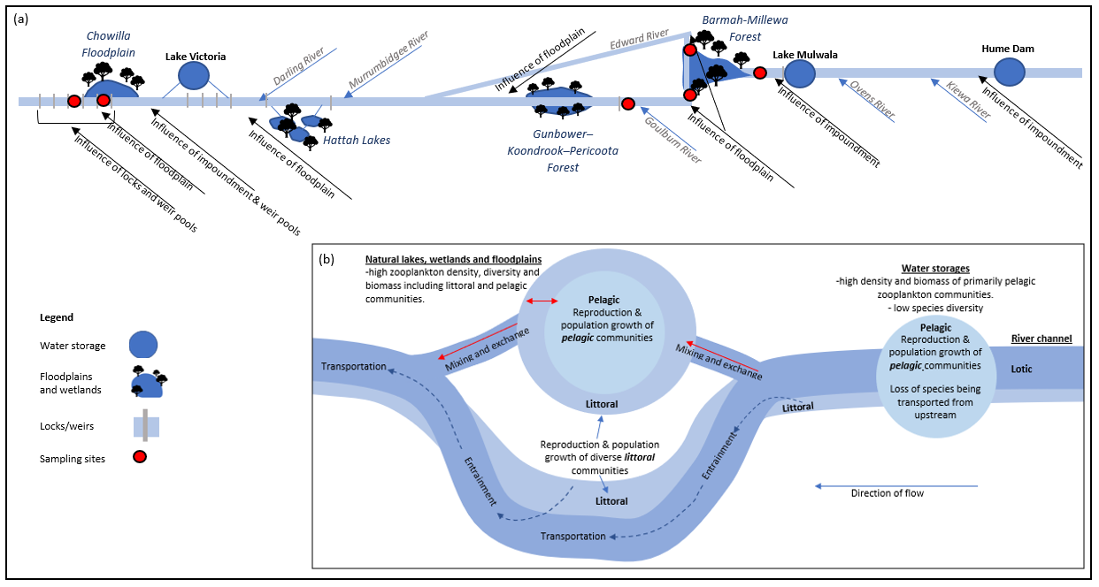

Figure 3: Schematic diagram of (a) the River Murray with major features, including floodplains, water storages, tributaries and locks, that influence primary and secondary productivity and (b) the primary habitats and movement of zooplankton. Black arrows and associated text indicate where influences from these major features may be detected, the red dots indicate the location of sampling sites, red arrows indicate mixing and exchange of zooplankton communities and blue broken arrows indicate zooplankton entrainment and downstream transportation. See Table 4 in the Appendix for additional information on how these features influence primary and secondary production and how these results may vary in relation to discharge.

# Methods

## Field sampling

Zooplankton sampling was conducted on seven occasions approximately fortnightly between the 9th of September and the 2nd of December 2019 (Table 2). Three replicate samples were taken at each site from the centre of the river channel approximately 100 m apart during the day. A Perspex Haney plankton trap (4.2−4.5 L capacity) was used in mid-channel (by boat) to collect two traps from each of the surface, middle and bottom (25.2−27 L) that were then filtered through a suspended 37 µm-mesh plankton net and rinsed into a 200 ml PET bottle, which made one composite replicate sample. The filtrate was then concentrated to approximately 50 ml and preserved in the field (100% ethanol) to a final concentration of ~75%, and a volume of <200 ml. Water quality was measured at each site using a Xylem YSI ProDSS water quality sonde. Water quality parameters measured included water temperature in degrees Celsius (°C), turbidity in nephelometric turbidity units (NTU), pH, electrical conductivity in milliseimens per centimetre (ms.cm-1) and dissolved oxygen in milligrams per litre (mg.L-1).

Table 2: Zooplankton sampling dates from the 9th of September to the 2nd of December 2019 and corresponding sampling trip number.

|  |  |
| --- | --- |
| Trip no. | Week beginning: |
| Trip 1 | 9 September 2019 |
| Trip 2 | 23 September 2019 |
| Trip 3 | 8 October 2019 |
| Trip 4 | 21 October 2019 |
| Trip 5 | 5 November 2019 |
| Trip 6 | 18 November 2019 |
| Trip 7 | 2 December 2019 |

## Laboratory analysis and calculations

In the laboratory, the 200 mL quantitative samples were inverted three times and a 1 mL sub-sample transferred into a pyrex gridded Sedgewick-Rafter cell. The entire sub-sample was counted, and zooplankton identified to the highest level possible based on gross morphology using a Leica compound microscope. The average number of zooplanktons was calculated and expressed as numbers of individuals per litre (ind. L-1) within the river.

Zooplankton biomass per litre was calculated by multiplying the estimated number of each taxa per litre, by the taxa dry weight. Dry weight estimates were obtained from the literature for the identified taxa (Dumont *et al.* 1975; Pauli 1989; Masundire 1994; Michaloudi 2005; Sendacz *et al.* 2006; Dagne *et al.* 2008). If estimates were not available for a particular species or genus, a taxon of similar size, appearance and/or genus was used. The sum of all taxa biomass per litre was calculated to obtain a total zooplankton biomass per litre estimate and converted to kilograms per gigalitre (kg.GL-1). These were then used to calculate daily load by multiplying the biomass per gigalitre by daily discharge and expressed as kilograms per day (kg.day-1). Discharge data for each site was provided by the Murray-Darling Basin Authority for all sites (MDBA). Discharge on the Monday of the week of sampling was used for daily load calculations (see Table 2). All biomass calculations are to be interpreted and used as rough estimates only, as there is sizable error associated with calculating biomass from published dry weight estimates.

## Statistical analysis

To test the influence of the spring flow pulse on zooplankton density, microcrustacean density and community structure, variation between sampling trips and sites was investigated. Zooplankton density included the total density of rotifers, cladocerans, copepods and ostracods. Microcrustacean density included the density of cladocerans, copepods and ostracods only. Community structure is characterised by the densities and the composition of taxa identified. Temporal and spatial variation in zooplankton mean density, microcrustacean mean density and community structure was analysed using two-factor univariate permutational multivariate analysis of variance (PERMANOVA) for microcrustacean and zooplankton density, and two-factor multi-variate PERMANOVA for community structure, Similarity Percentages (SIMPER) analysis and Non-metric Multi-Dimensional Scaling (MDS) in the software package PRIMER v. 6.1.12 (Clarke and Gorley 2006) and PERMANOVA + v.1.02 (Anderson et al. 2008). Euclidian similarity resemblance measures were used for univariate PERMANOVA’s and Bray-Curtis similarity resemblance measures were used for the multivariate PERMANOVA. A 40% contribution cut off was applied to SIMPER analysis. Species community structure data, using site means, were graphically presented in MDS plots. Each species was classified as either littoral, littoral (facultatively pelagic (f/p)) or pelagic for graphical representation of density data (see Terminology, definitions and abbreviations on page 9 for definitions of these classification categories). All statistical analyses were conducted on square-root transformed data. When the number of unique permutations were low (i.e. <100), Monte Carlo p-values have been reported (α = 0.05 for all analyses). All results are reported to two significant figures ±1 standard error. Bar and scatter plots were generated using the software package SigmaPlot 14.0.

# Results

## General trends

### Hydrology

A pulse of environmental water (including Commonwealth environmental water, The Living Murray water and River Murray Increased Flows) was delivered along the River Murray between September and the end of November 2019 (referred to throughout this document as the spring flow pulse) (Figure 4). This comprised of 246 and 135 GL of environmental water from the Hume Dam (River Murray) and Lake Eildon (Goulburn River), respectively. Discharge peaked in the mid-Murray at Tocumwal (~15,458 ML.day-1) between 8 September 2019 and 10 October 2019, and at McCoy’s Bridge on the Goulburn River (~7,909 ML.day-1) on 1 October 2019 (Figure 4). These combined discharges peaked at 17,381 ML.day-1 at Echuca on 1 October 2019 and at Lock 6 at 15,031 ML.day-1 on 21 October 2019 (Figure 4).

### Water quality

During the sampling period between early September and early December 2019, water temperature ranged from 10–24°C, and consistently increased in a downstream direction and over time (Figure 5a). Turbidity varied (9–113 NTU) along the length of the river and across sampling trips with higher turbidity commonly occurring at Edward River and Barmah and greater variability between sites occurring during trips 3, 4 and 5 (Figure 5b). Water pH ranged 5.1–8.1 and generally increased in a downstream direction and was more variable between sampling trips in the mid-Murray than the lower-Murray (Figure 5c). Electrical conductivity ranged 0.032–0.680 ms.cm-1 and also generally increased in a downstream direction, excluding at Echuca during trips 6 and 7, which exhibited higher electrical conductivity than all other sites. Variability in electrical conductivity between trips was generally lower in the mid-Murray than the lower-Murray (Figure 5d). Dissolved oxygen ranged 6.6–14 mg.L-1 and displayed no consistent longitudinal trends and generally decreased over time (Figure 5e).

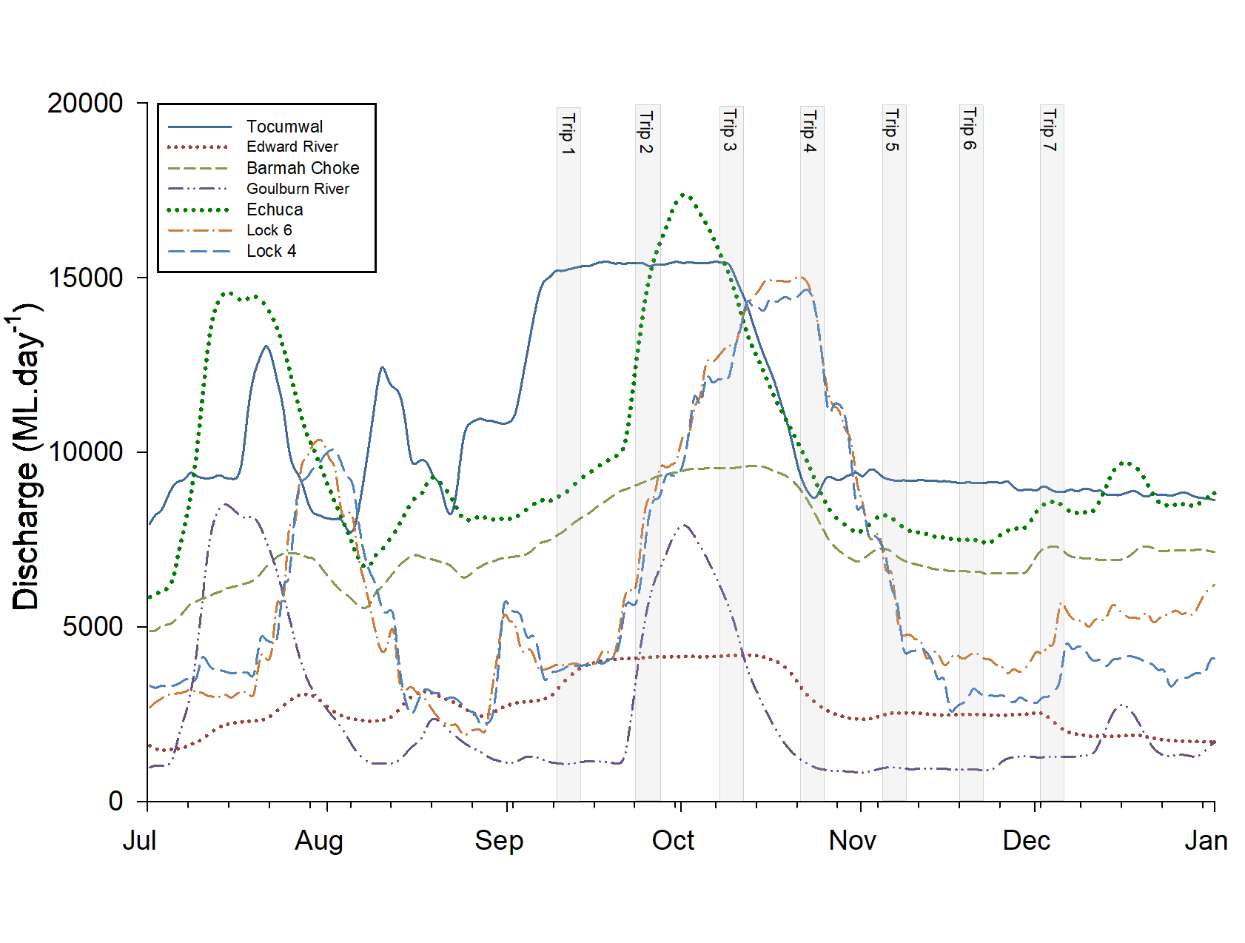

Figure 4: Discharge in the River Murray at Tocumwal, Barmah, the Edward River, the Goulburn River, Lock 6 and Lock 4 in megalitres per day (ML.day-1). Grey bars indicate zooplankton sampling dates.

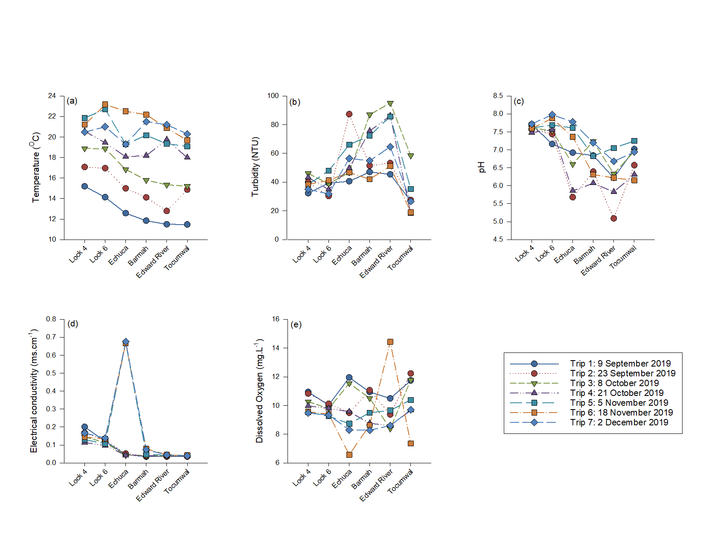

Figure 5: Water quality including (a) temperature (°C), (b) turbidity (NTU), (c) pH, (d) electrical conductivity (ms.cm-1) and (e) dissolved oxygen (mg.L-1) at all sites along the River Murray for sampling trips between early September and early December 2019.

### Zooplankton

Across trips and sites, mean zooplankton density varied between 51±6.6 and 2,070±253 ind.L-1 (Figure 6), translating to biomass and daily loads of 7.5±3.8 to 165±16 kg.GL-1, and 45±8.8 to 1071±142 kg.day‑1, respectively (Table 3). PERMANOVA of mean zooplankton density indicated a significant interaction between sampling trip and site, and that differences between sites were not consistent over time (P=0.0001). The same pattern was evident for mean microcrustacean density, which, across trips and sites, varied between 0 and 130±19 ind.L-1 (Figure 7). In the mid-Murray, microcrustacean density was significantly different among sites during the peak of the spring flow pulse (i.e. trips 2 and 3), but not during sampling trips 1, 4, 6 and 7 (Table 5).

Table 3: Zooplankton biomass per volume of water expressed in kilograms per gigalitre (kg.GL-1) and loads per day expressed in kilograms per day (kg.day-1) at Tocumwal, Edward River, Barmah, Echuca, Lock 6 and Lock 4 during sampling trips 1 to 7 between early September and early December 2019.

|  |  |  |  |  |  |  |  |
| --- | --- | --- | --- | --- | --- | --- | --- |
| **Biomass per volume (kg.GL-1)** | | | | | | | |
| **Sites** | **Trip 1** | **Trip 2** | **Trip 3** | **Trip 4** | **Trip 5** | **Trip 6** | **Trip 7** |
| Tocumwal | 47±13 | 7.5±3.8 | 17±2.3 | 25±2.4 | 8.7±3.1 | 11±2.3 | 39±0.84 |
| Edward River | 29±3.7 | 36±14 | 12±4.9 | 18±3.8 | 21±3.0 | 18±3.5 | 32±4.9 |
| Barmah | 43±14 | 26±14 | 42±1.8 | 45±8.5 | 25±3.5 | 23±9.0 | 47±3.8 |
| Echuca | 26±0.98 | 68±18 | 40±2.3 | 26±5.7 | 24±3.3 | 17±0.66 | 30±3.7 |
| Lock 6 | 54±8.6 | 33±6.2 | 44±1.7 | 54±1.5 | 20±1.2 | 67±9.2 | 165±16 |
| Lock 4 | 62±9.1 | 111±11 | 55±5.2 | 74±9.8 | 37±5.4 | 55±6.1 | 119±24.8 |
|  |  |  |  |  |  |  |  |
| **Daily load (kg.day-1)** | | | | | | | |
| **Sites** | **Trip 1** | **Trip 2** | **Trip 3** | **Trip 4** | **Trip 5** | **Trip 6** | **Trip 7** |
| Tocumwal | 714±204 | 116±59 | 258±35 | 239±23 | 80±29 | 98±21 | 355±7.6 |
| Edward River | 91±12 | 146±57 | 50±20 | 60±13 | 53±7.5 | 45±8.8 | 79±12 |
| Barmah | 328±102 | 238±122 | 405±17 | 403±76 | 182±25 | 153±59 | 343±28 |
| Echuca | 229±8.5 | 864±232 | 614±37 | 265±59 | 194±27 | 126±5.0 | 258±31 |
| Lock 6 | 210±34 | 209±39 | 569±22 | 815±23 | 130±7.7 | 275±39 | 697±65 |
| Lock 4 | 230±34 | 636±65 | 664±63 | 1071±142 | 261±38 | 154±17 | 355±74 |

PERMANOVA of community structure indicated a significant interaction between sampling trip and site, again suggesting differences between sites were not consistent over time (*P=*0.0001). In the mid-Murray, community structure demonstrated greatest inter-site variability during the peak and immediately following the spring flow pulse (trips 2–5) in comparison to sampling trips at the beginning (trip 1) or following the spring flow pulse (trips 6 and 7) (Figure 8 and Table 6). In the lower-Murray, community structure was distinctly different from that of the mid-Murray sites during all sampling events (Figure 8 and Table 6). Despite spatial differences, community structure throughout the River Murray demonstrated a general shift over time associated with increasing water temperature (from the top left to the bottom right of the MDS plot, Figure 8). See Appendix for full list of taxa identified at each site and sampling trip.

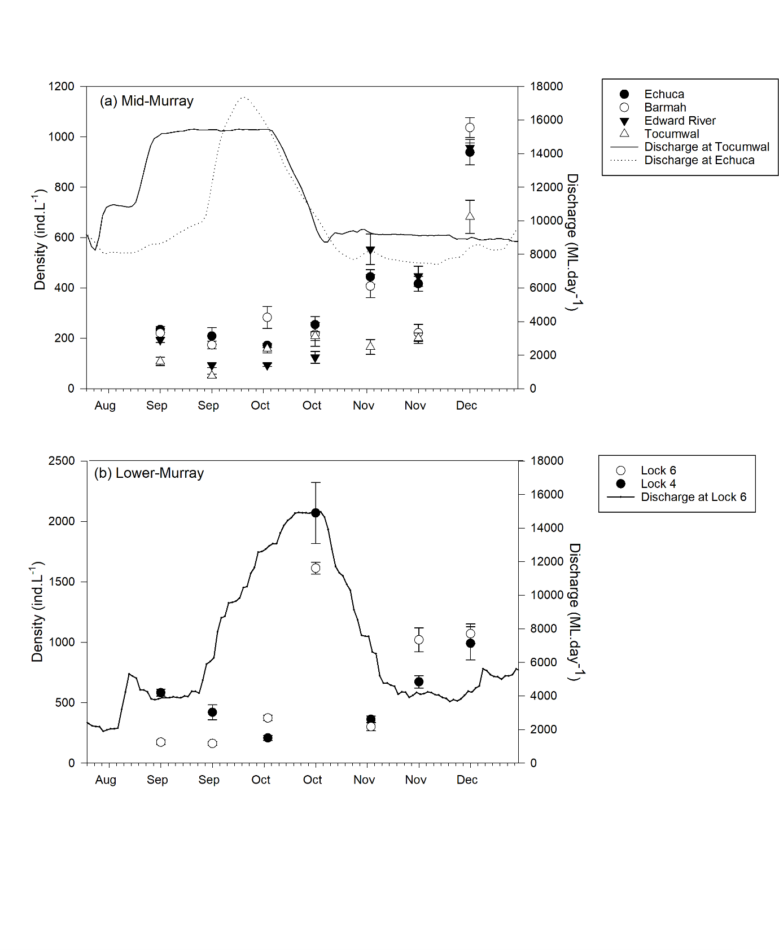

Figure 6: Differences in the mean density of zooplankton in individuals per litre (ind.L-1) including rotifers, cladocerans, copepods and ostracods (± SE) at each of (a) the four sites in the mid-Murray and (b) the two sites in the lower-Murray for seven sampling trips between early September and early December 2019. Note different primary y-axis scales.

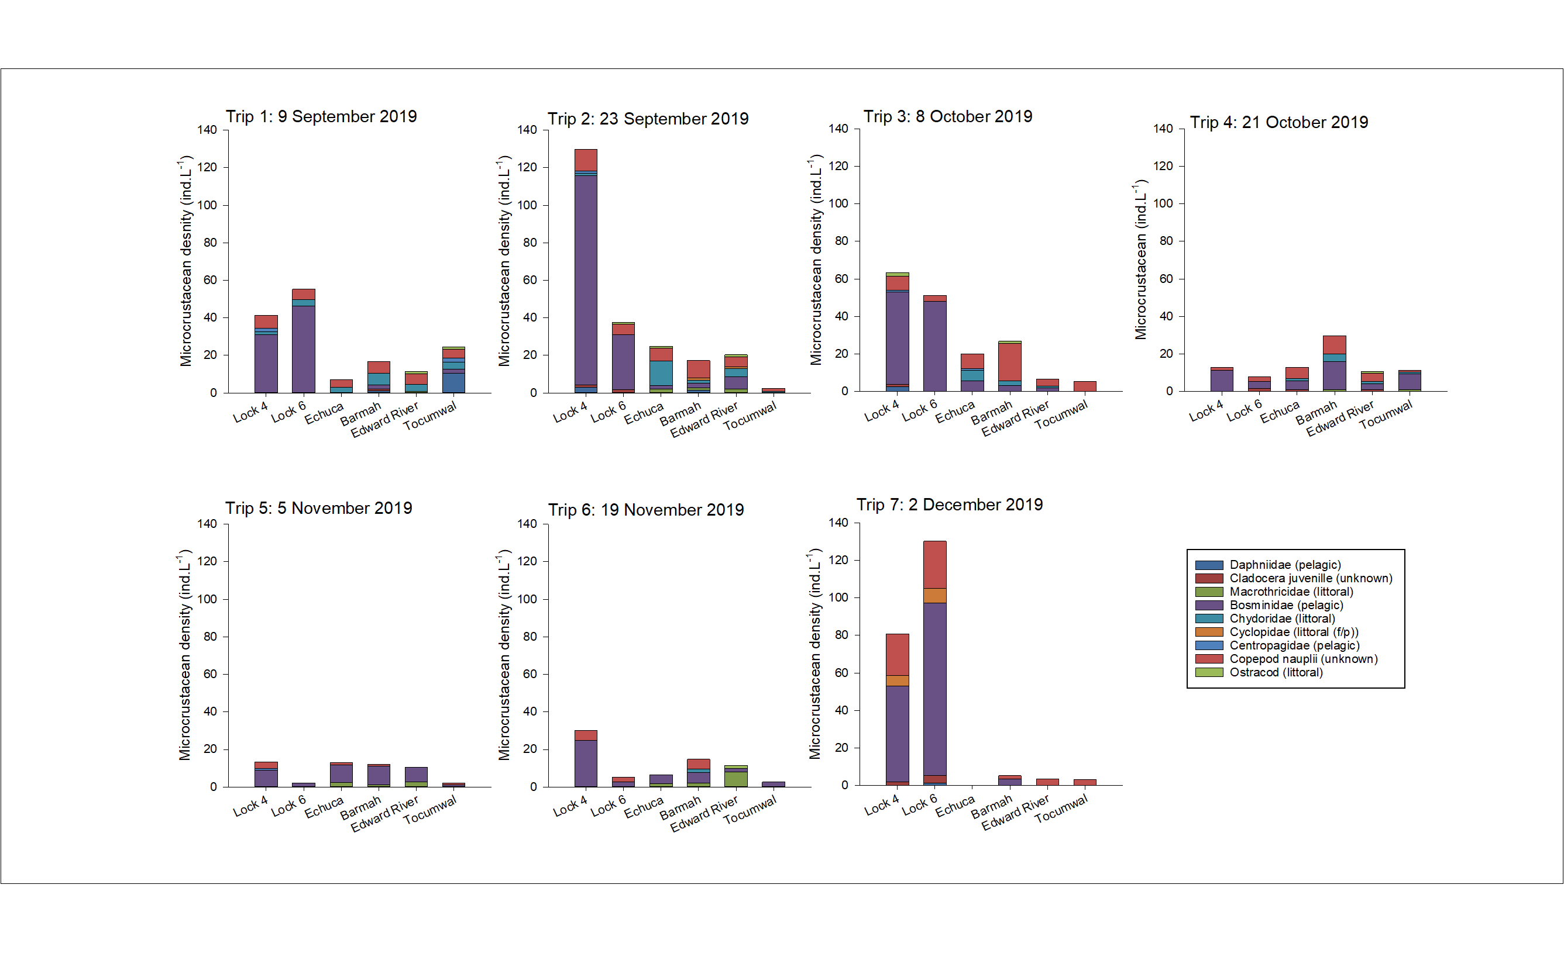

Figure 7: Site mean density of microcrustaceans (ind.L-1) by family for seven sampling trips between early September and early December 2019. Sites listed in the order in which they occur spatially along the River Murray (excluding the Edward River site) from the site furthest downstream on the left and the site furthest upstream on the right. The Edward River offtake is between the Tocumwal and Barmah sites.

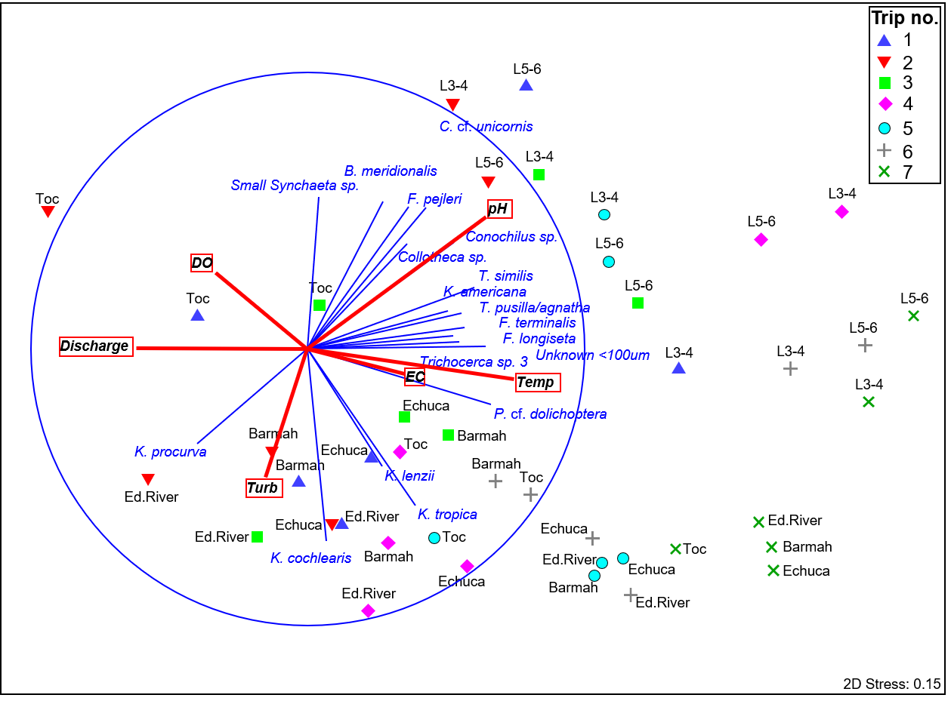

Figure 8: Nonmetric Multidimensional Scaling (MDS) ordination of zooplankton community structure across all sites (labelled) and sampling trips (indicated by symbol) between early September and early December 2019 with species correlations (vector correlation value set to = 0.5) and environmental correlations (vector correlation value set to 0.3). Where sites are labelled as Toc = Tocumwal, Ed.River = Edward River, Lock 6 = Lock 6, and Lock 4 = Lock 4.

## Sampling trips

### Trip 1: 9 September 2019

#### Mid-Murray

Discharge was at its peak at Tocumwal at ~15,000 ML.day-1 and rising at Barmah at 7,588 ML.day-1 and the Edward River (4 Post Reserve) at 3,157 ML.day-1 (Figure 4). Discharge was low in the Goulburn River at 1,097 ML.day-1 (Figure 4). Zooplankton density ranged between 108±17 and 235±12 ind.L-1 in the mid-Murray, and was significantly lower at Tocumwal in comparison to all other mid-Murray sites (*P=*0.0069–0.018) (Figure 6 and Table 7). The majority of the zooplankton communities at the mid-Murray sites were comprised of pelagic rotifers (Figure 9). Microcrustacean density was greater at Tocumwal, where the community was primary comprised of *Daphnia galeata*, an introduced cladoceran species that often invades and dominates reservoirs and lakes such as Lake Mulwala and is likely to have been flushed from the lake as discharge increased early during the spring flow pulse (Figure 7). Over 30 per cent of zooplankton biomass at Tocumwal was due to this species alone (Table 3). Due to high variability however, there was no significant difference in microcrustacean density between the mid-Murray sites (*P=*0.052–0.45) (Figure 7 and Table 5). Community structure was significantly different between Tocumwal and Echuca (*P=*0.044) (Figure 8 and Table 6). SIMPER analysis indicated that this was primarily due to greater densities of the introduced cladoceran species *Daphnia galeata* at Tocumwal and greater densities of the rotifer taxa *Keratella procurva, Keratella cochlearis, Keratella lenzii*, a solitary *Conochilus* species, a small *Synchaeta* species and *Trichocerca* *pusilla/agnatha* at Echuca.

#### Lower-Murray

During trip 1, discharge was low in the lower-Murray at Lock 6 (~3,901 ML.day-1) (Figure 4). Zooplankton density was 174±20 and 583±29 ind.L-1 at Lock 6 and Lock 4, respectively (Figure 6). Zooplankton density was significantly greater at Lock 4 than all mid-Murray sites (*P*<0.0004 for all comparisons) (Figure 6 and Table 7). Microcrustacean density was significantly greater at both lower-Murray sites in comparison to all mid-Murray sites excluding Tocumwal (P=0.0055–0.18) (Figure 7 and Table 5). At both lower-Murray sites, the majority of the zooplankton community was comprised of pelagic rotifers and the most abundant microcrustacean taxa was Bosminidae (Figure 7 and Figure 9).

### Trip 2: 23 September 2019

#### Mid-Murray

During trip 2, discharge was peaking at Tocumwal (~15,000 ML.day-1) and rising at Barmah (9,060 ML.day-1), the Edward River (4 post reserve) (4,102 ML.day-1) and the Goulburn River (3,625 ML.day-1) (Figure 4). Zooplankton density ranged between 51±6.6 and 420±62 ind.L-1 (Figure 6), with the majority of the zooplankton community at all mid-Murray sites comprised of pelagic rotifers (Figure 9). Zooplankton and microcrustacean densities were significantly greater at Edward River than at Tocumwal (*P=*0.023 and 0.019, respectively) (Figure 6, Figure 7, Table 5 and Table 7), and contributed to 4.5 times greater zooplankton biomass (36±14 and 7.5±3.8 kg.GL-1) and 1.3 times greater daily load (146±57 and 116±59 kg.day-1), despite the considerably lower discharge at Edward River (Figure 4 and Table 3). The microcrustacean community at Edward River was comprised primarily of Chydoridae, copepod nauplii, Macrothricidae and Bosminidae species (Figure 7). Chydoridae and Macrothricidae require significant areas of littoral and/or still water habitats for population growth. Therefore increases in these taxa indicate the flushing of off-channel habitats. Similarly, at Barmah, zooplankton density was significantly greater and community structure significantly different from that at Tocumwal (*P=*0.0016 and 0.041, respectively) (Figure 6, Figure 8, Table 5 and Table 6). Greater densities contributed to 3.25 times greater biomass (26±14 and 7.5±3.8 kg.GL-1, respectively) and 2 times greater daily load (238±122 and 116±59 kg.day-1, respectively), despite the considerably lower discharge at Barmah (Figure 4 and Table 3). SIMPER analysis indicated that the primary taxa driving the differences between these two sites were greater densities of *Keratella procurva, Keratella australis, Keratella cochlearis, Conochilus* species*, Trichocerca pusilla/agnatha* and a small *Synchaeta* species at Barmah. There was no significant difference in zooplankton density, microcrustacean density or community structure between Barmah and Echuca (*P=*0.40, 0.46 and 0.13) (Figure 6, Figure 7, Table 5, Table 6 and Table 7).

#### Lower-Murray

During trip 2, discharge was beginning to increase at Lock 6 (6,274 ML.day-1) (Figure 4)-. Zooplankton density was 163±15 and 420±62 ind.L-1 at Lock 6 and Lock 4, respectively (Figure 6). Zooplankton density was significantly greater at Lock 4 than all other sites (*P=*0.0013–0.031). The majority of the zooplankton community at both lower-Murray sites was comprised of pelagic rotifers (Figure 9). Microcrustacean density was also significantly greater at Lock 4 than all other sites and the community was primarily comprised of Bosminidae (*P=*0.00030–0.0076) (Figure 7 and Table 5). Microcrustaceans at Lock 4 contributed to approximately 50% of zooplankton biomass, which was higher than all other sites (111±11 kg.GL-1) (Table 3).

### Trip 3: 8 October 2019

#### Mid-Murray

During trip 3, discharge at Tocumwal remained at ~15,000 ML.day-1 and was rising toward the peak at Barmah (9,542 ML.day-1) and the Edward River (4 post reserve) (4,161 ML.day-1) (Figure 4). Discharge had peaked in the Goulburn River approximately one week earlier and at the time of sampling had decreased to 5,929 ML.day-1 (Figure 4). Zooplankton density was still generally low in the mid-Murray, ranging 94±6 to 283±44 ind.L-1 (Figure 6), and the community was dominated by pelagic rotifers (Figure 9). Zooplankton density was significantly lower and community structure significantly different at Edward River in comparison to Tocumwal (*P=*0.014 and 0.023, respectively) (Figure 6, Figure 9, Table 5 and Table 6). SIMPER analysis indicated that the primary taxa driving the differences between these two sites were lower densities of a small *Synchaeta* species, *Synchaeta pectinata* and a solitary *Conochilus* species at Edward River. At Barmah, zooplankton and microcrustacean density was significantly greater and community structure significantly different from that at Tocumwal (*P=*0.042, 0.043 and 0.024, respectively) (Figure 6, Figure 7, Figure 9, Table 5, Table 6 and Table 7). Greater densities contributed to ~2.5 times greater biomass (42±1.8 and 17±2.3 kg.GL-1) and 1.6 times greater daily load (405±17 and 258±35 kg.day-1), despite the considerably lower discharge at Barmah (Figure 4 and Table 3). SIMPER analysis indicated that the primary taxa driving the differences between these two sites were greater densities of *Keratella australis*, *Keratella procurva*, *Keratella cochlearis*, a solitary *Conochilus* species and copepod nauplii at Barmah. At Echuca, microcrustacean density was significantly greater than Tocumwal (*P*=0.048). Zooplankton density was significantly lower at Echuca than at Barmah (*P=*0.046), however, microcrustacean density and community structure was similar (*P=*0.40 and 0.18, respectively).

#### Lower-Murray

During trip 3, discharge at Lock 6 and was increasing (12,934 ML.day-1) and close to its peak (Figure 4). Zooplankton densities (Lock 6 = 373±22 ind.L-1, Lock 4 = 208±21 ind.L-1) were similar to those in the mid-Murray (Figure 6). The majority of the zooplankton community at Lock 6 was comprised of littoral (f/p) rotifers and at Lock 4, pelagic rotifers (Figure 9). Zooplankton density was significantly greater at Lock 6 than Lock 4 (*P=*0.0055) and zooplankton and microcrustacean densities significantly greater at Lock 6 than Tocumwal, Edward River and Echuca (*P=*0.0002–0.0011 and 0.0003–0.0045) (Figure 6, Figure 7, Table 5 and Table 7).

### Trip 4: 21 October 2019

#### Mid-Murray

During trip 4, discharge was decreasing at Tocumwal (9,470 ML.day-1), Barmah (8,979 ML.day-1) and Edward River (4 post reserve) (3,351 ML.day-1). Discharge was low in the Goulburn River at 1,232 ML.day-1. Zooplankton density ranged 124±23 ind.L-1 to 254±33 ind.L-1 in the mid-Murray (Figure 6). The majority of the community was comprised of pelagic rotifers (Figure 9). There was no significant difference in zooplankton density, microcrustacean density or community structure between Tocumwal and Barmah (*P=*0.98, 0.19 and 0.060, respectively) (Figure 6, Figure 7, Table 5, Table 6 and Table 7). There was a significant difference in zooplankton density and community structure between Tocumwal and Edward River (*P=*0.046and 0.042, respectively). There was no significant difference in microcrustacean density between Tocumwal and Edward River (*P=*0.081) (Figure 6, Figure 7, Table 5 and Table 7). SIMPER analysis indicated that these differences were driven by greater densities of a small *Synchaeta* species, *Synchaeta pectinata*, *Polyarthra dolichoptera* and an *Asplanchna* species at Tocumwal. There was no significant difference in zooplankton density, microcrustacean density or community structure between Barmah and Echuca (*P=*0.52, 0.16 and 0.15, respectively) (Figure 6, Figure 7, Table 5, Table 6 and Table 7).

#### Lower-Murray

Discharge was at its peak at Lock 6 (15,031 ML.day-1). Zooplankton density was 1,612±49 and 2,070±253 ind.L-1 at Lock 6 and Lock 4, respectively (Figure 6). Zooplankton density was significantly greater at the two lower-Murray sites in comparison to all mid-Murray sites (*P=*0.0001–0.0009) (Figure 6 and Table 7). These greater densities contributed to the second largest biomass per volume of 74±9.8 kg.GL-1 and the largest daily loads of 1,071±142 kg.day-1 across all sites during spring (trip 1 to trip 6) (Table 3). The community at the two lower-Murray sites was comprised primarily of littoral (f/p) rotifers (Figure 9).

### Trip 5: 5 November 2019

#### Mid-Murray

During trip 5, discharge was steady at Tocumwal (9,248 ML.day-1), decreasing at Barmah (7,228 ML.day-1‑) (due to Barmah Forest regulators being closed at the end of October and less water returning to the River Murray from the forest upstream from the Barmah sampling site), and was steady at Edward River (4 post reserve) (2,494 ML.day-1) due to Millewa Forest regulators remaining open until early December (Figure 4). Discharge was low in the Goulburn (965 ML.day-1) (Figure 4). Zooplankton densities ranged 167±30 ind.L-1 and 554±61 ind.L-1 in the mid-Murray (Figure 6). The majority of the community was comprised of pelagic rotifers (Figure 9). Zooplankton density was significantly greater and community structure significantly different at Edward River compared to Tocumwal (*P=*0.0038 and 0.038, respectively) (Figure 6, Table 6 and Table 7). Zooplankton and microcrustacean density were significantly greater and community structure was significantly different at Barmah compared to Tocumwal (*P*=0.010, 0.027 and 0.046, respectively) (Figure 6, Figure 7, Table 5, Table 6 and Table 7). The microcrustacean communities at Edward River and Barmah were almost solely comprised of *Bosmina meridionalis*, a common in-channel cladoceran species. Greater zooplankton densities contributed to ~2.5 times greater biomass per volume at Barmah and Edward River than at Tocumwal (25±3.5 and 8.7±3.1 kg.GL-1, and, 21±3.0 and 8.7±3.1 kg.GL-1, respectively) and greater daily load at Barmah than Tocumwal (182±25 and 80±29 kg.day-1, respectively) (Table 3). SIMPER analysis indicated that the taxa driving the differences included greater densities of *Trichocerca pusilla/agnatha*, *Keratella cochlearis*, *Keratella tropica* and *Polyarthra dolichoptera* at Barmah and Edward River as well as a solitary *Conochilus* species and *Bosmina meridionalis* at Barmah. There was no significant difference in zooplankton density, microcrustacean density or community structure between Barmah or Echuca (*P=*0.51, 0.0.91 and 0.29, respectively) (Figure 6, Figure 7, Table 5, Table 6 and Table 7).

#### Lower-Murray

During trip 5, discharge had decreased significantly since trip 4 at Lock 6 (6,619 ML.day-1). Zooplankton density was 301±32 and 363±27 ind.L-1 at Lock 6 and Lock 4, respectively (Figure 6). The majority of the community was comprised of pelagic rotifers (Figure 9). SIMPER analysis indicated that the taxa driving the differences included greater densities of a small *Synchaeta* species, *Conochilus* cf. *unicornis* and a *Collotheca* species and lower densities of *Keratella* *cochlearis*, *Keratella* *tropica*, *Trichocerca pusilla*/*agnatha* at the lower-Murray sites.

### Trip 6: 18 November 2019

#### Mid-Murray

During trip 6, discharge was steady at Tocumwal (9,112 ML.day-1), decreasing at Barmah (6,589 ML.day-1) and steady at Edward River (4 post reserve) (2,489 ML.day-1) (Figure 4). Discharge was low in the Goulburn (903 ML.day-1)(Figure 4). Zooplankton density ranged between 200±21 ind.L-1 and 446±40 ind.L-1 in the mid-Murray (Figure 6). The majority of the community at all mid-Murray sites was comprised of pelagic and littoral (f/p) rotifers (Figure 9). Zooplankton density was significantly greater at Edward River than Tocumwal however community structure was not significantly different (*P=*0.0044 and 0.087, respectively) (Figure 6, Table 6 and Table 7). These greater densities contributed to ~1.6 times greater biomass per volume at Edward River (18±3.5 and 11±2.3 kg.GL-1, respectively) (Table 3). There was no significant difference in zooplankton density or community structure at Barmah in comparison to Tocumwal (*P=*0.65 and 0.31, respectively) (Figure 6, Table 6 and Table 7). Zooplankton density was significantly greater however community structure was not significantly different at Echuca in comparison to Barmah (*P=*0.017 and 0.10, respectively) (Figure 6, Table 6 and Table 7). However, these greater densities did not contribute to greater biomass per volume at Echuca in comparison to Barmah (17±0.66 and 23±9.0, respectively) (Table 3).

#### Lower-Murray

During trip 6, discharge had returned to levels similar to those prior to the spring flow pulse at Lock 6 (4,096 ML.day-1) (Figure 4). Zooplankton density was 1,020±98 and 673±51 ind.L-1 at Lock 6 and Lock 4, respectively. The majority of the community was comprised of pelagic and littoral (f/p) rotifers (Figure 9). Zooplankton density was significantly greater at the two lower-Murray sites in comparison to the mid-Murray sites (*P=*0.0007−0.024) (Figure 6 and Table 7).

### Trip 7: 2 December 2019

#### Mid-Murray

During trip 7, discharge was steady at Tocumwal (9,017 ML.day-1) and Barmah (7,215 ML.day-1) and steady at Edward River (4 post reserve) (2,510 ML.day-1). The Millewa Forest regulators were closed on the 3rd December. Discharge was steady and low in the Goulburn (1,263 ML.day-1) (Figure 4). Zooplankton density ranged between 682±66 and 1,037±40 ind.L-1 in the mid-Murray. The majority of the community was a combination of both pelagic and littoral (f/p) rotifers (Figure 9). Zooplankton density was significantly greater and community structure significantly different at Edward River in comparison to Tocumwal (*P=*0.019 and 0.035, respectively) (Figure 6, Table 6 and Table 7). However, these greater densities did not contribute to greater biomass per volume at Edward River in comparison to Tocumwal (32±5 and 39±1 kg.GL-1, respectively) (Table 3). Zooplankton density was significantly greater however community structure was not significantly different at Barmah compared to Tocumwal (*P=*0.014 and 0.12, respectively). These greater densities contributed to slightly greater biomass per volume at Barmah in comparison to Tocumwal (47±3.8 and 39±0.84 kg.GL-1) (Table 3). Zooplankton density and community structure was not significantly different between Barmah and Echuca (*P=*0.2 and 0.17, respectively) (Figure 6, Table 6 and Table 7).

#### Lower-Murray

During trip 7, discharge was at levels similar to those prior to the spring flow pulse at Lock 6 (4,227 ML.day-1) (Figure 4). Zooplankton density was 1,070±81 and 991±138 ind.L-1 at Lock 6 and Lock 4, respectively. The majority of the community was comprised of pelagic rotifers (Figure 9). Zooplankton density was not significantly different at the lower-Murray sites in comparison to the mid-Murray sites (*P=*0.12−0.88) except for Tocumwal which had significantly lower densities than Lock 6 (*P=*0.021) (Figure 6 and Table 7).

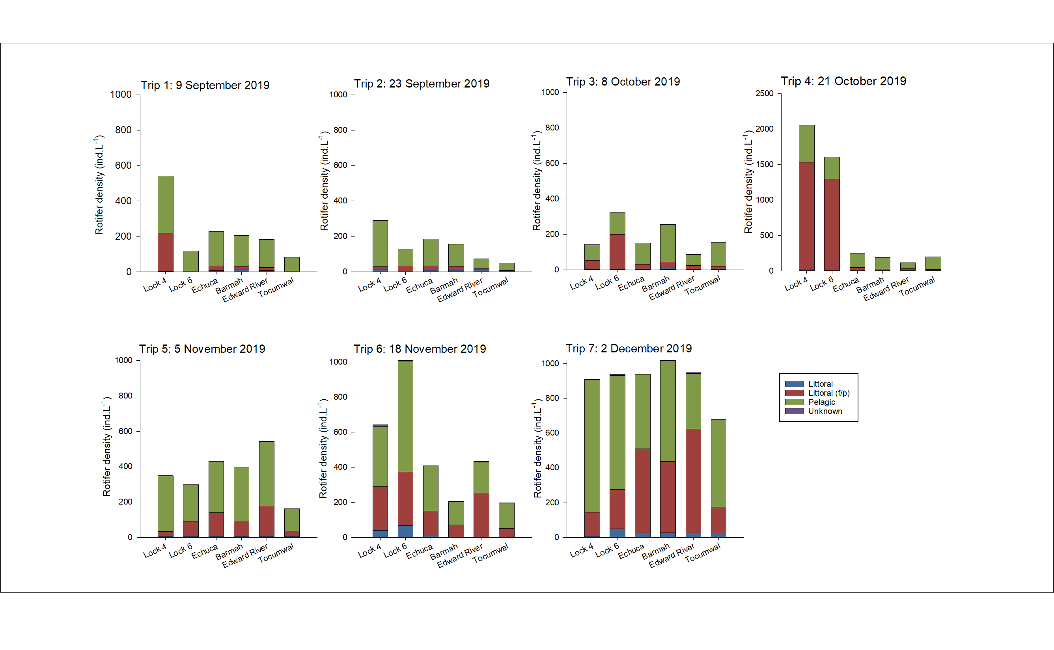

Figure 9: Site mean density of rotifers (ind.L-1) split into habitat categories (littoral, littoral (f/p) or pelagic), for seven sampling trips between early September and early December 2019. Sites listed in the order in which they occur spatially along the River Murray (excluding the Edward River site) from the site furthest downstream on the left and the site furthest upstream on the right. The Edward River offtake is between the Tocumwal and Barmah sites. Note Y axis scale difference for Trip 4.

# Discussion

The primary aim of this study was to investigate changes in the zooplankton community along the main channel of the River Murray in response to an environmental watering event, the 2019 spring flow pulse. Two specific objectives were: 1) to investigate the influence of the partial inundation of the BMF on the zooplankton community within the main river channel; and 2) to investigate the influence of the spring flow pulse on downstream zooplankton communities. The results suggest that in the mid-Murray the BMF contributed to higher densities of microcrustaceans in the river channel downstream and a shift in microcrustacean community structure. The rotifer response throughout the mid-Murray was less clear, as Tocumwal demonstrated at times lower rotifer densities than the mid-Murray sites downstream, during and following the spring flow pulse. However, based on current understanding of the influence of water velocity on rotifer productivity, it is likely that longitudinal increases during the spring flow pulse were also due to sourcing from the BMF. In the lower River Murray, high zooplankton densities and communities characterised by flow responsive species suggested positive responses related to timing of flow and longitudinal connectivity. Overall, the results demonstrate a number of positive outcomes in relation to zooplankton responses to the delivery of environmental water along the length of the River Murray in spring 2019. In conjunction with understanding of carbon and nutrient dynamics during this flow event from an allied project (Rees et al. 2020a), this data will inform future environmental water delivery with regard to improving riverine productivity and the transfer of energy between trophic levels.

## Changes in microcrustacean density and community structure

During trip 1 (early September 2019), the invasive cladoceran *Daphnia galeata* was detected in high densities at Tocumwal, approximately 95 river kilometres downstream of Lake Mulwala, where it contributed to over 30 percent of zooplankton biomass. Over recent years, this lentic species has been detected throughout the lower River Murray and Lower Lakes (Karabanov *et al.* 2018; Shiel 2020). Favourable conditions for *D. galeata* were possibly created within Lake Mulwala in the months leading up to this study, as it is known for its successful invasion of lakes following eutrophication (Rellstab *et al.* 2011; Wei *et al.* 2015). Its ability to successfully invade has been attributed to the species unusual habit of not discriminating against cyanobacteria as a food source, and in some instances, requiring eutrophic phytoplankton to persist (Pattinson 2001; Spaak *et al.* 2012). In the presence of cyanobacteria, *D*. *galeata* also reduce their rate of weight gain, resulting in smaller organisms that are more resistant to fish predation (Hairston Jr *et al.* 2001) and possibly present poor quality food for higher trophic organisms due to the poor quality of their own food resource (e.g. Brett *et al.* 2006). In the initial stages of the spring flow pulse, *D. galeata* was most likely flushed from the lake and displaced due to decreasing water residence times throughout Lake Mulwala and increasing water velocities downstream, which are unfavourable for reproduction. For the remainder of the study period (during and after the spring flow pulse), microcrustacean densities were low at Tocumwal, as has been consistently found in previous studies (Furst *et al.* 2017; Rees *et al.* 2020b). Little is known regarding the broader impacts of the invasion of this species, however, they are likely to be negative, as *D. galeata* populations are fast-growing and inhabit and often dominate a central position within lake communities (i.e. the pelagic zone, the largest area of habitat within lakes) where they are likely to replace native taxa.

The spring flow pulse was associated with longitudinal increases in microcrustacean densities and a shift in microcrustacean community structure in the mid-Murray. At the peak of the spring flow pulse during trip 2 (late September), a littoral/lentic microcrustacean community developed in the mid-Murray. Greater densities were measured at Edward River (significant), Barmah and Echuca (significant) in comparison to Tocumwal (20±5.1, 17±9.7 and 25±6.7 ind.L-1 in comparison to 2.5±1.4 ind.L-1 respectively), and were comprised largely of Chydoridae, Macrothricidae and copepod nauplii, all important food resources for fish (e.g. larval golden perch, Murray cod) (Arumugam and Geddes 1996; Kaminskas and Humphries 2009). These taxa, particularly Chydoridae and Macrothricidae, are commonly generated in abundance within off-channel habitats (e.g. floodplains) and therefore increases in these taxa in-channel indicate transferral from the floodplain. The inundation of the floodplain resulting from the spring flow pulse is likely to have provided habitat, longer WRT’s and food resources for community development and the lateral connectivity promoted the transferral of a proportion of these communities to the main river channel. At Echuca, the zooplankton community may have partially been influenced by flows from the Goulburn River. However, the majority of organisms were presumably derived from inputs from the BMF due to the habitat and WRT’s required to generate microcrustacean communities which were unlikely to have been present in the Goulburn River at the time. Additionally, during trip 3 (early October), greater densities of microcrustaceans were again detected at Barmah in comparison to Tocumwal. The community at Barmah was primarily comprised of copepod nauplii; as these nauplii may have been produced by a range of different taxa, the habitat type in which they likely originated is unknown. Following the peak of the spring flow pulse in the mid-Murray and for the entire study period in the lower-Murray, the microcrustacean community was dominated by the pelagic *Bosmina meridionalis*,a species that commonly thrives within the main channel River Murray.

These increases in microcrustacean densities and shifts in microcrustacean community structure influenced by the spring flow pulse were likely to have positive implications for higher trophic organisms. A study conducted by King (2004) in the Broken River (a tributary of the Goulburn River) demonstrated that the densities of microcrustaceans measured in the pelagic zone (where these samples were collected), reflect communities with around 100 times greater densities in the littoral zone of the main channel. Assuming a similar relationship between the pelagic and littoral zone within this region of the River Murray, densities within the littoral zone potentially increased from ~250 ind.L-1 at Tocumwal to ~2,500 ind.L-1 at Echuca. Rowland (1996) demonstrated that the survival of golden perch larvae in an aquarium setting increased from 1.6 to 7.2 per cent when prey densities were increased from 500−3000 ind.L-1. The increases in microcrustacean densities detected during this study may therefore have been great enough to promote survival of larval fish such as golden perch. Each of the different groups of microcrustaceans detected during this study have been found to be food resources for fish, however, those that were exported from the BMF (primarily littoral) inhabit a different position within communities than *Bosmina meridionalis* (pelagic), which dominated riverine communities throughout the study, and consequently provided a greater diversity of food resources for fish.

In this study, microcrustacean densities were lower than those observed during unregulated overbank flows at Barmah-Millewa in spring 2011 Rees *et al.* (2020b), however, the overbank flows in 2011 were considerably greater (up to ~ 27,000 ML.day-1) than those during this study. Additionally, the overbank flows in 2011 followed a large natural flood in 2010-11. Indeed, greater densities of microcrustaceans were also measured in-channel in the lower-Murray in October and early-November in 2017 following a large natural flood in 2016 (Ye *et al.* 2020). These greater responses from the microcrustacean community in years that follow large floods may be related to the replenishment of the microcrustacean egg bank during periods of high flows, while flow pulses in the following year promote their reproduction and thus increased densities. Overall, the results from this study suggest that increases in microcrustaceans due to the 2019 spring flow pulse were relatively small in comparison to those measured during previous inundation events.

## Changes in zooplankton density and community structure: Mid-Murray

Greater densities of zooplankton, primarily rotifers, were detected downstream in comparison to upstream of the BMF during the spring flow pulse and were most likely due to the increase in the availability of, and sourcing from, slow flowing/lentic habitats. A number of other studies have also detected increases in rotifer density between Tocumwal and Barmah and Edward River during overbank flows, where densities were similar to those measured during this study at the same time of year (Gigney *et al.* 2006; Rees *et al.* 2020b). Many zooplankton are not suited to water velocities greater than around 0.1−0.15 meters per second (m.s-1) (e.g. due to limited reproduction and ability to obtain food) (Richardson 1992; Lair 2006; Czerniawski *et al.* 2013; Czerniawski and Sługocki 2017), including the genus *Keratella*, one of the primary contributors to increases in zooplankton densities during the peak of the spring flow pulse (Czerniawski and Sługocki 2017). During sampling trips 1, 2 and 3, the area of in-channel habitat with water velocities <0.1 m.s-1 was likely to be low in the mid-Murray (for average water velocities at similar sites and under similar discharge see Furst *et al.* 2017). Water temperature was also relatively low and similar between sites in the mid-Murray at the time, (~12-16°C), which combined with higher water velocities, zooplankton productivity in-channel during this period was likely to have been limited. In further support of this, rotifers commonly dominate off-channel habitats for months following inundation, before shifting towards microcrustacean dominance (e.g. Obertegger *et al.* 2007; Furst 2014). Therefore, considering that increases in microcrustaceans were detected downstream during trip 2, less than a month after initial overbank flows (at ~9,000 ML.day-1), it is highly likely that significant numbers of rotifers were also being transferred from the floodplain at this time. Increases in phytoplankton, however, were detected downstream of the BMF during the spring flow pulse and may have played some role in increasing zooplankton productivity in-channel (Rees *et al.* 2020a).

Greater densities of zooplankton were also detected downstream in comparison to upstream of the BMF following the spring flow pulse and were possibly due to increases in slow flowing in-channel habitat, water temperature and availability of food resources. Once discharge decreased, the area of in-channel habitat with slower water velocities would have been greater than during the spring flow pulse, providing more opportunity for in-channel zooplankton productivity. Water temperature and the temperature gradient between Tocumwal and Echuca had also increased considerably by trips 5, 6 and 7 in comparison to trips 2 and 3. Monitoring in the lower-Murray in spring/summer from 2014 to 2018 demonstrated a consistent positive relationship between zooplankton density and water temperature, particularly for rotifers (Ye et al. 2020). Increases in water temperature result in higher primary productivity and thus greater food availability, as well as higher metabolic rates in zooplankton (e.g. Heinle 1969; White et al. 1991). Indeed, the floodplain acted as a source of nutrients during the spring flow pulse, potentially fuelling phytoplankton and biofilm productivity during and following the spring flow pulse (Rees *et al.* 2020a). It is expected that these combined increases in slow flowing habitat, water temperature, continued return flows from Millewa into the Edward River, and presumably food resources were driving increases in density through the BMF during trips 5, 6 and 7. It is possible however, that the section of river between Tocumwal, Barmah and Edward River provides the necessities for greater primary and secondary productivity at all times, due to nutrient inputs from the permanent vegetation aligning the main channel and in-channel littoral and backwater habitats. To gain a better understanding of the drivers of changes in rotifer densities throughout the BMF, further investigations are required that capture a diversity of discharge and temperature scenarios.

## Changes in zooplankton density and community structure: Lower-Murray

High densities of flow responsive littoral (f/p) rotifers were measured at the peak of the spring flow pulse in the lower-Murray in mid-October 2019. Zooplankton densities measured at the time (up to ~2,000 ind.L-1 during trip 4) were greater than those measured in the lower-Murray at the same time of year from 2014 to 2017, where densities in late-October to early-November fell between ~200 and 750 ind.L-1, as part of the CEWO Long-Term Intervention Monitoring project (Ye *et al.* 2020). The high densities in this project were primarily driven by taxa from the rotifer genus *Trichocerca*,which are typically referred to as a littoral species due to their tendency to live on and around littoral vegetation within lentic habitats (Chengalath and Mulamoottil 1975; Ermolaeva *et al.* 2019). However, over recent years a number of studies have found these taxa to have a positive association with longitudinal connectivity, water velocity and increased discharge for a period in spring within the main channel of the lower River Murray (Furst *et al.* 2017, 2018; Gibbs *et al.* 2020). It is possible, that under such conditions, a proportion of these organisms are swept from their preferred littoral habitat, entrained within the flowing water and transported downstream. Densities may then increase due to in-channel reproduction and/or the continual entrainment of these organisms within an envelope of water as it moves along the river channel. Indeed, disruptions to longitudinal connectivity associated with diversions and weirs that elicit decreases in water velocity have been shown to disrupt the downstream transportation of these organisms (Furst *et al.* 2018). In previous studies, as in this study, peaks in the abundance of *Trichocerca* frequently occur between October and November in water temperatures between ~19−21 °C (Furst *et al.* 2017, 2018). Therefore, the longitudinal connectivity and the timing of the delivery of this spring flow event is likely to have contributed to the substantially increased densities of these taxa.

The specific species of higher trophic levels that predate upon *Trichocerca* in the River Murray are unknown, but numerous international studies have found this genus to be an important food resource for both shrimp (e.g. Grossnickle 2001; Haskell and Stanford 2006) and fish (e.g. Van Den Avyle and Wilson 1980; McCullough and Stanley 1981; Dev and Rahmatullah 1998; Sampson *et al.* 2009). Additionally, invertebrates are limited in their capacity to synthesise some long-chain polyunsaturated fatty acids (LC-PUFA). Some of these molecules, termed essential fatty acids (EFAs), are critical for development and reproduction and must be attained from their diet (Guo et al 2017). An organism’s fatty acid composition is then influenced by a combination of both internally consistent features and the quality of food in which they consume (Brett *et al.* 2009). One of the most dominant *Trichocerca* species within the River Murray during spring is *T. pusilla*, which is thought to feed largely on *Aulacoseira*, a high quality diatom known to contain high concentrations of LC-PUFA (May *et al.* 2001). Consumers feeding on high quality diets retain many EFAs in their tissue in higher concentrations than those consuming poor-quality diets. Consequently, it is possible that *T. pusilla* represent a high-quality food resource for higher trophic organisms and potentially an important component of the aquatic food web in spring.

# Conclusion and recommendations

Over recent decades, the degraded ecological health of the River Murray has been well recognised. As such, central to contemporary river management is collaboration between environmental water holders, natural resource managers and scientists in attempts to rehabilitate aquatic habitats, populations and communities. A key approach is the use of environmental water to re-establish features of natural flow regimes (e.g. timing, magnitude and duration of flow events) and restore riverine ecological processes and functions. This project, together with an allied project on carbon and nutrient monitoring (funded by the MDBA), has improved understanding of river productivity and lower trophic level responses to environmental water delivery in which spatial and temporal aspects were guided by that of a small natural spring flow, a frequent and predictable component of the natural flow regime.

The results from this project indicated that the 2019 spring flow pulse generated a detectable response in zooplankton communities. The key findings were:

1. Higher densities of microcrustaceans including floodplain taxa such as Chydoridae and Macrothricidae, measured at the sites immediately downstream of the BMF compared to the control site upstream during the peak of the spring flow pulse. These results indicate the transferral of microcrustaceans from the BMF to the main river channel where they then provide food for higher trophic organisms, particularly larvae of large-bodied native fish.
2. Higher densities of rotifers measured at the sites immediately downstream of the BMF compared to the control site upstream during the spring flow pulse when in-channel productivity was likely to be minimal, indicating the transferral of resources from the BMF to the main river channel. This transferral of resources brings ‘new’ energy and food resources into the system that otherwise would not have been made available, fuelling downstream food webs.
3. Community shifts between littoral and pelagic microcrustacean communities, therefore increasing the variety of food available for higher trophic organisms that utilise different feeding niches.
4. High densities of flow responsive littoral (f/p) rotifers measured at the peak of the spring flow pulse in the lower-Murray in mid-October 2019, most likely influenced by the timing and longitudinal connectivity achieved with the delivery of this spring flow event. These significant increases in the density of these organisms are potentially an important component of the aquatic food web in spring that would have occurred almost annually under natural conditions.

The results of the current project may be used to inform future environmental water deliveries with the objective of promoting zooplankton responses. Recommendations should be considered in the broader context of ecological outcomes in the southern MDB. These include:

1. That environmental water delivery be provided to support future spring pulse flows, which influence floodplain inundation and hydraulics across large spatial scales to substantively influence riverine zooplankton communities, and potentially promote food webs.
2. Consideration be given to the different mechanisms driving zooplankton community structure and density between the mid-Murray and lower-Murray. Lower channel capacity resulted in floodplain inundation being a major driver of community structure and density in the relatively free-flowing mid-Murray, while in the highly regulated lower-Murray, increased transferral from littoral zones, likely resulting from increased water level and flow velocities, appears to be the primary driver.
3. Increasing the duration of spring flow pulses and associated floodplain inundation to increase WRT’s which may promote greater zooplankton densities and abundance, and communities more dominated by microcrustaceans.
4. Increasing the magnitude of spring flow pulses and associated area of floodplain inundation to increase habitat area for community development, and therefore the magnitude of response.
5. Delivering water later in the year when water temperatures are higher and therefore productivity greater.

It is recommended that future monitoring and investigations on the zooplankton response to environmental watering events at the system scale consider:

1. Dividing the system, from the headwaters to the end of the system, into regions based on topographic, geomorphic and hydraulic characteristics and having replicate sites (a minimum of three) within each region (for an example see Furst *et al.* 2017).
2. Including sites within major tributaries during periods in which they are contributing significantly to discharge within the River Murray.
3. Investigating changes in the quality of zooplankton communities as a food resource for higher trophic organisms using techniques such as fatty acid analysis under a diversity of temperature and discharge scenarios.
4. Investigating trophic pathways via a combination of methods such as traditional gut content, molecular and isotope analysis under a diversity of temperature and discharge scenarios.
5. Investigating the influence of engineered inundation (e.g. floodplain regulators) to augment inundation and zooplankton responses associated with pulse flows.

The current study, together with future investigations, will further improve our understanding of how energy is sourced and transported throughout the system under different flow and management regimes. Such knowledge can inform environmental water delivery and river management to influence ecological processes and food web responses at the local and system scale.

# Appendix

Table 4: Summary of the major features identified in the conceptual diagram above, their general influence on primary and secondary productivity, how this influence changes in relation to discharge and the sites sampled as part of this project that may detect some of these influences.

|  |  |  |  |
| --- | --- | --- | --- |
|  | **Primary and secondary productivity** | **Influences of discharge** | **Sites** |
| **Ephemeral floodplains, wetlands and backwater habitats** | When inundated, these habitats bring ‘new’ energy into the system including nutrients, detritus and zooplankton.  Promote high primary productivity, high zooplankton density and species diversity and zooplankton communities with a higher proportion of microcrustaceans than flowing water habitats. | As discharge increases, the area of ephemeral habitat and lateral connectivity also increase, promoting the development of phytoplankton and zooplankton communities and their transferral to the main river channel.  As the water residence time and/or the time since inundation of these habitats increase:   1. the biomass of primary and secondary producers increases, and 2. the proportion of the zooplankton community comprised of microcrustaceans increase. | Ed.River  Barmah  Echuca |
| **Water storages** | Disrupt natural longitudinal riverine processes e.g. downstream transportation of resources including nutrients and flow dependent phytoplankton and zooplankton.  Create lake/reservoir like environment that promotes the replacement of riverine communities with open water lake/reservoir communities. Zooplankton diversity is likely to be lower than in natural lakes due to low habitat heterogeneity.  Lakes/reservoirs present a higher risk of thermal stratification which increases the risk of cyanobacteria blooms and associated shifts in zooplankton community.  Cold, resource poor water is often released from the bottom layers of water storages, leading to low primary and secondary productivity downstream. | As discharge increases, water residence time within water storages decrease, reducing their influence on riverine primary and secondary producers. | Tocumwal |
| **Locks** | Disrupt natural longitudinal riverine processes e.g. downstream transportation of resources including nutrients and flow dependent phytoplankton and zooplankton.  Create lake/reservoir like environment that promotes the replacement of riverine communities with open water lake/reservoir communities. Zooplankton diversity is likely to be lower than in natural lakes due to low habitat heterogeneity. | As discharge increases, water residence time behind locks and their impact on hydrodynamics and water levels decrease, reducing their influence on riverine primary and secondary producers. | Possibly Lock 6  Possibly Lock 4 |
| **In-channel littoral zones and backwater habitats** | When inundated, these habitats bring ‘new’ energy into the system including nutrients, detritus and zooplankton.  Promotes littoral zooplankton and zooplankton communities with a higher proportion of microcrustaceans than adjacent flowing water habitats. | As discharge increases, the area of ephemeral habitat, lateral connectivity and water velocity/turbulence increase, promoting the development of littoral communities, their transferral to the main river channel and their entrainment and transportation downstream.  As the water residence time and/or the time since inundation of these habitats increase:   1. the biomass of primary and secondary producers increases, and 2. the proportion of the zooplankton community comprised of microcrustaceans increase. | Lock 6  Lock 4 |

Table 5: Summary of PERMANOVA pair-wise test monte-carlo p-values (due to low unique permutations) on microcrustacean density. Significant p-values have been highlighted in grey.

|  |  |  |  |  |  |  |  |
| --- | --- | --- | --- | --- | --- | --- | --- |
| Groups | Trip 1 | Trip 2 | Trip3 | Trip 4 | Trip 5 | Trip 6 | Trip 7 |
| Lock 4, Lock 6 | 0.38 | 0.0076 | 0.085 | 0.67 | 0.052 | 0.0025 | 0.17 |
| Lock 4, Echuca | 0.0050 | 0.0033 | 0.0014 | 0.80 | 0.10 | 0.0065 | 0.0038 |
| Lock 4, Barmah | 0.018 | 0.0047 | 0.016 | 0.24 | 0.92 | 0.14 | 0.010 |
| Lock 4, Ed.River | 0.0054 | 0.0029 | 0.00080 | 0.98 | 0.61 | 0.098 | 0.0095 |
| Lock 4, Toc | 0.18 | 0.00030 | 0.0025 | 0.87 | 0.058 | 0.0093 | 0.0089 |
| Lock 6, Echuca | 0.0088 | 0.31 | 0.0013 | 0.37 | 0.042 | 0.58 | 0.00030 |
| Lock 6, Barmah | 0.023 | 0.18 | 0.036 | 0.10 | 0.025 | 0.18 | 0.0010 |
| Lock 6, Ed.River | 0.012 | 0.17 | 0.00030 | 0.53 | 0.049 | 0.43 | 0.001 |
| Lock 6, Toc | 0.099 | 0.0054 | 0.0045 | 0.83 | 0.98 | 0.27 | 0.0011 |
| Echuca, Barmah | 0.052 | 0.46 | 0.40 | 0.16 | 0.91 | 0.27 | 0.13 |
| Echuca, Ed.River | 0.22 | 0.63 | 0.020 | 0.65 | 0.55 | 0.56 | 0.37 |
| Echuca, Toc | 0.079 | 0.013 | 0.048 | 0.65 | 0.046 | 0.22 | 0.37 |
| Barmah, Ed.River | 0.15 | 0.67 | 0.031 | 0.12 | 0.32 | 0.70 | 0.66 |
| Barmah, Toc | 0.45 | 0.15 | 0.043 | 0.19 | 0.027 | 0.11 | 0.62 |
| Ed.River, Toc | 0.17 | 0.019 | 0.65 | 0.81 | 0.055 | 0.22 | 0.98 |

Table 6: Summary of PERMANOVA pair-wise test monte-carlo p-values (due to low unique permutations) on zooplankton community structure. Significant p-values have been highlighted in grey.

|  |  |  |  |  |  |  |  |
| --- | --- | --- | --- | --- | --- | --- | --- |
| Groups | Trip 1 | Trip 2 | Trip 3 | Trip4 | Trip 5 | Trip 6 | Trip 7 |
| Lock 4, Lock 6 | 0.018 | 0.036 | 0.042 | 0.12 | 0.047 | 0.060 | 0.017 |
| Lock 4, Echuca | 0.0055 | 0.0041 | 0.014 | 0.0012 | 0.0034 | 0.0073 | 0.0042 |
| Lock 4, Barmah | 0.0073 | 0.024 | 0.010 | 0.0020 | 0.0034 | 0.0091 | 0.0050 |
| Lock 4, Ed.River | 0.0078 | 0.0084 | 0.0088 | 0.0041 | 0.0033 | 0.0061 | 0.0047 |
| Lock 4, Toc | 0.012 | 0.013 | 0.0031 | 0.0015 | 0.0071 | 0.0080 | 0.0082 |
| Lock 6, Echuca | 0.010 | 0.0060 | 0.0072 | 0.0017 | 0.0031 | 0.0039 | 0.0024 |
| Lock 6, Barmah | 0.011 | 0.018 | 0.0053 | 0.0014 | 0.0034 | 0.0063 | 0.0033 |
| Lock 6, Ed.River | 0.0094 | 0.012 | 0.0044 | 0.0047 | 0.0029 | 0.0038 | 0.0023 |
| Lock 6, Toc | 0.027 | 0.017 | 0.0019 | 0.0022 | 0.0058 | 0.0048 | 0.0061 |
| Echuca, Barmah | 0.17 | 0.13 | 0.18 | 0.15 | 0.29 | 0.10 | 0.17 |
| Echuca, Ed.River | 0.41 | 0.039 | 0.13 | 0.176 | 0.17 | 0.24 | 0.44 |
| Echuca, Toc | 0.044 | 0.016 | 0.029 | 0.025 | 0.049 | 0.16 | 0.08 |
| Barmah, Ed.River | 0.31 | 0.079 | 0.043 | 0.124 | 0.079 | 0.093 | 0.056 |
| Barmah, Toc | 0.081 | 0.041 | 0.024 | 0.060 | 0.046 | 0.31 | 0.12 |
| Ed.River, Toc | 0.083 | 0.054 | 0.023 | 0.042 | 0.038 | 0.087 | 0.035 |

Table 7: Summary of PERMANOVA pair-wise test monte-carlo p-values (due to low unique permutations) on total zooplankton density. Significant p-values have been highlighted in grey.

|  |  |  |  |  |  |  |  |
| --- | --- | --- | --- | --- | --- | --- | --- |
| Groups | Trip 1 | Trip 2 | Trip 3 | Trip 4 | Trip 5 | Trip 6 | Trip 7 |
| Lock 4, Lock 6 | 0.00030 | 0.0084 | 0.0055 | 0.14 | 0.22 | 0.036 | 0.64 |
| Lock 4, Echuca | 0.00040 | 0.031 | 0.18 | 0.00050 | 0.11 | 0.011 | 0.79 |
| Lock 4, Barmah | 0.00020 | 0.010 | 0.18 | 0.00090 | 0.45 | 0.0023 | 0.73 |
| Lock 4, Ed.River | 0.00010 | 0.0025 | 0.0041 | 0.00030 | 0.039 | 0.024 | 0.88 |
| Lock 4, Toc | 0.00030 | 0.0013 | 0.12 | 0.00040 | 0.012 | 0.0011 | 0.12 |
| Lock 6, Echuca | 0.067 | 0.26 | 0.00080 | 0.00020 | 0.033 | 0.0037 | 0.23 |
| Lock 6, Barmah | 0.16 | 0.65 | 0.14 | 0.00020 | 0.12 | 0.00080 | 0.74 |
| Lock 6, Ed.River | 0.41 | 0.016 | 0.00020 | 0.00010 | 0.017 | 0.0049 | 0.24 |
| Lock 6, Toc | 0.069 | 0.0022 | 0.0011 | 0.00010 | 0.041 | 0.00070 | 0.021 |
| Echuca, Barmah | 0.55 | 0.40 | 0.046 | 0.52 | 0.51 | 0.017 | 0.20 |
| Echuca, Ed.River | 0.057 | 0.019 | 0.0013 | 0.027 | 0.17 | 0.59 | 0.74 |
| Echuca, Toc | 0.0069 | 0.0036 | 0.49 | 0.28 | 0.0037 | 0.0035 | 0.039 |
| Barmah, Ed.River | 0.26 | 0.0089 | 0.0060 | 0.16 | 0.117 | 0.015 | 0.14 |
| Barmah, Toc | 0.011 | 0.0016 | 0.042 | 0.98 | 0.010 | 0.65 | 0.014 |
| Ed.River, Toc | 0.018 | 0.023 | 0.014 | 0.046 | 0.0038 | 0.0044 | 0.019 |

Table 8: Summary of the species identified at each site during trips 1−4. Where Lock 4 = Lock 4, Lock 6 = Lock 6, DS Goul = Echuca River confluence, Barm = Barmah, Ed. Rv. = Edward River and Toc = Tocumwal.

|  |  |  |  |  |  |  |  |  |  |  |  |  |  |  |  |  |  |  |  |  |  |  |  |  |
| --- | --- | --- | --- | --- | --- | --- | --- | --- | --- | --- | --- | --- | --- | --- | --- | --- | --- | --- | --- | --- | --- | --- | --- | --- |
|  | Trip one | | | | | | Trip two | | | | | | Trip three | | | | | | Trip four | | | | | |
|  | Lock 4 | Lock 6 | DS Goul | Barm | Ed. Rv. | Toc | Lock 4 | Lock 6 | DS Goul | Barm | Ed. Rv. | Toc | Lock 4 | Lock 6 | DS Goul | Barm | Ed. Rv. | Toc | Lock 4 | Lock 6 | DS Goul | Barm | Ed. Rv. | Toc |
| *Anauropsis coelata* |  |  |  |  |  |  |  |  |  |  |  |  |  |  |  |  |  |  |  |  |  |  |  |  |
| *Anauropsis fissa* |  |  |  |  |  |  |  |  |  |  |  |  |  |  |  |  |  |  |  |  |  |  |  |  |
| *Asplanchna* sp. | * | * | * | * | * | * |  |  | * |  | * |  |  | * | * | * | * | * | * | * | * | * | * | * |
| Bdelloid |  |  | * | * | * |  |  |  | * | * | * | * |  |  | * |  | * |  |  |  | * |  |  |  |
| *Brachionus angularis* | * |  |  |  | * |  |  |  |  |  |  |  |  |  |  |  |  |  | * |  |  | * |  | * |
| *Brachionus budapestinensis* |  |  |  |  |  |  |  |  |  |  |  |  |  |  |  |  |  |  |  |  |  |  |  |  |
| *Brachionus calyciflorus* | * | * |  |  |  |  |  | * |  |  |  |  |  |  |  |  |  |  |  | * | * |  |  |  |
| *Brachionus calyciflorus amph* |  |  |  |  |  |  |  |  |  |  |  |  |  |  |  |  |  |  | * |  |  |  |  |  |
| *Brachionus calyciflorus complex* |  |  |  |  |  | * |  |  |  |  |  |  |  |  |  |  |  |  | * |  |  |  |  |  |
| *Brachionus* cf. *bidens* |  |  |  |  |  |  |  |  |  |  |  |  |  |  |  |  |  |  |  |  |  |  |  |  |
| *Brachionus* cf. *urceolaris* |  |  | * |  |  | * |  |  |  |  |  |  |  |  |  |  |  |  |  |  |  |  |  |  |
| *Brachionus diversicornis* |  |  |  |  |  |  |  |  |  |  |  |  |  |  |  |  |  |  |  |  |  |  |  |  |
| *Brachionus caudaus* |  |  |  |  |  |  |  |  |  |  |  |  |  |  |  |  |  |  |  |  |  |  |  |  |
| *Brachionus dichotomus* |  |  |  |  |  |  |  |  |  |  |  |  |  |  |  |  |  |  |  |  |  |  |  |  |
| *Brachionus nilsoni* |  |  |  | * |  | * |  |  |  |  | * |  |  |  |  |  |  |  |  |  |  |  |  |  |
| *Brachionus quadridentatus* |  |  |  |  |  |  |  |  |  |  |  |  |  |  |  |  |  |  |  |  |  |  | * |  |
| *Brachionus quadridentatus quadridentatus* |  |  |  |  |  |  |  |  |  |  |  |  |  |  |  |  |  |  |  |  | * |  |  |  |
| c.f *Lophocharis* sp. |  |  |  | * |  |  |  |  |  |  |  |  |  |  |  | * |  |  |  |  |  |  |  |  |
| *Cephalodella catellina* |  |  |  |  |  |  |  |  |  | * |  |  |  |  |  |  |  |  |  |  |  |  |  |  |
| *Cephalodella forficula* |  |  |  |  |  |  |  |  |  |  |  |  |  |  |  |  |  |  | * |  |  |  |  |  |
| *Cephalodella gibba* |  |  |  | * |  |  |  |  |  |  |  |  |  |  |  |  |  |  |  |  |  |  |  |  |
| *Cephalodella* sp 1 |  |  |  |  | * |  |  |  |  |  |  |  |  |  |  |  |  |  |  |  | * |  |  |  |
| *Cephalodella* sp 2 |  |  |  |  | * |  |  |  | * |  |  |  |  |  |  |  |  |  |  |  |  |  |  |  |
| cf. *Ascomorpha* sp. |  |  |  |  |  |  |  |  |  |  |  |  |  |  |  |  |  |  |  |  |  |  |  |  |
| cf. *Beauchampiella* sp. |  |  |  |  |  |  |  |  |  |  |  |  |  |  |  | * |  |  |  |  |  |  |  |  |
| cf. *Dicranophorodides* sp. |  |  |  |  | * |  |  |  |  |  |  |  |  |  |  | * |  | * |  |  |  | * |  |  |
| cf. *Encentrum* sp. |  |  | * | * |  |  |  |  |  |  | * |  |  |  |  |  | * |  |  |  |  |  |  |  |
| cf. Gastropus sp. |  |  |  |  |  |  |  |  |  |  |  |  |  |  |  | * | * |  |  |  |  |  | * |  |
| cf. Lindia sp. |  |  |  |  |  |  |  |  |  |  |  |  |  |  |  |  |  |  |  |  |  |  | * | * |
| cf. *Notommata* sp. |  |  | * | * | * | * |  |  | * |  |  | * |  |  |  |  |  |  |  |  |  |  |  | * |
| cf. *Proalides* sp. |  |  |  |  |  |  |  |  |  |  |  |  | * |  |  |  |  |  | * | * |  |  |  |  |
| *Collotheca* sp. |  | * | * |  |  |  | * |  | * | * |  | * |  | * |  | * | * | * | * | * | * |  | * | * |
| *Colurella obtusa* |  |  |  |  |  |  |  |  |  |  |  |  |  |  | * |  | * |  |  |  |  |  |  |  |
| *Colurella* sp. |  |  |  |  |  |  |  |  |  |  |  |  |  |  |  |  |  |  |  |  |  |  |  |  |
| *Colurella uncinata bicuspidata* |  |  |  |  |  |  |  |  |  |  |  |  |  |  |  | * |  |  |  |  |  |  |  |  |
| *Conochilus dossuarius* | * |  |  |  |  |  |  |  |  |  |  |  |  |  |  |  |  |  |  |  |  |  |  |  |
| *Conochilus* sp. | * | * | * | * | * | * | * | * | * | * | * | * | * | * | * | * | * | * | * | * | * | * | * | * |
| *Conochilus unicornis* |  | * | * |  |  |  | * | * |  |  |  |  |  |  | * | * |  | * | * | * |  |  |  |  |
| *Euchlanis* sp. |  |  |  | * |  |  |  |  | * |  | * |  |  |  |  |  |  |  |  |  |  |  |  |  |
| *Filinia australiensis* |  |  |  |  |  |  |  |  |  |  |  |  |  |  |  |  |  |  | * |  |  |  |  |  |
| *Filinia brachiata* |  |  |  |  |  |  |  |  |  |  |  |  |  | * |  |  |  |  |  | * |  |  |  |  |
| *Filinia grandis* |  | * |  |  |  |  |  |  |  |  |  |  | * |  |  |  |  |  |  |  |  |  |  |  |
| *Filinia longiseta* | * |  | * |  | * | * |  |  | * |  |  |  | * |  | * |  |  | * |  |  | * |  | * | * |
| *Filinia passa* | * | * | * |  | * | * |  |  |  | * |  |  |  | * |  |  |  |  | * |  |  |  |  |  |
| *Filinia pejleri* | * | * | * | * | * | * | * | * |  |  |  | * | * | * | * |  |  |  | * | * |  | * |  | * |
| *Filinia cf.terminalis* | * | * |  | * |  | * |  | * |  |  |  |  | * | * |  | * |  |  | * | * | * |  |  |  |
| *Hexarthra* sp. |  |  |  |  |  |  |  |  |  | * |  |  |  |  |  |  |  |  |  |  |  |  |  |  |
| *Keratella americana* |  | * | * |  |  |  | * | * |  |  |  |  | * | * | * | * |  |  | * | * |  |  | * |  |
| *Keratella australis* | * |  | * | * | * |  | * |  | * | * | * |  | * |  | * | * | * |  | * |  | * | * | * | * |
| *Keratella cochlearis* | * |  | * | * | * | * | * |  | * | * | * | * |  | * | * | * | * | * |  | * | * | * | * | * |
| *Keratella lenzii* |  |  | * |  | * |  |  |  | * | * |  |  |  |  | * | * | * |  |  |  | * | * | * | * |
| *Keratella procurva* |  |  | * | * | * | * |  | * | * | * | * |  |  |  | * | * | * | * |  | * | * | * | * | * |
| *Keratella slacki* |  |  | * | * | * | * | * |  |  | * |  |  |  |  | * |  |  |  |  |  |  | * |  |  |
| *Keratella tropica* | * |  |  | * | * |  |  |  | * | * | * |  | * |  | * | * | * | * |  |  | * | * | * | * |
| *Lecane* (M) *lunaris* cf |  |  |  |  |  |  |  |  |  |  |  |  |  |  |  |  |  | * |  |  |  |  |  | * |
| Lecane (Monostyla) sp. | * |  |  |  |  |  |  |  |  |  |  |  |  |  |  | * |  |  |  |  |  |  |  |  |
| *Lecane bulla* |  |  |  |  |  |  |  |  |  |  |  |  |  |  |  |  | * |  |  |  | * |  |  |  |
| *Lecane flexis* |  |  | * |  |  |  | * |  |  | * |  |  |  |  |  |  |  |  |  |  |  |  |  |  |
| *Lecane papuana* |  |  |  |  |  |  |  |  |  |  |  |  |  |  |  |  |  |  |  |  |  |  |  |  |
| *Lecane sculata* cf. |  |  |  |  |  |  |  |  |  |  |  |  |  |  |  |  |  |  |  |  |  |  |  |  |
| *Lecane* sp |  |  |  |  |  |  | * |  |  |  | * |  |  |  |  |  |  |  |  |  | * |  | * |  |
| *Lepadella* sp. |  |  | * |  |  |  |  |  |  | * |  |  |  |  |  |  |  |  |  |  |  |  |  |  |
| *Polyarthra* sp. | * | * | * | * | * | * | * | * | * | * | * | * | * | * | * | * | * | * | * | * | * | * | * | * |
| *Proales* or *Eosphora* sp. |  |  |  |  |  |  |  |  |  |  |  |  |  |  |  |  |  |  |  |  |  |  |  |  |
| *Pytgura* sp. |  |  |  |  |  |  |  |  |  |  |  |  |  |  |  |  |  |  |  |  |  |  |  |  |
| *Synchaeta pectinata* |  |  | * | * | * | * |  |  | * | * | * | * |  |  | * | * | * | * | * |  |  | * |  | * |
| *Synchaeta* small sp. | * | * | * | * | * | * | * | * | * | * | * | * | * | * | * | * | * | * | * | * | * | * | * | * |
| *Taphrocampa* sp |  |  |  | * |  |  |  |  |  |  |  |  |  |  |  |  |  |  |  |  |  | * |  |  |
| *Testudinella patina* |  |  |  |  |  |  |  |  | * |  |  |  |  |  |  |  |  |  |  |  |  |  |  |  |
| *Trichocerca pusilla/agnatha* | * | * | * | * | * | * | * | * | * | * | * | * | * | * | * | * | * | * | * | * | * | * | * | * |
| *Trichocerca similis* | * |  | * | * | * | * | * | * | * | * |  | * | * | * | * | * | * | * | * | * | * | * | * | * |
| *Trichocerca* sp. 2 |  |  |  | * | * |  |  |  |  |  |  | * |  |  |  |  |  |  |  |  |  |  |  |  |
| *Trichocerca* sp. 3 |  |  |  |  |  |  |  |  |  |  |  |  |  |  |  |  |  |  | * |  |  |  |  |  |
| *Trichocerca* sp.1 |  |  | * |  | * |  | * | * |  | * | * | * |  |  |  | * |  |  |  |  |  |  |  | * |
| *Trichotria* sp. |  |  |  | * |  |  |  |  | * | * | * |  |  |  |  |  |  |  |  |  |  | * |  |  |
| Unknown <100um |  |  |  |  |  |  |  |  |  |  |  |  | * |  |  |  |  |  | * |  |  |  |  |  |
| Unknown 100-200um |  |  |  |  |  |  |  |  |  |  |  |  |  |  |  |  |  |  |  |  |  |  |  |  |
| *Daphnia lumholtzi* |  |  |  |  |  | * |  |  |  |  |  |  |  |  |  |  |  |  |  |  |  |  |  |  |
| *Daphnia* cf. *carinata* |  |  |  |  |  |  |  |  |  | * |  |  |  |  |  |  |  |  |  |  |  |  |  |  |
| *Daphnia galeata* |  |  |  | * |  | * |  |  |  |  |  |  |  |  |  |  |  |  |  |  |  |  |  |  |
| Cladocera juveniille |  |  |  | * |  |  | * | * |  |  |  |  | * |  |  |  |  |  |  | * | * |  | * |  |
| Neothrix sp. |  |  |  |  | * |  |  |  | * | * | * |  |  |  |  |  |  |  |  |  |  | * |  | * |
| *Bosmina meridionalis* | * | * |  | * |  | * | * | * | * | * | * |  | * | * | * | * | * |  | * | * | * | * | * | * |
| *Ilyocryptidae* |  |  |  |  |  |  |  |  |  |  |  |  |  |  |  |  |  |  |  |  |  |  |  |  |
| *Alona rigidicaudis* | * | * |  |  |  |  | * |  | * | * | * | * |  |  | * |  |  |  |  |  |  |  |  |  |
| cf. Coronatella rectangula novaezealandiae |  |  | * | * | * | * |  |  | * |  |  |  |  |  |  |  |  |  |  |  | * | * | * | * |
| *Kurzia latissia* |  |  |  |  |  |  |  |  |  |  |  |  |  |  |  | * |  |  |  |  |  |  |  |  |
| *Graptoleberis testudinaria occidentalis* |  |  |  |  |  |  |  |  |  |  |  |  |  |  |  |  | * |  |  |  |  |  |  |  |
| *Chydoridae* |  | * |  |  |  |  |  |  |  |  |  |  |  |  |  |  |  |  |  |  |  |  |  |  |
| *Ceriodaphnia* cf. *dubia* |  |  |  |  |  |  | * |  |  |  |  |  | * |  |  |  |  |  |  |  |  |  |  |  |
| Mesocyclops |  |  |  |  |  |  |  |  |  | * | * |  |  |  |  |  |  |  |  |  |  |  |  |  |
| *Boeckella triarticulata* | * |  |  |  |  | * | * |  |  |  |  |  | * |  | * |  |  |  |  |  |  |  |  |  |
| Copepod nauplii | * | * | * | * | * | * | * | * | * | * | * | * | * | * | * | * | * | * | * | * | * | * | * | * |
| Ostracod |  |  |  |  | * | * |  | * | * |  | * |  | * |  |  | * |  |  |  |  |  |  |  |  |
| Juvenile ostracod |  |  |  |  |  |  |  |  |  |  |  |  | * |  |  |  |  |  |  |  |  |  | * |  |

Table 9: Summary of the species identified at each site during trips 5−7. Where Lock 4 = Lock 4, Lock 6 = Lock 6, DS Goul = Echuca River confluence, Barm = Barmah, Ed. Rv. = Edward River and Toc = Tocumwal.

|  |  |  |  |  |  |  |  |  |  |  |  |  |  |  |  |  |  |  |
| --- | --- | --- | --- | --- | --- | --- | --- | --- | --- | --- | --- | --- | --- | --- | --- | --- | --- | --- |
|  | Trip five | | | | | | Trip six | | | | | | Trip seven | | | | | |
|  | Lock 4 | Lock 6 | DS Goul | Barm | Ed. Rv. | Toc | Lock 4 | Lock 6 | DS Goul | Barm | Ed. Rv. | Toc | Lock 4 | Lock 6 | DS Goul | Barm | Ed. Rv. | Toc |
| *Anauropsis coelata* |  |  |  |  |  |  | * |  |  |  |  |  |  |  |  |  |  |  |
| *Anauropsis fissa* | * |  |  |  | * |  |  |  |  |  |  |  | * |  | * |  |  |  |
| *Asplanchna* sp. | * | * | * | * | * | * | * | * | * | * | * | * | * | * | * | * |  | * |
| Bdelloid |  |  |  |  |  | * | * |  | * |  |  |  |  |  |  | * |  | * |
| *Brachionus angularis* |  |  |  |  |  |  | * |  |  |  |  |  | * |  |  | * |  |  |
| *Brachionus budapestinensis* |  |  |  |  |  |  | * |  |  |  |  |  |  |  |  |  |  |  |
| *Brachionus calyciflorus* | * |  |  | * |  |  |  |  |  |  | * |  | * | * |  |  |  |  |
| *Brachionus calyciflorus amph* |  |  |  |  |  |  |  |  |  |  |  |  |  |  |  |  |  |  |
| *Brachionus calyciflorus complex* |  |  |  |  |  |  |  |  |  |  |  |  |  |  |  |  |  |  |
| *Brachionus* cf. *bidens* |  |  |  |  |  |  | * | * |  |  |  |  | * | * |  | * |  |  |
| *Brachionus* cf. *urceolaris* |  |  |  |  |  |  |  |  |  |  |  |  |  |  |  |  |  |  |
| *Brachionus diversicornis* |  |  |  |  |  |  |  |  |  |  |  | * |  |  |  |  |  |  |
| *Brachionus caudaus* |  |  | * |  |  |  |  |  |  |  |  |  |  |  |  |  |  |  |
| *Brachionus dichotomus* |  |  |  |  |  |  |  |  | * |  |  |  |  |  |  |  |  |  |
| *Brachionus nilsoni* |  |  |  |  |  |  |  |  |  |  |  |  |  |  |  |  |  |  |
| *Brachionus quadridentatus* |  |  |  |  |  |  |  | * |  |  | * |  |  |  |  |  |  |  |
| *Brachionus quadridentatus quadridentatus* |  |  |  |  |  |  |  |  |  |  |  |  |  |  |  |  |  |  |
| c.f *Lophocharis* sp. |  |  |  |  |  |  |  |  |  |  | * |  |  |  |  |  |  |  |
| *Cephalodella catellina* |  |  |  |  |  |  | * | * |  | * |  |  | * | * |  | * |  |  |
| *Cephalodella forficula* |  |  |  |  |  |  |  |  |  |  |  |  |  |  |  |  |  |  |
| *Cephalodella gibba* |  |  |  |  |  |  |  |  |  |  |  |  |  |  |  |  |  |  |
| *Cephalodella* sp 1 |  |  |  |  |  |  |  |  |  |  |  |  |  |  |  |  |  |  |
| *Cephalodella* sp 2 |  |  |  |  |  |  |  |  |  |  |  |  |  |  |  |  |  |  |
| cf. *Ascomorpha* sp. |  |  |  |  |  |  |  |  |  |  |  |  |  | * |  |  |  |  |
| cf. *Beauchampiella* sp. |  |  |  |  |  |  |  |  |  |  |  |  |  |  |  | * |  |  |
| cf. *Dicranophorodides* sp. |  |  | * |  |  |  |  | * |  | * |  |  |  |  |  |  |  |  |
| cf. *Encentrum* sp. |  |  |  |  |  |  |  |  |  |  |  |  |  |  |  |  |  |  |
| cf. Gastropus sp. |  |  |  |  |  |  |  |  |  |  |  |  |  |  |  |  |  |  |
| cf. Lindia sp. |  |  |  |  |  |  |  |  |  |  |  |  |  |  |  |  |  |  |
| cf. *Notommata* sp. |  |  |  |  |  | * |  |  |  |  |  |  |  |  |  | * |  |  |
| cf. *Proalides* sp. | * |  |  |  |  |  | * | * |  |  |  |  | * | * | * |  |  |  |
| *Collotheca* sp. | * | * | * |  |  |  | * | * | * |  |  | * | * | * | * |  | * | * |
| *Colurella obtusa* |  |  |  |  |  |  |  | * |  |  |  |  |  |  |  |  |  |  |
| *Colurella* sp. |  |  |  |  |  |  |  |  | * |  |  |  |  |  |  |  |  |  |
| *Colurella uncinata bicuspidata* |  |  |  |  |  |  |  |  |  |  |  |  |  |  |  |  |  |  |
| *Conochilus dossuarius* |  |  |  |  | * |  |  |  |  |  |  |  |  | * |  |  |  |  |
| *Conochilus* sp. | * | * | * | * | * | * | * | * | * | * | * | * | * | * | * | * | * | * |
| *Conochilus unicornis* | * | * |  |  | * | * | * | * |  |  |  |  | * | * |  |  |  |  |
| *Euchlanis* sp. |  |  |  |  |  |  |  |  |  |  |  |  |  |  |  |  |  |  |
| *Filinia australiensis* |  |  |  |  |  |  |  |  |  |  |  |  |  |  |  |  |  |  |
| *Filinia brachiata* |  |  |  |  |  |  |  |  |  |  |  |  |  |  |  |  |  |  |
| *Filinia grandis* |  |  |  |  |  |  |  |  |  |  |  |  |  |  |  |  |  |  |
| *Filinia longiseta* | * |  | * | * | * | * | * | * | * | * | * | * | * | * |  | * | * | * |
| *Filinia passa* |  | * |  |  |  |  |  |  | * |  |  |  | * | * | * | * |  |  |
| *Filinia pejleri* | * |  |  |  | * |  | * | * | * | * | * | * | * | * | * | * | * |  |
| *Filinia cf.terminalis* | * | * | * | * | * | * | * | * | * | * | * | * | * | * | * | * | * | * |
| *Hexarthra* sp. |  |  |  |  |  |  | * | * |  |  |  |  | * | * |  |  |  |  |
| *Keratella americana* | * | * | * |  | * |  | * | * |  | * | * |  | * | * |  | * | * |  |
| *Keratella australis* |  | * | * | * | * | * |  |  | * | * | * | * | * |  | * |  |  | * |
| *Keratella cochlearis* |  |  | * | * | * | * | * | * | * | * | * | * | * |  | * | * | * | * |
| *Keratella lenzii* |  |  | * | * | * |  | * |  | * | * | * | * | * |  | * | * | * | * |
| *Keratella procurva* |  |  |  | * | * | * |  |  | * | * | * | * |  | * |  |  |  |  |
| *Keratella slacki* |  |  |  |  | * |  |  |  |  |  |  |  |  |  |  |  |  | * |
| *Keratella tropica* | * |  | * | * | * | * | * | * | * | * | * | * | * |  | * | * | * | * |
| *Lecane* (M) *lunaris* cf |  |  |  |  |  |  |  |  |  |  |  |  |  |  | * |  |  |  |
| Lecane (Monostyla) sp. |  |  |  |  |  |  |  |  |  |  |  |  |  |  |  |  |  |  |
| *Lecane bulla* |  |  |  |  |  |  |  |  |  |  |  |  |  |  |  |  |  |  |
| *Lecane flexis* |  |  |  |  |  |  | * |  | * |  |  |  |  |  |  |  |  |  |
| *Lecane papuana* |  |  | * |  |  |  |  |  |  |  |  |  |  |  |  |  |  |  |
| *Lecane sculata* cf. |  |  |  |  |  |  |  |  |  |  |  |  |  | * |  |  |  |  |
| *Lecane* sp | * |  |  |  |  |  |  |  |  |  |  |  |  | * |  |  |  |  |
| *Lepadella* sp. |  |  |  |  |  |  |  |  |  |  |  |  |  |  |  |  |  |  |
| *Polyarthra* sp. | * | * | * | * | * | * | * | * | * | * | * | * | * | * | * | * | * | * |
| *Proales* or *Eosphora* sp. |  |  | * |  | * |  |  |  |  |  |  |  |  |  |  |  |  |  |
| *Pytgura* sp. |  |  |  |  |  |  | * | * | * |  | * | * | * |  |  |  |  |  |
| *Synchaeta pectinata* | * | * |  |  | * | * | * | * |  | * |  | * | * | * |  | * | * | * |
| *Synchaeta* small sp. | * | * |  |  | * | * | * | * | * | * | * | * | * | * | * | * | * | * |
| *Taphrocampa* sp |  |  |  |  | * | * |  |  |  |  |  |  |  |  |  |  |  |  |
| *Testudinella patina* |  |  |  |  | * |  |  |  |  |  |  |  |  |  |  |  |  |  |
| *Trichocerca pusilla/agnatha* | * | * | * | * | * | * | * | * | * | * | * | * | * | * | * | * | * | * |
| *Trichocerca similis* | * | * | * | * | * | * | * | * | * | * | * | * | * | * | * | * | * |  |
| *Trichocerca* sp. 2 |  |  |  |  |  |  |  |  |  |  |  |  |  |  |  |  |  |  |
| *Trichocerca* sp. 3 | * | * |  | * |  |  | * | * | * |  |  | * | * | * | * | * | * | * |
| *Trichocerca* sp.1 | * |  | * | * | * |  |  |  | * |  |  |  |  |  |  | * |  | * |
| *Trichotria* sp. |  |  | * |  |  |  |  |  |  |  |  |  | * |  |  |  |  |  |
| Unknown <100um | * | * | * | * |  |  | * | * | * | * | * | * | * | * |  |  | * |  |
| Unknown 100-200um |  |  |  |  | * |  |  | * |  |  |  |  |  |  |  |  |  |  |
| *Daphnia lumholtzi* |  |  |  |  |  |  |  |  |  |  |  |  |  | * |  |  |  |  |
| *Daphnia* cf. *carinata* |  |  |  |  |  |  |  |  |  |  |  |  |  |  |  |  |  |  |
| *Daphnia galeata* |  |  |  |  |  |  |  |  |  |  |  |  |  |  |  |  |  |  |
| Cladocera juveniille |  |  |  |  |  |  |  |  |  |  |  |  | * | * |  |  |  |  |
| Neothrix sp. |  |  | * | * | * |  |  |  | * | * | * |  |  |  |  |  |  |  |
| *Bosmina meridionalis* | * | * | * | * | * | * | * | * | * | * | * | * | * | * |  | * |  |  |
| *Ilyocryptidae* |  |  |  | * |  |  |  |  |  |  |  |  |  |  |  |  |  |  |
| *Alona rigidicaudis* |  |  |  |  |  |  |  |  |  |  |  |  |  |  |  |  |  |  |
| cf. Coronatella rectangula novaezealandiae |  |  |  |  |  |  |  |  |  | * |  |  |  |  |  |  |  |  |
| *Kurzia latissia* |  |  |  |  |  |  |  |  |  |  |  |  |  |  |  |  |  |  |
| *Graptoleberis testudinaria occidentalis* |  |  |  |  |  |  |  |  |  |  |  |  |  |  |  |  |  |  |
| *Chydoridae* |  |  |  |  |  |  |  |  |  |  |  |  |  |  |  |  |  |  |
| *Ceriodaphnia* cf. *dubia* |  |  |  |  |  |  |  |  |  |  |  |  |  |  |  |  |  |  |
| Mesocyclops |  |  |  |  |  |  |  |  |  |  |  |  | * | * |  |  |  |  |
| *Boeckella triarticulata* | * |  |  |  |  |  |  |  |  |  |  |  |  |  |  |  |  |  |
| Copepod nauplii | * |  | * | * |  | * | * | * |  | * |  |  | * | * |  | * | * | * |
| Ostracod |  |  |  |  |  |  |  |  |  |  | * |  |  |  |  |  |  |  |
| Juvenile ostracod |  |  |  |  |  |  |  |  |  |  |  |  |  |  |  |  |  |  |

# References

Aldridge, K, Lorenz, Z, Oliver, R, Brookes, J (2012) Changes in water quality and phytoplankton communities in the Lower River Murray in response to a low flow-high flow sequence. *Goyder Institute for Water Research Technical Report Series* **12**,

Arumugam, PT, Geddes, MC (1988) Predation of golden perch (*Macquaria ambigua*) fry on *Daphnia carinata* in nursery ponds, Australia. *Verhandlungen. Internationale Vereinigung fur Theoretische und Angewandte Limnologie* **23**, 1773-1776.

Arumugam, PT, Geddes, MC (1996) Effects of golden perch (Macquaria ambigua (Richardson)) larvae, fry and fingerlings on zooplankton communities in larval-rearing ponds: An enclosure study. *Marine and Freshwater Research* **47**, 837-844.

Balcombe, SR, Bunn, SE, McKenzie-Smith, FJ, Davies, PM (2005) Variability of fish diets between dry and flood periods in an arid zone floodplain river. *Journal of Fish Biology* **67**, 1552-1567.

Bartolini, T, Butail, S, Porfiri, M (2015) Temperature influences sociality and activity of freshwater fish. *Environmental Biology of Fishes* **98**, 825-832.

Bice, CM, Gibbs, MS, Kilsby, NN, Mallen-Cooper, M, Zampatti, BP (2017) Putting the “river” back into the Lower River Murray: quantifying the hydraulic impact of river regulation to guide ecological restoration. *Transactions of the Royal Society of South Australia* **141**, 108-131.

Boon, PI, Shiel, RJ (1990) Grazing on bacteria by zooplankton in Australian billabongs. *Marine and Freshwater Research* **41**, 247-257.

Brett, MT, Müller-Navarra, DC, Ballantyne, AP, Ravet, JL, Goldman, CR (2006) Daphnia fatty acid composition reflects that of their diet. *Limnology and Oceanography* **51**, 2428-2437.

Brett, MT, Müller-Navarra, DC, Persson, J (2009) Crustacean zooplankton fatty acid composition. In 'Lipids in aquatic ecosystems.' pp. 115-146. (Springer:

Bunn, SE, Arthington, AH (2002) Basic principles and ecological consequences of altered flow regimes for aquatic biodiversity. *Environmental Management* **30**, 492-507.

Bunn, SE, Davies, PM, Winning, M (2003) Sources of organic carbon supporting the food web of an arid zone floodplain river. *Freshwater Biology* **48**, 619-635.

Chengalath, R, Mulamoottil, G (1975) Littoral rotifera of Ontario—genus Trichocerca. *Canadian Journal of Zoology* **53**, 1403-1411.

Czerniawski, R, Pilecka-Rapacz, M, Domagała, J (2013) Zooplankton communities of inter-connected sections of lower River Oder (NW Poland). *Open Life Sciences* **8**, 18-29.

Czerniawski, R, Sługocki, Ł (2017) Analysis of zooplankton assemblages from man-made ditches in relation to current velocity. *Oceanological and Hydrobiological Studies* **46**, 199-211.

Dagne, A, Herzig, A, Jersabek, CD, Tadesse, Z (2008) Abundance, Species Composition and Spatial Distribution of Planktonic Rotifers and Crustaceans in Lake Ziway (Rift Valley, Ethiopia). *International Review of Hydrobiology* **93**, 210-226.

Dev, B, Rahmatullah, S (1998) Food Selection and Electivity Indices of the Thai Barb Puntius (= Barbodes) gonionotus in Extensively Managed, Rain-fed Ponds in Bangladesh. *Asian Fisheries Science* **11**, 111-120.

Dumont, HJ, Velde, I, Dumont, S (1975) The dry weight estimate of biomass in a selection of Cladocera, Copepoda and Rotifera from the plankton, periphyton and benthos of continental waters. *Oecologia* **19**, 75-97.

Ermolaeva, N, Zarubina, EY, Bazhenova, O, Dvurechenskaya, SY, Mikhailov, V (2019) Influence of Abiotic and Trophic Factors on the Daily Horizontal Migration of Zooplankton in the Littoral Zone of the Novosibirsk Reservoir. *Inland Water Biology* **12**, 418-427.

Furst, D, Aldridge, K, Bice, C, Zampatti, B, Ye, Q, 2017. The influence of longitudinal hydrological connectivity on resource availability and lower order food web structure in the Murray River. Report to the Commonwealth Environmental Water Office and Murray-Darling Basin Authority, Canberra. .

Furst, D, Aldridge, K, Bice, C, Zampatti, B, Ye, Q (2018) Ecological response to the Lake Victoria bypass trial 2015–2017. Report to the Commonwealth Environmental Water Office, Canberra.

Furst, DJ (2014) Patterns and processes in zooplankton and water quality across the Chowilla Floodplain during a large flood.

Furst, DJ, Aldridge, KT, Shiel, RJ, Ganf, GG, Mills, S, Brookes, JD (2014) Floodplain connectivity facilitates significant export of zooplankton to the main River Murray channel during a flood event. *Inland Waters* **4**, 413-424.

Gibbs, M, Bice, C, Brookes, J, Furst, D, Gao, L, Joehnk, K, Marklund, M, Nicol, J, Zampatti, B, Wallace, R, 2020. Ecological connectivity of the River Murray: Managing ecological outcomes and water quality risks through integrated river management. Goyder Institute for Water Research Technical Report Series. *Draft report.*

Gigney, H, Petrie, R, Gawne, B, Nielsen, DL, Howitt, JA (2006) The Exchange of Material between the Murray River Channel and Barmah-Millewa Forest during the 2005/2006 Floodplain Watering.

Glazebrook, HS, Robertson, AI (1999) The effect of flooding and flood timing on leaf litter breakdown rates and nutrient dynamics in a river red gum (Eucalyptus camaldulensis) forest. *Australian Journal of Ecology* **24**, 625-635.

Grossnickle, N (2001) Predation and herbivory in the opossum shrimp, Mysis relicta Loven (Crustacea: Mysidacea). *Internationale Vereinigung für theoretische und angewandte Limnologie: Verhandlungen* **27**, 3694-3700.

Hairston Jr, N, Holtmeier, C, Lampert, W, Weider, L, Post, D, Fischer, J, Cáceres, CE, Fox, J, Gaedke, U (2001) Natural selection for grazer resistance to toxic cyanobacteria: evolution of phenotypic plasticity? *Evolution* **55**, 2203-2214.

Haskell, CA, Stanford, JA (2006) Ecology of an estuarine mysid shrimp in the Columbia River (USA). *River research and applications* **22**, 739-753.

Heinle, DR (1969) Temperature and zooplankton. *Chesapeake Science* **10**, 186-209.

Humphries, P (2005) Spawning time and early life history of Murray cod, Maccullochella peelii (Mitchell) in an Australian river. *Environmental Biology of Fishes* **72**, 393-407.

Jones, M (2006) Effects of Environmental Flow Allocations on the lateral movements of native fish in the Barmah-Millewa Forest. Final report to the Murray-Darling Basin Commission (now Murray-Darling Basin Authority). Arthur Rylah Institute for Environmental Research. .

Jones, NT, Gilbert, B (2016) Changing climate cues differentially alter zooplankton dormancy dynamics across latitudes. *Journal of Animal Ecology* **85**, 559-569.

Junk, WJ, Bayley, PB, Sparks, RE (1989) The flood pulse concept in river-floodplain systems. *Canadian special publication of fisheries and aquatic sciences* **106**, 110-127.

Kaminskas, S, Humphries, P (2009) Diet of Murray cod (Maccullochella peelii peelii)(Mitchell) larvae in an Australian lowland river in low flow and high flow years. *Hydrobiologia* **636**, 449.

Karabanov, DP, Bekker, EI, Shiel, RJ, Kotov, AA (2018) Invasion of a Holarctic planktonic cladoceran Daphnia galeata Sars (Crustacea: Cladocera) in the Lower Lakes of South Australia. *Zootaxa* **4402**, 136-148.

Kim, H-W, Hwang, S-J, Joo, G-J (2000) Zooplankton grazing on bacteria and phytoplankton in a regulated large river (Nakdong River, Korea). *Journal of Plankton Research* **22**, 1559-1577.

King, A (2004) Density and distribution of potential prey for larval fish in the main channel of a floodplain river: pelagic versus epibenthic meiofauna. *River research and applications* **20**, 883-897.

King, AJ, Tonkin, Z, Mahoney, J (2009) Environmental flow enhances native fish spawning and recruitment in the Murray River, Australia. *River research and applications* **25**, 1205-1218.

Lair, N (2006) A review of regulation mechanisms of metazoan plankton in riverine ecosystems: aquatic habitat versus biota. *River research and applications* **22**, 567-593.

Maheshwari, B, Walker, K, McMahon, T (1995) Effects of regulation on the flow regime of the River Murray, Australia. *Regulated Rivers: Research & Management* **10**, 15-38.

Mallen‐Cooper, M, Zampatti, BP (2018) History, hydrology and hydraulics: rethinking the ecological management of large rivers. *Ecohydrology* **11**, e1965.

Masundire, HM (1994) Mean individual dry weight and length-weight regressions of some zooplankton of Lake Kariba. *Hydrobiologia* **272**, 231-238.

May, L, Bailey-Watts, A, Kirika, A (2001) The relationship between Trichocerca pusilla (Jennings), Aulacoseira spp. and water temperature in Loch Leven, Scotland, UK. In 'Rotifera IX.' pp. 29-34. (Springer:

McClain, ME, Boyer, EW, Dent, CL, Gergel, SE, Grimm, NB, Groffman, PM, Hart, SC, Harvey, JW, Johnston, CA, Mayorga, E (2003) Biogeochemical hot spots and hot moments at the interface of terrestrial and aquatic ecosystems. *Ecosystems* **6**, 301-312.

McCullough, RD, Stanley, JG (1981) Feeding Niche Dimensions in Larval Rainbow Smelt(Osmerus mordax).

MDBA (2013) 'Murray-Darling Basin Authority.' Available at <http://www.mdba.gov.au/about-basin/how-river-runs/upper-murray> [Accessed 9 April].

Michaloudi, E (2005) Dry weights of the zooplankton of Lake Mikri Prespa (Macedonia, Greece). *Belgian Journal of Zoology* **135**, 223.

Naiman, RJ, Magnuson, JJ, Stanford, JA, McKnight, DM (1995) 'The freshwater imperative: a research agenda.' (Island Press:

Nalley, JO, O'Donnell, DR, Litchman, E (2018) Temperature effects on growth rates and fatty acid content in freshwater algae and cyanobacteria. *Algal research* **35**, 500-507.

Nielsen, DL, Brock, MA, Crosslé, K, Harris, K, Healey, M, Jarosinski, I (2003) The effects of salinity on aquatic plant germination and zooplankton hatching from two wetland sediments. *Freshwater Biology* **48**, 2214-2223.

Nielsen, DL, Cook, RA, Ning, N, Gawne, B, Petrie, R (2016) Carbon and nutrient subsidies to a lowland river following floodplain inundation. *Marine and Freshwater Research* **67**, 1302-1312.

Obertegger, U, Flaim, G, Braioni, M, Sommaruga, R, Corradini, F, Borsato, A (2007) Water residence time as a driving force of zooplankton structure and succession. *Aquatic Sciences - Research Across Boundaries* **69**, 575-583.

Olden, JD, Naiman, RJ (2010) Incorporating thermal regimes into environmental flows assessments: modifying dam operations to restore freshwater ecosystem integrity. *Freshwater Biology* **55**, 86-107.

Pattinson, K (2001) Blue-green algae and the seasonal succession of Daphnia.

Pauli, HR (1989) A new method to estimate individual dry weights of rotifers. *Hydrobiologia* **186-187**, 355-361.

Pilakouta, N, Killen, SS, Kristjánsson, BK, Skúlason, S, Lindström, J, Metcalfe, NB, Parsons, KJ (2019) Reduction in standard metabolic rate after multigenerational exposure to elevated temperatures in the wild. *bioRxiv* 749986.

Poff, NL, Allan, JD, Bain, MB, Karr, JR, Prestegaard, KL, Richter, BD, Sparks, RE, Stromberg, JC (1997) The natural flow regime. *BioScience* **47**, 769-784.

Puckridge, J, Walker, K (1990) Reproductive biology and larval development of a gizzard shad, Nematalosa erebi (Gunther)(Dorosomatinae: Teleostei), in the River Murray, South Australia. *Marine and Freshwater Research* **41**, 695-712.

Reckendorfer, W, Keckeis, H, Winkler, G, Schiemer, F (1999) Zooplankton abundance in the River Danube, Austria: the significance of inshore retention. *Freshwater Biology* **41**, 583-591.

Rees, GN, Biswas, TK, McInerney, PJ, Nielsen, DL, Joehnk, K, Pengelly, J, Furst, D, Watts, R, Liu, X, Ye, Q (2020a) Monitoring productivity outcomes of the 2019 River Murray channel multi-site water for the environment event – carbon and nutrient loads. Draft report prepared to the Murray-Darling Basin Authority. .

Rees, GN, Cook, RA, Ning, N, S.P, McInerney, PJ, Petrie, RT, Nielsen, DL, 2020b. Managed floodplain inundation maintains ecological function in lowland rivers. *Unpublished manuscript*.

Rellstab, C, Keller, B, Girardclos, S, Anselmetti, FS, Spaak, P (2011) Anthropogenic eutrophication shapes the past and present taxonomic composition of hybridizing Daphnia in unproductive lakes. *Limnology and Oceanography* **56**, 292-302.

Richardson, WB (1992) Microcrustacea in flowing water: experimental analysis of washout times and a field test. *Freshwater Biology* **28**, 217-230.

Rowland, S (1998) 'Aspects of the reproductive biology of Murray cod, Maccullochella peelii peelii, PROCEEDINGS-LINNEAN SOCIETY OF NEW SOUTH WALES.' (LINNEAN SOCIETY OF NEW SOUTH WALES:

Rowland, SJ (1996) Development of techniques for the large-scale rearing of the larvae of the Australian freshwater fish golden perch, Macquaria ambigua (Richardson, 1845). *Marine and Freshwater Research* **47**, 233-242.

Sampson, SJ, Chick, JH, Pegg, MA (2009) Diet overlap among two Asian carp and three native fishes in backwater lakes on the Illinois and Mississippi rivers. *Biological Invasions* **11**, 483-496.

Sendacz, S, Caleffi, S, Santos-Soares, J (2006) Zooplankton biomass of reservoirs in different trophic conditions in the State of São Paulo, Brazil. *Brazilian Journal of Biology* **66**, 337-350.

Shiel, R, 2020. Presence of Daphnia galeata in the lower Murray River.

Shiel, R, Walker, K, Williams, W (1982) Plankton of the lower River Murray, South Australia. *Marine and Freshwater Research* **33**, 301-327.

Spaak, P, Fox, J, Hairston Jr, NG (2012) Modes and mechanisms of a Daphnia invasion. *Proceedings of the Royal Society B: Biological Sciences* **279**, 2936-2944.

Tockner, K, Pennetzdorfer, D, Reiner, N, Schiemer, F, Ward, J (1999) Hydrological connectivity, and the exchange of organic matter and nutrients in a dynamic river–floodplain system (Danube, Austria). *Freshwater Biology* **41**, 521-535.

Tonkin, ZD, Humphries, P, Pridmore, PA (2006) Ontogeny of feeding in two native and one alien fish species from the Murray-Darling Basin, Australia. *Environmental Biology of Fishes* **76**, 303-315.

Van Den Avyle, M, Wilson, J (1980) Food habits and feeding selectivity of larval Dorosoma spp. *Center Hill Reservoir* 146-156.

van Dijk, GM, van Zanten, B (1995) Seasonal changes in zooplankton abundance in the lower Rhine during 1987–1991. *Hydrobiologia* **304**, 29-38.

Wei, W, Gießler, S, Wolinska, J, Ma, X, Yang, Z, Hu, W, Yin, M (2015) Genetic structure of Daphnia galeata populations in eastern China. *PloS one* **10**,

White, PA, Kalff, J, Rasmussen, JB, Gasol, JM (1991) The effect of temperature and algal biomass on bacterial production and specific growth rate in freshwater and marine habitats. *Microbial ecology* **21**, 99-118.

Ye, Q, Giatas, G, Brookes, J, Furst, D, Gibbs, M, Oliver, R, Shiel, R, Zampatti, B, Aldridge, K, Bucater, L, Busch, B, Hipsey, MR, Lorenz, Z, Maas, R, Woodhead, J (2020) Commonwealth Environmental Water Office Long-Term Intervention Monitoring Project 2014–2019: Lower Murray River Technical Report. A report prepared for the Commonwealth Environmental Water Office by the South Australian Research and Development Institute, Aquatic Sciences. .

Zampatti, BP, Leigh, SJ (2013) Within-channel flows promote spawning and recruitment of golden perch, Macquaria ambigua ambigua–implications for environmental flow management in the River Murray, Australia. *Marine and Freshwater Research* **64**, 618-630.