

Zooplankton community structure in relation to water quality and salt-wedge conditions in the Murray Estuary in spring/summer 2018-19

A report to the Commonwealth Environmental Water Office

Deborah Furst1, Luciana Bucater2 and Qifeng Ye2

1School of Biological Sciences & Environment Institute, University of Adelaide

2South Australian Research and Development Institute

October 2019

 

Disclaimer:

The results and comments contained in this report have been provided on the basis that the recipient assumes the sole responsibility for the interpretation and application of them. The authors give no warranty, expressed or implied, or assumes any legal liability or responsibility for the accuracy, completeness or use of the results and comments contained in this report by the recipient or any third party.

The views and opinions expressed in this publication are those of the authors and do not necessarily reflect those of the Australian Government or the Minister of the Environment. While reasonable efforts have been made to ensure that the contents of this publication are factually correct, the Commonwealth does not accept responsibility for the accuracy or completeness of the contents, and shall not be liable for any loss or damage that may be occasioned directly or indirectly through the use of, or reliance on, the contents of this publication.

Cite as: Furst, D., Bucater, L. and Ye, Q (2019). Zooplankton community structure in relation to water quality and salt-wedge conditions in the Murray Estuary in spring/summer 2018-19. A report to the Commonwealth Environmental Water Office, Canberra.

# Acknowledgments

Funding of this project was provided by the Commonwealth Environmental Water Office (CEWO), the South Australian Department of the Environment and Water (DEW) and The Living Murray initiative of the Murray-Darling Basin Authority (MDBA). The Living Murray is a joint initiative funded by the New South Wales, Victorian, South Australian, Australian Capital Territory and Commonwealth governments, coordinated by the MDBA. The authors would like to thank the South Australian Research and Development (SARDI) staff members David Short and Zygmunt Lorenz for assistance with field sampling and for the preparation of data and figures for the report and Dr Russell Shiel for assistance with zooplankton identifications. Thanks to Anthony Moore (CEWO), Adrienne Rumbelow and Kirsty Wedge (DEW) for project management and support to this work. Thanks to Jarrod Eaton, Peter Mettam, Claire Sims (DEW) and Adam Sluggett (MDBA) for providing barrage flow data. Thanks to Dr Russell Shiel and Dr Mike Geddes for reviewing this report and providing most welcome and constructive feedback.

# Executive summary

Estuaries are some of the most productive ecosystems on earth. Productivity in estuaries is driven by the interplay between tidal currents and freshwater flows, which dictate the continuous production, redistribution and restructure of lower trophic levels. Freshwater discharge freshens the system whilst delivering nutrients, detritus and freshwater plankton. Depending on factors such as the ebb and flow of tides, and the nature of freshwater discharge (e.g. magnitude and/or duration), the water column may become mixed (partially or completely) or stratified, each of which drive different productivity responses within the lower trophic levels of the food-web. Zooplankton community dynamics are tightly coupled with the biogeochemical changes driven by tidal currents and freshwater flows, and make up an important component of the lower food-web, acting as an intermediary between primary producers and higher trophic organisms.

The Murray Estuary and Coorong Lagoon, located at the terminus of the Murray-Darling Basin (MDB), is a Ramsar listed wetland of international importance and Icon site under The Living Murray Program (TLM). Throughout this report, the study area which includes the area from below the Goolwa Barrage through to approximately 5 km’s east of the Tauwitchere Barrage, is referred to as the Murray Estuary. The extensive regulation and water extraction in the basin and resulting changes to the natural flow regime have caused severe ecosystem and species population declines. In 2018-19, releases of small volumes of Commonwealth environmental water into the Murray Estuary were made with the aim of creating and testing the potential ecological benefits of a localised salt-wedge. This action was taken due to previous studies finding correlations between salt-wedges, increases in zooplankton, and the successful recruitment of Black Bream, a commercially and ecologically important estuarine species currently in decline in the Murray Estuary. This project aimed to improve our understanding of drivers of zooplankton community dynamics, including changes in barrage flow releases and salt-wedge conditions (salinity and temperature) in the Murray Estuary throughout the 2018-19 spring/summer.

Longitudinal and depth profiles of salinity (practical salinity units, PSU) and water temperature (°C) were recorded using a YSI EXO 2 sonde downstream of Goolwa Barrage (the Goolwa Barrage transect), Tauwitchere Barrage (the Tauwitchere Barrage transect) and one a short distance (~4.5 km’s) into the North Lagoon of the Coorong (the North Lagoon transect) by the South Australian Research and Development Institute (SARDI). Monitoring was conducted every three weeks, with a total of seven field trips, between 11 October 2018 and 15 February 2019. Measurements were taken using the continuous sampling mode at multiple sites along three transects with ~1 km intervals. At the same time, zooplankton samples were collected from six selected sites including two along the Goolwa Barrage transect, three along the Tauwitchere Barrage transect and one along the North Lagoon transect (Figure 1). Zooplankton assemblages were sampled using a Haney trap (4.5 L capacity) during each sampling event where three replicate samples were taken at the surface (~0.5 m below the surface) and the bottom (~0.5 m above the benthos) of the water column and filtered through a 30 μm plankton net. Additionally, at each site, a highly concentrated qualitative zooplankton sample was taken using a 30 μm plankton net to assist with identification.

The prolonged low/no flow conditions leading up to and during the sampling period resulted in salinities similar to that of seawater (~35 PSU) throughout the majority of the study area and resulted in the zooplankton community being dominated by marine/estuarine species. Typical of marine zooplankton communities, abundance and diversity was generally low. Adult calanoid and cyclopoid copepods were frequently absent or in very low abundances throughout the entire study area, suggesting high predation pressure and perhaps low productivity. A salt-wedge was present along the Goolwa Barrage transect for the majority of the study. At the sites located along the Goolwa Barrage transect, there were greater abundances of the pelagic marine rotifer *Synchaeta triophthalma*. There was no evidence of greater abundances in pelagic estuarine copepods, including those that have been found to be associated with salt-wedges in other studies, e.g. *Gladioferens* species. There was however, an abundant community of benthic harpacticoid copepods in this area. This community was most likely supported by organic material that had been transported with past and present freshwater discharge, and trapped within the estuary, a process enhanced by salt-wedge conditions.

This study described the zooplankton community in the Murray Estuary during spring/summer of a low flow year (2018-19). With low barrage releases, the productivity delivered to the estuary was most likely limited, despite the presence of salt-wedge conditions along the Goolwa Barrage transect. This was reflected in low abundances and diversity in the pelagic zooplankton community throughout the Murray Estuary. With the annual volume of freshwater discharge likely to decrease as climate change continues, it is imperative that we gain a better understanding of how the nuances of freshwater discharge drive food-web responses in the Murray Estuary. Such knowledge will inform managers to improve water management to effectively increase the productivity benefits for the ecosystem and achieve specific ecological targets/outcomes.

Table of Contents

Acknowledgments ii

Executive summary iii

Introduction 1

Study area 3

Methods 5

Salinity and temperature monitoring 5

Zooplankton sampling 5

Data analysis 7

Salinity and temperature stratifications 7

Zooplankton community assemblage 7

Results 8

Hydrology, salinity and water temperature 8

Zooplankton community assemblage 12

Discussion 21

Appendix 26

References 28

# Introduction

Estuaries are some of the most productive ecosystems on earth (McLusky *et al.*, 2004). They provide regionally distinct habitat for a diverse range of species that hold high ecological, commercial, recreational and cultural values. The interplay between tidal currents and freshwater flows enables the exchange and mixing of resources between freshwater and marine ecosystems (e.g. Stern *et al.*, 1991), and drives spatio-temporal water quality dynamics throughout the estuary. Therefore, the regime of freshwater inflow has a significant influence on estuarine processes, affecting food-web structure and function (e.g. Nelson *et al.*, 2015). Unfortunately, a large majority of the world’s river systems have been modified by human societies, resulting in significantly altered flow regimes and estuarine ecosystem degradation. This degradation includes, but is not limited to, habitat fragmentation, modified salinity regimes and reduced productivity (Sklar *et al.*, 1998). The difficulties associated with understanding such highly dynamic and complex systems, have contributed to their management and restoration lagging far behind that of their terrestrial and marine counterparts.

The interplay between tidal currents and freshwater flows within estuaries dictate the continuous production, redistribution and restructure of lower trophic levels. Freshwater discharge freshens the system whilst delivering nutrients, detritus and freshwater plankton (Bice *et al.*, 2015). The ebb and flow of tides, and the nature of freshwater discharge (e.g. magnitude, duration etc.), then determines whether the water column becomes mixed (partially or completely) or stratified (e.g. Simpson *et al.*, 1990). Mixing of fresh and saline water, to various degrees, freshens the system. However, when the more dense saline water pushes under the freshwater plume, stratification occurs and a salt-wedge develops. During salt-wedge conditions, transported nutrients concentrate, where they fuel productivity in both fresh (in the fresh upper layer) and marine (in the saline lower water) phytoplankton species (Watanabe *et al.*, 2014). This productivity then provides food for zooplankton, which in turn provide food for fish such as Sandy Sprat and Black Bream (Bice *et al.*, 2015; Newton, 1996). Particulate organic material within the freshwater plume flocculates as it encounters the saltwater, and sinks to the benthos where it can then become trapped. Here, it drives microbial and primary production as it decomposes and releases nutrients into the water column (e.g. Svensen *et al.*, 2007). The particulate organic material and associated bacteria, provides a bounty of food for the benthic zooplankton community (primarily harpacticoid copepods), which are an important food resource for fish such as juvenile salmon and sandy sprat (Bice *et al.*, 2015; Gee, 1987; Healey, 1982). Thus, the nature of tidal currents and freshwater discharge play a major role in determining the direction, extent and duration in which resources propagate up the food chain.

The Murray Estuary and Coorong Lagoon, located at the terminus of the Murray-Darling Basin (MDB), is a Ramsar listed wetland of international importance and Icon site under The Living Murray Program (TLM) (DEH, 2000; SA MDB NRM, 2009). The extensive flow regulation and water extraction in the basin and resulting changes to the natural flow regime have caused severe ecosystem decline (Kingsford *et al.*, 2011). Over the past two decades, numerous adaptive management interventions have been implemented, supported by monitoring and research, to restore the estuarine ecosystem of the Murray Estuary. These included the maintenance of barrage releases from October to March in 2017-18 using environmental water (Commonwealth Environmental Water Office (CEWO), TLM and the Victorian Environmental Water Holder (VEWH) environmental water) on top of unregulated flows. The intention of these releases were to create a salt-wedge. This action was taken due to the known relationship between salt-wedges and resulting increases in zooplankton, and the successful recruitment of Black Bream (Jenkins *et al.*, 2010; Nicholson *et al.*, 2008; Williams *et al.*, 2012; Williams *et al.*, 2013), a commercially and ecologically important estuarine species currently in decline in the Murray Estuary and Coorong Lagoon (Earl *et al.*, 2016; Ye *et al.*, 2013). The management intervention was a success, with a strong recruitment from spawning between late December 2017 and early February 2018. In 2018-19, significantly less freshwater was available and therefore a similar management action was not achievable. However, smaller releases were made with the aim of creating and testing the potential benefits of a localised salt-wedge.

This project aimed to investigate the zooplankton community response in the Murray Estuary during the 2018-19 spring/summer barrage releases. The key objectives were to:

1. Characterise the zooplankton community structure in relation to changes in freshwater discharge (supported by Commonwealth environmental water), salinity and temperature, and
2. Evaluate changes in zooplankton community structure and profile in relation to salt-wedge conditions.

The findings will improve our understanding of the impact of freshwater discharge and salt-wedge conditions on zooplankton, as a food resource for higher trophic organisms in the Murray Estuary. This information will assist decisions around the management of barrage releases that aim to maximise productivity in the Murray Estuary with benefits for the broader estuarine food-web.

# Study area

The Lower Lakes (Lakes Alexandrina and Albert), Murray Estuary and Coorong Lagoon is a terminal system at the end of Australia’s largest river system. The Murray River flows through Lake Alexandrina and into the Murray Estuary and Coorong Lagoon. Hereafter, the Murray Estuary refers to the area from below the Goolwa Barrage through to ~5 km east of the Tauwitchere Barrage (captured in Figure 1) and the area east of this point the Coorong Lagoon. In the 1930’s and 1940’s, barrages were built between Lake Alexandrina and the Murray Mouth. Discharge is now managed via barrages including the Goolwa, Boundary Creek, Ewe Island and Tauwitchere barrages (Figure 1). The Lower Lakes are now maintained as freshwater lakes and the Murray Estuary and Coorong Lagoon the only remaining part of the system that functions as an estuary (Geddes, 1984). Additionally, mean annual discharge has declined from ~12,233 GL (Puckridge *et al.*, 1998) to ~4,723 GL per year (CSIRO, 2008), and the timing of freshwater discharge often dictated by irrigation demands upstream (Kingsford *et al.*, 2011). These factors, combined with climatic stresses such as the “Millenium Drought”, have led to a significant decline in ecosystem health, which has been especially rapid over recent decades (Kingsford *et al.*, 2011).

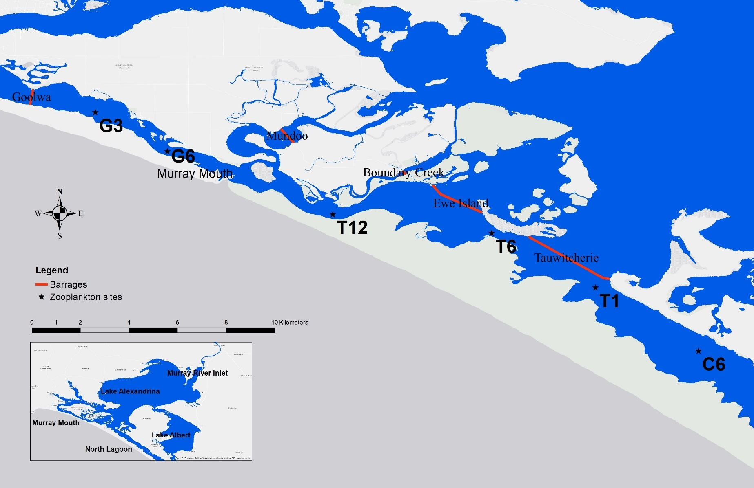

Figure 1: Map of the Murray Estuary, presenting microinvertebrate sampling sites as solid black stars. Red lines represent the Goolwa, Mundoo, Ewe Island and Tauwitchere barrages. Inset: the broader Lower Lakes, Murray Estuary and part of the North Lagoon of the Coorong.

# Methods

## Salinity and temperature monitoring

Salinity and temperature monitoring was conducted by the South Australian Research and Development Institute (SARDI) as part of the CEWO Black Bream monitoring project (Ye *et al.*, 2019b) and data provided to The University of Adelaide. Longitudinal and depth profiles of salinity (practical salinity units, PSU) and water temperature (°C) were recorded using a YSI EXO 2 sonde. Measurements were taken using the continuous sampling mode at multiple sites along three transects with ~1 km intervals. The three transects included the Goolwa Barrage transect which ran from the Goolwa Barrage to the Murray Mouth (7 km, 8 sites), the Tauwitchere Barrage transect which ran from the Tauwitchere Barrage to the Murray Mouth (13 km, 15 sites) and the North Lagoon transect which ran south-east from the south end of the Tauwitchere Barrage to Mark Point (7 km, 8 sites) (for more details on salinity and temperature monitoring see Ye *et al.*, 2019b). Monitoring was conducted approximately every three weeks, with a total of seven field trips between October 2018 and February 2019. Hereafter, sampling occasions will be referred to as Trip 1 to Trip 7 as outlined in Table 1.

Table 1: Sampling trip number and date

|  |  |
| --- | --- |
| **Trip number** | **Sampling date** |
| 1 | 12th October 2018 |
| 2 | 31st October 2018 |
| 3 | 26th November 2018 |
| 4 | 19th December 2018 |
| 5 | 4th January 2019 |
| 6 | 23rd January 2019 |
| 7 | 15th February 2019 |

## Zooplankton sampling

Zooplankton monitoring was also conducted by SARDI as part of the CEWO Black Bream monitoring project, and samples provided to The University of Adelaide. Sampling was conducted at the same time as salt-wedge monitoring (Table 1). Zooplankton samples were collected from six selected sites in the Murray Estuary, including two along the Goolwa Barrage transect (G3 and G6), three along the Tauwitchere Barrage transect (T1, T6 and T12) and one along the North Lagoon transect (C6) (Figure 1). Zooplankton assemblages were sampled using a Haney trap (4.5 L capacity) during each sampling event. Three replicate samples were taken at the surface (~0.5 m below the surface) and the bottom (~0.5 m above the benthos) of the water column and filtered through a 30 μm plankton net. Additionally, at each site, a highly concentrated qualitative zooplankton sample was taken using a 30 μm plankton net to assist with species/genus identification. The total volume of each sample was concentrated to approximately 50 mL by filtering through a 30 μm net. Concentrated samples were transferred to a 200 mL PET jar, preserved with ~ 70% ethanol, and returned to the laboratory for identification.

Quantitative samples were inverted three times and a 1 mL sub-sample transferred into a pyrex gridded Sedgewick-Rafter cell. The entire sub-sample was counted, and zooplankton dissected using an Olympus SZH10 dissecting microscope and identified using a Leica DM2500 compound microscope. The average number of zooplankton was calculated and expressed as numbers of individuals per meter cubed (ind.m3). If no microcrustaceans were recorded within a 1 mL count, the entire sample was allowed to settle and the volume pipetted into a 125 mm square gridded Greiner tray and all microcrustaceans counted. Qualitative samples were allowed to settle, then the volume pipetted into a 125 mm square gridded Greiner tray. The tray was scanned on an Olympus SZH10 dissecting microscope and identifiable organisms identified, providing a proportional composition and an estimate of species diversity.

# Data analysis

## Salinity and temperature stratifications

Salinity and temperature data was analysed by SARDI and graphs provided to The University of Adelaide for use in this report (Ye *et al.*, 2019b). Calculations were performed using R language (R Core Team 2017) and geometry operations with R package rgeos (Bivand and Rundel 2017). The profile data for salinity and temperature were converted into three longitudinal sections of Goolwa, Tauwitchere and Coorong. Grids were created by interpolating values at one centimetre vertical distance from sonde profiles using a cubic smoothing spline. In addition, the salinity gradient was calculated along the sections.

## Zooplankton community assemblage

Differences in the abundance of the major groups of zooplankton taxa, including cyclopoid copepods, calanoid copepods, harpacticoid copepods, copepod nauplii and rotifers, between trips, sites and depths (nested within site) were analysed using a multi-factor, multi-variate PERMANOVA (Anderson *et al.*, 2008). These analyses were performed on square-root transformed data and Bray-Curtis distance resemblance matrices.

# Results

## Hydrology, salinity and water temperature

Lake water level and discharge peaked prior to the beginning of sampling in August 2018 at 0.93 mAHD and 9801 ML.day-1, respectively (Figure 2). During the study period, water levels in the lakes decreased gradually from approximately 0.8 to 0.5 mAHD (Figure 2). Combined barrage discharge remained low throughout the study period (0 to 1487 ML.day-1) with a total of 97.84 GL used to maintain barrage releases between October 2018 and March 2019, of which 100 per cent was Commonwealth environmental water (Table 2). The majority of freshwater discharge occurred through the Tauwitchere Barrage (56 per cent) and resulted in a large area of the Murray Estuary below the barrage with salinities lower than seawater, particularly throughout January (~18–25 PSU) (Figure 3 and Figure 4). Discharge was lower at Goolwa (39 per cent) Barrage, however releases into a narrow constricted channel in the Murray Estuary, where a salt-wedge was present between the 12th of October 2018 and the 23rd of January 2019 (Figure 1, Figure 3 and Figure 4). Throughout this area, there was little thermal stratification (Figure 5). Ewe Island, Mundoo and Boundary Creek barrages together (5 per cent) had only minor releases (Figure 3).

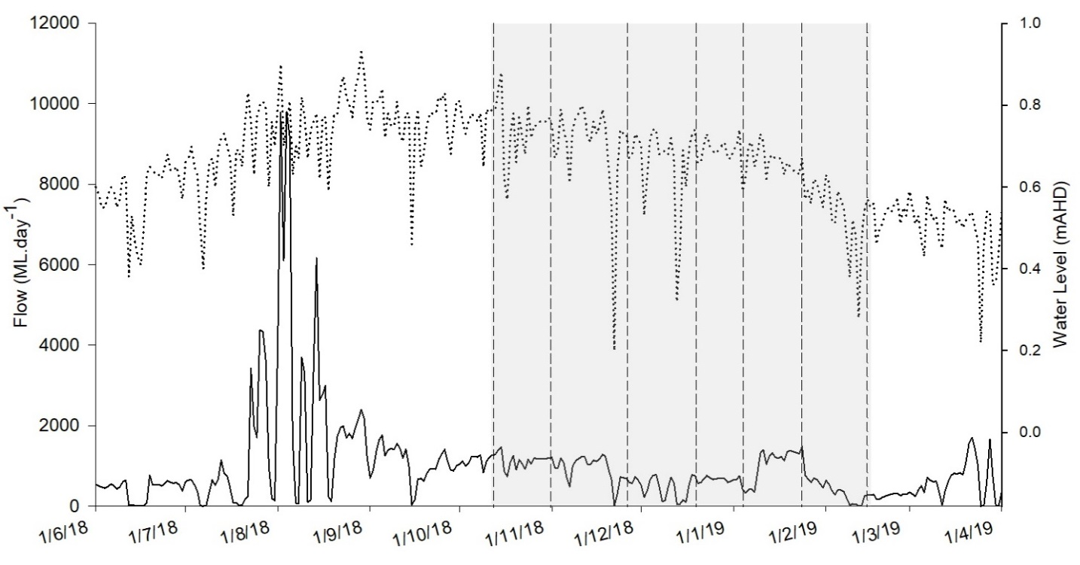

Figure 2: Combined daily flow discharge (ML.day-1) to the Murray Estuary (all barrages) (solid line) and daily water level (mAHD) at gauge A4261034 within the Lower Lakes (broken line) leading up to and during the study period. Grey shading indicates the study period. Data source: DEW.

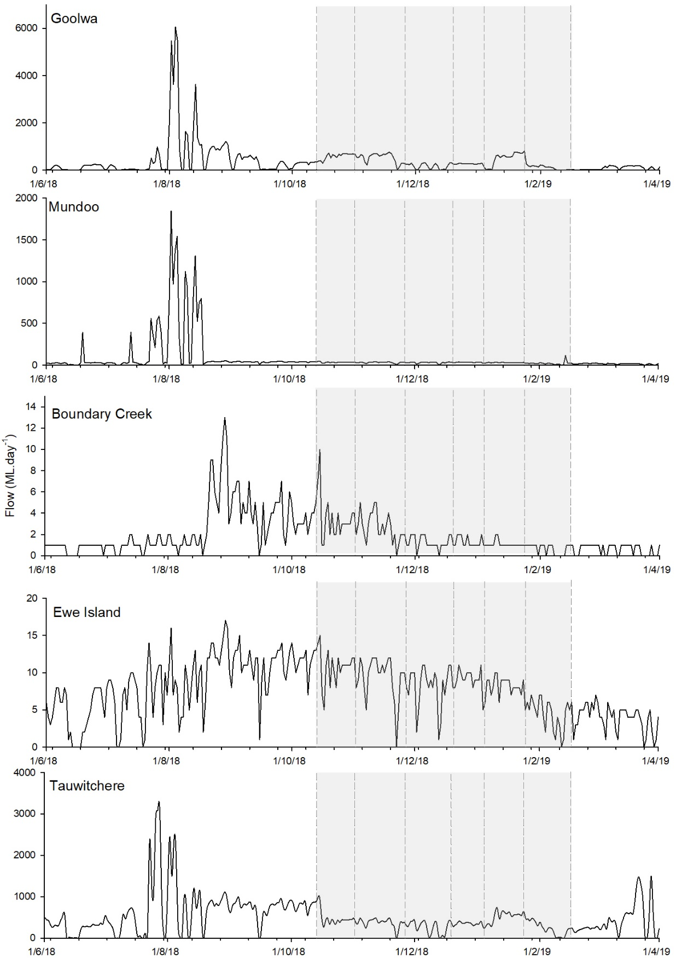

Figure 3: Daily flow discharge by individual barrages (ML.day-1) for 2018-19. a) Goolwa barrage, b) Mundoo barrage, c) Boundary Creek barrage, d) Ewe Island barrage, e) Tauwitchere Barrage and f) Combined discharge (five barrages). Grey shading indicates the study period. Data source: DEW.

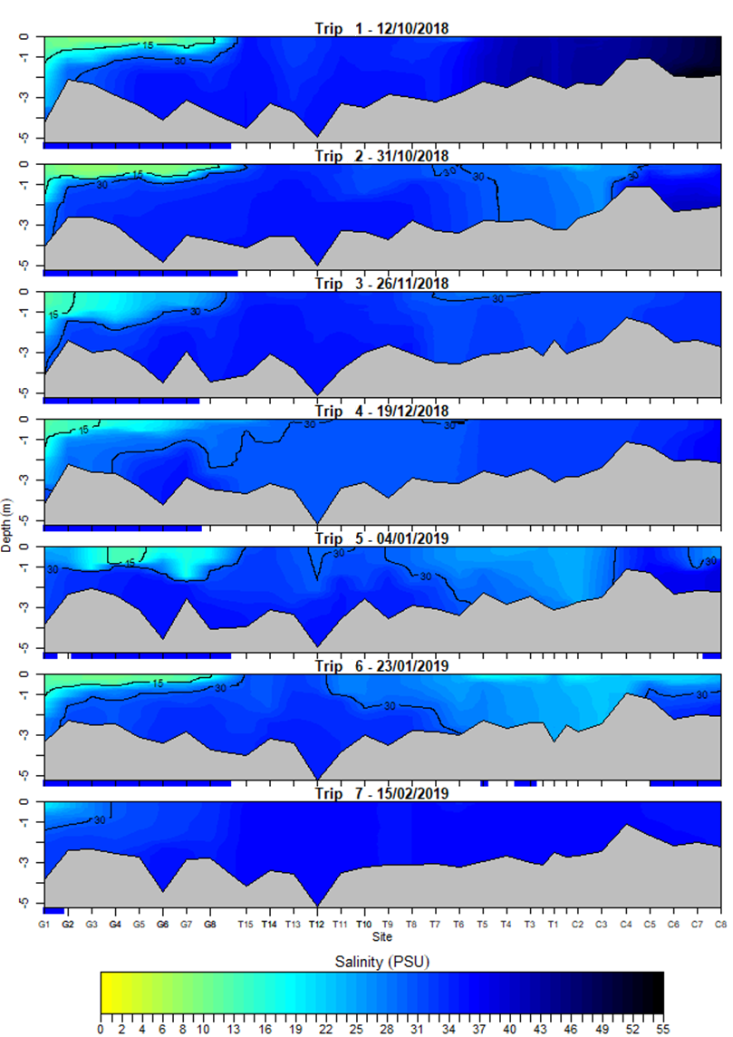

Figure 4: The longitudinal and depth profile of salinities measured at multiple sites with ~1 km interval along the Goolwa (G1−G8), Tauwitchere (T1−T15) and Coorong (C1−C8) transects in the Murray Estuary during seven trips between 12 October 2018 and 15 February 2019. Blue highlighting on the x-axis indicates areas with salinity stratification ≥10 PSU. G1: below Goolwa Barrage; T1: Pelican Point end of the Tauwitchere Barrage; C8: Mark Point; and Murray Mouth: between G8 and T15. Salinity contours of 15 PSU and 30 PSU are shown.

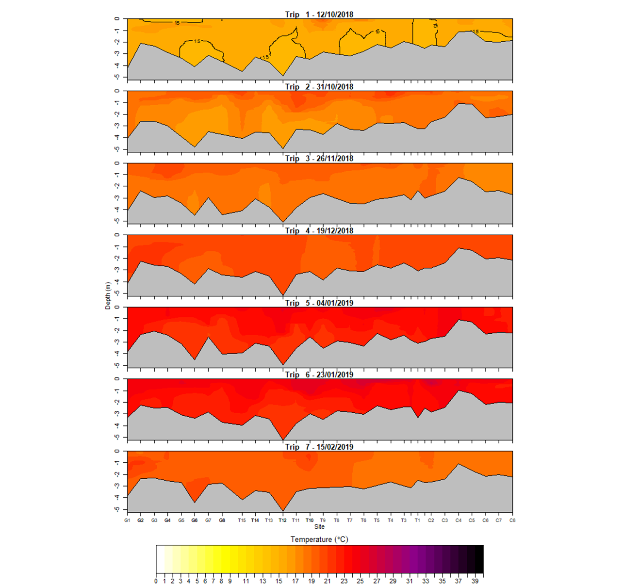

Figure 5: The longitudinal and depth profile of water temperature measured at multiple sites with ~1 km interval along the Goolwa (G1−G8), Tauwitchere (T1−T15) and Coorong (C1−C8) transects in the Murray Estuary during seven trips between 12 October 2018 and 15 February 2019. G1: below Goolwa Barrage; T1: Pelican Point end of the Tauwitchere Barrage; C8: Mark Point; and Murray Mouth: between G8 and T15.

## Zooplankton community assemblage

Throughout the study, between 1 and 9 species of zooplankton were identified at each site, demonstrating low species diversity in the Murray Estuary during the sampling period (Table 3 to Table 6). Abundance varied between 0 and 1.6 x 106 ind.m3 however was often below ~3 x 105 ind.m3 (Table 3 to Table 6). Average abundance of the different orders of copepods (cyclopoid, calanoid and harpacticoid), and rotifers, varied greatly between trips, sites and depths (Figure 6 and Figure 7). All major groups of zooplankton exhibited, at times, considerably greater abundances at the bottom, in comparison to, the surface of the water column (Figure 6 and Figure 7). For example, rotifers were 2.4 times more abundant at the bottom in comparison to the surface at T6 during Trip 5. A PERMANOVA on the abundance of the major zooplankton groups indicated that there was a significant interaction between trip and site (P=0.0001) and trip and depth (nested within site) (P=0.0001), signifying that temporal variability was not consistent among sites or depths. Post-hoc comparisons revealed that the majority of trips were significantly different. This excluded between Trip 1 and Trip 7, Trip 2 and Trip 6, and, Trip 3 and Trip 4 and Trip 7. Post-hoc comparisons also revealed a significant difference between depths in the northern end of study area at G3, G6 and T12.

Harpacticoid copepods dominated the copepod community at G3, G6 and T12, during Trip 2 (primarily *Mesochra parva*) and Trip 5 (primarily *Euterpina acutifrons*) (Figure 6c and Figure 8). The abundance of adult harpacticoid copepods aligned spatially and temporally with the abundance of copepod nauplii, suggesting that the majority of copepod nauplii present throughout the study were harpacticoid nauplii (Figure 6c-d). Together, adult and nauplii harpacticoids were the most abundant order of copepods throughout the study.

The cyclopoid and calanoid copepod communities both reached their maximum abundance at the site T12 where salinity was similar to that of seawater and during Trip 6 (~1.1 x 104 and 2.0 x 104 ind.m-3, respectively) when water temperature was the highest for the study (Figure 4, Figure 5 and Figure 6a-b). Unsurprisingly, commonly marine/estuarine *Oithona* species including *Oithona* cf. *plumifera*, *Oithona* cf. *atlantica*, *Oithona* cf. *simplex* and *Oithona* cf. *rigida*, dominated the cyclopoid copepod community (Table 3 to Table 6). Adult male calanoid copepods were absent throughout the majority of the study and therefore the species present were only identifiable on a limited number of occasions.

Rotifers were the most abundant taxa throughout the study, where peaks in abundance occurred across numerous sites and trips (Figure 7). The community was dominated by *Synchaeta* species including an undescribed *Synchaeta* species(common to Lake Alexandrina), *S. triophthalma*, *S. vorax* and *S.* cf *grandis* (Figure 9, Figure 10 and Table 3 to Table 6). The undescribed *Synchaeta* species peaked in abundance at T1 and T6 during Trip 5 (7.25 x 105 and 1.52 x 106 ind.m-3, respectively), which was associated with lower salinities below the Tauwitchere Barrage (Table 5, Figure 4 and Figure 9a). These lower salinities below Tauwitchere Barrage that occurred during Trip 5 and Trip 6 were also associated with greater abundances of freshwater rotifers including *Filinia* cf. *pejleri*, *F.* cf. *longiseta* and *Polyarthra dolichoptera* (Table 5). The marine/brackish species, *S*. *triophthalma* was the most dominant species during the study, especially throughout the northern end of the study area at G3, G6 and T12 (Figure 9b). Two large *Synchaeta* species, *S. vorax* and *S.* cf. *grandis*, both peaked in abundance at sites and during times in which salinity was similar to that of seawater (*S. vorax* at T12 during Trip 2 and *S.* cf. *grandis*. during Trip 6) (Table 5, Figure 4 and Figure 10).

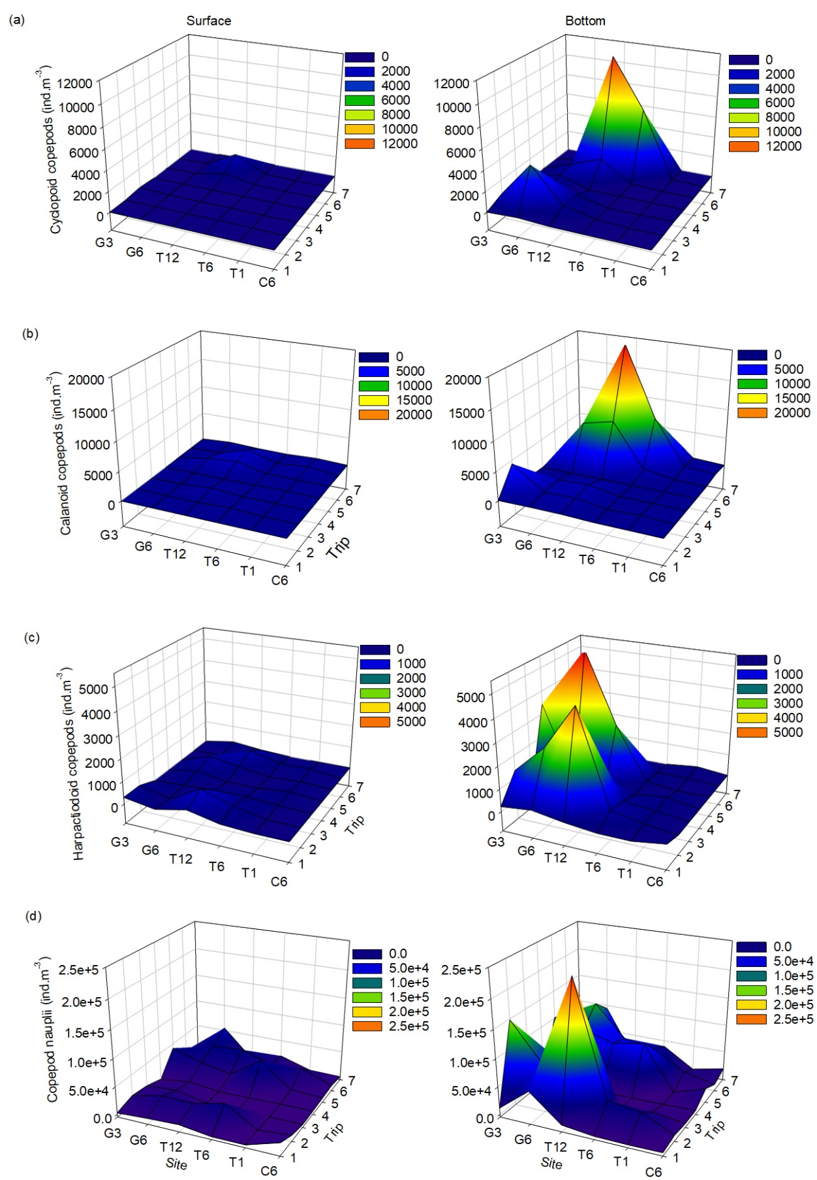

Figure 6: Differences in average number of (a) cylopoid copepods, (b), calanoid copepods, (c) harpacticoid copepods and (d) copepod nauplii per cubic meter (ind.m-3) at the surface and the bottom of the water column across all sites across trips.

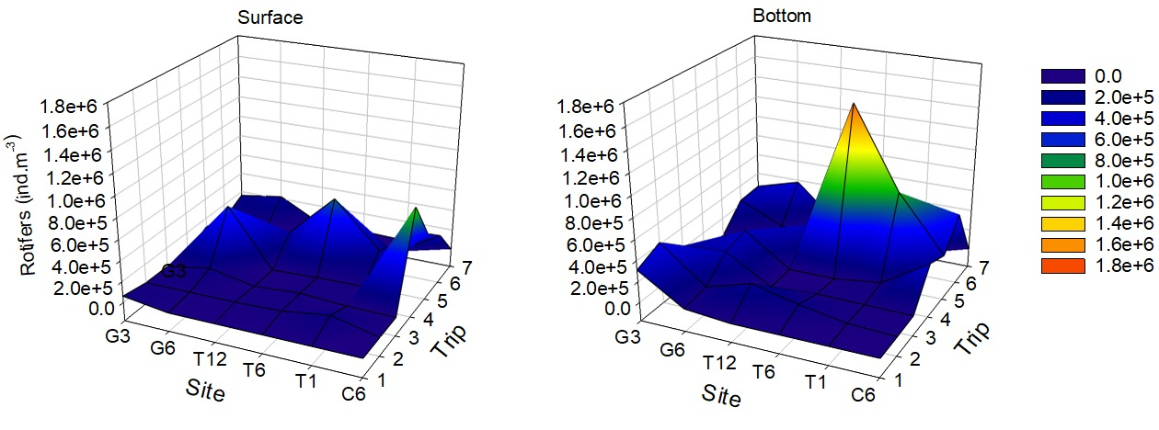

Figure 7: Differences in average rotifer abundance (ind.m-3) at the surface and the bottom of the water column across all sites across trips.

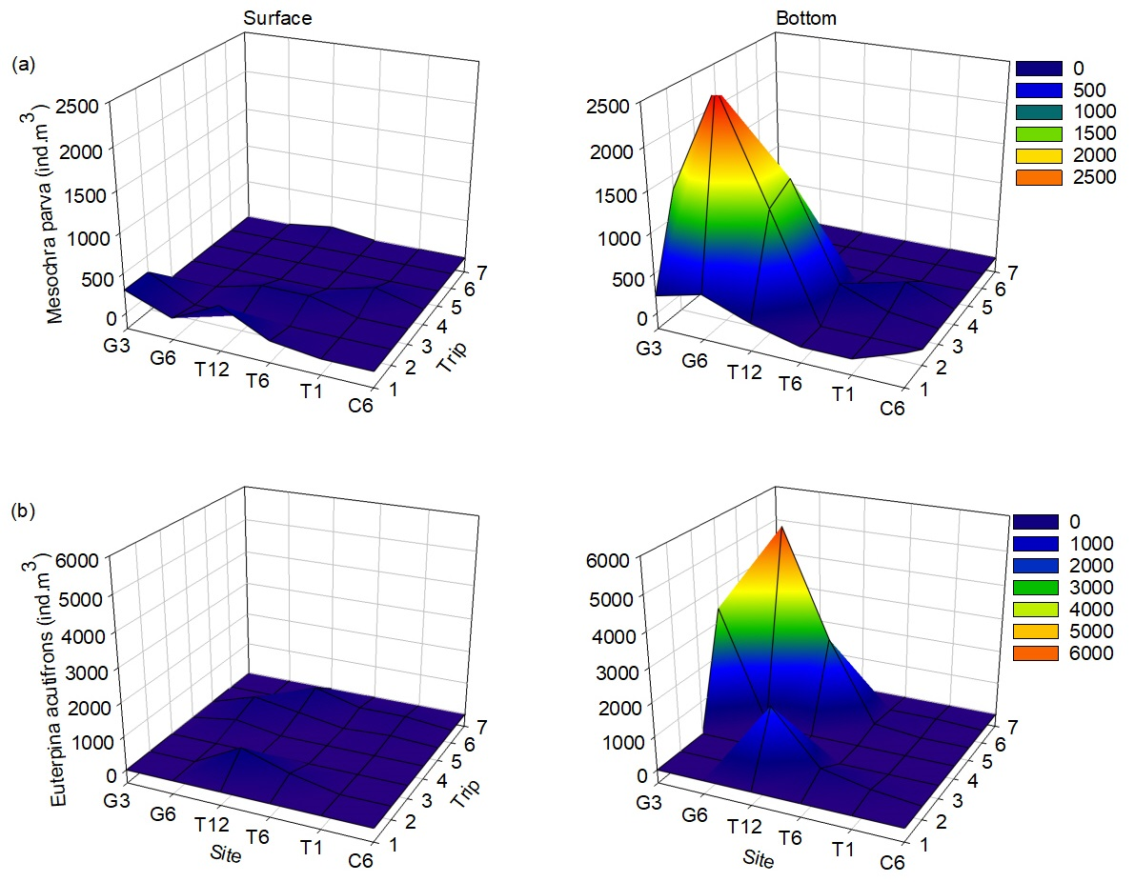

Figure 8: Differences in average number of (a) *Mesochra parva* and (b), *Euterpina acutifrons* (ind.m-3) at the surface and the bottom of the water column across all sites across trips.

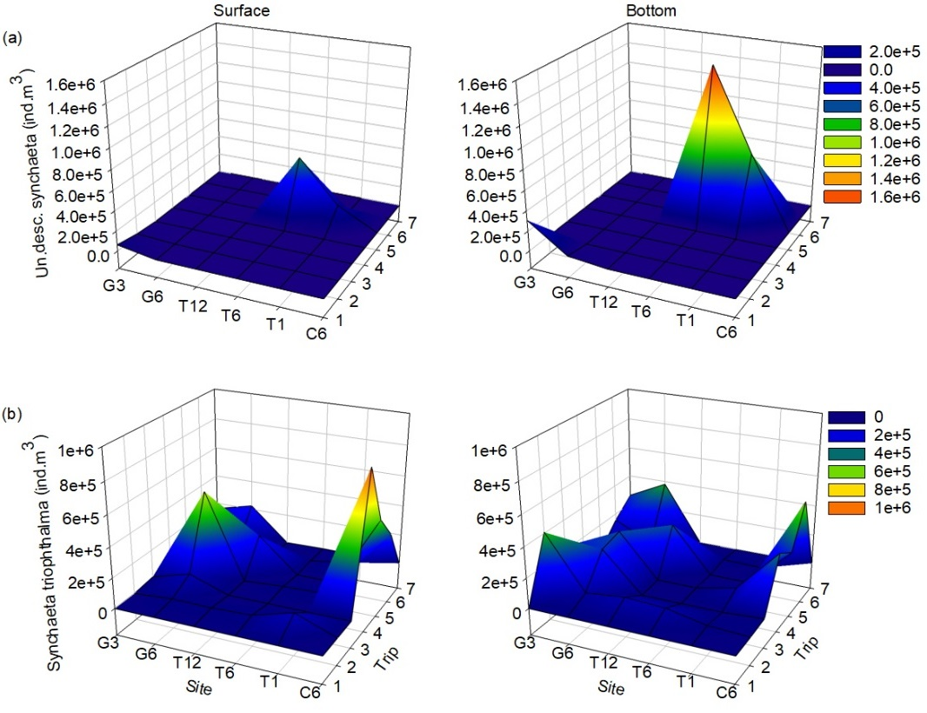

Figure 9: Differences in average number of (a) undescribed species of Synchaeta common to the CLLMM region, (b), *Synchaeta triophthalma* (ind.m-3) at the surface and the bottom of the water column across all sites across trips.

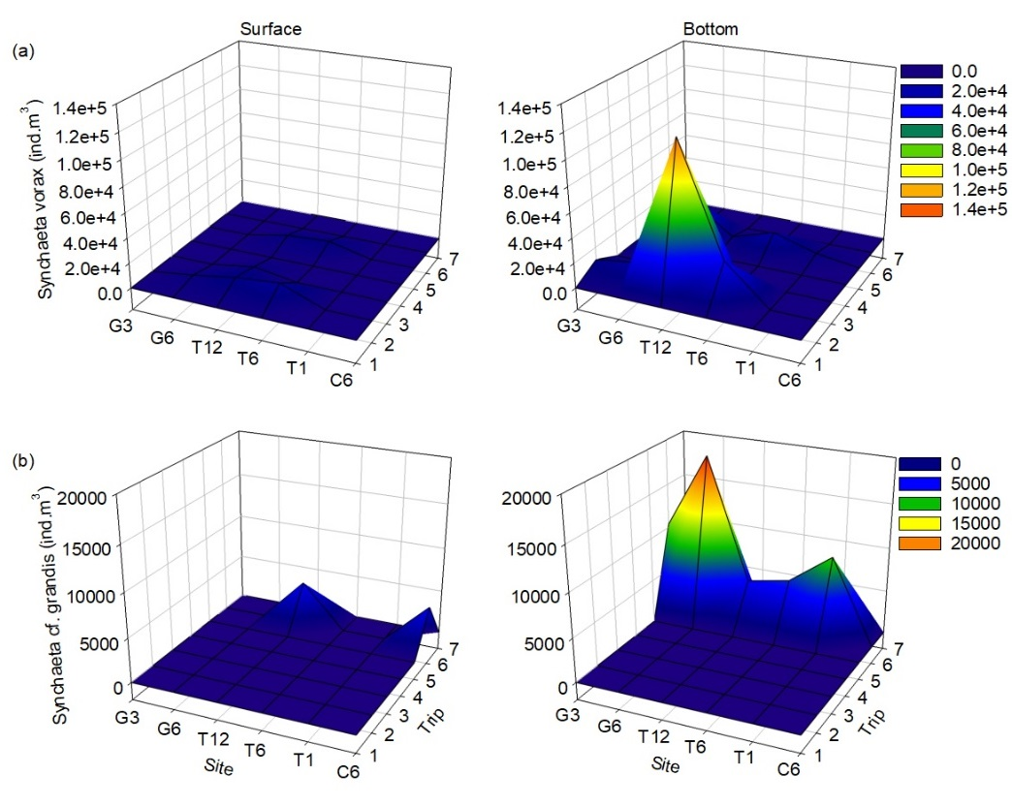

Figure 10: Differences in average number of (a) *Synchaeta cf. grandis* and (b), *Synchaeta vorax* (ind.m-3) at the surface and the bottom of the water column across all sites across trips.

**Table 3: Summary of the species identified and species abundance x 103 (ind.m3) at each site at the surface and the bottom of the water column (surface/bottom) during Trip 1 and Trip 2 and their preferred environment where F = fresh, M = marine, B = brackish and ? = unknown. Grey shading indicates that the species was only found in the bulk sample, not within the quantitative counts and blue shading indicates that the organism appeared to be dead at collection. All abundances have been rounded to two significant figures.**

|  |  |  |  |  |  |  |  |  |  |  |  |  |  |
| --- | --- | --- | --- | --- | --- | --- | --- | --- | --- | --- | --- | --- | --- |
|  |  | **Trip 1** | | | | | | **Trip 2** | | | | | |
|  | **Habitat** | **G3** | **G6** | **T1** | **T6** | **T12** | **C6** | **G3** | **G6** | **T1** | **T6** | **T12** | **C6** |
| ROTIFERS |  |  |  |  |  |  |  |  |  |  |  |  |  |
| *Trichocerca sp.* | - |  |  |  |  |  |  |  |  |  |  |  |  |
| *Hexarthra intermedia* | F |  |  |  |  |  |  |  |  |  |  |  |  |
| *Filinia* cf. *longiseta* | F |  |  |  |  |  |  |  |  |  |  |  |  |
| *Filinia* cf. *pejleri* | F |  |  |  |  |  |  |  |  |  |  |  |  |
| *Keratella tropica* | F |  |  |  |  |  |  |  |  |  |  |  |  |
| *Keratella australis* | F | 0/4.9 |  |  |  |  |  |  |  | 0/6.5 |  |  |  |
| *Brachionus angularis* | F |  |  |  |  |  |  |  |  |  |  |  |  |
| *Brachionus diversicornis* | F |  |  |  |  |  |  |  |  |  |  |  |  |
| *Polyarthra dolichoptera* | F |  |  |  |  |  |  |  |  |  |  |  |  |
| *Undescribed Synchaeta* | B/F | 63/309 | 0/39 |  |  |  |  | 21/0 |  |  |  |  |  |
| *Synchaeta triophthalma* | M/B |  |  |  |  |  |  | 0/407 | 19/60 | 102/20 | 27/74 | 17/87 | 0/5.4 |
| *Synchaeta vorax* | M/B |  |  |  |  |  |  | 0/10 | 4.5/15 |  | 14/31 | 10/118.07 |  |
| *Synchaeta cf. grandis* | M/B |  |  |  |  |  |  |  |  |  |  |  |  |
| *Colurella sp* | F |  |  |  |  |  |  |  |  |  |  |  |  |
| HARPACTICOIDS |  |  |  |  |  |  |  |  |  |  |  |  |  |
| *Mesochra parva* | B | 0.3/0.22 | 0.07/0.37 |  | 0.07/0 | 0.37/0.15 | 0.22 | 0.3/1.3 | 0/2.6 |  |  | 0/1.3 |  |
| *cf. Robertsonia sp* | M |  |  |  |  |  |  |  |  |  |  |  |  |
| *Euterpina acutifrons* | M/B |  |  |  |  |  |  |  |  | 0.15 | 0.3/0.44 | 0.74/2 |  |
| *cf. Quinquelaophonte* sp. | M |  |  |  |  |  |  |  |  |  |  |  |  |
| *cf. Robertsonia sp* | M |  |  |  |  |  |  |  |  |  |  | 0.66 |  |
| *Species a* | - |  |  |  |  |  |  |  |  |  |  | 0.66 |  |
| *Species b* | - |  |  |  |  |  |  |  |  |  |  |  |  |
| *Species c* | - |  |  |  |  |  |  |  |  |  |  |  |  |
| CYCLAPOIDS |  |  |  |  |  |  |  |  |  |  |  |  |  |
| *Oithona cf. plumifera* | M |  | 0.15 |  |  |  |  | 0.67 | 0/4.1 |  | 0.07/0.15 | 0.81 |  |
| *Oithona cf. atlantica* | M |  |  |  |  |  |  |  |  |  |  |  |  |
| *Oithona cf. simplex* | M |  |  |  |  |  |  |  |  |  |  |  |  |
| *Oithona cf. rigida* | M |  |  |  |  |  |  |  |  |  |  |  |  |
| *cf. Cyclopetta orientalis* | M/B |  |  |  |  |  |  |  |  |  |  |  |  |
| *cf. Misophriopsis sp.* | M |  |  |  |  |  |  |  |  |  |  |  |  |
| *Caligidae sp* | M/B/F |  |  |  |  |  |  |  |  |  |  |  |  |
| *Unidentified* | - |  |  |  |  |  |  |  |  |  |  |  |  |
| CALANOIDS |  |  |  |  |  |  |  |  |  |  |  |  |  |
| *Gladioferens pectinatus* | M/B |  |  |  |  |  |  |  |  |  |  |  |  |
| *Acartia* cf. *fancetti* | M/B |  |  |  |  |  |  |  |  |  |  |  |  |
| *Unidentified juveniles* | - | 0.07 | 0.15 |  |  | 0.15 |  | 0/4.4 | 0.59 | 0.22 | 0.22/0 | 0.74 |  |
| Copepod nauplii | - |  |  |  |  |  |  |  |  |  |  |  |  |
| *Nauplii* | - | 2.7/12 | 5.7/55 | 0.15 | 0.15/0.89 | 7.9/7.3 | 18/0.96 | 12/149 | 24/81 | 1.1/34 | 36/41 | 23/239 | 6/5.9 |
| CLADOCERA |  |  |  |  |  |  |  |  |  |  |  |  |  |
| *Bosmina meridionalis* | F |  |  |  |  |  |  |  |  |  |  |  |  |
| *cf. Pleopis polyphaemoides* | M/B |  |  |  |  |  |  |  |  |  |  |  |  |
| *Penilia avirostris* | M/B/F |  |  |  |  |  |  |  |  |  |  |  |  |
| OSTRACOD |  |  |  |  |  |  |  |  |  |  |  |  |  |
| *cf. Parakrithella sp.* | M |  |  |  |  |  |  |  |  |  |  |  |  |
| *cf. Mytilocypris sp.* | ? |  |  |  |  |  |  |  |  |  |  |  |  |
| Other |  |  |  |  |  |  |  |  |  |  |  |  |  |
| *cf. Transversotrema sp.* | M/B/F |  |  |  |  |  |  |  |  |  |  |  |  |
| *Hyperidae sp.* | M |  |  |  |  |  |  |  |  |  |  |  |  |
| *Total abundance* |  | 66/326 | 5.8/94 | 0.15 | 0.22/0.89 | 8.3/7.6 | 18/1.2 | 33/572 | 48/164 | 103/60 | 78/146 | 51/450 | 6/11 |
| *Total taxa identified* |  | 5 | 4 | 1 | 1 | 3 | 2 | 7 | 7 | 4 | 5 | 8 | 1 |
|  |  |  |  |  |  |  |  |  |  |  |  |  |  |

**Table 4: Summary of the species identified and species abundance x 103 (ind.m-3) at each site at the surface and the bottom of the water column (surface/bottom) during Trip 3 and Trip 4 and their preferred environment where F = fresh, M = marine and B = brackish. Grey shading indicates that the species was only found in the bulk sample, not within the quantitative counts and blue shading indicates that the organism appeared to be dead at collection. All abundances have been rounded to two significant figures.**

|  |  |  |  |  |  |  |  |  |  |  |  |  |  |
| --- | --- | --- | --- | --- | --- | --- | --- | --- | --- | --- | --- | --- | --- |
|  |  | **Trip 3** | | | | | | **Trip 4** | | | | | |
|  | **Habitat** | **G3** | **G6** | **T1** | **T6** | **T12** | **C6** | **G3** | **G6** | **T1** | **T6** | **T12** | **C6** |
| ROTIFERS |  |  |  |  |  |  |  |  |  |  |  |  |  |
| *Trichocerca sp.* | - |  |  |  |  |  |  |  |  |  |  |  |  |
| *Hexarthra intermedia* | F |  |  |  |  |  |  |  |  |  |  |  |  |
| *Filinia* cf. *longiseta* | F |  |  | 7.9/21 | 35/28 |  |  |  |  |  |  |  |  |
| *Filinia* cf. *pejleri* | F |  |  |  |  |  |  |  |  |  |  |  |  |
| *Keratella tropica* | F |  |  |  |  |  |  |  |  |  |  |  |  |
| *Keratella australis* | F |  |  |  |  |  |  |  |  |  |  |  |  |
| *Brachionus angularis* | F |  |  |  |  |  |  |  |  |  |  |  |  |
| *Brachionus diversicornis* | F |  |  |  |  |  |  |  |  |  |  |  |  |
| *Polyarthra dolichoptera* | F |  |  |  |  |  |  |  |  |  |  |  |  |
| *Undescribed Synchaeta* | B/F |  |  |  |  |  |  |  |  |  |  |  |  |
| *Synchaeta triophthalma* | M/B | 17/226 | 90/257 |  |  |  | 0/15 | 0/12 | 554/290 | 24/62 | 16.63/6.81 | 0/6.3 | 870/341 |
| *Synchaeta vorax* | M/B |  |  |  |  | 5.4/0 |  |  | 0/23 |  |  |  |  |
| *Synchaeta cf. grandis* | M/B |  |  |  |  |  |  |  |  |  |  |  |  |
| *Colurella sp* | F |  |  |  |  |  |  |  |  |  |  |  |  |
| HARPACTICOIDS |  |  |  |  |  |  |  |  |  |  |  |  |  |
| *Mesochra parva* | B |  |  | 0.07 | 0.15/0.3 | 0.15/1.5 |  |  |  | 0.15/0.22 | 0.07 |  |  |
| *cf. Robertsonia sp* | M |  |  |  |  |  |  |  |  |  |  |  |  |
| *Euterpina acutifrons* | M/B |  |  |  |  |  |  | 0/3.4 | 0.22/0.15 |  |  |  |  |
| *cf. Quinquelaophonte* sp. | M |  |  |  |  |  |  |  |  |  |  |  |  |
| *cf. Robertsonia sp* | M |  |  | 0.07/0.07 |  |  |  |  |  |  |  |  |  |
| *Species a* | - |  |  |  |  |  |  |  |  |  |  |  |  |
| *Species b* | - |  |  |  |  |  |  |  |  |  |  |  |  |
| *Species c* | - |  | 0.07/0.3 |  |  |  |  |  |  |  |  |  |  |
| CYCLAPOIDS |  |  |  |  |  |  |  |  |  |  |  |  |  |
| *Oithona cf. plumifera* | M |  |  |  |  | 0.67 | 0.07 |  | 0.96 |  |  |  |  |
| *Oithona cf. atlantica* | M |  |  |  |  |  |  |  |  |  |  |  |  |
| *Oithona cf. simplex* | M |  |  |  |  |  |  |  |  |  |  |  |  |
| *Oithona cf. rigida* | M |  |  |  |  |  |  |  |  |  |  |  |  |
| *cf. Cyclopetta orientalis* | M/B | 0.15/0 | 0.07 |  |  |  |  |  |  |  |  |  |  |
| *cf. Misophriopsis sp.* | M |  |  |  |  |  |  |  |  |  |  |  |  |
| *Caligidae sp* | M/B/F |  |  |  |  |  |  |  |  |  |  |  |  |
| *Unidentified* | - |  |  |  |  |  |  |  |  |  |  |  |  |
| CALANOIDS |  |  |  |  |  |  |  |  |  |  |  |  |  |
| *Gladioferens pectinatus* | M/B | 0.07 |  |  |  |  |  |  |  |  |  |  |  |
| *Acartia* cf. *fancetti* | M/B |  |  |  |  |  |  |  |  |  |  |  |  |
| *Unidentified juveniles* | - |  | 0.74 | 0.07/0.07 | 0.07/0.07 | 0.44/1.0 |  |  |  | 0.15/0 | 0.07/0 |  |  |
| Copepod nauplii | - |  |  |  |  |  |  |  |  |  |  |  |  |
| *Nauplii* | - | 8.9/22 | 12/71 | 1.2/9.7 | 0.22/1.9 | 0.81/26 | 0.15/2.2 | 0.37/3.3 | 6.8/65 | 1.4/0.96 | 0.15/0.3 | 0.15 | 1.3/2.6 |
| CLADOCERA |  |  |  |  |  |  |  |  |  |  |  |  |  |
| *Bosmina meridionalis* | F |  |  |  |  |  |  |  |  |  |  |  |  |
| *cf. Pleopis polyphaemoides* | M/B |  |  |  |  |  |  |  |  |  |  |  |  |
| *Penilia avirostris* | M/B/F |  |  |  |  |  |  |  |  |  |  |  |  |
| OSTRACOD |  |  |  |  |  |  |  |  |  |  |  |  |  |
| *cf. Parakrithella sp.* | M |  |  |  |  |  |  |  |  |  |  |  |  |
| *cf. Mytilocypris sp.* | ? |  |  |  |  |  |  |  |  |  |  |  |  |
| Other |  |  |  |  |  |  |  |  |  |  |  |  |  |
| *cf. Transversotrema sp.* | M/B/F |  |  |  |  |  |  |  |  |  |  |  |  |
| *Hyperidae sp.* | M |  |  |  |  |  |  |  |  |  |  |  |  |
| *Total abundance* |  | 27/248 | 102/329 | 9.2/31 | 36/30 | 6.8/29 | 0.15/18 | 0.37/19 | 561/379 | 26/63 | 17/7.2 | 0/6.4 | 871/344 |
| *Total taxa identified* |  | 4 | 6 | 7 | 4 | 7 | 2 | 2 | 4 | 4 | 3 | 1 | 1 |

**Table 5: Summary of the species identified and species abundance x 103 (ind.m-3) at each site at the surface and the bottom of the water column (surface/bottom) during Trip 5 and Trip 6 and their preferred environment where F = fresh, M = marine and B = brackish. Grey shading indicates that the species was only found in the bulk sample, not within the quantitative counts and blue shading indicates that the organism appeared to be dead at collection. All abundances have been rounded to two significant figures.**

|  |  |  |  |  |  |  |  |  |  |  |  |  |  |
| --- | --- | --- | --- | --- | --- | --- | --- | --- | --- | --- | --- | --- | --- |
|  |  | **Trip 5** | | | | | | **Trip 6** | | | | | |
|  | **Habitat** | **G3** | **G6** | **T1** | **T6** | **T12** | **C6** | **G3** | **G6** | **T1** | **T6** | **T12** | **C6** |
| ROTIFERS |  |  |  |  |  |  |  |  |  |  |  |  |  |
| *Trichocerca sp.* | - |  |  |  |  |  |  | 0/10 |  |  |  |  |  |
| *Hexarthra intermedia* | F |  |  |  |  |  |  |  |  |  |  |  |  |
| *Filinia* cf. *longiseta* | F | 0/5.4 |  |  | 0/6.6 |  |  | 0/45 |  |  |  |  |  |
| *Filinia* cf. *pejleri* | F |  |  | 0/55 | 17/0 |  |  |  |  |  |  |  |  |
| *Keratella tropica* | F |  |  |  |  |  |  | 0/25 |  |  |  |  |  |
| *Keratella australis* | F |  |  |  |  |  |  |  |  | 0/4.5 |  |  |  |
| *Brachionus angularis* | F |  |  |  |  |  |  |  |  |  |  |  |  |
| *Brachionus diversicornis* | F |  |  |  |  |  |  |  |  |  |  |  |  |
| *Polyarthra dolichoptera* | F |  |  | 17/0 |  |  |  |  |  |  |  |  |  |
| Undescribed *Synchaeta* | B/F |  |  | 202/725 | 619/1520 |  |  |  |  |  |  |  |  |
| *Synchaeta triophthalma* | M/B | 112/17 | 22/22 |  |  | 223/297 | 469/257 | 55/156 | 10/36 | 46/8.5 | 6.3/15 | 0/20 | 292/506 |
| *Synchaeta vorax* | M/B |  | 0/29 | 0/5.2 | 8.3/16 | 6.4/5.4 |  |  |  |  |  |  |  |
| *Synchaeta cf. grandis* | M/B |  |  |  |  |  |  | 0/10 | 0/19 | 0/9.6 | 0/6.1 | 4.9/5.2 | 4.7/0 |
| *Colurella sp* | F |  |  |  |  |  |  |  |  |  |  |  |  |
| HARPACTICOIDS |  |  |  |  |  |  |  |  |  |  |  |  |  |
| *Mesochra parva* | B |  |  |  |  |  |  |  |  |  |  |  |  |
| *cf. Robertsonia sp* | M |  |  |  |  |  |  |  |  |  |  |  |  |
| *Euterpina acutifrons* | M/B |  | 0.44/5.6 | 0.07/0 | 0.15 | 0.22/2.5 |  | 0.07 | 0.3 | 0.15/0.07 | 0.15/0.07 | 0.52/0.15 |  |
| *cf. Quinquelaophonte* sp. | M |  |  |  |  |  |  |  |  |  |  |  |  |
| *cf. Robertsonia sp* | M |  |  |  |  |  |  |  |  |  |  |  |  |
| *Species a* | - |  |  |  |  |  |  |  |  |  |  |  |  |
| *Species b* | - |  |  |  |  |  |  |  |  |  |  |  |  |
| *Species c* | - |  |  |  |  |  |  |  |  |  |  |  |  |
| CYCLAPOIDS |  |  |  |  |  |  |  |  |  |  |  |  |  |
| *Oithona cf. plumifera* | M |  |  |  |  |  |  |  | 0.3 | 0.07 | 0.07/6.6 |  |  |
| *Oithona cf. atlantica* | M |  |  |  |  |  |  |  |  |  |  |  |  |
| *Oithona cf. simplex* | M |  |  |  | 0.07/0.15 |  |  |  |  |  |  | 1.6/11 |  |
| *Oithona cf. rigida* | M |  | 0/1.0 |  |  | 0.59/2.1 |  |  |  |  |  |  |  |
| *cf. Cyclopetta orientalis* | M/B |  |  |  |  |  |  |  |  |  |  |  |  |
| *cf. Misophriopsis sp.* | M |  |  |  |  |  |  |  |  |  |  |  |  |
| *Caligidae sp* | M/B/F |  |  |  |  |  |  |  |  |  |  |  |  |
| *Unidentified* | - |  |  |  |  |  |  |  |  |  |  |  |  |
| CALANOIDS |  |  |  |  |  |  |  |  |  |  |  |  |  |
| *Gladioferens pectinatus* | M/B |  |  |  |  |  |  |  |  |  |  |  |  |
| *Acartia* cf. *fancetti* | M/B |  |  |  |  |  |  |  |  |  |  |  |  |
| *Unidentified juveniles* | - | 0.37 | 0.81/7.3 | 0.07/0.15 | 0.15/1.0 | 1.3/8.4 | 0.07/0 | 0.81 | 0.07/4.4 | 0.59/0.59 | 0.15/8.3 | 1.6/20 | 0.3 |
| Copepod nauplii | - |  |  |  |  |  |  |  |  |  |  |  |  |
| *Nauplii* | - | 41/101 | 24/87 | 6.2/1.3 | 49/82 | 13/73 | 3.04/21 | 18/18 | 37/120 | 26/20 | 22/53 | 41/63 | 5.1/6.7 |
| CLADOCERA |  |  |  |  |  |  |  |  |  |  |  |  |  |
| *Bosmina meridionalis* | F |  |  |  |  |  |  |  |  |  |  |  |  |
| *cf. Pleopis polyphaemoides* | M/B |  |  |  |  |  |  |  |  |  |  |  |  |
| *Penilia avirostris* | M/B/F |  |  |  |  |  |  |  |  |  |  |  |  |
| OSTRACOD |  |  |  |  |  |  |  |  |  |  |  |  |  |
| *cf. Parakrithella sp.* | M |  |  |  |  |  |  |  |  |  |  |  |  |
| *cf. Mytilocypris sp.* | ? |  |  |  |  |  |  |  |  |  |  |  |  |
| Other |  |  |  |  |  |  |  |  |  |  |  |  |  |
| *cf. Transversotrema sp.* | M/B/F |  |  |  |  |  |  |  |  |  |  |  |  |
| *Hyperidae sp.* | M |  |  |  |  |  |  |  |  |  |  |  |  |
| Total abundance |  | 154/124 | 47/152 | 226/787 | 694/1625 | 244/388 | 472/278 | 72/265 | 47/180 | 73/43 | 29/90 | 49/121 | 302/514 |
| Total taxa identified |  | 6 | 5 | 6 | 7 | 5 | 2 | 7 | 5 | 7 | 5 | 9 | 3 |

**Table 6: Summary of the species identified and species abundance x 103 (ind.m-3) at each site at the surface and the bottom of the water column (surface/bottom) during Trip 7 and their preferred environment where F = fresh, M = marine and B = brackish. Grey shading indicates that the species was only found in the bulk sample, not within the quantitative counts and blue shading indicates that the organism appeared to be dead at collection.**

|  |  |  |  |  |  |  |  |
| --- | --- | --- | --- | --- | --- | --- | --- |
|  |  | **Trip 7** | | | | | |
|  | Habitat | G3 | G6 | T1 | T6 | T12 | C6 |
| ROTIFERS |  |  |  |  |  |  |  |
| *Trichocerca sp.* | - |  |  |  |  |  |  |
| *Hexarthra intermedia* | F |  |  |  |  |  |  |
| *Filinia* cf. *longiseta* | F |  |  |  |  |  |  |
| *Filinia* cf. *pejleri* | F |  |  |  | 4.9/0 |  |  |
| *Keratella tropica* | F |  |  |  |  |  |  |
| *Keratella australis* | F |  |  |  | 4.9/0 |  |  |
| *Brachionus angularis* | F |  |  |  |  |  |  |
| *Brachionus diversicornis* | F |  |  |  |  |  |  |
| *Polyarthra dolichoptera* | F |  |  |  |  |  |  |
| *Undescribed Synchaeta* | B/F |  |  |  |  |  |  |
| *Synchaeta triophthalma* | M/B | 161/260 | 225/381 |  | 4.5/0 |  |  |
| *Synchaeta vorax* | M/B |  |  |  |  |  |  |
| *Synchaeta cf. grandis* | M/B |  |  |  |  |  |  |
| *Colurella sp* | F |  |  |  |  |  |  |
| HARPACTICOIDS |  |  |  |  |  |  |  |
| *Mesochra parva* | B |  |  |  |  | 0.07/0 |  |
| *cf. Robertsonia sp* | M |  |  |  |  |  |  |
| *Euterpina acutifrons* | M/B |  |  |  |  |  |  |
| *cf. Quinquelaophonte* sp. | M |  |  | 0.15 |  |  |  |
| *cf. Robertsonia sp* | M |  | 0.22/0.15 |  |  |  |  |
| *Species a* | - |  |  |  |  |  |  |
| *Species b* | - |  |  |  |  |  |  |
| *Species c* | - |  |  |  |  |  |  |
| CYCLAPOIDS |  |  |  |  |  |  |  |
| *Oithona cf. plumifera* | M |  |  |  |  |  |  |
| *Oithona cf. atlantica* | M |  |  |  |  |  |  |
| *Oithona cf. simplex* | M |  |  |  |  |  |  |
| *Oithona cf. rigida* | M |  |  |  |  |  |  |
| *cf. Cyclopetta orientalis* | M/B |  |  |  |  |  |  |
| *cf. Misophriopsis sp.* | M |  |  |  |  |  |  |
| *Caligidae sp* | M/B/F |  |  |  |  |  |  |
| *Unidentified* | - |  |  |  |  | 0.07/0 |  |
| CALANOIDS |  |  |  |  |  |  |  |
| *Gladioferens pectinatus* | M/B |  |  |  |  |  |  |
| *Acartia* cf. *fancetti* | M/B |  |  |  |  | 0.07/0 |  |
| *Unidentified juveniles* | - |  | 0.3/1.9 | 0.22/0.3 |  |  |  |
| Copepod nauplii | - |  |  |  |  |  |  |
| *Nauplii* | - | 6.3/7.0 | 55/94 | 2.1/4.3 | 20/39 | 1.8/2.7 | 0.89/17 |
| CLADOCERA |  |  |  |  |  |  |  |
| *Bosmina meridionalis* | F |  |  |  |  |  |  |
| *cf. Pleopis polyphaemoides* | M/B |  |  |  |  |  |  |
| *Penilia avirostris* | M/B/F |  |  |  |  |  |  |
| OSTRACOD |  |  |  |  |  |  |  |
| *cf. Parakrithella sp.* | M |  |  |  |  |  |  |
| *cf. Mytilocypris sp.* | ? |  |  |  |  |  |  |
| Other |  |  |  |  |  |  |  |
| *cf. Transversotrema sp.* | M/B/F |  |  |  |  |  |  |
| *Hyperidae sp.* | M |  |  |  |  |  |  |
| *Total abundance* |  | 167/267 | 280/476 | 2.3/4.7 | 34/39 | 2/2.7 | 0.89/17 |
| *Total taxa identified* |  | 1 | 5 | 3 | 3 | 3 | 0 |

# Discussion

The aim of this study was to improve our understanding of drivers of zooplankton community dynamics in the Murray Estuary throughout 2018-19 spring/summer barrage releases. There were two key objectives including (1) to characterise the zooplankton community structure in relation to changes in freshwater discharge (supported by Commonwealth environmental water), salinity and temperature and (2) to evaluate changes in zooplankton community structure and profile in relation to salt-wedge conditions. For objective one, due to the prolonged, low/no flow conditions leading up to and during the sampling period, salinities were similar to that of seawater (~35 PSU) throughout the majority of the study area, and the zooplankton community was dominated by marine/estuarine species. These conditions had likely contributed to the low zooplankton abundance and diversity measured during this study. Adult calanoid and cyclopoid copepods were frequently absent or in very low abundances throughout the entire area, suggesting high predation pressure and perhaps low food availability. For the second objective, a salt-wedge was present throughout along the Goolwa Barrage transect from October through to January. Throughout this area, there was no evidence of greater abundance in pelagic estuarine copepods, including those that have previously been found to be associated with salt-wedges, e.g. *Gladioferens* species (e.g. Williams *et al.*, 2013). There was however, an abundant community of benthic harpacticoid copepods throughout this area of the Murray Estuary. These results highlight how responses may vary between copepods in relation to freshwater discharge and salt-wedge conditions.

Zooplankton diversity and abundance was generally low, and the community dominated by estuarine/marine species between October 2018 and February 2019. Similarly, Geddes *et al* (2016) who sampled between 2001 and 2010, a period also characterised by an extended period of low freshwater discharge, recorded low species diversity in the Murray Estuary and Coorong Lagoon. In comparison, Shiel and Aldridge (2011) detected greater diversity and abundance during a high discharge period. For example, at a similar time of year and location within the study area, four species and zooplankton abundance of ~30 ind.L-1 was measured in this study, whereas ~11 species and zooplankton abundance of ~1600 ind.L-1 was measured in 2010 (Shiel & Aldridge, 2011). There are a number of factors likely to be contributing to these results. Firstly, productivity depends on the availability of dissolved nutrients and particulate organic material, both of which are strongly related to freshwater discharge (e.g. Jordan *et al.*, 1991). Under natural conditions, freshwater discharge to the Murray Estuary was far greater and more frequent, and the ecological ‘legacy effect’ that it most likely left behind would have potentially bridged discharge events (CSIRO, 2008; Cuddington, 2011; Maheshwari *et al.*, 1995). However, when low flows persist for highly extended periods, such as that experienced during this and the study conducted by Geddes *et al* (2016), the effects are likely to dissipate as time from discharge increases. Therefore, it is possible that the estuary was to some degree resource (dissolved nutrients and particulate organic material) limited leading up to and during this study. Secondly, the distinct barrier that the barrages create between freshwater and marine environments, in combination with very low discharge, resulted in salinities throughout the Murray Estuary becoming similar to that of seawater. Therefore, due to the low energy input likely leading up to sampling, coupled with high salinities throughout the study area, the low diversity, low abundances and dominance of marine/estuarine zooplankton species was not surprising.

Very low numbers of adult copepods, yet at times high abundances of nauplii or copepodites, suggest that top-down (e.g predation) and/or bottom up (e.g. nutrient limitation) pressures were limiting zooplankton productivity. Periods of low discharge can result in low dissolved nutrients and organic material. This in turn results in low abundances of zooplankton, coupled with intensified pressure from visual predators due to the low turbidity. Geddes *et al* (2016) found similar results during periods of no and low discharge in the Murray Estuary. The much greater abundances at the bottom of the water column, observed in almost all species detected during this study, was most likely due to predator avoidance (e.g. Bollens *et al.*, 1991). The most common cyclopoids throughout this study were *Oithona* species, the most abundant and ubiquitous copepod genus in marine environments. Their success has been attributed to their low respiration rates and ability to go without food for extended periods of time (>10 days) (Castellani *et al.*, 2005; Marshall *et al.*, 1966). Almost no adult calanoid copepods were found throughout the study, excluding two calanoid species, *A.* cf. *fancettii* and *G. pectinatus*,each on a single occasion at a single site. The estuarine species *G. pectinatus* was present at G3, the site closest to the Goolwa Barrage during Trip 3, which followed a period of slightly greater discharge through the barrage (~800 ML.day-1 in late October/early November in comparison to ~200 ML.day­1 in December). *Gladioferens* are one of the key genera of zooplankton commonly found to benefit from productivity increases associated with salt-wedges (Jenkins, Conron & Morison, 2010; Williams *et al.*, 2013). These results suggest that greater volumes of freshwater discharge containing high nutrients and productivity are probably required to promote the establishment of an abundant estuarine calanoid and cyclopoid copepod community including *Gladioferens* species throughout the study area.

A salt-wedge developed across Goolwa Barrage transect and was associated with an abundant benthic zooplankton community. The development and persistence of a salt-wedge depends on the rate of freshwater discharge and tidal currents. It is possible that the physical nature of this section of the Murray Estuary weakens the tidal current and wind effects and/or streamlines that of freshwater discharge, resulting in the formation of a salt-wedge even during periods of low discharge. Harpacticoid copepods, such as *M. parva* and *E. acutifrons* that were present in greatest abundances throughout this area of the Murray Estuary, live out the majority of their lives on the benthos and feed on detritus and associated bacteria (e.g. Dıaz *et al.*, 2003; Ustach, 1982). Under salt-wedge conditions, detritus flocculates and sinks to the benthos where it concentrates. This concentration of food resources is most likely why there was a greater abundance of harpacticoid copepods within this area. In turbulent environments such as the Murray Estuary, harpacticoid copepods become periodically suspended in the water column (Lancaster *et al.*, 1995; Menéndez *et al.*, 2012) and are then predated upon by pelagic fish such as Sandy Sprat (Bice *et al.*, 2015). Through this mechanism, harpacticoid copepods, whose productivity appears to be promoted by salt-wedges, provide a vital link between the benthic and pelagic food-web.

The rotifer community assemblage was primarily associated with the interrelated influences of freshwater discharge and salinity. The community was almost entirely comprised of just four species from the genus *Synchaeta*. This included a small undescribed species, first recorded in the area in spring 2011 at the Murray inlet to Lake Alexandrina. Subsequently, it has been recorded throughout Lake Alexandrina, in Goolwa Channel and, as during this study, below the Tauwitchere Barrage during periods of discharge (R. Shiel, pers. comm). Tauwitchere Barrage had greater discharge than all other barrages including Goolwa. In comparison to the sites below Goolwa Barrage, the sites below the Tauwitchere Barrage resulted in a more vertically mixed water column. This may be due to the wider and deeper channel below the Tauwitchere Barrage in comparison to the narrower and deeper channel below the Goolwa Barrage. Greater mixing is also characteristic of an estuary with weak river discharge and strong tidal currents. The remaining three *Synchaeta* species, all of which generally occur in marine/estuarine habitats, were absent from the sites below Tauwitchere Barrage, and peaked in abundance at sites and during trips when freshwater discharge was low and salinity high. A variety of *Synchaeta* species have been found to be a key food resources for adult calanoid and cyclopoid copepods. For example, Brandl (2005) investigated the predation of copepods on a range of different rotifer genera and found that soft-bodied rotifers including *Synchaeta* are among the most vulnerable. In turn, copepods are known to be a key food resource for estuarine fish such as Black Bream larvae. The presence of different *Synchaeta* species throughout the estuary that peaked under different water quality conditions suggest that they play a crucial role in supporting the food-web during extended periods of low discharge.

The productivity benefits delivered via barrage releases to the Murray Estuary in 2017-18 were likely to have been greater than during 2018-19. These differences in productivity benefits may have been a contributing factor to the successful spawning and recruitment of Black Bream in 2017-18 (Ye *et al.*, 2019a), however not in 2018-19 (Ye et al., 2019a). In 2017-18, lake levels went up to approximately 0.8 mAHD between June and August and remained there for three months throughout spring (see Appendix 1, Figure 12). This increase in water level most likely triggered the release of nutrients from the sediments, the breakdown of organic material and hatching of zooplankton from the egg bank. Nutrient increases would have fuelled primary production throughout spring, which in turn may have provided food for the zooplankton community. Resources would have become concentrated when water levels were drawn down in December and a portion of this concentrated productivity transferred to the Murray Estuary as the freshwater pulse was delivered in mid-December (see Appendix 1, Figure 12, Figure 13 and Figure 14). In comparison, in 2018-19, lake levels peaked earlier in August/September and unlike the pulse in freshwater discharge that occurred in December 2017-18, discharge was low and relatively steady. Therefore, the volume of freshwater discharge and the timing of lake level changes likely to have contributed to the low abundances of pelagic copepods throughout the study period. Lack of preferred food resources may have been a contributing factor to explain why Black Bream did not successfully recruit in 2018-19 (Ye et al., 2019a).

This study described the zooplankton community in the Murray Estuary during spring/summer of a low flow year (2018-19). With low barrage releases, the resources delivered to the estuary were most likely limited, despite the presence of salt-wedge conditions along the Goolwa Barrage transect. This was reflected in low abundances and diversity in the pelagic zooplankton community throughout the Murray Estuary. Nevertheless, there was an abundant community of benthic harpacticoid copepods, which have been highlighted by numerous studies as an important food resource for higher trophic organisms within estuarine environments (Bice *et al.*, 2015; Healey, 1982). This study highlighted the role that salt-wedges potentially play in driving productivity in their communities. A greater understanding of the mechanisms driving these higher abundances and the full extent of their role in the broader food-web would be beneficial for future management. With the annual volume of freshwater discharge likely to decrease as climate change continues, it is imperative that we gain a better understanding of how the nuances of freshwater discharge drive food-web responses in the Murray Estuary.

# Appendix

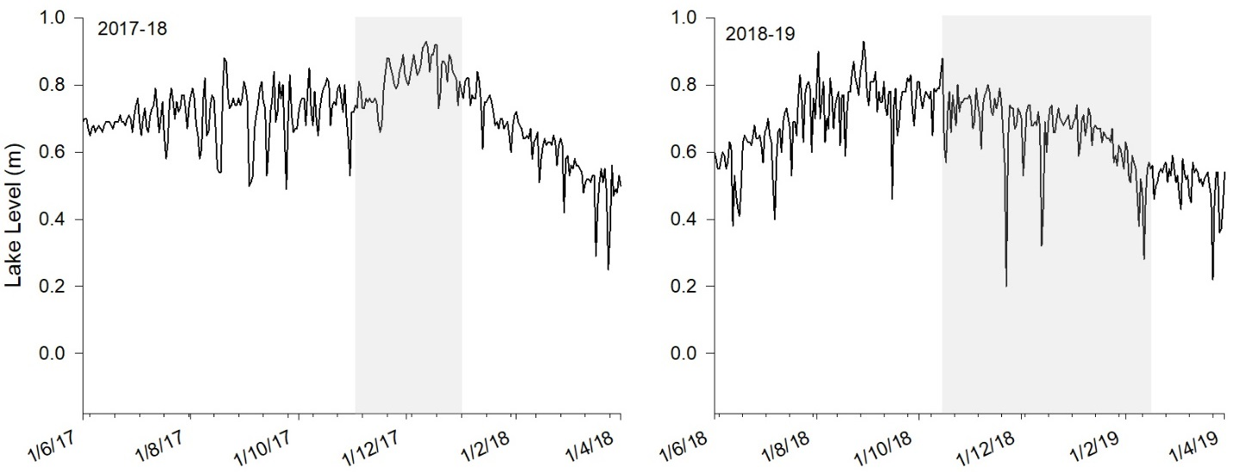

Figure 12: Daily water level (mAHD) at gauge A4261034 within the Lower Lakes from June to April in 2017-18 and 2018-19. Grey shading indicates the study period for the 2017-18 Black Bream monitoring (Ye *et al.*, 2019a) and the 2018-19 Black Bream and zooplankton monitoring. Data source: DEW.

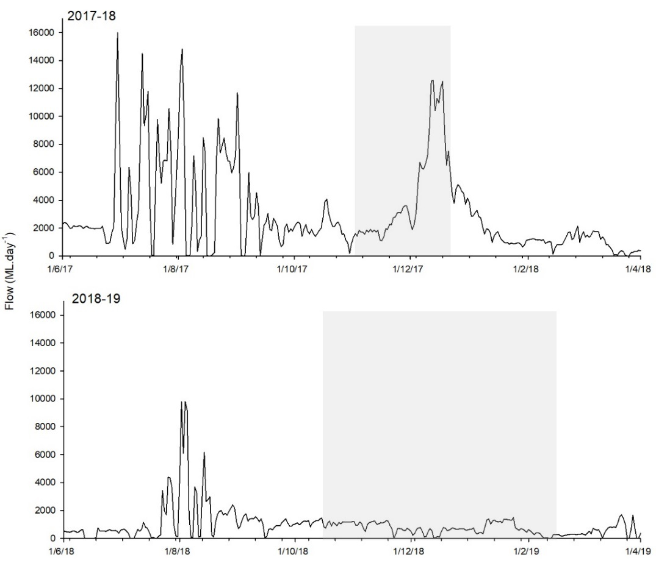

Figure 13: Combined daily flow discharge (ML.day-1) to the Murray Estuary (all barrages) from June to April in 2017-18 and 2018-19. Grey shading indicates the study period for the 2017-18 Black Bream monitoring (Ye *et al.*, 2019a) and the 2018-19 Black Bream and zooplankton monitoring. Data source: DEW.

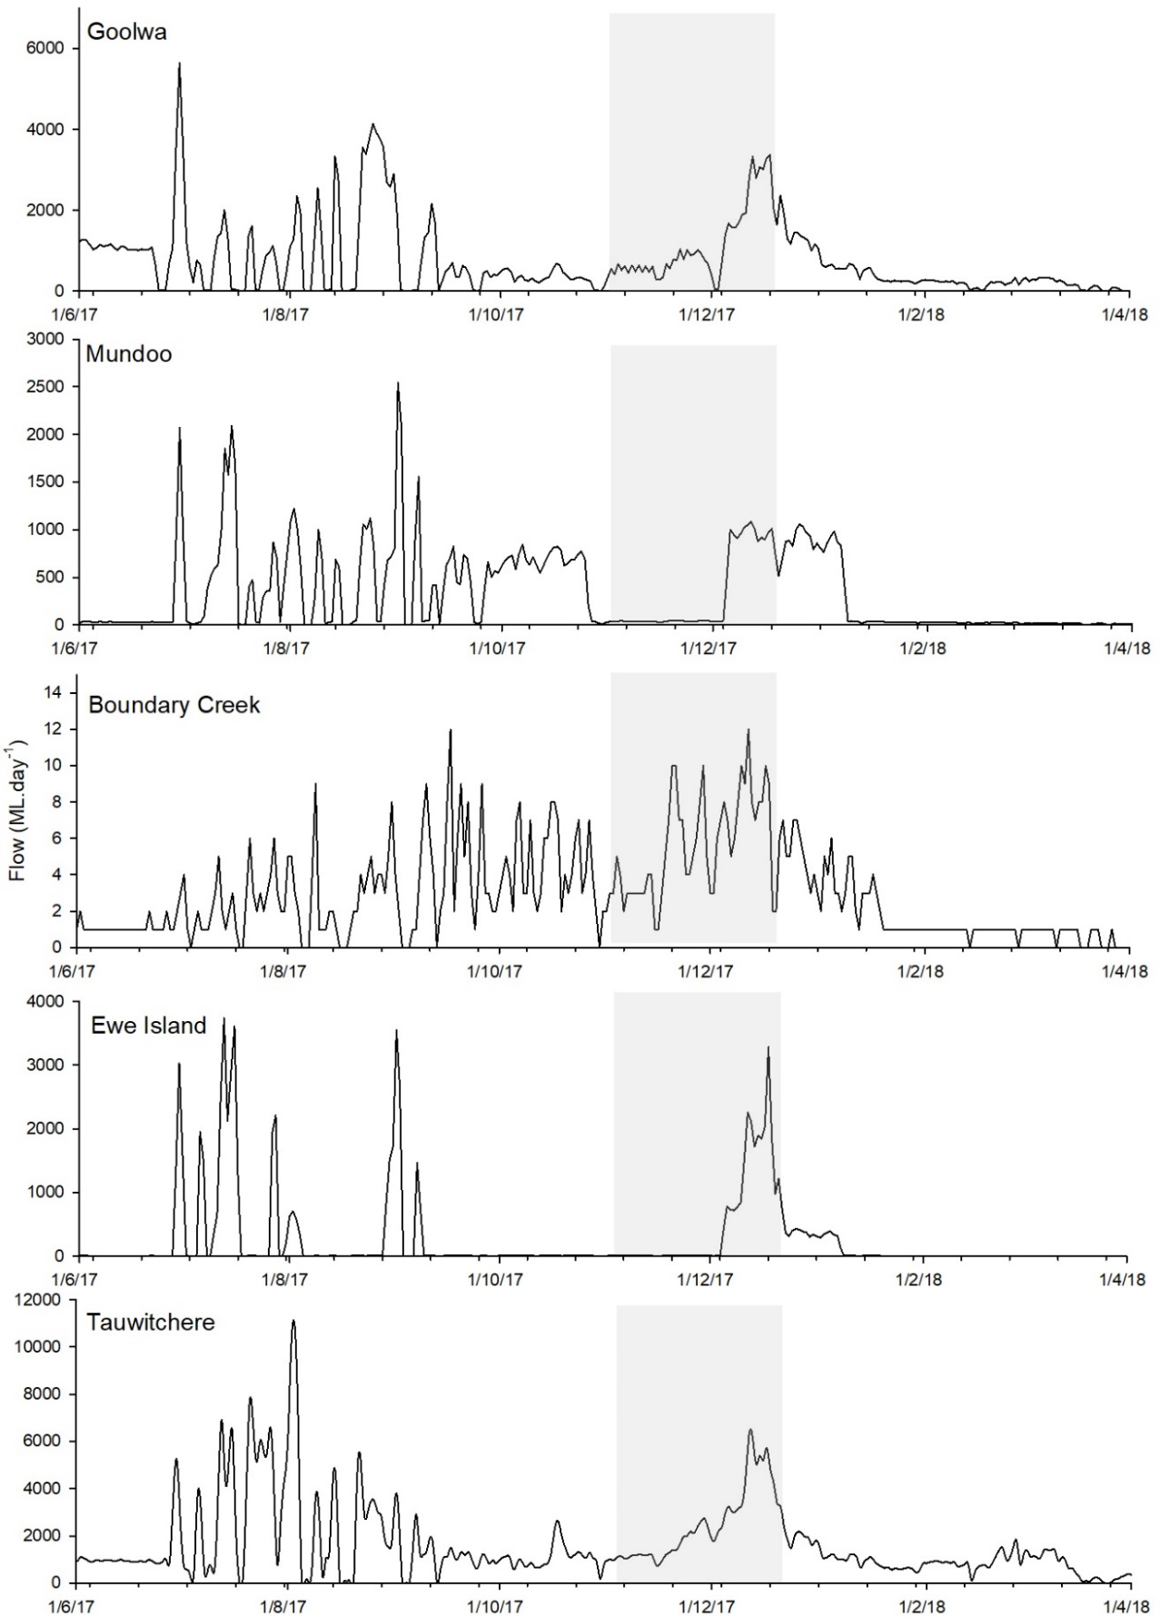

Figure 14: Daily flow discharge by individual barrages (ML.day-1) for 2017-18. a) Goolwa Barrage, b) Mundoo Barrage, c) Boundary Creek Barrage, d) Ewe Island Barrage, e) Tauwitchere Barrage and f) Combined discharge (five barrages). Grey shading indicates the study period for the 2017-18 Black Bream monitoring (Ye *et al.*, 2019a) and the 2018-19 Black Bream and zooplankton monitoring. Data source: DEW.

# References

Anderson M., Gorley R. & Clarke K.P. (2008) PRIMER: Guide to software and statistical methods. PRIMER-E, Plymouth, UK.

Bice C., Furst D., Lamontagne S., Oliver R., Zampatti B. & Revill A. (2015) The influence of freshwater discharge on productivity, microbiota community structure and trophic dynamics in the Murray estuary: evidence of freshwater derived trophic subsidy in the sandy sprat. Goyder Institute for Water Research Technical Report Series No. 15/40, Adelaide, South Australia. ISSN: 1839-2725.

Bollens S.M. & Frost B.W. (1991) Diel vertical migration in zooplankton: rapid individual response to predators. *Journal of Plankton Research,* **13,** 1359-1365.

Brandl Z. (2005) Freshwater copepods and rotifers: predators and their prey. *Hydrobiologia,* **546,** 475-489.

Castellani C., Robinson C., Smith T. & Lampitt R.S. (2005) Temperature affects respiration rate of *Oithona similis*. *Marine Ecology Progress Series,* **285,** 129-135.

CSIRO. (2008) Water availability in the Murray‐Darling Basin. *(Report to the Australian Government from the CSIRO Murray-Darling Basin Sustainable Yields Project)***,** 67.

Cuddington K. (2011) Legacy Effects: The Persistent Impact of Ecological Interactions. *Biological Theory,* **6,** 203-210.

DEH. (2000) Coorong, and Lakes Alexandrina and Albert Ramsar Management Plan.(Ed D.O.E.A. Heritage).

Dıaz E., Cotano U. & Villate F. (2003) Reproductive response of *Euterpina acutifrons* in two estuaries of the Basque Country (Bay of Biscay) with contrasting nutritional environment. *Journal of Experimental Marine Biology and Ecology,* **292,** 213-230.

Earl J., Ward T.M. & Ye Q. (2016) Black Bream (Acanthopagrus butcheri) Stock Assessment Report 2014/15. Report to PIRSA Fisheries and Aquaculture. South Australian Research and Development Institute (Aquatic Sciences), Adelaide. SARDI Publication No. F2008/000810-2. SARDI Research Report Series No. 885.

Geddes M. (1984) Limnology of Lake Alexandrina, River Murray, South Australia, and the effects of nutrients and light on the phytoplankton. *Marine and Freshwater Research,* **35,** 399-415.

Geddes M., Shiel R. & Francis J. (2016) Zooplankton in the Murray estuary and Coorong during flow and no-flow periods. *Transactions of the Royal Society of South Australia,* **140,** 74-89.

Gee J.M. (1987) Impact of epibenthic predation on estuarine intertidal harpacticoid copepod populations. *Marine Biology,* **96,** 497-510.

Healey M. (1982) Juvenile Pacific salmon in estuaries: the life support system. In: *Estuarine comparisons* pp. 315-341. Elsevier.

Jenkins G.P., Conron S.D. & Morison A.K. (2010) Highly variable recruitment in an estuarine fish is determined by salinity stratification and freshwater flow: implications of a changing climate. *Marine Ecology Progress Series,* **417,** 249-261.

Jordan T.E., Correll D.L., Miklas J.J. & Weller D.E. (1991) Long-term trends in estuarine nutrients and chlorophyll, and short-term effects of variation in watershed discharge. *Marine Ecology Progress Series*.

Kingsford R.T., Walker K.F., Lester R.E., Young W.J., Fairweather P.G., Sammut J. & Geddes M.C. (2011) A Ramsar wetland in crisis – the Coorong, Lower Lakes and Murray Mouth, Australia. *Marine and Freshwater Research,* **62,** 255-265.

Lancaster J. & Robertson A.L. (1995) Microcrustacean prey and macroinvertebrate predators in a stream food web. *Freshwater Biology,* **34,** 123-134.

Maheshwari B., Walker K. & McMahon T. (1995) Effects of regulation on the flow regime of the River Murray, Australia. *Regulated Rivers: Research & Management,* **10,** 15-38.

Marshall S. & Orr A. (1966) Respiration and feeding in some small copepods. *Journal of the Marine Biological Association of the United Kingdom,* **46,** 513-530.

McLusky D.S. & Elliott M. (2004) *The estuarine ecosystem: ecology, threats and management,* OUP Oxford.

Menéndez M.C., Piccolo M.C. & Hoffmeyer M.S. (2012) Short-term variability on mesozooplankton community in a shallow mixed estuary (Bahía Blanca, Argentina): Influence of tidal cycles and local winds. *Estuarine, Coastal and Shelf Science,* **112,** 11-22.

Nelson J.A., Deegan L. & Garritt R. (2015) Drivers of spatial and temporal variability in estuarine food webs. *Marine Ecology Progress Series,* **533,** 67-77.

Newton G.M. (1996) Estuarine ichthyoplankton ecology in relation to hydrology and zooplankton dynamics in salt-wedge estuary. *Marine and Freshwater Research,* **47,** 99-111.

Nicholson G., Jenkins G.P., Sherwood J. & Longmore A. (2008) Physical environmental conditions, spawning and early-life stages of an estuarine fish: climate change implications for recruitment in intermittently open estuaries. *Marine and Freshwater Research,* **59,** 735-749.

Puckridge J.T., Sheldon F., Walker K.F. & Boulton A.J. (1998) Flow variability and the ecology of large rivers. *Marine and Freshwater Research,* **49,** 55-72.

SA MDB NRM. (2009) Lower Lakes, Coorong and Murray Mouth Icon Site Condition Monitoring Plan (Ed S.a.M.-D.B.N.R.M. Board), Adelaide.

Shiel R.J. & Aldridge K.T. (2011) The response of zooplankton communities in the North Lagoon of the Coorong and Murray Mouth to barrage releases from the Lower Lakes, November 2010–April 2011. Final report prepared for the Department of Environment and Natural ….

Simpson J.H., Brown J., Matthews J. & Allen G. (1990) Tidal straining, density currents, and stirring in the control of estuarine stratification. *Estuaries,* **13,** 125-132.

Sklar F.H. & Browder J.A. (1998) Coastal environmental impacts brought about by alterations to freshwater flow in the Gulf of Mexico. *Environmental Management,* **22,** 547-562.

Stern M.K., Day J.W. & Teague K.G. (1991) Nutrient transport in a riverine-influenced, tidal freshwater bayou in Louisiana. *Estuaries,* **14,** 382-394.

Svensen C., Viličić D., Wassmann P., Arashkevich E. & Ratkova T. (2007) Plankton distribution and vertical flux of biogenic matter during high summer stratification in the Krka estuary (Eastern Adriatic). *Estuarine, Coastal and Shelf Science,* **71,** 381-390.

Ustach J.F. (1982) Algae, bacteria and detritus as food for the harpacticoid copepod, *Heteropsyllus pseudonunni* Coull and Palmer. *Journal of Experimental Marine Biology and Ecology,* **64,** 203-214.

Watanabe K., Kasai A., Antonio E.S., Suzuki K., Ueno M. & Yamashita Y. (2014) Influence of salt-wedge intrusion on ecological processes at lower trophic levels in the Yura Estuary, Japan. *Estuarine, Coastal and Shelf Science,* **139,** 67-77.

Williams J., Hindell J., Swearer S. & Jenkins G. (2012) Influence of freshwater flows on the distribution of eggs and larvae of black bream Acanthopagrus butcheri within a drought‐affected estuary. *Journal of Fish Biology,* **80,** 2281-2301.

Williams J., Jenkins G.P., Hindell J.S. & Swearer S.E. (2013) Linking environmental flows with the distribution of black bream Acanthopagrus butcheri eggs, larvae and prey in a drought affected estuary. *Marine Ecology Progress Series,* **483,** 273-287.

Ye Q., Bucater L., Giatas G. & Short D. (2019a) Monitoring salt wedge conditions and black bream (Acanthopagrus butcheri) recruitment in the Coorong during 2017-18. South Australian Research and Development Institute (Aquatic Sciences), Adelaide. SARDI Publication No. F2018/000425-1. SARDI Research Report Series No. 1012. 42pp.

Ye Q., Bucater L. & Short D. (2013) Coorong Fish Condition Monitoring 2008-2013: Black bream (*Acanthopagrus butcheri*), greenback flounder (*Rhombosolea tapirina*) and smallmouthed hardyhead (*Atherinosoma microstoma*) populations. SARDI Aquatic Sciences.

Ye Q., Furst D., Lorenz Z., Giatas G. & Short D. (2019b) Monitoring salt wedge dynamics, food availability and black bream (Acanthopagrus butcheri) recruitment in the Coorong during 2018-19. South Australian Research and Development Institute (Aquatic Sciences), Adelaide.