# The future of public sector forecasting in Australian agriculture

Rohan Nelson

Research by the Australian Bureau of Agricultural and Resource Economics and Sciences

Research Report 18.14

November 2018



© Commonwealth of Australia 2018

**Ownership of intellectual property rights**

Unless otherwise noted, copyright (and any other intellectual property rights, if any) in this publication is owned by the Commonwealth of Australia (referred to as the Commonwealth).

**Creative Commons licence**

All material in this publication is licensed under a Creative [Commons Attribution 4.0 International Licence](https://creativecommons.org/licenses/by/4.0/legalcode) except content supplied by third parties, logos and the Commonwealth Coat of Arms.

Inquiries about the licence and any use of this document should be emailed to [copyright@agriculture.gov.au](mailto:copyright@agriculture.gov.au).

C:\Documents and Settings\west merryn\Local Settings\Temporary Internet Files\Content.Word\by.png

**Cataloguing data**

This publication (and any material sourced from it) should be attributed as: Nelson, R 2018, *The future of public sector forecasting in Australian agriculture*, ABARES research report 18.14, Canberra, November. CC BY 4.0. <https://doi.org/10.25814/5becfadb45811>

ISBN 978-1-74323-403-7

ISSN 1447-8358

This publication is available at [agriculture.gov.au/publications](http://agriculture.gov.au/publications).

Department of Agriculture and Water Resources

GPO Box 858 Canberra ACT 2601

Telephone 1800 900 090

Web [agriculture.gov.au](http://agriculture.gov.au/)

The Australian Government acting through the Department of Agriculture and Water Resources, represented by the Australian Bureau of Agricultural and Resource Economics and Sciences, has exercised due care and skill in preparing and compiling the information and data in this publication. Notwithstanding, the Department of Agriculture and Water Resources, ABARES, its employees and advisers disclaim all liability, including liability for negligence and for any loss, damage, injury, expense or cost incurred by any person as a result of accessing, using or relying on any of the information or data in this publication to the maximum extent permitted by law.

**Disclaimer**

The views expressed in this paper about the future of public sector forecasting are ideas generated by the author for discussion. They do not represent a statement of strategy by the Department of Agriculture and Water Resources or of policy by the Australian Government.

**Acknowledgements**

This paper is the culmination of deliberation over many years with numerous colleagues including Ken Baxter, Laurie Bonney, Neil Byron, Peter Gooday, Steve Hatfield-Dodds and Mark Howden. I am very grateful to Alistair Watson, Neil Byron, Steve Hatfield-Dodds and especially Peter Gooday for providing detailed feedback on numerous drafts, while acknowledging that by writing the paper that I wanted to write I have not fully followed their advice. Not knowing what would emerge, Trish Gleeson courageously provided the initial support to launch this project, and I will be forever grateful for the opportunity.

Colleagues across ABARES and the Department of Agriculture and Water Resources provided a sounding board for these ideas as well as commenting on drafts. I am especially grateful to Dale Ashton, Andrew Cameron, Caroline Gunning-Trant, Lisa McKelvie and Matt Miller for their ideas and support for the project. The ABARES commodity team in 2017 and 2018 included Ben Agbenyegah, Peter Berry, Amelia Brown, Jack Mullumby, Nathan Pitts, Chris Price, Conrad Rees, Sarah Smith and Tim Whitnall. I’m grateful to all of them for helping to shape these ideas through active participation in workshops and seminars. I’m very grateful to Brian Fisher for confirming the existence of the ancient ‘defence-of-the-bureau’ file and to Sharen Tolhurst for helping me to find it. Karen Kidd went above and beyond to provide extreme library services in tracking down the hundreds of papers that fed into the literature review for this paper. Thanks to Emma Rossiter for editing the final version.

Rohan Nelson, Canberra, November 2018

rohan.nelson@agriculture.gov.au

## Foreword

All public sector organisations need to ensure their work and mission remain relevant and valuable in a changing world. This is especially true of organisations that seek to help others understand and adapt to these changes, and the challenges and opportunities they may present.

ABARES and its predecessors have been providing commodity market forecasts for Australia’s agricultural sector since the 1940s, as part of a wider suite of evidence‑based analysis and advice to policymakers and industry stakeholders. The operational context of ABARES and the industries we serve has changed a great deal over this period, and there are no signs that future changes will be slower or less profound.

This paper explores the future of public sector agricultural forecasting in the context of the past evolution of ABARES work. It identifies a range of challenges and opportunities for people involved in public sector forecasting, including the usual suspects of globalisation and global change, rapid improvements in information and communication technology, the emergence of big data (in all its forms), and new technology-enabled possibilities for interaction and co-production of knowledge.

But the paper also goes deeper than this—calling on everyone involved in public sector forecasting to rethink how and why we do our work. It calls us to create new ways of working together and to develop new forecasting and foresighting services.

The paper is written by a keen observer of, and leading contributor to, public forecasting and agricultural policy over the past two decades. The author, Dr Rohan Nelson, is an exemplar of reflective practice and a consistent advocate for recognising the wisdom, distinctive expertise and contributions of diverse stakeholders.

As such, the paper also represents an invitation from ABARES to our friends and colleagues across all sectors. Please join with us to help shape a future in which our forecasts and other insights continue to be as relevant and valuable as possible.



Steve Hatfield-Dodds

Executive Director

Australian Bureau of Agricultural and Resource Economics and Sciences

Contents

Foreword iii

Summary vi

Introduction 1

1 Analysing policy arguments 2

2 Institutional evolution of agricultural forecasting 4

2.1 Post-war policy goals for agricultural development 4

2.2 Forecasts for farm decision-making 4

2.3 Inheriting US institutions 5

2.4 Shared mistrust of markets 6

2.5 Implications of market regulation 7

2.6 Peak forecast effort and model development 8

2.7 Policy arguments for public sector forecasting 9

3 Economics of agricultural forecasting 11

3.1 Market failures and potential roles for government 11

3.2 Market efficiency value of forecasts 12

3.3 Targeting forecasts to the decisions they support 13

3.4 Equity value of forecasts 13

3.5 Economic value of planned policy 15

3.6 Economic arguments for and against public sector forecasting 16

4 Global influences on public sector forecasting 18

4.1 Structural economic change 18

4.2 ICT revolution 18

4.3 Microeconomic reform 19

4.4 Globalisation and vertically integrated value chains 20

4.5 Globalisation and the democratisation of expertise 21

4.6 Value of foresighting 22

4.7 Increasing sophistication of forecast users 23

4.8 Nuanced arguments for public provision 24

4.9 Policy demand into the 21st century 25

4.10 Policy arguments into the 21st century 26

5 Conclusions 28

References 29

**Figures**

Figure 1 The structure of policy arguments 2

Figure 2 Staff numbers in the BAE, ABARE and ABARES 9

Figure 3 Policy arguments used to establish the BAE 10

Figure 4 The market efficiency value of forecasts 12

Figure 5 The economic value of using forecasts to prevent monopsony pricing 14

Figure 6 The economics of using forecasts to plan policy responses 15

Figure 7 Economic arguments for establishing public sector forecasting 16

Figure 8 Policy arguments for providing public sector forecasting into the 21st century 27

## Summary

Australian governments since 1945 have provided commodity market forecasts for Australia’s agricultural sector. Since then the operating and policy context of Australian agriculture has changed dramatically. Public investment in agricultural forecasting fell from the 1990s onwards as technology made forecasting more efficient and as agriculture’s falling share of the economy reduced its priority within government. The acceleration of global change into the 21st century brings into question the future role of public sector forecasting in Australian agriculture and what these forecasting services should look like into the future.

Public sector forecasts for Australian agriculture have almost exclusively been provided by the Bureau of Agricultural Economics (BAE, 1945–1987) and its successors, the Australian Bureau of Agricultural and Resource Economics (ABARE, 1987–2010) and the Australian Bureau of Agricultural and Resource Economics and Sciences (ABARES, from 2010). The idea of creating a BAE surfaced during World War II and was initially driven by the need to provide an evidence base for policy development. Prior to the war, public investment in agricultural economics and market analysis was limited to research that supported sporadic industry inquiries.

The Australian Government’s commitment to providing forecasting services for agriculture emerged from 1943 onwards as the scale of dismantling wartime policy became clear. This was intensified by anticipation of the problems associated with resettling returned soldiers with limited farming experience onto farms acquired by governments. Many soldier settlement farms established after World War I had failed, partly as a result of naive commodity forecasts. The bureau’s flagship publication, the Quarterly Review of Agricultural Economics, was first published in January 1948 and included quarterly updates of expected trends in agricultural markets.

Australia’s BAE owed much in its original design to similar institutions that had already been established in the United States and Canada. Governments in the United States and Australia both saw the public provision of production and price forecasts as a means of addressing a perceived imbalance in information between farmers and traders. In Australia, the public provision of forecasting services was complemented by statutory marketing. Statutory marketing was designed to provide farmers with countervailing market power in their negotiations with traders. However, it also removed responsibility for marketing from farmers and incentives to innovate in response to market signals.

Statutory marketing was just one manifestation of a high level of post-war government involvement in agriculture that sustained policy demand for agricultural forecasts by central government agencies. BAE’s forecasting services expanded from the 1960s to the 1980s in terms of commodity coverage and methodological capability, with public investment in forecasting services peaking in the mid 1980s. In 1981–82, 65 staff were involved in commodity and marketing economics research and a further 42 in collecting and processing commodity data. The commitment of resources during the 1980s allowed experimentation with increasingly sophisticated structural and programming models.

Economists have always emphasised the economic value that forecasts provide through the efficient operation of markets, with benefits to consumers and producers. They also tend to be equivocal about whether and to what extent these services should have been exclusively funded by governments. Reliable forecasts can help reduce the uncertainty that farmers face when committing resources to production well in advance of knowing demand at the time of marketing. Consumers benefit through the timely availability of high quality and reasonably priced food. This provides an incentive for both consumers and producers to contribute to the cost of forecasts. Economic thinking can also be used to understand the value derived from using forecasts to make markets more equitable, and to support policy development.

Policy demand for agricultural forecasts remains strong into the 21st century. Although the emphasis on industries and issues changes constantly, the basic policy applications of ABARES forecasts have changed little since 1945. Forecasts and related market information are used to respond to stakeholder concerns and form policy responses to emerging issues, and continue to be used by central agencies for macroeconomic forecasting. ABARES forecasts remain essential for policy applications where independence from industry and markets is essential.

Beyond this policy role, globalisation has dramatically changed the policy arguments shaping the future public provision of forecasting services for Australian agriculture.

The growing sophistication of forecast users and development of interactive web-based technologies means that public sector forecasting services should focus on providing intermediate data and analyses that users can recombine to produce their own forecasts. In government, this would build the capacity of policy advisers to tailor advice in response to emerging issues. In the private sector, this would boost the value of public good data and analyses that consultants and others use to tailor commercial forecasts.

The growing expertise of users increases their independence from expert forecasters and creates a store of knowledge that forecasters should draw on. This will require ABARES to evolve from an expert-centric institution to one via which expert forecasters engage meaningfully with diverse groups of forecast users. This is likely to involve greater use of social media and interactive web-technologies that support innovative approaches to consensus-based foresighting of deeply uncertain future market scenarios.

Globalisation has fundamentally altered relationships between farmers and other participants along vertically integrated value chains. Former adversaries in spot markets are now mutually dependent on one another in vertically integrated value chains, which potentially improves the flow of information between them. This means that future forecasting services can no longer focus exclusively on farmgate prices, but need to inform the creation of value along vertically integrated value chains.

Public sector forecasting services also need to evolve a complementary focus on foresighting, using scenarios built through consultation that draws on diverse types of expertise and multiple perspectives. Scenario analysis that anticipates the future vulnerability of agricultural industries would support proactive policy design, particularly for significant and uncertain step-wise change that is difficult for markets and industries to assess and adapt to. It would also support the investigation of significant new investments and forays into unfamiliar markets by increasingly sophisticated forecast users.

.

## Introduction

Agricultural prosperity in general depends primarily upon the ability of farmers to anticipate the future.

Henry Taylor, Chief of the USDA Bureau of Agricultural Economics   
(Taylor 1924, p. 157)

Australian governments since 1945 have provided commodity market forecasts for Australia’s agricultural sector. Since then the operating and policy context of Australian agriculture has changed dramatically. Public investment fell from the 1990s onwards as technology made forecasting more efficient and as agriculture’s falling share of the economy reduced its priority within government. The acceleration of global change into the 21st century brings into question the future role of public sector forecasting in Australian agriculture and what these forecasting services should look like into the future. Have decades of downsizing left behind the shell of a forecasting system designed to meet the needs of the past? Or have forces akin to Darwinian evolution created a robust and flexible system capable of adapting to the needs of the 21st century?

Public sector forecasts for Australian agriculture have almost exclusively been provided by the Bureau of Agricultural Economics (BAE, 1945–1987) and its successors, the Australian Bureau of Agricultural and Resource Economics (ABARE, 1987–2010) and the Australian Bureau of Agricultural and Resource Economics and Sciences (ABARES, from 2010). This paper begins by exploring the early policy arguments used to establish and grow public sector forecasting services for Australia’s agricultural sector. These early policy arguments are then compared with economic thinking at the time to reveal the competing ideas that shaped the BAE and the forecasting services it provided. The paper then examines the panoply of forces often labelled globalisation that have dramatically altered the operating environment of Australian agriculture since the 1980s. Major pressures for change that do not yet seem to have been met with appropriate adaptation lead to principles guiding the institutional design of forecasting services into the 21st century.

## Analysing policy arguments

Public provision of forecasting services can be viewed as an intervention by governments to correct perceived deficiencies in information flows from agricultural markets in order to improve outcomes for producers and consumers. The effectiveness of any government intervention depends at least partly on how well it is designed to address a specific problem—usually a failure in services provided by markets or existing institutions. Analysing this requires deconstructing the logic used to justify each intervention and comparing it to the nature of the problem and the range of policy options for addressing it. Political discourse analysis provides one method for deconstructing policy arguments to reveal how well these justify government intervention (Fairclough & Fairclough 2012).

Political discourse analysis frames arguments in favour of (or against) government intervention in terms of actions with potential to bridge the gap between desired future states (such as informed, fair and stable agricultural markets) and perceived current circumstances (poorly informed, unfair and volatile agricultural markets). Actions themselves are based on value judgements that particular means (strategies and activities) will allow progress towards meeting goals. Perceptions of the current and desired future states of agricultural markets—and the actions that should be taken to achieve these desired future states—are derived from a set of underlying and often contested values about what should matter to governments (Figure 1).

Figure 1 The structure of policy arguments

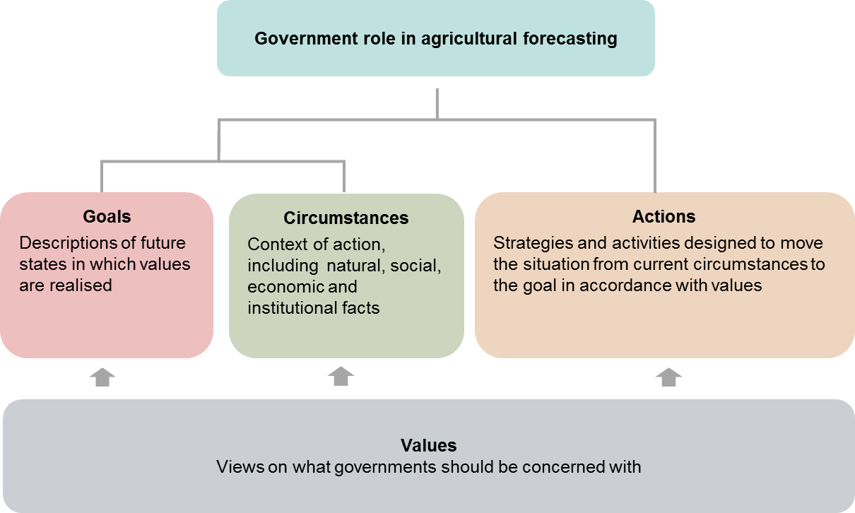

Adapted from Fairclough and Fairclough (2012, p. 45)

Descriptions of current circumstances—sometimes called situation analysis—are descriptions of the past performance of agricultural markets and the degree to which this performance matters to consumers and producers. Although these descriptions can be based on research and analysis of data, they are often highly subjective and contested. They tend to be shaped by different values that lead to different perceptions—for example, whether and why the operation of agricultural markets has been problematic, and whether and to what extent this has consequential impacts on rural communities and society generally. Values also affect which data and research are seen as legitimate for describing the current and potential future state of markets, and which actions are seen as potentially effective in improving this. Arguments for government actions often draw on analyses of institutional and market failures, and policy options for managing these.

An adapted version of the policy discourse analysis is used in the sections that follow to summarise and compare early policy thinking on the role of public sector forecasting in Australian agriculture with the view held by contemporary economists. This highlights the range of values at play during the evolution of Australia’s public sector forecasting services, and the pressure for these services to evolve in different ways. It is then used later in the paper to consider the impact of globalisation on the policy logic for providing these services into the 21st century.

## Institutional evolution of agricultural forecasting

### Post-war policy goals for agricultural development

Much can be inferred about the policy arguments used to establish and maintain public sector forecasting in Australian agriculture by analysing the institutional origins of the BAE. The idea of creating a BAE surfaced during World War II and was initially driven by the need to provide an evidence base for policy development. Prior to the war, public investment in agricultural economics and market analysis was limited to research that supported sporadic industry inquiries (Davidson 1981). During the war, central planning to supply food to the allied forces throughout the Pacific and the United Kingdom highlighted a lack of institutional capability to collect and analyse data on Australia’s agricultural production (Bureau of Agricultural Economics 1962). Significant knowledge gaps about the functioning of agricultural markets were highlighted by the administration of consumer rationing and price controls.

The immediate post-war policy motivation for providing public sector forecasting services was focused on returning Australia’s agricultural sector from a wartime footing of central planning to a market-based system. The Australian Government’s commitment to providing these services emerged from 1943 onwards as the scale of dismantling wartime policy became clear (Bureau of Agricultural Economics 1962). This was intensified by anticipation of the problems associated with resettling returned soldiers with limited farming experience onto farms acquired by governments. Many soldier settlement farms established after World War I had failed, partly as a result of naive commodity forecasts. It had been assumed that high wartime commodity prices would continue, resulting in the allocation of farms that were too small to remain viable in times of low prices and drought (Davidson 1981).

To avoid a recurrence of the World War I experience, the Rural Reconstruction Commission stressed:

…the importance of economic information to farmers, and strongly recommended that the proposed War Service Land Settlement Scheme be based on careful investigations both of the long term market outlook for particular commodities and the economic viability of the individual farms to be settled.

(Bureau of Agricultural Economics 1962, p. 3)

The BAE was established in July 1945 initially to provide ‘investigations’ into ‘the economic prospects of primary industries’ directed toward ‘economic analysis of land settlement proposals submitted by the states’ (Bureau of Agricultural Economics 1950, p. 4). These economic assessments required assumptions to be made about the future of agricultural markets, providing the initial impetus to develop a forecasting capability.

### Forecasts for farm decision-making

The early policy motivations for establishing public sector forecasting in Australian agriculture included providing market information to support on-farm decision-making. The intended beneficiaries of public sector forecasts were the thousands of returned soldiers learning to farm. Soldier settlers were very different socially and politically to other groups of more established farmers, which included a landed elite, especially in Australia’s then dominant wool industry (Massy 2011). This meant that soldier settlers were not just new to farming, but also faced social challenges to becoming networked into the industry institutions via which information flowed.

The bureau’s flagship publication, the Quarterly Review of Agricultural Economics, was first published in January 1948 and included quarterly updates of expected trends in agricultural markets. By 1950 the BAE had produced, or was working on, detailed outlooks for lamb, pig meat, horticulture, viticulture, potato, wool, beef, poultry, dairy, wheat and rice, and intended to update these annually (Secretary of the Department of Commerce and Agriculture 1950). By 1962 the forecasting functions of the BAE had evolved to providing ‘continuous review of the economic situation facing producers of important rural products, and the preparation of periodic assessments of the market outlook for those products’ with regular situation reports published for wool, wheat, coarse grains, beef, dairy, eggs and fibres other than wool (Bureau of Agricultural Economics 1962, p. 11). In this early period data and forecasts were distributed via paper-based publications.

### Inheriting US institutions

Australia’s BAE owed much in its original design to similar institutions that had already been established in the United States and Canada (Crawford 1945). The United States Bureau of Agricultural Economics (USBAE)—which later became the Economic Research Service—was established in 1922 and held its first annual Agricultural Outlook Forum in 1923. The USBAE’s early focus was on providing data and forecasts to smooth the operation of agricultural markets by supporting farmers and traders in their efforts to anticipate prices and set production and supply at levels consistent with expected demand (Taylor 1924). The founder of Australia’s BAE, Sir John Crawford, thought the work program of the US bureau was overly ambitious, but was impressed by the capability of its staff. As a result, he recommended that the Australian Government develop a smaller, resource appropriate BAE instilled with similar motivating philosophies and methods to its North American counterparts but with a more targeted focus.

Government collection of agricultural statistics in the United States was initially sporadic, driven by issues and problems emerging from agricultural development. In 1840 the Commissioner for Patents, Henry Ellsworth, convinced the US congress to fund questions on agricultural production in the population census (Ebling 1939). These first survey questions were driven by a desire to understand the impact on long-established eastern-state farmers of competition from new agricultural areas in the west. Early surveys were also driven by a desire to understand the impact of new technologies on comparative advantage and structural adjustment across diverse agricultural regions. For example, Ellsworth was interested in the relative rates at which steam power was likely to displace horse drawn traction in different industries and regions. As forecasting evolved into the 20th century, it was increasingly used to monitor the long-term supply of food and raw materials and inform national agricultural and land-use policy (Taylor 1924).

A difference in the early development of the US and Australian BAEs was the relationship between forecasters and forecast users. By the time the Australian BAE was established in the 1940s, public sector institutions in Australia and the United States were heavily expert-centric. The Australian approach to forecasting emphasised analysis by centrally located experts whose work was then disseminated via publications and (much later) via outlook conferences. There were fewer experts and the institutions that hosted them were less developed when agricultural information systems first emerged in the United States. US farmers and the merchants who used agricultural statistics were initially heavily involved in collecting them. This was a necessity in the days before government institutions developed the capacity to gather data across extensive regions. The use of surveys was refined over time, and from the 1920s onwards surveys of planting and breeding intentions were for many years conducted by rural mail carriers (Ebling 1939; Taylor 1924).

The advantages of consensus forecasting were also recognised early in the development of the USBAE. By 1924 an Agricultural Outlook Committee had been established to combine expert analysis with industry knowledge. In 1924 the Chief of the USBAE wrote that ‘the composite judgement of large numbers of business men [and women] throughout the country … can add greatly to such material as the Department of Agriculture can secure in providing a basis of judgement for the American farmer upon which to plan his next season’s work’ (Taylor 1924, pp. 161–2). Although these institutions later became more expert-centric on both sides of the Pacific, their history contains traces of this tradition of consensus. For example, Australia’s national outlook conferences have usually included forecasts from banks, consultants and other private sector sources alongside BAE/ABARE(S) forecasts.

### Shared mistrust of markets

A natural affiliation with similar US institutions helped mutually reinforce some shared policy values that motivated governments on both sides of the Pacific to invest in public sector forecasting. A series of booms and busts throughout the 19th century and following World War I left behind a deep mistrust of agricultural markets in Australia (Watson & Parish 1982). This resonated with a pervasive apprehension in the United States about the potential abuse of market power by traders, which was etched into the foundations of agricultural policy by market manipulation during the American Civil War (Ebling 1939). During the Civil War, traders were accused of manipulating agricultural markets to their own advantage through rumour mongering and speculation, contributing to extreme price volatility and food shortages (Ebling 1939). This led to a deeply held and long-lasting conviction amongst US policymakers that traders could—and would whenever given the chance—use their superior market knowledge to manipulate prices to the disadvantage of farmers and consumers.

Concerns over the abuse of market power lingering from the Civil War led to the evolution in the United States of two policy responses that have had a significant impact on public sector forecasting in Australian agriculture. The first policy response was to provide production estimates, and later forecasts, to address the perceived imbalance (asymmetry) in information between market participants. This led to the establishment of the United States Department of Agriculture (USDA) by President Lincoln in 1862, and the regular publication of information on seasonal conditions for crop production from 1863 (Ebling 1939; Parcell & Tonsor 2013). As data accumulated over the next 30 years, seasonal condition reports grew into production forecasts based on the degree to which current seasonal conditions were conducive to achieving long-term expected yields. Increasingly sophisticated assessments of seasonal conditions evolved in the US grain trade during the 1890s. Production forecasts were routinely published by the USDA from 1912.

The second policy strategy originating in the United States was to regulate the structure of agricultural markets to give farmers countervailing market power over traders using a strategy known at the time as orderly marketing. Orderly marketing involved organising farmers into cooperatives to exert monopoly power over prices (Sapiro 1923). The goal was to provide farmers with collective bargaining power to overcome the perceived marketing disadvantages of remoteness, isolation and a lack of expertise. Despite a number of Bills being drafted in the late 1920s to give it effect, its socialist characteristics meant that orderly marketing never received the statutory backing of libertarian US governments. Voluntary cooperatives failed because they could not exert sufficient control on supply to maintain monopoly pricing (Lewis 1961). Larger and more efficient farmers had an incentive to negotiate their own terms and sell larger volumes of produce at prices lower than the prices charged by monopolistic cooperatives (Parish 1967; PC 2016).

### Implications of market regulation

In Australia, orderly marketing was known as statutory marketing. It removed the responsibility for marketing from farmers and undermined incentives for farmers to use forecasts to self-manage market risk (Lewis 1961; Watson & Parish 1982). Control over supply was achieved by legally compelling farmers to sell their produce to marketing boards, which became euphemistically known as compulsory cooperatives (Lewis 1961). Tariff protection and import controls were used to segment domestic and international markets, and raise domestic prices above export prices.

Statutory marketing reinforced policy demand for agricultural commodity forecasts and redirected forecasting effort towards a diverse array of industries, for many of which Australia lacked comparative advantage (Lewis 1967). The administration of commodity price pools was complex and costly, and forecasts were necessary to guide the stock holding and marketing activities of marketing boards. For some commodities, such as wheat and oilseeds, the effectiveness of international stabilisation mechanisms meant long periods in which there was little point in forecasting prices, which tended to follow slow-moving administrative trends (Kingma, Longmire & Stoeckel 1980). However, for many other commodities price forecasting remained necessary because marketing boards could not control international prices. Marketing boards also had no control over the climate and production forecasts were necessary to predict variability in farm incomes (Lloyd 1982). Public sector forecasting was eventually directed to supporting an intricate network of 65 statutory marketing boards that had evolved in Australia by 1980 (Kingma, Longmire & Stoeckel 1980; Vinning 1980).

Statutory marketing was just one manifestation of a high level of post-war government involvement in agriculture that sustained policy demand for agricultural forecasts by central government agencies. The early policy history of agriculture and its importance to state and federal governments has been documented by Davidson (1981) and updated by Kerin (2017). A detailed history of government intervention in the wool industry and its effect on the federal budget has been provided by Massy (2011). Prior to the mining boom of the 1960s agriculture made a significant contribution to the Australian economy, contributing more than 14 per cent of gross domestic product until 1961 compared with less than 2 per cent in 2018. This meant that central agencies such as Treasury and the Department of Finance needed agricultural forecasts to predict tariff and other sources of revenue, and to estimate the cost of a raft of support measures. Drought relief, production subsidies and price floors throughout the post-war years were large enough at times to pose grave risks to the federal budget, culminating in the disastrous reserve price scheme for wool in the late 1980s. The propensity of both state and federal governments to provide drought support in 2018—despite record farm incomes and farm management deposits—shows that forecasting remains essential for managing budget risks.

### Peak forecast effort and model development

The institutional trajectory of the BAE’s public sector forecasting from the 1960s to the 1980s was expansionary in commodity coverage and deepening in methodological capability, including the development of sophisticated structural and programming models (Kingma, Longmire & Stoeckel 1980). A commitment to holding annual national Outlook conferences from 1971 onwards institutionalised annual forecasts for all major commodities, with estimates of the gross value of agricultural production and exports updated each quarter (Kingma, Longmire & Stoeckel 1980). Although efforts to improve the quality and efficiency of agricultural forecasts continue into the 21st century, peak public investment in forecasting services occurred at some point during the mid 1980s.

The expansion of forecasting and related modelling techniques into the 1980s was enabled by the increasing availability of highly trained professional staff and reliable funding (Kingma, Longmire & Stoeckel 1980). In 1948 the BAE had 25 professional staff with university degrees in economics or agricultural economics, and this number grew to 55 in 1954 and 85 in 1962 (Bureau of Agricultural Economics 1962) (Figure 2). By the mid 1970s the BAE had 200 staff, with 40 directly involved in producing commodity forecasts and others contributing indirectly through research into methods and models (Freebairn 1978). In 1981–82, 65 staff were involved in commodity and marketing economics research and a further 42 in collecting and processing commodity data (DPI 1982). The peak commitment of public resources to agricultural forecasting in Australia occurred between 1981–82 and the merger in 1987 of BAE and the Bureau of Mineral Resources to form ABARE.

The commitment of resources during the 1980s allowed experimentation with increasingly sophisticated structural and programming models. Models had been a logical extension of simpler forms of agricultural forecasting since consistent time series data became available in the 1920s (Working 1930). The growing capability of computers during the 1970s led to an explosion of model development to support agricultural forecasts (Allen 1994). As forecasting in the BAE expanded, more and more resources were allocated to the development of cross-commodity optimisation (programming) and structural models (Kingma, Longmire & Stoeckel 1980; Longmire & Watts 1981). An early goal of this international trend in model development was to test whether models could outperform less sophisticated approaches that relied more transparently on expert judgement (Allen 1994). The development of forecasting models within the BAE peaked in the mid 1980s with the publication of EMABA—the Econometric Model of Australian Broadacre Agriculture (Dewbre et al. 1985). A descendent of this model—the Global Meat Industry model—continues to be used by consulting firm the Centre for International Economics for longer-term scenarios of future markets (for example, CIE 2013).

A common misperception is that sophisticated structural and programming models have always been used to produce BAE/ABARES forecasts. However, models have only ever formed one of many inputs into simpler but more flexible, holistic and cost-effective balance sheet models. The grand modelling experiments of the 1980s found that structural models were costly to maintain and it was always unclear whether this cost was justified by any additional insight into short‑term and medium-term forecasts (Allen 1994; Freebairn 1978; Kingma, Longmire & Stoeckel 1980). It has also remained unclear how best to apply the structured thinking skills of modellers to make the best use of commodity data that were always (and continue to be) incomplete and fragmented. Data limitations and frequent structural changes to markets mean that models have never been able to replace the role of expert judgement in forecasting, especially for shorter-term forecasts (Bunn & Wright 1991; Working 1930).

Figure 2 Staff numbers in the BAE, ABARE and ABARES

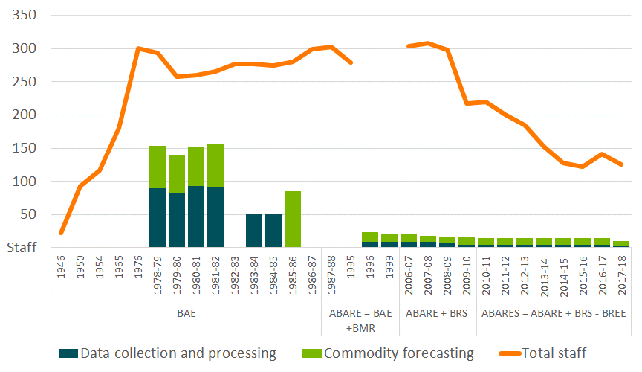

Source: ABARES internal documents and annual reports

The cost of maintaining sophisticated structural models became increasingly unsustainable during the 1990s. Loosely coupled partial equilibrium models were last used to support a fully integrated set of medium-term projections in 2001. Nonetheless, the sentiment that ‘more models should be used for forecasting’ lingers into the 21st century, partly as an artefact of an expert-centric approach to agricultural forecasting that evolved in the 1980s during the period of peak resourcing.

### Policy arguments for public sector forecasting

The policy arguments for establishing public sector forecasting in Australian agriculture are summarised in Figure 3. Australian governments in the 1940s initially committed to providing public sector forecasting to support policy development. To the limited extent that public sector forecasting was directed to supporting on-farm decision-making, the intended recipients were soldier settlers with little or no knowledge of farming. The public resources committed to agricultural forecasting in Australia were initially significant and reflected the then contribution of agriculture to the Australian economy. Consistent with the times, a centralised and expert-centric approach was used to provide advice to a diffuse network of inexperienced farmers scattered across multiple industries and regions.

Figure 3 Policy arguments used to establish the BAE

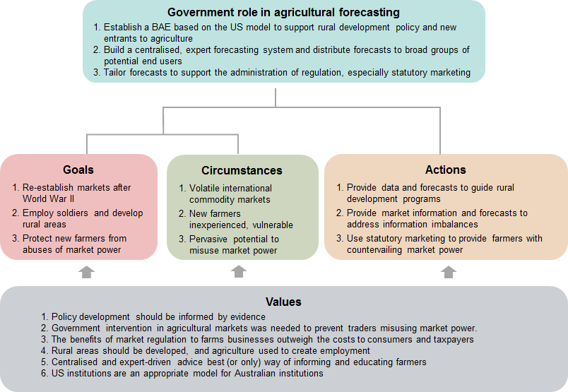

Reinforced by perceptions in the United States, the Australian Government’s commitment to public sector forecasting was partly motivated by perceived power imbalances between farmers and traders arising from remoteness and isolation. But while the provision of forecasts promoted self-reliant decision-making and risk management by farmers, this was undermined in many industries by the disincentives of statutory marketing. The industry coverage of public sector forecasting was strongly dictated by statutory marketing and employment-related policy goals, rather than Australia’s natural comparative advantage in extensive agriculture.

## Economics of agricultural forecasting

The tension between diverse political and economic viewpoints on the appropriate role of government in the agricultural sector helped to shape the evolution of the BAE and the forecasting services that it provided. Economists were highly critical of the level of government involvement that emerged following federation and were warning governments about the mounting costs to consumers and taxpayers well before World War II (Copland & Janes 1938). By the 1960s economic understanding of the costs imposed by agricultural regulation and the efficiency advantages of competitive markets were well understood (Lewis 1961). And by the 1970s a comprehensive economic understanding of the potential societal role of agricultural forecasting had consolidated in the writing of Australian agricultural economist John Freebairn.

### Market failures and potential roles for government

The success of any policy design depends on the type of argument that is made for government intervention and how well intervention is matched to the nature of the problem. Diagnoses of public, institutional and market failures allow policy options to be selected from a well-established selection that has evolved from the theory and practice of public policymaking (see for example, Bozeman & Sarewitz (2011) and Weimer & Vining (2015)). Each option can be combined and locally adapted to suit instances where markets and other institutions fail to deliver an appropriate mix of goods, services or other public values. Arguments for government intervention on the basis of market failure can be tempered via deliberative reflection on whether government intervention is likely to improve the situation, and the risk that it could make it worse. Policy arguments based on public, institutional and market failures are a dominant economic subset of means-goals arguments for government action within the framework of Fairclough and Fairclough (2012) in Figure 1.

A foundational assumption underlying the evolution of the BAE was that the advice of expert forecasters derived from increasingly sophisticated models would improve the efficient operation of agricultural markets by overcoming information imbalances. Economists such as Ebling (1939) and Taylor (1939) articulated a case for governments to use public sector forecasting to address market power arising from information imbalances long before this was framed in the economics literature as a market failure due to information asymmetry. However, few early authors addressed the more fundamental question of why and under what conditions governments should provide forecasting services.

During the peak development of the BAE’s forecasting capability in the 1970s, public funding of forecasting services was justified by a need to support policy and overcome a free rider problem that prevented the private sector from providing these services. Freebairn (1978) reasoned that governments needed agricultural forecasts to set policy priorities. Beyond this immediate need, the non-rival and non-excludable nature of forecasts provided a case for governments to pass on this information to a wider set of decision-makers. Freebairn argued that the number and diversity of businesses involved in agriculture at the time reduced the likelihood that individuals would invest sufficiently to fund a socially desirable level of forecasting services. This was thought to be a defining feature of agriculture because the volatility of prices and production made the future value of forecasts highly uncertain, while lags in production and processing meant that this value may not be realised until long after the cost of forecasts had been incurred.

Secondary economic arguments for government funding focused on the potential advantages that the public sector may have in producing forecasts. These included economies of scale and specialisation in data gathering and forecasting, and the authority and independence that government institutions can bring to assure objectivity and reliability (Freebairn 1978). The avoidance of conflicts of interest in determining industry levy payments was—and continues to be—an important motivator of public sector data provision. Freebairn also pointed out that public provision can be a pragmatic solution to the difficulty of attributing the cost of forecasts to the diffuse groups of consumers and producers who benefit from them.

### Market efficiency value of forecasts

Throughout the development of Australia’s public sector forecasting capability, economists have emphasised the economic value that forecasts provide through the efficient operation of markets. Freebairn (1975, 1976a, 1976b, 1978) argued that the value of agricultural forecasts is only realised when they are used by farmers or others to make better decisions. Reliable forecasts can help reduce the uncertainty that farmers face when committing resources to production well in advance of knowing demand at the time of marketing (Freebairn 1975, 1978). Producers benefit from committing an appropriate level of inputs to producing a volume of output that can be sold at a price that allows for costs and a reasonable return on their investment. Consumers benefit through the timely availability of high quality and reasonably priced food. This provides an incentive for both consumers and producers to contribute to the cost of forecasts.

Figure 4 The market efficiency value of forecasts

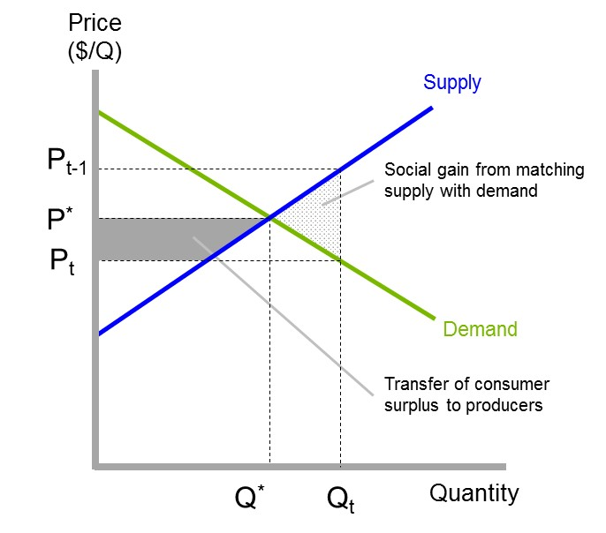

Adapted from Freebairn (1976a)

Freebairn demonstrated that consumers and producers generally share the benefits of using forecasts to improve the efficiency of resource allocation by markets. In figure 4 producers at the start of the season expect the price of a commodity to be Pt-1, and so aim to produce quantity Qt. However, at the time of marketing consumers are only willing to pay price Pt for this volume of production. By helping market participants identify the market-clearing price and quantity P*and Q*, forecasts result in a net social gain and rebalance the distribution of economic surplus between consumers and producers.

### Targeting forecasts to the decisions they support

A timeless consequence of Freebairn’s analysis is that improving the economic value of forecasts depends critically on understanding who uses them and what they use them for. Freebairn’s (1975, 1978) characterisation of the potential users of agricultural commodity forecasts expanded on the analysis of Taylor (1924). Freebairn defined the goal of forecasting as: ‘to provide decision makers with information to assist them form estimates of future market outcomes’ (p. 294). He reasoned that the atomistic nature of farm businesses meant that farmers were likely to find price forecasts more useful than forecasts of aggregate industry production. Production forecasts were only likely to be of interest ‘if they [decision makers, including farmers] have in mind a demand relationship for transferring quantity to price’ (p. 294).

Freebairn noted a general lack of research into the end use of forecasts by decision-makers, but inferred much about their potential use from an understanding of decision-making processes along agricultural value chains. Farmers require short-term product price forecasts to make production and marketing decisions, and longer-term price forecasts to make investments in long-lived assets such as machinery and land (Freebairn 1978). Decisions to change enterprise mix require forecasts of relative commodity prices, while risk management requires forecasts of price distributions and information on the reliability of forecasts. In contrast, the commercial success of input suppliers, processors and traders depends more on forecasts of quantity and input prices. Forecasts can also help decision-makers understand the future state of an industry given alternative policy scenarios.

Prescient of future concerns, Freebairn (1978) recognised that the use and value of forecasts depends partly on how well their dissemination is tailored to the communication and learning preferences of different users. The diversity of agricultural industries creates an opportunity to increase the value of forecasts by tailoring them and their associated dissemination strategies to diverse operating conditions, attitudes to risk and preferred methods of receiving information. Miller and Harris (1972) had earlier argued that forecasting of demand, supply and price was not an end in itself, but rather a means of improving decision-makers’ understanding of how markets work. Freebairn recognised a spectrum of dissemination strategies that matched the sophistication of users. Agricultural forecasts could be tailored to support specific decisions by knowledgeable users, and more general forecasts could assist less-experienced decision-makers to learn about markets. He speculated that the public provision of detailed forecasts was a transient educative phase for individual decision-makers that would no longer be required once they gained the skills necessary to gather information and form their own view of future markets.

### Equity value of forecasts

A similar conceptual model to that developed by Freebairn can be used to understand the value of public sector forecasting in overcoming the market power that information imbalances can give traders over farmers and consumers. A market with a sole buyer—or group of buyers with significant market power—is known as a monopsony (Robinson 1933, Weimer & Vining 2015). In Figure 5, a monopsony buyer of grain has a strong incentive to maximise profit by setting the price paid to farmers at PS. At this price, the marginal revenue earned by on-selling each tonne of grain equals the marginal cost of buying it from farmers. In a competitive market, farmers would receive a price of P^ as buyers compete until the marginal revenue is equal to the average price paid to farmers.

Figure 5 The economic value of using forecasts to prevent monopsony pricing

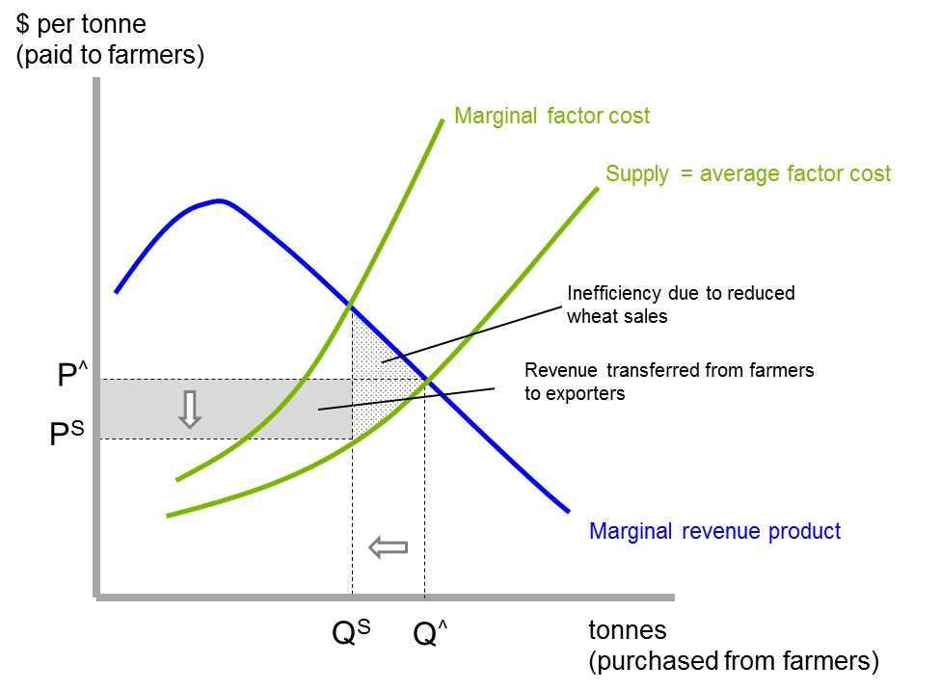

Adapted from Hirshleifer (1988).

Monopsony pricing has a detrimental effect on the social good by restricting how much grain is produced and made available to consumers (QS rather than Q^ in Figure 5). It also results in a transfer of revenue from farmers to buyers. Part of the social cost of monopsony is that this transfer is often dissipated through cost padding - incurring unnecessary expenses such as excessive executive salaries and travel. Cost padding undermines the social good because excess profit accrues to a small number of people in ways that do not reflect their productivity.

Public sector forecasting has no direct influence on the structural causes of monopsony that result in market power. Other policy instruments are needed to address these (Weimer & Vining 2015). Forecasting can, however, destabilise attempts by buyers to depress farmgate prices in situations where market power arises from imbalances in market information. If farmers know what price consumers are willing to pay, and understand the costs of processing and transport along the value chain, they can make better inferences about the share of retail prices they should be receiving. Economic theory and reviews of competition policy show that transparent markets often approach competitive outcomes regardless of their structure (Harper, Anderson, McCluskey, & O’Bryan 2015; Weimer & Vining 2015).

### **Economic** value of planned policy

Forecasting that improves government policy also provides economic benefits to society in ways that can be demonstrated using simple economic models. Governments need to design programs far in advance of their outcomes being known, and forecasts can reduce uncertainty and help adapt policy settings to changing conditions. Anticipating future conditions helps to increase the choice of flexible and low cost policy options available to governments and helps to avoid options with potentially adverse or irreversible consequences.

In Figure 6, the marginal cost of unplanned responses (MCU) is likely to start high and rise rapidly within a constrained set of policy options (MCU asymptotes). The costs of responding to change start high because a failure to plan ahead reduces the range of viable policy options. Those options that remain available are likely to be high cost, and there is no time to evaluate whether they are likely to have adverse or irreversible consequences.

Figure 6 The economics of using forecasts to plan policy responses

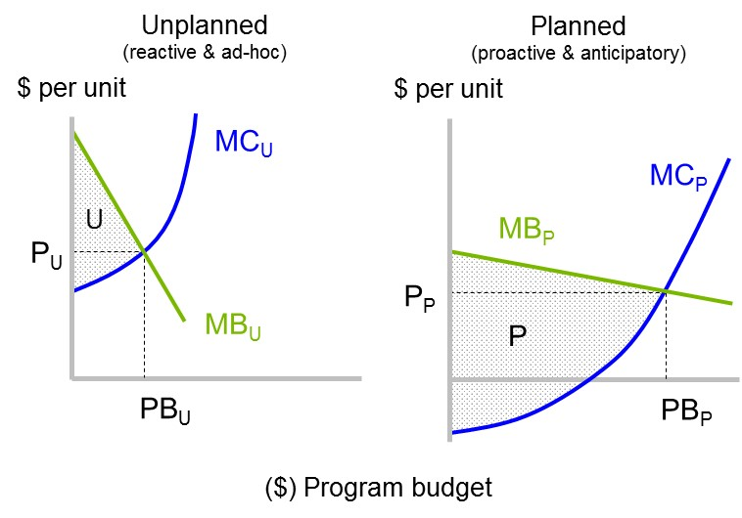

Adapted from Nelson, Byron, and Stafford-Smith (2011).

In contrast, the marginal cost of planned policy responses (MCp) starts low because governments have time to identify no-regret options that provide other benefits (marginal cost starts negative). Adequate time for planning and innovation means that the costs of responding to change rise slowly across a broad set of policy options and governments are much less likely to run out of viable options (MCp doesnot reach a vertical asymptote).

The marginal benefits of unplanned and planned policy responses also differ significantly. The benefits of unplanned policy responses start high but diminish rapidly (MBU in Figure 6 has a steep downward slope). Short-term crisis management dictates immediate responses regardless of cost, but the benefits of greater effort diminish and the total benefits are small (MBU is close to the y axis). In contrast, the marginal benefits of planned policy responses start low but diminish gradually because they have long-lasting positive impacts (MBP has a shallow slope). In this scenario, there is time to evaluate and avoid adverse or irreversible impacts.

The result is that planned policy responses generate much greater economic benefits than unplanned policy responses. The shaded areas P and U in Figure 6 show the net social benefits of each type of policy response. If forecasts are solely responsible for planned policy responses, their maximum economic value is the difference between the two (P minus U). This economic logic may help governments balance the short-term political benefits of unplanned policy responses against the longer-lasting benefits of planned responses.

### Economic arguments for and against public sector forecasting

There are some notable differences between the policy argument used to establish the BAE, and what economists at the time were thinking (Figure 7). Economists were equivocal about whether and to what extent these services should have been exclusively funded by governments. There was no ringing endorsement for exclusive public provision, but rather a recognition that public funding might be a pragmatic and transient policy response to free rider and attribution problems arising from the atomistic organisation of farmers. Governments needed forecasts for policy development anyway, and the non-rival nature of this information meant that the cost of providing it to others was probably outweighed by the societal benefits. These benefits accrued to both consumers and producers through the efficient or smooth operation of markets.

Figure 7 Economic arguments for establishing public sector forecasting

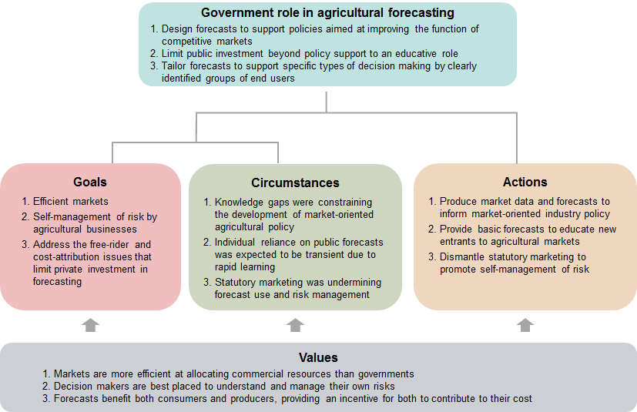

This economic logic is very different to the policy arguments used to establish the BAE. The economics of asymmetric information and potential abuse of market power received only passing allusions in the economic thinking of the time, and market imperfections were qualified as ‘alleged’ (Freebairn 1978, p. 306). In contrast to the policy goals of creating rural employment and empowering farmers, the value of forecasts was framed in terms of the economic benefits to producers and consumers of improving the efficient operation of markets. The centralised nature of the BAE model contrasted sharply with the degree to which economists emphasised the potential value of tailoring forecast information to the needs of specific decision-makers. The institutional focus in the BAE on delivering increasingly complex forecasts produced by expert-driven models was at odds with the educative goal of providing simpler forecasts to empower decision-makers to develop and apply their own understanding of agricultural markets.

## Global influences on public sector forecasting

Since public investment in agricultural forecasting peaked in the 1980s, an array of global influences has changed the policy arguments shaping the public provision of forecasting services for Australian agriculture. Documenting these changes is a crucial first step towards adapting public sector forecasting services to the policy and decision-making needs of the 21st century.

### Structural economic change

From the peak forecasting effort of the 1980s, funding for the BAE and then ABARE(S) declined dramatically from the 1990s onwards. From a peak of 65 staff in the BAE producing agricultural forecasts in 1981–82, the agricultural economics section of ABARE contracted to 30 staff in 1996, with perhaps only half of these involved in producing forecasts (Figure 2). Toward the end of the 1990s the number of staff working on commodity forecasts had fallen to between 9 and 12, stabilising at around 7 to 9 analysts from 2010 onwards. The resources allocated to public sector forecasting in agriculture has also declined in the United States. In 1983 the USDA’s budget was cut by 20 per cent, with significant further cuts in 2011 and 2013 (Xie et al. 2016).

To some extent, these reductions in resourcing reflect whole-of-government improvements in public sector efficiency, partly driven by improvements in technology. However, they also reflect a rebalancing of public sector resources as the Australian economy has diversified and agriculture has ceded its dominant share of the economy to other sectors, particularly the mining and services sectors. The mining boom of the mid 1960s began a long and slow downward trend in agriculture’s share of the Australian economy. Although the agricultural sector has continued to expand its output and contribution to exports, the mining boom reduced agriculture’s share of economic output from 11.5 per cent in 1965 to 6.5 per cent in 1975 (ABS 2018a). Further development of the mining and services sectors continued to reduce agriculture’s share of gross domestic product to below 5 per cent in the 1980s and below 3 per cent in the 1990s. By the March quarter of 2018 it was consistently below 2 per cent (ABS 2018a).

### ICT revolution

The rapid evolution of information and communication technology (ICT) and personal computers since the late 1980s has made the data, analysis and dissemination components of forecasting much more efficient, and has dramatically reduced the number of staff needed to produce and continually refine forecasting services. This has meant that reductions in resources have not always been matched by reductions in the coverage of forecasts and their quality has generally improved both in Australia and internationally. USDA forecasts of production, consumption and price for corn, soybeans and wheat became accurate to within around plus or minus 5 per cent over the period 1987–88 to 2009–10 (Isengildina-Massa, Karali & Irwin 2013), from around plus or minus 10 per cent in the mid 1970s (Freebairn 1978). Between 2012 and 2016 the accuracy of ABARES September forecasts of wheat, beef, cheese, cotton and wool prices for the current financial year averaged just under 4 per cent (author’s analysis), from a general forecast accuracy of 10 to 20 per cent in the mid 1970s (Freebairn 1978). Agricultural forecasts around the world have become increasingly accurate except during periods of significant structural change (Isengildina-Massa, Karali & Irwin 2013).

The development of ICT has made collating data and producing forecasts much easier, and enabled individual analysts to perform roles that had previously required large teams. These technological changes occurred independently of, and prior to, more general falls in public sector resourcing for agricultural policy. Figure 2 shows that the number of staff committed to agricultural forecasting fell well before total staff numbers in ABARE(S) began to decline. Teams of 3 to 5 staff working on a single commodity in the early 1990s were gradually reduced to individual analysts. Eventually some analysts were able to produce forecasts for more than one commodity or groups of related commodities. In early 2018 the quarterly cycle of forecasting and the format of publications had changed little since the early 1990s, requiring a minimum of 8 analysts and a section manager to operate in this form.

Pressures to increase efficiency have led to the adoption of streamlined but highly regimented and centralised processes for producing forecasts within ABARES, which into 2018 continued to rely as heavily on paper-based publication as they did in 1945. While reducing costs, a high degree of standardisation and centralisation has tended to work against the tailoring of forecasts for specific audiences. Standardised forecast coverage inevitably results in analysts committing more time and resources to the commodities with the greatest data challenges, rather than to those of most value to forecast users. Centralised and inflexible information technologies have constrained the development of interactive websites that would assist decision-makers to create their own forecasts using ABARES data and analyses.

### Microeconomic reform

One of the reasons why agricultural forecasting has become more efficient and required less resources is that world agricultural markets have become more stable and predictable. This is largely a result of global microeconomic reform. Floating exchange rates and trade liberalisation have reduced the volatility of agricultural commodity prices (Anderson 2014; Gropp, Hallam & Manion 2000). Trade liberalisation has improved market access and reduced trade protection on farm inputs, undermining one of the central arguments used to provide farmers with countervailing market power through statutory marketing (IC 1991). Trade practices and anti-dumping legislation were developed to protect the operation of competitive markets across the economy, which reduced the need for sector-specific measures. State-owned enterprises including statutory marketing boards came under intense scrutiny for cost padding and lack of innovation, as well as their potential to crowd out services that could be better provided by the private sector.

Competition policy reform has resulted in a near total dismantling of statutory marketing and has greatly reduced other forms of intervention by governments in agricultural marketing (PC 2016). Of the 65 statutory marketing boards that existed in 1980, only the statutory marketing of rice in New South Wales remains in 2018.

Microeconomic reform has had significant implications for public sector forecasting in Australian agriculture. The abolition of statutory marketing reduced pressure on ABARES to produce detailed forecasts for many of the minor commodities previously protected by statutory marketing. It has also restored responsibility for marketing to individual farm business owners and exposed them more directly to international market forces. Reinstating self-reliance for marketing has increased the demand for forecasting services and farm business owners are free to invest in tailored services to the extent that they expect to gain commercially from them.

### Globalisation and vertically integrated value chains

By the mid 1990s observers like Klein and Kerr (1995) had already noted that globalisation was fundamentally altering relationships between farmers and other participants along vertically integrated value chains. Information flows along value chains provide an opportunity to rethink relationships that were previously viewed as adversarial. Agricultural producers, processors and retailers are increasingly co-dependent because their ability to improve productivity and remain competitive depends critically on the productivity and competitiveness of other businesses along the value chain (PC 2016). Forecasting now plays a lesser role in addressing market power within vertically integrated value chains but may continue to be required by those operating independently. Vertical integration also means that forecasting services can no longer focus exclusively on farmgate prices but must also consider other influences along value chains.

The microeconomic reforms that transformed the Australian economy from the 1980s onwards were partly driven by the panoply of forces collectively referred to as globalisation (Friedman 2005). The most important of these for agricultural forecasting was the effect that ICT had on lowering ‘the cost of coordinating complex processes across great distances’ (Baldwin 2016, p. 109). In the same way that the invention of the steam and internal combustion engines during the industrial revolution allowed the rapid and low cost flow of goods, the invention of the internet allowed the rapid and low cost flow of information and ideas (Baldwin 2016; Mann 2006). Together the industrial and ICT phases of globalisation have enabled an ‘unbundling’ of the different stages of production along increasingly globalised value chains (Baldwin 2016, p. 109). Agricultural value chains can now be highly integrated in the flow of information on demand, supply and price (explicit knowledge about agricultural markets) regardless of the distance that separates the various stages of production, transport, processing and marketing (den Hertog 2000). The rapid evolution of these information flows created demand for new services in which experts provide advice to farm and other businesses on how to make the best use of these new market services (tacit know-how) (Klerkx & Leeuwis 2008).

The ICT revolution has dramatically reduced the transaction costs associated with finding new buyers and negotiating terms of sale. The result has been a general decline in the use of spot markets and associated market information by farmers, and an increase in direct sales via contracts—especially in livestock industries (Brorsen & Irwin 1994; Koontz & Ward 2011; Parcell & Tonsor 2013). This means that Australian farmers are much less atomistic than they used to be—or at least many are choosing not to be atomistic by participating in vertically integrated value chains.

A policy challenge arising from vertical integration is that the flow of information along value chains is difficult to observe from outside them. Observers outside vertically integrated value chains note a decline in the use of spot markets, followed by a decline in the provision of market information associated with them. This has consistently been interpreted by regulators in Australia and the United States as a market failure requiring mandatory industry reporting (ACCC 2017a, b). However, mandatory reporting can add to transaction costs and further discourage participation in spot markets (Koontz & Ward 2011). In these circumstances, public provision of market information may be the most practical and cost-effective strategy for overcoming the disincentive effects of mandatory reporting.

### Globalisation and the democratisation of expertise

The recent unbundling of knowledge following the earlier unbundling of production processes means that the effects of globalisation and the ICT revolution have not just been technical and have not been confined to changing relationships within agricultural value chains. Globalisation has fundamentally changed social relationships between forecasters and the users of forecasts.

Willis and Tranter (2006) argued that the ICT revolution—and rising levels of education—are associated in western democracies with a meritocratic trajectory towards social stratification based on scientific and technical knowledge rather than the traditional divisions of class, gender and race. This has contributed to a general democratisation of expertise, driven by a growing expectation among members of diverse publics that experts and policymakers should listen to them and allow them to participate in decisions affecting them (first documented by Arnstein (1969)). This was followed much later by an equivalent realisation by small minorities in scientific and policy communities from medicine to climate change that educated citizens have vital knowledge to contribute to the evidence base used to make policy and other decisions (Burgess 2014; Dietz, Ostrom & Stern 2003; Jasanoff et al. 1998). This has changed the role of experts—including forecasters—from independently generating and disseminating knowledge (the loading dock model of knowledge transfer) to facilitating the co-production of knowledge with end users into forms that support decision-making (Cash, Borck & Patt 2006; Dilling & Lemos 2011; Sulaiman et al. 2012).

Forecasting is a form of agricultural extension—the public provision of expert knowledge to farmers. The democratisation of expertise has been prominently expressed in agriculture via a dramatic change in the way agricultural extension is conceptualised and implemented. In the decades following World War II, agricultural extension was conceptualised as a linear transfer of technology (ToT) in which university-trained government experts provided advice to poorly educated farmers (Chambers & Ghildyal 1985). This led to systems of agricultural and natural resource governance that framed problems and created solutions in ways that reflected the values and priorities of experts, and which could therefore sometimes poorly reflect the values and priorities of farmers (Chambers & Ghildyal 1985). It also tended to ignore the grounded knowledge that local participants could contribute to defining problems and tailoring solutions (Dietz, Ostrom & Stern 2003). Brorsen and Irwin (1994) have argued that the same fate befell research into the value of agricultural price forecasting because much of it has been driven by academic pressure to publish rather than a desire to improve outcomes for decision-makers.

The democratisation of expertise via globalisation has led to the emergence of more participatory approaches to agricultural extension from the 1970s onwards (Sulaiman et al. 2012). These create mechanisms for the formal scientific and economic knowledge of experts to be combined with the grounded local knowledge of farmers to define problems and generate solutions (Chambers 1994).

In Australia, this global redefinition of agricultural extension has changed the way experts such as forecasters interact with farmers and other potential users of their advice, with significant implications for the way public sector forecasting in agriculture is done. Extension agents and other advisers are no longer experts in narrow technical fields, but expert facilitators and knowledge brokers performing a range of intermediation (brokering) tasks that integrate the formal knowledge of researchers with the grounded local knowledge of farmers (Marsh & Pannell 2000; Sulaiman et al. 2012). As a result, expert-centric and classroom-style training has given way to learning groups in which experts and farmers share knowledge and experiences (Kilpatrick & Rosenblatt 1998). These learning groups are increasingly provided by fee-for-service consultants, who tailor the learning process through which agricultural forecasts are adopted to the local operating conditions shared by participants (Llewellyn 2007). A transition from supply (expert-driven) push to demand (user-driven) pull for information like forecasts has given farmers much more direct control over what information is delivered to them and how it is delivered (Marsh & Pannell 2000).

### Value of foresighting

Surveys exploring forecast adoption since the ICT revolution of the 1990s have tended to find that farmers’ willingness to pay for forecasts is low. This low willingness to pay has been attributed by forecast providers to a free rider response bias (CFARE 2013). More independent observers allude to relevance problems caused by a mismatch between the mental models of price formation conceptualised by forecasters and those actually used by farmers (Brorsen & Irwin 1994).

However, a more fundamental explanation for the low willingness to pay is that the value of forecasts to farmers may be low, at least in industrialised agricultural sectors like those of Australia and the United States. Agricultural response functions are notoriously unresponsive to small changes in inputs, resulting in a wide range of input levels that produce very little change in output (Pannell 2006). This means that a wide range of fertiliser and other farm input levels can be used to produce similar pasture or crop yields. When this is the case, the on-farm benefit of investing in detailed forecasts to refine farm management is likely to be small. Detailed and more expensive forecasts are unlikely to provide better returns than more general, low cost forecasts. It also means that forecasts are only likely to generate significant benefits if they facilitate significant step changes in the relationship between agricultural inputs and outputs. For example, a forecast of this kind might provide evidence that an alternative crop or production method is likely to double profitability. Foresighting of uncertain but potentially profitable step-wise changes in markets is likely to have a much greater impact on decision-making. Forecasts that inform incremental refinements to existing management strategies are likely to be of low value.

Foresighting can also be used to overcome some of the inherent limitations of forecasting. Forecasting can constrain perceptions of the future to incremental, linear extrapolations of current technologies and markets, overlooking the agency that individuals and societies have to identify and work towards preferred futures (Cuhls 2003). It can encourage a narrow focus on predicting and managing easily quantifiable forms of short-term risk, and cause more fundamental changes to be overlooked. A stylised example in agriculture would be confining the use of forecasts to optimise inputs or industry policy for a commodity like tobacco or sugar, without considering longer-term prospects for demand with rising health awareness. These less quantifiable sources of uncertainty mean that decision-making is often more about creating new future options than it is about resolving the uncertainty surrounding a known set of current choices (Luehrman 1998). In practical terms this means crafting and pursuing new business strategies that both adapt to and influence future changes in agricultural markets.

Foresighting has emerged as a complementary approach for overcoming some of the limitations of forecasting by exploring the significantly different possible scenarios for the future that arise from deep uncertainty (Cuhls 2003). Foresighting is inherently more participatory and less expert-centric than forecasting because it emphasises working collaboratively towards preferred futures. It balances the expert framing of problems and solutions with the priorities and grounded knowledge of stakeholders (Cuhls 2003). It also addresses counterfactual scenarios by actively seeking external knowledge of deeply uncertain factors that those currently involved are unaware of. For agriculture, this is likely to mean greater interaction between expert forecasters and forecast users to frame forecasts of quantifiable risk within foresighting scenarios that guide longer-term adaptation to deeper structural change. For example, longer-term forecasts should increasingly be nested within scenarios that consider the likely impacts of climate change on Australia’s future international competitiveness.

### Increasing sophistication of forecast users

The demand for forecasts also depends on the evolving expertise of farmers and other forecast users. As Australian farmers become more sophisticated and self-reliant, the demand for forecasts of markets in which they have become expert is likely to fall. At the same time, the demand for foresighting scenarios supporting new investment in unfamiliar markets is likely to increase. For most agriculture-related inputs and commodities, farmers can learn about price and quality relationships from repeated and low cost transactions, overcoming an initial lack of information at reasonable cost. The search costs of information gathering are lowest when goods and services are of consistent quality (so that fewer transactions are needed to establish this) and when transactions are frequent (Weimer & Vining 2015). Under these conditions, buyers and sellers can build a reputation for fair dealing that overcomes the deep distrust that continues to motivate the public provision of agricultural forecasting services into the 21st century. This process of learning and trust building complements relationships established through vertically integrated value chains and is supported by the enforcement of competition laws that deal with infrequent—but harmful—abuses of market power.

Experience also helps decision-makers overcome biases in decision-making, reducing the need for public sector forecasts to do this. The development of prospect theory in the 1970s showed that decision-making is driven more by potential changes in welfare than the resulting levels of welfare, and that losses of welfare are valued more highly than gains (Kahneman & Tversky 1984). This means that agricultural decision-makers contemplating a change in management tend to be biased towards maintaining the status quo because they give more weight to potential losses than to potential gains. In agriculture this reinforces bias towards the status quo created by flat response functions. It also means that decision-makers can make inconsistent choices when the same decision problem is framed as a potential gain rather than as a potential foregone loss (and vice versa). These biases and inconsistencies are reduced through experience, which means that the value of forecasts designed to correct them depends heavily on the sophistication of the intended audience. This means that forecasts are likely to be of most value to new farmers or experienced farmers contemplating investments in unfamiliar markets.

Australian farmers are becoming better educated and more sophisticated decision-makers. The percentage of farmers with a university degree increased from 2 per cent in 1984, to 12 per cent in 2017. Over the same period the number of farmers with no post-school qualifications fell from 73 per cent to 50 per cent (ABS 2018b). The descendants of the soldier settlers who were the early focus of post-war agriculture policy have since become some of Australia’s most experienced agricultural decision-makers. Through repeated transactions, they have had the opportunity to learn how agricultural markets work and to establish trust relationships with buyers in those markets. They have also had the opportunity to become networked in their industries in ways that enabled them to compare and verify information provided to them by traders and supermarkets. As they have gained industry experience and become networked and better educated, they have also become much less prone to framing biases or being taken advantage of during sales negotiations. They are now only likely to consult forecasts for transactions in markets that they don’t frequently participate in, or to guide investments in unfamiliar markets. This shift in demand from incremental forecasts of existing activities to scenarios of new activities reinforces the demand for foresighting scenarios to complement forecasts.

### Nuanced arguments for public provision

Changes in our economic understanding of the public good characteristics of information have nuanced the case for public sector forecasting for Australian agriculture. In particular, we now understand that the data, analysis and dissemination components of forecasts differ in their public good characteristics and in the ability of the private sector to provide them. The collection, processing and analysis of data has always been the most fundamental component of forecasting systems because all credible forecasting methods begin with some understanding of trends in production, consumption and prices (Allen 1994; Freebairn 1975; Longmire & Watts 1981). Data are the least rival component of forecasting systems because they can often be used multiple times and for multiple purposes without reducing their value to additional users. However, the cost and complexity of collection and processing—and important but surmountable privacy concerns—can be used to restrict access to data, forgoing the potential social benefits of its wider use (data can be excludable).

In contrast to data, the analysis that becomes a published forecast is often more targeted to a specific application and audience. However, although forecasts can be tailored to provide specific decision-makers with a first-user advantage, this advantage is often transient because the nature of forecasts tends to be revealed once decision-makers act on them. This means that forecasts can be rival but only partly excludable. The degree to which forecasts are excludable depends on the dissemination systems used to communicate forecasts. Internet-based technologies mean that forecasts can be communicated to specific user groups or broadcast globally.

The data component of forecast systems is the least rival and the degree to which users can be excluded from accessing data provides a strong argument for public provision (CFARE 2013). The public good characteristics of forecasts and their dissemination pathways can vary with operating context and intended use. There is a strong case for the public provision of general forecasts produced to educate new entrants and interested observers about the operation of markets. This use of forecasts is highly non-rival and produces diffuse public benefits by improving the stability of markets and addressing potential information imbalances that could lead to the abuse of market power (Freebairn 1978). In contrast, there is a strong case for the private provision of forecasts tailored exclusively to commercial applications.

The ICT revolution has facilitated the tailoring of agricultural information services to commercial applications and they have gradually lost the public good characteristics that once justified public provision (Marsh & Pannell 2000). This has led to a more nuanced understanding of the appropriate provision of different types of agricultural information by the public and private sectors (Picciotto & Anderson 1997; Umali-Deininger 1997). Information associated with or embedded in market goods is generally thought to be most efficiently provided by the private sector. Information that is either rival but not excludable (common property resources) or vice versa (club or toll goods) is most efficiently co-produced by governments creating ‘enabling environments for private and voluntary action’ rather than directly providing these services (Picciotto & Anderson 1997, p. 254). The result is that very few types of agricultural information are pure public goods that require exclusive public provision—a conclusion that reinforces the earlier views of Freebairn (1978).

In a world connected by the internet the data, analysis and dissemination components of forecasting systems are increasingly being provided by a mix of private and public institutions. Ready access to easy-to-use data and analytical tools has reduced demand for final forecasts and increased demand for data products that sophisticated decision-makers can recombine to produce their own forecasts. The data and generic analyses produced by public sector forecasters have routinely been used by private sector forecasters to tailor forecasts for specific industries and regions, especially since the spread of internet in the mid 1990s. A growing problem for public forecasting agencies like ABARES is that forecast users do not realise the extent to which private sector forecasts depend on public content. In the only study of its kind, Just and Zilberman (2002) found that 14 per cent of the agricultural information used by four groups of US farmers in different industries and regions came directly from public sources, but that this doubled to 28 per cent when the public content of private information sources was considered. For intermediaries such as brokers, extension agents and consultants, direct use of public information was 32 per cent, but this increased to 58 per cent when use via private sources was counted.

### Policy demand into the 21st century

Policy demand for agricultural forecasts remains strong into the 21st century. Although the emphasis on industries and issues changes constantly, the basic policy applications of ABARES forecasts have changed little since 1945. ABARES continues to respond to daily requests from the parliamentary and electorate offices of the Minister for Agriculture and Water Resources for information on agricultural markets. A range of data products are provided to policy colleagues throughout the Department of Agriculture and Water Resources and other departments including Treasury and the Department of Foreign Affairs and Trade. Data and analyses tailored to specific questions are provided to these and other departments on a frequency that varies from daily to weekly. Forecasts and related information on trends in agricultural markets are used to respond to stakeholder concerns and form policy responses to emerging issues. Many similar data requests from the same sources are responded to over time, indicating an opportunity to standardise information products and create interactive data tools that enable policy users to easily find and apply the information they need.

ABARES forecasts are also used more strategically to anticipate policy priorities, shape policy responses to emerging issues and evaluate government programs. New government programs are always designed ahead of their known impacts, and ABARES forecasts and related information are used to understand and support modelling of the likely range of future scenarios for agricultural markets in which they will be implemented. Policy development often concerns future markets and industry structures that do not yet exist and ABARES forecasts are often used to construct policy narratives that explore a range of scenarios, many of which are beyond the capability of existing models. Examples encountered during 2017 and 2018 include the potential impacts on the dairy industry of changes in the processing sector and the potential impact of improved market access on trade.

ABARES forecasts are used to administer government programs, often in situations where independence from industry and markets is essential. For example, ABARES provides estimates of the gross value of production for a diverse array of agricultural industries that are used to calculate research and development levies co-funded by the Australian Government. Estimating the gross value of production involves forecasting to produce quarterly estimates for the current financial year 6 to 9 months before data from the Australian Bureau of Statistics becomes available. ABARES also works with the Australian Bureau of Statistics and other agencies to maintain the integrity of Australia’s agricultural statistics. This is becoming more challenging as funding declines in line with agriculture’s share of the economy.

ABARES forecasts continue to be used by central government agencies for macroeconomic forecasting. When forecasting gross domestic product and Australia’s balance of payments, the Australian Treasury forecasts economic activity across major sectors of the economy. Treasury’s forecasts of agricultural production and rural exports are based on ABARES forecasts and adjusted using on Treasury’s exchange rate assumptions. Treasury’s forecasts of gross domestic product and Australia’s balance of payments set the economic trajectory for the Australian Government’s fiscal policy outlook.

### Policy arguments into the 21st century

As was the case in 1945, the public provision of forecasting services for Australian agriculture is underpinned by a strong recognition that policy should be evidence based. Beyond this, global influences have dramatically changed the public policy arguments for providing public sector forecasting services into the 21st century (Figure 8).

The role of governments in agriculture has changed most dramatically, emphasising the self-management of market risk by participants through vertically integrated value chains, and working gradually toward a goal of limiting government intervention to economy-wide measures that protect the efficient operation of markets. The global democratisation of expertise and growing sophistication of forecast users has forever changed their relationship with forecasters. This requires the development of new approaches to forecasting that recognise and incorporate the expertise of users, complemented by the construction of foresighting scenarios that draw on diverse types of expertise and multiple perspectives. The ICT revolution has dramatically increased the ease with which forecasts can be tailored to commercial applications, while competition policy reform has reinforced early economic sentiments that forecasting services should be paid for by those who benefit from them.

Figure 8 Policy arguments for providing public sector forecasting into the 21st century

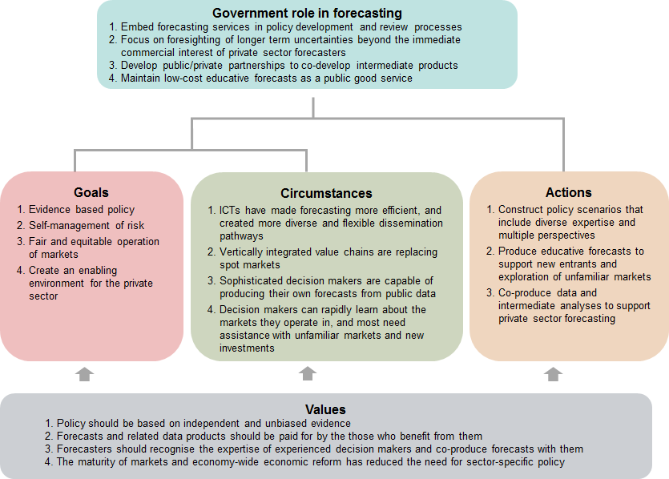

## Conclusions

Profound changes in the operating environment of Australian agriculture have significant consequences for the future provision of public sector forecasting services. Perhaps most importantly, those managing public sector forecasting services in ABARES (including the author) should focus on their future value. The technological efficiencies of the ICT revolution have enabled forecast coverage to be maintained and quality to improve despite a significant contraction of resources. Rather than referencing past goals and levels of resourcing, analysis of appropriate future levels of resourcing should focus on the future benefits that agricultural forecasting services can provide to government, industry and consumers.

Public sector forecasting services should empower forecast users to form their own view of future markets. The growing sophistication of forecast users and explosion of interactive web-based technologies means that public sector forecasting services should focus on providing intermediate data and analyses that users can recombine to produce their own forecasts. In government, this would build the capacity of policy advisers to tailor advice in response to emerging issues. In the private sector, this would boost the value of public good data and analyses that consultants and others use to tailor commercial forecasts.

Public sector forecasting services should become more participatory. The growing expertise of users increases their independence from expert forecasters and creates a store of knowledge that forecasters should draw on. This will require ABARES to evolve from an expert-centric institution to one via which expert forecasters engage meaningfully with diverse groups of forecast users. This is likely to involve greater use of social media and interactive web-technologies that support innovative approaches to consensus forming. Participatory methods such as focus groups, surveys and reference panels could be used to include forecast users in the design and development of forecasts.

Public sector forecasting services should produce forecasts that explain and help to inform the creation of value along vertically integrated value chains. This will make forecasting more relevant to the evolving business models of the 21st century and improve the understanding and acceptance of these business models by outside observers and regulators.

Public sector forecasting services should evolve a complementary focus on foresighting, using scenarios built through consultation that draw on diverse types of expertise and multiple perspectives. Scenario analysis that anticipates the future vulnerability of agricultural industries would support proactive policy design, particularly for significant and uncertain step-wise change that is difficult for markets and industries to assess and adapt to. It would also support the investigation of significant new investments and forays into unfamiliar markets by increasingly sophisticated forecast users.

## References

ABS 2018a, *6227.0 Education and Work, Australia*, Australian Bureau of Statistics, Canberra.

ABS 2018b, *Australian National Accounts: National Income, Expenditure and Product*, cat. no. 5206.0, Australian Bureau of Statistics, Canberra.

ACCC 2017a, *Cattle and beef market study - Final report*, Australian Competition and Consumer Commission, Canberra.

ACCC 2017b, Dairy inquiry interim report, Australian Competition and Consumer Commission, Canberra.

Allen, P 1994, ‘Economic forecasting in agriculture’, *International Journal of Forecasting,* vol. 10, no. 1, pp. 81–135.

Anderson, K 2014, ‘The intersection of trade policy, price volatility, and food security’, *Annual Review of Resource Economics,* vol. 6, no. 1, pp. 513–532.

Arnstein, S 1969, A ladder of citizen participation, *Journal of the American Institute of planners,* vol. 35, no. 4, pp. 216–224.

Baldwin, R 2016, *The Great Convergence*, Harvard University Press, Cambridge, Massachusetts.

Bozeman, B & Sarewitz, D 2011, ‘Public value mapping and science policy evaluation’, *Minerva,* vol. 49, no. 1, pp. 1–23.

Brorsen, B & Irwin, S 1994, ‘Research on Price Forecasting and Marketing Strategies: Improving Our Relevance’, paper presented at NCR-134 Conference: Applied Commodity Price Analysis, Forecasting, and Market Risk Management, Chicago, Illinois, pp. 1–14.

Bunn, D & Wright, G 1991, ‘Interaction of judgemental and statistical forecasting methods: issues & analysis’, *Management science,* vol. 37, no. 5, pp. 501–518.

Bureau of Agricultural Economics 1950, The functions of the Bureau of Agricultural Economics, Canberra.

Bureau of Agricultural Economics 1962, ‘Organisation and functions of the Bureau of Agricultural Economics’, Canberra.

Burgess, M 2014, ‘From ‘trust us’ to participatory governance: Deliberative publics and science policy’, *Public understanding of science,* vol. 23, no. 1, pp. 48–52.

Cash, D, Borck, J & Patt, A 2006, ‘Countering the loading-dock approach to linking science and decision making: comparative analysis of El Niño/Southern Oscillation (ENSO) forecasting systems’, *Science, technology, & human values,* vol. 31, no. 4, pp. 465–494.

CFARE 2013, *From farm income to food consumption: valuing USDA data products*, Council on Food, Agricultural and Resource Economics, Washington DC.

Chambers, R 1994, ‘The origins and practice of participatory rural appraisal’, *World development,* vol. 22, no. 7, pp. 953–969.

Chambers, R & Ghildyal, B 1985, ‘Agricultural research for resource-poor farmers: the farmer-first-and-last model’, *Agricultural administration,* vol. 20, no. 1, pp. 1–30.

CIE 2013, *Contribution of live exports to the Australian Wool Industry*, consulting report for Australian Wool Innovation, Centre for International Economics, Canberra.

Copland, D & Janes, C 1938, *Australian marketing problems: a book of documents 1932-1937,* Angus & Robertson, Sydney.

Crawford, J 1945, *Paper by J.G. Crawford on establishment of the Bureau of Agricultural Economics*, Cabinet Submission, Ministry of Post-War Reconstruction, Division of Agricultural Economics, Canberra.

Cuhls, K 2003, ‘From forecasting to foresight processes—new participative foresight activities in Germany’, *Journal of Forecasting,* vol. 22, no. 2–3, pp. 93–111.

Davidson, BR 1981, *European farming in Australia: An economic history of Australian farming*, Elsevier, New York.

den Hertog, P 2000, ‘Knowledge-intensive business services as co-producers of innovation’, *International journal of innovation management,* vol. 4, no. 4, pp. 491–528.

Dewbre, J, Shaw, I, Corra, G & Harris, D 1985, *EMABA. Econometric Model of Australian Broadacre Agriculture*, Bureau of Agricultural Economics, Canberra.

Dietz, T, Ostrom, E & Stern, PC 2003, ‘The struggle to govern the commons’, *Science,* vol. 302, no. 5652, pp. 1907–1912.

Dilling, L & Lemos, M 2011, ‘Creating usable science: Opportunities and constraints for climate knowledge use and their implications for science policy’, *Global environmental change,* vol. 21, no. 2, pp. 680–689.

DPI 1982, *Annual Report 1981-82*, Department of Primary Industries, Canberra.

Ebling, WH 1939, ‘Why the government entered the field of crop reporting and forecasting’, *Journal of Farm Economics,* vol. 21, no. 4, pp. 718–734.

Fairclough, I & Fairclough, N 2012, *Political Discourse Analysis: A Method for Advanced Students*, Taylor & Francis.

Freebairn, J 1975, ‘Forecasting for Australian agriculture’, *Australian Journal of Agricultural and Resource Economics,* vol. 19, no. 3, pp. 154–174.

Freebairn, J 1976a, ‘The value and distribution of the benefits of commodity price outlook information’, *Economic Record,* vol. 52, no. 2, pp. 199–212.

Freebairn, J 1976b, ‘Welfare implications of more accurate rational forecast prices’, *Australian Journal of Agricultural Economics*, vol. 20, no. 2, pp. 92-102.

Freebairn, J 1978, ‘An evaluation of outlook information for Australian agricultural commodities’, *Review of Marketing and Agricultural Economics,* vol. 46, no. 3, pp. 295–314.

Friedman, T 2005, *The world is flat: A brief history of the globalized world in the 21st century*, Allen Lane, London.

Gropp, L, Hallam, T & Manion, V 2000, *Single-desk marketing: assessing the economic arguments*, Staff Research Paper, Productivity Commission, Canberra.

Harper, I, Anderson, P, McCluskey, S, & O’Bryan, M 2015. *Competition policy review - Final report*, Australian Government, Canberra.

Hirshleifer, J 1988, *Price theory and applications 4th edition*, Prentice Hall, Englewood Cliffs.

IC 1991, *Statutory marketing arrangements for primary products*, Industry Commission, Canberra.

Isengildina-Massa, O, Karali, B & Irwin, S 2013, ‘When do the USDA forecasters make mistakes?’, *Applied Economics,* vol. 45, no. 36, pp. 5086–5103.

Jasanoff, S, Wynne, B, Buttel, F, Charvolin, F, Edwards, P, Elzinga, A, Haas, P, Kwa, C, Lambright, W & Lynch, M 1998, ‘Science and decision making’, in S Rayner & E Malone (eds), *Human choice & climate change,* Battelle Press*,* Columbus, pp. 1–87.

Just, D & Zilberman, D 2002, *Information Systems in Agriculture*, ARE Update 6:1, Giannini Foundation of Agricultural Economics, San Francisco.

Kahneman, D & Tversky, A 1984, ‘Choices, values, and frames’, *American Psychologist,* vol. 39, no. 4, pp. 341–350.

Kerin, J 2017, *The way I saw it; the way it was: The making of national agricultural and natural resource management policy*, Analysis & Policy Observatory, Melbourne.

Kilpatrick, S & Rosenblatt, T 1998, ‘Information vs training: issues in farmer learning’, *The Journal of Agricultural Education and Extension,* vol. 5, no. 1, pp. 39–51.

Kingma, O, Longmire, J & Stoeckel, A 1980, ‘A review of three research programs in quantitative modelling in the Bureau of Agricultural Economics’, *Australian Journal of Agricultural Economics,* vol. 24, no. 3, pp. 224–247.

Klein, K & Kerr, W 1995, ‘The globalization of agriculture: A view from the farm gate’, *Canadian Journal of Agricultural Economics,* vol. 43, no. 4, pp. 551–563.

Klerkx, L & Leeuwis, C 2008, ‘Matching demand and supply in the agricultural knowledge infrastructure: Experiences with innovation intermediaries’, *Food policy,* vol. 33, no. 3, pp. 260–276.

Koontz, S & Ward, C 2011, ‘Livestock mandatory price reporting: A literature review and synthesis of related market information research’, *Journal of Agricultural & Food Industrial Organization,* vol. 9**,** no. 1**,** pp. 1-31.

Lewis, J 1961, ‘Organized marketing of agricultural products in Australia’, *Australian Journal of Agricultural and Resource Economics,* vol. 5, no. 1, pp. 1–8.

Lewis, J 1967, ‘Agricultural price policies’, in D Williams (eds), *Agriculture in the Australian economy,* Sydney University Press*,* Sydney, pp. 299–314.

Llewellyn, R 2007, ‘Information quality and effectiveness for more rapid adoption decisions by farmers’, *Field Crops Research,* vol. 104, no. 1, pp. 148–156.

Lloyd, A 1982, ‘Agricultural Price Policy’, in D Williams (eds), *Agriculture in the Australian economy,* Sydney University Press*,* Sydney, pp. 353–382.

Longmire, J & Watts, G 1981 *On evaluating forecasts and forecasting methods*, BAE Working Paper 81–10, Bureau of Agricultural Economics, Canberra.

Luehrman, T 1998, ‘Strategy as a portfolio of real options’, *Harvard Business Review,* vol. 76**,** no. pp. 89-101.

Mann, C 2006, *Accelerating the globalization of America: The role for information technology*, Columbia University Press, Washington.

Marsh, S & Pannell, D 2000, ‘Agricultural extension policy in Australia: the good, the bad and the misguided’, *Australian Journal of Agricultural and Resource Economics,* vol. 44, no. 4, pp. 605–627.

Massy, C 2011, *Breaking the Sheep's Back: The Shocking True Story of the Decline and Fall of the Australian Wool Industry*, University of Queensland Press, Brisbane.

Miller, G & Harris, S 1972, ‘Price Formation, Price Projections and Commodity Marketing Research’, paper presented at 16th Annual Conference of the Australian Agricultural Economics Society, Sydney, New South Wales, Bureau of Agricultural Economics.

Nelson, R, Byron, R, & Stafford-Smith, M 2011. *Adaptation as a public policy agenda*, Adaptation Policy Forum, Discussion Paper 4, Department of Climate Change and Energy Efficiency, Canberra.

Pannell, D 2006, ‘Flat earth economics: the far-reaching consequences of flat payoff functions in economic decision making’, *Review of Agricultural Economics,* vol. 28, no. 4, pp. 553–566.

Parcell, J & Tonsor, G 2013, ‘Information and Market Institutions’, in W Armbruster & R Knutson (eds), *US Programs Affecting Food and Agricultural Marketing,* Springer, pp. 375–400.

Parish, R 1967, ‘Marketing agricultural products’, in D Williams (eds), *Agriculture in the Australian economy,* Sydney University Press*,* Sydney, pp. 278–298.

PC 2016, *Regulation of Australian Agriculture*, report no. 79, Productivity Commission, Canberra.

Picciotto, R & Anderson, J 1997, ‘Reconsidering agricultural extension’, *The World Bank Research Observer,* vol. 12, no. 2, pp. 249–259.

Robinson, J 1933, *The economics of imperfect competition*, Macmillan and Co., London.

Sapiro, A 1923, ‘Cooperative marketing’, *Iowa Law Bulletin,* vol. 8, no. 4, pp. 193–210.

Secretary of the Department of Commerce and Agriculture 1950, Notes of the Bureau of Agricultural Economics provided by the Secretary of the Department to the Prime Minister 11th March, 1950, Canberra.

Sulaiman, V, Hall, A, Kalaivani, N, Dorai, K & Reddy, T 2012, ‘Necessary, but not sufficient: critiquing the role of information and communication technology in putting knowledge into use’, *The Journal of Agricultural Education and Extension,* vol. 18, no. 4, pp. 331–346.

Taylor, H 1924, ‘Agricultural Forecasting’, *American Journal of Agricultural Economics,* vol. 6, no. 2, pp. 156–163.

Taylor, H 1939, ‘A century of agricultural statistics’, *Journal of Farm Economics,* vol. 21, no. 4,pp. 697–706.

Umali-Deininger, D 1997, ‘Public and private agricultural extension: partners or rivals?’, *The World Bank Research Observer,* vol. 12, no. 2, pp. 203–224.

Vinning, G 1980, *Statutory agricultural marketing authorities of Australia: a compendium*, Standing Committee on Agriculture, Canberra.

Watson, A & Parish, R 1982, ‘Marketing agricultural products’, in D Williams (eds), *Agriculture in the Australian economy,* Sydney University Press*,* Sydney, pp. 326–352.

Weimer, D & Vining, A 2015, *Policy Analysis: Concepts and Practice*, Taylor & Francis, London.

Willis, S & Tranter, B 2006, ‘Beyond the ‘digital divide’ – internet diffusion and inequality in Australia’, *Journal of Sociology,* vol. 42, no. 1, pp. 43–59.

Working, E 1930, ‘Evaluation of methods used in commodity price forecasting’, *Journal of Farm Economics,* vol. 12, no. 1, pp. 199–133.

Xie, R, Isengildina-Massa, O, Dwyer, G & Sharp, J 2016, ‘The impact of public and semi-public information on cotton futures market’, *Applied Economics,* vol. 48, no. 36, pp. 3416–3431.