# Information and communication technology use in Australian agriculture

A survey of broadacre, dairy and vegetable farms

Niki Dufty and Thomas Jackson

Research by the Australian Bureau of Agricultural and Resource Economics and Sciences

Research report 18.15

November 2018

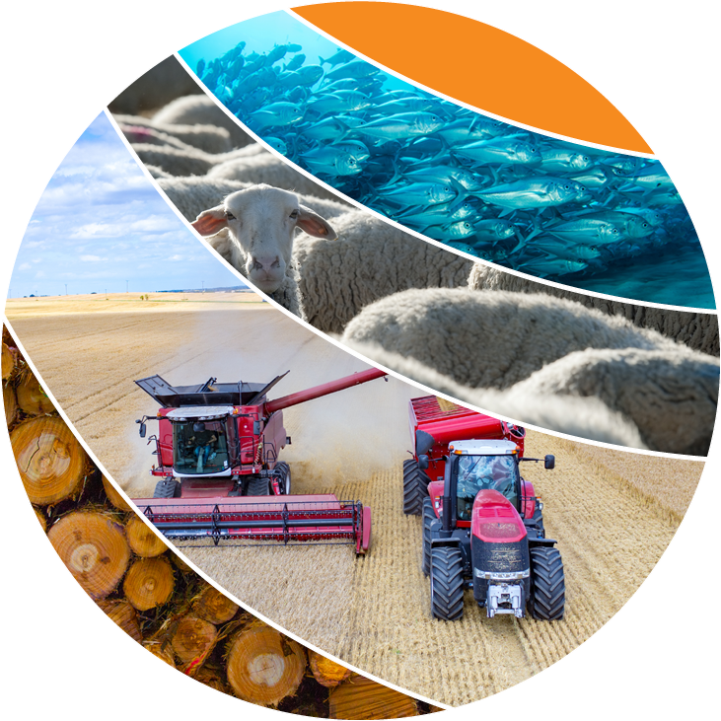

© Commonwealth of Australia 2018

**Ownership of intellectual property rights**

Unless otherwise noted, copyright (and any other intellectual property rights, if any) in this publication is owned by the Commonwealth of Australia (referred to as the Commonwealth).

**Creative Commons licence**

All material in this publication is licensed under a Creative [Commons Attribution 4.0 International Licence](https://creativecommons.org/licenses/by/4.0/legalcode) except content supplied by third parties, logos and the Commonwealth Coat of Arms.

Inquiries about the licence and any use of this document should be emailed to [copyright@agriculture.gov.au](mailto:copyright@agriculture.gov.au).

C:\Documents and Settings\west merryn\Local Settings\Temporary Internet Files\Content.Word\by.png

**Cataloguing data**

This publication (and any material sourced from it) should be attributed as: Dufty, N & Jackson, T, 2018, *Information and communication technology use in Australian agriculture*, ABARES research report 18.15, Canberra, November. CC BY 4.0.

ISBN 978-1-74323-406-8

ISSN 1447-8358

Report no. 18.15

This publication is available at [agriculture.gov.au/publications](http://agriculture.gov.au/publications).

Department of Agriculture and Water Resources

GPO Box 858 Canberra ACT 2601

Telephone 1800 900 090

Web [agriculture.gov.au](http://agriculture.gov.au/)

The Australian Government acting through the Department of Agriculture and Water Resources, represented by the Australian Bureau of Agricultural and Resource Economics and Sciences, has exercised due care and skill in preparing and compiling the information and data in this publication. Notwithstanding, the Department of Agriculture and Water Resources, ABARES, its employees and advisers disclaim all liability, including liability for negligence and for any loss, damage, injury, expense or cost incurred by any person as a result of accessing, using or relying on any of the information or data in this publication to the maximum extent permitted by law.

**Acknowledgements**

The authors thank interview and survey participants for their input. Thanks also to David Galeano for his comments on this report.

Contents

Summary 1

1 Introduction 2

2 ICT assets and investment 3

2.1 Results by industry 3

2.2 Results by farm size 5

3 Use of ICT assets 7

4 Impediments to uptake of new ICT tools 9

4.1 Skills 9

4.2 Internet access 10

4.3 Cost 10

4.4 Nothing new of interest 11

4.5 Other 11

5 Internet access and use on farms 12

5.1 Farmers connect in different ways 12

5.2 Business use of internet 13

5.3 Impediments to business arising from internet access 14

References 17

**Figures**

Figure 1 ICT as a share of plant and equipment, average per farm, 2016–17 3

Figure 2 Replacement value of ICT assets held, average per farm, by industry, 2016–17 4

Figure 3 Farms buying new ICT equipment in 2016–17, proportion of farms, by industry 5

Figure 4 Age of ICT assets held in 2016–17, average per farm, by industry 5

Figure 5 Value of ICT assets and contribution to asset value, average per farm, by industry and farm size, 2016–17 6

Figure 6 Use of ICT, proportion of farms, by industry, 2016–17 7

Figure 7 Main impediments to adopting new ICT, proportion of farms, by industry, 2016–17 9

Figure 8 Internet access as an impediment to the uptake of new ICT, proportion of farms, by internet connection type, 2016–17 10

Figure 9 Expenditure on new ICT, average per farm for those that purchased, by technology type and industry, 2016–17 11

Figure 10 Type of internet connection, by industry, 2016–17 12

Figure 11 Online presence, proportion of farms, by industry, 2016–17 14

Figure 12 Internet connection concerns, proportion of farms, by type of connection, 2016–17 14

Figure 13 Internet and mobile phone access and impediment, broadacre farms, by zone, 2016–17 15

**Tables**

Table 1 Comparison of internet plans 15

**Maps**

Map 1 Broadacre zones and Telstra mobile coverage, by type 16

**Boxes**

Box 1 The survey tool 2

## Summary

New information and communications technology (ICT) could deliver the next wave of productivity growth in Australian agriculture. ICT includes all digital technologies that facilitate the electronic capture, processing, storage and exchange of information.

To better understand the role of ICT in Australian agriculture and potential barriers to its use, ABARES surveyed over 2,200 farmers in 2016–17. Results from this survey are presented here for broadacre, dairy and vegetable farms.

Key findings:

* The overwhelming majority (96 per cent) of Australian farmers owned and used ICT assets, and 95 per cent were connected to the internet.
* Farmers used ICT for production activities, internet commerce, obtaining information and household purposes.
* Larger farms were more likely to invest in and use ICT than their smaller counterparts.
* ICT assets represented a relatively small share of total capital assets on most farms—this technology likely performs an enabling role to make other assets more productive and lift overall business efficiency.
* ICT applications on farms varied between industries. For example, GPS-enabled technologies are widely used on vegetable and grain farms, and electronic identification and herd management tools are commonly used on dairy farms.
* Reported obstacles to adoption of ICT included skills, internet access, cost and availability of useful new technologies. The relative importance of these constraints varied with industry and farm size. For example, a lack of skills was most commonly reported as an impediment by the owners of small farms, particularly those in the livestock industry.
* The availability and quality of internet services influences farmers’ access to and use of ICT. Farmers in relatively remote areas using mobile phone or satellite-based internet connections were more likely to report inadequate internet access as an impediment to their use of ICT and to the operation of their businesses more generally.

## Introduction

New ICT equipment and the data it generates are changing how farms are managed. The use of digital agriculture in Australia has the potential to increase production through optimising input use, more timely decision-making, labour savings, genetic gains and improved market access. Quantifying the effects of these changes is difficult. However, it has been estimated that fully implementing all currently available digital technology could increase production by up to 25 per cent compared with 2014–15 levels (Perrett et al. 2017).

Realising the benefits from digital technology requires farmers to adopt and use these tools. Farmers invest in ICT, like they do in other technologies, when they perceive that benefits exceed costs. Complexity and uncertainty about the benefits generated by new tools tends to slow adoption, because it reduces the expected value of benefits until sufficient learning can be done to obtain the required information.

Currently, many ICT applications on farms appear to be characterised by high complexity and uncertainty, largely because these technologies are in relatively early stages of development in Australia and globally. As the technologies mature and uncertainty is reduced, benefits and costs will become clearer for farmers to assess. Similarly, as the costs and benefits of access to this technology become clear, investors and others will be in a better position to solve constraints such as access to telecommunications infrastructure.

For governments and others with an interest in the potential gains from ICT it is necessary to understand the current state of ICT use on Australian farms and the barriers to uptake that farmers face.

This report summarises findings from ABARES survey of farmers on their ICT use (Box 1). In the future, ABARES plans to use the results from this survey for further analysis of the relationship between ICT investment and farm performance.

Box 1 The survey tool

|  |
| --- |
| The data used in this report were largely collected through a supplementary ICT survey that ABARES included in the 2016 survey of Australian vegetable-growing farms, the 2016 survey of Murray–Darling Basin Irrigation farms, the 2017 Australian Agricultural and Grazing Industries Survey and the 2017 Australian Dairy Industry Survey.  The supplementary survey focused on understanding ICT assets, current levels of investment and use on farms. This survey was completed by over 2,200 farmers. The survey also contained questions on impediments faced when adopting ICT, and the availability and quality of internet and mobile phone services on farms.  The supplementary survey was conducted as part of ABARES annual farm survey program, which collects detailed physical and financial information on the operations of farm businesses during the preceding financial year. The main collection method for the survey is face-to-face interviews with the owner–manager of the farm. The sample of farms in the survey is carefully selected to be representative of all farms in the population of interest. See [ABARES farm surveys definitions and methods](http://www.agriculture.gov.au/abares/research-topics/surveys/farm-definitions-methods) for more details. |

## ICT assets and investment

### Results by industry

#### ICT represents a small proportion of farm asset value

Almost all (96 per cent) Australian farmers own and use ICT assets, but ICT assets generally represent a relatively small share of farm capital. On average across broadacre, dairy and vegetable farms, the replacement value of ICT assets accounted for 2.6 per cent of plant and equipment capital in 2016–17 (and around 0.2 per cent of all capital including land).

The intensity of ICT ownership varies across industries—ICT assets accounted for 3.3 per cent of plant and equipment capital on grain farms, 2.7 per cent on vegetable farms, 2.0 per cent on dairy farms and 1.9 per cent on livestock farms (Figure 1).

In 2016–17 investment in ICT on grain farms was not as intense as in the past—ICT’s share of investment was lower than its share of assets. In contrast, other industries appear to have invested more heavily in the survey year than in the past—ICT made up a larger share of capital investment than the share of capital assets already owned (Figure 1). This difference is likely to reflect greater investment in ICT by grain farmers in earlier years and is also reflected in the replacement value and age of ICT assets held (Figure 2 and Figure 4).

Figure 1 ICT as a share of plant and equipment, average per farm, 2016–17

**a** Data reported for vegetables are for 2015–16.

Note: Data for mixed cropping–livestock farms are available online.

#### Farmers own technologies to suit their production systems

The type and value of ICT assets that farmers owned varied by industry, reflecting the specialisation of technologies to particular production systems. The most striking example of this is on grains farms, where investment in GPS-guided equipment and harvest monitoring technologies is widespread (Figure 2). In 2016–17 grain farms held ICT assets with an estimated replacement value of $34,000 on average, with 80 per cent of this value in GPS equipment.

In contrast, beef and sheep farms reported the smallest replacement value of ICT assets. There is limited uptake of precision agriculture on these farms, where production systems often rely on extensive pasture grazing. Digital technologies are increasingly available to manage livestock, such as electronic identification systems combined with satellite monitoring (AFI 2016), but adoption of these technologies remains concentrated in more intensive livestock industries such as dairy.

Dairy farmers generally held a larger stock of ICT assets than other livestock producers. In particular, dairy farmers have invested relatively heavily in sensors and other hardware to monitor individual animal production, tools that are not widely used in broadacre livestock farming. Dairy farmers have also invested relatively heavily in other hardware such as automated milking technologies, including cup removers, drafting gates, cleaning equipment and robotic dairies.

Vegetable farmers have invested relatively heavily in GPS technology, most likely reflecting the use of this technology for guiding planting and harvesting equipment—for example, when growing carrots and potatoes. On average, vegetable farmers have also invested relatively heavily in computers and sensors such as moisture probes and weather stations—most likely reflecting the widespread use of irrigation on these farms.

Figure 2 Replacement value of ICT assets held, average per farm, by industry, 2016–17

a

**a** Data reported for vegetables are for 2015–16.

Note: Data for mixed cropping–livestock farms are available online.

#### Only some farms purchase ICT assets in a given year

Most farms do not purchase ICT equipment every year—around 34 per cent of surveyed farms purchased some ICT equipment in 2016–17. This reflects the multi-year expected lifespan of many of these technologies and that they are often purchased as bundles—for example, investment in sensors in a particular year may be accompanied by purchase of software and a computer to collect and interpret data.

The most commonly purchased items were computers and phones (Figure 3), assets with relatively short lifespans that need to be replaced relatively often. Expected lifespans of common ICT assets are three years for mobile phones, four years for desktop computers and five years for precision-farming assets such as GPS units and controllers (ATO 2017).

Grain farmers tend to own newer ICT equipment than other farmers (Figure 4). This suggests that these farmers have invested relatively heavily in ICT equipment in recent years or that these farms tend to own equipment that needs updating more frequently. The lower average age of most types of ICT assets on grain farms helps explain their relatively low investment in the survey year, since newer assets are less likely to need replacing.

Figure 3 Farms buying new ICT equipment in 2016–17, proportion of farms, by industry

**a** Data reported for vegetables are for 2015–16.

Figure 4 Age of ICT assets held in 2016–17, average per farm, by industry

**a** Data reported for vegetables are for 2015–16.

### Results by farm size

Larger farms tend to invest more in ICT than other farms. On average, large broadacre, dairy and vegetable farms (defined as those with receipts over $1 million) held ICT assets with a replacement value of around $34,000. Medium-sized farms (those with receipts between $400,000 and $1 million) held just over $11,000 in ICT assets. Small farms (those with receipts less than $400,000) held approximately $4,000 in ICT assets.

One reason for greater investment in ICT on larger farms is that these farms generally have higher profits (Jackson & Shafron 2016), which may increase their capacity to fund investment. Larger farms can also spread new technologies over more inputs and outputs, increasing the benefits from adoption. Reflecting these factors, new technologies may also be marketed more towards larger farms because they are more likely to adopt them, increasing the likelihood of sales for technology developers (Castle, Lubben & Luck 2016; Daberkow & McBride 2003; Sheng & Chancellor 2018).

The types of ICT assets on broadacre farms (grains and livestock) were fairly consistent across farm size, even though the total value of these assets varied substantially (Figure 5). This suggests large and small farms can purchase ICT assets in proportion to business size. In contrast, larger farms in the dairy and vegetable industries tended to invest in somewhat different assets to smaller ones (Figure 5).

This difference in the types of ICT assets owned by large and small farms is also reflected in the share of ICT in plant and equipment capital. In particular, on larger broadacre farms, ICT assets made up a slightly lower proportion of plant and equipment capital than on smaller farms. This is likely because many ICT tools can be applied to larger areas without purchasing additional equipment. For example, a computer can analyse data from 1 or 10 sensors, and a yield monitor can collect data from 5,000 or 10,000 hectares.

In contrast, on large dairy and vegetable farms, ICT assets accounted for a slightly higher proportion of plant and equipment assets than on smaller farms. This may reflect large investment requirements in these industries as producers switch between different farm systems (for example, fully automated milking machines versus computerised feeding systems in the dairy industry).

Figure 5 Value of ICT assets and contribution to asset value, average per farm, by industry and farm size, 2016–17

a

**a** Data reported for vegetables are for 2015–16.

Note: Large farms had annual cash receipts over $1 million, medium-sized farms had receipts between $400,000 and $1 million and small farms had receipts less than $400,000.

## Use of ICT assets

Farmers were asked about their use of ICT assets across four broad categories—marketing and managing contracts, record keeping and input management, operating equipment and managing production, and gathering information. Results are shown in Figure 6.

Figure 6 Use of ICT, proportion of farms, by industry, 2016–17

**a** Data reported for vegetables are for 2015–16.

Across all industries, **record keeping** was the most commonly reported use of ICT assets, and over 80 per cent of farms now use ICT for this purpose. Electronic records can make it easier to capture information, generate reports and share data with service providers and customers. Nonetheless, some businesses still prefer to keep manual records. On average, farmers not using ICT for records management and book keeping tended to be older or operating smaller farms.

The majority of farmersalsoused ICT for **marketing and managing contracts** (61 per cent of farms), although face-to-face marketing also occurs widely in all industries. Grain and dairy farmers were more likely to use ICT for this purpose than other farmers, likely reflecting the relatively homogenous nature of these commodities, which facilitates online marketing. On vegetable farms, a tendency to sell in wholesale markets (Weragoda, Finlay & Ashton 2017) may limit use of ICT for marketing.

**Information gathering with ICT** was also widespread across all industries (61 per cent of farms). The use of ICT to access information was correlated with farm size—larger farms were more likely to report using ICT for this function.

**Operating equipment and managing production** was the second-most commonly reported use of ICT assets on grain farms (over 80 per cent of farms) but was not widely used in other industries (less than 30 per cent of beef and sheep, dairy and vegetable farms). This largely reflects the use of GPS equipment to operate precision agriculture tools on grain farms.

In addition to these uses, farmers reported using ICT for business-related training and education (26 per cent), entertainment (24 per cent), off-farm business activities (17 per cent), and children’s education (5 per cent).

Farmers also reported using ICT to access free software, online tools and apps. The most commonly reported use of freeware was for checking the weather—mainly the Bureau of Meteorology and other weather apps. Many farmers also reported using freeware from industries bodies such as the GRDC, MLA and Dairy Australia. These tools were used for a variety of purposes, including reporting (such as [Electronic National Vendor Declaration forms), accessing information (including on prices, herd management, soils, climate and weeds) and for managing the business. Farmers also reported using freeware from private organisations (including AgWorld, GrainCorp, CBH](https://www.mla.com.au/envd) and banks).

## Impediments to uptake of new ICT tools

Farmers were asked to report the main impediments to adopting new ICT tools across five broad categories—skills, internet access, cost, nothing new of interest, and other. Results are shown in Figure 7.

Figure 7 Main impediments to adopting new ICT, proportion of farms, by industry, 2016–17

a

**a** Data reported for vegetables are for 2015–16.

### Skills

Approximately one-third of farmers reported that a lack of skills was a constraint on their uptake of new ICT tools. The operators of smaller farms reported skills as a constraint more often than other farmers. Across all industries, 40 per cent of small farms reported lack of skills as an impediment, compared with around 25 per cent of medium-sized farms and less than 20 per cent of large farms. This may be because larger farms generally hire more workers and use contractors to a greater degree (Dufty et al. 2018), making them better placed to bring in workers with the required skills, or because they have greater capacity to delegate tasks, allowing more time for training and knowledge acquisition by managers.

Acquiring skills or becoming familiar with new technologies is time-consuming and can be a barrier to adoption of innovations. In agriculture, an important means of acquiring these skills and knowledge is the use of farm advisors and farmer networks, both of which have been found to increase user-knowledge about new technologies and encourage investment (Hochman & Carberry 2011; Kuehne et al. 2017; Llewellyn & Ouzman 2014; Rose et al. 2016).

Consistent with this, our data reveal that farmers in industries characterised by greater engagement with external providers of knowledge and information appear to have more of the skills required to adopt ICT. In particular, grain farmers have had a greater level of engagement with advisory services than other farmers in recent years (ABARES 2017). Relatively few grain farmers reported a lack of skills as a constraint on their adoption of new ICT, unlike livestock and dairy farmers, for whom it was the most commonly reported constraint.

### Internet access

A third of farmers reported that their access to the internet was impeding uptake of new ICT tools. Internet access was the most commonly reported constraint to the adoption of new ICT on grain farms and was also commonly reported by beef and sheep farmers (Figure 7). On dairy and vegetable farms, lower reporting of internet access as an impediment may reflect the greater availability or reliability of internet connections in more populated areas.

Across all industries, farmers with mobile and satellite internet connections were more likely to report internet access as an impediment to their uptake of new technologies than those with digital or fixed line connections (Figure 8). This suggests that it is the nature of the internet connection, rather than an industry-specific connection issue, that is causing the impediment to uptake of ICT.

The extent of internet coverage over the farm was related to the perceived impediment to technology uptake. Farmers reporting an impediment from internet access on average reported a smaller proportion of their farm covered. This trend was observed across all types of internet connection.

Figure 8 Internet access as an impediment to the uptake of new ICT, proportion of farms, by internet connection type, 2016–17

### Cost

Around 20 per cent of farmers reported that cost was a major impediment to the uptake of new ICT technology in 2016–17. Cost was more commonly reported as a constraint on grain and vegetable farms, which may reflect the relatively high up-front cost of ICT tools in these industries. Although relatively few grain or vegetable farms reported purchasing GPS, sensors or other hardware in 2016–17 (Figure 3), cropping and vegetable farmers that did purchase these items spent considerably more on them than dairy or livestock farmers spent on the same items (Figure 9).

Figure 9 Expenditure on new ICT, average per farm for those that purchased, by technology type and industry, 2016–17

a

**a** Data reported for vegetables are for 2015–16.

### Nothing new of interest

Around 20 per cent of farmers reported nothing new of interest as inhibiting their uptake of new ICT tools. Vegetable farmers reported this was a limitation more often than farmers in other industries. This may reflect the diversity of commodities and production systems used in the vegetable industry, which reduces the extent to which farmers can learn about innovations from peers (an important source of trusted information).

### Other

Farmers reporting other constraints to their uptake of new ICT commonly cited the operator’s age and a lack of interest. Across all industries, age appears to play a significant role in ICT investment decisions. Younger farmers (under the age of 50) spent more on new ICT equipment and used ICT for more applications in 2016–17, and reported skills as an impediment to adoption less often than older farmers.

Farmers also reported that time constraints were preventing them from adopting new ICT tools. Those reporting time constraints noted it was difficult to find the time required to understand the technologies and to gain the necessary skills to use them. Those citing a lack of time as an impediment to adoption also frequently reported costs, skills and nothing new of interest.

## Internet access and use on farms

The vast majority of Australian farms are now connected to the internet (95 per cent of farms surveyed). This estimate is consistent with ABS data, which indicated that 91 per cent of agriculture, forestry and fishery businesses were connected to the internet in 2015–16, up from 66 per cent in 2007–08 and 18 per cent in 1998–99 (ABS 2000, 2009, 2017a).

ABARES survey results show that larger farms were more likely to be connected to the internet (over 99 per cent of farms), as were grains farms (just under 99 per cent of farms). Smaller livestock, dairy and vegetable farms were less likely to be connected to the internet. As a result, these industries had lower overall connection rates—96 per cent for dairy, 94 per cent for broadacre livestock and 90 per cent for vegetables.

### Farmers connect in different ways

Farmers tend to connect to the internet differently to other business owners, mainly because of their location. According to the ABS, the most common type of business internet connection is digital fixed line (DSL) at 62 per cent of all businesses in the economy. However, the majority of farmers use connection types other than DSL, such as mobile wireless (28 per cent), fixed wireless (22 per cent) and satellite (15 per cent) as their main type of internet connection.

Our survey shows that more remotely located industries had a greater reliance on satellite and mobile internet (Figure 10). Broadacre farms had the greatest reliance on satellite (41 per cent of grain farms and 35 per cent of beef and sheep farms) and mobile wireless (32 per cent of grain farms and 26 per cent of livestock farms). Dairy farms had greater access to fixed wireless (34 per cent of dairy farms) and vegetable farms reported the greatest access to access DSL (31 per cent). This is likely to be because dairy and vegetable farms are generally located in more populated regions.

Figure 10 Type of internet connection, by industry, 2016–17

**a** Data reported for vegetables are for 2015–16.

### Business use of internet

#### Internet commerce

Internet commerce allows the purchase of goods or services quickly and conveniently and is increasingly available to farmers to make and receive orders online. Our survey results show over 40 per cent farms reported using the internet to receive orders or purchase inputs. For farms receiving orders, on average 15 per cent of farm income was generated through the internet. For farms using the internet to purchase inputs, on average 20 per cent of non-capital inputs (that is, chemicals, seeds, livestock) were purchased through the internet.

Large farms more commonly reported using the internet for commerce than small farms and also reported using it to generate a higher proportion of their orders and inputs. Over 50 per cent of large farms (those with receipts over $1 million) reported using the internet to make or receive orders, compared with a third of small farms (those with receipts less than $400,000).

#### Online presence

Social media is commonly used to develop a company image, market products and communicate with customers (ABS 2017a). Relatively few farms reported having a web presence (6 per cent), or a social media presence (5 per cent) or both (2 per cent). The limited online presence of farms was also observed by the ABS (2017b)—across all sectors of the economy, agriculture, forestry and fishing had the lowest proportion of businesses with a web presence in 2015–16 (12 per cent, compared with 50 per cent of all businesses) and the lowest proportion of businesses with a social media presence (11 per cent, compared with 38 per cent of all businesses).

Farms generally produce bulk commodities, which limits opportunities for direct sales through an online presence. The grains industry reported the highest share of income generated through the internet, but has very low online presence (Figure 11). This likely reflects the use of online trading platforms for selling grain, which do not require farms to have an online presence. The limited use of the internet for generating sales of bulk goods also seems to be reflected in the mining industry, where only 24 per cent of orders were received via the internet in 2015–16, even though 63 per cent of mining businesses had a web presence (ABS 2017a).

There may be more opportunities for marketing niche products through the internet. The vegetable and livestock industries reported the highest proportion of farms with an online presence. For the vegetable industry, this is likely to reflect direct sales and engagement with customers through farmers markets, which accounted for 12 per cent of vegetables sales in 2016–17 (Weragoda, Finlay & Ashton 2017).

In the beef and sheep industries, farms selling stud livestock were more likely to have an online presence. Just under half of beef and sheep farms that generated more than 10 per cent of sales from stud animals had an online presence. In comparison, less than 10 per cent of farms selling a smaller proportion of stock as studs had an online presence.

Figure 11 Online presence, proportion of farms, by industry, 2016–17

**a** Data reported for vegetables are for 2015–16.

### Impediments to business arising from internet access

Farmers were asked about the extent to which difficulties with their access to the internet and mobile phone services were impeding the operation of their businesses. Over 50 per cent of farms reported some business impediment arising from mobile phone or internet connectivity. Across all industries, farmers were more likely to report mobile phone issues as an impediment (45 per cent of farms) than problems with internet access from the home or business address (34 per cent of farms).

On average, farmers reported that internet coverage (non-mobile) was adequate for their needs 54 per cent of the time and that 43 per cent of their farm was covered by a wireless network or had access to mobile data in 2016–17. Coverage was lower on broadacre farms than dairy and vegetable farms. The main concerns raised about internet access were speed and reliability, followed by cost. This was consistent across all types of internet connection (Figure 12).

Figure 12 Internet connection concerns, proportion of farms, by type of connection, 2016–17

Reported concerns with internet services were related to the connection type. For example, speed was more of concern for those with digital connections (that is, ADSL) than for those on fixed wireless (which has greater maximum download speeds). Farmers relying on mobile and satellite connections were more likely to report speed and cost as impediments and in general faced higher data costs and slower maximum speeds (Table 1).

Table 1 Comparison of internet plans

|  |  |  |  |  |
| --- | --- | --- | --- | --- |
| **Plan** | **ADSL** | **Fixed wireless NBN** | **Mobile** | **Satellite NBN** |
| **Price per GB range** | $0.08–$1.00 | $0.01–$7.49 | $0.67–$15.00 | $0.24–$1.40 |
| **Highest speed download** | 20 Mbps | 50 Mbps | 4GX: 75 Mbps  4G: 2–50 Mbps  3G: 0.55–20 Mbps | 25 Mbps |

Source: Department of Communications and the Arts pers. comm. 2018; Telstra 2018, 2017, 2011

There was a link between the proportion of the farm with internet coverage and reporting that access to the internet was an impediment to business. In general, farms in more remote parts of Australia (such as the pastoral zone) generally had less coverage and were more likely to report an impediment to their operations than those farms in more densely populated areas such as the high rainfall zone (Figure 13, Map 1). These observations are consistent with the availability of mobile phone services across Australia (Map 1).

Figure 13 Internet and mobile phone access and impediment, broadacre farms, by zone, 2016–17

Map 1 Broadacre zones and Telstra mobile coverage, by type

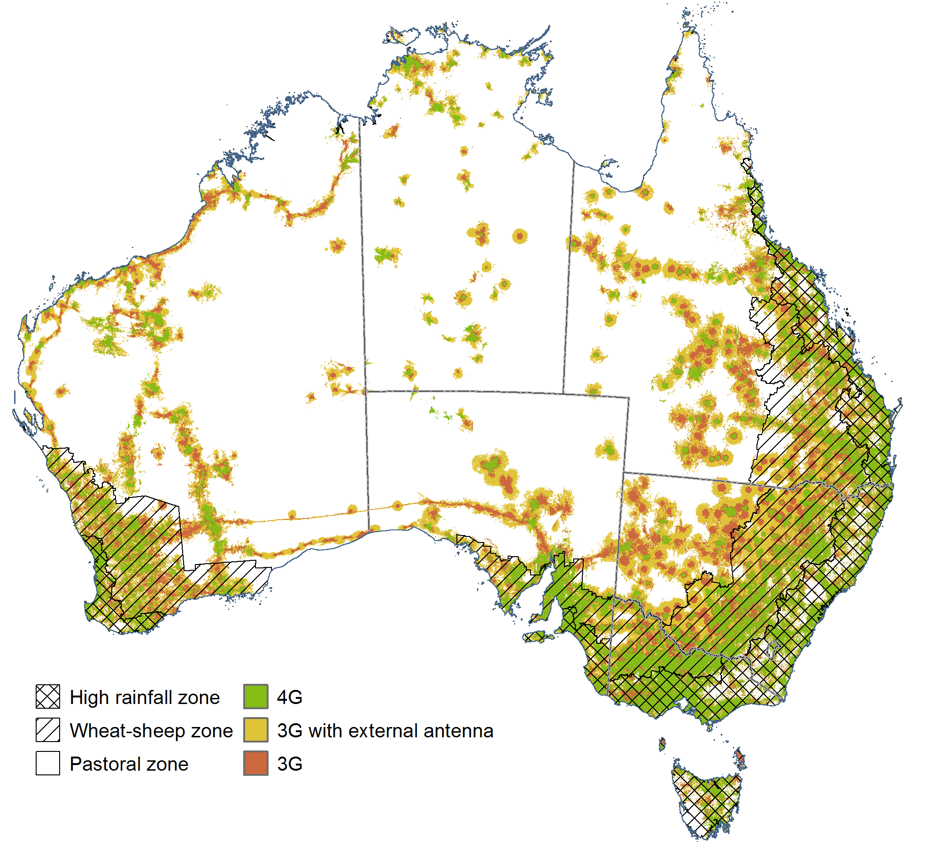

Source: ABARES; Telstra 2018

## References

ABARES 2017[, Rural research, development and extension investment in Australia,](http://www.agriculture.gov.au/abares/research-topics/productivity/related-research/rural-rde-investment) ABARES research report, Canberra, September.

ABS 2000, [Use of information technology on farms,](http://www.abs.gov.au/AUSSTATS/abs@.nsf/allprimarymainfeatures/61DA47437CFDF261CA256E5300755278?opendocument) 1998–99, cat. no. 8150.0, Australian Bureau of Statistics, October.

——2009, [Use of the Internet on Farms, Australia](http://www.abs.gov.au/ausstats/abs@.nsf/mf/8150.0), 2007–08, cat. no. 8150.0, Australian Bureau of Statistics, August.

——2017a, [Business Use of Information Technology](http://www.abs.gov.au/AUSSTATS/abs@.nsf/DetailsPage/8129.02015-16?OpenDocument), 2015–16, cat. no. 8129.0, Australian Bureau of Statistics, July.

——2017b, [Summary of IT Use and Innovation in Australian Business](http://www.abs.gov.au/ausstats/abs@.nsf/mf/8166.0), 2016–17, Australian Bureau of Statistics, cat. no. 8166.001, 2015–16, June, Canberra.

AFI 2016, [The implications of digital agriculture and big data for Australian agriculture](http://www.farminstitute.org.au/publications/research_report/big-data-report.html), Australian Farm Institute.

ATO 2017, [Taxation Ruling TR 2017/2, Income tax: effective life of depreciating assets,](https://www.ato.gov.au/law/view/document?DocID=TXR/TR20172/NAT/ATO/00001&PiT=99991231235958) Australian Taxation Office.

Castle, MH, Lubben, BD & Luck, JD 2016, [Factors Influencing the Adoption of Precision Agriculture Technologies by Nebraska Producers](http://digitalcommons.unl.edu/ageconworkpap/49), Presentations, Working Papers, and Gray Literature: Agricultural Economics, 49, UNL Digital Commons.

Hochman, Z & Carberry, PS 2011, [Emerging consensus on desirable characteristics of tools to support farmers’ management of climate risk in Australia](https://doi.org/10.1016/j.agsy.2011.03.001.), Agricultural Systems, vol. 104, no. 6.

Daberkow, SG & Mcbride, WD 2003, [Farm and operator characteristics affecting the awareness and adoption of precision agriculture technologies in the US](https://link.springer.com/article/10.1023/A:1024557205871), *Precision Agriculture, 4*(2), pp. 163–177.

Dufty, N, Zhao, S, Shafron, W & Valle, H 2018, [Dairy industry workforce survey 2015–16](http://www.agriculture.gov.au/abares/research-topics/labour/dairy-labour-2015-16#downloads), ABARES research report, Canberra, July.

Jackson, T & Shafron, W 2016, ‘Disaggregating farm performance statistics by size’ in [Agricultural commodities: March quarter 2016](http://www.agriculture.gov.au/abares/publications/display?url=http://143.188.17.20/anrdl/DAFFService/display.php?fid=pb_agcomd9abcc20160301_cQe9T.xml), Australian Bureau of Agricultural and Resource Economics and Sciences, Canberra.

Kuehne, G, Llewellyn, R, Pannell, DG, Wilkinson, R, Dolling, P, Ouzman, J & Ewing, M 2017, [Predicting farmer uptake of new agricultural practices: A tool for research, extension and policy](https://doi.org/10.1016/j.agsy.2017.06.007), Agricultural Systems, vol. 156, pp. 115–125.

Llewellyn, R & Ouzman, J 2014, [Adoption of precision agriculture-related practices: status, opportunities and the role of farm advisers,](https://grdc.com.au/resources-and-publications/all-publications/publications/2014/12/adoption-of-precision-agriculture-related-practices) CSIRO report for the Grains Research and Development Corporation, December.

Perrett, E, Heath, R, Laurie, A & Darragh, L 2017, [Accelerating precision agriculture to decision agriculture, Analysis of the economic benefit and strategies for delivery of digital agriculture in Australia.](https://www.crdc.com.au/precision-to-decision) Cotton Research and Development Corporation.

Rose, DC, Sutherland, WJ, Parker, C, Lobley, M, Winter, M, Morris, C, Twining, S, Foulkes, C, Amano, T & Dicks, LV 2016[, Decision support tools for agriculture: Towards effective design and delivery](https://www.sciencedirect.com/science/article/pii/S0308521X16305418), Agricultural Systems, vol. 149, pp. 165–174.

Sheng, Y & Chancellor, W 2018, [Exploring the relationship between farm size and productivity: evidence from the Australian grain industry,](https://www.sciencedirect.com/science/article/pii/S0306919218302422) Food Policy, March.

Telstra 2011, [What’s the difference between 3G, Next G and 4G?](https://crowdsupport.telstra.com.au/t5/Mobile-Plans-Rates/What-s-the-difference-between-3G-Next-G-and-4G/td-p/1106), June.

Telstra 2017, [Broadband Speeds (ADSL, Cable, NBN and Velocity)](https://crowdsupport.telstra.com.au/t5/Broadband-nbn/Broadband-Speeds-ADSL-Cable-NBN-and-Velocity/ta-p/42335), May.

Telstra 2018, [Telstra 4GX—What faster feels like](https://www.telstra.com.au/coverage-networks/telstra-4gx), accessed 10 July 2018.

Weragoda, A, Frilay, J & Ashton, D 2017, [Vegetable industry](http://www.agriculture.gov.au/abares/research-topics/surveys/vegetables), Australian Bureau of Agricultural and Resource Economics and Sciences, Canberra.