# Future opportunities for using forest and sawmill residues in Australia

Peter Lock and Linden Whittle

Research by the Australian Bureau of Agricultural and Resource Economics and Sciences

Research report 18.11  
November 2018

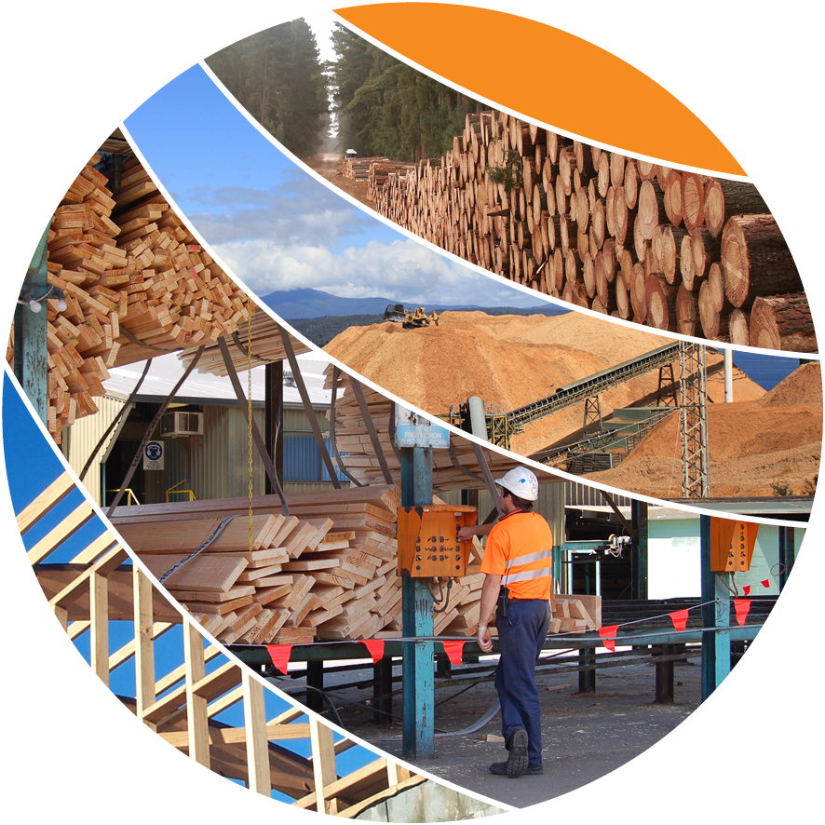

© Commonwealth of Australia 2018

**Ownership of intellectual property rights**

Unless otherwise noted, copyright (and any other intellectual property rights, if any) in this publication is owned by the Commonwealth of Australia (referred to as the Commonwealth).

**Creative Commons licence**

All material in this publication is licensed under a Creative [Commons Attribution 4.0 International Licence](https://creativecommons.org/licenses/by/4.0/legalcode) except content supplied by third parties, logos and the Commonwealth Coat of Arms.

Inquiries about the licence and any use of this document should be emailed to [copyright@agriculture.gov.au](mailto:copyright@agriculture.gov.au).

C:\Documents and Settings\west merryn\Local Settings\Temporary Internet Files\Content.Word\by.png

**Cataloguing data**

This publication (and any material sourced from it) should be attributed as: Lock, P & Whittle, L 2018, *Future opportunities for using forest and sawmill residues in Australia*, ABARES, Canberra, November. CC BY 4.0. [https:/doi.org/10.25814/5bdfaee303b64](https://doi.org/10.25814/5bdfaee303b64)

ISBN 978-1-74323-398-6

ISSN 1447-8358

ABARES project 43559

This publication is available at [agriculture.gov.au/abares/publications](http://agriculture.gov.au/abares/publications).

Australian Bureau of Agricultural and Resource Economics and Sciences (ABARES)

Postal address GPO Box 858 Canberra ACT 2601

Switchboard +61 2 6272 2010

Email [info.abares@agriculture.gov.au](mailto:info.abares@agriculture.gov.au)

Web [agriculture.gov.au/abares](http://agriculture.gov.au/abares/)

**Disclaimer**

The Australian Government acting through the Department of Agriculture and Water Resources, represented by the Australian Bureau of Agricultural and Resource Economics and Sciences, has exercised due care and skill in preparing and compiling the information and data in this publication. Notwithstanding, the Department of Agriculture and Water Resources, ABARES, its employees and advisers disclaim all liability, including liability for negligence and for any loss, damage, injury, expense or cost incurred by any person as a result of accessing, using or relying on any of the information or data in this publication to the maximum extent permitted by law.

**Acknowledgements**

The authors would like to thank Stuart Davey, Mijo Gavran, Beau Hug, Tim Westwood and Rhys Downham from ABARES for their support during the project and in preparing this report. The authors would also like to thank Jim Houghton from Forest and Wood Products Australia, Simon Penfold from African Mahogany Australia, and Richard Schaffner from AKD Softwoods for their invaluable advice and contribution.

Contents

Summary 8

Key findings 9

Introduction 12

1 Current production and use of wood residues 14

1.1 Current estimates of the supply of wood residues 14

1.2 Current use of wood residues 17

1.3 Potential uses of wood residues 19

2 Modelling framework and assumptions 22

2.1 Economic assumptions 22

2.2 Modelling the supply of harvest residues 24

2.3 Modelling sawmill residue production 26

2.4 Modelling different uses of residues 28

2.5 Strengths and limitations of the analysis 31

3 Future production and use of wood residues 33

3.1 Production and use by residue type 33

3.2 Production and use by state 37

3.3 Production and use by sawmill type 39

3.4 Residue use by end use 41

3.5 Transporting wood residues 46

4 Sensitivity analysis 49

4.1 Higher woodchip prices 51

4.2 Higher wood pellet prices 53

4.3 Higher briquette prices 55

4.4 Higher bioethanol prices 57

4.5 Higher wholesale electricity prices 59

Conclusion 63

Harvest and sawmill residues will be a substantial resource 63

Residues could be used in a range of applications 64

Changes in market conditions could create new opportunities 64

Appendix A: Infrastructure inputs 66

Appendix B: Detailed production and use estimates 68

Glossary 81

References 82

**Tables**

Table 1 Proportion of above-ground biomass recovered and left onsite 15

Table 2 Published estimates of harvest residue availability, 2011 to 2015 16

Table 3 Published estimates of sawmill residue production, 2011‑2015 17

Table 4 Harvest residues available per cubic metre of logs harvested 24

Table 5 Assumed extraction costs for harvest residues 26

Table 6 Sawmill residue types and end uses considered 27

Table 7 Breakdown of sawmill residues, by type 27

Table 8 Average sawmill residue production as a proportion of log input (tonnes), by sawmill type and size 27

Table 9 Recovery rates for wood products, per tonne of residue input 30

Table 10 Recovery rates for energy generated from burning residues 30

Table 11 Market prices for wood products and energy 31

Table 12 Scenario assumptions 49

Table A1 Modelled wood-processing capacity in Australia—sawmill and post and pole plants, 2014–15 66

Table A2 Modelled wood-processing capacity in Australia—panels, paper and paperboard, pulp and log and woodchip exports, 2014–15 66

Table A3 Mill investment options 67

Table B1 Production and use of harvest and sawmill residues in 2050, base case 69

Table B2 Energy use and generation by sawmills in 2050, base case 70

Table B3 Change in production and utilisation of harvest and sawmill residues in 2050, from base case to high woodchip price scenario 71

Table B4 Change in production and use of harvest and sawmill residues in 2050, from base case to high wood pellet price scenario 73

Table B5 Change in production and use of harvest and sawmill residues in 2050, from base case to high briquette price scenario 75

Table B6 Change in production and use of harvest and sawmill residues in 2050, from base case to high bioethanol price scenario 77

Table B7 Change in production and use of harvest and sawmill residues in 2050, from base case to high electricity price scenario 79

**Figures**

Figure S1 Estimated production and use of harvest and sawmill residues in 2050 9

Figure S2 Estimated changes in production and use of harvest and sawmill residues in 2050 from base case scenario 11

Figure 1 Estimates of the volume of harvest residues available for extraction, 2016–17 16

Figure 2 Estimates of the volume of sawmill residues produced, 2016–17 17

Figure 3 Pulplog harvest by end use, 2016–17 18

Figure 4 Potential residue uses, by technology readiness and economic benefit 19

Figure 5 Log and residue flows in the Forest Resource Use Model (FORUM) 23

Figure 6 Estimated maximum volume of harvest residues available for extraction, 2015–19 to 2045–49 25

Figure 7 Estimated harvest and sawmill residue flows in 2050 34

Figure 8 Harvest residue production and use in 2050, by forest and residue type, base case 35

Figure 9 Production and use of sawmill residues in 2050, by residue type, base case 36

Figure 10 High-quality harvest residues availability and use in 2050, by state, base case 37

Figure 11 Production and use of sawmill residues in 2050, by state, base case 39

Figure 12 Production and use of sawmill residues in 2050, by source mill type, base case 40

Figure 13 Use of sawmill residues in 2050, by source mill type and kiln ownership, base case 41

Figure 14 Number of operating sawmills by kiln ownership and onsite residue use in 2050, base case 42

Figure 15 Energy generation and use by sawmills that burn residues for heat and electricity in 2050, base case 43

Figure 16 Heat generation and use by sawmills that burn residues for only heat in 2050, base case 44

Figure 17 Proportion of residues transported in 2050, by residue type and distance travelled, base case 46

Figure 18 Proportion of residues transported in 2050, by end use and distance travelled, base case 47

Figure 19 Supply and use of harvest and sawmill residues in 2050, by end use, various scenarios 50

Figure 20 Changes in use of harvest residues in 2050 due to a 25 per cent increase in the price of woodchips, by forest type 51

Figure 21 Changes in the production and use of sawmill residues in 2050 from the base case due to a 25 per cent increase in the price of woodchips 53

Figure 22 Changes in the extraction and use of harvest residues in 2050 from the base case due to a 25 per cent increase in wood pellet prices, by forest type 54

Figure 23 Changes in production and use of sawmill residues in 2050 from the base case due to a 25 per cent increase in wood pellet prices by sawmill type and size 55

Figure 24 Changes in extraction and use of harvest residues in 2050 from base case to high briquette price scenario, by forest type 56

Figure 25 Changes in production and use of sawmill residues in 2050 from base case to high briquette price scenario, by source mill type 57

Figure 26 Changes in extraction and use of harvest residues in 2050 from base case to high bioethanol price scenario, by forest type 58

Figure 27 Change in sawmill residue use in 2050 from base case to high bioethanol price scenario, by source mill type 59

Figure 28 Changes in production and use of harvest residues in 2050 from base case to high wholesale electricity price scenario, by forest type 60

Figure 29 Change in sawmill residue use in 2050 from base case to high wholesale electricity price scenario, by source mill type 61

Figure B1 Change in residue use and supply in 2050, by residue type, from base case to high woodchip price scenario 72

Figure B2 Change in residue use and supply in 2050, by residue type, from base case to high wood pellet price scenario 74

Figure B3 Change in residue use and supply in 2050, by residue type, from base case to high briquette price scenario 76

Figure B4 Change in residue use and supply in 2050, by residue type, from base case to high bioethanol price scenario 78

Figure B5 Change in residue use and supply in 2050, by residue type, from base case to high wholesale electricity price scenario 80



## Summary

The Australian forest industry generates millions of tonnes of wood residues every year as a by-product of harvesting and sawmilling operations. Harvest residues consist of stumps, bark, crown material and tree heads and butts. They are typically left in forests to maintain forest and soil health for subsequent plantings. Sawmill residues consist of solid wood offcuts (including woodchips), sawdust, shavings and bark. These residues are typically used to produce woodchips or burned onsite for energy.

The efficient use of harvest and sawmill residues can reduce disposal costs and create additional revenue streams, contributing to the international competitiveness and sustainability of the Australian forest and wood processing industry.

Some regional analysis of the production of harvest and sawmill residues in Australia has been undertaken, but very little is known about the current volumes produced or used at the national level. In light of this, ABARES and Forest and Wood Products Australia jointly funded research into the long-term economic feasibility of using harvest and sawmill residues from production forests and sawmill operations in Australia.

This report presents estimates of the potential production and use of harvest and sawmill residues in Australia in 2050. Given uncertainties around the current use of residues, and potential timing of investment in emerging technologies, estimates for earlier periods are not presented. As such, the intention of this report is to provide some insights into what the production and use of wood residues may look like in decades to come, once any required investment in infrastructure has taken place.

Estimates of the production and use of harvest residues are broken down by forest type (hardwood native, hardwood plantation and softwood) and grade (high and low quality). Estimates of the production and use of sawmill residues are broken down by broad species (hardwood and softwood), residue type (solid offcuts, sawdust, shavings and bark) and mill size. End uses include conventional wood products (such as export grade woodchips, wood pulp and wood-based panels) and alternative uses such as wood-based fuels (wood pellets, bioethanol and briquettes) and burning for heat or electricity.

Forest growers and managers, sawmill operators and other wood processors can use these estimates to explore potential long-term opportunities and take advantage of future wood residue availability.

The estimates presented in this report are based on simulations run using the Forest Resource Use Model (FORUM) for the period 2020 to 2050. FORUM was developed by ABARES to estimate the optimal use of the wood resource over time (Burns et al. 2015; Whittle, Lock & Hug n.d), incorporating a range of factors such as infrastructure constraints, investment opportunities, transport costs and the available biomass from production forests and sawmills. Prices, costs and technologies are assumed to remain constant over the modelling period. The estimates presented for 2050 largely reflect current market conditions but take into account resource constraints and market demand in 2050, and new mill investment over the period 2020 to 2050.

### Key findings

#### Harvest and sawmill residues are a substantial resource

ABARES estimates that up to 6.5 million tonnes of harvest residues could have been available for extraction in 2016–17, based on a total log harvest of 33.1 million cubic metres. ABARES also estimates that at least 5.2 million tonnes of sawmill residues could have been produced in 2016‑17 from 10.2 million cubic metres of sawlogs processed domestically. However, the proportion of these residues that may have been used is uncertain.

Based on ABARES modelling around 5.6 million tonnes of log harvest residues could be available for further use in 2050, based on a total log harvest of 28.6 million cubic metres. Around 1.2 million tonnes of harvest residues are assumed to be high quality, or suitable for producing export grade woodchips, and the remaining 4.4 million tonnes are assumed to be low quality (Figure S1). Around 0.9 million tonnes, or 78 per cent of the available high-quality residues in 2050, could be exported as woodchips or used in wood-based panel production. In contrast, forward estimates indicate that extraction of low-quality harvest residues is unlikely to be viable.

Figure S1 Estimated production and use of harvest and sawmill residues in 2050

As described in text.

ABARES also estimates that around 5.6 million tonnes of sawmill residues could be produced in 2050 as a by-product of processing 11.3 million cubic metres of sawlogs. Around 5.0 million tonnes or 90 per cent of these residues are expected to be used in some form. The proportion of softwood sawmill residues used (95 per cent) is much higher than the proportion of hardwood sawmill residues used (65 per cent) because softwood sawmills tend to be located closer to potential downstream users and have economies of scale to make investments in onsite cogeneration technologies viable.

#### Wood residues could be used in numerous applications

ABARES estimates that combined generation of heat and electricity (cogeneration) for onsite use could be one of the most profitable uses of residues for some sawmills. By burning residues onsite for cogeneration, sawmills can avoid disposal costs and offset the costs of purchasing gas and electricity. ABARES modelling suggests that around 612,000 tonnes of sawmill residues (11 per cent of all sawmill residues) could be used to generate heat and electricity onsite in 2050. However, high upfront costs associated with installing cogeneration technology are likely to be a barrier for many sawmills, in particular smaller ones.

The benefits of burning wood residues to generate heat alone are far less than that of many alternative uses of residues. However, the high costs of transporting residues make this the most economic option for many regional sawmills.

ABARES modelling suggests that up to 1.9 million tonnes of sawmill residues (35 per cent of all sawmill residues) and 0.8 million tonnes of high-quality harvest residues (66 per cent of all high-quality harvest residues) could be exported as woodchips in 2050. This has the potential to make woodchip exports the single largest end use of harvest and sawmill residues in 2050. However, this is contingent on capacity being available at export facilities and a sufficient volume of residues being collected to achieve the necessary economies of scale.

ABARES also estimates that up to 626,000 tonnes of sawmill residues (11 per cent of all sawmill residues) and 69,000 tonnes of high-quality harvest residues (6 per cent of all high-quality harvest residues) have the potential to be used in the production of wood-based panels in 2050.

Wood pellet production is estimated to be the next main market for wood residues. ABARES estimates that around 796,000 tonnes of sawmill residues (14 per cent of all sawmill residues) could be used in the production of wood pellets in 2050, comprised mostly of sawdust and shavings, due to lower processing costs. ABARES also estimates that around 423,000 tonnes of sawmill residues (8 per cent of sawmill residues) and 6,000 tonnes of low-quality harvest residues could be used in the production of briquettes.

ABARES modelling suggests that under current market conditions, there is unlikely to be any new investment in bioethanol refineries or biomass electricity plants by 2050 due to high capital costs and more valuable alternative uses.

#### Changes in market conditions could have significant impacts on residue use

ABARES also estimated the potential production and optimal use of wood residues under a range of alternative scenarios, highlighting potential future opportunities and competition between uses of wood residues (Figure S2).

Increases in the prices of export grade woodchips, wood pellets and briquettes were estimated to increase the volume of harvest and sawmill residues used in these applications. A 25 per cent increase in wood pellet prices had the greatest impact on residue use with 1.4 million tonnes of harvest residues (25 per cent of all harvest residues) and an additional 344,000 tonnes of sawmill residues (43 per cent more than under the base case) being used in wood pellet production in 2050. Increases in wood pellet and briquette prices could also have a profound effect on the economic viability of extracting low quality harvest residues which, under current market conditions, are unlikely to be extracted.

While there is unlikely to be any investment in bioethanol refineries or biomass electricity plants under current market conditions, ABARES estimates that increases in bioethanol and wholesale electricity prices of 25 per cent could make investment in these facilities economically viable by 2050. If established, these facilities could use a substantial volume of residues in 2050, with 304,000 tonnes being used in bioethanol production and 520,000 tonnes used to generate electricity in standalone biomass power plants.

Figure S2 Estimated changes in production and use of harvest and sawmill residues in 2050 from base case scenario

As described in text.

Note: Negative values in the bottom half of the figure are associated with decreases in volumes, relative to the base case. The sum of all positive and negative values gives the total change in volume of harvest residues available for extraction and sawmill residues produced.

ABARES modelling shows how changes in market prices affect the optimal use of residues, providing insights into potential competition between specific uses of residues. For example, ABARES modelling suggests that an increase in wood pellet prices is likely to draw sawmill residues away from briquette production while increases in briquette and bioethanol prices could draw sawmill residues away from wood pellet production.

Finally, the findings from this analysis also highlight the inherent complexity of the Australian forest and wood processing industry—changes in market conditions often have unexpected effects on seemingly disconnected parts of the industry. For example, ABARES modelling suggests that increases in woodchip and briquette prices could potentially increase the volume of sawmill residues used in wood-based panel production. These unexpected impacts are primarily the result of a reallocation of sawlogs between sawmills to take advantage of proximity to particular downstream users. This highlights and further emphasises the important role that residue markets can play in the profitability of Australian sawmills.

## Introduction

Australia’s forest and wood processing industries generate large volumes of wood residues each year as a by-product of harvesting and sawmilling operations. Harvest residues consist of stumps, bark, crown material and tree heads and butts. They are often left in forests as a nutrient bank to maintain forest and soil health for subsequent plantings and regeneration but high costs extraction and transport costs, low returns, and a lack of suitable end uses are also contributing factors to their lack of use. Sawmill residues consist of solid wood offcuts (including hogged wood and woodchips), sawdust, shavings and bark. A significant volume of sawmill residues are currently used by downstream processors to produce wood-based panels or pulp, or burned onsite for heat or electricity cogeneration.

The efficient use of harvest and sawmill residues can reduce disposal costs and create additional revenue streams, contributing to the international competitiveness and sustainability of the Australian forest and wood processing industry.

In light of this, ABARES and Forest and Wood Products Australia commissioned this study to analyse the long-term economic feasibility of alternative uses of wood residues generated from forest harvesting and sawmill operations in Australia.

The report presents estimates of the total production, use and disposal of residues from harvesting and sawmilling operations in 2050. Given uncertainties around the current use of residues, and potential timing of investment in emerging technologies, estimates for earlier periods are not presented. As such, the intention of this report is to provide some insights into what the industry may look like in decades to come, once any required investment in infrastructure has taken place.

Potential uses of residues considered in this report include conventional wood products such as woodchips, pulp and wood-based panels; wood-based fuel products such as wood pellets, bioethanol and briquettes; and the direct combustion of residues to generate heat or electricity at mill sites or in standalone biomass electricity plants. Animal bedding, landscaping products, and emerging technologies such as bio-oils, chemicals, agri-char and food flavouring have not been considered due to data limitations.

Estimates of the production and use of harvest residues are broken down by forest type (hardwood native, commercial plantation hardwood and softwood) and grade (high quality and low quality). Estimates of the production of sawmill residues are broken down by broad species (hardwood and softwood) and residue type (solid offcuts, sawdust, shavings and bark).

The analysis is based on simulations run using the Forest Resource Use Model (FORUM). FORUM was developed by ABARES to assess the optimal use of Australia’s forest resources for wood production and has been recently used to provide long-term forecasts of the forest industry (Burns et al. 2015; Whittle, Lock & Hug n.d.). FORUM incorporates a range of factors—including recovery rates for sawmills, handling and transport costs, processing costs and capital outlays required for new mills.

When interpreting the findings of this report it is important to note that FORUM has a number of limitations. For example, the aggregation of regions, log and residue types, and wood products means that the modelled allocation of logs, residues and wood products will likely differ from actual volumes. The optimal allocation of logs, residues and wood products is based solely on the maximisation of net financial returns. Long-term supply agreements between forest growers and wood processors, transaction costs or other regional constraints are not accounted for. Assumptions around domestic and international prices, mill investment costs, transport costs and technology are fixed over time. Changes in these parameters, including the development of new products, could affect the feasibility of mill investment and optimal allocation of resources.

The remainder of this report is set out as follows:

* Chapter 1 provides a brief background on the current supply of harvest and sawmill residues in Australia and discusses current and alternative uses of wood residues.
* Chapter 2 outlines the modelling framework (FORUM) used to determine the potential future supply and use of harvest and sawmill residues in Australia in 2050. Key assumptions around the modelling of residues are discussed in detail.
* Chapter 3 presents estimates of the total volume of harvest and sawmill residues produced in 2050, along with how they could be used. Estimates are disaggregated by forest type, residue type, mill type and end use. The potential value of residues in different end uses are also discussed to provide insights into the optimal allocation of forest and sawmill residues.
* Chapter 4 presents estimates of the production and use of harvest and sawmill residue in 2050 under an alternative set of scenarios. These scenarios highlight how different economics conditions can affect the optimal use of the residue resource. The report concludes with a discussion of the key implications of the report for the forest industry and policymakers.

## Current production and use of wood residues

### Current estimates of the supply of wood residues

#### Harvest residues

Little is known about the current volume of harvest residues generated in Australia. One reason for this is that most harvest residues are left in forest and not reported in estimates of log harvest or production. However, another reason is that the volume of above-ground biomass left in forest after harvest can vary substantially between sites (Table 1). For example, Ghaffariyan and Apolit (2015) estimate that around 19 per cent of above-ground biomass in softwood harvesting operations is left in forest but Ximenes et al. (2008) estimated more than 35 per cent could be left in forest. For native forest harvesting operations, Burrows et al. (2001), Taylor et al. (2005) and Ximenes et al. (2006, 2008, 2016) estimate that between 30 per cent and 60 per cent of the pre-harvest above-ground biomass could be left in forest. The composition of harvest residues also varies significantly across species, forest type and studies. Despite this, the crown (branches, needles cones and foliage) generally comprise the largest proportion (between 17 per cent and 45 per cent) of unrecovered biomass.

Despite these difficulties, the Australian Renewable Energy Agency (ARENA) has published estimates of the potential volume of harvest residues for Victoria, Tasmania, Queensland and New South Wales (Table 2). ARENA estimates that for these states an average annual volume of 7.2 million tonnes of harvest residues were available for extraction between 2011 and 2015. Although the estimated volumes are not comparable across states (because definitions of harvest residues differ) and some jurisdictions have not been included, these estimates highlight a potentially significant resource at the national level.

Due to inconsistent reporting across states shown in Table 2, and difficulties in verifying the quality of the ARENA estimates, ABARES developed its own estimates of the current volume of forest harvest residues available for extraction (see Chapter 2). Based on the assumptions outlined in Chapter 2, and total log harvest of 33.1 million cubic metres in 2016–17, ABARES conservatively estimates that around 6.5 million tonnes of residues could have been available for extraction across all states and territories in 2016–17 (Figure 1). These residues include high-quality harvest residues, which are suitable for export grade woodchips, pulp and wood-based panel production, and low-quality harvest residues, which are suitable for combustion and producing wood-based fuels.

More than half (55 per cent) of the available harvest residues in 2016–17 are estimated to come from softwood plantations and around one-third (35 per cent) are estimated to have come from hardwood plantations. Only 10 per cent of harvest residues available for extraction are estimated to come from native forest harvesting operations.

Table 1 Proportion of above-ground biomass recovered and left onsite

|  |  |  |  |  |  |  |  |  |  |
| --- | --- | --- | --- | --- | --- | --- | --- | --- | --- |
| Forest type | Biomass recovered—logs (%) | Biomass left in forest—branches (%) | Biomass left in forest—cones (%) | Biomass left in forest—needles (%) | Biomass left in forest—foliage (%) a | Biomass left in forest—crown (%) b | Biomass left in forest—bark (%) | Biomass left in forest—stump (%) | Source |
| Softwood plantation—exotic and native pine | 81.2 | 12.2 | 1.9 | 3.9 | – | – | 0.8 | – | Ghaffariyan & Apolit 2015 |
| Cypress pine | 45 | 35 | – | – | 10 | – | 0 | 10 | Burrows et al. 2001, Taylor et al. 2005 |
| Hardwood native | 40 | 33 | – | – | 2 | – | 15 | 10 | Ximenes et al. 2006, 2016 |
| Softwood plantation—exotic | 64.7 | – | – | – | – | 20.4 | 12.6 | 2.1 | Ximenes et al. 2008 |
| Cypress pine | 63.1 | – | – | – | – | 24.4 | 11.6 | 2.8 | Ximenes et al. 2008 |
| Blackbutt | 45.4 | – | – | – | – | 44.8 | 7.3 | 2.4 | Ximenes et al. 2008 |
| Messmate | 70.2 | – | – | – | – | 17.2 | 6.6 | 6.0 | Ximenes et al. 2008 |
| Spotted gum | 57.0 | – | – | – | – | 29.1 | 9.1 | 4.8 | Ximenes et al. 2008 |

**a Foliage includes cones and needles depending on species. b** Crown includes branches, leaves, buds and fruits, and cones, depending on species.

Note: Bark is only available where the log is debarked in forest. In practice hardwood logs are commonly debarked in forest, and softwood logs are transported with bark.

Source: Queensland Government Department of Science, Information Technology and Innovation 2017; Ximenes et al. 2008

Table 2 Published estimates of harvest residue availability, 2011 to 2015

|  |  |  |  |  |
| --- | --- | --- | --- | --- |
| State | Hardwood native (t) | Hardwood plantation (t) | Softwood (t) | Total (t) |
| Victoria | na | 917,557 | 1,054,818 | **1,972,375** |
| Tasmania | 672,000 | 297,000 | 110,000 | **1,079,000** |
| Queensland | 766,414 | na | 308,344 | **1,074,758** |
| New South Wales | 1,948,486 | 163,044 | 979,520 | **3,091,050** |
| **Total** | **3,386,900** | **1,377,601** | **2,452,682** | **7,217,183** |

**na** Not available.

Note: All estimates are in green tonnes.

Source: ARENA 2017

Figure 1 Estimates of the volume of harvest residues available for extraction, 2016–17

Victoria is estimated to have produced the largest volume of harvest residues in 2016–17 (1.9 million tonnes) followed by New South Wales (1.1 million tonnes), Tasmania (1.0 million tonnes),   Western Australia (1.0 million tonnes), South Australia (0.9 million tonnes) and Queensland (0.6 million tonnes). 
The majority of harvest residues produced in New South Wales, Queensland and South Australia are from softwood harvesting operations while the majority of harvest residues produced in Western Australia and Tasmania are from hardwood harvesting operations. Harvest residues produced in Victoria are split roughly evenly between hardwood and softwood harvesting operations.
The majority of harvest residues from hardwood harvesting operations are predominately from Victoria, Western Australia and Tasmania, while harvest residues from softwood forests are predominately from New South Wales, South Australia, Victoria and Queensland.


Note: Volume of harvest residues available for extraction is proportional to the volume of logs harvested. All estimates are in green tonnes. ACT is included in NSW. NT is included in WA.

Source: ABARES estimates

#### Sawmill residues

Similar to harvest residues, limited information is available on the current supply and use of sawmill residues in Australia. Use or sale of sawmill residues are often negotiated directly between wood processors and downstream users and do not appear in any aggregate production estimates.

The volume of sawmill residues produced at a mill depends on a number of factors including the species of wood processed, input capacity and final products produced. However, softwood sawmills typically exhibit higher recovery rates than hardwood sawmills (Gavran et al. 2014).

Estimates of the annual volume of sawmill residues produced in Victoria and Queensland between 2011 and 2015 have been published by ARENA (2017) (Table 3). Across the two states around 2.2 million tonnes of sawmill residues is estimated to be produced each year, with 1.7 million tonnes of residues coming from softwood sawmills alone. This reflects the much larger volume of softwood sawlogs processed each year. In contrast, most hardwood plantation logs are chipped for export, producing little or no sawmill residues.

Table 3 Published estimates of sawmill residue production, 2011‑2015

|  |  |  |  |  |
| --- | --- | --- | --- | --- |
| State | Hardwood native (t) | Hardwood plantation (t) | Softwood (t) | Total (t) |
| Victoria | 257,978 | 24,635 | 962,760 | **1,245,373** |
| Queensland | 279,856 | na | 724,346 | **1,004,202** |
| **Total** | **537,834** | **24,635** | **1,687,106** | **2,249,575** |

**na** Not available.

Note: All estimates are in green tonnes.

Source: ARENA 2017

Due to inconsistent reporting between Victoria and Queensland, and difficulty verifying the quality of the ARENA estimates, ABARES has generated its own estimates of the volume of sawmill residues produced in Australia (Figure 2). Based on average recovery rates (see Chapter 2) from the ABARES national wood processing survey (Gavran et al. 2014), and an estimated 10.2 million cubic metres of sawlogs processed in 2016–17, ABARES estimates that around 5.2 million tonnes of sawmill residues could have been produced nationally in 2016–17. Of this, 4.1 million tonnes (78 per cent) are estimated to have been produced by softwood sawmills, which process the majority of sawlogs in Australia, and 1.1 million tonnes (21 per cent) are estimated to have been produced by hardwood sawmills.

Figure 2 Estimates of the volume of sawmill residues produced, 2016–17

New South Wales is estimated to have produced the largest volume of sawmills residues in 2016–17 (1.5 million tonnes) followed by Victoria (1.1 million tonnes), Queensland (1.0 million tonnes),   South Australia (0.9 million tonnes), Western Australia (0.4 million tonnes) and Tasmania (0.3 million tonnes). 
Softwood sawmill residues account for the majority of sawmill residues produced in each state with the remainder made up of primarily hardwood native residues. An exception is South Australia where all sawmill residues are from the processing of softwood sawlogs.
Hardwood plantation sawmill residues are negligible.


Note: Volume of sawmill residues produced is based on average recovery rates and the volume of sawlogs processed domestically in 2016–17. All estimates are in green tonnes. ACT is included in NSW. NT is included in WA.

Source: ABARES estimates

### Current use of wood residues

No data is publicly available on the degree to which harvest and sawmill residues are currently used in Australia. However, in general, harvest residues are left in forest and sawmill residues are either used onsite or sold to downstream processors or markets.

#### Conventional wood products

For the purposes of this report, conventional wood products that can use harvest or sawmill residues include woodchips for exports, pulp for domestic paper manufacturing and wood-based panels. Figure 3 shows the volume of pulplogs harvested in 2016–17 by conventional use. In 2016–17 around 14.2 million cubic metres or 73 per cent of all pulplogs harvested in Australia were exported as woodchips. The vast majority of these pulplogs exported were from commercial hardwood plantations. Woodchip exports represent one of the largest current and future opportunities for using hardwood residues in Australia.

Figure 3 Pulplog harvest by end use, 2016–17

Around 10.9 million cubic metres of hardwood plantation pulplogs were harvested in Australia in 2016–17 with 10.6 million cubic metres exported as woodchips, 0.3 million cubic metres used in pulp production, and 5 kilotonnes used in wood-based panel production. 
Around 6.5 million cubic metres of softwood pulplogs were harvested in 2016–17 with 2.2 million cubic metres exported as woodchips, 3.0 million cubic metres used in pulp production, and 1.4 million cubic metres used in wood-based panel production.
Around 2.0 million cubic metres of native hardwood pulplogs were harvested in 2016–17 with 1.4 million cubic metres exported as woodchips, 0.5 million cubic metres used in pulp production, and 32 kilotonnes used in wood-based panel production. 
Softwood includes a small volume of native cypress pine.

Source: ABARES 2017

A smaller but still significant volume of pulplogs (3.8 million cubic metres or 20 per cent of pulplogs) are used to produce pulp for domestic paper and paperboard production. Most pulplogs harvested for domestic pulp production come from softwood plantations and are typically used to produce pulp for packaging and industrial paper products.

Wood-based panel products, including medium-density fibreboard (MDF) and particleboard, are a relatively minor user of pulplogs in Australia. In 2016–17 around 1.4 million cubic metres of pulplogs (7 per cent) were used to produce wood-based panels (ABARES 2017), with the vast majority coming from softwood plantations. MDF and particleboard are typically used in internal applications including the manufacture of cabinetry and furniture.

#### ****Heat and electricity generation at sawmills****

Harvest and sawmill residues can also be burned in kiln boilers to produce heat for drying sawnwood. Burning residues for heat can offset some or all of the costs associated with purchasing conventional fuels such as natural gas or liquefied petroleum gas (LPG). Burning residues onsite has the added advantage of avoiding disposal costs, which can include substantial transport and handling costs, as well as a disposal fee.

ABARES determined which sawmills have kilns onsite using the ABARES wood processing infrastructure database, which is based on the ABARES national wood processing survey 2012–13 (Gavran et al. 2014). ABARES modelling assumptions for kilns and onsite use of residues are discussed in greater detail in Chapter 2.

Excess heat from kilns can be converted to electricity through investment in cogeneration technologies. Cogeneration, much like burning residues in kilns, provides another opportunity for sawmills to reduce their input costs, helping sawmills remain competitive with overseas producers. The burning of residues to produce electricity can also qualify (depending on scale) for credits under the Emissions Reduction Fund, providing additional cash flow to mills that adopt this technology.

### Potential uses of wood residues

Emerging technologies represent a significant opportunity for the forestry industry by enabling sawmills to use a greater proportion of their residues or offering better returns to current uses. Figure 4 outlines the technological readiness and economic benefit of current and emerging uses of wood residues (Goble & Peck 2013). The subset of technologies considered in this report are briquettes, wood pellets, heat, electricity, cogeneration of heat and power (CHP; referred to as cogeneration) and biofuels. All of these products or uses derive their value from the energy stored in wood. Other technologies are not considered in this report due to a lack of information around potential costs and prices.

Figure 4 Potential residue uses, by technology readiness and economic benefit

Future potential uses of residue considered in this report, in order of technological readiness, are heat generation, briquettes, wood pellets, electricity generation, cogeneration, and biofuels. 
According to Goble and Peck (2013) Briquettes are expected to provide the least economic benefit followed by electricity generation, heat generation, wood pellets, cogeneration, and biofuels.


Source: Goble &Peck 2013

#### ****Electricity generation by standalone electricity plants****

Residues may also be burned in standalone biomass power plants to generate baseload electricity. Biomass generation is common in other countries, especially in Europe and the west coast of the United States.

Currently, the burning of harvest residues from native forests for electricity generation is eligible for credits under the Renewable Energy Target. The analysis in this report assumes that this will remain the case, and prices received will reflect the current situation.

#### ****Solid fuels****

Briquettes and wood pellets are dense dry wood fuels burned for energy for residential or industrial applications. Only industrial grade briquettes and wood pellets are considered in this report due to limited data on residential use of these wood products.

Briquettes are manufactured through compressing wood residues and fibres to form solid bricks of consistent density and moisture. Briquettes are able to be exported, used domestically for generation of electricity and heat, or used for further manufacturing including mineral refining. Although limited data is available on the use of sawmill and harvest residues in the manufacture of briquettes in Australia, briquette manufacturers have indicated that they do use recycled wood products, principally from furniture manufacturers and demolition sites. It is assumed that briquettes may be manufactured from all residue types, including bark, shavings, sawdust and solid offcuts.

Similar to briquettes, wood pellets are manufactured by grinding wood residues into sawdust that is subsequently compressed through a mould to form a dense wood fuel. Wood pellets are typically dried, resulting in much higher energy densities and improved combustion efficiency. Australia has limited wood pellet production capacity, with numerous pilot plants and two commercial producers. Limited data is currently available on the use of wood pellets in Australia. Domestic production is largely exported to North-East Asia (Japan and South Korea) for use in electricity generation. For these reasons, only wood pellets for export are considered in this report (see Chapter 2).

#### ****Liquid fuels****

Bioethanol is the only liquid biofuel considered in this analysis. Biodiesel may also be produced from woody biomass, but it has not been considered because bioethanol (as a replacement for fossil fuel derived methanol) is an input into the production of biodiesel (IEA 2007). Bioethanol produced in Australia is currently derived from food crops or food crop residues (including corn and sugar cane) and is used as an additive into conventional petroleum used for transport.

Production of wood-based bioethanol is the least technologically ready investment option considered in the analysis, but may have the largest economic benefits given the scale of petroleum use. Significant research (ed. Pandey 2009) has also been conducted on the potential for bioethanol to be produced from lignocellulosic biomass (which includes woodchips and residues). Commercial wood-based bioethanol production facilities are currently being planned and constructed globally, with a 50 million litre plant planned for Jakobstad, Finland, to be fuelled entirely by wood residues (Yle 2016). However, biofuels are not currently produced from wood residues in Australia. Future investment in domestic wood biorefineries will have to compete with biorefineries using sugar cane and other food crop residues.

Problems associated with using wood for biofuel production stem from difficulties in the breakdown of lignocellulose to liberate sugars for fermentation into ethanol. Enzymatic processes are currently being developed and refined to improve the commercial feasibility of wood-based biofuels. New processes are likely to eventuate over the coming decades, providing the opportunity for investment in wood-based biofuel production in the future.

#### Other uses of wood residues not considered in this report

ABARES is aware that some hardwood sawmills currently sell sawdust to agricultural producers for animal bedding and that some residues may also be sold as landscape products such as mulch. These opportunities have not been included in the analysis because they are largely region specific, or specific to individual sawmills, and cannot accurately be addressed using a national model.

Potential future opportunities that exist in bio-oils, platform chemicals or other chemical products such as agri-char and food flavouring have not been considered. While these products may have significant economic benefits, the technology is not currently ready at a commercial scale. Many or all of these additional products could reach commercial viability over the coming years, but due to the uncertainties around the costs of production, recovery rates and prices, ABARES was not able to include these in the analysis.

## Modelling framework and assumptions

The analysis in this report is based on simulations run using the Forest Resource Use Model (FORUM)—a modelling framework developed by ABARES to assess the optimal use of Australia’s forest resources for wood production. It is used to forecast future harvest volumes, assess future processing investment opportunities and determine the most economically efficient mix of domestic production and net trade to meet Australia’s future demand for wood products (Burns et al. 2015; Whittle, Lock & Hug n.d.).

FORUM is a dynamic mixed-integer linear programming model that uses a cost‒benefit analysis approach to simulate the flow of resources in the forestry sector and maximise the present value of returns from use of the wood resource (Figure 5). The model determines the optimal allocation of the wood resource to sawmills and final products to markets by considering harvesting, transport and processing costs, mill capacity and recovery rates, mill investment opportunities and final demand for wood products. The FORUM framework was extended as part of this analysis to include harvest and sawmill residue products, onsite use by sawmills and additional investment opportunities.

### Economic assumptions

In FORUM, the optimal allocation of logs and residues from forests to mills, and products from mills to markets, is based purely on maximisation of the present value of profits at the industry level. Many other factors that affect the real world allocation of logs and residues were not considered, including long-term supply contracts and imperfect information.

Forecasts of log availability for existing forests, domestic demand for wood products and wood product prices are exogenous assumptions in FORUM (see Burns et al. 2015). This means they are determined outside of the model and are unaffected by changes in other model parameters. It is also assumed that agents operating in the forestry sector have perfect foresight and make decisions accordingly.

The model requires that domestic demand for most products be met each period through either domestic production or wood product imports. Imports are assumed to be sold into the domestic market at domestic market prices. The industry will favour imports over domestic production where the costs of meeting demand through imports are less than the costs of domestic production (including any potential forgone returns from exporting domestic production).

Demand for Australian wood product exports, including woodchips and wood pellets, is unconstrained in the model framework. In the absence of better data, ABARES has assumed that export facilities can increase their capacity at little or no cost. As such, the volume of exports is determined by the relative returns of selling into domestic markets or exporting, subject to domestic demand being met. Domestic demand for briquettes and bioethanol is also assumed to be unconstrained over the modelling period but production is ultimately limited by the number of investment options included.

Figure 5 Log and residue flows in the Forest Resource Use Model (FORUM)

The FORUM framework considers potential flows of logs, harvest residues, sawmill residues, heat and electricity between forests, sawmills and other facilities.
Facilities include kilns; biomass electricity plants; briquette and wood pellet facilities; bioethanol refineries; pulp, particle board, medium-density-fibreboard and hardboard mills; and woodchip export facilities.
Sawlogs may flow from forests to sawmills.
Pulplogs and high-quality harvest residues may flow from forests to all types of facilities but low-quality harvest residues may only be used by kilns; biomass electricity plants; briquette and wood pellet facilities; bioethanol refineries.
Solid offcuts may flow from sawmills to all types of facilities but sawdust and shavings can only be used by kilns; biomass electricity plants; briquette and wood pellet facilities; and bioethanol refineries. Bark residues from sawmills have even more limited options and may only be used by kilns; biomass electricity plants; and briquette facilities.
Heat and electricity generated by kilns can be sold into the wholesale electricity market or used onsite, while electricity generated by biomass power plants can only be sold into the wholesale electricity market.


Transport distances between forests, mills and markets underpin the allocation of resources in the FORUM framework. Forest, mill and market locations are mapped spatially, with road distances calculated and weighted according to road type (such as dual carriageway or secondary roads). The maximum transport distance between forests and mills and between any two mills was assumed to be 325 kilometres along the modelled road network and 25 kilometres off-road. The off-road distance accounts for sawmills and forests that are not on the modelled road network. No limits were placed on the distance final products could be transported between mills and markets.

More information on the FORUM framework can be found in Burns et al. (2015) and Whittle, Lock & Hug (n.d.).

### Modelling the supply of harvest residues

#### Estimated supply of harvest residues

Harvest residues, whether in the form of stumps, bark, stem wood or crown material, play an important role in preserving the health of native and plantation forests through nutrient retention and cycling (Ximenes et al. 2017).

The analysis in this report assumes that only stem wood (comprising tree head and butts) and the crown of harvested trees (in particular larger branches) can be extracted without having an adverse effects on forest health or productivity. In practice, nutrient loss due to harvest is inevitable and can be exacerbated by collecting a greater proportion of forest biomass (Ximenes et al. 2017). Selective harvesting of biomass can mitigate nutrient loss and promote forest health by leaving nutrient rich biomass (bark, leaves and small branches) in forest. Stumps, bark, twigs and needles or leaves are assumed to be left in forest to maintain forest health and are not considered available for extraction.

The volume of harvest residues available for extraction is assumed to be proportional to the volume of logs harvested. For every cubic metre of hardwood plantation or softwood logs harvested an additional 0.2 tonnes of residues are assumed to be available for extraction. For every cubic metre of hardwood native logs harvested an additional 0.16 tonnes of residues are assumed to be available for extraction.

The analysis in this report distinguishes between high-quality and low-quality harvest residues. High-quality harvest residues refer to stem wood that can be used to produce export grade woodchips. These can be used in the production of pulp, wood-based panels or wood-based fuels, or can be burned for energy onsite or in standalone electricity plants. High-quality residues are assumed to account for 29 per cent of all available harvest residues from native forest harvesting operations and 20 per cent of all available harvest residues from plantation operations (Table 4).

Table 4 Harvest residues available per cubic metre of logs harvested

|  |  |  |  |
| --- | --- | --- | --- |
| Forest residue type | Hardwood native (tonnes/m3) | Hardwood plantation (tonnes/m3) | Softwood (tonnes/m3) |
| High quality | 0.046 | 0.040 | 0.040 |
| Low quality | 0.114 | 0.160 | 0.160 |
| **Total** | **0.160** | **0.200** | **0.200** |

Source: ABARES assumptions

In contrast, low-quality residues refer to the crown of the tree and larger branches that cannot be debarked. Low-quality residues are not suitable for producing export grade woodchips or for use in pulp or wood-based panel production. However, low-quality harvest residues can be used in the production of wood-based fuels or burned for energy. Low-quality residues are assumed to account for 71 per cent of all available harvest residues from native forest harvesting operations and 80 per cent of all available harvest residues from plantation operations. All harvest residues available for extraction are assumed to be chipped in forest to reduce transportation costs.

Applying these proportions to estimates of future log availability gives the maximum potential volume of harvest residues available for extraction (Figure 6). Log availability estimates for plantations are based on Australia’s plantation log supply 2015–2059 (ABARES 2016a) and log availability estimates for native forests are based on ABARES forecasts of sustainable yield for native forests (Burns et al. 2015). Log availability estimates for public native forest in Tasmania are based on the low scenario in Burns et al. 2015.

Figure 6 Estimated maximum volume of harvest residues available for extraction, 2015–19 to 2045–49

The potential supply of harvest residues from hardwood native forests is projected to increase slightly from 0.8 million tonnes per year in the period 2020–24 to 0.9 million tonnes per year in the period 2045–49. 
The potential supply of harvest residues from hardwood plantation forests is expected to fluctuate but decrease overall from 2.1 million tonnes per year in the period 2020–24 to 1.6 million tonnes per year in the period 2045–49.
The potential supply of harvest residues from softwood forests forests is expected to fluctuate but increase overall from 2.3 million tonnes per year in the period 2020–24 to 2.7 million tonnes per year in the period 2045–49.


Note: Softwood includes a small volume of native cypress pine.

Source: ABARES estimates, based on Burns et al. 2015 and ABARES 2016a.

Assuming that all available logs are harvested, the potential volume of softwood harvest residues available for extraction is forecast to increase by 366,000 tonnes or around 16 per cent from 2020 to 2050 as a result of the volume of softwood logs available for harvest increasing. The potential volume of harvest residues available for extraction from native forests is forecast to increase by around 91,000 tonnes or 11 per cent over the same period. However, the potential volume of harvest residues available from hardwood plantations is forecast to decrease by around 477,000 tonnes or 23 per cent, reflecting the gradual return of low commerciality hardwood plantations to agricultural land. The estimated volume of harvest residues extracted (see Chapter 3 and Chapter 4) will differ from these estimates because log harvests may be delayed or brought forward.

#### Harvest residue extraction costs

The costs of extracting and transporting harvest residues are important determinants of the economic feasibility of using those residues.

The extraction costs assumed in the analysis are presented in Table 5. Differences between native and plantation collection costs are due to the increased difficulty in accessing native forest harvest sites, when compared with plantation sites, leading to greater time spent collecting residues. Collection costs also vary between high-quality and low-quality residues due to the costs associated with debarking high-quality forest residues. Hardwood and softwood plantations exhibit similar collection costs because of the established methods of harvesting mature plantations.

Table 5 Assumed extraction costs for harvest residues

|  |  |  |  |
| --- | --- | --- | --- |
| Forest residue type | Collection and grading ($/green tonne) | Chipping ($/green tonne) | Total ($/green tonne) |
| Hardwood native **a** | 30 | 15 | 45 |
| High-quality plantation | 15 | 15 | 30 |
| Low-quality plantation | 10 | 15 | 25 |

**a** There is assumed to be no difference in extraction costs for high and low-quality harvest residues for native forests.   
Source: Parratt and Associates 2010

All harvest residues that are extracted from forest are assumed to be chipped at the roadside using mobile woodchippers. As such, the cost of chipping is assumed to be the same across forest types and residue quality. Mobile woodchippers are assumed to be located at each harvested forest stand and do not have costs associated with relocation or investment due to an absence of data. The costs of transporting harvest residues to processing facilities is assumed to be similar to current transport costs for pulplog woodchips (14 cents per tonne per kilometre).

### Modelling sawmill residue production

#### Types of sawmill residues

For this report, FORUM was extended to include more detailed residue categories, a range of additional uses of sawmill and harvest residues and additional investment options. Sawmill residues are categorised as either solid offcuts, sawdust, shavings or bark and are also differentiated by forest type. No disaggregation of softwoods into native and non-native species is undertaken because the volume of native softwood species harvested (principally cypress pine) is small compared with plantation species. The selection of these specific types of sawmill residues was informed by Goble and Peck (2013). Goble and Peck (2013) also note that hardwood sawmills receive debarked logs so are assumed to produce no bark residues.

Solid offcuts are assumed to be suitable for all uses, while sawdust and shavings are only suitable for particleboard, wood-based fuels and burning for energy (Table 6). Bark has the most limited range of applications and can only be used in the manufacturing of briquettes or burned for energy.

#### Modelling sawmill residue production

The volume of sawmill residues produced in FORUM depends on the volume of logs processed domestically and the assumed recovery rates of modelled sawmills. ABARES collects sawmill recovery rates as part of the ABARES National Wood Processing Survey (Burns et al. 2009; Burns & Burke 2012; Gavran et al. 2014). Domestic processing volumes and outputs are determined endogenously within the FORUM framework.

Sawmill residue recovery rates collected in the 2012–13 wood processing survey were rarely provided at a disaggregated level. Sawmills that provided completely disaggregated residue recovery rates had their responses directly incorporated into the FORUM framework. Where sawmills reported an aggregated estimate of residues and waste, residue outputs were based on the estimated proportions in Table 7.

Table 6 Sawmill residue types and end uses considered

|  |  |  |  |
| --- | --- | --- | --- |
| Residue type | Conventional wood products | Wood-based fuels | Energy generation |
| Solid offcuts (includes woodchips) | Pulp, wood-based panels and woodchips | Wood pellets, briquettes and bioethanol | Onsite heat and electricity generation and external electricity generation |
| Sawdust and shavings | Wood-based panels (particleboard only) | Wood pellets, briquettes and bioethanol | Onsite heat and electricity generation and external electricity generation |
| Bark | None | Briquettes | Onsite heat and electricity generation and external electricity generation |

Note: For the purposes of this report wood-based panels include hardboard, medium-density fibreboard and particleboard.

Table 7 Breakdown of sawmill residues, by type

|  |  |
| --- | --- |
| Sawmill residue types | Proportion of residues (%) |
| Solid offcuts (includes woodchips) | 66 |
| Sawdust | 11 |
| Shavings | 9 |
| Bark | 13 |

Note: Typical proportions for a softwood sawmill.

Source: Adapted from Goble and Peck 2013

Sawmills that did not participate in the ABARES wood processing survey were assigned the average recovery rate for sawmills of the same type, size and state that provided responses. Table 8 presents average recovery rates for residues by sawmill size and species processed, expressed as a proportion of log input by weight.

Table 8 Average sawmill residue production as a proportion of log input (tonnes), by sawmill type and size

|  |  |  |  |  |  |
| --- | --- | --- | --- | --- | --- |
| Sawmill type | Log input capacity (’000 m3) | Solid offcuts (%) | Sawdust (%) | Shavings (%) | Bark a  (%) |
| Hardwood sawmills **ab** | <3 | 40 | 11 | 3 | – |
| 3–50 | 42 | 14 | 4 | – |
| >50 | 36 | 11 | 3 | – |
| Hardwood posts and poles plant **ab** | All | 4 | 1 | 0 | – |
| Softwood sawmill | <50 | 27 | 9 | 2 | 3 |
| 50–100 | 27 | 17 | 2 | 3 |
| >100 | 33 | 7 | 3 | 4 |
| Cypress pine sawmill | All | 36 | 9 | 3 | 4 |
| Softwood posts and poles plant | All | 15 | 2 | 1 | 2 |

**a** Hardwood sawlogs are assumed to be debarked in forest. **b** Recovery rates are only presented for native forest sawlogs.

Source: Gavran et al. 2014

Hardwood sawmills exhibit lower sawnwood recovery rates than softwood sawmills due to the greater variation in native hardwood sawlog dimensions, species and inherent defects. However softwood sawmills produce significantly more residues in aggregate because a much larger volume of softwood sawlogs is processed (8.0 million cubic metres in 2015–16) than hardwood sawlogs (1.8 million cubic metres in 2015–16) (ABARES Gross Value of Production survey unpublished).

#### ****Transport and disposal costs****

The cost of transporting sawmill residues (offcuts, sawdust, shavings and bark) was assumed to be around 14 cents per tonne per kilometre with handling costs of $10 per tonne at the point of origin.

In the absence of new mill investment, sawmills that are further than 325 kilometres by road from potential downstream users may have no economically viable option other than to dispose of their residues as waste. Disposal costs modelled in FORUM are assumed to include costs associated with piling residues onsite and disposal in landfill. These costs provide a financial incentive for sawmills to find cost-effective uses for the residues. Disposal costs of $5 per tonne were assumed, although this is likely to be lower than actual costs of disposal.

### Modelling different uses of residues

#### Existing infrastructure

FORUM includes over 380 wood-processing facilities (including export facilities) covering 30 different wood-processing types and 40 product lines. Every wood-processing facility is defined by its location and input processing capacity, recovery rates and processing costs.

ABARES collects generalised data on processing recovery rates for sawmills and some wood-based panel mills. ABARES has derived recovery rates from other sources for other wood-based panel mills and paper and pulp facilities. Assumptions for estimating processing costs and depreciation rates are based on ABARES research, surveys of wood processors and extensive workshops with industry and government stakeholders. Processing costs have been adjusted to calibrate FORUM to actual harvest and production levels in 2014–15.

ABARES estimates of the number of wood processors operating in Australia as at June 2016, along with their aggregated input or output capacity, are presented in Appendix A (Table A1 and Table A2).

ABARES used satellite imagery and responses to the 2012–13 wood processing survey (Gavran et al. 2014) to determine which sawmills have a kiln onsite. Hardwood sawmills with input capacities of 100,000 cubic metres or greater, and softwood sawmills with input capacities of 50,000 cubic metres or greater, were all assumed to have a kiln. Some smaller sawmills that have specified the use of a kiln in responses to ABARES sawmill survey were also modelled as having a kiln onsite. Overall, ABARES estimates that as many as 103 operating sawmills have a kiln onsite.

ABARES does not currently collect any information on the use of cogeneration technology by sawmills. For simplicity, ABARES assumed that now sawmills currently have cogeneration facilities but all sawmills with an operating kiln have the option to invest in cogeneration technology from 2020 onwards.

ABARES also notes that wood-based panel, paper and paperboard manufacturers may use residues from their own, or other processors’, production activities to generate heat and electricity (Visy 2015 and Borg Manufacturing 2018). However, due to limited information on the potential production of residues and onsite energy requirements of these facilities, their use of harvest and sawmill residues is not considered in this report.

#### Future investment options

Investment options considered in the analysis are presented in Appendix A (Table A3). Potential investment options are located in all states and the Northern Territory and, depending on the specific mill option, are able to process all residue types evaluated in the current analysis. It is assumed that potential investment options can be realised at any point during the modelling period (2020 to 2050).

All of the mill investment options considered are modelled as standalone facilities that can accept wood residues or unprocessed logs. Mobile wood pellet machines are not considered in this report due to the complexities of modelling a moving mill. However, the advantages over a standalone wood pellet mill, or permanent wood pellet machines at sawmills, are considered minor when there is a high density of sawmills and the available residue supply is sufficient.

Panel, woodchip and pulp mill input capacities and investment costs were derived from various sources and are outlined in Burns et al. (2015) and Whittle, Lock and Hug (n.d.). Investment and processing costs for briquettes, wood pellets kilns, biomass power plants and cogeneration were derived from Goble and Peck (2013), while capital and processing costs for bioethanol refineries were derived from de Jong et al. (2017).

#### Recovery rates and energy content

Recovery rates refer to the volume of outputs produced per unit of input. Recovery rates for transforming harvest and sawmill residues into final products are outlined in Table 9. These were derived from the ABARES wood processing survey (Gavran et al. 2014) where possible and a review of the available literature. The recovery rates for bioethanol were based on 90 per cent of the theoretical yield of ethanol from wood through fermentation processes outlined by Zhang et al. (2015).

ABARES assumptions around the moisture content and energy generated by burning various residue types are summarised in Table 10. These were derived from Goble and Peck (2013), and take into account average moisture content at the time of burning and an assumed conversion efficiency of wood to heat of 30 per cent. Recovery rates for conversion of heat to electricity were assumed to be 40 per cent. Electricity generated onsite can be used to offset electricity used by the mill or sold at wholesale electricity prices. The amount of heat and electricity that can be generated for onsite use is limited to 1.7 gigajoules (GJ) of heat and 0.26 GJ of electricity per cubic metre of dried sawnwood produced by the mill.

Table 9 Recovery rates for wood products, per tonne of residue input

|  |  |  |  |  |  |  |  |
| --- | --- | --- | --- | --- | --- | --- | --- |
| End use | Unit | Harvest residues | | Mill residues | | | |
| **High quality** | **Low quality** | **Solid offcuts** | **Sawdust** | **Shavings** | **Bark** |
| **Conventional wood products** | | | | | | | |
| Hardboard **a** | m3 | 0.60-0.68 | – | 0.60-0.68 | – | – | – |
| Particleboard **b** | m3 | 0.85 | – | 0.85 | 1.19 | 1.45 | – |
| MDF | m3 | 0.85 | – | 0.85 | – | – | – |
| Kraft HW pulp | t | 0.27 | – | 0.27 | – | – | – |
| Kraft SW pulp | t | 0.27 | – | 0.27 | – | – | – |
| Mechanical pulp | t | 0.40 | – | 0.40 | – | – | – |
| Woodchips (export) | bdt | 0.49 | – | 0.49 | – | – | – |
| **Wood fuel products** | | | | | | | |
| Pellets **b** | t | 0.55 | 0.55 | 0.55 | 0.77 | 0.94 | – |
| Bioethanol **b** | kl | 0.40 | 0.40 | 0.40 | 0.48 | 0.68 | – |
| Briquettes **b** | t | 0.55 | 0.55 | 0.55 | 0.77 | 0.94 | 0.55 |

**a** The range reflects differences in recovery rates between hardwood native residues and plantation residues on a per cubic metre basis, due to different densities. **b** These recovery rates differ across sawmill residue types because of differences in moisture content. **bdt** Bone dry tonnes. **HW** Hardwood. **kl** Kilolitres. **m3** Cubic metres. **SW** Softwood. **t** Tonnes.

Source: ABARES estimates; Gavran et al. 2014; Zhang et al. 2015

Table 10 Recovery rates for energy generated from burning residues

|  |  |  |  |  |  |  |  |
| --- | --- | --- | --- | --- | --- | --- | --- |
| End use | Unit | Harvest residues | | Sawmill residues | | | |
| **High quality** | **Low quality** | **Solid offcuts** | **Sawdust** | **Shavings** | **Bark** |
| Average moisture content | % | 50 | 50 | 50 | 30 | 15 | 50 |
| Total energy content | GJ | 8.85 | 8.85 | 8.85 | 12.90 | 15.95 | 8.85 |
| Realised heat | GJ | 2.66 | 2.66 | 2.66 | 3.87 | 4.79 | 2.66 |
| Onsite electricity generation | GJ | 1.06 | 1.06 | 1.06 | 1.55 | 1.92 | 1.06 |
| Biomass electricity plant | GJ | 3.79 | 3.79 | 3.79 | 5.31 | 6.44 | 3.79 |

**GJ** Gigajoules.

Source: Goble and Peck 2013

#### Final product prices

Table 11 presents the final product prices for the products manufactured from harvest and sawmill residues. Prices for woodchips, panel products, wood pellets and briquettes were determined using an eight-year moving average of the export prices for products where available. Where there was no trade in the final product, a proxy was used where possible. For example, non-wood ethanol prices were used in the place of prices for ethanol produced from wood. Prices are assumed to remain constant between now and 2050.

The price for bioethanol was based on the per litre price of conventional ethanol, which was reported as $0.57 per litre prior to government incentives (BREE 2014). ABARES adjusted the price slightly upwards to $0.60 per litre or $600 per kilolitre to reflect the general trend towards higher energy prices.

Table 11 Market prices for wood products and energy

|  |  |  |
| --- | --- | --- |
| Final product | Units | Prices |
| Woodchip—hardwood native | $/bdt | $158 |
| Woodchip—hardwood plantation | $/bdt | $175 |
| Woodchip—softwood | $/bdt | $160 |
| Hardboard | $/m³ | $1,054 |
| Medium-density fibreboard | $/m³ | $464 |
| Particleboard | $/m³ | $461 |
| Bioethanol | $/kl | $600 |
| Briquettes | $/t | $120 |
| Wood pellets | $/t | $200 |
| Kiln—heat | $/GJ | $7 |
| Cogeneration electricity **a** | $/GJ | $62–$89 |
| Biomass power plant electricity | $/GJ | $28 |

**a** The retail price of electricity differs across states.

Source: ABARES estimates

The value of heat generated onsite was based on average gas prices (expressed in dollars per GJ of energy released), reflecting the value of offsetting the cost of buying and using natural gas for heat with heat generated from residues. Similarly, the value of electricity generated onsite for use by the mill was based on the retail price of electricity (expressed in dollars per GJ) in each state. The value of electricity generated onsite, or in biomass power plants, for sale to the electricity grid is based on an average wholesale electricity price and concessions under the Commonwealth Renewable Energy Target of $0.10 per kilowatt hour, converted into gigajoules.

### Strengths and limitations of the analysis

The FORUM framework uses comprehensive ABARES datasets on the forest sector—including logs harvested, processing infrastructure, forest areas, and log availability from native forests and plantations. ABARES, in collaboration with state government agencies and forest sector associations, has collected these datasets using surveys for several decades and are detailed in regular ABARES publications, including Australian forest and wood products statistics (ABARES various years), Australia’s State of the Forests Report (MIG & NFISC 2013) and reports of the National Plantation Inventory (ABARES 2016b and preceding issues;. Incorporation of these datasets in a unified framework ensures that estimates of the potential allocation of wood residues accounts for real world infrastructure and resource availability constraints.

However, FORUM has several limitations that should be considered when interpreting the results. For example, in many regions, log and residue types, and wood products have been aggregated because of data limitations. These aggregations may not be applicable to individual forest stands or mills and mean that the modelled allocation of logs, residues and wood products will likely differ from what actually occurs. ABARES has calibrated the model to 2014–15 data, but this is only approximate.

The optimal allocation of logs, residues and wood products is based solely on the maximisation of net returns. It does not reflect other considerations that may affect the allocation of logs and residues among wood-processing facilities, such as long-term supply agreements between forest managers and wood processors, transaction costs or other regional constraints.

Assumptions around domestic and international prices, mill investment costs, transport costs and technology are fixed over time. The products considered in the current analysis are all technologically feasible at the time of publication. Changes in these parameters, including the development of new products, could affect the feasibility of mill investment and optimal allocation of resources. Similarly, deviations from forecasted log availability and domestic demand due to changes in technology, consumer preferences or governmental policy will also affect the optimal allocation of wood residues.

## Future production and use of wood residues

This chapter presents estimates of the production and use of harvest and sawmill residues in 2050. Harvest residues are broken down by forest type (hardwood native, hardwood plantation and softwood) and grade (high versus low quality). Sawmill residues are also broken down by broad species (hardwood and softwood), residue type (solid offcuts, sawdust, shavings and bark) and mill size.

These estimates show what is economically viable under current conditions and assumptions of future log availability and demand for wood products in 2050, referred to as the base case. Actual production and use of residues will depend on a variety of factors including long-term contracts and transaction costs. For example, potential users of harvest or sawmill residues may be locked into supply agreements for natural gas, or the cost of finding a potential supplier or buyer of residues may outweigh the benefits of sale.

Summary results are presented in Figure 7. Detailed estimates are presented in Table B1 and Table B2 in Appendix B.

### Production and use by residue type

#### Harvest residues by species and grade

ABARES estimates that approximately 5.6 million tonnes of harvest residues could be available for extraction from forests in 2050 (Figure 8), based on a total annual harvest of 28.6 million cubic metres of logs. This is comprised of 4.4 million tonnes of low-quality harvest residues and 1.2 million tonnes of high-quality (woodchip grade) harvest residues.

The availability of harvest residues by forest type largely follows the profile of log harvesting in Australia. For example, 3.3 million tonnes, or approximately 60 per cent of all harvest residues, are estimated to come from softwood plantations and 1.6 million tonnes, or 29 per cent of all harvest residues, are estimated to come from hardwood plantations. The remaining 596,000 tonnes, or 11 per cent of all harvest residues, are estimated to come from native forest operations.

ABARES modelling suggests that of the 4.4 million tonnes of low-quality harvest residues available for extraction in 2050 only a negligible amount of softwood harvest residues (6,000 tonnes) is likely to be extracted.

In contrast, of the 1.2 million tonnes of high-quality harvest residues available for extraction in 2050, ABARES estimates that 892,000 tonnes, or 78 per cent, could viably be extracted. This is comprised of 452,000 tonnes of softwood harvest residues, 320,000 tonnes of hardwood plantation harvest residues and 120,000 tonnes of hardwood native harvest residues. Extraction rates for high-quality harvest residues are estimated to be highest for hardwood plantations (98 per cent), which are typically located in close proximity to woodchip export facilities (reducing transport costs). Extraction rates for softwood plantations (68 per cent) and hardwood native forests (70 per cent) are lower, but the majority of high-quality residues from these harvesting operations are still extracted.

Figure 7 Estimated harvest and sawmill residue flows in 2050

11.3 million cubic metres of sawlogs are estimated to be processed domestically in 2050.
Around 898 kilotonnes of harvest residues are estimated to be extracted in 2050 compared with 4,676 kilotonnes of harvest residues left in forest. The majority of harvest residues left in forest are low quality while almost all of the harvest residues extracted are high quality. 
Around 3,613 kilotonnes of solid offcuts, 828 kilotonnes of sawdust, 313 kilotonnes of shavings and 276 kilotonnes of bark residues from sawmills are estimated to be used in 2050. In contrast, around 311 kilotonnes of solid offcuts, 77 kilotonnes of sawdust, 23 kilotonnes of shavings and 122 kilotonnes of bark residues from sawmills are estimated to be disposed of.
Woodchip exports is estimated to be the largest use of harvest residues (764 kilotonnes tonnes), followed by wood-based panels (69 kilotonnes), pulp (58 kilotonnes) and briquettes (6 kilotonnes).
Woodchip exports are also expected to be the largest use of solid-offcuts from sawmills (1,939 kilotonnes) followed by pulp (544 kilotonnes), wood-based panels (402 kilotonnes), onsite energy (341 kilotonnes), briquettes (264 kilotonnes) and wood pellets (59 kilotonnes).
Wood pellets are expected to be the largest used of sawdust (542 kilotonnes) followed by briquettes (76 kilotonnes) and onsite energy (51 kilotonnes).
Wood pellets are also expected to be the largest used of shavings (195 kilotonnes) followed by wood-based panels (65 kilotonnes), briquettes (37 kilotonnes) and onsite energy (16 kilotonnes).
Most bark residues are expected to be burned for onsite energy (229 kilotonnes) with the remaining 46 kilotonnes used in briquette production.


**kt** Kilotonnes.  
Note: Forests include native forests and plantations.

Figure 8 Harvest residue production and use in 2050, by forest and residue type, base case

As described in text.
**HW** Hardwood.

Note: High and low refer to the grade of harvest residue (see 1.1.1). A small volume (6,000 tonnes) of low-quality harvest residues from softwood plantations is extracted for briquette production. Softwood includes cypress pine.

ABARES modelling suggests that high-quality hardwood harvest residues could be exclusively exported as woodchips. In practice, the export of harvest residues as woodchips is contingent on there being available capacity in export facilities and a sufficient volume of residues being collected to achieve the necessary economies of scale. The majority of high-quality harvest residues extracted from softwood forests may also be exported as woodchips (325,000 tonnes) but around a quarter (127,000 tonnes) could also be used in the production of wood-based panels and Kraft pulp. In contrast, only a negligible volume of high-quality harvest residues from hardwood native forests are estimated to be used in the manufacturing of pulp.

#### Sawmill residues by species and type

ABARES estimates that around 5.6 million tonnes of sawmill residues could be produced in 2050, as a by-product of processing 11.3 million cubic metres of sawlogs. Around 4.7 million tonnes, or 84 per cent of all sawmill residues, are estimated to come from softwood sawmills and 845,000 tonnes, or 15 per cent, from native hardwood sawmills (Figure 9). Only a very small volume of residues (67,000 tonnes) are generated from processing hardwood plantation sawlogs because the volume of hardwood plantation sawlogs processed in Australia is estimated to be only around 316,000 cubic metres in 2050.

Around 5.0 million tonnes or 90 per cent of all sawmill residues are expected to be used in some form in 2050 but the proportion of sawmill residues used (utilisation rate) is estimated to be higher for softwood sawmill residues (95 per cent) compared with hardwood sawmill residues (65 per cent).

Figure 9 Production and use of sawmill residues in 2050, by residue type, base case

As described in text.

**HW** Hardwood. **SW** Softwood.

Around 3.3 million tonnes or 70 per cent of all softwood sawmill residues are estimated to be solid offcuts. This is a substantial resource compared with the 4.3 million cubic metres of softwood pulplogs estimated to be harvested in 2050. Around half of all softwood solid offcuts are exported as woodchips (49 per cent). The remainder are used in pulp production (18 per cent), wood-based panel production (12 per cent), burned onsite for energy (10 per cent) or disposed of as waste (2 per cent).

The remaining 30 per cent of softwood sawmill residues are comprised of sawdust, bark and shavings. Most softwood sawdust and shavings residues (63 per cent) are used in wood pellet production. The remainder are used to produce particleboard (23 per cent) or briquettes (10 per cent), burned onsite for energy (1 per cent), or disposed of as waste (3 per cent). Softwood bark residues, which account for 9 per cent of all softwood sawmill residues, are burned onsite for energy (58 per cent), used in the production of briquettes (12 per cent) or disposed of as waste (30 per cent).

Hardwood sawmill residues are also largely comprised of solid offcuts (72 per cent) but only around 655,000 tonnes are estimated to be produced in 2050. These residues are primarily exported as woodchips (54 per cent) or disposed of as waste (39 per cent) but small proportions are also used in the production of briquettes (4 per cent) and pulp (3 per cent).

Sawdust and shavings make up the remaining 28 per cent of hardwood sawmill residues. The majority of these residues are used to produce wood pellets (44 per cent). The remainder burned onsite for energy (23 per cent), used in briquette production (7 per cent), or disposed of as waste (31 per cent). Bark residues are not produced by hardwood sawmills because hardwood logs are assumed to be debarked in forest.

### Production and use by state

#### Harvest residues by state

The volume of harvest residues available for extraction in each state reflects the total volume of logs harvested in that state. For example, Tasmania has the largest volume of high-quality hardwood harvest residues available for extraction (151,000 tonnes) because the volume of hardwood logs harvested is highest in this state (Figure 10). Similarly, Victoria and New South Wales have the largest volumes of high-quality softwood harvest residues (184,000 tonnes and 182,000 tonnes, respectively) because of the large softwood plantation estates in these states.

Figure 10 High-quality harvest residues availability and use in 2050, by state, base case

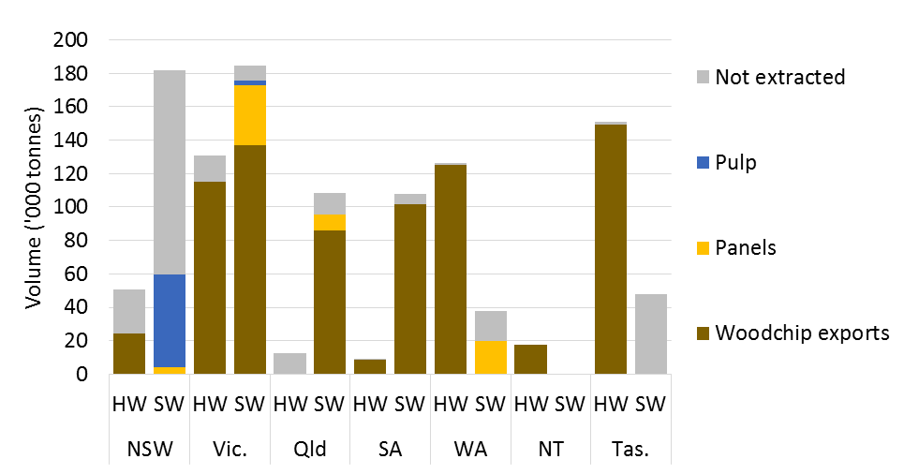

**HW** Hardwood. **SW** Softwood.

Note: ACT is included in NSW.

The estimated proportion of available high-quality harvest residues extracted for further use also varies across states/territories and forest types. Extraction rates for hardwood and softwood harvest residues combined are highest in the Northern Territory (100 per cent) followed by South Australia (94 per cent), Victoria (92 per cent), Western Australia (88 per cent), Queensland (79 per cent), Tasmania (75 per cent) and New South Wales (36 per cent).

Extraction rates for hardwood harvest residues tend to be higher in states/territories that harvest a higher volume of hardwood logs, with the exception of the Northern Territory where all high-quality hardwood harvest residues are extracted. For example, almost all high-quality hardwood harvest residues in Tasmania (99 per cent) and Western Australia (98 per cent) are extracted under the base case, and around 88 per cent of high-quality hardwood harvest residues in Victoria are extracted. These states already have the infrastructure required to process large volumes of hardwood pulplogs, so are able to process large volumes of high-quality harvest residues as well.

Similarly, extraction rates for softwood harvest residues tend to be higher in states that harvest a higher volume of softwood logs. For example, around 95 per cent of high-quality softwood harvest residues available for extraction in Victoria and South Australia are extracted, and 88 per cent of high-quality softwood harvest residues in Queensland are estimated to be extracted. New South Wales is an exception to this, where only around a third (33 per cent) of available high-quality softwood harvest residues are being extracted.

Most high-quality softwood harvest residues extracted for further use are exported as woodchips. However, this is not the case for New South Wales and Western Australia where all high-quality softwood harvest residues that are extracted are used in the production of pulp or wood-based panels.

#### Sawmill residues by state

The volume of sawmill residues generated varies across states and largely reflects the volume of logs processed by sawmills in those states. For example, sawmills in New South Wales, Victoria and Queensland are estimated to process the majority of logs harvested in 2050 and account for more than three-quarters of all sawmill residues (Figure 11).

The estimated utilisation rates for softwood sawmill residues in 2050 range from 91 per cent in Queensland to 100 per cent in Western Australia and South Australia. Estimated utilisation rates for hardwood sawmill residues range from 35 per cent in Queensland to 100 per cent in Western Australia and Tasmania. Utilisation rates for hardwood sawmill residues are lower than for softwood sawmill residues in all states except Western Australia and Tasmania, which are heavily geared towards the production of hardwood woodchips for export.

The allocation of sawmill residues to different end uses also varies across states according to wood-processing capacity and the geographical spread of sawmills. For example, around 70 per cent of all sawmill residues exported as woodchips come from sawmills in Victoria and South Australia, where there are a large number of softwood sawmills within an economically viable distance of softwood woodchip export facilities. Conversely, over 90 per cent of sawmill residues used in pulp production come from softwood sawmills in New South Wales, where the bulk of Australia’s pulp processing capacity is located. Similarly, most residues used in panel production come from sawmills in New South Wales (39 per cent), Queensland (35 per cent) and Western Australia (19 per cent). Wood pellet manufacturers draw on residues from sawmills in all states except the Northern Territory and briquette manufacturers draw on residues from all states except South Australia and the Northern Territory.

Figure 11 Production and use of sawmill residues in 2050, by state, base case

As described in text.
**HW** Hardwood. **SW** Softwood.

Note: NSW includes data for the ACT. Cogen - onsite refers to cogeneration at the sawmill site where residues where produced. Cogen - offsite refers to cogeneration at a sawmill site other than where the residues were produced.

### Production and use by sawmill type

ABARES estimates that softwood sawmills with input capacities of 100,000 cubic metres or more could produce 4.1 million tonnes of residues in 2050 from the processing of 8.6 million cubic metres of softwood sawlogs (Figure 12). This is estimated to be more than three-quarters (78 per cent) of all sawmill residues produced in 2050. Other softwood sawmills (including cypress pine and softwood pole plants) are estimated to produce around 564,000 tonnes of residues (10 per cent of all sawmill residues) from 1.2 million cubic metres of sawlogs processed. Hardwood sawmills (of all sizes) are estimated to produce 901,000 tonnes of residues (16 per cent of all sawmill residues) from processing 1.4 million cubic metres of hardwood sawlogs.

Figure 12 Production and use of sawmill residues in 2050, by source mill type, base case

As described in text.


Note: Softwood sawmills include pole plants. Cogen - onsite refers to cogeneration at the sawmill site where residues where produced. Cogen - offsite refers to cogeneration at a sawmill site other than where the residues were produced.

Total utilisation rates for sawmill residues differ across species and mill size (Figure 12). For example, almost all residues (98 per cent) from softwood sawmills with input capacities greater than 100,000 cubic metres are estimated to be used in 2050. In contrast, 84 per cent of residues from the smallest softwood sawmills (input capacities less than 50,000 cubic metres) and 64 per cent of residues from all hardwood sawmills are expected to be used. Cypress pine sawmills exhibit the lowest utilisation rates (19 per cent).

Sawmill utilisation rates are higher for larger sawmills, and in particular softwood sawmills, because these mills tend to be co-located with other wood-processing facilities, reducing transport costs. These mills are also more likely to have a kiln, allowing the burning of residues onsite to generate heat, offsetting the costs of purchasing gas. Sawmills with kilns may also invest in additional cogeneration technology to generate electricity for onsite use or sale to the electricity grid. Many medium and small sawmills do not have kilns and the ones that do are unlikely to have the economies of scale needed to make investment in cogeneration technology economically viable .As such, larger sawmills tend to have more options for using or selling the residues that they produce.

On average, having a kiln onsite reduces residue disposal rates for softwood sawmills (Figure 13). This is not the case for hardwood sawmills, where disposal rates for the smallest sawmills (input capacities less than 3,000 cubic metres) and largest sawmills (input capacities greater than 50,000 cubic metres) are estimated to be higher for sawmills with a kiln. However, only a handful of small and large hardwood sawmills have a kiln onsite. The specific location of these individual mills may make the sale of residues to downstream facilities unviable given transport costs or limited local processing capacity.

Figure 13 Use of sawmill residues in 2050, by source mill type and kiln ownership, base case

As described in text.

Note: Softwood sawmills include pole plants. Cogen - onsite refers to cogeneration at the sawmill site where residues where produced. Cogen - offsite refers to cogeneration at a sawmill site other than where the residues were produced.

### Residue use by end use

The allocation of wood residues to different uses at a national level (Figure 8 and Figure 9) depends on several factors. These include general factors such as final product prices, processing costs and recovery rates, as well as location-specific factors such as transport costs and capacity constraints. For this reason, the value of using residues varies by end use and location.

In this section, the estimated values of residues take into account extraction costs (for harvest residues), processing and handling costs, and final product prices. Transport and investment costs for new mills have been incorporated into the modelling framework but are not included in the reported estimates of value because they are location specific. As such, the estimated values represent upper bounds on the returns that can be achieved before transport costs are incurred, and after any required investment has taken place.

#### Heat and electricity

Burning sawmill residues onsite to offset heat and electricity use can significantly reduce operating costs. ABARES estimates that around 612,000 tonnes or 11 per cent of sawmill residues may be burned onsite for energy in 2050. In doing so, sawmills are able to substitute heat and electricity generated onsite for natural gas and electricity purchased from retailers.

ABARES estimates that residues burned onsite to generate heat and electricity for onsite use can be worth between $63 and $182 per tonne, reflecting the different moisture contents of different residue types and variations in electricity prices across states. For example, the most valuable residues as an input to cogeneration are shavings ($130–$183 per tonne) and sawdust ($101–$143 per tonne), which have typical moisture contents of 15 per cent and 30 per cent, respectively. However, these returns do not include the costs of investing in cogeneration technology, which can be substantial.

Most sawmills lack the economies of scale needed to make investment in cogeneration facilities economically viable. For example, of the 72 sawmills that have kilns and are expected to be operating in 2050, ABARES estimates that only 6 would invest in cogeneration technology (Figure 14).

Figure 14 Number of operating sawmills by kiln ownership and onsite residue use in 2050, base case

Sawmills with larger input capacities are more likely to have kilns. 
Of the sawmills that own kilns, the majority do not burn any residues for heat. 
A small number of sawmills burn residues just for heat and an even smaller number of sawmills with input capacities greater than 50,000 cubic metres could invest in cogeneration. 


Note: Figure includes new sawmills invested in before 2050.

Solid softwood offcuts are expected to be the most common type of residue used in cogeneration (341,000 tonnes) followed by softwood bark (229,000 tonnes). Only a relatively small amount of sawdust (51,000 tonnes) and shavings (16,000 tonnes) are estimated to be burned onsite for heat and electricity, despite being a better fuel source. This is because burning solid offcuts onsite allows sawdust and shavings to be used in other high-value applications (such as wood pellets) (see Section 3.4.2).

ABARES modelling suggests that sawmills that invest in cogeneration facilities could generate more than twice the amount of electricity needed onsite to meet operational requirements (Figure 15). Surplus electricity can be sold to the grid at wholesale electricity prices, which are much lower than the retail electricity prices paid by sawmills. As such, the returns to cogeneration drop significantly once onsite electricity needs are met. However, ABARES estimates that residues used to generate heat and surplus electricity are still worth between $26 and $65 per tonne, depending on the residue type.

Figure 15 Energy generation and use by sawmills that burn residues for heat and electricity in 2050, base case

Softwood sawmills with input capacities greater than 100,000 cubic metres, generated 2,600 GJ of energy from sawmill residues, with 500 GJ being in the form of electricity. Hardwood sawmills with input capacities greater than 50,000 cubic metres generated only around 250 GJ of heat and electricity and softwood sawmills with capacities between 50,000 to 100,000 cubic metres generated around 200 GJ of heat and electricity.

Note: Figure includes new sawmills invested in before 2050. Sawmills with smaller log input capacities than shown in this figure are not estimated to invest in cogeneration technology under the base case.

Burning residues to generate heat alone is profitable but far less so than many other applications. ABARES estimates that the value of burning residues to offset onsite heat use ranges from $7 to $22 per tonne, depending on the type of residue. This is typically lower than the returns to using residues to produce bioethanol, wood pellets or conventional wood products. As such, only 25,000 tonnes of residues are estimated to be burned onsite for just heat in 2050.

However, burning residues (particularly sawdust and shavings) heat but not electricity can be the best option for sawmills in regional areas once transport costs to other processors are taken into account. ABARES estimates that of the 72 sawmills operating with kilns in 2050, 15 could burn residues to generate heat alone. While these sawmills may have more than enough residues in total to cover their onsite heat needs (Figure 16), ABARES modelling suggests that only sawdust and shavings will likely be burned for heat because alternative uses provide a higher return for solid offcuts.

Figure 16 Heat generation and use by sawmills that burn residues for only heat in 2050, base case

Of the sawmills that burn residues just for heat, softwood sawmills with input capacities greater than 100,000 cubic metres generated the most energy (40 GJ), accounting for around half of their onsite heat requirements. 
Hardwood sawmills with input capacities between 3,000 and 5,000 cubic metres generated 29 GJ of heat, accounting for around a third of their total onsite heat requirements; and softwood sawmills with input capacities less than 50,000 cubic metres generated 8 GJ of heat, accounting for around half of their total onsite heat requirements. 
Other types of sawmills typically do not burn residues onsite, or do not burn residues onsite for just heat.


Note: No hardwood sawmills with log input capacities greater than 50,000 cubic metres, or less than 3,000 cubic metres, burn residues for only heat.

Based on ABARES assumptions, the value of burning residues in standalone biomass electricity plants ranges between $15 and $106 per tonne of sawmill residues and between $6 and $14 per tonne of harvest residues, depending on the type of residue. However, ABARES estimates that no investment in biomass electricity plants will be undertaken under the base case due to a combination of high capital costs and more valuable alternative uses.

#### Wood-based fuels

ABARES estimates that wood pellets could use around 796,000 tonnes or 14 per cent of sawmill residues in 2050. The value of using sawmill residues in wood pellet production is estimated to range between $4 and $102 per tonne. Shavings ($102 per tonne) and sawdust ($90 per tonne) are the most valuable inputs to pellet production because they require the least amount of drying and grinding. In contrast, solid offcuts ($4 per tonne) are the least valuable because of a higher moisture content and larger particles. The value of using harvest residues in pellet production is even lower, ranging between $17 and $3 per tonne, because of the additional costs of extraction. As such, no harvest residues are estimated to be used in wood pellet production.

Sawdust is estimated to be the most common residue type used in wood pellet production, accounting for around 68 per cent of all residue inputs to wood pellet production. The remaining inputs for wood pellet production are primarily shavings (24 per cent) and solid offcuts (7 per cent). The returns to using solid offcuts in wood pellet manufacturing are extremely low (around $4 per tonne), but new pellet mills tend to be located very close to large softwood sawmills. As a result, residues are often transported very short distances to be used in pellet production. This makes the use of use of solid offcuts economically viable (see Section 3.5).

Briquettes are estimated to use around 423,000 tonnes or 8 per cent of sawmill residues in 2050. The value of using sawmill residues in the production of briquettes is estimated to range between $18 and $72 per tonne, with shavings being the most valuable input ($72 per tonne), followed by sawdust ($61 per tonne) and solid offcuts and bark ($18 per tonne). Solid residues are a more valuable feedstock for briquette manufacturing compared with wood pellets, because the grinding and drying costs for briquette manufacturing are lower. The value of using harvest residues in pellet production is lower, ranging between $13 and $7 per tonne, because of the additional costs of extraction. As a result, only 6,000 tonnes of low-quality harvest residues are estimated to be used in briquette production in 2050.

Solid offcuts are estimated to account for around 62 per cent of all residue inputs to briquette production. The remaining inputs are made up of sawdust (18 per cent), shavings (9 per cent) and bark (11 per cent). Although solid offcuts are not the ideal residue input for briquette manufacturing (worth $18 per tonne), briquette manufactures are unlikely to be able to compete with pellet manufacturers for sawdust and shavings residues.

ABARES estimates that the value of sawmill residues used in bioethanol production could range between $30 and $84 per tonne, with shavings being the most valuable input ($84 per tonne) followed by sawdust ($44 per tonne) and solid offcuts ($18 per tonne). However, ABARES modelling suggests that there will be no investment in bioethanol refineries that use wood as a feedstock before 2050 once transport costs, capital costs and alternative uses are taken into account. Solid offcuts are more valuable as an input to briquette production ($30 per tonne) than bioethanol production ($18 per tonne) and sawdust and shavings are more valuable as inputs to wood pellet production ($90 and $102 per tonne) than bioethanol production ($44 and $84 per tonne). The capital costs per tonne of input capacity are also much higher for a new bioethanol refinery ($1.6 million per 1,000 tonnes) than that for a new wood pellet facility ($100,000 per 1,000 tonnes) or small-scale briquette equipment ($16,000 per 1,000 tonnes) (see Table A3 in Appendix A).

#### Conventional wood products

ABARES estimates that the manufacturing of Kraft and mechanical pulp could be one of the highest value conventional uses of residues, due to the high value added component of paper and paperboard products. For example, before transport costs, residues used to produce Kraft pulp can be worth up to $86 per tonne and residues used to produce mechanical pulp can be worth up to $102 per tonne. As a result, around 58,000 tonnes or 5 per cent of high-quality harvest residues and 609,000 tonnes or 11 per cent of solid sawmill offcuts are estimated to be used in the production of pulp in 2050.

After cogeneration and pulp production, woodchip exports and wood-based panel production are the most economically viable uses of harvest and solid sawmill offcuts. ABARES estimates that around 764,000 tonnes or 66 per cent of high-quality harvest residues and 1.9 million tonnes or 35 per cent of sawmill residues could viably be exported as woodchips in 2050. A further 69,000 tonnes or 6 per cent of high-quality harvest residues and 626,000 tonnes or 11 per cent of sawmill residues could also be used in wood-based panel production in 2050.

All types of solid sawmill offcuts (hardwood native, hardwood plantation and softwood) are expected to be exported as woodchips or used in panel production to some degree. Similarly, all types of high-quality harvest residues (hardwood native, hardwood plantation and softwood) are expected to be exported as woodchips. However, only high-quality harvest residues from softwood plantations are estimated to be used in the production of wood-based panels. This is because there is limited hardboard production in Australia (hardboard uses hardwood biomass only) and solid hardwood offcuts from sawmills are more profitable when the costs of extracting harvest residues are taken into account. Although it is more profitable to use residues in the production of wood-based panels, than it is to export them as woodchips, limited processing capacity in wood-based panel facilities and transport costs can make exporting residues as woodchips a more viable option.

### Transporting wood residues

Transport costs are a key determinant of the economic viability of using harvest or sawmill residues in downstream processing. Figure 17 shows the proportion of harvest and sawmill residues transported for further processing by residue type, species and distance. Figure 18 shows the proportion of residues transported by residue type, end use and distance in 2050. Distances of less than 5 kilometres are most commonly associated with onsite use in kilns and cogeneration but can also be associated with co-location with downstream processors.

Figure 17 Proportion of residues transported in 2050, by residue type and distance travelled, base case

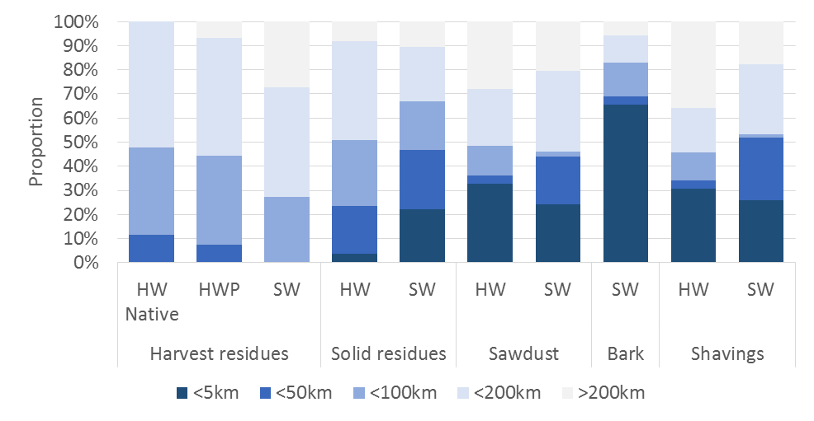

**HW** Hardwood. **HWP** Hardwood plantation. **SW** Softwood.

Note: Hardwood sawmills do not produce bark as logs are assumed to arrive debarked.

Under the base case, ABARES estimates that it may be economically viable to transport high-quality softwood harvest residues further than 200 kilometres, with around 27 per cent of extracted high-quality softwood harvest residues being transported more than 200 kilometres under the base case. In contrast, ABARES estimates that harvest residues extracted from hardwood plantation and hardwood native forests are likely to be transported much shorter distances, with only 7 per cent of extracted hardwood plantation residues and no hardwood native harvest residues estimated to be transported further than 200 kilometres. Native harvest residues are more costly to extract, making long distance transport economically unviable. Hardwood plantation harvest residues can be transported long distances but this is unnecessary in many cases because most hardwood plantations are typically established within close proximity to woodchip export facilities.

Figure 18 Proportion of residues transported in 2050, by end use and distance travelled, base case

As described in text.


**HW** Hardwood. **SW** Softwood.

Note: Hardwood sawmills do not produce bark as logs are assumed to arrive debarked.

Sawmill residues tend to be transported shorter distances than harvest residues because of the higher proportion of onsite use and co-location with downstream users of residues. Despite this, ABARES found that it may still be economically viable for some residues to be transported distances over 200 kilometres. For example, ABARES estimates that around 12 per cent of softwood sawmill residues that are used, and 15 per cent of hardwood sawmill residues that are used, are transported more than 200 kilometres for further processing in 2050.

When sawmill residues are transported further than 5 kilometres, softwood residues tend to be moved shorter distances than hardwood residues. This is because softwood sawmills tend to be co-located with downstream processing facilities, such as wood-based panel or pulp and paper mills, and hardwood sawmills are more dispersed. Another reason is that a larger proportion of softwood sawmills have kilns onsite, while many hardwood sawmills have to send their residues to other wood-processing facilities for further use.

On average, sawdust, bark and shavings tend to be transported shorter distances than solid offcuts because they are primarily used to generate heat or electricity onsite. However, sawdust and shavings used in the production of wood pellets can be transported long distances—more than 26 per cent of shavings used in wood pellet production are transported further than 200 kilometres. In contrast, solid offcuts used in the production of wood pellets are only transported less than 5 kilometres because ABARES estimates that further distances would not be economically viable.

Under the base case, bark is estimated to primarily be used as an onsite energy source for kiln heat and electricity (cogeneration). While most residues used in kilns will likely be sourced onsite, ABARES modelling suggests that a large proportion of bark burned in kilns could be used in offsite kilns. Furthermore, transporting these residues some distance may be profitable. For example, ABARES estimates that 16 per cent of bark residues burned in kilns may be transported further than 100 kilometres and a further 6 per cent may be transported further than 200 kilometres. However, this represents a very small volume of residues and the circumstances that make this an optimal use of bark are unlikely to be common in practice.

## Sensitivity analysis

Estimates of the supply and use of harvest and sawmill residues under the base case are highly dependent on a range of assumptions that affect the value of residues as an input to downstream manufacturing activities. The analyses presented in this section provide insights into the potential impacts of changes in prices for selected products on the supply and use of harvest and sawmill residues.

The scenarios considered in this section are summarised in Table 12. Each scenario considers a 25 per cent increase in the price of a final product that heavily uses harvest or sawmill residues. These include woodchips for export, wood pellets, briquettes, bioethanol and wholesale electricity. Summary results for the base case and five scenarios are presented in Figure 19 and detailed results are presented in Appendix B.

Table 12 Scenario assumptions

|  |  |  |
| --- | --- | --- |
| Scenario | Base case price assumption | Scenario assumption |
| 25 per cent increase in woodchip prices | Softwood woodchips = $160/bdt  HW Plantation woodchips = $175/bdt  HW Native woodchips = $158/bdt | Softwood woodchips = $192/bdt  HW Plantation woodchips = $210/bdt  HW Native woodchips = $190/bdt |
| 25 per cent increase in wood pellet prices | $200 per tonne | $240 per tonne |
| 25 per cent increase in briquette prices | $120 cents per tonnes | $150 per tonne |
| 25 per cent increase in bioethanol prices | $0.60 cents per litre | $0.72 per litre |
| 25 per cent increase in wholesale electricity prices | $28 per GJ or 10.1 cents per kWh | $33.60 per GJ or 12.1 cents per kWh |

**bdt** Bone dry tonnes. **GJ** Gigajoules. **HW** Hardwood. **kWh** Kilowatt hours.

Changes in the prices of final products that use residues will ultimately affect the value of residues as a feedstock to those products. To maximise the value of the wood resource, this will necessitate a reallocation of residues to different uses. In the simplest case this may involve a single forest grower or sawmill operator redirecting residues to an alternative market or downstream user. However, changes in the relative value of residues can have more complex and indirect effects on the allocation of logs and residues. For example, sawlogs can be redirected to different mills based on the value of the residue by-products produced or specific location, which can have implications for investment. The results presented in this section are for the industry as a whole and capture both the direct and indirect effects of price changes.

Figure 19 Supply and use of harvest and sawmill residues in 2050, by end use, various scenarios

A 25 per cent increase in the price of a particular wood product, tends to increase the volume of residues utilised by that application. In the case of harvest residues, this typically comes about through a reduction in the volume of harvest residues left in forest. In the case of sawmill residues, this typically comes about through a reduction in the volume of sawmill residues used in alternative applications.

Note: Negative values in the bottom half of the figure are associated with decreases in volumes, relative to the base case. The sum of all positive and negative values gives the total change in volume of harvest residues available for extraction and sawmill residues produced.

### Higher woodchip prices

Under current conditions woodchips are estimated to account for the largest share of harvest and sawmill residues. For this reason, changes in woodchip prices could have significant impacts on the volume of residues produced and used. Based on ABARES assumptions, a 25 per cent increase in woodchip prices could raise the potential value of exporting residues as woodchips by between $19 and $21 per tonne, resulting in redirecting residues away from other uses to woodchip exports. However, it can also effect the volume of logs harvested and therefore the volume of harvest residues available for extraction.

#### Harvest residues

ABARES estimates that a 25 per cent increase in woodchip export prices could increase the total volume of logs harvested in 2050 by 803,000 cubic metres, resulting in an additional 35,000 tonnes of high-quality harvest residues and 108,000 tonnes of low-quality harvest residues being available for extraction.

The volume of high-quality harvest residues actually extracted in 2050 is estimated to increase by 69,000 tonnes, which is more than the additional volume of harvest residues becoming available. This is because around 34,000 tonnes of harvest residues that were previously left in forest under the base case become viable to extract under higher woodchip prices.

The volume of high-quality harvest residues exported as woodchips is estimated to increase by 92,000 tonnes (12 per cent more than the base case), which is around 23,000 tonnes more than the increase in high-quality harvest residues extracted (Figure 20). This implies that around 23,000 tonnes of high-quality harvest residues that were previously used in other applications under the base case will be redirected to woodchip exports instead.

Figure 20 Changes in use of harvest residues in 2050 due to a 25 per cent increase in the price of woodchips, by forest type

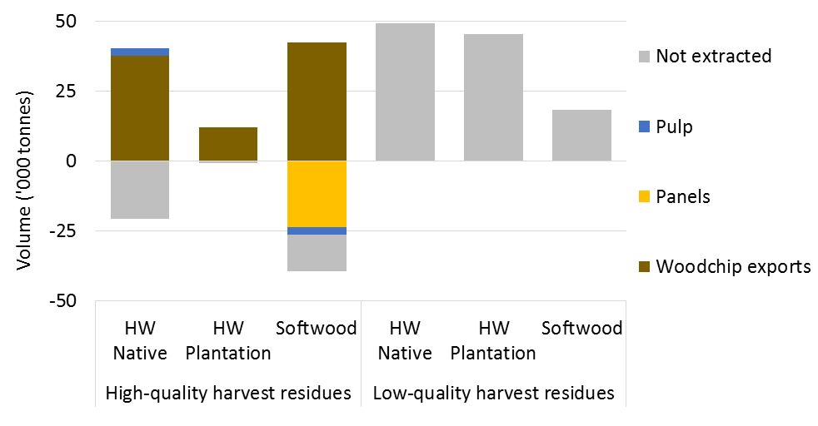

**HW** Hardwood.

Note: Negative values are associated with decreases in volumes, relative to the base case. The sum of all positive and negative values for each residue type gives the total change in volume of harvest residues available for extraction.

Of the 92,000 tonnes of additional high-quality harvest residues exported as woodchips, around 50,000 tonnes (54 per cent) are estimated to come from hardwood native and hardwood plantation harvesting operations and 42,000 tonnes (46 per cent) are estimated to come from softwood plantations. The additional hardwood harvest residues exported as woodchips were primarily left in forest, or were not available for extraction, under the base case (due to a lower log harvest). In contrast, the additional softwood harvest residues exported as woodchips were either left in forest or used in wood-based panel production under the base case.

Higher woodchip prices are estimated to have very little effect on the volume of low-quality harvest residues extracted because they do not meet the specifications to be exported as woodchips. As such, almost all of the additional low-quality harvest residues that become available are not extracted.

#### Sawmill residues

ABARES estimates that a 25 per cent increase in woodchip prices could increase the volume of sawmill residues produced in 2050 around 87,000 tonnes, due to an increase in the volume of logs processed by sawmills.

While the total volume of sawmill residues used is estimated to increase by only around 14,000 tonnes the total volume of sawmill residues exported as woodchips is estimated to increase by around 121,000 tonnes. This implies that around 108,000 tonnes of sawmill residues are redirected from other uses to woodchip exports.

Of the 121,000 tonnes of additional sawmill residues exported as woodchips in 2050, around 101,000 tonnes (84 per cent) are estimated to come from softwood sawmills and 20,000 tonnes (16 per cent) from hardwood sawmills (Figure 21). Most of the additional hardwood sawmill residues exported as woodchips in 2050 were previously disposed of, or used to produce briquettes, under the base case. In contrast, ABARES also found that most of the additional softwood sawmill residues exported as woodchips were originally burned onsite for energy, or used to produce briquettes, under the base case.

ABARES modelling suggests that increases in woodchips prices could also increase the volume of sawmill residues used to produce products other than woodchips. For example, a 25 per cent increase in woodchip prices is estimated to increase the volume of sawmill residues used in wood-based panel production by 97,000 tonnes (11 per cent more than the base case), partially offsetting a reallocation of pulplogs from wood-based panels to woodchip exports. The volume of residues used in pulp production was also estimated to increase by around 62,000 tonnes (9 per cent more than the base case) due to an increase in production of softwood sawmill residues. The volume of residues (mostly sawdust and shavings) used in wood pellet production is estimated to increase by 53,000 tonnes (7 per cent more than the base case). Most of the additional residues used in wood pellet production would otherwise have been used to produce briquettes. However, due to the increased value of woodchips relative to briquettes, less investment in briquette facilities is expected (see Table B3 and Figure B1 in Appendix B). These results highlight the inherent complexity in the Australian forest and wood processing industry and how seemingly disconnected parts of the industry are in fact linked.

Figure 21 Changes in the production and use of sawmill residues in 2050 from the base case due to a 25 per cent increase in the price of woodchips

As described in text.

Note: Negative values are associated with decreases in volumes, relative to the base case. The sum of all positive and negative values for each mill types gives the total change in volume of sawmill residues produced.

### Higher wood pellet prices

Under the base case, wood pellet manufacturing was the largest application of sawdust and shavings residues. ABARES estimates that a 25 per cent increase in wood pellet prices could raise the value of residues in wood pellet production by between $28 and $47 per tonne. This could have implications for other major users of these residues such wood-based panels or briquettes, as well as for the extraction of low-quality harvest residues that were not used under the base case.

#### Harvest residues

ABARES estimates that a 25 per cent increase in the price of wood pellets would likely have a negligible impact on the volume of harvest residues available for extraction in 2050. However, the volume of harvest residues actually extracted in 2050 is estimated to increase substantially, with an additional 34,000 tonnes of high-quality harvest residues and an additional 1.4 million tonnes of low-quality harvest residues being extracted. This implies that almost all of the additional harvest residues extracted were previously available for extraction but left in forest under the base case.

The volume of harvest residues used in wood pellet manufacturing is estimated to increase by around 1.4 million tonnes, roughly equal to the total volume of additional harvest residues extracted (Figure 22). As such, there is minimal reallocation of harvest residues away from other uses to wood pellet manufacturing.

Of the 1.4 million tonnes of additional low-quality harvest residues extracted, around 764,000 tonnes (56 per cent) are estimated to come from hardwood plantations and the remaining 609,000 tonnes (46 per cent) from softwood plantations. ABARES estimates that no hardwood native harvest residues are used in the production of wood pellets in 2050, even under higher pellets prices. This is because of the additional costs associated with extracting native harvest residues.

Figure 22 Changes in the extraction and use of harvest residues in 2050 from the base case due to a 25 per cent increase in wood pellet prices, by forest type

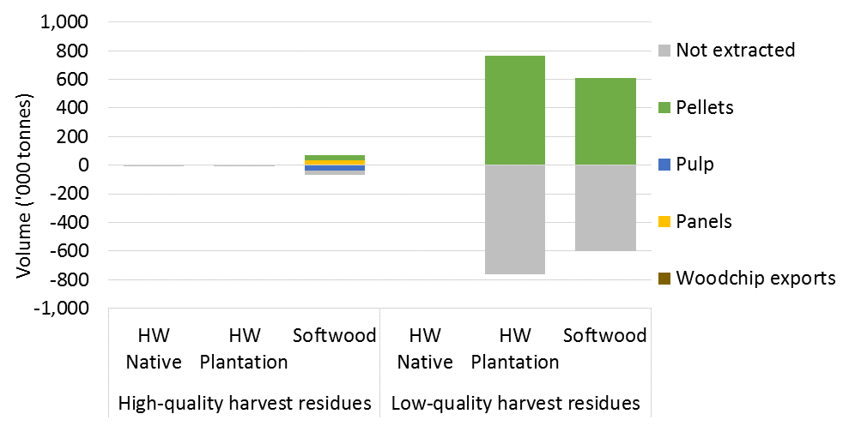

**HW** Hardwood.

Note: Negative values are associated with decreases in volumes, relative to the base case. The sum of all positive and negative values for each residue type gives the total change in volume of harvest residues available for extraction.

Higher pellet prices are estimated to have little impact on the volume of high-quality harvest residues extracted for wood pellets because woodchip exports are still a higher value use of these residues.

#### Sawmill residues

ABARES estimates that a 25 per cent increase in wood pellet prices would likely have a negligible impact on the volume of sawmill residues produced in 2050. While the total volume of sawmill residues used is also estimated to increase only slightly (10,000 tonnes) the total volume of sawmill residues used to produce wood pellets is estimated to increase by 344,000 tonnes (Figure 23). This implies that around 343,000 tonnes of sawmill residues are redirected from other uses to wood pellet manufacturing as a result of higher wood pellet prices.

Of the 344,000 tonnes of additional sawmill residues used in wood pellet production in 2050, around 317,000 tonnes (92 per cent) are estimated to come from softwood sawmills with input capacities greater than 100,000 cubic metres. These additional residues were originally used to produce briquettes under the base case.

Figure 23 Changes in production and use of sawmill residues in 2050 from the base case due to a 25 per cent increase in wood pellet prices by sawmill type and size

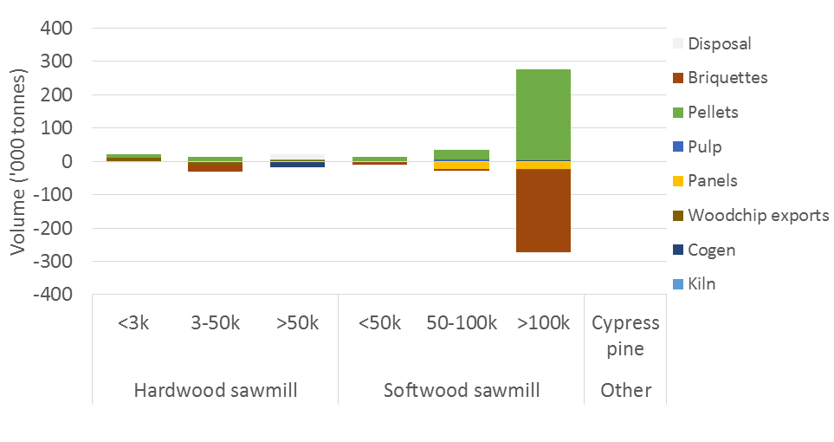

Note: Negative values are associated with decreases in volumes, relative to the base case. The sum of all positive and negative values for each mill types gives the total change in volume of sawmill residues produced.

### Higher briquette prices

Wood briquettes are estimated to primarily use solid sawmill residues under the base case, competing against more conventional uses such as woodchip exports, pulp and wood-based panels for these residues. However, briquette producers are also expected to compete with pellet manufacturers for sawdust and shavings, which are the ideal input to briquette manufacturing. A 25 per cent increase in briquette prices is estimated to increase the value of residues used in briquette manufacturing by between $17 and $23 per tonne. This could have implications for the use of residues in conventional wood products such as woodchips, pulp or panels and also for the use of residues in other wood-based fuels such as pellets.

#### Harvest residues

ABARES estimates that a 25 per cent increase in briquette prices would likely have a negligible impact on the volume of harvest residues available for extraction in 2050. However, the volume of harvest residues actually extracted from forests in 2050 is estimated to increase substantially, with an additional 10,000 tonnes of high-quality harvest residues and 605,000 tonnes of low quality harvest residues being extracted. These additional residues are almost exclusively used in briquette production (Figure 24). Similar to the higher pellet price scenario, this implies that almost all of the additional harvest residues extracted were previously available for extraction but left in forest under the base case. It also means that there is minimal reallocation of harvest residues away from other uses to briquette manufacturing.

Of the 605,000 tonnes of additional low-quality harvest residues used in briquette production, around 353,000 tonnes (58 per cent) are estimated to come from hardwood plantations and the remaining 251,000 tonnes (42 per cent) from softwood plantations. Almost all of these additional low-quality harvest residues used in briquette production were originally left in forest under the base case. ABARES estimates that no hardwood native harvest residues are used in the production of briquettes in 2050, even under higher briquette prices, due to the higher extraction costs.

Figure 24 Changes in extraction and use of harvest residues in 2050 from base case to high briquette price scenario, by forest type

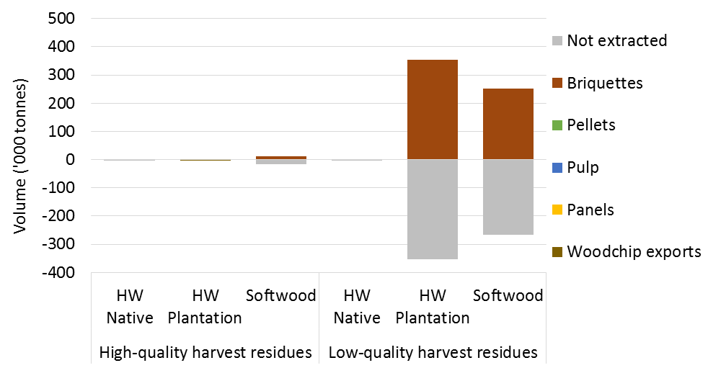

**HW** Hardwood.

Note: Negative values are associated with decreases in volumes, relative to the base case. The sum of all positive and negative values for each residue type gives the total change in volume of harvest residues available for extraction.

#### Sawmill residues

ABARES estimates that a 25 per cent increase in briquette prices could reduce the total volume of sawmill residues produced in 2050 by around 76,000 tonnes, due to a reduction in the volume of logs processed by sawmills. This reduction in the volume of logs processed is primarily due to less investment in new wood pellet facilities and subsequent reduction in investment in new softwood sawmills that relied on sales of their residues to these wood pellet facilities to be profitable. Although this is a relatively small decrease in the total volume of sawmill residues produced, it serves to highlight the potentially important impact of residue markets on the profitability of Australian sawmills.

While the total volume of sawmill residues used in 2050 is also estimated to fall (by around 85,000 tonnes) the volume of sawmill residues used in briquette production is estimated to increase by 249,000 tonnes (Figure 25). This implies that around 164,000 tonnes of sawmill residues are redirected from other uses to briquette manufacturing as a result of higher briquette prices.

Of the 249,000 tonnes of additional sawmill residues used in briquette production, around 179,000 tonnes (72 per cent) are estimated to come from softwood sawmills and 69,000 tonnes (28 per cent) from hardwood sawmills. These additional sawmill residues are comprised almost entirely of sawdust and shavings that otherwise would have been used to produce wood pellets (see Table B5 and Table B3 in Appendix B). This suggests that if briquette prices increase briquette manufacturers may be able to outcompete some wood pellet manufacturers for sawdust and shavings.

Figure 25 Changes in production and use of sawmill residues in 2050 from base case to high briquette price scenario, by source mill type

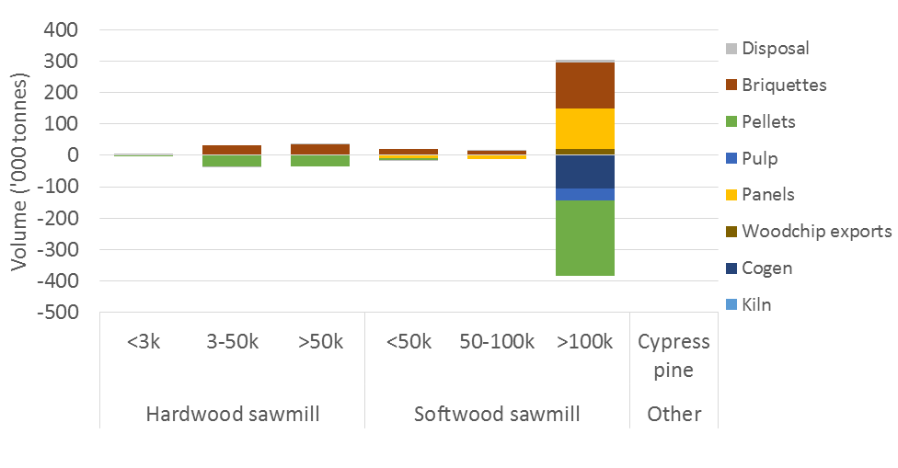

Note: Negative values are associated with decreases in volumes, relative to the base case. The sum of all positive and negative values for each mill types gives the total change in volume of sawmill residues produced.

Increases in briquette prices were also found to have an effect on the volume of sawmill residues used in wood-based panel production and burned onsite for energy. For example, a 25 per cent increase in briquette prices reduced the total volume of sawmill residues burned onsite for energy by around 105,000 tonnes (49 per cent less than the base case) and increased the volume of residues used in wood-based panel production by around 109,000 tonnes (17 per cent more than the base case). This reallocation occurs because of a reduction in investment in cogeneration facilities by some sawmills as a result of a lower volume of logs being processed and smaller volume of sawmill residues being available for burning. This further highlights the inherent complexities in the Australian forest and wood processing sector and how specific producers may be affected in unforeseen ways as a result of changed market conditions.

### Higher bioethanol prices

Under the base case, no investment in bioethanol processing facilities is estimated. However, ABARES estimates that a 25 per cent increase in bioethanol prices could increase the value of residues used to produce bioethanol by between $60 and $102 per tonne. ABARES found that this could be sufficient to encourage investment in bioethanol facilities that use wood as a feedstock. However, other biomass materials (such as sugar cane) could be more economically viable feedstocks to bioethanol production in some regions.

#### Harvest residues

ABARES estimates that a 25 per cent increase in bioethanol prices would likely have a negligible impact on the volume of harvest residues available for extraction in 2050. The volume of high-quality harvest residues actually extracted in 2050 is also unaffected by higher bioethanol prices and the volume of low-quality harvest residues extracted is estimated to increase only slightly (10,000 tonnes). All of the additional low-quality harvest residues extracted are expected to come from hardwood native forests and be used in bioethanol production (Figure 26). These residues were all available for extraction under the base case but were not economically viable to extract.

Figure 26 Changes in extraction and use of harvest residues in 2050 from base case to high bioethanol price scenario, by forest type

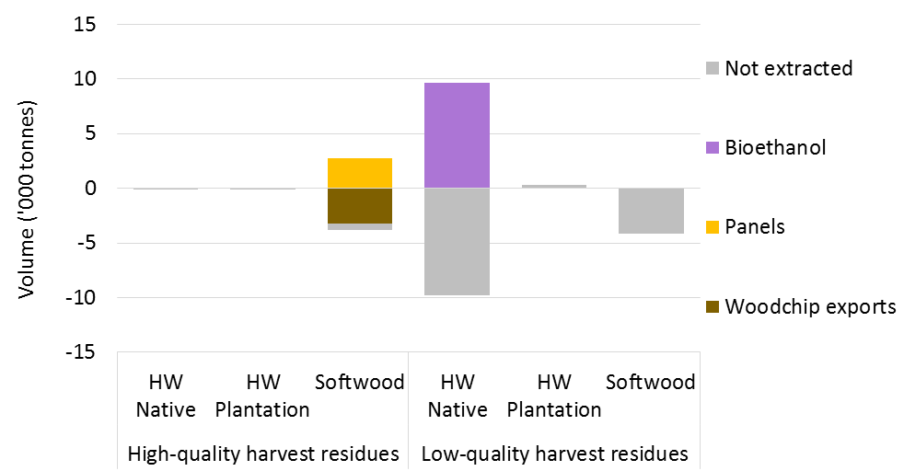

**HW** Hardwood.

Note: Negative values are associated with decreases in volumes, relative to the base case. The sum of all positive and negative values for each residue type gives the total change in volume of harvest residues available for extraction.

#### Sawmill residues

ABARES estimates that a 25 per cent increases in bioethanol prices would likely have a negligible impact on the volume of sawmill residues produced in 2050. While the total volume of sawmill residues used is estimated to increase by around 42,000 tonnes, the volume of sawmill residues used in bioethanol production is estimated to increase by 294,000 tonnes (Figure 27). This implies that around 252,000 tonnes of sawmill residues are redirected from other uses to bioethanol production.

Of the 294,000 tonnes of sawmill residues used in bioethanol production, around 199,000 tonnes (67 per cent) are estimated to come from softwood sawmills with input capacities greater than 100,000 cubic metres. These residues were primarily used to produce wood pellets or exported as woodchips under the base case. However, some residues are also drawn from hardwood sawmills that otherwise would have been used in wood pellet production, burned onsite for energy or disposed of as waste. These results suggest that higher bioethanol prices could have a positive impact on the profitability of hardwood sawmills through a reduction in residue disposal rates for these sawmills.

Bioethanol refineries are estimated to use around 117,000 tonnes of sawdust, 106,000 tonnes of shavings and 31,000 tonnes of solid offcuts (see Table B4 and Table B6 in Appendix B). The sawdust and shavings used in bioethanol production were previously used in wood pellet production under the base case. As such, a 25 per cent increase in bioethanol prices could enable bioethanol producers to outcompete wood pellet manufacturers for sawdust and shavings.

Figure 27 Change in sawmill residue use in 2050 from base case to high bioethanol price scenario, by source mill type

As described in text. Note: Negative values are associated with decreases in volumes, relative to the base case. The sum of all positive and negative values for each mill types gives the total change in volume of sawmill residues produced.

Increases in bioethanol prices were also found to result in a reallocation of solid sawmill offcuts from woodchip exports to pulp production. This arises because an increase in bioethanol prices was found to result in a reallocation of logs from sawmills near woodchip export facilities to those near new bioethanol plants and, by coincidence, pulp mills.

### Higher wholesale electricity prices

Under the base case assumptions, ABARES estimated that no investment in biomass electricity power plants would be made by 2050. ABARES estimates that a 25 per cent increase in wholesale electricity prices could increase the value of burning residues onsite for heat and electricity by between $7 and $13 per tonne and the value of burning residues in standalone biomass electricity plants by between $23 and $45 per tonne. ABARES found that these increases could be sufficient to encourage investment in biomass electricity power plants that use wood as a feedstock.

#### Harvest residues

ABARES estimates that a 25 per cent increase in wholesale electricity prices would likely have a negligible impact on the volume of harvest residues available for extraction in 2050. ABARES modelling also suggests that the volume of high-quality harvest residues extracted in 2050 is unlikely to be affected by an increase in wholesale electricity prices.

However, the volume of low-quality harvest residues extracted could increase by around 19,000 tonnes. Of this, 17,000 tonnes is expected to be used to generate electricity in biomass electricity plants and 2,000 being used in briquette production (Figure 28). Of the low-quality harvest residues used by biomass electricity plants, 14,000 tonnes are estimated to come from softwood plantations and the remainder (3,000 tonnes) from hardwood plantations. These residues were left in forest under the base case because extracting them was not economically viable. In contrast, no harvest residues from native forests are estimated to be used by biomass electricity plants due to the higher costs of extraction.

Figure 28 Changes in production and use of harvest residues in 2050 from base case to high wholesale electricity price scenario, by forest type

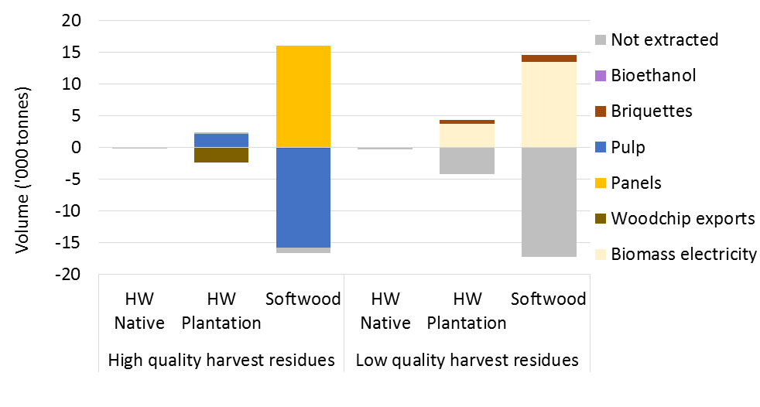

**HW** Hardwood.

Note: Negative values are associated with decreases in volumes, relative to the base case. The sum of all positive and negative values for each residue type gives the total change in volume of harvest residues available for extraction.

Increases in wholesale electricity prices were also found to result in a reallocation of 16,000 tonnes of high-quality softwood harvest residues from pulp production to wood-based panel production. This partially offsets a redirection of sawmill residues away from panels to biomass power plants.

Increases in wholesale electricity prices were also found to have an effect on the volume of sawmill residues used in pulp and wood-based panel production. For example, a 25 per cent increase in wholesale electricity prices resulted in around 16,000 tonnes of residues that were previously used in pulp production being redirected to wood-based panels. This reallocation occurs because of a redirection of sawmill residues away from panels to biomass power plants (see section 4.5.2). This is another example of how complex the Australian forest and wood processing sector can be and how specific producers may be impacted in unforeseen ways as a result of changes in market conditions.

#### Sawmill residues

ABARES estimates that a 25 per cent increase in wholesale electricity prices would likely have a negligible impact on the volume of sawmill residues produced in 2050. However, the total volume of sawmill residues used in 2050 is estimated to increase by 193,000 tonnes, implying that most of these residues would otherwise have been disposed of under the base case.

The total volume of sawmill residues used in biomass power plants is estimated to be around 503,000 tonnes (Figure 29), suggesting that around 310,000 tonnes of sawmill residues are redirected away from other uses to biomass power plants. Of the sawmill residues used in biomass power plants in 2050, around 306,000 tonnes (61 per cent) are estimated to come from softwood sawmills and 197,000 tonnes (39 per cent) from hardwood native sawmills.

Figure 29 Change in sawmill residue use in 2050 from base case to high wholesale electricity price scenario, by source mill type

As described in text.

Note: Negative values are associated with decreases in volumes, relative to the base case. The sum of all positive and negative values for each mill types gives the total change in volume of sawmill residues produced.

ABARES estimates that biomass electricity plants will likely primarily draw on residues from larger softwood sawmills (input capacities greater than 100,000 cubic metres) that otherwise would have been used to produce wood pellets or briquettes under the base case (Figure 29). This suggests that, under the right market conditions, biomass electricity plants could outcompete wood pellet and briquette manufacturers for sawmill residues.

In contrast, ABARES estimates that the residues drawn from hardwood sawmills would have primarily been disposed of as waste under the base case. This suggests that increases in wholesale electricity prices could have a greater impact on the profitability of hardwood sawmills through reductions in residue disposal.

Around 246,000 tonnes, or half of the sawmill residues used in biomass electricity plants, are estimated to be sawdust (246,000 tonnes) with the remainder made up of solid offcuts (115,000 tonnes), shavings (89,000 tonnes) and bark (52,000 tonnes). Sawdust and shavings are the ideal biomass feedstock for biomass power plants due to lower processing costs.

Higher wholesale electricity prices were also found to increase the volume of residues burned onsite for energy. For example, a 25 per cent increase in wholesale electricity prices are estimated to increase the volume of sawmill residues burned onsite for energy by 114,000 tonnes or 18 per cent relative to the base case. In some cases this is due to sawmills retaining residues that otherwise would have been sold to downstream processors. In other cases it is due to investment in cogeneration technology that was previously economically unviable at lower wholesale electricity prices.

## Conclusion

Little is known about the current production and use of harvest and sawmill residues in Australia. Based on current log harvest and sawmill production, ABARES estimates that around 6.5 million tonnes of harvest residues and 5.2 million tonnes of sawmill residues could have been produced in 2016–17. As such, harvest and sawmill residues represent a substantial wood resource. The efficient use of these residues is essential to maintaining the competitiveness and sustainability of the Australian forest industry.

This report presented estimates of the potential production and use of harvest and sawmill residues in Australia in 2050. The results highlight future market opportunities that may be available to forest growers and sawmill operators for using or selling on their residues. Potential downstream users of wood residues can also take note of these opportunities.

ABARES considered a number of competing potential uses of wood residues, some of which are currently in operation and others that are not. Conventional wood products made from wood residues include export grade woodchips, pulp (for paper production or export) and wood-based panels. Alternative uses of wood residues include wood-based fuel products such as bioethanol, wood pellets and briquettes and the direct combustion of wood residues for generation of heat or electricity.

### Harvest and sawmill residues will be a substantial resource

ABARES estimates that around 5.6 million tonnes of harvest residues could be available for extraction in 2050, comprising 1.2 million tonnes of high-quality harvest residues (woodchip grade) and 4.4 million tonnes of low-quality harvest residues. These volumes represent a substantial resource compared with the 14.8 million cubic metres of pulp logs estimated to be harvested in 2050.

Most high-quality harvest residues are estimated to be exported as woodchips or used to produce wood-based panels or pulp. However, ABARES estimates that the extraction of low-quality harvest residues (suitable for particleboard, wood-based fuels and burning onsite for energy) is either economically unviable or offers inferior returns compared with using other types of residues (such as sawmill residues).

ABARES also estimates that 5.6 million tonnes of sawmill residues could be produced in Australia in 2050. This is a significant resource compared with the 14.8 million cubic metres of pulplogs expected to be harvest. Based on ABARES modelling, only a small proportion of sawmill residues are likely to be waster, with around 5.0 million tonnes or 90 per cent of sawmill residues expected to be used in 2050.

The largest softwood sawmills are expected to produce most of Australia’s sawmill residues. However, these sawmills are also estimated to sell, or use onsite, almost all of their residues. This is because these mills are more likely to have the economies of scale needed to make investment on onsite cogeneration technology economically viable, and they are also more likely to be co-located with downstream processors, reducing transport costs.

### Residues could be used in a range of applications

Conventional wood products such as woodchip exports, wood-based panels and pulp are estimated to account for the majority of harvest and sawmill residues used in 2050. Woodchip exports are expected to use up to two-thirds of all high-quality harvest residues and over one-third of all sawmill residues available in 2050. Pulp and wood-based panels are estimated to use around 11 per cent of all high-quality harvest residues and 22 per cent of all sawmill residues produced in 2050.

Wood-based fuel products, which include wood pellets and briquettes, are also estimated to account for a significant share of sawmill residues used in 2050. These applications are estimated to use more than two-thirds of all sawdust and shavings residues due to lower processing costs and fewer alternative uses.

Burning sawmill residues onsite to offset heat and electricity use can significantly reduce operating costs. However, sawmills typically produce more than enough residues to meet their electricity needs, at which point alternative uses of residues become more competitive. As such, only a small proportion of sawmill residues are burned onsite.

Under current market conditions, ABARES modelling suggests that investment in biofuel refineries and standalone biomass electricity plants fuelled by wood residues are economically unviable once transport costs, capital costs and alternative uses are taken into account.

The allocation of wood residues to these different uses reflects the relative values of wood residues as a feedstock to various products. However, regional-specific factors such as transport costs and capacity constraints also play an important role. Sawmill residues are the preferred feedstock in many cases because they do not incur the same extraction or transport costs as harvest residues. Processing costs for sawmill residues, such as sawdust and shavings, can also be lower due to the smaller particle sizes and lower moisture content.

### Changes in market conditions could create new opportunities

ABARES also estimated the potential production and optimal use of wood residues under a range of alternative scenarios based on selected wood product prices. These scenarios highlight potential future opportunities under different future economic conditions as well as potential competition between users of wood residues.

With the vast majority of sawmill residues expected to be used in 2050, changes in relative prices highlighted potential future competition between users of residues. In particular, sawdust and shavings residues will likely be highly sought after because they are less costly to process and have a higher energy content per tonne. This makes them the ideal feedstock to many wood-based energy products. In contrast, low-quality harvest residues are estimated to be largely unused and represent a large source of potential residues for wood pellet and briquette producers if market conditions were to improve.

The findings from this analysis also highlighted the inherent complexity of the Australian forest and wood processing industry—changes in market conditions often have unexpected effects on seemingly disconnected parts of the industry. For example, increases in woodchip and briquette prices were found to result in a larger volume of sawmill residues being used to produce wood-based panels. Similarly, increases in bioethanol prices increased the volume of residues used in pulp production. These unexpected impacts were primarily the result of a reallocation of sawlogs between sawmills to take advantage of proximity to particular downstream users. These findings further highlight the important role that residue markets can play in the profitability of Australian sawmills.

Finally, ABARES found that some products that are not expected to be economically viable under current prices could be viable under moderate improvements to those prices. In particular, increases in bioethanol and wholesale electricity prices, of 25 per cent, could make investment in bioethanol refineries and biomass electricity plants economically viable by 2050. These facilities could use large volumes of sawmill residues and potentially pay more for these residues than wood pellet manufacturers or even woodchip exporters.

## Appendix A: Infrastructure inputs

Table A1 Modelled wood-processing capacity in Australia—sawmill and post and pole plants, 2014–15

|  |  |  |  |  |  |  |  |  |
| --- | --- | --- | --- | --- | --- | --- | --- | --- |
| Jurisdiction | Hardwood sawmill | | Softwood sawmill | | Cypress pine sawmill | | Post and pole plants | |
| **No. of mills** | **Input capacity (’000 m3)** | **No. of mills** | **Input capacity (’000 m3)** | **No. of mills** | **Input capacity (’000 m3)** | **No. of mills** | **Input capacity (’000 m3)** |
| New South Wales | 63 | 772 | 14 | 2,869 | 4 | 48 | 3 | np |
| Victoria | 28 | 612 | 12 | 1,477 | – | – | 7 | 163 |
| Queensland | 48 | 281 | 17 | 1,859 | 15 | 127 | 3 | np |
| South Australia | – | – | 13 | 1,750 | – | – | 1 | np |
| Western Australia | 15 | 205 | 3 | np | – | – | 3 | np |
| Tasmania | 35 | 362 | 4 | 469 | – | – | 2 | np |
| Australia **a** | 189 | 2,232 | 63 | 8,424 | 19 | 175 | 19 | 163 |

**a** Total does not include capacities of jurisdictions with small numbers of processors. **np** Not provided. Data for jurisdictions with small numbers of processors are included in modelling analysis but have not been provided in the table. Data in table represent mills (and their capacities) that operated or were closed but may reopen in the future.

Note: Modelling analysis presented in this report considered all such mills as available for processing logs and residues.

Table A2 Modelled wood-processing capacity in Australia—panels, paper and paperboard, pulp and log and woodchip exports, 2014–15

|  |  |  |  |  |  |  |  |  |
| --- | --- | --- | --- | --- | --- | --- | --- | --- |
| Jurisdiction | Wood-based panels | | Paper and paperboard | | Pulp | | Log and woodchip exports b | |
| **No. of mills** | **Input capacity (’000 m3) c** | **No. of mills** | **Input capacity (’000 m3) cd** | **No. of mills** | **Input capacity (’000 m3) c** | **No. of mills** | **Input capacity (’000 m3) c** |
| New South Wales | 7 | 819 | 7 | 2,111 | 4 | 4,759 | 5 | np |
| Victoria | 3 | np | 11 | 1,374 | 5 | 2,227 | 8 | np |
| Queensland | 5 | 548 | 2 | 279 | 1 | np | 4 | np |
| South Australia | 2 | np | 2 | np | – | – | 1 | np |
| Western Australia | 2 | np | – | – | – | – | 6 | np |
| Tasmania | 5 | 362 | 2 | np | 1 | np | 9 | np |
| Australia **a** | 24 | 1,729 | 24 | 3,764 | 11 | 6,986 | 33 | np |

a Total does not include capacities of jurisdictions with small numbers of processors. **b** Includes ports used for exporting woodchips from infield mobile chipping. **c** Total potential input capacity. Actual input may be logs or residues. **d** Includes pulp machines co-located with paper mills and mills using recovered paper. **np** Not provided. Data for jurisdictions with small numbers of processors are included in modelling analysis but have not been provided in the table.

Note: Data in table represent mills (and their capacities) that operated or were closed but may reopen in the future. Modelling analysis presented in this report considered all such mills as available for processing logs and residues.

Table A3 Mill investment options

|  |  |  |  |  |  |
| --- | --- | --- | --- | --- | --- |
| Mill type | No. of mills | States | Annual input capacity (t.) | Capital cost ($m) | Residue processing costs ($/t) |
| Hardwood woodchip export | 2 | WA, NT | 1,000,000 | $20 | $0–$15 |
| Hardboard | 8 | NSW, Vic., Qld, WA, Tas. | 150,000 | $60 | $632 |
| Medium-density fibreboard | 4 | NSW, Vic., SA | 300,000 | $150 | $317–$332 |
| Particleboard | 4 | NSW, Vic., SA | 300,000 | $115 | $320–$335 |
| Pulp hardwood kraft | 6 | NSW, Vic., WA, Tas. | 3,000,000 | $2,300 | $83 |
| Mechanical pulp | 6 | Vic., SA, WA, Tas. | 700,000 | $1,300 | $190–$214 |
| Bioethanol | 9 | NSW, Vic., Qld, WA, Tas. | 70,000 | $80 | $150–$200 |
| Briquettes | 15 | NSW, Vic., Qld, WA, Tas. | 25,000 | $0.4 | $135–$150 |
| Wood pellets | 16 | NSW, Vic., Qld, SA, WA, Tas. | 250,000 | $25 | $72–$96 |
| Kilns | 31 | NSW, Vic., Qld, Tas., NT | 100,000 or 300,000 | $5 or $10 | $10 |
| Cogeneration | 112 | NSW, Vic., Qld, SA, WA, Tas. | 250–900,000 **a** | $2.2-$90.6 **a** | $0 |
| Biomass power plant | 9 | NSW, Vic., WA, Tas. | 130,000 | $60 | $10 |

**a** Depends on input capacity of the parent sawmill.

Note: Sawmills that maintain or invest in onsite kilns, can also invest in a cogeneration turbine. Cogeneration may only be invested in if the sawmill maintains an onsite kiln.

Sources: ABARES estimates; de Jong et al. 2017; Goble and Peck 2013

## Appendix B: Detailed production and use estimates

This appendix presents detailed tables for the production and use of harvest and sawmill residues in 2050, as discussed in Chapter 3 and Chapter 4. Table B1 shows the volume of harvest and sawmill residues produced and use in 2050, by type and end use, under the base case. Table B2 shows the number of sawmills operating in 2050, by kiln ownership and onsite residue use, along with estimates of total energy use and generation. Table B3 to Table B7 show changes in the volumes of harvest and sawmill residues produced and used, by residue type and end use, from the base case (Table B1) under each of the four scenarios considered in Chapter 4.

Table B1 Production and use of harvest and sawmill residues in 2050, base case

|  |  |  |  |  |  |  |  |  |  |  |  |  |  |
| --- | --- | --- | --- | --- | --- | --- | --- | --- | --- | --- | --- | --- | --- |
| End use | High-quality harvest residues (’000 tonnes) | | | Low-quality harvest residues (’000 tonnes) | | | Sawmill residues (’000 tonnes) | | | | | | ****Total residue use**** (’000 tonnes) |
| **HW native** | **HW plant.** | **SW** | **HW native** | **HW plant.** | **SW** | **Solid offcuts HW native** | **Solid offcuts HW plant.** | **Solid offcuts SW** | **Sawdust** | **Shavings** | **Bark** |
| **Direct combustion** | | | | | | | | | | | | | |
| Cogen—onsite **a** | - | - | - | - | - | - | - | - | 340.8 | 34.1 | 7.3 | 123.7 | **505.9** |
| Cogen—offsite **a** | - | - | - | - | - | - | - | - | - | - | 0.2 | 105.7 | **105.8** |
| Biomass electricity | - | - | - | - | - | - | - | - | - | - | - | - | **0.0** |
| Kiln heat—onsite | - | - | - | - | - | - | - | - | - | 16.7 | 8.6 | - | **25.3** |
| Kiln heat—offsite | - | - | - | - | - | - | - | - | - | - | - | - | **0.0** |
| **Wood fuels** | | | | | | | | | | | | | |
| Pellets | - | - | - | - | - | - | - | - | 58.8 | 542.4 | 195.1 | 0.0 | **796.2** |
| Briquettes | - | - | - | - | - | 6.1 | 22.9 | 6.2 | 234.6 | 76.3 | 37.0 | 46.3 | **429.4** |
| Bioethanol | - | - | - | - | - | - | - | - | - | - | - | - | **-** |
| **Conventional wood products** | | | | | | | | | | | | | |
| Mechanical pulp | 0.1 | - | - | - | - | - | 19.9 | 0.7 | 44.1 | - | - | - | **64.8** |
| Softwood pulp | - | - | 58.2 | - | - | - | - | - | 543.8 | - | - | - | **602.1** |
| Hardwood pulp | - | - | - | - | - | - | - | - | - | - | - | - | - |
| Hardboard | - | - | - | - | - | - | - | - | - | - | - | - | - |
| MDF | - | - | 41.6 | - | - | - | - | - | 143.4 | - | - | - | **185.0** |
| Particleboard | - | - | 27.7 | - | - | - | - | - | 258.6 | 158.9 | 64.6 | - | **509.8** |
| Woodchips | 119.9 | 319.9 | 324.6 | - | - | - | 327.2 | 25.4 | 1,586.5 | - | - | - | **2,703.5** |
| **Not extracted/disposed** | | | | | | | | | | | | | |
| Not extracted | 50.2 | 7.6 | 216.2 | 425.6 | 1,309.9 | 2,666.8 | - | - | - | - | - | - | **4,676.4** |
| Disposed | - | - | - | - | - | - | 229.9 | 23.0 | 58.4 | 77.0 | 22.9 | 122.4 | **533.7** |
| **Total supply** | **170.2** | **327.5** | **668.2** | **425.6** | **1,309.9** | **2,672.9** | **600.0** | **55.3** | **3,269.0** | **905.5** | **335.7** | **398.0** | **11,137.8 a** |

**a** Total supply and use of wood residues including disposal. **HW** Hardwood. **SW** Softwood.

Note: Offsite refers to the burning of residues in a kiln that does not belong to the parent sawmill.

Source: ABARES estimates

Table B2 Energy use and generation by sawmills in 2050, base case

|  |  |  |  |  |  |  |  |  |  |
| --- | --- | --- | --- | --- | --- | --- | --- | --- | --- |
| Kiln ownership and onsite residue use | Measure | Hardwood | | | Softwood | | | Other | Total |
| **Small** | **Medium** | **Large** | **Small** | **Medium** | **Large** | **Cypress** |
| Operating sawmills with no kiln **a** | No. mills | 27 | 36 | 4 | 13 | 3 | 0 | 17 | 100 |
| Electricity used (GJ) | 6 | 74 | 54 | 26 | 75 | 988 | 18 | 1,240 |
| Sawmills with kilns that don’t burn residues | No. mills | 0 | 27 | 1 | 2 | 3 | 17 | 1 | 51 |
| Heat used (GJ) | 0 | 186 | 62 | 10 | 190 | 4,379 | 9 | 4,835 |
| Sawmills that burn residues just for heat | No. mills | 1 | 10 | 0 | 2 | 0 | 1 | 1 | 15 |
| Heat generated for onsite use (GJ) | 1 | 54 | 0 | 10 | 0 | 40 | 1 | 106 |
| Heat purchased (GJ) | 0 | 29 | 0 | 8 | 0 | 40 | 0 | 78 |
| Sawmills that burns residues for heat and power | No. mills | 0 | 0 | 2 | 0 | 1 | 3 | 0 | 6 |
| Heat generated for onsite use (GJ) | 0 | 0 | 168 | 0 | 100 | 1,416 | 0 | 1,684 |
| Heat purchased (GJ) | 0 | 0 | 34 | 0 | 69 | 582 | 0 | 685 |
| Electricity generated for onsite use (GJ) | 0 | 0 | 31 | 0 | 26 | 306 | 0 | 362 |
| Electricity sold (GJ) | 0 | 0 | 36 | 0 | 14 | 261 | 0 | 311 |

**a** Sawmills without kilns are assumed to have no onsite heat requirements.

Note: Estimates include new sawmills invested in before 2050, under the base case.

Table B3 Change in production and utilisation of harvest and sawmill residues in 2050, from base case to high woodchip price scenario

|  |  |  |  |  |  |  |  |  |  |  |  |  |  |
| --- | --- | --- | --- | --- | --- | --- | --- | --- | --- | --- | --- | --- | --- |
| End use | High quality harvest residues (‘000 tonnes) | | | Low quality harvest residues (‘000 tonnes) | | | Sawmill residues (‘000 tonnes) | | | | | | Total residue use  (‘000 tonnes) |
| **HW Native** | **HW Plant.** | **SW** | **HW Native** | **HW Plant.** | **SW** | **Solid offcuts HW Native** | **Solid offcuts HW Plant.** | **Solid offcuts SW** | **Sawdust** | **Shavings** | **Bark** |
| **Direct combustion** | | | | | | | | | | | | | |
| Cogen—onsite **a** | - | - | - | - | - | - | - | - | -146.4 | -0.2 | 0.4 | -29.6 | **-175.8** |
| Cogen—offsite **a** | - | - | - | - | - | - | - | - | - | - | -0.2 | -6.2 | **-6.4** |
| Biomass electricity | - | - | - | - | - | - | - | - | - | - | - | - | **-** |
| Kiln heat—onsite | - | - | - | - | - | - | - | - | - | 6.0 | 4.8 | - | **10.9** |
| Kiln heat—offsite | - | - | - | - | - | - | - | - | - | - | - | - | **-** |
| **Wood fuels** | | | | | | | | | | | | | |
| Pellets | - | - | - | - | - | - | - | - | 0.0 | 40.9 | 12.0 | - | **52.9** |
| Briquettes | - | - | - | - | 0.7 | -5.0 | -14.5 | -4.9 | -77.0 | -70.2 | -15.9 | 35.9 | **-150.9** |
| Bioethanol | - | - | - | - | - | - | - | - | - | - | - | - | **-** |
| **Conventional wood products** | | | | | | | | | | | | | |
| Mechanical pulp | 2.7 | - | - | - | - | - | -3.0 | -0.1 | 0.1 | - | - | - | **-0.4** |
| Softwood pulp | - | - | -2.8 | - | - | - | - | - | 64.5 | - | - | - | **61.7** |
| Hardwood pulp | - | - | - | - | - | - | - | - | - | - | - | - | **-** |
| Hardboard | 0.0 | - | - | - | - | - | - | - | - | - | - | - | **0.0** |
| MDF | - | - | -17.4 | - | - | - | - | - | 68.5 | - | - | - | **51.1** |
| Particleboard | - | - | -6.0 | - | - | - | - | - | -3.6 | 27.2 | 4.9 | - | **22.5** |
| Woodchips | 37.7 | 12.1 | 42.5 | - | - | - | 19.7 | 0.1 | 101.1 | - | - | - | **213.2** |
| **Not extracted/disposed** | | | | | | | | | | | | | |
| Not extracted | -20.7 | -0.6 | -13.0 | 49.2 | 45.4 | 18.3 | - | - | - | - | - | - | **78.7** |
| Disposed | - | - | - | - | - | - | 8.6 | -0.5 | 56.0 | 1.0 | -0.3 | 7.6 | **72.4** |
| **Total supply** | **19.7** | **11.5** | **3.3** | **49.2** | **46.1** | **13.3** | **10.9** | **-5.6** | **63.2** | **4.7** | **5.8** | **7.7** | **229.9 a** |

**a Total supply and use of wood residues including disposal. HW Hardwood. SW Softwood.**

**Note: "Offsite" refers to the burning of residues in a kiln that does not belong to the parent sawmill**

**Source: ABARES Estimates**

Figure B1 Change in residue use and supply in 2050, by residue type, from base case to high woodchip price scenario

A 25 per cent increase in woodchip prices, increases the volume of residues exported as woodchips and reduced the volume of residues used to generate energy onsite, and used in briquette production. 
The volume of sawmill residues produced and harvest residues available for extraction are estimated to increase. However, the volume of sawmill residues disposed of and harvest residues left in forest are also estimated to increase by similar amounts.


Note: Negative values are associated with decreases in volumes, relative to the base case. Cogen refers to cogeneration of heat and electricity at sawmills. Harvest waste refers to harvest residues left in forest.

Table B4 Change in production and use of harvest and sawmill residues in 2050, from base case to high wood pellet price scenario

|  |  |  |  |  |  |  |  |  |  |  |  |  |  |
| --- | --- | --- | --- | --- | --- | --- | --- | --- | --- | --- | --- | --- | --- |
| End use | High quality harvest residues (‘000 tonnes) | | | Low quality harvest residues (‘000 tonnes) | | | Sawmill residues (‘000 tonnes) | | | | | | ****Total residue use**** (‘000 tonnes) |
| **HW Native** | **HW Plant.** | **SW** | **HW Native** | **HW Plant.** | **SW** | **Solid offcuts HW Native** | **Solid offcuts HW Plant.** | **Solid offcuts SW** | **Sawdust** | **Shavings** | **Bark** |
| **Direct combustion** | | | | | | | | | | | | | |
| Cogen—onsite **a** | - | - | - | - | - | - | - | - | -2.8 | -14.2 | -2.8 | 1.2 | **-18.6** |
| Cogen—offsite **a** | - | - | - | - | - | - | - | - | - | 0.1 | 0.0 | 4.7 | **4.8** |
| Biomass electricity | - | - | - | - | - | - | - | - | - | - | - | - | **-** |
| Kiln heat—onsite | - | - | - | - | - | - | - | - | - | 0.0 | -0.1 | - | **-0.1** |
| Kiln heat—offsite | - | - | - | - | - | - | - | - | - | - | - | - | **-** |
| **Wood fuels** | | | | | | | | | | | | | |
| Pellets | - | - | 34.2 | 0.8 | 764.2 | 608.8 | - | - | 170.0 | 108.2 | 65.8 | - | **1,752.0** |
| Briquettes | - | - | - | - | 0.7 | -5.0 | -0.4 | -2.5 | -162.2 | -76.1 | -36.7 | -5.0 | **-287.2** |
| Bioethanol |  |  |  |  |  |  |  |  |  |  |  |  |  |
| **Conventional wood products** | | | | | | | | | | | | | |
| Mechanical pulp | 0.0 | - | - | - | - | - | 0.0 | 0.0 | -2.1 | - | - | - | **-2.0** |
| Softwood pulp | - | - | -37.7 | - | - | - | - | - | 5.3 | - | - | - | **-32.4** |
| Hardwood pulp | - | - | - | - | - | - | - | - | - | - | - | - | **-** |
| Hardboard | 0.0 | - | - | - | - | - | - | - | - | - | - | - | **0.0** |
| MDF | - | - | - | - | - | - | - | - | -1.9 | - | - | - | **-1.9** |
| Particleboard | - | - | 36.8 | - | - | - | - | - | 4.5 | -19.1 | -28.2 | - | **-6.1** |
| Woodchips | 0.8 | 0.0 | 0.0 | - | - | - | 10.1 | -5.7 | -0.6 | - | - | - | **4.6** |
| **Not extracted/disposed** | | | | | | | | | | | | | |
| Not extracted | -0.2 | -0.2 | -33.1 | 0.8 | -765.8 | -603.0 | - | - | - | - | - | - | **-1,401.5** |
| Disposed | - | - | - | - | - | - | -2.2 | -0.6 | -2.0 | 13.6 | 2.6 | 0.1 | **11.5** |
| **Total supply** | **0.6** | **-0.2** | **0.2** | **1.6** | **-0.9** | **0.8** | **7.6** | **-8.8** | **8.2** | **12.5** | **0.6** | **1.0** | **23.0 a** |

**a Total supply and use of wood residues including disposal. HW Hardwood. SW Softwood.**

**Note: "Offsite" refers to the burning of residues in a kiln that does not belong to the parent sawmill**

**Source: ABARES Estimates**

Figure B2 Change in residue use and supply in 2050, by residue type, from base case to high wood pellet price scenario

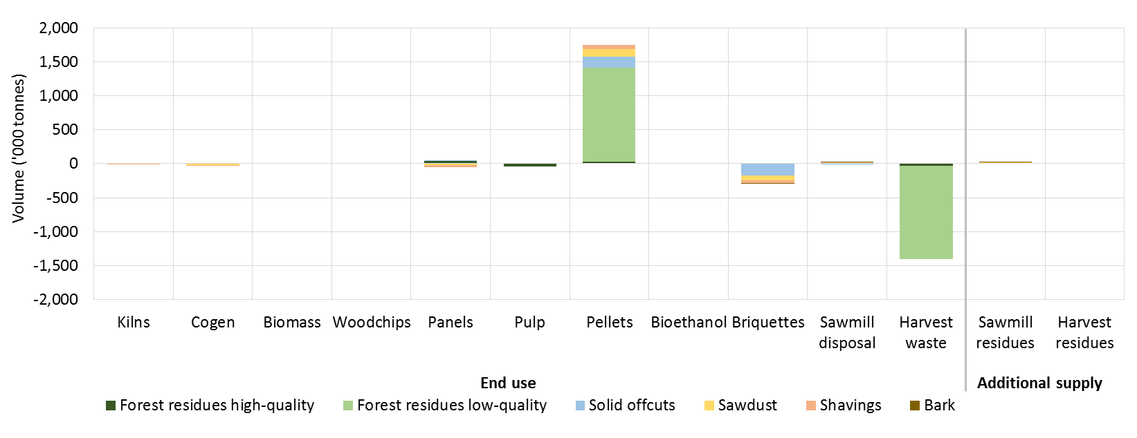

Note: Negative values are associated with decreases in volumes, relative to the base case. Cogen refers to cogeneration of heat and electricity at sawmills. Harvest waste refers to harvest residues left in forest.

Table B5 Change in production and use of harvest and sawmill residues in 2050, from base case to high briquette price scenario

|  |  |  |  |  |  |  |  |  |  |  |  |  |  |
| --- | --- | --- | --- | --- | --- | --- | --- | --- | --- | --- | --- | --- | --- |
| End use | High quality harvest residues (‘000 tonnes) | | | Low quality harvest residues (‘000 tonnes) | | | Sawmill residues (‘000 tonnes) | | | | | | ****Total residue use**** (‘000 tonnes) |
| **HW Native** | **HW Plant.** | **SW** | **HW Native** | **HW Plant.** | **SW** | **Solid offcuts HW Native** | **Solid offcuts HW Plant.** | **Solid offcuts SW** | **Sawdust** | **Shavings** | **Bark** |
| **Direct combustion** | | | | | | | | | | | | | |
| Cogen—onsite **a** | - | - | - | - | - | - | - | - | -111.5 | 19.7 | 20.7 | -21.7 | **-92.7** |
| Cogen—offsite **a** | - | - | - | - | - | - | - | - | - | 0.2 | 0.2 | -11.9 | **-11.5** |
| Biomass electricity | - | - | - | - | - | - | - | - | - | - | - | - | **-** |
| Kiln heat—onsite | - | - | - | - | - | - | - | - | - | -0.2 | -0.2 | - | **-0.3** |
| Kiln heat—offsite | - | - | - | - | - | - | - | - | - | - | - | - | **-** |
| **Wood fuels** | | | | | | | | | | | | | |
| Pellets | - | - | - | - | - | - | - | - | -58.8 | -145.5 | -113.3 | - | **-317.5** |
| Briquettes | - | - | 10.1 | - | 353.2 | 251.5 | 0.0 | 0.1 | -1.2 | 97.6 | 134.2 | 17.9 | **863.3** |
| Bioethanol | - | - | - | - | - | - | - | - | - | - | - | - | **-** |
| **Conventional wood products** | | | | | | | | | | | | | |
| Mechanical pulp | - | - | - | - | - | - | - | 0.0 | -39.8 | - | - | - | **-39.8** |
| Softwood pulp | - | - | - | - | - | - | - | - | 0.8 | - | - | - | **0.8** |
| Hardwood pulp | - | - | - | - | - | - | - | - | - | - | - | - | **-** |
| Hardboard | 0.0 | - | - | - | - | - | 0.0 | - | - | - | - | - | **0.0** |
| MDF | - | - | -1.8 | - | - | - | - | - | 89.2 | - | - | - | **87.4** |
| Particleboard | - | - | 0.1 | - | - | - | - | - | 45.5 | 21.1 | -46.4 | - | **20.2** |
| Woodchips | 0.0 | 0.0 | 1.8 | - | - | - | 0.0 | -0.2 | 19.0 | - | - | - | **20.6** |
| **Not extracted/disposed** | | | | | | | | | | | | | |
| Not extracted | 0.0 | 0.0 | -13.7 | 0.0 | -353.2 | -265.8 | - | - | - | - | - | - | **-632.7** |
| Disposed | - | - | - | - | - | - | -0.3 | 0.2 | -0.4 | 0.0 | 0.0 | 8.7 | **8.2** |
| **Total supply** | **0.0** | **0.0** | **-3.6** | **0.0** | **0.1** | **-14.3** | **-0.3** | **0.0** | **-57.1** | **-7.1** | **-4.8** | **-7.0** | **-94.1 a** |

**a Total supply and use of wood residues including disposal. HW Hardwood. SW Softwood.**

**Note: "Offsite" refers to the burning of residues in a kiln that does not belong to the parent sawmill**

**Source: ABARES Estimates**

Figure B3 Change in residue use and supply in 2050, by residue type, from base case to high briquette price scenario

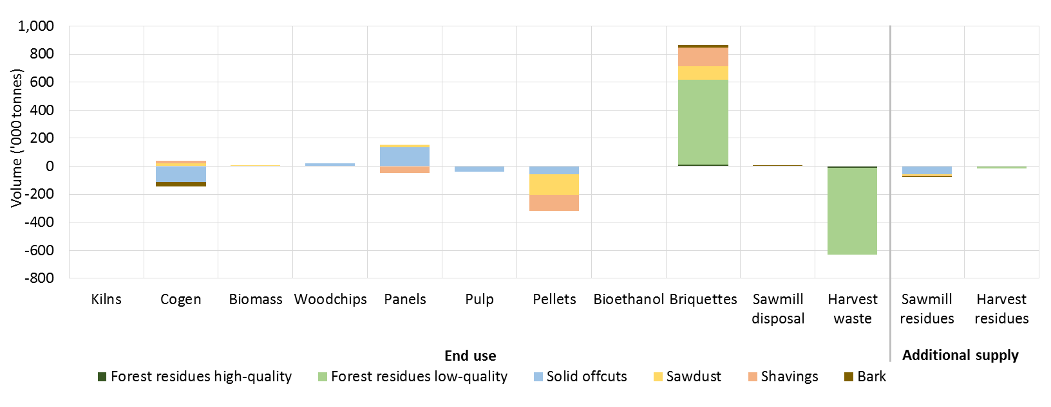

Note: Negative values are associated with decreases in volumes, relative to the base case. Cogen refers to cogeneration of heat and electricity at sawmills. Harvest waste refers to harvest residues left in forest.

Table B6 Change in production and use of harvest and sawmill residues in 2050, from base case to high bioethanol price scenario

|  |  |  |  |  |  |  |  |  |  |  |  |  |  |
| --- | --- | --- | --- | --- | --- | --- | --- | --- | --- | --- | --- | --- | --- |
| End use | High quality harvest residues (‘000 tonnes) | | | Low quality harvest residues (‘000 tonnes) | | | Sawmill residues (‘000 tonnes) | | | | | | ****Total residue use**** (‘000 tonnes) |
| **HW Native** | **HW Plant.** | **SW** | **HW Native** | **HW Plant.** | **SW** | **Solid offcuts HW Native** | **Solid offcuts HW Plant.** | **Solid offcuts SW** | **Sawdust** | **Shavings** | **Bark** |
| **Direct combustion** | | | | | | | | | | | | | |
| Cogen—onsite **a** | - | - | - | - | - | - | - | - | -4.6 | -19.9 | -4.6 | 1.3 | **-27.8** |
| Cogen—offsite **a** | - | - | - | - | - | - | - | - | - | - | -0.2 | 6.9 | **6.7** |
| Biomass electricity | - | - | - | - | - | - | - | - | - | - | - | - | **-** |
| Kiln heat—onsite | - | - | - | - | - | - | - | - | - | -4.5 | -2.3 | - | **-6.8** |
| Kiln heat—offsite | - | - | - | - | - | - | - | - | - | - | - | - | **-** |
| **Wood fuels** | | | | | | | | | | | | | |
| Pellets | - | - | - | - | - | - | - | - | 0.0 | -35.9 | -142.8 | - | **-178.7** |
| Briquettes | - | - | - | - | - | 0.0 | -10.7 | -0.1 | 11.1 | -20.7 | -10.5 | 0.2 | **-30.8** |
| Bioethanol | - | - | - | 9.7 | - | - | 10.8 | 1.1 | 0.3 | 99.9 | 182.1 | - | **303.9** |
| **Conventional wood products** | | | | | | | | | | | | | |
| Mechanical pulp | 0.0 | - | - | - | - | - | 0.0 | 0.0 | 0.0 | - | - | - | **0.0** |
| Softwood pulp | - | - | - | - | - | - | - | - | 58.7 | - | - | - | **58.7** |
| Hardwood pulp | - | - | - | - | - | - | - | - | - | - | - | - | **-** |
| Hardboard | - | - | - | - | - | - | - | - | - | - | - | - | **-** |
| MDF | - | - | 3.6 | - | - | - | - | - | -7.2 | - | - | - | **-3.6** |
| Particleboard | - | - | -0.9 | - | - | - | - | - | 25.0 | 1.3 | -19.7 | - | **5.7** |
| Woodchips | 0.0 | 0.1 | -3.2 | - | - | - | 4.7 | 0.8 | -78.7 | - | - | - | **-76.3** |
| **Not extracted/disposed** | | | | | | | | | | | | | |
| Not extracted | 0.0 | 0.0 | -0.6 | -9.8 | 0.3 | -4.2 | - | - | - | - | - | - | **-14.3** |
| Disposed | - | - | - | - | - | - | -5.6 | -1.7 | -0.3 | -25.9 | -1.7 | -7.8 | **-43.0** |
| **Total supply** | **0.0** | **0.1** | **-1.0** | **-0.1** | **0.3** | **-4.2** | **-0.8** | **0.1** | **4.3** | **-5.7** | **0.3** | **0.5** | **-6.2 a** |

**a Total supply and use of wood residues including disposal. HW Hardwood. SW Softwood.**

**Note: "Offsite" refers to the burning of residues in a kiln that does not belong to the parent sawmill**

**Source: ABARES Estimates**

Figure B4 Change in residue use and supply in 2050, by residue type, from base case to high bioethanol price scenario

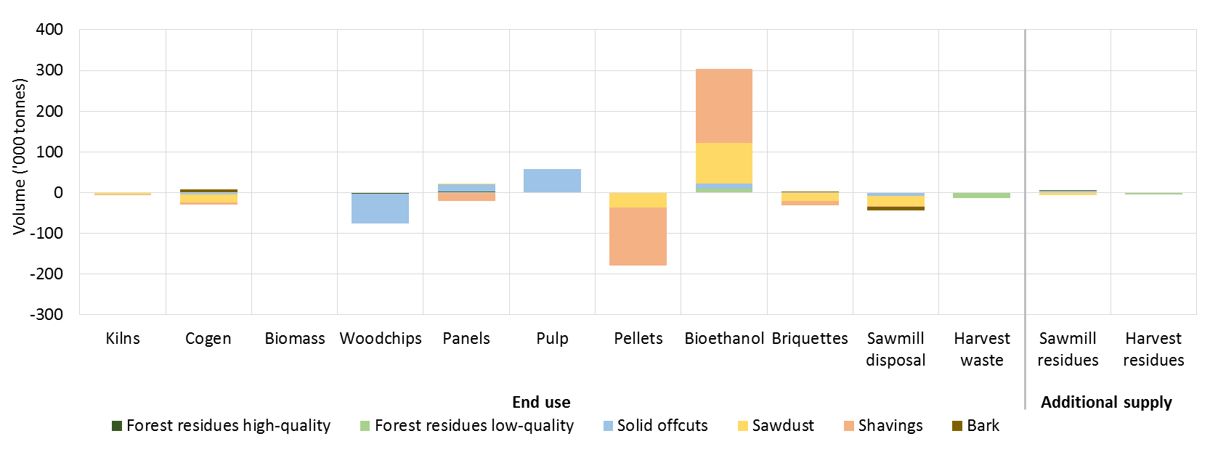

Note: Negative values are associated with decreases in volumes, relative to the base case. Cogen refers to cogeneration of heat and electricity at sawmills. Harvest waste refers to harvest residues left in forest.

Table B7 Change in production and use of harvest and sawmill residues in 2050, from base case to high electricity price scenario

|  |  |  |  |  |  |  |  |  |  |  |  |  |  |
| --- | --- | --- | --- | --- | --- | --- | --- | --- | --- | --- | --- | --- | --- |
| End use | High quality harvest residues (‘000 tonnes) | | | Low quality harvest residues (‘000 tonnes) | | | Sawmill residues (‘000 tonnes) | | | | | | ****Total residue use**** (‘000 tonnes) |
| **HW Native** | **HW Plant.** | **SW** | **HW Native** | **HW Plant.** | **SW** | **Solid offcuts HW Native** | **Solid offcuts HW Plant.** | **Solid offcuts SW** | **Sawdust** | **Shavings** | **Bark** |
| **Direct combustion** | | | | | | | | | | | | | |
| Cogen—onsite **a** | - | - | - | - | - | - | 26.5 | - | 139.0 | -4.0 | -2.4 | -40.1 | **119.0** |
| Cogen—offsite **a** | - | - | - | - | - | - | - | - | - | - | -0.1 | 2.5 | **2.3** |
| Biomass electricity | - | 0.1 | 0.1 | - | 3.7 | 13.5 | 57.6 | 16.0 | 41.7 | 246.4 | 89.2 | 51.8 | **520.0** |
| Kiln heat—onsite | - | - | - | - | - | - | - | - | - | -5.0 | -2.3 | - | **-7.2** |
| Kiln heat—offsite | - | - | - | - | - | - | - | - | - | - | - | - | **-** |
| **Wood fuels** | | | | | | | | | | | | | |
| Pellets | - | - | - | - | - | - | - | - | -58.8 | -158.2 | -56.3 | - | **-273.3** |
| Briquettes | - | - | - | - | 0.7 | 1.1 | -1.7 | 0.3 | -85.5 | -14.1 | -19.2 | 27.7 | **-90.6** |
| Bioethanol | - | - | - | - | - | - | - | - | - | - | - | - | **-** |
| **Conventional wood products** | | | | | | | | | | | | | |
| Mechanical pulp | - | 2.0 | - | - | - | - | -3.9 | - | -1.4 | - | - | - | **-3.3** |
| Softwood pulp | - | - | -15.6 | - | - | - | - | - | 5.9 | - | - | - | **-9.7** |
| Hardwood pulp | - | - | - | - | - | - | - | - | - | - | - | - | **-** |
| Hardboard | - | - | - | - | - | - | 25.0 | - | - | - | - | - | **25.0** |
| MDF | - | - | 0.1 | - | - | - | - | - | 4.1 | - | - | - | **4.2** |
| Particleboard | - | - | 15.9 | - | - | - | - | - | -34.0 | -20.7 | -0.2 | - | **-39.1** |
| Woodchips | -0.1 | -2.3 | -0.1 | - | - | - | -25.8 | -0.2 | -6.5 | - | - | - | **-35.0** |
| **Not extracted/disposed** | | | | | | | | | | | | | |
| Not extracted | 0.0 | 0.3 | -0.9 | -0.3 | -4.3 | -17.2 | - | - | - | - | - | - | **-22.4** |
| Disposed | - | - | - | - | - | - | -80.7 | -13.1 | -0.3 | -41.3 | -8.3 | -41.4 | **-185.1** |
| **Total supply** | **-0.1** | **0.0** | **-0.6** | **-0.3** | **0.1** | **-2.6** | **-3.0** | **3.0** | **4.3** | **3.1** | **0.4** | **0.5** | **-4.8 a** |

**a Total supply and use of wood residues including disposal. HW Hardwood. SW Softwood.**

**Note: "Offsite" refers to the burning of residues in a kiln that does not belong to the parent sawmill**

**Source: ABARES Estimates**

Figure B5 Change in residue use and supply in 2050, by residue type, from base case to high wholesale electricity price scenario

A 25 per cent increase in wholesale electricity prices is estimated to increase the volume of sawmill residues burned for electricity onsite and in biomass electricity plants. The feedstock for these increases is largely comprised of sawmill residues that would have been used to produce wood pellets or briquettes, or disposed of. Higher wholesale electricity prices had little effect on the volume of sawmill or harvest residues produced, or used in other applications.

Note: Negative values are associated with decreases in volumes, relative to the base case. Cogen refers to cogeneration of heat and electricity at sawmills. Harvest waste refers to harvest residues left in forest.

## Glossary

| Term | Definition |
| --- | --- |
| ABARES | Australian Bureau of Agricultural Resource Economics and Sciences |
| CHP | Cogeneration heat and power |
| FORUM | The Forest Resource Use Model is a national-scale model of the Australian forest industry. It was developed by ABARES to assess the optimal use of Australia’s forest resources for wood production. |
| Harvest residues | Stem wood, small trees, branches and tree tops resulting from the harvest of commercial logs. |
| HWN | Hardwood native |
| HWP | Hardwood plantation |
| HW | Hardwood |
| MDF | Medium-density fibreboard |
| Recovery rate | The proportion of feedstock converted into primary product for an individual mill. For example, the recovery rate for a sawmill refers to the proportion of log inputs converted to sawnwood products. |
| Sawmill residues | Solid offcuts, sawdust, shavings and bark produced as a by-product of cutting sawlogs to produce sawnwood. |
| SW | Softwood |
| Utilisation rate | The proportion of sawmills produced that are used on site or sold. |

## References

ABARES 2017, [Australian forest and wood products statistics: March and June quarters 2017](http://agriculture.gov.au/abares/publications/display?url=http://143.188.17.20/anrdl/DAFFService/display.php?fid=pb_afwpsd9abfe20171107.xml), Australian Bureau of Agricultural and Resource Economics and Sciences, Canberra, November.

ABARES 2016a, [Australia’s plantation log supply 2015–2059](http://agriculture.gov.au/abares/publications/display?url=http://143.188.17.20/anrdl/DAFFService/display.php?fid=pb_afplsd9aafe20161215.xml), Australian Bureau of Agricultural and Resource Economics and Sciences, Canberra, December.

ABARES 2016b, [Australian Plantation Statistics 2016 update](http://agriculture.gov.au/abares/publications/display?url=http://143.188.17.20/anrdl/DAFFService/display.php?fid=pb_aplnsd9abfe20160816.xml), Australian Bureau of Agricultural and Resource Economics and Sciences, Canberra, August.

ARENA 2017, [Australian Renewable Energy Mapping Infrastructure](http://nationalmap.gov.au/renewables/), Australian Renewable Energy Agency, Canberra, accessed on 14 September 2017.

BREE 2014[, An assessment of key costs and benefits associated with the Ethanol Production Grants program. A report for the Department of Industry](http://webarchive.nla.gov.au/gov/20161017101754/http:/www.industry.gov.au/Office-of-the-Chief-Economist/Publications/Pages/An-assessment-of-key-costs-and-benefits-associated-with-the-Ethanol-Production-Grants-program.aspx), Bureau of Resources and Energy Economics, Canberra, February

Borg Manufacturing 2018, [Environment and Sustainability](https://www.borgmanufacturing.com.au/environmental/), Borg Manufacturing, accessed 12 April 2018.

Burns, K, Gupta, M, Davey, S, Frakes, I, Gavran, M & Hug, B 2015, [Outlook scenarios for Australia’s forestry sector: key drivers and opportunities](http://agriculture.gov.au/abares/publications/display?url=http://143.188.17.20/anrdl/DAFFService/display.php?fid=pb_osafsd9abfe20150414_11a.xml), ABARES report to client prepared for the Department of Agriculture, Canberra, April.

Burrows, WH, Hoffmann, MB, Compton, JF & Back, PV 2001, [Allometric relationships and community biomass stocks in white cypress pine (Callitris glaucophylla) and associated eucalypts of the Canarvon area—South Central Queensland (with additional data for Scrub Leopardwood—Flindersia dissosperma)](http://pandora.nla.gov.au/tep/23322), National Carbon Accounting System Technical Report No. 33.

Gavran, M 2015, [Australian plantation statistics 2015 update](http://agriculture.gov.au/abares/publications/display?url=http://143.188.17.20/anrdl/DAFFService/display.php?fid=pb_aplnsd9abfs20150513_11a.xml), Australian Bureau of Agricultural and Resource Economics and Sciences, Canberra, May.

Gavran, M, Burns, K, Hug, B, Frakes, I & Gupta, M 2014, [ABARES National Wood Processing Survey: 2012–13](http://agriculture.gov.au/abares/publications/display?url=http://143.188.17.20/anrdl/DAFFService/display.php?fid=pb_nwpsad9abfe20140708_11a.xml), ABARES research report 14.6, Canberra, July.

Ghaffariyan, M & Apolit, R 2015, [Harvest residues assessment in pine plantations harvested by whole tree and cut-to-length harvesting methods](https://www.cabdirect.org/cabdirect/abstract/20163391368) (a case study in Queensland, Australia), *Silva Balcanica*, vol. 16(1).

Goble, D & Peck, M 2013, [Opportunities for using Sawmill Residues in Australia](https://www.fwpa.com.au/resources/processing/265-opportunities-for-using-sawmill-residues-in-australia-2013.html), The Carnot Group, Melbourne.

IEA 2007, [IEA Energy Technology Essentials: Biofuel Production](https://www.iea.org/topics/renewables/subtopics/bioenergy/publications/), International Energy Agency.

de Jong, S, Hoefnagels, R, Wetterlund, E, Pettersson, K, Faaij, A & Junginger, M 2017, [Cost optimization of biofuel production – The impact of scale, integration, transport and supply chain configurations](https://www.sciencedirect.com/science/article/pii/S0306261917303513), *Applied Energy*, vol. 195, 1055–1070.

Montreal Process Implementation Group for Australia and National Forest Inventory Steering Committee 2013, [Australia’s State of the Forests Report 2013](http://agriculture.gov.au/abares/publications/display?url=http://143.188.17.20/anrdl/DAFFService/display.php?fid=pb_sof13d9abf_20140328_11a.xml), ABARES, Canberra, December.

Pandey, A (ed) 2009, Handbook of plant-based biofuels, CRC Press, Boca Raton, Florida.

Parratt & Associates 2010, [Scoping Biorefineries: Temperate Biomass Value Chains, prepared for Biotechnology Innovation Policy Section, Pharmaceuticals, Health Industries & Enabling Technologies Branch, Innovation Division,](https://archive.industry.gov.au/industry/IndustrySectors/nanotechnology/Publications/Documents/TemperateBiomassStudyExecutiveSummary.pdf) Department of Innovation, Industry, Science and Research, Canberra.

Queensland Government, Department of Science, Information Technology and Innovation 2017, [Australian Biomass for Bioenergy Assessment: Queensland technical methods – Forestry](https://publications.qld.gov.au/dataset/abba-tech-methods), State of Queensland, Brisbane.

Taylor, D, King, J, Swift, S, Hopewell, G, Debuse, V, Roberts, S & Cotter, D 2005, [The influence of forest management on sawn timber recovery and value in Cypress Pine](https://rirdc.infoservices.com.au/downloads/04-184.pdf), publication no. 04/184, Rural Industries Research and Development Corporation, Canberra.

Whittle, L, Lock, P & Hug, B n.d., Economic potential for new plantation establishment in Australia: outlook to 2050, ABARES, Canberra, unpublished.

Ximenes, F, Coburn, R, Mclean, M, Samuel, J, Cameron, N, Law, B, Threllfall, C, Wright, K & Macintosh, S 2017, [North Coast Residues: A project undertaken as part of the 2023 North Coast Forestry Project](https://www.dpi.nsw.gov.au/forestry/north-coast-residues-project), NSW Department of Primary Industries, Sydney, November.

Ximenes, F, Bi, H, Cameron, N, Coburn, R, Maclean, M, Matthew, DS, Roxburgh, S, Ryan, M, Williams, J & Boer, K 2016, [Carbon stocks and flows in native forests and harvested wood products in SE Australia](https://www.fwpa.com.au/resources/r-and-dworks-webinars/955-carbon-stocks-and-flows-in-native-forests-and-harvested-wood-products-in-se-australia.html), project no: PNC285-1112, Forest & Wood Products Australia Limited, Melbourne.

Ximenes, FA, Gardner, WD & Kathuria, A 2008, [Proportion of above-ground biomass in commercial logs and residues following the harvest of five commercial forest species in Australia](https://www.sciencedirect.com/science/article/pii/S0378112708003708), *Forest Ecology and Management*, vol. 256(3), 335–346.

Ximenes, FA, Gardner, WD & Richards, GP 2006, [Total above-ground biomass and biomass in commercial logs following the harvest of spotted gum (Corymbia maculata) forests of SE NSW](https://www.tandfonline.com/doi/abs/10.1080/00049158.2006.10675001), *Australian Forestry*, vol. 69(3): 213–222.

Visy 2015, [Clean energy, co-generation, waste to energy plants](https://www.visy.com.au/about/clean-energy/), Visy, accessed 12 April 2018.

Yle 2016, Major bioethanol plant slated for Jakobstad, sawdust raw material, accessed 17 August 2017.

Zhang, J, Gu, F, Zhu, JY & Zalesny, RS Jr. 2015, [Using a combined hydrolysis factor to optimize high titer ethanol production from sulfite-pretreated poplar without detoxification](https://www.sciencedirect.com/science/article/pii/S0960852415004125?via%3Dihub), *Bioresource Technology,* vol. 186(2015) 223–231.