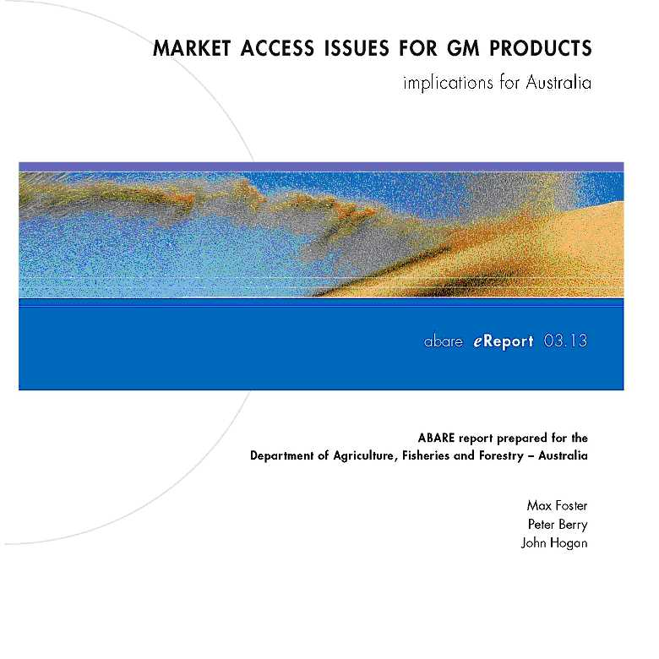

July 2003 abare

© Commonwealth of Australia 2003
This work is copyright. The Copyright Act 1968 permits fair dealing for study, research, news reporting, criticism or review. Selected passages, tables or diagrams may be reproduced for such purposes provided acknowledgment of the source is included. Major extracts or the entire document may not be reproduced by any process without the written permission of the Executive Director, ABARE.
ISSN 1447-817X ISBN 0 642 76485 9
Foster, M., Berry, P. and Hogan, J. 2003, Market Access Issues for GM Products: Implications for Australia, ABARE eReport 03.13 to the Department of Agriculture, Fisheries and Forestry – Australia, Canberra, July.
Australian Bureau of Agricultural and Resource Economics GPO Box 1563 Canberra 2601
Telephone +61 2 6272 2000 Facsimile +61 2 6272 2001
Internet www.abareconomics.com
ABARE is a professionally independent government economic research agency.
ABARE project 2880
Acknowledgments
The authors wish to acknowledge the helpful comments and suggestions from Perry Smith and Vernon Topp from ABARE, and Brian Jones, Richard Kerr, John Madden, Kathy Salter and John Stratton from Agriculture Fisheries and Forestry – Australia.

contents
Introduction 2
World grain market and the progress of GM crops 3
Key market access restrictions and conditions 5
Implications of market access restrictions and conditions 9
Impact on trade patterns of market access conditions 10
‘Spillovers’ to non-GM industries 13
Price premiums for non-GM grains 17
Conclusions 19
Argentina 23
Australia 25
Brazil 27
Canada 29
China 31
Chinese Taipei 33
European Union 35
Indonesia 41
Japan 43
Republic of Korea 45
Malaysia 47
Philippines 49
Saudi Arabia 51
Thailand 53
United States 55
References 62

market access issues for GM products

Introduction
Since 1995 a number of genetically modiﬁed (GM) crops have been rapidly adopted in some of the most important grain producing countries in the world, most notably the United States. However, various concerns about these crops — even after the crops have been assessed by government authorities to be safe for humans and the environment — have resulted in consumer resistance to products from genetically modiﬁed organisms (GMOs) in some countries, particularly in Europe.
Consumer resistance is occurring despite there being no credible evidence of food safety problems with GM crops that have been released for human consumption. In 2000, a group of world experts concluded that premarketing safety assessments already assure that a GM food is as safe as its conventional counterpart (FAO/WHO 2000). They acknowledged that little is known about the long term effects of consumption of GM foods, as is the case with any food.
There is speculation that GM concerns could be spilling over to adversely affect demand for non-GM products. Some possible examples are food products from animal industries that use GM feedstuffs, and honey (a partial coproduct of cropping systems). Marketers of non-GM grains, such as wheat and barley, are concerned that traces of GM grains will affect their international competitiveness and prices.
In response to perceived safety issues, a number of countries have implemented measures restricting access for GM products to their markets. These include import restrictions on ostensibly sanitary and phytosanitary grounds, and the introduction of technical requirements, such as product labeling and traceability. However, there are concerns that GM regulations are being used to protect domestic industries against import competition rather than dealing with the alleged safety issue.
The aim in this report is to outline the key market access restrictions that are affecting international trade in GM grains and to assess their impact on the pattern of world grain trade. The main part of this report is an overview — more details on country policies are provided in appendix A. A range of statistics on the supply and disposal of crops and animal products relevant to this analysis is provided electronically on AFFA’s web site (www.affa.gov.au/ gmmarkets).

World grain market and the progress of GM crops
There has been rapid and extensive adoption of GM crops in north and south America (ﬁgure A). As shown in the diagram, the rate of world adoption of GM crops has been very rapid since they were introduced in 1995 for four main broadacre crops — soybeans, maize, cotton and canola. In 2002, GM plantings accounted for around 20 per cent of the total world area planted to these four crops.
The most sought after trait with GM crops is herbicide tolerance. In 2002, herbicide tolerant crops made up around three quarters of total GM plantings, with insect resistant crops making up another 17 per cent.
The original adopters of GM crops were the United States, Canada and Argentina. There are now fourteen countries growing GM varieties on a commercial basis. Additions to this group in 2002 were India and Colombia, with insect resistant cotton, and Honduras with insect resistant maize. China has been the big mover in recent years, with around half of its cotton crop now being GM. The United States dominates, with two-thirds share of world

GM plantings in 2002, followed by Argentina (25 per cent), Canada (6 per cent) and China (4 per cent).
_{A}

World area harvest of GM broadacre crops

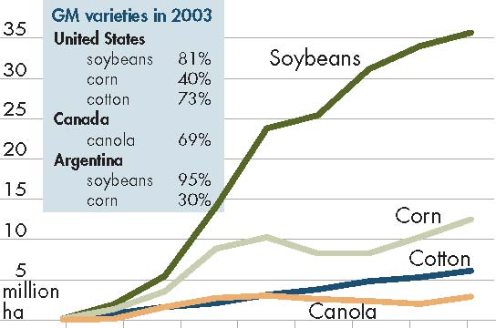
The most significant nonadopters of GM crops are the European Union and Brazil. In the European Union, the reaction of legislative and regulatory bodies to consumer resistance to GM products has meant that no GM crops have been commercially released since 1998. In Brazil, the stumbling block has been a legal challenge to environmental release of GM crops. Despite this, illegal GM
plantings are believed by some to make up around 10–20 per cent of the total soybean area in Brazil
1995 1996 1997 1998 1999 2000 2001 2002
(US Department of Agriculture 2003d).

The main grain exporting countries are shown in figure B. GM producing countries dominate world grain trade, accounting for 79 per cent of world maize exports in the five years to 2002-03 (including intra-EU trade), 69 per cent of soybeans, 53 per cent of cottonseed, and 42 per cent of canola (nearly 80 per cent excluding intra-EU trade). Even in the GM adopting countries, it seems that perceptions of consumer resistance to GM crops are slowing the commercialisation of new GM varieties, particularly GM food crops. For example, a recent proposal to introduce herbicide tolerant wheat in Canada and the United
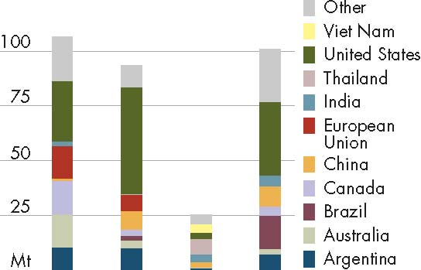
B Main grain exporters
Average, five years to 2002-03

States has met with strong resistance from the key marketers in those countries who say the majority of their customers have indicated that they will look elsewhere for their wheat supplies if GM wheat is adopted.
Furthermore, it is noticeable that while a country like China has adopted GM cotton with enthusiasm, it has been much more wary with food crops and authorities have not approved any GM food crops for growing yet, despite having developed at least a few of these.
The influence of the European Union on the worldwide adoption and acceptance of GM crops would seem to be pivotal. This inﬂuence has two aspects. First, EU human health and environmental safety concerns over GM products seem to spill over to inﬂuence attitudes in other countries, particularly poorer countries that do not have the resources to carry out their own safety assessments of these crops. Second, countries with EU markets need to meet EU import standards that include bans on some GM crop varieties, mandatory GM labeling, and strict traceback

requirements with GM products. (If intra-EU trade is included, the European Union accounted for 44 per cent of the total value of world food imports in the three years to 2001. This share will get bigger with the enlargement of the European Union in 2004 that takes in a number of eastern European countries.) This was one of the reasons why Zimbabwe initially rejected US food aid of maize in 2002. Rightly or wrongly, Zimbabwe saw the possibility of its EU export market being threatened if GM maize became accidentally established in Zimbabwe.

Australian GM progress
Australia is a significant player in world markets for grains (table 1). It is also an important exporter of dairy products, beef, veal, sheep meat, live sheep and cattle, and also exports small quantities of pig meat. The beef industry is largely based on grass feeding but substantial quantities of grain are used in feedlots or to finish grass fed cattle for the market. Supplementary feeding of grain as an aid to pasture management has become increasingly common in the Australian dairy industry over the last decade (Kompas and Che 2002).
1Summary, Australian grains industry a
^{Averages, 1998-99 to 2002-03}
^{Production}
_______________________ ^{Share of}
^{Volume} ^{Value} ^{world exports}
^{kt} ^{$m} %
^{Cereals}
^{Winter}
^{Barley} ⁵ ⁸⁹¹ ¹ ¹³² ¹⁹
^{Oats} ¹ ²²⁶ ¹⁶⁵ ⁷
^{Triticale} ⁹⁴ ⁹⁴ ^{na}
^{Wheat} ²⁰ ⁵¹⁴ ⁴ ⁵²⁸ ¹⁴

^{Summer}
^{Maize} ³⁷⁴ ²⁸⁴ ⁻
^{Rice} ¹ ¹⁵⁶ ²⁵¹ ²
^{Sorghum} ¹ ⁷⁶⁴ ²⁸⁴ ⁷

^{Oilseeds}
^{Winter}
^{Canola} ¹ ⁶⁶² ⁵⁶¹ ¹⁵

^{Summer}
^{Cottonseed} ⁹⁰⁷ ¹⁷⁹ ³⁷
Sunflowerseed 110 34 ¹⁵
^{Soybeans} ⁷⁰ ²⁹ ⁰

^{Pulses}
^{Chickpeas} ¹⁹⁵ ¹¹³ ³³
^{Field peas} ³³⁷ ¹⁰¹ ⁹
^{Lupins} ¹ ²⁹⁵ ²⁴⁰ ⁹⁹
a World exports include intra-EU trade. na Not available

Key market access restrictions and conditions
The key market access restrictions relating to GM crops and crop products are summarised in box 1.
Sanitary and phytosanitary restrictions are aimed at protecting human, animal and environmental health and safety. The rationale for mandatory labeling is that it enables consumers
Box 1: Key market access conditions or restrictions for genetically modified crops
Sanitary and phytosanitary
European Union
The European Union does not allow the import of genetically modiﬁed products apart from three varieties of insect resistant maize (another three varieties grown in the United States do not have approved status), one variety of herbicide tolerant maize and all varieties of herbicide tolerant soybeans.

China
Safety certiﬁcates required for each GM variety being imported. Under interim regulations that cover the period to April 2004, technology companies can apply for interim safety certiﬁcates for their GM crops, based on valid safety assessments issued by the relevant authority in their home or third country. Safety assessments based on ﬁeld trials in China are necessary for permanent approval. The regulations have a grey area because thresholds for accidental contamination with GM material have not been set.
Mandatory labeling

Australia
1.5.2 of the Australian Food Standards Code requires labeling of all GM food and ingredients, apart from that prepared for immediate consumption (such as restaurant and takeaway food) and highly reﬁned foods where the novel DNA or novel protein has been removed. A tolerance of 1 per cent is allowed for accidental presence of GM material.

Brazil
From 31 December 2001, GM labeling is required for all foods intended for human consumption where more than 4 per cent of the ingredients are derived from GMOs. The threshold was lowered to 1 per cent from June 2003

European Union
EU regulation 1139/98 requires that foodstuffs derived from GM soybeans and maize be labeled. Subsequent EU regulations 49 and 50/2000 that came into force in January 2000 establish that a material derived from GMOs, either ingredients or food comprising of a single ingredient, are exempt from labeling when they make up less than 1 per cent of the material.
Continued

to make more informed decisions. For example, some consumers may want to avoid products that contain unacceptable levels of GM materials.
There are concerns, however, that market access conditions are being implemented to protect domestic industries from imports, rather than to correct situations where unfettered markets would lead to undesirable social outcomes.
Box 1: Key market access conditions or restrictions for genetically modified crops continued
New legislation extends the current labeling provisions to all GM food or feed, irrespective of the detectability of GM DNA or protein. The new legislation does not require labeling of products where a GM processing aid has been used, provided the aid is not an ingredient in the final product. The new legislation allows for the presence of GM material in a food or feed up to a maximum 0.9 per cent below which labeling will not be enforced. The threshold is 0.5 per cent for the presence of GM material that has received a favorable scientiﬁc risk assessment by the scientiﬁc committees advising the European Commission, but that has not yet been ﬁnally approved to be placed on the market.

China
Ministry of Health requires labeling of all food containing GMOs.

Chinese Taipei
Phased introduction of labeling starting from 1 January 2001. Tolerance for GM presence is 5 per cent, by weight, but products derived from GMOs that do not contain detectable GM DNA or proteins do not require labeling.

Japan
From 1 April 2001 Japan required labeling of 24 foods made from maize and soybeans, including tofu, maize snacks, and natto (fermented soybeans), but only if they make up more than 5 per cent of the material. The list has since been extended to 44 foods. Oils and other highly processed foods made with GM ingredients are excluded from the list because current testing procedures cannot verify GM content.

Republic of Korea
From 31 July 2001 all products containing GM products as a ‘major input’ are required to be labeled, except where the ﬁnal product does not contain foreign protein or recombinant DNA (that is, they are removed during processing). From 1 March 2001, unprocessed soybeans and maize produced through biotechnology will have to be labeled. The tolerance level for adventitious contamination will initially be set at 3 per cent but could be reduced to 1 per cent at some unspeciﬁed time in the future

Russian Federation
Effective from 1 July 2000 (with revisions effective from 1 September 2002), all food and medical products derived from GM sources must be labeled, except where these foods do not contain the modiﬁed protein or recombinant DNA (as can happen with oils derived from genetically modiﬁed plants for example).

Thailand
From 11 May 2003, Thailand’s Food and Drug Administration requires that food products that contain any GMO ingredient of at least 5 per cent as one of the top three ingredients be labeled as containing GM food products.

In May 2003, the United States, Argentina and Canada announced that they would challenge EU rules for GM products on the basis of possible violations of agreements under the World Trade Organisation (WTO) arrangements (Office of the US Trade Representative 2003). Along with Australia, the list of countries supporting this challenge as third parties include Chile, Colombia, El Salvador, Honduras, Mexico, New Zealand, Peru and Uruguay. The WTO Agreement on Sanitary and Phytosanitary (SPS) Measures establishes the circumstances under which a country may refuse access to its domestic market on the grounds of risks to the environment and to human and animal health. The Agreement on Technical Barriers to Trade, covering issues such as packaging, marking and labeling, seeks to ensure technical regulations do not create unnecessary obstacles to trade.
The European Union says its set of GM rules (to come into force in September 2003 with a compliance period of six months) provides a comprehensive framework that is paving the way for the lifting of the virtual moratorium on new approvals of GM crops that has operated since 1998 (European Commission 2003a).
Another international agreement that affects international trade is the Cartagena Protocol on Biosafety that was adopted by the Conference of the Parties to the Convention on Biological Diversity as a supplementary agreement to the convention in January 2000. The protocol seeks to protect biological diversity from the potential risks posed by living modiﬁed organisms (LMO) resulting from modern biotechnology. The basis of the protocol is an advance informed agreement (AIA) procedure for ensuring that countries are provided with the information necessary to make informed decisions before agreeing to the import of such organisms into their territory. In addition, the detailed requirements for documentation of shipments of LMOs and liability treatments are to be determined once the protocol comes into force. Having reached the required ratiﬁcation by ﬁfty countries on 13 June 2003, the protocol comes into force ninety days later, on 11 September 2003. Australia has not ratiﬁed the protocol.
The preamble to the protocol states that it should not be interpreted as implying a change in the rights and obligations of a party under any existing international agreements (Secretariat of the Convention on Biological Diversity 2000). However, a feature of the protocol is that its operational provisions are couched in terms of the precautionary principle, which holds that lack of scientiﬁc certainty from insufﬁcient scientiﬁc information and knowledge of the impact of an organism shall not prevent a decision on the import of that organism. This implies that a country may refuse the import of a particular GMO when there is a lack of scientiﬁc certainty about its potential harmfulness. The concern is that this provision of the protocol could be used to impose unjustiﬁable restrictions on trade and could weaken the scientiﬁc basis of risk assessment that unpins the WTO’s Sanitary and Phytosanitary (SPS) Agreement.
Sanitary and phytosanitary conditions
The key allegedly SPS based restriction is that the European Union does not allow the import of some GM varieties. The European Union does allow imports of some varieties of GM maize and soybeans introduced before 1998. Since 1998, a virtual moratorium on the approval of imports of new varieties of GM crops has existed. This excludes EU imports of GM canola and some varieties of maize (such as herbicide tolerant maize), crops that are widely traded elsewhere in world markets.
At present there appears to be zero tolerance for grain imports with unintended presence of seeds of GM varieties not approved in the European Union. However, new EU legislation applying from September 2003 seems to allow a threshold of 0.5 per cent for the presence of GM material that has received a favorable scientific risk assessment by the scientific committees advising the European Commission, but which has not yet been ﬁnally approved to be placed on the market.
In recent years, Saudi Arabia (2000) and Sri Lanka (2001) have proposed bans on imports of GM products but both countries either dropped or deferred these plans. While Turkey is reportedly trying to prohibit all GM imports through the use of existing health regulations, its imports of maize and soybeans from the United States, a GM producer, have been substantial in recent years. According to Department of Agriculture, Western Australia (2003), Pakistan would be lifting its ban on imports of GM crops by the end of 2002. In March 2003, Pakistan purchased around 100 000 tonnes of Canadian (GM) canola.
China’s requirement that safety certiﬁcates for imported GM varieties be based on ﬁeld trials of the varieties in China poses a signiﬁcant market access condition, at least in the short run.
Mandatory labeling and traceability
Countries that have introduced mandatory labeling, or have ﬂagged their intentions to introduce it, include Australia, Brazil, China, Chinese Taipei, the European Union, Malaysia, New Zealand, Japan, Republic of Korea, the Russian Federation and Thailand. Such labeling requirements may be a signiﬁcant barrier to world trade where they impose higher costs on suppliers of GM products. These costs can spill over to suppliers of conventional products. The countries that have explicitly refused to introduce mandatory labeling include the main GM producers, the United States, Canada and Argentina.
It can be seen from box 1 that the nature of these labeling regimes differs significantly between countries. For example, the European Union intends to allow accidental contamination of 0.9 per cent by volume before a product must be labeled as containing GM material. Japan and Korea allow 5 per cent and 3 per cent respectively. And Japan, for example, does not require labeling of processed GM products where modiﬁed DNA or protein is not detectable, whereas the European Union’s new regulations do. The EU rule means that oil derived from GM oilseeds must be labeled even though processing means that no modiﬁed DNA or protein is usually detectable.
Under new legislation, the European Union will also be extending mandatory labeling to animal feed containing GM materials.
At this stage, there do not appear to be any market access conditions set by governments for products that are derived from animals that are fed GM materials. A number of large supermarket chains in Europe have responded to perceived consumer concerns over genetically modiﬁed organisms by requiring that their suppliers of food animal products — for example meat, milk and eggs — do not use GM feedstuffs. Many animal products in Europe are labeled as being produced from only non-GM feedstuffs. At one stage in 2002, the European Union had mooted making labeling mandatory for food products produced from animals fed GM materials but did not go ahead with this.
The estimated proportions of world grain imports, by grain type, that are subject to each GM labeling threshold (or tolerance) for adventitious presence of GMOs are shown in table
2. (It is assumed that the new labeling requirements operate in the European Union, including a 0.5 per cent tolerance that would apply with canola that contained quantities of a nonapproved GM canola variety.) Hence, around 83 per cent of world canola trade entered countries with mandatory labeling regimes for GM products, compared with only 52 per cent for cottonseed. But, as discussed earlier, the main processed products of oilseeds — oil and meal for animal feed — would essentially only require labeling in the European Union. In the case of oilseeds, this effectively means that mandatory labeling actually only applies to around a third of world canola trade, 45 per cent of soybeans, and 21 per cent of cottonseed. The effective labeling proportion is also much lower for maize because around 70 per cent of maize is consumed as animal feed.
The European Union is introducing mandatory protocols to provide the means to trace products containing or produced from genetically modiﬁed organisms through the production and distribution chains. The European Union considers that traceability allows control and veriﬁcation of product labeling claims and targeted monitoring of potential environmental effects where appropriate (European Commission 2003a). Traceability also allows the withdrawal of the product from the market if unforeseen risks to human health or the environment are established. Under this new regulation, business operators must transmit and retain information about products that contain or are produced from genetically modiﬁed organisms at each stage of trade in the market. These procedures are expected to reduce the need for sampling and testing of products for GM content and facilitate regulation of the industry (European Commission 2003a).
Proportions of world unprocessed grain imports subject to each GM labeling threshold, by grain type a
Labeling threshold/tolerance Canola Cottonseed Maize Soybeans
Zero 24.9 9.4 3.6 24.6
0.5 per cent b 33.6 20.7 c c
0.9 per cent b 0.0 0.0 3.7 35.4
1 per cent 0.1 0.2 1.2 1.9
2 per cent 0.1 0.0 1.8 1.0
3 per cent - 7.9 15.1 1.0
4 per cent 0.0 0.0 0.0 3.9
5 per cent 24.5 13.7 29.1 16.3

Total, all thresholds 83.2 51.9 54.5 84.1
No labeling 16.8 48.1 45.5 15.9
a Averages, based on imports for the ﬁve years to 2003-03. Includes intra-EU trade.
b Thresholds for the European Union under new legislation applying from September 2003.
c Not identiﬁe

Implications of market access restrictions and conditions
Market access restrictions and conditions could lead to changes in the pattern of world trade and to price premiums for non-GM grains.
The extent to which import bans on GM varieties spill over to affect trade in non-GM varieties is importantly determined by tolerances for accidental presence of unapproved GM varieties. For example, zero tolerance in an importing country for contamination with GM canola would make it very difﬁcult, if not impossible, for a country producing a mix of GM and non-GM canola to access that market. Whereas a tolerance of 5 per cent, for example, would make access much easier and less costly because simple measures, such as appropriate buffer zones between GM and non-GM crops, and reasonable care with grain harvesting and handling arrangements, would enable that tolerance to be met.
A number of incidents in recent years illustrate the difﬁculty of preventing the accidental presence of GM material, either through cross pollination or adventitious (unintended) mixing in the grain handling system. Starlink (GM) maize made up less than 1 per cent of total US plantings in 1999 and 2000 but in 2000-01 traces of its unique genetic material were found in around 11 million tonnes of maize in the United States, equivalent to about 4 per cent of annual US maize production (Gadsby 2001). There have been other smaller incidents: for example, in April 2001 in Canada, a variety of GM canola seed was recalled after it was found to contain genetic modiﬁed material from another strain of GM canola that was not approved for export (Monsanto 2001).
The requirement to label GM products can add signiﬁcantly to the cost of delivering non-GM products through requiring elaborate procedures that keep GM and non-GM products separate and traceable throughout the supply chain. It could be expected that the lower the tolerance level for accidental contamination, the higher is the cost of getting it to the point of use. To make labeling mandatory can lock consumers into higher costs than they would be willing to pay in a market where labeling is voluntary.
Furthermore, the requirement for a product to bear a GM label can adversely affect demand through stigmatising the product in the eyes of consumers. For example, the effect of Australia’s mandatory labeling regimes appears to be that food manufacturers have largely removed GM inputs from their products where the presence of these inputs would have required labeling. At this stage, it appears that only a few food items, including some brands of processed meat and packaged donuts, bear GM labels in Australia.
A combination of consumer resistance and market access barriers means it is possible that non-GM grain may command higher prices in world markets than GM grain. This would reflect the higher cost associated with delivering certified non-GM grain and any price rationing effect where the demand for non-GM grain is high in relation to its supply.

Impact on trade patterns of market access conditions
The introduction of GM grains has led to complex changes in the pattern of grain trade. This reﬂects changes in comparative advantage between countries arising from productivity gains associated with GM crops, consumer resistance, and the imposition of market access restrictions and conditions. As discussed earlier, in some cases the market access restrictions are a response to the consumer acceptance issue, for example, labeling.
A number of quantitative analyses, including Foster (2001) and Stone, Matysek and Dolling (2002) have been aimed at assessing the impacts of GM crops on the pattern of world trade. Some indication of the impact of market access restrictions is provided in Foster (2001). Employing a multicountry model of the world grain–livestock complex, it was estimated that exports of coarse grains and oilseeds would fall by 4–5 per cent if market access restrictions required that world GM grain supplies be completely segregated from non-GM grain. This analysis was based on the assumption that identity preservation requirements would add 10 per cent to the cost of delivering both GM and non-GM grain to the consumer. The magnitude of this cost assumption is broadly consistent with assessments such as Buckwell, Brookes and Bradley (1998), Economic Research Service (2000), and Bullock and Desquilbet (2002) that generally suggest cost increases of 5–15 per cent.
Analysis of markets for individual GM grains can identify some impacts of market access barriers for GM products on the pattern of world grain trade.
Canola trade impact
The European Union’s import ban on GM canola led to Canada withdrawing from this market. Canada is the world’s largest exporter of canola, accounting for nearly 80 per cent of world trade if intra-EU trade is excluded. The European Union had been an important market in some years for Canada before the introduction of GM canola in Canada (table 3).
Despite the EU ban, however, Canadian exports of canola reached record levels in 2000-01 (ﬁgure C). Ready markets for Canadian canola have been found in Japan, China and Mexico, to more than compensate for the loss of the EU market (table 3). There was a substantial decline in Canadian canola exports in 2001-02 and 2002-03 but this was driven by reductions in export availabilities arising from poor production conditions in Canada.
Export destinations for Canadian canola
1992 |  | 1993 | 1994 | 1995 | 1996 | 1997 | 1998 | 1999 | 2000 | 2001
-93 |  | -94 | -95 | -96 | -97 | -98 | -99 | -2000 | -01 | -02 a
kt |  | kt | kt | kt | kt | kt | kt | kt | kt | kt
China | – | – | 252 | – | – | 11 | 1 269 | 1 211 | 1 890 | 214
Europe | 272 | 868 | 1 139 | 322 | 162 | 11 | 1 | 1 | – | 2.1
Japan | 1 485 | 1 662 | 1 655 | 1 678 | 1 734 | 1 829 | 1 814 | 1 801 | 1 854 | 1 590
Mexico | 104 | 434 | 495 | 531 | 356 | 593 | 529 | 570 | 846 | 631
United States | 14 | 253 | 261 | 272 | 265 | 391 | 278 | 280 | 165 | 106
Other | 1 | 130 | 110 | 1 | 1 | 128 | 9 | 22 | 104 | 1
Total | 1 876 | 3 347 | 3 912 | 2 804 | 2 519 | 2 964 | 3 900 | 3 885 | 4 859 | 2 543
Source: Statistics Canada (2003).

The Chinese requirement for safety certiﬁcates for its market has been a complicating factor for canola. Canola exports from Canada to China declined from an average of 1.15 million tonnes over the four calendar years to 2001, to only 66 000 tonnes in 2002. This decline can also be partly explained by reduced Canadian export availabilities caused by drought in that country.

A recent study (Department of Agriculture, Western Australia 2003) concluded that the introduction of GM canola in Western Australia would have only a minimal impact
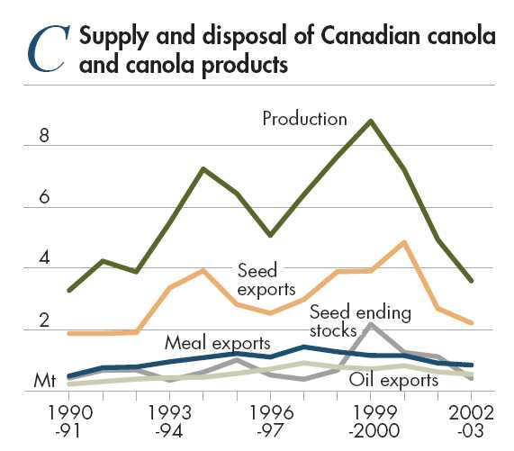

on that state’s canola export markets. It was pointed out in the study that the European Union is only an occasional market for Western Australian canola.

Maize trade impact
The GM status of US maize, or the possibility that approved maize varieties could contain detectable quantities of unapproved GM varieties, has been cited as a contributory factor to the EU market largely disappearing as a destination for US maize (Paarlberg 2001). US maize exports to Europe declined from an average 1.9 million tonnes in the five years to 1996 (the ﬁrst year that GM maize was marketed), to only 51 000 tonnes in 2001. This lost market was picked up by Argentina, also a producer of GM maize, but only of EU approved varieties.
In recent years, US maize exports to countries like Japan and the Republic of Korea have been adversely affected by the so-called Starlink incident. Starlink is a GM variety of maize that was approved for feed use but not food use because the modified gene resulted in a substance that had similarities to a known allergen. According to US Department of Agriculture (2001a), US maize

exports in 2000-01 were reduced because some importers, especially Japan and the Republic of Korea, wanted to avoid maize contaminated with Starlink. These importers have reportedly been willing to pay a premium for maize from alternative suppliers such as South Africa, Argentina, China and Brazil (US Department of Agriculture 2001a). That both South Africa and Argentina are producers of GM maize suggests that GM maize varieties other than Starlink are generally acceptable to the Japanese market.
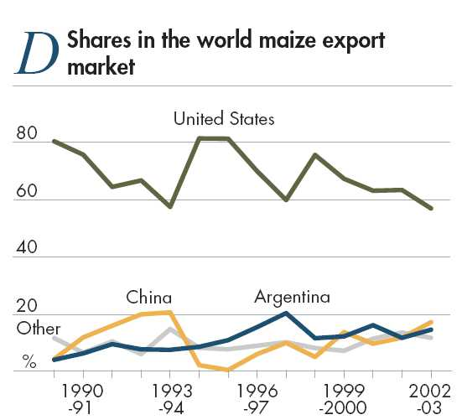

Soybean trade impact
GM soybean producers in the United States and Argentina have seen their shares of the EU soybean import market decline steadily since the introduction of GM soybeans in 1996, while Brazil’s share has increased sharply (ﬁgure E).

The loss of market share in the world soybean market by the United States to Brazil is partly explained by the massive expansion in Brazilian soybean production as new land was opened up. But it seems reasonable to say that mandatory labeling requirements, particularly in the European Union, Japan and the Republic of Korea, have contributed to this decline, notwithstanding increasing suspicion that there are illegal plantings of GM soybeans in southern parts of Brazil. According to US Department of Agriculture (2002b), the Republic of Korea is essentially a non-GM market as retailers refrain from placing ‘GM’ labels with soybean (and maize) products on store shelves to avoid adverse consumer reaction.
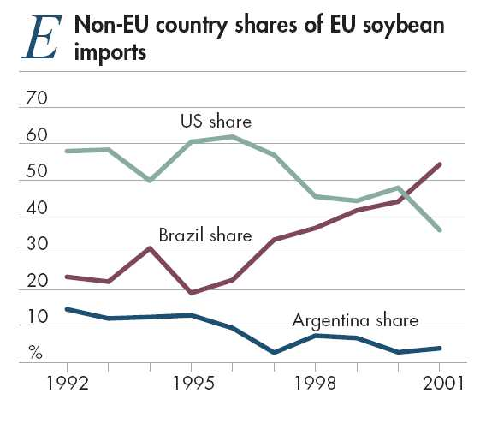

‘Spillovers’ to non-GM industries
The presence or use of GM material in other food products could also be affecting market access for non-GM products.
Organic industry
There is potential for plant and animal industries based on organic production practices to be affected by the introduction of GM crops. This is because the production standards specifically exclude the use, directly or indirectly, of GMOs. All exports of organic produce from Australia must be certiﬁed as having been produced in accordance with the National Standard for Organic and Biodynamic Produce. The certifying organisations are audited by a government agency, the Australian Quarantine and Inspection Service (AQIS), to ensure that they are complying with this standard.
A new draft of the standard that is currently being considered prohibits the use in organic farming of genetically modiﬁed/engineered seed and transgenic (GM) plants or application of GMO derived substances for treating plants (Organic Produce Export Committee 2001). For livestock products to be labeled as organic, the livestock diet must be sourced from feed produced using organic standards. With honey, beekeepers must demonstrate that hive locations are in foraging areas that are more than ﬁve kilometres from ﬂower bearing crops that are genetically modiﬁed.
The value of certiﬁed organic produce in Australia in 2000-01 was estimated at around $89 million at the farm gate (Wynen 2003), representing about 0.3 per cent of the total estimated farm gate value of food and ﬁsheries production in Australia in that year. (The corresponding estimated retail value in Wynen was $165 million.) Shares in this total farm gate value were: meat, 38 per cent; cereals, 21 per cent; horticulture 25 per cent; oilseeds, 4 per cent; and dairy, 2 per cent. In 2002, exports of certified organic produce from Australia were 16 200 tonnes, of which 12 300 tonnes were grain and grain products, and 700 tonnes were meat and meat products (Australian Quarantine and Inspection Service).
In some cases, the introduction of GM grains could impose greater costs on organic producers through requiring measures to avoid use in the production process or unintentional presence of GM materials in the ﬁnal product. However, arguably the organic industry beneﬁts from the existence of market access barriers for GM products because the organic industry already has in place the production and marketing systems, including certifying processes, that can assure customers that their products do not contain GM materials. The market access barriers raise the cost of delivering competing products, such as non-GM grains that are conventionally produced.
Barley
The Australian Barley Board (ABB), Australia’s largest barley exporter, says some of its major buyers are requesting certiﬁcation to assure them that their purchases are free of GMOs (Australian Barley Board 2002). ‘Saudi Arabia is particularly concerned and requires a GMO free certiﬁcate to be issued with every shipment of grain while also indicating that they may refuse to trade barley with the ABB if Australia produces any GM grain crops in the future’, the board says. Other Middle East customers, Chinese Taipei, China and Japan have also asked for certiﬁcation ‘from time to time’.
Australia’s barley exports to these ‘at risk’ markets in recent years are shown in table 4. Saudi Arabia accounted for 29 per cent of the total volume of Australian feed barley exports over the ﬁve years to 2001-02 but did not appear to import Australian malting barley in this period. Over the same period, Japan and China had shares in total Australian barley exports of 21 per cent and 26 per cent respectively. (The European Union is the world’s large barley exporter and not an export market for Australian barley.)
It is evident from table 4 that Canada and the United States, have continued to secure access for their barley to the major ‘at risk’ markets identified by the ABB, despite their grain handling systems also handling GM grains. The disappearance of Canada and the United States from the Saudi Arabian market in 2001-02 reﬂects their restricted barley availabilities caused by poor seasonal conditions.
Wheat
The Australian Wheat Board recently stated that it opposed the commercialisation of GM canola at this stage in Australia because it believed that the accidental presence of GM canola seed in its wheat shipments could jeopardise some of its markets, or raise the cost of its wheat blending operations that enable premiums to be realised (McMullen 2003). The AWB’s recommendation is for a one to two year moratorium on the commercial release in Australia of any GM grain to allow for the reﬁnement of protocols governing the supply chain and
Australian, Canadian and US barley exports to selected countries
 |  | Chinese |  | Korea, | Saudi
 | China | Taipei | Japan | Rep. of | Arabia | Total
 | kt | kt | kt | kt | kt | kt
Australia a
1997-98 | 546 | 158 | 670 | 37 | 176 | 2 513
1998-99 | 1 320 | 148 | 930 | 51 | 1 094 | 4 213
1999-00 | 265 | 77 | 527 | 11 | – | 3 284
2000-01 | 1 182 | 146 | 793 | 79 | 610 | 3 576
2001-02 | 1 381 | 148 | 932 | 76 | 1 67 | 4 384
Canada
1997-98 | 562 | – | 254 | – | 387 | 2 127
1998-99 | 291 | – | 183 | 0 | – | 1 100
1999-00 | 428 | – | 376 | – | 163 | 1 727
2000-01 | 552 | – | 264 | – | 293 | 1 941
2001-02 | 399 | – | 55 | – | – | 1 091
United States
1998 | – | 34 | 315 | 0 | – | 568
1999 | – | 5 | 419 | 0 | – | 640
2000 | 57 | 57 | 255 | 0 | 305 | 1 069
2001 | – | – | 452 | 0 | 111 | 831
2002 | – | – | 240 | 0 | – | 469

a Over the ﬁve years to 2001-02, 11 per cent and 18 per cent, respectively, of Australian feed and malting barley exports
were ‘country conﬁdential’, so individual country data could be understated. – Indicates less than 500 tonnes.
Sources: Australian Bureau of Statistics (2003); Canadian Wheat Board (2002); US Department of Agriculture (2003b).
for the AWB’s customers to assess their needs and understanding of the technology (McMullen 2003).
Of the GM producers, the United States lost share in the world wheat market around the mid-1990s, about the time that GM crops were introduced, but it has generally maintained its share in subsequent years, albeit at the lower level (figure F). In the main, this market share was picked up

by Australia, largely reﬂecting the sharp shift to grain production in Australia from the mid-1990s, at the expense of livestock industries, particularly wool.

There is little or no obvious evidence that wheat exporting countries that are also producers of GM grains are experiencing market access difﬁculties with their wheat. As can be seen from table 5, Canada and the United States are continuing to ship wheat in generally undiminished quantities to markets that can be considered to be GM sensitive.
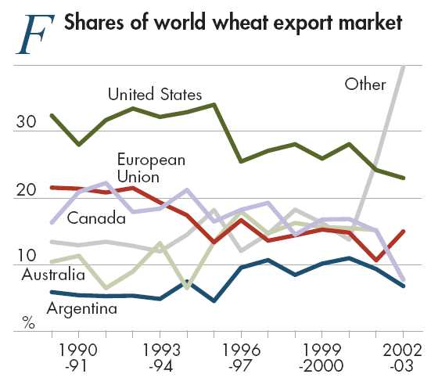

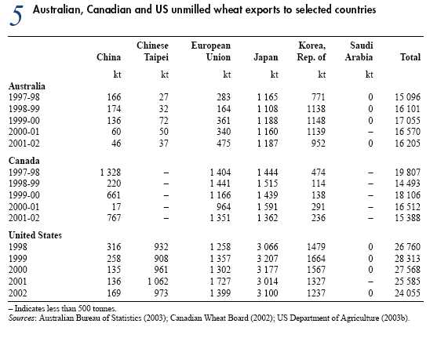
Other grains

No evidence was found that the key GM producers, the United States, Argentina or Canada, have had problems gaining access to export markets for grain sorghum (a feed grain), oats and pulses arising from the unintended presence of GM grains. As outlined below, export destination for these countries included GM-sensitive markets such as the European Union, Japan and the Republic of Korea. The United States dominates the world export markets for grain sorghum, with a share of over 80 per cent in the ﬁve years to 2002–03. Australia and Argentina are the other major exporters. The main US export markets are Mexico (74 per cent) and Japan (20 per cent).

Canada is the world’s largest exporter of pulses, with a market share of 26 per cent in the five years to 2001; Australia has a 10 per cent share. Canada’s main markets were the European Union (32 per cent), India (25 per cent) and Bangladesh (7 per cent). Canada is also the main oats exporter, with a market share of 54 per cent over the ﬁve years to 2002–03. However, nearly all the trade (96 per cent) went to the United States, with Japan and the Republic of Korea being the only other markets of signiﬁcance.

Dairy and livestock products

With Australian labeling laws, no dairy products have been identiﬁed as requiring any changes to labeling (Australian Dairy Corporation 2002). There is a form of chymosin — the milk clotting agent used in making cheese — that is produced by GM bacteria. This ‘synthetic’ form replaces the traditional form of chymosin taken from the stomach linings of newly born calves. Chymosin is used in around 60 per cent of all cheese manufacturing worldwide, particularly hard cheeses. However, it would appear that even EU regulations exclude food products made using GM chymosin — a processing aid — from its GM labeling requirements, if they are otherwise non-GM.
As discussed earlier, there is evidence in Europe that some important retailers are requiring that producers of animal products do not use GM feedstuffs. There is also anecdotal evidence that some buyers of Australian livestock products are seeking assurances that GM feedstuffs are not being used in the production process. No country currently mandates labeling of livestock product produced using GM materials.

Price premiums for non-GM grains
Canola price premiums
There is no clear evidence to suggest that there is currently a premium for non-GM canola. There is some evidence that the gap between Canadian and Australian canola prices, expressed in US dollars, has narrowed in recent years (ﬁgure G). However, this narrowing could simply reﬂect the greater security of supply that has occurred with Australian canola over the same time, the continuing problems that Canada has had in disposing of a record canola production increase that occurred in 1998 and 1999, relative movements between the Australian and Canadian currencies over this time period, and severe drought in Australia in 2002-03.
Based on discussions with major canola traders and industry representatives in October 2002, Natural Resources and Environment, Victoria (2002) found that there were no premiums for bulk non-GM canola shipments. However, premiums of the order of US$5–10 a tonne (after identity preservation costs) were being paid with around 40–50 thousand tonnes worldwide of containerised canola trade, mostly to Japan.

At present, Australia is the main export supplier of non-GM canola to the world market. The effect of Australia commercialising GM canola would be to reduce these supplies, leading perhaps to increased price premiums for non-GM canola. In the long run, the premiums for non-GM canola will reﬂect production and marketing costs, including identity preservation costs. At this stage, however, the extent of price premiums for non-GM canola and market access difficulties for GM grains in world markets do not appear to be large enough to offset the agronomic beneﬁts that GM canola is likely to offer under Australian conditions (Foster 2003).
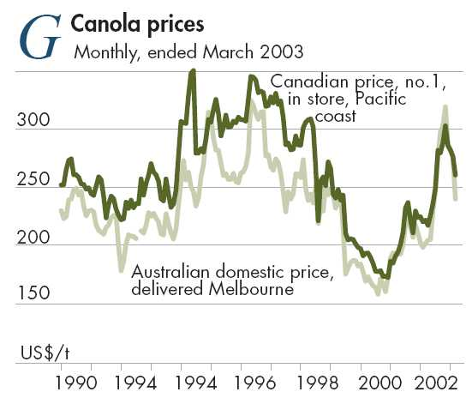

It is also possible that Canada has accumulated stocks rather than take lower prices to clear those stocks. Canada did US$/t accumulate unprecedentedly large stocks of canola up to 2000-01 (figure C), at a time when other key canola exporters, including Australia, were able to dispose of most of their supplies. The logistical problems of dealing with such a large crop may have contributed to this steep stock increase. However, Canadian stocks had declined to very low levels by the end of 2001-02, in response to poor seasonal conditions in both Canada and Australia that resulted in low world canola supplies.
Soybean, maize and sorghum price premiums
There is some limited evidence that Brazilian soybean prices have increased compared with US soybean prices in recent years (ﬁgure H). However, it is difﬁcult to attribute this widening to demand for non-GM soybeans, because the price margin in Argentina (a GM producer) has also increased.

A futures contract for non-GM soybeans has listed on the Tokyo Grain Exchange, alongside a futures contract for conventional US sourced soybeans. In 2002-03, the price for the non-GM soybeans contract averaged a premium of 7.3 per cent over the price for the US soybeans contract. However, the volume of the trade in this contract in 2002-03 was equivalent to only 39 000 tonnes of soy beans, or around 1 per cent of Japan’s annual soybean imports.

Surveys of elevator operators in the United States in 2000 and 2001 (US Grains Council 2002) identified premiums for segregated non-GM maize of around 3.5 per cent. Non-GM maize represented around 4 per cent of the total quantity of maize handled by the elevator operators who responded to the
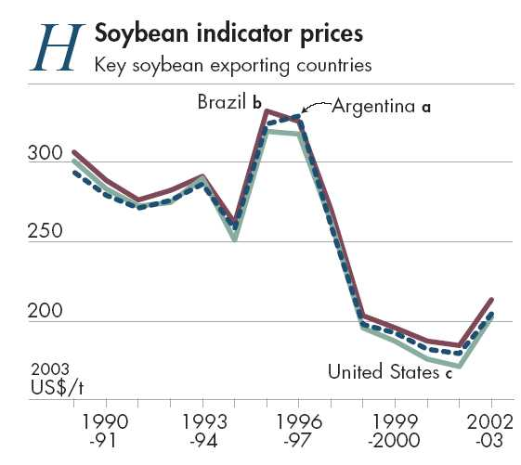

survey. This probably understates the actual quantity of non-GM maize traded in the United States because farmers also deliver directly to food processors who require non-GM maize.

From late 2000, world sorghum demand and prices were boosted by the problems experienced with Starlink maize in the United States. At one stage in mid-2001, sorghum (US no. 2, fob Gulf ports) was selling at prices more than 10 per cent above the normal price relationship with maize (US no.2, yellow, fob Gulf ports). However, this premium for sorghum has declined as Starlink corn has been eliminated from the US grain system.

Conclusions
A range of market access restrictions related to GM products means that it is easier to trade non-GM grains in the current market environment than it is to trade GM grains. There is some evidence of changes in the pattern of world grain trade attributable to market access barriers for GM products. The most signiﬁcant changes seem to have occurred with the EU import markets for canola and maize, due mainly to the virtual import bans on some GM varieties.
The mandatory labeling regimes now being applied in many key grain importing countries also represent signiﬁcant market access barriers through the potentially stigmatising effect of a GM label and through raising the cost of delivering both GM and non-GM products by requiring identity preservation. The labeling requirement could lead to price premiums for non-GM products, reﬂecting the cost of identity preservation. It is estimated that around 84 per cent of world canola and soybean trade (including intra-EU trade) enters countries that have such mandatory labeling regimes, and over 50 per cent of world cottonseed and maize trade. However, because it is mainly the European Union that currently requires GM labeling of products derived from oilseeds, such as oil and meal for animal feed, the requirement effectively only applies to around a third of world canola trade, 45 per cent of soybeans, and 21 per cent for cottonseed. In the case of canola, much of that trade is intra-EU.
Despite these market access barriers, the conclusion of this analysis is that there is no strong evidence to suggest that GM grains generally are not ﬁnding ready markets throughout the world. GM producing countries already dominate the world grain trade, with export market shares (including intra-EU trade) of 79 per cent for maize, 69 per cent for soybeans, 53 per cent for cottonseed, and 42 per cent for canola. Moreover, there is limited evidence of willingness by consumers to pay higher prices for products that are certiﬁed to not contain GM materials. At this stage, the market for certiﬁed non-GM grain would appear to be only a niche one.
There is also the issue of whether the presence of GM materials in non-GM products will affect the market access for those non-GM products. For example, the Australian Wheat Board is concerned that the presence of GM canola in Australian wheat would pose market access problems for its wheat. Generally, Australian marketers of grain argue that the non-GM nature of Australia’s grain industry (with the exception of GM cottonseed that is largely handled outside the central grain bulk handling system) gives them a competitive advantage in world markets over the GM grain exporting countries because there is a much lower risk of adventitious presence of GM grains. There is little evidence that GM producing countries are experiencing difficulties in gaining market access for their non-GM grains. Whether there is competitive advantage for a country with the marketing of non-GM grains through not being a GM producer is very difﬁcult to prove or disprove.
Some marketers of Australian livestock products based on grain feeding are saying that their customers are seeking assurances that GM feeds are not being used in production processes. However, no country mandates labeling of livestock products produced using GM feedstuffs.
Market access conditions and restrictions on GM products are continuing to evolve throughout the world. Key developments to watch for with both import restrictions and labeling requirements are tolerances speciﬁed by governments for adventitious presence of GM material. Zero or very low tolerances would make it difﬁcult, if not impossible, to operate a mixed production system of GM and non-GM crops in a way that enables the diverse range of consumer requirements to be met. Other key developments are whether GM labeling is required with animal feeds or with products where the modified DNA or protein is not detectable, such as oils. This would substantially increase the amounts of grain products that would require GM labeling. Mandatory labeling of livestock products produced using GM feedstuffs would also have important implications.

appendixes
A. Key grain trading countries
The aim in this appendix is to detail the regulatory arrangements for GM products in key countries. The choice of countries covered reﬂects a range of factors including importance in world trade as either an importer or an exporter; importance to Australia as an export destination; and status as a GM producer. Tables are provided for each country, outlining its trade in agricultural commodities that are relevant to this analysis, based on data from US Department of Agriculture (2003b). Where data are not available for a country from this source for a commodity, it is usually because the country is a very minor producer and trader of that commodity.
World food trade

In the main, the world’s largest food exporters are also the main importers (table 6). Most are located in western Europe and north America.

In 2001, Australia was ranked as the eleventh largest food exporter in value terms in the world and thirtieth largest importer (table 6). The most important countries in Australia’s food export trade are shown in figure I. A great deal more information on the nature and composi tion of Australia’s food trade is available in AFFA (2003).
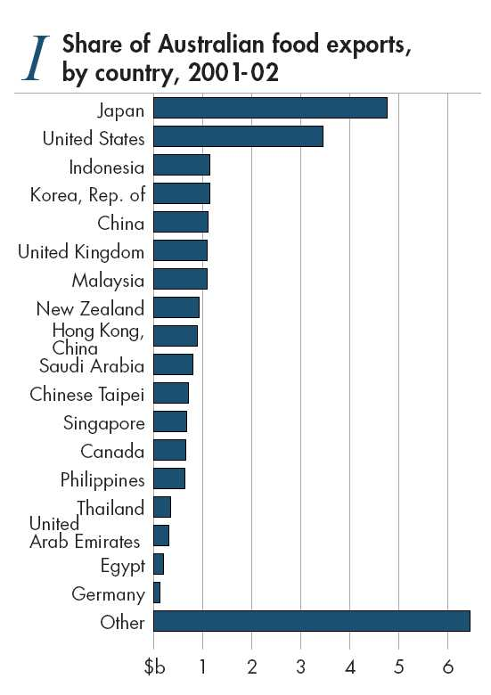

 Main food trading countries, by value of trade, 2001
Exporters |  |  | Importers
Rank | Country | Share | Rank | Country | Share
 |  | % |  |  | %
1 | United States | 12.6 | 1 | United States | 12.5
2 | France | 7.9 | 2 | Japan | 10.7
3 | Netherlands | 6.5 | 3 | Germany | 8.6
4 | Germany | 6.2 | 4 | United Kingdom | 6.6
5 | Canada | 5.0 | 5 | France | 5.6
6 | Belgium | 4.5 | 6 | Italy | 4.8
7 | Spain | 4.4 | 7 | Netherlands | 4.0
8 | Italy | 4.0 | 8 | Belgium | 3.7
9 | Brazil | 3.9 | 9 | Spain | 3.6
10 | China | 3.6 | 10 | Canada | 3.1
11 | Australia | 3.3 | 30 | Australia | 0.7

Source: AFFA (2003).

Argentina
Argentina is a major exporter of a range of grains, particularly maize, sorghum, soybeans and wheat (table below). It is also a significant exporter of beef and veal. The European Union is an important export market for Argentine grains, along with countries in South America, particularly Brazil. Export trade matrixes for Argentina for agricultural products are provided in the electronically supplied statistical annex. [A matrix shows trade by country of destination (for exports) or origin (for imports)].
GM varieties make up virtually all of Argentina’s soybeans and around 30 per cent of its maize.
Summary statistics for the grain–livestock complex in Argentina a
Product |  | Production |  |  |  |  |  |  |  | Exports |  |  |  | Imports
Volume |  |  |  |  |  |  | World share |  |  | Volume | World share b |  |  | Volume | World share b
kt |  |  |  |  |  |  | % |  |  | kt | % |  |  | kt | %
Cereals
Barley | 547 |  |  |  |  |  |  |  | 0.4 | 128 |  | 0.8 |  | 5 |  | –
Oats | 564 |  |  |  |  |  |  |  | 2.2 | 11 |  | 0.5 |  | 0 |  | 0.0
Maize | 15 000 |  |  |  |  |  |  |  | 2.5 | 10 156 |  | 13.7 |  | 14 |  | –
Rice c | 608 |  |  |  |  |  |  |  | 0.2 | 382 |  | 1.5 |  | 14 |  | 0.1
Sorghum | 2 966 |  |  |  |  |  |  |  | 5.3 | 579 |  | 8.4 |  | 1 |  | –
Wheat | 14 986 |  |  |  |  |  |  |  | 2.6 | 9 782 |  | 9.3 |  | 10 |  | –
Oilseeds
Canola/rapeseed
Cottonseed |  |  | 216 |  |  |  |  | 0.6 |  | 0 |  | 0.0 |  | 0 |  | 0.0
Sunﬂowerseed |  |  | 4710 |  |  |  |  | 19.3 |  | 381 |  | 11.8 |  | 0 |  | 0.0
Soybeans |  |  | 26 800 |  |  |  |  | 15.3 |  | 6 057 |  | 11.7 |  | 417 |  | 0.8
Pulses |  |  | 350 |  |  |  |  | 0.6 |  | 295 |  | 3.6 |  | 6 |  | 0.1
Food livestock products
Beef and veal d |  |  |  |  | 2 732 |  |  |  | 5.5 | 303 |  |  | 5.2 | 22 |  | 0.4
Dairy
– milk |  |  |  |  |  | 9 100 |  |  | 2.1 | 18 |  | 10.1 |  | 2 |  | 1.0
– wholemilk powder |  |  |  |  |  | 196 |  |  | 6.5 | 111 |  | 8.2 |  | 0.4 |  | 0.1
– skim milk powder |  |  |  |  |  | 39 |  |  | 1.2 | 22 |  | 2.1 |  | 0 |  | 0.0
– butter |  |  |  |  |  | 49 |  |  | 0.8 | 4 |  | 0.6 |  | 0 |  | 0.0
– cheese |  |  |  |  |  | 408 |  |  | 3.3 | 20 |  | 1.9 |  | 4 |  | 0.4
Pig meat d
Poultry meat |  |  |  | 825 |  |  |  |  | 1.7 | 6 |  |  | 0.1 | 36 |  | 0.9

a Average, ﬁve years to 2003 (2001 for pulses). b Includes intra-EU trade. c Milled. d Carcass weight equivalent. Sources: US Department of Agriculture (2003b); FAO (2003).
Regulatory arrangements for GMOs and
GM products in Argentina

Experimental and commercial release into the environment

Marketing approval

Imports

Labeling

National Commission on Agricultural Biosafety evaluates the scientific and technical issues associated with encironmental release of GM crops and makes recommendations to the Secretary of Agriculture who makes the final release decision.

A further requirement before commercialization of GMOs is that the National Directorate of Agrifood Markets (DNMA) assesses the possible impact of commercialization fo Argentina’s export markets (Burachik and Traynor 2002).

The National Agrifood Health and Quality Service (SENASA) regulates food safety in regard to GMOs.

CONABIA and SENASA provide safety assessments. The decision is made by the Secretary of Agriculture.

There are no specific labeling requirements for GM products.

Argentina was one of the first countries to establish a system of regulatory oversight for GMOs (Nap, Metz, Escaler and Conner 2003). Several agencies, all within the Agriculture Directorate of the Secretariat of Agriculture, Livestock, Fisheries and Food, are involved in regulating the use of GMOs and their products. The regulatory arrangements applying in Argentina are outlined in the box above. More details are provided in Burachik and Traynor (2002).

Australia
Australia is a major exporter of a range of agricultural commodities (table below). The only broadacre GM crops that have been commercialised in Australia are two different forms of cotton — insect resistant cotton and herbicide tolerant cotton.
The national regulatory framework for GMOs in Australia is outlined in the box below. One key component of the framework is the Commonwealth Gene Technology Act 2000, another is food safety standards and labeling requirements, prescribed in the Australian Food Standards Code and administered by Food Standards Australia and New Zealand (FSANZ). A more detailed description of this framework is provided in AFFA (2002).
Summary statistics for the grain–livestock complex in Australia a
Product |  | Production |  |  |  |  |  | Exports |  |  | Imports
Volume |  |  |  |  |  | World share |  | Volume | World share b |  | Volume | World share b
kt |  |  |  |  |  | % |  | kt | % |  | kt | %
Cereals
Barley | 5 937 |  |  |  |  |  | 4.4 | 3 294 |  | 19.2 | 6 |  | –
Oats | 1 226 |  |  |  |  |  | 4.8 | 141 |  | 6.6 | 1 |  | –
Maize | 368 |  |  |  |  |  | 0.1 | 51 |  | 0.1 | 30 |  | –
Rice c | 849 |  |  |  |  |  | 0.2 | 523 |  | 2.1 | 54 |  | 0.2
Sorghum | 1 813 |  |  |  |  |  | 3.2 | 476 |  | 6.9 | 0 |  | 0
Wheat | 21 444 |  |  |  |  |  | 3.7 | 14 837 |  | 14.1 | 144 |  | 0.1
Oilseeds
Canola/rapeseed |  |  |  | 1 710 |  |  | 4.7 | 1 330 |  | 15.1 | 0 |  | 0
Cottonseed |  |  |  | 903 |  |  | 2.7 | 470 |  | 37.4 | 0 |  | 0
Sunﬂowerseed |  |  |  | 109 |  |  | 0.4 | 9 |  | 0.3 | 0 |  | 0
Soybeans |  |  |  | 107 |  |  | 0.1 | 0 |  | 0.0 | 10 |  | –
Pulses |  |  |  | 2 500 |  |  | 2.5 | 830 |  | 10.1 | 11 |  | 0.1
Food livestock products
Beef and veal d |  |  | 2 016 |  |  |  | 4.1 | 1 327 |  | 22.5 | 5 |  | 0.1
Dairy
– milk |  |  |  |  | 11 024 |  | 2.5 | 81 |  | 46.4 | 4 |  | 1.9
– wholemilk powder |  |  |  |  | 189 |  | 6.3 | 168 |  | 12.4 | 4 |  | 0.6
– skim milk powder |  |  |  |  | 263 |  | 7.9 | 230 |  | 21.5 | 2 |  | 0.2
– butter |  |  |  |  | 164 |  | 2.8 | 117 |  | 16.9 | 9 |  | 2.6
– cheese |  |  |  |  | 379 |  | 3.1 | 206 |  | 19.8 | 40 |  | 4.7
Pig meat d |  |  |  |  | 377 |  | 0.5 | 49 |  | 1.4 | 36 |  | 1.1
Poultry meat |  |  |  |  | 568 |  | 1.1 | 15 |  | 0.3 | 0 |  | 0.0

a Average, ﬁve years to 2003 (2001 for pulses). b Includes intra-EU trade. c Milled. d Carcass weight equivalent. Sources: US Department of Agriculture (2003b); FAO (2003).
Regulatory arrangements for GMOs and GM products in Australia

Experimental and
commercial release
into the environment

Marketing approval

Imports

Labeling
All field trials and commercial releases of GMOs must be approved by the Gene Technology Regulator, a position established under the Gene Technology Act 2000. The object of this Act is to protect the health and safety of people and to protect the environment, by identifying risks posed by, or as a result of gene technology, and by managing those risks through regulating certain dealings with GMOs.

All genetically modiﬁed (GM) foods must undergo a rigorous science-based
pre-market safety assessment by Food Standards Australia New Zealand
(FSANZ). This safety assessment is aimed at ensuring that GM foods sold in
Australia are at least as safe as non-GM varieties of the same crop.
Imports of live and viable GMOs must be approved by the Gene Technology Regulator.
The Australian Quarantine and Inspection Service (AQIS) also has a role through its responsibility to regulates the importation into Australia of all animal, plant and biological products that may pose a pest or disease risk in accordance with the Quarantine Act 1908. The Act requires an importer to give notice of a proposed importation. Declaration of the presence of a genetic modiﬁcation and type of modiﬁcation must be stated on the import permit application. Where the parent organisms have previously been assessed, plant and animal products that have been genetically modiﬁed are assessed for potential quarantine pest, weed and diseases risks associated with the introduced traits for those species; if a species has not been imported previously then a full assessment is undertaken for that species of which the GMO assessment would form a subsequent component.
An Imported Food Inspection Program is administered jointly by FSANZ and AQIS. FSANZ advises on food risk assessments for the program, with AQIS having responsibility for inspection and sampling.
Label identiﬁcation is mandatory for a food that is, or contains as an
ingredient, including a processing aid, a food produced using gene technology
that:
■ contains novel DNA and/or novel protein; or
■ has altered characteristics;

but does not include:
■ highly reﬁned food, other than that with altered characteristics, where the effect of the reﬁning process is to remove novel DNA and/or novel protein;
■ a processing aid or food additive, except where novel DNA and/or novel protein from the processing aid or food additive remains present in the food to which it has been added;
■ ﬂavors present in the food in a concentration no more than 1 g/kg; or
■ a food, ingredient, or processing aid in which genetically modiﬁed food is unintentionally present in a quantity of no more than 10 g/kg per ingredient.

Brazil
Brazil is a major exporter of beef and veal, soybeans and maize (table below). There has been rapid expansion in agricultural production in Brazil over the past twenty years, particularly of soybeans, as new land has been opened up. In value terms, Brazil is now the world’s ninth largest food exporting country. Export matrices for Brazil for key agricultural commodities are provided in the statistical annex.
Since 1999, court action in Brazil over the environmental impact has held up the commercialisation of a particular variety of GM soybeans called Roundup Ready soybeans. An appeal is currently under way in the Brasilia Appeals Court. The new federal administration
Summary statistics for the grain–livestock complex in Brazil a
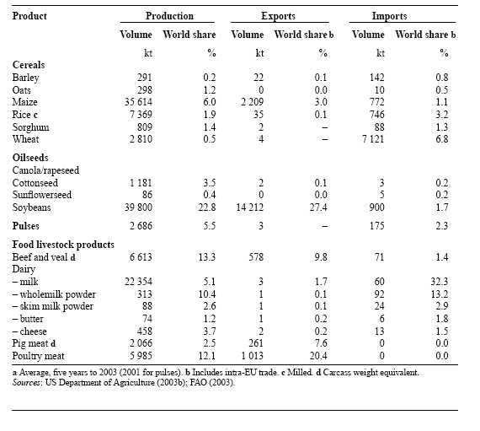
a Average, ﬁve years to 2003 (2001 for pulses). b Includes intra-EU trade. c Milled. d Carcass weight equivalent. Sources: US Department of Agriculture (2003b); FAO (2003).

Regulatory arrangements for GMOs and
GM products in Brazil
Experimental and | The Ministry of Agriculture and Food Supply (MAPA) provides
commercial release | authorisation, following recommendation from the National Technical
into the environment | Commission on Biosafety (CTNBio) which undertakes safety assessments.
Marketing approval | Authorisation by MAPA, following recommendation from CTNBio.
Imports | Authorisation by MAPA, following recommendation from CTNBio.
Labeling | From 31 December 2001, labeling is required for all foods intended for
 | human consumption where more than 4 per cent of the ingredients are derived
 | from GMOs. From June 2003, the threshold was lowered to 1 per cent.

in Brazil has made the resolution of this holdup a priority in 2003. Despite this, around 70 per cent of the soybean crop in the southern Brazilian state of Rio Grande do Sul is believed to consist of illegal GM varieties, with an estimated overall proportion in Brazil of 10–20 per cent (US Department of Agriculture 2003a).
Regulatory arrangements in Brazil for GMOs are outlined in the box above.

Canada
Canada is a major grain exporter with a particular importance in the canola, oats, barley, pulse and wheat markets (table below). Canada also imports substantial quantities of maize for its intensive livestock industries, mainly from the United States. Key markets for Canada’s agricultural commodities are China, the European Union, Japan, Mexico and the United States. Trade matrices for Canada are provided in the statistical annex.
Canada was the thirteenth largest market for Australian food exports in 2001-02, with a total value of $644 million, made up mainly of beef and veal, sugar and wine.
Summary statistics for the grain–livestock complex in Canada a
Product |  | Production |  |  |  |  |  |  | Exports |  |  | Imports
Volume |  |  |  |  |  |  |  | World share | Volume |  | World share b | Volume | World share b
kt |  |  |  |  |  |  |  | % | kt |  | % | kt | %
Cereals
Barley | 11 441 |  |  |  |  |  | 8.5 |  | 1 264 | 7.4 |  | 92 |  | 0.5
Oats | 3 286 |  |  |  |  |  | 12.8 |  | 1 175 | 54.6 |  | 35 |  | 1.7
Maize | 8 479 |  |  |  |  |  | 1.4 |  | 381 | 0.5 |  | 2 523 |  | 3.5
Rice c | 0 |  |  |  |  |  | 0 |  | 0 | 0 |  | 249 |  | 1.1
Sorghum
Wheat | 22 744 |  |  |  |  |  |  | 3.9 | 14 931 | 14.2 |  | 246 |  | 0.2
Oilseeds
Canola/rapeseed |  |  |  |  | 6 430 |  | 17.5 |  | 3 498 | 39.6 |  | 190 |  | 2.2
Cottonseed
Sunﬂowerseed |  |  | 122 |  |  |  |  | 0.5 | 69 | 2.1 |  | 18 |  | 0.6
Soybeans |  |  | 2 436 |  |  |  |  | 1.4 | 734 | 1.4 |  | 578 |  | 1.1
Pulses |  |  | 3 331 |  |  |  |  | 4.2 | 2 130 | 25.9 |  | 63 |  | 0.8
Food livestock products
Beef and veal d |  |  |  | 1 235 |  |  |  | 2.5 | 526 |  | 8.9 | 271 |  | 5.4
Dairy
– milk |  |  |  |  |  | 8 146 |  | 1.9 | 7 | 3.9 |  | 0 |  | 0
– wholemilk powder |  |  |  |  |  | 4 |  | 0.1 | 8 | 0.2 |  | 3 |  | 0.2
– skim milk powder |  |  |  |  |  | 89 |  | 2.7 | 48 | 4.5 |  | 2 |  | 0.2
– butter |  |  |  |  |  | 86 |  | 1.4 | 16 | 2.3 |  | 17 |  | 4.9
– cheese |  |  |  |  |  | 323 |  | 2.6 | 17 | 1.6 |  | 27 |  | 3.2
Pig meat d |  |  |  |  |  | 1 618 |  | 2.0 | 642 | 18.8 |  | 76 |  | 2.4
Poultry meat |  |  |  |  |  | 879 |  | 1.8 | 60 | 1.2 |  | 66 |  | 1.6

a Average, ﬁve years to 2003 (2001 for pulses). b Includes intra-EU trade. c Milled. d Carcass weight equivalent. Sources: US Department of Agriculture (2003b); FAO (2003).

Regulatory arrangements for GMOs and
GM products in Canada
Experimental and | The Canadian Food Inspection Agency (CFIA) assesses the potential risk of
commercial release | adverse environmental effects and authorises and oversees conﬁned trials,
into the environment | unconﬁned release and variety registration (CFIA 2003a).
Marketing approval | Health Canada is responsible for assessing the human health safety of
 | products derived through biotechnology including foods. In the case of novel
 | foods, each safety assessment considers the process used to develop the novel
 | food, its characteristics compared to those of its traditional counterpart, its
 | nutritional quality, the potential presence of any toxicants or anti-nutrients,
 | and the potential allergenicity of any proteins introduced into the food (CFIA
 | 2003a).
 | CFIA is responsible for assessing the safety of animal feeds and animal feed
 | ingredients.
Imports | The CFIA authorises and oversees import permits.
Labeling | Health Canada and the new Canadian Food Inspection Agency (CFIA) carry
 | joint responsibility for federal food labeling policies in Canada under the
 | Food and Drugs Act.
 | Labeling is usually voluntary but is mandatory — a decision made by Health
 | Canada — if there is a health or safety concern, that is, from allergens or a
 | signiﬁcant nutrient or compositional change (CFIA 2003b).

GM varieties of canola make up around two-thirds of total Canadian canola plantings and Canada has also commercialised GM varieties of maize and soybeans.
Regulatory arrangements for GMOs and GM products in Canada revolve around two government agencies: the Canadian Food Inspection Agency (CFIA) and Health Canada. The arrangements are outlined in the box above.

China
It can be see from the table below that China is an important importer of grains (particularly barley, canola and soybeans) and an important exporter of maize, rice and wheat. China’s only GM grain crop is cottonseed (from insect resistant cotton), making up around half of its total cotton plantings. Trade matrices for China for key agricultural products are provided in the statistical annex.
China is a rapidly growing market for Australian food exports, ranking ﬁfth largest in 200102, with a total value of $1.05 billion. Cereals and oilseeds made up around 68 per cent of this total, with meat and dairy products each contributing 8 per cent.
Summary statistics for the grain–livestock complex of China a
Product |  |  | Production |  |  |  |  | Exports |  |  | Imports
Volume |  |  |  |  |  |  | World share | Volume |  | World share b | Volume | World share b
kt |  |  |  |  |  |  | % | kt |  | % | kt | %
Cereals
Barley | 2 759 |  |  |  |  |  | 2.1 | 2 | – |  | 2 083 |  | 12.4
Oats | 610 |  |  |  |  |  | 2.4 | 0 | 0 |  | 0.2 |  | –
Maize | 121 226 |  |  |  |  |  | 20.3 | 8 432 | 11.4 |  | 112 |  | 0.2
Rice c | 131 136 |  |  |  |  |  | 33.1 | 2 344 | 9.2 |  | 266 |  | 1.1
Sorghum | 3 069 |  |  |  |  |  | 5.5 | 22 | 0.3 |  | 5 |  | 0.1
Wheat | 97 079 |  |  |  |  |  | 16.8 | 995 | 0.9 |  | 859 |  | 0.8
Oilseeds
Canola/rapeseed |  |  |  | 10 329 |  |  | 28.1 | 0 |  | 0 | 1 863 |  | 21.3
Cottonseed |  |  |  | 8 274 |  |  | 24.5 | 0 |  | 0 | 5 |  | 0.4
Sunﬂowerseed |  |  |  | 1 711 |  |  | 7.0 | 33 |  | 1.0 | 10 |  | 0.3
Soybeans |  |  |  | 15 330 |  |  | 8.8 | 239 |  | 0.5 | 10 816 |  | 20.6
Pulses |  |  |  | 4 685 |  |  | 7.9 | 634 |  | 7.7 | 181 |  | 2.4
Food livestock products
Beef and veal d |  |  |  |  | 5 254 |  | 10.6 | 60 |  | 1.0 | 271 |  |  | 5.4
Dairy
– milk |  |  |  |  |  | 10 709 | 2.4 | 27 | 15.4 |  | 12 |  |  | 6.6
– wholemilk powder |  |  |  |  |  | 553 | 18.3 | 15 | 1.1 |  | 60 |  |  | 8.6
– skim milk powder |  |  |  |  |  | 68 | 2.0 | 0.2 | – |  | 22 |  |  | 2.7
– butter
– cheese
Pig meat d |  | 40 810 |  |  |  |  | 49.6 | 131 |  | 3.8 | 51 |  | 1.6
Poultry meat |  | 8 955 |  |  |  |  | 18.1 | 418 |  | 8.4 | 507 |  | 12.5

a Average, ﬁve years to 2003 (2001 for pulses). b Includes intra-EU trade. c Milled. d Carcass weight equivalent. Sources: US Department of Agriculture (2003b); FAO (2003).

Regulatory arrangements for GMOs and
GM products in China
Experimental and | Companies that export GM products to China must apply for an interim
commercial release | certiﬁcate from the Agricultural GMO Safety Administration Ofﬁce. Interim
into the environment | approval is based on valid safety evaluation documents issued by the national
 | safety evaluation agency from the country of origin (or another reputable
 | country). Permanent approval from the Ministry of Agriculture requires that
 | ﬁeld trials to evaluate safety of the crop have been conducted in China.
Marketing approval | The Ministry of Health evaluates GM food safety and nutritional quality.
Imports | GM food shall not be imported without the approval of the Ministry of
 | Health. Certiﬁcation is required from the government of the exporting country
 | showing the product has been approved for production, operation and use in
 | that country.
Labeling | The Ministry of Health requires labeling of food products that contain GMOs
 | or ‘GM expressed product’.

China’s regulatory policies in regard to GMOs (outlined in the box) are still developing, with administrative responsibility for GMOs yet to be ﬁnally settled by government.
In June 2001, China issued a set of regulations for agricultural GMOs that made it clear that risk assessments and labeling would be required for GM crops. In response to representations from GM producing countries, China agreed to allow trade to continue as normal until the new regulations were ﬁnalised.
In January 2003, China announced implementation regulations that would require safety assessments and labeling. Under pressure from the United States over the associated 270 day approval process that threatened to disrupt trade in soybeans and canola, China agreed to a set of interim regulations. Technology companies can apply for interim safety certiﬁcates based on safety assessments undertaken in other countries, provided they are also applying for permanent approval.
Originally intended to expire in December 2002, the interim regulations were ﬁrst extended to September 2003 and then later to April 2004. Field trials to assess safety are required to be conducted in China, despite the protests of GM producing countries like the United States that their own approval documents contained enough scientific evidence to establish the safety of these crops. Unofﬁcial English translations of ofﬁcial Chinese circulars outlining the regulations are provided in US Department of Agriculture (2002b,c).

Chinese Taipei
Chinese Taipei is a signiﬁcant importer of maize, soybeans and dairy products, with virtually no exports of agricultural commodities apart from a small amount of rice (table below).
In 2001-02, Chinese Taipei was Australia’s eleventh largest export market, with a total value of $700 million. The main components of these exports, by value, were meat (28 per cent), dairy products (21 per cent), processed seafood (13 per cent) and bulk grains (8 per cent).
The outline of the regulatory arrangements for GM products in Chinese Taipei in the box on the next page is largely based on information in US Department of Agriculture (2001b).
Summary statistics for the grain–livestock complex in Chinese Taipei a
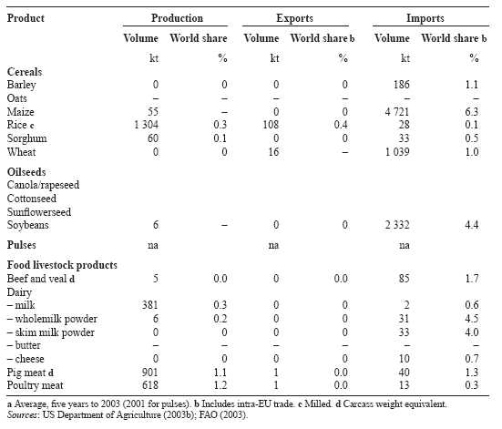

Regulatory arrangements for GMOs and
GM products in Chinese Taipei

Experimental and
commercial release
into the environment

Marketing approval

Imports
Labeling
The Council of Agriculture reviews and supervises research and development activity related to biotechnology in agriculture.

From 1 January 2003, any GM soybean or corn shall not be manufactured, processed, prepared, packed, imported or exported for food use, unless being registered with and approved by the Department of Health (Food Sanitation Bureau). (All GM varieties of soybean and corn currently on the market were required to be registered by 30 April 2002.)
Approval required from the Department of Health.
All food products containing GM soybeans or maize ingredients that are more than 5 per cent by weight should be labeled, except for soy sauce, soybean oil, corn oil, corn syrup, and corn starch. Introduction is phased, with compliance dates of:
■ 1 January 2001 for raw soybeans and corn, soybean meal/ﬂour, corn grit/meal/ﬂour;
■ 1 January 2004 for primarily processed products such as tofu, soy milk, soy curd, frozen corn, canned corn, soy protein; and
■ 1 January 2005 for highly processed soybean and maize products.

European Union
The European Union is the dominant trading bloc in world food trade. In the three years to 2001, EU countries accounted for around 42 per cent of the world’s food export value and 44 per cent of the world’s food import value (including intra-EU trade). The European Union is a major exporter in world grain markets, as well as being a significant importer (table below).
EU agricultural production is heavily subsidised under its Common Agricultural Policy (CAP) and is dominated by livestock products (particularly meat and dairy products), grains, vegetables, wine, fruit and sugar. Major EU export commodities include wheat, barley, sugar,
Summary statistics for the grain–livestock complex in the European Union a
Product |  | Production |  |  |  |  |  | Exports |  |  | Imports
Volume |  |  |  |  |  | World share |  | Volume | World share b |  | Volume | World share b
kt |  |  |  |  |  | % |  | kt | % |  | kt | %
Cereals
Barley | 49 820 |  |  |  |  |  | 37.1 | 6 782 |  | 39.5 | 398 |  |  | 2.4
Oats | 6 469 |  |  |  |  |  | 25.3 | 725 |  | 33.7 | 9 |  |  | 0.4
Maize | 37 729 |  |  |  |  |  | 6.3 | 168 |  | 0.2 | 2 655 |  |  | 3.7
Rice c | 1 769 |  |  |  |  |  | 0.4 | 366 |  | 1.4 | 886 |  |  | 3.7
Sorghum | 639 |  |  |  |  |  | 1.1 | 32 |  | 0.5 | 122 |  |  | 1.8
Wheat | 99 328 |  |  |  |  |  | 17.2 | 14 830 |  | 14.1 | 6 531 |  |  | 6.3
Oilseeds
Canola/rapeseed |  |  |  | 9 656 |  |  | 26.3 | 2 957 |  | 33.5 | 2 932 |  | 33.5
Cottonseed |  |  |  | 748 |  |  | 2.2 | 182 |  | 14.5 | 251 |  | 20.7
Sunﬂowerseed |  |  |  | 3 134 |  |  | 12.8 | 633 |  | 19.5 | 2 448 |  | 78.2
Soybeans |  |  |  | 1 180 |  |  | 0.7 | 1 536 |  | 3.0 | 18 518 |  | 35.3
Pulses |  |  |  | 2 389 |  |  | 4.4 | 1 499 |  | 18.2 | 2 788 |  | 36.8
Food livestock products
Beef and veal d |  |  | 7 390 |  |  |  | 14.9 | 678 |  | 11.5 | 424 |  |  | 8.5
Dairy
– milk |  |  |  |  | 117 524 |  | 26.8 | 0 |  | 0 | 0 |  | 0
– wholemilk powder |  |  |  |  | 897 |  | 29.8 | 526 |  | 38.7 | 13 |  | 1.8
– skim milk powder |  |  |  |  | 1 034 |  | 31.0 | 223 |  | 20.8 | 62 |  | 7.5
– butter |  |  |  |  | 1 724 |  | 29.0 | 179 |  | 26.0 | 106 |  | 30.4
– cheese |  |  |  |  | 5 409 |  | 44.2 | 437 |  | 42.0 | 145 |  | 16.8
Pig meat d |  |  |  |  | 17 639 |  | 21.4 | 1 275 |  | 37.3 | 53 |  | 1.7
Poultry meat |  |  |  |  | 6 746 |  | 13.6 | 776 |  | 15.6 | 298 |  | 7.4

a Average, ﬁve years to 2003 (2001 for pulses). b Includes intra-EU trade. c Milled. d Carcass weight equivalent. Sources: US Department of Agriculture (2003b); FAO (2003).

dairy products, beef, poultry, pork, fruit, vegetables and wine. Major agricultural imports are typically comprised of products that are not suited to the northern Europe’s cool temperate climate and include soybeans (and their products), cotton, tobacco, tropical products, offseason fruit and vegetables, coffee, cocoa, tea, and spices. The European Union also imports large quantities of animal feed to supplement domestically produced supplies.
Soybeans are the main GM crop imported into the European Union, sourced from the United States and Argentina. EU regulations have meant that Canadian canola is effectively excluded from the EU market and have made it difﬁcult to import GM maize from the United States because of the existence of unapproved GM varieties in that country. However, the European Union imports substantial quantities of maize from Argentina, a GM maize producer, as they grow only EU approved varieties.
The value of Australian food exports to the European Union was $1.85 billion in 2001-02. Nearly 60 per cent of this total value was contributed by wine exports (mainly to the United Kingdom), but exports of meat (13 per cent), cereals (9 per cent), dairy products (4 per cent) and oilseeds (2 per cent) were also important contributors.
The European Union now has among the most stringent and wide ranging regulations on genetically modiﬁed food and feed in the world. This has come largely as a response to the
Regulatory arrangements for GMOs and GM products in the European Union

Experimental and commercial release into the environment

Marketing approval

Imports

Experimental release is granted by the appropriate authorities of the member states. Arrangements for commercial release are speciﬁed under Directive 2001/18/EC. The applicant seeks approval from the competent national
authority of the member state. The next step is approval from other member states. If objections are raised, the commission asks for the opinion of its scientiﬁc committee. A favorable opinion sees the decision referred to the regulatory committee, composed of representatives of the member states. The process with an unfavorable opinion from the regulatory committee is submission to the Council of Ministers for adoption by qualiﬁed majority.
Rules are set out under EC Regulation 258/97 on novel food and novel food ingredients (the Novel Foods Regulation). The process is essentially the same as with commercial release into the environment — that is, approval required from all member states, or the decision is referred to scientiﬁc and regulatory committees. It is believed that application of 258/97 will be superseded by the proposed traceability and labeling regulations (see below).
As a derogation from the full authorisation procedure, the regulation provides for a simpliﬁed procedure for foods derived from GMOs but no longer containing GMOs that are ‘substantially equivalent’ to existing foods with respect to composition, nutritional value, metabolism, intended use and the level of undesirable substances.
Import approvals are effectively governed by the Novel Foods Regulation. Prior to this regulation, varieties of GM soybeans and maize were authorised for import under Directive 90/220/EEC.
Continued

recent incidences of mad cow disease (bovine spongiform encephalopathy or BSE) and foot and mouth disease (FMD) that damaged European consumer conﬁdence in government regulatory agencies and agribusiness groups. These concerns have developed to include a negative view of GM foods and of the companies that create and market these products. In addition, the role of some environmental activist groups and ongoing maintenance of trade barriers against agricultural imports in general has resulted in strong political pressure to regulate GM products.
Existing and new regulatory arrangements for GM products in the European Union are outlined in the box. New legislation to come into force in September 2003 with a compliance period of six months will set up a harmonised community system to trace GMOs, introduce the labeling of GM feed, reinforce the current labeling rules on GM food, and establish

Regulatory arrangements for GMOs and GM products in the European Union continued
Labeling Existing legislation
The Novel Foods Regulation provides for mandatory labeling of foods and food ingredients that contain or consist of a GMO without prejudice to other labeling requirements of EU law.
Regulation (EC) 1139/98 lays down the provisions for labeling based on the presence of DNA or protein resulting from genetic modiﬁcation. Regulation (EC) 50/2000 requires labeling of additives and ﬂavorings.
Regulation (EC) 49/2000 introduced a 1 per cent minimum threshold for adventitious presence of GM material.
Currently there is no requirement to label GM feedstuffs.
New legislation
New legislation to come into force in September 2003 extends the current mandatory labeling provisions to all GM food and feed, irrespective of the detectability of GM DNA or protein. Under this legislation there is:
■ a 0.9 per cent threshold for the labeling of food and feed; and
■ a 0.5 per cent threshold for presence of GM material in food or feed, provided the GMO has received a favorable scientiﬁc assessment, by the scientiﬁc committees or the European Food Safety Authority, but which have not been ﬁnally approved to be placed on the EU market.

Traceability Existing legislation
Traceability for GMOs was speciﬁcally introduced with Directive 2001/18/EC. The aims of traceability are to facilitate: control and veriﬁcation of labeling claims, targeted monitoring of potential effects on the environment, and withdrawal of products that contain GMOs if an unforseen risk to human health or the environment is established (European Commission 2003a).
New legislation
Business operators will be required to transmit and retain information about products that contain or are produced from GMOs at each stage of the production, processing and marketing chain.
a streamlined authorisation procedure for GMOs in food and feed and their deliberate release into the environment (European Commission 2003a). The European Union says its GM rules are paving the way for the lifting of the virtual moratorium on new approvals of GM crops that has operated since 1998 (European Commission 2003a).
A recent signiﬁcant development within the European Union are attempts by the European Commission to establish a framework in which organic and conventional farming can coexist in a sustainable way with GM crops (see European Commission 2003b). Some aspects of the coexistence framework could be appropriate measures at the farm level to minimise the adventitious presence of GMOs, and potential insurance systems to cover possible ﬁnancial losses arising from the adventitious presence of GM crops in non-GM crops. It is not clear at this stage how such a framework will affect market access barriers for GM products but there is the potential for signiﬁcant impact.

India
Government agricultural policies in India are largely aimed at increasing India’s self sufﬁciency in food production and have provided some encouragement for research into agricultural biotechnology. India is a massive producer of agricultural commodities and, despite its large population, it is a signiﬁcant exporter of beef and veal, rice and wheat, and only a minor importer of agricultural commodities (table below).
Foodstuffs, ingredients in foodstuffs, and additives including processing aids, containing or consisting of genetically modiﬁed organisms or cells cannot be produced, sold, imported or used in India except with the approval of the Genetic Engineering Approval Committee
Summary statistics for the grain–livestock complex in India a
Product |  | Production |  |  | Exports |  |  |  | Imports
Volume |  |  |  | World share | Volume |  | World share b |  | Volume | World share b
kt |  |  |  | % | kt |  | % |  | kt | %
Cereals
Barley |  | 1 506 |  | 1.1 | 0 |  | 0 |  | 0 | 0
Oats
Maize |  | 11 660 | 1.9 |  | 38 | 0.1 |  |  | 155 |  | 0.2
Rice c |  | 86 130 | 21.7 |  | 3 397 | 13.4 |  |  | 18 |  | 0.1
Sorghum |  | 8 147 | 14.6 |  | 0 | 0 |  |  | 0 |  | 0
Wheat |  | 71 544 | 12.4 |  | 2 571 | 2.4 |  |  | 389 |  | 0.4
Oilseeds
Canola/rapeseed |  | 4 407 | 12.0 |  | 0 |  | 0 |  | 0 | 0
Cottonseed |  | 5 054 | 15.0 |  | 0 |  | 0 |  | 0 | 0
Sunﬂowerseed |  | 1 365 | 5.6 |  | 0 |  | 0 |  | 0 | 0
Soybeans |  | 5 250 | 3.0 |  | 0 |  | 0 |  | 0 | 0
Pulses |  | 13 236 | 25.0 |  | 175 |  | 2.1 |  | 952 | 12.6
Food livestock products
Beef and veal d |  | 1 707 |  | 3.4 | 320 |  | 5.4 |  | 0 |  | 0.0
Dairy
– milk |  | 80 850 | 18.5 |  | 0 |  |  | 0 | 0 |  |  | 0
– wholemilk powder
– skim milk powder |  | 170 | 5.1 |  | 7 |  | 0.7 |  | 7 |  | 0.8
– butter |  | 2 170 | 36.5 |  | 3 |  | 0.4 |  | 4 |  | 1.1
– cheese
Pig meat d
Poultry meat | 1 052 |  |  | 2.1 | 1 |  | 0.0 |  | 0 |  | 0.0

a Average, ﬁve years to 2003 (2001 for pulses). b Includes intra-EU trade. c Milled. d Carcass weight equivalent. Sources: US Department of Agriculture (2003b); FAO (2003).

Regulatory arrangements for GMOs and
GM products in India
Experimental and | All experimental and commercial releases of GMOs require the approval of
commercial release | Genetic Engineering Approval Committee (GEAC) that comes under the
into the environment | Ministry of Environment and Forests.
Marketing approval | Approval required from GEAC.
Imports | Approval required from GEAC.
Labeling | GM labeling is not required.

(GEAC) (US Department of Agriculture 2002d). Regulatory arrangements in India for GMOs and GM products are outlined in the table on the previous page.
In April 2002, GEAC gave approval for the commercial release of three varieties of insect resistant (Bt) cotton for a three year period, the first GM crops commercialised in India. Those planting GM cotton must meet a set of stipulations aimed at preserving the viability of the technology, including the requirement for ‘refuge belts’ of non-GM cotton surrounding the GM cotton equivalent to at least 20 per cent of the total cotton plantings. The approval terms and conditions are detailed in US Department of Agriculture (2002d).
GEAC appears to be close to approving the commercial release of a GM mustard seed, despite some controversy over the effectiveness of the testing and approval process. Questions have also been raised about the economic viability of this particular crop — the GM mustard seed is claimed to be inferior to existing Indian varieties. Domestic research is currently under way into varieties of GM rice, tomato, potato and tobacco.
At present there is no requirement to label products derived from GMOs. However, the commercial release of GM cotton has rekindled this debate (US Department of Agriculture 2002d).

Indonesia
Indonesia is a net food importer, mainly of rice, dairy products, wheat and soybeans (table below).
Indonesia was the third largest market for Australian food in 2001-02, following a severe downturn in the late 1990s because of the so-called ‘Asian ﬁnancial crisis’. The total value of food imports from Australia in 2001-02 was $1.15 billion, made up of grains (47 per cent), live animals (18 per cent), dairy products (13 per cent) and meat (7 per cent).
Summary statistics for the grain–livestock complex in Indonesia a
Product |  |  |  | Production |  |  |  |  |  |  | Exports |  |  |  | Imports
Volume |  |  |  |  |  |  |  | World share |  |  | Volume | World share b |  |  | Volume | World share b
kt |  |  |  |  |  |  |  | % |  |  | kt | % |  |  | kt | %
Cereals
Barley
Oats
Maize | 6 140 |  |  |  |  |  |  |  | 1.0 |  | 76 |  | 0.1 |  | 1 063 |  | 1.5
Rice c | 32 839 |  |  |  |  |  |  |  | 8.3 |  | 0 |  | 0 |  | 2 746 |  | 11.6
Sorghum
Wheat |  |  | 0 |  |  |  |  |  |  | 0 | 45 |  |  | – | 3 918 |  |  | 3.8
Oilseeds
Canola/rapeseed
Cottonseed |  |  |  |  | 14 |  |  |  |  | – | 14 |  | 1.1 |  | 0 |  |  |  | 0
Sunﬂowerseed
Soybeans |  | 1 075 |  |  |  |  |  |  | 0.6 |  | 0 |  | 0 |  | 1 396 |  |  | 2.7
Pulses |  | 286 |  |  |  |  |  |  | 0.6 |  | 6 |  | 0.1 |  | 39 |  |  | 0.5
Food livestock products
Beef and veal d
Dairy
– milk
– wholemilk powder |  |  |  |  |  |  | 47 |  | 1.6 |  | 15 |  | 1.1 |  | 26 |  | 3.8
– skim milk powder |  |  |  |  |  |  | 0 |  | 0 |  | 18 |  | 1.7 |  | 97 |  | 11.7
– butter
– cheese
Pig meat d
Poultry meat |  |  |  |  |  | 437 |  |  | 0.9 |  | 2 |  | 0.0 |  | 4 |  |  | 0.1

a Average, ﬁve years to 2003 (2001 for pulses). b Includes intra-EU trade. c Milled. d Carcass weight equivalent. Sources: US Department of Agriculture (2003b); FAO (2003).

Regulatory arrangements for GMOs and
GM products in Indonesia
Experimental and  commercial release  into the environment | The Agency for Agricultural Research and Development of the Ministry of
Experimental and  commercial release  into the environment | Agriculture has responsibilities for the assessment, approval and monitoring
Experimental and  commercial release  into the environment | of agricultural biotechnology.
Marketing approval

Imports

Labeling | Government Regulation No. 69/1999 on Food Labeling and Advertising
 | requires food derived from biotechnology to be labeled as such.
 | There are plans to extend the GM labeling requirement to GM feeds.

In 2000, Indonesia commercialised GM cotton (insect resistant through the insertion of the Bt gene). Indonesia produces only a small amount of cottonseed but apparently all of this is exported (table on previous page).
The regulatory arrangements for GMOs and GM products in Indonesia are outlined in the box above.

Japan
Limited agricultural resources in relation to its population size mean that Japan is heavily dependent on food and feed imports (table below). Japan sources the bulk of its agricultural commodity imports from the United States but it is a very important export market for Australia for commodities like beef and veal, barley, canola, dairy products, seafood, sugar and wheat. Japan is Australia’s largest food export market, with a total export value of $4.76 billion in 2001-02. Import matrixes for key agricultural commodities for Japan are provided in the statistical annex.
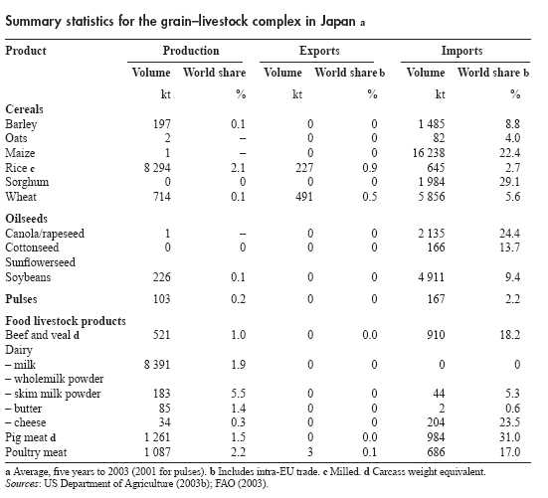

Regulatory arrangements for GMOs and
GM products in Japan
Experimental and | The Ministry of Agriculture, Forestry and Fisheries (MAFF) is responsible
commercial release | for environmental safety assessments. Assessments are voluntary. New
into the environment | legislation in 2003 to accompany Japan’s ratiﬁcation of the Biosafety Protocol
 | will formalise the regulatory procedures already in place.
Marketing approval | Food safety is regulated under the Food Sanitation Law, administered by the
 | Ministry of Health, Labour and Welfare (MHLW). A new advisory body to
 | the MHLW — the Food Safety Commission — will operate from mid-2003.
 | MAFF is responsible for assessing the safety of GM feed. From 1 April 2003,
 | these assessments are mandatory.
Imports | Foods cannot be imported that contain unapproved GM varieties. In April
 | 2003, MAFF set a tolerance of 1 per cent adventitious presence of GM
 | varieties in feed that are approved in other countries but not yet approved in
 | Japan. Regular testing is carried out by MAFF and MHLW with food and
 | feed imports to check compliance.
Labeling | Labeling requirements are implemented under the Food Sanitation Law and
 | the Japan Agriculture Standards Law, administered by MAFF. MHLW also
 | plays a role in enforcing labeling standards under these laws. There are 44
 | foods subjected to this labeling requirement because they are made from
 | ingredients that could include GM varieties and because GM DNA or proteins
 | can be identiﬁed in the foods (US Department of Agriculture 2002b).
 | Since April 2001, labeling is mandatory if modiﬁed DNA or protein can be
 | scientiﬁcally detected in the ﬁnished foods but only if the GM content
 | exceeds 5 per cent. The tolerance only applies to GM varieties approved in
 | Japan. To be labeled ‘non-GM’, a supplier must also be able show that the
 | ingredients were identity preserved from production through to processing
 | (US Department of Agriculture 2003b).

Japan has a pragmatic approach to regulation of GMOs that reﬂects its dependence on imports of food and animal feed. Japan has approved 44 GM varieties for food use and 184 for ﬁeld trials — see US Department of Agriculture (2003c) for a list of approved crops and plant products as at December 2002. Japanese regulatory arrangements are outlined in the box above.

Republic of Korea
The Republic of Korea is a major importer of grain and livestock products, producing only rice and pig meat in substantial quantities (table below). Import matrixes for key agricultural commodities for the Republic of Korea are provided in the statistical annex.
In 2001-02, the Republic of Korea was the fourth largest market for Australian food exports, with a total value of $1.14 billion. The main components by value in 2001-02 were meat (33 per cent), grains (28 per cent), sugar (19 per cent), dairy products (8 per cent) and beer and malt (4 per cent).
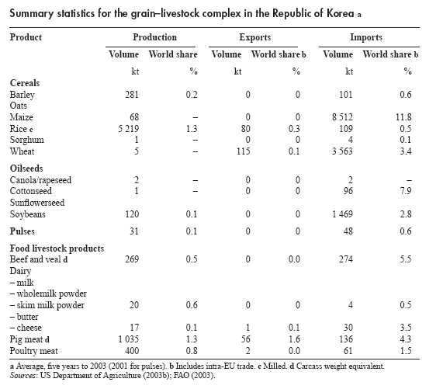
Regulatory arrangements for GMOs and GM products in the Republic of Korea
Experimental and Safety assessments for environmental release are operated on a voluntary basis.
commercial release Mandatory assessments by the Ministry of Agriculture and Forestry (MAF) are
into the environment expected with soon to be enacted legislation.

Marketing approval Safety assessments are voluntary for food and feed. Mandatory assessments by the Korean Food and Drug Administration (KFDA) are expected with impending legislation.

Imports Current voluntary procedures for import approvals will be replaced by mandatory arrangements when new legislation is enacted. The Law on Transboundary Movement, Etc of Living Genetically Modiﬁed Organisms will be activated when Republic of Korea ratiﬁes the Biosafety Protocol

Labeling Labeling requirements for bulk (unprocessed corn) are enforced by MAF with maize, soybeans, soybean sprouts, and potatoes. To avoid labeling, adventitious presence of GM varieties must be less than 3 per cent and identity preservation procedures observed.
With processed products, the Korean Food and Drug Administration enforces mandatory labeling where the primary ingredients are subject to MAF GM labeling requirements and where GM ingredients are one of the ﬁve major raw ingredients used.

New legislation governing regulation of GMOs in the Republic of Korea is soon to be enacted. The outline of the current and proposed regulatory arrangements that is provided in the box above draws heavily on US Department of Agriculture (2002a).

Malaysia
Malaysia is the dominant exporter in the world palm oil market (not shown in the table below) but a net importer of most temperate climate agricultural commodities.
Malaysia was ranked seventh as a destination for Australian food exports in 2001-02 with a total value of $1.08 billion, with the main components by value being sugar (30 per cent), dairy products (20 per cent), grains (18 per cent) and meat (7 per cent).
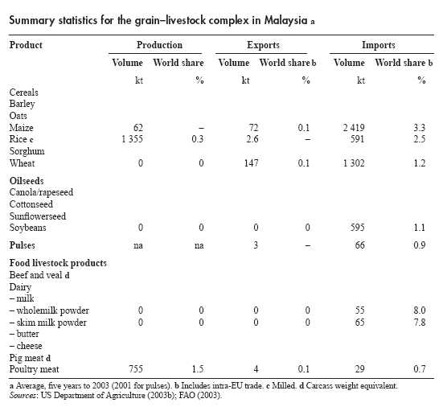

Regulatory arrangements for GMOs and GM products in Malaysia
Experimental and Application to release genetically modiﬁed organisms into the environment (ﬁeld trials or
commercial release commercial planting) is voluntary, and assessed by the Genetic Modiﬁcation Advisory
into the environment Committee (GMAC). The Department of Agriculture,
on the advice of GMAC, issues permits for the ﬁeld testing/planting of GM plants.
Marketing approval Division of Food Quality Control (DFQC) of the Ministry Of Health oversees food safety matters.
Imports Import permits are required from the Director General of the Agriculture Department.
Labeling DFQC is responsible for food labeling. It is believed that mandatory labeling will be introduced for GM food and feed at the beginning of 2004, with a tolerance for adventitious presence of GM material of 3 per cent by volume.
Malaysia is in the process of enacting a biosafety law to ensure the responsible development of biotechnology here while assuring human health and environmental safety. The existing arrangements are outlined in the box above.

Philippines
Agriculture contributes around a quarter of the gross domestic product of the Philippines. Nevertheless, the Philippines is a large importer of rice, dairy products and meat and live animals (mainly cattle). It also imports signiﬁcant quantities of soybeans, wheat and maize.
The Philippines is an important market for Australia food exports, with a total value of $636 million in 2001-02. The main components, by value, of these exports were dairy (53 per cent) and meat and live animals (20 per cent).
Summary statistics for the grain–livestock complex in Philippines a
Product |  |  | Production |  |  |  |  |  |  | Exports |  |  |  | Imports
Volume |  |  |  |  |  |  | World share |  |  | Volume | World share b |  |  | Volume | World share b
kt |  |  |  |  |  |  | % |  |  | kt | % |  |  | kt | %
Cereals
Barley
Oats
Maize | 4 531 |  |  |  |  |  |  | 0.8 |  | 0 |  |  | 0 | 270 |  |  | 0.4
Rice c | 7 896 |  |  |  |  |  |  | 2.0 |  | 0 |  |  | 0 | 1 200 |  |  | 5.1
Sorghum
Wheat |  | 0 |  |  |  |  |  |  | 0 | 32 |  |  | – | 577 |  |  | 0.6
Oilseeds
Canola/rapeseed
Cottonseed
Sunﬂowerseed
Soybeans |  |  | 1 |  |  |  |  | – |  | 0 |  |  | 0 | 360 |  |  | 0.7
Pulses |  |  | 57 |  |  |  |  | 0.1 |  | 0 |  |  | 0 | 71 |  |  | 0.9
Food livestock products
Beef and veal d |  |  |  |  | 211 |  |  | 0.4 |  | 0 |  | 0.0 |  | 103 |  |  | 2.1
Dairy
– milk
– wholemilk powder |  |  |  |  |  | 0 |  |  | 0 | 0 |  |  | 0 | 45 |  | 6.5
– skim milk powder |  |  |  |  |  | 0 |  |  | 0 | 0 |  |  | 0 | 94 |  | 11.3
– butter
– cheese
Pig meat d |  |  |  | 1 015 |  |  |  | 1.2 |  | 0 |  | 0.0 |  | 16 |  |  | 0.5
Poultry meat |  |  |  | 539 |  |  |  | 1.1 |  | 0 |  | 0.0 |  | 11 |  |  | 0.3

a Average, ﬁve years to 2003 (2001 for pulses). b Includes intra-EU trade. c Milled. d Carcass weight equivalent. Sources: US Department of Agriculture (2003b); FAO (2003).

Regulatory arrangements for GMOs and
GM products in the Philippines
Experimental and | The Bureau of Plant Industry (BPI), the Philippine Department of Agriculture
commercial release | approves applications for ﬁeld trials and for commercialisation of GM plant
into the environment | and plant products.
Marketing approval | In effect, the BPI is responsible for marketing approval for GM plant and
 | plant products. For GM products intended for food use, it refers applications
 | to the Bureau of Agricultural and Fisheries Product Standards for comment;
 | for feed use, the agency from which comment is sought is the Bureau of
 | Animal Industry.
Imports | BPI is responsible for approval for importation of GM plants and plant
 | products for direct use as food or feed, or for processing.
Labeling | GM labeling is voluntary.

One GM crop has been approved for commercialisation in the Philippines — insect resistant maize based on the Bt gene in December 2002. The rules and regulations for the import and release into the environment of plants and plant products derived from the use of modern biotechnology are set out in Administrative Order no. 8, Series of 2002 of the Philippine Department of Agriculture. The regulatory arrangements for GMOs are outlined in the box above.

Saudi Arabia
Limited rainfall means that Saudi Arabia has a small agricultural output, largely based on the use ground and desalinated water. Subsidies apply to Saudi production and to imports of maize, soymeal and feed barley. (The subsidy on barley production was removed in 2002.) The main Saudi agricultural commodity imports are barley (all for feed purposes), maize and rice (table below). Import matrixes for Saudi Arabia are provided in the statistical annex.
Saudi Arabia is an important market for Australian food exports, ranking tenth in terms of value in 2001-02, with a total value of $796 million. The main components of these exports
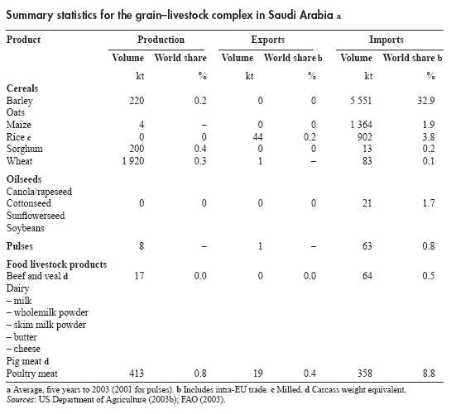

Regulatory arrangements for GMOs and
GM products in Saudi Arabia
Experimental and
commercial release
into the environment
Marketing approval | Same as for imports (see below). A decree in March 2003 established the Food and Drug Authority that will eventually take over the food safety role.
Imports | Each shipment of GM products exported to Saudi Arabia must be  accompanied by a health certiﬁcate stating that the GM ingredient(s) have been approved in the country of origin for consumption. Imports are regulated by the Ministry of Commerce (MOC). Imports of GM animals, birds and their products are banned.
Labeling | Labeling has been required by MOC since December 2001 on all imported and locally produced processed products that have GM ingredients. There appears to be a 1 cent threshold for unintended presence of GMO before labeling is required. In March 2003, a decree by the Ministry of Agriculture (MOA) extended this labeling requirement to all imported and locally produced GM animal feed, planting seed, fruits, vegetables and other products under its authority. A twelve month period of grace has been granted from the date of the decree to enable compliance.

were grain (24 per cent by value), dairy products (28 per cent), live animals (mainly sheep but also cattle, 19 per cent), meat (18 per cent) and sugar (7 per cent).
Saudi Arabia’s regulatory arrangements for GMOs are outlined in the box above. These arrangements are described in more detail in US Department of Agriculture (2003d).

Thailand
Thailand is one of the world’s largest food exporters and the only net food exporting country in Asia. Thailand is a major producer and exporter of agricultural products such as rice (world’s largest exporter), seafood, poultry, and frozen/canned fruits such as pineapples, bananas, mangoes and papayas. Trade matrixes for Thailand are provided in the statistical annex.
Thailand ranked ﬁfteenth in terms of value as a destination for Australian food exports in 2001-02, with a total value of $349 million. The main components of these exports were dairy products (42 per cent), grains (22 per cent) and beer and malt (10 per cent).
Summary statistics for the grain–livestock complex in Thailand a
Product |  |  | Production |  |  |  |  |  | Exports |  |  |  |  | Imports
Volume |  |  |  |  |  | World share |  |  | Volume | World share b |  |  |  | Volume | World share b
kt |  |  |  |  |  | % |  |  | kt | % |  |  |  | kt | %
Cereals
Barley
Oats
Maize | 4 260 |  |  |  |  |  | 0.7 |  | 170 |  | 0.2 |  |  | 135 |  | 0.2
Rice c | 16 754 |  |  |  |  |  | 4.2 |  | 7 099 |  | 28.0 |  |  | 3 |  | –
Sorghum | 200 |  |  |  |  |  | 0.4 |  | 4 |  | 0.1 |  |  | 0 |  | 0
Wheat | 0 |  |  |  |  |  | 0 |  | 77 |  | 0.1 |  |  | 923 |  | 0.9
Oilseeds
Canola/rapeseed
Cottonseed
Sunﬂowerseed
Soybeans |  | 314 |  |  |  |  | 0.2 |  | 0 |  |  | 0 |  | 1 300 |  | 2.5
Pulses |  | 280 |  |  |  |  | 0.6 |  | 39 |  |  | 0.5 |  | 6 |  | 0.1
Food livestock products
Beef and veal d
Dairy
– milk
– wholemilk powder |  |  |  |  | 0 |  |  | 0 | 0 |  |  |  | 0 | 30 |  | 4.3
– skim milk powder |  |  |  |  | 0 |  |  | 0 | 0 |  |  |  | 0 | 54 |  | 6.6
– butter
– cheese
Pig meat d
Poultry meat |  |  |  | 1 118 |  |  | 2.3 |  | 356 |  |  | 7.2 |  | 0 |  | 0.0

a Average, ﬁve years to 2003 (2001 for pulses). b Includes intra-EU trade. c Milled. d Carcass weight equivalent. Sources: US Department of Agriculture (2003b); FAO (2003).

Regulatory arrangements for GMOs and
GM products in Thailand
Experimental and | Under the Plant Quarantine Act, all imports of GM plants for experimental
commercial release | purposes are prohibited unless permission is granted by the Director General
into the environment | of the Thai Department of Agriculture.
Marketing approval | Thai Department of Livestock Development approves commercial release of
 | GM animal feed (and GM animals).
Imports
Labeling | From 11 May 2003, Thailand’s Food and Drug Administration requires that
 | food products that contain any GMO ingredient of at least 5 per cent as one of
 | the top three ingredients be labeled as containing GM food products.

In terms of agricultural biotechnology and its products, the Government of Thailand has taken the view that consumers have a right to be informed of GM foods under the country’s constitution.

United States
The United States either dominates or is an important player in world markets for most agricultural commodities. The nature of the US grain–livestock complex is summarised in the table below and export trade matrixes for key agricultural products are provided in the statistical annex.
The main GM crops in the United States are cotton (insect resistant, herbicide tolerant or combining both these traits), soybeans (herbicide tolerant), canola (herbicide tolerant) and maize (insect resistant or herbicide tolerant). In 2003, it is estimated that 81 per cent of
Summary statistics for the US grain–livestock complex a
Product |  | Production |  |  |  |  |  | Exports |  |  | Imports
Volume |  |  |  |  |  | World share |  | Volume | World share b |  | Volume | World share b
kt |  |  |  |  |  | % |  | kt | % |  | kt | %
Cereals
Barley | 6 216 |  |  |  |  |  | 4.6 | 710 |  | 4.1 | 569 |  | 3.4
Oats | 2 026 |  |  |  |  |  | 7.9 | 31 |  | 1.4 | 1 752 |  | 85.1
Maize | 241 915 |  |  |  |  |  | 40.4 | 47 886 |  | 64.5 | 333 |  | 0.5
Rice c | 6 297 |  |  |  |  |  | 1.6 | 2 934 |  | 11.6 | 367 |  | 1.6
Sorghum | 12 548 |  |  |  |  |  | 22.4 | 5 634 |  | 81.4 | 0 |  | 0
Wheat | 55 619 |  |  |  |  |  | 9.7 | 26 872 |  | 25.5 | 2 475 |  | 2.4
Oilseeds
Canola/rapeseed |  |  |  | 771 |  |  | 2.1 | 209 |  | 2.4 | 211 |  | 2.4
Cottonseed |  |  |  | 5 811 |  |  | 17.2 | 197 |  | 15.7 | 244 |  | 20.2
Sunﬂowerseed |  |  |  | 1 731 |  |  | 7.1 | 215 |  | 6.6 | 62 |  | 2.0
Soybeans |  |  |  | 74 968 |  |  | 42.9 | 26 307 |  | 50.7 | 82 |  | 0.2
Pulses |  |  |  | 1 629 |  |  | 3.1 | 604 |  | 7.3 | 175 |  | 2.3
Food livestock products
Beef and veal d |  |  | 12 127 |  |  |  | 24.4 | 1 067 |  | 18.1 | 1 354 |  | 27.0
Dairy
– milk |  |  |  |  | 75 962 |  | 17.3 | 0 |  | 0.0 | 0 |  | 0.0
– wholemilk powder |  |  |  |  | 35 |  | 1.1 | 4 |  | 0.3 | 3 |  | 0.4
– skim milk powder |  |  |  |  | 651 |  | 19.5 | 146 |  | 13.6 | 5 |  | 0.6
– butter |  |  |  |  | 586 |  | 9.9 | 4 |  | 0.5 | 19 |  | 5.5
– cheese |  |  |  |  | 3 746 |  | 30.6 | 50 |  | 4.8 | 206 |  | 23.7
Pig meat d |  |  |  |  | 8 720 |  | 10.6 | 632 |  | 18.5 | 410 |  | 12.9
Poultry meat |  |  |  |  | 13 619 |  | 27.5 | 2 197 |  | 44.2 | 4 |  | 0.1

a Average, ﬁve years to 2003 (2001 for pulses). b Includes intra-EU trade. c Milled. d Carcass weight equivalent. Sources: US Department of Agriculture (2003b); FAO (2003).
Regulatory arrangements for GMOs and GM products in the United States
Experimental and Animal and Plant Health Inspection Service (APHIS) of the United States Department
commercial release of Agriculture the lead agency for ensuring the safety of GMOs for the environment.
into the environment The Environment Protection Agency has a joint responsibility with APHIS for the release of crops that have been modiﬁed to have anti-pest proteins, such as insect resistant cotton. Permits for both experimental release and commercial (unregulated) release must be obtained from these agencies.

Marketing approval The Food and Drug Administration assesses food safety. The assessment is
essentially based on the concept of ‘substantial equivalence’ (Nep et al.
2003).
Imports
Labeling Labeling is not required if the Food and Drug Administration rules substantial equivalence but is required if consumers must be alerted to a safety issue.
soybean plantings in the United States were GM varieties, 73 per cent with cotton, and 40 per cent with maize (National Agricultural Statistics Service 2003).
In terms of value, the United States was the second largest market for Australian food exports in 2001-02. The total value of Australian food exports to the United States in 2001-02 was $3.5 billion, the main components of which were meat (62 per cent), wine (19 per cent), dairy products (5 per cent) and oilseeds (mainly cottonseed, 2 per cent). Australia’s food imports from the United States in 2001-02 were only $0.46 billion, comprising processed fruit and vegetables, 22 per cent; spirits, 20 per cent; and fresh fruit and nuts, 7 per cent.
GMOs are regulated in the United States under a science based risk assessment system that was initially established in 1986 as the Coordinated Framework for Regulation of Biotechnology. The framework was based on existing government agencies; it was considered that no new and speciﬁc biotechnology regulation system was necessary (Nap, Metz, Escaler and Conner 2003). The regulation focuses on the characteristics of the products rather than the way in which the product was produced. The regulatory arrangements for GMOs are detailed in the box above.

statistical annex
This annex consists of a range of data in tables for grain and animal products that could conceivably be affected by the introduction of GM crops. The data are gathered from a range of different sources and are provided in Excel format. The tables include:
■ Supply and disposal tables for key grains, grain products (such as ﬂour, oil and meal) and food animal products, such as beef and veal, pig meat, poultry meat and dairy products (milk, dried skim milk, butter and cheese).

■ Import and export trade matrixes for key countries in the world for key grain, grain products and food animal products.

The tables are provided online at www.affa.gov.au/gmmarkets. Sample tables are provided on the following pages for:

■ world maize supply and disposal; and

■ Australian feed barley exports, by country.

sample tables
 Maize: World supply and disposal
 | 1998-99 | 1999-00 | 2000-01 | 2001-02 p | 2002-03 f | Share a
 | kt | kt | kt | kt | kt | %
Production
Argentina | 13500 | 17200 | 15400 | 14400 | 14500 | 2.5
Brazil | 32393 | 31641 | 41536 | 35501 | 37000 | 5.9
Canada | 8952 | 9161 | 6827 | 8389 | 9065 | 1.4
China | 132954 | 128086 | 106000 | 114088 | 125000 | 20.2
Egypt | 5605 | 5678 | 5636 | 6160 | 6200 | 1.0
European Union | 35295 | 36404 | 37823 | 39685 | 39440 | 6.3
Hungary | 6000 | 7000 | 5000 | 7858 | 6080 | 1.1
India | 10680 | 11470 | 12068 | 13510 | 10570 | 1.9
Indonesia | 6500 | 6200 | 5900 | 6000 | 6100 | 1.0
Mexico | 17788 | 19240 | 17920 | 20400 | 19000 | 3.2
Nigeria | 4950 | 5100 | 4000 | 5000 | 5200 | 0.8
Philippines | 4894 | 4449 | 4508 | 4505 | 4300 | 0.8
Romania | 8000 | 10500 | 4800 | 7000 | 7500 | 1.3
Serbia | 5174 | 6140 | 2944 | 6200 | 5400 | 0.9
South Africa | 7946 | 11455 | 8040 | 9700 | 9000 | 1.5
Ukraine | 2301 | 1737 | 3848 | 3641 | 4200 | 0.5
United States | 247882 | 239549 | 251854 | 241485 | 228805 | 40.4
Other countries | 55024 | 56286 | 54160 | 55203 | 56592 | 9.3
Total production | 605838 | 607296 | 588264 | 598725 | 593952 | 100.0
Consumption
Brazil | 33615 | 33500 | 34500 | 34500 | 35700 | 5.7
Canada | 9029 | 9055 | 10123 | 11965 | 12521 | 1.7
China | 115500 | 118000 | 118000 | 120000 | 122000 | 19.6
Egypt | 9292 | 10178 | 10900 | 11050 | 11400 | 1.7
European Union | 38578 | 38600 | 40300 | 41600 | 41600 | 6.6
India | 10853 | 11350 | 11950 | 13050 | 11900 | 1.9
Indonesia | 6711 | 7279 | 7150 | 7150 | 7200 | 1.2
Japan | 16436 | 16317 | 16200 | 16300 | 16200 | 2.7
Korea Rep. | 7526 | 8624 | 8616 | 8735 | 8960 | 1.4
Mexico | 23037 | 23657 | 24000 | 24500 | 25500 | 4.0
Nigeria | 4950 | 5100 | 4000 | 5030 | 5250 | 0.8
Philippines | 4643 | 5081 | 4904 | 4790 | 4550 | 0.8
Romania | 8621 | 9500 | 6250 | 6800 | 7200 | 1.3
Serbia | 5048 | 6091 | 3119 | 6175 | 5100 | 0.8
South Africa | 7936 | 8854 | 8705 | 8800 | 9000 | 1.4
Taiwan | 4690 | 5047 | 5000 | 4850 | 4650 | 0.8
United States | 185788 | 192496 | 198102 | 201453 | 199780 | 32.2
Other countries | 90431 | 97076 | 93580 | 93398 | 91205 | 15.4
Total consumption | 582684 | 605805 | 605399 | 620146 | 619716 | 100.0
Exports
Argentina | 7848 | 8859 | 12229 | 8581 | 10500 | 13.0
Brazil | 8 | 50 | 3741 | 3857 | 2300 | 2.7
Canada | 830 | 449 | 127 | 211 | 400 | 0.5
China | 3340 | 9935 | 7276 | 8611 | 12000 | 11.1
European Union | 99 | 210 | 266 | 63 | 200 | 0.2
Hungary | 1829 | 1786 | 730 | 2751 | 1800 | 2.4
Paraguay | 126 | 309 | 386 | 262 | 300 | 0.4
Romania | 400 | 400 | 50 | 200 | 200 | 0.3
Serbia | 126 | 49 | 50 | 50 | 300 | 0.2
South Africa | 798 | 836 | 1415 | 1182 | 1400 | 1.5
Ukraine | 365 | 55 | 397 | 349 | 600 | 0.5
United States | 52030 | 49493 | 48329 | 47131 | 45500 | 65.6
Other countries | 893 | 1008 | 1561 | 1095 | 905 | 1.5
Total exports | 68692 | 73439 | 76557 | 74343 | 76405 | 100.0
Imports
Algeria | 1171 | 1300 | 1500 | 1537 | 1700 | 2.0
Brazil | 945 | 1789 | 671 | 297 | 400 | 1.1
Canada | 936 | 1115 | 2843 | 4022 | 4000 | 3.5
Chile | 1268 | 1260 | 1362 | 1278 | 1400 | 1.8
Colombia | 1570 | 2005 | 1857 | 1911 | 1900 | 2.5
Costa Rica | 430 | 550 | 513 | 463 | 500 | 0.7
Cyprus | 133 | 160 | 233 | 275 | 200 | 0.3
Dominican Rep. | 814 | 1000 | 968 | 1038 | 1000 | 1.3
Ecuador | 285 | 225 | 149 | 309 | 300 | 0.3
Egypt | 3687 | 4600 | 5268 | 4950 | 5200 | 6.4
El Salvador | 375 | 400 | 469 | 287 | 350 | 0.5
European Union | 2716 | 2296 | 2857 | 2906 | 2500 | 3.6
Guatemala | 385 | 500 | 549 | 584 | 550 | 0.7
Honduras | 125 | 200 | 252 | 217 | 300 | 0.3
India | 175 | 250 | 50 | 1 | 300 | 0.2
Indonesia | 455 | 1229 | 1280 | 1149 | 1200 | 1.4
Iran | 1205 | 1249 | 1265 | 1261 | 1200 | 1.7
Israel | 579 | 800 | 993 | 1021 | 500 | 1.1
Jamaica | 207 | 235 | 221 | 241 | 225 | 0.3
Japan | 16336 | 16117 | 16340 | 16395 | 16000 | 22.0
Jordan | 448 | 450 | 454 | 439 | 350 | 0.6
Kenya | 250 | 250 | 700 | 20 | 200 | 0.4
Korea DPR | 200 | 150 | 688 | 288 | 300 | 0.4
Korea Rep. | 7517 | 8694 | 8743 | 8608 | 9000 | 11.5
Kuwait | 180 | 200 | 128 | 107 | 200 | 0.2
Lebanon | 225 | 275 | 184 | 263 | 200 | 0.3
Libya | 91 | 275 | 252 | 235 | 250 | 0.3
Malaysia | 2384 | 2296 | 2588 | 2425 | 2400 | 3.3
Mexico | 5615 | 4911 | 5928 | 4025 | 6500 | 7.3
Morocco | 729 | 750 | 966 | 850 | 900 | 1.1
Mozambique | 24 | 46 | 40 | 369 | 300 | 0.2
Panama | 265 | 300 | 249 | 237 | 250 | 0.4
Peru | 1050 | 862 | 861 | 858 | 900 | 1.2
Russian Federation | 524 | 870 | 150 | 534 | 300 | 0.6
Saudi Arabia | 1265 | 1500 | 1389 | 1268 | 1400 | 1.8
Slovenia | 108 | 189 | 163 | 337 | 400 | 0.3
South Africa | 307 | 350 | 0 | 726 | 800 | 0.6
Syria | 570 | 750 | 794 | 892 | 600 | 1.0
Taiwan | 4575 | 5023 | 4924 | 4585 | 4500 | 6.4
Tunisia | 561 | 566 | 776 | 793 | 800 | 0.9
Turkey | 887 | 1250 | 608 | 1193 | 750 | 1.3
United States | 479 | 367 | 179 | 254 | 450 | 0.5
Venezuela | 1463 | 1300 | 1207 | 515 | 300 | 1.3
Vietnam | 107 | 200 | 50 | 263 | 300 | 0.2
Zimbabwe | 350 | 50 | 50 | 301 | 400 | 0.3
Other countries | 4721 | 4285 | 4846 | 3816 | 3930 | 5.8
Total imports | 68692 | 73439 | 76557 | 74343 | 76405 | 100.0
Closing stocks
Brazil | 999 | 550 | 1648 | 1074 | 774 | 0.7
Canada | 885 | 1552 | 880 | 1056 | 1200 | 0.8
China | 102092 | 102314 | 83127 | 68654 | 59754 | 56.7
European Union | 3739 | 3629 | 3743 | 4671 | 4811 | 2.8
Japan | 1355 | 1156 | 1297 | 1393 | 1194 | 0.9
Korea Rep. | 889 | 1038 | 1229 | 1162 | 1259 | 0.8
Mexico | 1850 | 2336 | 2167 | 2042 | 2027 | 1.4
Romania | 950 | 1650 | 500 | 580 | 730 | 0.6
Taiwan | 1475 | 1475 | 1458 | 1246 | 1146 | 0.9
Ukraine | 500 | 267 | 944 | 966 | 996 | 0.5
United States | 45391 | 43628 | 48240 | 40551 | 25505 | 27.7
Other countries | 9429 | 11450 | 8677 | 9094 | 7329 | 6.3
Total closing stocks | 169554 | 171045 | 153910 | 132489 | 106725 | 100.0
a Average, five years to 2002-03.
Source: US Department of Agriculture, 'PS&D Online' (www.fas.usda.gov/psd)

Australian feed barley exports, by country

Australian feed barley exports, by country
 | 1997-98 | 1998-99 | 1999-00 | 2000-01 | 2001-02 | Share a
 | kt | kt | kt | kt | kt | %
Bahrain | 0 | 0 | 0 | 0 | 0 | 0.0
Bangladesh | 0 | 0 | 0 | 0 | 0 | 0.0
China | 0 | 248 | 53 | 39 | 169 | 4.7
Chinese Taipei | 111 | 108 | 71 | 98 | 89 | 4.4
Colombia | 0 | 51 | 0 | 0 | 0 | 0.5
Fiji | 0 | 0 | 0 | 0 | 0 | 0.0
France | 0 | 0 | 0 | 0 | 0 | 0.0
French Polynesia | 0 | 0 | 0 | 0 | 0 | 0.0
Hong Kong | 0 | 0 | 0 | 0 | 0 | 0.0
Indonesia | 0 | 0 | 0 | 0 | 0 | 0.0
Iran | 95 | 0 | 0 | 166 | 53 | 2.9
Japan | 546 | 802 | 465 | 593 | 767 | 29.3
Jordan | 33 | 0 | 0 | 0 | 0 | 0.3
Korea, Rep. | 0 | 0 | 0 | 0 | 1 | 0.0
Kuwait | 163 | 231 | 71 | 175 | 215 | 7.9
Libya | 0 | 0 | 0 | 0 | 0 | 0.0
Macau | 0 | 0 | 0 | 0 | 0 | 0.0
Malaysia | 0 | 0 | 0 | 0 | 0 | 0.0
Mauritius | 0 | 0 | 0 | 0 | 0 | 0.0
Netherlands | 0 | 0 | 0 | 0 | 0 | 0.0
New Caledonia | 0 | 0 | 0 | 0 | 0 | 0.0
New Zealand | 5 | 45 | 20 | 3 | 29 | 0.9
No Country Detail (Confidential) | 134 | 0 | 1061 | 0 | 0 | 11.0
Norway | 0 | 0 | 0 | 0 | 0 | 0.0
Oman | 17 | 49 | 10 | 27 | 55 | 1.5
Pakistan | 0 | 0 | 0 | 0 | 0 | 0.0
Peru | 0 | 6 | 0 | 0 | 0 | 0.1
Philippines | 3 | 4 | 4 | 4 | 3 | 0.2
Qatar | 29 | 21 | 19 | 30 | 17 | 1.1
Saudi Arabia | 176 | 1094 | 0 | 610 | 1267 | 29.1
Singapore | 0 | 0 | 0 | 0 | 0 | 0.0
Sri Lanka | 0 | 0 | 0 | 0 | 0 | 0.0
Switzerland | 0 | 0 | 0 | 0 | 0 | 0.0
United Arab Emirates | 82 | 227 | 77 | 153 | 128 | 6.2
Vanuatu | 0 | 0 | 0 | 0 | 0 | 0.0
Vietnam | 0 | 0 | 0 | 0 | 0 | 0.0
Total | 1396 | 2887 | 1851 | 1898 | 2794 | 100.0
(value, $m) | 264.5 | 427.2 | 326.4 | 409.3 | 585.0
a Average, five years to 2001-02.
Source: Australian Bureau of Statistics, International Trade, electronic data service, cat. no. 5464.0, Canberra.

References
AFFA (Department of Agriculture, Fisheries and Forestry – Australia) 2002, ‘Regulatory framework in Australia’, Canberra (www.affa.gov.au/content/output.cfm?ObjectID= D39889BE-E4BF-4A1A-B718231979EEEE49).
—— 2003, Australian Food Statistics, Canberra.
Australian Barley Board 2002, ‘Our markets don’t want GMO: ABB’, Media release, Adelaide 3 October.
Australian Bureau of Statistics 2003, International Trade, Electronic Data Service, cat. no. 5464.0, Canberra.
Australian Dairy Corporation 2002, ‘New GM labelling now in force’, The Australian Dairy Report, Melbourne, January/February.
Buckwell, A., Brookes, G. and Bradley, D. 1998, Economics of Identity Preservation for Genetically Modiﬁed Crops, Report to the Food Biotechnology Communications Initiative, December.
Bullock, D.S. and Desquilbet, M. 2002, ‘The economics of non-GMO segregation and identity preservation’, Food Policy, vol. 27, no. 1, pp. 81–99.
Burachik, M. and Traynor, P. 2002, Analysis of a National Biosafety System: Regulatory Policies and Procedures in Argentina, ISNAR Country Report no. 63, International Service for National Agricultural Research, the Hague, the Netherlands.
CFIA (Canadian Food Inspection Agency) 2003a, ‘Regulation of biotechnology in Canada’, Ottawa (www.inspection.gc.ca/english/sci/biotech/bioteche.shtml).
—— 2003b, ‘Labeling of genetically engineered foods in Canada’, Ottawa (www.inspec-tion.gc.ca/english/sci/biotech/labeti/response.shtml).
Canadian Wheat Board 2002, ‘2001-02 statistical tables’, Winnipeg, Manitoba (www.cwb.ca/en/publications/students_researchers/pdf/stats_english_2001-02.pdf)
Department of Agriculture, Western Australia 2003, Assessment of International Markets for Genetically Modiﬁed Canola, Perth, March.
Economic Research Service 2000, ‘Biotechnology: US grain handlers look ahead’, Agricultural Outlook, US Department of Agriculture, Washington DC, pp. 29–34.
European Commission 2003a, Questions and Answers on the Regulation of GMOs in the EU, MEMO/02/160 – REV, Brussells, 4 March.
—— 2003b, ‘Scenarios for co-existence of genetically modiﬁed, conventional and organic crops in European agriculture’, Brussels (europa.eu.int/comm/agriculture/publi/reports/coex-istence/index_en.htm)
FAO (Food and Agriculture Organisation of the United Nations) 2003, FAOSTAT, Rome (apps.fao.org).
FAO/WHO (Food and Agriculture Organisation of the United Nations and World Health Organisation) 2000, Safety Aspects of Genetically Modiﬁed Foods of Plant Origin, Report of a Joint FAO/WHO Expert Consultation on Foods Derived from Biotechnology, Geneva.
Foster, M. 2001, Genetically Modified Grains: Market Implications for Australian Grain Growers, ABARE Research Report 01.10, Canberra.
—— 2003, GM Canola: What are its Economics under Australian Conditions?, Grains Research and Development Corporation, ABARE, Canberra.
Gadsby, M.C. 2001, Starlink Corn Containment Program, Aventis Crop Science, Research Triangle Park, North Carolina, April.
Kompas, T. and Che, N. 2002, Production, Efﬁciency and Productivity of Australian Dairy Farms, Report for the Australian Dairy Research and Development Corporation, Canberra, December.
McMullen, G. 2003, AWB views on genetically modiﬁed organisms, Presentation made to the AFFA Forum on GM Canola, Canberra, 14 May.
Monsanto 2001, ‘Quest canola seed replacement offered’, Press Release, Winnipeg, 25 April.
Nap, J., Metz, P., Escaler, M. and Conner, A. 2003, ‘The release of genetically modified crops into the environment’, Plant Journal, vol. 33, no. 1, pp. 1–18.
National Agricultural Statistics Service 2003, Acreage, June 2003, Washington DC.
Natural Resources and Environment, Victoria 2003, ‘World market brief on genetically modified canola’ (www.nre.vic.gov.au/web/root/domino/cm_da/NRECTI.nsf/TOC/ 814A9406F59D9A75CA256CFA000511D7).
Ofﬁce of the US Trade Representative 2003, ‘US and cooperating countries ﬁle WTO case against EU moratorium on biotech food and crops’, USTR Press Release, 13 May, Washington DC.
Organic Produce Export Committee 2001, National Standard for Organic and Biodynamic Produce, Third Edition, Canberra, September (www.affa.gov.au/corporate_docs/publica-tions/word/quarantine/anprog/National_Standard_1st_draft_3rd_Edition_Sept_2001.do)
Paarlberg, R.L. 2001, Shrinking international markets for GM crops? Paper presented at the USDA Agricultural Outlook Forum 2001, Washington DC, 22–23 February.
Secretariat of the Convention on Biological Diversity 2000, Cartegena Protocol on Biosafety to the Convention on Biological Diversity: Text and Annexes, Montreal.
Statistics Canada 2003, Cereals and Oilseeds Review, Ottawa (various issues).
Stone, S., Matysek, A. and Dolling, A. 2002, Modelling Possible Impacts of GM Crops on Australian Trade, Productivity Commission Staff Research Paper, Melbourne, October.
US Department of Agriculture 2001a, Feed Outlook, Washington DC, March.
—— 2001b, Taiwan: New Bioengineered Food Regulations 2001, Foreign Agricultural Service GAIN Report no. TW1007, Washington DC, March.
—— 2002a, A Summary of Korean Regulations on Agro-Biotechnology Products, Foreign Agricultural Service GAIN Report no. KS2034, Washington DC, July.
—— 2002b, China, People’s Republic: Food and Agricultural Import Regulations and Standards: Ministry of Health Admin Measures for GM Food Hygiene 2002, Foreign Agricultural Service GAIN Report no. CH2031, Washington DC, July.
—— 2002c, China, People’s Republic: Food and Agricultural Import Regulations and Standards: MOA Circular222 and Interim Ag GMO Measures 2002, Foreign Agricultural Service GAIN Report no. CH2052, Washington DC, October.
—— 2002d, India Enters the GMO Era, 2002, Foreign Agricultural Service GAIN Report no. IN2023, Washington DC, April.
—— 2003a, Brazil Oilseeds and Products Annual 2003, Foreign Agricultural Service GAIN Report no. BR3003, Washington DC, April.
—— 2003b, PS&D Online, Washington DC (www.fas.usda.gov/psd/).
—— 2003c, Update on Japan’s Biotechnology Safety Approval and Labeling Policies 2003, Foreign Agricultural Service GAIN Report no. JA3002, Washington DC, February.
—— 2003d, Saudi Ministry of Agriculture Issues a GMO Labeling Requirements 2003, Foreign Agricultural Service GAIN Report no. SA3005, Washington DC, March.
—— 2003e, ‘US Trade Internet System – FATUS commodity aggregations’, Washington DC (www.fas.usda.gov/ustrade/).
US Grains Council 2002, ‘2001-02 Value Enhanced Grain Quality Report’ (www.vcegrains.org/ documents/2002veg_report.html).
Wynen, E. 2003, Organic Agriculture in Australia — Levies and Expenditure, RIRDC Publication n. 03/002, Canberra, March.

