

A report on the impacts of the Sugar Industry Reform Program (SIRP): 2004 to 2008

November 2010

Lyndal Thompson, Michelle Young, Max Foster, Arlene Bury, Sophie Cartwright, Patty Please, James Tyson, Bill Binks and Anna Carr

ABARES report to client prepared for Agricultural Productivity Division of the Department of Agriculture Fisheries and Forestry

Thompson, L, Young, M, Foster, M, Bury, A, Cartwright, S, Please, P, Tyson, J, Binks, B and Carr, A, 2010, A report on the impacts of the Sugar Industry Reform Program (SIRP): 2004 to 2008, ABARES report prepared for the Agricultural Productivity Division in the Department of Agriculture, Fisheries and Forestry, Canberra, November.

© Commonwealth of Australia 2011
This work is copyright. The Copyright Act 1968 permits fair dealing for study, research, news reporting, criticism or review. Selected passages, tables or diagrams may be reproduced for such purposes provided acknowledgment of the source is included. Major extracts or the entire document may not be reproduced by any process without the written permission of the Executive Director, Australian Bureau of Agricultural and Resource Economics and Sciences (ABARES).
The Australian Government acting through ABARES has exercised due care and skill in the preparation and compilation of the information and data set out in this publication. Notwithstanding, ABARES, its employees and advisers disclaim all liability, including liability for negligence, for any loss, damage, injury, expense or cost incurred by any person as a result of accessing, using or relying upon any of the information or data set out in this publication to the maximum extent permitted by law.

Postal address:
ABARES
GPO Box 1563
Canberra ACT 2601
Phone: +61 2 6272 2010
Fax: +61 2 6272 2001
Email: info@abares.gov.au
Web: www.abares.gov.au

ABARES project 23714

2010 CONTEXT
The situation for the sugar industry has changed substantially since the Sugar Industry Reform Program 2004 was introduced, with higher sugar prices, fewer growers and a better understanding among growers of the issues facing the industry. Therefore, the context in which this report is read should take the changed situation into account. See Section 1 of this report for updated information on industry performance and the current context in 2010.

Executive summary

Scope
In 2008 the Bureau of Rural Sciences (BRS), through its Social Science Program, was contracted by the Agricultural Productivity Division in the Department of Agriculture, Fisheries and Forestry (DAFF) to undertake an evaluation of the Sugar Industry Reform Program 2004 (referred to as SIRP 2004). The program was implemented between 2004 and 2008 and has not previously been evaluated.
Note that the report does not assess the overall profitability or efficiency of the industry over time (i.e. now compared to before SIRP 2004).
Three main questions were identified for the evaluation in this report, based on the primary objectives of SIRP 2004 (below).
- What was the level of uptake of the key funding components of SIRP 2004?
- What were the SIRP 2004 institutional arrangements and were they effective ?
- What were the direct and indirect impacts of SIRP 2004 investment for the reform and restructure of the sugar industry?

Objectives of SIRP 2004
The government’s two primary objectives for implementing SIRP 2004 were:
- alleviate the immediate financial hardship of millers and growers
- reform the industry structure through rationalisation and diversification, to make it competitive and sustainable.
To meet these objectives, SIRP 2004 comprised two main funding components: welfare and reform. The uptake and distribution data for these components are used in this evaluation to indicate how effectively the program was implemented.
The two primary objectives are reflected in more detail in the Statement of Intent agreed to by the Australian Government and sugar industry stakeholders, and in the Industry Oversight Group (IOG) Strategic Vision.
The IOG’s Strategic Vision for reform of the sugar industry is summarised as:
- Integrating systems of production at the regional level
- Improvements in long-term costs
- Achieving economies of scale
- Diversification and value-adding
- Capacity building.
The Statement of Intent can be summarised as seeking six main outcomes, which have assisted in structuring the findings of this report:
- Industry has ownership of the reform process
- Options under SIRP 2004 are clearly communicated to industry
- Broad uptake of programs by industry participants
- The sugar industry engages in rationalisation and restructure
- Planning around the value chain is taken up at a regional level
- The sugar industry increases innovation and diversification.

Methods
The evaluation methodology comprised the following two elements:
- A desktop analysis of records kept by DAFF and Centrelink. The ABS Census and ABARE commodity information and annual reports were also used as data sources to track changes in the industry’s performance to 2010.
- Interviews with key stakeholders from the administrative bodies involved in SIRP 2004 (‘administrative participants’), as well as with SIRP 2004 component recipients such as growers, harvesters and millers from two Queensland cane-growing regions (‘regional participants’). Interviews were conducted between July and September 2008. A second round of interviews was conducted in the Bundaberg and Herbert regions and with available DAFF staff in May 2010.

Key findings
SIRP 2004 has met the key objectives for change as identified in the two primary objectives and the Statement of Intent signed between the government and industry. Of the $444.4 million allocated for SIRP 2004, $334 million (75 per cent) was spent under the program, indicating a large uptake of the funding components.
Core objectives for developing regional approaches to operations and planning were achieved. There was capacity building in agribusiness planning and management in all stakeholder groups, as well as an infrastructure upgrade that has increased efficiencies of production.
Diversification projects were initiated in several regions, ranging from biofuel and furfural projects to crop rotations and the adoption of precision agriculture.
Some components of the program that were less well taken up than others, primarily relating to intergenerational transfer and exit for cane growers.
SIRP 2004 was highly successful in the objective of reducing financial hardship for cane growers, harvesters and mills, via the various grants and welfare payments available. Interviewees consistently indicated that without SIRP 2004 funding, the industry would not have survived the low sugar prices that preceded 2004 and persisted for several following years.
SIRP 2004 was successful in the objective of creating structural change. This was achieved through the uptake of regional planning, the exit of some growers and harvesters from the industry, and via the diversification projects implemented. Attitudinal change was also achieved, with interviewees from all stakeholder groups reporting that cane growers in particular have adopted an agribusiness approach to the industry.

Overview of outcomes

Industry ownership of reform process
- SIRP 2004 provided growers, in particular, with insight into changes in the global sugar market and the likely repercussions for the Australian industry. Interviewees indicated that the SIRP 2004 requirement for regional planning made it easier for industry stakeholders to work together and that collaboration continues in some regions.

Communication of SIRP 2004
- It is clear that industry stakeholders were aware of SIRP 2004 and recognised the objectives and opportunities for funding. This is primarily indicated through uptake of funding components and interviewee awareness of the program. The SIRP 2004 institutional structure was designed specifically to achieve extensive communication with Regional Advisory Groups (RAGs) and with the Sugar Executive Officers (SEOs) based in the sugar regions identified under the program.

Program uptake by industry
Welfare components:
- These components of the program, aimed at alleviating immediate financial hardship, had a high degree of uptake, with an average 92.2 per cent of allocated welfare funding utilised through distribution to the industry.
- Welfare components included Sustainability Grants, Income Support and Crisis Counselling. Welfare funding such as income support allowed many stakeholders to remain operational while deregulation and structural change were implemented.
- All eligible stakeholders received funding under the Sustainability Grants component. The total funding actually distributed represents 91.4 per cent of $146 million originally allocated, as the number of eligible stakeholders had decreased at the time funds were distributed. Interviewees reported that this funding was vital to their ability to restructure and forward plan. An issue with welfare funding was sensitivity associated with people accessing Centrelink services and payments.
Reform components:
- These components, aimed at longer term support, included Business Planning Grants, Re-establishment Grants, Restructuring Grants and Regional Community Projects (RCPs) funding for innovative proposals.
- Utilisation of the various components ranged from 1.6 per cent up to 75 per cent of allocated funding (averaging 62.5 per cent).
- RCPs had the highest level of uptake, with all regions submitting applications aimed at building regional capacity. Projects ranged from development of biofuels and furfural to the implementation of high-technology equipment. A total of $56.4 million was provided to 73 projects at an average of $728 963 per project. Eligibility criteria were the primary issues related to the RCP funding process.
- Business Planning Grants were utilised at levels of around 50 to 60 per cent of allocation (overall, $7.1 million used of $13.9 million allocated). Grants were particularly instrumental in facilitating forward planning for mills. Growers in Queensland received $5.49 million in total at an average of $2201 per recipient grower. The participation rate was 47 per cent of all growers. Milling businesses received $0.71 million in total at an average of $88 750 per business.
- Re-establishment Grants assisted growers and harvesters to exit the industry. In Queensland, 12 per cent of all growers took up $57.4 million in total grants, at an average of $91 278 per grower. Of these growers, 47 per cent left agriculture altogether. Harvesters received $1.81 million in total, at an average of $48 813 per recipient harvester.
- Restructuring Grants were offered to growers remaining in the industry to promote changes in farm productivity and business management. Across all regions 3499 growers received grants totalling $25.94 million, at an average of $7413 per recipient grower.
- Retraining Grants and Intergenerational Transfer Grants were allocated a combined 5 per cent of total funding available under SIRP 2004. Both these components had low rates of uptake (1.6 per cent and 3.5 per cent use of allocations, respectively) compared to other components. In Queensland the participation rate in the intergenerational transfer scheme was 0.62 per cent of all growers.

Rationalisation and restructure
- Funding components of SIRP 2004 provided opportunities for consolidation through exit of growers, mills and harvesters from the industry. Harvesters restructured with numbers reduced in several regions and contract-based approaches implemented (for example, the Herbert region). Three mills were closed in different regions, and 624 growers used Re-establishment Grants to exit the industry for at least 5 years.

Planning at a regional level
- All sugar regions developed and implemented regional plans. These planning processes brought stakeholders in each region together as a cohesive group working toward common goals. Although the government did not seek to extend the RAGs past the end of SIRP 2004, under transition plans developed some regions opted to keep the RAG structure beyond 2008

Innovation and diversification
- Several diversification-related projects were launched, including biofuel and furfural production, ‘cow candy’ cattle fodder and low glycemic index sugar and molasses, while growers implemented more innovative operational practices such as adoption of precision agriculture and rotational cropping systems. These projects were primarily facilitated through RCP funding and were designed to spur interest in the regions by creating ‘pilot’ projects that could be emulated more broadly within the sugar industry over time. The full benefits of these pilots and on-farm improvements resulting from the restructuring grants are yet to be realised.

Contents
Executive summary ii
Contents vii
Tables viii
Figures viii
Abbreviations and definitions ix
1. Introduction 10
1.1 The Australian sugar industry 10
2. SIRP 2004 and uptake of funding components 18
2.1 The Sugar Industry Reform Program 2004 18
2.2 Delivery of funding components 19
2.3 Uptake of SIRP funding components 22
3. Institutional arrangements for SIRP 36
3.1 SIRP 2004 administrative groups 37
3.2 Regional plans 38
3.3 Queensland Government alignment with SIRP 2004 39
3.4 The effect of institutional arrangements 39
4. Impacts of SIRP 2004 41
4.1 Outcomes identified in the IOG Strategic Vision 41
4.2 Outcomes from the Statement of Intent 44
4.3 Conclusion: Impacts of SIRP 2004 46
Appendix A: Statement of Intent and IOG Strategic Vision 47
Appendix B: Research methods 50
Desktop review 50
Stakeholder interviews 51
Appendix C: Sugar industry description 54
Production profile – ABS Agricultural Census 54
Sugar research and innovation 58
References 62

Tables
Table 1: Area harvested in Queensland for crushing (hectares) 12
Table 2: Cane crushed in Queensland regions (tonnes) 13
Table 3: Sugar produced in Queensland regions (tonnes IPS) 13
Table 4: Allocation and utilisation of funding for SIRP 2004 (nationally) 23
Table 5: Distribution of allocated Sustainability Grant funding between sugar producing states 24
Table 6: Distribution of income support funds via Centrelink, for Queensland 25
Table 7: Distribution of funding to growers for business planning in Queensland sugar growing regions 27
Table 8: Detailed distribution of sugar cane growers taking up Re-establishment Grant opportunities to leave sugar and/or agriculture in Queensland 29
Table 9: Distribution of harvesters taking up Re-establishment Grant opportunities to leave sugar and/or agriculture 29
Table 10: Distribution of Restructuring Grant across Queensland sugar growing regions 30
Table 11: Distribution of funding for Intergenerational Transfer in Queensland sugar growing regions 32
Table 12: Number of approved Regional and Community Project proposals, by funding round 35
Table 13: SIRP regions and mills 38

Figures
Figure 1: Production and gross value of production, Australian sugar industry 11
Figure 2: Australian sugar regions in Queensland and New South Wales and production in 2007–08 12
Figure 3: World sugar indicators 14
Figure 4: Pool returns of Queensland Sugar Limited a 14
Figure 5: Area harvested of sugar cane for crushing, Australia 15
Figure 6: Australian sugar exports and export prices 15
Figure 7: Aggregate financial performance of key sugar millers/refiners in Australia a 17
Figure 8: Average ‘reform component’ expenditure on a per grower basis for the Queensland regions 26
Figure 9: Re-establishment Grant—number of participants for Queensland regions 28
Figure 10: Restructuring Grant participation rates by Queensland regions 31
Figure 11: Comparative age distribution for sugar cane growers and the Queensland workforce 33
Figure 12: Distribution of total expenditure and number of successful Regional and Community Projects, by region 34
Figure 13: Key players and relationships in the delivery of SIRP 2004 36

Abbreviations and definitions

ABARE Australian Bureau of Agricultural and Resource Economics
ABS Australian Bureau of Statistics
Administrative participants IOG, RAG and SEO members who were interviewed
BRS Bureau of Rural Sciences
CANEGROWERS registered business name of the Queensland Cane Growers Organisation Ltd
Centrelink Australian Government statutory agency, delivering a range of Commonwealth services to the Australian community
CPA cane production area
CPB Cane Production Board
DAFF Australian Government Department of Agriculture, Fisheries and Forestry
DITRDLG Australian Government Department of Infrastructure, Transport, Regional Development and Local Government
FaHCSIA Australian Government Department of Families, Housing, Community Services and Indigenous Affairs
GI glycemic index
IOG Industry Oversight Group
IPS International Pol Scale. A price adjustment scale that defines incremental price premiums applied to sugar of 96 degrees polarisation (used for sale of raw sugar)
NSW New South Wales
Qld Queensland
QSL Queensland Sugar Limited
RAG Regional Advisory Group
RCP Regional Community Project
Regional participants growers, harvesters and mill owners who were interviewed for the project
SEO Sugar Executive Officer
SIRP Sugar Industry Reform Program
SLA Statistical Local Area
SRDC Sugar Research and Development Corporation
WA Western Australia

1. Introduction
In 2008 the Bureau of Rural Sciences (BRS) was contracted by the Agricultural Productivity Division in the Department of Agriculture, Fisheries and Forestry (DAFF) to undertake an evaluation of the Sugar Industry Reform Program 2004 (referred to from here as SIRP 2004). The program was implemented between 2004 and 2008 and has not previously been evaluated. The government’s two primary objectives for implementing SIRP 2004 were (Howard, 2004):
- alleviate the immediate financial hardship of millers and growers
- assist the industry transition through a reform period of rationalisation and diversification (restructure).
The BRS project proposal identified three main questions for this evaluation, based on those primary objectives.
- What was the level of uptake of the key funding components of SIRP 2004? (addressed in Section 2)
- What were the SIRP 2004 institutional arrangements and were they effective? (addressed in Section 3)
- What were the direct and indirect impacts of SIRP 2004 investment for the reform and restructure of the sugar industry? (addressed in Section 4)
These three evaluation questions have been approached by examining how effective SIRP 2004 was in meeting the two primary objectives of SIRP as well as those objectives detailed by the Statement of Intent and the Industry Oversight Group (IOG) Strategic Vision (Appendix A).
A desktop review and stakeholder interviews were the principal methods of data collection used for the evaluation. Data were collected in two stages: between July and October 2008 and in May 2010. The desktop review was confined to a review of the Queensland sugar industry as this state is the largest sugar producer in Australia.
The reach or uptake of SIRP 2004 was assessed using data on financial allocation and participation rates recorded by agencies that administered various program components. Where data were available, changes in key indicators were identified. Indicators of change include cane production figures, number of mills and cane growers, farm incomes, harvester numbers and the area of land under cane. Appendix B has further details of the research methods used.
A brief overview of the Australian sugar industry is provided below. Section 1.1.1 gives an update on the performance of the Australian sugar industry as at 2010.

1.1 The Australian sugar industry
Sugar cane is grown in 17 geographically separate regions in Australia (grouped into seven sugar producing regions under SIRP 2004) and there are 25 sugar mills. The estimated gross value of the Australian cane growing industry in 2009–10 was $1.6 billion (Figure 1). In the same year, ABARE estimates that the cane milling and sugar refining sector generated sales revenue of $2.7 billion. The Australian sugar industry produces around 30 to 35 million tonnes of cane per year on average which, when processed, equates to around 4.3 to 4.8 million tonnes of sugar. In 2008–09 Australia exported sugar to the value of $1.338 billion (ABARE 2010).
Queensland produces 95 per cent of Australia’s raw sugar. New South Wales and Western Australia produce the remainder of Australia’s sugar. Around 85 per cent of Queensland’s raw sugar is sold on the world market, with exports in 2003–04 at 4.06 million tonnes and in 2008–09 at 3.24 million tonnes (ABARE 2010). Queensland accounts for virtually all of Australian sugar exports, with New South Wales production being mostly sold in the domestic market.

Figure 1: Production and gross value of production, Australian sugar industry
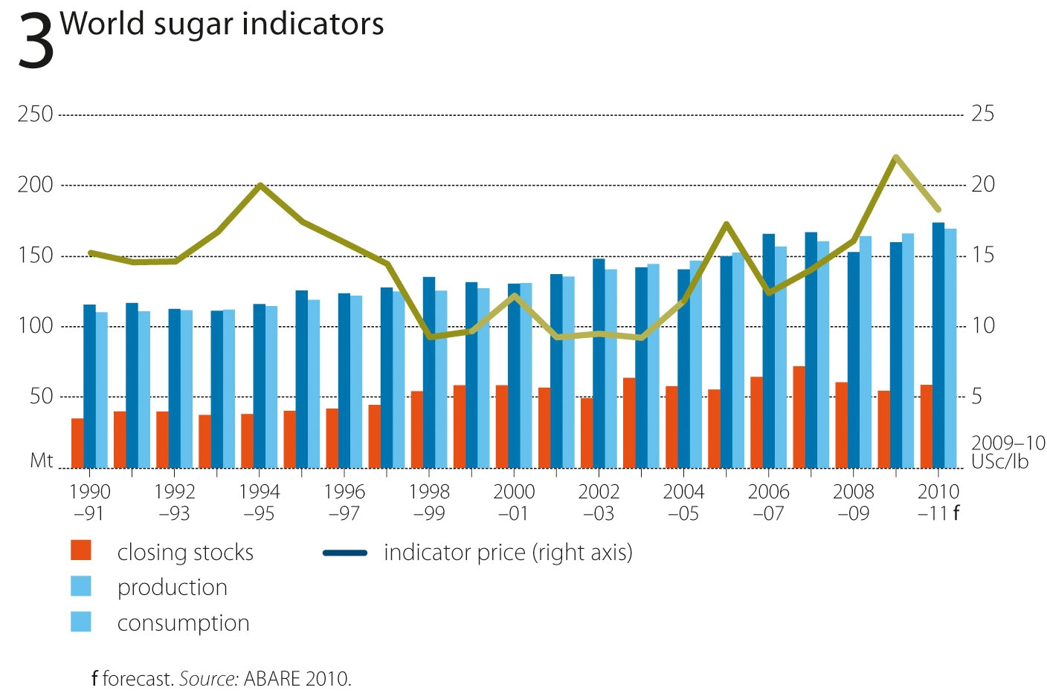
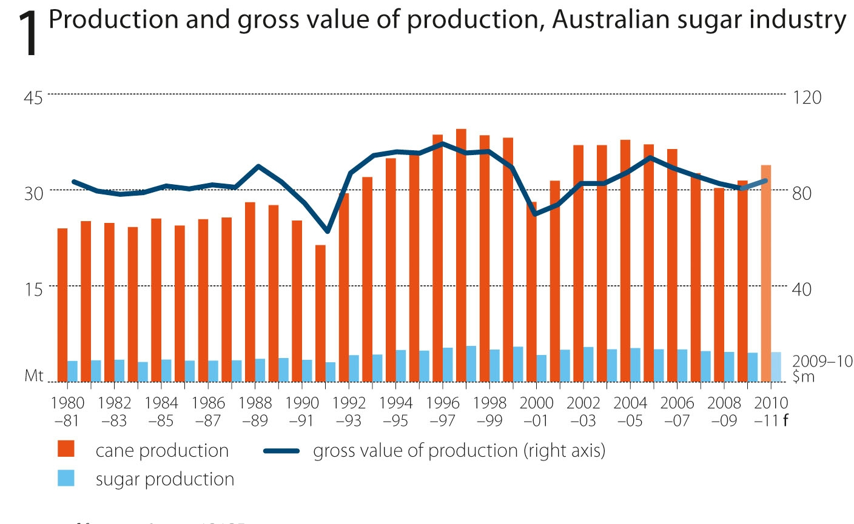

Figure 2 shows the location of sugar mills and production levels of Australia’s main sugar growing regions in Queensland and New South Wales, in 2007–08. Currently there are 25 mills operating in Australia, with three located in New South Wales and 22 in Queensland.
In 2007, the sugar mill near Kununurra in the Ord River region of Western Australia closed after 12 years of operation. It had contributed just below 1 per cent of Australia’s raw sugar production.
Figure 2: Australian sugar regions in Queensland and New South Wales and production in 2007–08
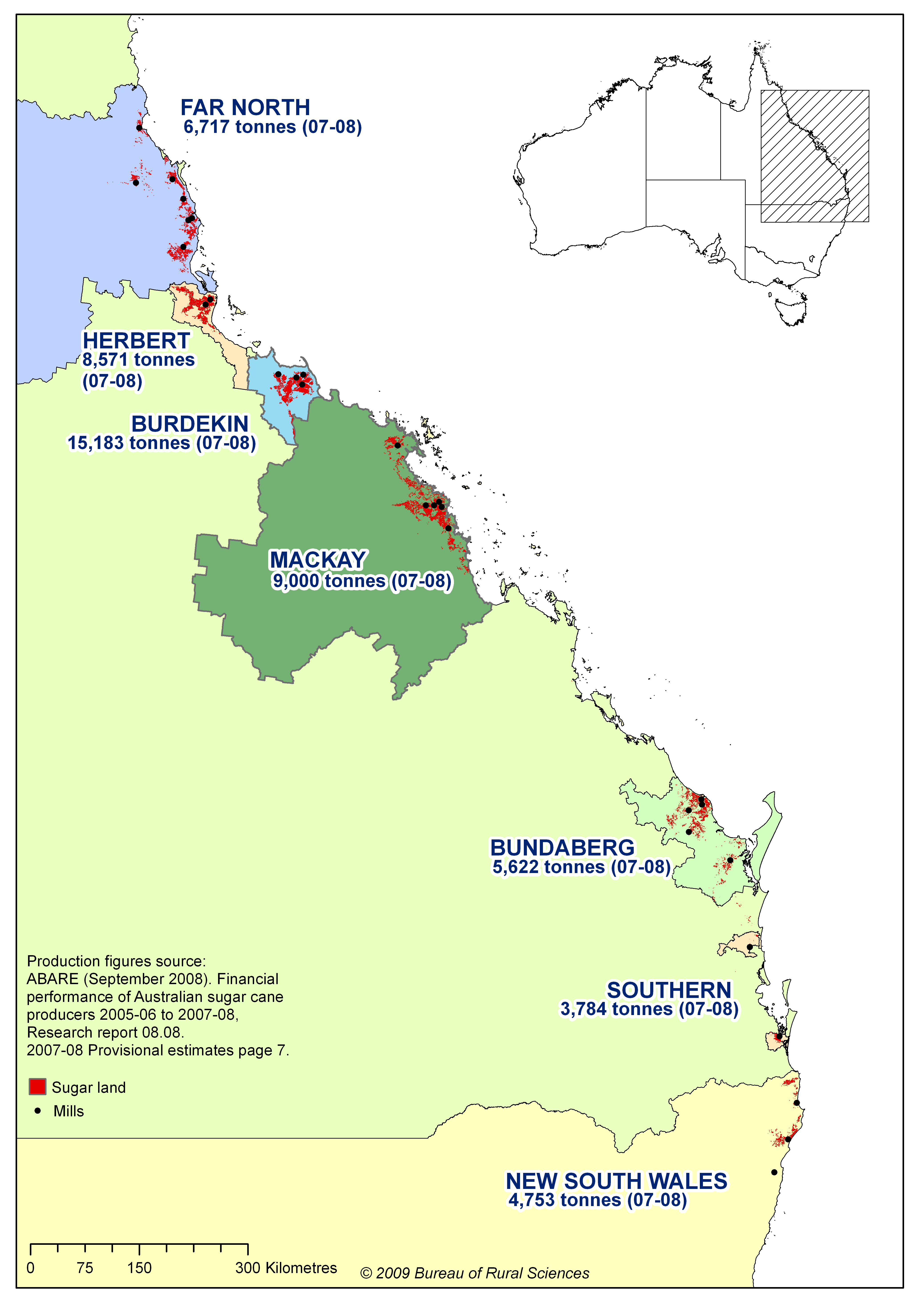

The most up-to-date data available on harvested areas and production, from the Australian Sugar Milling Council (ASMC 2010), are shown in Tables 1 to 3. They indicate a steady decline
in the area of sugar cane harvested for crushing (Table 1); a decline in the amount of cane crushed, except in 2005 (Table 2); and a similar steady decline in sugar production from 2004 to 2009 (Table 3).
Table 1: Area harvested in Queensland for crushing (hectares)
Region | 2004 | 2005 | 2006 | 2007 | 2008 | 2009
Northern | 88 097 | 84 121 | 80 558 | 79 095 | 74 488 | 70 635
Herbert–Burdekin | 130 722 | 128 620 | 127 321 | 127 005 | 120 880 | 119 816
Mackay–Proserpine | 118 105 | 115 477 | 116 026 | 114 853 | 111 465 | 108 854
Southern | 59 630 | 52 812 | 55 061 | 49 716 | 46 595 | 44 797
Queensland | 396 555 | 381 029 | 378 966 | 370 669 | 353 428 | 344 102

Table 2: Cane crushed in Queensland regions (tonnes)
Region | 2004 | 2005 | 2006 | 2007 | 2008 | 2009
Northern | 7 377 162 | 7 576 486 | 5 631 724 | 5 968 425 | 6 160 453 | 5 406 722
Herbert–Burdekin | 13 578 799 | 13 986 949 | 12 921 548 | 12 511 375 | 12 332 782 | 11 154 444
Mackay–Proserpine | 9 021 914 | 9 839 573 | 9 745 779 | 9 839 287 | 8 123 242 | 8 124 844
Southern | 4 695 072 | 4 492 296 | 4 824 881 | 3 629 487 | 3 554 844 | 3 475 400
QUEENSLAND | 34 672 947 | 35 895 304 | 33 123 932 | 31 948 574 | 30 171 321 | 28 161 410
Table 3: Sugar produced in Queensland regions (tonnes IPS)
Region | 2004 | 2005 | 2006 | 2007 | 2008 | 2009
Northern | 985 051 | 975 320 | 660 370 | 771 029 | 826 875 | 765 951
Herbert–Burdekin | 2 040 337 | 2 009 488 | 1 853 542 | 1 839 127 | 1 791 903 | 1 693 194
Mackay–Proserpine | 1 339 027 | 1 339 154 | 1 347 357 | 1 372 501 | 1 183 000 | 1 233 509
Southern | 685 645 | 598 674 | 662 389 | 475 510 | 484 492 | 505 500
QUEENSLAND | 5 050 060 | 4 922 635 | 4 523 658 | 4 458 167 | 4 286 270 | 4 198 154

Australia provided around 3 per cent of world sugar production in 2009–10, but around 8 per cent of world sugar exports. Brazil is the dominant producer and exporter of sugar in the world market, accounting in 2009–10 for 23 per cent of world sugar production and 48 per cent of world sugar exports.
In terms of cane production the Australian sugar industry is around one-twentieth the size of the expanding industry in Brazil. However, more than half of Brazil’s cane production is used for ethanol production rather than sugar production. This means that, in terms of sugar production, the Australian industry is a little less than one-tenth the size of the Brazilian industry.

1.1.1 Key indicators of Australian industry performance to 2010
This section provides an updated view on the current performance of the Australian sugar industry. Where possible, key indicators are compared from 2004 to 2010.
There has been a steady increase in world sugar prices since 2003–04, driven by steadily growing world demand for sugar of over 2 per cent a year. The world indicator price for sugar (Intercontinental Commodities Exchange no.11 spot, fob Caribbean) reached very high levels in 2009–10, mainly because of increased Indian sugar import demand due to a poor Indian monsoon season in 2009. World sugar prices are forecast to ease in 2010–11 as the tight world sugar supply–demand situation in 2009–10 is eased by markedly higher world sugar production, but are expected to remain substantially above the lows of the early 2000s.

Figure 3: World sugar indicators

Reflecting world sugar prices, there has been a steady improvement in returns to Australian sugar producers since 2003–04, with the exception of 2007–08, despite some appreciation in the Australian dollar (Figure 4). The seasonal pool price of Queensland Sugar Limited is estimated to be $509 a tonne in 2009–10, 85 per cent higher than 2003–04 when compared in constant dollar terms, before easing to a forecast $450 a tonne in 2010–11.
Figure 4: Pool returns of Queensland Sugar Limited a
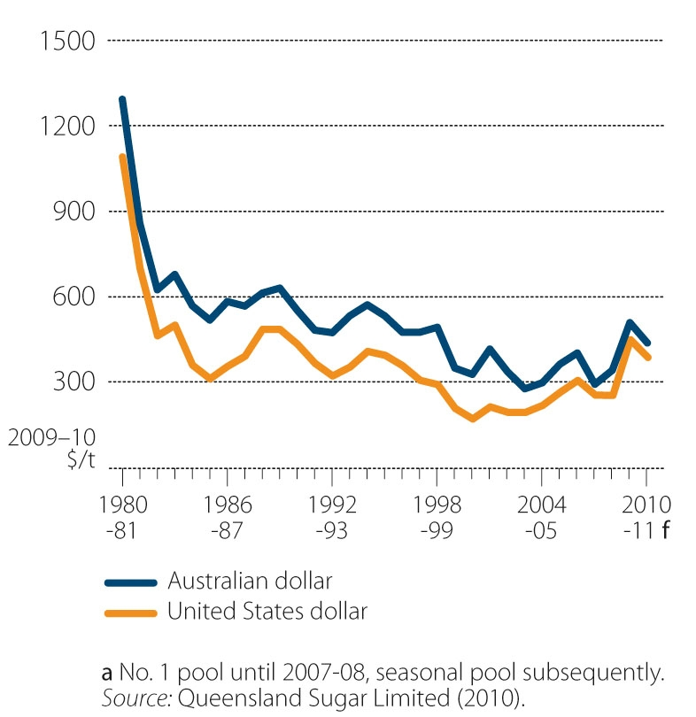

The area of cane harvested for crushing in 2010–11 is forecast to be 405 000 hectares. This is only slightly below the average of the ten years to 2009–10 of 411 000 hectares, but well below the record harvesting of 448 000 hectares in 2003–04 (Figure 5).
Figure 5: Area harvested of sugar cane for crushing, Australia
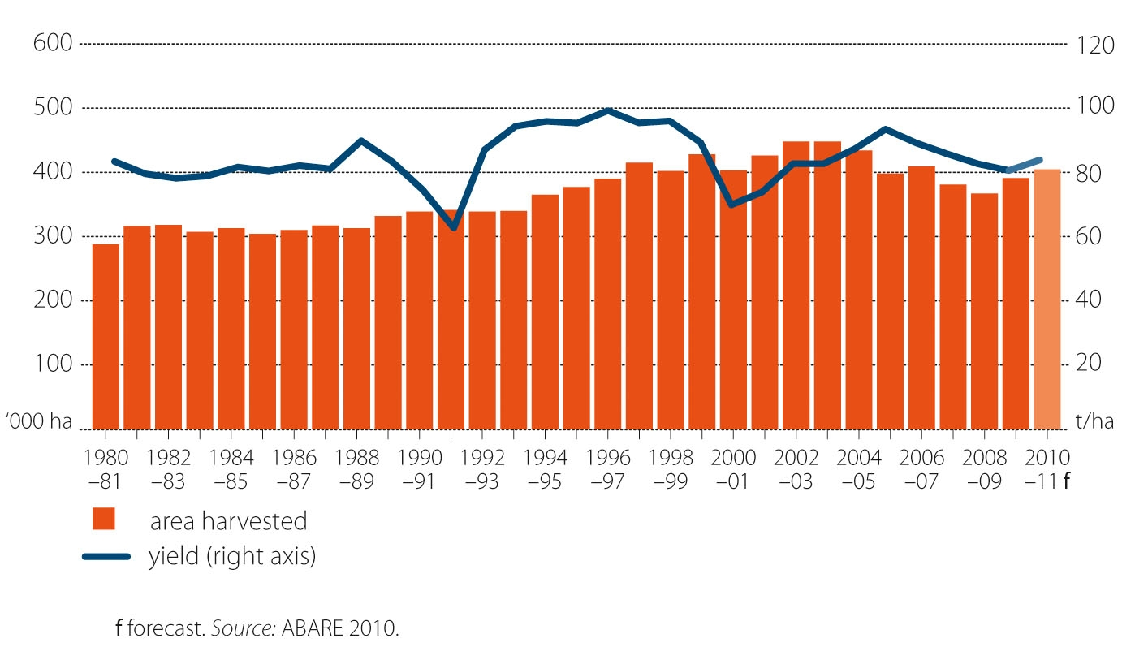

There has been a steady decline in Australian sugar exports since 2003–04, because of lower Australian sugar production and steady growth in domestic sugar use. However, Australian sugar exports are forecast to stabilise at around 3.28 million tonnes in 2010–11 (Figure 6).

Figure 6: Australian sugar exports and export prices
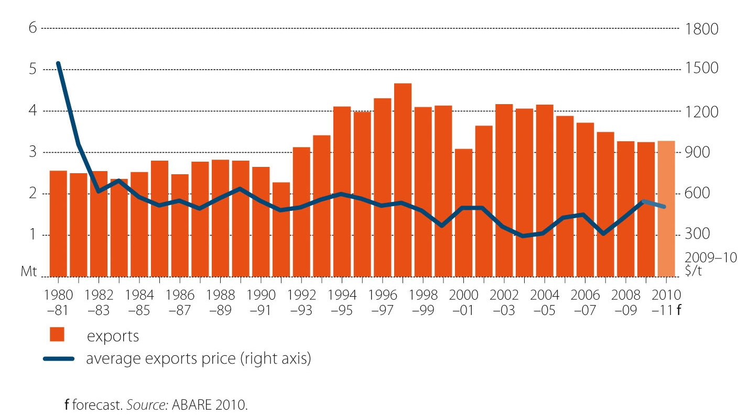

There is some evidence of economies of scale in the Australian sugar cane industry. The ABARE survey of sugar cane growers, commissioned by the IOG, found that in 2007–08 growers producing more than 50 000 tonnes of sugar cane per farm realised an average gross margin of $6.30 a tonne compared with $1.24 a tonne for producers growing less than 7500 tonnes per farm (Hooper 2008).
Some elements of the Australian sugar industry are competitive with the Brazilian sugar industry; however, it is likely that smaller and lower-performing farms will need to continue to be amalgamated in order to achieve the required economies of scale. ABARE research shows that in 2007–08 around two-thirds of Australia’s sugar farmers accounted for around 25 per cent of national sugar cane production, while 3 per cent of growers accounted for 20 per cent of sugar cane production (Hooper 2008). Hooper reported that while production remains relatively stable, there was a trend toward fewer producers and larger farms.
The trend toward larger farms has been driven by poor world prices (although prices improved significantly during 2009—see section below). The average gross margin of sugar cane production is estimated to have been around $3 a tonne in 2007–08, well below the 2006–07 figure of slightly more than $11 a tonne (Hooper 2008).
At a farm income level, results from ABARE surveys of cane growers indicate farm cash incomes have varied considerably over recent years:
- $66 600 average income per grower in 2005–06
- $94 000 average income per grower in 2006–07
- $7000 average income per grower in 2007–08
The dramatic decrease in 2007–08, when only around one-quarter of businesses were estimated to have made a profit, was attributed to lower sugar prices and increased costs of farming inputs. Regions with a higher concentration of small-scale growers, including southern Queensland, New South Wales and Far North Queensland have recorded below average incomes (Hooper et al. 2007).
Data were compiled on the financial performance of the key sugar millers and refiners in the Australian sugar industry — namely Sucrogen (the sugar division of CSR Limited), Bundaberg Sugar (part of the multinational Finasucre Group), Mackay Sugar, Maryborough Sugar Factory and Proserpine Cooperative Sugar Milling Association. Together these companies accounted for more than 85 per cent of the sugar cane crushed in Australia in 2009–10. In aggregate, these data indicate that the profitability of the Australian sugar industry has improved substantially since 2003–04 (Figure 7). It should be noted that returns of these millers and refiners in the period 2003–04 to 2006–07 were boosted by substantial SIRP payments.

Figure 7: Aggregate financial performance of key sugar millers/refiners in Australia a
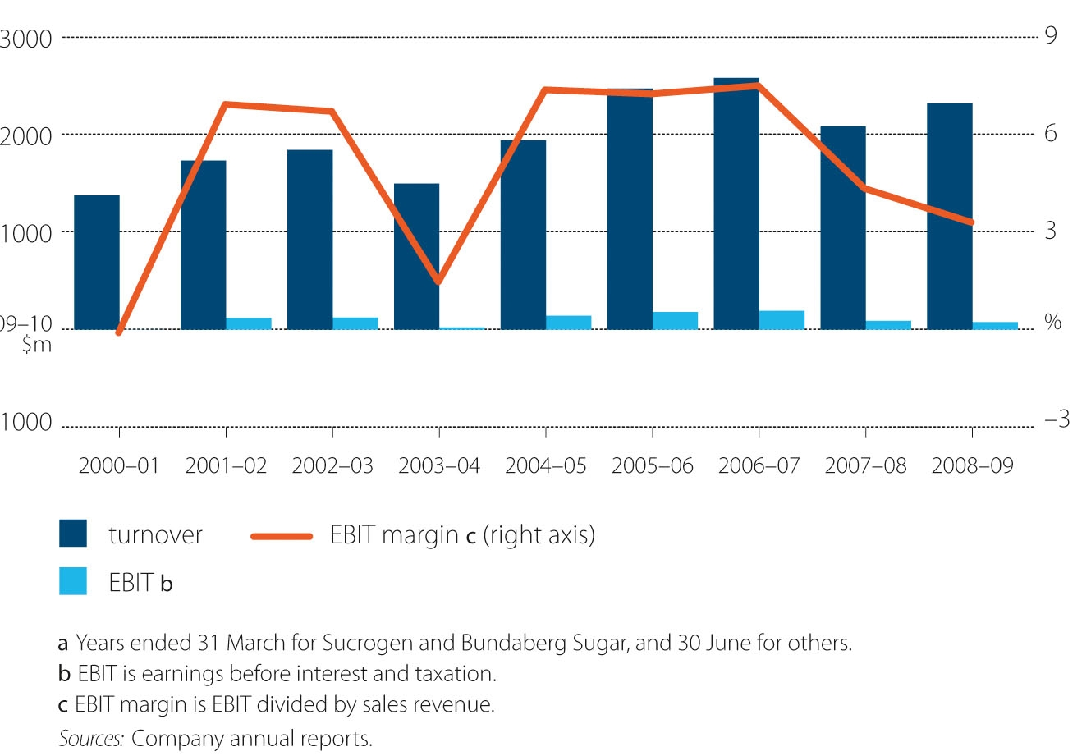

Higher world sugar prices in 2009–10 and 2010–11 are expected to result in substantial improvements in the profitability of these companies in these years. At the time of writing this report, only Sucrogen and Bundaberg Sugar have reported financial results for 2009–10 (year ended 31 March) and their EBITs—defined as earnings before interest and taxation, divided by sales revenue—were 7.1 per cent and 11.1 percent, respectively, up substantially from 2008–09.
The data indicate that the sugar industry is currently in a profitable period, driven mainly by improved world sugar prices. However, the restructuring facilitated under SIRP 2004 has also made some of this progress possible—as discussed in the following sections.

2. SIRP 2004 and uptake of funding components
This section provides background on the impetus behind introduction of the SIRP 2004 program and goes on to address Question 1: What was the level of uptake of the key funding components of SIRP 2004? The practical implementation of SIRP 2004 is described and examined via the key funding components, how they were implemented and their uptake.

2.1 The Sugar Industry Reform Program 2004
The impetus for introducing the Sugar Industry Reform Program 2004 (SIRP 2004) arose from several different factors. These included an independent assessment of the sugar industry commissioned by the Australian Government in 2002 (Hildebrand 2002), low global sugar prices and the exclusion of sugar in a free trade agreement with the United States.
The Hildebrand assessment found that the sugar industry was largely unprofitable and that communities in sugar regions were under pressure as a result of successive seasons with low production, low prices, high debt, and succession difficulties. It also documented a lack of business management skills within the industry and concluded that a whole-of-value-chain systems approach to all aspects of operations was lacking, particularly in Queensland (Hildebrand 2002). A key recommendation from the Hildebrand assessment was the need for the industry to adopt a ‘mill area’ or ‘mill region’ focus in all its operations, where regional production capacity is aligned with regional milling capacity.
The Australian Government agreed in 2004 to provide up to $444.4 million to fund a comprehensive range of measures to serve two primary purposes:
- alleviate the immediate financial hardship of millers and growers
- assist the industry transition through a reform period of rationalisation and diversification (restructure).
The government and the sugar industry agreed on the need for significant reform in several areas. SIRP 2004 responded to the sugar industry’s commitment to support and promote comprehensive reform and restructure, as formalised through the Statement of Intent signed by industry leaders and the Australian Government in 2004 (see Appendix A).
SIRP 2004 was partially funded by a levy on domestic sugar sales, including imported sugar. The levy rate was set at three cents a kilogram of sugar. The levy was in place from 1 January 2003 to 30 November 2006 and raised approximately $80 million (Australian Government Treasury 2006). Australia imports only very small quantities of sugar; so virtually all Australian sugar sales are sourced domestically.

2.2 Delivery of funding components
SIRP 2004 had two core funding objectives. Its immediate concern was to stabilise an industry under extreme economic stress and alleviate the immediate financial hardship and associated social stress. This is referred to as the ‘welfare’ component of SIRP 2004. The second, longer-term objective was to provide for the restructuring and reform of the sugar industry. This is referred to as the ‘reform’ component of SIRP 2004.
This section summarises the funding components delivered; Section 2.3 provides further analysis of regional uptake and distribution, focusing on Queensland, the largest sugar producing state.

2.2.1 Welfare components of SIRP 2004
Three key funding areas were administered under the welfare component of SIRP 2004, over the five financial years from 2003–04 to 2007–08. Funding for individual elements was not necessarily available in each year; Crisis Counselling was the only component funded in all five years. Funding components were delivered via DAFF, Centrelink and the Department of Families, Housing, Community Services and Indigenous Affairs (FaHCSIA).

Sustainability Grants
Sustainability Grants were designed to alleviate the immediate financial hardship facing the industry and to assist with adjustment to further reforms. Cash funding was provided in the form of grants to all operating mills and growers. It was paid in two tranches: June 2004 and September 2005. The development of regional plans was a requirement for payment of the second tranche of the Sustainability Grant. Grants were administered by DAFF.
Funding of $146 million was allocated over two financial years, with $133 million utilised.

Income Support Payments
Payments were provided to eligible growers and harvesters to help farming families most in need for up to 12 months. This funding was administered by Centrelink.
Funding of $17.0 million was initially allocated over two financial years, with a final amount of $17.4 million utilised across all regions.
In Queensland 1535 growers received $5.16 million in payments, which equates to an average of $3361 per grower.

Crisis Counselling
This funding provided additional support to growers and their families during the industry’s downturn. The funding increased the capacity of existing financial counselling and family support services. Counselling was available through FaHCSIA.
Funding of $4.56 million was allocated over five financial years, with $3.68 million utilised.

2.2.2 Reform components of SIRP 2004
The reform components of SIRP 2004, delivered over five financial years from 2003–04 to 2007–08 comprised six key funding areas. All grants were administered through Centrelink.

Business Planning Grants
Grants were provided to help growers and harvesters analyse their business situation. Growers and harvesters receiving income support were eligible for up to $2500, while those not receiving income support were eligible for up to $1500.
Grants were available to cooperative and smaller single site mill businesses to obtain advice from accredited professional advisers on their financial viability and to develop comprehensive business plans. Eligible mills could receive up to $100 000 to improve their market position or to plan for an ‘orderly exit from the industry’.
Funding of $13.9 million was allocated over three financial years for growers/harvesters and mills, with a total of $7.1 million utilised.
In Queensland, 2494 growers and harvesters received $5.49 million in total grants, at an average of $2201 per recipient grower. The overall participation rate was 47 per cent of growers in the industry.
Grants totalling $0.71 million were payed to eight milling businesses, with an average of $88 750 per business.

Re-establishment Grants
These grants provided assistance to growers and harvesters who decided to leave the industry. Growers were asked to choose whether they wished to leave the sugar industry for at least five years and diversify into other crops or to sell their properties and leave agriculture altogether.
Funding of $95.2 million was allocated over three financial years, with $63.0 million utilised across all regions (66 per cent utilisation).
In Queensland, 12 per cent of the grower population (624 growers) received grants totalling $57.4 million, at an average of $91 278 per grower; 37 harvesters received grants totalling $1.81 million, at an average of $48 813 per recipient harvester.

Retraining Grants
The grants provided access to training courses and the opportunity to re-skill in a different occupation.
Funding of $5.7 million was allocated over four years, with $0.09 million utilised. This level of uptake (1.6 per cent) was low compared with other components.

Restructuring Grants
Grants were available to sugar farm enterprises to undertake significant operational restructuring.
Funding of $39.1 million was allocated over three financial years, with $25.94 million utilised across all regions.
A total of 3499 growers received these grants, at an average of $7413 per recipient grower.

Intergenerational Transfer Scheme
This component provided eligible sugar cane growers with an opportunity to gift their farm, without recourse to the normal conditions that apply to the age pension.
Funding of $20.2 million was allocated over five financial years, with $0.70 million utilised. This level of uptake (3.5 per cent) was low compared with other components.
In Queensland, 32 growers participated; a rate of 0.62 per cent of growers statewide.

Regional and Community Projects (RCPs)
The objective of the RCPs was to provide grants at a regional level to stimulate medium to long-term restructuring of the sugar industry. The focus of the projects was to promote cross-sectoral partnerships and whole-of-system solutions. The projects were administered with input from the RAGs, SEOs, the IOG, and DAFF.
Funding of $75.05 million was originally allocated over three financial years, with $56.4 million utilised in total.
Grants were provided to 73 projects in total, with an average project value of $728 963.

2.3 Uptake of SIRP funding components
This section of the evaluation reports on uptake and distribution of the welfare and reform funding components of SIRP 2004. Data have been gathered from a variety of sources, including primary data provided by Centrelink, DAFF and FaHCSIA, the bodies responsible for administering the funding. Examination of personal interviews also provides qualitative information about why some components of the funding were less well subscribed than others.
DAFF provided grants and funding to industry stakeholders, primarily through Centrelink, worth $315.417 million in total, out of an allocation of $424.999 million (Table 4). This represents a 73 per cent utilisation of the allocated funding. Almost all of the welfare allocation (92.2 per cent) and nearly two-thirds of the reform allocation (62.5 per cent) was utilised. Funding allocations for reform components represents 58 per cent of total allocation, with welfare components allocated 38 per cent. Administration costs account for the remaining 4 per cent.
Figures on utilisation of reform allocations shows that the ‘intergenerational transfer’ and ‘retraining’ grants components were particularly under-utilised, with only 3.5 per cent and 1.6 per cent uptake, respectively. Around two-thirds of the larger reform components—‘re-establishment’ and ‘restructuring’ grants—were utilised, and 75 per cent of funding allocated to the RCPs component was utilised. Table 4 indicates the breakdown and utilisation of funding administered under each component of SIRP 2004 nationally, over the four years of the program.

Table 4: Allocation and utilisation of funding for SIRP 2004 (nationally)
SIRP 2004 component | Funding allocated  ($ million) | Percentage of SIRP allocation  (%) | Funding utilised  ($ million) | Percentage of allocated funding utilised  (%)
Welfare components
Sustainability Grants | 146.100 | 33 | 133.580 | 91.4
Income Support | 17.088 | 4 | 17.414 | 101.9
Crisis Counselling | 4.568 | 1 | 3.688 | 80.7
Total welfare components | 167.756 | 38 | 154.682 | 92.2 (avg)
Reform components
Business planning—growers/harvesters | 12.774 | 3 | 6.395 | 50.0
Business planning—mills | 1.200 | <1 | 0.710 | 59.2
Re-establishment Grants | 95.239 | 21 | 63.048 | 66.2
Retraining Grants | 5.701 | 1 | 0.094 | 1.6
Restructuring Grants | 39.108 | 9 | 25.940 | 66.3
Intergenerational Transfer Grants | 20.171 | 4 | 0.696 | 3.5
Regional and Community Projects | 75.050 | 17 | 56.362 | 75.1
IOG/RAG funding | 8.000 | 2 | 7.490 | 93.6
Total reform components | 257.243 | 58 | 160.735 | 62.5 (avg)
Subtotal (welfare and reform) | 424.999 | 96 | 315.417 | 73.5 (avg)
Administration
Other (agency costs) | 19.401 | 4 | 18.876 | 97.3
Total | 444.400 | 100 | 334.293 | 75.2 (avg)
Note: Figures for percentages in the table are rounded to the nearest whole percentage point
Source: DAFF—as of 30 June 2009

2.3.1 Welfare components
This section provides detailed information about the regional distribution of the welfare component funding. These data are primarily available for the Queensland regions only. There is no region-by-region allocation information available for some SIRP 2004 welfare components, including crisis counselling and income support. However, Queensland regional allocation data are available for many of the reform components (see below).

Sustainability Grants
Sustainability Grants were the major funding component of SIRP 2004. This grant was available to mills and passed on to growers through a production-based formula. Because of different regulatory frameworks, the method for distributing payments differed between states. In Queensland, payments were made to operating mills based on the portion of total raw sugar supplied to Queensland Sugar Limited (QSL) over the three-year period between 2001 and 2003. Mills received a portion of the payment based on the ratio of total sugar cane supplied (over the three-year period) to the total payment received from QSL for the crushed sugar. Payment between individual growers was determined by the grower’s share of mill revenue (averaged over the three-year period). In New South Wales and Western Australia, payments were distributed through the milling organisations in accordance with local industry payment arrangements.
These grants provided cash income during a time of financial stress for sugar cane growing and milling businesses. Table 5 shows the distribution of the Sustainability Grant allocations between states.
Table 5: Distribution of allocated Sustainability Grant funding between sugar producing states
State | Amount  ($ million) | Share  %
Qld | 137.027 | 93.79
NSW | 7.802 | 5.34
WA | 1.271 | 0.87
Total | 146.1 | 100%
Source: DAFF

Income support
Centrelink information was available indicating the regional breakdown of payments (Table 6).
Table 6: Distribution of income support funds via Centrelink, for Queensland
SIRP region | Total payment  $ | Number of recipient growers | Average payment per grower  $ | Total industry growers | Grower participation  rate  % | Distribution of growers by region  (%)
Far North | 762 036 | 180 | 4 234 | 1 023 | 18 | 11.7
Herbert | 844 830 | 253 | 3 339 | 657 | 39 | 16.5
Burdekin | 1 170 840 | 243 | 4 818 | 883 | 28 | 15.8
Mackay | 1 672 585 | 622 | 2 689 | 1 626 | 38 | 40.5
Bundaberg | 637 895 | 178 | 3 584 | 830 | 21 | 11.6
Southern | 71 705 | 55 | 1 304 | 181 | 30 | 3.6
Rest of state | 24 005 | 4 | 6 001 | 51 | 8 | 0.3
Total | 5 159 892 | 1 535 | 3 361 | 5 251 | 29 | 100
Source: Centrelink

2.3.2 Reform component
This section reports on regional uptake of reform component funding in Queensland, using data provided by Centrelink and DAFF. Regional details for the Business Planning for Mills grant are not included, as data was not available.
Through the reform components for which regional data were available, a total of $146 million was distributed in Queensland regions (out of $160.7 million in total). The 2001 ABS Population Census data (the most recent ABS population data at the start of SIRP in 2004) indicate that there were 5251 cane growers in Queensland in 2001. Based on these numbers, the average spend on reform components was $27 820 per grower in Queensland (Figure 8).
Figure 8 shows that expenditure on reform funding varied markedly across Queensland regions. Based on the ABS regional population data in 2001, growers in the Southern region received the highest amount, with an average $37 668 per grower.

Figure 8: Average ‘reform component’ expenditure on a per grower basis for the Queensland regions
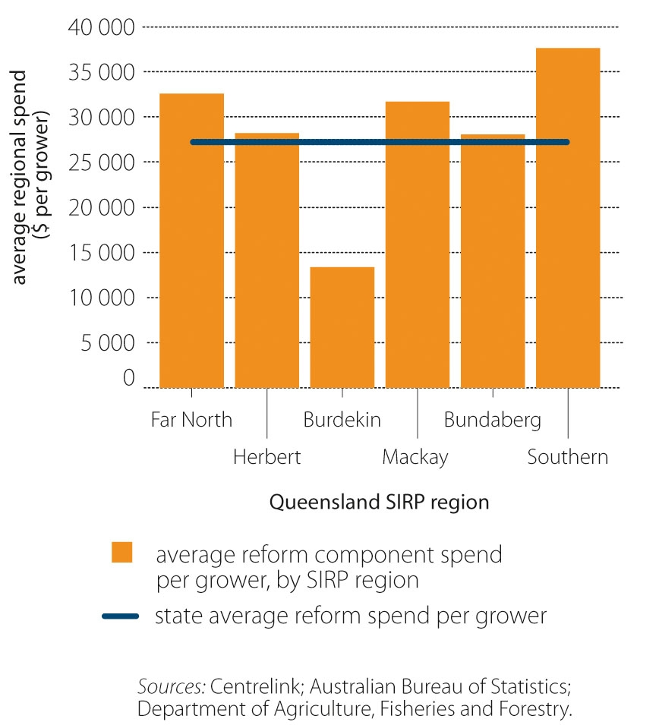

Business planning
SIRP 2004 allocated up to $12.7 million for growers and harvesters to undertake business planning and up to $1.2 million for cooperative and smaller single site mill businesses to obtain business planning advice.
Growers and harvesters: The Business Planning component for growers and harvesters was administered by Centrelink. Those who received SIRP 2004 Income Support payments were provided with assistance of up to $2500 to develop business plans. Growers and harvesters who had not received income support were eligible to obtain advice to the value of $1500. This funding was to help them analyse their business situation, identify and implement appropriate strategies to improve their sugar operation’s financial position, or consider alternatives outside the industry.
The funding enabled participants to obtain advice from accredited professionals and then reclaim the cost. Participants also received assistance to develop and implement an activity plan to improve future enterprise viability.
It was a condition for several of the other SIRP 2004 components that recipients would do business planning.
Business Planning was the second most utilised component of SIRP 2004, after the Restructuring Grants. A total of 2777 growers and harvesters across all states received the grant. In Queensland 2494 growers received Business Planning funding, totalling $5.49 million (Table 7), which equates to an average of $2201 per grower. The uptake of grants was influenced by the eligibility for other funding being contingent on the completion of a business plan.
Table 7: Distribution of funding to growers for business planning in Queensland sugar growing regions
SIRP region | Number of participants | Amount  $ | Number of growers  in region | Participation rate  %
Far North | 534 | 489 600 | 1 022 | 52
Herbert | 380 | 965 000 | 656 | 58
Burdekin | 330 | 837 500 | 886 | 37
Mackay | 657 | 1 692 500 | 1 626 | 40
Bundaberg | 491 | 1 242 500 | 829 | 59
Southern | 97 | 250 000 | 184 | 53
Rest of state | 5 | 12 500 | 51 | 10
Total | 2 494 | 5 489 600 | 5 254 | 47
Source: Centrelink
Mills: The Business Planning component for mills was administered by DAFF. The grant was only available for cooperative and smaller single site mill businesses so that they could obtain advice from accredited professional advisers on their financial viability and develop comprehensive business plans. Business planning was considered important for mills in Queensland because of the changing regulatory environment. Eligible mills received up to $100 000 to assist them to identify strategies to improve their market position or to plan for exit from the industry.
Cooperatives owning more than one mill were only eligible for one Business Planning Grant. Mills that received the grant were required to prepare a report on the issues they faced and the strategic direction of the mill. They were not required to release commercial-in-confidence information that arose from the business planning assessment but they were required to prepare a general report for the consideration of DAFF. The purpose of the report was to encourage mills to consult openly with other stakeholders in the supply chain about the future direction of the mill, and to assist the RAGs in applications for RCP funding.
At the time of SIRP 2004 there were 12 milling entities representing the 28 mills in operation. Of the 12 eligible entities, eight accessed the grant, with an average payment of $88 750.

Re-establishment Grants
The Re-establishment Grant, commonly referred to as an ‘exit’ grant, was administered by Centrelink. The one-off grants were available for growers and harvesters deciding to exit the industry, with maximum amounts varying according to date of exit:
- $100 000 until 30 June 2006 (limited to $50 000 for harvesters)
- $50 000 from 1 July 2006 to 30 June 2007
Growers: Growers needed to choose whether they wished to leave the sugar industry for at least five years; diversify into other crops; or sell their properties and leave agriculture altogether.
Re-establishment Grants were paid once the farm property had been sold or retired from cane production, or the grower had ceased to be involved in the sugar enterprise. Recipients also had to dispose of their sugar terminal and mill shares. Recipients did not have to qualify for Income Support to gain access to the Re-establishment Grant; however, asset tests did apply. In Queensland, $57.415 million was distributed to growers to encourage them to leave the sugar cane industry. According to Centrelink data, 624 growers received the grant, representing 12 per cent of the population of growers (Table 8). This equates to an average grant of $91 278 per recipient grower (based on 2001 Census figures).
Under the grant, there were two separate packages. A grower could elect to take the grant subject to tax, and still remain on the farm so long as they did not grow sugar cane. Alternatively, the grower could receive the grant not subject to any tax, provided they left the agriculture industry for a minimum of five years.
The Burdekin region had the lowest rate of participation, with only 7 per cent of all growers receiving the grant. The highest participation rate was in the Bundaberg region, where nearly one in five growers received the grant (Table 8).
Figure 9: Re-establishment Grant—number of participants for Queensland regions
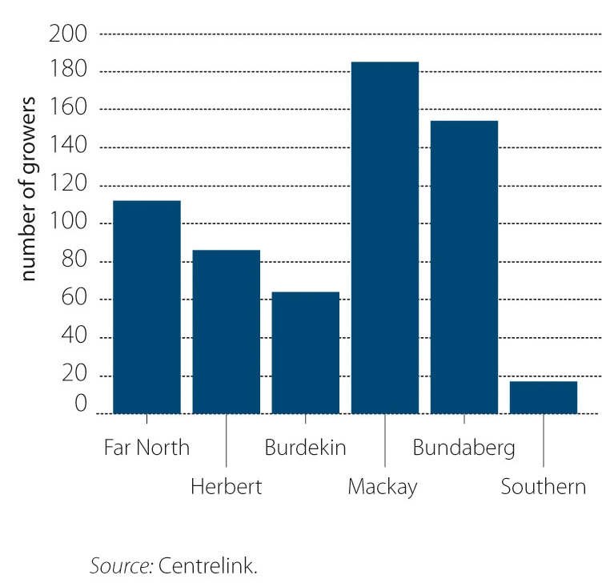

As shown in Table 8, just under half the recipient growers (47 per cent) elected to leave agriculture altogether, though there was significant regional variations. For example, the Far North and Bundaberg regions had comparatively low rates of growers leaving the farm, with approximately one in three growers taking the non-taxable package (30.4 per cent and 34.4 per cent, respectively). In contrast, the Southern (76.5 per cent), Burdekin (73.4 per cent) and Herbert (65.1 per cent) regions all experienced a high percentage of growers that left agriculture entirely.

Table 8: Detailed distribution of sugar cane growers taking up Re-establishment Grant opportunities to leave sugar and/or agriculture in Queensland
 | 5 year exit from sugar |  | Left agriculture |  | Total grants |  | Average grant  $ | Participation rate of growers
SIRP Region | Amount  $ | Number of  farmers | Amount  $ | Number of  farmers | Amount  $ | Number of  farmers | Average grant  $ | Participation rate of growers
Far North | 7 307 442 | 78 | 2 916 942 | 34 | 10 224 384 | 112 | 91 289 | 10.9%
Herbert | 2 814 337 | 30 | 5 198 778 | 56 | 8 013 116 | 86 | 93 176 | 13.1%
Burdekin | 1 568 631 | 17 | 4 291 006 | 47 | 5 859 636 | 64 | 91 557 | 7.2%
Mackay | 8 767 074 | 97 | 8 194 663 | 88 | 16 961 736 | 185 | 91 685 | 11.4%
Bundaberg | 9 535 655 | 101 | 4 810 725 | 53 | 14 346 379 | 154 | 93 158 | 18.6%
Southern | 326 235 | 4 | 1 128 698 | 13 | 1 454 933 | 17 | 85 584 | 9.4%
Rest of State | 100 000 | 1 | 455 000 | 5 | 555 000 | 6 | 92 500 | 11.8%
Total | 30 419 374 | 328 | 26 995 811 | 296 | 57 415 185 | 624 | 91 278 | 11.9%
Source: Centrelink
Harvesters: The Re-establishment Grant for harvesters operated in the same manner as for growers. There were two packages, one taxable for recipients remaining in the sugar industry and the other non-taxable for recipients leaving agriculture altogether. In total, 37 harvesters in Queensland accepted grants totalling $1.81 million (Table 9), which equates to an average $48 813 per harvester. The majority of these harvesters (89 per cent) accepted grants to leave agriculture altogether. The Burdekin (11), Herbert (10) and Mackay (9) regions had the highest number of grant recipients.
Table 9: Distribution of harvesters taking up Re-establishment Grant opportunities to leave sugar and/or agriculture
 | Left sugar |  | Left agriculture
SIRP region | Amount  $ | Number of  harvesters | Amount  $ | Number of  harvesters
Far North | – | – | 50 000 | 1
Herbert | – | – | 544 322 | 11
Burdekin | – | – | 483 093 | 10
Mackay | 149 364 | 3 | 429 299 | 9
Bundaberg | 50 000 | 1 | 100 000 | 2
Total | $199 364 | 4 | $1 606 714 | 33
Source: Centrelink

Retraining Grants
As indicated in Table 4, only $94 000 was spent on Retraining Grants, representing 1.6 per cent of funding allocated to this component. No data were available on distribution.

Restructuring Grants
The Restructuring Grants were administered by Centrelink and were allocated up to $39.108 million. Restructuring Grants were targeted at the individual farm level for growers who chose to remain in the industry. Grants were available to sugar farm enterprises to undertake significant operational restructuring within the industry. Grants were paid in two instalments over two years for a range of activities, including:
- improving farm management practices
- enhancing productivity and reducing cost of production
- engaging in alternative business structures
- assisting in diversifying the enterprise base.
Grants were paid at a rate of $75 per hectare to a total of $15 000 ($7500 an instalment). First instalments were available until 30 June 2005, and the second instalments were available until 30 June 2006. Applicants were required to include a business plan in their application in order to be considered eligible.
Across all regions $25.940 million was distributed to 3499 growers, at an average of $7413 per grower. In Queensland, 3133 growers received the grant (60 per cent of all growers), with an average of $7656 per grower, as shown in Table 10. The Herbert, Bundaberg and Southern regions had the highest participation rates (above 65 per cent); and the Far North, Burdekin and Mackay regions had lower participation rates (55 per cent) (Figure 10).
For the first instalment, growers were required to indicate what restructuring activities they intended to undertake. Successful applicants needed to demonstrate appropriate use of funds in the first year—by providing receipts for expenses—to qualify for the second payment. The return rate measured the proportion of growers who received both payments; across Queensland 19 out of 20 recipients successfully obtained both payments.
Table 10: Distribution of Restructuring Grant across Queensland sugar growing regions
SIRP region | Amount  $ | Number of participants | Average payment  $ | Total number of growers | Participation rate  %
Far North | 4 195 894 | 562 | 7 466 | 1 023 | 54.9
Herbert | 3 954 498 | 464 | 8 523 | 657 | 70.6
Burdekin | 4 031 473 | 491 | 8 211 | 883 | 55.6
Mackay | 7 594 073 | 906 | 8 382 | 1 626 | 55.7
Bundaberg | 3 494 883 | 585 | 5 974 | 830 | 70.5
Southern | 690 487 | 119 | 5 802 | 181 | 65.7
Rest of state | 25 089 | 6 | 4 182 | 51 | 11.8
Total | 23 986 397 | 3 133 | 7 656 | 5 251 | 59.7
Source: Centrelink

Figure 10: Restructuring Grant participation rates by Queensland regions
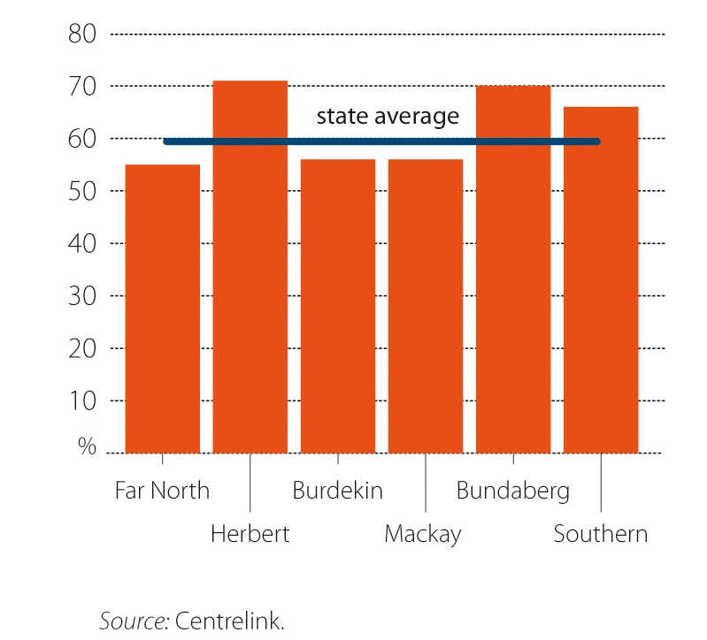

Intergenerational Transfer Grants
The Intergenerational Transfer component was administered by Centrelink and was allocated funding up to $20.171 million, of which only $696 000 was expended (Table 4). The component was designed to promote succession planning within the sugar industry and was also targeted toward smaller operators. It provided growers, who satisfied the criteria, with an opportunity to gift their farm without attracting the disposal (gifting) of assets rules that apply to Income Support payments paid by Centrelink and the Department of Veterans’ Affairs.
To be eligible for the scheme, the net value of the farm could not exceed $500 000. The transfer had to be a gift and divest the grower of all legal interest (except the home). The income test was equivalent to that for the aged pension for singles and couples. The next generation had to be actively involved in the farm for three years before the transfer, and retiring growers had to have owned the property for at least 15 years, or been actively involved in farming for 20 years. Growers accessing the Intergenerational Transfer scheme were ineligible to receive a Re-establishment Grant.
The Intergenerational Transfer component was the most under-utilised scheme of SIRP 2004. Based on Centrelink data, 37 growers transferred their property. This was less than 1 per cent of all growers.

Table 11: Distribution of funding for Intergenerational Transfer in Queensland sugar growing regions
SIRP region | Number of growers | Number of growers in region | Participation rate for region  (%)
Far North | 7 | 1 022 | 0.68
Herbert | 4 | 656 | 0.61
Burdekin | 9 | 886 | 1.02
Mackay | 8 | 1 626 | 0.49
Bundaberg | 4 | 829 | 0.48
Southern | NA | 184 | NA
Rest of state | NA | NA | NA
Total | 32 | 5 203 | 0.62 (avg)
NA = data not available
Source: Centrelink

The uptake of the Intergenerational Transfer Grant is reviewed in the context of the age profile and demographic trends occurring within the industry prior to the introduction of these grants. The analysis of the changes from the ABS census data between 2001 and 2006 reveals a trend for many younger farmers to leave the growing sector, with older farmers remaining. In Queensland, the number of cane farmers aged 15 to 39 years decreased by 600 (54 per cent) between 2001 and 2006. Similarly there was a decrease in the number of farmers aged 40 to 59 years (by 758 farmers or 29.2 per cent) and the number of farmers aged 60 to 69 years (by 143 or 13.2 per cent). Compared with the average of the entire Queensland workforce (all industries and all occupations), the age profile of sugar cane farmers has a disproportionately large percentage of its workforce in the older age brackets and substantially fewer in the 15 to 39 year age bracket (Figure 11).

Figure 11: Comparative age distribution for sugar cane growers and the Queensland workforce
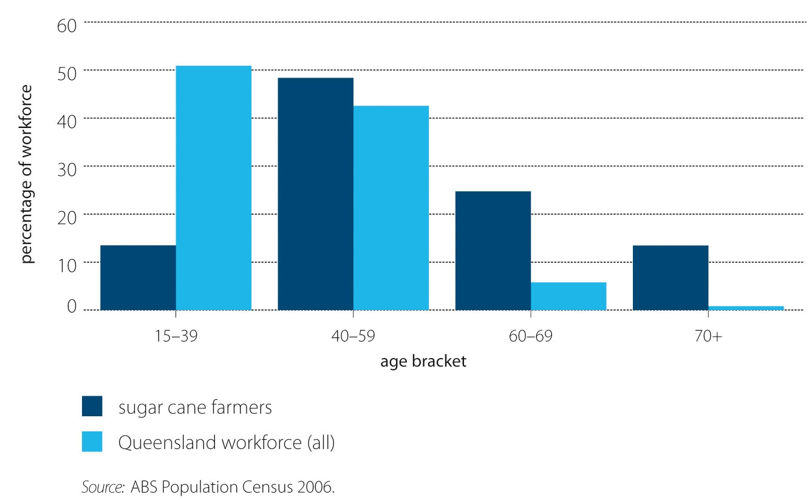

The low numbers of young people participating in the sugar cane industry compared with the total Queensland workforce indicates that there are existing factors that already make the industry less attractive than other areas for younger participants, or that present barriers to their participation. Several interviewees indicated that because of the unprofitability of sugar at the time SIRP 2004 was introduced, many cane growers were actively discouraging their children from working on the farm and instead promoted work in the mines or obtaining a trade qualification. These factors may explain why it was difficult for older farmers to gift their farms despite the availability of the Intergenerational Transfer Grants.

Regional and Community Projects
The RCPs component was allocated $75.05 million of funding under SIRP 2004. The objective of the RCPs was to provide grants at a regional level that aimed to stimulate medium to long-term restructuring of the sugar industry. They were administered with support from the RAGs, the SEOs, the IOG and DAFF. RCPs were developed by the industry, reviewed by the relevant RAG in the context of the regional plan and rated, then submitted to the IOG for assessment against its guidelines (which had been developed by DAFF). The IOG then sent recommendations for funding to the Minister for Agriculture, Fisheries and Forestry, who sought advice from DAFF.
Individuals or financially viable business entities within the sugar industry could apply for RCP funding. Applicants had to submit proposals outlining how their project would contribute to the reform and restructure of the sugar industry and the value it would bring to the region. RCPs had to comply with one or more of the reform aims, which included:
- promoting cross-sectoral partnerships and adoption of whole-of-system solutions
- enhancing revenue and cost efficiency
- facilitating environmental and social sustainability across the industry chain.
Proposals were assessed on a competitive basis and were conditional on the applicant providing at least 50 per cent of total project costs, which could include cash or value-in-kind. Successful applicants were required to enter into funding agreements with DAFF, which oversaw the reporting, auditing requirements and project milestones of the RCPs.
According to data supplied by DAFF, a total of 76 projects, worth $85.450 million, were initially approved over four funding rounds. Three projects withdrew, leaving 73 projects worth $71.220 million collectively (Table 12).
Actual expenditure on RCPs to 30 June 2009 was $57.708 million, with funding still to be provided to outstanding or ongoing projects. Of the 73 funded projects, the highest value project was $12 million, while the lowest was $10 000. The range shows how diverse RCP proposals were and how versatile the component was in accommodating the differences. The average project value was $728 963, while the median value was $184 843. Figure 12 shows the funding distribution of approved RCPs.
Figure 12: Distribution of total expenditure and number of successful Regional and Community Projects, by region
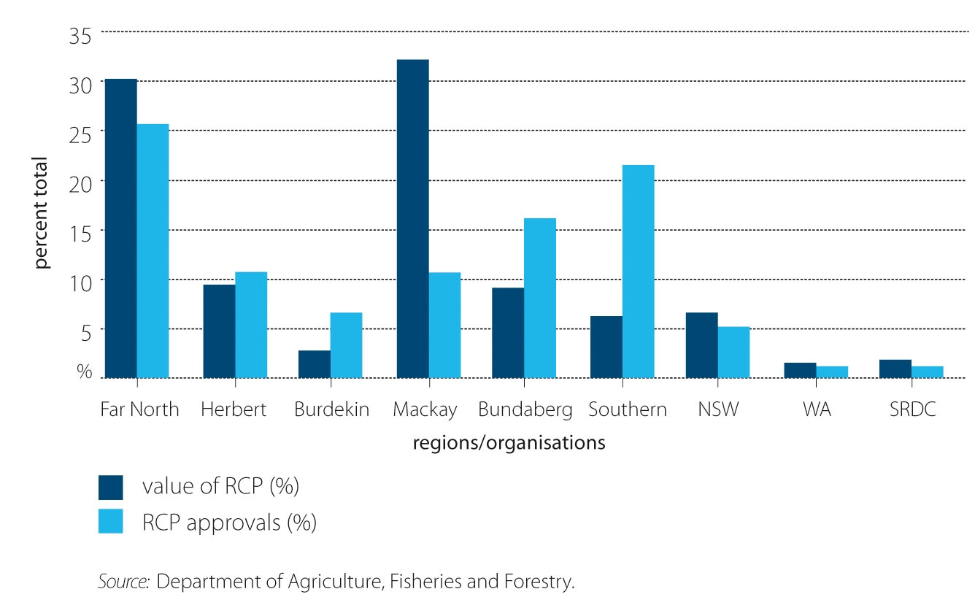

Table 12 shows the number of RCP approvals and associated funding. Round 1 had less than 5 per cent of all project approvals. Rounds 2 and 3 had substantially larger numbers of projects approved. In round 4 a large number of substantially smaller projects were approved. The increase in later rounds resulted from a relaxation of the criteria following round 1. In round 4, which had the highest number of approvals, the time to complete the projects was shortened and the average value of the grant was $390 886, while the average in previous rounds exceeded $1.0 million per project.

Table 12: Number of approved Regional and Community Project proposals, by funding round
 | Number of RCPs approved |  | Value of RCPs approved ª
Funding round | No. | % of approvals | $ million | % of total $ approved
RCP 1 | 3 | 4 | 4.700 | 7
RCP 2 | 19 | 26 | 21.900 | 31
RCP 3 | 22 | 30 | 33.520 | 47
RCP 4 | 29 | 40 | 11.100 | 15
TOTAL | 73 | 100 | 71.220 | 100
ª Funding committed but not necessarily expended depending on milestones being met and project success
Source: DAFF

3. Institutional arrangements for SIRP
This section addresses Question 2: What were the SIRP 2004 institutional arrangements and were they effective?
Following review of the main administrative groups (in section 3.1), the regional planning requirements (section 3.2), alignment with state government support (section 3.3), and some comment about the effects of the arrangements (section 3.4) are provided. Refer to Appendix C for additional information on the role of key sugar research and industry stakeholders and their linkages with SIRP 2004.

Delivery model for SIRP 2004
The model for program delivery under SIRP 2004 was a partnership between government and industry, with industry having the opportunity to take a leading role in developing and implementing the agenda for the program. Figure 13 identifies the relationships between different agencies and industry bodies responsible for administering the components of SIRP 2004. The SIRP 2004 program was also supported by parallel action by the Queensland Government, which moved to deregulate the industry and provide funding under its own package.
Figure 13: Key players and relationships in the delivery of SIRP 2004
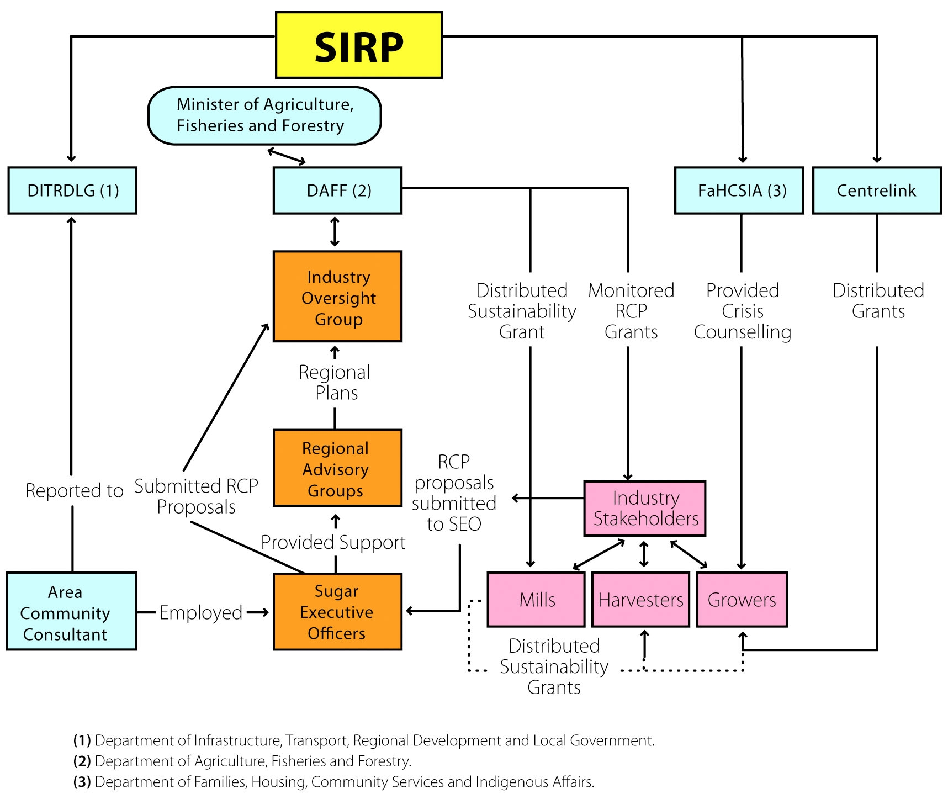

As can be seen from Figure 13, SIRP 2004 was delivered through four Australian Government agencies: Centrelink, DAFF, DITRDLG and FaHCSIA. Program components were delivered by the agencies that had the relevant capabilities. Centrelink was uniquely placed to deliver funding into the community; DITRDLG provided connections to the local communities; FaHCSIA had the specialist capability with respect to support services; and DAFF had the lead role in terms of policy and project administration.
The underlying assumption was that this model of program delivery would:
- be efficient and cost-effective
- create opportunities for developing a self-reliant industry
- facilitate the development of planning, consultation and networking at the regional level of the industry
- encourage the emergence of leadership across the industry
- provide the opportunity for innovation.
A critical principle of the model was industry accountability for program outcomes. As such, a core component of SIRP 2004 was the creation of several industry roles with a regional focus, under leadership groups appointed by the Minister for Agriculture, Fisheries and Forestry.

3.1 SIRP 2004 administrative groups
For the purposes of implementing SIRP in 2004, the Minister for Agriculture, Fisheries and Forestry (the minister) established and resourced an Industry Oversight Group (IOG), Regional Advisory Groups (RAGs) and Sugar Executive Officers (SEOs). The RAGs and SEOs provided a regional focus overseen by a group focused on industry-wide change. The SEO role was designed to provide a liaison between the IOG and RAGs as well as to provide executive assistance to the regional groups. These roles are described in more detail below.

3.1.1 Industry Oversight Group
The IOG comprised six members appointed by the minister and included a mixture of industry and independent advisers. DAFF provided a secretariat service to the IOG, with one full time DAFF officer providing support for the entire period of the program. Key tasks for this secretariat position included administrative arrangements, report writing and providing a link between the RAGs, SEOs and other DAFF officers.
The IOG was tasked with providing direction for the reforms by developing a Strategic Vision for the sugar industry. This involved an assessment of Australia’s sugar industry in the context of other world players, particularly Brazil, and an examination of whole-of-system reform priorities. The IOG then worked with the RAGs to develop their regional plans in alignment with the Strategic Vision. The IOG also examined proposals from the RAGs for funding under the Australian Government’s Regional and Community Projects (RCP) component of SIRP and made recommendations about these to the minister. The minister had the final decision on which RCPs received funding.

3.1.2 Regional Advisory Groups
The RAGs were designed to promote industry reform from a ‘grassroots’ level. They were composed of industry and community representatives from the region who were appointed by the minister. Seven RAGs were created; six in Queensland growing regions and one in New South Wales. The regions and the associated mill areas are detailed in Table 13.
The RAGs were expected to support and assist with intersectoral collaboration on project proposals. The RAGs were also asked to examine the RCP applications to prioritise projects for consideration by the IOG. The IOG then provided advice to the minister as to which projects should be approved. After seeking comment from DAFF, the minister announced the final project list.
Table 13: SIRP regions and mills
Region | Mill areas
Far North (Qld) | Mossman, Mulgrave, Babinda, Tableland, Mourilyanª, South Johnstone, Tully
Herbert (Qld) | Macknade, Victoria
Burdekin (Qld) | Invicta, Pioneer, Kalamia, Inkerman
Mackay (Qld) | Proserpine, Farleigh, Racecourse, Pleystowe^{b}, Marian, Plane Creek
Bundaberg (Qld) | Fairymead^{c}, Millaquin, Bingera
South (Qld) | Isis, Maryborough, Rocky Point
NSW | Condong, Broadwater, Harwood
ª Closed in 2006. ^{b} Closed in 2008. ^{c} Closed in 2005.

The primary purpose of the RAGs was to identify the key challenges facing the regional sugar industry, and to develop and oversee the implementation of a regional reform plan. The RAGs were required to provide progress reports on milestones in the regional plans and to maintain communication with industry stakeholders in the region. Funding for the operation of the RAGs was provided under SIRP 2004 until the program ended in 2008.

3.1.3 Sugar Executive Officers
Each RAG, with the exception of New South Wales, was allocated a Sugar Executive Officer. It was the role of the SEO to provide administrative support and advice to the RAG, and to assist potential RCP applicants with their proposals.
SEOs were co-located with and officially employed by regional Area Consultative Committees. The committees were administered under the auspices of the then Department of Transport and Regional Services. The RAGs worked in close consultation with SEOs to provide the IOG with initial advice on RCP proposals.

3.2 Regional plans
The regional plans were a key platform for the reform of the sugar industry as stipulated in the Statement of Intent (Appendix A). Reform focused on a ‘whole-of-system’ regional approach and the regional plans were the key vehicle for delivering this regional focus and self-reliance.
The regional plans required the RAG members in each of the seven SIRP 2004 regions to look at cane growing and sugar production in that region as a system and to put forward ideas for that region to drive innovation and financial sustainability at a whole-of-industry scale.
The IOG provided direction on the principles and planning processes for the plans and it was agreed that the priority areas identified in the IOG’s Strategic Vision statement would be reflected in each of the regional plans. The goal was for the plans to be developed at the grassroots level, but after several months the IOG recognised the need for professional expertise in plan development and support was provided to each RAG by the consulting firm PricewaterhouseCoopers.

3.3 Queensland Government alignment with SIRP 2004
SIRP 2004 received complementary support from the Queensland Government, which undertook deregulation of the industry in Queensland and provided funding and grants at the same time as SIRP 2004 was implemented. During the SIRP 2004 period, the Queensland Government distributed $33 million for structural reform via three funding initiatives (Queensland DPI&F 2004):
- The Sugar Industry Change Management Program ($13 million) provided six Sugar Resource Officers to work with industry at the regional level to identify and manage opportunities for change.
- The Sugar Industry Innovation Fund ($10 million) provided funding for innovative management systems and technologies.
- The Farm Consolidation Loan Scheme ($10 million) offered concessional interest rates to growers and provided flexible repayment options.
The Queensland Government also provided institutional support for sugar industry reform by repealing the statutes that formed the regulatory framework for the industry. The newly developed Sugar Industry Reform Bill 2004 introduced the following changes:
- the abolition of regulated cane production areas, enabling growers to transfer cane from their current mill to another mill of their choice
- the abolition of collective cane supply contracts which enabled growers to negotiate directly and individually with mills if they chose
- the abolition of Queensland Sugar Limited (QSL) as the statutory marketing authority, which allowed sugar regions to market and sell their sugar directly to overseas clients.
The complementary support from state government was important to fundamental structural change in the sugar industry given that Queensland represents the majority of Australian sugar production.

3.4 The effect of institutional arrangements
Just as the funding elements are important to the implementation and effect of SIRP 2004, these would not have been possible without a supportive institutional arrangement. This arrangement represents a carefully considered structure that was designed to provide growers, harvesters and mills with responsibility at the regional level through the RAGs, particularly through the development of regional plans. The focus on regional industry responsibility, a core component of the Statement of Intent, is reflected also in the establishment of the IOG, which included industry representation as well as independent advisers.
The institutional arrangements were also the source of discontent for some stakeholders as indicated through several interviews. Although the institutional arrangements were an attempt to ensure stakeholder involvement and responsibility for change, some interviewees saw their hierarchical nature as reinforcing perceptions of a ‘top down’ approach to implementation. Communication was identified by some administrative and regional participant interviewees as an issue between SIRP stakeholders and DAFF, as well as between the RAGs and the IOG. This was particularly related to the evaluation of RCP applications and selection of projects by the IOG and DAFF, with some interviewees from the RAGs and growers indicating frustration with a process that they perceived as highly politicised and bureaucratic.

4. Impacts of SIRP 2004
This section addresses Question 3: What were the direct and indirect impacts of SIRP investment for the reform and restructure of the sugar industry?
Impacts of SIRP 2004 are discussed in relation to the two primary SIRP objectives identified earlier, the IOG Strategic Vision and the Statement of Intent. These objectives are reflected practically by the ‘welfare’ funding component aimed at alleviating hardship, and the industry ‘reform’ objective.
Commentary on impacts is drawn primarily from qualitative data collected from stakeholder interviews conducted in 2008. Two key stakeholder groups were identified for the interviews: ‘administrative participants’, who had been involved in the administration of SIRP 2004; and ‘regional participants’ who were recipients of various SIRP 2004 components. Twenty interviews were conducted with administrative participants including representatives of the IOG and RAG. Twenty three regional participants were interviewed in two selected case study regions: the Herbert and Mossman regions in Far North Queensland. These regional interviews explored perceptions of SIRP 2004 from the perspective of growers and mill businesses.
It should be noted that as with any qualitative data, these reflect a comment made by an individual at a particular time, may not reflect current views and are not representative of a population. Appendix B has more details of the research method used, including the selection of regional case studies.

4.1 Outcomes identified in the IOG Strategic Vision
The ‘reform’ impacts of SIRP 2004 are discussed within the framework of the five outcomes identified from the IOG’s Strategic Vision for reform of the sugar industry:
- Integrating systems of production at the regional level
- Improvements in long-term costs
- Achieving economies of scale
- Diversification and value-adding
- Capacity building.

4.1.1 Integrating systems of production at the regional level
Administrative participants reported that the process of developing the regional plans had been useful in developing awareness and an acceptance of change, and in creating new working relationships. For example, the planning process was reported to have raised awareness of cost structures and the increasing importance of diversified agribusinesses. The process of developing plans was reported to have created acceptance of the need for ‘one regional voice’.
Benefits from the process of developing plans were also reported in terms of bringing the sectors together and talking ‘around the table’, thereby enabling stakeholders to understand and acknowledge their different viewpoints, and see themselves (as sectors) as part of a bigger picture. The regional plans were reported to have brought people together to solve problems.
Both the planning process and the implementation of projects identified in the plans were reported by administrative participants to have improved communication within the industry. For example, it was reported that some landholders, whose land was being used for new railway sidings, opted to have ‘preferred access’ for cane delivery to these sidings in preference to financial compensation. Under the agreement, they are required to give three days notice to other growers who use the siding of their intention to use the siding. The regional participants reported that this had, in effect, ‘forced’ growers to start talking to each other and that some are now coordinating their harvesting schedules.
Regional plans provided an opportunity for the industry to integrate systems of production at the regional level. Interviewees observed that while a number of factors hindered plan development, there were benefits from the planning process in terms of networks and improving the capacity of those who were involved in the RAGs to work together.

4.1.2 Improvements in long-term costs and achieving economies of scale
Long-term cost improvement involves productivity efficiencies, harvesting and transport cost reductions, economies of scale and the adoption of new technology. The Restructuring Grant and the RCP were the components of SIRP 2004 with potential to deliver gains in this priority area.
Both administrative and regional participants interviewed regarded the Restructuring Grants as having facilitated changes to production practices that would not otherwise have been possible, including legume fallows, increased row spacing, improved nutrition (lime/silica applications) and the building or modification of machinery. There were also examples given of growers pooling the Restructuring Grants to invest cooperatively in farm capital. The Herbert area Mossman Agricultural Services received Restructuring Grant funding for a soil analysis project to identify nutrient deficiencies. Growers reported that they continued with soil testing and planting after SIRP 2004 ended. The Herbert region also implemented a precision agriculture project—which is still continuing in 2010—involving high-technology equipment on harvesters that allows for direct communication of harvesting figures to growers and mills. This project has resulted in the Herbert region forging links with researchers in Brazil, where this technology is also used.
Of the 60 completed RCPs, 44 were aimed at reducing long-term costs, and this represented 44.6 per cent of allocated RCP funding. The RCP component was reported to have provided significant cash injections to the Herbert and the Mossman regions, in particular to improve cane transport efficiency, on-farm information data collection and technical extension and farming techniques.
Other SIRP 2004 components that aimed at improvements in scale were the Re-establishment Grants and the Intergenerational Transfer Grants. Two-thirds of the funding available for the Re-establishment Grant was accessed by growers and harvesters. Grants were provided to 37 harvesters and 618 growers.
Participants from both interview groups suggested that the Re-establishment Grant did not produce farm consolidation. There is evidence from the interviews of some participants asserting there was opportunity for accountants and legal services to take advantage of these grants without fundamentally altering grower business structures. Also, it was reported that increasing sugar prices in 2006 resulted in some growers staying in the industry longer than they would have if the downturn in sugar prices had persisted.
Only 3 per cent of funds made available for the Intergenerational Transfer Grant were accessed. Uptake may be due to the demographic changes occurring in the industry prior to the introduction of the grants, as discussed in Section 2.3.2. ABS census data indicate that the number of cane growers aged less than 40 years halved between 2001 and 2006. Growers could only access the grant if they gifted their farm to a younger generation family member who had been actively involved in the farm for more than three years. With so many younger farmers having departed from the industry, many growers may not have had an eligible family member to receive their farm. Several interviewees suggested that many farmers were also actively encouraging their children to move away from the sugar industry and so did not wish to pass on the farm.
Some regional participants reported that they had used the Restructuring Grant to restructure the ownership of machinery through sharing arrangements to avoid regional over-investment. There were also some initiatives to buy equipment with the Restructuring Grant and to share it through cooperatives.

4.1.4 Diversification and value-adding
The RCPs provided the opportunity for the industry to scope and invest in diversification and value-adding. However, regional participants raised many questions about how seriously value-adding/diversification options were pursued and supported. Some regional participants complained that some diversification projects were not allocated funding, which meant that significant opportunities were lost to the industry in their regions. Some growers interviewed considered that while SIRP 2004 had assisted with infrastructure funding, it had missed the opportunity to progress value-adding in their area.
One administrative participant claimed that diversification in terms of value-adding (for example, cogeneration of electricity, fuels from by-products) may attract RCP funding. Some regional participants claimed that diversification projects were not supported because the focus was on sugar rather than on cane as a result of the IOG being dominated by representatives from the milling sector.
These claims are not supported by analysis of the RCP funding. Ten out of 60 completed projects—coded into categories according to the priority areas—were diversification projects, and this represented 51 per cent of the overall funding for the 60 projects. As an example, Far North Queensland is now bagging sugar following an RCP grant used to build a facility to produce food-grade sugar. It is also producing low glycemic index (GI) sugar, albeit in small amounts. Deregulation allowed the low GI project to be considered and meant that the Mossman mill could capitalise on high-quality sugar that had previously been blended with sugar from other regions.
Another example of significant innovation is the development of a furfural at the Proserpine mill. Furfural is an intermediate product used by the chemical industry for making a range of chemical products (RIRDC 2006). Although the project suffered from construction delays, the bagasse drier was commissioned at the end of the 2008 (the last project element). Test runs indicated that the plant would run at the expected capacity when finalised (PCSMA 2009).

While there was investment in diversification projects, it is unclear yet whether these new production lines will grow to the point where the industry is considered diversified.

4.1.5 Capacity building
A key component of SIRP 2004 for achieving gains in the capacity-building area was the business planning component. This may have been assisted by the requirement that the Restructuring Grants were contingent on the submission of a business plan. This component was highly successful in terms of reaching growers and mills. For some growers it shifted their view of their property from being a family farm to a business entity.
The regional plans and RCPs also had the potential to contribute to capacity building. A review of the regional plans indicates that four regions included capacity-building initiatives. For example, implementation of the regional plans delivered achievements in capacity building for the Burdekin region, where the Cane Productivity Initiative (CPI) program has been introduced under the joint management of the Bureau of Sugar Experiment Stations, Burdekin Productivity Services and CSR Limited. The CPI involved presentations and demonstrations of innovation and technology. Forty grower groups have formed around these activities, with some groups developing and implementing new farming structures for cooperative planting and harvesting and general operations which may lead to consolidated holdings.

4.2 Outcomes from the Statement of Intent
The Statement of Intent identified a number of outcomes, that can also be used as measures of impact. They are summarised here as:
- Industry has ownership of the reform process
- Options under SIRP 2004 are clearly communicated to industry
- Broad uptake of programs by industry participants
- The sugar industry engages in rationalisation and restructure
- Planning around the value chain is taken up at a regional level
- The sugar industry increases innovation and diversification.
The IOG Strategic Vision covers many of the outcomes identified by the Statement of Intent. Therefore, only brief reference is made as to how these outcomes were fulfilled.

4.2.1 Industry has ownership of the reform process
SIRP 2004 is viewed as providing all stakeholders—but again, growers especially—with a new and better understanding of how the global sugar market is changing and the likely repercussions for the Australian industry. Interviewees indicated that the SIRP 2004 requirement for regional planning made it easier for industry stakeholders to work together and still do to this day.

4.2.2 Options under SIRP 2004 are clearly communicated to industry
It is clear that industry stakeholders were aware of SIRP 2004 and that the objectives and opportunities for funding were recognised. This is primarily indicated through uptake of funding components and interviewee awareness of the program. The SIRP 2004 institutional structure was designed specifically to achieve extensive communication with the RAGs and SEOs based in the sugar regions identified under the program. The grants and funding administered by Centrelink were also extensively promoted by that organisation.

4.2.3 Broad uptake of programs by industry participants
This outcome has clearly been met, with the exceptions of Retraining Grants and Intergenerational Transfer Grants, which had very low rates of utilisation compared to all other components—as described in Section 2 and above.

4.2.4 The sugar industry engages in rationalisation and restructure
SIRP 2004 was successful in creating structural change. This was achieved through the uptake of regional planning, the exit of growers and harvesters from the industry and the diversification projects implemented. Attitudinal change was also achieved, with interviewees from all stakeholder groups reporting that cane growers in particular have adopted a more business-oriented approach to farming.

4.2.5 Planning around the value chain is taken up at a regional level
All sugar regions developed and implemented regional plans. These planning processes were variously successful in bringing stakeholders in the individual regions together as a cohesive group working toward common goals through the RAGs. Although the government did not seek to extend the RAGs past the end of SIRP 2004, under transition plans developed some regions opted to keep the RAG structure beyond 2008.

4.2.6 The sugar industry increases innovation and diversification
SIRP 2004’s various funding components provided opportunities for consolidation through grower, mill and harvester exit from the industry. Harvesters have restructured, with numbers reduced in several regions and contract-based approaches implemented (for example, the Herbert region). Three mills were closed during SIRP 2004, including one mill in Far North Queensland, one in Mackay and one in Bundaberg (another had closed in Southern Queensland in 2003), 321 farmers decided to exit from the sugar industry for five years and 296 farmers exited farming permanently.
Several projects related to diversification were launched, including biofuel production, furfural production, ‘cow candy’ cattle fodder, mulching and use of cane trash for erosion control, low GI sugar and molasses and adoption of precision agriculture and rotational cropping systems. These were primarily facilitated through RCP funding and were designed to spur interest in the regions by creating ‘pilot’ projects that could be emulated by others over time.

4.3 Conclusion: Impacts of SIRP 2004
SIRP 2004 facilitated a substantial number of improvements, particularly in reducing long-term costs, through funding planting, harvesting, transport and technology improvements. In particular, the strengthening of social networks within the industry through bringing key stakeholders together—via the regional planning processes—is a key achievement of SIRP 2004. This result is in line with the Statement of Intent objectives for creating a sustainable regional approach to sugar cane production.
It is not possible to determine if SIRP 2004 contributed to an increase in the long-term financial viability of the sugar industry because of the relatively short period of time that has passed since funding was provided and because of other influences affecting the industry. However, there would be value in conducting an ongoing survey of the financial performance of the industry now and comparing this with the most recent ABARE survey result for 2007–08.
During the period in which SIRP 2004 was implemented, a number of economic and other circumstances affected the industry. While the Restructuring Grants, the RCP funds and the corresponding industry contributions were invested into productivity initiatives, it is not known to what extent these were offset by underlying economic drivers affecting the industry, such as low world sugar prices. Other relevant factors during this period include drought; Cyclone Larry (in 2006); the prevalence of sugar cane smut; urban encroachment on agricultural land; increased use of rotation crops; and higher returns from production alternatives, particularly plantation forestry (for example, sandalwood in the Ord River Irrigation Area). What can be said, however, is that SIRP 2004 provided a substantial amount of funding that allowed stakeholders to continue operating during a difficult economic period. The program was also very successful in facilitating improvement in infrastructure that contributes to improved efficiency and production, as well as providing the opportunity for mills in particular to engage in in-depth and long-term business planning, which would have been unlikely without SIRP 2004.

Appendix A: Statement of Intent and IOG Strategic Vision
STATEMENT OF INTENT
The Australian sugar industry and the Australian Government recognise that the industry will actively pursue long term economic, social and environmental sustainability by
- undertaking significant reform across all sectors;
- comprehensively rationalising and restructuring its operations;
- diversifying its economic base; and
- adapting to its new operating environment.
The industry agrees that:
- It will undertake structural change, crucial to the industry’s future, based on a strong mill area and regional focus of operations.

- Some industry participants will need to re-establish themselves in the new operating environment and that this in turn will promote the longer-term prospects for the industry as a whole.

- Growers, harvesters and millers will critically examine their businesses and work to improve their commercial viability.

- Rationalisation and restructuring, which will enhance revenue and cost efficiency and facilitate environmental and social sustainability, will be undertaken through a “whole-of-system” regional approach.

- It will support the adoption of regionally-Based plans to be developed and implemented through Regional Advisory Groups. These plans will strongly reflect local priorities and help achieve the necessary changes to sustain regional communities.

- Raw sugar continues to be the industry’s core business, however there will be a serious exploration of new opportunities for the alternative uses for sugarcane, current sugarcane land and value adding opportunities.
In recognition of the above, the Australian Government will authorise first payment of a Sustainability Grant, which will help industry through a transition phase.
The Australian Government will also put in place a comprehensive range of other assistance measures to assist with and facilitate industry reform – through diversification, re-establishment and restructuring. The Sugar Industry Reform Program 2004 will be in addition to more than $80 million in assistance provided since 2000, as well as ongoing research and development support and assistance provided through other Australian Government programmes. The Australian sugar industry endorses these assistance measures.
The Australian sugar industry recognises that payment of the second instalment of the Sustainability Grant scheduled for January 2005 will occur once the Australian Government is satisfied with progress on industry reform, including development of regional plans.
Industry leadership commits to:
- Ensuring the broader industry takes ownership of and drives the reform process.
- Actively communicate the options available to industry participants.
- Encourage all industry participants to avail themselves of the further opportunities being provided, to work to better position the industry’s future and to act upon reform-based decisions.

The Sugar Industry Oversight Group (IOG) developed and released a Strategic Vision on 9 February 2006. The full document is 145 pages long. However, it is summarised in a letter to the Minister for Agriculture, Fisheries and Forestry, which is reproduced here.

SUGAR INDUSTRY OVERSIGHT GROUP
STRATEGIC VISION

SUGAR INDUSTRY
OVERSIGHT GROUP

The Hon Peter McGauran MP
Minister for Agriculture, Fisheries and Forestry
Parliament House
CANBERRA ACT 2600

Dear Minister

We submit the unanimous Report of the Sugar Industry Oversight Group (IOG), The Strategic Vision for a Commercially Vibrant Sustainable and Self-Reliant Industry in Australia, including 10 Recommendations to further drive reform and change.

Under the Terms of reference we are required to develop a Strategic Vision and align regional plans with the Vision. In doing so we have been mindful of the Hildebrand and Industry Guidance Group Reports.

The IOG Vision is

A commercially vibrant, sustainable and self-reliant raw sugar and sugarcane derived products industry through:

- Committed can growers and milloe5rs being responsive to international and domestic market forces; and
- Operating in an open, deregulated industry environment, within Australia’s corporate governance framework.

The key message in the Vision is for a self reliant raw sugar and sugarcane derived products industry to operate in an international and domestic commercial market environment unimpeded by sector specific legislation, in short – deregulated. This will allow clear signals to floe, enabling individual industry participants to respond to real costs and prices.

The Vision includes sugarcane derived products. At this stage, it is clear that industry will be raw sugar dependent for some time. Diversification through the development of sugarcane derived products needs a concerted effort.

A critical success factor for export commodity based industries and businesses is a lean value chain efficiently managed throughout. Long run cost reductions are imperative as commodity prices decrease in real terms. An important tool to facilitate this is effectively managed scale. Not scale for scale’s sake but rather a scale of enterprise which, through good management (including continual benchmarking) affords more opportunities to reduce operating unit costs and more scope to apply existing and new technology and better purchasing power for goods and services.

In economic terms it has frequently been demonstrated worldwide that effectively managed scale has been a survival mechanism in some industries in both agriculture and non-agriculture. Sometimes scale is misconstrued as a threat to family ownership. Scale does not necessarily have to imply ownership; it can be achieved in a variety of different ways including commercial leasing, share farming, joint ventures and co-operation between those with a common interest. It is a democratic issue of choice. What matters is that the benefits belong to those who want to strive for a viable and sustainable industry and not to those whose real interests lie elsewhere; those who have taken the “lifestyle” options; or those rally interested in land banking for development. The costs of those who might choose the latter categories should be borne by themselves and not have any consequential cost burdens averaged across the industry.

It is a cyclical industry, therefore the recent favourable prices will not last. The duration of the upturn is unknown. The industry should, as a matter of urgency during this upturn, take the opportunity to further reform and restructure, build reserves and retire embedded debt.

Chairs and members of the Regional Advisory Group (RAGs) and support staff have applied themselves and worked many hours in a constructive endeavour to help the industry ensure a good outcome having regard for the regional and community issues and the environment.

We commend this Report to you, strongly believing that should the recommendations be accepted and implemented with purpose, intellectual honesty, vigour and with a sense of urgency, the industry should be better placed to achieve viability and sustainability and be a proud, self-reliant industry, without recourse to the taxpayers of Australia.

Much remains to be done with a sense of urgency in the implementation phase. Consistent with this report, the IOG will continue to work with the RAGs in their regions to communicate and drive reform and restructure.

Thank you for your confidence and support.

Yours sincerely

Signed by Signed by
Bruce Vaughan AO Aivars Blums
Chairman Deputy Chairman

Signed by Signed by
Alf Christaudo Geoff Mitchell AO
Member Member

Signed by Signed by
Raoul Nieper Vivienne Quinn
Member Member

9 February 2006

Appendix B: Research methods
The principal research methods used in this study were a desktop review of data available about SIRP 2004 components, and interviews with industry stakeholders. Details of the research methods are provided below.

Desktop review
For the desktop review, reach or uptake of SIRP 2004 program components was assessed using data recorded by the administering agencies Centrelink, the Department of Agriculture, Fisheries and Forestry and the Department of Families, Housing, Community Services and Indigenous Affairs.
Table B1 indicates the source and type of data used to assess the reach of each component. Key points about the data are as follows.
- The Centrelink dataset was provided by postcode. This could be the farm’s postcode, or the postcode of the post office box (in town). This does not affect the accuracy of expenditure, or participation rates; it may have a marginal impact on the accuracy of lower level—that is, Statistical Local Area (SLA)—regional analysis.
- The population data used are based on figures from the ABS Population Census, 2001, the most recent data available at the commencement of SIRP 2004. As there was a Queensland-wide decline in cane grower numbers from 2001 to 2006 of over 27 per cent, with each region losing cane farmers in this period, the participation rates may be an underestimation of actual participation.
- In the analysis using ABS data, the postcodes were matched to a corresponding SLA. This process has a margin of error that is insignificant when SLAs are aggregated into milling areas and wider growing regions.
Centrelink supplied data on the SIRP 2004 components it administered for all of Australia. The data were used to analyse the regional distribution of uptake rates in each component. However, because of variations in the data that were available not all components could be subjected to the same level of analysis.

Table B1: Data source and type
Component | Primary data source | Data availability
Sustainability Grant | DAFF | State level distribution only
Income support | Centrelink | Expenditure and participation
Business Planning—growers  Business Planning—mills | Centrelink | Expenditure and participation
Re-establishment Grant—growers and harvesters | Centrelink | Expenditure and participation
Intergenerational Transfer | Centrelink | Expenditure and participation
Restructuring Grant | Centrelink | Expenditure and participation
Retraining Grant | Centrelink | Participation only
Crisis Counselling | FaHCSIAª | Partial data—financial counselling only
Regional and Community Projects | DAFF | RCP
ª The Department of Families, Housing, Community Services and Indigenous Affairs provided limited data on the number of case files.

Stakeholder interviews
The approach taken for each of the stakeholder groups identified for the study—‘administrative participants’ and ‘regional participants’—is outlined below.

Administrative participants
Twenty semi-structured interviews were conducted with administrative participants defined as ‘individuals involved in the administration of SIRP 2004 during July and August 2008’. Respondents included six members of the IOG, seven RAG chair/members, five SEOs and four key industry stakeholders (Table B2). The key themes explored in the interviews were:
- the effects of SIRP 2004 on consolidation and restructure
- industry resilience to adverse economic conditions
- the extent to which RCPs had succeeded in building on regional plans
- responses to various SIRP 2004 components
- perspectives on how the administration of SIRP 2004 had functioned.
Table B2: Industry representation of administrative participants
Key industry representatives | Industry Oversight Group | Regional Advisory Group chairpersons | Sugar Executive Officers
4 | 6 | 7 | 5

Regional participants
Two cane growing regions in Queensland were strategically chosen to explore the regional participants’ experiences with and perceptions of SIRP 2004. The choice of regions was supported by the following criteria:
- mills must have remained operational for the duration of SIRP (2004 to 2008)
- future of the industry in the region, with a focus on maintaining the regional sugar industry as an important social and economic component in the area
- difference in strategies to safeguard the industry’s future in the region; for example, diversification of products from cane and sugar versus cost reduction
- difference in the mill sector structure and/or mill ownership; for example, one-mill region versus multiple-mill region and cooperatively owned mill(s) versus corporately owned mill(s).

Case study 1—the Herbert region
The Herbert region:
- is one of the major sugar producing regions in Australia and among the most efficient
- chose a cost-reduction / productivity-improvement strategy as the core of its regional plan, with three funded RCPs to support this strategy
- had two mills, which were both owned by CSR Limited, a publicly listed company.

Case study 2—Mossman, in the Far North region
Mossman:
- focused its future investment strategies on diversification and featured majority grower-owned mills
- actively engaged in the process of deregulation by selling sugar independently of Queensland Sugar Limited. Mossman had been considered a marginal sugar producing area (Hildebrand 2002), yet continued to survive throughout the protracted period of low prices and high input costs.

Face-to-face interviews were conducted with 23 regional participants during October 2008; this included 12 interviews in the Herbert region, and 11 interviews in the Mossman region. The purpose of the interviews was to explore with growers, harvesters and mills the benefits that SIRP 2004 had generated (see Appendix 2 for the list of questions).
Mills were contacted through the Regional Community Projects (RCP) grant recipient list provided by DAFF. Growers and harvesters who had participated in SIRP 2004 were initially contacted either by the former regional SEOs, a regional cane growers association or the Australian Cane Farmers Association. The names of willing interviewees were then provided to the researcher.
In the Herbert region, seven interviews were with sugar cane growers, one was with both a grower and a harvester of sugar cane, three were with recipients of RCP funding and one was with an accountant who had helped numerous people in the industry access grant money, in particular the Re-establishment Grant.
In the Mossman region, eight interviews were with sugar cane growers, three of whom also harvested their own cane and/or contract harvested to other growers. Two interviewees were recipients of RCPs funding in the region. One interviewee was a sugar cane grower who was not directly involved with any aspects of SIRP 2004. He was able to provide an opinion on aspects of the program and the sugar industry from the perspective of a young individual involved in the industry. The representation of review participants and the components they received are shown in Table B3.

Table B3: SIRP 2004 components received by review participants
Participant | Number | RCP | SG | RG | BP | EG | IT
Grower | 13 | 1 | 13 | 12 | 12 | 2 | 0
Grower and harvester | 3 | 1 | 3 | 3 | 3 | 0 | NA
Mill | 2 | 3 | NA | NA | 0 | NA | NA
Productivity services | 2 | 3 | NA | NA | 1 | NA | NA
Accountant | 1 | 0 | NA | NA | NA | NA | NA
RCP=Regional and Community Projects; SG=Sustainability Grant; RG=Restructure Grant, BP=Business Planning, EG=Re-establishment Grant, IT=Intergenerational Transfer Grant.

Appendix C: Sugar industry description

Production profile – ABS Agricultural Census
In 2001 and 2006, the Australian Bureau of Statistics (ABS) conducted a census of all agricultural business in Australia. These data cannot be interpreted as a reflection of SIRP 2004 but they do identify changes that were occurring in the industry prior to and during some of SIRP 2004 implementation.
The Agricultural Census is repeated every five years and covers all agricultural operations with a gross value of production greater than $5000. The analysis of the 2001 and 2006 Agricultural Census examined trends in production and size of sugar cane farms. The measures included cane cut for crushing (area and production), cane cut for plants (area and production), total area under sugar cane and number of sugar cane businesses. The production figures in the ABS 2006 Agricultural Census actually represent sugar cane grown during the 2005 growing season. Cyclones Larry (20 March 2006) and Monica (17 April 2006), which passed over the Far North Queensland coastline had no effect on the 2005 sugar cane crop cut for crushing reported in the 2006 Agricultural Census.
There is evidence of increasing yields and a consolidation of sugar cane farms within the industry. Between 2001 and 2006, the number of sugar cane businesses fell significantly while the average area of a sugar cane farm increased slightly. Furthermore, while the total area of cane growing land fell by 7.6 per cent, the amount of cane cut for crushing increased by over a third. With fewer producers and increased production it is not surprising that median weekly incomes have increased by 30 per cent over the five-year period. In the five years to 2006 the Herbert region had the largest increase in average farm size (see Figure C2) as well as the largest increase in production (an increase of 83.1 per cent).
The cane growing sector is dominated by family farms. Average farm size increased from 33 to 117 hectares between 1960 and 2006 because of expansion onto new land and consolidation of farms. Harvesting is carried out mainly by private operators under contract to groups of growers.
There has been consolidation in the mill sector also. In 2002, 30 mills operated in Australia. The Kununurra mill has since closed, as have the Mourilyan, Fairymead, Morton and Pleystowe mills. Only two new mills have been established in Australia over the past 70 years, in new cane growing areas in the Ord River valley and the Atherton Tablelands.
Sugar mills in Australia are either publicly listed, shareholder owned companies or grower cooperative owned companies.

Area under cane
In 2001, the total area of land under sugar cane production was 531 794 hectares. By 2006 the total area under sugar cane production had fallen by 7.6 per cent or 40 679 hectares. The vast majority of sugar cane in 2001 and 2006 was grown in Queensland (Table C1).
In 2007, all sugar cane production in Western Australia ceased with the closure of Kununurra Mill.
Table C1: Total area of sugar cane by state
 | 2001 |  | 2006 |  | Change
 | ha | % | ha | % | ha | %
New South Wales  Queensland  Western Australia  All Australia | 33 393  494 540  3 860  531 794 | 6.3%  93.0%  0.7%  100% | 33 846  452 485  4 784*  491 115 | 6.9%  92.1%  1.0%  100% | 453  -42 055  924  -40 679 | 1.4%  -8.5%  23.9%  -7.6%
Source: ABS Agricultural Census 2001 and 2006

Number of sugar cane farmers
According to the ABS Population Census there were 5251 farmers growing sugar cane in Queensland in 2001. Census data shows that between 2001 and 2006, over a quarter (1459) of these Queensland growers left the industry. ABS data also indicate that sugar cane growers are an ageing demographic. Between 2001 and 2006 the number of growers aged 70 years or more increased by 11.4 per cent. In 2006 growers aged 60 years and over made up nearly 40 per cent of Queensland’s cane growers. Only 13.5 per cent of growers in 2006 were aged less than 40 years.

Figure C1: Decrease in the number of cane farmers by region
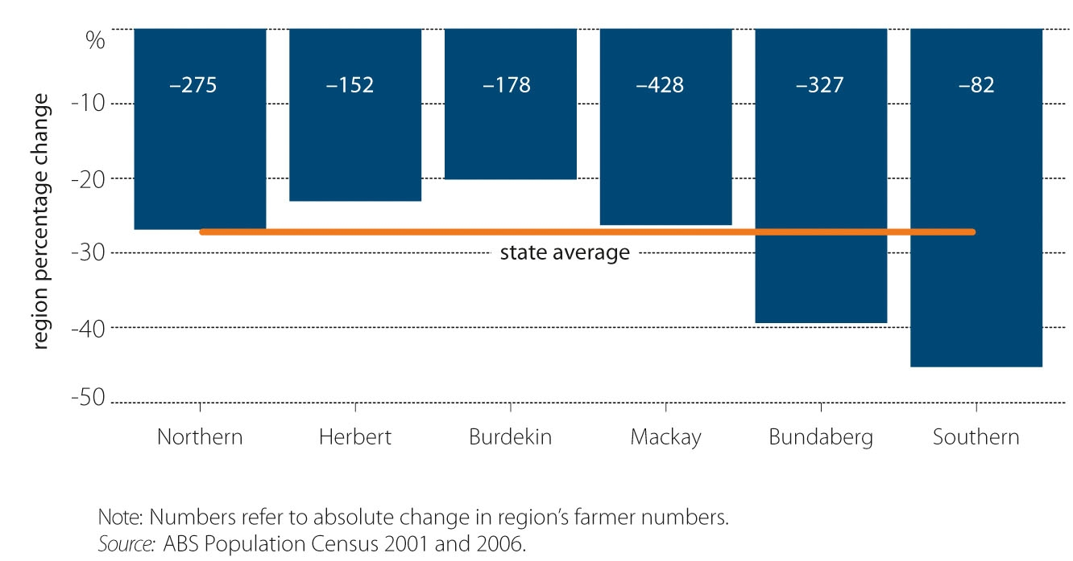

Farm size
In 2001, the average area of a sugar cane farm in Queensland was 110 hectares. By 2006, the average area had increased slightly to 111 hectares per farm business. There was, however, significant regional variation. The Herbert and Far North regions were the only two regions that had an increase in average farm size. The Herbert region experienced a significant increase of 12.5 per cent while the Far North increased by 3.8 per cent.
The average farm size in the Southern region fell by more than a quarter from 92 hectares in 2001 to 68 hectares in 2006 (Figure C2).

Figure C2: Average sugar cane property size by region
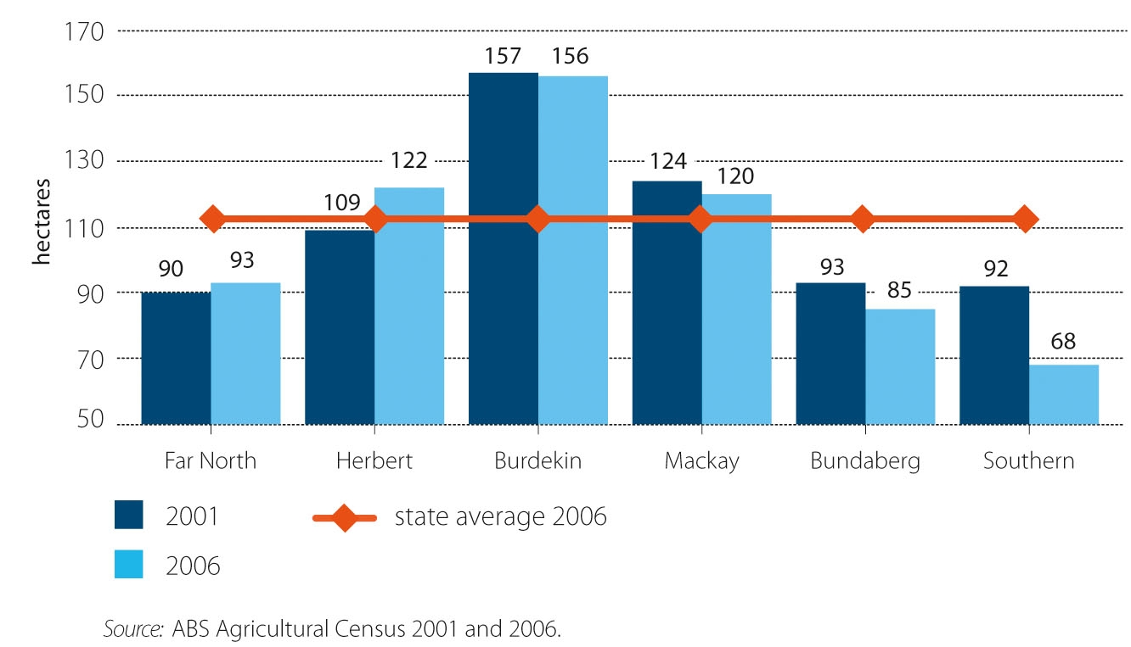

Number of businesses growing sugar cane
In 2001, there were 4477 businesses growing sugar cane in Queensland. By 2006, the number of businesses growing sugar cane had fallen to 4066. Every region (other than the Burdekin) experienced a decline in the number of sugar cane businesses. The Southern region had the greatest decline, with the number of businesses producing cane nearly halving in the five-year period.

Figure C3: Change in number of businesses growing sugar cane, 2001 to 2006
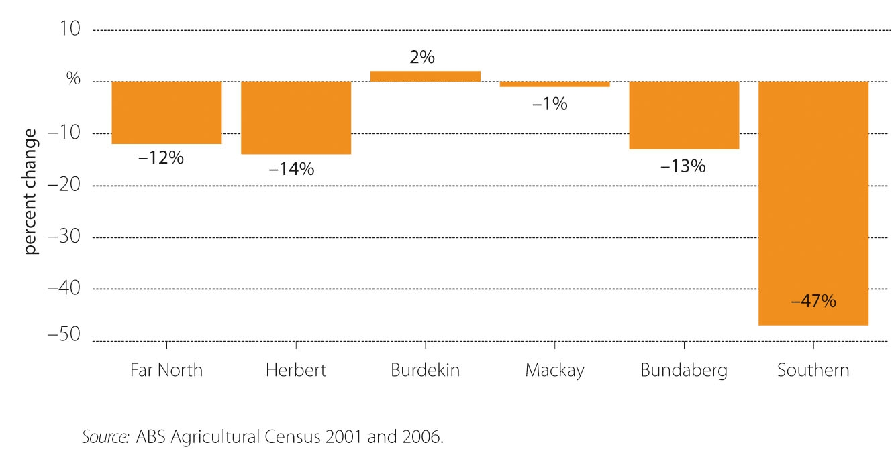

Farm income
In 2006, the median weekly income for a sugar cane farmer was $626, increasing from $502 in 2001. Cane farmers in the Burdekin region earned the highest median weekly income ($671) and those in the Bundaberg region earned the lowest ($530) (Hooper 2008).
The results from ABARE surveys of cane growers show that in 2005–06 farm cash income for sugar cane growers averaged $66 600 (Hooper et al. 2007; Hooper 2008). There were economies of size, with larger farms generally reporting better results because average unit cash costs of production decline as farms expand production (Hooper et al. 2007). An estimated 27 per cent of producers reported negative farm cash incomes. Most of the farms reporting negative farm cash incomes were smaller sugar cane growers producing less than 7500 tonnes in 2005–06 (Hooper et al 2007).
Average cane farm cash income in the financial year 2006–07 was just under $94 000—an increase of approximately 41 per cent on the 2005–06 average income (Hooper 2008). However, in 2007–08 farm cash income averaged approximately $7000 per farm—a decline of 93 per cent on the previous year as a result of lower sugar prices and continued large increases in the costs of farming inputs (Hooper 2008). Only 25 per cent of all cane growing businesses in 2007–08 were estimated to have made a profit. All regions were estimated to have recorded an average negative farm profit in the year 2007–08.
Sugar cane production was most profitable for growers in the Ord River region (the Ord River Mill ceased production in 2007) and Herbert region. Regions with below average incomes included southern Queensland, New South Wales, Bundaberg and Far North Queensland. These regions had a relatively high concentration of small-scale sugar cane growers (Hooper et al. 2007).

Number of mills and mill efficiencies
Table C2: Milling regions, 2006
Milling region | Production |  | Farming enterprises |  | Harvester groups | Mills: capacity (tonnes/hour)
 | Area | Tonnes crushed |  | %<15,000t
Far North | 80 502 ha | 7.3 million | 1036 | 93.6 | 137 | - Mossman: 320  - Mulgrave: 450  - Babinda: 350  - South Johnstone: 465  - Tableland: 200  - Mourilyanª: n/a  - Tully: 710  Region total: 2495
Herbert | 68 500 ha | 4.5 million | 762 | 94.8 | 91 | - Macnade: 520  - Victoria: 1100  Region total: 1620
Burdekin | 69 677 ha | 8 million | 556 | 68.3 | 125 | - Invicta: n/a  - Pioneer: n/a  - Kalamia: n/a  - Inkerman: n/a
Mackay | 115 513 ha | 9.84 million | 1157 | 85.5 | 258 | - Proserpine: n/a  - Farleigh: n/a  - Racecourse: n/a  - Pleystoweb: n/a  - Marian: n/a  - Plane Creek: n/a
Bundaberg/Isis | 38 541 ha#  #area under cane, not total farm area | 3.35 million | 691 | 95.6 | 104 | - Fairymeadc: n/a  - Millaquin: n/a  - Isis: n/a  - Bingera: n/a
Southern | 16 411 ha | 1.16 million | 232 | n/a | 12 | - Maryborough: n/a  - Moretond: n/a  - Rocky Point: n/a
NSW | n/a | n/a | n/a | n/a | n/a | - Condong: n/a  - Broadwater: n/a  - Harwood: n/a
n/a = data not available; ª closed 2006; ^{b} closed 2008; ^{c} closed 2005; ^{d} closed 2003.

Sugar research and innovation
This section outlines the role of the Sugar Research Development Corporation (SRDC), the primary research body for the Australian sugar industry, and its relationship to SIRP 2004. It also gives an update of the main sugar producer, Sucrogen (formerly CSR Sugar) and describes the work of the Cooperative Research Centre for Sugar Industry Innovation through Biotechnology (which concludes in 2010).

Sugar Research Development Corporation (SRDC)
The SRDC works with the sugar cane industry and the government to provide research and development for an innovative and sustainable sugar industry. The SRDC was created under the Primary Industries and Energy Research and Development Act 1989 and is also subject to the Commonwealth Authorities and Companies Act 1997 (SRDC nd). The SRDC is a major contributor to the future of the sugar industry.
The SRDC suggests that profits are set to increase and relates this to the restructure of the sugar industry that has made it more competitive and financially viable through improved efficiency and innovation. It has identified that a sustainable and profitable sugar industry relies on both technical and social improvements.
The SRDC has indicated that there have been many changes in the sugar industry in the past five years, including deregulation, supporting assertions that SIRP 2004 has been successful on several fronts. The SRDC suggests that deregulation has been crucial to making the regions and millers more responsible for their business (SRDC nd). In the past five years individuals in the industry have to a greater extent investigated their competitors and attempted to understand the industry value chain and the benefits of increased collaboration between industry sectors (SRDC nd). There has also been an increase in the involvement of youth and women in the industry (SRDC nd), as well as improvements in the learning and adaptability of people in the industry. This includes learning skills from similar groups and industries and from organisations in the industry (SRDC nd).
The findings from the SRDC are directly related to the primary objectives of SIRP 2004: to alleviate the immediate financial hardship of millers and growers; and to reform the industry structure to make it more competitive and sustainable. The intended scope of SIRP 2004 was to increase broader industry involvement with the reform process, and actively improve commercial viability, as well as investigating more innovative options for the uses of sugar cane, current sugar cane land and value-adding opportunities.
Major sugar companies such as Sucrogen have contributed to the financial viability of the industry by remaining commercially competitive and engaging in innovation. Sucrogen is presented as an example of how innovation and progress have been made in the sugar industry.

Sucrogen (formerly known as CSR Sugar)
CSR Limited began in 1855 in Sydney as a sugar refining company and grew into the most dominant Australian sugar producer and refiner. In 2010 CSR’s sugar and renewable energy company, now trading under the name Sucrogen, demerged from CSR Limited. CSR Sugar remains as a brand name used for marketing Sucrogen’s sugar products.
Sucrogen produces more than 40 per cent of Australia’s raw sugar. Sugrogen also has a 75 per cent share in the Sugar Australia Limited joint venture with Mackay Sugar Limited that produces refined sugar products.
Sucrogen is also an important supplier of ethanol, low GI sugar production and is ‘Australia’s largest producer of renewable energy from biomass, using the waste cane fibre by-product of sugar cane production (bagasse)’ (CSR 2010). In 2008 the company committed to the Greenhouse Challenge Plus, a cooperative partnership between government and industry (CSR 2008). The contributions of the ethanol, cane products (mainly raw sugar, molasses and electricity) and sweeteners (mainly refined sugar) division of Sucrogen are shown in Figure C4.

Figure C4: Sector contributions to the EBIT of Sucrogen a
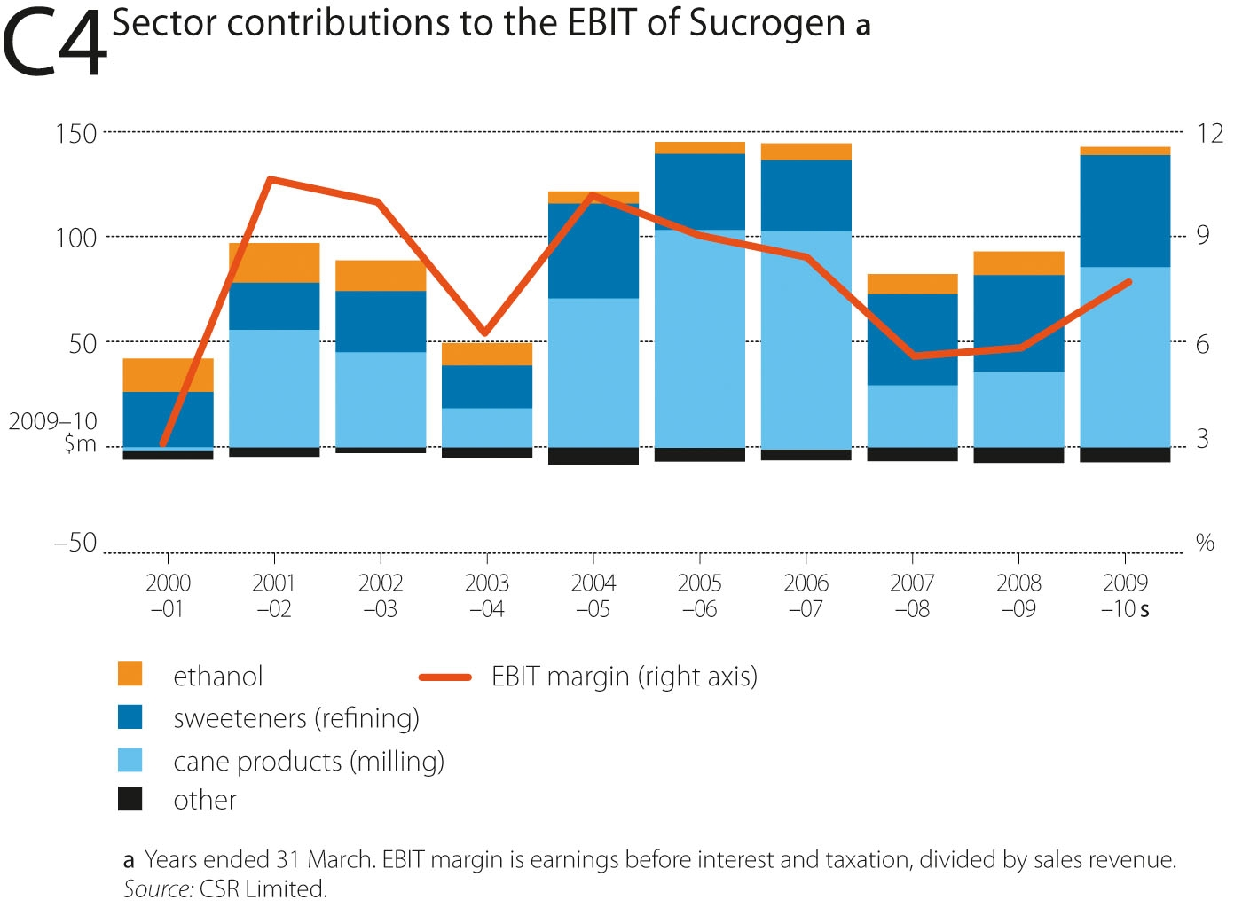

In 2009 Sucrogen and Syngenta Crop Protection AG signed a research and commercialisation licence agreement for ‘Sugar Booster’ gene technology (www.CSR.com 2009)—expected to enable ‘the development of novel sugars and sugarcane varieties with increased sugar content’ (www.CSR.com 2009). CSR also noted then that ‘Sugar Booster has primary global application in the increase of sugar yields for food and biofuel production in key sugar crops’ (www.CSR.com 2009).
The SIRP 2004 goal of helping to encourage diversification is visible in the range of initiatives that Sucrogen has engaged in since SIRP 2004 was implemented. As indicated by one interviewee, the idea of the RCP grants in particular was to develop pilot projects to help foster a culture of innovation through successful examples. It was hoped that these projects would encourage the industry to build further innovations into their planning.

Cooperative Research Centre for Sugar Industry Innovation through Biotechnology
Innovations in the industry are being found in other research organisations such as the Cooperative Research Centre for Sugar Industry Innovation through Biotechnology (CRC SIIB). The CRC SIIB had four primary areas of work: Technology Transfer; Enhanced Sugarcane Farming Systems; New Product Development from Sugarcane (Bioproducts); and Education (CRC Sugar 2008). The CRC SIIB also identified a natural GI modifier; a substance called GI-Wise, which is able to dramatically lower blood sugar levels and could be used in the development of complementary medicines (CRC Sugar 2008). The work of the CRC SIIB concluded in 2010, although its website will remain active for a further four years to support the industry.

References
ABARE 2010, Australian Commodities, vol. 16, no. 2, Canberra (and previous issues).
ABC 2010, ABC North Queensland (Townsville) Rural Report, 28 May 2010 6.22 am. Summary ID: W00039130696 (media monitors).
ASMC 2010, Australian Sugar Milling Council, map and figures provided via personal communication with Jim Crane.
Australian Government Treasury 2006, Abolition of domestic sugar levy, Media release, 23 November 2006, Viewed 27 August 2008, <www.treasurer.gov.au/DisplayDocs.aspx?doc=transcripts/2006/176. htm&pageID=&min=phc&Year=2006&DocType=2>.
Bellamy, J 2005, Regional natural resource management planning: the challenges of evaluation as seen through different lenses, in Occasional Symposium held on 15 October 2004 by the CSIRO Sustainable Ecosystems and CIRM Social Dimensions of NRM Working Group, Queensland Department of Natural Resources and Mines, Indooroopilly.
CSR 2008, CSR Now: Annual Report 2008, viewed 4 May 2010, <www.csr.com.au/investorcentre/documents/files/report20080331/CSR%20Annual%20Report.pdf>.
CSR 2009, CSR Sugar licenses SugarBooster™ technology for development of sugar and biofuels applications to Syngenta, viewed 5 May 2010, <www.csr.com.au/news/Pages/news_release091216.aspx>.
CSR 2010a, Sucrogen to increase renewable energy capacity, viewed 13 May 2010, <www.csr.com.au/news/Documents/100331%20Sucrogen%20to%20increase%20renewable%20energy%20capacity.pdf>.
CSR 2010b, Annual Report 2009, viewed 10 August 2010, <www.csr.com.au/investorcentre/documents/files/report20080331/CSR%20Annual%20Report.pdf> (and previous issues).
CRC Sugar 2008, Programs, CRC Sugar Industry Innovation through Biotechnology, viewed 10 May 2010, <www.crcsugar.com/OurPrograms/Programs/tabid/70/Default.aspx>.
CRC Sugar 2008(1), News-Archive, CRC Sugar Industry Innovation through Biotechnology, viewed 10 May 2010, <www.crcsugar.com/News/NewsArchive/tabid/123/xmmid/519/xmid/195/xmvie..>.
Gain 2010, Australia Sugar Annual 2010, USDA Foreign Agricultural Service, Global Agricultural Information Network Report, viewed 25 May 2010, <http://gain.fas.usda.gov/Recent%20Gain%20Publications/sugar%20Annual_Canberra_Australia_4-15-2010.pdf>
Hildebrand, C 2002, Independent assessment of the sugar industry, Report to the Hon. Warren Truss MP, Minister for Agriculture, Fisheries and Forestry, Commonwealth of Australia (DAFF), Canberra.
IOG 2006, Sugar Industry Oversight Group Strategic Vision, in: Forestry, DAFF (Ed.), Commonwealth of Australia, Canberra.
Hooper, S 2008, Financial performance of Australian sugar cane producers 2005–06 to 2007–08, ABARE research report 08.8 for the Australian Government Department of Agriculture, Fisheries and Forestry, Canberra.
Hooper, S, Henry, C, Ashton, D and Lubulwa, M 2007, Australian sugar cane growers financial performance 2005–06, ABARE research report 07.18 for the Australian Government Department of Agriculture, Fisheries and Forestry, Canberra.
PCSMA 2009, Proserpine Cooperative Sugar Milling Association Limited Seventy Eighth Annual Report for the year ended 28th February 2009, viewed 13 July 2010, <www.prosugar.com.au/uploads/Annual%20Report%202009.pdf>.
Queensland DPI&F 2004, Queensland Government and the sugar industry, viewed 27 August 2008, <www.dpi.qld.gov.au/sugar/12091.html>.
Queensland Sugar Limited, Annual Report 2009, Brisbane (and previous issues)
RIRDC 2006, Furfural Chemicals and Biofeuls from Agriuclture: A report for the Rural Industries Research and Development Corporation by Wondu Business and Technology Services, RIRDC publication No. 06/127, project No. WBT-2A.
SRDC nd, Research and Development Plan 2007–2012, Australian Government Sugar Research and Development Corporation, viewed 20 May 2010, < www.srdc.gov.au/UserImages/File/Publications/SRDC%20RandD%20Plan%202007-2012.pdf>.
Sugar Australia 2004, History of Sugar Australia, viewed 4 May 2010, <www.sugaraustralia.com.au/History.aspx>.

