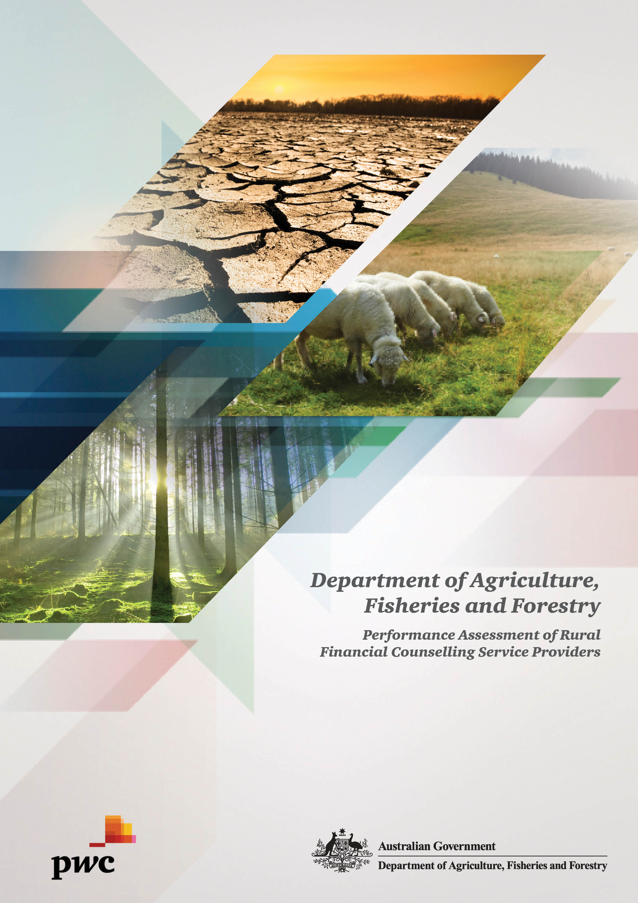

Contents
1 Executive summary 1
1.1 Introduction 1
1.2 Background 1
1.3 Assessment Approach 2
1.4 Assessment Objectives 2
1.5 Qualifications 3
1.6 Assessment Methodology 3
1.7 Conclusion 4
2 2007 Recommendations 8
3 Performance of RFCS Organisations 9
3.1 Corporate Governance 9
3.1.1 Background 9
3.1.2 Summary of Performance 9
3.1.3 Areas of Good Practice 12
3.1.4 Areas for Improvement 12
3.1.5 Areas for Focus for the Department 13
3.2 Financial Management 15
3.2.1 Background 15
3.2.2 Summary of Performance 15
3.2.3 Areas of Good Practice 16
3.2.4 Areas for Improvement 16
3.2.5 Areas for Focus for the Department 16
4 Service Delivery 18
4.1.1 Background 18
4.1.2 Summary of Performance 18
4.1.3 Areas of Good Practice 19
4.1.4 Areas for Improvement 20
4.1.5 Areas for Focus for the Department 20
5 Appendix A – Business Continuity – Key Phases 22

- Executive summary

- Introduction
This report summarises the findings of the recently completed performance assessments of 14 service providers delivering the Rural Financial Counselling Service (RFCS) Program to 30 June 2015.
The assessments and this report were completed by PricewaterhouseCoopers (PwC) for the Australian Government Department of Agriculture, Fisheries and Forestry (the Department).
- Background
The RFCS Program provides grants to state and regional organisations to supply free financial counselling to primary producers, fishers and small rural businesses, who are suffering financial hardship and who have no alternative sources of impartial financial information to manage the challenges of industry change and adjustment.
The Program started in 1986 in response to increased financial difficulties across the rural sector, and was implemented to meet an identified gap in the services offered to farm families and the small businesses that directly service the sector.
The Program has undergone a series of significant changes, most recently in 2006. The implementation of new administrative arrangements in 2006 saw 16 service providers selected through a competitive grants process to deliver the reformatted Program, with some organisations being an amalgamation of one or more of the previous delivery entities. The new Program, which came into effect from 1 August 2006, included improved corporate governance, better risk management, more stringent monitoring and reporting requirements, and an increased focus on delivering a flexible and responsive service.
In 2007, WalterTurnbull conducted a performance assessment of the 16 RFCS service providers. The focus of this process was to evaluate the 16 organisations’ performance and compliance with the new Deed of Grant. The performance assessment found that most organisations were performing at a medium to high level, had successfully implemented the new service delivery arrangements, and were able to demonstrate their organisation had adopted the required corporate governance structure (e.g. the Board focusing on the organisation’s strategic directions and the Executive Officer focusing on day-to-day operations).
Whilst the overall performance of the 16 RFCS service providers in 2007 was considered to be satisfactory, the assessment did find that some organisations experienced difficulties and delays while establishing the Program under the new service delivery arrangements. These issues notwithstanding, the performance assessment established that organisations were able to:
- increase their focus on strategic and business planning
- develop and implement all necessary supporting documentation, including policies and procedures and
- develop and implement structured, measurable performance management processes for rural financial counsellors, Executive Officers and the organisation as a whole.
A further competitive grants process was undertaken in late 2007, with 14 service providers being selected to deliver the Program from 1 July 2008 to 30 June 2011. Of the 16 existing RFCS service delivery areas, two were taken over by other service providers as the previous organisations delivering the service elected not to re-apply for funding, while one incumbent service provider was not successful in bidding for funding for its area.
On 29 April 2011, the Australian Government agreed to fund the Program for a further four years from 1 July 2011 to 30 June 2015 and extended the contractual arrangements with the 14 existing service providers for this funding period.
As approximately five years have passed since the 2007 WalterTurnbull performance assessment, this assessment seeks to provide an up-to-date evaluation of the current service providers against the same service delivery standards used in the 2007 assessment.
- Assessment Approach
This assessment provides an independent evaluation of the service providers receiving funding to deliver the RFCS Program. The assessment forms part of a suite of resources aimed at ensuring good management and use of public funds.
The assessment does not affect service providers’ current funding allocations but, rather, identifies areas which can be improved. It also identifies opportunities for streamlining and simplifying governance and administration requirements for these non-government, not-for-profit organisations.
Each service provider has been rated ‘High’, ‘Medium’ or ‘Low’ in overall performance. Specific areas for improvement are identified in the individual service providers’ reports with comments on the risk to the organisation and how improvements could be made. Individual plans for addressing the findings will be developed jointly by the Department with the service providers.
- Assessment Objectives
The objective of the assessment was to evaluate the performance of the RFCS service providers against the following criteria:
- Corporate Governance
- Financial Management
- Service Delivery.
The assessment also evaluated the service providers’ performance and compliance with their 2011-15 Deeds of Grant and the RFCS Program Resource Manual.

- Qualifications
PwC was engaged to conduct the performance assessment against the agreed criteria of corporate governance, financial management and service delivery. The engagement of PwC for this task did not constitute an audit or assessment in accordance with Australian Auditing Standards. Accordingly PwC provides no opinion or other form of assurance with regard to its work or the information upon which its work is based. If PwC were to perform additional procedures, other matters may come to its attention which could have a material impact on the results reported.
- Assessment Methodology
The table below summarises the methodology used by PwC when assessing the RFCS service providers in accordance with the objectives outlined in Section 1.3.
Process | Approach
Planning | - The development of a comprehensive Assessment Assignment Plan, including Departmental input, to guide the assessment in investigating:  Corporate Governance: including key areas such as organisational structure, skills of Board Members, risk management, insurance, employee appraisal processes and ongoing reporting.  Financial Management: including fundamental financial information e.g. projected surplus / deficit, financial reporting and skills of finance staff.  Service Delivery: including monitoring compliance with the relevant Deed of Grant, use of appropriately qualified staff and adequate client and service monitoring.
Fieldwork | - Reviewing key documentation such as strategic plans, financial statements, Board minutes and other management documentation.  - Assessing the existing documentation against what PwC considers better practice based on its previous assessment of the RFCS Program and its experience in performing similar assessments across the Commonwealth.  - Engaging in ‘real-time’ communications with the Chairperson, Board Members, Executive Officer and other key staff to work through the Assignment Plan. Ensure all key staff are aware of the assessment’s status and findings through a ‘no surprises’ approach.  - Conducting a final “on site” meeting to discuss the issues identified during the assessment process and confirm key findings. Management endorsement of these matters to be sought prior to departure.
Reporting | - Reports to be provided to the Department include individual organisation performance assessments which include commentary on corporate behaviours consistent with better practice and recommendations for improvement on identified weaknesses.
- Conclusion
The performance assessments of the 14 RFCS service providers found that most of the organisations (10 out of 14) are performing at a ‘Medium’ level or above (six ‘Medium’ and four ‘High’), meaning they prompt few or no major concerns in relation to their corporate governance, financial management and service delivery frameworks. However, four organisations had more serious risks for the program’s delivery and were assessed as performing at a ‘Low’ level.
The overall assessments across the 14 organisations are summarised in the graph below:
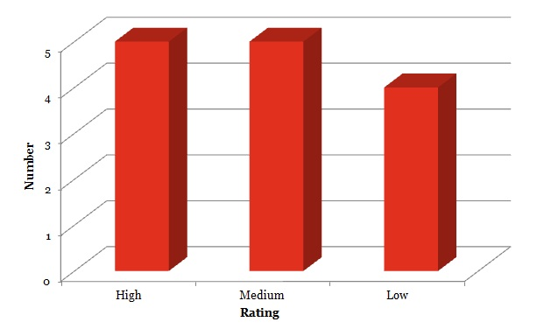
The overall performance ratings assigned to each service provider were based on a number of factors including the number of adverse findings in the corporate governance, financial management and service delivery frameworks, the relative level of risk these findings posed for each organisation (i.e. the same finding may pose a different level of risk for different organisations due to the organisation’s size or the availability of alternative resources and expertise in their community), as well as the extent to which innovative and better practice processes were used. In addition, the overall risk profile of the organisation and evidence of the implementation of the 2007 recommendations were considered when assigning the overall assessment.
Risk Level Definitions
The risk levels and associated recommended management actions arising from the findings are categorised as follows:
Risk level | Recommended management actions
 | Serious breaches or issues of concern which should be addressed immediately.
 | Issues requiring management attention which should be addressed in the near future (next three to six months).
 | Issues which should be addressed after high and medium priorities (within 12 months).
Performance Rating Definitions
Performance rating | Definition
A ‘High’ performance rating means that:
- The organisation has acceptable levels of governance and management performance.
- An action plan may, or may not, be required to address minor issues.
- Normal monitoring of reporting and stakeholder management should continue.
A ‘Medium’ performance rating indicates that:
- There are some concerns about the organisation in relation to governance and management performance.
- The organisation has a number of specific issues that require addressing.
- An action plan to address the issues needs to be developed as soon as practicable.
A ‘Low’ performance rating means that there are serious concerns about the service provider in relation to governance and management performance, specifically:
- The organisation has a range of issues that require addressing.
- An action plan to address the issues needs to be developed as soon as practicable.
The plan should include, as a minimum, an immediate business improvement review, consultation between the service provider and the Department to reach agreement on actions to address the specific issues, timeframes for deliverables to be met, follow up “on site” visits to test progress against the set of actions, and regular reviews and monitoring of progress against the plan.
There were a total of 80 findings for improvement and most of these (57) were related to corporate governance. The number of findings for improvement for each organisation ranged from one to 12, with an average number of six findings per organisation.
The assessments found that, generally, there is a level of maturity and robustness in the organisations’ frameworks in relation to both financial management and service delivery. This can be attributed to the embedding of processes as the Program and organisations have matured, as well as the high rate of implementation of recommendations from previous assessments. However, there does remain scope for further strengthening of the corporate governance frameworks across the organisations. This is evidenced by the spread of findings for the organisations across the three criteria as shown in the table below:
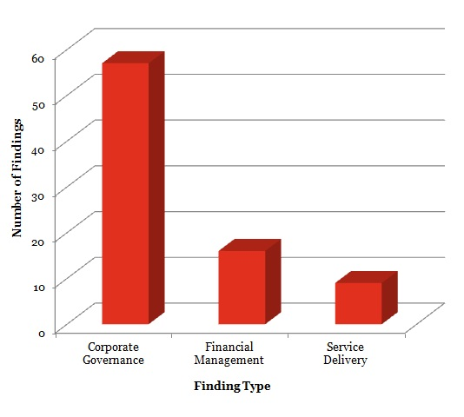

- 2007 Recommendations
Part of this performance assessment examined if and to what extent the 173 recommendations made in the 2007 assessment had been implemented. It was noted that the majority of organisations had demonstrated significant progress in implementing the various recommendations for enhancing their corporate governance, financial management and service delivery outcomes.
The graph below shows the service providers’ progress in implementing the 2007 recommendations.
Whilst it should be noted that there was some variation amongst organisations, analysis indicates that most of the 2007 recommendations were fully implemented (153 out of the total of 173), providing assurance that there is commitment towards continuous improvement across the majority of the organisations.
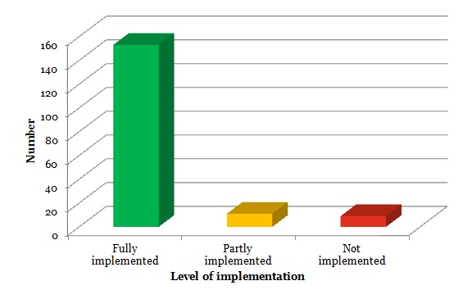

- Performance of RFCS Organisations
A total of 80 findings were identified by this performance assessment and reported in the individual reports for each RFCS organisation. The 80 findings reflect the number of findings identified across the entire RFCS network, however, a number of these findings were common to a number of the organisations. As such, these common findings indicate that there are some trends which should be considered by the entire network of RFCS organisations. Trends include:
- Absence of full compliance with requirements of the Deed of Grant, in areas such as clearly accounting for and reporting on the use of RFCS funds and patchy completion of staff performance reviews and employee files.
- Absence of, incomplete or out of date business continuity and disaster recovery arrangements.
- Out of date policies and procedures for service delivery operations and governance of the organisation.
The following section of this report provides a summary of the key areas for improvement identified from the assessments of the 14 RFCS service providers.
- Corporate Governance
- Background
Corporate governance is about having the structures, systems, processes and accountabilities in place to ensure effective leadership and management in conducting service provider business. To assess corporate governance, the following standards were considered:
Establishing and Maintaining Governance: whether an organisation has processes in place to ensure it has the skills and experience needed to manage its business affairs and the commitment to continuously improve its capability.
Policies and Procedures: whether an organisation has clearly defined policies and procedures in place to guide the values, behaviours, management and decision making within the organisation.
Corporate Planning, Review and Development: whether an organisation undertakes regular strategic and business planning to set its strategic objectives and enable it to implement its priorities and manage the risks to their achievement.
Transparency and Accountability: whether an organisation has clearly documented processes in place for how decisions are made, how its business is conducted, and to be accountable to its stakeholders, including funding providers and the community it services.
Employment of staff: whether an organisation advertises and employs staff, such as rural financial counsellors, in accordance with service delivery standards.
- Summary of Performance
Since the 2007 assessment, in broad terms, the 14 service providers have implemented a number of measures to better govern their daily and strategic operations. This has included the implementation of recommendations from the 2007 assessment, as well as other improvements, such as in the management, planning and accountability of the governing Board, and the completion of comprehensive key corporate documents such as strategic plans.
However, findings and observations from the current assessment have highlighted a need for organisations to improve their corporate governance arrangements to ensure their ongoing organisational capacity to deliver services under the RFCS Program. There were 57 corporate governance findings out of the total 80 across the 14 RFCS service providers. The graph below provides a summary of the number of corporate governance findings identified, and their risk level:
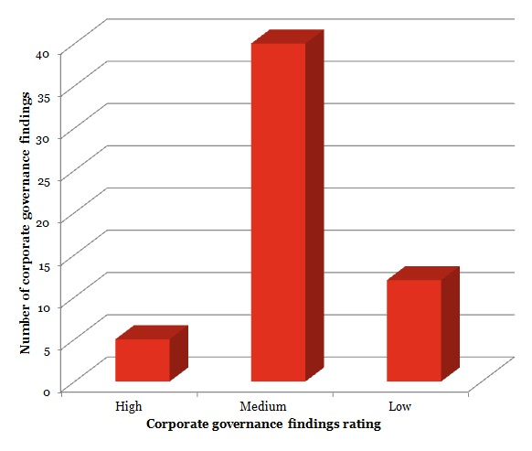
Of the corporate governance findings identified by this assessment, 70 per cent were considered to be of ‘Medium’ risk to the RFCS service providers; that is, they are important for the accountability, transparency and ongoing organisational strength of the organisations and their capacity to continue to deliver rural financial counselling services. The findings require the RFCS organisations to take action within the next three to six months to address them.
On the whole, Boards are meeting on a regular basis and are being provided with sufficiently detailed and timely reports on organisations’ finances and operations.
However, the level of documentation maintained in regard to policies and procedures for both strategic and operational matters was variable across the RFCS organisations: some organisations maintain comprehensive suites of documentation, while others require immediate attention to complete or update their policies and procedures.
Findings and observations from the performance assessments have highlighted that organisations need to implement policies and strategies to:
- Demonstrate compliance with all requirements of the Deed of Grant, particularly in areas such as the appropriate use and reporting of RFCS expenditure, regular completion of staff performance reviews and maintenance of complete employee files.
- Ensure that the Board is aware of matters or actions arising in the administration and delivery of services since their previous meeting so that these may be acknowledged, appropriately dealt with by the Board and documented.
- Demonstrate the maintenance of organisational constitutional requirements, such as appropriate activities and documents for clear transparency in the election and appointment of Board Members, specifying the term that Board Members can hold office before they must seek re-election, and the registration of organisational members and participants.
- Ensure that organisational performance against strategic objectives is monitored and key activities to manage the organisation’s current performance and focus on future development can be tracked.
- Ensure that supporting documentation, such as policies, procedures, roles and responsibilities for all staff and Board Members are complete, endorsed and implemented, and that these are reviewed on a regular basis and updated (if needed).
- Ensure that all organisational committees, sub–committees, advisory groups and reference groups have current Terms of Reference to define their scope, responsibilities, engagement and accountability. These groups should be further supported by annual agendas or calendars to support their planning activities and focus.
- Ensure that all staff and Board Members are adequately trained and skilled to undertake their assigned duties by implementing systems such as training programs and registers, which specify training requirements and monitor their completion.
- Ensure that the reported time and effort of staff is formally verified to reduce the risk of fraud against the organisations, such as that associated with timesheet falsification.
- Identify, resolve and record potential conflicts of interest of the organisations, their staff and Board Members.
- Ensure that grievance reporting and investigation processes avoid Conflicts of Interest.
- Ensure that critical risks associated with the possible loss of Board Members and key staff, such as the Executive Officer, are addressed.
- Allow organisations to maintain and re-establish critical business functions in the event of a business disruption incident or disaster.
Specifically, some organisations need to ensure they have:
- A Risk Management Plan, which assigns final ratings to identified business risks, has associated mitigation strategies and assigned officers responsible for monitoring the status of the risk. The identified risks should consider fraud, business viability, and business continuity, which in turn should be cross referenced with organisational strategies and management plans.
- Defined Fraud Control policies that outline how organisations will prevent, detect and investigate fraud.
- A ‘Compliance Register’ that informs organisations of key compliance activities that should be completed for the Department and regulatory bodies, and their associated deadlines.
- Areas of Good Practice
The following areas of good practice were identified during the performance assessment of the RFCS service providers and their overall corporate governance framework:
- Utilisation of a self-assessment survey tool to evaluate Board performance, with the results being used to further improve its focus and performance.
- Establishment of Board sub-committees which operate in a manner to meet the changing needs and risks of RFCS organisations. These sub-committees are formally reviewed on an annual basis to determine their effectiveness and appropriateness to continue.
- Development of strategic plans that provide organisations with guidance on their strategic vision and goals, and how operational activities will be managed to achieve these goals.
- Use of comprehensive induction packages for all commencing employees, which outline the requirements that must be met by the employee at commencement, and the subsequent months following.
- Maintenance of a detailed matrix of the skills, qualifications and training requirements for each of the Board Members.
- Provision of individual rural financial counsellor’s ‘snap shot’ reports to the Board for review and discussion. This reporting allows the Board to gain a simple yet effective overview of the activities and performance of rural financial counsellors and the overall effectiveness of the service delivery.
- Provision of an introductory letter to clients, which encourages them to contact a Board Member or the Executive Officer if they have any concerns regarding rural financial counsellor performance.
These areas were found to not only be compliant with the Department’s governing guidelines but also assisted the organisations to ultimately deliver a higher level of service to their clients through effective management of their structures, systems and processes.
These areas were not found in all organisations, however, where applicable, these should be considered for implementation by the other organisations in addition to the improvement areas summarised above.
- Areas for Improvement
Key areas where improvements could be made in relation to the general governance standards of the service providers are listed below. The level of improvement required across the 14 organisations varies considerably, with the points below being general recommendations for improvement and alignment with better practice.
- The assessment highlighted that the level of documentation maintained in regard to policies and procedures for both strategic and operational matters was variable across the organisations: some organisations maintain comprehensive suites of documentation, while others require immediate attention to complete or update their policies and procedures.
- Business continuity and disaster recovery arrangements should be documented in sufficient detail to guide the organisations in restoring their critical functions in an efficient and effective manner.
- All organisations should both be cognisant of, and formally document, succession planning arrangements, in particular for key positions such as the Executive Officer and the Chairperson. Organisations may find it useful to refer to the themes, guidance and templates provided at the following link: http://www.business.gov.au/Howtoguides/Exitingabusiness/Pages/Successionplanning.aspx
- Documented training plans/schedules for Board Members should be implemented to ensure that their ongoing training and development needs are considered on a regular basis. Whilst the training needs of Board Members will vary, examples of relevant training include corporate governance and understanding of financial statements.
- The respective powers, roles, responsibilities and accountabilities of the Board and Executive Officer should be appropriately documented.
- Areas for Focus for the Department
The following corporate governance related issues should be closely monitored by the Department while the RFCS Program is in operation.
Rolling Audit Program
Five years have elapsed since an assessment of the organisations has been performed. During those five years there has been significant reform in the rural sector and the risks, challenges and focus of rural Australia have also been evolving. Given this, it is recommended that the Department reconsider its approach to conducting performance assessments and implement a rolling audit program to provide continuous visibility of the performance of service providers. The rolling assessments should be conducted on a risk based approach, with key themes and observations allowing for the dissemination of advice, policy and training across the broader Program.
General Governance Arrangements
Corporate governance is regularly defined in Australia as, “the framework of rules, relationships, systems and processes within and by which authority is exercised and controlled in corporations.” It encompasses the mechanisms by which companies, and those in control, are held to account.
Given the majority of findings across the organisations related to weaknesses in corporate governance frameworks, the Department should consider providing training or educational opportunities to ensure that key members of the organisations are aware of what constitutes good corporate governance and its importance. This could include governance training at forums such as the six-monthly Executive Officer/Chair meetings, recognising that it would be limited to only those attending.
There is a significant amount of publicly available better practice guidance on the subject of corporate governance which could be utilised by organisations. This includes guidance issued by the Australian Government Department of Finance and Deregulation. Whilst focused on Government Business Enterprises, which are Commonwealth authorities, there are key principles that are relevant for organisations operating under the RFCS Program. This guidance can be found at the following link:
www.finance.gov.au/publications/governance-arrangements/index.html
Business Continuity and Disaster Recovery Arrangements
The performance assessments identified a general lack of understanding and rigour in documentation for both business continuity and disaster recovery arrangements. Both business continuity and disaster recovery are critical elements of the risk management frameworks for any organisation and are particularly relevant to these organisations given that they are commonly dealing with ‘business continuity’ issues for their clients.
The Department should consider ensuring that the organisations are adequately educated in business continuity and disaster recovery, including the need for ensuring that arrangements for both these functions are adequately documented. All organisations should have both business continuity and disaster recovery arrangements in a stand-alone document, which will assist with the restoring of ‘business as usual’ in an efficient and effective manner in the event of a disaster occurring.
The Australian National Audit Office has produced a user-friendly guide on business continuity arrangements, which would provide the organisations with a clear framework of what they need to have in place. This document can be found at the following link:
www.anao.gov.au/~/media/Uploads/Documents/business_continuity_management_.pdf

- Financial Management
- Background
Effective financial management is essential for the delivery of good outcomes from public funds. An organisation’s financial management framework should be comprised of systems, processes and procedures which support effective financial management, accountability and reporting, and are consistent with government requirements. To assess financial management, the following standards were considered:
Financial Operations and Reporting: whether an organisation uses its financial resources well and has systems in place for financial planning and reporting accountabilities to ensure compliance with all relevant legislation and regulatory requirements.
Financial Systems: whether an organisation has financial systems which support effective financial management and accountability.
- Summary of Performance
Overall, the performance assessment found that the RFCS service providers demonstrated a sound level of financial management, and the number of findings identified in relation to financial management was small (16) compared with the number of findings attached to corporate governance (57). However, it is noted that a relatively large number of these findings (33 per cent or five out the total of the 16 Financial Management findings) were considered to present a ‘High’ level of risk. This is because some organisations did not fully comply with Deed of Grant requirements in relation to the use, management and reporting of RFCS funds. Where applicable, organisations need to implement policies and strategies to:
- Ensure their ongoing operations are financially viable and within the means of their existing funding agreements: this includes ensuring that the Board is able to monitor organisational income and expenditure against budget.
- Ensure that financial reporting formats are provided to the Department in compliance with the Deed of Grant.
- Ensure Board Members are adequately trained and skilled in financial management and are aware of their responsibilities.
- Ensure that appropriate approvals and separation of duties are in place in relation to internet banking transactions.
- Track all RFCS income and expenditure activities such that they may be effectively segregated from other organisational activities.
- Provide Board members with appropriate financial information, such as budget income and expenditure, so that this may be considered as part of the Board’s decision making.

The graph below provides a summary of the number and risk level of findings identified:
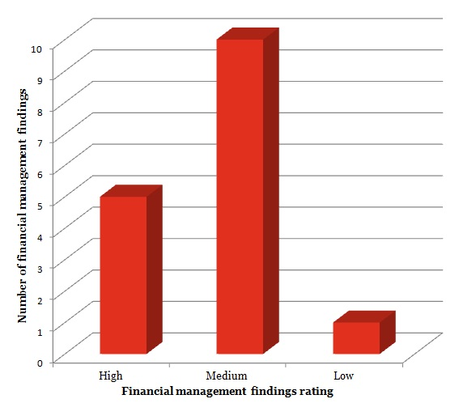
- Areas of Good Practice
The assessment did not identify any specific areas of good practice beyond those expected of the RFCS service providers in maintaining compliance with the financial management requirements of the Deed of Grant.
- Areas for Improvement
Key areas where improvements could be made in relation to financial management of the organisations are listed below. It is noted that the level of improvement required across the 14 organisations varies considerably, with the points below being general themes where scope remains for further improvement and alignment with better practice.
- All organisations should be cognisant of their financial reporting requirements, including the current requirement to provide audited special purpose financial statements to the Department.
- Comprehensive policies and procedures for the financial management and operation of each organisation need to be documented, finalised and approved by the Board.
- All organisations need to ensure appropriate approvals and separation of duties are in place in relation to internet banking transactions.
- Areas for Focus for the Department
The following financial management related issues should be closely monitored by the Department while the RFCS Program is in operation.
Financial Reporting Requirements
The performance assessment identified a need for clarification in relation to financial reporting requirements of the organisations. It remains critical for the Department that there is complete visibility of the expenditure of funding provided through the RFCS Program whilst not requiring unnecessarily onerous reporting to be performed by the organisations. As such, the Department should consider allowing audited General Purpose Financial reports to be provided on an annual basis (providing visibility on the viability of the organisation). However, these should be accompanied by an audited grant acquittal which clearly shows the income and expenditure of the RFCS funding separated from other funding sources (such as supplementary non-RFCS related state government funding).
- Service Delivery
- Background
The RFCS Program is administered by the Department in a manner in which there is a clear emphasis on the provision of high quality and accessible rural financial counselling services to clients. To assess service delivery, the following standards were considered:
Client Service Standards: whether an organisation is committed to providing a high quality and accessible service to its clients.
Confidentiality and Privacy: whether client confidentiality and privacy is respected and maintained.
Complaints and Appeals: whether complaints and appeals of decisions are addressed promptly, fairly, confidentially and without retribution.
Staff Retention and Ongoing Support: whether an organisation’s processes support retention of suitably skilled, motivated and committed staff through adequate and appropriate support and the use of development opportunities and capacity building options.
Training and Development of Staff: whether all staff are provided with the opportunity to develop and improve their skills through both informal and formal training programs.
- Summary of Performance
Observations gathered throughout the performance assessment found that RFCS service providers’ performance in relation to service delivery was generally adequate and there were a low number of findings identified in relation to this (nine findings across the network of organisations). The graph below provides a summary of service delivery findings identified, and the level of risk they pose:
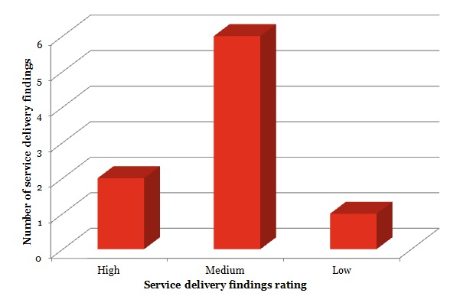
However, it should be noted that the findings identified were considered to be significant (two were ‘High’ and six were ‘Medium’) as they may affect the continued ability of clients to access high quality services. These findings indicate that some important improvements need to be made immediately (for findings of ‘High’ level of risk) or within six months (for ‘Medium’) by some organisations, to improve their service delivery. The findings include some inadequacies in documentation that publicly demonstrates procedures for ensuring privacy and confidentiality. Where applicable, RFCS organisations should consider implementing activities to:
- Ensure that all rural financial counsellors are appropriately trained and certified to have the minimum skills required for their duties and as specified under the Deed of Grant.
- Ensure that adequate frameworks are in place to foster ongoing development and education of all staff so they are adequately skilled to discharge their duties and ultimately deliver quality services to clients.
- Ensure that the level of service provided by the organisations and their rural financial counsellors is formally monitored and reported through regular and structured activities, including client surveys, performance assessments, reports to Boards, and the completion of client file audits.
- Ensure that adequate guidance is available to specify the key minimum requirements for client services. This guidance may be utilised in client file audits and other performance management activities.
- Ensure that any deficiencies identified in maintaining minimum service requirements are addressed by management through specific remediation activity and follow-up activities, such as targeted audit of client files.
- Staff performance monitoring and appraisal is undertaken and maintained on file as part of the evidence required to track all activity relating to staff and rural financial counsellor performance assessments or client file audits.
- Areas of Good Practice
The following areas of good practice were identified during the performance assessment of the RFCS service providers and their overall service delivery framework:
- The utilisation of a Client Management Framework which provides a one-page overview of the organisation’s client management process. This may be used as a tool for ensuring that all key steps and decisions are made by the rural financial counsellors and for recording client decisions and outcomes. The framework may be further incorporated into client management files and used as a tool to review the performance of individual rural financial counsellors.
- The utilisation of ongoing rural financial counsellor support through various activities including:
- Ongoing mentoring between rural financial counsellors,
- Support Groups / Local Reference Groups,
- Compulsory psychologist sessions for each rural financial counsellor each year,
- Board Members attending staff meetings, which provides staff with the opportunity to speak to the Board, and
- Consideration and implementation of relevant training needs.
These areas were found to not only be compliant with governing guidelines but also assisted the organisations to deliver a higher level of service to their clients.
The above strengths were not found in all RFCS organisations. Those organisations who were found to not have these as particular strengths, are encouraged to consider them for implementation as further ways to improve.
- Areas for Improvement
Key areas where improvements could be made in relation to the service delivery of the service providers are listed below. It is noted that the level of improvement required varies considerably across the 14 organisations, with the points below being general recommendations for improvement and alignment with better practice.
- Organisations should ensure the ongoing monitoring of client service standards covering areas such as accessibility, responsiveness, timeliness and quality of services against which they can regularly monitor the organisation’s (and rural financial counsellor’s) performance.
- All organisations should ensure that rural financial counsellor and Executive Officer reviews are carried out and documented regularly, with client file audits to be completed as part of the rural financial counsellor reviews.
- All organisations should ensure they have detailed policies and procedures in relation to confidentiality and privacy, complaints, and occupational health and safety, which are finalised and approved by the Board.
- Areas for Focus for the Department
The following service delivery related issues should be closely monitored by the Department while the RFCS Program is in operation.
Collaboration between Organisations
The performance assessment conducted in 2007 identified some level of collaboration between organisations in an attempt to assist with service delivery. This assessment found that there remains scope for a further increase in the level of collaboration between all organisations, with some organisations found to be actively looking to collaborate whilst others continued to operate largely on an independent basis.
The Department should, both formally when conducting meetings of RFCS organisations and when issuing correspondence, as well as informally through ongoing communications, ensure that they encourage an increased level of collaboration between all organisations in an attempt to ultimately improve the level of service that is provided. The individual audit reports identified areas of better practice and it is recommended that the Department use these to develop a register to assist any organisations who require improvement.
Organisations Undertaking Additional Functions
The performance assessment noted that there is an increased appetite across the service providers to undertake activities in addition to those performed under the RFCS Program. Discussions with key personnel, including Executive Officers and Chairs of the Board, identified that this was largely to diversify funding risk.
While no judgement is made about the appropriateness of this broadening of activity, it does have implications for financial and other management aspects related to the use of public funds. With this increase in alternative activity there are increased risks of the Department’s funding being used outside the terms of the RFCS Deed of Grant.
In addition, the increase in the sources of funding (and related expenditure) also creates further risks to the Department, such as being able to clearly identify the ownership of any surplus funds and the ambiguities that can result from different financial reporting requirements.
Whilst it is not unreasonable for the organisations to consider and ultimately pursue alternative activities, the Department should ensure that it is fully (and formally) informed of the nature of any alternative activities and that organisations remain cognisant of the financial reporting requirements of the Department.

- Appendix A – Business Continuity – Key Phases
As noted throughout this report, the performance assessment identified a need to strengthen both the understanding and documentation of business continuity arrangements. Business continuity is an essential part of any risk management framework and is fundamental for assisting any organisation with the efficient and effective restoration of critical functions. They may be particularly important for rural-based organisations with the relatively limited availability of infrastructure, capital, skills and expertise.
Below are the key phases of a business continuity response that organisations may consider in the development of a business continuity plan. These phases should be considered in conjunction with the better practice guide issued by the Australian National Audit Office, which provides commentary on team structure, activation requirements etc, as well as organisational specific elements which need to be included.
PHASE ONE – RESPOND
Ensure immediate emergency response actions have been initiated [ ]
Confirm that accounting for staff has occurred or is being undertaken (where relevant) [ ]
Notify business continuity team members that a disruption has occurred [ ]
Activate appropriate command centre location and convene business continuity team [ ]
Notify Executive Officer that a disruption has occurred and that the business continuity team has [ ] been activated
Identify the nature and scope of the disruption and determine the immediate next steps [ ]
Make a disruption declaration to staff and key stakeholders [ ]
PHASE TWO - RECOVER
Confirm immediate people that issues at the disrupted location have been addressed [ ]
Confirm the status of the situation, current impacts and likely duration [ ]
Confirm which business processes have been disrupted and assess their recovery criticality [ ]
Determine initial recovery priorities and resource requirements [ ]
Identify and allocate resources from unaffected business units (where required) [ ]
Confirm strategy for communicating with media, employees, members and stakeholders [ ]
Provide updates to Executive Officer and notify employees of the situation and any actions they [ ] should take
Provide approved updates to relevant stakeholders and the media [ ]
Confirm effectiveness of response and reassess situation status, impacts and likely duration [ ]
Reassess recovery priorities and resource requirements [ ]
Resolve issues and road blocks and issue action plan [ ]
Maintain situational awareness and determine the timing of the next cycle [ ]
PHASE THREE - RESUME
Confirm that situation has been stabilised and that critical business processes have been [ ] re-established
Confirm that all assigned tasks are completed and that reallocated resources have been returned [ ] (where possible)
Establish a long term recovery project team (where appropriate) [ ]
Provide update to Executive Officer and notify employees of the situation and any actions they [ ] should take
Provide approved updates to relevant stakeholders and the media [ ]
Deactivate the Command Centre and stand down the business continuity team (retain all records) [ ]
Complete Post Incident Reporting [ ]



