

Evaluation of Rural Communities Program

History of the Rural Communities Program 2
Acknowledgements 21
Executive summary 22
Appendix 1: Maps showing results of database analysis 27
Appendix 2: Questionnaire 44
Appendix 3: List of written submissions 49
Appendix 4: Interview guides 55
Appendix 5 Case studies 61
Discussion and recommendations 99
Methods and results 114
References 154
Terms of reference 157

History of the Rural Communities Program
The Rural Communities Program (RCP) is a Commonwealth Government funding program originally established within the former Department of Primary Industries and Energy (DPIE), now Agriculture, Fisheries and Forestry - Australia (AFFA). Its current goal is ‘To encourage diverse, dynamic and self reliant rural communities, and profitable and sustainable rural industries’. The intent is to develop the capacity of regional and rural communities to take control of their own development.
The RCP evolved from the Rural Communities Access Program (RCAP) established in 1994 as a result of a Federal Cabinet decision to amalgamate previous programs known as the Rural Counselling Program, Business Advice for Rural Areas, Rural Access Program, Telecentres Program, Australian Country Information Service and Countrylink. In terms of previous evaluations, the RCAP was evaluated in 1997 by a team from the Centre for Rural Social Research at Charles Sturt University together with staff of the former DPIE (Alston, Share, Heazlewood and Kent, 1997). They in turn built on previous reviews of the various program components, including one by Bird Cameron Rural Management Services (Bird Cameron, 1994).
Following the October 1998 Federal election, administration of the RCP was split between the newly-created AFFA and the Department of Transport and Regional Services (DTRS), with the financial counselling component remaining with AFFA and all other components being transferred to DTRS. This was despite the earlier intent of having an integrated program to allow communities to address their needs in a holistic way. The RCP has since been advertised together with another current Commonwealth program, RuralPlan, which is administered by DTRS, as comprising the ‘Regional Communities Programmes’.
The opportunity for this evaluation arises because the RCP is nearing the end of its current funding cycle (funding ceases on 30 June 2001 and the last round of applications has closed), and Government accountability requires its performance to be assessed. The evaluation is intended to help guide the future direction of the program. It is also oriented towards identifying factors influencing the success or failure of projects funded by the RCP in order to make better decisions about which projects to fund in the future and, if necessary, identify ways to improve program administration. The exact terms of reference are given in a following section.
A Steering Committee was established for the evaluation. Its membership was:
Ms Liz Chapman (Chair), member of RCP Advisory Committee and consultant
Ms Lib McClure, Manager, Rural Affairs, Primary Industries and Resources South Australia
Ms Christine Forster, Chair, Western Rural Services Consortium
Ms Jenny Cupit, Director, Farm Business Management, AFFA
Mr Bernie Scott, Director, Regional Programmes, DTRS (after his retirement in June 2000 replaced by Ms Judy Jenkins, A/Director, Regional Programmes, DTRS).
The outcomes of this evaluation have been to some extent pre-empted by the announcement on 18 June 2000 by Minister John Anderson, Deputy Prime Minister and Minister for Transport and Regional Services, that a new program called the ‘Regional Solutions Programme’ will be established, with initial funding of $90 million (Anderson, 2000). It will be established for four years and a first round of applications is expected to begin in October 2000. From the initial description provided by the Minister and in accompanying fact sheets from DTRS, it appears that the new program is intended to be similar in scope and form to the current RCP, but will be able to fund individual projects worth up to $500,000. However, the announcement made no specific mention of the financial counselling component of the RCP, nor did it mention any involvement by AFFA.
Program description
An outline of the RCP’s major elements overall is given in Figure 1. The RCP funds community projects falling under the general headings of:
- Financial Counselling Services (FC) – for people in financial difficulty
- Community Planning (CP) – small scale
- Information Provision (IP) - information about Commonwealth Government initiatives and programs
- Information Services Technology (IT) – access and training
- Community Development (CD) e.g. training courses and newsletters
- Projects of national significance.
Projects in the last category are not considered here as they form a very minor element of the overall RCP. These different categories for projects are referred to in this report as ‘program components’.
Any not-for-profit, representative groups with strong community or regional involvement can apply for funds as long as they are incorporated, or sponsored by an incorporated body. Purchase of major capital equipment is not funded. Funding provided for community planning activities is generally up to a maximum of $3,000. Funding for other program components is generally up to a maximum of $50,000, but financial counselling services have in some cases received considerably larger sums. Funding applications frequently include budgets to employ project staff and/or consultants.
Applicants are expected to contribute cash or ‘in-kind’ contributions to the project. For financial counselling projects, applicants must provide at least 50% of the total cost. For projects in all other categories except community planning, applicants must provide at least 25% of the cost. There are no formal agreements with State Governments for matching or ‘top-up’ funding, although on a project-by-project basis, State Governments have contributed 20-25% of funding for financial counselling projects. State contributions are subject to approval by the respective State Ministers.
As mentioned above, all funding under the current program ceases on 30 June 2001 which provides a ‘sunset’ for existing projects. In the past, projects could be funded for a maximum of three financial years although have usually been funded for 18 months or less, with the exception of the financial counselling services which have generally been funded for the maximum three-year period. Six-monthly project reports and annual reports are required, together with annual audited financial statements. Renewal of project funding is subject to project management committees providing audited accounts and reports detailing achievements against milestones.
Figure 1 Schematic diagram of the main elements of the RCP
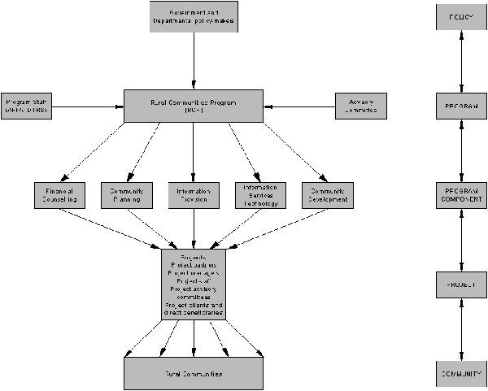
The RCP has an Advisory Committee established to consider applications and make recommendations to the appropriate Minister about project funding, and to consider project reports. It usually meets quarterly in Canberra. Application funding rounds are closed off three to four weeks before each meeting to allow time for staff to complete assessments and recommendations. Members of the Advisory Committee are people with backgrounds and expertise in rural community matters, and knowledge of rural and regional issues, particularly in the areas they represent. Current members of the Advisory Committee and their home locations are:
Ms Jane Mouritz
Hyden, WA
Mr John Wearne
Bingara, NSW
Ms Liz Chapman
Baddaginnie, Vic.
Mr John Neal
Eudunda, SA
Mr Andrew Hunter
Armidale, NSW
Mr Mark Needham
Canberra, ACT (representing the National Farmers’ Federation)
Dr John Stone
St George, Qld.
In terms of additional eligibility criteria, at its preliminary meeting in February 1998, the Advisory Committee agreed that the RCP should focus on small communities, and even when an applicant was located in a larger centre, that the major beneficiaries of RCP-funded projects or services should be residents of small communities. The nominal population cap for ‘small communities’ was agreed to be 10,000, although a specific figure is not stated in application guidelines or assessment criteria. It was recognised that joint applications from several communities could exceed this nominal cap but still be consistent with the Advisory Committee’s intent.
Calls for RCP funding applications are made at successive funding rounds (usually three or four per year), widely advertised in rural and regional newspapers around Australia. Information about the RCP is also available on the two Departments’ respective web-sites, and application forms can be downloaded electronically. RCP administrative staff (AFFA staff for financial counselling projects, DTRS staff for other project components), assess applications against specific criteria set out in application guidelines, and pass these assessments and recommendations to members of the RCP Advisory Committee. Advisory Committee members then make their own assessments and pass on recommendations to the respective Minister.
A form setting out assessment guidelines for staff was obtained from DTRS. Administrative staff may seek advice from other appropriate government agencies (Commonwealth, State or Local), and Area Consultative Committees, before passing assessments to the Advisory Committee. A copy of a DTRS comment form was obtained. The evaluation team was advised that all applications are referred to the State and Commonwealth Departments that program staff consider relevant, depending on the nature of the application. Applications have also been referred to Area Consultative Committees (ACC’s) since the signing of a Memorandum of Understanding about the cross-Departmental roles of ACC’s by Ministers Reith, Anderson and Kemp in June 1999. Before this time, consultation with ACC’s was less consistent. ACC’s, first established by the Commonwealth Department of Employment, Workplace Relations and Small Business, form a key regional network for the Commonwealth Government. Their role, as described on their web-site, is to work in partnership with government, business and the community to identify and foster opportunities for jobs growth, skills development, regional growth and service delivery, and to find community-based solutions to these issues.
In the case of Queensland financial counselling applications, copies of applications are sent to the Office of Rural Communities, Queensland Department of Primary Industries, and they in turn seek comment from other State agencies as necessary. In the year 2000 funding rounds, all Queensland applications were also forwarded to a Remote Areas Liaison Officer, recently established by DTRS and based in Longreach, Queensland.
Program staff enter information about all applications into a project database (referred to here as the ‘Administration database’). This gives basic information about all applications, the contact person, records success or failure of applications, and information about project reports received. The database was also split when administration of the RCP was split between AFFA and DTRS. The evaluation team obtained a copy of each version of the database.
After considering applications and assessment information provided by project staff, the Advisory Committee makes recommendations to the respective Minister as to which projects should be funded. The final decision on funding of information provision, information services technology, community development, and community planning projects is made by the Minister for Regional Services, Territories and Local Government, and on financial counselling projects by the Minister for Agriculture, Fisheries and Forestry.
Project assessment criteria are:
- feasibility of project
- impact of initiative/magnitude of opportunity
- contribution by and general support of local community, industry and government agencies
- generation of a community resource
- ability of applicant to conduct the project
- extent of public and private benefits to the local/community/region/industry/nation
- link to improved competitiveness and sustainability of rural communities and industries
- extent and urgency of need.
Program staff score each project on each of these criteria on a scale of 1-10, and these scores are included on the assessment sheet together with an overall recommendation about the project’s priority for funding, for the Advisory Committee to consider. The evaluation team obtained copies of the pro-forma assessment sheet and actual assessments for a range of projects.
The main elements of the application and assessment process are outlined in Figure 2.
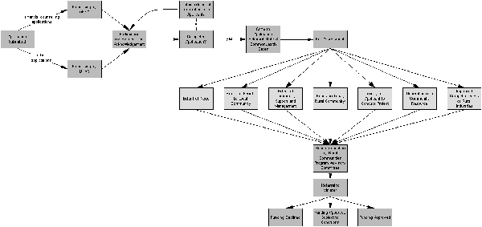
Figure 2 Outline of the process for assessing RCP applications
Successful applicants enter into a Deed of Agreement (commonly referred to as a contract) with the Commonwealth to deliver project outcomes. There are standardised forms of these deeds, and the one for financial counselling services provides details of the duties and responsibilities of counsellors and reporting requirements. The approved budget for the project is part of the Deed of Agreement, and any significant changes to project budgets and expenditure require a variation to the contract. Projects may be administered by existing community management bodies or committees, or a new one may need to be established by the community. In either case, the community body administering the project must establish a chair for their management committee.
Another database, referred to as the ‘AT-LAS’ database, provides a pro-forma reporting basis for use by staff employed by successful financial counselling projects, and records client statistics. Financial counsellors can report directly to the Canberra-based administrative staff using this database loaded on their own computers and can send reports electronically. The evaluation team also obtained a copy of this database.
AFFA and DTRS staff provide pro-formas establishing the style and headings for annual and the interim six-monthly reports to project management committees.
Program model
The RCP’s model is seen by policy-makers, program staff and advisory committee members as involving community-government partnerships. It is seen as being largely ‘bottom-up’ in that it allows communities to identify their own needs and solutions, identify community organisations and management committees to administer projects, and to submit applications covering a wide range of different types of community-based projects. Project management is highly devolved to communities and government reporting requirements are seen as being minimal. The program model is considered to be flexible because it allows responsiveness to changing community needs rather than priorities being set beforehand by government. For example, the information material for the newly-announced Regional Solutions Programme, also based on the same model, explains ‘How communities can use the Regional Solutions Programme to tailor their own solutions’ (DTRS, 2000).
This model can be related to the ‘ladder’ of citizen participation in government decision-making developed by Arnstein (1969). This ladder ranges from complete citizen control at the top to manipulation of citizens by government at the bottom, with a range of possibilities in between. Partnership is the third rung from the top, with only delegated power and citizen control lying above it.
As part of the evaluation, opinions were sought from a variety of stakeholders on these aspects of the RCP and its underlying model.
Program statistics
From the database information supplied to the evaluation team, summary statistics about the RCP have been derived. These are presented below. Further analysis of the database information has been carried out and results are presented in map form (Appendix 1). This aspect of the evaluation is discussed further in the section Database analysis.
Number of RCP-funded projects
Table 1 shows the numbers of projects funded by the RCP over this period by State or Territory, broken down into three categories: financial counselling (FC), community planning (CP), and a grouping of community development (CD), information provision (IP), and information services technology (IT).

Table 1 Number and type of RCP-funded projects by State/Territory over the 1998-2001 financial years. None was based in the ACT

State/Territory | FC | CP | CD, IP, IT | Total
New South Wales | 28 | 15 | 37 | 80
Victoria | 15 | 15 | 28 | 58
Western Australia | 8 | 13 | 36 | 57
South Australia | 13 | 7 | 18 | 38
Queensland | 11 | 9 | 15 | 35
Tasmania | 1 | 3 | 10 | 14
Northern Territory | 0 | 2 | 1 | 3
Total | 76 | 64 | 145 | 285

Project funding
Table 2 shows the amount of RCP funding provided for projects in each State or Territory, excluding community planning projects which are shown separately in Table 3. These figures were supplied separately by DTRS as an up-date to the original figures obtained from the database.
Table 2 Total RCP project funding (excluding community planning projects) by State/Territory. No projects were funded in the ACT

State/Terr. | 1998-99 | 1999-2000 | 2000-01 | Total
New South Wales | $2,494,255 | $2,878,621 | $2,730,140 | $8,103,016
Victoria | $1,446,288 | $1,582,964 | $1,344,093 | $4,373,345
Queensland | $1,073,707 | $1,235,735 | $1,082,562 | $3,392,004
Western Australia | $817,159 | $1,043,830 | $986,385 | $3,053,374
South Australia | $917,315 | $1,095,480 | $995,868 | $3,049,668
Tasmania | $258,570 | $333,610 | $227,170 | $819,350
Northern Territory | - | $3,360 | - | $3,360
Total | $7,007,294 | $8,173,600 | $7,366,218 | $22,794,117

Table 3 Funding for community planning projects by State/Territory. None was in the ACT. No projects of this kind were funded in 2000-2001
State/Terr. | 1998-99 | 1999-00 | Total
New South Wales | $99,238 | $20,500 | $119,738
Victoria | $87,862 | $6,000 | $93,862
Western Australia | $37,995 | $13,695 | $51,690
Queensland | $42,388 | $9,000 | $51,388
South Australia | $46,224 | $19,593 | $65,817
Northern Territory | $3,000 | $3,000 | $6,000
Tasmania | $20,561 | - | $20,561
Total | $337,268 | $71,788 | $409,056

Table 4 shows a detailed breakdown of funding for financial counselling services by State. The figures shown are the average yearly funding over the financial years 1998-99, 1999-2000, and 2000-2001, based on the length of the contract. Most services have a 36-month contract, but a number have 12- or 24-month contracts. Before calculating State totals, yearly averages for each service were calculated.
Table 4 Funding for financial counselling services by State. None was in the ACT or the NT
State | Average yearly funding | Average funding per service | Average funding per counsellor
New South Wales | $1,817,004.30 | $56,781.40 | $51,914.40
Victoria | $929,610.30 | $40,417.80 | $40,417.80
Queensland | $664,860.00 | $41,553.80 | $45,852.40
South Australia | $608,027.30 | $32,001.40 | $46,771.30
Western Australia | $478,317.30 | $47,831.70 | $47,831.70
Tasmania | $107,893.30 | $107,893.30 | $53,946.70
Geographical distribution of financial counselling services
Table 5 shows the distribution of RCP-funded financial counselling services by State. A series of maps indicating the location of projects according to funding component are located in Appendix 1.
Table 5 Distribution of financial counselling services by State. None was in the ACT or the NT

State | No. of services | No. of locations | No. of counsellors
New South Wales | *28 | 33 | 34
Victoria | 15 | 20 | 21
South Australia | 13 | 13 | 13
Queensland | 11 | 12 | 16
Western Australia | 8 | 9 | 10
Tasmania | 1 | 2 | 2
Total | 76 | 89 | 96

*Bland Advisory Group is currently closed
Table 6 compares the proportion of total RCP funding and the proportion of non-metropolitan population for each State or Territory (the ACT is not included). Following ABS definitions, non-metropolitan refers to non-capital city populations. This simple analysis suggests that Western Australia and South Australia are over-represented with respect to RCP project funding compared with other States. In contrast, the Northern Territory and Queensland are under-represented. New South Wales, Tasmania and Victoria have received funding at levels roughly commensurate with their non-metropolitan populations. It is important to note that this per capita analysis does not incorporate any consideration of community need or level of socio-economic disadvantage, and consequently should be interpreted with caution. Analysis of project locations with respect to degree of socio-economic disadvantage and degree of remoteness/accessibility is considered in the Database analysis section of the report.
Table 6 Comparison of non-metropolitan population and total RCP funding (excluding the ACT)

State | Proportion of non-metropolitan population (%) | Proportion of total RCP funding (%)
New South Wales | 34.7 | 36.3
Victoria | 18.7 | 21.2
Queensland | 27.9 | 15.4
Western Australia | 7.2 | 12.9
South Australia | 5.8 | 10.4
Tasmania | 4.1 | 3.7
Northern Territory | 1.6 | 0.04

Program and policy context
The RCP is one of a range of Commonwealth programs and initiatives designed to assist rural and regional communities. Rural and regional communities are generally considered to be those lying outside capital cities or other cities with populations of 100,000 or more. However, as mentioned above, the practice in RCP decision-making has been to only consider applications that come from, or propose to provide services to, communities with a population of 10,000 or less.
Many rural communities and their issues have had a high profile politically and in the media in recent years, partly because of trade globalisation; reduced prices for major agricultural commodities like wheat and wool; and contraction of government and private sector services in some rural areas. Overall, there have been major shifts as the Australian economy has adjusted structurally from being one based mainly on primary products and commodities, to one based far more on services (Lawrence, Share and Campbell, 1992). The farm sector’s contribution to Gross Domestic Product fell from 10% in 1968 to 3% in 1998-99. Associated with this, the number of Australian farms has been falling steadily, and is now about 115,000 (Stayner, 2000). In the 1997-98 financial year, it was estimated that 65% of these farms made a ‘business loss’ (ABARE, 1999; Stayner, 2000). Agriculture now only directly employs 14% of the rural Australian workforce.
In addition, the Australian population as a whole has become more highly urbanised. Although many rural centres have grown, the overall percentage of the population living in rural Australia has diminished, and an increasing percentage of rural Australians now live in coastal and near-coastal areas (Haberkorn et al., 1999; Stayner, 2000; Productivity Commission, 1999). ABARE has pointed out that the share of the population in centres of less than 1,000 people has declined from 14.7% in 1986 to 10.9% in 1996 (Berry, Hogan and Thorpe, 1999). This tends to mask the fact that many rural centres, particularly those in coastal areas, are growing, while the decline is largely in the inland. Approximately 5.1 million people now live in rural and regional Australia (29% of the total population), and there are about 1,640 Australian towns with populations of between 200 and 50,000 people. However, there are only eight Australian medium-sized cities with populations between 50,000 and 100,000 (Stayner, 2000). Much of the rural population therefore lives in small towns, as recognised in the RCP’s focus on communities of 10,000 or less.
Partly as a result of these population shifts from the inland to the coast, and the increasing proportion of the population living in urban or near-urban areas, some rural centres have lost essential services. Rural communities have tended to see these losses as being a result of government and private sector providers pursuing economic rationalist policies at the expense of social and community welfare. The telecommunications revolution has also opened up new ways of providing traditional services or conducting business, and because many rural and regional communities are in relatively remote locations, Government, some private sector providers, and communities themselves, are keen to take advantage of these new opportunities.
Some statistics indicate that Australians living outside metropolitan areas do suffer significant social disadvantages in terms of access to services and in living standards. For example, using Census data, the National Centre for Social and Economic Modelling (NATSEM) (2000) found that Australia-wide, average household incomes for 1996 were $44,783 in capital cities, and $30,609 in rural towns (defined as having populations between 200 and 999). Using comparisons for the period 1991-1996, NATSEM (2000) also concluded, among other things, that:
- there was a large and growing income gap between those living in capital cities and those living in the rest of Australia
- household incomes in metropolitan areas increased at about double the rate of major urban centres and regional and rural towns
- farmers living in rural areas (outside towns) enjoyed the largest increase in household income
- regional Australia was not uniformly disadvantaged and was not uniformly declining
- the picture aggregated across Australia hid very different experiences in particular States and regions.
However, NATSEM pointed out that household income is not necessarily a good measure of quality of life, and other indicators such as employment rates and health status also need to be considered. In terms of employment, ABARE (2000) found that between 1986 and 1996, employment growth was greatest in coastal areas (19.2%), followed by remote areas (12.4%), and was least in inland areas (9.3%). Across all regions, the retail and wholesale trade had increased its share of employment while agriculture, forestry, fishing and hunting had decreased its share. Country matters: a social atlas of rural and regional Australia (Haberkorn et al., 1999) depicts statistics that indicate some aspects of disadvantage faced by rural Australians, based on data from the 1996 Census of Population and Housing. These disadvantages have been further reported by Wahlquist (2000). While there is great regional variation, disadvantages include:
- shorter life spans
- poorer access to medical specialists, dentists, physiotherapists, psychologists and pharmacists
- lower levels of education
- higher unemployment
- higher accident and suicide rates.
Commonwealth Government has responded to concerns about rural and regional disadvantage by developing a range of programs and services aimed specifically at rural and regional communities, in addition to broadly-based programs available to all Australians. While this evaluation has not focused in detail on examining overlaps or gaps between current programs for rural and regional Australia, people interviewed during the evaluation were asked about these and their responses are discussed later in the report. It is clear that there are a number of Government programs related to the RCP. These include the Rural Transaction Centres program, FarmBis, Networking the Nation, and the Regional Assistance Program. State Governments also provide programs with similar or overlapping objectives, including those run by their departments and agencies with responsibilities for primary industries, regional development, communications, and social and community services. Because many indigenous people live in rural and remote areas, some Aboriginal programs are also relevant to the RCP and may provide alternative sources of funding for indigenous communities.
Several recent events and initiatives involving Government and non-Government organisations are relevant to this evaluation. A National Rural Communities Conference was held in Coonabarabran, New South Wales, on 27-29 September 1999, and was attended by one member of the evaluation team. It brought together approximately 200 people involved with the RCP and produced a conference communiqué strongly supporting the program and its approach (Chudleigh, 1999).
The Regional Australia Summit, held in Canberra in October 1999, developed a vision statement and 250 strategies to address challenges facing regional Australia. The vision statement is:
A strong and resilient regional Australia which, by 2010, has the resources, recognition and skills to play a pivotal role in building Australia’s future and is able to turn uncertainty and change into opportunity and prosperity.
(Regional Australia Steering Committee, Interim Report, April 2000)
Key recommendations made by the Summit Steering Committee are shown in Box 1.
Box 1 Key recommendations of the Regional Australia Summit Steering Committee Interim Report, April 2000

- that governments recognise the value of regional Australia to Australia’s economy and social fabric and commit to a long term investment strategy for regional Australia over ten years, focusing on economic development and improvements in service standards
- that governments seek to bring regional and urban Australians closer together and in particular bring regional Australia up to the standards of living, services and opportunities expected by most Australians
- that the Federal Government embark on a comprehensive new program of reform of its policies, programs and relationships with other levels of government and develop new initiatives that enable regional Australia to continue to play an important role in building Australia’s future. A key centrepiece could be the embedding of regional objectives into Commonwealth Government decision-making to ensure the relevance, accessibility, appropriateness and value of government programs to regional Australia
- that the response to the Summit and all future government schemes should be based on enabling communities to form their own local community/regional/industry partnerships and to decide and define their opportunities and priority needs.

The Summit Steering Committee further identified three key strategic areas for change:
- community empowerment
- economic and business development in regional communities
- equity of services in regional communities.
In relation to the first strategic area, community capacity was seen as the ‘essential element’, and several working groups at the Summit stressed the view that many regional communities need a stronger skills base and stronger leadership to be able to adapt to change and capitalise on new opportunities.
In discussing equity of services, participants expressed concerns about lack of coordination in delivery of government services, the ‘plethora’ of programs, and stressed the need for a coordinated approach across all levels of government. The Summit Steering Committee supported a recent meeting of regional development Ministers from the various States that made a commitment to establish a framework for cooperation in regional development. Summit participants wanted a whole-of-government process to allow communities to access existing programs and make them more ‘community friendly’ (Centrelink and Countrylink represent moves in this direction). Another recommendation was to use a network of facilitators and liaison officers to help communities to better access government programs (the appointment of a DTRS remote area liaison officer in Longreach is in line with this recommendation).
The last Federal Budget brought down in May 2000 announced a number of new initiatives to benefit rural and regional Australia. They included a Stronger families and communities strategy investing $240 million over four years on childcare, parenting skills, and helping families at risk of breakdown. Another initiative was enhancement of the existing Agriculture Advancing Australia package by $309.4 million. The Parliamentary Secretary to the Minister for Agriculture, Fisheries and Forestry, Senator Judith Troeth, said in her media release that:
This year’s budget has demonstrated that the Federal Government is listening to rural and regional Australia and is putting in place policies that will help to renew these communities. The position of rural and regional Australia is an ongoing priority for the Coalition Government.
(Troeth, 2000)
Findings of last evaluation
The most recent evaluation relevant to the current RCP is one of the RCAP completed by Alston and her co-workers in 1997, in collaboration with DPIE staff (Alston, Share, Heazlewood and Kent, 1997). It had similar terms of reference to this evaluation and used similar methods, but included a more extensive program of site visits reaching approximately 25% of the project sites current at the time. The main conclusions of that evaluation were that the RCAP had facilitated access to services and information among rural residents, and was empowering communities to develop innovative solutions to their needs. Alston and her co-workers concluded that the program had contributed to building strong and sustainable communities. They also concluded, among other things, that:
- there was a need for the services being provided by RCAP projects
- this need was not being met by other service providers, or clients could not afford those services if they existed
- one of the real strengths of the program was its ‘bottom-up’ approach
- the services funded by the RCAP were effective in supporting development of community infrastructure
- significant outcomes had been achieved for a range of stakeholders
- support strategies had evolved to meet changing rural community needs.
The evaluation considered that the RCAP components were efficient and cost-effective, largely because of the significant in-kind support from local communities. It also concluded that the program had contributed to building social capital and enhanced the competitiveness of the rural sector through, for example:
- facilitating the adjustment process
- facilitating technological transfer to rural communities
- providing access to information
- working towards business development.
In the evaluation team’s opinion, the RCAP’s community management model did have a number of advantages, but raised some issues that needed addressing. The main issues identified were the need to ensure:
- committees are representative of the community
- committee members have skills and vision to carry out tasks effectively
- committee members are adequately supported in their role.
The evaluation identified a number of indicators it considered supported the case that there was a continuing need for the types of projects funded by the RCAP. These included the increasing number of Countrylink calls, increasing numbers of funding applications, the number of written submissions sent to the evaluation (124), and the number of community people willing to speak to evaluation team members during visits.
Government was seen to have a continuing role in facilitating access to information and services for rural and remote Australia. In particular, the Commonwealth Government’s role was seen as justified for a number of reasons, including economies and efficiencies of scale, and its responsibility to ensure equity in provision of services right across Australia.
The report made a number of recommendations, summarised in Box 2.
Other relevant reviews
Two other reports prepared for the former DPIE are relevant to this evaluation. One is the Report on the review of the Rural Adjustment Scheme (Synapse Consulting, 1992), and Rural adjustment: managing change, the mid-term review of the Rural Adjustment Scheme (RAS) (McColl, Donald and Shearer, 1997). These are relevant to the extent that the RCP and the projects it funds are also assisting rural communities to adjust to change. To the extent that programs like the RAS and the RCP serve or have served common objectives, they also face similar issues in achieving these objectives. Both the Synapse and McColl reports do, however, focus mainly on farmers and farm families rather than on rural communities generally as does the RCP.
The RAS evolved through various forms over the period 1971 to 1998. It was officially abolished in 1997-98, but Commonwealth and State Governments honoured existing commitments until the 1999-00 financial year. Basically the RAS was an umbrella arrangement that enabled financial assistance to be provided to eligible farmers through a variety of means such as subsidies on interest paid on commercial loans, household support, farm exit provisions, and ‘exceptional circumstances’ provisions. The RAS was seen as particularly important to rural producers during the droughts of the 1990s. The Synapse Consulting review recommended that:
- the over-riding performance criterion for the RAS should be increased sustainable economic returns from all the resources of the farm unit (human, physical, financial)
Box 2 Summary of recommendations from evaluation of the RCAP (Alston et al., 1997)

1 There should be an emphasis on developing clear objectives, performance indicators and milestones; and maximum integration of components e.g. data management, reporting, payment and contractual procedures
2 The Commonwealth recognise ongoing community need for access the services and information, and its legitimate role in assisting with this
3 The Commonwealth maintain its role as a purchaser of services in conjunction with other levels of government where appropriate and effective
4 That both the positive aspects and challenges of the current program be used as the basis for future development
5 That appropriate performance indicators be developed that are easily assessed, monitored and evaluated
6 That the program be re-named and operate as a menu-based program to support regional and rural communities to access information and services
7 That the new program be widely publicised and promoted, and that information, community development initiatives, and ‘best practice’ ideas developed through the new program be widely and systematically communicated
8 That formal agreements are developed with other departments to disseminate Commonwealth information to rural areas
9 That a re-named public information section of the new integrated program develop or provide:
- a 1800 telephone line and a newsletter about the new program
- a database for local groups
- disseminate rural community development initiatives and best-practice models
- the Rural Book
- Internet information to rural areas
- conferences/training/support for local groups and service providers
- be responsible for statistical collection and analysis of the new integrated program
- provide community information service stands for local groups and contracted services for other departments
10 That the new integrated program provide data management and support for service providers
11 That some of the services identified in Recommendation 9 be tendered out if appropriate.

- assistance should be provided on a needs basis towards improving the performance of those farming operations that contribute significantly to the economic role of the sector, or have the potential to do so
- the focus of the scheme should be on the economic performance of the farm rather than the nature of the farming operation or other factors such as debt level
- the RAS should aim to remove the causes rather than the symptoms of low productivity
- industry and regional factors affecting the potential productivity gains of individual farms should be taken into account.
Synapse Consulting’s view was that eligibility and performance criteria for the RAS needed to be altered so that they focused more clearly on achieving improved returns to farm investment. They also recommended that eligibility, assessment, performance, and needs criteria should be developed for the various components of the RAS; and in particular, that these criteria should be interpreted within a policy framework defined by the Scheme’s overall purpose and goal, and by each component’s objective.
The second report (widely referred to as the ‘McColl report’), includes a set of recommendations developed specifically for the RAS, and also includes summaries of other studies covering similar topics. Like this evaluation, the McColl report provided opportunities for public submissions to be made and also conducted public hearings. The recommendations of the McColl report most relevant to this evaluation are summarised in Box 3.
Box 3 Relevant recommendations of the mid-term review of the Rural Adjustment Scheme
(McColl et al., 1997)
Future program structure
- future government programs for rural adjustment should not use interest rate subsidies or grants to farm businesses for productivity improvements or exceptional circumstances support
- the program established in 1992 should be terminated and replaced by a program that addresses issues of management skills, re-establishment, savings and welfare, subject to honouring some existing commitments
- the new program structure should include:
  - a farm business improvement scheme (FarmBis) with a focus on promoting a culture of continuous learning and enhancing the capacity of farm managers to identify, acquire and apply the skills and information needed to improve the performance of their farm business in terms of profitability and sustainability
  - a farm re-establishment scheme to encourage those farmers who wish to leave to do so as early as possible to maximise their assets (subsequently re-named the ‘Farm Family Re-Start Scheme’ or FFRS)
  - development of improved instruments to promote farm savings and a strategy for handling business risk
  - more responsive welfare arrangements
Regional considerations
- program design should allow regional delivery of FarmBis and FFRS in conjunction with other relevant Commonwealth/State programs
Links with other programs
- the new program structure should contribute to a broad vision for agriculture, and have a clearly defined set of objectives, outputs and outcomes that are complementary
Program administration
- the major elements of FarmBis and FFRS should be delivered on a contestable tender basis using a purchaser/provider relationship (with DPIE being the purchaser)
- an efficient program monitoring process should be established with clearly defined outcomes, performance indicators and a process for monitoring those indicators
- the new program package should be effectively promoted
- a new advisory panel should be established with expertise in relevant areas including farm and program management, administration, education, research and development, farm finance, natural resource management and rural social adjustment.

In relation to the financial counselling component of the RCP, the evaluation team examined a report prepared by the Australian Bureau of Agriculture and Resource Economics (ABARE) on issues relating to delivery of Commonwealth social support programs (ABARE, 1997), and a cost-benefit analysis of the Commonwealth Financial Counselling Program run by the former Department of Industry, Science and Tourism (Network Australia, 1998). The ABARE report, based on a survey of 3,500 farm families and a series of 12 detailed household case studies, showed that Commonwealth social support programs were widely used by farm families, but that there were deficiencies in delivery of these programs. Done during the droughts of the 1990s, the survey showed that a significant number of households (including some with high asset levels), were experiencing financial difficulties as shown by reported cut-backs in spending on basic food items. The report discusses eligibility tests applied for different types of Commonwealth assistance (for example AUSTUDY, Age Pension, Drought Relief Payment, Basic Family Payment, Job Search), including assets and hardship tests. It concludes that many families that were not receiving Commonwealth support at the time of the survey were likely to be eligible for support if they applied. In some cases this reflected ignorance of possible support programs or misunderstanding of assets tests.
The cost-benefit analysis of 46 financial counselling services throughout Australia funded by the Commonwealth Financial Counselling Program, found that the program generated two dollars in benefits for every dollar expended, and provided services more cheaply than the private sector. Program benefits were in terms of reduced suicides, reduced unemployment and reduced debt collection costs, as well as many intangible family and community benefits that were difficult to quantify. The analysis considered locations of services and recommended that program administrators take into account the socio-economic profiles of areas where services are to be located by examining indicators such as income levels, housing ownership, ethnic composition, unemployment and education levels. Recommendations were made about the need to consider accessibility of services, overlaps with similar services, and equity considerations in ensuring that as many Australians as possible have access to these services. The report identified circumstances under which it considered that competitive tendering for financial counselling services is appropriate.
Theories and concepts
Rural community development and related ideas of community capacity-building and empowerment have stimulated much research in Australia and other western nations over the last few decades. The pace of research has accelerated partly because many challenges facing these communities around the world are shared ones related to the changing global economy, and a move some writers describe as being from industrial to post-industrial society, or the ‘information’ or ‘knowledge’ age (Inglehart, 1990; Lawrence et al., 1992; Pigg, 1999; Stayner, 2000). Other writers use the terms ‘old’ and ‘new’ economies, seeing traditional commodity-based economies as having been overtaken by expansion in new technology-related and services sectors including telecommunications, computing, e-commerce, personal and business services. Another set of oppositions is expressed in identifying a move from a ‘development’ paradigm to a ‘post-development’ paradigm (McMichael, 1996). This contrasts former views that national economic growth and welfare need to be managed, with ‘post-development’ views that global economic growth and global welfare should be the focus. Accompanying this recognition of change are a range of other terms, some of which have already been mentioned (micro-economic reform, structural adjustment, globalisation), as well as increasing emphasis on ideas of resilience and sustainability (social, economic, ecological). Sustainability as a concept gained prominence following the publication of the Brundtland report (World Commission on Environment and Development, 1987), and was furthered in Australia by the Commonwealth Government’s Ecologically Sustainable Development (ESD) process (Commonwealth of Australia, 1990).
A widely accepted definition of ESD is:
Using, conserving and enhancing the community’s resources so that ecological processes, on which life depends, are maintained, and the total quality of life, now and in the future, can be increased.
(Council of Australia Governments, 1992).
The Commonwealth Government’s sustainability principles include:
- the improvement of individual and community wellbeing and welfare by following a path of economic progress that does not impair the welfare of future generations
- the provision of equity between generations (frequently referred to as the principle of ‘intergenerational equity’)
- recognition of the global dimension
- protection of biodiversity and maintenance of ecological processes and systems
(Commonwealth of Australia, 1990).
In contrast to a focus on globalisation and global dimensions of sustainability, another feature of this period has been a revival of interest in ideas of community and recognition of the different types of communities that exist today, whether place-based or interest-based or both (Sale, 1985; Barr and Cary, 1989; Bolton, 1992; Read, 1996). It is clear that for communities that depend on agriculture to a greater or lesser extent, social, economic and ecological sustainability may be closely linked to developing more sustainable agricultural practices. Alternatively, these communities may need to diversify their economic bases so that they are less vulnerable to the effects of uncertain commodity markets and the vagaries of the weather - this is the idea of social and economic ‘resilience’.
Apart from general literature dealing with evaluation methods and concepts, other social science areas relevant to this evaluation include those dealing with:
- social capital
- capacity-building
- community development and sustainability
- community monitoring and evaluation.
Many of the ideas expressed by specialists in these areas have come to be widely used by community members as well, as is evident from the outcomes of the Regional Australia Summit.
Social capital
The idea of social capital is a rather elusive one and draws on economic metaphors for social processes. Social capital has been mentioned in social and economic texts dating back many years (Silverman, 1935; O’Connor, 1973; Coleman, 1988). It refers to the intangible assets that communities have as a result of inter-relationships and interactions between their members. These interactions can be spoken, written, verbal or non-verbal. Social capital can refer to the consequences of these interactions, for example enhanced levels of trust between individuals who know one another well and interact regularly (Putnam, 1993, 1996; Falk, Harrison and Kilpatrick, 1998). Other authors liken social capital to a framework supporting the process of learning through interaction, and requiring networking across agencies and sectors (horizontal networking), and between agencies, communities and individuals (vertical networking) (Allen, 2000). Social capital is not measured by any conventional economic measures, but it can be argued that high levels are an important community asset and can help enhance the social and economic well-being of community members. This is because all social and economic initiatives require interactions between community members, and the ‘oil’ lubricating those interactions is part of the community’s social capital (Coleman, 1988). Some writers argue that interactions both use pre-existing social capital and produce new social capital (Falk et al., 1998).
If social capital is a useful concept and similar in some respects to other kinds of capital, the immediate question that arises is ‘how can it be measured’? Research has focused on identifying indicators. For example, Falk and his colleagues suggest three groups of indicators:
- knowledge resources – measures of shared knowledge about community, personal, individual and collective information
- identity resources – measures of shared understanding of personal, individual and collective identities (measures of ‘belonging’)
- consolidated resources – measures of shared understanding and familiarity with community assets that are aggregated and used for mutual benefit.
(Falk et al., 1998)
Robert Putnam, a major researcher in this field, considers social capital to be the networks, norms and trust that enable people to act effectively to pursue shared goals (Putnam, 1996). He suggests measures of collective action, for example numbers of people attending meetings about community affairs, or numbers joining political parties, are appropriate indicators of social capital. These are measures of different kinds of ‘civic engagement’. Other researchers have developed social capital assessment ‘tools’ based on measures of networks between community organisations, and the nature of the organisations themselves (Krishna and Shrader, 1999).
The relevance of social capital to programs like the RCP is that researchers applying this idea claim that social capital is a key factor in social sustainability, and is linked to community entrepreneurial activity and self-development. High levels of social capital in a community mean that entrepreneurialism and responsibility for self-development are also likely to be high. The goal of the RCP is therefore very close to being one of building social capital in rural and regional communities.
Capacity building
The idea of capacity building is very close to the idea of building social capital. It recognises that the quality of the social processes and relationships needed for learning to take place is very important in influencing learning outcomes and outcomes of collaborative ventures (where learning is always needed). Analogous to social capital is ‘human capital’, the skills and capabilities of individuals (Coleman, 1988). Human capital is built through learning, both formal and informal. If the link is taken one step further, it can be suggested that high levels of social capital are important in achieving successful collective action and in producing societies and communities with the capacity to learn and adjust to change (Allen, 2000).
Links between capacity building and sustainability underpin either implicitly or explicitly many government programs aiming to encourage communities to take responsibility for their own development, and to encourage community participation in collaborative environmental and natural resource management activities. Examples include community-based movements like Landcare, collaborative catchment management activities, and the many environmental monitoring groups like Waterwatch, Streamwatch and Coastcare. In these kinds of movements, a link is being made between community and sustainability through the ideas of building community capacity and social capital.
Community development and sustainability
Community development is also an area where a great deal of research is taking place in western and non-western countries. It has become an important topic in many nations faced with major declines in the profitability of the rural industries that formerly sustained rural and regional communities. It has been suggested that globalisation has impoverished rural communities worldwide. To counter this, a widely held view today is that communities wanting to survive need to develop themselves with the help of other supporters. Ernesto Sirolli, for example, suggests that society needs to give up its ‘pushy and paranoid pursuit’ of trying to motivate people to work, let them discover ‘what really grabs them’, and then be available to help them do that (Sirolli, 1998). This is close to the RCP philosophy. In a similar way, Kretzmann and McKnight (1993) take issue with the traditional focus of service providers on the ‘needs and deficiencies’ of neighbourhoods, and stress that individual skills, organisational resources and networks are the most effective building blocks for regenerating communities.
The Canadian Centre for Community Enterprise has compiled a book of case studies on ten successful Canadian initiatives aimed at building sustainable communities (Perry and Lewis, 1999). The book particularly focuses on what makes a community economic development organisation and its projects effective. Its conclusions are in Box 4.
Box 4 Conclusions from ten successful Canadian community development initiatives (Perry and Lewis, 1999)
- the most successful community development organisations take a multi-functional approach and/or supplement their activities through close relations with other groups that take on some of the functions
- the multi-functional approach makes the organisation more effective in merging economic and social goals and empowering disadvantaged populations and communities
- the successful projects organisations run become focused and specific about what they are trying to do through strategic planning or similar systematic efforts
- building assets and searching out a range of financing sources are critical to longevity and accelerated growth of the organisation
- most successful organisations arise from local initiatives rather than from top-down strategies, and virtually all develop through independent non-profit entities.

The book also concludes that most successful initiatives do not ‘fit nicely the boxes of conventional public programs in which line departments, budgets, and program criteria shape what is do-able or acceptable’ (Perry and Lewis, 1999).
At a broad level, Schaffer (1995) considers that sustainable community development must recognise a move to a ‘new’ development paradigm that acknowledges:
- development is a long-term transformation
- benefits of growth need conscious policy efforts to achieve equity
- individuals can understand only part of what is occurring and what is needed
- technological change is only one of many possible solutions and not necessarily the best
- there is no guarantee that tomorrow will look like today
- externalities of space, time, and social groups must be explicitly considered
- dynamic economies create new choices, reframe issues and change perceptions of markets, resources and value
- social-economic-biological elements are interdependent.
He concludes that sustainable development initiatives must:
- take time and future generations into account
- seek to establish equity in sharing costs and benefits
- make efforts to include the most adversely-affected groups in decision-making
- actively acquire and improve access to knowledge regarding the range of choices available and their implications.
Community monitoring and evaluation
Another area relevant to this evaluation is the growth area of community monitoring and evaluation. As mentioned above, governments now support many environmental programs involving community groups in discussing and monitoring the state of their local environment, developing plans, and sharing knowledge about effective actions to resolve natural resource management issues. While the environmental outcomes of these programs are sometimes questioned, there is little doubt that they are effective ways of increasing awareness of issues and encouraging community discussion about them. They have an important capacity, social and human capital-building aspect that may perhaps only partly coincide with achieving government’s original program goals.
In relation to measuring community success and sustainability, a useful source of ideas is the website of the North Central Regional Centre for Rural Development, based at Iowa State University in the United States. The website includes a guidebook, Measuring community success and sustainability (North Central Regional Centre for Rural Development, 2000). The guidebook is based on the action learning cycle, and has a structured approach to monitoring, designed for communities to apply themselves. The main components of the approach are shown in Figure 3.
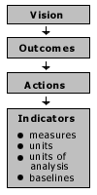
Figure 3 Main components of a system for monitoring community success and sustainability (from North Central Regional Centre for Rural Development, 2000)
The vision is a broad statement of community goals. Vision statements usually suggest outcomes – conditions the community wants to achieve. Outcomes drive outputs and activities.
When the North Central Regional Centre for Rural Development asked communities to name the outcomes that spelt success, they consistently named five types:
- increased use of the skills, knowledge and ability of local people
- strengthened relationships and communication
- improved community initiative, responsibility and adaptability
- sustainable, healthy ecosystems with multiple community benefits
- appropriately diverse and healthy economies.
A key to monitoring progress towards community goals is identifying one or more key indicators of progress towards each desired outcome. Each indicator must then have a measure that allows the status of the indicator to be assessed – number of, percentage of, quality of, or rating of, for example. Then in turn the measure must have units; a unit of analysis that sets limits on what units are counted (for example a Local Government Area); and a base line defining the starting point for measurement.
As the RCP is a community-based program, it seems appropriate to ask how communities themselves might monitor the outcomes of the projects they manage, and how they might be able to relate these outcomes to both their own and the Commonwealth Government’s goals for the RCP.

Acknowledgements
The evaluation team would like to thank all the RCP project staff, management committee members, community members and State Government representatives who contributed to this evaluation either as respondents to the questionnaire, through written submissions, or during case study visits. Their help is much appreciated. We would particularly like to thank the RCP program staff in AFFA and DTRS for their help in gathering information and responding to our questions. Those who were most involved were: Ms Anni Chilton, Ms Jennifer Cupit, Mr Brett Harrison, Ms Judy Jenkins, Mr Matt Koval, Ms Heidi Michaels, Ms Anna Pellew, Mr Bernie Scott, Ms Vivienne Slater and Ms Kerrie Westcott. Members of the RCP advisory committee and the steering committee for the evaluation were also most helpful, particularly Ms Liz Chapman, Mr Mark Needham and Mr John Wearne.
We would like to thank the following people for their help during case study visits: Ms Caroline Amos, Mr Wayne Appleton, Ms Lorraine Argus, Mr Erroll Bambrick, Mr Paul Brown, Ms Karen Burgess, Ms Chris Capel, Mr Mike Chuk, Mr Gary Cooper, Mr Lawrie Cremin, Ms Tania Davis, Mr Gerry Dixon, Mr Brian Dodson, Mr Glen Doyle, Mr John Flemming, Mr David Furniss, Mrs Jeanette Gellard, Ms Paula Gordon, Ms Del Harland, Mr Ian Heinrich, Mrs Janice Kelly, Mr Mathew Harris, Mrs Lyn Heasyman, Ms Helen Hynes, Mr Malcolm Letts, Mr David Loch, Ms Ruth Martin, Ms Lib McClure, Ms Geraldine McPhee, Ms Kirsty Morrison, Mr Michael Pullen, Mr Lindsay Ryan, Rev. John Sabel, Ms Janet Simpson, Ms Edith Speer, Ms Terri Smart, Mr Bruce Stuart, Mr John Swain, Ms Barbara Thomas, and Mr Graeme Whyte.
We would like to acknowledge the following BRS staff for their help in preparing this report and the maps and figures: Ms Christine Ateyo, Mr Nick Bauer, Mr Brett Cullen, Mr Jean-Marc Porigneaux and Mr Dale Young.
While the Steering Committee provided guidance and comments on drafts of the report, we wish to emphasise that not all members of the Steering Committee agreed with the conclusions and recommendations as they appear here. As authors of the report we accept responsibility for its findings, and any errors or misinterpretations that remain are our responsibility.

Executive summary
In early 2000, the Social Sciences Centre of the Bureau of Rural Sciences was commissioned by Agriculture, Fisheries and Forestry - Australia (AFFA) and the Department of Transport and Regional Services (DTRS) to evaluate the Rural Communities Program (RCP), a program they jointly administer. The program has a goal of encouraging ‘diverse, dynamic and self-reliant communities and profitable and sustainable rural industries’. The RCP provides funding to community groups in rural and regional Australia on a competitive application basis. Projects can fall under different program components or elements, as follows:
- community planning
- information provision
- information services technology
- community development
- financial counselling
- projects of national significance.
The evaluation did not cover projects in the last category. The RCP was previously managed by the former Commonwealth Department of Primary Industries and Energy (DPIE). Following a Departmental re-organisation and re-naming in early 1999, management of the financial counselling component became the responsibility of the re-named DPIE, now called AFFA, while management of the remaining components became the responsibility of DTRS.
Terms of reference for the evaluation were to examine:
1 Program performance
1.1 The extent to which the program has achieved its objective encompassing both the program as a whole and the various program elements (as described above)
1.2 The efficiency and effectiveness of the performance of community groups in administering projects and influencing community development.
1.3 Identify performance measures suitable for incorporation into ongoing monitoring
1.4 Determine factors related to project success or non-performance.
2 Future directions and options for change
2.1 The identification of any appropriate adjustments and the future direction for the program.
2.2 The extent of ongoing community need for RCP projects in the future.
Methods used by the evaluation team to address the terms of reference included:
- conducting a review of relevant literature, including previous evaluations
- analysing relevant program databases
- administering a questionnaire to chairs of project management committees (or their nominees)
- conducting interviews with program staff and advisory committee members
- analysing written submissions
- completing five case studies of RCP-funded projects around Australia. Locations were Dover, Tasmania; Kangaroo Island, South Australia; Bremer Bay, Western Australia; Mildura area, Victoria and New South Wales; and Longreach, Queensland.
The evaluation team developed a series of recommendations, given below under the term of reference to which they relate.
1 Program performance
1.1 The extent to which the program has achieved its objective encompassing both the program as a whole and the various program elements
The evaluation team answered this question with a qualified ‘yes’. The team found that RCP funding had led to good outcomes for particular communities and locations, and is strongly supported by community members in successful locations.
The need for qualification to the answer arises partly because the evaluation has been based on evidence provided by successful community groups. Neither the views of unsuccessful applicants nor a wider needs assessment of rural and regional communities has been undertaken. There were concerns that the most isolated and disadvantaged rural and regional communities are those of inland Australia, and particularly indigenous communities in the Northern Territory, inland Western Australia, South Australia and Queensland. Few projects had been funded in these areas. However, it was recognised that indigenous communities have access to a range of other funding sources, particularly through programs administered by the Aboriginal and Torres Straight Islander Commission (ATSIC).
The program’s broad goal statement and lack of specific objectives for different program components also made answering this question difficult. It is not possible to separate out the effects of the RCP from the effects of a wide range of other similar programs, and also from the impacts of ongoing socio-economic changes in rural and regional Australia.
The evaluation team recommends that a clear and specific program goal statement is written for the new program together with specific objectives for each program component. The goal should be clearly related to the policy basis for the new program. The team also considers that a set of regional priorities and objectives is an important part of the new program to enable specific objectives to be developed and program performance to be monitored against objectives.
The evaluation team recommends that a clear and specific program goal statement is written for the new program together with specific objectives for each program component. The goal should be clearly related to the policy basis for the new program. The team also considers that a set of regional priorities and objectives is an important part of the new program to enable specific objectives to be developed and program performance to be monitored against objectives.
1.2 The efficiency and effectiveness of the performance of community groups in administering projects and influencing community development
At the level of projects and communities, the evaluation found evidence of variable performance by community groups in managing projects effectively and efficiently, although the substantial voluntary community contributions to projects were evident, as also were the considerable contributions from State and Local Governments. Case studies highlighted issues community groups may face in managing projects efficiently. They included obtaining suitable premises, finding members for management committees, reducing turnover among management committee members and project staff, obtaining funding for project administration, and fulfilling reporting requirements. Nonetheless, there was evidence that RCP funding had made significant contributions to building human and social capital among committee members and project staff, and had led to successful applications for further community projects. In this way, the program had contributed to community development and built community capacity.
The evaluation team recommends that applicants be encouraged to identify existing bodies and organisations as project management committees wherever possible, and that wherever appropriate, regional development boards or other relevant local organisations with access to offices, office equipment and professional administrative staff be asked to take on this role.
1.3 Identify performance measures and indicators suitable for incorporation into ongoing monitoring
The team found difficulties in monitoring and evaluation arose from the fact that the current program has an extremely broad goal statement and lacks specific objectives and outcomes for different program components. These are needed as the basis for a monitoring framework.
The evaluation team recommends that a performance monitoring and evaluation framework be developed at the program component level, addressing regional priorities for each component. This framework should require regularly updated maps or tables to be presented to the new advisory committee showing:

- geographical distribution of numbers of applications and funded projects for each program component
- numbers of applications and funded projects for each component against ARIA and SEIFA scores
- numbers of applications and funded projects for each component against regional priorities for that component.
At the project level, the team considered that community groups should have a major role in monitoring and evaluating their own projects, and assessing progress towards community sustainability objectives.
The evaluation team recommends that all applicants be required to develop a monitoring and evaluation framework for their projects, and that successful applicants be required to report back to the Commonwealth against this framework. The framework for all projects should include measures of success and sustainability (social, economic, ecological).
1.4 Determine factors related to project success or non-performance
Case studies and written submissions addressed this term of reference in a qualitative sense, and further evidence came from questionnaire responses. Some of the factors identified as influencing project success included the quality and enthusiasm of project staff and management committee members; continuity of committee membership; opportunities for training and education of staff and committee members; support from other stakeholders; extent of ‘community ownership’ of projects; and access to an ‘umbrella’ organisation to manage projects that had a paid executive and a recognised management body.
Issues of concern included the shortage of potential committee and staff members in small communities and the fact that the few willing people may have multiple and possibly conflicting roles. Multiple roles may also make it difficult for committee members to effectively manage projects and staff. Effective control and management of staff and committees was seen as a key success factor in some written submissions and by some interviewees.
Government administrative arrangements were also seen as influencing project success. Aspects identified included the difficulties created by the split of the RCP between two departments; lack of coordination and integration between government agencies, both Commonwealth and State; and lack of continuity in program or project funding.
2 Future directions and options for change
2.1 The identification of any appropriate adjustments and the future direction for the program
The evaluation addressed this term of reference at the program and policy levels, and also developed recommendations relating to a number of issues arising under earlier terms of reference.
In regard to the overall program model, the team found that many communities strongly supported the basic model of community-government partnership. However, it was evident that in some cases this approach had led to coordination issues arising with State and Local Governments, and in some cases with regional authorities like development boards. The team considered that these issues could be addressed by building in a more formal role for these authorities in assessing project applications, and ensuring that specific individuals are identified as on-going State and regional representatives on assessment panels. At the regional level this may only require formally identifying and specifying the role already played by Area Consultative Committees (ACC’s) in assessing applications.
The evaluation team recommends that the new program incorporate a clearly-articulated, staged process for assessing applications and providing feedback on results of funding rounds back to State and regional level. The process should incorporate formally-identified state assessment panels with appropriate State Government representation, and regional assessment panels with Local Government and regional development organisation representation. These panels should be involved in developing regional priorities for the new program and assessing applications, and should receive direct and timely feedback about outcomes of funding rounds.
Remote area liaison officers, established on a trial basis by DTRS, appeared to have a useful role in RCP projects, and the team considered their role could be further explored.
The evaluation team recommends that consideration be given to exploring the role of Commonwealth remote area liaison officers as an integral part of the new program.
Policy issues related particularly to the financial counselling component of the RCP, and other components proved less controversial, as shown by the focus of written submissions to the evaluation. Questions are raised about the Commonwealth Government’s role in intervening in rural adjustment - Government-subsidised financial counselling can be seen as an indirect form of intervention.
The evaluation team recommends that AFFA and DTRS and their respective Ministers, take into account the McColl review’s decision principles for government intervention in rural adjustment in deciding the goal and objectives of the RCP’s successor, and in deciding the future of the financial counselling component of the current RCP.
The team concluded that the financial counselling component, in its current form, does not fit well with the rest of the RCP and should not be part of the RCP’s successor in its current form. This is because of the nature of the advice provided and its potentially serious implications for clients; the need for prescribed qualifications, performance standards and performance monitoring for staff; the need for professional management of financial counselling services; and the unreasonable risks incurred by the voluntary committees who manage services under the current RCP model.
The evaluation team recommends that any new financial counselling component of the RCP’s successor be administered independently of the other components of the new program if it is to continue to be oriented towards providing needs-based financial counselling for rural people experiencing current financial difficulties.
It was also not clear whether the current financial counselling services are a form of social welfare or have mainly a capacity-building role. This has implications for where they are most appropriately placed both geographically and administratively, and how they are run. It also has implications for whether they are continuing services or are only needed to respond to periods of particular difficulty for rural and regional communities - as for example during severe droughts.
The evaluation team recommends that any new financial counselling component of the RCP focus on agricultural and social adjustment rather than attempting to meet development or welfare objectives. Any financial counselling component of the new program should be responsive to changing circumstances and the changing regional needs for government-supported adjustment assistance.
Recognising the uncertainty being faced by staff, committees and clients of existing services, the evaluation team considered that there may be a case for extending these services while future options are investigated.
The evaluation team recommends that because of the uncertainty faced by current financial counselling services, that a twelve-month lead-time be allowed to indicate changes to program direction and establish the future form of these services.
A range of sustainability issues arose in the evaluation. They concerned the sustainability of projects and services themselves; benefits arising from projects or services; communities; government programs; and the ecological sustainability of land use practices.
The evaluation team recommends that the new program include in its goal statement and objectives, specific reference to sustainability (social, economic and ecological), and that sustainability issues be given higher priority in program guidelines, criteria for assessing projects, and in the monitoring and evaluation framework.
As mentioned above, coordination and integration of projects and services, and issues of coordination between the activities of different government agencies were evident in the evaluation. The recommendation about a staged assessment process addresses some of these issues. In addition:
The evaluation team recommends that staff of the new program investigate how better integration and coordination can be achieved with related government programs, and how information about the new program can be disseminated through existing government agencies and networks, particularly Centrelink and Countrylink.
Monitoring and evaluation was a specific term of reference for the evaluation and one that has clear implications for setting up the new program.
The evaluation team recommends that the performance monitoring and evaluation framework for the new program specifically addresses equity aspects of program funding, and that this aspect is taken into account in investigating appropriate options for future delivery of the RCP-funded financial counselling services.
Equity and distributional aspects of the new program also needed to be addressed in the new program. One way of achieving better outcomes is through a purpose-designed communication strategy.
The evaluation team recommends that staff of the new program, in consultation with the advisory committee, develop a broadly-based communication strategy using all relevant media. Appropriate funding should be set aside from the budget for the new program to develop and implement this communications strategy, if necessary with expert assistance from communications specialists.
To improve the performance of community groups in managing projects and delivering on project outcomes, the evaluation team considered that there may be a place for further guidelines and information material to be provided to committee members and project staff. This may help clarify their roles and guide their operations.
The evaluation team recommends that guidelines for the new program include advice to applicants about size and composition of project management committees, rotation of office bearers, role of project staff in relation to management committees, and meeting frequency and procedures.
Training and development needs were an issue for project committees and staff, and related to their operating efficiency and the success of their projects.
The evaluation team recommends that sufficient funds be set aside in the new program to develop and implement a training and development strategy for project staff and management committee members.
The evaluation team was asked to consider the question of community cash and in-kind contributions to projects, and whether current levels were appropriate. In response to evaluation findings, and also because of distributional and equity considerations, the evaluation team considered there was a good case for not arbitrarily specifying these contribution levels.
The evaluation team recommends that in the new program, percentages for community cash and in-kind contributions to projects are not arbitrarily specified but assessed on a project-by-project basis, taking into account any evidence of community ability to contribute. However, standardised instructions for estimating the value of community contributions should be included in application guidelines.
2.2 The extent of ongoing community need for RCP projects in the future
Many written submissions argued that there is an ongoing community need for RCP funding, and particularly for ongoing funding of financial counselling services. The evaluation team considered that these arguments should be treated with caution because communities are clearly anxious to maintain existing services. More objective sources of evidence about conditions in rural and regional Australia need to be examined to answer this question. Examples of the kind of evidence relevant to this question include those provided in recent studies of access to services and from data provided by the Australian Bureau of Statistics. These studies and data tend to suggest that the majority of rural and regional centres are increasing in population, and that differences in the socio-economic status and access to services between rural and urban Australians are declining. Nonetheless, areas of significant disadvantage remain in rural and regional Australia, some examples of which were noted in evaluation case studies. There is therefore an argument for a continuing need for additional government support for rural and regional communities through programs like the RCP, especially if they are appropriately targeted to the most disadvantaged communities and regions.

Appendix 1: Maps showing results of database analysis

Rural financial counselling services mapped against SEIFA

Map 1 Rural financial counsellors and degree of socioeconomic disadvantage (SEIFA) 1996 - Australia
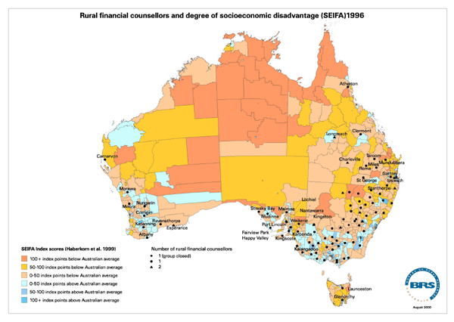
Map 2 Rural financial counsellors and degree of socioeconomic disadvantage (SEIFA) 1996 - New South Wales
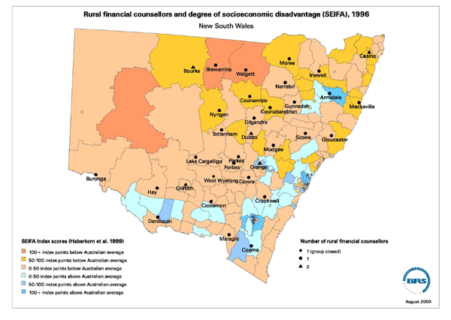
Map 3 Rural financial counsellors and degree of socioeconomic disadvantage (SEIFA) 1996 - Victoria
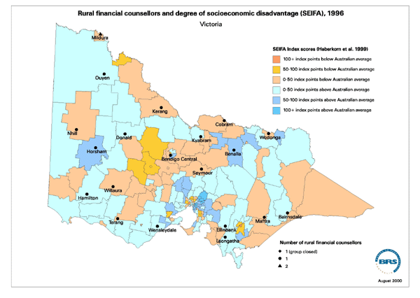
RCP-funded projects overall mapped against SEIFA and ARIA

Map 4 Location and type of RCP-funded projects and degree of socioeconomic disadvantage (SEIFA) 1996 - New South Wales
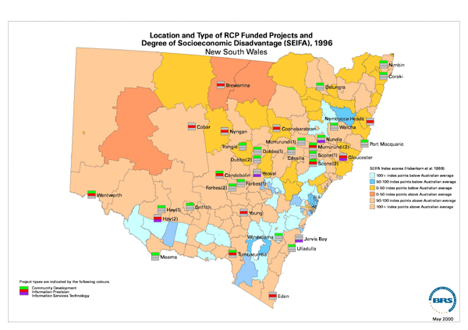
Map 5 Location and type of RCP-funded projects and degree of accessibility/remoteness (ARIA) 1996 - New South Wales
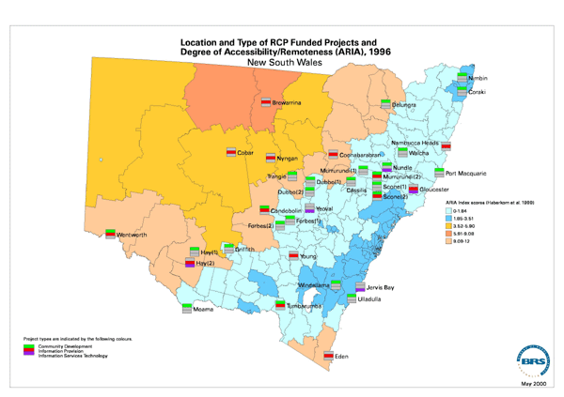
Map 6 Location and type of RCP-funded projects and degree of socioeconomic disadvantage (SEIFA) 1996 - Northern Territory
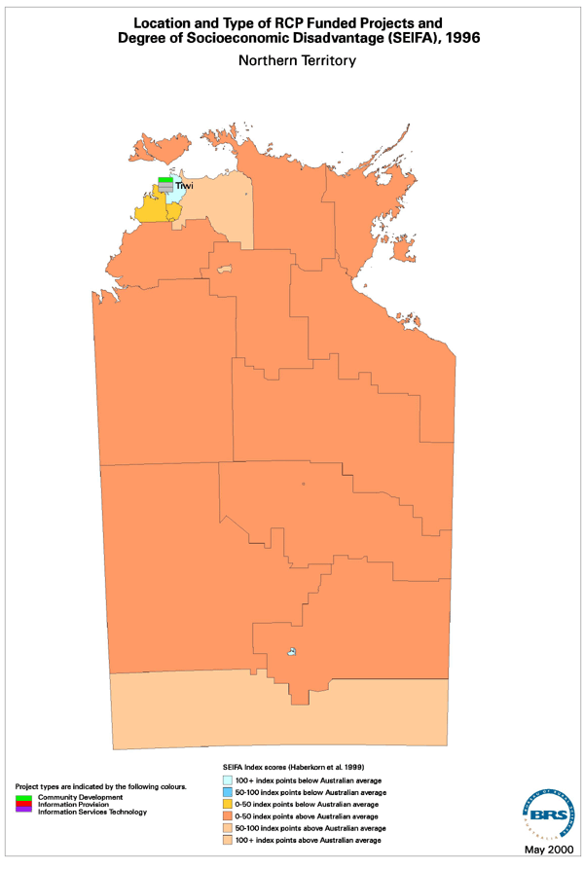

Map 7 Location and type of RCP -funded projects and degree of accessibility/remoteness (ARIA) 1996 - Northern Territory
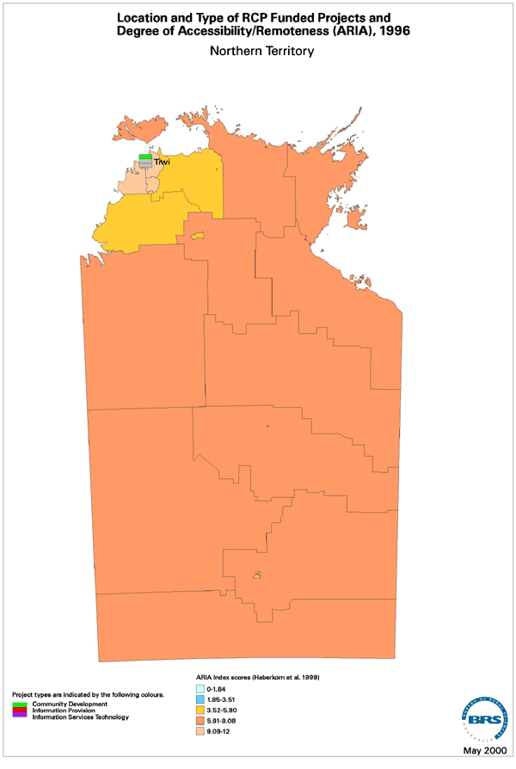
Map 8 Location and type of RCP-funded projects and degree of socioeconomic disadvantage (SEIFA) 1996 - Queensland
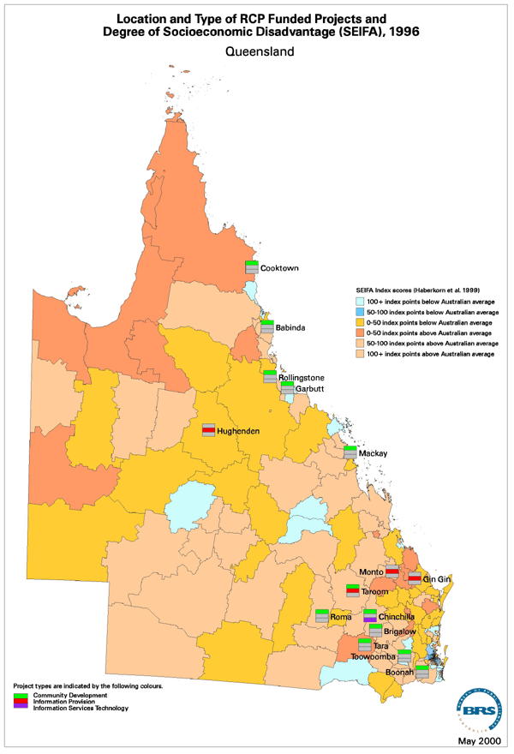
Map 9 Location and type of RCP-funded projects and degree of accessibility/remoteness (ARIA) 1996 - Queensland
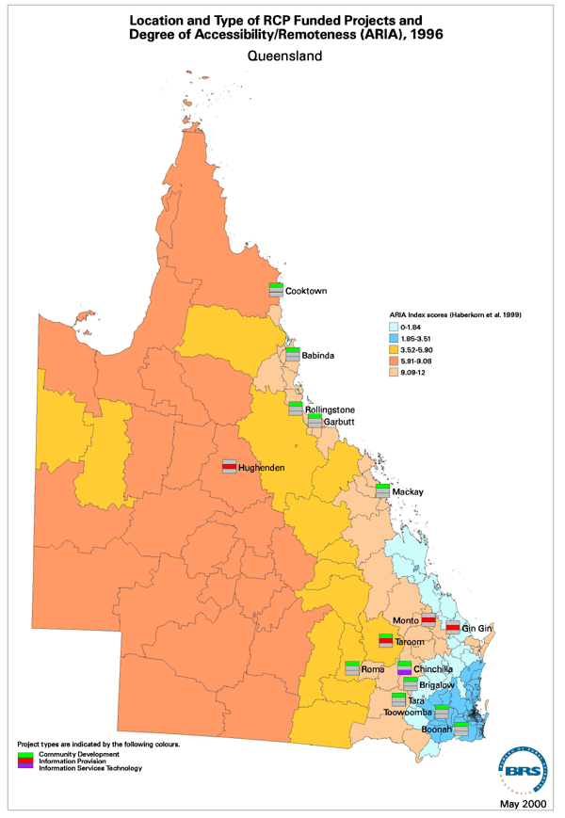
Map10
Map10 Location and type of RCP-funded projects and degree of socioeconomic disadvantage (SEIFA) 1996 - South Australia
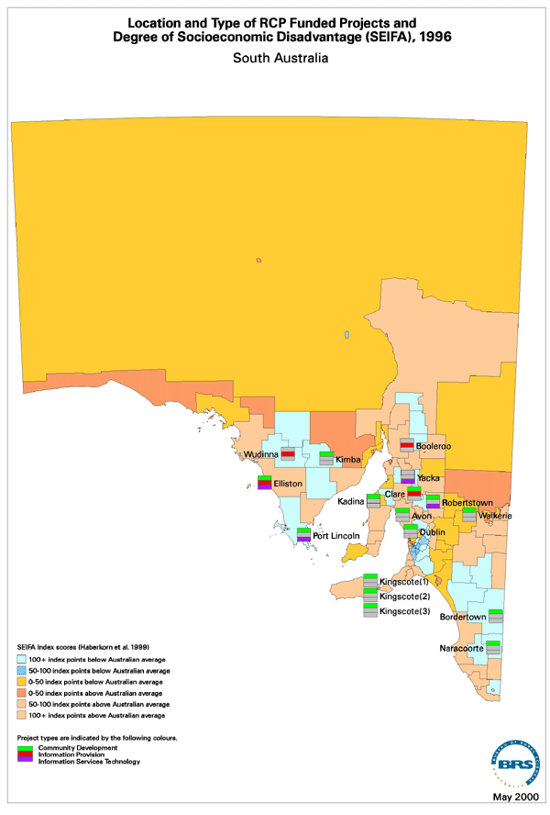
Map 11 Location and type of RCP-funded projects and degree of accessibility/remoteness (ARIA) 1996 - South Australia
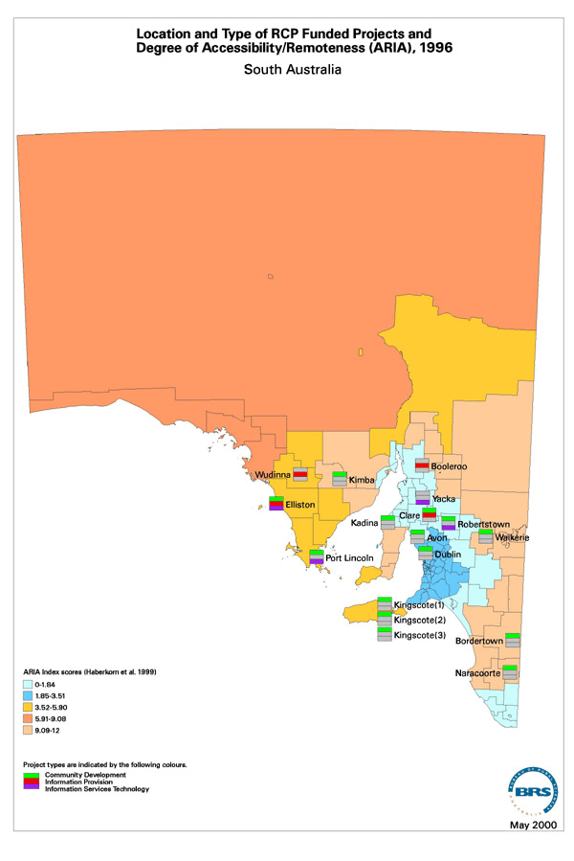
Map 12 Location and type of RCP-funded projects and degree of socioeconomic disadvantage (SEIFA) 1996 -Tasmania
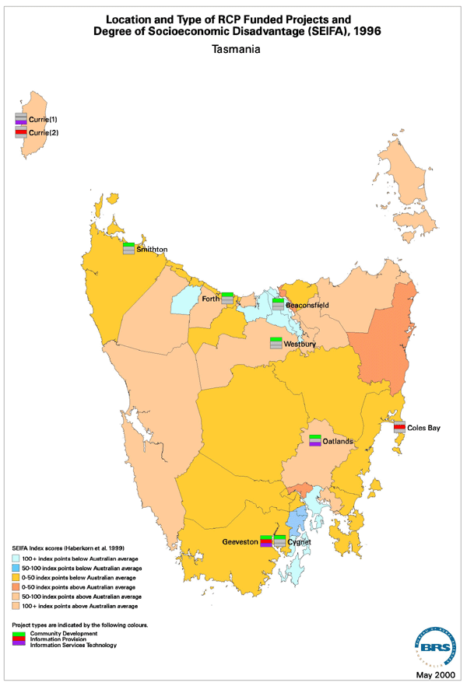
Map 13 Location and type of RCP-funded projects and degree of accessibility/remoteness (ARIA) 1996 - Tasmania
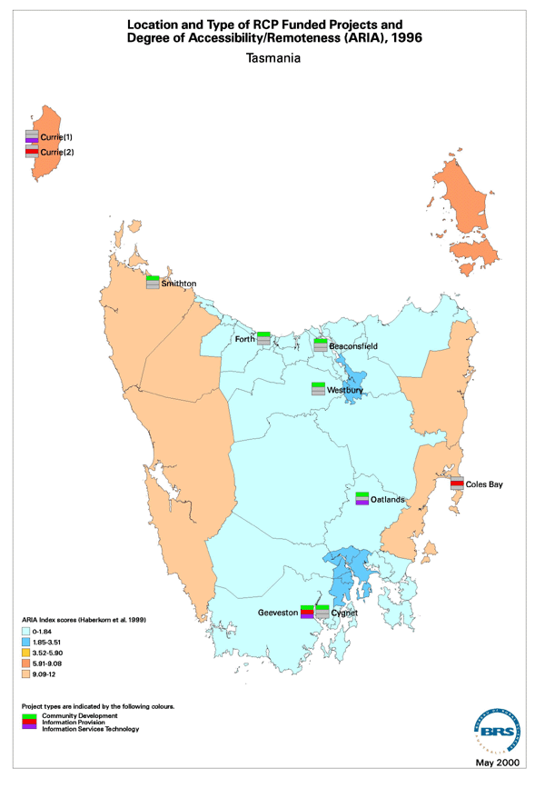
Map 14 Location and type of RCP-funded projects and degree of socioeconomic disadvantage (SEIFA) 1996 - Victoria
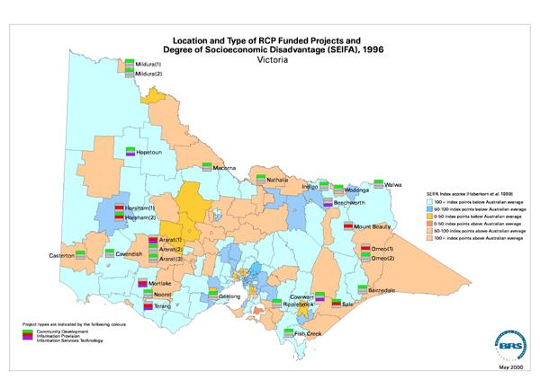
Map 15 Location and type of RCP-funded projects and degree of accessibility/remoteness (ARIA) 1996 - Victoria
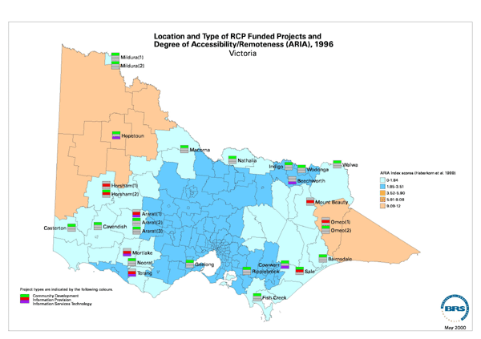
Map 16 Location and type of RCP-funded projects and degree of socioeconomic disadvantage (SEIFA) 1996 - Western Australia
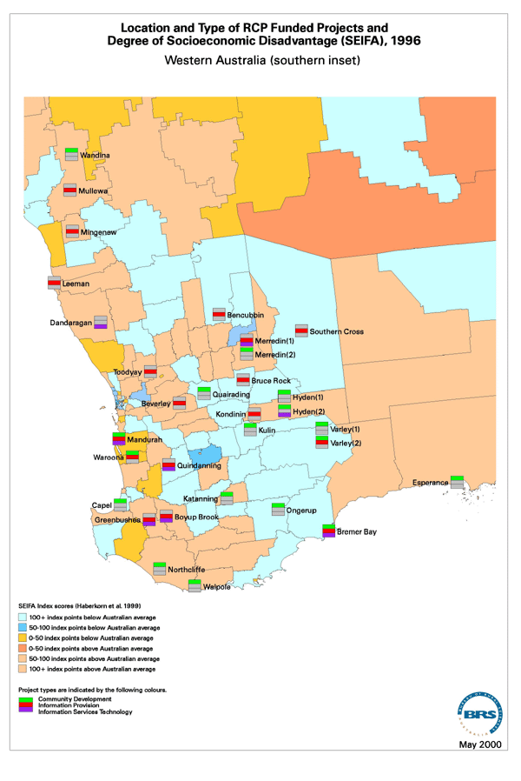
Map 17 Location and type of RCP-funded projects and degree of socioeconomic disadvantage (SEIFA) 1996 - Western Australia (southern inset)
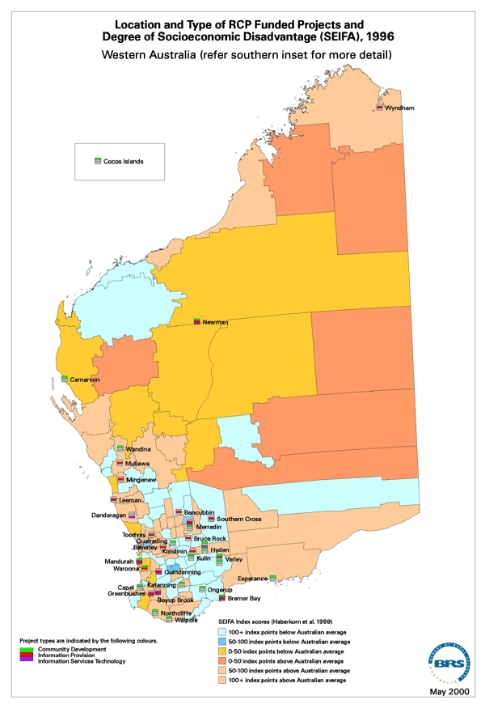
Map 18 Location and type of RCP-funded projects and degree of accessibility/remoteness (ARIA) 1996 - Western Australia
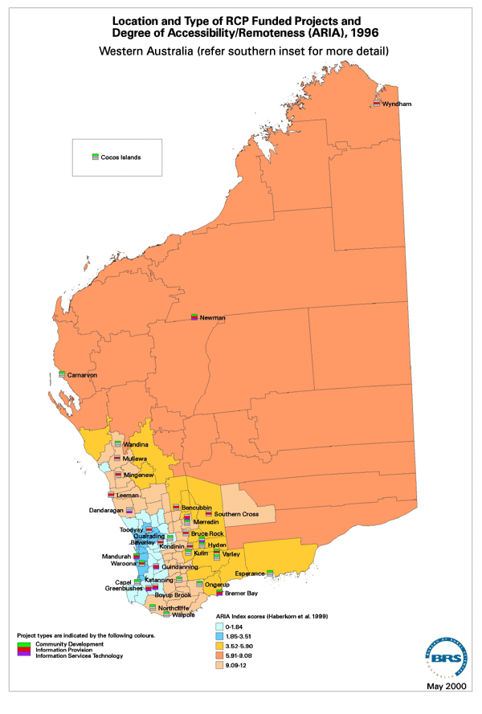
Map 19 Location and type of RCP-funded projects and degree of accessibility/remoteness (ARIA) 1996 - Western Australia (southern inset)
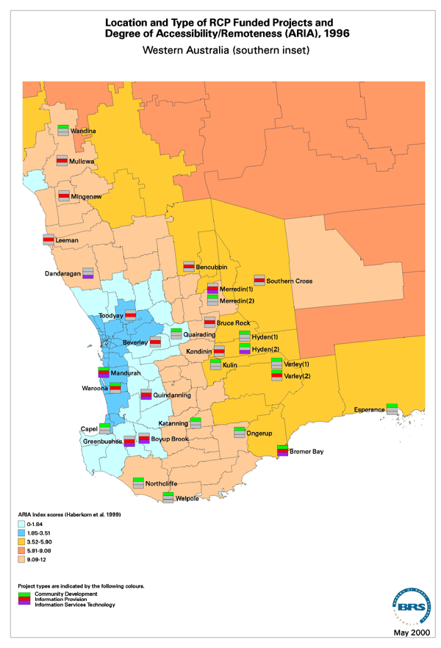

Appendix 2: Questionnaire
Evaluation of the
Rural Communities Program
Telephone Questionnaire
Strictly Confidential
Good morning/afternoon its {INTNAME} calling from Datacol Research in Canberra, on behalf of the Bureau of Rural Sciences. Could I speak with {NAME} please?
***When speaking with respondent***
Good morning/afternoon its {INTNAME} calling from Datacol Research in Canberra. We recently sent you a letter about a review of the Rural Communities Program that is being conducted by the Bureau of Rural Sciences. We would like to conduct a short interview with you in your capacity as the Chair person of the management committee for {INTCOMMITTEE} that received funding from the Rural Communities Program.
The survey includes questions about the management of your organisation and about the Rural Communities Program-funded services you provide.
Do you feel that you would be able to answer questions about your organisation and the Rural Communities Program?
***If not find out who would be the most appropriate person to speak with***
The survey takes about 12 minutes to complete. Is now a good time to do it or would you prefer me to call back later?
Throughout this interview the questions refer only to the project/s funded through the Rural Communities Program, and not other projects that your organisation manages.
Part A: Your Management Committee
To start with I’d like to ask you some questions about your management committee.

- How many members does your management committee have?

- Which of the following groups are represented on your management committee (Indicate as many as appropriate).

  - local government
  - local farmer
  - local townsperson>
  - local businesses
  - local school or other educational institutions
  - banks or other financial institutions
  - state government
  - industry sector bodies (e.g. Farmers Federation, Chamber of Commerce)
  - others:

- Do you experience any difficulties in recruiting and retaining members on your management committee?

  - no
  - yes
If yes, why do you think this is the case? (Indicate as many as appropriate).

  - lack of interested individuals
  - lack of skilled individuals
  - individuals too busy with other work/family/community commitments
  - burnout of previous committee members
  - other:

- Does your organisation employ any staff to administer its Rural Communities Program funded services?

  - no
  - yes
If yes, how many?

- Do you experience any difficulties in recruiting and retaining staff?

  - no
  - yes
If yes, why do you think this is the case? (Indicate as many as appropriate)

  - lack of skilled individuals
  - pay/conditions not attractive enough
  - remoteness/isolation of community/town
  - other:

- Does your organisation experience any difficulties fulfilling the reporting requirements of funding from the Rural Communities Program?

  - no
  - yes
If yes, what causes these difficulties? (Indicate as many as appropriate)

  - insufficient staffing/volunteers
  - staff/volunteers do not have the skills
  - reports are required too frequently
  - level of detail required is too great
  - other:

Part B Your Services
Next I’d like to ask you about the services that your organisation provides with funding from the Rural Communities Program.

- During the 1999-2000 financial year did your organisation provide any of the following services? (Indicate as many as appropriate)

  - information about state government services
  - information about Commonwealth government services
  - public photocopying, facsimile and office facilities
  - public computers for community use
  - public e-mail access
  - public Internet access (World Wide Web)
  - health promotion (eg men’s health, women’s health) <
  - farm business budget preparation
  - non-farm business budget preparation
  - cash flow preparation
  - negotiating with creditors
  - debt mediation
  - personal counselling
  - career counselling
  - community/local newspaper
  - video-conferencing
  - insolvency advice
  - farm succession planning
  - applications for and access of social security/government benefits
  - applications for interest rate subsidy
  - loan applications
  - stress management
  - crisis counselling
  - flood/drought assistance

- How does your organisation deliver these services? (Indicate as many as appropriate)

  - telephone
  - shop-front
  - farm/home/business visit
  - newsletters/mail-outs
  - Internet or World Wide Web

- Who do you consider to be the primary client group of your organisation? (Indicate one only)

- Are the services provided by your organisation specifically targeted towards any of the following groups? (Indicate as many as appropriate)

  - youth
  - long-term unemployed
  - indigenous peoples
  - women
  - men
  - older people

- On the scale below indicate the demand over the past 12 months for the services your organisation provides (Indicate one level only)

  - decreasing demand
  - slightly decreasing demand
  - stable demand
  - slightly increasing demand>
  - increasing demand

- On the scale below indicate the level of community support for the services your organisation provides (Indicate one level only)

  - no support
  - weakly supportive
  - moderately supportive
  - strongly supportive
- What would you say is the single most important achievement of your Rural Communities Program funded project?
Part C: Funding
Next I’d like to ask you some questions about the funding you receive from the Rural Communities Program.

- To receive funding from the Rural Communities Program the local community has to demonstrate its support through cash or in-kind contributions. What do you think is an appropriate level of contribution? The percentage indicated refers to the proportion of the total costs. (Indicate one only)

  - 0%
  - 25% or less
  - 26% to 50%
  - 51% to 75%
  - 76% to 100%

- Did your organisation have any difficulties in raising the community contribution required to ensure government funding?
  - no
  - yes

- Does your organisation currently charge clients for any services?

  - no
  - yes
If yes, for which services?

- In addition to Rural Communities Program Funding, from what other sources of funding did your organisation receive funding during the 1999-2000 financial year? (Indicate as many as appropriate)

  - other Commonwealth funding programs
  - rural plan
  - networking the nation (regional telecommunications infrastructure fund)
  - rural partnership program
  - regional assistance program
  - State/Territory funding programs
  - local government/council/shire
  - local businesses
  - others:

To finish up I’d like your response to a number of statements about your organisation and the services it offers.
For each of the following statements please indicate the extent to which you agree or disagree by using the appropriate number. (1 = strongly agree; 2 = agree; 3 = neither agree nor disagree; 4 = disagree; 5 = strongly disagree)
 |  | SA | A | N | D | SD
18. | The services we offer have assisted in sustaining the local community. | 1 | 2 | 3 | 4 | 5
19. | The services we offer are relevant to most of the members of the local community. | 1 | 2 | 3 | 4 | 5
20. | My organisation offers an efficient, professional service. | 1 | 2 | 3 | 4 | 5
21. | The services we offer are only relevant to farmers. | 1 | 2 | 3 | 4 | 5
22. | My organisation only deals with people who can’t afford professional help. | 1 | 2 | 3 | 4 | 5
23. | My organisation only deals with individuals | 1 | 2 | 3 | 4 | 5
24. | The split of the Rural Communities Program between two Commonwealth Departments has complicated access to the Program. | 1 | 2 | 3 | 4 | 5
25. | Our services compete with other service providers. | 1 | 2 | 3 | 4 | 5
26. | We receive adequate support from the Canberra staff of the Rural Communities Program. | 1 | 2 | 3 | 4 | 5
That brings us to the end of the survey. Thank you for your time in answering these questions. This interview has been conducted by Datacol and my name is {INTNAME}. If you have any questions about this survey or about the evaluation being done by the Bureau of Rural Sciences, I have a number that you could call. Would you like that number? Feel free to contact Trevor Webb on (02) 6272 3233.

Appendix 3: List of written submissions
CP – Community Planning
FC – Financial Counselling
IP – Information Provision
IT – Information Services Technology
CD – Community Development
Submission  no. | Source | Subject matter
1 | Mr Carl V. Belle  Chairman  Barossa, Hills & Plains Rural Counselling Service Inc.  PO Box 11  Fairview Park SA 5126 | CP, FC, IP, IT, CD
2 | Mr Barry Evans  Rural Financial Counsellor  Brewarrina & District Rural Counselling Service Inc.  PO Box 80  Brewarrina NSW 2839 | CP, FC, IP
3 | J.B. Nugent  Hon. Secretary (on behalf of Management Committee)  Moree Rural & Community Counselling Service  PO Box 527  Moree NSW 2400 | FC
4 | Doug Winter  Chairman  Warrumbungle Rural Community Program Inc.  PO Box 531  Coonabarabran NSW 2357 | CP, FC, IT
5 | Wilma Western  President  South Gippsland Farmers Support Group  Rural Financial Counselling Service  PO Box 362  Leongatha Vic. 3953 | FC, CD, relationship to other Government programs
6 | Mal Peters  Chairman  Rural Affairs Committee  NSW Farmers’ Association  GPO Box 1068  Sydney NSW 1041 | CP, FC, IP, IT, CD
7 | Ben Fargher  Deputy Director, Rural Policy  National Farmers’ Federation  PO Box E10  Kingston ACT 2604 | CP, FC, IP, IT, CD
8 | (Anonymous, NSW) | FC
9 | Clemencia Barnes  Coordinator  Network, Access, Technology and Training Program  C/o Tasmanian Rural Counselling Inc.  (e-mail submission) | FC, general comments, enclosed training strategy
10 | Neville Anderson, Jeremy Moloney and Raelene Mitchell  Office of Rural Communities  Dept of State and Regional Development  Melbourne Vic.  (e-mail submission) | FC, general comments, draft strategy for developing RCP
11 | South Australian Association of Rural Counselling Services Inc. | CP, FC, IP, IT, CD
12 | William Thompson  North East Riverina Rural Counselling Service Inc.  PO Box 104  Coolamon NSW 2701 | FC, IP, copy of letter to DTRS re case studies
13 | Patricia Brooks (on behalf of Management Committee)  Secretary  Walgett Advisory Group Inc.  PO Box 31  Walgett NSW 2832 | FC
14 | Linda Duffy  Rural Financial Counsellor  Southern Riverina Rural Advisory Service Inc.  PO Box 937  Deniliquin NSW 2710 | CP, FC, IP, IT, CD
15 | Stan Hague  Chairperson  Lower Lachlan Community Services Inc.  PO Box 36  Lake Cargelligo NSW 2672 | FC, IP, IT
16 | Bernie Climie  Southern Agcare  PO Box 105  Gnowangerup WA 6335 | FC
17 | Kay Bodman  Manager, Business Development  Agwest Farm Business Development  Level 15, International House  26 St Georges Tce  Perth WA 6000 | FC, general comments
18 | Gerry Dixon  Manager, Farm Financial Counselling Service  Queensland Dept of Primary Industries  Ann St  Brisbane Q. 4000 | FC, CD
19 | Bruce C. Bashford  Secretary  NSW Association of Rural Counselling Groups  PO Box 761  Cooma NSW 2630 | FC
20 | Wendy Deinum (on behalf of Management Committee)  Yorke Peninsula Rural Counselling and Information Service  PO Box 20  Nantawarra SA 5550 | FC, IP
21 | L.C. Cremin  Co-Chairman  Queensland Association of Rural Financial Counselling Services | CP, FC, IP, IT, CD
22 | Geoff Rodda  Committee Member  Wentworth/Balranald Rural Counselling Service  PO Box 6  Buronga NSW 2739 | FC, general comments about rural conditions
23 | John Watson  Chair  National Rural Advisory Council  AFFA  GPO Box 858  Canberra ACT 2601 | FC, general comments  Follow-up meeting held 3/7/00
24 | Sarah Thompson  Secretary of Management Committee  Upper Hunter Rural Counselling Service Inc.  ‘Ballantyne’  Cassilis NSW 2329 | FC, general comments
25 | Josie Black  Secretary  Corangamite Rural Financial Counselling Service  Shadforth St  Terang Vic. 3264 | FC
26 | The Hon. David Llewellyn  Minister for Primary Industries, Water and Environment  First Floor  Franklin Square Offices  Hobart Tas. 7000 | FC
27 | Judy McClean  Secretary/Treasurer  Rural Support Tasmania  PO Box 322  Launceston, Tas. 7250 | FC, supplementary letters of support received 1/8/00
28 | Wilma Western  President  South Gippsland Farmers Support Group  Rural Financial Counselling Service  PO Box 362  Leongatha Vic. 3953 | Follow-up to submission 5, including letters of support
29 | John Hamilton  Regional Agricultural Economist  Dept of Natural Resources and Environment  Hamilton Vic. (e-mail submission on behalf of South West Rural Support) | FC
30 | Murray Valley Rural Industries Assistance Group  Cobram  Victoria (fax-ed submission) | FC
31 | Phil Grinter  NDCSG  PO Box 6  Morowa WA 6623 | FC
32 | Gippsland Rural Financial Counselling Service  1 Stratford Rd  Maffra Vic. 3860

Appendix 4: Interview guides
Interview guide for management committee members and project staff

- Could you please describe for me what your role is in relation to the current RCP-funded project(s) (or previously funded project if completed)?

- Could you please outline for me your experience with RCP-funded project(s)?

- What geographical area is covered by the current project?

- Who are the major clients/beneficiaries of the RCP-funded project you administer?

- Are there any groups in particular who don’t benefit/don’t use the service?

- Do you obtain any feedback from (or do any surveys of) project clients/beneficiaries?

- Are any other similar projects being conducted in this area?

- Have you experienced any problems or issues that affect you or your organisation’s efficiency or effectiveness in administering the current project?

- (If ‘yes’) Can you suggest what could be done to resolve these problems?

- Do you or your organisation have any difficulties in fulfilling the government’s requirements for RCP funding?

- What would help you in fulfilling these requirements?

- The current goal of the RCP is stated as being ‘to encourage diverse, dynamic and self-reliant communities, and profitable and sustainable rural industries’.

Has RCP funding contributed to making your community ‘diverse, dynamic and self-reliant’?

- Does your community have a continuing need for the types of projects currently funded by the RCP?

- Apart from the RCP, are there any other sources of funding available to you to continue this or similar projects in the future?

- What would you suggest should be the future direction for the RCP bearing in mind your community’s needs?

- Is there anyone else in this community you think I should speak to about matters covered in this interview?

- Do you have any other comments?

Interview guide for community members

- Could you tell me what relationship your organisation has to the organisation administering the current RCP project?

- Could you please outline for me your experience with RCP-funded projects?

- To the best of your knowledge, who in the community (for example individuals, groups, sectors) benefits from the current project?

- Do you think there any groups in particular who don’t benefit/don’t use the service?

- Have you seen any problems or difficulties with the current project?

- (If ‘yes’) What do you think could be done to resolve these problems?

- Are you aware of any other similar projects being conducted in this area?

- The current goal of the RCP is stated as being ‘to encourage diverse, dynamic and self-reliant communities, and profitable and sustainable rural industries’.

Has RCP funding contributed to making your community ‘diverse, dynamic and self-reliant’?

- Does your community have a continuing need for the types of projects currently funded by the RCP?

- Apart from the RCP, are you aware of any other sources of funding available to your community to continue the current project or undertake similar projects in the future?

- What would you suggest should be the future direction for the RCP bearing in mind your community’s needs?

- Is there anyone else in this community you think I should speak to about matters covered in this interview?

- Do you have any other comments?

Interview guide for State Government staff

- Could you please tell me what relationship your organisation has to the RCP and RCP-funded projects?

- Could you please outline for me your experience with RCP-funded projects?

- Is your organisation involved in assessing RCP applications and/or monitoring project outcomes?

- How does the RCP relate to State Government programs and projects?

- Have you seen any problems with overlap/duplication/coordination between the RCP or RCP-funded projects and similar State programs or projects?

- (If yes) What do you think could be done to resolve these problems?

- Can you tell me what contributions your State Government makes to RCP projects, and on what basis it decides whether or not to contribute?

- (If appropriate ask) What is your opinion of the case study project(s) we are looking at as part of this evaluation?

- The current goal of the RCP is stated as being ‘to encourage diverse, dynamic and self-reliant communities, and profitable and sustainable rural industries’.

Has RCP funding contributed to making [State] communities ‘diverse, dynamic and self-reliant’?

- Do [State] communities have a continuing need for the types of projects currently funded by the RCP?

- Apart from the RCP, are you aware of any other sources of funding available to [State] communities to continue current projects or undertake similar projects in the future?

- In view of the needs of [State] rural and regional communities, what would you suggest should be the future direction for the RCP?

- Is there anyone else in this State you think I should talk to about matters covered in this interview?

- Do you have any other comments?

Appendix 5 Case studies
Dover Community Telecentre, Tasmania
Kangaroo Island Rural Counselling Service, South Australia
Mildura Rural Financial Counselling Services, New South Wales and Victoria
Bremer Bay Community Resource Centre, Western Australia
Central Western Queensland Remote Area Planning and Development Board Rural Financial Counselling Service, Queensland

Dover Community Telecentre, Tasmania
Trevor Webb and Kate Brinkley
Applicant’s name: Dover Community Telecentre Inc.
Amount received from RCP and other sources
The Dover Community Telecentre Inc. (DCT) received a planning grant of $1,711 in Round 3 (18-19/8/98) of the RCP.
Project description
The planning grant was used to engage a facilitator to consult with community groups and local organisations to identify community needs as a guide for the development of a Rural Community Centre of the 21st Century. The community consultation was carried out from October 1998 to January 1999. Among those consulted were 23 community-based organisations, 47 small and other businesses and 47 individuals. The consultation documented the needs of the Dover community in terms of specific community organisations, children and young people, women, aged people, and other identified needs. Among the outcomes of the community consultation was the genesis of support and motivation to restore the Dover Old School as a community centre.
Methods
The site visit was carried out on 23-25 May 2000.
Relevant files from DTRS (incorporating correspondence, grant application, grant assessment, financial and final reports) were consulted.
Membership of management committee
A number of management committees existed for different aspects of the projects discussed here, so membership is not detailed.

Interviewees
President, Dover Cultural Resource Centre
President, Dover Community Telecentre
Co-coordinator, Dover Online Centre
Manager Community Services, Huon Valley Council
Secretary, Dover Medical Facilities Ladies Auxiliary
Co-coordinator, Dover Online Centre
President, Dover Online Centre
Geographic and social profile of town
Dover is located 80 km south of Hobart, situated on the shores of D’Entrecasteaux Channel. Surrounded by mountains and linked to Hobart by a winding road, Dover is an isolated township (ARIA 2.98), in a region known as the Far South. It was originally founded as Port Esperance as a probation station for convicts, with the first land being divided in 1850-51.
Population
Dover’s population has fallen over the last decade, as indicated by the 1991 and 1996 ABS Census figures outlined below. However, in recent times local residents seem to agree that the decline has stabilised or that numbers are in fact increasing. While the town itself has a population of around 500 people, there are a further 835 people in the surrounding region, which extends from Glendevie to Cockle Creek (approx 918 km²).
The Dover and surrounding communities can be roughly divided into two demographic groups. One represents the traditional Anglo-European inhabitants of the area. Typically, these residents were born and have grown up in the area, and have strong familial ties to the region. Such families are often involved in agricultural and fishing enterprises. The other demographic group represents those that have migrated to the region in more recent times. This includes those that have adopted ‘alternative’ lifestyles and moved to the region during the 1970s and individuals who have retired or taken redundancies from employment in larger mainland cities and moved to Dover and the Far South in more recent times. One interviewee referred to the original families and the newer arrivals as the ‘pumpkin scones’ and the ‘mung beans’ respectively.
Dover population statistics (Source: ABS Census of Population and Housing)

1996 Population | Male | Female | Under 16 | Over 65
481 | 246 | 235 | 113 | 52
1991 Population | Annual growth rate (1991-96) |  | Growth rate (1991-96)
521 | -1.6% |  | -7.7%

Industries and Resources
The employment focus of the local area has changed over time. Following convict settlement, the area supported a thriving forestry industry, and latter fruit growing and cattle industries. Although good soils provide the basis for the local horticultural industry and extensive forests support the forest industry, these enterprises have given way to wild-capture fishing and aquaculture.
Forestry, fruit growing and cattle farming are still sources of income and employment for the town, however the largely pristine natural areas which ensure Dover’s clean water supply have allowed the development of wild-capture fishing and aquaculture industries. These industries are now the most important in terms of numbers employed and income. Seventy percent of Dover’s income comes from abalone and scallop fishing and Atlantic salmon, pacific oyster and blue mussel aquaculture.
The Far South is also renowned for its natural scenery, which includes beaches, rivers, mountains, caves and thermal pools. The largely maintained natural area has provided additional sources of economic development through tourism and spring water production.
Services:
Dover has access to a wide range of services. These include:
Health Care Services:
Aged care/assisted care centre, multi-purpose health centre, volunteer St Johns Ambulance, nurse, pharmacy, general practitioner
Retail:
Bakery, butcher, general store, hair dresser, hardware store, laundrette, service station, supermarket, take away/coffee shop, specialty shops (gemstones, books, computers, clothing, video rental)
Utility Services:
Electrician, plumber, builder, gasfitter
Civil Services:
Post office (including a bank and bill paying agency), police station, fire station (volunteer bush fire brigade), Telecentre and Online Access Centre
Educational Services:
Childcare, school (kindergarten to year 12)
Although these services are present in the town, their accessibility can be quite poor. For example, childcare is available only one day a week (Fridays), the police officer is only present 20 hours a week, and out-of-hours ambulance access can take up to 1½ hours from Geeveston.
Furthermore, there are a number of services which Dover lacks altogether. For example, Dover does not have any bank branches, and has not had any for last ten years. Dover also lacks a dentist, a mental health officer, a library, Centrelink and Medicare agents, a taxi service and a vet.
Access to some of these services is available in the larger nearby centres, principally Geeveston (pop. 778; 20 km away) and Huonville (pop. 1718; 43 km away). However, frequently the accessibility is no better – the dentist is available one day a week in Geeveston, while the library is open only 12 hours a week.
Community life
Dover has a wide range of sporting clubs. These include a golf club, a bowls club, an 8-ball club, an axeman’s club, a Regatta Association and aquatic club, men’s and women’s darts clubs, and a football club. Other social clubs include the Southerly Busters Choir, and religious associations. In addition to the sporting clubs, a number of service associations are operating in the community. These include the Dover Medical Facilities Ladies Auxiliary, Meals on Wheals, Probus, and Parents and Friends. However, other organisations have ceased to exist, including Neighbourhood Watch, the Country Women’s Association and Lions. The township has its own monthly community newspaper (The Bush Telegraph), which has been running for ten years and has a circulation of between 600 and 800. Recently the DCT purchased The Bush Telegraph to ensure its operation as a locally-based community newspaper.
Background and context
The DCT was initiated as a consequence of a successful grant application under the Telecentre component of the Rural Communities Access Program in 1994. Under the program, the DCT was funded for three years. It was one of the sites visited by the Alston review team in 1996. They found that the DCT was successful in providing the community with education and training in computer and related applications (Alston et al., 1997). Furthermore Alston et al. (1997) found that the Dover site was under significant financial hardship, though they expected the DCT to be self-funding. After RCAP funding ceased in 1996, the DCT continued to survive on a break-even basis from 1997 to 1998, but only because the manager worked without salary. The rent on the commercial shop-front was a major funding drain and, to survive, the Telecentre required rent-free premises.
The Dover Cultural Resource Centre (DCRC) was also in need of suitable premises to house its gallery and shop front. The DCRC had been successful in gaining funding under the Rural Access Program component of RCAP. This funding enabled DCRC to employ a part-time coordinator to run a gallery and gift shop and other activities in 1994-1996. However, this was a temporary situation.
The Dover Old School had been used by a number of community organisations in Dover as a meeting hall. By 1998 it was in a state of disrepair and considered an eyesore by some sections of the Dover community. The Huon Valley Council was set to debate its demolition when the DCT and DCRC formed an alliance to lobby the Huon Valley Council for access to the building. The Huon Valley Council estimated the work required to bring the building up to standards for habitation would cost approximately $80,000 to $100,000. (See photos at the end of this case study for the state of the Dover Old School in 1998.)
The DCT developed a strategic plan to restore the building and identify funding sources. Furthermore, they successfully lobbied the Huon Valley Council not to demolish the Dover Old School and formed a management committee at a public forum organised by the Huon Valley Council. They were also successful in having the building placed upon the Tasmanian Heritage Council’s permanent register, thus preventing the building from being demolished. The Dover community was divided over the protection of the Dover Old School with many people considering demolition the best and only option. The planning grant received by the DCT that enabled the community consultation was fundamental in providing an opportunity for the community to envisage what they thought should happen to the Dover Old School if it was not to be demolished.
The community consultation identified a number of needs and issues for the various demographic groups of the Dover and surrounding community. These were:
Children and young people:
- a lack of appropriate recreational options
- drug and alcohol abuse
- sexual health information and access to services
- limited affordable childcare facilities
- limited employment opportunities.
Women:
- largely responsible for the burden of community and voluntary work
- require flexible learning options in new technologies
- a lack of appropriate space for social and cultural activities.
Aged people:
- lack of safe and equitable access to town’s services
- lack of recreational options (exacerbated by limited accessibility for disabled people).
Other identified needs and issues:
- non-diagnostic health services and lifestyle information
- community resource acquisition, storage and sharing
- real and virtual visitor information centre
- resources and encouragement of sustainable enterprise initiatives
- community coordinator to facilitate partnerships between community and businesses.
In addition to identifying these needs, the community consultation made it clear that different sections of the community had a number of common needs. Following this identification the consultation highlighted the capacity for different sections to work together to achieve solutions to these needs. In addition to the eventual restoration of the Dover Old School, the community consultation achieved the following outcomes:
Community news page:
A Community News page provides the opportunity for community groups and organisations to promote themselves and their activities. It is contained within the local monthly newsletter, The Bush Telegraph.
Communication skills workshop:
A workshop run by TAFE Tasmania Workplace Adult Education Services provided the opportunity for nine local community organisations to identify their common goals, and potential for greater collaboration between groups. The workshop also highlighted the importance of managing groups and the limitations of volunteer organisations.
Christmas pageant:
This was an on-going event in Dover, however with community support wanning the Pageant was close to closing down (only six floats, including four fire trucks, were involved in 1997). Two individuals, having been involved in the community consultation and the communication skills workshop, coordinated the 1998 pageant achieving increased community ownership and record involvement (nearly 30 floats).
Women’s Community Choir:
Following interest generated during the consultation, the Southerly Busters were formed. The choir contains about 15 regular members who range in age from the 20s to the 30s. They have performed at various public events including the Anzac Memorial Service and the opening of the Dover Old School.
Case study findings
While the RCP-funded project was a modestly-funded community consultation process under the community planning component, it led to strong outcomes. The community consultation had built upon the networks and history of the previously RCAP-funded DCT, and by the time of our site visit, had manifested in the tangible reality of the restored Dover Old School complete with a range of community facilities (see photographs below for the restored Dover Old School in 2000). Indeed, those interviewed did not identify the community consultation separately from the campaign to save the Dover Old School and its subsequent reincarnation as a community centre. It would be quite difficult, and somewhat nonsensical, to attempt to isolate the impacts of the RCP-funded project alone. Consequently, the ensuing discussion focuses on the goal the community consultation was working towards, that is, to develop a rural community centre for the twenty-first century.
As a result of the community consultation, two incorporated community organisations, the Dover Community Telecentre and the Dover Cultural Resource Centre, were able to restore and occupy the Dover Old School. These two organisations seek to represent the technological and the cultural aspects of community life in Dover. They provide the infrastructure through which other non-incorporated community groups are able to access government funding and support. Accordingly, the DCT has been able to source funding for, amongst others, the Dover Online Access Centre (through Regional Telecommunications Infrastructure Fund via Tasmanian Communities Online) and Esperance Press (through Arts Tasmania). The Online Centre provides the community with free access to basic computer training and to Internet and e-mail facilities. The DCRC has been able to seek funding for a local Coastcare group and Seafest, a local maritime festival. The Online Access Centre, Esperance Press, and the DCRC’s Art and Craft Gallery now occupy the Dover Old School in addition to the DCT and the DCRC. Both the incorporated bodies have elected management committees, as does the Online Centre. Similarly a Committee manages the Dover Old School, with representatives of the two incorporated bodies and other community members.
Though not strictly delineated along these lines, the major bases of support for the campaign to save and restore the Dover Old School came from come from the newer arrivals to the region (‘mung beans’), while the major sources of opposition came from those with generational ties to the area (‘pumpkin scones’). However, one of the major outcomes of the community consultation, and the restoration, has been the increasing involvement and support for the Dover Old School and the services it provides to the ‘pumpkin scones’. One of the major sources of opposition to the Dover Old School project was the Dover Medical Facilities Ladies Auxiliary. This group raises about $10,000 a year in various fundraising activities for the medical centre and age care centre, both of which are located immediately behind the Dover Old School. it was evident from the interview with the Secretary of the Auxiliary that they were very active in their opposition to the plans of the DCT. However, on completion of the restorations they are now very supportive. In representing the more traditional demographic of Dover, the secretary remarked there would still be a few that did not like the activities and operation of the Dover Old School, but that the majority of Dover would support the Dover Old School and be proud of the achievements of the Dover community. This bridging of cultures has significantly contributed to the store of social capital in the Dover community and thus assists in maintaining the longer-term social sustainability of the community.
The ability of the community to come together to re-invent the Dover Old School was largely augmented by the existence of the DCT. It provided an infrastructure that if were lacking would have made the task significantly more difficult. Importantly, as the DCT had existed in the community for the previous five years it had a reputation and constituency that it could draw on. The Manager of the DCT estimates there would be very few families in Dover who had not used the services of the DCT, whether for photocopying sports club minutes, buying a roll of fax paper, getting information on how to prepare resumes and job applications, or in learning how to use a computer. The success of the Dover Old School can, in part, be attributed to the initial funding through the RCAP that allowed the establishment of the DCT.
The Dover Old School serves the community of Dover and the region north to Glendevie (approximately 30 mins drive) and south to Cockle Creek (approximately 45 mins drive). Importantly, the activities of the Dover Old School, in particular the Online Access centre, are accessed by a broad cross section of the Dover community. Records maintained by the Centre indicate that both women and men from a range of age groups (from school age through to older individuals) utilise the Centre. The management of the Centre is proactive and constantly exploring new opportunities for greater community involvement. For example, a month specialising in small business activities is currently being discussed (which would build upon a recent GST seminar the DCT organised). Similarly the DCT has recently applied for funding to open the childcare centre up for an additional afternoon a week to enable mothers to access the Online Centre more readily. A number of individuals have been able to use the skills acquired through the Online Centre to find paid work in designing web pages and desktop publishing for local businesses.
The DCT has been very successful in gaining support through various Commonwealth, Tasmanian and Huon Valley Council funding schemes. Similarly, it has not had difficulties in raising community in-kind support. For example, the Dover Old School restorations cost approximately $110,000. Of this, approximately $50,000 in cash was provided through funding programs, with the remaining $60,000 being in the form of business sponsorships of goods and services, volunteer workers and to a lessor extent local fund raising activities. While there have not been difficulties in raising in-kind support, the economically depressed nature of the Far South suggest raising cash support would be far more difficult. In calculating the cost of restoring the Old School non-manual labour has been excluded, thus the cost greatly underestimates the actual donation of time in managing the process and the day-to-day management of the DCT (e.g. seeking sponsorships, applying for funding).
The DCT has been innovative in its approach to developing the Rural Community Centre of the 21st Century. It has evolved from its original focus on providing computer access and training to becoming a sponsoring body for other groups. It has recently been successful in seeking a $10,000 grant from the Rural Transaction Centres scheme to carry out a feasibility study for the development of a RTC in Dover. The DCT has been able to adapt and be responsive to the changing needs of the local community, and has clearly contributed to making Dover a dynamic and diverse rural community. The co-location of the DCT and the DCRC provides a well-rounded community centre with a focus on the technological and the cultural. Importantly, the Dover Old School is a result of a local community defining its needs and seeking their satisfaction in an era of decreasing service provision in rural and regional centres.
Despite the very clear successes of the DCT there are a number of limitations that may threaten its ongoing success. Of particular concern is the heavy reliance on volunteers for management committees and in performing many of the necessary tasks in maintaining such a community centre. It was estimated that about 18 individuals in the Dover community are on all the management committees in operation, from the Dover Old School through to the Ladies Auxiliary. Many individuals are on several committees, and while this adds to the cross fertilisation of ideas and successful bridging of cultural gaps it may also lead to the burn out of volunteers. The success of the Dover Old School can be traced to several individuals from the DCT and the DCRC. Should these individuals, for whatever reason, be no longer willing or able to sustain their level of involvement the future of the community centre may be well be threatened. In this, the Dover Old School may not be as socially sustainable as desirable.
Currently, a part-time coordinator position is funded for 12 months as part of the Online Access Centre grant. This position is split between two individuals, and there are no other employed positions within either the DCRC or the DCT. A funded part-time coordinator for the Dover Old School would go some way to ensuring the sustainability of the community centre. Unfortunately most funding programs are restricted to a finite time frame and this will always restrict the sustainability of community centres, particularly in areas that are economically depressed. In some cases there may well be a justifiable case for recurrent funding to such initiatives.
Those individuals interviewed made few specific recommendations for improvements to the RCP, besides increased availability and length of funding. However, individuals from both organisations that had received RCP (or RCAP) funding were critical of the lack of direct contact from program staff, other than routine reporting requirements. There was a feeling that they were given ‘a wad of cash’ and as long as they acquitted their funds the program staff were not particularly interested in the project per se. There may well be a case for greater program officer involvement in projects if for no other reason than to see how well the program is assisting local communities to evolve and cope with ever-changing futures.
Conclusions
It is apparent that the grants the DCT and DCRC have received through the RCP and previously the RCAP have provided skills, experience and the infrastructure that has recently manifested in the restoration of the Dover Old School and the establishment of a Rural Community Centre for the 21st Century. The combination of the cultural (through the DCRC) and the technological (through the DCT) provides a model that may well be applicable to other rural communities. The initiatives of the groups have assisted in bridging cultural gaps within the community and provided much needed services in a relatively poorly-resourced region. While concerns over the long-term sustainability remain, it is likely that even minor levels of support from businesses or government will ensure its longevity.

Kangaroo Island Rural Counselling Service, South Australia
Heather J. Aslin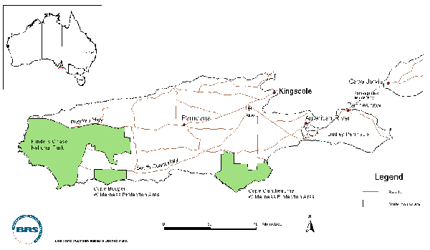
Applicant’s name: Kangaroo Island Rural Counselling Service Inc.
Amount received from RCP and other sources

Year | 1998-99 | 1999-00 | 2000-01
RCP | $84,700 | $75,700 | $79,000
Cash and in-kind | $27,000 | $27,000 | $27,000

Total RCP funding: $239,400
Project duration
The project extends from 1 July 1998 to 30 June 2001.
Project description
While officially under the umbrella of a counselling service, the project provides a range of services to the Kangaroo Island community in the RCP categories of:
- financial counselling
- information provision
- information services technology.
The financial counselling service has existed since 1991 and has been funded by previous versions of the RCP. The current project expands the original counselling service to a wider range of clients, and also includes the establishment of a Community Information Network investigating current access to information services on Kangaroo Island, building on existing services, and developing improved access to services for the community. It also includes establishment of a community computing facility to provide access to computers and to the Internet on a user-pays basis. A project officer provides personal computer assistance to new users.
The project is based in Kingscote, the largest town on Kangaroo Island, and at the time of the case study visit, project staff were establishing a computer facility in new premises in ‘Shop 6’ a short distance from the counselling service office in Dauncey St, Kingscote (postal address - PO Box 44, Kingscote, SA 5223, phone/fax 08 8553 2234, e-mail com.access@kin.on.net). The project employs three staff: a financial counsellor, a secretary, and a project officer for the Community Information Network. At the time of the visit, the financial counsellor had just resigned and a new counsellor has since replaced her.
Membership of management committee
Rev. J. Sabel Chairperson, member of the clergy
Mr P. Maxfield Vice-Chairperson, member of staff of Bank SA
Mr R. Hams Secretary, primary producer
Miss L. Dohle Minutes Secretary, Land Management Officer Primary Industries South Australia (PIRSA)
Miss J. Cann Treasurer, community representative (also administrative officer for the service)
Ms Cherie Tyley Community representative
Mr C. Whitham Accountant
Ms H. Richards Project officer, Landcare
Mr Kim Blenkiron PIRSA staff member and farmer
Ms Cheryl May Farmer
Mr Mark Cuthbertson Financial counsellor (replacing Mrs Jeanette Gellard)
Ms Janet Simpson Information officer
It should be noted that the three staff employed by the project are listed as being members and/or office bearers of the project management committee, and the administrative officer for the project is indicated as being the treasurer of the committee.
Methods
Dates visited: 29-31 May 2000
Relevant AFFA and DTRS files were examined, and general information obtained about Kangaroo Island and organisations relevant to the case study from Internet searches. These searches showed that there are other current RCP-funded projects on the island: Advance Kingscote (establishment of a community resource centre); Primary Industries Kangaroo Island (support for a peak body representing interests of Kangaroo Island primary producers); and South Australian Rural Women’s Gathering (support for a meeting of rural women to be held on the island in August 2000).
During the case study, the author visited relevant locations around Kingscote, including the project’s two locations, the local library, information centre, council offices, the regional office of PIRSA, and offices of the Kangaroo Island Development Board.
Six people associated with or with special knowledge of the project and its context were interviewed, as listed below. Two State Government representatives were also interviewed in Adelaide while returning from the case study trip. The documents cited in the reference list were obtained and used as information sources in compiling this report.
Interviewees
Kangaroo Island
Financial Counsellor
Information Officer
Mayor of Kangaroo Island
Chair, Project Management Committee
Chief Executive Officer, Kangaroo Island Development Board
Chair, Kangaroo Island Primary Industries Inc., and primary producer
Adelaide
Two PIRSA staff members
Geographic and social profile of region
Geography and natural resources
Kangaroo Island is Australia’s third largest offshore Island (excluding Tasmania), and is approximately 100 km south-west of Adelaide at the entrance to St Vincents Gulf. It is separated from the mainland by the 16 km wide Backstairs Passage. The island has an area of 4,350 sq km and a coastline length of more than 450 km. Rainfall is highly reliable by Australian standards and only eight drought years have been recorded in the twentieth century. Rainfall is highly seasonal with nearly half falling in winter, and the annual average ranges from 900 mm in the west to 500 mm in the east. This significant rainfall gradient from west to east is reflected in the native vegetation and influences agricultural production on the island. The overall climate is maritime and mild, with mean monthly temperatures ranging from a low of around 7° C in winter to a high of 24° C in summer. Occasional light frosts occur in the interior. The island is known as a windy area as westerlies blow towards it relatively uninterrupted across the Great Australian Bight.
Topographically, the island has steep high cliffs on the northern coast, particularly at the north-western end, and a central plateau that tilts towards the lower cliffs and sand dunes of the southern coastline. There are numerous sandy beaches and coves around the coastline as well as rugged cliffs. The central plateau is a remnant of the original land surface and has an eastern outlier, Dudley Peninsula, connected by a narrow isthmus. There are several significant rivers, including Cygnet, Middle and Rocky Rivers, and large semi-saline lagoons, notably Murrays Lagoon inland from Cape Gantheaume. Salinisation of freshwater bodies is a significant problem because of the highly salt-laden island environment. In terms of geology, the island’s main plateau is capped by an ironstone crust, but streams and rivers have in places exposed underlying sedimentary and metamorphic rocks. Water erosion has produced underground cave systems, notably at Kellys Hill on the western end of the island. Island soils are generally infertile and deficient in trace elements important for agricultural production.
Kangaroo Island has been isolated from the mainland since the close of the last glacial period, approximately 10,000 years ago. As a result it has endemic species of flora and fauna and is an important refuge for wildlife now rare on the adjacent mainland. While numerous species of animals have been introduced (some for conservation reasons), the island has no foxes or rabbits and relatively few weeds. This has contributed to the survival of many native plants and animals, with the result that the island has considerable conservation significance today and has areas considered high quality wilderness. The absence of rabbits and foxes is also a significant advantage to island agriculture.
Social profile
The largest town is Kingscote, near the site of South Australia’s first European settlement in 1836. However, the mainland settlement at Port Adelaide soon became the State’s main colony and Kingscote now has a population of only 3,300. Kingscote has an ARIA score of 8.1, making it moderately- to highly-remote. The total population of the island is 4,400, approximately 0.3% of the South Australian population. Apart from Kingscote, the other island towns are Penneshaw (where the ferry terminal is located), Parndana, and American River. Parndana is the only inland town and the only new country town established in South Australia since 1945.
The nearest mainland settlement to Kangaroo Island is Cape Jervis on Fleurieu Peninsula. The island is well-serviced by air and sea transport. Flying time from Adelaide to Kingscote via Emu Airways or Kendell Airlines is approximately 30 mins. Sealink Kangaroo Island Ferries operate two combined passenger-freight ferry vessels between Penneshaw on Kangaroo Island and the South Australian mainland at Cape Jervis (with connecting buses to Adelaide for passengers). These ferries operate in each direction at least three times a day. The island has a well-developed road network, with approximately 1,600 km of made roads. Power is supplied by an undersea electricity cable from the mainland, but there is also a wind farm on the island selling surplus power to the mainland. Water is supplied either from dams on Middle River, or from de-salinated seawater in the case of Penneshaw and American River.
Kangaroo Island was shunned by the Aboriginal people of the adjacent mainland as it was considered the ‘land of the dead’. The evidence is that Aboriginal people visited the island only very occasionally and left very little sign of their presence. As a result there was no indigenous population at the time of European settlement of South Australia, nor do indigenous people live on the island today. Today’s resident population is overwhelmingly of Anglo-Saxon or Anglo-Celtic origin. The population increased slightly between 1986 and 1996 from about 3,800 to the present 4,400. The age pyramid shows a marked deficiency in the 15-29 year age range, particularly for males, as compared with the State overall. This results from young people in this age range leaving the island due to lack of tertiary education facilities and employment opportunities.
Following the amalgamation of two earlier councils (Dudley and Kingscote), Kangaroo Island is now administered by a single Kangaroo Island Council with offices in Kingscote and Penneshaw. The State Government has offices in Kingscote representing a range of government functions including primary industries.
The economy of Kangaroo Island is based principally on tourism and agriculture, with fishing and aquaculture increasing in importance. In September 1997, there were an estimated 562 businesses on the island, 362 of which were in the agriculture, fishing and forestry sector (mainly small family farms). The wholesale and retail sectors comprised the next largest sector with a total of 59 businesses. Only seven Kangaroo Island businesses employed more than 20 people in 1997. Agriculture, fishing and forestry businesses are the main employers, followed by the wholesale and retail trade.
Isolation from the mainland has necessitated development of an independent business and services sector, with Kingscote being the main centre for these. The level and range of services is good, although there are a few notable gaps. For example there are no dry cleaning services and no taxis, although there are several car hire agencies. As mentioned above, tertiary educational opportunities are limited, although Onkaparinga College of TAFE is establishing a Kangaroo Island Campus at Kingscote. There are no university teaching facilities but the University of Adelaide has a field station in Flinders Chase. There is a Flexible Learning Centre in Kingscote providing vocational skills training in cooperation with TAFE. In comparison with the South Australian population as a whole, the Kangaroo Island population shows a slight deficiency in the percentage of people with university qualifications and a slight excess of people with vocational qualifications.
The island has a high level of personal computer ownership and 60% of homes are estimated to have a computer with Internet access. The local Internet service provider, Kangaroo Island Network, has 750 subscribers.
There is a local weekly newspaper, The Islander, and a local radio station, KIX-FM.
The unemployment rate on the island fluctuates seasonally, with more people employed in summer due to seasonal tourism-related work. In summer the unemployment rate is generally below the State average, but the overall rate seems to have trended upwards slightly over the period June 1994 to March 1999. Significantly, on the basis of 1996 Census data, the average individual taxable income for the island’s population was more than $5,600 below the State average. The postcode district of American River near the island’s eastern end was the third lowest taxable income area in Australia in the 1995/96 financial year, with an average individual income of $19,251.
Agriculture, fishing and forestry
South Australia’s first crops were grown at Cygnet River near Kingscote, and supplied the local population as well as itinerant sealing and whaling expeditions. The War Service Settlement (‘Soldier Settler’) Scheme begun after World War II produced the town of Parndana in the island’s central west, and 174 farms were established in the area as part of this scheme. Most of the large scale clearing and settlement of the western part of the island occurred between 1947 and 1962. Clearing is now controlled under the South Australian Native Vegetation Act.
Primary production on the island was estimated as having a gross value of $40.2 million in 1996, more than 85% of which was from wool. Hay, cereals, lamb and beef are the other main commodities produced. Because of the dependence on primary production, fluctuations in agricultural commodity prices, particularly wool, have a major influence on the island’s economy. Corresponding to the downturn in wool prices there has been an expansion in cropping. Between 1980 and the early 1990s, there was a contraction of about 25% in the number of farms on the island, while the area of cultivated land increased by about 14,000 ha over this period.
Scale fish, particularly whiting, are the main seafood produced, together with rock lobsters, abalone, oysters and mussels. Fishing is estimated to be worth approximately $10 million to the island’s economy. The main ports are Kingscote, American River, Penneshaw and Vivonne Bay. Most fish are transported to the mainland for sale.
Approximately 3,200 ha of the island are under forest plantations and there appears to be potential for agro-forestry to expand. Both Tasmanian blue gum and radiata pine are grown.
While some farmers are extremely conservative, others are experimenting with a range of non-traditional primary production activities, including cool climate viticulture; venison; olives; marron (a freshwater crayfish); agro-forestry; and ligurian bee products (a strain of these bees is established on the island). There is an emphasis on ‘clean, green’ production due to the island’s relatively unpolluted environment.
Tourism
Kangaroo Island is a popular tourist destination in summer, being noted for its spectacular coastal scenery and abundant wildlife (including Kangaroo Island kangaroos, koalas, echidnas, Cape Barren geese, Australian sea lions and New Zealand fur seals). There is substantial variation in published figures, but approximately 150,000 tourists visit each year and the island generated about $50 million from tourism in 1997, 1.4% of South Australia’s total tourism income. International tourists make up about 40% of the total. Kangaroo Island tourism supports approximately 200 jobs on the island and approximately 800 in South Australia as a whole. The western third of the island is contained within Flinders Chase National Park, and there are numerous other parks and reserves protecting wildlife and scenic locations.
Current issues
A number of general issues affecting Kangaroo Island’s society and economy, and in particular the viability of primary production, emerged during the visit. These were:
- freight costs to and from the island (the Sealink service charges $40 per tonne for freight)
– these costs reduce the profitability of primary production, particularly when unprocessed commodities are shipped to the mainland
- increased workload and costs associated with the introduction of the GST
- loss of youth from the island and lack of youth services
– a major social issue and significant in relation to property succession planning (a 1992 survey indicated that only 26% of young people living on Kangaroo Island expected to remain in the long term)
- the current outbreak of Ovine Johne’s disease
– this sheep wasting disease has had a depressing effect on the economy and has necessitated de-stocking of properties.
Case study findings
Counselling service
The counselling service was established in 1991 and provides assistance to all Kangaroo Island residents, not only primary producers, although they are the main clients. The counsellor estimated that 60-65% of clients are farmers, 10-15% small business people, and the remainder are household wage earners or unemployed people. The counsellor visits many clients on their properties rather than having them visit the Kingscote office, which is in very inadequate premises by government standards. This also helps safeguard client confidentiality, which can be an important issue in small rural communities, and reduces transport costs for clients. New clients are obtained mainly through word-of-mouth referrals. The counsellor works closely with local accountants and solicitors in assisting clients. The role of the counsellor has broadened over the years, and she provides help to people with a wide range of debt levels as well as being involved with community issues associated with agricultural viability.
There is no other financial counselling service based on Kangaroo Island although State-funded counsellors do visit the island and present seminars or workshops.
A community consultation process and community household survey were undertaken before the current application was submitted. The survey indicated that 81.7% of respondents supported the service’s continuation. In terms of on-going evaluation and monitoring, the counsellor initiates evaluations by going through her files and sending out evaluation forms to clients on a regular basis – approximately 12 forms are posted out per month. Results are supplied in the project progress reports and annual reports to AFFA. In the period the service has operated, only one negative evaluation has been received. The counsellor reports to Kangaroo Island Council meetings and is well-known and well-regarded in the community, hence her success in obtaining a position with the Kangaroo Island Development Board.
The management committee for the service meets bi-monthly and some members have been on the committee since the service started, indicating considerable stability. The current chair has played this role for ten years, during which time his role has expanded to cover the information technology and information services projects as well. One interviewee suggested that there is a need for a training budget for committee members to enhance their development opportunities, and a need for a possible revival of a previous national conference series held for financial counsellors.
In terms of funding requirements, the cash contribution required from the community has been an issue and a preference was expressed for a 72:25 split rather than the current 50:50 for financial counselling. (The State Government contributes $20,000 per year to the service’s costs.) Commonwealth reporting requirements have not been a problem, although it was suggested that the process could be speeded by submitting reports electronically rather than in hard copy. On one occasion there was a delay in receiving a progress payment from the Commonwealth after a project report was lost. Suggestions were also made about the value of establishing an integrated Commonwealth rural and regional portfolio and an accompanying streamlined, coordinated approach to providing funding.
There appears to be strong community support for the counselling service and a belief it is valuable to the island community, particularly in encouraging forward planning and succession planning by farm families, and encouraging them to see the options available to them. The view was expressed that turnover of properties is less than it might have been without the service. The importance of having an impartial person to be a go-between for farmers and financial institutions was stressed – ‘helping banks to be civil’. The service does not duplicate nor compete with existing government or private sector services. However, the need for coordination and integration between different levels of government was stressed by some interviewees, together with attention to the special circumstances of island communities.
Information provision and information services technology
The current information officer started in November 1999 following the resignation of the previous officer. It was noted that a previous officer, Ms Catherine Bennett, also left the position to take up a job with the Development Board as has the counsellor interviewed during the case study. The current officer services the whole of Kangaroo Island, and distance creates some challenges. A wide range of community members use the service on a needs basis, including youth, members of progress associations (each major town on the island has a progress association), and organised groups as well as individuals. Youth are important beneficiaries of the service and they represent a group with ‘big problems of living’ as one interviewee expressed it. The information officer is also working on organising the Rural Women’s gathering funded by a separate project as listed above.
Fees charged for the service are $1.50 per half hour for computer use, $3.00 per half hour for Internet access, 20c per page for black and white printing, 30c per page for colour printing, and $1 per page for scanning colour photos.
Feedback on these services is relatively informal except for that provided via the Kangaroo Island Community Forum, a community group that meets monthly and discusses a wide range of current community issues.
During this case study, issues arose over possible overlap and duplication in the information services and information technology areas. As mentioned above, at the time of the visit the information officer was establishing these services in new premises (shared with Centrelink). The previous premises were next door to the Council-funded public library, which also has several computers and provides public Internet access. However, the assurance was given that there is liaison with the librarian, and also that the library does not provide personal assistance to computer users. The information officer is a member of a relevant Council committee, helping to ensure coordination. However, there is clearly potential for overlap with Council-provided services. A local accommodation house in Kingscote also provides public Internet access on a fee-paying basis.
Another area of concern was the potential conflicts of interest raised by the three project staff being included as members of the project management committee, and particularly the administrative officer (who is employed by the management committee) serving as treasurer of the committee. Issues relating to members of small rural communities having multiple and possibly conflicting roles arise here, and the difficulties this may create for clear separation of different roles and responsibilities.
The view was expressed that Kangaroo Island is a small community and is becoming increasingly stretched in terms of providing cash or in-kind contributions to projects, particularly when the economy is at ‘an all time low’. This is one reason small charges have been introduced for use of computers, printers, and for Internet access. Nonetheless, the basic philosophy of the RCP was applauded and the importance of community ownership of projects was stressed. There was a belief that funding for these kinds of services is not likely to be available from sources other than the RCP.
The need to fund a person to play a broader community development and coordination role was emphasised – this is not part of the currently-funded projects. The Kangaroo Island Development Board has a significant role in strategic planning for the island and may be an appropriate management body for some future Commonwealth-funded projects.
Conclusions
The services provided by the Kangaroo Island Rural Counselling Service were valued and supported by the people interviewed, and all expressed the belief that these services make a positive contribution to Kangaroo Island’s community and its socio-economic viability. The counsellor’s work in particular was supported by very positive client feedback.
Although not far ‘as the crow flies’ from major mainland population centres, Kangaroo Island’s population does have some special socio-economic disadvantages. In particular:
- the population has relatively low average individual incomes
- the population faces issues of small size and relative isolation because of the water barrier
- loss of youth is a significant problem and may become even worse in the future without new employment opportunities and expansion of tertiary education services (distance education could partly resolve this problem)
- primary producers and other island residents are disadvantaged by having to pay additional freight and transport costs not borne by nearby mainlanders
- the downturn in the wool industry has had severe consequences for the island’s economy as wool production has traditionally been an economic mainstay.
These factors, when taken together, suggest there is a good case for communities like that of Kangaroo Island receiving some special consideration in government funding programs. Coordination and integration of services are issues, however, and in this case study, the potential for overlap and duplication between services provided by different levels of government became apparent. The need for community-wide strategic planning is evident – local and regional development authorities may be the appropriate bodies to do this in consultation with relevant State and Local Government agencies. Planning frameworks may constrain the activities of community groups in some respects, but may also improve efficiency in using limited community resources and limited government financial support.
Issues relating to RCP-funded staff serving as members or office-bearers of project management committees and possibly experiencing conflicts of interest were apparent in this case study, and raise the need for guidelines about membership and operation of committees.
Questions of the appropriate placement of RCP-funded services (both geographically and administratively), and the relationship of these services and their management committee to the local Development Board also arose in this study.
References
Chamberlain, L. & Associates (1999) Youth issues on Kangaroo Island. Report prepared for the Kangaroo Island Development Board, Kingscote.
Kangaroo Island Development Board (1998) A regional profile of Kangaroo Island, South Australia. Kangaroo Island Development Board, Kingscote.
Kangaroo Island Development Board (1999) Annual Report 1998/99. Kangaroo Island Development Board, Kingscote.
Kangaroo Island Rural Counselling Service Inc. (1999) Third progress Report, 1/5/99 – 31/10/99. Unpublished report. Kangaroo Island Rural Counselling Service, Kingscote.
Kangaroo Island Rural Counselling Service Inc. (1999) Annual report 1999. Unpublished report. Kangaroo Island Rural Counselling Service, Kingscote.
QED Pty Ltd (1999) Kangaroo Island freight strategy study. Final study report. QED Pty Ltd, Adelaide.
Wilkins Tourist Maps (1997) Kangaroo Island. http://www.ozemail.com.au/~wilmap/SA66.HTML

Main street of Kingscote, Kangaroo Island

Mildura Rural Financial Counselling Services, New South Wales and Victoria
Trevor Webb
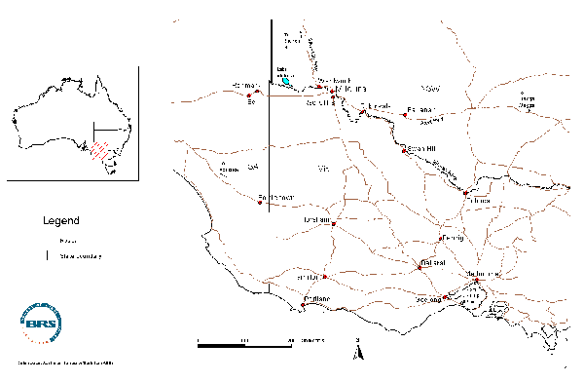
Applicants’ names:
Wentworth and Balranald Rural Counselling Service
Sunraysia Rural Counselling Service
Mallee Rural Counselling Service
Amount received from the RCP
Service | RCP Project no. | 1998-99 | 1999-00 | 2000-01 | Total
Wentworth and Balranald Rural Counselling Service | 59 | $83,760 | $83,760 | $83,760 | $251,280
 | 723 | - | $64,700 | $67,100 | $131,800
 | 750 | - | $45,220 | $61,740 | $106,960
Sunraysia Rural Counselling Service | 57 | $100,000 | $50,000 | $50,000 | $200,000
 | 416 | $15,000 | - | - | $15,000
Mallee Rural Counselling Service | 58 | $100,000 | $100,000 | $100,000 | $300,000
Description of projects
Three rural financial counselling services receive funds from the RCP and operate from Mildura, namely the Wentworth and Balranald, Sunraysia, and Mallee Rural Counselling Services. In addition to financial counselling services, Wentworth and Balranald, and Sunraysia Rural Counselling Services have received RCP funding for other projects (see table above).
Sunraysia Rural Counselling Service (Projects 57 and 416)
Sunraysia Rural Counselling Service has received RCP funding for two full-time financial counsellors in 1998-99, and funding for one full-time counsellor for the subsequent two years. The Service also employs a part time administrative assistant. The Service is based in Mildura and located in accommodation provided by the Victorian Department of Natural Resources and Environment. The Service operates in the irrigated horticultural areas along both sides of the Murray and Darling Rivers from the South Australian border to Swan Hill. This area contains approximately 4000 specialised growers producing wine grapes, grapes for the dried fruit market and citrus crops, among others. Sunraysia Rural Counselling Service was the first service to be established in Australia, appointing their first full time financial counsellor in 1984. The Service’s current financial Counsellor has been in the position since October 1999, and currently has approximately 30-40 clients. During the 1998-99 financial year the previous financial counsellors had 151 clients.
Additionally, Sunraysia Rural Counselling Service received funding for a community development project to establish and manage a local coordinating committee for the three rural counselling services, known as the Inland Rural Alliance (Project 416). The Alliance comprises two representatives from each of the three services and an independent Chair. The Alliance arose from the recommendations of a review of the three services carried out by PEP Consultants (Dingle, 1998). The Alliance was to be responsible for networking, promoting and coordinating the three services by developing a strategic plan for the services. In exploring the needs of the local communities this project funded a survey of the needs of farming families in the three financial counselling service regions. The results from the survey highlighted that demand increased for rural counselling services as economic conditions became worse. However, the survey also highlighted the stressful nature of adjustment in rural families and the need for the integration of personal and family counselling services with financial counselling services. The results of the survey were subsequently used by Wentworth and Balranald Rural Counselling Service to justify additional funding for a rural adjustment counsellor (project 750) and funding for a community development officer to enhance the Inland Rural Alliance (project 723).
Wentworth and Balranald Rural Counselling Service (projects 59, 723 and 750)
Wentworth and Balranald Rural Counselling Service have received RCP funding for a full-time financial counsellor and a part-time administrative assistant (project 59). The Service is co-located with the Mallee Rural Counselling Service’s northern mallee financial counsellor in premises of the Rural City of Mildura Council, and has been operating since 1991. The Service primarily operates in the New South Wales shires of Wentworth and Balranald but also services Broken Hill, Milparinka and part of both Wilcannia and Wanaaring. The area serviced covers approximately 52% of the Western Division or 23% of NSW, and contains approximately 550 farming businesses. Sheep grazing is the dominant rural industry and continued poor returns on both wool and meat have maintained financial pressure upon the region’s graziers. In addition drought conditions continue through the region with areas in Hillston and Balranald being declared under Drought Exceptional Circumstances and Wentworth being declared under Exceptional Circumstances. The service had 204 clients in the calendar year of 1999, of which 37 were new clients.
In addition to the financial counsellor Wentworth and Balranald Rural Counselling Service also received funding through the RCP to employ a full-time rural adjustment counsellor (project 750). The adjustment counsellor’s role is to work with existing service providers, financial institutions, government agencies and in particular farming families to assist them to deal with the complexities surrounding a decision to exit farming. It is estimated that 70 families need immediate assistance with adjustment within the region. The rural adjustment counsellor started work in September 2000.
Wentworth and Balranald Rural Counselling Service has also received funding on behalf of the Inland Rural Alliance (project 723). A survey of community needs in 1999 identified the need for a community development officer to work with rural communities throughout the regions serviced by the three rural counselling services. The project, which builds upon project 416 (Sunraysia Rural Counselling Service) also envisages the enhancement of the Inland Rural Alliance and the provision of a central office for the three services and the community development officer to work from. The position had not been filled at the time of the site visit.
Wentworth and Balranald Rural Counselling Service has also been successful in gaining funding through other programs and initiatives. During 1999-2000 it employed a community worker on a trial program with funding from WEST 2000 to provide personal and crisis counselling support and referral information. This service has worked via a 1800 telephone line. Initially the occupant of the position was to work jointly with the financial counsellor to provide integrated financial and personal counselling services to farming families. However, this aspect of the trial project has not eventuated.
Mallee Rural Counselling Service (Project 58)
The Mallee Rural Counselling Service currently employs two full-time financial counsellors and two part-time administrative assistants. The Service provides financial advice to farmers in the Victorian mallee covering the shires of Buloke and Yarriambuck and the Rural City Councils of Swan Hill and Mildura. The region is divided into the southern mallee with a financial counsellor based in Donald, and the northern mallee with a financial counsellor based in Mildura. The region is dominated by broad-acre cropping producing wheat and barley. The area contains approximately 2400 farming families in an area approximately 26% of the state of Victoria. The service was the second Australian rural financial counselling service, being established in 1986 as the Mallee Crisis Committee. The southern mallee counsellor has been employed since 1989, while the current northern mallee counsellor commenced employment in May 2000. Drought has exacerbated the impact of reduced commodity prices for mallee farmers and Exceptional Circumstances has been declared for Millewa and the southern and eastern mallee. During the 1998-99 financial year, the Service had 166 clients.
Membership of management committees
The three services each had a management committee that comprised a range of members from the serviced area’s community. The composition of the three management committees is summarised in the table below.
Management committee membership
Representation | Wentworth/Balranald | Mallee | Sunraysia
Farmer/Grazier/Horticulturist | 6 | 5 | 2
Accountant/Financial Adviser | 1 | - | 4
Shire/Local Council | 2 | 2 | -
West 2000/SunRise 21 | 1 | - | 1
Mental Health | 1 | - | -
State Agency | 1 | 1 | 2
Bank/Financial Institution | - | - | 2
Community Organisation | - | 3 | 1
Other Business | - | 1 | 2
Centrelink | 1 | - | 1
Total | 13 | 12 | 15
Methods
The site visit was carried out on 13-16 June 2000.
Relevant files from AFFA and DTRS (Including correspondence, grant application, grant assessment, financial and progress reports) were consulted.
Interviewees
National Bank Representative, Sunraysia Rural Counselling Service Management Committee
Administrative Assistant, Sunraysia Rural Counselling Service
Community Worker, Wentworth & Balranald Financial Counselling Service
Financial Counsellor, Wentworth and Balranald Rural Counselling Service
Centrelink Representative, Wentworth and Balranald Rural Counselling Service Management Committee
Chair, Inland Rural Alliance
Financial Counsellor, Mallee Rural Counselling Service
Chair, Sunraysia Rural Counselling Service Management Committee
Administrative Assistant, Mallee Rural Counselling Service
Administrative Assistant, Wentworth and Balranald Rural Counselling Service
Financial Counsellor, Sunraysia Rural Counselling Service
Commonwealth Bank Representative, Sunraysia Rural Counselling Service Management Committee
Focus group discussions were also conducted with attendees at the following meetings:
- Inland Rural Alliance, 15 June 2000
- Wentworth and Balranald Financial Counselling Service Management Committee, 15 June 2000.
Geographic and social profile of region
As indicated in the project descriptions, the three Financial Counselling Services operate in three distinct agro-ecological areas. Wentworth and Balranald Rural Counselling Service operates in the rangelands of New South Wales with the production of wool and sheep meat being the dominant agricultural activities. Mallee Rural Counselling Service operates throughout the dryland cropping districts of north-west Victoria, where cereal cropping is the major activity of the region’s farming families. In stark contrast to both of these regions, Sunraysia Rural Counselling Service deals with those growing wine grapes, dried fruit grapes and citrus fruits in irrigated horticulture. While drought has been of considerable concern to farmers in both the Mallee and Wentworth and Balranald Rural Counselling Service areas, this is not the case for Sunraysia clients. The latter may be confronted by the consequences of water reform.
The social profiles of the three regions are also quite distinct. Wentworth and Balranald Rural Counselling Service’s area is very sparely populated, with less than 0.1 person per square kilometre. The Mallee Rural Counselling Service’s area is slightly more densely populated, but still less than 1 person per square kilometre. In contrast, Sunraysia Rural Counselling Service operates in region with more than 1 person per square kilometre. The table below indicates the populations of the urban centres and localities throughout the three regions. The irrigated horticulture area also has a sizeable minority of non-English speaking background farmers, in particular Turkish farmers. This has necessitated the provision of targeted services to this community by the financial counsellor. For example GST seminars have been targeted at this group of farmers.
Population and remoteness for serviced regions (Source: ABS 1996 Census of Population and Housing)

Service | Urban centres and localities | Population (1996) | ARIA score
Wentworth and Balranald Rural Counselling Service | Balranald | 1419 | 4.34
 | Broken Hill | 20963 | 3.24
 | Wentworth | 1504 | 3.01
 | Wilcannia | 688 | 8.02
Sunraysia Rural Counselling Service | Mildura | 24142 | 2.5
 | Robinvale | 1758 | 4.0
 | Swan Hill | 9385 | 2.9
Mallee Rural Counselling Service | Charlton | 1096 | 3.0
 | Donald | 1383 | 3.2
 | Hopetoun | 670 | 4.6
 | Ouyen | 1251 | 4.0
 | Sea Lake | 694 | 3.9

In addition to the sparsely-populated nature of the Wentworth and Balranald and the Mallee Rural Counselling Services’ areas, they are highly isolated and remote regions. This remoteness, particularly for those in the western division of New South Wales severely limits the accessibility of residents to services. Mildura is the major regional centre for the three serviced areas, and most services are available there. These include:
Financial services Numerous banks and financial institutions, over 30 accounting businesses
Educational services TAFE, Adult education
Health services Hospitals, community health centre, mental heath services, general practitioners, dentists, personal/relationship counsellors
Government services Local Government, Victorian Department of Environment and Natural Resources, Centrelink
Other services Small business advice, Veterans Affairs, legal services
For those living near Mildura, access to services is not a major problem. Thus for the most part the horticultural farmers of the irrigated have access to most services. Furthermore, in addition to Mildura, many of the above-mentioned services are also provided in the smaller regional centres including Swan Hill and Wentworth. However, for farmers located in the mallee regions of Victoria and particularly western division of NSW, access to services is considerably poorer. Indeed for the western division, the only other major service centre is Broken Hill, some 300 km north of Mildura. For Victorian mallee farmers, limited services are also available in Donald and Ouyen. However, residents typically need to travel to Mildura or Swan Hill for most services. Some professional services from Mildura and Swan Hill provide outreach operations to other regional centres on an ad hoc basis.
Case study findings
Community management model
It was apparent from the focus groups with the two committees and from individual interviews with other committee members that they are dedicated and hardworking individuals with a commitment to the long-term future of agricultural industries in their regions. The committees are typically fairly large, by RCP-funded project standard which had a median committee membership of nine, though a number of factors mitigate against all members attending all meetings. Committee members are often business people with the commitments of their own business to attend, in addition to that of the management committee. They are not reimbursed for their time or out-of-pocket expenses such as petrol to travel to meetings. The travel required to attend meetings can be demanding. For the members of Wentworth and Balranald, and Mallee Rural Counselling Service Management Committees, the distance travelled can be quite substantial. For example, one member of the Wentworth and Balranald Rural Counselling Service Management Committee travels in excess of five hours (one way) to attend meetings, while other members travel from between one and three hours. For the Mallee Service, the distances are less, and travelling time is around one to two hours for most members. In contrast, most of the members of Sunraysia’s Management Committee live in Mildura. In addition to time and cost of travel, other costs incurred by management committee members (e.g. STD telephone phone calls) are typically not reimbursed. While the provision exists for these expenses to be paid for by the Rural Counselling Service, they are often donated by committee members, being factored into the community cash and in-kind contributions in seeking RCP funding.
While Sunraysia’s Management Committee has a diverse membership, the other two Committees are less diverse, with higher numbers of farmers. This is not surprising, as Sunraysia has a different bank of expertise to draw upon in constituting its committee. Indeed, unlike the other two services, Sunraysia has not had difficulties in recruiting and maintaining members on their Management Committee. As noted, membership on voluntary committees makes a large demand on individuals. Consequently those with a particular interest in the service are usually those willing to volunteer. This creates the very real potential of committee members also being clients of the service, which in turn may lead to difficult conflict of interest situations. These situations should be avoided where possible.
The community management model of the RCP envisages the management committee as the manager of financial counselling services, who in turn employs a financial counsellor to provide services to their region. In practice, the financial counsellor takes on a far greater role in the day-to-day administration and management of the service. In addition to client contact, the counsellor is largely responsible for identifying and securing ongoing funding through grant applications and associated lobbying. He or she is also responsible for any reporting obligations and for managing any staff (e.g. administrative assistants). In a sense the financial counsellor is not just a financial counsellor but also the executive officer of the organisation. Such a situation detracts from the time they can spend in client work. One of the financial counsellors estimated they spent about 60% of their time doing client-based work, the remainder being organisational support work. The additional administrative burden of the GST will further reduce the time counsellors are able to devote to client work. There may be some latitude for the management committee to take on greater responsibilities in the running of the service, particularly in relation to the sourcing of funding and support.
However, in general, management committees exhibit varying degrees of competence in the skills required to effectively manage such services (e.g. knowledge of legal responsibilities, taxation, occupational heath and safety, industrial democracy, equal employment opportunity, professional development). There is a clear requirement that if the community management model is to prosper in increasingly complex operating environments, the management committees will need to be resourced and trained to meet these challenges. The National Financial Counsellors Conferences that were held annually provided an opportunity for some training. Some state associations of financial counsellors currently hold annual conferences and there is an opportunity for these to provide some training and development component. However, the reinstatement of the National Conference with targeted training and development for committee members as well as financial counsellors could provide for work-standards to be developed across Australia.
Service cooperation
An ongoing issue that confronts the three financial counselling services is how to work effectively together. The potential for greater cooperation and the sharing of resources and experiences between the services has been noted for some time (Dingle, 1998). At the time of PEP Consulting’s community consultation process in May 1998, the three financial counselling services were operating out of three offices all located within a 10 km radius. At the time of this case study visit, Wentworth and Balranald Rural Counselling Service and the northern financial counsellor of the Mallee Rural Counselling Service were co-located, while Sunraysia Rural Counselling Service was operating from separate premises. Among PEP’s (1998) recommendations was the establishment of a Local Rural Communities Program Committee to be responsible for networking, promoting and coordinating the three services by developing a coordinated strategy and clear policies. The RCP funding received by Sunraysia Rural Counselling Service (project 416) enabled the community needs survey to be carried out in addition to the provision of seed funding for the Inland Rural Alliance.
During the case study visit it was apparent there was considerable discussion between the three services about moving into one premises. However, uncertainty about future funding and the differential rates that the services are currently paying for accommodation mitigated against an agreement for the three services to co-locate. Co-location would be highly desirable from a professional development perspective, in that some counsellors have particular skills and experiences that other financial counsellors could take advantage of. The professional development needs of staff could also be addressed through mechanisms other than co-location (for example regular meetings between counsellors).
There were growing reservations among some committee members about the benefits of the Inland Rural Alliance. Concerns were expressed about the increasing time spent by the various management committees regarding the Inland Rural Alliance. For some individuals the IRA represented the desires of Canberra-based bureaucrats rather than the needs of the local community. While greater levels of co-operation and strategic planning may bring considerable benefits to the three counselling services, particularly in the areas of corporate sponsorship, the individual identities of the three services will need to be maintained. Each service deals with clients from quite distinct agricultural sectors in distinct geographical regions, and the management committees and operation of the services should reflect this diversity.
Funding
Raising community cash and in-kind contributions for 50% of RCP financial counsellor funding was problematic for all three services. Ongoing structural adjustment in the wool industry, low commodity prices and drought severe enough for Exceptional Circumstances to be declared in some areas have produced a generally economically depressed agricultural sector. Not surprisingly these communities have little spare cash to contribute to support the financial counselling services, though ironically, these are the communities in most need of financial counselling services. While there are limited opportunities for cash support, local community members demonstrate their support through in-kind contributions. This was particularly demonstrated in the case of committee members, who do not receive sitting fees and travel long distances to attend meetings.
Financial counsellors in the three services were spending increasing levels of their time in seeking funding to make up the 50% non-RCP component. Concerns were expressed by management committee members about financial counsellors working on such matters rather than working with clients. In the case of these three services, there is scope for the Inland Rural Alliance to strategically deal with funding and sponsorship issues. Indeed with re-skilled management committees it is a role for which they may choose to take greater responsibility. There was also some concern expressed over the priorities of financial counselling under the RCP. In particular, there was a feeling from some of those interviewed that the move to include small businesses and clients other than farming businesses was retrograde. Furthermore, the emphasis given to community development as a consequence of financial counselling being packaged within RCP was perceived as detracting from the main issue, that of providing financial counselling to farm businesses. Where, in order to obtain funding for financial counselling, the service had to broaden and include these other considerations.
As a consequence of staff vacancies within Sunraysia Rural Counselling Service, funds allocated to a financial counselling position had not been spent during the latter half of 1999. The Service sought and gained permission to use these funds to employ a locum counsellor to work with the three services, and in doing so relieved some of their workload. The ability of the financial counselling services to employ additional casual staff to assist during periods of heavy work loads (e.g. following EC declarations) could be explored in greater detail. For the services operating out of Mildura, in excess of three months work exists for a casual locum just in ensuring the services are maintained when counsellors take annual leave and time due to illness.
The question of funding beyond the end of the current RCP (30 June 2001) was a source of particular anxiety among financial counsellors and their management committees. There was a general acceptance that there was an on-going need for financial counselling in the three regions. However, at this stage there is no commitment for on-going funding of the services. In addition to restricting long-term planning, the funding uncertainty may lead to increased stress levels for employees and create difficulties in recruiting and retaining appropriate staff.
Other issues
Two final issues arose during the site visits and are worthy of comment. The first is a general observation that financial counselling to farm families invariably deals with issues other than the ‘nuts and bolts’ of the businesses financial situation. The counsellors are called upon to deal with the emotional stresses and pressures that financial difficulties bring to farming families. In some cases counsellors may not be adequately qualified or resourced to professionally deal with personal and relationship counselling. Strong links with those who provide these services, such as Mallee Family Care, have been developed and offer opportunities for counsellors to refer personal and relationship counselling issues to qualified individuals. It is anticipated that the rural adjustment counsellor (project 750) would be qualified in personal and relationship counselling and there may be scope for these skills to be more widely utilised. In addition, the emotional well-being of the counsellors themselves must be a priority of the three services. At the time of the site visit, only one counsellor received regular professional de-briefing. The other two were yet to establish regular sessions. To reduce stress-related turnover of financial counselling staff, professional debriefing could be established as a priority for all counsellors.
The second observation relates to the way all three counselling services collect feedback from their clients. At this stage, feedback is on an ad hoc opportunistic basis, typically with clients sending in thank-you letters or otherwise making contact through the counsellor to the service. There is potential to develop a more comprehensive and systematic form of feedback on the effectiveness of the counselling service to guide its future development. A number of other financial counselling services have developed evaluation questionnaires for clients to complete and return. At present there is considerable diversity in these questionnaires. A standardised evaluation questionnaire for clients could be developed. This would enable the services to evaluate the quality of their operations and provide comparable information about services to the program’s administrators.
Conclusions
The three financial counselling services operating from Mildura provide a well-supported service throughout three socially and agro-ecologically distinct regions. Residents in the Victorian mallee and the Western Division of New South Wales are particularly isolated from services, while those nearer to Mildura have better access. Drought in various areas, coupled with the low commodity prices, have maintained a demand for financial counselling services throughout the region.
The community management model has been effective in providing dedicated and hard-working committees whose members contribute considerable time and energy, at some cost to their own businesses, to ensure the longevity of the services. With increased resources and targeted training and development, management committee members may be able to assume greater responsibilities for some tasks now carried out by financial counsellors.
There has been considerable effort toward greater integration between the three services through the development of the Inland Rural Alliance. At this stage, however, a limit to integration appears to have been reached. It is likely that continued external pressure for further integration will be counter-productive, and this pressure should only be applied on areas where the benefits of integration are clear, for example in securing sponsorship.
Funding was a central concern of financial counsellors and their management committees. In particular, securing 50% of cash or in-kind contribution was seen as an onerous task and often diverted the attention of financial counsellors away from client-based work. Funding to 75%, as is the case for other RCP projects, may be a more equitable level. Recognising that financial difficulties in farm families will require more than financial advice, financial counsellors need to be aware of services to which to refer their clients.
Additionally, financial counsellors themselves need to have access to professional debriefing to ensure their own emotional well-being. The financial counselling services of the region represent the earliest operations of rural financial counselling in Australia. Conditions that have created on-going demand for financial counselling services since their inception, particularly in the pastoral zone, are likely to continue, and suggest that three-year fixed-term programs may be inappropriate. Longer-term alternatives could be seriously explored where there is good evidence of continuing need.
References
Dingle, R. (1998) Consultation for the Rural Communities Programs Sunraysia, Wentworth/Balranald and Mallee Rural Counselling Services, May 1998. PEP Consultants Pty Ltd, Geelong.
Lees, J., McKenzie, B., Jackson, N. and Greaney, J. (1989) The MCC Experience: A review. A report to the Mallee Crisis Committee (for the period September 1985 to July 1988). The Rural Development Centre, University of New England, Armidale.

Bremer Bay Community Resource Centre, Western Australia
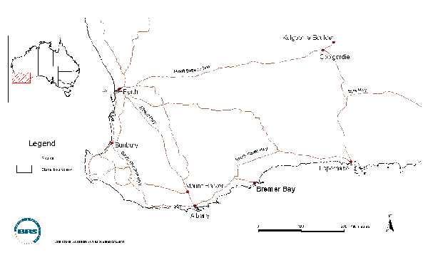

Applicant’s name: John W. Cary - Bremer Bay Community Resource Centre
Amount received from RCP and other sources

Year | 1998-99 | 1999-00 | 2000-01
RCP | $39,000 | $56,092 | $46,092
Cash and in-kind | $41,880 | $28,800 | $30,000

Project duration
The project extends from 1 July 1998 to 1 July 2001.
Project description
The project provides a coordinator to provide Internet training and services, and informal and formal education. The funded coordinator was to extend the exiting coordination component of the Bremer Bay Telecentre with further flexibility to provide for special socio-economic needs. The project assists with providing access to external studies and training and provides for the conduct of workshops and conferences. A Deed of Variation (approved October 1999) provided a Seniors’ Coordinator who supervises recently-introduced seniors’ programs. The program provides improved information services and community communication with the production of a monthly community bulletin and the development of a Netcafe for locals and holidaying visitors. The project also seeks to provide a site for better government communication (particularly information from CentreLink, Albany) and the extension of government agency services. The program has provided resources for local business and clubs to develop relevant local web pages.
The project is centred on Bremer Bay, a moderately isolated community situated 100 km from the Shire Office at Jerramungup (ARIA score 6.5). The area suffers from a lack of many community, educational and health services. Many farm families in the rural hinterland have experienced financial crisis. The commercial fishing industry has also recently closed. Bremer Bay is an important local holiday and recreation centre.
Membership of project management committee
Mr Bruce Stuart Chairperson, local business owner
Mrs Del Harland Vice Chair Primary School Teacher, farmer’s wife
Mrs Carol Lee Secretary, local business owner
Mrs Jody Brown Treasurer, community member (young mother)
Mr Wes Thomas Farmer
Mr Ben Olsen Manager, Jerramungup Business Enterprise Centre
Mrs Shirley Hobley Community member
Mr Bob Wilson Local business owner
Methods
Dates visited: 4 - 6 July 2000
All DTRS files related to the Bremer Bay application, grant and progress reports were perused.
Interviewees
Chair, Bremer Bay Community Resource Centre Management Committee (local retailer and businessman)
Coordinator (and librarian) Bremer Bay Resource Centre (funded by Western Australia Government Telecentre Support Unit)
Rural Community Program Coordinator (funded by RCP)
Seniors’ Program Coordinator (funded by RCP, appointed November 1999)
Vice-Chair, Bremer Bay Community Resource Centre Management Committee; original committee member.
Geographic and social profile of region
The township of Bremer Bay is located on the southern coast Western Australia. It is situated at the mouth of the Wellstead Estuary, 180 km northeast of Albany and 515 km south-east of Perth. It abuts the Fitzgerald River National Park and the Fitzgerald Biosphere Reserve.
The stable population of Bremer Bay is approximately 250 people. During holiday period the population is 6,000 to 7,000 and up to 10,000 people. The township of Bremer Bay is located in the Shire of Jerramungup. The Shire has only one other significant township – the town of Jerramungup (population 334 persons).
An agricultural area, Bremer Bay's main local industries are fishing, grain growing, cattle, sheep and pig-rearing. Tourism plays a major role in the region's economy with the annual display of spring wildflowers and whalewatching in season attracting many visitors.
Jerramungup was a War Service Land Settlement Area. In 1953, 123 farms were cleared and settled. Sheep and wool production is still of major importance to the district's economy. Cattle and pigs are also farmed and grain crops have been established.
More recently, a commercial fishing industry was established. However, the local professional pilchard industry has recently collapsed, and the WA Department of Fisheries has closed the industry for up to five years to allow the fish stocks to recover. There was a fleet of eight boats with crew, plus two processing factories to cater for the catch. These are now closed, and the boats have moved on. This has had a significant impact on local employment with a marked loss of families, many with young children, who have left to seek employment elsewhere. Recreational and amateur fishing continues to be an important attraction for Bremer Bay.
There have been significant changes in the local rural sector. Eight of the local farms have recently been sold for tree farming. This change has structural ramifications for the other industries that were associated with traditional farming, such as shearing teams, tractor


drivers, chemical and other farm related providers, who now have fewer employment opportunities locally.
Fitzgerald River National Park occupies an extremely attractive section of the south coast of Western Australia. The Fitzgerald River National Park is an internationally-recognised Biosphere Reserve and is only 17 km east of Bremer Bay. The Fitzgerald River National Park is famous for its magnificent variety of native plants. The Park is world-renowned for its rare flora and fauna and also the viewing of southern right whales from July to October each year. The park's landscape consists of undulating sandplains divided by spectacular river valleys, narrow gorges and precipitous cliffs. At the southern end of the Park, sandy beaches stretch for kilometres. Bushwalking in the area is popular, as is beach and rock fishing.
Catchment for Bremer Bay Community Resource Centre
The catchment extends from Bremer Bay coast north to Gardiner River (Bremer Bay Road) to Fitzgerald River National Park (eastern boundary) and Wellstead (western boundary).
Case study findings
There was initial funding from the Rural Access Program (for an initial 12 months) for education and access to government services.
RCP funding allowed continuation of many services which were initiated with original funding from the Rural Access Program and the development of services for needs identified in the initial program.
Subsequent access to RCP funding allowed considerable expansion of these services and more explicit focus on training and services related to the Telecentre activities.
A major component of RCP funding for the Bremer Bay Resource Centre has been for coordinator and facilitator personnel. The currently-funded RCP facilitator (Kirsty Morrison) has been in the position since September 1999. Barbara Thomas, the Seniors’ Program Coordinator, has filled the position funded by RCP since November 1999.
The mission statements of the Bremer Bay Resource Centre are:
To link Bremer Bay to the world through modern technology and telecommunication facilities, provide educational opportunities, employment options and to support sustainable business and enterprise; and
To foster community leadership and initiative through personal development and community participation.
Agreed milestones at inception of the RCP project were to:
- Produce a newspaper on a fortnightly basis
- Establish seniors’ computer and Internet club
- Appoint a coordinator
- Develop a local web site
- Purchase equipment
- Consult with community on project activities
- Conduct seniors training
- Conduct leadership training
- Attain local call access to the Internet.
Eight of the original nine milestones, which were to be achieved over the three-year grant, were achieved in the first 12 months of the operation of the grant – specifically, appointment of a coordinator, local call access, web page, seniors club, two leadership courses, purchase of equipment, The Bremer Bulletin, and community consultation.

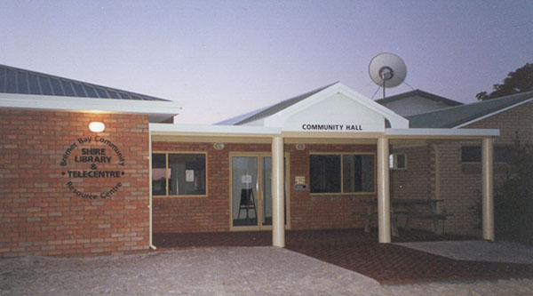I

Comments on specific programs
Newsletter
The production cycle for the monthly newsletter, The Bremer Bulletin, alternates with the local newspaper. The newsletter provides news and local activities information, a letters section and Shire Council news. Sponsorship of the newsletter by local businesses pays for its production.
Bremer Bay Achievement Group
This group was formed as a result of the Leadership courses ‘Bremer Way’ held in 1998. Participants felt the skills they had developed during the courses needed to be maintained to encourage a more positive community attitude. A catalyst for the formation of the Group was the depressed state of the local economy that created a sense of negativity in the local community. Group activities are designed to improve community spirit by doing things together, creating positive feelings about the community and identifying what the community can do to help move Bremer Bay forward to a promising future.
The role of the RCP coordinator has been to facilitate this group. The projects of this group – to foster a strong community spirit within the town and local region – have included Christmas carol singing, Christmas House lights competition, Australia Day Family Fun day incorporating a "Citizen of the Year" presentation, and a local four wheel drive rally. Members of this group have attended a regional Community Builders conference.
Seniors’ Program
Twenty-five active seniors (up to 50 sometimes) come to the Centre regularly every week. This is the most successful component of the RCP program. It involves recreation programs, health information and education, fitness enhancing programs. The seniors also provide volunteers for the Resource Centre.
Seniors’ computer and Internet club
The seniors’ computer and Internet club has not been successful as, understandably, seniors did not find this a relevant form of communication. However, provision of Internet services and education to other sectors of the community has found ready and widespread acceptance. A grant was received to purchase gymnasium equipment for the seniors. Physiotherapists suggested this was a way of increasing flexibility and muscle strength thus avoiding some of the physical problems associated with ageing.
Telecentre
There is a broad range of users including primary school children, mothers of primary-age children through to seniors. Instruction is provided on a one-to-one basis when required for accessing e-mail and Internet services. The Telecentre Coordinator offers in-home hook ups and support to local residents. Workshops have demonstrated to local rural women the advantages of using the Internet to access information, keep in touch with people and using ‘chat rooms’ for subjects of common interest.
Web site
A web site has been established: http://www.comswest.net.au/~bremertc/index.html. There are eight web pages describing local commercial service providers and tourist activity provision. There is a need for an expansion of the site to provide more tourist and eco-tourist information and increased emphasis on marketing the Bremer bay attractions. Currently the web site is two years old and a little ‘dated’. The site is to be updated in next three months.
Childcare facilities
It is planned to have a childcare area attached to the new Community Resource Centre. There have been expressions of interest from local women to become qualified carers. When the childcare facility is operational it will provide employment, albeit to a limited extent initially, to local women who are qualified. It will also enable mothers with small children the opportunity to pursue educational or general interest courses through the Telecentre, whilst their children are being looked after.
Conclusions
An overall assessment is that Bremer Bay Community Resource Centre has met the stated objectives of the project as proposed for RCP funding. In doing so it has identified, and effectively addressed, additional community needs beyond those originally proposed for funding via RCP. The Resource Centre has improved communication within the Bremer Bay area and the Shire of Jerramungup, made some inroads towards increasing education and alternative employment opportunities and significantly increased access to modern telecommunications.
In terms of the objectives of the RCP, the Bremer Bay Community Resource Centre is a successful example of the work of a relatively remote community which has been able to meet the challenges of the future through community identification of service needs and community ownership of service delivery. The Resource Centre has facilitated improved information services, strengthened community networks, and provided access to information services technology.
The suite of activities and the resources of the Bremer Bay Centre are funded by the RCP, State Government agencies, the local Shire and other sources. The staff supported by the RCP are key ‘social cement’ in ensuring the ongoing viability of a very significant community resource in a fairly remote, socially disadvantaged, location with very limited economic capacity to otherwise support such staff. Given current local economic conditions there are very limited alternative funding sources for supporting key elements of the project if RCP funding were no longer available. The project thus far has built significant community capacity and skills.

Central Western Queensland Remote Area Planning and Development Board Rural Financial Counselling Service, Queensland
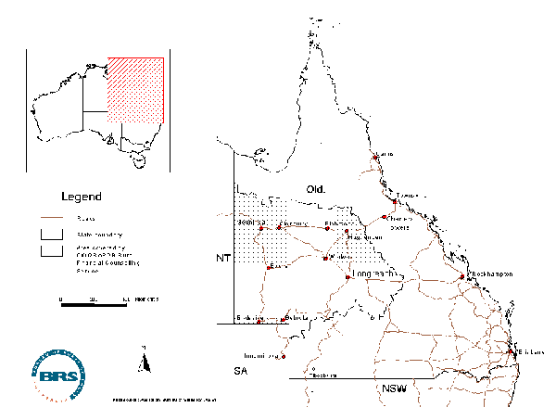
Heather J. Aslin

Applicant’s name: Central Western Queensland Remote Area Planning and Development Board Inc.
Amount received from RCP and other sources
Year | 1998-99 | 1999-00 | 2000-01
RCP | $120,000 | $120,000 | $120,000
Cash and in-kind | $119,750 | $119,750 | $119,750
Total RCP funding: $360,000
Project duration
The project extends from 1 July 1998 to 30 June 2001.
Project description
This counselling service, based in Longreach in central Queensland, is operated by the Central Western Queensland Remote Area Planning and Development Board (locally known as ‘RAPAD’). The service was established in 1995, and now employs two counsellors, one of whom started in the position approximately nine weeks before the case study visit). The service is based in the offices of RAPAD, centrally located in Longreach township (20 Swan St, Longreach, or PO Box 592, Longreach, Q. 4730). The premises are shared with a local accounting firm. The two counsellors travel extensively to speak to clients on properties in the area they cover, indicated by stippling on the map above. (It should be noted that the two counsellors prefer the term ‘rural financial adviser’ and use this description on their business cards, but ‘counsellor’ is used here for consistency). The area the counsellors cover in servicing clients is approximately 500,000 sq km, one-third of Queensland, and includes clients in 17 Queensland local government shires (Boulia, Dalrymple, Mt Isa, Etheridge, McKinlay, Richmond, Flinders, Aramac, Jericho, Barcaldine, Tambo, Blackall, Isisford, Barcoo, Ilfracombe, Winton and Longreach).
The administering organisation, RAPAD, is a limited liability, non-profit organisation established to promote regional development and provide community services, including training, computer and information services, policy and investment advice, youth services, and evaluative reviews. It is governed by a Board of Directors who also serve as the management committee for the financial counselling service. RAPAD seeks and obtains funding from a variety of sources, including State, Commonwealth and Local Government. It receives substantial support from Longreach Shire Council. RAPAD has a current project funded by Networking the Nation, and has installed telecentres in Winton and Barcaldine and a community access point in Muttaburra under this project. RAPAD has also had a previous RCP grant for community planning ($6,000) and used this to conduct a community consultation process to examine needs and issues in western Queensland. The report of this project was completed in May 1998.
RAPAD currently employs four staff, a chief executive officer, two counsellors, and an administrative officer. The Chief Executive Officer also serves as secretary and public officer for RAPAD. At the time of the visit, RAPAD also had two office trainees funded by a State Government program.
Membership of project management committee (RAPAD Board of Directors)
Mr Dougal Davidson Chair of Board and Mayor, Tambo Shire
Mr Neil Crotty Treasurer of Board, CEO representative Longreach Shire
Mr Gary Peoples Mayor, Aramac Shire Council
Mr Greg Horn Councillor, Barcaldine Shire
Mr Bruce Scott Mayor, Barcoo Shire
Mr Ron McGlinchey Mayor, Boulia Shire
Mrs Karen Ann Jorgenson Councillor, Boulia Shire
Mr Frank Keenan Community representative, staff member Longreach Pastoral College
Mr Pat Tanks Councillor, Longreach Shire (acting for Mayor, Mrs Joan Maloney)
Mrs Lesley Marshall Community representative, member of Desert Uplands Project
Mr Garth Tully Councillor, Diamantina Shire
Mr Michael Chuk Community representative, Longreach Shire Councillor, and staff member, Qld Dept of Natural Resources
Mr Ed Warren Councillor, Winton Shire
Mr Paul Smith Community representative, local business owner
Mr Scott Mead Boulia Shire, CEO representative
Mr Anthony Lyons Aramac Shire, CEO representative
Methods
Dates visited: 11-14 July 2000.
Relevant AFFA and DTRS files and databases were examined, and Internet searches done for information about the district. The databases contained information about another relevant project, the planning grant mentioned above. The offices of the Queensland Department of Primary industries in Ann St, Brisbane, were also visited on 10 July and interviews held with two staff members there.
The case study included visits to Longreach tourist information offices, Longreach Shire offices and public library, as well as the RAPAD offices. The two counsellors arranged a four-wheel drive tour of the area they cover, and visits to three client families on their properties. This included informal discussions with the families, each lasting about 1 hour. The tour covered approximately 960 km overall, and allowed the author to see a significant area of the country and the townships servicing the local population. The author also visited the Longreach offices of the Lake Eyre Basin Coordinating Group (another relevant non-government organisation involved with natural resource management) during the visit. In addition to more formal interviews, informal discussions were held with Longreach residents and Shire council staff.
Relevant documents and maps were collected during the visit, some of which are listed below.
DTRS currently has a remote communities liaison officer based in Longreach, operating from the offices of the Longreach School of Distance Education. The position is a pioneering one established on a trial basis to help coordinate Commonwealth funding and services to remote communities like those of central Queensland. This officer was also interviewed during the visit.
Interviewees
Longreach
CEO, RAPAD
Rural Financial Counsellor, RAPAD
Rural Financial Counsellor, RAPAD
RAPAD Board member, Longreach Shire Councillor, and Q. Dept of Natural Resources staff member
Staff member, Qld Office of Rural Communities (interviewed by phone)
DTRS Remote Communities Liaison Officer
Brisbane
Two staff members, Qld Dept of Primary Industries
Geographic and social profile of region
Geography and natural resources
Longreach is located on Thomson River and the Matilda Highway, 1,170 km by road north-west of Brisbane, and is a regional centre for inland Queensland. It lies in the Lake Eyre Catchment and the rivers of the region ultimately all drain south-west into the Diamantina, Cooper and Barcoo systems and towards Lake Eyre - none ever reaches the sea. The town is on the Tropic of Capricorn and is at approximately the same latitude as Rockhampton to the east. It has an ARIA score of 11.57, indicating it is extremely remote.
The climate of the area is arid to semi-arid with markedly seasonal rainfall. Little rain falls in winter, particularly in the northern parts of the region. The Longreach area is prone to prolonged droughts and has high summer temperatures. The mean minimum temperature in June is approximately 8ºC and the mean maximum in November 35ºC, but temperatures of over 40ºC are common in summer. Occasional light frosts occur in winter. Humidity is generally low.
Longreach lies in an area of mainly sheep and cattle grazing on undulating to flat areas of native pastures, although there is a small amount of irrigated agriculture, mainly growing of forage crops like sorghum and lucerne, where suitable water is available. Mitchell grass is considered by pastoralists to be one of the most desirable native pasture grasses. Much of the country is lightly timbered with acacia species (gidgee, boree), and other native shrubs like whitewood and leopardwood. Coolibahs grow along rivers and creeklines. Many pastoralists consider there is a ‘woody weed’ problem, particularly with the introduced prickly acacia (a South African species). These species tend to compete with the desirable pasture grasses and also make access difficult. Harvesting of wild kangaroos and pigs are significant primary industries in the area as well as stock grazing. Red kangaroos were particularly common in the area during the visit. Shooters must negotiate access with property owners or lessees, but do not receive proceeds from harvesting.
Availability of pasture for grazing animals varies greatly with the seasons, and during the visit, the country was in very good condition due to good rains several months previously that caused localised flooding and inundated the bridge over the Thomson River. In response to previous flooding, a new bridge over the river in Longreach is currently being built using State and Commonwealth funds, but even that was flooded temporarily. The river flows only seasonally and is mostly a waterhole approximately 11 km long near Longreach. The town itself obtains water from this river and from artesian bores, with both sources being reticulated.
Social profile
While the counselling service is based in Longreach, it covers an extremely large, thinly populated area. Longreach is, however, one of the larger towns the region and relatively central in relation to location of clients’ properties. Other main towns of the area are Mt Isa (the largest centre by far with a population of approximately 22,000), Cloncurry, Hughenden, Winton and Charleville, but there are many small centres often separated by hundreds of kilometres from their nearest neighbours. In the time available, it was not possible to visit all the other towns of the region, so this information focuses mainly on Longreach and its immediate surrounds. The town has a population of approximately 3,800, and the Shire of Longreach as a whole had 4,419 residents in an area of 23,517 sq km at the time of the 1996 Census. The population of the Shire appears to be increasing slightly.
The town was established in 1887 following initial pastoral settlement along the Thomson River. There is a history of establishment of relatively small pastoral holdings (approximately 40,000 acres) as this was considered a viable size at the time. These holdings are much smaller than those established in neighbouring areas of South Australia and the Northern Territory, and the need for property amalgamations remains an issue today. Properties include both leasehold and freehold, and freeholding is continuing. Before white settlement, the area was occupied by the Guwa Aboriginal people. However, it was reported that native title claims are not a major issue for pastoralists in the area at present. The town’s population is mainly of white European descent and Australian-born. Figures from the 1996 Census indicate that the Shire has 3,970 Australian-born residents, only 116 of whom were of Aboriginal and/or Torres Strait Islander descent. Only 231 residents were born overseas. Longreach has an image related to outback life and culture, outback exploration, the pastoral industry, and in particular is well-known as the site of the Australian Stockman’s Hall of Fame, a museum celebrating the pastoral way of life which opened in 1988.
Longreach is administered by Longreach Shire Council, with offices in the town’s main street. The Council is a significant local employer and provides technical (water and sewerage, parks and gardens, works, road and stock route maintenance), environmental health, administration, finance, youth and community development services. The Queensland Government is the major employer of townspeople, and offices of the Queensland Department of Primary Industries, and the Department of Natural Resources are located in town. Together these two Departments employ about 90 local staff. The Queensland Department of Education has about 120 employees based in Longreach. Other State Departments with local offices include Family, Youth and Community Care; Justice and Attorney General’s Department; Department of Environment; and Department of Transport. Commonwealth Government agencies with local employees include Australia Post, the Bureau of Meteorology, DTRS, the Plague Locust Commission, and the Aboriginal and Torres Strait Islander Commission.
The immediate area of Longreach is comparatively well-serviced, as summarised in the table below (indicative only, not comprehensive). Residents who were asked did not consider any major services were lacking.
Health care Longreach Base Hospital (five doctors), Flying Doctor Service, Longreach Family Medical Centre, ambulance and emergency services, Home and Community Care, Pioneers Nursing Home and Hostel, visiting immunisation clinics, Unicare Respite Care, dental clinic (one dentist), physiotherapist, occupational therapist, speech therapists (2), Aboriginal and Torres Strait Islander health worker, mobile women’s health services
Retail Range of retail services including two supermarkets/grocery shops, two butchers, coffee shops, restaurants, six clothing stores, electrical store, computer store, two pharmacies, tourist souvenir shops, two newsagents, video store, hardware store, variety store
Trades Electrician, plumber, building services
Professions Two legal firms, accountancy firms
Utilities Post office, police station, fire brigade, service stations, banks and financial institutions (ANZ, Commonwealth, National, Westpac, Primac Elders, Suncorp Metway, Pioneer Building Society) - 3 ATMs available, Council-run information office
Education One kindergarten, two pre-schools, Catholic College (to Year 7), Evesham State Primary School, Longreach State High School, Open Learning Centre, Annexe of Central Q. College of TAFE, Longreach Pastoral College, Longreach School of Distance Education
Transport McCafferty’s Coaches terminal, Flight West Airlines, Queensland Rail, specialised tourist transport and travel services, 2 car hire agencies, 3 taxi companies
Communications Regional radio stations (4QL and 4LG), Telstra and Optus STD and ISD services, mobile phone services within 25 km, four television channels received, local weekly newspaper (The Longreach Leader), local Internet server, public Internet access at library
Service /sporting Rotary, Lions, RSL, Zonta, Q. Country Women’s Association, wide range of sporting clubs
Religious Range of Christian denominations represented
Longreach has good transport links with Flight West Airlines providing a daily service to Brisbane. The airport was recently upgraded to allow jet aircraft to land as well as turboprop aircraft. Flying time to Brisbane is approximately two hours. McCaffertys Coaches operate a daily service to Brisbane and Mt Isa, and to Rockhampton three days a week. ‘The Spirit of the Outback’ passenger train arrives twice weekly from Rockhampton, and there are rail freight services as well. Roads are good during dry weather and the major routes are largely sealed.
Tourism is important to Longreach and the region, with major attractions including the Stockman’s Hall of Fame, the ‘Spirit of the Outback’ train journey, the Qantas Founders Outback Museum, dinosaur tracks and fossils at Muttaburra and Lark Quarry, and cruises on the Thomson River. There are 13 motels, hotels or lodges in the township; and three caravan parks offering caravan sites and on-site cabins. Some local sheep and cattle stations also offer accommodation for tourists.
Current issues
Socio-economic and natural resource management issues currently prominent in Longreach and its surrounding area include:

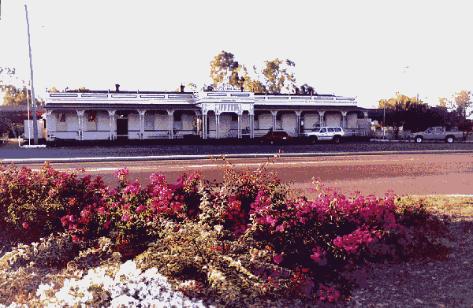
Longreach Railway Station
- relatively low commodity prices (beef and wool)
- need for consolidation of grazing properties to achieve economic viability
- land clearing regulations and effects on ‘woody weed’ control
- control of pest plants - prickly acacia, rubbervine, parkinsonia and mesquite
- better protection from and responses to flooding events (concern being expressed about inundation of the new bridge currently under construction over the Thomson River)
- improving telecommunications services and infrastructure.
Case study findings
The counselling service is exceptional in the extremely large area it services and the considerable time the two counsellors spend in travelling to clients’ properties. Each counsellor has a four-wheel drive vehicle (leased) and access to an expense account to cover accommodation and meals while in the field. Each also has a laptop computer to use to display financial information to clients (using the Quicken software package). They also use the standardised database to keep records of their work and provide reports to the RAPAD Board. Both current counsellors have backgrounds in the banking industry. In terms of office premises and administrative support, the counsellors seem to very well-placed within RAPAD. The advantages of being located within a well-known local organisation, with substantial project management experience and relatively stable staffing, are evident. This also provides economies of scale in terms of auditing of accounts. One previous counsellor, Mr Peter Whip, recently obtained a position with the accounting firm whose premises RAPAD currently shares, but the Chief Executive officer, Mr Lawrie Cremin, has occupied his position for six years and is well-known in the local community. The relatively large RAPAD Board, with strong local government representation, also may help ensure stability in project administration, and good community input.
The following table shows details of the numbers of clients the service has had since its inception (including figures from both counsellors), and location of clients’ properties by Shire:
Shire | Number of clients
Aramac | 37
Barcaldine | 9
Barcoo | 16
Blackall | 9
Boulia | 6
Dalrymple | 13
Etheridge | 2
Flinders | 80
Ilfracombe | 7
Isisford | 17
Jericho | 14
Longreach | 72
McKinlay | 13
Mt Isa | 4
Richmond | 15
Tambo | 7
Winton | 59
Total | 380

In the 1999/2000 financial year, the two counsellors between them saw 153 clients, 55 of whom were new for the period. This involved approximately 2,451 client contact hours, with total consultation periods with individual clients ranging from 30 mins to more than 40 hours. The majority of clients are primary producers on family-owned properties (estimated 90-95% of clients, with the remainder being small business people or individuals having financial difficulties). The major source of client income is beef production, with wool being a secondary source. Some clients are producing forage crops under irrigation, some are running bed and breakfast operations, and others are involved in farming goats or harvesting wild kangaroos. Clients generally have relatively high levels of equity in their properties, of the order of 75%; average assets in the order of $1.5 million; and average debt levels of around $350,000. They are thus ‘asset-rich’ but heavily dependent on a reliable income stream to service their debts.
In relation to demand for their service, the counsellors reported that the service had been advertised previously, but they were unable to cope with the resulting demand. They now rely on word-of-mouth referrals (particularly from banks). A brochure advertising rural financial counselling services generally (both State and Commonwealth-funded) was available at the RAPAD offices.
The counsellors have not sought formal evaluations of the service in the past (although they were drawing up a survey form at the time of the visit), but have not received any complaints. The clients with whom discussions were held during the case study trip clearly appreciated and valued the advice provided, although of course they had been selected by the counsellors as ‘satisfied customers’. The counsellors have received a number of unsolicited letters of support from clients, and the service has experienced a growth in demand during the five years it has operated. The view was expressed that it complements rather than competes with local banks, accountants and tax agents, and that RCP-funded counsellors have a good relationship and liaison with counsellors employed by the Queensland Department of Primary Industries in Richmond and Barcaldine.
Conclusions
The RAPAD Service, located as it is in an extremely remote and sparsely populated area, raised a number of interesting issues. They include:
- the questions of providing this kind of service in a pastoral area as opposed to a more densely settled agricultural area - is the current model the best way to provide this service, requiring as it does extensive travel time and travel costs for the counsellors?
- the question of client circumstances and assessing need - many of the pastoralists who were clients of this service were ‘capital-rich’, although it is appreciated that it is not always easy to capitalise on assets tied up in properties
- the great seasonal fluctuations in arid and semi-arid regions like western Queensland and their effects on clients’ incomes (both pastoralists and local businesses)
- the benefits of having services managed and administered by established community organisations, in this case with strong Local Government support
- the role of remote area liaison officers in the RCP generally.
Questions of sustainability of land-use practices arose in this case study, and the extent to which counsellors should be advocating or supporting particular land uses. There was some concern about expansion of irrigated agriculture - growing of forage crops - in this semi-arid region, and whether this should be encouraged on ecological sustainability grounds. It requires clearing of native vegetation (possibly contributing to greenhouse gas emissions and biodiversity loss), and diversion of water from rivers (in this case rivers of the Lake Eyre Basin). It is possible that by indirectly encouraging these activities, the Departments responsible for the RCP may be working against program goals in other Commonwealth agencies or elsewhere in their own agencies (for example goals related to ecological sustainability and maintenance of water quality in catchments).
Nonetheless, it was clear that the counsellors for this service were well-regarded in the community, and had clients who were strongly supportive. The service benefited greatly in administrative efficiency as a result of being located within RAPAD and being managed by its Board. This gave the service status and visibility that it might otherwise not have had. It also meant that it benefited from economies of scale and the experience of Board Members and the Executive Officer in managing other projects. The strong representation and support from a range of Local Governments was clearly a major asset to this service and contributed to economies of scale.
References
Cremin, L. (1998) Rural Communities Program Community Consultation Report. RAPAD, Longreach. May 1998.
Longreach Shire Council Library (n.d.) The Longreach prospectus. Unpublished report. Longreach Shire Council, Longreach.
Longreach Shire Council (1999) Longreach Shire Council Annual Report 1997-1998. Longreach Shire Council, Longreach.
Queensland Office of Economic and Statistical Research (1999) Regional profiles. Central West. http://www.statistics.qld.gov.au
RAPAD (1999) 7th Annual General Meeting. Longreach, 22 November 1999. RAPAD, Longreach.

Discussion and recommendations

The research reported here enabled the evaluation team to obtain a wide range of background information and views on the RCP. It became clear early in the evaluation that the financial counselling services were the most controversial element of the program and perhaps the area where most change was needed. This was revealed partly by the apparent concern of some rural communities that these services would be discontinued. In the case of RCP-funded projects, these community issues were particularly apparent because of the strong sense of community ownership engendered by the ‘bottom-up’ approach, and because this approach has contributed to building social and human capital in rural communities as well as funding individual projects. Many rural communities are now extremely effective in making their own case for continued funding of projects and services. This in itself is indirect evidence of the success of programs like the RCP.
However, the evaluation has been based largely on information from communities and community members who have been successful in obtaining funding. The evaluation did not include a survey of those who have been unsuccessful, let alone those who have never applied, nor did it include a wider needs assessment for rural communities (although in some cases the successful communities had done assessments in their own areas). This is an important aspect that needs to be borne in mind in weighing up this evaluation’s findings and recommendations. Some of the information presented here, including the mapping of RCP-funded projects against ARIA and SEIFA scores, as shown in Maps 1-19, highlights distributional and equity issues related to needs assessment for rural and regional communities. The communities that in many cases are suffering the highest relative socio-economic disadvantage and can perhaps best make a case for additional government support, are the remote and isolated communities of the inland. This includes many indigenous and non-indigenous communities in the Northern Territory, and inland Western Australia, South Australia and Queensland, who live in SLAs which have low SEIFA scores (see Map 1). Few RCP projects are being funded in these areas, and presumably few applications come from these communities (one indigenous-run project based in Wyndham was mentioned by interviewees). The evaluation team is aware that other funding sources are available to indigenous communities living in rural and regional Australia. It has not examined the scope of these programs to see how similar they are to the RCP.
Therefore, there is an important question remaining about whether the program has reached the most disadvantaged rural communities. It is unreasonable to expect communities where projects are based, or their project staff and management committees, to attend to this aspect or even to be concerned about it necessarily. They achieve their objectives when they obtain funding for their projects and communities, and deliver on their projects. It is not their responsibility to consider overall program objectives and whether they are being met – these must be addressed by policy-makers and government. This is where possible tensions between rewarding community entrepreneurship and addressing social disadvantage become evident. Any competitive funding process that depends to some extent on the quality of community applications is almost inevitably going to favour those communities that already have good social and human capital. Others may never apply or may be unsuccessful in their applications. The evaluation team was advised that RCP staff attempt to address these inequities by providing substantial advice and assistance to potential applicants, and by encouraging those community members who make initial inquiries to submit applications. The Advisory Committee and program staff base their assessments as much as possible on the potential benefits that may arise from the project, but of course it may be difficult to assess benefits if appropriate information is not provided in applications. The evaluation did not include assessing the success rate of applications, but Steering Committee members advised that it is of the order of 70%, which is likely to be relatively high for a program of this kind.
Supporting concerns about distributional effects, are the data presented in Table 6 showing that over the 1998-99, 1999-2000, and 2000-01 financial years, 36.3% of total RCP funding (excluding the small community planning grants) went to projects based in New South Wales, only 3.7% to Tasmania, and 0.04% to the Northern Territory. In the case of the Northern Territory, this no doubt partly reflects availability of other funding sources for indigenous communities, as mentioned above. However, it would be hard to argue that the funding distribution matches disadvantage or development need in rural and regional Australia, although it does reflect to some extent total population in the different States and Territories. Nonetheless it could be argued that it may be the people in the most sparsely populated areas that have the greatest need for assistance, and some reports documenting rural and regional disadvantage point out that it is inland communities that have been experiencing the greatest population declines in recent years (Haberkorn et al., 1999; NATSEM, 2000). Distribution of RCP funding may not be a serious issue if sufficient funding is available from other programs, including those with a stronger needs-assessment basis.
Nonetheless, there is concern that programs like the RCP, while succeeding in building social and human capital, and improving access to services in some places, may be contributing to greater social inequality in the bush overall. Commonwealth Government has a responsibility to attend to national issues like these in its funding programs, and also to take account of the fact that rural communities have objectives of their own that only partially correspond with Government’s policy and program objectives. Community members’ loyalties and accountability are primarily to fellow community members, while Government’s accountability is to the citizenry as a whole.
A recent project has been completed on access to services for DTRS (Haberkorn and Bamford, 2000). The results of this project, together with other existing data about relevant service availability in rural and regional Australia, could be used to help develop regional priorities for service provision components of the new program. Similarly, other regionalised socio-economic data (population trends, income, educational levels) could be used to develop regional planning and development priorities for other program components. Some regional development boards and local governments have already carried out analyses like these for their own areas, and State planning and regional development authorities have similar information at a State-wide level to feed into national priorities.
An example of the way regional priorities could be developed is by using data presented in Haberkorn and Bamford’s report for access to rural financial counsellors. These authors find that in Australia as a whole, 7.7% of the population lives more than 80 km from their nearest rural financial counsellor. The highest proportions of the population living more than 80 km from a counsellor occur in the Northern Territory (47.8%), Tasmania (24.1%), and Western Australia (18.5%). A priority call for applications to establish new rural counselling services could be made in these geographical areas or regions within them, and a targeted communication campaign mounted to develop applications fitting the priorities. Recognising the need for indigenous-run services, particularly in the Northern Territory and Western Australia, in consultation with ATSIC, specific indigenous communities, Aboriginal Land Councils or other appropriate bodies could be approached to prepare funding applications tailored to suit their circumstances and their enterprises.
Similar priorities could be developed for other RCP components, depending of course on the availability of relevant national and State data relating to the projects or services included in each component. In this way, regional priorities could both respond to disadvantage as identified nationally, and allow local communities in disadvantaged areas to tailor services to their local needs. State and regional assessment panels could also be involved in priority-setting as applied to their geographical areas. This would minimise the possibility that priority-setting is seen as a ‘top-down’ process.
Equity concerns are perhaps most acute in the case of the financial counselling component of the RCP. For this component, the Commonwealth’s ability to examine and manage distributional and equity aspects is still further weakened – it has been funding community groups to provide services to fellow community members, and committing funding to them over longer time periods than for the other components. Over the time some of these services have existed, the situation in rural Australia has changed greatly. AFFA has not had specific needs or assets criteria in place for assessing clients’ eligibility for these services, unlike many comparable social welfare programs run by other Commonwealth agencies (ABARE, 1997).
These points are in line with Schaffer’s (1995) stress on the need for conscious policy efforts to achieve equity in community development and community support initiatives. They also recognise that rural communities have greatly-varying levels of social and human capital, as well as financial capital. Without targeted government policies and programs, these inequalities are likely to continue and perhaps even to increase. Equity, both within and between generations, is a key plank of ecologically sustainable development and therefore needs to be addressed in all Government programs that aim to build sustainable communities or industries (Commonwealth of Australia, 1990; Council of Australian Governments, 1992).
The evaluation raises other policy issues that the respective Departments and Ministers responsible for the RCP and its successor may need to consider. Is the program still consistent with the Commonwealth Government’s role in rural and regional Australia, and policy and legislation underpinning this role? The current Government has made a commitment to assist rural communities and to address disadvantages in their access to services. These commitments were re-stated by Minister Anderson in announcing the new Regional Solutions Programme (Anderson, 2000). In these announcements, the Minister supported the program’s flexibility and stressed its role in strengthening social structures, and building community capacity and economic bases. While it is not clear to what extent the Regional Solutions Program is intended to be the successor to the RCP, the current program is consistent with these commitments in providing funding to rural communities to plan and develop future options, and develop and apply their own models of service provision. So, in these respects, the RCP’s goal (at least as far as the community planning, community development, information provision, and information services technology components are concerned), aligns well with current policy as well as with the major recommendations of the 1999 Regional Summit.
1 Program performance
1.1 The extent to which the program has achieved its objective
Because of the considerations mentioned above, the evaluation team believes it can respond to the question of whether the program has achieved its objectives, and whether it is effective and efficient, with only a qualified ‘yes’. The program’s goal is expressed extremely broadly, and there are no specific objectives for the various program elements, making it virtually impossible to answer this question in regard to the overall program.
There is little doubt that RCP funding has produced good results for some rural communities, and that these communities strongly supported the program and its underlying model. Questionnaire results showed that 66.1% of respondents believed there was strong community support for RCP-funded services, and a further 31.0% indicated moderate support. The successes described in case studies like those of Dover and Bremer Bay indicate that RCP funding has produced good results and built social and human capital in communities and among project staff and management committee members. In some cases, comparatively small amounts of money have produced excellent outcomes and led to the communities concerned developing and completing further projects. But a comprehensive framework is not in place to determine whether Australia’s rural communities overall have become more ‘diverse, dynamic and self-reliant’, nor whether rural industries generally have become more ‘profitable and sustainable’. The overall structural changes taking place in the Australian economy, and the relative decline in the economic importance of agriculture to rural communities, demonstrate that Government programs always take place in a wider socio-economic context that is to some extent outside the capacity of national governments to influence. This is also recognised in a report by the Productivity Commission (1999) that concludes that broad, long-term economic forces beyond the control or influence of governments have been the key drivers of economic and social changes affecting country Australia. Even if a more comprehensive framework existed to assess the overall situation of rural communities, it is impossible to separate out the effects of one Commonwealth program from all the other programs and policies affecting rural Australia, and possibly contributing to or detracting from achieving the RCP’s goal. The question of goals and monitoring and evaluation frameworks is considered further below.
In terms of the success of the various program elements, a lack of specific objectives for each of these elements also makes it difficult to assess performance. However, in relation to the general statements of the aims of the various elements that is part of RCP guidelines, it was apparent that appropriate kinds of projects are being funded under each of the elements, and funds are being expended in accordance with the generally-stated descriptions of the different elements.
The policy basis of the program needs to be established before goals and objectives can be specified. Questions about goals can be asked of all components of the current RCP, and all would benefit from a clear goal statement and an accompanying set of objectives.
To respond to the difficulty of assessing program performance, and distributional concerns about program funding, the evaluation team considers that these objectives need to include regional priorities for each component of the new program.
Regional priorities are further justified by the emerging picture of great variation in the socio-economic circumstances of rural and regional communities, as discussed in the Introduction, and the rapid pace of change. The need for regional priorities was recognised at the Regional Australia Summit (1999), with the qualification that rural and regional communities needed to be involved in setting these priorities. The Commonwealth Government, however, needs to maintain a national overview. Regional and State panels could be involved in setting regional priorities for the RCP’s successor, and perhaps reviewing them on an annual basis.
The evaluation team recommends that a clear and specific program goal statement is written for the new Regional Solutions Programme together with specific objectives for each program component. The goal should be clearly related to the policy basis for the new program. The team also considers that a set of regional priorities and objectives is an important part of the new program to enable specific objectives to be developed and program performance to be monitored against objectives.
A further set of issues connected with the questions of whether or not the RCP is achieving its goal, relate to sustainability. Sustainability is mentioned in one of the criteria for assessing project applications, and is part of the goal statement in the form of ‘sustainable rural industries’. Many projects are of course not intended in their own right to be sustainable - they have a specified time frame and completion date. However, to build sustainable rural industries, projects need to produce lasting outcomes or support socially and ecologically sustainable activities. Interviews and written submissions produced a number of reports about how RCP-funded projects had led to other community initiatives and in this sense had produced outcomes lasting well beyond the duration of individual projects. For example, the submission from the New South Wales Association of Rural Counselling Groups included a list of 34 other projects that it considered were initiated or facilitated by New South Wales rural financial counselling services.
1.2 The efficiency and effectiveness of the performance of community groups in administering projects and influencing community development
This question can only be answered in a relative way, and as management of projects by voluntary community committees is an integral part of the RCP’s model, it is probably most useful to ask what factors might improve the performance of community groups rather than trying to assess their performance against an arbitrary efficiency standard. Arbitrary standards are probably inappropriate for community volunteers and project staff working in highly varied situations that are not necessarily comparable to government offices.
The evaluation team obtained reports of variable performance by community groups from interviews and written submissions, but did not attempt to quantify this aspect of the evaluation. Case studies such as the one of the Mildura Rural Counselling Services provided evidence of the substantial voluntary inputs made by members of management committees, and one written submission valued the contributions of committee members at $10,500 per group per year. The program would cost Government a great deal more than it does if these contributions were not made voluntarily. In its written submission, the Queensland Department of Primary Industries considered that more than 50% of the management committees for rural counselling services in Queensland were efficient.
The Kangaroo Island case study revealed some of the difficulties experienced by community groups in finding suitable office premises - a factor that undoubtedly affects efficiency and effectiveness. The Dover case study showed that providing suitable premises in the form of the restored Dover Old School was an important factor in allowing future community projects to proceed. The Longreach case study provided evidence of the advantages of a having an established community organisation (the Central Western Queensland Remote Area Planning and Development Board), with a relatively high profile and good Local Government support, as the administrative organisation for RCP projects. Similarly, in the Kangaroo Island case study it appeared that the local Regional Development Board would be an appropriate organisation to administer RCP projects; and that this would achieve economies and efficiencies by using existing infrastructure and administrative support, as well as aiding integration with regional planning initiatives.
The problems associated with the AT-LAS database showed that some financial counsellors and their staff have difficulties in using this database and providing reports to program staff. This is an efficiency aspect that could be improved by better design of reporting systems and appropriate training for project staff. More generally, one-fifth (22%) of overall questionnaire respondents indicated they had difficulties in fulfilling the reporting obligations accompanying RCP funding.
Questionnaire responses highlighted other factors related to efficiency and effectiveness of community groups. For example, many respondents indicated that they had difficulty in attracting and retaining committee members. The main reason given was that community members were too busy (91% of respondents who indicated they had difficulties identified this as the main one). Similarly, 17% of questionnaire respondents indicated they had difficulty in attracting and retaining project staff. The main reasons given were remoteness, poor working conditions, and lack of skilled individuals in the community. Staff turnover and the stress experienced by financial counselling staff, in particular, emerged as issues in the Kangaroo Island and Mildura case studies, even though Mildura is a large regional centre.
It was also evident to evaluation team members during case studies that some projects lacked the basic infrastructure and administrative support to enable them to operate efficiently, or to provide an acceptable working environment and career development opportunities for project staff. The Regional Australia Summit recognised infrastructure issues in recommending ‘Investing in Regional Infrastructure’ as a major element in addressing regional disadvantage for both indigenous and non-indigenous communities (Regional Australia Summit, 2000). Lack of infrastructure and administrative support contributes to variable performance of staff and committees despite their best efforts. It also appears to contribute to relatively high turnover among project staff, although this may in fact be evidence of the success of the human capital-building aspects of the RCP. It appears that project staff in some cases become key community ‘resource people’ and subsequently take on other important community roles, contributing to overall community development.
The evaluation team recommends that applicants be encouraged to identify existing bodies and organisations as project management committees wherever possible, and that wherever appropriate, regional development boards or other relevant local organisations with access to offices, office equipment and professional administrative staff be asked to take on this role.
1.3 Identify performance measures and indicators suitable for incorporation into ongoing monitoring
Programs can only be monitored and evaluated if they have specific and measurable objectives logically related to their goal. The current RCP does not have these. In the case of a broadly-based program like the RCP, different objectives need to be developed for different program components, and they in turn need to be teased out further to reach the level at which appropriate performance indicators and measurements can be identified. Program staff and policy makers, in consultation with the new Advisory Committee, need to develop and apply this framework for the program. Parts of the framework have been identified in this report, but they need to relate logically to the goals and objectives for each component of the new program.
At the overall program level, while it may be extremely difficult for the Advisory Committee to assess progress towards a broad goal of building rural Australia’s social and economic base, it may be useful for them to be presented with regularly up-dated, regionalised information about trends in rural Australia e.g. population, income, numbers of small businesses, performance of major agricultural sectors. Up-dates of some of the kinds of information presented in the recently-produced social atlas of rural and regional Australia (Haberkorn et al., 1999) could form the basis for this scene-setting and broader overview, as well as help guide regional priority-setting, together with updated and appropriately-analysed information from other national data available from agencies like the Australian Bureau of Statistics.
The evaluation team recommends that a performance monitoring and evaluation framework be developed at the program component level, addressing regional priorities for each component. This framework should require regularly updated maps or tables to be presented to the new advisory committee showing:
- geographical distribution of numbers of applications and funded projects for each program component
- numbers of applications and funded projects for each component against ARIA and SEIFA scores
- numbers of applications and funded projects for each component against regional priorities for that component.
The Advisory Committee could then take this information into account in assessing new rounds of applications, and targeted strategies could be developed to address any emerging discrepancies between submitted or successful applications, and regional priorities for that component. The equity and distributional aspects of the program discussed above could then be monitored and adjustments made.
Written submissions contained a range of suggestions about monitoring various elements of the program, particularly financial counselling services. While these are at the next level of detail down from monitoring the performance of the program as a whole, they could be taken into account in setting up the new program.
There is another element of the monitoring framework, which is at the project level. As the RCP is a community-based program, it is appropriate to ask communities to be involved in monitoring outcomes. Their appropriate role is in relation to the projects for which they submit applications and which they manage if successful. Community members are the best people to identify ways to measure project outcomes in their communities. This monitoring needs to go beyond project milestones and timetables to examine community outcomes and relate them back to the objectives for the appropriate program component. An excellent guide to participatory evaluation that could help in this respect is available from Greening Australia (Woodhill and Robins, 1998).
The evaluation team recommends that all applicants be required to develop a monitoring and evaluation framework for their projects, and that successful applicants be required to report back to the Commonwealth against this framework. The framework for all projects should include measures of success and sustainability (social, economic, ecological).
New program guidelines and relevant Internet sites could include information and references to material that would help communities develop these frameworks in a consistent way but as applied to their particular circumstances. Developing monitoring frameworks could in itself be an important capacity-building aspect of the new program. As part of developing the new program, DTRS and AFFA could identify appropriate training providers and organise a series of regional workshops or training courses to help communities develop and report against monitoring frameworks. Figure 21 outlines the suggested monitoring framework.
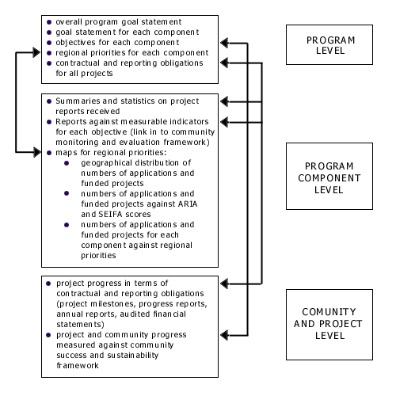
Figure 21 Main components of a suggested monitoring framework for the RCP
1.4 determine factors related to project success or non-performance
Some factors related to project success have been discussed in addressing community groups’ performance in managing projects - an important contributor in determining whether or not projects are successful in achieving their stated aims. Written submissions also addressed this term of reference. Factors mentioned included: quality and enthusiasm of staff and committee members, continuity of committee membership, appropriate appraisal and reporting mechanisms, networking ability and links with related programs, opportunities for continual education of staff and committee members, support from Local and State Government organisations and other key stakeholders, ‘community ownership’, flexibility and ability to respond to emerging community needs, and formation of an ‘umbrella’ organisation to administer projects, with a paid executive and a board of directors. It is clear that many of these factors relate directly to the people involved in submitting, managing and carrying out projects.
Case studies raised several issues relevant to this term of reference. The problem of community members being ‘too thinly spread’ was an issue in the Mildura and Kangaroo Island case studies. Small communities may have few potential members for project management committees or for positions as project staff, and these few people may have multiple community roles. This detracts from their ability to put time into managing projects or staff, and may also create conflicts of interest. The case of a project staff member serving as the treasurer for the project management committee was mentioned in the Kangaroo Island case study, for example. Multiple demands may also make it difficult for committee members to keep track of the details of projects or to manage staff effectively. In administering the questionnaire in this evaluation, for example, the team found that a significant percentage of the nominated Chairs of management committees did not feel able to answer questions about the project they were managing, and some of these Chairs referred the questionnaire to a project staff member. (Exact percentages of these referrals could not be obtained as some referrals to other people were due to changes in Chairs or incorrect contact details.) This raises questions about the extent to which voluntary management committees are able to effectively manage projects and staff when they work elsewhere and have limited time available to perform their roles.
Similar points were also made in the written submission from the Queensland Department of Primary Industries, which suggested among other things that successful financial counselling projects are run by groups that manage several projects (thereby achieving economies of scale and building expertise among committee members); are run by committee members, not project staff; and have committees that do effectively manage the counsellors.
Other factors raised in written submissions related to project success also concern the community members involved, and in particular that these members are motivated by a desire to achieve community benefits, not individual agendas.
Government administration also influences project success. Factors identified in the questionnaire and in written submissions included the split of the RCP between AFFA and DTRS and the difficulties this had created for administrative staff and project personnel; lack of coordination and integration between State and Commonwealth Departments; short project time frames and lack of certainty about continuing funding, particularly for financial counselling services; time for funding decisions to be made; limited funding time frame for components other than rural counselling; and lack of funding for project management.
Evaluation of the Rural Communities Program, Discussion and recommendations, Future directions and options for change
2 Future directions and options for change
2.1 The identification of any appropriate adjustments and the future direction for the program
Program model
The evaluation identified issues relating to the current program model. While rural communities expressed strong support for the basic model, actual or potential problems were evident in coordination with State, regional and local authorities and the services they provide. This was apparent in the Kangaroo Island case study where the Council-funded library was providing very similar services to the RCP-funded information officer; and in the Mildura study with the regional coverage of different financial counselling services. It was also apparent in the Longreach study in inconsistencies and potential duplications between State- and RCP-funded financial counselling services in the region. State Government staff consulted were dis-satisfied with their role and the lack of feedback from the Commonwealth. It was apparent from questionnaire responses that State and Local Governments make substantial financial contributions to many projects, but have limited involvement in decision-making and lack an overall formally-identified role in assessing applications. This arises partly because of the diversity of projects funded by the RCP and the fact that applications may be relevant to a range of State agencies; and because of the wide geographical spread of applications, they may be relevant to a range of Local Government authorities. These observations strengthen the need for a regionalised and systematic approach to establishing program priorities and assessing applications.
The evaluation team suggests that consultation issues could be addressed by using a staged assessment process for applications, which could also help in developing and implementing regional priorities for the new program. A similar model to that used for delivering Natural Heritage Trust funding could be applied, with ACCs taking the place of the Regional Assessment Panels for the Natural Heritage Trust. Where possible, these existing panels should be asked to take on this new role rather than new ones being set up for the Regional Solutions Programme alone. These panels should have the opportunity to comment on all applications in their geographical area. This would help provide a consistent assessment and feedback framework that would help ensure that State and regional considerations are better-integrated into the process, and that potential duplications or conflicts in providing projects or services are avoided as much as possible.
The evaluation team recommends that the new program incorporate a clearly-articulated, staged process for assessing applications and providing feedback on results of funding rounds back to State and regional level. The process should incorporate formally-identified state assessment panels with appropriate State Government representation, and regional assessment panels with Local Government and regional development organisation representation. These panels should be involved in developing regional priorities for the new program and assessing applications, and should receive direct and timely feedback about outcomes of funding rounds.
This model is depicted in Figure 22. The evaluation team recognises that a staged assessment process can potentially create additional delays in processing
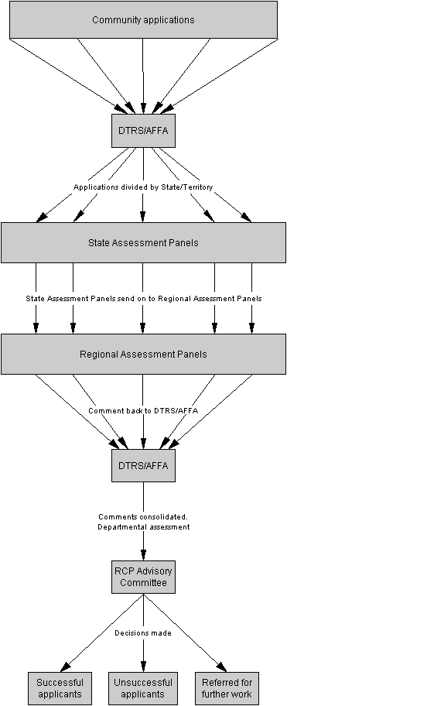
Figure 22 Suggested three-stage process for assessing RCP applications
applications, but suggests this can be minimised by using e-mail, tele- or video-conferences if necessary to avoid the need to convene face-to-face meetings. In practice, because program staff already consult a range of State agencies and ACC’s, this staged process is unlikely to place significantly greater burdens on staff or require significantly more time.
This model for program delivery and the need to develop regional priorities suggests there may be good justification for Commonwealth remote area liaison officers being appointed more widely. Officers like these could have an extremely valuable role in relation to the RCP’s successor and other related Commonwealth programs.
The evaluation team recommends that consideration be given to exploring the role of Commonwealth remote area liaison officers as an integral part of the new program.
Remote area liaison officers could:
- assist program staff and the program advisory committee in developing regional priorities
- assist communities in preparing and submitting applications
- assist in organising meetings of assessment panels and obtaining comment from State or regional assessment panels
- provide on-going advice to communities about project issues
- assist in liaising between Canberra-based staff and project staff
- help implement the program communication strategy in conjunction with local media and local Members of Parliament
- help implement a program training strategy in collaboration with local education and training providers.
A remote area liaison officer has the possibility of being or becoming part of the community and becoming a ‘resource person’ in a way that cannot be achieved through occasional visits by Canberra-based staff (which is not to say that these visits should not continue). However, locations for these liaison officers and staff to fill the positions would need to be chosen with great care. ARIA scores could be used to help decide locations.
Policy issues
The nature of a bottom-up program like the RCP means that projects may not fit neatly into pre-established government categories and each may serve a variety of community purposes that are hard to relate directly to specific Departmental roles or government’s policies for particular sectors. While beyond the scope of this evaluation to some extent, this raises policy issues about the appropriate placement of broad programs like the RCP and their relationship to Departmental boundaries. The question of where a successor program to the RCP should be based has in a sense already been resolved by the announcement of the new Regional Solutions Program by the Minister for Regional Services, Territories and Local Government (depending on the extent to which the Regional Solutions Program is intended to succeed the RCP). However, whether AFFA has a continuing role needs to be considered by policy-makers in relation to AFFA’s goals and objectives.
The policy basis for the financial counselling component is not entirely clear. Some economists argue against government intervention in agricultural markets for equity and welfare reasons, and suggest there is a trade-off between economic efficiency and equity. They argue that government assistance should be through the welfare system where eligibility is independent of occupational category (McColl et al., 1997). On the other hand, there is evidence from the social capital literature that better-trained or more highly qualified farmers run more profitable farms (Kilpatrick, 1996). So, if financial counselling helps build farmers’ and farm families’ business planning and financial skills, it may contribute to farm economic viability and the overall profitability of the agricultural sector. These are important issues for the goal and objectives of the financial counselling component of the RCP – is it welfare, training or community development? Or all three? The answer to these questions will help decide how best to manage this component in the future, without necessarily requiring that it serve only one kind of objective. As welfare, training or community development, financial counselling may well have a legitimate role in an appropriate Departmental and program context with an appropriate goal and objectives.
The evaluation team recommends that AFFA and DTRS and their respective Ministers, take into account the McColl report’s decision principles for government intervention in rural adjustment in deciding the goal and objectives of the RCP’s successor, and in deciding the future of the financial counselling component of the current RCP.
It was clear to the evaluation team that the current financial counselling component does not fit well with the rest of the program, and whatever its future, in its current form it should not be part of the RCP’s successor. Judging by the case studies and written submissions, there is strong community support for these services, and some communities feel they are essential. However, as mentioned above, the evaluation team considers it is not appropriate for the Commonwealth to continue to fund them in their current form. Some of these reasons are at the policy level, others relate to inadequate evidence of continuing need for these services, and others relate to social equity. Other reasons relate to the nature and form of these services, which appears to require much more detailed specification than other components. Required skills and qualifications of counsellors need to be specified and they need to follow clear performance criteria in providing services, and refer clients to other kinds of services if requirements go beyond their professional skills. The need for detailed specifications arises because of the sensitive and confidential services financial counsellors provide, and the possibly serious implications for clients and the services themselves if bad advice is given. The Mildura case study showed the stress counsellors may experience and their need for professional and emotional support in their roles. In addition, the evaluation team believes that tests of client need or eligibility for services are required for equity reasons (this is discussed further below). All these factors suggest that financial counselling services need much tighter specification and management than other program components, and may require professional management skills beyond the abilities of community volunteers to provide. Community members of management committees for financial counselling services may be exposed to unreasonable risks and have unreasonable expectations placed upon them.
The evaluation team recommends that any new financial counselling component of the RCP’s successor be administered independently of the other components of the new program if it is to continue to be oriented towards providing needs-based financial counselling for rural people experiencing current financial difficulties.
Financial counselling applications have been assessed against the same criteria as for other RCP components, and from the evidence of SEIFA scores, services are generally located in relatively disadvantaged areas (83.9% of counsellors were in SLAs with SEIFA scores below the national average). But unless there are well-thought-out criteria for assessing client need, applied to services Australia-wide, there is a real risk that there will be substantial and possibly increasing disparities between the financial circumstances and neediness of clients using different services. Also, without common criteria, real community need for services is extremely difficult to assess. Client numbers are not sufficient evidence to establish relative need in different locations, particularly when it is evident that counsellors in different locations are providing different types of services and using different descriptions for them (‘adviser’ versus ‘counsellor’ for example). Questionnaire responses supported the view that clients of RCP-funded services are not necessarily facing crisis situations any more – a large majority of responses to the statement ‘My organisation only deals with individual in crisis situations’ were in the ‘disagree’ or ‘strongly disagree’ categories. In addition, the questionnaire highlighted the fact that services are provided to clients who, in the opinion of the respondents, could afford to pay private sector providers.
Details of clients using current financial counselling services were not as good as the evaluation team would have liked, and obtaining these does of course raise questions of confidentiality. But there was doubt, for example, about whether owners of large pastoral properties, who on average had substantial capital assets and high equity in their properties, could be seen as needing on-going, free Government-provided financial advice. However, they may need assistance during drought periods when incomes are low. In the case studies reported here, there was some evidence of real financial hardship in the Victorian Mallee and Western Division of New South Wales, and on Kangaroo Island, South Australia. It is extremely difficult to make comparative judgements without good financial information about client circumstances. ‘Need’ is also a relative term, and many rural people have a strong attachment to their land, their local communities, and the rural way of life. This makes it very difficult for them to contemplate change even when their financial circumstances are difficult.
The evaluation team recommends that any new financial counselling component of the RCP focus on agricultural and social adjustment rather than attempting to meet development or welfare objectives. Any financial counselling component of the new program should be responsive to changing circumstances and the changing regional needs for government-supported adjustment assistance.
Because of the uncertainty faced by current staff of these services and their management committees, DTRS and AFFA could investigate the possibility of extending current contracts while the future of the services is decided and appropriate arrangements made. Overlaps with similar services need to be further investigated and better tests of need for services identified and applied.
The evaluation team recommends that because of the uncertainty faced by current financial counselling services, that a twelve-month lead-time be allowed to indicate changes to program direction and establish the future form of these services.
There is a range of possible options for the future of these services, some of which were mentioned in written submissions. They include:
- maintaining the status quo (not favoured by the evaluation team for the reasons outlined above)
- establishing a new program to fund rural financial counselling services (either within AFFA or DTRS)
- investigating delivery of current services by the States
- investigating delivery of current services by another Commonwealth agency e.g. Family and Community Services
- introducing a voucher or referral system for clients to go to other providers (government or private sector)
- investigating gaps in access to financial counselling services and need for these services throughout rural and regional Australia, and letting competitive tenders or grants for providing services in priority locations.
Various combinations of these options could be used according to circumstances in particular States or regions.
While many specific issues arose about financial counselling services (e.g. level of cash and in-kind contributions, performance measures and standards, counsellor qualifications and skills, database issues and reporting requirements), these are at a level of detail not appropriate to consider further until delivery options are investigated. Some of these details would need to be part of any agreements entered into with other agencies to provide services, or part of tender documents.
Sustainability
Some aspects of the social sustainability of RCP-funded projects have already been discussed. However, the evaluation team was concerned about the ecological sustainability of some projects and activities being supported indirectly by the RCP. An example was a counselling service client in the Longreach region expanding into irrigated agriculture by diverting water from a local river. Sustainability of government funding was also an issue for communities themselves and particularly for financial counsellors. The Commonwealth is entitled to ask questions about the social, economic and ecological sustainability of its program and projects as well as needing to consider what the impacts on communities may be when its programs end. This is for efficiency and welfare reasons; because the Commonwealth is responsible for setting national standards; and because some activities funded may have implications for trans-border and trans-national environmental issues like salinity, water quality, greenhouse and biodiversity for which the Commonwealth has responsibility and which need ongoing attention. Both Commonwealth and State Governments have made commitments to ecologically sustainable development, as have many industry sectors and Local Governments (Council of Australian Governments, 1992; Commonwealth of Australia, 1990).
For these reasons, there are valid questions about whether the current RCP is achieving socially, economically and ecologically sustainable outcomes.
The evaluation team recommends that the new program include in its goal statement and objectives, specific reference to sustainability (social, economic and ecological), and that sustainability issues be given higher priority in program guidelines, criteria for assessing projects, and in the monitoring and evaluation framework.
Integration and coordination issues
Integration and coordination of government programs emerged as a significant issue during this evaluation. It is a concern shared by both communities and government. While moves have been made to provide common access points and sources of information about government programs, much remains to be done in this area. It is an ongoing problem exacerbated by constant re-badging, re-grouping, and re-naming of departments and programs as well as new policy and program initiatives. Use of the Internet has helped to some degree, but issues of coordination and integration are not easy to solve.
The evaluation team recommends that staff of the new program investigate how better integration and coordination can be achieved with related government programs, and how information about the new program can be disseminated through existing government agencies and networks, particularly Centrelink and Countrylink.
Monitoring and evaluation
Specific aspects of program monitoring and evaluation have already been discussed, and in particular, questions raised about equity and distributional aspects of previous program funding decisions. They lead to the following recommendation for the new program:
The evaluation team recommends that the performance monitoring and evaluation framework for the new program specifically addresses equity aspects of program funding, and that this aspect is taken into account in investigating appropriate options for future delivery of the RCP-funded financial counselling services.
Communication
Equity issues relate closely to the program’s reach and how and where it is advertised – those people who do not hear about the program do not submit applications. Currently there is strong reliance on print media and word-of-mouth referrals. To improve the new program’s reach and ensure that a wider range of communities seek funding, there may be a need to think outside current boundaries, and to consider targeted communication activities.
The evaluation team recommends that staff of the new program, in consultation with the advisory committee, develop a broadly-based communication strategy using all relevant media. Appropriate funding should be set aside from the budget for the new program to develop and implement this communications strategy, if necessary with expert assistance from communications specialists.
The evaluation team notes that the McColl report considered 5% of program funds an appropriate amount to commit to communication activities. Consideration could also be given to translating program material into other languages and advertising in a wide range of ethnic media, including Aboriginal media. Videos and CD-ROMs providing information about ‘best practice’ projects could be produced in addition to the book of case studies already written, and distributed through existing State and Commonwealth offices in rural and regional Australia.
Project and community issues
Other issues raised by the evaluation are perhaps best considered as project- or community-level issues. They concern management committees, project staff, and community contributions to projects. As discussed above, there was evidence of variable performance by management committees, suggesting they may need further advice and guidance in ways of operating. This does not necessarily preclude them from modifying the advice to suit their local conditions and circumstances.
The evaluation team recommends that guidelines for the new program include advice to applicants about size and composition of project management committees, rotation of office bearers, role of project staff in relation to management committees, and meeting frequency and procedures.
Training and development needs were an issue for project committees and staff, and related to their operating efficiency and the success of their projects. Satisfying these needs is an important part of building capacity and social and human capital in rural and regional communities. It is recognised that the current program can cater for these needs by funding specific applications, but more systematic and coordinated action at the overall program level may be needed. This action would recognise that communities may have common needs, and also that training is warranted to help community members prepare applications and comply with contractual obligations.
The evaluation team recommends that sufficient funds be set aside in the new program to develop and implement a training and development strategy for project staff and management committee members.
An educational consultant may be needed to carry out this task. The strategy should as much as possible identify existing training courses relevant to staff and management committees who will operate under components of the new program. Training in project management, monitoring and evaluating project outcomes, and assessing community success and sustainability, would be relevant. The role of remote area liaison officers could include organising or providing this sort of training, as mentioned above. Training and development opportunities may need to be extended to members of State and regional assessment panels as well.
Community cash and in-kind project contributions were identified in the terms of reference as an item for the evaluation to address. Many concerns expressed in interviews and written submissions related to the 50% contribution from non-Commonwealth sources required for the financial counselling component. However, there may be equity reasons for not arbitrarily specifying levels of community contributions but assessing them on a project-by-project basis. Arbitrary requirements may exclude needy communities from applying for funding and therefore affect the program’s ability to reach the most disadvantaged communities.
The evaluation team recommends that in the new program, percentages for community cash and in-kind contributions to projects are not arbitrarily specified but assessed on a project-by-project basis, taking into account any evidence of community ability to contribute. However, standardised instructions for estimating the value of community contributions should be included in application guidelines.
Recommending standardised instructions for calculations of community contributions is not intended to disadvantage projects that face higher costs than others, only to make the basis for comparisons between community contributions to different projects more equitable.
The extent of ongoing community need for RCP projects in the future
Community members involved with successful projects endorsed the RCP’s model as an appropriate one for achieving its goal, and the written submissions in particular argued that there is an ongoing community need for financial counselling services. However, it is clear that it is in the interests of successful communities to maintain existing services and to obtain funding for future projects, so this type of evidence needs to be interpreted with caution. The same caution applies to using evidence of increasing demand for services, particularly when these services are provided free of charge. Arguments can be made on wider grounds that rural and regional communities are facing significant ongoing adjustment pressures that may justify providing continuing Government assistance not necessarily available to urban communities. Arguments for continuing need raised in written submissions included seasonal conditions, low commodity prices, rising interest rates, economic rationalist policies, industry structural adjustment, and introduction of the GST.
The evaluation team has pointed out, however, that there is a need to re-examine the financial counselling component of the RCP and investigate future options for delivering these services. This is partly because rural and regional circumstances have changed greatly over the period these services have existed, and eligibility tests for clients may be needed to justify continuing Government subsidies.
Stayner (2000) has argued that while Australians have a long tradition of accepting that there is special value in maintaining the farming sector that justifies additional public support for this sector, the characteristics of populations in rural areas are tending to converge on those of urban areas. However, in the case studies it was found, for example, that average individual taxable incomes of Kangaroo Island residents were more than $5,600 below the South Australian average. These residents were also significantly disadvantaged in terms of access to services like higher education. Likewise, residents of Dover in Tasmania lacked ready access to many services taken for granted by urban Australians. SEIFA scores applied to RCP project locations overall demonstrated that many RCP-funded projects are based in areas that are socio-economically disadvantaged as compared with the Australian average.
Observations like these can be used to argue that although rural and regional relative disadvantage may be diminishing overall, some rural and regional communities remain significantly socio-economically disadvantaged in comparison with urban Australians. This supports the argument that these communities have a continuing need for programs like the RCP on equity grounds. However, an important role of the monitoring and evaluation framework for the RCP (including the contribution community groups can make to monitoring their own community’s progress), is establishing a more rigorous basis for assessing whether ongoing government support is needed in particular locations. Another important role for monitoring and evaluation is keeping track of how the program, the projects it funds, and the communities who initiate and carry out the projects, are responding to the rapid socio-economic changes occurring in rural and regional Australia.
Conclusion
The evaluation team suggests that if the recommendations made in this report are implemented, the successor to the current RCP could become even more useful than the previous program in contributing to building ‘diverse, dynamic, and self-reliant rural communities’. Moreover, the successor program could help encourage communities and government to direct attention to the distributional aspects of their activities, and the implications of these activities for developing more sustainable rural and regional communities Australia-wide.

Methods and results

Data base analysis
Two databases are relevant to the evaluation of the RCP. The administration database is an Access database designed to store information about all RCP projects. AT-LAS is a specifically-designed Access database to store client statistics for rural financial counsellors. Information from both databases has been accessed and utilised throughout the evaluation.
Administration database
The administration database contains information about project applications and the assessments of funding applications. If a project application is successful the database is then used to store contract and payment information in addition to records of agreed milestones and reporting requirements for each project. The database also has the capacity for program staff to maintain records of contact with project personnel.
The administration database was used in a number of ways throughout the evaluation. These include:
- extracting summary data regarding funded projects
- providing project descriptions to assist in choosing case study sites
- obtaining background material on case study sites
- developing contact lists for use in the questionnaire
- preparing geographical descriptions of funded projects.
The first four uses of the administration database are covered in other sections of the report and the remainder of this section will deal with preparing geographical descriptions of funded projects. Two sets of state maps showing the locations of financial counselling projects and showing the location of community development, information services technology and information provision projects were prepared for the evaluation. These are located in Appendix 1. In addition to showing the geographic distribution of RCP-funded projects, they have been mapped against relevant social indicators. Specifically an index of accessibility and remoteness (ARIA) and an index of socio-economic disadvantage (SEIFA) have been used.
The Accessibility/Remoteness Index of Australia (ARIA) is a generic index of the relative degree of remoteness of all parts of non-metropolitan Australia. It is based upon the road distance of a place to the nearest population centre in each of four population categories (Department of Health and Aged Care, 1999; Haberkorn et al., 1999). Implicit in the ARIA index is the notion that the closer a place is to larger population centres the more accessible services are for people living in that place. The index ranges from a minimum value of 0 (‘high accessibility’) through to a maximum of 12 (‘high remoteness’). The locations of community development, information services technology, and information provision projects are mapped against the five levels of ARIA ranging from ‘highly accessible’ through to ‘very remote’. Financial counsellor locations have not been not been mapped against ARIA as a community’s accessibility to services was not considered critical to the placement of these services. ARIA has been mapped at the level of a Statistical Local Area (SLA), which for much of Australia equates approximately to Local Government/Shire areas.
Figure 4 indicates the locations of community development, information services technology, and information provision projects with respect to the five levels of ARIA. Approximately half of the projects (53.2%) are located in SLAs that are considered to be accessible or highly accessible. The remainder are located in SLAs with lesser degrees of accessibility, with 19.9% of projects located in either remote or very remote SLAs.
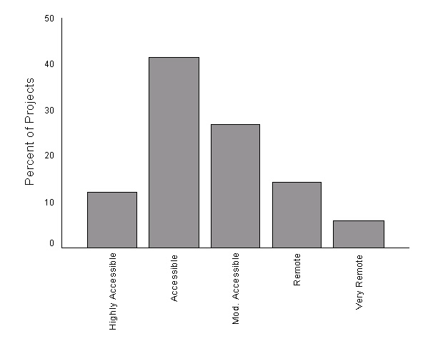
Figure 4 Locations of community development, information services technology, and information provision projects by ARIA score categories
The Socio-Economic Index for Areas (SEIFA) is an index developed by the Australian Bureau of Statistics (ABS). It draws upon a number of variables collected during the regular Census of Population and Housing, including income levels, unemployment levels, level of education, number of individuals in low skilled occupations and the number of households in public housing (ABS, 1998: p.152). The index is a relative index and the value for Australia as a whole has been standardised at 1,000. A score of less than 1,000 for an area indicates a lower level of socio-economic wellbeing than the Australian standard, while a score greater than 1000 indicates a higher level of socio-economic wellbeing. There are important regional differences, with a non-metropolitan average score of 972 and a metropolitan average score of 1,021 (Haberkorn et al., 1999). The locations of financial counsellor projects and community development, information services technology, and information provision projects have been mapped against the SEIFA score at the SLA level. It is important to note that SEIFA is based upon the 1996 Census of Population and Housing. Accordingly there will have been changes in socio-economic wellbeing in the four years from when the data comprising the index were collected. This is particularly relevant to the location of financial counsellors in areas that have since had Exceptional Circumstances (EC) status declared over them.
Figure 5 is a histogram of financial counsellors and the SEIFA scores for the SLAs in which they are located. The dashed reference line represents the Australian standard SEIFA score of 1,000. It is apparent that the majority of financial counsellors (84%) are located in SLAs with socio-economic wellbeing lower than the Australian standard. Approximately half (51%) of the financial counsellors are located in SLAs with socio-economic wellbeing lower than the non-metropolitan standard. However, it is important to recognise that while some financial counsellors are located in SLAs with higher than average levels of economic wellbeing, they may well service regions of considerably lower than average levels of wellbeing.

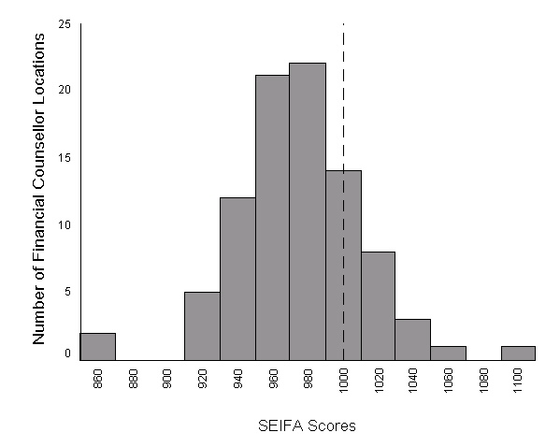
Figure 5 Financial counsellors’ locations by SEIFA score categories

Figure 6 is a histogram of community development, information services technology and information provision projects and the SEIFA scores for the SLAs in which they are located. Again the reference line indicates the Australian standard for socio-economic wellbeing at a SEIFA score of 1,000. As with the financial counsellor projects, a majority (78.6%) of projects in these categories are located in SLAs with socio-economic wellbeing lower than the Australian standard. However, a lower proportion of projects in these categories (41.4%) are located in SLAs with socio-economic wellbeing less than the non-metropolitan average, than are located in SLAs with lower than average socio-economic wellbeing Australia-wide.
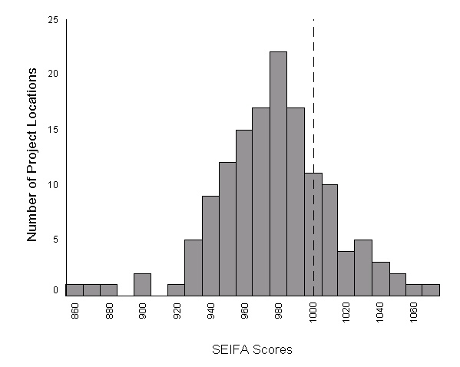
Figure 6 Locations of community development, information services technology and information provision projects by SEIFA score categories

AT-LAS database
AT-LAS allows the following information to be entered and stored:
Client information
- business details
- business structure (company, family trust, partnership etc.)
- contact details
- dependents’/partners’ details
- demographic details.
Client details
- types of assistance given
- property enterprise (farm size, major enterprise types, location data)
- finance (details on assets, liabilities, peak debts and cash income)
- assessment (causes of difficulty, viability scale and general notes)
- referrals (provides a range of options to indicate from which agencies clients were referred and to whom the counsellor referred them).
Client notes
- allows for notes from sessions with clients to be recorded
- time spent in a session with a particular client.
Counsellor activities
- activity log (to record non-client related activity and time recording)
- counsellor details.
Reporting facilities within the database allow detailed reports to be produced for each client so that the financial counsellor can consider clients’ progress over time. Additionally, summary reports can be produced that satisfy the client statistics reporting obligations to AFFA. These reports aggregate the data across clients to ensure client confidentiality. Financial counsellors with access to e-mail may use it to provide AFFA with their reports. However, the majority provides the report on a diskette via standard post. The summary database that AFFA receives from each financial counsellor contains the following data:
- farmer’s average age
- total number of dependents
- average farm size
- client locations
- business type
- enterprise type (primary, secondary and tertiary)
- financial data (cash income, off farm income sources and income, creditors, debts)
- cause of difficulty
- types of assistance provided
- types and level of support (e.g. EC, FFRS)
- referred to
- referred by
- sale status
- viability
- number new clients in reporting period
- client work times
- details of non-client counsellor activities.
Despite the diversity and thoroughness of data that can potentially be recorded about financial counselling clients through AT-LAS, its utility in the evaluation was limited. There were a number of reasons for this. Of the 96 financial counsellors, only 67 had provided reports for the 1 January–31 December 1999 period at the time the evaluation team obtained the data.
Of the 67 reports supplied, a number had data entered for less than the full suite of reported statistics. In addition, categories within the database appear to be interpreted differently between different financial counselling services. This is partly due to difficulty in providing concise and clear definitions for many categories. This is a problem where the database allows the financial counsellors to define extra categories that are not standard across services. For example, in addition to the eight categories of ‘causes of difficulties’ provided for within the database (climatic variation, commodity prices, debt levels, declining land values, farm size, management skills, personal factors and other), one counselling service has added additional categories of low commodity prices, small farm sizes, financial management skills, high debt/low equity, high interest rates and physical management skills. While these additional categories are more informative than those originally allowed, they reduce the comparability of the data between financial counselling services. This is similarly repeated for other sets of categories in the database. Other examples include the 121 different categories of agencies that referred clients to financial counsellors and the 153 different categories of agencies to which financial counsellors subsequently referred their clients. It is important to note, however, that financial counsellors themselves wanted user-defined categories to allow them to customise the database. This is an important consideration. However, the main impetus for the introduction of AT-LAS was to provide program managers with useful and reliable information about the level and nature of demand for financial counselling services. The lack of standardisation restricts the usefulness of the database for this purpose. AFFA staff have recognised the limited usefulness of AT-LAS and are taking steps to improve it. There is potential to design a better system to provide program managers with accurate and reliable data, useful in assessing the state of financial counselling services while simultaneously reducing the time it takes financial counsellors and their assistants to enter data.
Despite the limitations of AT-LAS, some data from the reports have been used where appropriate to provide insights into the operation of financial counsellors. Figure 7 indicates the average number of clients per counsellor according to each State. The national average is 111.7 clients per counsellor. New South Wales, Queensland and South Australia all exceed the national average. All States exceed an average of 70 clients per counsellor, which is the generally-accepted client load for a full time financial counsellor, although there is some variation between individual services.

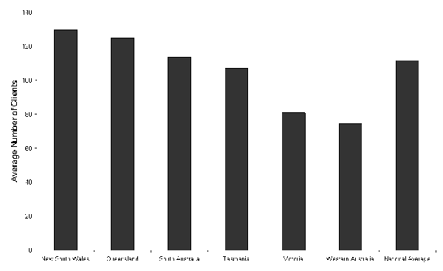
Figure 7 Average number of clients per counsellor by State
1 January – 31 December 1999
Figure 8 indicates the causes of financial difficulty reported by clients. User-defined categories have been re-coded into the standard set of eight categories. The most commonly-reported cause of difficulty was climatic variation, followed closely by commodity prices.
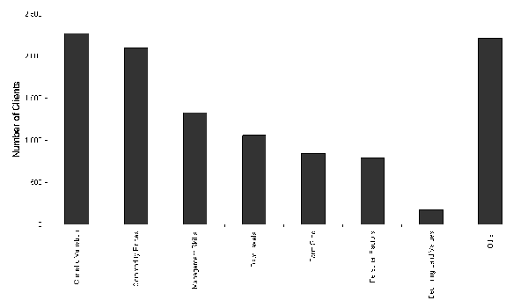
Figure 8 Reported causes of financial difficulty
1 January – 31 December 1999
Figure 9 indicates the types of assistance financial counsellors are providing to their clients. The figure ignores those types of assistance provided to less than 200 clients. In addition, the ‘other’ category has been excluded but is not insignificant with financial counsellors providing ‘other’ types of assistance to 4,548 clients in the period 1 January to 31 December 1999. The primary form of assistance provided is with EC applications. Notably, financial counsellors provided personal counselling to more than 1,000 clients, although financial counsellors may not be appropriately qualified to provide these sorts of services.
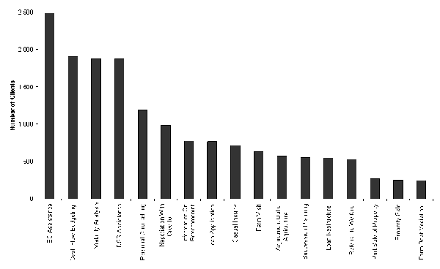
Figure 9 Types of assistance provided
1 January – 31 December 1999
During the previous evaluation, Alston et al. (1997) found that the reporting requirements for rural financial counselling were particularly onerous. In large part this was due to the difficulties associated with AT-LAS. Similarly, AT-LAS remains a source of concern for administrative assistants and financial counsellors. The time taken to enter clients’ data and limited ability to manipulate data easily were identified as problems by some staff. Considering overall reporting obligations, 30% of respondents from financial counselling organisations indicated they had difficulties in fulfilling reporting obligations. Despite concerns with AT-LAS, some form of reporting of client statistics was recognised as being necessary.
A difficulty identified with AT-LAS is that staff of different financial counselling services may interpret and enter data differently. While this is not a cause for concern within each financial counselling service providing definitions are applied consistently over time, it will introduce bias and errors when data from several services are aggregated. Training and skills development opportunities would help ensure that AT-LAS is used consistently across services. Such opportunities have been provided at several State Rural Counsellor Association Conferences. An important aspect of training and development is providing appropriate induction to new staff of financial counselling services. A number of administrative assistants learnt AT-LAS ‘on-the-job’ and ‘on-the-run’ as the previous incumbent was leaving. While this sort of training may be enough for some indication.

Questionnaire
Methods
The questionnaire was designed to collect data on the RCP from the perspective of those communities that had received funding. Questionnaire drafting went through several iterations to incorporate feedback from the Steering Committee and program staff. The draft questionnaire was then re-scripted for telephone administration by Datacol Research Pty Ltd as a Computer-Assisted Telephone Interview (CATI).
The questionnaire (Appendix 2) contained questions covering:
- management committees
- project staffing
- project services
- mechanisms for delivering services
- clients
- funding sources.
Interviews were sought from the Chair of each project’s management committee, with the sample being derived from DTRS- and AFFA-supplied Chair contact lists. Given the information sought, recipients of small short-term planning grants were excluded unless they had also received funding under other program components. Furthermore, where an organisation had received funding for several projects, these were amalgamated following advice from program staff that these organisations typically had only one management committee responsible for all funded projects. This gave a total of 199 Chairs of management committees for RCP-funded projects. Datacol were provided with a database of the Chairs and their contact details.
A letter was sent to each Chair before the questionnaire was administered. The letter informed them of the imminent questionnaire and the topics it would cover. The letter also allowed any wrong contact details to be corrected. Datacol conducted the telephone interviews between 25 May 2000 and 23 June 2000, and calls were made to respondents between 8am and 10pm. On average the questionnaire took 16.5 mins to complete, with the shortest taking just 4.25 mins and the longest 29.0 mins.
Of the potential sample of 199 individuals, 173 completed the telephone interview giving a response rate of 87%. Of the 26 who did not complete the interview, several had only recently received notice they were successful in their funding application and felt unable to provide reasonable responses, while others were not contactable. At the beginning of the interview, the Chair was given the opportunity to delegate the interview to somebody they considered better able or more appropriate to answer the questions. This occurred for 54 (31%) of the potential respondents. The person selected was typically, although not always, someone employed by the management committee to carry out the RCP-funded project.
Datacol provided a data file containing coded responses to the interview questions. The final sample was divided into two groups: firstly, those management committees that had projects funded under the financial counselling component of RCP, and secondly, those funded under the community development, information provision and information services technology components. Those management committees that had projects in both groups were included only within financial counselling category.
Results
A management committee existed for each project. The number of members varied from a minimum of 3 through to a maximum of 28 members, with a median of 9 members (Table 7).
Table 7 Number of management committee members
No. of members | No. of committees | %
<=5 | 26 | 15
6-10 | 88 | 51
11-15 | 40 | 23
>15 | 19 | 11
A range of groups was represented on each management committee as indicated in Table 8. It is noteworthy that financial counselling management committees tended to have higher levels of farmer, industry sector, government and financial institutional representation than did management committees for community development, information provision and information services technology program components. However, for both groups, local townspeople were represented on most committees. Overall there was high level of local representation, although this was expected as it is required under the funding guidelines.
Table 8 Community representation on management committees
Representative | FC % | CD, IP, IT % | Overall %
local townspeople | 94 | 95 | 95
local farmer | 100 | 71 | 82
local business | 76 | 75 | 75
Local Government | 77 | 64 | 69
industry sector body | 77 | 36 | 52
local education | 35 | 50 | 44
State Government | 52 | 19 | 31
bank/financial institution | 47 | 11 | 24

Approximately one-third of the respondents (36%) indicated they had difficulties in recruiting and retaining volunteers on their management committees. There were no significant differences between the levels of difficulty expressed by respondents from each group. Those that reported some difficulty indicated that individuals being too busy was the main cause (91%). Other causes are highlighted in Table 9.
Table 9 Reasons for difficulties in recruiting and retaining committee members (n=64)
Reason | %
individuals too busy | 91
burn out of individuals | 60
lack of interested individuals | 31
lack of skilled individuals | 25

Other reasons volunteered for difficulties in recruiting and retaining committee members were the distance committee members would have to travel (9%), and a general decline in rural and regional populations (6%).
AFFA records indicate that all financial counselling projects employ some staff, while responses to the interview indicated that 66% of community development, information provision and information services technology projects overall also employed some staff. Table 10 indicates the number of staff employed, with the majority employing one staff member.
Table 10 Number of staff employed by RCP-funded projects (n=128)
No. of staff | No. of cases | %
1 | 64 | 50
2 | 33 | 26
3 | 23 | 18
4 | 5 | 4
5 | 3 | 2

Fewer respondents reported having difficulties in recruiting and retaining staff for their RCP project (17%) than had difficulties in recruiting and retaining committee members. However, there was a trend suggesting that financial counselling services were more likely to have difficulties in recruiting and retaining staff than projects in the community development, information provision, and information services technology components. Remoteness, poor working conditions, and lack of skilled individuals were reported to be the main reasons for this difficulty (Table 11).
Table 11 Reasons for difficulties in recruiting and retaining staff (n=21)
Reason | %
remoteness/isolation of town or community | 52
pay/conditions not attractive enough | 48
lack of skilled individuals | 48

Approximately one-fifth (22%) of respondents indicated they had difficulties in fulfilling the reporting obligations accompanying RCP funding. However, financial counselling services were more likely to have difficulties in fulfilling reporting obligations than were projects in the community development, information provision and information services technology components (c ²=4.295, df=1, p=0.038). The reasons for the difficulty are given in Table 12. There were no significant differences between the two groups.
Table 12 Reasons for difficulties in fulfilling reporting obligations (n=38)
Reason | %
level of detail required too great (n=36) | 58
reports required too frequently | 42
insufficient staff/volunteers | 34
staff/volunteers lack skills | 24

Table 13 highlights the diversity of services offered by RCP-funded projects. As is apparent from the data, financial counselling services offer a set of services that differentiate them from other projects funded under the community development, information provision, and information services technology program components. These services include financial advisory services such as negotiating with creditors, cash flow preparation, debt mediation, farm succession planning, and farm business budget preparation. These services are not offered by other projects funded under other program components to any significant extent. Importantly, personal and crisis counselling were also services offered by financial counselling services.
These services are delivered using a range of methods, as shown in Table 14. Overall, newsletters and mail-outs were the most popular method, with the Internet being used to deliver services less often. As a sub-group, financial counsellors almost universally offer their services through farm/home/business visits, and this distinguishes them from projects in the community development, information provision, and information services technology program components (Visit_{FC}=99%; Visit_{CD,IP,IT}=30%). Similarly, financial counsellors are also more likely to deliver their services over the telephone than staff of projects in the community development, information provision and information services technology components (Telephone_{FC}=85%; Telephone_{CD,IP,IT}=48%). The second group use mail outs and newsletters to a far greater extent than do financial counselling services (Newsletters_{CD,IP,IT}=83%; Newsletters_{FC}=64%).
Table 15 indicates the primary client base for RCP-funded projects. Primary producers and general local communities are the two dominant client groups. Other groups were identified as clients by less than 10% of the respondents.
Table 13 Services offered by RCP-funded projects
Service | FC (n=65) | CD, IP, IT (n=102) | Overall (n=167)
 | % | % | %
information about Commonwealth Government services | 95 | 67 | 78
information about State Government services | 91 | 68 | 77
applications to social security and other government benefits | 89 | 46 | 63
personal counselling | 85 | 33 | 53
health promotion (eg men’s health, women’s health) | 48 | 53 | 51
farm business budget preparation | 97 | 20 | 50
cash flow preparation | 99 | 18 | 49
community/local newspaper | 49 | 49 | 49
public photocopying, facsimile and office facilities | 39 | 54 | 48
non-farm business budget preparation | 82 | 27 | 48
negotiating with creditors | 100 | 14 | 47
stress management | 75 | 28 | 47
debt mediation | 97 | 8 | 43
farm succession planning | 97 | 8 | 43
loan applications | 94 | 9 | 42
applications for interest rate subsidy | 88 | 9 | 40
crisis counselling | 68 | 20 | 38
public computers for community use | 20 | 44 | 35
career counselling | 32 | 33 | 33
insolvency advice | 74 | 6 | 32
flood or drought assistance | 72 | 7 | 32
public e-mail access | 17 | 41 | 32
public Internet access | 17 | 40 | 31
video-conferencing | 15 | 10 | 12
other | 37 | 68 | 56

Table 14 Methods of delivering project services
Delivery method | %
newsletters/mail outs (n=170) | 75
telephone (n=170) | 62
shop-front (n=169) | 59
farm/home/business visits (n=169) | 57
Internet/WWW (n=166) | 37

Table 15 Primary client groups
Primary client group | %
primary producers | 49
local community | 27
unemployed/welfare | 6
youth/children/students | 5
community organisation | 2
women | 2
health communities | 2
other | 6

In addition to the primary client groups identified above, Table 16 indicates the specific targeting of RCP projects to identified demographic groups. While only 2.3% of projects considered women to be their primary client group, more than 49% of projects specifically targeted women in providing services.
Table 16 Target groups for services
Target group | % of services
women (n=171) | 49
older people (n=171) | 47
youth (n=169) | 44
men (n=171) | 37
long-term unemployed (n=171) | 34
indigenous people (n=170) | 29

Tables 17 and 18 show the level of community demand and the level of community support for the services provided by each RCP-funded project. These both suggest strong community demand and strong community support for the services offered. However, this was gauged through the Chair or nominee of the management committee for each project and not through a sample of community members. Nonetheless, the Chair or nominee would be well-placed to gauge the demand and support of the community given the committee’s role in raising community cash and in-kind contributions for each project. There were no significant differences in support or demand between financial counselling projects and community development, information provision, and information services technology projects.

Table 17 Demand for project services (n=160)
Demand | %
increased greatly | 41
increased slightly | 31
remained stable | 25
decreased slightly | 3
decreased greatly | 0

Table 18 Community support for RCP-funded services (n=172)
Community support | %
strong support | 66
moderate support | 31
weak support | 3
no support | 0

Table 19 indicates the level of community cash and in-kind contributions the respondents felt they should be responsible for obtaining. Overall, the median level of appropriate community cash and in-kind funding is between 1% and 25% of the total project budget. This is also the median for the financial counselling group, while the community development, information provision, and information services technology group considered a higher level of community cash and in-kind contribution, between 26% and 50%, appropriate. Interestingly, financial counselling committees considered an amount less than they are currently required to find as appropriate, while community development, information provision and information services technology projects considered an amount greater than they are currently required to find as appropriate.
Table 19 Appropriate level of community cash and in-kind support
Support level | FC (n=66) | CD, IP, IT (n=107) | Overall (n=173)
 | % | % | %
0% | 0 | 3 | 2
between 1% and 25% | 88 | 45 | 61
between 26% and 50% | 9 | 43 | 30
between 51% and 75% | 2 | 7 | 5
between 76% and 100% | 2 | 3 | 2

The differences between the two groups were more apparent in the level of difficulty in raising community cash and in-kind contributions for the project than in the amount required per se. Overall, 30% of the respondents noted they had difficulties in raising the contribution, while a greater proportion of the financial counsellors (54%) had difficulties than did community development, information provision and information services technology projects (16%). The latter group is currently required to find only 25% of the total project costs in community cash and in-kind contributions, while financial counselling projects require 50%. This may explain the greater difficulty financial counselling projects have in securing the required funding.
In raising their community contribution, 27% of projects charged their clients for some services. A higher proportion of community development, information provision, and information services technology projects charged clients than did financial counselling projects (Charge_{CD,IP,IT}=32%; Charge_{FC}=20%). Figure 10 shows the services most commonly charged for. The three main services were providing non-computing office facilities (e.g. photocopying and faxing); access to computers, e-mail and the Internet; and thirdly, training courses.
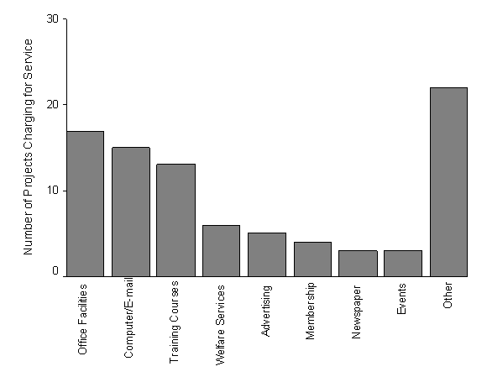
Figure 10 Services most commonly charged for

In addition to RCP funding, 36% of projects received additional funding from the Commonwealth Government in the 1999-2000 financial year. The Regional Assistance Program and Networking the Nation were the most common additional sources of Commonwealth funding. State or Territory Governments provided funding to 80% of the projects, including 97% of financial counselling projects, during this same period. Similarly, Local Government provided funding to 73% of the projects. Local businesses were much less-frequent supporters, providing funds to only 45% of the projects during the 1999-2000 financial year.
During the interview a series of belief statements was read to the respondents and they were asked to indicate the strength of their agreement or disagreement with each statement. The results are shown in Figures 11 to 19. For each statement, a mean is given to indicate the average response of the sample. The mean is based on the scale 1=strongly disagree; 2=disagree; 3=neither agree nor disagree; 4=agree; and 5=strongly agree. Thus the overall mean in Figure 11 of 4.59 indicates agreement with the statement tending towards the strong end of the scale. Therefore, respondents tended to strongly agree that the services they offered have assisted in sustaining the local community. Where there are significant differences between the financial counsellors and the community development, information provision and information services technology group, the means for each are given.
For Figure 11 the difference was significant, with respondents from financial counselling projects agreeing more strongly with the statement than the community development, information provision, and information services technology group. Figure 12 indicates strong overall agreement with the belief that services provided by RCP-funded projects were relevant to most community members. There were no significant differences between the two groups. Figure 13 indicates general agreement that funded organisations provided efficient and professional services, although financial counselling services agreed more strongly with this statement than the community development, information provision, and information services group.
While both groups indicated that the services offered are not only relevant to farmers, financial counsellors indicated they believed this less strongly (Figure 14).
Figures 15 and 16 suggest that respondents considered that RCP-funded services were not restricted only to those who cannot afford professional help nor only to those in crisis situations. This may suggest a problem with interpretation of this question. Respondents from RCP-funded services may have interpreted their services as being professional services rather than interpreting ‘professional’ as meaning private sector services that clients must pay to access. This may emphasise the fact that project services, including financial counselling, are no longer responding to financial crises but have taken on a broader community role. Alternatively it may mean that that respondents considered that clients who could pay preferred to use the RCP-funded service rather than a private sector one.
Figure 17 shows concern about the split of the RCP between the two Departments. Respondents from financial counselling services considered that the split had complicated access, while respondents from the community development, information provision, and information services group did not agree that the split had complicated access. This is a logical result as the second group only deals with one Department, DTRS. In contrast, financial counselling committees that also have community development, information provision, or information services technology projects need to deal with both Departments.

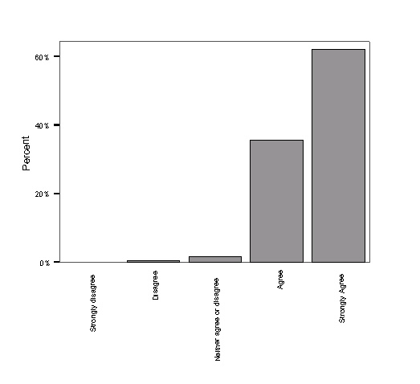
Figure 11 The services we offer have assisted in sustaining the local community
(Mean_{Overall}=4.59; Mean_{FC}=4.76; Mean_{CD,IP,IT}=4.49)
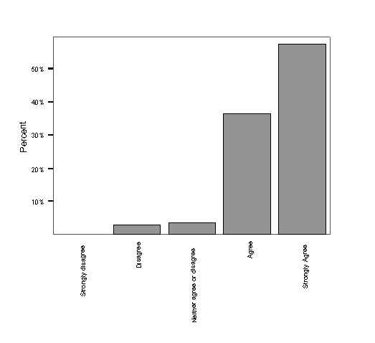

Figure 12 The services we offer are relevant to most of the members of the local community(Mean_{Overall}=4.48)
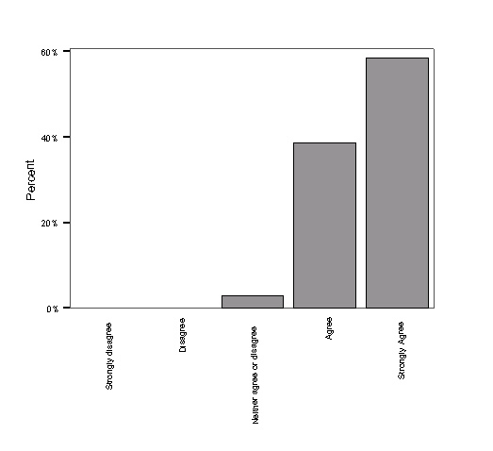
Figure 13 My organisation offers an efficient, professional service
(Mean_{Overall}=4.55; Mean_{FC}=4.77; Mean_{CD,IP,IT}=4.42)
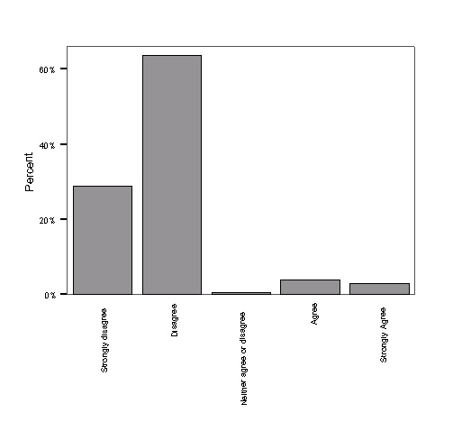
Figure 14 The services we offer are only relevant to farmers
(Mean_{Overall}=1.88; Mean_{FC}=2.09; Mean_{CD,IP,IT}=1.76)

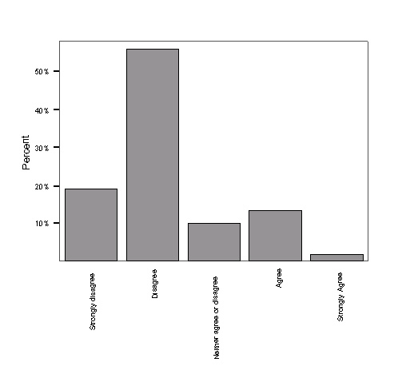
Figure 15 My organisation only deals with people who can’t afford professional help
(Mean_{Overall}=2.23)
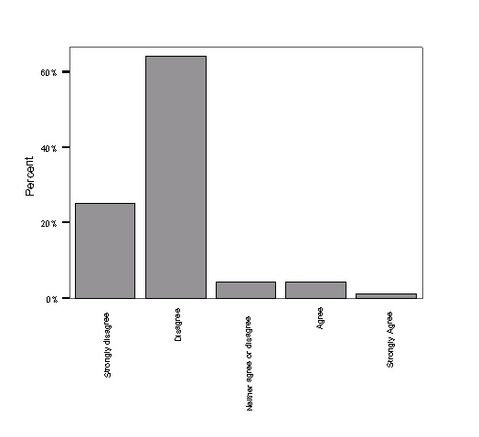
Figure 16 My organisation only deals with individuals in crisis situations
(Mean_{Overall}=1.92; Mean_{FC}=2.14; Mean_{CD,IP,IT}=1.79)
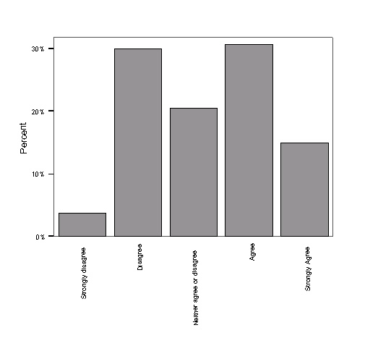
Figure 17 The split of the Rural Communities Program between two Commonwealth Departments has complicated access to the Program
(Mean_{Overall}=3.23; Mean_{FC}=3.69; Mean_{CD,IP,IT}=2.93)
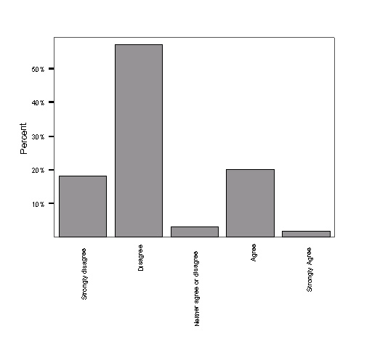
Figure 18 Our services compete with other service providers
(Mean_{Overall}=2.31)
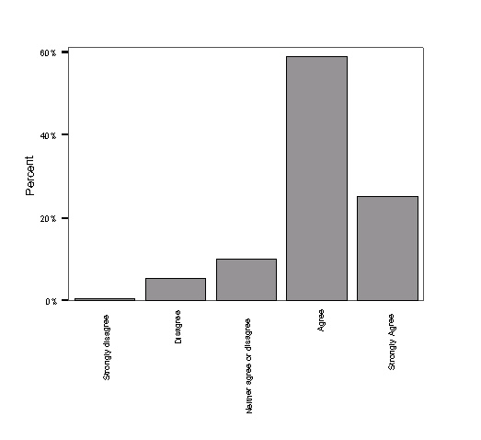
Figure 19 We receive adequate support from the Canberra staff of the Rural Communities Program
(Mean_{Overall}=4.03)

Figure 18 indicates that the majority of respondents did not believe their service competes with other service providers. Finally, a majority of both groups considered that support from Canberra-based staff was adequate (Figure 19).

Interviews with RCP staff and Advisory Committee members
Face-to-face or telephone interviews were conducted with seven current or previous RCP administrative staff (four from AFFA, three from DTRS), and three current RCP Advisory Committee members. Four interviewees were male and six were female. Interviews were semi-structured and the questions asked in the interview guide are shown in Appendix 4. The questions were closely related to the evaluation’s terms of reference and also sought basic information from interviewees to enable the evaluation team to understand better how the program originated, its philosophy and context, and how it is administered. Interviews were carried out between 16 March and 11 April 2000, and took between 25 and 55 mins to complete. All interviews were tape-recorded with the interviewees’ permission, and detailed notes of conversations were later made from the tapes. A summary table of responses was prepared and used as the basis for this discussion.
Each interviewee was initially asked to outline his or her experience with the RCP (either in its current form or previous forms). Six interviewees had been involved for more than five years, and had experience with predecessors to the current program. These interviewees had also been involved with the evaluation of the RCP’s immediate predecessor, the Rural Communities Access Program (Alston et al., 1997). One interviewee with this length of involvement had since moved to another area of DTRS. Two other interviewees had either been members of Alston’s evaluation team or been interviewed by that team, and had subsequently become members of the current Advisory Committee. The remaining interviewees had varying lengths of involvement with the RCP, ranging from approximately nine months to two years. Most interviewees either had experience visiting RCP project locations and speaking to community members involved with projects, or were currently members of rural communities themselves (in some cases they had both types of experience).
Interviewees were also asked what components of the RCP they had experience with – nine of the ten had experience with all components while one had worked only with financial counselling.
The following discussion summarises replies to each question asked in the interview.
Factors contributing to making rural communities diverse, dynamic and self-reliant
This question was drawn from one version of the RCP’s goal statement, and sought the interviewee’s opinion on what is important in achieving this goal. (In another version of the goal statement, the term ‘vibrant’ rural communities is used.) The question elicited comments about the rationale and underlying philosophy for the community-government partnership model on which the RCP is based. One interviewee expressed the view that this philosophy is one of ‘grass roots development’ and is completely different from the model used by other government programs. This model was variously described by interviewees as:
- encouraging community empowerment and ownership
- encouraging community capacity-building and learning from experience
- achieving flexibility and responsiveness to community needs
- achieving devolution of power from government to communities, being ‘bottom up’
- enabling a ‘higher emphasis on holistic community planning’
- encouraging ‘cross-border cooperation’ between communities rather than isolationism
- enabling emerging community needs to be identified and addressed
- allowing communities to develop their own solutions to losses of services and to rural adjustment issues.
Interviewees acknowledged that the success of this approach is critically dependent on ‘the people on board’. One interviewee replied that there are ‘two key words: leadership and cooperation’, and that there is ‘enormous capacity for success’ if these two factors are present. On the other hand, another pointed out that some funding applications made to the RCP ‘fall by the wayside’. This interviewee thought this ‘is probably the way it should be’, as those groups submitting unsuccessful applications may not have put sufficient time into them or may not have done sufficient background research.
All interviewees supported the current program model to a greater or lesser extent, and by implication believed it is appropriate in achieving the RCP’s goal. One interviewee commented that devolution of power to communities had probably gone as far as it could go with the RCP, although some communities would like it to go further.
Program context
Interviewees were asked whether they thought there were other programs (either government or private sector) that either complemented or conflicted with the RCP and its components. These were the agencies and areas identified as having some similarities or overlaps with the RCP and RCP-funded projects:
Commonwealth Government
Department of Family and Community Services (Community Financial Information Service)
Department of Health and Aged Care
Department of Communications, Information Technology and the Arts (information services, Networking the Nation)
Department of Employment, Training and Youth Affairs
Department of Employment, Workplace Relations and Small Business (Regional Assistance Program)
DTRS (Rural Transaction Centres, RuralPlan)
Aboriginal and Torres Strait Islander Commission
AFFA (FarmBis)
Rural women’s programs generally
State Government
Information services
Extension services
Private sector
Financial counselling services (fee-for-service basis).
Several interviewees discussed the need for ‘whole of government’ approaches to helping rural communities, and pointed out that work was being done towards this end. They suggested that the RCP had in a small way already pulled together a range of government programs and represented a start on a ‘whole of community approach’ as a parallel to a whole of government approach. One interviewee mentioned a Ministerial Coordinating Group charged with looking at overlaps between Commonwealth Government programs, but was uncertain of its outcomes. Another commented on the ‘proverbial silo approach’ from government agencies, and the difficulties that still exist between State and Commonwealth agencies.
While identifying similarities between the RCP and other programs, interviewees stressed that generally this was not a problem, except perhaps in the financial counselling area. One interviewee commented that there was a ‘fairly pervasive’ need to consolidate financial counselling services. RCP program staff spoke of the efforts they made to liaise, consult, and discuss funding applications with agencies running similar programs. Program staff also mentioned that alternative funding sources are often suggested in letters sent to unsuccessful applicants.
One interviewee did not think there was any overlap between the RCP and other programs, and commented that overall there is a ‘very serious shortage of public resources for development programs’.
Problems or issues
This question asked interviewees whether they had noticed any particular problems or issues with the RCP’s operation at any level. Issues raised are categorised and summarised in Box 5. The majority referred to matters Government needs to deal with, although a range of community and management committee issues was also mentioned. A few comments related to specific components of the program as shown below.
Box 5 Issues raised in interviews with RCP staff and Advisory Committee members
Departmental/government issues
- Departmental split and differing Departmental priorities e.g. ‘regional’ for DTRS and ‘rural’ for AFFA – led to communication and administrative problems, hindered holistic approach
- ‘run-around’ cycle as a result of overlapping government programs
- change in program focus from farming to broader rural community focus
- program reach and advertising - need to target areas where skills are lacking e.g. remote, island and indigenous communities, Northern Territory
- difficulties in getting training and development programs running for committee members
- delays in approving projects, ‘turnaround time’
- lack of time for consultation between Government agencies
- lack of travel time
- amount of time used doing contracts and contract variations
- need for feedback to unsuccessful applicants, coordinated among Advisory Committee members
- staff turnover and ‘burnout’, use of contract staff
- budget issues and need to re-design forms
- restricted role of Local Government in projects
- inaction on outcomes of last evaluation
Community/project issues
- community splits or personality issues, conflicts, insularity, territoriality or parochialism
- ‘burnout’ of community members, strain on volunteers
- naivety of committees about reporting requirements
- applicants’ lack of financial skills
- problems getting project reports from committees
- mergers and regionalisation of committees - loss of ownership
- difficulties finding new people for committees
- inability of small communities to find in-kind contributions
Financial counselling issues
- change in focus of financial counsellors to broader facilitation role
- divergences between financial counsellors’ views of their roles and Government’s view
- possible loss of funding for services
- amalgamations of counselling and information provision services
Community planning issues
- need to expand this component to achieve integration between projects.

There were many comments about issues related to the split of the RCP between two Departments and resulting administrative changes. One interviewee mentioned that this had led to confusing instructions to committees, duplication of letters, confusion about contact officers, and loss of reports. Communication between the two Departments was an issue. In this interviewee’s view the whole RCP ‘should have gone to DTRS’. Another interviewee said that there were difficulties in getting a high profile for a program like the RCP in a commodity-oriented Department like AFFA, and indicated that the differences between the two Departments were like those between ‘economic rationalists and welfare economists’.
Staffing was an issue for RCP staff. Staff numbers had been reduced significantly in AFFA following the split. This had led to difficulties in processing applications (with three to four rounds per year) and payments, and assessing project reports.
Interviewees recognised the substantial voluntary contributions made by management committee members and some of the difficulties they faced. But they also mentioned personality issues and attitudes that made it difficult to deal with some rural communities. In the view of some interviewees, there were cases of community groups who had a ‘them and us’ attitude and allowed personal rivalries to dominate community benefit considerations. Interviewees took the view that communities must work these issues out themselves and it was not Government’s role to ‘play umpire or pick winners’. However, one case was mentioned where a staff member had been obliged to intervene.
One interviewee commented on the need to expand the community planning component of the RCP. This interviewee thought the program must get away from ‘knee-jerk, quick-fix, scatter-gun’ approaches and take a wider, more strategic approach to rural community development.
Success stories
This question asked interviewees whether they had seen any particular success stories as a result of the RCP. Responses to this question were used to help select case studies for this evaluation. Interviewees generally thought that there were many success stories, and the comment was also made that there are ‘no failures, only learning experiences’. Examples of success stories included projects based at Longreach, Kangaroo Island, Eyre Peninsula, Dubbo, Parkes, Coonabarabran, Ravensthorpe/Esperance, West Wyalong, Bremer Bay, Hyden and Wyndham. The last is particularly interesting as one of the few Aboriginal-run projects funded by the RCP. It was described as a ‘best practice’ example where a project staff member catches a bus in 50° C heat to provide an information service on Commonwealth Government programs in a very isolated location.
Other comments in reply to this question pointed out the ‘spin-offs’ that often result from seed-funding projects, and the high levels of enthusiasm shown by many communities. One interviewee thought that all RCP-funded projects were successful in achieving their goals, and another commented that there was no evidence that the Advisory Committee had made mistakes or wasted money in any of the projects funded.
Community role
Interviewees were asked whether the role community groups played in RCP-funded projects was appropriate, and whether they thought groups were effective and efficient. One interviewee could not comment on this question, and expressed some concerns about the need for community groups to include a good cross-section of community members, particularly youth in the case of information services technology projects. Several interviewees commented that community groups play a ‘massive role’, and one interviewee estimated that RCP projects cost only about one-third as much as they would if run by Government. The point was also made that Government does not have the infrastructure to provide services at the ‘micro-level’ (small communities), and community management is probably the only option at this level. However, it was thought important not to exploit community donation of time and recognise that country people have other priorities.
Several interviewees indicated that they thought the quality of management committees was variable. Two specific instances were mentioned where there had been problems with particular committee members, or with committees not managing employees effectively. But generally the view was that while there are substantial differences between committees, the majority is effective and efficient. Training was acknowledged as an important issue for committees. The role of RCP projects in community capacity-building was seen as important and appropriate, and the help given by RCP administrative staff was considered good in this respect.
Community funding
This question asked the interviewee’s opinion about the current requirements for community funding of projects and the way in-kind contributions are calculated. Virtually all interviewees thought that communities should make some financial contribution, but there were differences about how much this should be, and whether the percentage should be fixed. Three interviewees thought there was a need for clear benchmarks on how to calculate in-kind contributions, and a need to offset community ‘creativeness’ in calculating the dollar values of their contributions.
The difficulties created by the differing requirements for financial counselling contributions (50% cash or in-kind from the community) and those for community development, information provision, and information services technology components (25%), were raised by several interviewees, and one suggested that ‘dollar amounts [for community contributions] are arbitrary and pointless’. Another interviewee thought there needed to be flexibility in this area and opportunity to take special community circumstances into account. This interviewee thought Government had to be prepared to accept some risk in terms of outlays, but pointed out that under the current program, maximum exposure is limited to a six monthly payment on a project of up to $50,000 in total (other than for financial counselling, where exposure could be higher).
Several interviewees thought that some rural communities are ‘cash-strapped’ and are finding it very difficult to find monetary contributions – they are ‘using up the kitty’.
Program monitoring
Interviewees’ views were sought on how the performance of the RCP could best be monitored – this was one of the items in the terms of reference for the evaluation. There was a wide range of responses to this question, although a number of interviewees acknowledged the difficulty of monitoring such a diverse program – it was like ‘comparing apples and oranges’. The difficulty of attributing causation was also raised.
Some specific monitoring suggestions referred to using existing information more effectively. This included:
- project reports and financial statements
- statistics from the AT-LAS database
- ABS data
- Centrelink data (which may raise confidentiality issues).
The other main set of suggestions focused on appointing case study officers or resourcing Advisory Committee members to visit project sites on a regular basis and make regular phone calls to community groups. A detailed suggestion was that case study officers be appointed from among administrative staff to:
- visit projects as they unfold
- ask questions and challenge those involved to prompt debate and discussion
- prepare reports on their findings
- report back to the Advisory Committee at each meeting.
In terms of monitoring of specific projects, interviewees pointed out that some community groups do undertake their own surveys but that there is no uniformity or coordination. Another point made was that State Governments get no reports at present, nor are regular reports provided to Ministers.
Appropriateness of goal
This question asked interviewees their opinion of the RCP’s overall goal, as quoted to them earlier in the interview, and whether they thought it needed to be changed. Points made in response were that the program does need a broad motherhood statement like the current one, but that this is not an objective, and you have to ‘draw long bows to make connections’. One interviewee indicated it was necessary to go down to the level of the program components to make the goal meaningful.
Concerns about the way the current goal is expressed were:
- there is an increasing shift away from agriculture towards a broader concern for rural communities and service delivery to them – the meaning of rural industries also needs to be broadened
- focus on profitability of rural industries conflicts with ideas of treating communities as a whole
- profitability should not be the main concern – the main focus should be on helping communities to develop themselves
- sustainability needs more attention – all Government programs come to an end
- a range of time frames needs to be considered – long term (‘developing the kids’), medium (developing the communities), and short (addressing immediate problems)
- DTRS uses the term ‘regional’ rather than ‘rural’.
Further comments
The last question asked interviewees for any further comments about the RCP. Several expressed their enthusiasm for the program, with one saying ‘I think it’s a wonderful program. Not many others cover such a wide range’, and ‘It’s a delight when we get to talk to the people’. Another commented: ‘It’s great work, very rewarding - seeing good outcomes, seeing communities working together’.
However, another interviewee stressed the need to acknowledge the change in the financial counselling component of the program and to consider whether this component was still needed. Points were also made about changes in program context and possibilities for exploring partnership arrangements with other agencies for delivering services.
<< Previous

Written submissions
The evaluation team received 32 written or e-mailed submissions between 12 May and 1 August 2000. Many were re-directed to the team by AFFA staff, as an official letter had been sent to chairs of management committees for RCP-funded financial counselling services advising them of the evaluation and asking for comment. Submissions received are listed in Appendix 3, and the breakdown of these submissions by State or Territory of origin is shown in Table 20. No submissions were received from the Northern Territory. The author of one submission asked to remain anonymous and only the State of the writer is given in Appendix 3. Two members of the evaluation team held a meeting with members of the National Rural Advisory Council (NRAC) (authors of Submission 23) at their request on 3 July 2000, and a transcript of the conversation was made for later consideration. Discussion of the NRAC submission is based on both written and verbal comments.

Table 20 Written submissions by State/Territory
State/Territory | No. of submissions
ACT | *2
NSW | 12
Q. | 2
SA | 3
Tas. | 3
Vic. | **7
WA | 3
Total | 32
*These submissions dealt with national issues not specifically ACT ones
**One group sent two separate submissions (counted separately)

Submissions overall focused heavily on issues surrounding the financial counselling component of the RCP, and a number came from RCP-funded financial counselling services or their management committees. All submissions dealt with financial counselling issues to some extent. Many submissions argued for continued funding for the RCP as a whole or for existing RCP-funded counselling services. The submission from the NSW Farmers’ Association ended by saying ‘The Association is very supportive of the programs delivered under the Rural Communities Program and is adamant that they be maintained … ‘ (Submission 6).
As many submissions specifically addressed the evaluation’s terms of reference and made comments against some or all terms, these terms have been used as the basis for the following content analysis.
1 Program performance
1.1 The extent to which the program has achieved its objective
Under this heading, many submissions provided descriptions of their projects or services and their achievements, and some made general comments about the RCP model, commenting for example that the partnership model ‘has merit’ and is strongly supported by rural communities. A large majority of submissions were strongly supportive either of the RCP as a whole or financial counselling in particular. An enthusiastic comment was from Lower Lachlan Community Services who commented that their management committee had ‘never envisaged that so many wonderful things for our community could be achieved in such a short time’ (Submission 15). Another comment was that the RCP is a ‘fabulous program’ (Upper Hunter Rural Counselling Service, Submission 24). Other submissions commented on the importance of empowering communities to take control of their own futures and indicated that the RCP model encourages this. Rural Support Tasmania enclosed 13 supporting letters, including a number from Tasmanian Members of Parliament, attesting to the value of the services it provides (Submission 27). South Gippsland Farmers Support Group included in its second submission six supporting letters from banks and a local legal firm (Submission 28).
Many submissions made the point that financial counselling services have changed from crisis counselling for farmers during the droughts of the 1980s and 1990s to providing on-going advice to rural communities generally, including small businesses, to help them adjust to social and economic changes. One submission suggested that financial counsellors are no longer the ‘reactive white knight’ but have a more pro-active role in helping rural people prepare for and accept change (Queensland Association for Rural Financial Counselling Services, Submission 21). Some submissions commented that ‘seed’ funding had led to spin-offs or synergies as communities followed up successful financial counselling applications with applications for community planning or information provision projects – ‘small grants reap large dividends’ (Victorian Office of Rural Communities, Submission 10). The New South Wales Association of Rural Financial Counselling Groups included a list of 34 other projects that it considered were initiated or facilitated by New South Wales rural financial counselling services (Submission 19). Authors of some submissions considered that financial counselling services had contributed to the sustainability of rural communities and led to better farm management. Many submissions stressed that financial counselling services were essential and highly regarded by communities. The importance of financial counsellors in helping farmers to prepare applications for other government financial support such as disaster relief, Centrelink applications, Agriculture Advancing Australia funding and exceptional circumstances funding, and even in submitting applications to State Governments to clear native vegetation, was mentioned in some submissions (for example the Walgett Advisory Group, Submission 13).
Nonetheless there were a few critical comments. One anonymous submission, the submission from the Victorian Office of Rural Communities, and the submission from NRAC, suggested that financial counselling services are not always getting to those most in need. This is either because potential clients are reluctant to use these services (shame, fear of gossip); or perhaps more importantly, because the most needy communities lack the ‘human capital’ to prepare successful applications to obtain funding for these services (Submissions 8, 10 and 23). Two of these submissions also suggested that government subsidies may inhibit the development of private sector counselling services. Members of NRAC expressed a range of concerns about the financial counselling component, and these are discussed in more detail in Section 2.1.
There were far fewer comments about the success or failure of other components of the RCP than there were about financial counselling, and many of these comments were specific to the experiences of particular organisations, projects, or locations. Many comments referred to projects funded by other Commonwealth Government programs, not only the RCP, suggesting that departmental and program boundaries do not matter much to rural communities, and community objectives are much more important than program objectives.
1.2 Efficiency and effectiveness of community groups in administering projects and influencing community development
Eighteen of the 32 submissions addressed this term of reference to some extent, and many of these stated their opinion that community groups are effective and efficient. The most common reason for believing this was that communities provided substantial voluntary input into projects through membership of management committees, and through cash or in-kind contributions. The submission from the New South Wales Association of Rural Financial Counselling Services valued voluntary committee members’ contributions at $10,500 per group per year (based on travel costs and sitting fees of $200 per person per day) (Submission 19). It was also suggested in some submissions that many projects have minimal overheads and are ‘streamlined’ in comparison with similar government-run ones. Other comments referred to the efficiency of covering several Local Government Shires, as many RCP-funded services do. North East Riverina Rural Counselling Service referred to the Alston review, which it said substantiated its efficiency in administering the service (Submission 12).
Other submissions referred to the variable performance of management committees and acknowledged that performance depended on the commitment and experience of members and project staff. The South Australian Association of Rural Counselling Services commented that administration of government grants is ‘an art form in itself, and one which few groups have mastered’ (Submission 11). Nonetheless, the good intentions of most groups were acknowledged. The Queensland Department of Primary Industries considered that more than 50% of the management committees for rural counselling services in Queensland were efficient (Submission 18).
1.3 Identify performance measures and indicators for incorporation into ongoing monitoring
Here again, a large majority of comments referred to measuring the performance of financial counselling services, and there was little comment on how to monitor the RCP’s performance as a whole, or other RCP components. Several submissions referred to difficulties due to the need for client confidentiality, or commented that further research was needed. Others considered that the absence of complaints was a sufficient indicator of satisfactory performance. Further suggestions for performance measures/indicators included:
- monthly reports
- meeting project milestones and outcomes, progress toward project goals
- total numbers of clients or new clients over reporting period, and/or increase in demand (for both financial counselling and information services)
- numbers of client contact hours
- details of services provided to clients
- results of client or lenders surveys and feedback sheets (some services already use these)
- client outcomes assessment
- success of client applications for other types of financial assistance (where aided by counsellors e.g. FFRS, now Farm Help)
- numbers of meetings with financial institutions and other contacts on clients’ behalf
- numbers of endorsements or referrals from other institutions e.g. banks
- regular auditing (this is of course already required annually)
- measures of ‘community self-direction’
- level of activity of local groups
- financial gains to region.
Some of these measures are already available from the information the counsellors provide to the AT-LAS database.
Detailed suggestions for monitoring and evaluating financial counselling services came from the Queensland Department of Primary Industries (Submission 18). The author of this submission also provided further documentation on the monitoring and evaluation scheme used for financial counselling services provided by the Queensland Government when a member of the evaluation team visited him in Brisbane as part of case study travel. This scheme has been developed because of the need to set standards and provide detailed guidance to counsellors employed by the Queensland Government, and to provide performance documentation in case any counsellors prove unsatisfactory. (The Steering Committee advised that that this scheme is derived from one originally developed for RCP-funded financial counselling services and is supplied to funded financial counselling projects for their information.) The main elements are:

- Performance measures for services
- number of clients for whom a basic level of financial analysis is completed (clients who do not receive an analysis are considered ‘referral and advice’ clients)
- client numbers – suggested benchmark of minimum 50 active clients per year for services in pastoral areas and 80 in intensive industry areas (or some intermediate figure as appropriate to area covered)
- individual performance of counsellors – measures identified including professional development needs and performance against minimum standards for service delivery.
- Performance measures/standards for committees
- development of stated and measurable objectives for operation
- measures of diversity of community representation
- achievement of quorum without project staff
- established process for rotation of office bearers
- adoption and implementation of ‘best practice’ or minimum standards for counsellors.
Several submissions included copies of evaluation sheets or surveys done for their financial counselling services. Submission 28 from the South Gippsland Farmers Support Group included results of a survey sent to clients asking them about details of services received and degree of satisfaction with these services. It also included specific feedback from clients on how the service could be improved. Similarly Submission 29, made on behalf of South West Rural Support (Victoria) enclosed the results of a client survey completed in June 2000.
The lack of systems, standards and measures for performance of information services and information officers was pointed out in one submission.
1.4 Determine factors related to project success or non-performance
Not all submissions addressed this term of reference. However, factors mentioned as contributing to the success of projects included:
- the quality and enthusiasm of staff and committee members – and the importance of good selection processes
- continuity of committee membership
- appropriate appraisal and reporting mechanisms
- networking ability and links with related programs
- opportunities for continual education of staff and committee members
- support from Local and State Government organisations and other key stakeholders
- the nature of the services provided e.g. with counselling, the one-to-one confidential service
- strong community leadership
- learning from analysis of past projects
- the grass-roots nature of the organisations – ‘community ownership’
- the flexibility of the RCP and ability to respond to emerging community needs
- formation of an ‘umbrella’ organisation to administer projects, big enough to have a paid executive and a board of directors.
There were two detailed responses to this term of reference. The first was from the Queensland Department of Primary Industries, who suggested that successful financial counselling projects are run by groups that:
- have broadly-based community support
- have regular rotation of office-bearers
- manage several projects
- are run by committee members, not project staff
- have committees that do manage the counsellors
- operate for community benefit, not to individual agendas.
On the other hand, factors limiting success were suggested to be:
- community people being too thinly spread
- limited skilled resources
- competition for cash with other local organisations
(Submission 18).
The second detailed response was from the New South Wales Association of Rural Counselling Groups who suggested that success factors include:
- use of external facilitators in strategic planning
- ensuring early involvement of key stakeholders
- creating partnerships with other organisations
- starting with a manageable project and expanding later
- identifying future funding sources.
The Association considered that factors working against success were:
- the Departmental split
- differences between State and Commonwealth Departments
- limited funding time frame for components other than rural counselling
- timing of funding decisions
- lack of funding for project management
(Submission 19).
2 Future directions and options for change
2.1 Identification of appropriate adjustments and future direction
Many adjustments suggested in submissions raised issues and would require actions far beyond the scope of the evaluation, and would need to be addressed by a wider range of players than those immediately involved here. Many highlight general issues that could equally well apply to almost any Government-funded program.
Several submissions referred to resource issues, particularly the difficulty in finding the 50% cash and in-kind community contributions for financial counselling services. The submission from the Queensland Department of Primary Industries recommended that the community contribution should be reduced to 25% or waived altogether (Submission 18). It also suggested that a monetary value be placed on voluntary input to projects, and that this value be included in application budgets. Another suggestion was that management committees should be allowed to carry over any project budget surplus from one year to the next (this is currently possible but the comment indicated that the writer was unaware of this). Other resource issues included inability to cope with client demand with existing staff and the need for funding to employ additional counsellors, and in some cases, administrative staff as well. The issue of needing sufficient funding to cover transport costs for counsellors was also mentioned (Submission 19).
A related resourcing issue raised in several submissions was the need to include funding or provide opportunities for both staff and committee members to attend training and development courses to improve their skills. (This is also possible under current program arrangements.)
A major issue for financial counselling services was uncertainty of future funding, and several submissions argued that these services need a guarantee of on-going Government support. One submission argued that these services should be funded in their own right as essential services, not as a component of the RCP.
Some submissions raised the need to attend to Government issues. These included the problems caused by the Departmental split, resulting in some committees having to answer to two Ministers; and the difficulties communities have in coping with frequent Departmental name changes and policy shifts. Another Government issue was overlaps, gaps, and lack of coordination between different Commonwealth Government agencies, and between State and Commonwealth Government. The idea of the Government ‘one-stop-shop’ was raised in the submission from the Warrumbungle Community Program (Submission 4). Some submissions pointed out that committees were required to provide separate reports for State and Commonwealth Government agencies. The uncertainty of support from Local Government was also raised as an issue.
The submission from the New South Wales Farmers’ Association raised the need for a ‘structured system’ for establishing financial counselling services. It pointed out that a need for a service may exist in a particular area, but there may not be a suitable community group there to prepare an application or administer the service. It considered this was a weakness with RCP funding of these services. Similarly, in discussing community planning, it suggested that priority ‘should be given to those towns where there are the greatest needs in terms of basic services’ (Submission 6).
As mentioned under 1.1, Submission 8 suggested that current financial counselling services are not getting to those most in need and that the system may need a 'total re-think'. The submission from NRAC raised the question of the compatibility of the financial counselling component with other elements of the RCP and asked whether ‘it would be more appropriate for it to be placed with another program or be a program on its own?’ (Submission 23). In discussion, members of NRAC expressed their concerns that there were increasing mismatches between the services financial counsellors were originally employed to provide and those they were now taking on. As a result they thought it would be better to transform these services into a referral system, providing clients with free consultations to suit their needs up to an agreed value. This could be called a ‘Farm Help Program voucher’ for example. They also considered there was an issue with ‘portability’ of services, pointing out that counselling services have developed their own in-built momentum and constituencies in particular locations, and are not going to say ‘Well it’s a done job, it’s time for it to move on … ’. Instead it was considered that these services take on other community roles once the immediate need for financial counselling has passed.
Several other submissions raised the need to make adjustments to acknowledge the broadened role rural financial counsellors have assumed over the years (servicing a wider range of clients, playing a broader community facilitation role), and perhaps to change their name to better reflect this new role. One submission argued that their role should be extended to cover ‘social counselling’ generally, but several pointed out that skills of current counsellors may not match this wider social role.
A minor problem raised in several submissions was the difficulty created by the fact that the reporting period for the financial counselling component of the RCP does not correspond with the financial year. It was suggested this needs to be adjusted.
2.2 Extent of ongoing community need
A large majority of submissions argued there is an ongoing need for RCP funding of financial counselling services. Many cited a range of factors – seasonal conditions, low commodity prices, rising interest rates, economic rationalist policies, industry structural adjustment, introduction of the GST – as contributing to ongoing change and uncertainty for rural communities. The argument was also made that increasing levels of use of counselling services indicate continuing need. Some submissions predicted rising demand as a result of current policy initiatives, for example the dairy industry re-structuring package. Several stated that there were no alternative services available to many rural people and that services are essential to help overcome rural disadvantage, isolation and communication barriers, and ensure rural industries remain competitive. The submission from the Queensland Association of Rural Financial Services argued that it is critical that the ‘infrastructure’ established by existing services is ‘not torn down’ (Submission 21). By contrast, as mentioned above, the anonymous submission and the submission from NRAC questioned the need for continuing Government-funded financial counselling services (Submissions 8 and 23).
Few comments were made about ongoing need for other program components, although the submission from Lower Lachlan Community Services suggested the possibility of combining financial counselling and information provision roles, or having financial counsellers work part-time (Submission 15).
Several submissions did point out the requirement to obtain evidence of continuing need for financial counselling, for example through keeping track of client numbers or commissioning regular surveys. It was suggested that the fact that communities may be able to maintain their contribution to these services may reflect their ability to pay rather than continuing need for the services.
Case studies
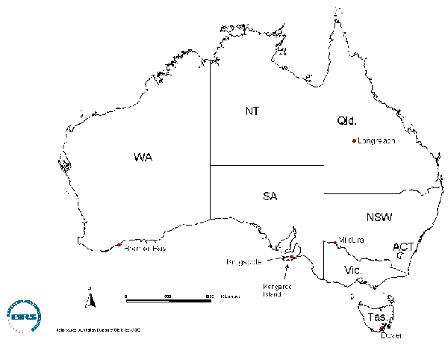
Figure 20 Location of case studies

Case study selection
The case studies aimed to:
- provide an understanding of a range of project contexts and achieve geographical spread
- sample projects in the different RCP program components (FC, CD, IT, IP, CP)
- examine projects considered successful and examine what contributed to success
- where possible talk to staff and management committee members involved with more than one RCP-funded project in the local area
- talk to a range of community members as well as project staff and committee members
- where possible during case study travel, to also gather views of relevant State Government staff about the case study project(s) and the RCP.
Selecting and conducting case studies was guided by information provided by RCP staff, Advisory and Steering Committee members in interviews or meetings; a table of projects prepared by a consultant compiling an RCP case study book for DTRS; and information contained in the administrative and AT-LAS databases.
Consideration was also given to the extent to which some projects had also been a focus of previous attention, in order to avoid burdening project staff and volunteers with too many visits from Government staff.
Using this information and the criteria given above, a table of possible case studies was prepared and discussed with the evaluation’s Steering Committee. This resulted in locations and projects shown in Table 21 being selected.
Table 21 Case study locations and projects, and dates visited
Location | Project name and type | Dates visited
Dover, Tas. | Dover Community Telecentre (CP) | 24-26 May 2000
Kangaroo Island, SA | Kangaroo Island Rural Counselling Service (IP, FC, IT) | 29-30 May 2000
Mildura area, NSW/Vic. | Sunraysia Rural Counselling Service (FC, CD)  Wentworth and Balranald Rural Counselling Service (FC, CD)  Mallee Rural Counselling Service (FC) | 13-16 June 2000
Bremer Bay, WA | Bremer Bay Community Resource Centre (IP, CD, IT) | 4-6 July 2000
Longreach, Qld | Central Western Queensland Remote Area Planning and Development Board Financial Counselling Service (FC) | 10-14 July 2000

Case study methods
A pro-forma for conducting case studies was prepared together with three interview guides containing suggested questions for project management committee members or project staff, community members, and State Government staff respectively. The questions asked in the interview guides are shown in Appendix 4. Two checklists, one of local services and the other of community groups, were prepared to help team members examine the range of services available and range of community groups at each site. These checklists were based loosely on similar lists used in a ‘social capital assessment tool’ (Krishna and Shrader, 1999).
Case studies were divided up among evaluation team members. Before undertaking case studies, the responsible team member or members examined relevant AFFA and DTRS project files and database entries, and conducted Internet searches for sites relevant to the case study. During case studies, project locations were visited as well as other appropriate local sites, and interviews conducted with relevant community members as guided by advice given both before and during the case study. Interviews were semi-structured. Notes were taken during interviews and interviews were also tape-recorded for later reference if interviewees granted permission to do so. Photographs of project locations were taken and relevant documents collected on-site.
Appendix 5 contains detailed reports of each case study and some of their findings are picked up in the discussion and recommendations following this section.
Table 22 summarises some main points from each of the case studies.
Table 22 Key findings of case studies
Case study project(s) | Positive findings | Issues raised
Dover Community Telecentre (CP) | - modest funding has led to good outcomes e.g. Dover Old School restored  - providing infrastructure for community organisations has enabled them to obtain funding for a range of other community projects  - project has provided much-needed services in a relatively poorly-resourced region  - project has helped develop social and human capital for the Dover Community Telecentre, with subsequent wider community benefits | - heavy reliance on small number of volunteers, possibly not socially sustainable at community level  - difficulties in raising community cash contributions  - short Government funding time frame may threaten project sustainability  - feeling from project staff of relative lack of contact and interest from RCP staff
Kangaroo Island Rural Counselling Service (IP, FC, IT) | - counselling service evaluated very positively by clients and supported by community members, including Local Government  - no other financial counselling service based on Island, so project fills a gap for relatively disadvantaged community  - funding has helped build human capital in that two project staff have since obtained other positions with the local Development Board | - coordination and integration between information services provided by Local and Commonwealth Government  - coordination and integration of RCP projects with strategic planning and other local Development Board activities  - expansion in role of financial counsellors  - difficulties in obtaining appropriate premises and infrastructure for RCP projects  - staff turnover and career development for project staff  - possible conflicts of interest for project staff with roles on project management committees
Sunraysia Rural Counselling Service (FC, CD)  Wentworth and Balranald Rural Counselling Service (FC, CD)  Mallee Rural Counselling Service (FC) | - community members support services and believe there is an ongoing need for financial counselling services  - relatively disadvantaged region in services access  - RCP community management model supported by project staff and committee members | - demands on members of management committees, and need for additional training and resourcing for counsellors and committee members  - potential conflicts of interest for management committee members who are also clients of services  - possible need for integration and co-location of services to achieve economies  - uncertainty of future funding for financial counselling  - difficulties in obtaining 50% cash or in-kind contributions for financial counselling  - staff turnover, workloads and stress levels  - need for standardised client feedback methods
Bremer Bay Community Resource Centre (IP, CD, IT) | - project milestones and objectives met  - additional community needs identified as a result of RCP projects  - projects have improved access to communication and information services, and improved education and employment opportunities for a relatively remote community  - social capital built in terms of strengthened community networks, ‘social cement’  - human capital built in terms of skills of RCP project staff | - need for up-dating and maintaining information provided by RCP projects e.g. web sites - issues of continued funding  - possible lack of alternative sources of funding for similar projects
Central Western Queensland Remote Area Planning and Development Board Financial Counselling Service (FC) | - financial counselling service covers a large, extremely remote region with limited access to similar services  - administrative arrangements (located within Development Board) appear to work well, achieve economies of scale and promote integration  - strong Local Government support and integration with Local Government activities as a result of location within Development Board  - possible valuable role for DTRS remote area liaison officers (trial position established in Longreach) | - lack of formal client evaluations of financial counselling service  - service delivery difficulties due to long distances and road travel time to pastoral properties - is this the best way to provide these services in pastoral areas?  - equity of service provision and tests for client need - pastoral clients in this area have relatively high capital assets and property equity, but marked seasonal variations in income  - questions about ecological sustainability of some land-use activities indirectly supported by financial counselling services

References
ABARE (1997) Issues in the delivery of Commonwealth social support programs to farm families. ABARE Research Report 97.7, ABARE, Canberra.
ABARE (1999) Australian farm surveys report 1999. ABARE, Canberra.
ABARE (1999) Regional Australia: incomes, industry location and infrastructure. ABARE, Canberra.
Anderson, J. (2000) $90 million Federal funding for ‘Regional Solutions’. Media release from Office of Deputy Prime Minister and Minister for Transport and Regional Services, Canberra, 18 June 2000.
Allen, W. (2000) Improving the use of collaborative approaches within natural resource management. Topics: Capacity building (social capital), and Participatory monitoring and evaluation (NRM-changelinks web-site)
http://www.nrm.massey.ac.nz/changelinks/capacity.html
Alston, M., Share, P., Heazlewood, T. and Kent, J. (1997) Evaluation of the Rural Communities Access Program. DPIE, Canberra.
Arnstein, S.R. (1969) A ladder of citizen participation. Journal of the American Institute of Planners 35: 216-224.
Barr, N.F. and Cary, J.W. (1989) Greening a brown land: the Australian search for sustainable agriculture. Macmillan Education, Melbourne.
Berry, P., Hogan, L. and Thorpe, S. (1999) Regional Australia: incomes, industry location and infrastructure. Australian Commodities 6(4), 674-687.
Bird Cameron Rural Management Services (1994) National overview of the Rural Counselling Program. DPIE, Canberra.
Bolton, R. (1992) ‘Place prosperity vs people prosperity’ revisited: an old issue with a new angle. Urban Studies 29(2), 185-203.
Centre for Community Enterprise (1999) The community resilience manual: A resource for rural recovery and renewal (Draft). Centre for Community Enterprise, Port Alberni, British Columbia.
Chudleigh, J. (1999) Communique from the National Rural Communities Conference, Coonabarabran, 27-29 September 1999 (unpublished manuscript).
Coleman, J.S. (1988) Social capital in the creation of human capital. American Journal of Sociology 94, Supplement S95-120.
Commonwealth of Australia (1990) Ecologically sustainable development (ESD). A Commonwealth discussion paper. Commonwealth of Australia, Canberra.
Council of Australian Governments (1992) National strategy for ecologically sustainable development. Australian Government Publishing Service, Canberra.
Department of Health and Aged Care (1999) Accessibility/Remoteness Index of Australia (ARIA). Occasional Paper Series No. 6, Department of Health and Aged Care, Canberra.
DTRS (2000) Regional Solutions Programme. (Folder of material outlining new program.) DTRS, Canberra.
Haberkorn, G. and Bamford, E. (2000) Servicing regional Australia: a GIS study of accessibility to services in non-metropolitan Australia. Bureau of Rural Sciences, Canberra.
Haberkorn, G., Hugo, G., Fisher, M. and Aylward, R. (1999) Country matters: social atlas of rural and regional Australia. Bureau of Rural Sciences, Canberra.
Inglehart, R. (1990) Culture shift in advanced industrial society. Princeton University Press, Princeton, New Jersey.
Falk, I., Harrison, L. and Kilpatrick, S. (1998) How long is a piece of string? Issues in identifying, measuring and building social capital. University of Tasmania, Launceston.
Kilpatrick, S. (1996) Change, training and farm profitability. National Farmers’ Federation Research Paper No.10, National Farmers’ Federation, Canberra.
Kretzmann, J.P. and McKnight, J.L. (1993) Building communities from the inside out: A path toward finding and mobilizing a community’s assets. Institute for Policy Research, Evanston, Illinois.
Krishna, A. and Shrader, E. (1999) Social capital assessment tool. Paper prepared for the Conference on Social Capital and Poverty Reduction, The World Bank, Washington DC, 22-24 June 1999.
Lawrence, G., Share, P. and Campbell, H. (1992) The restructuring of agriculture and rural society: evidence from Australia and New Zealand. Journal of Australian Political Economy No. 30: 1-23.
McColl, J.C., Donald, R., and Shearer, C. (1997) Rural adjustment: managing change. DPIE, Canberra.
McMichael, P. (1996) Globalization: myths and realities. Rural Sociology 61(1): 25-55.
NATSEM (2000) A divide between the cities and the bush? Income Distribution Report, May 2000.
Network Australia (1998) Cost-benefit analysis of the Commonwealth Financial Counselling Program. Report to the Consumer Affairs Division, Dept of Industry, Science and Tourism. Network Australia Organisational Consulting Group, Brisbane.
North Central Regional Centre for Rural Development (1999) Measuring community success and sustainability. North Central Regional Centre for Rural Development, Iowa State University, Iowa. http://www.ag.iastate.edu/centers/rdev/Community_Success/perform.html
O’Connor, J. (1973) The fiscal crisis of the State. St Martin’s Press, New York.
Perry, S.E. and Lewis, M. (1999) What 10 Canadian initiatives can teach us about building creative, inclusive & sustainable communities. Centre for Community Enterprise, Port Alberni, British Columbia.
Pigg, K. (1999) Community networks and community development. Presentation to the Conference of the International Association for Community Development, Edinburgh, Scotland, April 1999.
Productivity Commission (1999) Impact of competition policy reforms on rural and regional Australia. Productivity Commission, Canberra.
Putnam, R. (1993) Making democracy work: civic traditions in modern Italy. Princeton University Press, Princeton, New Jersey.
Putnam, R. (1996) Who killed Civic America? Prospect, March 1996, pp. 66-72.
Read, P. (1996) Returning to nothing: the meaning of lost places. Cambridge University Press, Melbourne.
Regional Australia Summit (2000) Steering Committee Interim Report. Regional Australia Summit, Canberra, 1999. http://www.dotrs.gov.au/regional/summit/outcomes/committee…/executive_summary.html
Sale, K. (1985) Dwellers in the land: the bioregional vision. Sierra Club, San Francisco.
Schaffer, R. (1995) Achieving sustainable economic development in communities. Journal of the Community Development Society 26(2): 145-154.
Silverman, H. (1935) The substance of economics: Eighth Edition. Pitman and Sons, Melbourne.
Sirolli, E. (1998) Ripples from the Zambezi: passion, entrepreneurship and the rebirth of local economies. New Society Publishers,
Stayner, R. (2000) Rural realities. Paper presented to symposium on ‘Australian values – rural policies’, Canberra, 28-29 August 2000.
Synapse Consulting (Aust) Pty Ltd (1992) Report of the review of the Rural Adjustment Scheme. Synapse, Brisbane.
Troeth, J. (2000) A stronger rural and regional Australia. Media release from the Office of the Parliamentary Secretary to the Minister for Agriculture, Fisheries and Forestry, Canberra, 10 May 2000.
Truss, W. (1999) Federal Government scheme to support local farm families through the tough times. Media release from the Office of the Minister for Agriculture, Fisheries and Forestry, Canberra, 3 August 1999.
Wahlquist, A. (1999) Demographic and social changes in Australia. Keynote presentation to Regional Australia Summit, Canberra, October 1999.
Woodhill, J. and Robins, L. (1998) Participatory evaluation for Landcare and catchment groups: a guide for facilitators. Greening Australia, Canberra.
World Commission on Environment and Development (1987) Our common future. World Commission on Environment and Development, London. (The ‘Brundtland report’).

Terms of reference
At its inception meeting the Steering Committee confirmed the following terms of reference for the evaluation.
To evaluate the RCP having regard to:
1 Program performance
1.1 The extent to which the program has achieved its objective encompassing both the program as a whole and the various program elements which are:
  - financial counselling
  - community planning
  - information provision
  - information services technology
  - community development.
1.2 The efficiency and effectiveness of the performance of community groups in administering projects and influencing community development.
1.3 Identify performance measures suitable for incorporation into ongoing monitoring
1.4 Determine factors related to project success or non-performance.
2 Future directions and options for change
2.1 The identification of any appropriate adjustments and the future direction for the program
2.2 The extent and ongoing community need for RCP projects in the future.

