A Growth Plan for the Tasmanian Fruit and Vegetable Industries
A report by the Tasmanian Fruit and Vegetable Industry Taskforce
August 2014
---Page intentionally left blank ---

Taskforce Members
Dr Michele Allan, Chair*
Mr David Addison of Charlton Farms
Ms Sally Chandler from the Tasmanian Chamber of Commerce and Industry
Mr Andrew Craigie from Heathermoor and Springbanks farms
Mr Simon Drum of Harvest Moon
Mr Callum Elder of Simplot Australia
Mr Stuart Greenhill of Greenhill Bros.
Ms Lucy Gregg from Reid Fruits
Mr Howard Hansen of Hansen Orchards
Mr Anthony Houston of Houston Farms
Mr Chris Oldfield from Tasmanian Irrigation Pty Ltd
Mr Michael Toby of the Costa Group
The Hon. Barnaby Joyce MP, Minister for Agriculture
Mr Eric Hutchinson MP, the Federal Member for Lyons.
*Dr Allan was appointed as an independent chair. She is not a participant in the fruit and vegetable industry but has extensive experience in other agricultural industries including being Chair of the board of Meat and Livestock Australia and non- executive director of Tasmanian Irrigation Pty Ltd.

Secretariat
Horticultural Policy Section
Agricultural Industries Branch
Australian Government Department of Agriculture

Table of Contents
Letter of Transmission to the Minister 3
Introduction 4
Findings 5
Recommendations 9
Appendix 1 Announcement of Taskforce 11
Appendix 2 Terms of Reference 13
Appendix 3 Discussion Paper and literature review 14
Appendix 4 Consolidated Actions from Previous Reports 97
Appendix 5 List of Invited Speakers and Out-of-Session Papers 104
Appendix 6 Overview of the Tasmanian fruit and vegetable industries 105

Letter of Transmission to the Minister
Tasmanian Fruit and Vegetable Industry Taskforce
13 August 2014
The Hon. Barnaby Joyce MP
Minister for Agriculture
PO Box 6022
Parliament House
CANBERRA ACT 2600
Dear Minister
The Tasmanian Fruit and Vegetable Industry Taskforce was appointed to review existing work, draw conclusions and develop a growth plan for the Tasmanian fruit and vegetable industries. Under its terms of reference the Taskforce was expected to complete the plan within three months of its first meeting.
The Taskforce met three times over the period 8 May 2014 to 11 July 2014. It heard from a range of industry and government speakers and undertook an extensive review of literature relating to the Tasmanian fruit and vegetable industries.
As Chair of the Taskforce, I am pleased to provide our final report. It makes eight recommendations with the main focus on growing sales of Tasmanian fruit and vegetables to domestic and export destinations.
The Taskforce enabled a wide cross-section of expert contributions from individuals with a common interest and commitment to growing investment and employment in the Tasmanian fruit and vegetable industries. I was especially pleased that members of the Taskforce took a ‘Tasmania first’ approach to the task and thank them for their commitment and expertise in developing the taskforce’s report.
Thank you for the opportunity to provide this report, which completes our terms of reference.
Yours sincerely

Dr Michele Allan
Chair
Tasmanian Fruit and Vegetable Industry Taskforce

Introduction
The Coalition’s Economic Growth Plan for Tasmania—August 2013 committed the Coalition Government to establish a Tasmanian Fruit and Vegetable Industry Taskforce (the Taskforce). The Australian Government announced its establishment on 19 March 2014 (Appendix 1).
The Taskforce was guided strongly by its terms of reference (Appendix 2) and the three month timeframe to complete its work. Members agreed that the focus should be on further developing domestic and export markets and increased competitiveness; if these were achieved then increasing grower returns should follow.
The Taskforce noted that issues such as labour market reform, the removal of red and green tape, and freight costs, which are critical to the growth of the Tasmanian fruit and vegetable industries, are being addressed by governments through other forums. It therefore restricted its considerations to matters that are more directly under the control of the local industry.
The Taskforce reviewed 13 reports, prepared between 2007 and 2014, addressing Tasmanian and national issues related to the performance of the fruit and vegetable industries. It drew upon a paper summarising these reports (Appendix 3) and assessed progress against their recommendations and actions. The Taskforce identified and ranked those actions requiring further attention (Appendix 4).
The Taskforce also considered other information circulated out-of-session and invited speakers to present on related matters (Appendix 5).
It held three face-to-face meetings in Devonport, Tasmania on 7–8 May, 12–13 June and
10–11 July 2014.
The Taskforce drew heavily upon the extensive experience and expertise of its members. It has made seven findings and eight recommendations.

Findings
- There have been many reviews and reports but implementation has been ‘patchy’
The challenges and opportunities faced by Tasmania’s fruit and vegetable industries have been well documented and subject to many reviews, with at least 13 reports over the last decade. While much good work has been done, the Taskforce found implementation of recommendations and actions has been ‘patchy’: some have progressed well, many have not.
The Taskforce notes that in many cases the recommendations were general in nature and it was unclear who was accountable for their implementation. The Taskforce concluded that in developing its plan, recommendations would need to be focused and accountability should be clear.
- Cultural and structural issues and lack of leadership are barriers to implementation
The Taskforce considers cultural and structural issues such as a lack of confidence and capability of growers to invest, a lack of scale at the individual farm level, a production rather than market focus and often an adversarial and competitive attitude, rather than a collaborative approach, are significant barriers to growth in the Tasmanian fruit and vegetable sectors.
A number of previous reports recommended the establishment of an appropriate industry body to oversee the implementation of identified actions. The Taskforce considers the lack of a person or organisation tasked to lead implementation of previous strategies is a major weakness and was the prime reason for the overall lack of progress in implementing actions of previous reports.
- There is a need for a strategic market focus
The Taskforce found there is a need to lift the broader industry’s awareness of marketing, how to identify promising markets overseas and the complementary roles of each sector in the supply chain. Further, continued development of mainland and export markets will be critical to growth in the Tasmanian fruit and vegetables industries.
The Taskforce determined the key focus of its recommendations should be a sales-driven plan. The industry must have the clear intent of increasing sales to both mainland and export markets. Other actions such as research, skills and product development, supply chain efficiency and innovation all must be pursued under the umbrella of driving sales. The industry needs a vision that is aspirational, yet is both realistic and measurable.
The Taskforce identified four key drivers of sales growth for the Tasmanian fruit and vegetable industries: Markets, People, Funding and Innovation, and proposed the following conceptual model explaining the relationships between these drivers:

SALES
People
Funding (investment)
Innovation
Markets
The Taskforce considers that if profitable new markets are identified for Tasmanian fruit and vegetable products, support for the other drivers of growth will follow.
- Tasmanian Irrigation Pty Ltd provides a successful leadership model
As discussed under Finding 2, the Taskforce considers the lack of a person or organisation tasked to lead implementation of previous strategies is a major weakness. An individual/s or an organisation needs to be tasked to lead implementation of the many worthwhile actions identified from previous reports and strategies.
The Taskforce discussed a range of enterprise models that could provide the necessary leadership. It noted that Tasmanian Irrigation Pty Ltd (TI) has proved to be a successful leader in implementing a Tasmanian Government decision to reform and expand Tasmania’s irrigation infrastructure. The Taskforce found that the critical success factors of the TI enterprise model are:
- Outcome focused. The company is told the outcome expected by the owners—not how to do it
- Customer focused
- Skills-based, not a representation-based board
- Operational flexibility similar to a private company
- Staffed by people with appropriate skills and drive for the job
- Clear and measurable objectives
- Recent irrigation developments are creating new opportunities
Under the National Partnership Agreement on Water for the Future, significant irrigation development has occurred in Tasmania. Total development costs to date are approximately $310 million, comprising an Australian Government component ($140 million) and a Tasmanian Government component ($80 million), with the balance of $90 million provided by farm-user contributions and investors through the purchase of tradeable water rights. Furthermore, an estimated additional $265 million will be invested in on-farm infrastructure by the private sector. These developments are estimated to deliver up to 100 000 megalitres of water per year, to an area of around 146 000 hectares with the potential to deliver up to $192 million of new produce per annum at the farm gate.
Previous reports have identified the development of irrigation capacity as important to support further growth of Tasmania’s horticultural industries. The Taskforce considers the increased irrigation capacity will provide opportunities for the growth of the fruit and vegetable sectors, especially in the development of ‘greenfields’ sites. Such developments could address the lack of scale identified in previous reports as a barrier to expanded production and profitability.
- National vegetable research and development is becoming more aligned with consumer preference
The Taskforce notes the Australian Vegetable Industry Strategic Investment Plan 2012–2017 report that previous national R&D allocation, at least in the vegetable sector, has focused primarily on in-field productivity and resource use and been characterised by small, short-term investments. The strategic investment plan demonstrates a whole value-chain approach to understanding and meeting consumer and customer demands, and developing products and a capacity to expand into new markets.
Horticulture Australia Limited (HAL) has recently funded a series of projects to deliver better information about export market opportunities and export capacity building for the Australian vegetable industry. HAL also invests in an export market intelligence program for the apple and pear and cherry industries. The Taskforce finds that this change of emphasis in national R&D allocation is important to the future growth of the national and Tasmanian fruit and vegetable sector.
- Profitable export opportunities exist but require a dedicated focus
The Taskforce notes reports of the growing demand in Asia for premium quality, safe food. Tasmania is considered a relatively high-cost producer compared to alternative international suppliers. The Taskforce believes that Tasmanian growers and suppliers, to compete with international suppliers, will need to exploit particular niches where they have a unique comparative advantage or face continued pressure to reduce production costs, even for higher value produce.
The Taskforce considers success in developing profitable export markets requires a strategic, long term approach as opposed to the opportunistic use of export markets in response to domestic over-supply. There are a number of export markets (such as Hong Kong, Malaysia, Singapore and Vietnam) that are currently open to a range of Australian fruit and vegetables with no quarantine barriers, as well as other markets that are accessible with varying degrees of regulation (see Table 1). The Taskforce finds that a targeted, collaborative focus on these markets is required, which may be country or even retail chain specific.
Table 1: Australian Horticultural Exports (key products) - January to December 2013
Source: ITC Comtrade, Department of Agriculture Market Coordination and Strategy Analysis July 2014.

Recommendations
Recommendation 1
That a realistic and measurable vision for the Tasmanian fruit and vegetable industries be adopted. The Taskforce recommends this vision be: ‘Tasmania to be an innovative, profitable and sustainable supplier of fruit and vegetables to the world, with annual sales of $750 million by 2020’.

Recommendation 2
That a Tasmanian Horticulture Market Growth Project be established and that a market growth facilitator, with appropriate skills and experience, be appointed to provide leadership in identifying and exploiting additional market opportunities for the Tasmanian fruit and vegetable industries.

Recommendation 3
That the Australian and Tasmanian governments identify a suitable Tasmanian-based host organisation for the Tasmanian Horticulture Market Growth Project. The organisation needs to be appropriately governed and incorporated and have a non-representative, independent skills-based board.

Recommendation 4
That the Australian and Tasmanian governments together with the Tasmanian fruit and vegetable industry stakeholders identify funding sources of up to $4 million over five years to support the Tasmanian Horticulture Market Growth Project.

Recommendation 5
That a Tasmanian Horticulture Market Growth Reference Group be appointed jointly by the Australian and Tasmanian Governments. The Reference Group will provide direction, support and guidance to the Tasmanian Horticulture Market Growth Project. Members of the Reference Group should have expertise in fruit and vegetable export, a diverse commercial background and governance expertise. The Reference Group should consist of no more than six members.

Recommendation 6
That the Tasmanian Horticulture Market Growth Reference Group in consultation with the host organisation:
a) develop a one-year interim plan to guide the Tasmanian Horticulture Market Growth Project, and
b) develop a five-year plan within its first year of appointment.
The priority actions identified and consolidated by the Taskforce from previous reports (Appendix 4) should inform the development of these plans.

Recommendation 7
That the Tasmanian Horticulture Market Growth Reference Group report on its first year of operation to the Australian Government Minister for Agriculture, the Tasmanian Minister for Primary Industries and Water, and members of the Taskforce (noting the Taskforce itself will have ceased to exist).

Recommendation 8
That other priority actions identified by the Taskforce in Appendix 4 be addressed by industry stakeholders and government.

Appendix 1 Announcement of Taskforce
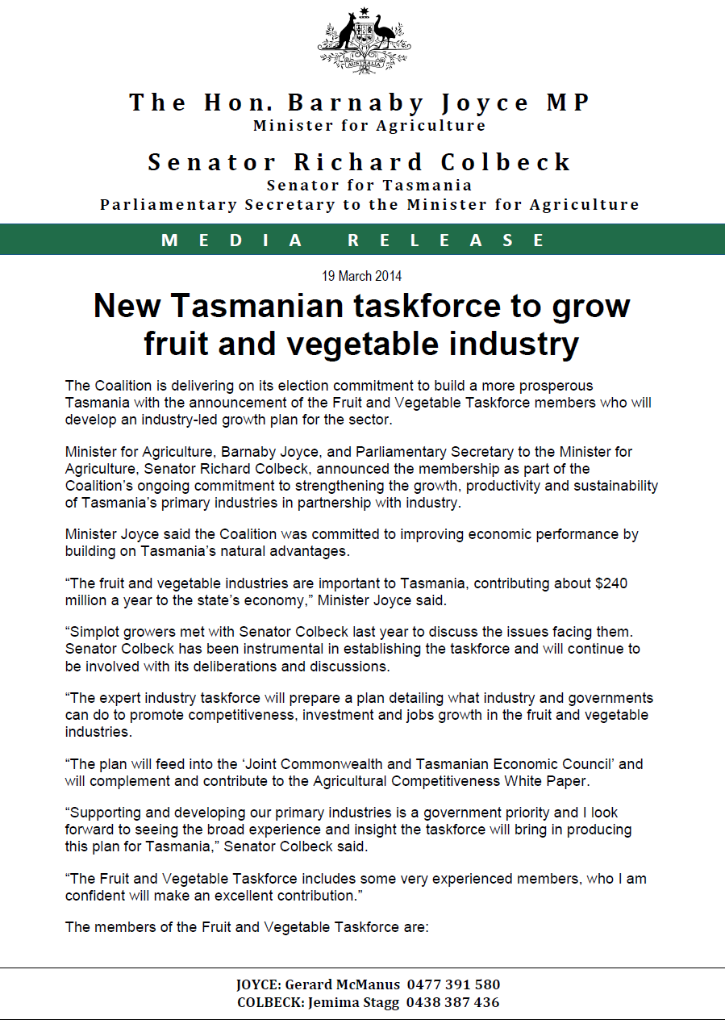

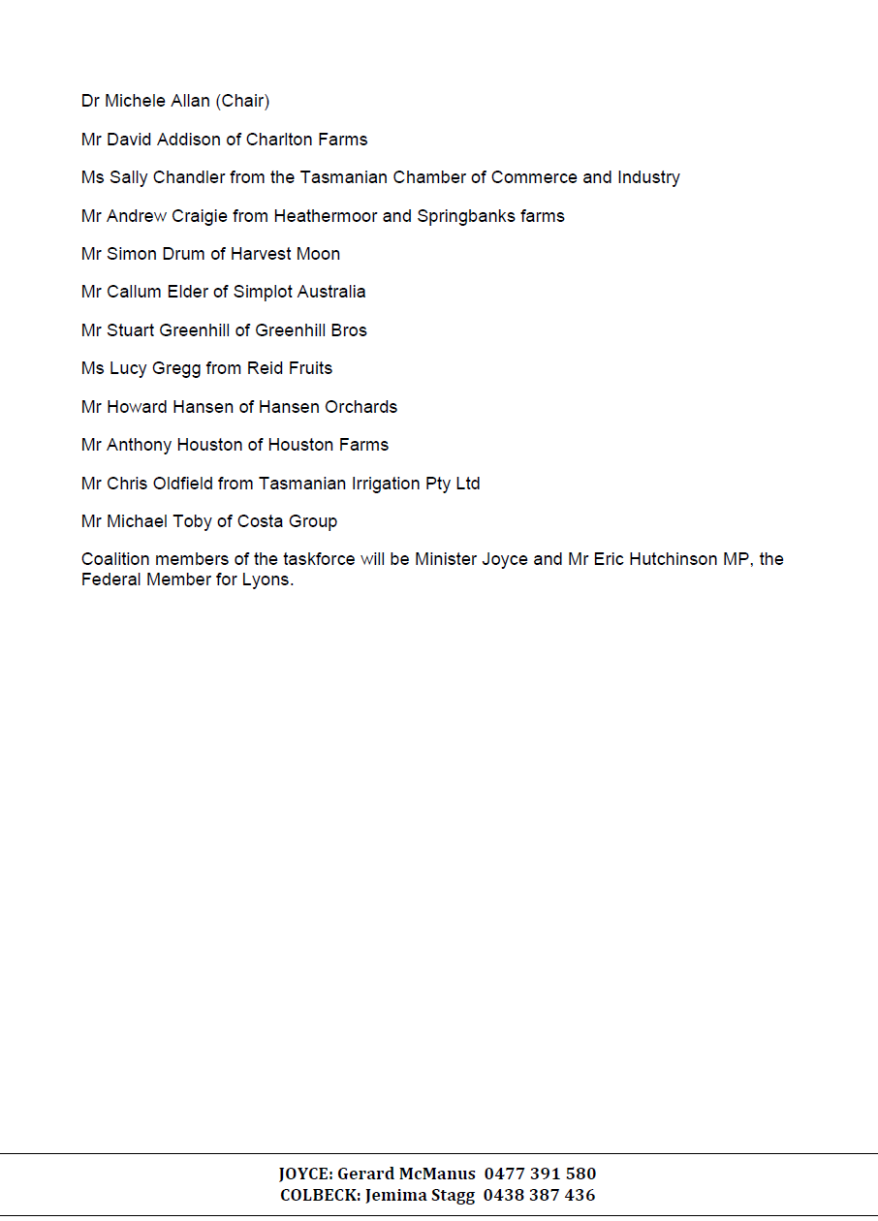

Appendix 2 Terms of Reference

Background
The Australian Government is committed to improving Tasmania’s economic performance by building on the State’s natural advantages, its expertise as a manufacturer of a wide variety of quality products and the potential to attract high value-added industries.
The fruit and vegetable industries make an important contribution to the Tasmanian economy and the government believes they have considerable potential for growth. The government has appointed an expert industry Taskforce to prepare an agreed plan that will detail what industry and governments can do to promote competitiveness, investment and jobs growth in these industries.

Scope
The Taskforce will review existing work, draw conclusions and develop a unified and agreed plan for the Tasmanian fruit and vegetable industries to:
- increase grower returns and reduce their costs;
- increase competitiveness, investment and jobs growth across the supply chain; and
- develop domestic and export markets.

Membership
The Taskforce will comprise an independent Chair and up to 12 members with skills and experience related to the production and marketing of horticultural produce and allied service industries and the Australian Government Minister for Agriculture.

Operation
The Taskforce will meet as necessary, in person or by other means, at the discretion of the Chair. It will develop its own work-plan to address the Terms of Reference. The Taskforce may commission expert advice or other assistance, if required.

Consultation
The Taskforce will decide on the appropriate extent and means of industry consultation required to develop the plan.

Reporting
Once completed, the plan will be made available to industry and also submitted to the Minister for Agriculture who will provide the plan with an accompanying report to the ‘Joint Commonwealth and Tasmanian Economic Council’. The plan will complement and contribute to the White Paper on Australia’s Agricultural Competitiveness.

Secretariat
The Department of Agriculture will provide secretariat and administrative support for the Taskforce.

Funding
The activities of the Taskforce and the secretariat will be funded by the Department of Agriculture.

Term
The Taskforce is expected to complete the plan within three months of its first meeting.

Appendix 3 Discussion Paper and literature review

Note: Appendix 3 – pages 14 to 96 is provided as a separate document at http://www.daff.gov.au/agriculture-food/hort-policy/tas-fruit-veg-industry-taskforce

Appendix 4 Consolidated Actions from Previous Reports
The Taskforce’s key recommendation is to establish a Tasmanian Horticulture Market Growth Project and that a market growth facilitator be appointed to identify and explore market opportunities and link these back to the local supply chain. The market growth facilitator would be overseen by the Tasmanian Horticulture Market Growth Reference Group made up of a skills-based industry group. The reference group is to develop a five-year plan for the project.
To inform the development of this plan, the Taskforce reviewed the actions recommended by previous strategies and reports as identified in the Literature Review and Discussion Paper (Appendix 3). It consolidated and ranked them as high, medium or low priorities. It then nominated responsibility for implementing them to either the market growth facilitator, or to industry organisations and/or government. The actions for the facilitator are listed in Table One (Actions 1–22) and those for industry organisations and government in Table Two (Actions 23–46). In each table, the actions have been categorised into one of the four drivers of sales growth (Markets, People, Funding and Innovation). Table One also includes the Taskforce’s recommended actions to establish the Tasmanian Horticulture Market Growth Project.
Note: references in the tables are from the Literature Review and Discussion Paper at Appendix 3.
Table One: Actions for the market growth facilitator
MARKET DRIVER
(Additional actions recommended by Taskforce):
- Establish a Tasmanian Horticulture Market Growth Project with sufficient resources to:
  - Work with industry to realise market opportunities for Tasmanian fruit and vegetables and connect Tasmanian growers/suppliers with Australian and overseas buyers. The focus would initially be on identifying an opportunity in one market that is already accessible to Tasmanian suppliers and aggressively pursue sales outcomes.
  - Identify opportunities for growth of specific fruit and vegetable products in various markets as the demand in developing economies in the Asian region grows. The focus is on future opportunities that may require changes to production systems and/or market access negotiations and associated R&D activities.
To test and refine their approach, the facilitator should initially identify one group of growers/suppliers for the product to the single market.
- Establish a Tasmanian Horticulture Market Growth Reference Group to:
- Develop a 5-year work plan to realise market opportunities for Tasmanian fruit and vegetables and connect Tasmanian growers/suppliers with overseas buyers.
- Guide and mentor the market growth facilitator.
In developing the work plan, the reference group should consider those actions listed below, in addition to any other actions they consider relevant based on their expertise and experience.
(Actions from previous reports):
High priority actions
- Collate information on priority Australian and export markets for fruit and vegetables and the products required by these markets (AUSVEG 2012).
- Identify the opportunities for growth of specific fruit and vegetable products in various markets, including cities in China, as the demand in developing economies in our region grows (AUSVEG 2012).
Medium priority actions
- Investigate strategies to link local growers and suppliers into national and international networks (AUSVEG 2012).
- Examine and document where appropriate the experiences of vegetable businesses already exporting to Asia (Bensley 2013)
- Promote the use of existing services such as Austrade and the Export Market Development Grants scheme (AUSVEG 2013)
- Encourage and facilitate the ‘clustering’ of growers (and suppliers) to better target export market opportunities (Simplot Vegetable Growers Group 2013)
- Facilitate trade missions in conjunction with peak industry bodies and state and Commonwealth departments where appropriate (Simplot Vegetable Growers Group 2013)
- Utilise and leverage the Tasmania brand image, under Brand Australia, in the development of ‘niche’ fruit and vegetable products (West et al. 2012; Simplot Vegetable Growers Group 2013)
- Facilitate the development of the fresh and minimally processed categories with branded premium vegetable products marketed in terms of ‘fitness for purpose’ and a range of functionally and/or nutritionally enhanced branded vegetables (McKinna et al Pty Ltd 2007)
- Implement a change management strategy and infrastructure to enable change including: market intelligence, leadership program; overseas study tours, benchmarking study and competitor analysis (McKinna et al Pty Ltd 2007)
Lower priority actions
- Raise the national profile of the Tasmanian vegetable industry by seasonal promotion with mainland independent retailers and supermarkets of Tasmania’s icon vegetable products (McKinna et al Pty Ltd 2007)
- Maximise opportunities in the local (Tasmanian) market by collaborating with the major supermarkets and assessing the potential to supply the local (Tasmanian) market (McKinna et al Pty Ltd 2007)
PEOPLE DRIVER
(Additional actions recommended by Taskforce):
- Work with industry including growers, packers and others in the supply chain on collaborating to support the entry and/or expansion of Tasmanian fruit and vegetables in selected markets.
The initial focus should be targeted to one or two groups of growers and suppliers to test and refine the approach for fostering collaboration for market success.
(Actions from previous reports):
High priority action
- Facilitate the establishment of efficient and collaborative supply chains models (Laird 2007).
Medium priority actions
- Facilitate the development of grower (and supply chain partners) clusters to maximise production/supply chain efficiencies (Laird 2007)
- Facilitate benchmarking of grower’s cost of production to allow greater insight into best practice business methods (TFGA 2014, Simplot Vegetable Growers Group 2013)
- Provide opportunities for study trips to improve business management practices (Simplot Vegetable Growers Group 2013)
- Establish a network of successful growers/exporters across a range of industries to allow sharing of ideas and knowledge (after AUSVEG 2013)
- Develop and deliver programs to improve market awareness and supply chain understanding by growers (Heap 2012)
- Establish a (fruit and) vegetable industry round table & communication program to foster a collaborative rather than adversarial approach (McKinna et al Pty Ltd 2007)

Table Two provides the priority and associated actions that the Taskforce assessed to be the primary responsibility of industry organisations and/or government. There are ten high priority actions listed under the Markets, People, Investment and Innovation drivers and a number of medium and low priority actions. Comments on the linkage between the Tasmanian Horticulture Market Growth Project are also provided.
Table Two: Actions for Industry Organisations and Government
Actions from previous reports
MARKET DRIVER
High priority actions
- Continue market development and maintenance activities to maintain and/or grow existing markets and access new markets, including R&D to remove sanitary/ phytosanitary and other barriers to trade (West et al. 2012, AUSVEG 2012)
- A Brand Australia program that encompasses Australian safe and premium produce should be pursued, along with a campaign to be used in Asia that promotes Australian horticulture’s safety and premium quality (Bensley 2013)
- Government should investigate ways to provide more cost-effective access to tools essential to market access, such as information on phytosanitary requirements, market information and fees associated with export registration to encourage exporters to export (Bensley 2013)
- The Federal Government should make the completion of the Australian-China FTA a priority (Bensley 2013)
Medium priority actions
- Ensure that collective industry price negotiations reflect efficiency-based grower pricing rather than a price to cover the highest cost growers (Heap 2012)
- Protect the processing industry by implementing a generic promotional program for frozen vegetables jointly funded by processors and processor growers (McKinna et al Pty Ltd 2007)
- Governments should focus on building relationships within Australia (between Commonwealth, State and Territory governments and industry) to ensure a ‘unified front’ when approaching the challenge of market access to China (Bensley 2013)
Comments
The role of the market growth facilitator will be to establish contacts in the relevant Federal and Tasmanian government agencies and maintain an awareness of current information on markets such as phytosanitary requirements and national commodity export marketing strategies when considering market opportunities for Tasmania. The Australian Government provides support to exporters and/or potential exporters through the Export Market Development Grants scheme to pursue export opportunities. The Tasmanian Horticulture Market Growth Project should promote this scheme and any similar grants schemes to the Tasmanian fruit and vegetable industries.
Actions such as collective price negotiations and generic promotional programs are a matter for the parties directly involved in these issues, such as the Tasmanian Farmers and Graziers Association (TFGA), processors such as Simplot and processing vegetable growers.
Background: Free Trade Agreements (FTA) are helping Australian exporters access new markets and expand trade in existing markets. The Australian Government works closely with agriculture industries to establish sectoral market access priorities, aimed at negotiating FTAs that eliminate barriers to trade and are underpinned by rules that encourage the free flow of bilateral and regional trade.
Australia has seven FTAs currently in force with New Zealand, Singapore, Thailand, US, Chile, the Association of South East Asian Nations (ASEAN) (with New Zealand) and Malaysia. The countries covered by these FTAs account for 26 per cent of Australia's total trade.
Australia signed an FTA with Korea in April 2014 and an EPA with Japan in July 2014. These agreements will enter into force when domestic processes have been completed. Korea and Japan account for 5 and 11 per cent of Australia’s total trade, respectively.
Australia is currently engaged in seven FTA negotiations - three bilateral FTA negotiations: China, India and Indonesia; and four plurilateral FTA negotiations: the Trans-Pacific Partnership Agreement (TPP), the Gulf Cooperation Council (GCC), the Pacific Trade and Economic Agreement (PACER Plus), and the Regional Comprehensive Economic Partnership Agreement (RCEP). The additional countries covered by these negotiations account for a further 29 per cent of Australia’s total trade.
The Australian Government Department of Agriculture has been actively pursuing improvements to the consultation arrangements with Australian horticultural industries, particularly in terms of the processes to identify priority projects for market access negotiation. There have been considerable achievements to date with the movement to more informed (evidence-based) analysis of market access applications and the strengthening of the engagement of industry in the strategies underpinning Australia’s approaches, and the subsequent negotiations, to gain, improve or maintain access. The primary forum for advice to the department regarding the horticultural sector’s priorities for market access is the Office of Horticultural Market Access, which is an industry project, funded by Horticulture Australia Limited from industry levies and matching Australian Government payments.
In addition, the Horticulture Export Industry Consultative Committee provides the horticulture industry the opportunity to assist with the establishment of process reforms and standards to further promote efficiencies in the export pathways. On 13 May 2014, the Australian Government announced a $15 million package assisting small exporters which will; provide small exporters a rebate in 2004–15; include a fees and charges review and; fund projects to benefit small exporters. The rebate will be available to eligible small exporters in sectors where there is a specific export registration charge—that is, meat, dairy, egg, seafood, horticulture, and the grain export sectors.
Five specific industry consultative committees will work with the Department of Agriculture to roll out this initiative. This will involve leading the discussions on the fees and charges review, and making recommendations to the Hon. Barnaby Joyce, MP, Minister for Agriculture by 30 June 2015 about the equity and sustainability of the current fees and charges, including a proposal for a new structure, if appropriate. The consultative committees will also recommend suitable projects to the Minister by 30 June 2015 to improve market access for small exporters.
PEOPLE DRIVER
High priority actions
- Continue the development and implementation of education and training plans for the Tasmanian fruit and vegetable industry at both the business (farm) management and worker skill levels. The plan should account for producer capability to exploit new and emerging technology and consider strategies for attracting skilled labour (Laird 2007, AUSVEG 2012, Simplot Vegetable Grower Group 2013).
Comment
The market growth facilitator should keep a watching brief on this issue and will need to establish contacts in the relevant industry associations and Australian and Tasmanian government departments.
Background: Agricultural education to up-skill growers and workers will be critical to the competitiveness of the industry.
The Australian Government recognises the challenges agricultural employers face in meeting their workforce demands, and the importance of agricultural education and training in creating a skilled and resilient workforce for the sector. One of the government’s key aims is to encourage more young people into the agriculture industry.
On 3 July 2014 the Minister for Education, the Hon Christopher Pyne MP announced Federal Government funding of $2 million over two years for the Agriculture in Education program. A total of 60 five-minute online teacher support videos and a further 30 curriculum resources will be developed in the first year of the project. The resources will be available as part of the National Online Learning Services (formerly known as the National Digital Learning Resources Network). They are being developed by the Primary Industries Education Foundation and Agrifood Skills Australia.
The government provided funding of $14.9 million from 1 July 2011 to 30 June 2104 to Agrifood Skills Australia to provide accurate industry intelligence on current and future skills needs and training requirements for the rural and related industries. Funding has been extended to 30 June 2015.
The Department of Agriculture has provided support to the Primary Industries Education Foundation since their formation in 2008, through annual membership fees and project funding, to promote learning about agriculture in schools.
On 13 May 2014 in the Budget, the Minister for Industry, the Hon Ian Macfarlane MP, announced a Federal Government initiative of a new $476 million Industry Skills Fund, to commence on 1 January 2015, to streamline training and better position Australian industry to succeed in a rapidly changing global economy. It will deliver close to 200 000 targeted training places and training support services over four years and will complement the Government’s investment in the Trade Support Loans scheme.
Under the Trade Support Loans scheme, from 1 July 2014 the Government will offer loans of up to $20 000 over the life of an apprenticeship for target occupations on the National Skills Needs List including trades such as diesel mechanics and fitters that provide important support to agriculture. Like HELP loans for tertiary students, the loans will help apprentices to afford the costs associated with undertaking an apprenticeship and be repayable once apprentices are earning a sustainable income.
The Industry Skills Fund fund will assist small and medium sized businesses to successfully diversify and improve competiveness in a global market. Registered Training Organisations will deliver to businesses high-quality accredited and targeted training. The fund will help make Australian industry more flexible so it can seize emerging opportunities like new markets in Asia from Free Trade Agreements. The fund will be delivered through the new streamlined Single Business Service initiative to make it easier for businesses to deal with Government.
The Australian Government is also developing a White Paper on Agricultural Competitiveness, which will outline a clear strategy to improve the competitiveness and profitability of the agricultural sector. It will specifically consider ways to boost jobs growth, and how skills, training, education and human capital can contribute to industry efficiency and competitiveness.
The Tasmanian Government made pre-election commitments to a number of initiatives including providing an additional $450 000 to implement the TFGA Agricultural Skills Plan; and establishing an Agricultural Industry Training Advisory Board. These are subject to consideration in the context of the August 2014 Budget.

Table Two continued:
INVESTMENT DRIVER
High priority actions
- Invest in transport infrastructure (West et al. 2012; Simplot Vegetable Growers Group 2013)
- Provide information and facilitation services to attract new investors (Laird 2007; West et al. 2012)
- Remove regulatory barriers that are specific to the industry sectors (West et al. 2012)
- The Federal Government should consider tax incentives for on-farm infrastructure (Centre for International Economics 2010)
Medium priority actions
- Irrigation infrastructure (West 2009; West et al. 2012; Tasmanian Labor Government 2014).
- Government grants for farm energy audits; clean energy opportunities; irrigation energy efficiency (Simplot Vegetable Growers Group 2013)
Low priority actions:
- develop a prospectus and canvass interest from commercial parties to invest in greenhouse vegetable production in Tasmania (McKinna et al Pty Ltd 2007).
Comments
The market growth facilitator may play a role in working to attract new private investment into Tasmanian fruit and vegetable industries by promoting the opportunities created by major infrastructure investments.
The most appropriate mechanism may be to work with Invest Tasmania (the Tasmanian Government’s investment promotion and facilitation arm). The facilitator should also seek external funding opportunities as they arise through various grant programs and make information on current grant programs available to industry.
Background: Both Tasmanian and Federal governments have made significant investments in irrigation and transport infrastructure in Tasmania. The Tasmanian Government has also committed to creating a new, independent body called Infrastructure Tasmania to manage and invest in vital infrastructure including rail, major roads, energy, ports, and water and sewerage.
Both the Tasmanian State and Federal governments have deregulation agendas. The Tasmanian Government has committed to establishing the Regulation Reduction Coordinator in the Office of Coordinator-General to help cut red and green tape, and the Federal Government is committed to reducing the cost of red-tape by $1 billion per annum. Issues such as taxation and regulatory reform are also being considered through the Federal Government’s White Paper on Agricultural Competitiveness.

INNOVATION DRIVER
High priority actions
- Research and development to deliver more standardised quality assurance standards, occupational health and safety standards, domestic biosecurity arrangements, traceability and grower registration leading to more competitive domestic markets (AUSVEG 2012).
Medium priority actions
- R&D to develop effective strategies for increasing labour efficiency (AUSVEG 2012)
- Encourage ‘LEAN thinking’ in agricultural value chains (Simplot Vegetable Growers Group 2013)
- Encourage R&D:
- to better understand costs and technical issues with retailers
- on emerging post-harvest production technologies such as novel thermal and non-thermal technologies
- on emerging technologies for quality assessment
- on emerging technologies to extend quality
- on packaging/processes and automation (AUSVEG 2012)
- Increased research and development particularly in new varieties/crops and new production systems, including developing production guidelines to meet the needs of supply chain stakeholders (West et al. 2012; AUSVEG 2012; Simplot Vegetable Growers Group 2013).
Low priority actions
- Develop an occupational health and safety pro-forma standard approach (Simplot Vegetable Growers Group 2013)
- More efficient resource utilisation-precision agriculture and controlled traffic farming (Simplot Vegetable Growers Group 2013)
- Develop more fertiliser use efficient varieties of high input crops (for example, potatoes) (Heap 2012).
- Research and development on new management models, technologies, different ways of doing business and managing risk for example, forward selling and hedging (AUSVEG 2012)
Comments
The market growth facilitator should have a general role in promoting a culture of innovation in the industry. This may best be achieved by monitoring and establishing networks with major R&D providers such as Horticulture Australia Limited, the Centre For Food Innovation and Tasmanian Institute of Agriculture as well as monitoring progress in other large horticultural producing countries. Being aware of and promoting training opportunities as they arise such as leadership training and study grants should be considered.
Background: There is a range of public and private sector providers of horticultural R&D. For example Horticultural Australia Limited forecast that it will invest $87 million in horticultural related R&D in 2014–15 which includes $43.5 million in Australian Government matching funds.
The University of Tasmania also launched its Centre for Food Innovation in April 2013. Research projects are to include, ‘increasing export market access for fresh produce by extending shelf life using innovative processing and packaging technologies’.

Appendix 5 List of Invited Speakers and Out-of-Session Papers

List of Invited Speakers
- Mr Mike Evans, Managing Director, Fresh Partners Marketing
  - ‘Experience and lessons from BananaBar’
- Mr Craig Burns, Managing Director, Rural Industries Research and Development Corporation
  - ‘Promoting Agriculture in North West Tasmania’
- Mr Andre Mayne, Director Plant Export Operations, Department of Agriculture
  - ‘Observations regarding Australia’s position in fresh produce export markets’
- Mr Chris Oldfield, Chief Executive Officer, Tasmanian Irrigation Pty Ltd
  - ‘The Tasmanian Irrigation Pty Ltd Model’
- The Hon. Jeremy Rockliff MP, Deputy Premier and Minister for Primary Industries and Water
  - ‘Agri-Growth Tasmania’
- Professor Roger Stanley, Director, Centre for Food Innovation, University of Tasmania.
  - ‘New Enabling Technology for Fruit and Vegetable Processing’

List of Out of Session Papers
- Briefing Paper on recently commissioned Horticulture Australia Limited vegetable projects—AUSVEG, May 2014
- The Role of Social Capital in the Tasmanian Cherry Industry Value Chain—Summary Report—Sophie Folder, University Of Queensland, June 2013
- Enabling More Value Added Exports of Packaged Foods—Professor Roger Stanley, Director, Centre for Food Innovation at the University of Tasmania
- Processed Vegetable Cost of Production Comparison 2013–14 Tasmania and New Zealand—Macquarie Franklin April 2014
- 2014 Environmental Scan of the Food Industry—AgriFood Skills Australia

Appendix 6 Overview of the Tasmanian fruit and vegetable industries
Tasmanian fruit and nuts comprised around three per cent, and vegetables around six per cent, of the total value of Australian fruit and vegetable production in 2012–13 (ABS 2014). In the 12 months to June 2013, Tasmania exported $44 million of fresh fruit and vegetables, 6.7 per cent of the total value of national exports of fresh fruit and vegetables (World Trade Atlas 2014).
The main Tasmanian crops are potatoes, onions, carrots, cherries, pomefruit and berries. In 2012–13, the gross value production of fruit and nuts in Tasmania was $112.6 million, vegetables $236.6 million and nursery production (nurseries, cut flowers and cultivated turf) $27.9 million (ABS 2014). The historical gross value of production for Tasmanian fruit and vegetables is shown in Figure 1.
Figure 1: Gross Value of Production, Vegetablesª and Fruit^{b}, Tasmania, 1993–94 to 2012–13
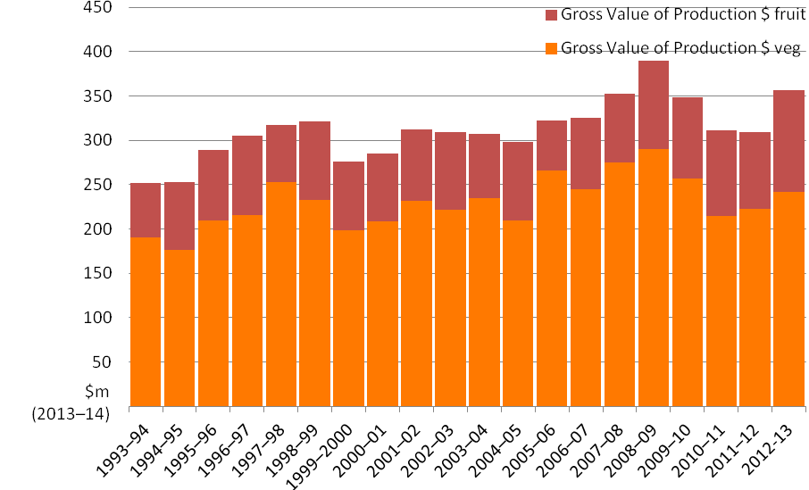
ª Includes vegetables produced for seed as well as human consumption. ^{b} All fruit excluding grapes - includes Citrus fruit, Pome fruit, Stone fruit, Other orchard fruit, Berry fruit, Plantation fruit and Nuts. Note: Results are presented in 2013–14 dollars.
Source: data from ABS, Value of agricultural production, cat. no. 7503.0, various years, Australian Bureau of Statistics, Canberra

Vegetables
The four highest value vegetable crops grown in Tasmania in 2012–13 were potatoes, carrots, onions and beans (Table 1). Other vegetable crops grown for processing includes peas, cauliflower and broccoli.

Table One: The gross value of production, production volume and number of producing businesses for the four highest value vegetable crops in Tasmania in 2012–13.

Crop | Value  ($ million) | Volume  (tonnes) | Number of businesses
Potatoes | $ 120.1 | 350 470 | 394
Carrots | $ 29.4 | 50 917 | 62
Onions | $ 27.5 | 87 457 | 104
Beans | $ 7.0 | 6 964 | 61

Onions are the predominant vegetable export. In 2012–13, 44 720 tonnes of onions with a value of $22.9 million were exported, representing 94 per cent of the total value of Tasmanian vegetable exports. Tasmania accounted for 86 per cent of all onions exported from Australia in 2012–13 (World Trade Atlas 2014). In 2012 the Australian exports of fresh onions accounted for 0.9% of global exports of these products (World Trade Atlas 2014).
In contrast to other states, exporting and direct sales to processors are the predominant sales channels for fresh produce. For example, in 2011–12, an estimated 70 per cent of Tasmanian vegetable growers sold their produce directly to a processor and 10 per cent for export (Valle et al. 2014). This compares to the national average of 26 per cent and four per cent respectively (Valle et al. 2014). In 2011–12 only five per cent of Tasmanian vegetable farms reported selling direct to state capital wholesale, compared to the national average of 62 per cent (Valle et al. 2014).

Fruit
The two highest value fruit crops grown in Tasmania in 2012–13 were cherries and apples (Table 2). Grapes for wine production had a gross value of $ 26 million, but are not included as the wine industry is considered separate from the horticulture industry. Other fruit and nuts had a value of $22 million, with the majority of this being berries. Recent investments in berry production in Tasmania will lead to increased production and value from the sector in the near term.
Cherries represented 98 per cent of the total value of Tasmanian fruit exports in 2012–13, with 1 499 tonnes exported with a value of $19.5 million. Tasmania accounted for 52 per cent of all cherries exported from Australia in 2012–13 (World Trade Atlas 2014). In 2012 the Australian exports of fresh cherries accounted for 0.4% of global exports of these products (World Trade Atlas 2014).
Tasmanian apple exports have been in long term decline, with less than one per cent of production (207 tonnes) exported in 2012–13, compared to the height of the industry in 1967–68 when 151 322 tonnes was produced, with more than 70 per cent exported. There are currently no berry exports from Tasmania.
Table Two: The gross value of production, production volume and number of producing businesses for the two highest value fruit crops in Tasmania in 2012–13.
Crop | Value  ($ million) | Volume  (tonnes) | Number of businesses
Cherries | $ 36.5 | 3 859 | 74
Apples | $ 34.9 | 28 453 | 65

Further detail on the Tasmanian fruit and vegetable industries, including the overarching operating environment is provided in the discussion paper and literature review at Appendix 3.

References:
ABS 2014, Value of Agricultural Commodities Produced cat no. 7503.0, Australian Bureau of Statistics, Canberra.
Valle, H, Caboche, T and Lubulwa, M, 2014, Australian vegetable growing farms: An economic survey, 2011–12 and 2012–13, ABARES Research report 14.1 prepared for Horticulture Australia Limited, Canberra, February.
World Trade Atlas 2014, www.gtis.com/english/GTIS_products.html, viewed on 8 January 2014.

