REPORT TO LEVIES STAKEHOLDERS
2015-2016


CONTENTS
LEVIES AT A GLANCE 2015-16 3
ABOUT THIS REPORT 4
EXECUTIVE SUMMARY 4
FINANCIAL MANAGEMENT 5
Levies and charges disbursed in 2015–16 5
Processing levies and charges 7
Levies management systems 8
COST RECOVERY 9
Levy Efficiency and Feasibility (LEAF) Rating 11
NATIONAL COMPLIANCE PROGRAM 16
Compliance activities in 2015–16 16
Compliance results in 2015–16 16
Selection of levy agents for compliance 17
APPENDICES 19
Appendix A: Cost recovery charges by LRB ($) – 2012-13 to 2016-17 19
Appendix B: Cost recovery charges by commodity ($) – 2012-13 to 2016-17 21
Appendix C: Levy disbursed by LRB ($) 25
Appendix D: Levy disbursed by commodity ($) 26
Appendix E: LRB analytical data 30
Appendix F: Commodity analytical data 31
Appendix G: 2015-16 LEAF commodity ratings 35
Appendix H: Risk ratings - comparison over last 12 months 38
GLOSSARY 41
CONTACT 42

LEVIES AT A GLANCE 2015-16
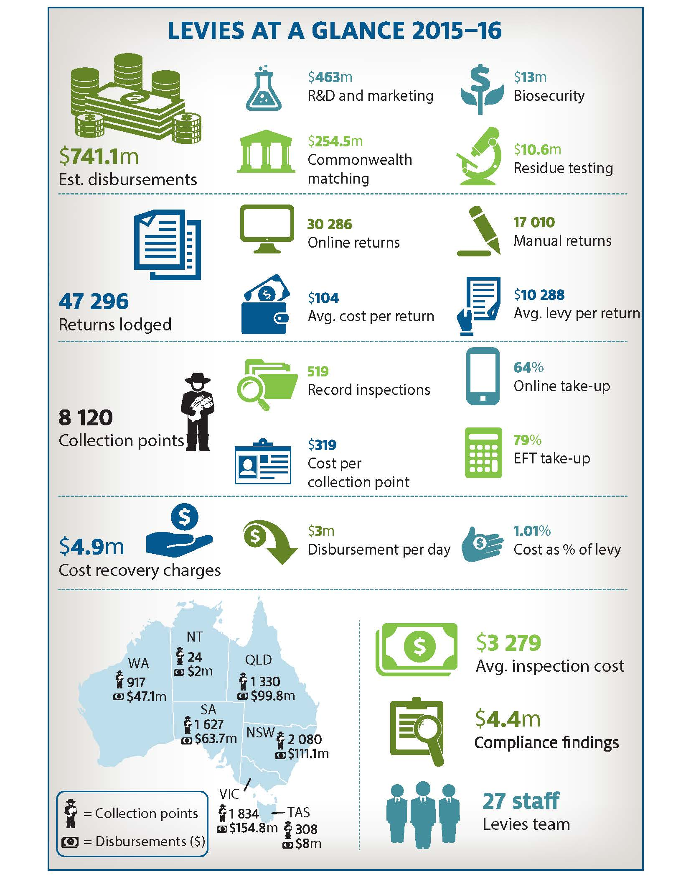

ABOUT THIS REPORT
This report outlines the operations and financial performance of levies administration under the Department of Agriculture and Water Resources. The report provides levy recipient bodies (LRBs) and industry representative bodies (IRBs) with information about the annual performance of the department’s levy collection function, with particular focus on the fees and charges associated with providing this service.

EXECUTIVE SUMMARY
The department is responsible for the collection, administration and disbursement of levies and charges on behalf of Australia’s primary industries. The key functions that the department manages to ensure that levy collection is materially complete and that administration is efficient and cost effective are shown in Table 1.
In 2015–16, the department disbursed $741.072 million in levies, charges and Commonwealth matching payments to 18 LRB’s for research and development, marketing, biosecurity and residue testing. From the 47 296 returns lodged with the department, $463.005 million was directed to R&D and marketing, $12.995 million was directed to biosecurity and $10.580 million was directed to residue testing. Eligible R&D that attracted Commonwealth matching payments totalled $254.492 million.
The department operates under a cost recovery arrangement to administer levies and charges. In 2015–16, the total cost incurred by the department was $4.896 million. On average, the cost to the department to process a return was $104, with an average of $10 288 collected in levy per return from 8 120 collection points. The department encourages online levy returns and electronic funds transfer (EFT) to reduce the cost of processing levy returns, invoices and receipts. In 2015–16, 17 010 manual returns were processed and 30 286 online returns were lodged with 79 per cent of payments made by EFT.
Table 1: Levies administrative functions
Function | Brief description
Financial Management | Disbursement of levy and charge funds and Commonwealth matched payments and internal budgeting and reporting.
Processing | Process levy returns, invoices, receipts, penalty remissions and refunds.
Management Systems (Phoenix/Levies Online) | Administration of Phoenix, the department’s levies management information system and systems support for Levies Online, the department’s external platform for levy payers to calculate, lodge and track levy returns.
Cost Recovery | Activity based costing methodology applied to costs that are incurred by the department to manage the levies program and assigned to LRBs, and the analysis of estimates and costs year–on–year.
Compliance | Deliver the National Compliance Program and its sub–tasks, including the Operational Compliance Program, Strategic Compliance Program, Targeted Compliance Assessment Program (TCAP) and real–time compliance and monitoring activities.
Stakeholder Management, Legislation and Policy | Support stakeholders to establish or amend levies and charges through the Australian Government’s Levy Principles and Guidelines, provide policy and legislative advice and manage day to day internal/external stakeholder relationships.

FINANCIAL MANAGEMENT
The 2015–16 levies operating statement, demonstrates a relatively stable financial position to 2016–17. Overall expenditure in 2015–16 was $5.120 million. This amount has reduced year-on-year from $5.203 million in 2014–15, as shown in Table 2.
The 2015–16 increase in employee expenses is attributed to additional staff employed to manage statistical reporting and other administrative processes which are offset by a decrease in departmental overheads, supplier and other expenses while also recording an increase in revenue from government. The decrease in supplier expenses is attributed to reductions in costs for travel, information technology and telecommunications, contractors and consultants.
Table 2: 2014-15 to 2016-17 levies operating statement
Operating statement | 2014-15 ($) | 2015-16 ($) | Variance ($) | Variance (%) | 2016-17 Est ($)¹
Revenues from government | 219 182 | 223 415 | 4 233 | 1.93% | 221 232
Other revenue | 5 659 | 35 415 | 29 756 | +100.00% | –
Cost recovery charges | 4 978 468 | 4 896 450 | (82 018) | –1.65% | 4 901 017
Total revenue | 5 203 309 | 5 155 279 | (48 030) | –0.92% | 5 122 249
Employee expenses | 2 998 178 | 3 117 839 | 119 661 | 3.99% | 3 153 247
Supplier expenses | 632 830 | 476 044 | (156 786) | –24.78% | 611 989
Other expenses | 20 045 | 7 312 | (12 733) | –63.52% | 8 865
Depreciation and amortisation | 174 757 | 176 023 | 1 266 | 0.72% | 156 072
Departmental overheads | 1 377 500 | 1 342 654 | (34 845) | –2.53% | 1 192 081
Total expenses | 5 203 309 | 5 119 873 | (83 436) | –1.60% | 5 122 254
Net surplus/(deficit) | – | 35 407 | 35 407 | –100.00% | (5)
Levy disbursed | 488 783 571 | 486 580 008 | (2 203 563) | –0.45% | 446 309 343³
Commonwealth matching | 245 898 049 | 254 492 230² | 8 594 181 | 3.50% | 263 516 000³
Total disbursed | 734 681 620 | 741 072 238 | 6 390 618 | 0.87% | 709 825 343
- 2016–17 reflects the initial estimate and is subject to change.
- 2015–16 Commonwealth matching is current as at 30 June 2016, however, this amount is subject to change based on final claims received from LRBs.
- Levy disbursed and Commonwealth matching for 2016–17 is current as at 30 June 2016 and are based on estimates provided by LRBs

Levies and charges disbursed in 2015–16
In 2015–16, the department collected $486.580 million in levies and charges from 47 296 returns. The Commonwealth matching payments for eligible research and development is expected to be $254.492 million, pending final payments.
The amount of levy and charges disbursed to each of the 18 LRBs is shown in Chart 1.
Chart 1: 2015-16 total levy disbursed by LRB ($m)
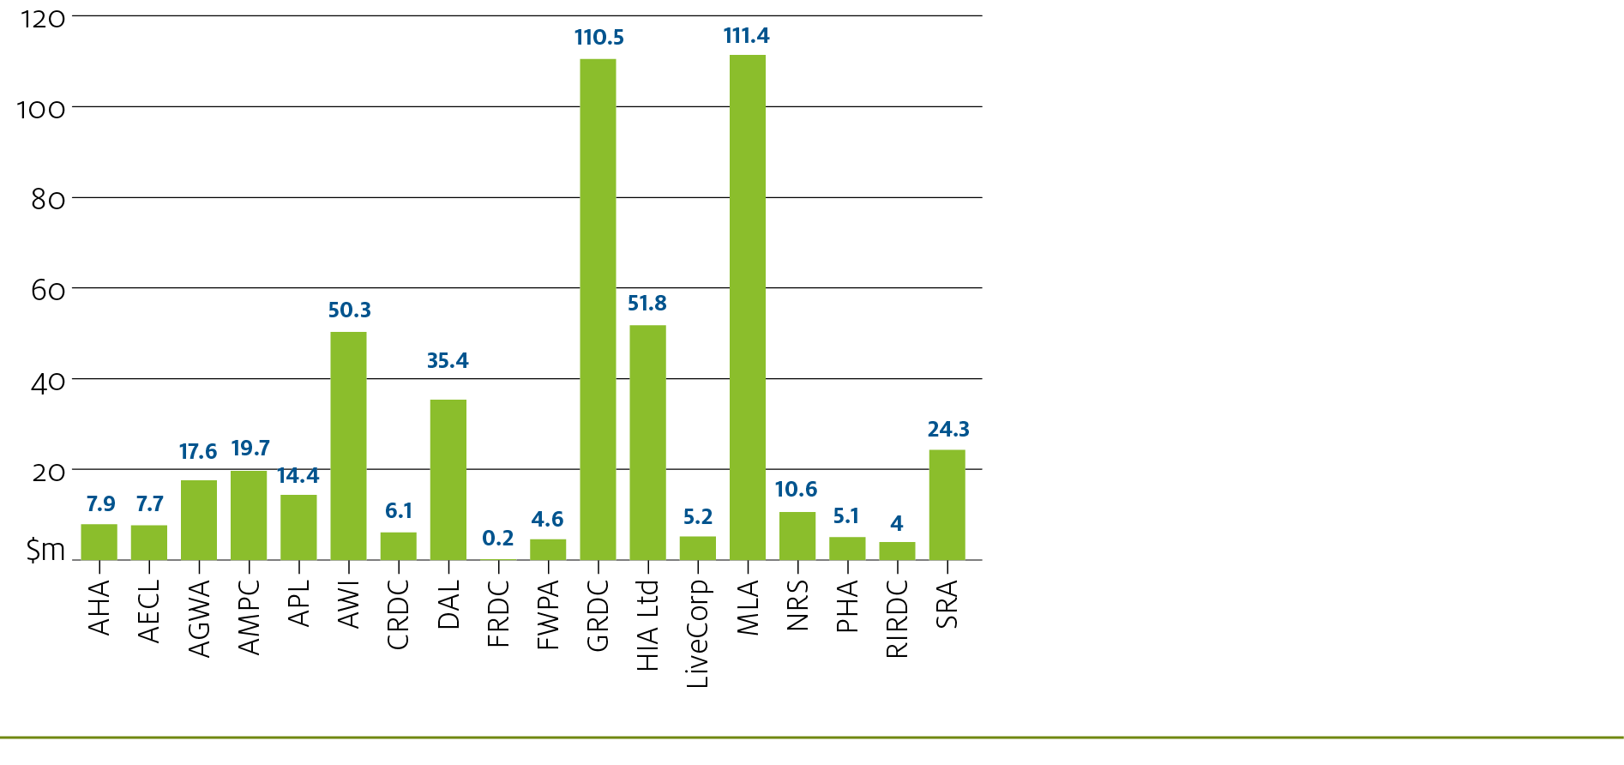
The amount of levy and charges disbursed by industry category is shown in Chart 2.
Chart 2: 2015-16 total levy disbursed by industry category ($m)
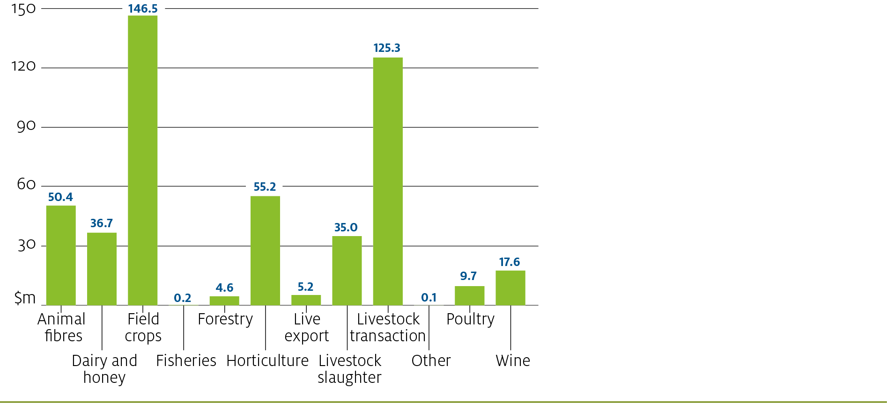
In 2015–16, the average levy submitted per return was $10 288. The average amount of levy submitted per LRB is shown in Chart 3.
Chart 3: 2015-16 average levy submitted per return
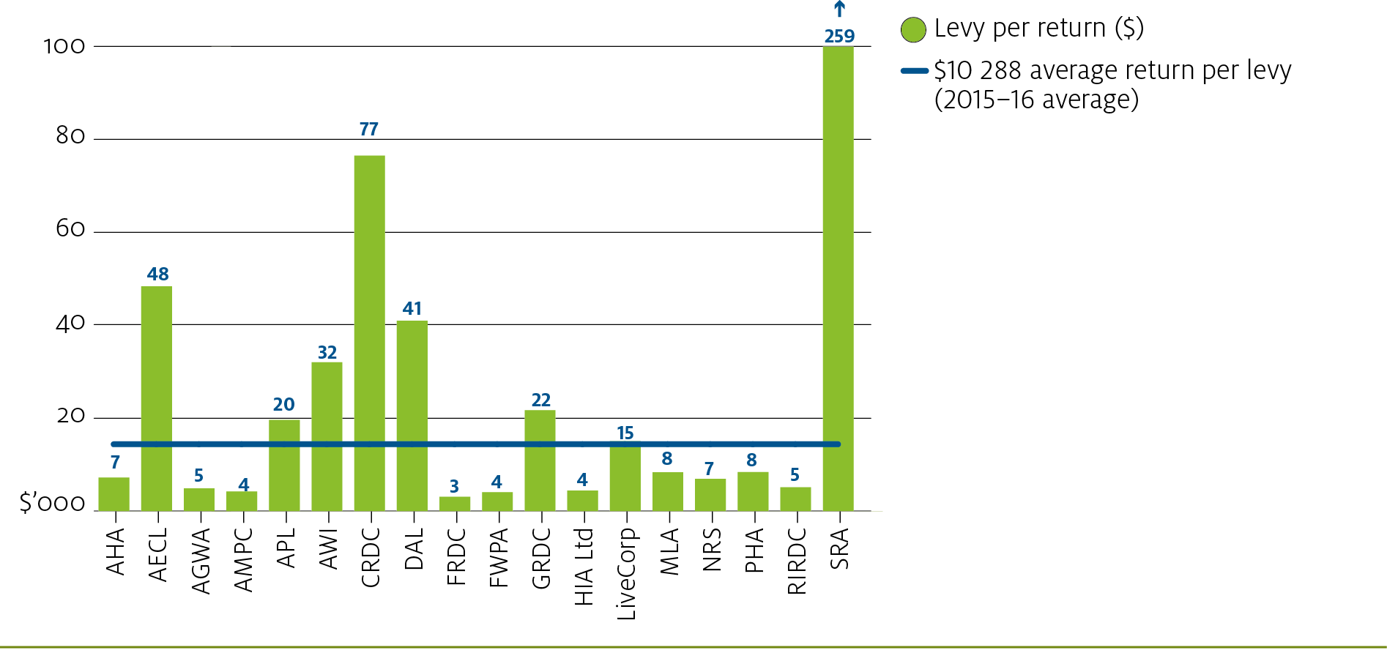

Processing levies and charges
The department encourages all levy payers and intermediaries to submit their returns using Levies Online and to make their payments via EFT. Online returns reduce the amount of processing time that the department cost recovers from industry, as well as limiting the number of errors reported in processing manual returns.
In 2015–16, the number of returns submitted through Levies Online increased to 30 286, reducing the number of manual returns to 17 010. The type and number of returns per industry group is shown in Table 3 and the percentage of online and EFT take-up by industry group is shown in Chart 4.
Table 3: 2015-16 returns and receipts processed by industry group
Industry group | EFT receipts processed | Other¹ receipts processed | Total receipts processed | Manual returns lodged | Online returns lodged | Total returns lodged
Animal fibres | 1 110 | 504 | 1 614 | 820 | 756 | 1 576
Dairy and Honey | 906 | 187 | 1 093 | 655 | 634 | 1 289
Field crops | 5 316 | 865 | 6 181 | 1 515 | 3 915 | 5 430
Fisheries | 31 | 20 | 51 | 52 | – | 52
Forestry | 976 | 192 | 1 168 | 344 | 788 | 1 132
Horticulture | 10 285 | 3 200 | 13 485 | 4 495 | 7 794 | 12 289
Live Export | 372 | 20 | 392 | 40 | 320 | 360
Livestock slaughter | 3 749 | 1 191 | 4 940 | 2 199 | 3 338 | 5 537
Livestock transaction | 10 609 | 3 441 | 14 050 | 5 455 | 9 981 | 15 436
Other | 136 | 61 | 197 | 96 | 100 | 196
Poultry | 272 | 88 | 360 | 310 | 95 | 405
Wine | 4 260 | 552 | 4 812 | 1 029 | 2 565 | 3 594
TOTAL | 38 022 | 10 321 | 48 343 | 17 010 | 30 286 | 47 296
- Other consists of cheque and money order payments.
Chart 4: Percentage of online and EFT take-up by industry category
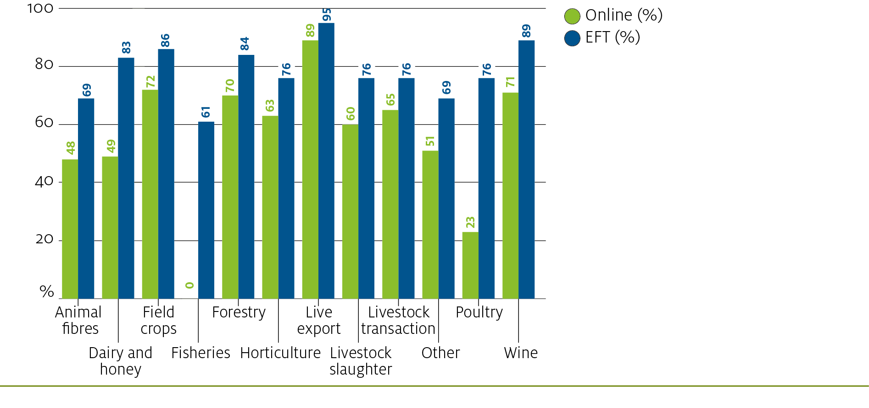

Levies management systems
The administration of levies and charges is supported by Phoenix and Levies Online. Phoenix is a bespoke levy management information system used by the department for processing levy returns, receipts, disbursements and compliance management. Levies Online has streamlined the connection between levy payers, agents and the department, providing levy payers with a web-based platform to calculate, lodge and track levy returns and update personal information.
The department is committed to delivering a transparent, sustainable and highly cost-efficient levies collection service. Throughout 2016, service delivery improvements that support levy administration will continue to be made through the Australian Government’s digitisation agenda. The department will complete upgrades to essential components of Phoenix and Levies Online to further automate levy transactions and administrative activities. The provision of simultaneous levy payments and returns, reporting capabilities, real-time analysis of levy activities performed by the department and providing online agents with greater accessibility to update their account details.

COST RECOVERY
The department operates under a cost recovery arrangement to collect levies and charges on behalf of Australia’s primary industries. Industries that collectively invest in research and development, marketing or biosecurity are, therefore, liable for the cost incurred by the department to administer the levies and charges.
Over the five year period from 2011–12 to 2015–16, the department has reduced its cost of administering levies and charges by 13.8 per cent. The department has reduced these costs through service delivery modernisation and working closely with industries to ensure that their levy and collection mechanisms are efficient.
Chart 5: 2011-12 to 2016-17 cost recovery charges and levy disbursed
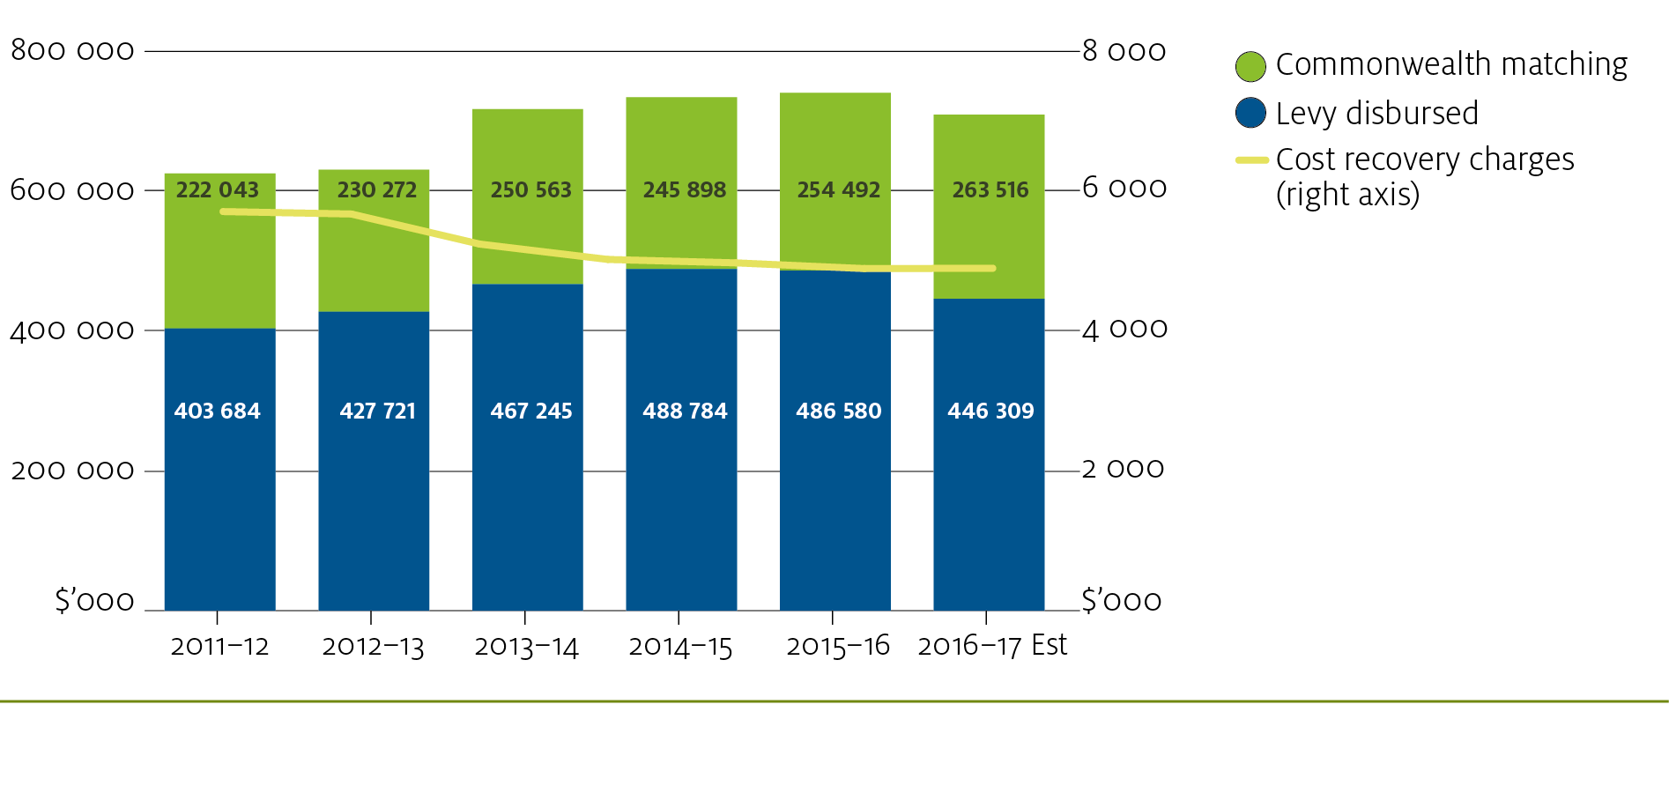
The department’s costs are made up of direct and indirect costs. These costs are based on timesheets recorded by staff in the Levies – Industry Support Branch. The costs are coded directly to a collection point or a commodity depending on the activity, or for indirect effort (program management), allocated on a proportional basis. Industries that attract more direct effort, including for establishing or amending a levy and its collection mechanism, or through the department providing statistical analysis should, therefore, expect to receive a greater proportion of the department’s overall cost recovery charges.
In 2015–16, the department’s levy administration costs reduced by 1.65 per cent from 2014–15, representing 1.01 per cent of the total levies collected and disbursed. More information about the levy administrative costs are provided in Table 4 and the cost recovery charges, as a percentage of levy disbursed are shown in Chart 6.
Table 4: 2014-15 to 2016-17 costs by cost pool
Cost Pool | 2014–15 ($)¹ | 2015–16 ($) | 2016–17 Est ($)
Direct charges (e.g. legal services, IT costs) | 37 974 | 55 420 | –
Agent management (e.g. liaising with levy–payers and/or intermediaries) | 411 028 | 432 918 | 455 778
Queries (generated by incorrect returns and/or payments) | – | 192 597 | 188 928
Processing (e.g. returns and payments) | 371 888 | 261 842 | 207 115
Statistics (statistical information entered alongside returns) | – | 112 378 | 122 780
Targeted compliance (e.g. OCP and SCP) | 1 056 107 | 964 376 | 1 014 760
Non–targeted compliance (e.g. missing returns and debt management) | 467 934 | 400 196 | 436 366
Other actions (e.g. reporting, commodity specific requests for support) | 379 989 | 220 321 | 165 197
Program management (e.g. non–attributable activities) | 2 253 549 | 2 256 404 | 2 310 093
TOTAL | 4 978 468 | 4 896 450 | 4 901 017
- Queries and statistics were included as part of other actions in 2014–15 and not as individual cost pools. Detailed cost recovery charges can be found at Appendix A (LRBs) and Appendix B (commodities).
Chart 6: 2015-16 cost recovery charges as a percentage of levy disbursed by LRB

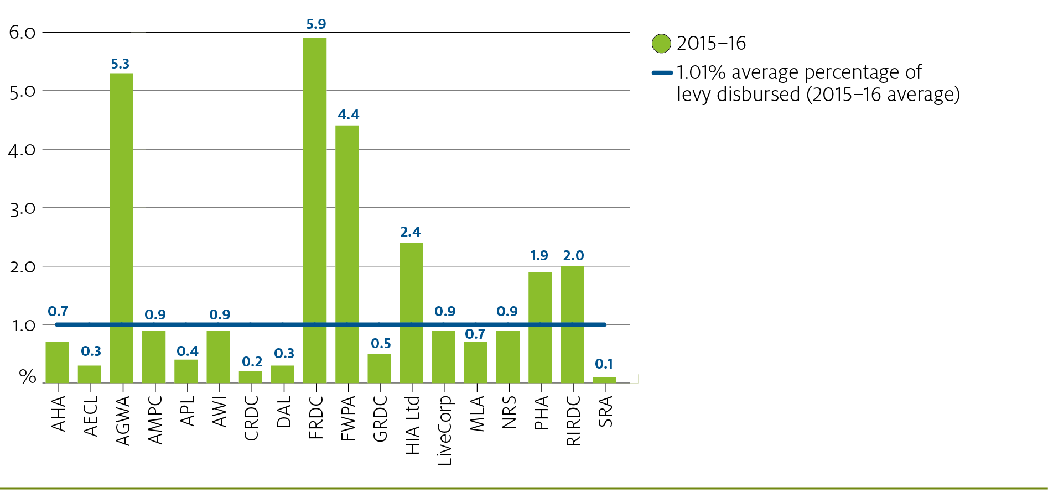

2015-16 levy changes
Throughout 2015–16, the following levy activities contributed to the department’s costs for administering the levies and charges:
- the fodder industry introduced a research and development export charge at 50 cents per tonne of exported hay and straw and
- the responsibility of collecting the wine export charge was transferred from the department to the Australian Grape and Wine Authority, the wine export regulator under the Australian Grape and Wine Authority Act 2013.
Six existing levies and charges were also amended, including the:
- chestnut Emergency Plant Pest Response (EPPR) levy and export charge activated to
1 cent per kilogram (overall rate increased to 11 cents per kilogram)
- citrus research and development levy and export charge rate increased from $1.97 per tonne to
- $3.20 per tonne and the Plant Health Australia levy and export charge rate increased from 3 cents per tonne to 30 cents per tonne
- deer velvet levy and export charge set to zero and the charge on live deer exports set to zero
- pig slaughter marketing levy increased to its final increment from $1.95 to $2.25 per pig slaughtered (overall rate increased to $3.425 per pig slaughtered)
- Pinus sp. (exotic softwood) private plantation logs EPPR levy and export charge activated to 5 cents per cubic metre of logs (overall rate increased to 10.5 cents per cubic metre of logs) and
- sweet potato industry introduced a marketing levy and export charge at 1 per cent of the value of the sweet potato at the first point of sale (overall rate increased to 1.5 per cent of the value at first point of sale).

Levy Efficiency and Feasibility (LEAF) Rating
The department contributes to the productivity, competitiveness and profitability of Australia’s agricultural industries by developing and implementing national policy, legislative frameworks and associated administrative arrangements. The administrative arrangements that support an efficient and cost-effective levy collection service, while maintaining material completeness, is a high priority for the department.
The Levy Efficiency and Feasibility (LEAF) rating was developed in 2014–15 to demonstrate to stakeholders how efficient and feasible a levy or export charge is to collect. It was also developed to provide industries with a comparison of their position against other industries and to better understand the cost drivers that impact their position.
The rating system scores a commodity based on two factors, levy effectiveness and cost effectiveness, on a scale of zero to ten, ten being the highest. Table 5 summarises the scoring system:
Table 5: How LEAF factors are calculated
LEAF factor | Measure | High score typified by: | Low score typified by:
Levy effectiveness (#/10) | Levy ($)/return (#) | High levy ($)/return | Low levy ($)/return
Levy effectiveness (#/10) | Levy ($)/collection point (#) | High levy ($)/collection point | Low levy ($)/collection point
Levy effectiveness (#/10) | Total levy ($) | High levy ($) | Low levy ($)
Cost effectiveness (#/10) | Cost ($)/return (#) | Low cost ($)/return | High cost ($)/return
Cost effectiveness (#/10) | Cost ($)/collection point (#) | Low cost ($)/collection point | High cost ($)/collection point
Cost effectiveness (#/10) | Cost (%) of total levy | Low cost as % of total levy | High cost as % of total levy
The rating system is designed to be quantitative, not qualitative. There are numerous factors to consider when deciding the feasibility of a levy. The LEAF rating of a commodity is intended to provide initial insight into a levy’s feasibility, with close regard to the reasons for setting it up in the first place. Commodities will fall in one of four categories:

Leaders | High cost effectiveness | High levy effectiveness
Challengers | High cost effectiveness | Low levy effectiveness
Bolters | Low cost effectiveness | High levy effectiveness
Developers | Low cost effectiveness | Low levy effectiveness

Chart 7: 2015-16 LEAF matrix
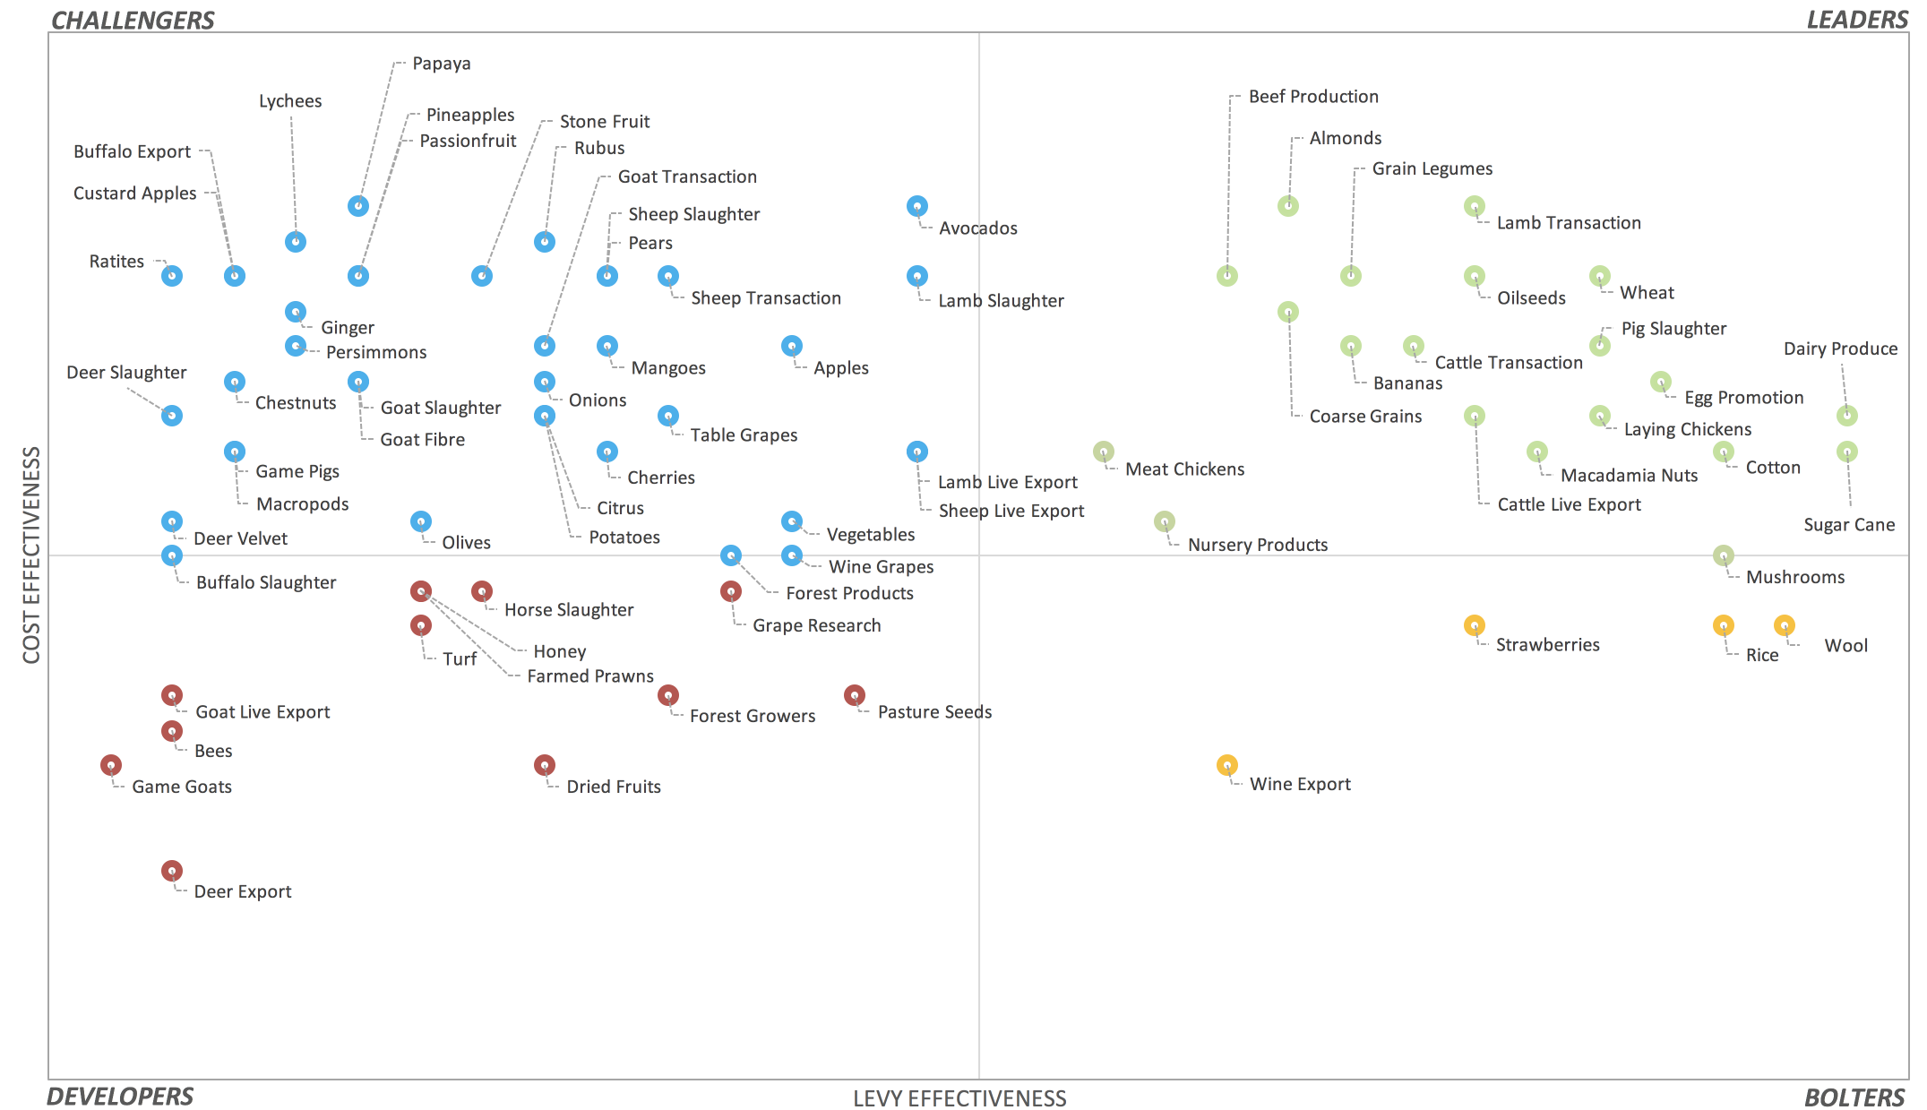
From 2014–15 to 2015–16, the LEAF rating for 13 commodities changed, as shown in Table 6.
Table 6: Commodity LEAF movements from 2014-15 to 2015-16
Commodity | 2014–15 LEAF Rating | Movement | 2015–16 LEAF Rating
Bees | Challenger | Down | Developer
Deer Velvet | Developer | Up | Challenger
Forest Products | Developer | Up | Challenger
Game Pigs | Developer | Up | Challenger
Goat Fibre | Developer | Up | Challenger
Goat Live Export | Challenger | Down | Developer
Honey | Challenger | Down | Developer
Horse Slaughter | Challenger | Down | Developer
Mushrooms | Bolter | Up | Leader
Nursery Products | Bolter | Up | Leader
Olives | Developer | Up | Challenger
Sheep Live Export | Leader | Down | Challenger
Wine Export | Challenger | Across | Bolter
Levies are considered financially viable in the Challenger, Bolter or Leader quadrants. However, this does not mean that levies classified as Developers are not feasible. Decisions to keep levies or charges activated are not focused on levy or cost effectiveness alone. Other considerations, such as signing a biosecurity deed with Plant Health Australia or Animal Health Australia, residue testing requirements through the National Residue Survey, or other policy positions should to be considered, alongside the financial viability.
The number of collection points per LRB and the average cost for each collection point is shown in Chart 8. The amount of levy collected per collection point is shown in Chart 9 and more information about a commodity’s LEAF rating is available in Appendix G.
Chart 8: Number of collection points by LRB
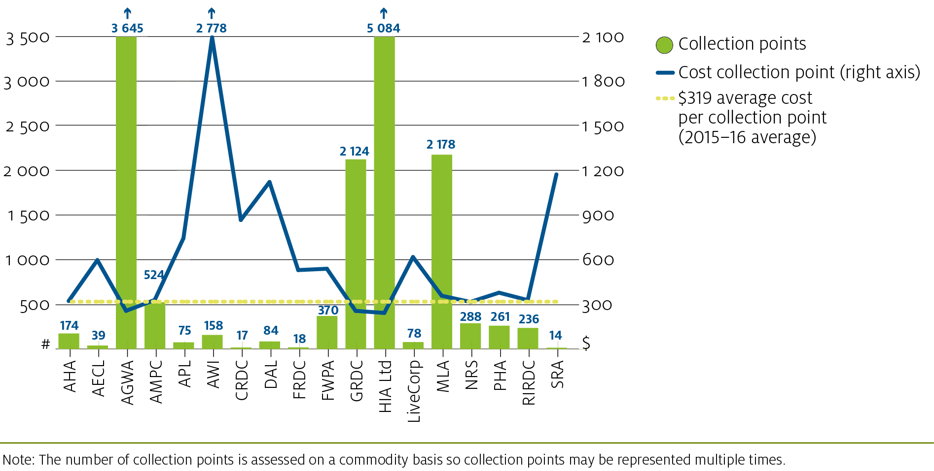
Note: The number of collection points is assessed on a commodity basis so collection points may be represented multiple times.
Chart 9: Amount of levy collected per collection point by LRB
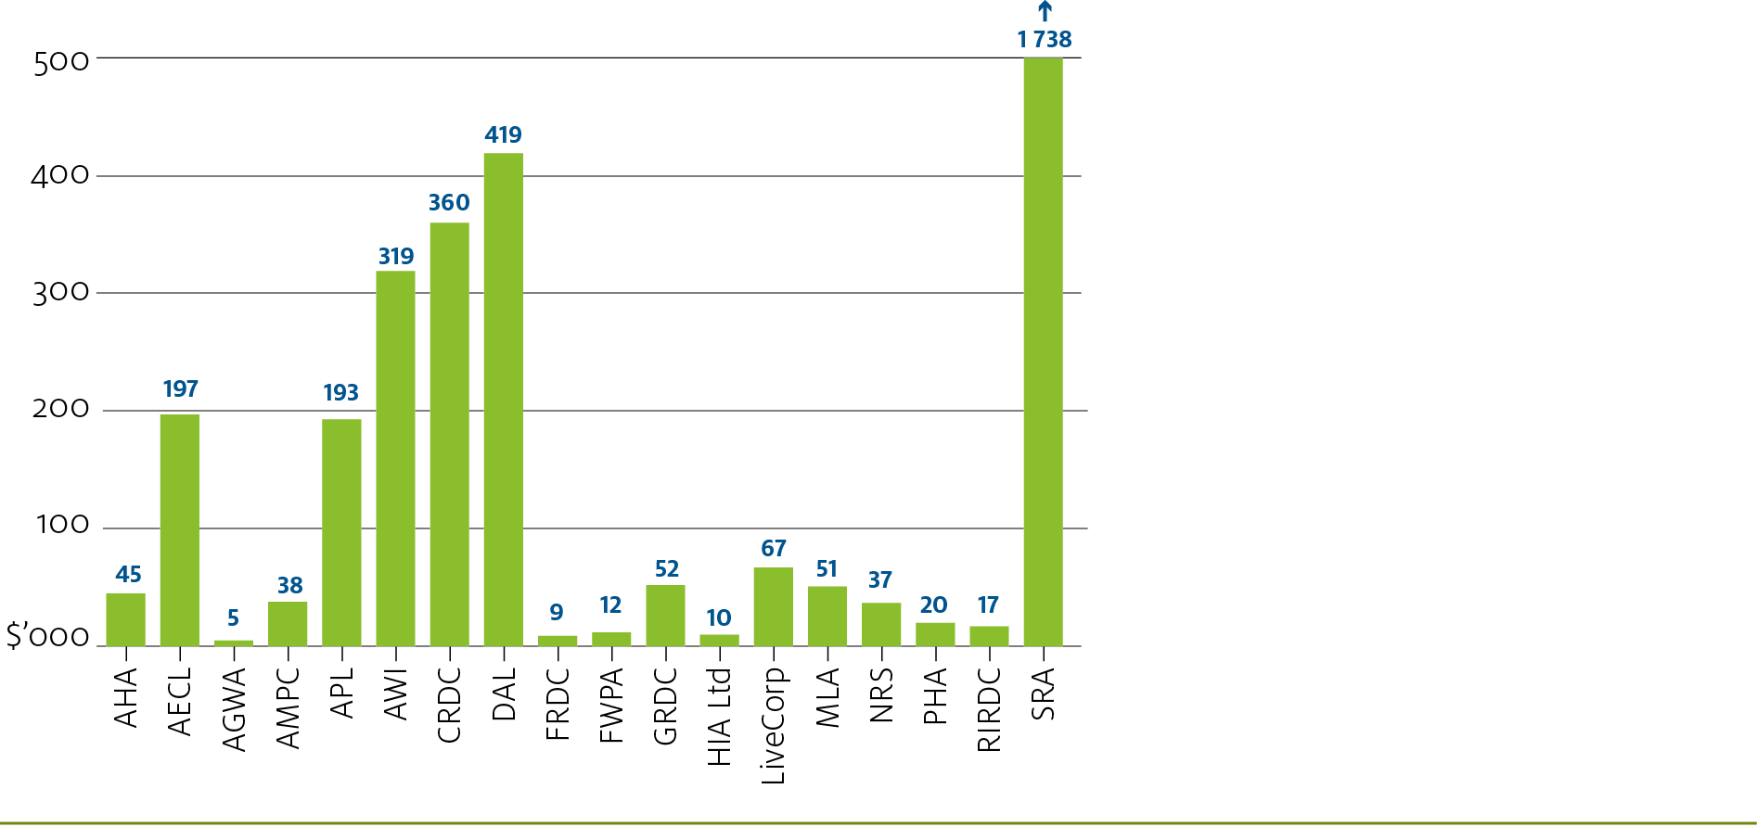
There are a number strategies that an industry can use to improve their LEAF rating. Commodities that are categorised as Challengers need to improve their levy effectiveness, while Bolters need to improve their cost effectiveness to achieve a Leader rating. Developers require an improvement to both levy and cost effectiveness.
Strategies that may assist an industry to increase the efficiency of their levy or charge, include:
- improving the compliance rate of levy payers and intermediaries by reducing the number of missing returns or debt actions
- reducing the complexity of the levy or charge, the number of collection points and the return frequency and
- lodging returns through Levies Online and making payments via EFT.

NATIONAL COMPLIANCE PROGRAM
The National Compliance Program (NCP) is a risk-based approach to managing levies compliance.
The NCP targets agents or commodities of operational or strategic risk and comprises three risk-based programs, the: Operational Compliance Program (OCP), a national record inspection program that certifies the accuracy of levies and charges being paid by business type or commodity; the Strategic Compliance Program (SCP), delivering projects to address specific areas of non-compliance; and the Targeted Compliance Assessment Program (TCAP), focusing on agents not selected in the OCP. Non-targeted compliance activities are also carried out under the NCP, as required.
The 2015–16 NCP results found $4.447 million of inaccurate levies and charges from 519 inspections completed across Australia. Of this amount, $4.281 million was reported as levies and charges that were underpaid by levy agents and $166 434 in overpaid levies and charges, which were refunded accordingly.

Compliance activities in 2015–16
In 2015–16, the National Compliance team delivered the NCP from four of the department’s regional offices in Sydney, Melbourne, Brisbane and Adelaide. Key activities that were delivered throughout 2015–16 include:
- the Commodity Liaison Program, engaging with industry representatives to share information on trends, industry developments and compliance matters and to promote the systems that are available to support them in meeting their obligations
- the Business Improvement Program, assessing the capability and efficiency of levy administration and making recommendations to improve its performance
- account management, monitoring approximately 8 120 levy agent accounts to ensure accurate and consistent levy returns and payments
- completing real-time non-targeted compliance activities that arise from reports of potential levy leakage
- analysis about the outcomes of the NCP to refine the program’s activities and levels of risk and
- debt management.

Compliance results in 2015–16
The National Compliance team, under the OCP, completed 519 field inspections across New South Wales, Victoria, Queensland and South Australia. The 2015–16 agent compliance rate was
64 per cent and the average number of agents with errors identified was 35 per cent, comparable to the 2014–15 figure of 34.8 per cent.
Of the 519 inspections, 25.3 per cent were targeted at high-risk agents, 12.0 per cent were targeted at key industry agents, 48.8 per cent were targeted at medium-risk agents and
13.9 per cent were targeted at low-risk agents. Levies compliance officers also completed
16 desktop reviews where distance, remote locality or agent availability prevented physical inspection of agent records from Victoria, Queensland and South Australia.

Selection of levy agents for compliance
The department recognises the top three levy payers for each commodity as the key industry agents, regardless of their risk category. The three levy agents are selected for inspection on a three year cycle. Risk ratings by industry category are shown in Chart 10. High risk agents are selected on a 50 per cent basis and can expect a record inspection once every two years. The remaining selections are made up of a random sample of 75 per cent medium risk and
25 per cent low risk agents, with a maximum of 15 per cent of an industry being selected in any one OCP.
The selection process was externally reviewed in 2013–14 and 2014–15. The review outcomes demonstrated that the selection program performs well in its capacity to provide assurance that overall levy collection is materially complete.
Chart 10: Risk ratings by industry category
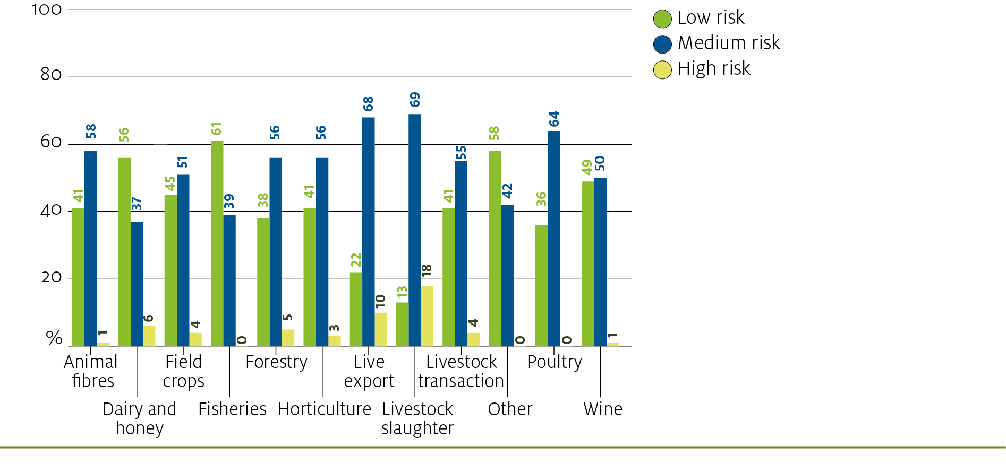
The number of inspection outcomes reported against the risk category assigned to a levy-paying agent are shown in Table 7.
Table 7: 2015-16 OCP inspection outcomes by risk category
Risk category | New South Wales | Victoria | Queensland | South Australia | Total
High risk | 24 | 31 | 14 | 42 | 111
Key industry | 2 | 19 | 6 | 3 | 30
Medium risk | 28 | 30 | 29 | 170 | 257
Low risk | 9 | 7 | 9 | 21 | 46
TOTAL | 63 | 87 | 58 | 236 | 444
Note: Figures quoted reflect errors identified in inspections carried out by Levies Compliance Officers based in the four states, who travel to inspect records in all states and territories.
The number of inspection outcomes reported against the state in which the inspection was carried out are shown in Table 8.
Table 8: 2015-16 OCP inspection outcomes by risk category
Inspection outcomes | New South Wales | Victoria | Queensland | South Australia | Total¹
Levy leakage | 34 | 45 | 26 | 166 | 271
Refund due | 15 | 33 | 19 | 35 | 102
New agents identified | 2 | 7 | 1 | 73 | 83
Statistics error | 10 | 2 | 7 | 1 | 20
Inadequate records | – | 1 | 4 | – | 5
Nil | 96 | 87 | 93 | 56 | 332
Note: Figures quoted reflect errors identified in inspections carried out by Levies Compliance Officers based in the four states, who travel to inspect records in all states and territories.
1. Due to multiple outcomes being recorded against individual inspections the total number of outcomes does not match the number of inspections completed.
The average cost per record inspection in 2015–16 was $3 279. The cost per record inspection across industries ranges from $1 385 to $3 696. More information about the number of record inspections by industry category, including the cost of the inspection and the 2015–16 average are shown in Chart 11.
Chart 11: 2015-16 record inspections by industry category
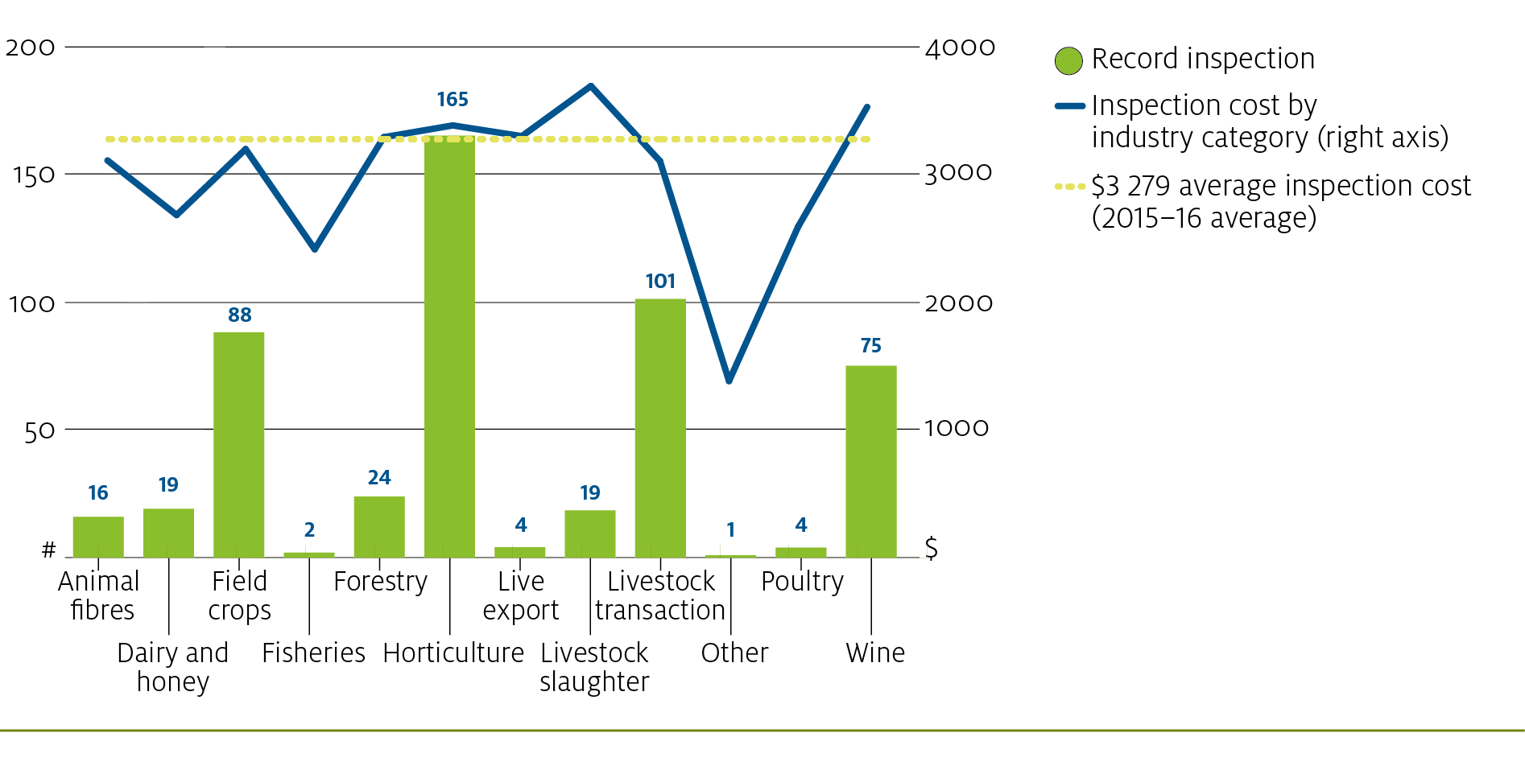

APPENDICES

Appendix A: Cost recovery charges by LRB ($) – 2012-13 to 2016-17
Levy Recipient Body | 2012-13 ($) | 2013-14 ($) | 2014-15 ($) | 2015-16 ($) | 2016-17 Est ($)¹
Animal Health Australia | 96 155 | 98 472 | 62 792 | 56 384 | 48 152
Australian Egg Corporation Limited | 28 400 | 33 117 | 27 399 | 23 280 | 31 378
Australian Grape and Wine Authority² | 1 010 314 | 1 056 530 | 974 166 | 936 622 | 855 648
Australian Meat Processors Corporation | 175 513 | 161 124 | 165 347 | 173 010 | 214 076
Australian Pork Limited | 40 048 | 53 011 | 43 646 | 55 572 | 45 387
Australian Wool Innovation | 359 735 | 346 267 | 480 936 | 438 966 | 431 963
Cotton Research and Development Corporation | 4 256 | 13 254 | 17 612 | 14 590 | 19 772
Dairy Australia Limited | 75 335 | 96 288 | 85 439 | 94 694 | 82 558
Fisheries Research and Development Corporation | 16 172 | 11 503 | 14 877 | 9 559 | 14 561
Forest and Wood Products Australia Ltd | 301 879 | 205 975 | 227 652 | 200 059 | 104 000
Grains Research and Development Corporation | 556 298 | 544 347 | 583 386 | 545 487 | 706 118
Horticulture Innovation Australia Ltd | 1 444 727 | 1 316 357 | 1 309 765 | 1 234 561 | 1 347 494
LiveCorp | 38 040 | 46 451 | 44 184 | 48 241 | 44 564
Meat and Livestock Australia | 727 478 | 737 698 | 688 293 | 781 129 | 643 092
National Residue Survey | 179 672 | 169 042 | 90 821 | 91 343 | 87 767
Plant Health Australia | 10 671 | 7 882 | 38 124 | 98 870 | 125 361
Rural Industries Research and Development Corporation | 118 745 | 109 901 | 107 777 | 77 646 | 88 309
Sugar Research Australia | 22 799 | 19 804 | 16 250 | 16 439 | 10 816
Wheat Exports Australia³ | 40 662 | - | - | - | -
TOTAL | 5 246 899 | 5 027 023 | 4 978 468 | 4 896 450 | 4 901 017
1. 2016-17 has been revised based on timesheet activity between 1 May 2015 and 30 April 2016.
2. The Australian Grape and Wine Authority has been formed since 1 July 2014 and includes amalgamated historical costs for Grape and Wine Research Development Corporation and Wine Australia Corporation.
3. Wheat Exports Australia was abolished on 31 December 2012.

Appendix B: Cost recovery charges by commodity ($) –
2012-13 to 2016-17
Industry Group | Commodity | 2012-13 ($) | 2013-14 ($) | 2014-15 ($) | 2015-16 ($) | 2016-17 Est ($)
Animal fibres | Goat Fibre | 2 449 | 1 182 | 6 069 | 684 | 4 021
 | Wool | 359 735 | 346 267 | 480 936 | 438 966 | 431 963
Total Animal fibres |  | 362,183 | 347 449 | 487 005 | 439 650 | 435 984
Dairy and Honey | Dairy Produce | 83 832 | 105 811 | 87 143 | 96 583 | 83 905
 | Honey | 59 387 | 59 684 | 50 815 | 65 674 | 50 924
Total Dairy and Honey |  | 143,219 | 165 495 | 137 958 | 162 256 | 134 829
Field crops | Coarse Grains | 259 128 | 247 885 | 209 814 | 211 207 | 270 392
 | Cotton | 4 271 | 13 300 | 17 762 | 14 755 | 20 001
 | Fodder export | - | - | - | 4 178 | 10 866
 | Grain Legumes | 109 234 | 94 466 | 126 278 | 95 826 | 135 037
 | Oilseeds | 60 844 | 53 214 | 55 300 | 54 125 | 66 717
 | Pasture Seeds | 4 069 | 3 246 | 5 643 | 3 962 | 4 346
 | Rice | 5 287 | 5 659 | 7 125 | 6 803 | 1 325
 | Sugar Cane | 22 799 | 19 804 | 16 250 | 16 439 | 10 816
 | Wheat | 186 707 | 207 256 | 209 512 | 200 865 | 254 955
 | Wheat Export | 40 662 | - | - | - | -
Total Field crops |  | 693 001 | 644 829 | 647 684 | 608 159 | 774 453
Fisheries | Farmed Prawns | 16 172 | 11 503 | 14 877 | 9 559 | 14 561
Total Fisheries |  | 16 172 | 11 503 | 14 877 | 9 559 | 14 561
Forestry | Forest Growers | 114 593 | 84 444 | 102 514 | 95 986 | 46 410
 | Forest Products | 187 286 | 121 531 | 128 591 | 119 062 | 81 900
Total Forestry |  | 301 879 | 205 975 | 231 105 | 215 047 | 128 310
Horticulture | Almonds | 10 608 | 8 520 | 12 738 | 3 913 | 12 108
 | Apples | 85 656 | 70 376 | 64 705 | 75 959 | 85 690
 | Avocados | 35 247 | 42 741 | 31 831 | 38 255 | 80 043
 | Bananas | 59 114 | 43 983 | 44 532 | 61 033 | 72 016
 | Cherries | 102 562 | 57 566 | 50 873 | 47 057 | 60 486
 | Chestnuts | 17 571 | 10 604 | 13 586 | 8 772 | 11 683
 | Citrus | 96 467 | 109 222 | 80 688 | 89 666 | 102 012
 | Custard Apples | 10 368 | 5 097 | 5 989 | 8 065 | 8 943
 | Dried Fruits | 28 127 | 12 681 | 18 700 | 22 080 | 21 818
 | Ginger | 11 810 | 11 098 | 24 651 | 13 447 | 22 618
 | Lychees | 14 593 | 6 086 | 7 003 | 6 556 | 9 889
 | Macadamia Nuts | 27 953 | 22 495 | 31 865 | 20 856 | 38 581
 | Mangoes | 43 422 | 30 423 | 35 220 | 39 818 | 49 510
 | Mushrooms | 6 161 | 14 103 | 14 986 | 7 173 | 8 714
 | Nashi | (8) | - | - | - | -
 | Nursery Products | 61 165 | 64 676 | 51 449 | 47 435 | 54 912
 | Olives | 24 767 | 60 266 | 51 791 | 17 393 | 25 576
 | Onions | 40 483 | 35 907 | 42 013 | 41 537 | 44 583
 | Papaya | 17 933 | 11 092 | 9 620 | 9 060 | 10 547
 | Passionfruit | 16 447 | 9 641 | 10 308 | 13 291 | 11 315
 | Pears | 49 137 | 43 499 | 34 027 | 38 567 | 41 199
 | Persimmons | 15 431 | 11 387 | 11 199 | 10 406 | 8 809
 | Pineapples | 15 761 | 9 154 | 9 540 | 10 759 | 9 438
 | Potatoes | 53 523 | 78 842 | 56 944 | 51 201 | 48 065
 | Rubus | 16 594 | 6 086 | 8 521 | 7 301 | 9 837
 | Stone Fruit | 70 898 | 54 334 | 47 454 | 34 791 | 47 275
 | Strawberries | 4 894 | 8 254 | 6 333 | 6 240 | 9 968
 | Sweet Potato | - | - | - | 25 157 | 25 143
 | Table Grapes | 80 470 | 63 072 | 71 281 | 61 789 | 66 756
 | Turf | 123 556 | 136 855 | 105 890 | 88 370 | 73 878
 | Vegetables | 336 452 | 307 964 | 411 383 | 383 674 | 358 794
Total Horticulture |  | 1,477,160 | 1 346 024 | 1 365 119 | 1 289 622 | 1 430 206
Live Export | Buffalo Export | 2 075 | 1 277 | 1 484 | 677 | 634
 | Cattle Live Export | 15 257 | 25 399 | 24 401 | 21 351 | 22 520
 | Deer Export | 1 652 | 1 170 | 428 | 1 086 | 947
 | Goat Live Export | 10 574 | 7 923 | 5 784 | 8 547 | 6 182
 | Lamb Live Export | 2 767 | 3 067 | 2 325 | 4 206 | 3 976
 | Sheep Live Export | 9 442 | 10 062 | 11 674 | 14 137 | 11 886
Total Live Export |  | 41,767 | 48 898 | 46 096 | 50 004 | 46 145
Livestock slaughter | Beef Production | 81 111 | 68 397 | 82 512 | 76 133 | 102 092
Livestock slaughter | Buffalo Slaughter | 2 763 | 692 | 1 140 | 1 481 | 1 175
 | Deer Slaughter | 7 041 | 3 911 | 5 211 | 3 304 | 3 553
 | Goat Slaughter | 22 526 | 17 436 | 21 091 | 17 440 | 17 613
 | Horse Slaughter | 5 195 | 481 | 1 517 | 2 892 | 1 605
 | Lamb Slaughter | 37 248 | 40 342 | 32 127 | 41 985 | 60 818
 | Pig Slaughter | 44 009 | 58 254 | 46 273 | 58 868 | 47 673
 | Sheep Slaughter | 34 629 | 34 948 | 29 617 | 37 451 | 33 553
Total Livestock slaughter |  | 234,521 | 224 463 | 219 488 | 239 553 | 268 081
Livestock transaction | Cattle Transaction | 520 239 | 559 807 | 475 028 | 567 507 | 447 196
Livestock transaction | Goat Transaction | 74 895 | 61 487 | 54 804 | 53 833 | 49 742
 | Lamb Transaction | 149 428 | 178 139 | 153 427 | 161 400 | 161 745
 | Sheep Transaction | 141 446 | 100 199 | 102 759 | 105 260 | 80 468
Total Livestock transaction |  | 886,008 | 899 632 | 786 019 | 888 000 | 739 151
Poultry | Egg Promotion | 21 062 | 22 941 | 15 857 | 14 190 | 19 563
 | Laying Chickens | 8 950 | 12 409 | 12 180 | 10 485 | 13 433
 | Meat Chickens | 16 586 | 16 600 | 20 475 | 18 952 | 22 387
Total Poultry |  | 46 597 | 51 950 | 48 513 | 43 626 | 55 382
Wine | Grape Research | 141 944 | 152 094 | 185 098 | 181 700 | 135 549
 | Wine Export | 268 281 | 370 273 | 277 653 | 190 181 | 29 071
 | Wine Grapes | 600 090 | 534 695 | 512 917 | 567 090 | 692 091
Total Wine |  | 1 010 314 | 1 057 063 | 975 668 | 938 971 | 856 712
Other | Bees | 9 127 | 5 810 | 85 | 445 | 70
 | Deer Velvet | 5 990 | 2 048 | 5 356 | 1 508 | 1 491
 | Game Goats | 675 | 349 | 1 193 | 100 | 131
 | Game Pigs | 3 127 | 2 013 | 2 786 | 1 311 | 1 899
 | Macropods | 12 630 | 12 846 | 8 395 | 8 118 | 9 347
 | Ratites | 2 531 | 677 | 1 122 | 520 | 4 265
Total Other |  | 34 079 | 23 743 | 18 938 | 12 002 | 17 202
TOTAL |  | 5 246 899 | 5 027 023 | 4 978 468 | 4 896 450 | 4 901 017

Appendix C: Levy disbursed by LRB ($)
Levy Recipient Body | 2012-13 ($) | 2013-14 ($) | 2014-15 ($) | 2015-16 ($)
Animal Health Australia | 6 432 242 | 7 138 856 | 7 630 079 | 7 886 556
Australian Egg Corporation Limited | 5 491 612 | 7 045 342 | 6 424 048 | 7 654 720
Australian Grape and Wine Authority¹ | 17 116 821 | 18 486 133 | 17 525 053 | 17 598 226
Australian Meat Processors Corporation | 18 055 718 | 20 202 353 | 22 034 673 | 19 664 293
Australian Pork Limited | 12 279 206 | 12 423 453 | 15 077 293 | 14 379 323
Australian Wool Innovation | 43 744 739 | 43 308 614 | 48 303 558 | 50 330 876
Cotton Research and Development Corporation | 11 801 096 | 10 977 077 | 7 298 282 | 6 054 115
Dairy Australia Limited | 31 282 632 | 32 981 436 | 35 372 937 | 35 369 207
Fisheries Research and Development Corporation | 127 204 | 148 956 | 189 250 | 161 515
Forest and Wood Products Australia Ltd | 3 667 921 | 3 991 812 | 4 352 385 | 4 568 525
Grains Research and Development Corporation | 118 396 000 | 120 416 725 | 117 590 342 | 110 520 065
Horticulture Innovation Australia Ltd | 41 198 123 | 42 110 614 | 45 958 821 | 51 819 514
LiveCorp | 3 169 751 | 4 305 821 | 5 612 011 | 5 194 447
Meat and Livestock Australia | 93 789 332 | 106 000 399 | 114 766 843 | 111 382 631
National Residue Survey | 9 553 323 | 10 442 360 | 10 980 124 | 10 579 782
Plant Health Australia | 1 951 769 | 2 229 210 | 2 509 499 | 5 108 870
Rural Industries Research and Development Corporation | 4 623 309 | 5 475 688 | 4 479 362 | 3 974 195
Sugar Research Australia | 4 341 583 | 19 560 494 | 22 679 009 | 24 333 149
Wheat Exports Australia² | 698 418 | 22 | - | -
TOTAL | 427 720 800 | 467 245 363 | 488 783 571 | 486 580 008
1. The Australian Grape and Wine Authority has been formed since 1 July 2014 and includes amalgamated historical costs for Grape and Wine Research Development Corporation and Wine Australia Corporation.
2. Wheat Exports Australia was abolished on 31 December 2012.

Appendix D: Levy disbursed by commodity ($)
Industry Group | Commodity | 2012-13($) | 2013-14($) | 2014-15($) | 2015-16($)
Animal fibres | Goat Fibre | 11 719 | 34 393 | 20 680 | 28 582
 | Wool | 43 744 739 | 43 308 614 | 48 303 558 | 50 330 876
Total Animal fibres |  | 43 756 458 | 43 343 007 | 48 324 239 | 50 359 458
Dairy and Honey | Dairy Produce | 31 914 767 | 33 639 308 | 36 078 511 | 36 074 690
 | Honey | 517 240 | 536 027 | 434 678 | 646 310
Total Dairy and Honey |  | 32,432,007 | 34 175 335 | 36 513 188 | 36 721 001
Field crops | Coarse Grains | 23 319 283 | 26 667 797 | 28 120 104 | 25 774 322
 | Cotton | 11 825 381 | 11 020 528 | 7 360 240 | 6 122 676
 | Grain Legumes | 10 752 818 | 8 518 488 | 10 590 236 | 17 405 898
 | Oilseeds | 23 100 080 | 22 183 647 | 16 604 264 | 18 071 809
 | Pasture Seeds | 88 436 | 187 270 | 172 294 | 133 410
 | Rice | 2 892 328 | 3 492 660 | 2 492 627 | 2 085 358
 | Sugar Cane | 4 341 583 | 19 560 494 | 22 679 009 | 24 333 149
 | Wheat | 64 747 304 | 66 657 835 | 65 828 282 | 52 615 473
 | Wheat Export | 698 418 | 22 | - | -
Total Field crops |  | 141 765 632 | 158 288 740 | 153 847 056 | 146 542 093
Fisheries | Farmed Prawns | 127 204 | 148 956 | 189 250 | 161 515
Total Fisheries |  | 127 204 | 148 956 | 189 250 | 161 515
Forestry | Forest Growers | 1 124 778 | 1 201 822 | 1 400 324 | 1 511 898
 | Forest Products | 2 543 143 | 2 789 990 | 3 001 153 | 3 101 129
Total Forestry |  | 3 667 921 | 3 991 812 | 4 401 477 | 4 613 027
Horticulture | Almonds | 919 973 | 1 359 559 | 1 388 775 | 1 542 450
 | Apples | 4 049 542 | 4 049 366 | 3 846 594 | 4 019 106
 | Avocados | 4 282 215 | 3 652 284 | 4 151 817 | 5 142 969
 | Bananas | 5 778 680 | 6 305 183 | 6 345 198 | 9 031 600
 | Cherries | 964 962 | 711 635 | 962 717 | 1 094 477
 | Chestnuts | 84 124 | 88 415 | 110 472 | 96 353
 | Citrus | 1 833 262 | 1 724 755 | 1 648 672 | 1 874 496
 | Custard Apples | 62 667 | 72 655 | 73 656 | 84 833
 | Dried Fruits | 302 131 | 369 568 | 322 476 | 368 141
 | Ginger | 92 477 | 160 004 | 174 307 | 160 871
 | Lychees | 126 235 | 117 956 | 139 747 | 170 299
 | Macadamia Nuts | 2 857 953 | 3 243 817 | 3 465 318 | 4 050 725
 | Mangoes | 1 018 377 | 904 761 | 1 227 523 | 1 211 245
 | Mushrooms | 2 716 452 | 2 476 956 | 4 296 349 | 4 819 417
 | Nashi | 1 | (158) | - | -
 | Nursery Products | 1 748 603 | 1 944 998 | 2 124 520 | 2 388 718
 | Olives | - | 283 100 | 250 134 | 339 500
 | Onions | 501 395 | 479 741 | 705 920 | 1 018 999
 | Papaya | 254 079 | 302 761 | 278 985 | 333 296
 | Passionfruit | 201 076 | 209 539 | 210 423 | 251 408
 | Pears | 1 448 082 | 1 428 345 | 1 400 853 | 1 565 851
 | Persimmons | 140 855 | 134 053 | 123 173 | 100 944
 | Pineapples | 245 789 | 241 368 | 280 114 | 260 601
 | Potatoes | 967 169 | 957 730 | 1 026 351 | 1 038 398
 | Rubus | 172 371 | 240 080 | 327 363 | 444 391
 | Stone Fruit | 1 012 309 | 927 459 | 948 196 | 991 649
 | Strawberries | 600 508 | 697 731 | 734 722 | 761 083
 | Sweet Potato | - | - | - | 243 036
 | Table Grapes | 1 190 807 | 1 635 998 | 1 601 681 | 1 783 911
 | Turf | 495 734 | 503 974 | 516 012 | 587 326
 | Vegetables | 7 754 742 | 7 802 565 | 8 367 293 | 9 442 185
Total Horticulture |  | 41 822 569 | 43 026 201 | 47 049 360 | 55 218 275
Live Export | Buffalo Export | 3 422 | 9 339 | 19 497 | 25 051
 | Cattle Live Export | 1 836 083 | 3 068 768 | 4 221 723 | 3 978 898
 | Deer Export | - | 30 | - | 515
 | Goat Live Export | 34 770 | 43 357 | 47 821 | 37 652
 | Lamb Live Export | 202 681 | 195 402 | 202 652 | 251 393
 | Sheep Live Export | 1 096 217 | 998 294 | 1 139 815 | 926 504
Total Live Export |  | 3 173 173 | 4 315 190 | 5 631 508 | 5 220 013
Livestock slaughter | Beef Production | 13 233 406 | 14 722 217 | 16 533 486 | 14 464 252
 | Buffalo Slaughter | 1 167 | 1 173 | 1 562 | 1 049
 | Deer Slaughter | 17 931 | 26 315 | 23 259 | 21 701
 | Goat Slaughter | 238 052 | 251 082 | 264 567 | 228 666
 | Horse Slaughter | 44 195 | 51 030 | 41 762 | 53 261
 | Lamb Slaughter | 3 360 449 | 3 600 937 | 3 790 719 | 3 701 983
 | Pig Slaughter | 13 100 237 | 13 243 880 | 15 984 490 | 15 232 114
 | Sheep Slaughter | 1 223 812 | 1 628 116 | 1 445 902 | 1 269 392
Total Livestock slaughter |  | 31,219,249 | 33 524 751 | 38 085 746 | 34 972 418
Livestock transaction | Cattle Transaction | 67 800 817 | 77 613 091 | 84 660 198 | 80 206 603
Livestock transaction | Goat Transaction | 1 080 573 | 1 160 990 | 1 267 777 | 1 102 167
 | Lamb Transaction | 33 769 998 | 36 848 407 | 39 759 656 | 40 969 485
 | Sheep Transaction | 2 894 056 | 3 610 788 | 3 319 544 | 3 036 008
Total Livestock transaction |  | 105,545,445 | 119 233 276 | 129 007 176 | 125 314 264
Poultry | Egg Promotion | 3 733 859 | 4 851 217 | 4 394 571 | 5 270 073
 | Laying Chickens | 1 844 990 | 2 303 019 | 2 141 674 | 2 750 282
 | Meat Chickens | 1 344 192 | 1 401 347 | 1 516 459 | 1 661 053
Total Poultry |  | 6 923 041 | 8 555 582 | 8 052 704 | 9 681 408
Wine | Grape Research | 3 417 930 | 3 633 862 | 3 419 307 | 3 471 619
 | Wine Export | 2 141 993 | 2 183 689 | 2 338 182 | 2 590 386
 | Wine Grapes | 11 605 113 | 12 698 273 | 11 794 918 | 11 582 334
Total Wine |  | 17 165 036 | 18 515 824 | 17 552 407 | 17 644 339
Other | Bees | 9 394 | 6 938 | 8 622 | 722
 | Deer Velvet | 9 867 | 8 696 | 12 414 | 12 871
 | Game Goats | 25 | 16 | 18 | -
 | Game Pigs | 5 649 | 4 762 | 9 457 | 15 717
 | Macropods | 88 119 | 96 898 | 87 357 | 91 818
 | Ratites | 10 011 | 9 378 | 11 592 | 11 069
Total Other |  | 123 065 | 126 688 | 129 460 | 132 197
TOTAL |  | 427 720 800 | 467 245 363 | 488 783 571 | 486 580 008

Appendix E: LRB analytical data
Levy Recipient Body | Collection Points (#)¹ | Cost / collection point ($) | Levy / collection point ($) | Returns processed (#)² | Cost / Return ($) | Levy / Return ($) | Record inspections (#) | OCP Costs ($)³ | Average Inspection Cost ($)
AHA | 174 | 323 | 45 208 | 1 094 | 52 | 7 208 | 6 | 17 725 | 3 133
AECL | 39 | 598 | 196 595 | 158 | 147 | 48 377 | 2 | 3 632 | 2 335
AGWA | 3 645 | 257 | 4 828 | 3 586 | 261 | 4 908 | 75 | 264 438 | 3 531
AMPC | 524 | 330 | 37 527 | 4 631 | 37 | 4 246 | 9 | 40 350 | 4 302
APL | 75 | 745 | 192 812 | 733 | 76 | 19 629 | 8 | 23 903 | 3 181
AWI | 158 | 2 778 | 318 550 | 1 571 | 279 | 32 037 | 16 | 49 924 | 3 112
CRDC | 17 | 868 | 360 157 | 80 | 184 | 76 533 | 2 | 7 544 | 3 815
DAL | 84 | 1 123 | 419 473 | 863 | 110 | 40 994 | 13 | 35 194 | 2 761
FRDC | 18 | 531 | 8 973 | 52 | 184 | 3 106 | 2 | 4 833 | 2 417
FWPA | 370 | 540 | 12 331 | 1 120 | 179 | 4 080 | 24 | 78 037 | 3 291
GRDC | 2 125 | 257 | 52 019 | 5 086 | 107 | 21 731 | 80 | 254 443 | 3 185
HIA | 5 084 | 243 | 10 192 | 11 664 | 106 | 4 443 | 158 | 533 844 | 3 387
LiveCorp | 78 | 618 | 66 595 | 345 | 140 | 15 056 | 4 | 13 528 | 3 305
MLA | 2 178 | 359 | 51 134 | 13 318 | 59 | 8 363 | 90 | 279 748 | 3 101
NRS | 288 | 317 | 36 694 | 1 526 | 60 | 6 934 | 11 | 32 423 | 2 978
PHA | 261 | 379 | 19 580 | 607 | 163 | 8 420 | 10 | 32 943 | 3 198
RIRDC | 236 | 329 | 16 852 | 771 | 101 | 5 157 | 9 | 24 445 | 2 864
SRA | 14 | 1 174 | 1 738 082 | 94 | 175 | 258 863 | 2 | 5 078 | 2 539
TOTAL | 15 369 | 319 | 31 660 | 47 296 | 104 | 10 288 | 519 | 1 702 033 | 3 279
1. Collection points, or levy payers, can be counted more than once if they deal in multiple commodities and go to multiple LRBs. The active levy agent base as at 30 June 2016 is 8 120.
2. Some returns contain multiple commodities, resulting in some that are counted multiple times against different LRBs.
3. The Operational Compliance Program (OCP) annually selects levy agents for a record inspection using a risk based algorithm covering likelihood and consequence of non-compliance.

Appendix F: Commodity analytical data
Commodity | Collection Points (#)¹ | Cost / collection point ($) | Levy / collection point ($) | Returns processed (#)² | Cost / Return ($) | Levy / Return ($) | Record inspections (#) | OCP Costs ($)³ | Average Inspection Cost ($)
Almonds | 21 | 186 | 73 450 | 44 | 89 | 35 056 | 1.02 | 2 041 | 2 007
Apples | 305 | 249 | 13 177 | 751 | 101 | 5 352 | 11.93 | 43 276 | 3 626
Avocados | 237 | 161 | 21 700 | 541 | 71 | 9 506 | 4.48 | 19 112 | 4 262
Bananas | 159 | 384 | 56 803 | 452 | 135 | 19 981 | 9.91 | 36 648 | 3 697
Beef Production | 176 | 433 | 82 183 | 1 716 | 44 | 8 429 | 4.19 | 15 393 | 3 675
Bees | 1 | 445 | 722 | 2 | 222 | 361 | - | - | -
Buffalo Export | 4 | 169 | 6 263 | 13 | 52 | 1 927 | 0.02 | 60 | 2 770
Buffalo Slaughter | 8 | 185 | 131 | 14 | 106 | 75 | 0.09 | 217 | 2 322
Cattle Live Export | 29 | 736 | 137 203 | 154 | 139 | 25 837 | 1.66 | 4 915 | 2 955
Cattle Transaction | 1 257 | 451 | 63 808 | 7 059 | 80 | 11 362 | 75.57 | 225 904 | 2 989
Cherries | 292 | 161 | 3 748 | 238 | 198 | 4 599 | 3.47 | 13 012 | 3 749
Chestnuts | 70 | 125 | 1 376 | 92 | 95 | 1 047 | 0.18 | 951 | 5 255
Citrus | 385 | 233 | 4 869 | 1 103 | 81 | 1 699 | 10.55 | 40 947 | 3 882
Coarse Grains | 792 | 267 | 32 543 | 2 043 | 103 | 12 616 | 29.25 | 90 310 | 3 088
Cotton | 17 | 868 | 360 157 | 80 | 184 | 76 533 | 2.00 | 7 630 | 3 815
Custard Apples | 111 | 73 | 764 | 184 | 44 | 461 | 0.78 | 2 814 | 3 601
Dairy Produce | 86 | 1 123 | 419 473 | 880 | 110 | 40 994 | 13.00 | 35 896 | 2 761
Deer Export | 2 | 543 | 258 | 2 | 543 | 258 | - | - | -
Deer Slaughter | 17 | 194 | 1 277 | 93 | 36 | 233 | 0.09 | 209 | 2 308
Deer Velvet | 9 | 168 | 1 430 | 9 | 168 | 1 430 | - | - | -
Dried Fruits | 22 | 1 004 | 16 734 | 64 | 345 | 5 752 | 2.00 | 9 558 | 4 779
Egg Promotion | 32 | 443 | 164 690 | 88 | 161 | 59 887 | 0.83 | 1 946 | 2 335
Farmed Prawns | 18 | 531 | 8 973 | 52 | 184 | 3 106 | 2.00 | 4 833 | 2 417
Forest Growers | 153 | 627 | 9 882 | 413 | 232 | 3 661 | 9.75 | 35 035 | 3 592
Forest Products | 222 | 536 | 13 969 | 719 | 166 | 4 313 | 14.25 | 44 033 | 3 091
Game Goats | 1 | 100 | - | - | - | - | - | - | -
Game Pigs | 3 | 437 | 5 239 | 32 | 41 | 491 | 0.02 | 27 | 1 385
Ginger | 101 | 133 | 1 593 | 281 | 48 | 572 | 1.77 | 4 890 | 2 770
Goat Fibre | 3 | 228 | 9 527 | 5 | 137 | 5 716 | - | - | -
Goat Live Export | 17 | 503 | 2 215 | 59 | 145 | 638 | 0.93 | 3 471 | 3 728
Goat Slaughter | 87 | 200 | 2 628 | 572 | 30 | 400 | 0.76 | 2 220 | 2 937
Goat Transaction | 252 | 214 | 4 374 | 1 121 | 48 | 983 | 5.03 | 15 236 | 3 030
Grain Legumes | 451 | 212 | 38 594 | 974 | 98 | 17 871 | 14.11 | 41 673 | 2 953
Grape Research | 805 | 226 | 4 313 | 632 | 287 | 5 493 | 24.54 | 85 091 | 3 468
Honey | 187 | 351 | 3 456 | 409 | 161 | 1 580 | 6.18 | 15 594 | 2 525
Horse Slaughter | 2 | 1 446 | 26 631 | 23 | 126 | 2 316 | 1.00 | 2 362 | 2 362
Lamb Live Export | 10 | 421 | 25 139 | 24 | 175 | 10 475 | 0.26 | 762 | 2 973
Lamb Slaughter | 129 | 325 | 28 698 | 1 186 | 35 | 3 121 | 2.04 | 11 835 | 5 814
Lamb Transaction | 485 | 333 | 84 473 | 3 688 | 44 | 11 109 | 15.04 | 54 453 | 3 620
Laying Chickens | 8 | 1 311 | 343 785 | 81 | 129 | 33 954 | 0.83 | 1 946 | 2 335
Lychees | 102 | 64 | 1 670 | 118 | 56 | 1 443 | 0.40 | 1 251 | 3 159
Macadamia Nuts | 25 | 834 | 162 029 | 182 | 115 | 22 257 | 3.00 | 6 978 | 2 326
Macropods | 21 | 387 | 4 372 | 133 | 61 | 690 | 0.98 | 1 358 | 1 385
Mangoes | 257 | 155 | 4 713 | 456 | 87 | 2 656 | 4.59 | 15 039 | 3 275
Meat Chickens | 21 | 902 | 79 098 | 236 | 80 | 7 038 | 2.33 | 6 481 | 2 777
Mushrooms | 11 | 652 | 438 129 | 20 | 359 | 240 971 | 2.00 | 3 774 | 1 887
Nursery Products | 73 | 650 | 32 722 | 212 | 224 | 11 268 | 4.00 | 10 481 | 2 620
Oilseeds | 254 | 213 | 71 149 | 479 | 113 | 37 728 | 5.95 | 21 235 | 3 568
Olives | 91 | 191 | 3 731 | 73 | 238 | 4 651 | 1.00 | 2 579 | 2 579
Onions | 208 | 200 | 4 899 | 465 | 89 | 2 191 | 6.69 | 22 517 | 3 364
Papaya | 120 | 76 | 2 777 | 328 | 28 | 1 016 | 0.73 | 2 710 | 3 701
Passionfruit | 127 | 105 | 1 980 | 290 | 46 | 867 | 1.43 | 5 254 | 3 666
Pasture Seeds | 4 | 991 | 33 352 | 10 | 396 | 13 341 | 1.00 | 3 285 | 3 285
Pears | 245 | 157 | 6 391 | 628 | 61 | 2 493 | 5.66 | 17 052 | 3 015
Persimmons | 141 | 74 | 716 | 151 | 69 | 669 | 1.01 | 3 852 | 3 826
Pig Slaughter | 79 | 745 | 192 812 | 776 | 76 | 19 629 | 7.96 | 25 321 | 3 181
Pineapples | 107 | 101 | 2 436 | 243 | 44 | 1 072 | 1.55 | 4 263 | 2 745
Potatoes | 250 | 205 | 4 154 | 585 | 88 | 1 775 | 5.80 | 24 133 | 4 158
Ratites | 4 | 130 | 2 767 | 20 | 26 | 553 | - | - | -
Rice | 4 | 1 701 | 521 339 | 6 | 1 134 | 347 560 | 1.00 | 4 507 | 4 507
Rubus | 53 | 138 | 8 385 | 86 | 85 | 5 167 | 1.01 | 2 898 | 2 856
Sheep Live Export | 22 | 643 | 42 114 | 108 | 131 | 8 579 | 1.24 | 4 380 | 3 527
Sheep Slaughter | 132 | 284 | 9 617 | 1 157 | 32 | 1 097 | 2.40 | 10 902 | 4 541
Sheep Transaction | 531 | 198 | 5 718 | 3 568 | 30 | 851 | 5.75 | 19 433 | 3 382
Stone Fruit | 371 | 94 | 2 673 | 684 | 51 | 1 450 | 3.23 | 10 456 | 3 239
Strawberries | 7 | 891 | 108 726 | 14 | 446 | 54 363 | 1.00 | 2 851 | 2 851
Sugar Cane | 14 | 1 174 | 1 738 082 | 94 | 175 | 258 863 | 2.00 | 5 078 | 2 539
Sweet Potato | 74 | 340 | 3 284 | 83 | 303 | 2 928 | 0.03 | 205 | 5 919
Table Grapes | 284 | 218 | 6 281 | 608 | 102 | 2 934 | 9.06 | 34 568 | 3 815
Turf | 216 | 409 | 2 719 | 693 | 128 | 848 | 13.51 | 26 103 | 1 932
Vegetables | 854 | 449 | 11 056 | 2 620 | 146 | 3 604 | 53.49 | 189 621 | 3 545
Wheat | 692 | 290 | 76 034 | 1 744 | 115 | 30 169 | 32.98 | 108 938 | 3 303
Wine Export | 11 | 17 289 | 235 490 | 926 | 205 | 2 797 | 0.14 | 474 | 3 487
Wine Grapes | 2 840 | 200 | 4 078 | 2 036 | 279 | 5 689 | 50.48 | 179 831 | 3 562
Wool | 158 | 2 778 | 318 550 | 1 571 | 279 | 32 037 | 16.04 | 49 924 | 3 112
TOTAL | 15 369 | 319 | 31 660 | 47 296 | 104 | 10 288 | 519 | 1 702 033 | 3 279
1. Collection points, or levy payers, can be counted more than once if they deal in multiple commodities and go to multiple LRBs. The active levy agent base as at 30 June 2016 is 8 120.
2. Some returns contain multiple commodities, resulting in some that are counted multiple times against different LRBs.
3. The Operational Compliance Program (OCP) annually selects levy agents for a record inspection using a risk based algorithm covering likelihood and consequence of non-compliance

Appendix G: 2015-16 LEAF commodity ratings
Category | Commodity | Levy efficiency | Cost efficiency
Bolter | Nursery Products | 6.0 | 5.3
 | Rice | 9.0 | 4.3
 | Strawberries | 7.7 | 4.3
 | Wine Export | 6.3 | 3.0
 | Wool | 9.3 | 4.3
Challenger | Apples | 4.0 | 7.0
 | Avocados | 4.7 | 8.3
 | Bees | 0.7 | 3.3
 | Buffalo Export | 1.0 | 7.7
 | Buffalo Slaughter | 0.7 | 5.0
 | Cherries | 3.0 | 6.0
 | Chestnuts | 1.0 | 6.7
 | Citrus | 2.7 | 6.3
 | Custard Apples | 1.0 | 7.7
 | Deer Slaughter | 0.7 | 6.3
 | Deer Velvet | 0.7 | 5.3
 | Forest Products | 3.7 | 5.0
 | Game Pigs | 1.0 | 6.0
 | Ginger | 1.3 | 7.3
 | Goat Slaughter | 1.7 | 6.7
 | Goat Transaction | 2.7 | 7.0
 | Lamb Live Export | 4.7 | 6.0
 | Lamb Slaughter | 4.7 | 7.7
 | Lychees | 1.3 | 8.0
 | Macropods | 1.0 | 6.0
 | Mangoes | 3.0 | 7.0
 | Olives | 2.0 | 5.3
 | Onions | 2.7 | 6.7
 | Papaya | 1.7 | 8.3
 | Passionfruit | 1.7 | 7.7
 | Pears | 3.0 | 7.7
 | Persimmons | 1.3 | 7.0
 | Pineapples | 1.7 | 7.7
 | Potatoes | 2.7 | 6.3
 | Ratites | 0.7 | 7.7
 | Rubus | 2.7 | 8.0
 | Sheep Slaughter | 3.0 | 7.7
 | Sheep Transaction | 3.3 | 7.7
 | Stone Fruit | 2.3 | 7.7
 | Table Grapes | 3.3 | 6.3
 | Vegetables | 4.0 | 5.3
 | Wine Grapes | 4.0 | 5.0
Developer | Deer Export | 0.7 | 2.0
 | Dried Fruits | 2.7 | 3.0
 | Farmed Prawns | 2.0 | 4.7
 | Forest Growers | 3.3 | 3.7
 | Game Goats | 0.3 | 3.0
 | Goat Fibre | 1.7 | 6.7
 | Goat Live Export | 0.7 | 3.7
 | Grape Research | 3.7 | 4.7
 | Honey | 2.0 | 4.7
 | Horse Slaughter | 2.3 | 4.7
 | Pasture Seeds | 4.3 | 3.7
 | Turf | 2.0 | 4.3
Leader | Almonds | 6.7 | 8.3
 | Bananas | 7.0 | 7.0
 | Beef Production | 6.3 | 7.7
 | Cattle Live Export | 7.7 | 6.3
 | Cattle Transaction | 7.3 | 7.0
 | Coarse Grains | 6.7 | 7.3
 | Cotton | 9.0 | 6.0
 | Dairy Produce | 9.7 | 6.3
 | Egg Promotion | 8.7 | 6.7
 | Grain Legumes | 7.0 | 7.7
 | Lamb Transaction | 7.7 | 8.3
 | Laying Chickens | 8.3 | 6.3
 | Macadamia Nuts | 8.0 | 6.0
 | Meat Chickens | 5.7 | 6.0
 | Mushrooms | 9.0 | 5.0
 | Oilseeds | 7.7 | 7.7
 | Pig Slaughter | 8.3 | 7.0
 | Sheep Live Export | 4.7 | 6.0
 | Sugar Cane | 9.7 | 6.0
 | Wheat | 8.3 | 7.7

Appendix H: Risk ratings - comparison over last 12 months
Commodity | @ Jun-14 |  |  |  | @ Jun-15 |  |  |  | @ Jun-16
Commodity | Agents (#) | Low Risk | Medium Risk | High Risk | Agents (#) | Low Risk | Medium Risk | High Risk | Agents (#) | Low Risk | Medium Risk | High Risk
Almonds | 33 | 55% | 36% | 9% | 26 | 42% | 42% | 15% | 21 | 52% | 38% | 10%
Apples | 341 | 39% | 57% | 4% | 357 | 39% | 57% | 3% | 305 | 40% | 56% | 4%
Avocados | 266 | 36% | 62% | 2% | 292 | 34% | 62% | 4% | 237 | 33% | 63% | 4%
Bananas | 164 | 30% | 66% | 3% | 185 | 28% | 69% | 3% | 159 | 35% | 60% | 4%
Beef Production | 167 | 13% | 69% | 18% | 173 | 13% | 71% | 16% | 176 | 14% | 69% | 17%
Bees | 19 | 42% | 58% | 0% | 19 | 42% | 58% | 0% | 1 | 100% | 0% | 0%
Buffalo Export | 4 | 25% | 25% | 50% | 4 | 25% | 50% | 25% | 4 | 25% | 50% | 25%
Buffalo Slaughter | 7 | 0% | 86% | 14% | 9 | 11% | 78% | 11% | 8 | 0% | 75% | 25%
Cattle Live Export | 26 | 12% | 69% | 19% | 26 | 8% | 81% | 12% | 29 | 23% | 65% | 13%
Cattle Transaction | 1 416 | 52% | 43% | 4% | 1 369 | 53% | 44% | 4% | 1 257 | 53% | 44% | 3%
Cherries | 336 | 40% | 58% | 2% | 330 | 34% | 63% | 3% | 292 | 44% | 53% | 2%
Chestnuts | 106 | 36% | 63% | 1% | 107 | 33% | 64% | 3% | 70 | 45% | 54% | 1%
Citrus | 415 | 41% | 56% | 3% | 428 | 40% | 56% | 4% | 385 | 41% | 55% | 3%
Coarse Grains | 865 | 42% | 52% | 6% | 859 | 42% | 53% | 5% | 792 | 46% | 51% | 3%
Cotton | 17 | 6% | 82% | 12% | 18 | 6% | 94% | 0% | 17 | 6% | 94% | 0%
Custard Apples | 112 | 31% | 67% | 2% | 138 | 26% | 70% | 4% | 111 | 24% | 73% | 4%
Dairy Produce | 81 | 12% | 70% | 17% | 83 | 12% | 69% | 19% | 86 | 16% | 65% | 19%
Deer Export | 1 | 0% | 100% | 0% | 1 | 0% | 100% | 0% | 2 | 0% | 100% | 0%
Deer Slaughter | 16 | 0% | 81% | 19% | 18 | 0% | 89% | 11% | 17 | 0% | 94% | 6%
Deer Velvet | 12 | 83% | 17% | 0% | 10 | 80% | 20% | 0% | 9 | 90% | 10% | 0%
Dried Fruits | 18 | 22% | 78% | 0% | 20 | 25% | 75% | 0% | 22 | 61% | 35% | 4%
Egg Promotion | 35 | 17% | 83% | 0% | 34 | 21% | 79% | 0% | 32 | 25% | 75% | 0%
Farmed Prawns | 20 | 55% | 45% | 0% | 18 | 56% | 44% | 0% | 18 | 61% | 39% | 0%
Forest Growers | 181 | 23% | 62% | 15% | 172 | 26% | 66% | 9% | 153 | 34% | 60% | 6%
Forest Products | 238 | 30% | 58% | 11% | 232 | 32% | 60% | 8% | 222 | 41% | 54% | 4%
Game Goats | 2 | 50% | 50% | 0% | 1 | 0% | 100% | 0% | 1 | 0% | 100% | 0%
Game Pigs | 5 | 20% | 80% | 0% | 3 | 33% | 67% | 0% | 3 | 33% | 67% | 0%
Ginger | 92 | 42% | 55% | 2% | 100 | 42% | 57% | 1% | 101 | 45% | 53% | 2%
Goat Fibre | 3 | 100% | 0% | 0% | 3 | 100% | 0% | 0% | 3 | 100% | 0% | 0%
Goat Live Export | 16 | 19% | 56% | 25% | 15 | 13% | 73% | 13% | 17 | 26% | 68% | 5%
Goat Slaughter | 85 | 7% | 68% | 25% | 89 | 13% | 67% | 19% | 87 | 13% | 70% | 17%
Goat Transaction | 289 | 31% | 59% | 10% | 295 | 31% | 61% | 8% | 252 | 28% | 66% | 6%
Grain Legumes | 542 | 44% | 50% | 7% | 549 | 43% | 52% | 5% | 451 | 45% | 51% | 4%
Grape Research | 827 | 57% | 41% | 3% | 830 | 58% | 40% | 2% | 805 | 58% | 41% | 2%
Honey | 201 | 59% | 41% | 0% | 192 | 66% | 34% | 0% | 187 | 75% | 25% | 0%
Horse Slaughter | 3 | 33% | 67% | 0% | 2 | 0% | 100% | 0% | 2 | 0% | 100% | 0%
Lamb Live Export | 10 | 20% | 60% | 20% | 7 | 14% | 71% | 14% | 10 | 8% | 83% | 8%
Lamb Slaughter | 130 | 14% | 65% | 22% | 134 | 16% | 64% | 20% | 129 | 15% | 67% | 19%
Lamb Transaction | 535 | 26% | 64% | 10% | 531 | 27% | 65% | 8% | 485 | 27% | 68% | 5%
Laying Chickens | 10 | 30% | 70% | 0% | 10 | 20% | 80% | 0% | 8 | 50% | 50% | 0%
Lychees | 126 | 33% | 65% | 2% | 140 | 27% | 69% | 4% | 102 | 29% | 67% | 4%
Macadamia Nuts | 28 | 43% | 50% | 7% | 30 | 40% | 50% | 10% | 25 | 27% | 65% | 8%
Macropods | 25 | 56% | 44% | 0% | 23 | 48% | 52% | 0% | 21 | 59% | 41% | 0%
Mangoes | 281 | 37% | 60% | 2% | 301 | 31% | 64% | 4% | 257 | 33% | 62% | 4%
Meat Chickens | 22 | 50% | 50% | 0% | 22 | 55% | 41% | 5% | 21 | 48% | 52% | 0%
Mushrooms | 10 | 40% | 50% | 10% | 11 | 36% | 55% | 9% | 11 | 36% | 55% | 9%
Nursery Products | 73 | 32% | 55% | 14% | 72 | 31% | 64% | 6% | 73 | 42% | 55% | 3%
Oilseeds | 303 | 34% | 57% | 9% | 308 | 36% | 56% | 8% | 254 | 39% | 54% | 6%
Olives | 100 | 34% | 61% | 5% | 98 | 30% | 68% | 2% | 91 | 58% | 41% | 1%
Onions | 210 | 46% | 51% | 3% | 241 | 43% | 55% | 2% | 208 | 42% | 53% | 5%
Papaya | 129 | 29% | 68% | 2% | 145 | 26% | 71% | 3% | 120 | 27% | 70% | 3%
Passionfruit | 141 | 33% | 65% | 1% | 158 | 32% | 65% | 3% | 127 | 34% | 63% | 4%
Pasture Seeds | 4 | 25% | 50% | 25% | 4 | 25% | 75% | 0% | 4 | 50% | 50% | 0%
Pears | 280 | 36% | 61% | 3% | 296 | 34% | 61% | 4% | 245 | 33% | 63% | 4%
Persimmons | 148 | 34% | 63% | 3% | 172 | 28% | 67% | 5% | 141 | 33% | 62% | 6%
Pig Slaughter | 81 | 11% | 63% | 26% | 81 | 14% | 59% | 27% | 79 | 14% | 63% | 23%
Pineapples | 92 | 30% | 68% | 1% | 116 | 25% | 73% | 2% | 107 | 29% | 68% | 4%
Potatoes | 263 | 50% | 48% | 3% | 287 | 47% | 52% | 1% | 250 | 51% | 47% | 2%
Ratites | 3 | 0% | 100% | 0% | 4 | 0% | 75% | 25% | 4 | 0% | 100% | 0%
Rice | 5 | 0% | 80% | 20% | 4 | 0% | 75% | 25% | 4 | 20% | 60% | 20%
Rubus | 70 | 37% | 60% | 3% | 70 | 34% | 64% | 1% | 53 | 42% | 55% | 4%
Sheep Live Export | 20 | 15% | 60% | 25% | 21 | 10% | 71% | 19% | 22 | 25% | 67% | 8%
Sheep Slaughter | 134 | 12% | 67% | 21% | 137 | 15% | 66% | 20% | 132 | 14% | 70% | 17%
Sheep Transaction | 583 | 29% | 63% | 8% | 580 | 30% | 62% | 7% | 531 | 31% | 65% | 5%
Stone Fruit | 417 | 41% | 57% | 2% | 421 | 38% | 58% | 4% | 371 | 42% | 55% | 3%
Strawberries | 9 | 33% | 67% | 0% | 7 | 14% | 86% | 0% | 7 | 25% | 50% | 25%
Sugar Cane | 15 | 13% | 60% | 27% | 14 | 7% | 64% | 29% | 14 | 7% | 67% | 27%
Sweet Potato | - | 0% | 0% | 0% | - | 0% | 0% | 0% | 74 | 42% | 55% | 3%
Table Grapes | 301 | 37% | 59% | 4% | 329 | 31% | 66% | 3% | 284 | 35% | 61% | 4%
Turf | 227 | 43% | 52% | 4% | 226 | 41% | 56% | 3% | 216 | 57% | 41% | 2%
Vegetables | 881 | 45% | 53% | 2% | 905 | 42% | 55% | 3% | 854 | 48% | 49% | 3%
Wheat | 755 | 43% | 51% | 7% | 767 | 43% | 51% | 6% | 692 | 46% | 50% | 4%
Wine Export | 1 700 | 41% | 58% | 1% | 2 101 | 38% | 62% | 1% | 11 | 25% | 75% | 0%
Wine Grapes | 2 910 | 53% | 45% | 2% | 2 971 | 52% | 47% | 1% | 2 840 | 47% | 52% | 1%
Wool | 171 | 37% | 61% | 2% | 166 | 39% | 58% | 3% | 158 | 40% | 59% | 1%
AVERAGE |  | 33% | 59% | 8% |  | 30% | 63% | 7% |  | 35% | 59% | 6%
Note: Agents Risk Profile represents the quantitative measure of risk of agent non-compliance, the system calculated score is in three bands: Low, Medium, High. The above table shows summary analysis for a particular period. Results by Commodity is based on averages calculated from commodity counts, of which agents might fall into more than one commodity category.

GLOSSARY
AECL | Australian Egg Corporation Limited
Agent management | The department’s engagement with levy-payers
AGWA | Australian Grape and Wine Authority
AHA | Animal Health Australia
APL | Australian Pork Limited
AWI | Australian Wool Innovation Limited
CRDC | Cotton Research and Development Corporation
CRM | Customer relationship module
DAL | Dairy Australia Limited
Direct charges | Costs incurred by the department on behalf of industry
EADR | Emergency Animal Disease Response
EFT | Electronic funds transfer
EPPR | Emergency Plant Pest Response
EPR | End point royalties
FRDC | Fisheries Research and Development Corporation
FTE | Full time equivalent
FWPA | Forest and Wood Products Australia Limited
GRDC | Grains Research and Development Corporation
HIAL | Horticulture Innovation Australia Limited
IRB | Industry representative body
Levies Online | web-based platform for levy payers to calculate, lodge and track returns
LiveCorp | Australian Livestock Export Corporation Limited
LPGs | Levy principles and guidelines
LRB | Levy recipient body
MLA | Meat and Livestock Australia Limited
MSO | Meat Service Operator
Non-targeted compliance | Behaviour driven compliance program activities
NRS | National Residue Survey
OCP | Operational compliance program
PHA | Plant Health Australia
Phoenix | The department’s levies management information system
Processing | Receiving and processing levy returns and receipts
Program management | Operating the levies program
RIRDC | Rural Industries Research and Development Corporation
Statistics | Analysis of statistical information to inform levy returns
SCP | Strategic compliance program
Targeted compliance | Operational compliance program activities
SRA | Sugar Research Australia Limited

CONTACT
Phone | 1800 020 619
Email | levies.policy@agriculture.gov.au
Website | agriculture.gov.au/levies
DA2658_0816

