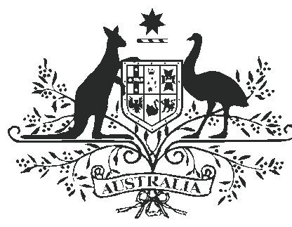

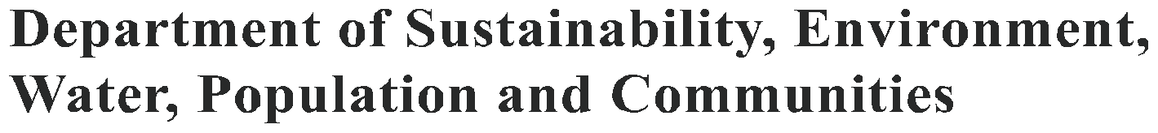

THE FERAL PIG (SUS SCROFA)

Feral pigs are environmental and agricultural pests. They cause damage to the environment through wallowing, rooting for food and selective feeding. They destroy crops and pasture, as well as habitat for native plants and animals. They spread environmental weeds and could spread exotic diseases should there be an outbreak. Research is continuing into techniques that will control feral pigs and minimise the
damage they cause to native plants and animals.

History

Domestic pigs were brought to Australia at the time of European settlement as a food source, and were transported around the country by 19th century settlers. Initially, the pigs that escaped
or were allowed to wander were associated with human habitation, but truly feral colonies eventually became established. Their spread — mainly
along watercourses and floodplains — is not well documented, but by the 1880s, feral pigs reached such numbers that they were considered a pest in parts of New South Wales.

Today, up to 23.5 million feral pigs are spread across about half of the continent, from western Victoria, through New South Wales into Queensland, and across northern Australia. Isolated populations can also be found on a few offshore islands.
Ecology

Because they need to drink daily in hot weather, feral pigs are not found in the dry inland. In
hot weather, they are usually found within two kilometres of water. Densities vary depending on conditions, with about one feral pig per kilometre square in eucalypt woodland, forest and grazing land, and as many as 10–20 per kilometre square in wetlands and seasonally inundated floodplains. Feral pigs are active from late afternoon to early morning. They eat a wide range of foods — including plants and small animals, and they will scavenge on dead animals.
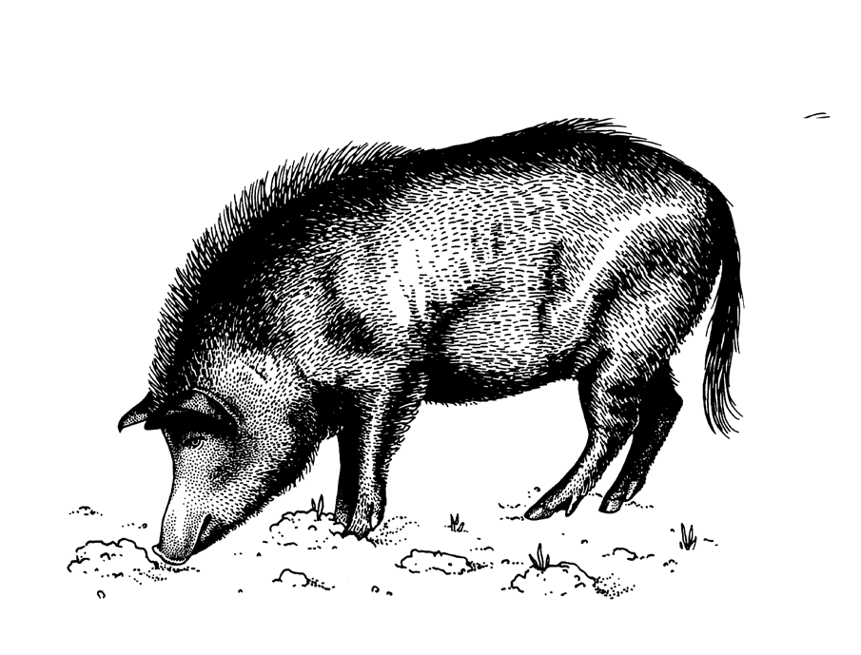

Distribution of feral pigs in Australia
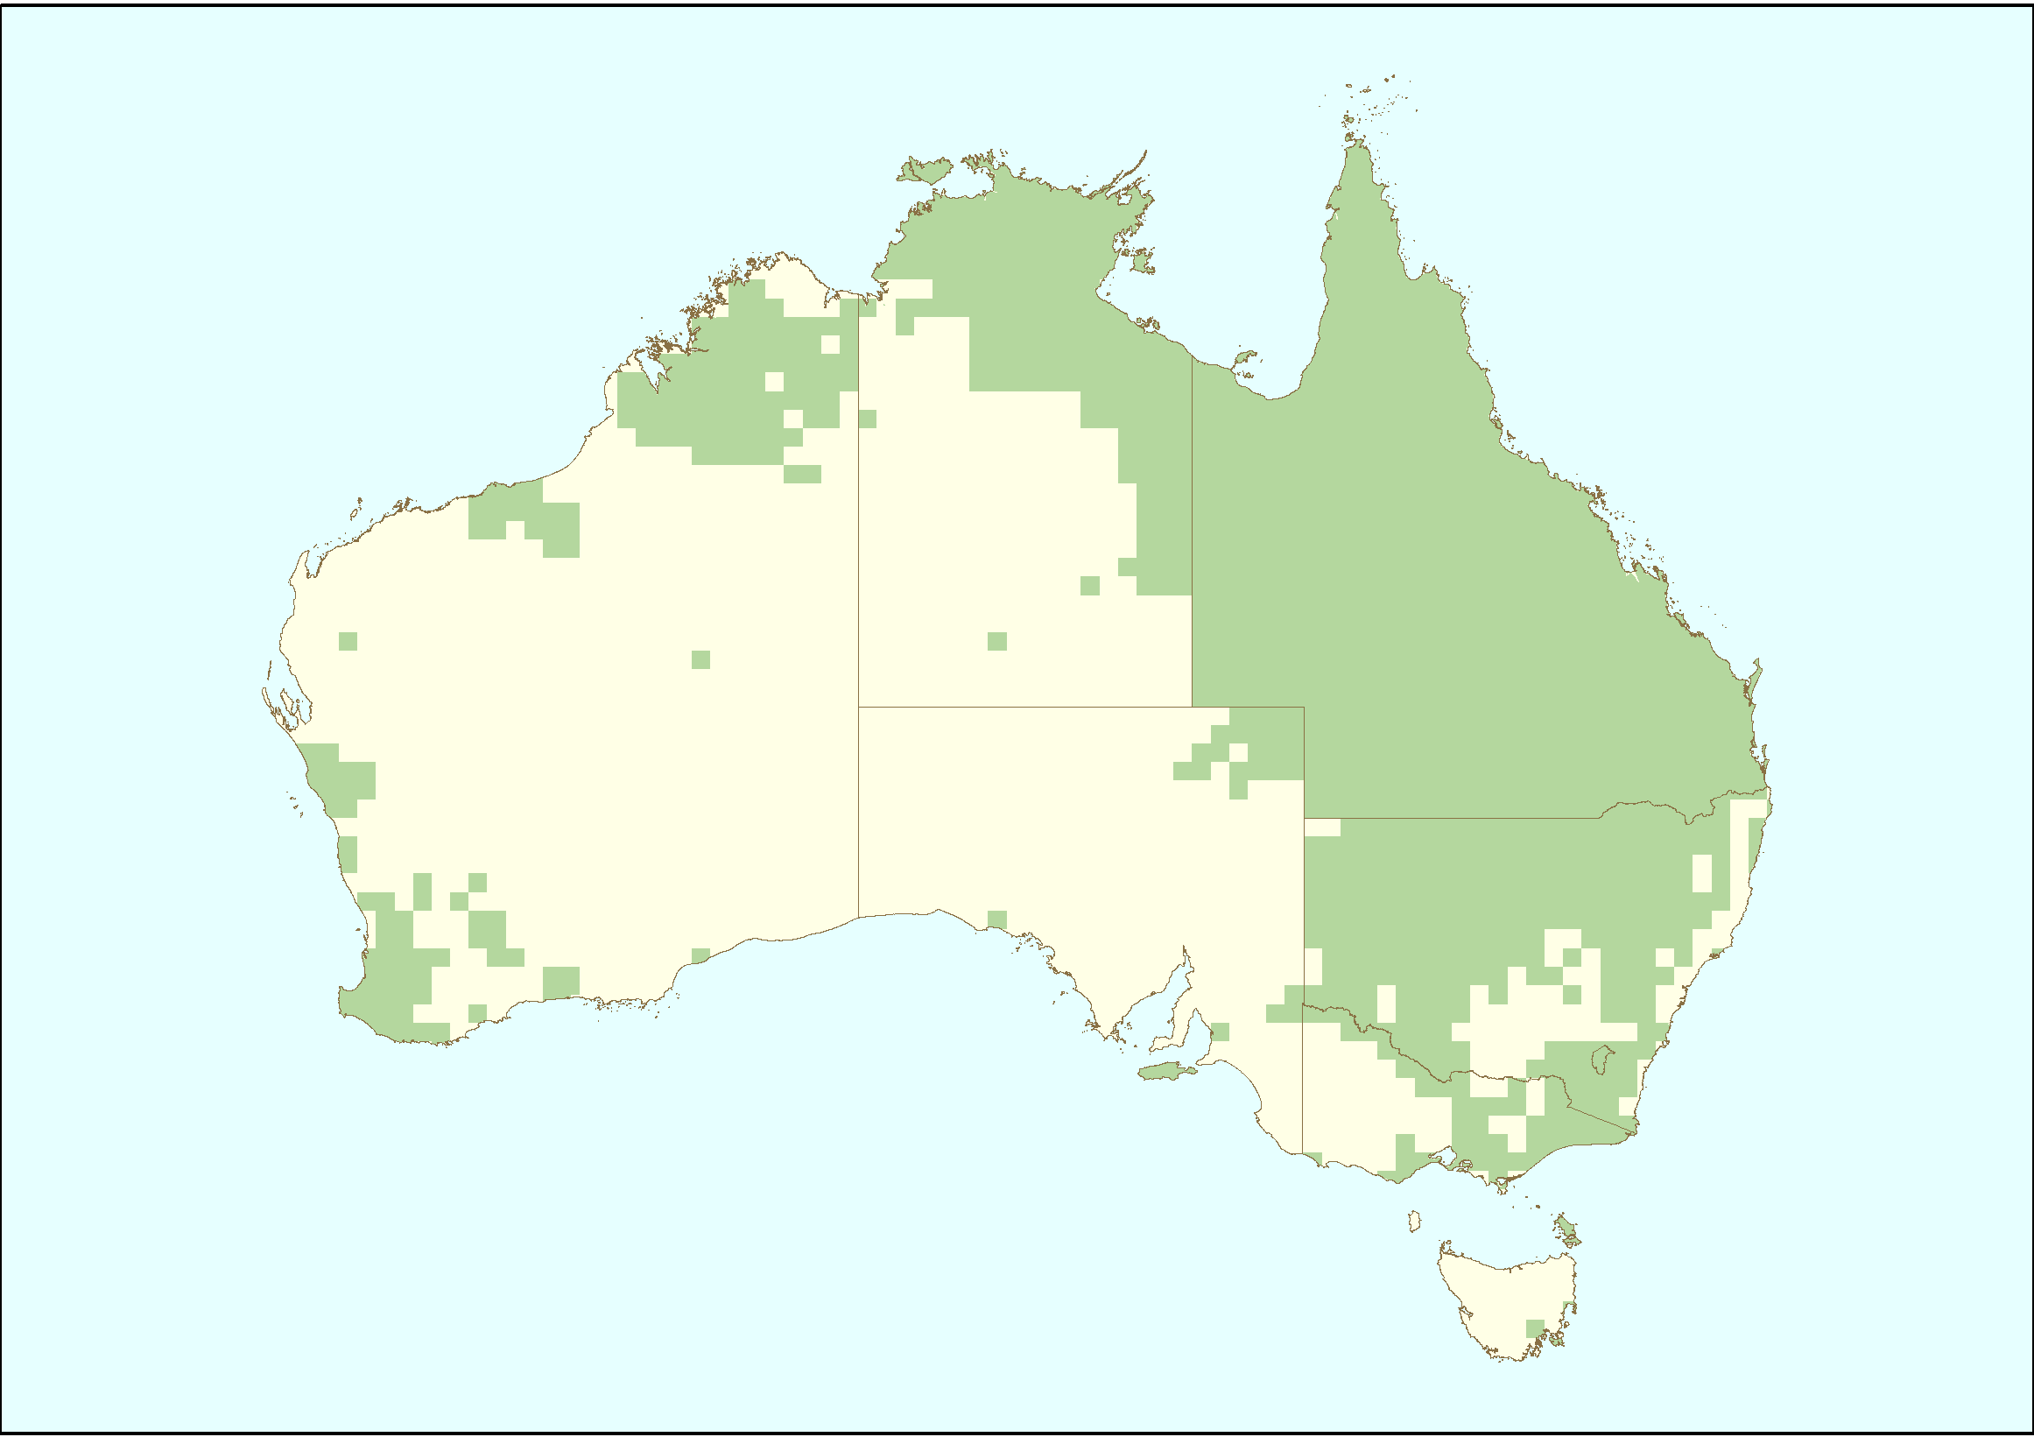

Sources: National Land & Water Resources Audit (2008) Assessing invasive animals in Australia 2008, NLWRA, Canberra./SEWPaC (2010) Feral animals on offshore islands database located at http://www.environment.gov.au/ biodiversity/invasive/ferals/islands/

Adult male feral pigs (boars) generally roam alone over an area of up to 43 kilometre square, while females (sows) range over areas smaller than 20 kilometre square. During dry conditions, groups

of up to 100 pigs may gather around waterholes. To breed, a male joins a group of 12–15 females. Feral pigs can breed from the age of 7–12 months, and usually produce one or two litters of about six piglets each year. Many piglets are lost to dingos and wild dogs, starvation and loss of contact with their mother. This rapid reproductive rate, similar to
rabbits, can increase a population by up to 86 per cent each year in ideal conditions.

Impact

Environmental damage caused by feral pigs can be hard to measure. By wallowing and rooting around the edges of watercourses and swamps, they destroy the vegetation that prevents erosion and provides food and nesting sites for native wildlife. They compete with native animals for food, pose
a threat to ground-nesting birds, and can spread

environmental weeds. Feral pigs have destroyed breeding sites and degraded key habitats of the endangered white-bellied frog, orange-bellied frog and corroboree frog.

Feral pigs can be a serious agricultural pest. They cause losses of an estimated 20 000 tonnes of sugarcane each year. In some areas, they kill and eat up to 40 per cent of newborn lambs. Feral pigs are hosts for pathogens such as brucellosis and leptospirosis, and could also carry diseases such as foot-and-mouth disease, African swine fever
and rabies, should those diseases be accidentally introduced into Australia.

Control

A number of techniques are available to control
feral pigs. In open country, mustering and shooting from helicopters can be effective in the short term, and pigs shot in the wild may be used for their
meat. Shooting from the ground is considered to only be effective in small accessible populations. The market for wild pig meat is worth approximately
$20 million annually.

Feral pigs can be controlled using poison grain or meat baits, usually with compound 1080 (sodium monofluoroacetate). Poisoning requires free- feeding of non-toxic bait prior to the toxic bait to attract the pigs. Free-feeding also reduces the risk of poisoning to non-target animals.

Traps baited with grain can be used to control feral pigs. Traps are built near areas where pigs are active, such as watering holes. Land-holders often leave traps erected permanently, but only activating the gate when pig activity is evident.

Electric fences are also used to protect small areas of high conservation priority from feral pigs.
Which ever method of control is used, the feral pig’s rapid breeding cycle often results in rapid population recovery following control activity.

Research is currently focusing on improving knowledge of the impact of feral pigs on the environment and improving baiting toxins and methods.

How the Australian Government is dealing with a national problem

‘Predation, habitat degradation, competition and disease transmission by feral pigs’ is listed as a key threatening process under the Commonwealth Environment Protection and
Biodiversity Conservation Act 1999 (EPBC Act). Under the EPBC Act, the Australian Government, in consultation with the states and territories,
has developed the Threat Abatement Plan for Predation, Habitat Degradation, Competition and Disease Transmission by Feral Pigs.

The threat abatement plan aims to reduce the impacts of feral pigs on native wildlife and habitats by:
• preventing feral pigs from establishing in areas where they currently do not occur or are in low eradicable numbers, and where they are likely
to pose a threat to biodiversity, especially where they would impact on nationally listed threatened species and ecological communitites

• integrating feral pig management plans and their implementation into natural resource planning and investment at the regional, state and territory, and national level through consultation and liaison with key stakeholders

• increasing awareness and understanding of land managers and the general community about the damage that feral pigs cause and management options

• quantifying the impacts feral pigs have on biodiversity (especially nationally listed threatened species and ecological communities) and determine the relationship between feral pig density and the level of damage, and

• improving the effectiveness, efficiency and humanness of techniques and strategies for managing the environmental damage due to feral pigs.

Feral pig control programs also need to be coordinated with other activities taking place, including the on-ground protection of threatened plants and animals, and control of other invasive species, such as feral goats and rabbits. The threat abatement plan provides a national framework
that will enable the best use of the resources available for feral pig management. The Australian Government works with the states and territories to deal with this national problem.
More information about the threat abatement plan can be found at: http://www.environment.gov.au/ biodiversity/threatened/publications/tap/pig.html
Further reading:

Choquenot D, McIlroy J and Korn T (1996). Managing Vertebrate Pests: Feral Pigs. Bureau of Resource Sciences, Canberra.

For further information, contact:

Department of Sustainability, Environment, Water, Population and Communities
GPO Box 787
Canberra ACT 2601
Phone: 1800 803 772
Web site http://www.environment.gov.au/
biodiversity/invasive/index.html

InvasiveSpecies@environment.gov.au

BIO57.0610

Photo credits in order: Feral pig illustration (Karina Hansen McInnes), Feral pigs in Cape York and Far North Queensland (J. Mitchell, Biosecurity Queensland).

© Commonwealth of Australia 2011

This work is copyright. You may download, display, print and reproduce this material in unaltered form only (retaining this notice) for your personal, non-commercial use or use within your organisation. Apart from any use as permitted under the Copyright Act 1968, all other rights are reserved. Requests and inquiries concerning reproduction and rights should be addressed to Commonwealth Copyright Administration, Attorney General’s Department, Robert Garran Offices, National Circuit, Barton ACT 2600 or posted at www.ag.gov.au/cca.

Disclaimer

The views and opinions expressed in this publication are those of the authors and do not necessarily reflect those of the Australian Government or the
Minister for Sustainability, Environment, Water, Population and Communities.

