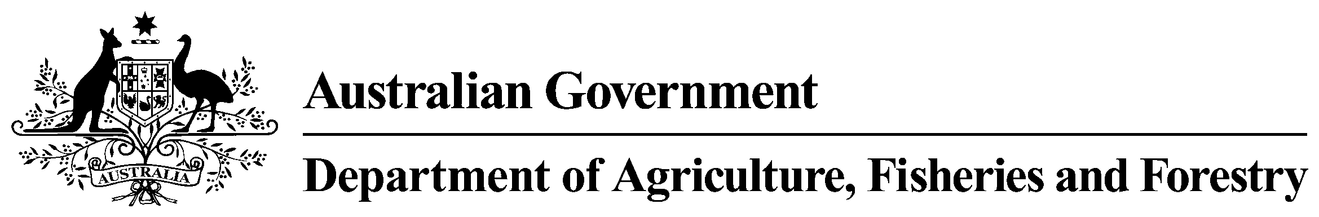

Wild-caught Scallop Annual Results 2011-12
Table 1 AGRICULTURAL CHEMICALS AND ANIMAL TREATMENTS. ENVIRONMENTAL CONTAMINANTS: METALS
Chemical | Matrix | LOR (mg/kg) | Aust. Std  (mg/kg) | No. of samples  tested | Analytical findings  (no. of detections)
 |  |  |  |  | > LOR  ≤ Aust. Std | > Aust. Std
antimony | Flesh | 0.01 | No limit | 20 | 0 | n/a
arsenic (inorganic) | Flesh | 0.05 | 1 | 20 | 0 | 20
arsenic (total) | Flesh | 0.05 | No limit | 20 | 0 | n/a
cadmium | Flesh | 0.01 | 2 | 20 | 20 | 0
chromium | Flesh | 0.05 | No limit | 20 | 0 | n/a
lead | Flesh | 0.01 | 2 | 20 | 1 | 0
mercury (total) | Flesh | 0.01 | 0.5 | 5 | 0 | 0
methylmercury | Flesh | 0.01 | No limit | 5 | 0 | 0
LOR = Limit of reporting; Aust. Std = Australian Standard
Not set - No Australian Standard has been set for the chemical in the edible matrix and any detection is a contravention of the Australia New Zealand Food Standards Code.
No Limit - No Australian Standard applicable for the contaminant. The 'as low as reasonably achievable' principle applies.
Detections at low levels are allowable.
Not defined - Standards are not defined in urine and faeces.
n/a - Australian Standard does not apply. No limit set or defined.

