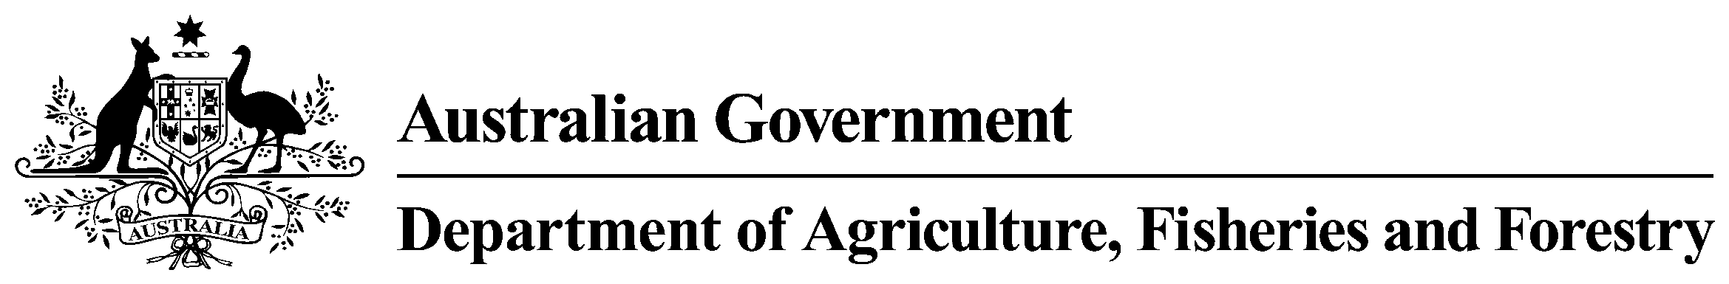

Wild-caught Prawn Annual Results 2011-12
Table 1 AGRICULTURAL CHEMICALS AND ANIMAL TREATMENTS. ENVIRONMENTAL CONTAMINANTS: METALS
Chemical | Matrix | LOR (mg/kg) | Aust. Std  (mg/kg) | No. of samples  tested | Analytical findings  (no. of detections)
 |  |  |  |  | > LOR  ≤ Aust. Std | > Aust. Std
antimony | Flesh | 0.01 | No limit | 20 | 0 | n/a
arsenic (inorganic) | Flesh | 0.05 | 2.0 | 20 | 0 | 0
arsenic (total) | Flesh | 0.05 | No limit | 20 | 0 | n/a
cadmium | Flesh | 0.01 | No limit | 20 | 0 | n/a
chromium | Flesh | 0.05 | No limit | 20 | 0 | n/a
lead | Flesh | 0.01 | No limit | 20 | 0 | n/a

