ERRATUM

Agricultural food statistics 2010–11

Figure 8, page 6, Employment in farm and fisheries production in Australia, the section of the chart relating to ‘Other crops production’ is shown with an incorrect number of employment in 2000–01.

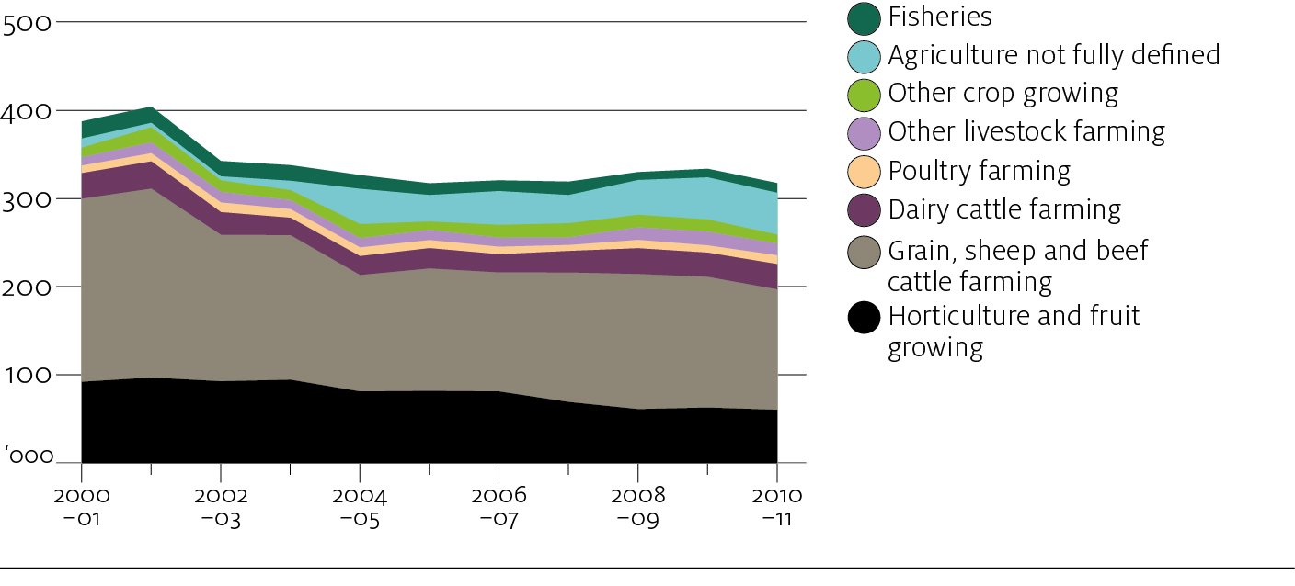

Page 5, the sentence ‘Employment in 2010–11 was around two-thirds of the level in 2000–01’ should read ‘Employment in 2010–11 was around 82 per cent of the level in 2000–01’.

