LAND anD WATER

TraNSIT: Unlocking options for efficient logistics infrastructure in Australian agriculture



Executive Summary



Authors: Andrew Higgins, Stephen McFallan, Adam McKeown, Caroline Bruce, Oswald Marinoni, Chris Chilcott, Peter Stone, Luis Laredo, Matt Beaty

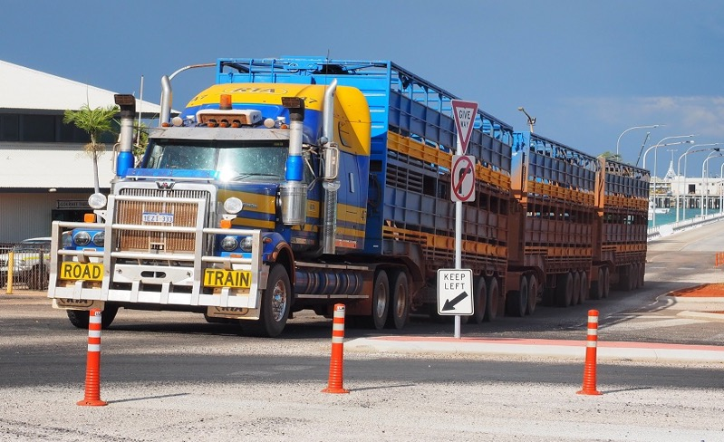

Insert suitable photo

Citation

Higgins AJ, McFallan S, McKeown A, Bruce C, Marinoni O, Chilcott C, Stone P, Laredo L, Beaty M (2017) TraNSIT: Unlocking options for efficient logistics infrastructure in Australian agriculture. CSIRO, Australia.

Copyright

© Commonwealth Scientific and Industrial Research Organisation 2017. To the extent permitted by law, all rights are reserved and no part of this publication covered by copyright may be reproduced or copied in any form or by any means except with the written permission of CSIRO.

Important disclaimer

CSIRO advises that the information contained in this publication comprises general statements based on scientific research. The reader is advised and needs to be aware that such information may be incomplete or unable to be used in any specific situation. No reliance or actions must therefore be made on that information without seeking prior expert professional, scientific and technical advice. To the extent permitted by law, CSIRO (including its employees and consultants) excludes all liability to any person for any consequences, including but not limited to all losses, damages, costs, expenses and any other compensation, arising directly or indirectly from using this publication (in part or in whole) and any information or material contained in it.

CSIRO is committed to providing web accessible content wherever possible. If you are having difficulties with accessing this document please contact [csiroenquiries@csiro.au](mailto:csiroenquiries@csiro.au).

# Background

Transport infrastructure is essential to moving over 80 million tonnes of Australian agricultural output between farms, storage, processors and to markets each year. Agriculture in Australia is characterised by long supply chains with total distance between production, processing and markets often exceeding thousands of kilometres, and rarely less than hundreds. While most highways and major roads are sealed, much of the sparse rural road network, particularly near production areas, is unsealed and in poor condition. Industry, local, state and federal governments are developing a range of possible future industry scenarios to reduce costs of existing supply chains and to plan for new production and markets.

CSIRO developed the Transport Network Strategic Investment Tool (TraNSIT) to provide a comprehensive view of transport logistics costs and benefits due to infrastructure investments and policy changes in agricultural supply chains in Australia. TraNSIT can be applied to:

* Analysing the impact of road upgrades such as sealing and widening, first/last mile improvements and upgrading roads and bridges for higher productivity vehicles;
* Informing improvements to rail infrastructure at different locations including new freights hubs and integration with road transport;
* Optimising supply chains in the private sector;
* Forecasting freight volumes, supply chain dynamics and bottlenecks under future production scenarios, at the farm scale to national scale;
* Testing potential outcomes for changes in policy;
* Comparing infrastructure investment and regulatory change opportunities that maximise transport cost reductions for a given (limited) investment budget.

Initially (in 2012/13) the tool was built to model livestock supply chains in northern Australia but in 2014, TraNSIT was extended to all beef transport in Australia. TraNSIT was subsequently used to inform outcomes from the $100 million Beef Roads Programme - an initiative in the 2015 White Paper on Developing Northern Australia which required assessment of 60 road upgrade submissions from government and industry. In 2015, funded through the Agricultural Competitiveness White Paper, TraNSIT’s application was broadened to other Australian agricultural commodities. The outputs of this broadened project provide governments, industry, the farming community and other agricultural stakeholders with a baseline of freight transport costs between Australian agricultural value chain enterprises, along with a capacity to identify and evaluate a range of scenarios to reduce transport related costs. The initial project goal of extending TraNSIT to 25 agricultural commodities was exceeded with the extension of the Tool to over 30 commodities representing 98% of Australian agricultural volume transported. Extension of TraNSIT to all Australian agricultural commodities was conducted with support, input and validation from over 70 organisations, agencies and associations representing the agricultural/horticultural and transport sectors. TraNSIT is now a comprehensive logistics tool that has been applied to an extensive agricultural value chain dataset assembled through this project.

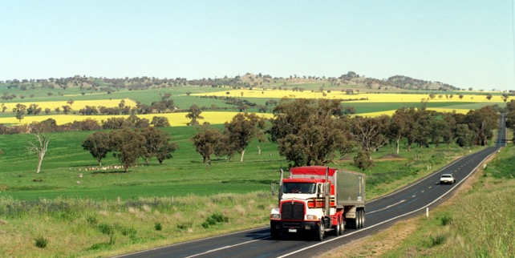

# Baseline

A baseline analysis provides information on the number of vehicles or wagons travelling along each road/rail segment for a representative year (e.g. 2016), along with related transport costs. To construct the baseline, data for 222,000 enterprises was incorporated into TraNSIT, including 216,000 farms, 350 processors, 500 saleyards/feedlots, 530 storage facilities, and 3600 supermarkets and distribution centres. Commodities included were: beef, sheep/goats, dairy, pigs, poultry, grains (wheat, sorghum, oats, barley, chickpeas, canola, lentils, maize, peas, durum, fababeans), cotton, rice, sugar, buffalo, stockfeed and horticulture (oranges, mandarins, potatoes, broccoli, onions, apples, pears, mangoes, bananas, pumpkins, melons, carrots, lettuces and pineapples). This data was used to create a set of road and rail movements, for which TraNSIT then calculated the cost of transport optimising the transport route and vehicle selection. These costs were then aggregated to provide the cumulative freight flows and transport costs. Summary of modelled annual transport cost for each commodity is shown in Table 1, with annual freight volumes across the road network shown in Figure 1. Total annual transport cost (road and rail) was $5.8 billion or 9.8% of the total farm gross value of production in 2015/2016. Transport costs can be provided in various ways: by State; Local Government; and road or rail segment, depending on the need.

Table 1 Total cost of transport (annual average) for each commodity. This represents the total transport costs across the supply chain from paddock to domestic market (except for grain) or port.

|  |  |  |  |
| --- | --- | --- | --- |
|  | Road | Rail | Road CO2 (tonnes) |
| Beef (including buffalo) | $572,438,780 | $31,656,477 | 244,082 |
| Grain | $2,149,790,452 | $487,280,313 | 862,184 |
| Pigs | $29,012,052 |  | 11,156 |
| Rice | $134,177,281 |  | 55,437 |
| Dairy | $881,736,430 |  | 337,294 |
| Sugar | $52,245,332 | $9,951,700 | 16,174 |
| Sheep/Goats | $221,773,671 |  | 85,883 |
| Cotton | $76,914,483 | $13,259,573 | 36,385 |
| Horticulture | $617,806,580 |  | 256,295 |
| Post Processing* | $249,680,948 |  | 98,080 |
| Mixed (DC to Market)^ | $284,535,545 |  | 109,157 |
| Poultry | $28,196,377 |  | 8,766 |
| Total | $5,298,307,931 | $542,148,063 | 2,120,893 |

*includes boxed beef, chicken, lamb, pork to domestic markets and port

^mixture of horticulture and post processed commodities between DC’s and supermarkets

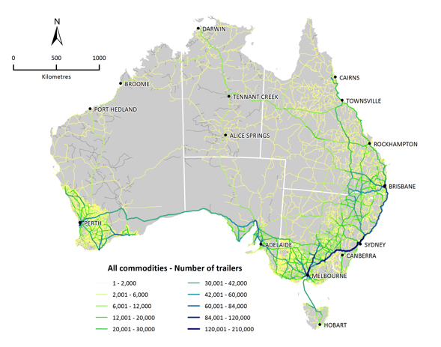

Figure 1 Baseline annual trailer (semi-trailer equivalent) freight flow map for all commodities

# Case Studies

Industry and government identified several case studies for analysis by TraNSIT throughout the project. The seven case studies selected were chosen to represent a diversity of applications across Australia: 1) Toowoomba Second Range Crossing; 2) Higher mass limit for milk transport in Victoria; 3) New sheep feedlotting near Albany Western Australia; 4) Road closures from flooding in the Forbes region; 5) Evaluation of the successful Northern Australia Beef Roads submissions; 6) Higher productivity vehicles between Barringun and Nyngan; and 7) All agriculture shifted from rail to road. The main report provides detail for all case studies, while summary results for three are presented below.

Toowoomba Second Range Crossing (TSRC): TSRC is a 41km bypass ([www.tmr.gov.au/projects](http://www.tmr.gov.au/projects)) allowing vehicles to avoid 18 sets of traffic lights (and related congestion) in Toowoomba and reducing the need for slow speeds of heavy vehicles due to the steep gradient of the existing main route through Toowoomba. From the baseline analysis, there were 130,645 semi-trailer equivalents passing through or stopping at Toowoomba each year, comprising 30% grains, 21% cattle, 11% horticulture, 9% cotton, 5% poultry, 1% pigs and 24% processed or mixed commodities. TraNSIT estimated that usage of the TSRC would result in total transport cost savings per year of $5.4 million or $20.68 per semi-trailer equivalent, though the savings vary significantly across commodities and transport path. Cost savings and utilisation of the TSRC will depend on the toll imposed, and extension of this case study can involve TraNSIT testing the sensitivity of cost savings and freight volumes against tolls set for different types of vehicles.

Successful Northern Australian Beef Roads submissions: The $100 million Beef Roads Programme formed part of “Our North, Our Future: White Paper on Developing Northern Australia”. In 2015/2016, TraNSIT informed this Programme by estimating the transport cost savings to the beef industry for each of the 60 road upgrade submissions to the Programme. In October 2016, the Australian Government announced 18 projects would be funded. TraNSIT estimated that implementation of the 18 road projects would lead to an annual transport cost saving of $957,616, with most of those savings ($738,919) from a road upgrade between Gracemere and the Rockhampton abattoirs to allow direct access of Type 1 vehicles. The remaining projects led to a combined total annual saving of $218,597 across 440,400 cattle transported across those road segments per year. Some road upgrade scenarios will create additional benefits, particularly increased road safety. These additional benefits were not costed by the Tool.

All agriculture shifted from rail to road: This hypothetical scenario examined the impact of shifting all agriculture (grains, beef, sugar, cotton) that currently transport on rail, to road. Shifting all agriculture from rail to road led to an overall annual increase in transport costs of $180 million per year, with grains costing $209 million or 42% more, and beef costing $26 million or 70% less. The shift to road also led to an increase of up to 150,000 extra semi-trailer equivalents on some key freight routes.

# Next Steps

New projects are underway for TraNSIT to address transport bottlenecks (rail and road) in agriculture and forestry within different regions across Australia:

1. Through an Australian Centre for International Agricultural Research initiative, TraNSIT is now being used abroad, particularly in Indonesia, Laos and Vietnam to address supply chain inefficiencies and cross-border bottlenecks.

2. TraNSIT will also be enhanced to account for the impacts of extreme weather and floods. This will provide Australian agricultural stakeholders and federal and state governments the capacity to identify opportunities to reduce the economic impact of extreme weather and floods that disrupt either transport access, and thus inform infrastructure and related supply chain investments.

3. A recommendation of the Australian Infrastructure Plan released by Infrastructure Australia in February 2016, was that the National Freight and Supply Chain Strategy be informed by TraNSIT.

4. To improve the ability of key federal and state agencies to test a range of transport infrastructure and regulatory scenarios, TraNSIT Web will be developed. The web based version will protect sensitive industry information, whilst providing flexibility and real time access to subscribers.

|  |  |  |
| --- | --- | --- |
|  | | |
| CONTACT US  t 1300 363 400  +61 3 9545 2176  e csiroenquiries@csiro.au  w [www.csiro.au](http://www.csiro.au)  w [www.csiro.au/transit](http://www.csiro.au/transit)  At CSIRO, we do the  extraordinary every day  We innovate for tomorrow and help improve today – for our customers, all Australians and the world.  Our innovations contribute billions of dollars to the Australian economy  every year. As the largest patent holder  in the nation, our vast wealth of intellectual property has led to more  than 150 spin-off companies.  With more than 5,000 experts and a burning desire to get things done, we are Australia’s catalyst for innovation.  CSIRO. WE IMAGINE. WE COLLABORATE.  WE INNOVATE. |  | For further information  CSIRO Land and Water  Andrew Higgins t +61 7 3833 5738  e [Andrew.higgins@csiro.au](mailto:Andrew.higgins@csiro.au)  Stephen McFallan t +61 7 3833 5722  e [Stephen.McFallan@csiro.au](mailto:Stephen.McFallan@csiro.au)  Adam McKeown  ++61 7 4059 5009  e [Adam.McKeown@csiro.au](mailto:Adam.McKeown@csiro.au)  Chris Chilcott t +61 8 8944 8422  e [Chris.Chilcott@csiro.au](mailto:Chris.Chilcott@csiro.au)  Caroline Bruce  t ++61 7 4059 5024  e [Caroline.Bruce@csiro.au](mailto:Caroline.Bruce@csiro.au)  Oswald Marinoni  t++61 7 3833 5713  e [Oswald.Marinoni@csiro.au](mailto:Oswald.Marinoni@csiro.au) |
|  |  |  |