Monday, February 2, 2015
Department of Agriculture Statistics - Total Chilled & Frozen Meat Exports by Load Port -- January 2015 -- Tonnes Shipped Weight
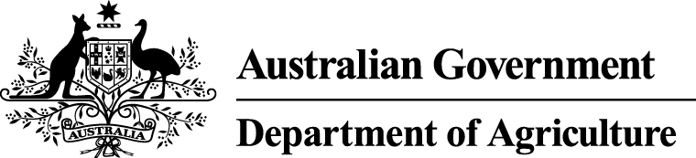
EU
Western
Europe
Eastern
Europe
USA
East
USA
West
Canada
East
Canada
West
Japan
Taiwan
Korea
Other
Asia
Middle
East
Other
Dest
State &
Load Port

Total
NSW
NEWCASTLE
0
0
0
0
0
0
0
0
0
0
0
0
0
0
PORT BOTANY
0
0
0
0
0
0
0
0
0
0
0
0
0
0
SYDNEY
401
25
0
2660
1290
454
115
1027
1221
376
4390
1575
786
14320
401
State Total
25
0
2660
115
1290
454
1027
1221
376
4390
1575
786
14320
VIC
PORTLAND
0
0
0
0
0
0
0
0
0
0
0
0
0
0
GEELONG
0
0
0
0
0
0
0
0
0
0
0
0
0
0
MELBOURNE
1124
124
50
10185
4426
588
177
4386
3053
638
11060
8545
3000
47356
1124
State Total
124
50
10185
177
4426
588
4386
3053
638
11060
8545
3000
47356
QLD
CAIRNS
0
0
0
0
0
0
0
0
0
0
0
0
0
0
TOWNSVILLE
0
0
0
0
0
0
0
0
0
0
0
0
0
0
BOWEN
0
0
0
0
0
0
0
0
0
0
0
0
0
0
MACKAY
0
0
0
0
0
0
0
0
0
0
0
0
0
0
PORT ALMA
0
0
0
0
0
0
0
0
0
0
0
0
0
0
GLADSTONE
0
0
0
0
0
0
0
0
0
0
0
0
0
0
BRISBANE
399
67
24
8282
3555
678
249
11583
4950
1517
6302
2173
1736
41515
399
State Total
67
24
8282
249
3555
678
11583
4950
1517
6302
2173
1736
41515
SA
PORT LINCOLN
0
0
0
0
0
0
0
0
0
0
0
0
0
0
ADELAIDE
441
12
0
567
335
22
100
124
77
193
1380
587
208
4046
441
State Total
12
0
567
100
335
22
124
77
193
1380
587
208
4046
1
Note: Components May Not Add to Totals Due to Rounding

EU
Western
Europe
Eastern
Europe
USA
East
USA
West
Canada
East
Canada
West
Japan
Taiwan
Korea
Other
Asia
Middle
East
Other
Dest
State &
Load Port

Total
WA
GERALDTON
0
0
0
0
0
0
0
0
0
0
0
0
0
0
PORT HEDLAND
0
0
0
0
0
0
0
0
0
0
0
0
0
0
NORTHERN WA
0
0
0
0
0
0
0
0
0
0
0
0
0
0
BUNBURY
0
0
0
0
0
0
0
0
0
0
0
0
0
0
ALBANY
0
0
0
0
0
0
0
0
0
0
0
0
0
0
FREMANTLE/PERTH
140
34
0
380
288
0
30
638
526
211
2217
1616
256
6336
140
State Total
34
0
380
30
288
0
638
526
211
2217
1616
256
6336
TAS
BURNIE
0
0
0
0
0
0
0
0
0
0
0
0
0
0
DEVONPORT
0
0
0
0
0
0
0
0
0
0
0
0
0
0
LAUNCESTON
0
0
0
0
0
0
0
0
0
0
0
0
0
0
HOBART
0
0
0
0
0
0
0
0
0
0
0
0
0
0
BELL BAY
0
0
0
0
0
0
0
0
0
0
0
0
0
0
0
State Total
0
0
0
0
0
0
0
0
0
0
0
0
0
NT
DARWIN
0
0
0
0
0
0
0
0
0
0
0
0
0
0
ALICE SPRINGS
0
0
0
0
0
0
0
0
0
0
0
0
0
0
0
State Total
0
0
0
0
0
0
0
0
0
0
0
0
0
2505
Australia
262
74
22074
9894
1742
671
17758
9827
2935
25349
14496
5986
113573
2
Note: Components May Not Add to Totals Due to Rounding

