Monday, June 1, 2015
DEPARTMENT AGRICULTURE - Total Chilled & Frozen Meat Exports by Load Port -- May 2015 -- Tonnes Shipped Weight
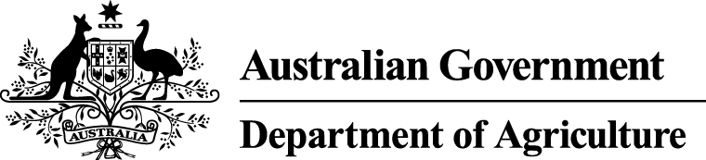
EU
Western
Europe
Eastern
Europe
USA
East
USA
West
Canada
East
Canada
West
Japan
Taiwan
Korea
Other
Asia
Middle
East
Other
Dest
State &
Load Port

Total
NSW
NEWCASTLE
0
0
0
0
0
0
0
0
0
0
0
0
0
0
PORT BOTANY
0
0
0
0
0
0
0
0
0
0
0
0
0
0
SYDNEY
163
9
25
2472
2472
160
126
1519
1500
451
4568
1910
1168
16543
163
State Total
9
25
2472
126
2472
160
1519
1500
451
4568
1910
1168
16543
VIC
PORTLAND
0
0
0
0
0
0
0
0
0
0
0
0
0
0
GEELONG
0
0
0
0
0
0
0
0
0
0
0
0
0
0
MELBOURNE
954
93
177
11564
4289
1088
201
6120
3696
658
14301
9613
3825
56579
954
State Total
93
177
11564
201
4289
1088
6120
3696
658
14301
9613
3825
56579
QLD
CAIRNS
0
0
0
0
0
0
0
0
0
0
45
0
0
45
TOWNSVILLE
0
0
0
0
0
0
0
0
27
0
13
0
0
40
BOWEN
0
0
0
0
0
0
0
0
0
0
0
0
0
0
MACKAY
0
0
0
0
0
0
0
0
0
0
0
0
0
0
PORT ALMA
0
0
0
0
0
0
0
0
0
0
0
0
0
0
GLADSTONE
0
0
0
0
0
0
0
0
0
0
0
0
0
0
BRISBANE
876
87
19
18081
7493
2278
548
19332
11715
2706
14340
3361
2518
83354
876
State Total
87
19
18081
548
7493
2278
19332
11742
2706
14398
3361
2518
83439
SA
PORT LINCOLN
0
0
0
0
0
0
0
0
0
0
0
0
0
0
ADELAIDE
319
11
49
366
134
0
54
259
253
176
1754
920
337
4632
319
State Total
11
49
366
54
134
0
259
253
176
1754
920
337
4632
1
Note: Components May Not Add to Totals Due to Rounding

EU
Western
Europe
Eastern
Europe
USA
East
USA
West
Canada
East
Canada
West
Japan
Taiwan
Korea
Other
Asia
Middle
East
Other
Dest
State &
Load Port

Total
WA
GERALDTON
0
0
0
0
0
0
0
0
0
0
0
0
0
0
PORT HEDLAND
0
0
0
0
0
0
0
0
0
0
0
0
0
0
NORTHERN WA
0
0
0
0
0
0
0
0
0
0
0
0
0
0
BUNBURY
0
0
0
0
0
0
0
0
0
0
0
0
0
0
ALBANY
0
0
0
0
0
0
0
0
0
0
0
0
0
0
FREMANTLE/PERTH
206
46
0
86
268
18
58
478
246
254
2477
2032
515
6684
206
State Total
46
0
86
58
268
18
478
246
254
2477
2032
515
6684
TAS
BURNIE
0
0
0
0
0
0
0
0
0
0
0
0
0
0
DEVONPORT
0
0
0
0
0
0
0
0
0
0
0
0
0
0
LAUNCESTON
0
0
0
0
0
0
0
0
0
0
0
0
0
0
HOBART
0
0
0
0
0
0
0
0
0
0
0
0
0
0
BELL BAY
0
0
0
95
0
0
0
0
115
0
61
48
0
319
0
State Total
0
0
95
0
0
0
0
115
0
61
48
0
319
NT
DARWIN
0
0
0
381
95
0
0
59
126
0
0
0
15
676
ALICE SPRINGS
0
0
0
0
0
0
0
0
0
0
0
0
0
0
0
State Total
0
0
381
0
95
0
59
126
0
0
0
15
676
2518
Australia
246
270
33045
14751
3544
987
27767
17678
4245
37559
17884
8378
168872
2
Note: Components May Not Add to Totals Due to Rounding

