Friday, October 2, 2015
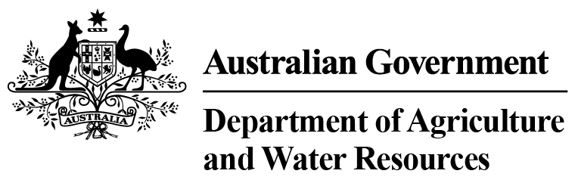
Total Chilled & Frozen Meat Exports by Load Port -- Fiscal YTD to September 2015 -- Tonnes Shipped Weight
EU
Western
Europe
Eastern
Europe
USA
East
USA
West
Canada
East
Canada
West
Japan
Taiwan
Korea
Other
Asia
Middle
East
Other
Dest
State &
Load Port

Total
NSW
NEWCASTLE
0
0
0
0
0
0
0
0
0
0
0
0
0
0
PORT BOTANY
0
0
0
0
0
0
0
0
0
0
0
0
0
0
SYDNEY
1009
35
123
9556
6460
395
391
7280
5124
636
13093
5636
2868
52606
1009
State Total
35
123
9556
391
6460
395
7280
5124
636
13093
5636
2868
52606
VIC
PORTLAND
0
0
0
0
0
0
0
0
0
0
0
0
0
0
GEELONG
0
0
0
0
0
0
0
0
0
0
0
0
0
0
MELBOURNE
2696
216
525
25961
12437
2341
502
16109
8130
2598
37672
26189
10869
146245
2696
State Total
216
525
25961
502
12437
2341
16109
8130
2598
37672
26189
10869
146245
QLD
CAIRNS
0
0
0
0
0
0
0
0
0
0
90
0
0
90
TOWNSVILLE
0
0
0
0
0
0
0
0
12
0
0
0
42
54
BOWEN
0
0
0
0
0
0
0
0
0
0
0
0
0
0
MACKAY
0
0
0
0
0
0
0
0
0
0
0
0
0
0
PORT ALMA
0
0
0
0
0
0
0
0
0
0
0
0
0
0
GLADSTONE
0
0
0
0
0
0
0
0
0
0
0
0
0
0
BRISBANE
4218
209
31
51420
20019
6603
1063
54006
32483
7466
45567
10228
5993
239306
4218
State Total
209
31
51420
1063
20019
6603
54006
32495
7466
45657
10228
6035
239450
SA
PORT LINCOLN
0
0
0
0
0
0
0
0
0
0
0
0
0
0
ADELAIDE
1390
33
49
1623
1113
19
186
1417
1139
232
4780
1938
1335
15254
1390
State Total
33
49
1623
186
1113
19
1417
1139
232
4780
1938
1335
15254
1
Note: Components May Not Add to Totals Due to Rounding

EU
Western
Europe
Eastern
Europe
USA
East
USA
West
Canada
East
Canada
West
Japan
Taiwan
Korea
Other
Asia
Middle
East
Other
Dest
State &
Load Port

Total
WA
GERALDTON
0
0
0
0
0
0
0
0
0
0
0
0
0
0
PORT HEDLAND
0
0
0
0
0
0
0
0
0
0
0
0
0
0
NORTHERN WA
0
0
0
0
0
0
0
0
0
0
0
0
0
0
BUNBURY
0
0
0
0
0
0
0
0
0
0
0
0
0
0
ALBANY
0
0
0
0
0
0
0
0
0
0
0
0
0
0
FREMANTLE/PERTH
255
43
49
783
789
181
248
1079
988
590
6845
5569
1163
18582
255
State Total
43
49
783
248
789
181
1079
988
590
6845
5569
1163
18582
TAS
BURNIE
0
0
0
0
0
0
0
0
0
0
0
0
0
0
DEVONPORT
0
0
0
0
0
0
0
0
0
0
0
0
0
0
LAUNCESTON
0
0
0
0
0
0
0
0
0
0
0
0
0
0
HOBART
0
0
0
0
0
0
0
0
0
0
0
0
0
0
BELL BAY
0
0
0
229
38
0
0
0
106
0
53
100
0
526
0
State Total
0
0
229
0
38
0
0
106
0
53
100
0
526
NT
DARWIN
0
0
0
1395
629
14
0
94
254
60
52
0
68
2566
ALICE SPRINGS
0
0
0
0
0
0
0
0
0
0
0
0
0
0
0
State Total
0
0
1395
0
629
14
94
254
60
52
0
68
2566
9568
Australia
536
777
90967
41485
9553
2390
79985
48236
11582
108152
49660
22338
475229
2
Note: Components May Not Add to Totals Due to Rounding

