Tuesday, December 1, 2015
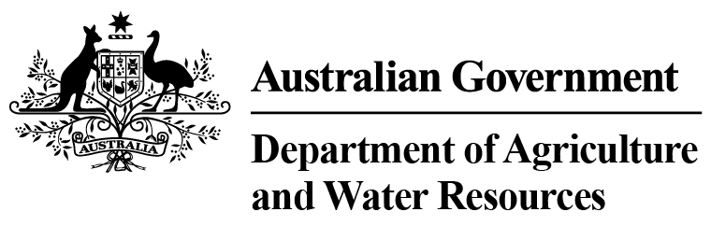
Department of Agriculture and Water Resources Statistics
Total Chilled & Frozen Meat Exports by Load Port -- November 2015 -- Tonnes Shipped Weight
EU
Western
Europe
Eastern
Europe
USA
East
USA
West
Canada
East
Canada
West
Japan
Taiwan
Korea
Other
Asia
Middle
East
Other
Dest
State &
Load Port

Total
NSW
NEWCASTLE
0
0
0
0
0
0
0
0
0
0
0
0
0
0
PORT BOTANY
0
0
0
0
0
0
0
0
0
0
0
0
0
0
SYDNEY
387
21
0
1355
1027
739
103
1231
1802
424
5679
1541
1012
15321
387
State Total
21
0
1355
103
1027
739
1231
1802
424
5679
1541
1012
15321
VIC
PORTLAND
0
0
0
0
0
0
0
0
0
0
0
0
0
0
GEELONG
0
0
0
0
0
0
0
0
0
0
0
0
0
0
MELBOURNE
821
81
177
7226
3946
1778
183
5896
4184
737
15275
8213
4658
53175
821
State Total
81
177
7226
183
3946
1778
5896
4184
737
15275
8213
4658
53175
QLD
CAIRNS
0
0
0
0
0
0
0
0
0
0
49
0
0
49
TOWNSVILLE
0
0
0
0
0
0
0
0
0
0
0
0
13
13
BOWEN
0
0
0
0
0
0
0
0
0
0
0
0
0
0
MACKAY
0
0
0
0
0
0
0
0
0
0
0
0
0
0
PORT ALMA
0
0
0
0
0
0
0
0
0
0
0
0
0
0
GLADSTONE
0
0
0
0
0
0
0
0
0
0
0
0
0
0
BRISBANE
1176
136
65
4631
3214
2531
232
19085
11364
2444
16309
2556
2039
65782
1176
State Total
136
65
4631
232
3214
2531
19085
11364
2444
16358
2556
2052
65844
SA
PORT LINCOLN
0
0
0
0
0
0
0
0
0
0
0
0
0
0
ADELAIDE
313
22
0
593
226
57
67
620
496
95
2875
745
498
6607
313
State Total
22
0
593
67
226
57
620
496
95
2875
745
498
6607
1
Note: Components May Not Add to Totals Due to Rounding

EU
Western
Europe
Eastern
Europe
USA
East
USA
West
Canada
East
Canada
West
Japan
Taiwan
Korea
Other
Asia
Middle
East
Other
Dest
State &
Load Port

Total
WA
GERALDTON
0
0
0
0
0
0
0
0
0
0
0
0
0
0
PORT HEDLAND
0
0
0
0
0
0
0
0
0
0
0
0
0
0
NORTHERN WA
0
0
0
0
0
0
0
0
0
0
0
0
0
0
BUNBURY
0
0
0
0
0
0
0
0
0
0
0
0
0
0
ALBANY
0
0
0
0
0
0
0
0
0
0
0
0
0
0
FREMANTLE/PERTH
328
19
0
24
147
70
138
615
506
159
4163
2190
504
8863
328
State Total
19
0
24
138
147
70
615
506
159
4163
2190
504
8863
TAS
BURNIE
0
0
0
0
0
0
0
0
0
0
0
0
0
0
DEVONPORT
0
0
0
0
0
0
0
0
0
0
0
0
0
0
LAUNCESTON
0
0
0
0
0
0
0
0
0
0
0
0
0
0
HOBART
0
0
0
0
0
0
0
0
0
0
0
0
0
0
BELL BAY
0
0
0
0
0
0
0
0
168
0
26
78
0
272
0
State Total
0
0
0
0
0
0
0
168
0
26
78
0
272
NT
DARWIN
0
0
0
0
0
15
0
102
145
47
15
0
16
340
ALICE SPRINGS
0
0
0
0
0
0
0
0
0
0
0
0
0
0
0
State Total
0
0
0
0
0
15
102
145
47
15
0
16
340
3025
Australia
279
242
13829
8560
5190
723
27549
18665
3906
44391
15323
8740
150422
2
Note: Components May Not Add to Totals Due to Rounding

