Tuesday, February 2, 2016
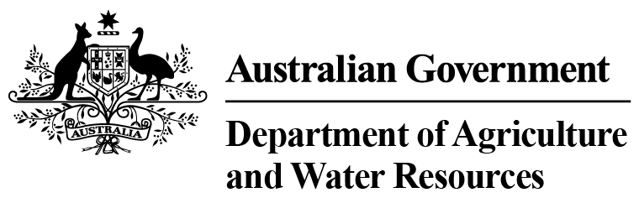
Total Chilled & Frozen Meat Exports by Load Port -- January 2016 -- Tonnes Shipped Weight
EU
Western
Europe
Eastern
Europe
USA
East
USA
West
Canada
East
Canada
West
Japan
Taiwan
Korea
Other
Asia
Middle
East
Other
Dest
State &
Load Port

Total
NSW
NEWCASTLE
0
0
0
0
0
0
0
0
0
0
0
0
0
0
PORT BOTANY
0
0
0
0
0
0
0
0
0
0
0
0
0
0
SYDNEY
370
5
0
1842
1375
201
125
863
1237
293
3704
1376
587
11978
370
State Total
5
0
1842
125
1375
201
863
1237
293
3704
1376
587
11978
VIC
PORTLAND
0
0
0
0
0
0
0
0
0
0
0
0
0
0
GEELONG
0
0
0
0
0
0
0
0
0
0
0
0
0
0
MELBOURNE
909
66
62
8262
3967
964
255
4516
3628
455
9791
7550
3475
43900
909
State Total
66
62
8262
255
3967
964
4516
3628
455
9791
7550
3475
43900
QLD
CAIRNS
0
0
0
0
0
0
0
0
0
0
0
0
0
0
TOWNSVILLE
0
0
0
0
0
0
0
0
0
0
0
0
12
12
BOWEN
0
0
0
0
0
0
0
0
0
0
0
0
0
0
MACKAY
0
0
0
0
0
0
0
0
0
0
0
0
0
0
PORT ALMA
0
0
0
0
0
0
0
0
0
0
0
0
0
0
GLADSTONE
0
0
0
0
0
0
0
0
0
0
0
0
0
0
BRISBANE
610
43
42
4298
1871
348
138
7384
5416
1024
6947
1732
1137
30990
610
State Total
43
42
4298
138
1871
348
7384
5416
1024
6947
1732
1149
31002
SA
PORT LINCOLN
0
0
0
0
0
0
0
0
0
0
0
0
0
0
ADELAIDE
614
26
0
1290
370
19
0
492
317
123
1868
851
473
6443
614
State Total
26
0
1290
0
370
19
492
317
123
1868
851
473
6443
1
Note: Components May Not Add to Totals Due to Rounding

EU
Western
Europe
Eastern
Europe
USA
East
USA
West
Canada
East
Canada
West
Japan
Taiwan
Korea
Other
Asia
Middle
East
Other
Dest
State &
Load Port

Total
WA
GERALDTON
0
0
0
0
0
0
0
0
0
0
0
0
0
0
PORT HEDLAND
0
0
0
0
0
0
0
0
0
0
0
0
0
0
NORTHERN WA
0
0
0
0
0
0
0
0
0
0
0
0
0
0
BUNBURY
0
0
0
0
0
0
0
0
0
0
0
0
0
0
ALBANY
0
0
0
0
0
0
0
0
0
0
0
0
0
0
FREMANTLE/PERTH
146
10
0
278
208
25
158
635
482
49
2803
2593
342
7729
146
State Total
10
0
278
158
208
25
635
482
49
2803
2593
342
7729
TAS
BURNIE
0
0
0
0
0
0
0
0
0
0
0
0
0
0
DEVONPORT
0
0
0
0
0
0
0
0
0
0
0
0
0
0
LAUNCESTON
0
0
0
0
0
0
0
0
0
0
0
0
0
0
HOBART
0
0
0
0
0
0
0
0
0
0
0
0
0
0
BELL BAY
0
0
0
171
19
0
0
0
124
0
77
103
24
518
0
State Total
0
0
171
0
19
0
0
124
0
77
103
24
518
NT
DARWIN
0
0
0
457
112
15
0
74
93
0
86
0
15
852
ALICE SPRINGS
0
0
0
0
0
0
0
0
0
0
0
0
0
0
0
State Total
0
0
457
0
112
15
74
93
0
86
0
15
852
2649
Australia
150
104
16598
7922
1572
676
13964
11297
1944
25276
14205
6065
102422
2
Note: Components May Not Add to Totals Due to Rounding

