Tuesday, March 1, 2016
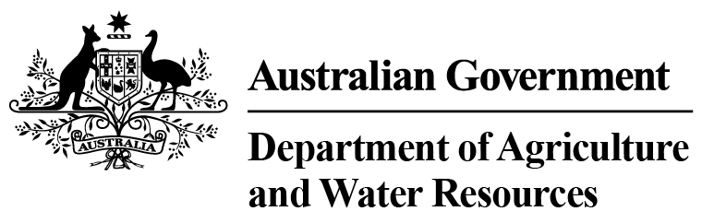
Department Agriculture and Water Resources Statistics –
Total Chilled & Frozen Meat Exports by Load Port -- February 2016 -- Tonnes Shipped Weight
EU
Western
Europe
Eastern
Europe
USA
East
USA
West
Canada
East
Canada
West
Japan
Taiwan
Korea
Other
Asia
Middle
East
Other
Dest
State &
Load Port

Total
NSW
NEWCASTLE
0
0
0
0
0
0
0
0
0
0
0
0
0
0
PORT BOTANY
0
0
0
0
0
0
0
0
0
0
0
0
0
0
SYDNEY
399
23
0
2778
1958
132
165
1517
1690
424
5167
1562
925
16740
399
State Total
23
0
2778
165
1958
132
1517
1690
424
5167
1562
925
16740
VIC
PORTLAND
0
0
0
0
0
0
0
0
0
0
0
0
0
0
GEELONG
0
0
0
0
0
0
0
0
0
0
0
0
0
0
MELBOURNE
1337
58
73
10337
6062
1332
297
4820
4318
680
13185
7542
4352
54393
1337
State Total
58
73
10337
297
6062
1332
4820
4318
680
13185
7542
4352
54393
QLD
CAIRNS
0
0
0
0
0
0
0
0
0
0
0
0
0
0
TOWNSVILLE
0
0
0
0
0
0
0
0
0
0
0
0
0
0
BOWEN
0
0
0
0
0
0
0
0
0
0
0
0
0
0
MACKAY
0
0
0
0
0
0
0
0
0
0
0
0
0
0
PORT ALMA
0
0
0
0
0
0
0
0
0
0
0
0
0
0
GLADSTONE
0
0
0
0
0
0
0
0
0
0
0
0
0
0
BRISBANE
1089
96
100
9091
3115
1687
663
13973
11170
1817
11992
1989
1401
58183
1089
State Total
96
100
9091
663
3115
1687
13973
11170
1817
11992
1989
1401
58183
SA
PORT LINCOLN
0
0
0
0
0
0
0
0
0
0
0
0
0
0
ADELAIDE
577
33
25
853
315
114
0
367
455
61
2991
957
710
7458
577
State Total
33
25
853
0
315
114
367
455
61
2991
957
710
7458
1
Note: Components May Not Add to Totals Due to Rounding

EU
Western
Europe
Eastern
Europe
USA
East
USA
West
Canada
East
Canada
West
Japan
Taiwan
Korea
Other
Asia
Middle
East
Other
Dest
State &
Load Port

Total
WA
GERALDTON
0
0
0
0
0
0
0
0
0
0
0
0
0
0
PORT HEDLAND
0
0
0
0
0
0
0
0
0
0
0
0
0
0
NORTHERN WA
0
0
0
0
0
0
0
0
0
0
0
0
0
0
BUNBURY
0
0
0
0
0
0
0
0
0
0
0
0
0
0
ALBANY
0
0
0
0
0
0
0
0
0
0
0
0
0
0
FREMANTLE/PERTH
251
27
0
445
185
67
69
569
431
180
3619
2819
430
9092
251
State Total
27
0
445
69
185
67
569
431
180
3619
2819
430
9092
TAS
BURNIE
0
0
0
0
0
0
0
0
0
0
0
0
0
0
DEVONPORT
0
0
0
0
0
0
0
0
0
0
0
0
0
0
LAUNCESTON
0
0
0
0
0
0
0
0
0
0
0
0
0
0
HOBART
0
0
0
0
0
0
0
0
0
0
0
0
0
0
BELL BAY
0
0
0
286
19
0
0
0
129
0
112
128
101
775
0
State Total
0
0
286
0
19
0
0
129
0
112
128
101
775
NT
DARWIN
0
0
0
563
19
0
0
0
268
32
26
0
41
949
ALICE SPRINGS
0
0
0
0
0
0
0
0
0
0
0
0
0
0
0
State Total
0
0
563
0
19
0
0
268
32
26
0
41
949
3653
Australia
237
198
24353
11673
3332
1194
21246
18461
3194
37092
14997
7960
147590
2
Note: Components May Not Add to Totals Due to Rounding

