Monday, May 2, 2016
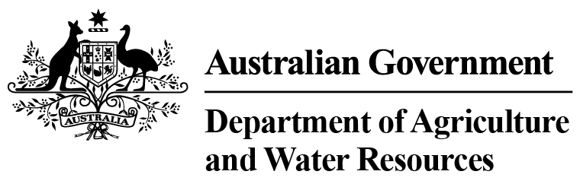
D.A.W.R Statistics - Total Chilled & Frozen Meat Exports by Load Port -- April 2016 -- Tonnes Shipped Weight
EU
Western
Europe
Eastern
Europe
USA
East
USA
West
Canada
East
Canada
West
Japan
Taiwan
Korea
Other
Asia
Middle
East
Other
Dest
State &
Load Port

Total
NSW
NEWCASTLE
0
0
0
0
0
0
0
0
0
0
0
0
0
0
PORT BOTANY
0
0
0
0
0
0
0
0
0
0
0
0
0
0
SYDNEY
445
9
14
1500
2017
212
106
1677
1710
360
4884
2011
1047
15992
445
State Total
9
14
1500
106
2017
212
1677
1710
360
4884
2011
1047
15992
VIC
PORTLAND
0
0
0
0
0
0
0
0
0
0
0
0
0
0
GEELONG
0
0
0
0
0
0
0
0
0
0
0
0
0
0
MELBOURNE
950
143
53
8196
4448
603
130
6050
3039
628
10583
8220
2761
45804
950
State Total
143
53
8196
130
4448
603
6050
3039
628
10583
8220
2761
45804
QLD
CAIRNS
0
0
0
0
0
0
0
0
0
0
0
0
0
0
TOWNSVILLE
0
0
0
0
0
0
0
0
80
0
0
0
0
80
BOWEN
0
0
0
0
0
0
0
0
0
0
0
0
0
0
MACKAY
0
0
0
0
0
0
0
0
0
0
0
0
0
0
PORT ALMA
0
0
0
0
0
0
0
0
0
0
0
0
0
0
GLADSTONE
0
0
0
0
0
0
0
0
0
0
0
0
0
0
BRISBANE
1153
79
23
8527
3577
950
163
18552
10930
2200
11251
1451
1257
60113
1153
State Total
79
23
8527
163
3577
950
18552
11010
2200
11251
1451
1257
60193
SA
PORT LINCOLN
0
0
0
0
0
0
0
0
0
0
0
0
0
0
ADELAIDE
552
17
17
1094
168
19
13
391
344
88
2682
797
475
6657
552
State Total
17
17
1094
13
168
19
391
344
88
2682
797
475
6657
1
Note: Components May Not Add to Totals Due to Rounding

EU
Western
Europe
Eastern
Europe
USA
East
USA
West
Canada
East
Canada
West
Japan
Taiwan
Korea
Other
Asia
Middle
East
Other
Dest
State &
Load Port

Total
WA
GERALDTON
0
0
0
0
0
0
0
0
0
0
0
0
0
0
PORT HEDLAND
0
0
0
0
0
0
0
0
0
0
0
0
0
0
NORTHERN WA
0
0
0
0
0
0
0
0
0
0
0
0
0
0
BUNBURY
0
0
0
0
0
0
0
0
0
0
0
0
0
0
ALBANY
0
0
0
0
0
0
0
0
0
0
0
0
0
0
FREMANTLE/PERTH
145
54
0
336
300
61
83
470
454
127
3281
2784
367
8462
145
State Total
54
0
336
83
300
61
470
454
127
3281
2784
367
8462
TAS
BURNIE
0
0
0
0
0
0
0
0
0
0
0
0
0
0
DEVONPORT
0
0
0
0
0
0
0
0
0
0
0
0
0
0
LAUNCESTON
0
0
0
0
0
0
0
0
0
0
0
0
0
0
HOBART
0
0
0
0
0
0
0
0
0
0
0
0
0
0
BELL BAY
0
0
0
171
19
0
0
0
130
0
255
26
1
602
0
State Total
0
0
171
0
19
0
0
130
0
255
26
1
602
NT
DARWIN
0
0
0
436
74
0
0
0
224
16
137
0
24
911
ALICE SPRINGS
0
0
0
0
0
0
0
0
0
0
0
0
0
0
0
State Total
0
0
436
0
74
0
0
224
16
137
0
24
911
3245
Australia
302
107
20260
10603
1845
495
27140
16911
3419
33073
15289
5932
138621
2
Note: Components May Not Add to Totals Due to Rounding

