Monday, July 4, 2016
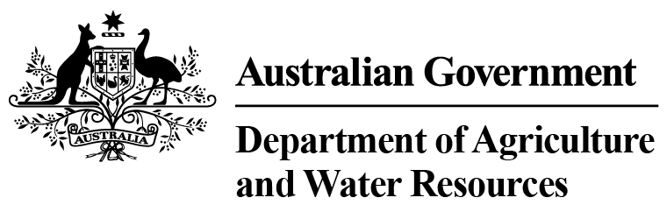 Total Chilled & Frozen Meat Exports by Load Port -- June 2016 -- Tonnes Shipped Weight
EU
Western
Europe
Eastern
Europe
USA
East
USA
West
Canada
East
Canada
West
Japan
Taiwan
Korea
Other
Asia
Middle
East
Other
Dest
State &
Load Port

Total
NSW
NEWCASTLE
0
0
0
0
0
0
0
0
0
0
0
0
0
0
PORT BOTANY
0
0
0
0
0
0
0
0
0
0
0
0
0
0
SYDNEY
257
39
58
1419
1754
73
68
1752
1480
374
4652
1570
748
14244
257
State Total
39
58
1419
68
1754
73
1752
1480
374
4652
1570
748
14244
VIC
PORTLAND
0
0
0
0
0
0
0
0
0
0
0
0
0
0
GEELONG
0
0
0
0
0
0
0
0
0
0
0
0
0
0
MELBOURNE
1039
107
0
7329
3801
605
164
5287
2883
735
11412
6615
3569
43546
1039
State Total
107
0
7329
164
3801
605
5287
2883
735
11412
6615
3569
43546
QLD
CAIRNS
0
0
0
0
0
0
0
0
0
0
0
0
34
34
TOWNSVILLE
0
0
0
0
0
0
0
0
72
32
73
0
21
198
BOWEN
0
0
0
0
0
0
0
0
0
0
0
0
0
0
MACKAY
0
0
0
0
0
0
0
0
0
0
0
0
0
0
PORT ALMA
0
0
0
0
0
0
0
0
0
0
0
0
0
0
GLADSTONE
0
0
0
0
0
0
0
0
0
0
0
0
0
0
BRISBANE
1431
61
2
7722
3895
807
420
18780
12069
2981
14817
1452
1927
66364
1431
State Total
61
2
7722
420
3895
807
18780
12141
3013
14890
1452
1982
66596
SA
PORT LINCOLN
0
0
0
0
0
0
0
0
0
0
0
0
0
0
ADELAIDE
534
11
0
551
239
23
0
1988
1263
82
3123
580
409
8803
534
State Total
11
0
551
0
239
23
1988
1263
82
3123
580
409
8803
1
Note: Components May Not Add to Totals Due to Rounding

EU
Western
Europe
Eastern
Europe
USA
East
USA
West
Canada
East
Canada
West
Japan
Taiwan
Korea
Other
Asia
Middle
East
Other
Dest
State &
Load Port

Total
WA
GERALDTON
0
0
0
0
0
0
0
0
0
0
0
0
0
0
PORT HEDLAND
0
0
0
0
0
0
0
0
0
0
0
0
0
0
NORTHERN WA
0
0
0
0
0
0
0
0
0
0
0
0
0
0
BUNBURY
0
0
0
0
0
0
0
0
0
0
0
0
0
0
ALBANY
0
0
0
0
0
0
0
0
0
0
0
0
0
0
FREMANTLE/PERTH
135
67
0
323
227
48
114
316
348
151
2949
2215
436
7329
135
State Total
67
0
323
114
227
48
316
348
151
2949
2215
436
7329
TAS
BURNIE
0
0
0
0
0
0
0
0
0
0
0
0
0
0
DEVONPORT
0
0
0
0
0
0
0
0
0
0
0
0
0
0
LAUNCESTON
0
0
0
0
0
0
0
0
0
0
0
0
0
0
HOBART
0
0
0
0
0
0
0
0
0
0
0
0
0
0
BELL BAY
0
0
0
190
152
0
0
0
46
0
328
0
0
716
0
State Total
0
0
190
0
152
0
0
46
0
328
0
0
716
NT
DARWIN
0
0
0
476
286
19
0
0
46
18
451
0
24
1320
ALICE SPRINGS
0
0
0
0
0
0
0
0
0
0
0
0
0
0
0
State Total
0
0
476
0
286
19
0
46
18
451
0
24
1320
3396
Australia
285
60
18010
10354
1575
766
28123
18207
4373
37805
12432
7168
142554
2
Note: Components May Not Add to Totals Due to Rounding

