Monday, August 1, 2016
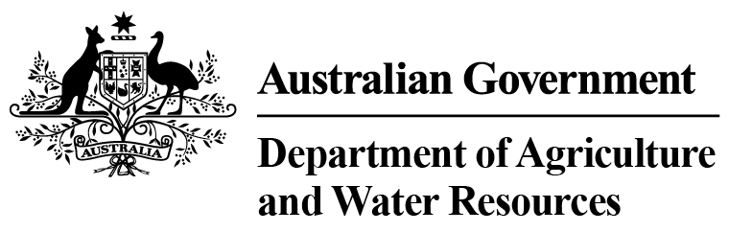 Department of Agriculture and Water Resources Statistics
Total Chilled & Frozen Meat Exports by Load Port -- Fiscal YTD to July 2016 -- Tonnes Shipped Weight
EU
Western
Europe
Eastern
Europe
USA
East
USA
West
Canada
East
Canada
West
Japan
Taiwan
Korea
Other
Asia
Middle
East
Other
Dest
State &
Load Port

Total
NSW
NEWCASTLE
0
0
0
0
0
0
0
0
0
0
0
0
0
0
PORT BOTANY
0
0
0
0
0
0
0
0
0
0
0
0
0
0
SYDNEY
274
19
0
1264
1831
76
111
1458
1429
300
3777
1271
652
12462
274
State Total
19
0
1264
111
1831
76
1458
1429
300
3777
1271
652
12462
VIC
PORTLAND
0
0
0
0
0
0
0
0
0
0
0
0
0
0
GEELONG
0
0
0
0
0
0
0
0
0
0
0
0
0
0
MELBOURNE
657
74
42
5188
3392
479
169
5770
2707
510
8130
5129
2869
35116
657
State Total
74
42
5188
169
3392
479
5770
2707
510
8130
5129
2869
35116
QLD
CAIRNS
0
0
0
0
0
0
0
0
0
0
0
0
0
0
TOWNSVILLE
0
0
0
0
0
0
0
0
0
0
0
0
0
0
BOWEN
0
0
0
0
0
0
0
0
0
0
0
0
0
0
MACKAY
0
0
0
0
0
0
0
0
0
0
0
0
0
0
PORT ALMA
0
0
0
0
0
0
0
0
0
0
0
0
0
0
GLADSTONE
0
0
0
0
0
0
0
0
0
0
0
0
0
0
BRISBANE
816
68
0
5874
2856
986
318
18286
10924
2659
12994
1452
1573
58806
816
State Total
68
0
5874
318
2856
986
18286
10924
2659
12994
1452
1573
58806
SA
PORT LINCOLN
0
0
0
0
0
0
0
0
0
0
0
0
0
0
ADELAIDE
331
4
0
466
103
0
0
207
239
19
1345
246
406
3366
331
State Total
4
0
466
0
103
0
207
239
19
1345
246
406
3366
1
Note: Components May Not Add to Totals Due to Rounding

EU
Western
Europe
Eastern
Europe
USA
East
USA
West
Canada
East
Canada
West
Japan
Taiwan
Korea
Other
Asia
Middle
East
Other
Dest
State &
Load Port

Total
WA
GERALDTON
0
0
0
0
0
0
0
0
0
0
0
0
0
0
PORT HEDLAND
0
0
0
0
0
0
0
0
0
0
0
0
0
0
NORTHERN WA
0
0
0
0
0
0
0
0
0
0
0
0
0
0
BUNBURY
0
0
0
0
0
0
0
0
0
0
0
0
0
0
ALBANY
0
0
0
0
0
0
0
0
0
0
0
0
0
0
FREMANTLE/PERTH
8
21
0
163
224
0
49
409
430
157
2039
726
404
4630
8
State Total
21
0
163
49
224
0
409
430
157
2039
726
404
4630
TAS
BURNIE
0
0
0
0
0
0
0
0
0
0
0
0
0
0
DEVONPORT
0
0
0
0
0
0
0
0
0
0
0
0
0
0
LAUNCESTON
0
0
0
0
0
0
0
0
0
0
0
0
0
0
HOBART
0
0
0
0
0
0
0
0
0
0
0
0
0
0
BELL BAY
0
0
0
170
114
0
0
0
69
0
167
0
0
520
0
State Total
0
0
170
0
114
0
0
69
0
167
0
0
520
NT
DARWIN
0
0
0
552
324
114
57
62
76
84
103
0
0
1372
ALICE SPRINGS
0
0
0
0
0
0
0
0
0
0
0
0
0
0
0
State Total
0
0
552
57
324
114
62
76
84
103
0
0
1372
2086
Australia
186
42
13677
8844
1655
704
26192
15874
3729
28555
8824
5904
116272
2
Note: Components May Not Add to Totals Due to Rounding

