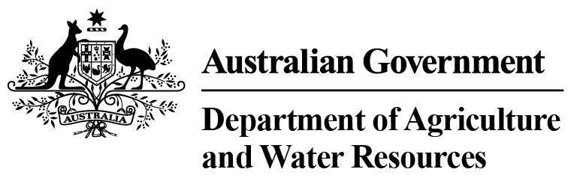
Thursday, September 1, 2016

Department of Agriculture and Water Resources Statistics - Total Chilled & Frozen Meat Exports by Load Port
Fiscal YTD to August 2016 -- Tonnes Shipped Weight
EU
Western
Europe
Eastern
Europe
USA
East
USA
West
Canada
East
Canada
West
Japan
Taiwan
Korea
Other
Asia
Middle
East
Other
Dest
State &
Load Port

Total
NSW
NEWCASTLE
0
0
0
0
0
0
0
0
0
0
0
0
0
0
PORT BOTANY
0
0
0
0
0
0
0
0
0
0
0
0
0
0
SYDNEY
742
55
41
2669
3704
182
180
2970
3102
768
7344
2278
1465
25500
742
State Total
55
41
2669
180
3704
182
2970
3102
768
7344
2278
1465
25500
VIC
PORTLAND
0
0
0
0
0
0
0
0
0
0
0
0
0
0
GEELONG
0
0
0
0
0
0
0
0
0
0
0
0
0
0
MELBOURNE
1294
155
80
10322
6565
1035
245
11195
5373
1061
16303
11328
6436
71392
1294
State Total
155
80
10322
245
6565
1035
11195
5373
1061
16303
11328
6436
71392
QLD
CAIRNS
0
0
0
0
0
0
0
0
0
0
71
0
0
71
TOWNSVILLE
0
0
0
0
0
0
0
0
0
33
0
0
3
36
BOWEN
0
0
0
0
0
0
0
0
0
0
0
0
0
0
MACKAY
0
0
0
0
0
0
0
0
0
0
0
0
0
0
PORT ALMA
0
0
0
0
0
0
0
0
0
0
0
0
0
0
GLADSTONE
0
0
0
0
0
0
0
0
0
0
0
0
0
0
BRISBANE
1705
138
4
11506
5566
2094
417
36908
22819
5595
24323
3255
3189
117519
1705
State Total
138
4
11506
417
5566
2094
36908
22819
5628
24394
3255
3192
117626
SA
PORT LINCOLN
0
0
0
0
0
0
0
0
0
0
0
0
0
0
ADELAIDE
901
18
0
1237
297
38
0
404
388
80
3975
659
789
8786
901
State Total
18
0
1237
0
297
38
404
388
80
3975
659
789
8786
1
Note: Components May Not Add to Totals Due to Rounding

EU
Western
Europe
Eastern
Europe
USA
East
USA
West
Canada
East
Canada
West
Japan
Taiwan
Korea
Other
Asia
Middle
East
Other
Dest
State &
Load Port

Total
WA
GERALDTON
0
0
0
0
0
0
0
0
0
0
0
0
0
0
PORT HEDLAND
0
0
0
0
0
0
0
0
0
0
0
0
0
0
NORTHERN WA
0
0
0
0
0
0
0
0
0
0
0
0
0
0
BUNBURY
0
0
0
0
0
0
0
0
0
0
0
0
0
0
ALBANY
0
0
0
0
0
0
0
0
0
0
0
0
0
0
FREMANTLE/PERTH
123
67
0
342
667
0
205
904
915
289
4844
2759
802
11917
123
State Total
67
0
342
205
667
0
904
915
289
4844
2759
802
11917
TAS
BURNIE
0
0
0
0
0
0
0
0
0
0
0
0
0
0
DEVONPORT
0
0
0
0
0
0
0
0
0
0
0
0
0
0
LAUNCESTON
0
0
0
0
0
0
0
0
0
0
0
0
0
0
HOBART
0
0
0
0
0
0
0
0
0
0
0
0
0
0
BELL BAY
0
0
0
283
190
0
0
0
160
0
456
0
0
1089
0
State Total
0
0
283
0
190
0
0
160
0
456
0
0
1089
NT
DARWIN
0
0
0
838
531
133
57
62
151
120
247
0
19
2158
ALICE SPRINGS
0
0
0
0
0
0
0
0
0
0
0
0
0
0
0
State Total
0
0
838
57
531
133
62
151
120
247
0
19
2158
4765
Australia
433
125
27197
17520
3482
1104
52443
32908
7946
57563
20279
12703
238468
2
Note: Components May Not Add to Totals Due to Rounding

