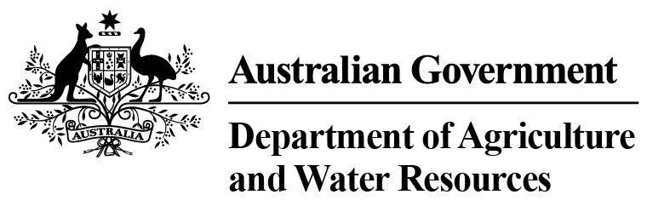
Thursday, September 1, 2016

Department of Agriculture and Water Resources Statistics - Total Chilled & Frozen Meat Exports by Load Port –
August 2016 -- Tonnes Shipped Weight
EU
Western
Europe
Eastern
Europe
USA
East
USA
West
Canada
East
Canada
West
Japan
Taiwan
Korea
Other
Asia
Middle
East
Other
Dest
State &
Load Port

Total
NSW
NEWCASTLE
0
0
0
0
0
0
0
0
0
0
0
0
0
0
PORT BOTANY
0
0
0
0
0
0
0
0
0
0
0
0
0
0
SYDNEY
468
37
41
1405
1873
106
69
1512
1673
468
3567
1007
814
13040
468
State Total
37
41
1405
69
1873
106
1512
1673
468
3567
1007
814
13040
VIC
PORTLAND
0
0
0
0
0
0
0
0
0
0
0
0
0
0
GEELONG
0
0
0
0
0
0
0
0
0
0
0
0
0
0
MELBOURNE
637
81
38
5134
3172
556
76
5425
2666
551
8173
6199
3567
36275
637
State Total
81
38
5134
76
3172
556
5425
2666
551
8173
6199
3567
36275
QLD
CAIRNS
0
0
0
0
0
0
0
0
0
0
71
0
0
71
TOWNSVILLE
0
0
0
0
0
0
0
0
0
33
0
0
3
36
BOWEN
0
0
0
0
0
0
0
0
0
0
0
0
0
0
MACKAY
0
0
0
0
0
0
0
0
0
0
0
0
0
0
PORT ALMA
0
0
0
0
0
0
0
0
0
0
0
0
0
0
GLADSTONE
0
0
0
0
0
0
0
0
0
0
0
0
0
0
BRISBANE
889
70
4
5632
2710
1108
99
18622
11895
2935
11329
1803
1616
58712
889
State Total
70
4
5632
99
2710
1108
18622
11895
2968
11400
1803
1619
58819
SA
PORT LINCOLN
0
0
0
0
0
0
0
0
0
0
0
0
0
0
ADELAIDE
570
14
0
772
194
38
0
197
150
61
2629
414
383
5422
570
State Total
14
0
772
0
194
38
197
150
61
2629
414
383
5422
1
Note: Components May Not Add to Totals Due to Rounding

EU
Western
Europe
Eastern
Europe
USA
East
USA
West
Canada
East
Canada
West
Japan
Taiwan
Korea
Other
Asia
Middle
East
Other
Dest
State &
Load Port

Total
WA
GERALDTON
0
0
0
0
0
0
0
0
0
0
0
0
0
0
PORT HEDLAND
0
0
0
0
0
0
0
0
0
0
0
0
0
0
NORTHERN WA
0
0
0
0
0
0
0
0
0
0
0
0
0
0
BUNBURY
0
0
0
0
0
0
0
0
0
0
0
0
0
0
ALBANY
0
0
0
0
0
0
0
0
0
0
0
0
0
0
FREMANTLE/PERTH
115
45
0
179
443
0
155
495
485
133
2805
2033
398
7286
115
State Total
45
0
179
155
443
0
495
485
133
2805
2033
398
7286
TAS
BURNIE
0
0
0
0
0
0
0
0
0
0
0
0
0
0
DEVONPORT
0
0
0
0
0
0
0
0
0
0
0
0
0
0
LAUNCESTON
0
0
0
0
0
0
0
0
0
0
0
0
0
0
HOBART
0
0
0
0
0
0
0
0
0
0
0
0
0
0
BELL BAY
0
0
0
114
76
0
0
0
91
0
290
0
0
571
0
State Total
0
0
114
0
76
0
0
91
0
290
0
0
571
NT
DARWIN
0
0
0
286
208
19
0
0
76
36
144
0
19
788
ALICE SPRINGS
0
0
0
0
0
0
0
0
0
0
0
0
0
0
0
State Total
0
0
286
0
208
19
0
76
36
144
0
19
788
2679
Australia
247
83
13522
8676
1827
399
26251
17036
4217
29008
11456
6800
122201
2
Note: Components May Not Add to Totals Due to Rounding

