Tuesday, October 4, 2016
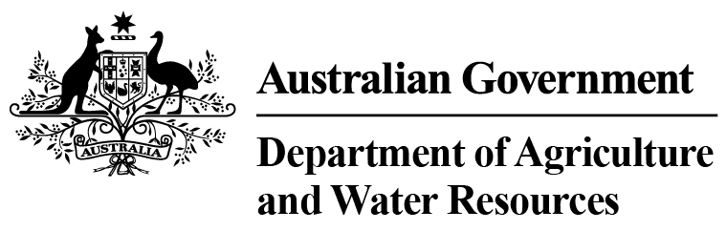 Department of Agriculture and Water Resources Statistics-Total Chilled & Frozen Meat Exports by Load Port
Fiscal YTD to September 2016 -- Tonnes Shipped Weight
EU
Western
Europe
Eastern
Europe
USA
East
USA
West
Canada
East
Canada
West
Japan
Taiwan
Korea
Other
Asia
Middle
East
Other
Dest
State &
Load Port

Total
NSW
NEWCASTLE
0
0
0
0
0
0
0
0
0
0
0
0
0
0
PORT BOTANY
0
0
0
0
0
0
0
0
0
0
0
0
0
0
SYDNEY
1413
76
53
3635
4878
326
255
4239
4674
1125
11405
3722
2163
37964
1413
State Total
76
53
3635
255
4878
326
4239
4674
1125
11405
3722
2163
37964
VIC
PORTLAND
0
0
0
0
0
0
0
0
0
0
0
0
0
0
GEELONG
0
0
0
0
0
0
0
0
0
0
0
0
0
0
MELBOURNE
2132
219
165
15090
9842
1429
357
15761
7895
1755
24632
17155
10060
106492
2132
State Total
219
165
15090
357
9842
1429
15761
7895
1755
24632
17155
10060
106492
QLD
CAIRNS
0
0
0
0
0
0
0
0
0
0
71
0
0
71
TOWNSVILLE
0
0
0
0
0
0
0
0
48
67
157
0
5
277
BOWEN
0
0
0
0
0
0
0
0
0
0
0
0
0
0
MACKAY
0
0
0
0
0
0
0
0
0
0
0
0
0
0
PORT ALMA
0
0
0
0
0
0
0
0
0
0
0
0
0
0
GLADSTONE
0
0
0
0
0
0
0
0
0
0
0
0
0
0
BRISBANE
2542
216
4
16139
8179
2793
536
53633
35142
7857
37341
5116
4637
174135
2542
State Total
216
4
16139
536
8179
2793
53633
35190
7924
37569
5116
4642
174483
SA
PORT LINCOLN
0
0
0
0
0
0
0
0
0
0
0
0
0
0
ADELAIDE
1429
39
0
2085
396
57
0
749
727
180
7553
1295
1153
15663
1429
State Total
39
0
2085
0
396
57
749
727
180
7553
1295
1153
15663
1
Note: Components May Not Add to Totals Due to Rounding

EU
Western
Europe
Eastern
Europe
USA
East
USA
West
Canada
East
Canada
West
Japan
Taiwan
Korea
Other
Asia
Middle
East
Other
Dest
State &
Load Port

Total
WA
GERALDTON
0
0
0
0
0
0
0
0
0
0
0
0
0
0
PORT HEDLAND
0
0
0
0
0
0
0
0
0
0
0
0
0
0
NORTHERN WA
0
0
0
0
0
0
0
0
0
0
0
0
0
0
BUNBURY
0
0
0
0
0
0
0
0
0
0
0
0
0
0
ALBANY
0
0
0
0
0
0
0
0
0
0
0
0
0
0
FREMANTLE/PERTH
532
111
37
375
1026
21
381
1591
1467
557
8484
5585
1148
21315
532
State Total
111
37
375
381
1026
21
1591
1467
557
8484
5585
1148
21315
TAS
BURNIE
0
0
0
0
0
0
0
0
0
0
0
0
0
0
DEVONPORT
0
0
0
0
0
0
0
0
0
0
0
0
0
0
LAUNCESTON
0
0
0
0
0
0
0
0
0
0
0
0
0
0
HOBART
0
0
0
0
0
0
0
0
0
0
0
0
0
0
BELL BAY
0
0
0
341
208
19
0
0
229
0
656
99
0
1552
0
State Total
0
0
341
0
208
19
0
229
0
656
99
0
1552
NT
DARWIN
0
0
0
1349
588
133
57
75
293
187
548
0
34
3264
ALICE SPRINGS
0
0
0
0
0
0
0
0
0
0
0
0
0
0
0
State Total
0
0
1349
57
588
133
75
293
187
548
0
34
3264
8048
Australia
661
259
39014
25117
4778
1586
76048
50475
11728
90847
32972
19200
360733
2
Note: Components May Not Add to Totals Due to Rounding

