Tuesday, October 4, 2016
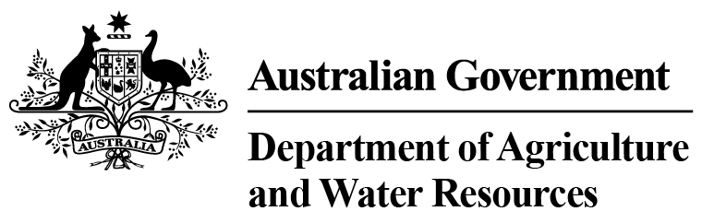 D.A.F.F Statistics - Total Chilled & Frozen Meat Exports by Load Port
September 2016 -- Tonnes Shipped Weight
EU
Western
Europe
Eastern
Europe
USA
East
USA
West
Canada
East
Canada
West
Japan
Taiwan
Korea
Other
Asia
Middle
East
Other
Dest
State &
Load Port

Total
NSW
NEWCASTLE
0
0
0
0
0
0
0
0
0
0
0
0
0
0
PORT BOTANY
0
0
0
0
0
0
0
0
0
0
0
0
0
0
SYDNEY
672
20
12
967
1175
144
75
1269
1572
357
4061
1444
698
12466
672
State Total
20
12
967
75
1175
144
1269
1572
357
4061
1444
698
12466
VIC
PORTLAND
0
0
0
0
0
0
0
0
0
0
0
0
0
0
GEELONG
0
0
0
0
0
0
0
0
0
0
0
0
0
0
MELBOURNE
837
65
85
4768
3277
394
113
4566
2522
695
8328
5827
3624
35101
837
State Total
65
85
4768
113
3277
394
4566
2522
695
8328
5827
3624
35101
QLD
CAIRNS
0
0
0
0
0
0
0
0
0
0
0
0
0
0
TOWNSVILLE
0
0
0
0
0
0
0
0
48
34
157
0
2
241
BOWEN
0
0
0
0
0
0
0
0
0
0
0
0
0
0
MACKAY
0
0
0
0
0
0
0
0
0
0
0
0
0
0
PORT ALMA
0
0
0
0
0
0
0
0
0
0
0
0
0
0
GLADSTONE
0
0
0
0
0
0
0
0
0
0
0
0
0
0
BRISBANE
837
79
0
4633
2613
699
120
16725
12323
2262
13018
1861
1449
56619
837
State Total
79
0
4633
120
2613
699
16725
12371
2296
13175
1861
1451
56860
SA
PORT LINCOLN
0
0
0
0
0
0
0
0
0
0
0
0
0
0
ADELAIDE
528
21
0
847
99
19
0
346
339
100
3578
636
363
6876
528
State Total
21
0
847
0
99
19
346
339
100
3578
636
363
6876
1
Note: Components May Not Add to Totals Due to Rounding

EU
Western
Europe
Eastern
Europe
USA
East
USA
West
Canada
East
Canada
West
Japan
Taiwan
Korea
Other
Asia
Middle
East
Other
Dest
State &
Load Port

Total
WA
GERALDTON
0
0
0
0
0
0
0
0
0
0
0
0
0
0
PORT HEDLAND
0
0
0
0
0
0
0
0
0
0
0
0
0
0
NORTHERN WA
0
0
0
0
0
0
0
0
0
0
0
0
0
0
BUNBURY
0
0
0
0
0
0
0
0
0
0
0
0
0
0
ALBANY
0
0
0
0
0
0
0
0
0
0
0
0
0
0
FREMANTLE/PERTH
410
44
37
32
359
21
177
687
552
267
3640
2825
345
9396
410
State Total
44
37
32
177
359
21
687
552
267
3640
2825
345
9396
TAS
BURNIE
0
0
0
0
0
0
0
0
0
0
0
0
0
0
DEVONPORT
0
0
0
0
0
0
0
0
0
0
0
0
0
0
LAUNCESTON
0
0
0
0
0
0
0
0
0
0
0
0
0
0
HOBART
0
0
0
0
0
0
0
0
0
0
0
0
0
0
BELL BAY
0
0
0
57
18
19
0
0
69
0
200
99
0
462
0
State Total
0
0
57
0
18
19
0
69
0
200
99
0
462
NT
DARWIN
0
0
0
511
57
0
0
13
142
67
301
0
15
1106
ALICE SPRINGS
0
0
0
0
0
0
0
0
0
0
0
0
0
0
0
State Total
0
0
511
0
57
0
13
142
67
301
0
15
1106
3284
Australia
229
134
11815
7598
1296
485
23606
17567
3782
33283
12692
6496
122267
2
Note: Components May Not Add to Totals Due to Rounding

