FARM MANAGEMENT DEPOSITS SCHEME STATISTICS – mAY 2018
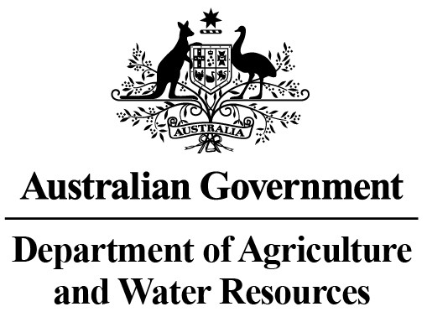
INDUSTRY DESCRIPTION | NSW |  | VIC |  | QLD |  | SA |  | WA |  | TAS |  | ACT & NT |  | NATIONAL TOTALS
INDUSTRY DESCRIPTION | No. of FMD accounts | Value of deposits ($’000) | No. of FMD accounts | Value of deposits ($’000) | No. of FMD accounts | Value of deposits ($’000) | No. of FMD accounts | Value of deposits ($’000) | No. of FMD accounts | Value of deposits ($’000) | No. of FMD accounts | Value of deposits ($’000) | No. of FMD accounts | Value of deposits ($’000) | No. of FMD accounts | Value of deposits ($’000)
HORTICULTURE | 1,028 | 117,301 | 1,074 | 127,788 | 1,107 | 159,680 | 958 | 97,702 | 313 | 48,542 | 113 | 13,557 | 14 | 1,370 | 4,607 | 565,940
SUGAR | 112 | 6,880 | * | * | 1,474 | 135,745 | 0 | 0 | 0 | 0 | 0 | 0 | 0 | 0 | 1,586 | 142,625
CROPS | 772 | 79,070 | 385 | 27,762 | 704 | 87,597 | 361 | 29,003 | 83 | 8,647 | 57 | 2,902 | ** | ** | 2,362 | 234,981
GRAIN | 2,007 | 244,039 | 1,496 | 140,615 | 907 | 134,581 | 2,523 | 305,544 | 1,461 | 261,982 | 14 | 852 | ** | ** | 8,408 | 1,087,613
GRAIN-SHEEP/BEEF | 3,570 | 369,865 | 2,343 | 216,560 | 1,065 | 122,015 | 2,519 | 270,661 | 1,714 | 268,188 | 79 | 6,548 | 10 | 2,065 | 11,300 | 1,255,902
BEEF | 2,376 | 193,135 | 1,626 | 119,631 | 3,258 | 405,123 | 344 | 37,330 | 370 | 48,524 | 223 | 19,432 | 29 | 6,719 | 8,226 | 829,894
SHEEP-BEEF | 1,692 | 139,814 | 988 | 74,590 | 500 | 50,146 | 593 | 54,699 | 188 | 17,197 | 105 | 7,777 | 9 | 445 | 4,075 | 344,668
SHEEP | 1,457 | 132,550 | 1,060 | 79,218 | 118 | 10,589 | 565 | 46,261 | 285 | 27,551 | 90 | 7,498 | 8 | 708 | 3,583 | 304,375
PIG | 31 | 2,683 | 26 | 4,453 | 46 | 3,679 | 40 | 3,963 | 10 | 630 | 8 | 1,083 | 0 | 0 | 161 | 16,491
INTENSIVE LIVESTOCK | 562 | 47,268 | 284 | 24,028 | 326 | 30,018 | 157 | 12,679 | 75 | 6,075 | 31 | 1,274 | ** | ** | 1,435 | 121,342
DAIRY | 346 | 31,032 | 1,864 | 163,994 | 274 | 22,125 | 146 | 14,915 | 91 | 10,094 | 119 | 10,202 | 0 | 0 | 2,840 | 252,362
FORESTRY & FISHING | 201 | 14,688 | 157 | 10,876 | 173 | 14,021 | 184 | 21,085 | 165 | 24,358 | 55 | 3,327 | ** | ** | 935 | 88,355
OTHER | 15 | 787 | 16 | 944 | *** | *** | *** | *** | *** | *** | *** | *** | 0 | 0 | 31 | 1,731
STATE/TERRITORY TOTAL  # | 14,169 | 1,379,112 | 11,319 | 990,459 | 9,952 | 1,175,319 | 8,390 | 893,842 | 4,755 | 721,788 | 894 | 74,452 | 70 | 11,307 | 49,549 | 5,246,279
#Note: The total number of accounts does not indicate the number of primary producers participating in the FMD Scheme as a primary producer may hold multiple FMD accounts.
* Victorian sugar industry FMD accounts and holdings have been aggregated with the respective New South Wales FMD accounts and holdings for privacy reasons.
** Northern Territory and Australian Capital Territory crops, grain, intensive livestock and forestry & fishing industries FMD accounts and holdings have been aggregated with the respective New South Wales FMD accounts and holdings for privacy reasons.
*** Queensland, South Australian, Western Australian and Tasmanian other industry FMD accounts and holdings have been aggregated with the respective Victorian FMD accounts and holdings for privacy reasons.
These monthly FMD statistics are derived from data provided by Authorised Deposit-taking Institutions (ADIs) (such as banks and credit unions). These statistics may, due to the complex nature of FMDs, include a level of discrepancy, leading to a minor overstatement or understatement of the actual holdings eligible for the FMD taxation concessions. The Australian Government, acting through the Department of Agriculture and Water Resources, has exercised due care in compiling this information. Notwithstanding, the department, its employees and advisers disclaim all liability, including liability for negligence, for any loss, damage, injury, expense or cost incurred by any person as a result of accessing, using or relying upon any of the information or data on FMDs to the maximum extent permitted by law.

