# Agricultural Innovation - A National Approach to Grow Australia’s Future: Full report

**March 2019**

Preamble

About this report

The World Bank defines an innovation system as “a network of organisations, enterprises, and individuals focused on bringing new products, new processes, and new forms of organisation into economic use, together with the institutions and policies that affect their behaviour and performance.” (World Bank 2006) The system, which includes people, culture, policies, laws and infrastructure, defines the way in which different agents interact, share and use knowledge.

This report refers to Australia’s agricultural, fishery and forestry industries, inputs, supply chains and food and fibre products collectively, as “agriculture”, the “agricultural sector”, and “sector.”

Australian agricultural innovation has helped the sector become more profitable and productive, improve sustainability, and achieve social outcomes. Today, our agricultural sector faces unprecedented change, including climate and water related risks, shifts in consumer preferences and rapid digitisation.

To ensure that we have the best system possible, one that is optimised for the future and delivers beneficial outcomes for every Australian, the Australian Government Department of Agriculture and Water Resources (“the Department”) commissioned EY in September 2018 to develop a shared vision for the future of the Australian agricultural innovation system.

This report presents the resulting vision for the Australian agricultural innovation system. The vision was informed by consultation with a diverse range of people and organisations in Australia and overseas, through extensive desktop research and analysis, as well as through a series of workshops and focus groups around Australia.

Acknowledgment

EY would like to acknowledge the significant contributions made by all who participated and shared their perspectives on how to modernise Australian agricultural innovation. We greatly appreciate your time to talk with us on the phone, meet with us in person, and attend focus groups and workshops around the country. It has been very clear, through the passion displayed, that the many people engaged in Australia’s agriculture innovation today care deeply about the future of innovation in the sector. It has been a great privilege for us to undertake this project and meet some of the people involved across all parts of the agricultural value chain. We are excited that the Australian agriculture innovation system will be supported by passionate and visionary people in the sector, taking it forward over the years and decades ahead.

Engaged stakeholders included: farmers, fishers, foresters, input providers, processors, retailers and consumer groups, Commonwealth, State and Territory Governments, universities, research providers, multinationals, industry bodies, start-ups, incubators, accelerators and venture capitalists. Stakeholders also included a range of international experts, organisations and innovation system leaders, as well as other related sectors, such as financial services. We would like to take the opportunity to thank everyone involved for their contribution to this important initiative. For a full list of organisations that participated in the development of the vision, please refer to Appendix C: acknowledgement.

We would also like to acknowledge the support of the Department. EY worked in a joint team with the Department of Agriculture and Water Resources to develop this vision; and their knowledge, expertise and skills were critical to the vision as well as engagement across the sector.

Disclaimer

Ernst & Young has prepared this report for the benefit of the Department as agreed on 12 September 2018. Ernst & Young has not been engaged to act, and has not acted, as advisor to any other party on this matter. Accordingly, Ernst & Young makes no representations as to the appropriateness, accuracy or completeness of the report for any other party's purposes. Specifically, where submissions that were collected during the course of the project are reproduced in the report, the submissions have not been verified for accuracy or completeness or for any other purpose.

Table of contents

Executive Summary 1

Will our approach to agricultural innovation continue to work well in the future? 4

Vision for the Australian agricultural innovation system 5

Recommendations 7

Roadmap 8

1 Introduction and context 9

1.1 Introduction and approach to the project 9

1.2. Introduction to Australian agriculture 13

2 Australian agricultural innovation 17

2.1. A snapshot of existing agricultural innovation: Historical view of developments 17

2.2. Current state of Australian agricultural innovation 17

2.3 The impact delivered by agricultural innovation includes agriculture productivity growth, economic and social benefits 25

2.4. Stakeholder consultations highlighted six key strengths of our existing agricultural innovation 26

Overview of Australian agricultural innovation 28

3 Is there a need for change? 29

3.1 There are multiple indicators that Australia could improve performance and investment in agricultural innovation 29

3.2 Australian agricultural innovation will need to evolve to respond to new challenges and address future opportunities 35

3.3 Stakeholder consultations have identified potential changes required for Australian agricultural innovation to deliver the best possible outcomes for the future 37

3.4 Leading practices from international jurisdictions signal how Australia could position its agricultural innovation for future opportunities 56

3.5 There is a compelling case to change the current approach to Australian agricultural innovation 80

4 Vision for the Australian agricultural innovation system 86

Purpose of Australia’s Agricultural Innovation System 86

What will the Australian agricultural innovation system look like in 2050? 87

Outcomes of the future agricultural innovation system 88

Our values to support 89

5 Recommendations and proposed actions 90

Recommendation 1: Strengthening ecosystem leadership, cohesion and culture 91

Recommendation 2: Funding and investment 95

Recommendation 3: World-class innovation practices 98

Recommendation 4: Strengthening regions 102

Recommendation 5: Next generation innovation platform 105

6 Roadmap for the future 108

Roadmap to 2050 108

Success factors 110

7 Appendices 112

Appendix A: glossary 112

Appendix B: definitions 113

Appendix C: acknowledgements 115

Appendix D: international research 125

Appendix E: approach to stakeholder consultations and insights 135

Appendix F: approach to relative positioning comparison to other countries 140

Appendix G: detailed megatrends 142

Appendix H: Reference list 154

Table of figures

Figure 1 Countries examined as part of this project 2

Figure 2 Geographical locations of stakeholder consultations in Australia 2

Figure 3 Countries examined as part of this project 12

Figure 4 Geographical locations of stakeholder consultations in Australia 12

Figure 5 Australia Agriculture gross product value 1977 – 2018 using chain volume measure (ABARES 2018)* 17

Figure 6 Overview the current Australian agricultural innovation landscape (Food and Agriculture Organisation of the United States 2019) 18

Figure 7 Examples of Australian innovation precincts 20

Figure 8 Value of rural R&D funding in 2014-15 (Millist, Chancellor & Jackson 2017) 21

Figure 9 Gross Value Added based on Multifactor Productivity Index 1989-2017 (ABARES 2018) 31

Figure 10 International scientific collaboration on innovation, 2012 (World Economic Forum 2013) 32

Figure 11 Firms collaborating on innovation with higher education or research institutions 2010-13 (OECD 2017) 33

Figure 12 Geographical locations of stakeholder consultations globally 56

Figure 13 Agriculture R&D spending across Australia and different countries 57

Figure 14 Comparison of key statistics for selected countries and Australia 58

Figure 15 Relative positioning across key innovation focus areas 59

Figure 16 Relative positioning across key influences on investment 61

Figure 17 Relative positioning on whole of system dimensions 62

Figure 18 Approximate locations and key facts on various agriculture and food hubs in the Netherlands (Wouters 2014) 101

Figure 19 Strategic choice framework used during phase 2 stakeholder consultations 137

Figure 20 Share of world agri-food demand, the global diet 2007-50 (kg / person / year) (ABARES 2012) 143

Figure 21 Illustrative figure of % of dietary energy obtained from unhealthy food, 2000-30 (CSIRO 2016) 144

Figure 22 Current and estimated potential land use suitable for agriculture in Queensland (% of state land) (Department of Agriculture and Fisheries 2018) 146

Figure 23 Annual aggregated values of investment in the Australian AgTech market (AgFunder 2017) 150

Figure 24 Impact of ‘Internet of Things’ on Australian GDP, 2015 – 2030 (CSIRO 2016) 152

Table 1 Investment in agricultural innovation 30

## Executive Summary

Agriculture has, for many years, been linked to the Australian identity and prosperity. Australia’s agriculture, fisheries and forestry industries are highly successful in producing a large variety of food and fibre products for our nation and our trading partners. Innovation – doing new or different things – has always been a significant contributor to the success of Australian agriculture.

Australian farmers, fishers and foresters are genuinely interested in adopting new and different practices provided they are aware of and understand the associated benefits. Participants across the agriculture value chain are constantly improving practices to drive productivity and profitability, determined to make Australia a global leader in food and fibre products.

Australia is recognised for excellent agricultural research outcomes supported by multiple streams of industry and government-backed investments (OECD, 2017). However, agricultural innovation in Australia was not designed to operate as a cohesive system – it is made up of many institutions and bodies put in place over time across different jurisdictions and commodities. This is limiting the effectiveness of our innovation investments.

Looking to the future, Australian agriculture faces unprecedented change, driven by various factors, such as changing global markets, increasing international competition, technological disruption, transforming industry structures, climate variability and change, water scarcity, and increasing threats from pests and disease (CSIRO, 2016).

Accelerating productivity growth is essential if we are to harness opportunities and mitigate the risks confronting Australian agriculture. The National Farmers’ Federation has set an ambitious target for a $100 billion agriculture sector by 2030 – world class innovation will be essential to drive the transformational productivity gains required to meet this target (National Farmers’ Federation).

Given this context, in September 2018, Ernst & Young was commissioned by the Department to develop a shared vision to best position the Australian agricultural innovation system for the future. This project drew on the wealth of information and experiences from people who participate in Australian agricultural innovation, and supplemented these ideas with research on world leading innovation systems from other countries.

This project collected more than 12,000 observations from over 550 stakeholders using a co-design approach that included interviews, workshops, focus groups and online surveys. The engagement targeted participants involved today, including researchers and research institutions, Research and Development Corporations (RDCs), industry representatives, producers, processors, investors, government agencies, input providers, multinationals and entrepreneurs across the start-up, accelerator and incubator community. We thank them for their highly cooperative engagement that has been fundamental to the preparation of this report. This project also studied agricultural innovation systems in a number of other countries as well as some selected companies, to learn from them and identify how we can capitalise on our existing innovation activities. For a full list of organisations that participated in the development of the vision, please refer to Appendix C: acknowledgements.

This report highlights opportunities for Australian agricultural innovation to progress and evolve, and in doing so make even more significant contributions to the agricultural sector over the years and decades ahead. Thus, this report proposes a shared vision for the future and makes a number of recommendations of major areas of endeavour that should be pursued over the coming decades to create a truly world class innovation system. If adopted, we believe that these will substantially strengthen the coherence and effectiveness of the system.

Figure Countries examined as part of this project

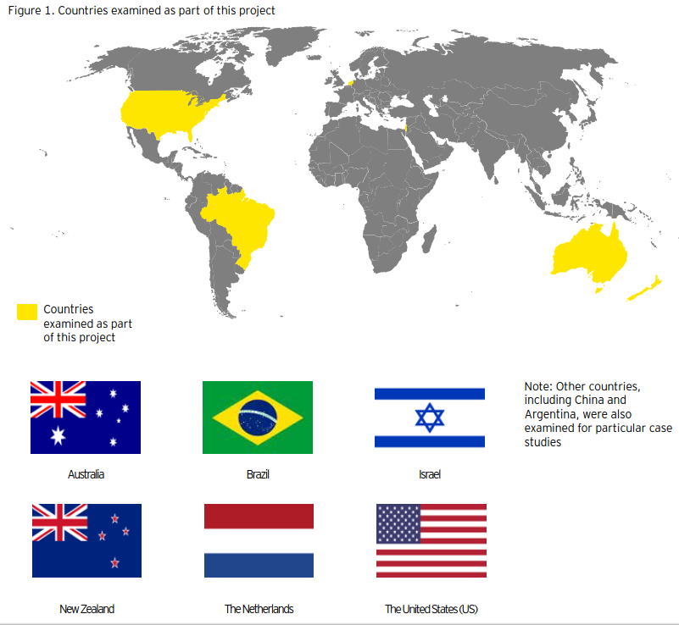

Figure Geographical locations of stakeholder consultations in Australia

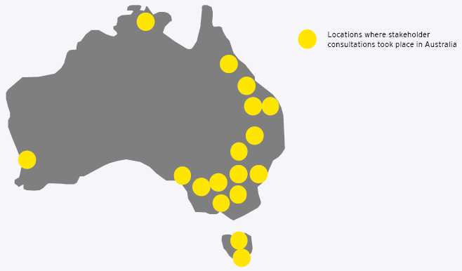

Consultations included over 550 stakeholders from 16 different user groups:

* Approximately 20 venture capitalists and financial institutions
* Approximately100 stakeholders from the Government (Commonwealth, state and local)
* Approximately 50 RDC staff and board members
* Approximately 60 producers
* Approximately 15 input providers (chemicals, machinery and AgTech to farms)
* Approximately 35 universities
* Approximately 85 industry representative bodies
* Approximately 30 start-ups
* Approximately 30 industry consultations, advisors and farming system groups
* Approximately 5 members of CSIRO
* Approximately 35 post farm gate stakeholders (buyers, markets and processors)
* Approximately 35 international stakeholders
* Approximately 15 incubators and accelerators
* Approximately 5 research organisations
* Approximately 10 CRCs
* Approximately 20 other organisations (for example, multinational corporations)

### Will our approach to agricultural innovation continue to work well in the future?

Looking to the future, there is opportunity for Australian agricultural innovation to modernise and achieve greater and more diverse outcomes from investment in innovation, to adopt a more coordinated approach to respond to future opportunities, threats and trends and to better position Australia as a globally relevant agricultural innovation system.

Based on insights gathered from extensive stakeholder engagement, coupled with research into global agricultural innovation systems, there is a compelling case for change and opportunity to strengthen Australian agricultural innovation.

1. Future opportunities, threats and trends within the agriculture sector will occur in a larger, more complex and a faster manner than ever before, requiring leadership and cohesion across the ecosystem to set strategic priorities and drive a more coordinated and cross-domain approach

Agricultural innovation is siloed with strategic priorities and direction set independently by system participants. Agricultural innovation has a national framework and priorities; however, these do not currently drive investment decisions. There is evidence that participants are not yet collaborating in a strategic and sustained manner to address shared challenges and draw on experience from other sectors. As a result, the effectiveness and efficiency of Australian agricultural innovation is undermined by poor cross-industry and cross-sectoral collaboration. Looking to 2050, traditional ways of working are unlikely to be sufficient to address new challenges.

1. Improving the mix of investment in innovation and growing the total funding pool including private sector investment would achieve better and more diverse outcomes

Investment portfolios are largely focused on applied, commodity-specific and incremental innovations. The innovation focus needs to shift towards a more balanced approach to deliver greater transformational innovation, address cross-sectoral challenges, and target economic, environmental and social outcomes. Increasing private sector investment in agriculture helps to shift this balance. Although private investment has been growing, Australian agricultural innovation still lags behind international benchmarks. There is an opportunity to grow the total funding pool through new collaborations, engagement of non-traditional participants and greater private sector participation to drive increased efficiency and greater impact.

1. An innovation culture that is more dynamic, encourages entrepreneurship and a more open approach to risk taking, would better position our future agricultural innovation system within the global innovation landscape

The innovation culture in Australia is generally considered to present a barrier to disruptive innovation and entrepreneurship. Key elements are a risk averse culture, a territorial view of Intellectual Property (IP) and a lack of diversity. Today, Australian agricultural innovation also lacks strong commercialisation capabilities, and the pursuit of global commercialisation opportunities is not a clear priority for the sector. Australia’s agricultural innovation system is fragmented and international organisations and multinationals find it difficult to identify potential collaborators in Australia, limiting our global competitiveness.

There are significant opportunities to position Australia to draw in greater private and foreign investment, develop key partnerships and collaborations with international organisations and leverage global expertise and resources. There is scope for greater leadership across the system to prioritise investments, provide incentives and set a stronger culture that supports and encourages effective collaboration and action to address cross-sectoral and transformational innovation.

1. Strengthening the role of regions would improve innovation uptake

A lack of information and uncertainty about the benefits of innovation is a barrier to adoption. Australian agricultural innovation provides fragmented extension services, limiting the speed of innovation uptake, hindering productivity gains and limits value adding. There is a large opportunity to empower our regions so that they can contribute to national priority setting and maximise opportunities for commercialisation from investment in innovation.

1. The foundations of the system need to be improved to meet the needs of the future and to provide a next generation innovation platform

The foundations of agricultural innovation – data, physical infrastructure and the regulatory environment – are not adapted to the needs of the future. Agriculture is becoming increasingly digitised and existing data is highly disaggregated, siloed and inconsistent. Complexity and regulatory burden across different levels of government can restrict innovation and discourage collaboration and investment. There are opportunities to strengthen foundational capabilities to better inform decision-making and increase the speed of innovation and adoption.

Further details to support the case for change are contained in Section 3, which covers stakeholder insights, findings from international research, and a discussion on implications of megatrends for Australia’s agricultural innovation system.

### Vision for the Australian agricultural innovation system

The vision is to establish an Australian agricultural innovation system that is cohesive, coherent, fit for the future and globally recognised.

“Harness the power of knowledge: to make our food and fibre systems more competitive, prosperous and sustainable”

Our system will be connected, dynamic and work seamlessly together to create and inspire cutting-edge science and technology breakthroughs. In particular, our future system will:

* serve an increasingly diverse range of stakeholders, including producers and communities in rural areas, value adding processors and innovators. We will feed an increasing number of people and become a significant exporter of premium food and fibre products, IP and services
* be recognised globally as a leading innovation nation, with extensive collaborations in place as interactions between people and information become fluid, allowing increased speed, higher impact and greater outcomes
* actively support transformation of the agricultural industry, driving investment into innovation and pursuing global opportunities
* embrace a balance of incremental and disruptive innovations. The scope of our innovation system will be expanded, covering the full range of agricultural-related industries, social and environmental domains and end-to-end considerations along multiple, diverse value chains and our current and future consumers
* make visionary investments in national agricultural priorities, missions, and the conversion of ideas into cutting-edge technology that is commercialised
* look to the world of 2100 and beyond, addressing economic, social and environmental concerns of our future generations

This vision will be supported by people who are passionate, ambitious, collaborative, entrepreneurial and dynamic, and drive value through specialisation to be globally differentiated. Achieving our shared vision will enhance Australia’s prosperity, sustainability, global competitiveness, innovation excellence and social impact. The vision will ensure that our future agricultural innovation system is ahead of the game.

The system will be ranked in the top tier of innovation systems globally, developing breakthrough innovations to real world problems, with participants across the value chain working seamlessly together to shape and define the future of Australian agriculture. The system will consist of:

1. Strengthened ecosystem leadership, cohesion and culture: innovation will thrive and be targeted towards clear overarching priorities, and participants will work seamlessly together to drive change and success. Strong ecosystem leadership and cohesion across the system will be instrumental to the establishment of our global presence. We will become recognised as a leading agricultural innovation nation, where interactions between people and information are fluid, enabling increased speed, higher impact and greater outcomes
2. Funding and investment: our innovation system will make visionary investments in national priorities and apply a mission oriented approach to tackling challenges. It will be well-funded by leveraging a diverse source of capital to develop breakthrough innovations. Researchers and innovators will be attracted to become part of our system as capital flows to the best ideas and teams
3. World-class innovation practices: our system will build capacity and capability to innovate and transform the agricultural industry. Young innovators will be inspired throughout their education to explore, design and develop transformational solutions. Our innovation precincts will become world-renowned, pursuing global opportunities for innovation
4. Strengthened regions: regions will become the backbone of our system as they influence and help to shape directions and priorities for agricultural innovation. They will be highly regarded and connected internationally and respected for their expertise and knowledge contributions to solving world problems
5. Next generation innovation platform: our innovation system will be powered by a world-leading platform that generates connections and collaborations to inspire cutting-edge science and technology. We will bring data to life through modern technologies, such as machine learning and artificial intelligence, to create the catalysts to innovate. We will support innovations through strong regulation and infrastructure that will evolve at a pace aligned with the speed of innovation

### Recommendations

This project identified five overarching recommendations and areas of change that will drive the success of the sector to modernise our innovation system. These areas require ongoing commitment and focus to evolve the system into the future.

#### Recommendation 1: strengthening ecosystem leadership, cohesion and culture

1.1. Establish shared priorities across the system to guide innovation investment and activities

1.2. Position Australian agricultural innovation as a cohesive, coherent, fit for the future and globally recognised system

1.3. Influence a culture that supports entrepreneurship and risk appetite towards transformational innovation

1.4. Establish ecosystem leadership

#### Recommendation 2: funding and investment

2.1. Shift the balance of public investment towards transformational and cross-sectoral outcomes

2.2. Increase flexibility and contestability of funding across the system

2.3. Encourage new collaborations, non-traditional participants and greater private sector involvement

2.4. Foster an attractive environment to attract private investment

2.5. Target key partnerships and collaborations to leverage global expertise and resources

2.6. Improve transparency and access of information on research activities and outcomes

2.7. Grow the total funding pool

#### Recommendation 3: world-class innovation practices

3.1. Scale-up a small number of innovation precincts into national flagship precincts for agricultural innovation

3.2. Introduce requirements for research funding applications to include commercial and adoption focus

3.3. Make more agricultural research publicly available to increase opportunities for commercialisation

3.4. Encourage diversity of capability and promote the future of the agricultural sector to improve innovation outcomes

3.5. Establish common and standard practices for repeatable processes in the innovation system

#### Recommendation 4: strengthening regions

4.1. Strengthen the extension and adoption of innovation by enhancing farming systems groups

4.2. Create an avenue for agricultural innovation system participants to contribute to national priority setting

4.3. Create communities of regions with similar characteristics to network both locally and internationally

4.4. Build capability to better inform decision-making and increase the speed of innovation and adoption

#### Recommendation 5: next generation innovation platform

5.1. Enhance data infrastructure and its use (such as data hub, new data standards, literacy programs)

5.2. Strengthen and demonstrate how data could be created and shared across the system

5.3. Improve awareness of the availability of existing telecommunications technology solutions

5.4. Support the improvement of rural and regional areas to maximise opportunities from investing

5.5. Create a more flexible regulatory environment to foster agricultural innovation

5.6. Perform ongoing scanning of global innovation systems to learn, adapt and establish international collaborations

### Roadmap

Implementation of this vision may take many courses and forms and further engagement with participants is recommended to test options to achieve the vision. ‘Implementation pathways’ will need to be carefully explored and examined, as to their ability to achieve the future vision. It will be important that these ‘implementation pathways’ continue to build cohesiveness and collaboration across the system and to strengthen it for the future.

## Introduction and context

### 1.1 Introduction and approach to the project

#### 1.1.1 Purpose of this project: Co-designing a shared vision for the future

This project was commissioned in September 2018 to develop a shared vision for the future of Australian agricultural innovation. In order to achieve this objective, a comprehensive consultation process was undertaken with stakeholders across the Australian agricultural sector, including: research providers, rural research and development corporations (RDCs), industry representatives, governments, investors, start-ups, accelerators, incubators, producers, growers and farming systems groups, processors and retailers. This project also investigated best practice systems for innovation across Australia and around the globe. Insights through stakeholder consultations formed important input to co-creating a shared vision for the future of the agricultural innovation system, to enable opportunities for a vibrant agricultural sector.

For the purpose of this report, the term ‘agricultural innovation’ encompasses all agricultural commodities, fisheries and forestry. This report also recognises that the agricultural innovation system fits within broader Australian and global innovation systems.

#### 1.1.2 Scope and focus of this project

The scope of this project is limited to Australian agricultural innovation, which includes all commodity types and participants across the agricultural value chain. Innovation includes all types of activities stakeholders employ to innovate, from the individual level, organisational level, through to the whole ecosystem. The key areas of focus of this project include:

* improving adoption of Australian research outcomes, including faster commercialisation of products
* increasing private and foreign investment in Australian research and AgTech development
* optimising rural research and development (R&D) investments, so that our investments are targeted to activities that will maximise productivity and ensure the long-term prosperity of the Australian agricultural sector
* improving collaboration across the agricultural innovation system and reducing duplication

As part of the international research, this project examined innovation systems from five countries: Brazil, Israel, New Zealand, the Netherlands, and the US. It should be noted that there are a range of other innovation systems around the world that are also of relevance, however, these have not been studied in detail as part of this project (for example, Agri-Tech East in the United Kingdom).

#### 1.1.3 Approach to stakeholder consultation

This project, and the shared vision for the future that it presents, are underpinned by extensive stakeholder consultations and research. It consisted of two phases.

##### Phase 1: understand the current landscape

* Connected with stakeholders across Australian agricultural innovation to understand how they innovate, their roles, motivations, needs and barriers to innovate
* Developed an understanding of the strengths and weaknesses of Australian agricultural innovation
* Canvassed early ideas about the possible vision for the future

Stakeholder consultations during Phase One explored questions such as:

* How do you innovate today?
* How do you define the agricultural innovation system?
* What are the critical functions or roles of the system?
* What are the key strengths and weaknesses of the current innovation system?
* What does the future of agriculture, fisheries and forestry in Australia look like in 2050?
* What would a vision for the future of the rural innovation system look like?
* What barriers exist that need to be overcome? How can this be achieved?

##### Phase 2: explore options for a vision for the innovation system

* Built, tested and refined the vision of Australia's agricultural innovation system through a co-design process*
* Challenged and refined vision options based on insights gained from international case studies and leading practices
* Agreed on a list of priority focus areas that would inform the final vision

Stakeholder consultations during Phase Two explored questions such as:

* What outcomes should our agriculture industry be striving towards?
* What markets should we be targeting?
* How far does the innovation system’s role extend to?
* Where along the value chain should the agricultural innovation system focus on?
* Which horizon should the innovation system focus on?
* Where is the focus for investment in the agricultural innovation system?

*Co-design process: during consultations, stakeholders explored a range of strategic choices and identified what they thought should be the primary areas of focus for the future of Australia’s agricultural innovation system. Appendix E provides more information on the strategic choice framework and key findings.

#### 1.1.4 Approach to international research

This project also examined the agricultural innovation systems in a number of other countries to understand what could be relevant to Australia. The objective of this research was to gain a better understanding of:

* the role of innovation in their agriculture, fisheries and forestry sector
* the capabilities, approaches, and unique characteristics that have contributed to the success of their agricultural innovation system
* the key actors in their agricultural innovation system
* the importance of collaboration to the success of their innovation system
* Australia’s reputation for agricultural innovation internationally

International research involved a combination of stakeholder interviews and desktop research. This included a range of topics:

1. purpose of their agricultural innovation systems
2. how their innovation systems operate
3. coordination in their innovation systems, including roles, responsibilities and accountabilities
4. how adoption of innovation works
5. optimisation of investment to balance incremental and disruptive innovation and to better target cross-sectoral and public good outcomes
6. the need to attract diverse sources of investment
7. world-leading research and innovation
8. collaboration across their innovation systems
9. foundations of their innovation systems (people, infrastructure, data)

#### 1.1.5 Participants involved in stakeholder consultations

Over 550 stakeholders across the Australian agricultural sector and agricultural innovation were engaged in a variety of ways, including interviews, teleconferences, workshops, site visits, focus groups and online surveys. They provided valuable insights regarding the current performance of Australian agricultural innovation, including its strengths, opportunities for improvement, and ways forward. These insights were a critical input to establishing a shared vision that is reflective of the viewpoints of all primary stakeholder groups.

In addition, international stakeholders from five countries, including Brazil, Israel, New Zealand, the Netherlands, and the US, were consulted. China was also reviewed at a higher level to determine any applicable learnings for Australia. Bioceres, an agricultural technology solution provider based in Argentina, was also studied in order to learn from its business model. Figure 1 illustrates the geographical locations in which this project consulted.

Figure Countries examined as part of this project

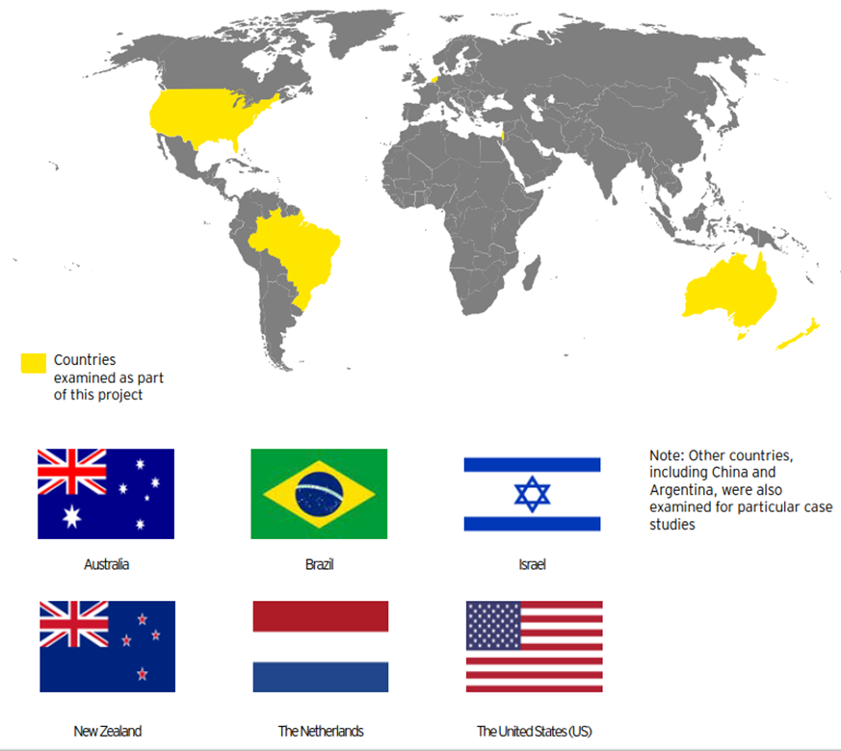

Figure Geographical locations of stakeholder consultations in Australia



A range of methods were applied as part of stakeholder consultations

* Over 290 stakeholder interviews performed
* 400 hours of stakeholder engagement
* 3 weeks of regional tours with industry participants
* 10 workshops across Australia’s capital cities
* 4 focus groups to explore key areas of opportunity

This resulted in a wide range of comments and observations from stakeholder consultations into high-level and actionable insights

* Participants shared over 12,000 observations
* More than 85 participant insights: key themes were workshopped across user groups to draw insights

### 1.2. Introduction to Australian agriculture

Australia’s agricultural sector is a critical contributor to economic, social and environmental wellbeing in Australia and around the world

#### The agricultural sector plays a crucial role in supplying our nation and global trading partners with essential products

##### The Australian agricultural sector creates a diverse range of outputs

Australian agriculture generates products that support the lives of Australians and our export partners. Our unique physical environment and climate enable Australian agriculture to produce a large variety of primary products that are crucial to providing food and fibre, both locally and abroad (including trading partners, such as the US, China and Japan). The agricultural sector produces a diverse range of commodities, including food for consumption, fibre for clothing, forestry and wood products for construction and other value-adding processes (for example, paper for businesses and households). As such, consumers have multiple daily touchpoints with agricultural products and rely on such products to live happy, healthy lives.

##### Australian agricultural products are positioned as premium, reliable, safe, clean and green by our trading partners

Globally, there is growing demand for Australian food and fibre products, driven by growing wealth and a rising middle class in developing countries. We have strong biosecurity controls and food safety standards, which contribute to Australia's reputation for premium, reliable, safe, clean and green agricultural products (Daly et al. 2015). Such a reputation has attracted key export partners with rising middle classes, such as India and China, to our outputs. Consumers in these economies and throughout the world have unprecedented access to information surrounding the safety, quality, provenance and sustainability of food sourcing and production. Notably, consumers are increasingly expecting robust traceability that verifies product integrity throughout the supply chain. Consumers have more options to satisfy their preferences and have greater means and willingness to pay for high-end agricultural products.

#### The Australian agricultural sector generates significant, renewable value for our economy

##### Agriculture serves as a cornerstone of the Australian economy

Agriculture is a pillar of our economy, directly employing 304,200 people in 2016-17 (National Famers’ Federation 2017). We are a net exporter of agricultural products, and will continue to have an increasingly important role to play, given our proximity to expanding Asian markets. The Australian agriculture industry has grown in value to $60 billion-a-year (DAWR 2018) and agricultural production accounted for approximately 2.7% of Australia’s GDP in 2016-17 (ABARES 2018). However, this does not reflect broader economic benefits, which have been estimated at $800 billion (Rural R&D Corporations 2018). These broader economic benefits arise because Australia’s food and fibre production sector sits within and provides a base for much larger and diverse value chains, which encompass ecological, sociological, economic and production elements (Rural R&D Corporations 2018).

##### Australian agriculture has achieved significant export growth

Approximately two‑thirds of the total value of agricultural production is now exported, accounting for approximately 17% of total Australian exports in 2016–17 (Thirlwell 2017). In 2016, the value of Australia's agriculture exports was $44.7 billion, which accounted for approximately 14% of Australia's total goods and services exports (World Trade Organisation 2019). The nature of the products exported has also become more diverse, with less reliance on traditional commodities, and an increasing focus on processed products, such as wine.

#### The sector is essential to creating positive community and social impact

##### Provision of income to regions across Australia

Agricultural activities support income production in rural regions of Australia, utilising the resources naturally available in these parts. In 2016–17, the Australian agricultural supply chain, which includes the affiliated food and fibre industries, created approximately 1.6 million jobs for the Australian economy, creating employment opportunities and support services for agricultural supply chain participants in these rural communities (National Farmers’ Federation 2017). During this period, there were 304,200 people directly employed in Australian agriculture (National Farmers’ Federation 2017).

##### Agriculture delivers flow on benefits to rural communities

The agricultural sector is not limited to the production of food and fibre products and delivers additional benefits to rural communities. It is recognised that rural landscapes deliver more value than only production of food and fibre products. Some communities have diversified into farm-based tourism (Lockie 2015). The agricultural sector is contributing not only to tourism for the rural community but also allowing for technical tours for overseas stakeholders, such as farmers and researchers, incorporating product sampling and being able to purchase straight from the source as part of the experience (Lockie 2015).

#### Food and fibre industries contribute to the preservation of Australia’s natural resources for future generations

##### Sustainable practices to protect the longevity of the industry and production

With 59% of our landmass occupied by agriculture (ABARES 2010), Australia’s agricultural sector forms the fabric of our national identity. Agricultural industries use the environment as a key input and therefore, have a critical interest in the preservation of natural resources, including soil, water and air quality. The agricultural sector has a unique responsibility to maintain the environment, and has demonstrated ownership of this responsibility with 94% of Australian farmers actively undertaking natural resource management (National Farmers’ Federation 2018). With the pressures of climate change and climate variability and the increased pressure on the agricultural sector to mitigate greenhouse gas (GHG) emissions (explored further in Section 3.1.2), the industry is preparing itself for potential disruption and the need to change to meet these challenges. These issues could challenge Australia to change the way it operates in the agricultural sector, such as production locations to deal with the increasing variability of the climate. Sustainable practices by participants along the supply chain is vital to maintain the long-term viability of the industry, and the Australian agricultural sector is contributing to reduce its impacts on the environment as evidenced through the 63% reduction in greenhouse gas emissions intensity from Australian agriculture between 1996-2016 (National Farmers’ Federation 2018).

#### Overview of our sector

Key statistics:

* 1.6 million people employed across the agricultural supply chain (National Famers’ Federation 2017)
* 304,200 people employed in Australian agricultural in 2016-17 (National Farmers’ Federation 2017)
* 59% our landmass is occupied by agriculture (ABARES 2010)

Gross value (2017-18) of farm, fisheries and forestry production (ABARES 2017)

* $12,828m of crops (grains, oilseeds and pulses)
* $9,826m of horticulture
* $2,275m of forestry
* $5,674m of industrial crops (cotton, sugar cane, wine grapes)
* $8,642m of livestock products
* $22,606m of livestock (slaughtering, live exports)
* $3,000m of fisheries products

The sector is essential to creating positive community and social impact

* Our sector feeds 60 million of the global population (University of Queensland 2016)
* 94% of Australian farmers are actively undertaking natural resource management (National Farmers’ Federation 2017)

Agriculture serves as a cornerstone of the Australian economy

* $600b a year industry (DAWR 2018)
* $800b all across the value chain (Rural R&D Corporations 2018)
* 34% increase in output value (from $49 billion in 1998-99 to $66 billion in 2017-18) (ABARES 2018)
* 2.7% of Australia’s GDP is generated by Australian agriculture in 2016-17 (ABARES 2018)

## Australian agricultural innovation

### 2.1. A snapshot of existing agricultural innovation: Historical view of developments

The Australian agricultural sector has seen a rise in gross product value over multiple decades; increasing from $17 billion in 1974-75 to $42 billion in 2017-18 (ABARES 2018) (Figure 2). Across this period, significant changes have taken place that affected research, development and extension (RD&E). In the late 80’s and early 90’s, the first RDCs were established, and the Cooperative Research Centres (CRC) program was introduced to develop industry-led and outcome-focused collaborative research partnerships. The RDCs are a joint model of government and industry funding (levy payers), and manage the investments in RD&E for agricultural commodities. The National Primary Industries Research, Development and Extension Framework (NPIRDE Framework) was introduced in 2005 to promote collaboration and continuous improvement in the investment of RD&E. More recently, there have been greater public and private investments into precincts for agriculture development, such as Agribio, and investments into strategies that aim to shape the industry’s direction, such as National Farmers’ Federation’s (NFF) 2030 Roadmap.

Figure Australia Agriculture gross product value 1977 – 2018 using chain volume measure (ABARES 2018)*

Note: *Chain volume measure = a constant price estimate that is used by the Australian Bureau of Statistics to measure GDP

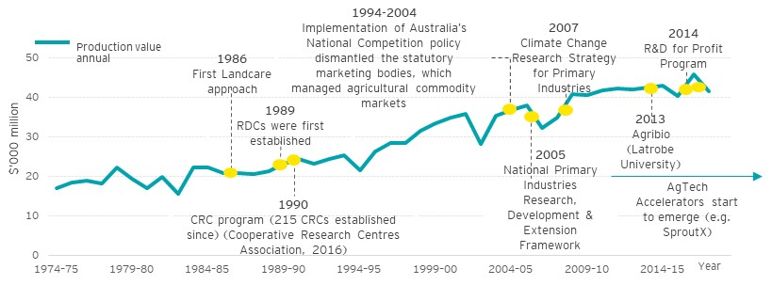

### 2.2. Current state of Australian agricultural innovation

#### 2.2.1 Key organisations involved in agricultural innovation

Australian agricultural innovation encompasses the knowledge, practices, institutions and policies required to innovate within the agricultural value chain. This is comprised of numerous organisations with diverse roles and responsibilities. Specifically, there are currently 15 government-funded RDCs that are funded through R&D levy payments and Commonwealth Government funding arrangements (ABARES, 2017). Other research and extension organisations include four agriculture and four food CRCs, universities and other education providers, and numerous organisations within the private sector (for example, Australian Farm Institute (AFI), Australian Export Grains Innovation Centre), producers, processors and others within the agricultural value chain.

End users of agricultural innovation are typically participants within the agricultural value chain. Innovation extends to the education and finance sectors, as human and financial capital act as important inputs for innovation. Figure 3 illustrates the range of players within existing Australian agriculture innovation - please refer to Appendix B for the definitions and explanations of agents and groups.

Figure Overview the current Australian agricultural innovation landscape (Food and Agriculture Organisation of the United States 2019)

Note: Some organisations displayed in the figure perform multiple roles

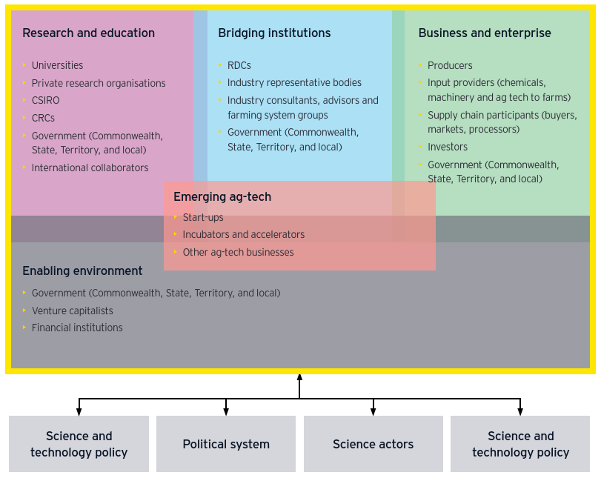

Australian agricultural innovation was not designed as a cohesive system that facilitates or encourages participants to work towards goals or challenges such as resource efficiency or soil health. It does not have an overarching, shared purpose or strong coordination to unite participants. As such, the current innovation system is referred to as ‘Australian agricultural innovation’ throughout this report. Examples of such complexity and variation across different parameters include:

* Strategy and objectives: Different organisations generally develop strategies independently from one another, to drive the agricultural innovation sector forward. As a result, there are variations in the aim and focus of these strategies, as well as the timeframe for such strategies to be executed
* Measuring performance: Impact of innovation is measured in a range of different ways without standardised processes, such that different measurements and criteria are used. This contributes to the difficulty in specifying the value delivered by innovation
* Environments: Innovators in agriculture operate in a wide range of environmental conditions, including natural, infrastructure, partnerships, capacity and capability to innovate. These variations are factors in the success of these organisations, to innovate, collaborate and have impact
* Levy payments: Levies are collected for specific agricultural products (for example, cotton, sugar, pork, and eggs). As such, a farm that produces multiple products will pay levies for the different products
* Practices and decision making: Practices and decision-making often varies across different stakeholder groups. For example, start-ups may to use design thinking and agile lean methodologies, while RDCs and universities may employ a project-based approach
* Roles and responsibilities: Different stakeholder groups within Australian agricultural innovation often play multiple roles. The lack of well-defined roles, responsibilities and accountabilities can contribute to duplication in effort and lack of coordination across innovation in the Australian agricultural sector
* Funding: There are a diverse range of funding sources available for innovation, including public (for example, Federal, State and Local Government) and private (including direct investment, levies, institutional, venture capital (VC)) funding. Each of these brings with it a unique set of obligations and expectations, which influences the nature of innovation that is conducted
* Expectations for R&D projects: Different stakeholders have different expectations on the returns delivered by R&D projects. For example, levy payers may expect their payments to result in short-term returns, which can sometimes take priority over solutions that could provide greater benefits in the longer term.

Roles and responsibilities across agricultural innovation have evolved over time. For example, in the early 90’s, the RDCs and the CRC program were introduced to develop industry-led and outcome-focused collaborative research partnerships. The role of Commonwealth, State and Territory Governments has also changed over time, particularly regarding extension. Specifically, the Commonwealth Government provides the majority of public funding for extension (which has increased from $76 million in 2005–06 to $104 million in 2014–15, in real terms (ABARES 2017)). State and Territory Governments have changed their role in extension, by targeting investments according to the RD&E framework. This resulted in a reduction in funding for extension (which has declined in real terms from $61 million in 2005–06 to $41 million in 2014–15 (ABARES 2017)).

More recently, new approaches to innovation have begun to emerge throughout Australia. One example is the development of precincts, which are a geographic clustering of innovation activity. Figure 4 illustrates examples of innovation precincts that exist across Australia. New entrants and investors have emerged in agricultural technology (AgTech), with approximately 300 AgTech and food technology (foodtech) companies operating in Australia (National Farmers’ Federation 2030). Recent Australian start-ups have found success in tracking and using agronomical data, blockchain technology for supply chain solutions, and farm management software. While Australia’s venture capital market has expanded substantially in recent years, doubling in total size from 2016 to 2017 (United States Studies Centre 2018), our AgTech market is still very much in its infancy stages when compared to other countries, such as the US or Israel (Australian Farm Institute 2018).

Key statistics:

* $24 million raised in 2018 by Australian AgTech start-ups; AgriDigital, Blockchain and AgriWebb (Smartcompany 2018)
* $10 million start-up fund (SproutX) launched with national AgTech precinct in 2016 (Smartcompany 2018)

Figure Examples of Australian innovation precincts

Note: This graphic is designed to give an example of some Australian precincts, it is not a comprehensive list.

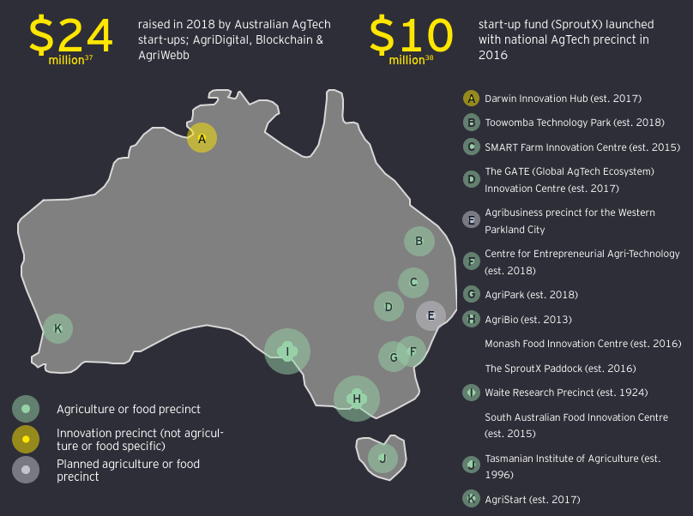

#### 2.2.2 Funding arrangements for Australian agricultural innovation

Agricultural innovation in Australia is funded both publicly and privately. It is estimated that the annual funding for 2014-15 was $3.3 billion, which included $316 million for extension (Millist, Chancellor & Jackson 2017). Figure 5 provides a breakdown of public and private expenditure during this period.

Figure Value of rural R&D funding in 2014-15 (Millist, Chancellor & Jackson 2017)

Note 1: Rural R&D funding excluding extension was measured in real terms. Extension funding during the same period was measured in nominal terms

Note 2: $206m Commonwealth Government contribution to RDCs refer to the total match funding

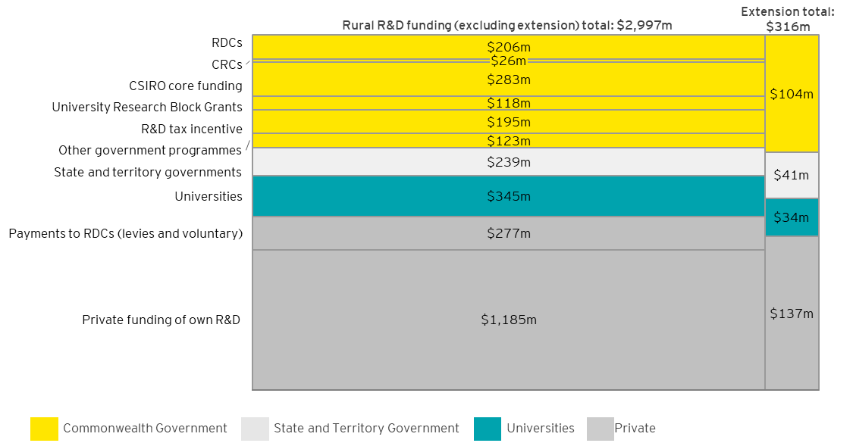

#### 2.2.3 Strategies of Australian agricultural innovation

Agricultural innovation is not static - multiple strategies have been developed by different organisations to drive the agricultural innovation sector forward. Some of the key strategies, outlining priorities and opportunities for the future include:

#### National Farmers' Federation: The Voice of Australian Farmers (National Farmers’ Federation 2018) and 2030 Roadmap (National Farmers’ Federation 2018)

Vision: To exceed $100 billion in farm gate output by 2030

* Pillar 1: Customers and the value chain
* Pillar 2: Growing sustainability
* Pillar 3: Unlocking innovation
  + Public and private R&D efforts work seamlessly to translate world-class research into tools and services which give Australian agriculture a competitive edge
  + The agricultural value chain is highly digitised, with the benefits of new technology shared fairly among participants
  + The agricultural value chain has reduced its reliance on fossil fuels, in favour of biofuels and renewable sources of electricity that are affordable and reliable
* Pillar 4: People and communities
* Pillar 5: Capital and risk management. This will require industry collaboration:
  + The NFF family: Including state farming organisations, commodity groups and partner organisations
  + Value chain partners: Transporters, processors, input providers, investors, retailers, and others in the agricultural value chain
  + Community: The Australian and global community
  + Education and training providers: Schools, higher and vocational educational providers, leadership and professional development bodies
  + Research and extension bodies: Corporations, universities, government research & extension agencies, grower groups, and technical advisers
  + Farm businesses: Individual farmers and farm businesses
  + Government: Federal, State, Territory and local governments

#### CSIRO: Australia's innovation catalyst CSIRO Strategy 2020 (CSIRO 2015)

Vision: Australia’s innovation catalyst, collaborating to boost Australia’s innovation performance

Mission: Create benefit for Australia through impactful science and innovation

Strategic actions:

* Customer first: Create deeper innovation relationships with our customers and prioritise the highest value investments
* Global outlook, national benefit: Deliver connectivity to the global science, technology and innovation frontier as well as access new markets for Australian innovation
* Collaboration hub: Integrate the best solutions for our customers, increase our flexibility and enhance Australia’s innovation performance
* Breakthrough innovation: Increase our capacity to help reinvent existing industries and create new industries for Australia and deliver public good
* Excellent science: Create breakthrough technology and knowledge and be a trusted advisor for Australia
* Health, safety and environment: Enhance staff safety and wellbeing and further our aspiration towards zero harm
* Inclusion, trust and respect: Fully enable and support the innovation capacity of our creative people and teams to create risk and deliver to customers
* Deliver on commitments: Enhance our agility, financial sustainability and capacity to respond at the speed of business

#### Council of Rural R&D Corporations: Vision 2050 (Rural R&D Corporations 2018)

Vision: Rural R&D Corporations’ vision is of flourishing agriculture, fisheries and forestry industries underpinning a thriving agrisystem. Driving future success is a globally-connected, highly effective and dynamic knowledge and innovation ecosystem

Recommendations:

* Develop and implement a national framework to drive a globally-connected, high performing and effective knowledge and innovation ecosystem
* Develop and implement a national, integrated, whole-of-government strategy for an enhanced agrisystem
* Detailed analysis of the agrisystem and of Australia’s involvement in global agrisystem value chains, to identify opportunities for intervention and improvement

#### The Australian Academy of Science: Decadal plan for Australian Agricultural Sciences (2017–26) (Australian Academy of Science 2017)

The Australian Academy of Science’s plan outlines strategies to improve the strength and efficiency of agricultural research in Australia in ways that will increase the ability of governments and producers to maintain productivity and efficiency in the face of evolving natural challenges.

Recommendations:

* The Australian Government establish a national agricultural research translation and commercialisation fund, to invest in promising agricultural discoveries and fast-track their commercialisation into new and improved Australian products and services in domestic and international markets. It is suggested that this fund be modelled on the Biomedical Translation Fund; selecting appropriately qualified and experienced fund managers to stimulate private sector investment at the early stage of agricultural research translation
* The academic, industry and government sectors partner to create a doctoral training and early career support centre for the agricultural sciences
* The agricultural research community engage strongly with infrastructure planning processes at all levels to enable agricultural research to benefit from, and contribute to, shared national capabilities, including emerging data-infrastructure and maintaining the pool of skilled technicians that unlock value from national infrastructure capability
* The Australian Government consider reviewing and updating arrangements for national coordination of agricultural research and innovation in Australia. One option would be to establish an organisation that provides a central point of coordination for agricultural research and its applications
* All organisations in the agricultural sector do more to understand and effectively engage with the public on social acceptance of agricultural science and the enterprises it supports. This also applies to understanding that agriculture reaches far beyond the farm gate

#### Innovation and Science Australia: Australia 2030: Prosperity through Innovation (Innovation and Science Australia 2017)

Vision: Innovation and Science Australia’s vision for 2030 is that Australia will be counted within the top tier of innovation nations. We will take pride in our global reputation for excellence in science, research and commercialisation.

Five imperatives are set out:

* Education: Respond to the changing nature of work by equipping all Australians with skills relevant to 2030
* Industry: Ensure Australia’s ongoing prosperity by stimulating high-growth firms and raising productivity
* Government: Become a catalyst for innovation and be recognised as a global leader in innovative service delivery
* Research & Development: Improve R&D effectiveness by increasing translation and commercialisation of research
* Culture & Ambition: Enhance the national culture of innovation by launching ambitious National Missions

#### Led by Cotton Research and Development Corporation (CRDC): Accelerating Precision Agriculture to Decision Agriculture – Enabling digital agriculture in Australia (CRDC 2017)

The Precision to Decision project detailed 13 recommendations to achieve the future state of digital agriculture in Australia:

* Develop a Data Management Policy for Australian Digital Agriculture
* Develop a voluntary Data Management Code of Practice and a Data Management Certification or Accreditation Scheme
* Policy and investment to improve telecommunications to farms and rural businesses
* New investment models including public/private investment
* RDCs develop Digital Agricultural Strategy’s and implementation roadmap
* Big Data Reference Architecture and Data Management Implementation Plan
* Establish, review, and refine foundational data sets
* Establish a Digital Agriculture Taskforce for Australia headed by the Chief Digital Agricultural officer – to deliver outcomes
* Establish a Digital Agriculture Taskforce for Australia Working Group – to provide guidance
* Provide education and capacity building to increase digital literacy in the agricultural sector
* Establish baseline patterns of data usage and a national mobile network coverage database
* Digitalise and automate data collection including for regulatory compliance activities
* Execute a cross-industry survey every three years to identify producers’ needs and issues in digital agriculture

### 2.3 The impact delivered by agricultural innovation includes agriculture productivity growth, economic and social benefits

* In 2014-15 annual funding for rural RD&E was $3.3 billion — $3 billion of this was for rural R&D and $316 million for extension (Millist, Chancellor & Jackson 2017). Just over half (52%) of the RD&E funding was provided by the public sector, namely the Commonwealth, State and Territory Governments and universities (Sheng et al. 2011). For every dollar the government invests in agriculture RD&E there is a $12 return on investment over 10 years (Sheng et al. 2011). Benefits include broader economic, environmental and social benefits, such as reduction of chemical usage
* Since inception in 1991, the CRC program, with approximately a quarter of the CRCs (of the 215) being in agriculture, provided the sector with economic benefits of $237 million annually (Allen Consulting Group 2012). Between 1991-92 and 2009-10, an estimated 2,200 research postgraduate degrees were supported through CRCs in the agricultural sector
* 2016-17 saw the emergence of Australian AgTech start-ups and entrepreneurs. New players emerged within agricultural innovation and the market experienced an increase in investment. As of 2018, there are approximately 300 AgTech and foodtech companies operating in Australia (National Farmers’ Federation 2018). The impact of this trend is further elaborated on in Section 3
* Australia has achieved strong biosecurity controls that protect our agriculture industry, environment and community from pests and diseases. Ongoing initiatives such as the $25.2m Biosecurity Innovation Program will invest into ongoing research of new technologies and approach to support our national biosecurity system in a changing environment (DAWR 2019). Our biosecurity controls aim to anticipate, detect and prevent biosecurity risks. This is a strong contributor to ongoing market access to many of our international partners and prevents loss of income that would have occurred if there was a biosecurity incident (annual broadacre farm profits of $12,000 to $17,500) (Hafi et al. 2015)
* $12 return is generated by farmers for every dollar the Government invests in agricultural R&D over a 10 year period (ABARES 2011)
* $12,000-17,500 farm profits attributed to biosecurity practice (Hafi et al. 2015)

#### Case study – Cotton industry (Cotton Seed Distributions 2007) (CSIRO 2015)

The cotton industry is a significant contributor to the agricultural sector, with exports in 2016–17 worth $1.8 billion. However, cotton crops are vulnerable and threatened by weather extremes, disease, and insect pests.

##### Solution

Cotton Breeding Australia is a joint venture that was formed between Commonwealth Scientific and Industrial Research Organisation (CSIRO) Plant Industry and Cotton Seed Distributors Ltd in 2007. This joint venture funded cotton breeding and targeted research for a 10-year initial term, and brought about the introduction of insect resistant traits, developed by Monsanto, into cotton varieties bred especially for Australian conditions.

##### Impact

This joint venture yielded an estimated 80:1 return on investment. Benefits of over $379.5 million are projected over the next decade through further increases in yield productivity and the development of higher grade cotton products. These have reduced Australian insecticide use by at least 85% and herbicide use by 52%.

### 2.4. Stakeholder consultations highlighted six key strengths of our existing agricultural innovation

#### Leading research

Our research institutions produce leading research outcomes for agriculture. CSIRO, CRCs and a number of universities have been credited by stakeholders as generating fundamental research outcomes for the agriculture industry. Australia ranks well amongst Organisation for Economic Co-operation and Development (OECD) nations on measures relating to academic research (OECD 2017).

Supporting quote from stakeholders: “Australian research in agriculture is well respected internationally”

#### Interest in innovation at farm-gate

Many Australian farmers are generally interested in adopting innovative practices and technologies, provided they are aware of and are able to tangibly understand associated benefits. This willingness to change will be essential in the future as emerging technologies play an increasingly prominent role in production.

Supporting quote from stakeholders: “There is a keenness to use technology to create efficiencies and create better income despite it being a family small business”

#### Emerging innovation precincts

Over the past decades, several innovation precincts have emerged, focusing on technologies, food and agriculture. These are predominantly articulated around universities, research centres, existing labs or key industry players. They provide a central point for innovation participants to network, share resources and collaborate, and are innovating at a deep level of specialisation which is attracting attention from international systems.

Supporting quote from stakeholders: “The innovation precinct was one of the main reasons we located our business there. It helped us to get on our feet and our first commercial successes were in that area”

#### A skilled population

We have an educated population, ranking seventh in the world for tertiary education attainment (Department of Industry, Innovation and Science 2017). We are seeing more talented people with skills such as digital capabilities, researchers in areas such as health, and engineering come through the ranks, which will be important to our agriculture innovation system. This is reflected in the fact that many Australian universities have risen in global rankings over the past decade.

Supporting quote from stakeholders: “Australia has no lack of resources (hard or soft) to deliver on a vision – we have the talent”

#### Unique RD&E models

We have unique RD&E investment models:

* The RDC co-investment, levy based model
* The Nuffield scholarship promotes excellence in Australian agricultural sector and knowledge transfer across industries and countries
* The effective government programs, such as R&D for Profit with its focus on driving collaboration, productivity and profitability

This diverse and distinct model has gained positive recognition for agricultural innovation globally.

Supporting quote from stakeholders: “We have great programs like the Nuffield scholarship, which transfers knowledge across industries”

#### A steady stream of funding

Agricultural innovation has benefited from a steady stream of R&D investment in recent decades that has improved productivity. Agricultural innovation has delivered positive outcomes equivalent to a return of $12 for every $1 dollar invested over a 10-year time period (ABARES 2011). This ongoing security of funding has been at the core of the growth of Australia’s agricultural sector.

Supporting quote from stakeholders: “The RDC model has been a world leading solution to drive funding into the industry that would not otherwise exist, and has assisted farmers to identify ways to increase yields while reducing costs”

### Overview of Australian agricultural innovation

Key statistics on research and education:

* 5 Australian universities ranked in the top 50 in the world for Agriculture and Forestry (QS World University 2018)
* $6.15b of economic benefits to agricultural sector by CRCs since 1991 (Allen Consulting Group 2012)
* CSIRO is ranked in the top 1% of global research institutions in 14 out of 22 research fields, and in the top 0.1% in four research fields (CSIRO 2018)

Key statistics on emerging AgTech:

* 300 AgTech or foodtech companies in Australia (National Farmers’ Federation 2018)
* Total amount of VC sourced capital deployed in Australian AgTech in 2017 was $6.5m (United States Studies Centre 2018)

Key statistics on business and enterprise:

* 91 agricultural related patents in 2017 (Australian Government, IP Australia 2018)
* $3.3b was invested in RD&E in 2014-15 (ABARES 2018)
* Funding by private sector for own R&D was $1.3b (ABARES 2018)

Key statistics on bridging institutions:

* 15 rural research and development corporations (ABARES 2018)
* 38% of RDCs’ expenditure against the rural R&D priorities is accounted for by productivity and value adding activities, followed by supply chain and markets (18%), and natural resource management (10%) (ABARES 2017)

Estimates of rural RD&E funding by source, 2014-15 (ABARES 2017):

* Private sector funding of own R&D accounted for 38% of rural RD&E funding, followed by contributions from universities (11%), and private sector payments to RDCs (levies and voluntary) (10%)

## Is there a need for change?

Will Australian agricultural innovation continue to work well in the future?

As discussed in Section 2, Australian agricultural innovation has delivered many benefits over the last 50 years, including strong productivity growth. Agricultural innovation is currently characterised by excellent research capabilities, a diverse commodity base, stable and recurring funding, the unique RDC model, a globally recognised science organisation, respected universities and the emergence of the start-up sector, and a long history of farmers who innovate to solve problems.

Looking to the future, there is opportunity for Australian agricultural innovation to modernise and achieve greater and more diverse outcomes from investment in innovation, to adopt a more coordinated approach to respond to future opportunities, threats and trends and to better position Australia as a globally relevant agricultural innovation system.

Considerations for the future have been identified with insights obtained across four key areas of research:

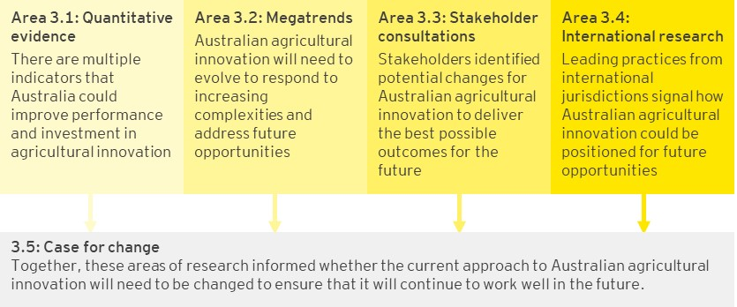

### 3.1 There are multiple indicators that Australia could improve performance and investment in agricultural innovation

As discussed in Section 2, Australian agricultural innovation today has contributed greatly to Australia’s agricultural sector, with strong productivity growth over the last 50 years attributed to investment in agricultural innovation.

However, a comparison with other countries reveals a clear opportunity for Australia to further improve performance and investment in agricultural innovation:

* There is an opportunity to improve the impact and efficiency of investment in Australian agricultural innovation
* Australian agricultural innovation does not have a strong presence internationally
* The innovation culture in Australian agriculture lags behind those in other countries, with limited opportunities to leverage international innovation and slow diffusion of such technologies in Australia
* Australia has insufficient investment into agricultural innovation compared to other countries

#### 3.1.1 There is an opportunity to improve the impact and efficiency of investment in Australian agricultural innovation

##### While Australia ranks 31st in the world for innovation outputs, it is ranked 76th for innovation efficiency

There is strong potential for Australia to further benefit from its research by improving pathways for researchers to create commercial outcomes. On the Global Innovation Index, Australia is ranked 20th overall, 31st for innovation outputs and only 76th in the world for innovation efficiency (defined as output per input based on turning research into commercial outcomes) (Cornell University, INSEAD & World Intellectual Property Organisation, 2018).

##### There is a lack of comparable metrics to assess the performance of agricultural innovation

It was identified that there is a lack of comparability of metrics when measuring the performance of innovation against international benchmarks. The measures identified considered:

* varying investment sources: RDC, government or total public and private investment return
* varying time horizons: 10, 25, 30, 40 and 50-year periods were identified
* varying benefits considered: return on investment, economic, social or environmental benefits considered

In addition, performance measures identified in Australia are generally not consistently tracked over time. Different measures were used by the Council of R&D Corporations in 2010 and 2018, limiting the ability to track performance overtime. The future system should have standardised measures across the nation in order to benchmark performance against leading practice and highlight possible areas of improvement.

Table Investment in agricultural innovation

| **Investment source** | **Australian RDC investment (Council of Rural R&D Corporations 2018)** | **Australian RDC investment (Council of Rural R&D Corporations Chairs 2010)** | **Australian Government investment (Bettles 2017)** | **US Public agricultural research (Heisey & Fuglie 2007)** | **US Public agricultural research and extension (Alston et al. 2009)** |
| --- | --- | --- | --- | --- | --- |
| Results | 4.5:1 | 10.5:1 | 12:1 | 10:1 | 21:1 |
| Measures | Return on investment | Return on investment | Return to farmers | Return of benefits to the economy | Benefit cost ratio |
| Time horizon | 30 years | 25 years | 10 years | 40 years | 50 years |

#### Australia could benefit from a more diverse range of innovation outcomes, enabling Australian agricultural innovation to have greater positive environmental and social impact

There are unclear and fragmented objectives for agricultural innovation, with a bias towards Return On Investment (ROI) at an institutional level, giving limited priority to social and environmental outcomes. Australia should examine and measure a range of innovation outcomes including economic, social and environmental impacts to have a complete picture of the benefits delivered through innovation

#### Productivity growth of the Australian agricultural sector has slowed down in recent years

The Australian agricultural sector has experienced an upward trend in multifactor productivity over the period between 1989 and 2017. However, this growth has slowed in recent years. The strong consistent growth experienced from 1989 to 2005, averaging 4.2% year-on-year, was followed by relatively stagnant growth since 2005, with an average of 0.7% year-on-year.

Figure Gross Value Added based on Multifactor Productivity Index 1989-2017 (ABARES 2018)

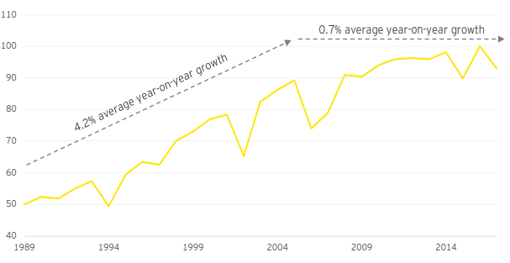

#### 3.1.2 Australian agricultural innovation does not have a strong presence internationally

##### Australian agricultural innovation has limited international focus

Historically, Australian innovation does not generally target international markets. Instead, the focus has primarily been on the Australian market. Limited Australian innovations and technologies have been successfully commercialised in other countries. As a point of comparison, in 2017, the Netherlands exported over €91.7 billion (~AU$146 billion) worth of agriculture-related goods, such as farm machinery, chemical fertilisers and plant protection products (Government of the Netherlands 2018). Significant growth in international markets presents an opportunity for the Australian agricultural sector.

##### A limited number of global agricultural companies chose to set up their R&D operations in Australia

Many global agricultural companies have chosen to set up their R&D operations in countries other than Australia. The Netherlands boasts more than 5,300 companies in the agrifood sector, and is home to the major production or R&D sites of 12 of the world’s largest agrifood companies (Netherlands Foreign Investment Agency 2018). Similarly, Israel has successfully attracted over 500 multinationals onshore, and the number of multinationals investing in agricultural innovation in Brazil continues to grow.

##### Australia has built a limited number of international scientific collaborations compared to other countries

As shown in Figure 7, international cooperation and collaboration on publications and patenting for Australia is below the OECD average. Differing priorities, cultures and objectives have limited incentives for international players to engage with Australia. This is coupled with additional structural factors, such as lower return on investment and the lack of scalable opportunities.

Figure International scientific collaboration on innovation, 2012 (World Economic Forum 2013)

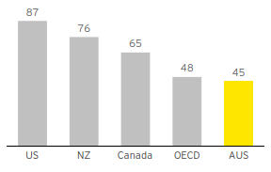

#### 3.1.3 The innovation culture in Australian agriculture lags behind those in other countries

##### The innovation culture in Australia is hindered by its relatively low risk and failure tolerance

A survey of entrepreneurs by the World Economic Forum found that on the pillar of ‘cultural support’ for entrepreneurial ecosystems, only 29% of Australian entrepreneurs believed that ‘cultural support’ was readily available in their region, compared to 75% for the US (World Economic Forum 2013). The cultural support pillar considered components such as tolerance of risk and failure, preference for self-employment, success stories or role models, research culture, positive image of entrepreneurship and celebration of innovation. The survey shows that Australia faces a gap in encouraging a culture of both entrepreneurship and risk taking when compared to other countries.

##### Australia is also facing challenges in developing, attracting and retaining the best talent

The Australian university sector has seen a decline in the number of graduates in agriculture-related degrees (including agricultural sciences, animal sciences, horticulture and viticulture, and agribusiness) from 1,300 in 2001 to approximately 550 in 2014 (Pratley 2016). Participation in science, technology, engineering and mathematics (STEM) subjects in Australian schools is also declining and currently at the lowest level in 20 years (Wood 2017).

##### Collaboration amongst participants in Australian agricultural innovation is lower compared to that in other countries’ agricultural innovation systems

Collaboration is a key success factor for innovation. This includes cross-organisation and cross-sector collaboration, as well as collaboration with international parties. Compared to other countries, such as the Netherlands or New Zealand, Australia sees limited levels of collaboration and is ranked the lowest of all OECD countries on collaboration between industry and research (OECD 2017). In 2010-13, only 3% of Australian innovation-active firms source their ideas from the research sector.

Figure Firms collaborating on innovation with higher education or research institutions 2010-13 (OECD 2017)

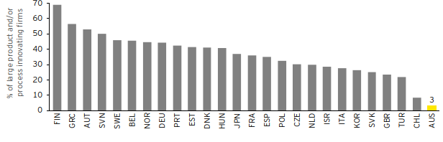

#### 3.1.4 Australia has insufficient investment in agricultural innovation compared to other countries

##### Australia is underinvesting in agricultural innovation compared to other countries

While Australia has grown its investment in agricultural innovation, the potential for further growth is evident when compared to other countries, such as the US, Canada and other European countries. There is an opportunity for greater Venture Capital (VC) investment, with Australia being in the lowest third of OECD nations in terms of VC investments as a proportion of GDP (United States Studies Centre 2018).

##### Private capital investment into large scale transformation is insufficient to benefit the broader industry

Private sector investment is still limited in Australia. The majority of growth in private capital over the last 10 years has come from firms investing in their own R&D. In addition, the majority of investments in 2017 were distributed towards small, short-term projects, hindering transformative agricultural programs. Eighty-five percent of all investments were less than $1 million (compared to 31% globally), with most being government grants and accelerator programs (Sheng et al. 2011).

##### VC investment per capita is lagging behind that of other countries. A gap between research and commercialisation exists in Australian agricultural innovation

VC firms and corporate investors, who typically deploy higher level of financing to support large-scale investments, have been relatively small in the Australian market given difficulties experienced in translating ideas into commercial outcomes. Stakeholders have identified that this gap is due to lack of investor support provided to start-ups in the pre-seed and seed phases, which inhibits the ability of start-ups to scale their business. VC investment per capita in AgTech in the US and Israel is 50 times higher than that in Australia, despite Australian agriculture contributing 2.7% of Australia’s total GDP (2016-17) (United States Studies Centre 2018), compared to 1.01% in the US and 1.17% in Israel (Sheng et al. 2011).

##### Given positive return on investment and the potential to improve the efficiency and impact of investment, Australian agricultural innovation could largely expand the size of the prize

Every dollar the Australian government invests today results in a $12 return on investment over 10 to 30 years, and estimates from Australian Bureau of Agricultural and Resource Economics (ABARES) suggest there is potential to generate an additional $1.98 billion in productivity over 10 years by utilising the same level of investment more effectively (Sheng et al. 2011). Currently, there are fragmented and incremental innovation efforts, which stem from private interests and short-term goals. This results in competing projects and duplication of efforts across the system. More coordinated efforts focused on transformational research and development could improve how investment is utilised in the future agricultural innovation system. In addition, increasing the level of actual investment though private capital or VC could generate significant uplift to the overall productivity.

Key statistics:

* VC investment per capita in the US compared to that in Australia is 50 times higher (United States Studies Centre 2018)
* Proportion of investment directed to larger scale projects (greater than $1 million) in Australia is 15% (compared to. 69% globally) (United States Studies Centre 2018)

### 3.2 Australian agricultural innovation will need to evolve to respond to new challenges and address future opportunities

Trend 1: Global demand for food and fibre products

* Population growth: 9.7 billion people to feed and clothe globally by 2050 (Food and Agriculture Organisation 2017)
* Increase in food and fibre demand: 70% increase in food production required to feed the global population by 2050 (Food and Agriculture Organisation 2017)
* Ageing population: population aged 80 or over will more than triple (Food and Agriculture Organisation 2017)
* Real world income is expected to increase threefold (Food and Agriculture Organisation 2017)

Trend 2: Increasing consumer expectations

* Increased focus on health and wellness benefits: 93% of consumers in the Asia-Pacific region would be willing to pay a premium for healthier food (The Nielsen Company 2015)
* Estimated decrease from ~37.5% to ~25% in dietary energy obtained from unhealthy food between 2000 and 2030 (CSIRO 2030)

Trend 3: Increasing competition for natural resources

* Decrease in productive land: 12 million hectares of land lost annually to desertification and urbanisation (United Nations 2019)
* Increase in water use: Estimated to be ~20% higher in agriculture by 2050 (Global Agriculture 2019), with increased production resulting in greater demand for water
* Currently farming accounts for almost 70% of global water withdrawals and up to 95% in certain developing countries (Food and Agriculture Organization of the United Nations 2017)

Trend 4: Increased variability and volatility

* Increase in temperatures by 2070: 1.0-2.5 °C in Australia (CSIRO 2019)
* Climate variability: Altered precipitation patterns, extended heat waves, and elevated frequency and severity of extreme weather events (for example, bushfires, flood and droughts) (CSIRO 2019)
* Global threat of pests and diseases: ~20-40% of global crop yields lost annually to crop and plant pests (Food and Agriculture Organisation 2017)

Trend 5: Embrace non-traditional players

* Increase in multinational in-house R&D in Australian agriculture: Bayer and John Deere invested €4.5 billion101 and ~$2 billion in R&D102 respectively in 2017
* Growing AgTech investment: 76% increase in the amount of funding deals in Australia (AgFunder 2017)
* New entrants into agriculture, such as technology players and start-ups

Trend 6: Digital disruption

* Digital agriculture has significant benefit; $20.3 billion potential increase in gross value of production by 2050 (CRDC 2017)
* More prominence of artificial intelligence (AI) in agriculture: 24% Compound Annual Growth Rate (CAGR) of AI in agriculture by 2024 (Energias Market Research 2017)
* Cross sectoral automation benefits are significant: ~$7 billion (EY 2018)

Implications for trends 1 and 2

The average productivity growth rate realised from agricultural innovation has been decreasing since 2005. There are opportunities for Australia to meet the growing global demand for food and fibre products and to maintain or improve our exporter ranking.

Further, there is an opportunity to shift innovation focus towards new and premium products that meet changing consumer needs and their willingness to pay. In order to achieve this, greater understanding of customers and improved collaboration across the value chain is needed.

Key statistics on trends 1 and 2:

* 0.7% average productivity growth since 2005 year-on-year (ABARES 2018)
* 60m people are currently fed by Australian agriculture today (University of Queensland 2016)
* 14% of Australia’s total goods and services exports in 2016 came from agriculture (Department of Foreign Affairs and Trade 2019)
* 6/15 RDC strategies include a focus on consumer innovation

Implications for trends 3 and 4

The effects of climate change have amplified the need for resilient and adaptive farming practices. Innovating to respond to climate change will require a cohesive system effort.

Australia has an opportunity to be a leading global exporter of biosecurity practices. Maintaining our pest and disease status is fundamental to Australia’s ‘clean and green’ reputation, which will be increasingly valuable in a growing and highly competitive global market. Australia can leverage this reputation, in conjunction with a brand for food safety and robust traceability, to capitalise on export opportunities arising from growing global demand.

In order to realise these opportunities, greater collaboration and cohesion across agricultural innovation participants is critical.

Key statistics on trends 3 and 4:

* 2.2% of all employed people in Australia in 2018 worked in the agricultural industry (ABARES 2018)
* $121.6m in the 2018-19 Australian budget over five years to enhance Australia’s biosecurity system (DAWR 2018)
* 420,000 deaths annually caused by food contamination globally (WHO 2017)

Implications for trends 5 and 6

Increasing VC and multinational funding in agriculture will allow Australian agricultural innovation to leverage a more diverse source of capability to support the commercialisation and scale-up of start-ups. In order to attract greater VC and multinational funding, Australian agricultural innovation needs to target key partnerships, and incentivise greater participation from the private sector.

Australia has the opportunity to increase agricultural productivity through digital solutions. In order to achieve this, Australia will need to invest in enabling infrastructure, upskilling farmers with technology and increase the aggregation and accessibility of data.

* 80% of Australian investments in AgTech were less than A$1m, in 2018, with most being from government grants and accelerator programs (United States Studies Centre 2018)
* 61% of respondents to a survey conducted by the P2D project knew nothing at all or very little about on-farm telecommunications options (CRDC 2017)
* 43% of producer respondents to the P2D had little to no mobile coverage across the entire farm (CRDC 2017)

### 3.3 Stakeholder consultations have identified potential changes required for Australian agricultural innovation to deliver the best possible outcomes for the future

Stakeholders across the agricultural innovation value chain shared views on challenges experienced in the current state, and opportunities for the future Australian agricultural innovation system. These insights were summarised into nine key themes:

1. System coordination and integration: There is a need for greater coordination and integration across the innovation value chain to drive increased efficiency, and more consumer and end user focused solutions
2. Innovation culture: There is a need for a stronger innovation culture through a greater awareness and appetite for risk, support for entrepreneurship and encouraging diversity in the future system
3. Relevance on the world stage: Australia’s strong history of world-leading research and innovation is at risk as we slip from relevance on the world stage due to our lack of a clear value proposition, which is required to address the barriers of geographic isolation and a relatively small market on the global stage
4. Transformational and cross-commodity investment: Australian agricultural innovation has key strengths in incremental and commodity-focused R&D, but there is a gap in investment in transformational, cross-commodity and public good activities
5. Innovation capabilities: There is an opportunity to attract diverse talent and improve our commercialisation focus to enhance our innovation capabilities and outputs
6. Innovation infrastructure: There is an opportunity to better connect innovation participants and build a global reputation for Australian agricultural innovation through innovation platforms that accelerate knowledge sharing
7. System collaboration: There is an opportunity to increase the amount of collaboration occurring among different elements and participants in Australian agricultural innovation to develop effective relationships that lead to solutions with greater impact
8. Extension and adoption: There is an opportunity to improve extension and adoption of innovations through greater support, communication, involvement and understanding of end user needs within agricultural innovation
9. System flexibility and adaptability: Australian agricultural innovation needs to be more adaptable and flexible to respond to global drivers and capitalise on new opportunities as they arise

#### 3.3.1 Stakeholder insight #1: System coordination and integration

Although Australian agricultural innovation today has delivered benefits to the Australian agricultural sector, there are opportunities for improvements through greater coordination and strategic planning. Stakeholders question the influence and impact of national rural R&D priorities and frameworks on investment decisions and activities. The absence of a unifying purpose to guide decisions and activities has contributed to duplication of effort and spending, and deters foreign investments.

##### Agricultural innovation is siloed and does not deliver transformational and long-term solutions for the whole industry

Australian agricultural innovation tends to take place in vertical silos, with limited joint efforts across commodity types or organisations. This is evidenced by the diverse range of strategies and visions from stakeholder groups, which have contrasting objectives, as explored in Section 2.2. Australian agricultural innovation today lacks agility and does not deliver proactive, transformational and long-term solutions for the whole industry. Research is often driven by various users of the innovation value chain in isolation. Each has his or her own incentives, scope, commodity focus, and the projects have different scope and timeframe, which result in transactional interactions, fragmentation of purpose and duplication of effort and spending.

Supporting quote from stakeholders: “The current system is too bureaucratised, we have a number of organisations that act as control gates that block innovation. This means processes are too slow to enable rapid innovation”

##### There is a misalignment between user needs across the value chain and the delivery of agricultural innovation

Stakeholders revealed that there are often misalignments among participants within agricultural innovation. As a result, it builds partnerships that are short-term and project-based, rather than long-term, strategic partnerships that share success.

Similarly, stakeholders observed a misalignment between research and end user needs. With responsibilities and accountabilities being spread across the system, solutions developed do not systematically address end user needs, diminishing the impact of research and the likelihood of adoption.

Supporting quote from stakeholders: “All challenges and opportunities we are facing are cross sectoral – they’re not commodity specific – this is a fundamental problem for the RDCs”

##### New entrants to Australian agricultural innovation have a fragmented experience when interacting with Australia’s agricultural innovation

Participants across the value chain, particularly start-ups and international entrants, have found it difficult to interact with Australia’s agricultural innovation. These interactions are impeded as there are no clear pathways for accessing the stakeholders required for innovation. Roles and responsibilities across the agricultural innovation value chain often display conflicting objectives. External parties looking to interact with Australia’s agricultural innovation notice an absence of clear direction and leadership.

Supporting quote from stakeholders: “If you don’t have an established connection with an agriculture person, it’s extremely difficult to break-in – you have no foothold”

##### Lack of coordinated, transparent evaluation of activities across agricultural innovation

The lack of a clear evaluation framework for agricultural innovation makes it difficult to assess its performance and gauge the benefits delivered. A lack of overarching objectives and common direction means that there is no foundation for an evaluation framework and no clear indicators of success for stakeholders to strive towards. Consequently, it is difficult to assess innovation performance against national rural R&D priorities and the appropriateness of investment allocation.

##### What is required to succeed?

Our national priorities need to be defined to unite stakeholders, address key upcoming challenges, capitalise on opportunities and work collaboratively towards transformational innovation. These should drive short- and long-term gains for the industry. We will need to develop a national innovation strategy to unite participants within the future system and provide a cohesive ecosystem to oversee the execution of the strategy and effective operation of the innovation system. This will be strengthened by a common uniting purpose across the agricultural innovation value chain, with a system leader (or leaders) to facilitate collaboration by working towards this common objective.

#### 3.3.2 Stakeholder insight #2: Innovation culture

End users of agricultural innovation are known for adopting incremental solutions when they make commercial sense. However, there is an opportunity to strengthen the innovation culture in agriculture to deliver more transformational outcomes for the industry. Researchers, entrepreneurs, producers, and other participants along the value chain have limited incentives to take risks or adopt transformational technologies, hindering the potential of innovation.

##### A risk averse culture limits the potential for innovation

Whilst there are efforts to foster entrepreneurship, the current environment is risk averse and does not place high value on learning from failure, collaboration and diversity. Stakeholders attributed the formation of such a culture to the inherent risks and costs of agricultural businesses. The cost of capital to implement new technologies can be significant for smaller businesses. The ageing farm owner population (ABS 2012) can also be resistant to change if they do not see clear benefits to adopting new technologies.

Due to Australia’s risk averse culture, investments are awarded to innovations that are focused on solutions that are easy to develop and have quicker payback periods. This approach limits the development of transformational ideas which may require longer and more significant capital and resource investment which is not easily accessible to all participants in the value chain.

Supporting quote from stakeholders: “Older generations in particular do not like being told what to do on their farm and are less inclined to take on debt to innovate or try new things”

##### Australia provides limited incentives to innovate in agriculture

According to the Harvard Business Review, Australia’s innovation is stalling compared to that of other nations, including New Zealand, the Netherlands and Korea (Harvard Business Review 2015). While Australia does well on a number of criteria (for example, access to credit), it does not foster an entrepreneurial culture that encourages innovators to experiment, celebrate success, and prepare for failure. Stakeholders acknowledged that this is important for agriculture, partially due to media perception, which tends to focus upon the negative aspects attributed to agriculture and shows limited recognition of agricultural innovation.

There are gaps in incentives (or de-risking, which is observed in other markets), particularly for early stage innovations. As a result, entrepreneurs are entering other industries or are moving overseas to countries with a more supportive innovation environment.

Supporting quote from stakeholders: “The future will be more technological – we will need more incentives and support set up for this shift”

##### Agricultural innovation lacks scalability limiting the attractiveness of Australia for entrepreneurs

There is commodity-based specialisation and multiple organisations with different focus within Australian agricultural innovation. This has led to limited cross-industry and cross-organisation collaboration, resulting in solutions that are smaller in scale, limiting viability for transformational innovation.

Innovations created in Australia have largely been developed to address the Australian market. This has limited the number of Australian innovations and technologies successfully commercialised overseas. For example, in 2017, the Netherlands exported over $14 billion worth of agriculture-related goods, such as farm machinery, chemical fertilisers and plant protection products (Government of the Netherlands 2018).

Supporting quote from stakeholders: “Australia lacks ambition and needs a change in mentality to look at producing products that can go global”

##### What is required to succeed?

A risk averse culture represented by a low tolerance for failure and experimentation is a barrier to transformational innovation. The future innovation system needs to build a unique Australian agricultural innovation culture, which is distinctive and successful in driving more effective innovation and commercialisation. Australia will need to increase connectivity amongst different players in the innovation system, and change policy settings that currently may discourage risk taking.

#### 3.3.3 Stakeholder insight #3: Relevance on the world stage

Despite being home to only 0.3% of the world's population, Australia produces over 3% of the world's scientific publications (Australian Financial Review 2018). The number of citations for Australian researchers is consistently growing and our researchers are sent around the world to collaborate and provide their insights on key topics. However, Australian innovation in agriculture more broadly is at risk as we slip from relevance on the world stage due to our lack of clear value proposition in international innovation markets, which is required to address our barriers such as geographic isolation and a relatively small market.

##### At a global level, Australian agriculture does not have a clear value proposition

Australia is a relatively small/niche player in a global agricultural innovation market. International stakeholders were unclear on the value proposition to collaborate with Australia. Local stakeholders indicated potential opportunities to build from our clean, green, safe image, noting that this competitive edge is diminishing. They also noted the opportunity to leverage our diverse natural environment and strength in science based research.

The lack of clear value proposition and small market size is a constraint to innovation that needs to be addressed in order to leverage from global innovations and attract partnerships and investment.

Supporting quote from stakeholders: “International collaboration requires clarity on the value proposition for Australia”

##### Australian agricultural innovations have largely focused on the domestic market

As discussed in 3.3.2, innovations from Australia largely focus on addressing opportunities and challenges of the domestic market. There is an opportunity to focus on more global challenges and export innovative products overseas as well as to adopt or complement global innovations for Australian benefit. This agricultural innovation trade has the potential to become a stronger part of the Australian agricultural sector going forward.

Australia has built limited international scientific collaborations compared to other countries, with a level of international cooperation and collaboration below the OECD average (OECD 2012).

##### Attracting and retaining the best global talent is a challenge for Australia

To keep Australia relevant at the global level and at the forefront of agricultural innovation, there is a need to attract and retain the world’s best talent. This includes those with skills and knowledge from other countries and other industries. Australia struggles to attract new talent through agricultural education, entrepreneurs, multinationals and researchers and therefore cannot utilise their expertise. For example, stakeholders have identified a challenge amongst universities in attracting and retaining research talent, citing competition for funding and outdated research metrics, which have created instability and career uncertainty for researchers.

The more global and diverse talent Australia can attract and the longer we retain them, the more Australia will benefit from their skills and connections to generate highly scalable and impactful outputs from agricultural innovation.

Supporting quote from stakeholders: “Increased time and exposure overseas will expose Australia to different ideas, insights, technology and business models that could be appropriated here. It will also increase global relationships towards greater foreign investment and collaboration with Australia”

Supporting quote from stakeholders: “Our best researchers are going overseas because they don’t get the right support here”

##### What is required to succeed?

In order to remain relevant on the global stage, Australian agricultural innovation will require a clear value proposition, including sustained investment into building our global brand and improving our innovation trade capacity. Austrade's Agriculture 4.0 initiative is a first step towards building this and promoting it internationally. This initiative will need to be supported by a more diverse combination of skills, stemming from talent with international experience and expertise. This would increase Australia’s relevance on the world stage and increase global relationships towards greater foreign investment and collaboration.

#### 3.3.4 Stakeholder insight #4: Transformational and cross-commodity investment

The current approach to attracting and allocating capital results in funding being invested into areas that deliver incremental innovation rather than longer-term, transformational programs of work.

***Parts of agricultural innovation are focused on commodity-specific and incremental innovation***

The Commonwealth Government invests around $1.1 billion a year in agricultural RD&E through the RDCs, CRCs, CSIRO, universities, the R&D tax incentive and other programs such as the Rural R&D for Profit Program (CSIRO 2016). There is opportunity for greater public good benefit through encouraging cross-commodity collaboration, longer-term programs, and transformational and higher risk innovations.

Supporting quote from stakeholders: “There needs to be more coverage rather than just focusing on marginal and low risk productivity gains”

##### Investments are typically directed towards discrete, short-term projects that align with annual or 3-year funding cycles

Investments are often distributed towards small, short-term projects, whilst agricultural programs are capital intensive. In Australia, 85% of all investments were less than $1 million (compared to 31% globally) (United States Studies Centre 2018), with most being sourced from government grants and accelerator programs. An over-reliance on government grants slows the innovation process due to additional administrative requirements. Some start-ups do not consider grants an accessible option due to human capital constraints.

##### Australia faces unique challenges in attracting foreign investment

Australia struggles to attract foreign investment due to its relatively small market size and geographic isolation. This results in limited scalable opportunities for research, which may also be incompatible with the business objectives of multi-national investors (Australian Farm Institute 2017). Productivity improvements from foreign investment can be more than double domestic investment due to new technology, diversified skills and global supply chains (Australian Farm Institute 2017).

##### There is limited use of private capital that is capable of transforming new ideas into commercial outcomes

Private investment has grown in the last decade, mainly from firms investing in their own R&D with the objective to create IP (King, Toole and Fugile 2012). However, previous reviews have shown that a component of public funding used to support innovation could have been substituted with producer funds. Consultations from this project have confirmed this, meaning there is an opportunity for greater private investment and potential for better use of public funds.

VC firms and corporate investors are present in Australia but there is a lack of agriculture-specific VC firms, particularly in the pre-seed and seed stages of a start-up. This means that early stage agriculture start-ups have difficulty scaling to achieve commercial outcomes. For example, VC investment per capita in AgTech is 50 times higher in the US despite Australia having a greater focus on agriculture. Australian agriculture contributed 2.7% of Australia’s GDP127 in 2016-17, compared to only 1.01% in the US (United States Studies Centre 2018).

##### What is required to succeed?

Australian agricultural innovation needs to increase the collaboration on broader, cross-commodity issues and pool resources across the value chain to create scalable solutions. Change will involve realigning the allocation of government funding towards providing more incentives for greater private investment to address system-wide dilemmas and encourage disruptive innovation. Investment should be focused on bridging the gap between research ideas and commercialisation opportunities.

#### 3.3.5 Stakeholder insight #5: Innovation capabilities

To enable Australian agricultural innovation to be adaptive, flexible and future-fit, attracting and developing a broader range of different skills and capabilities is required.

Australian agricultural innovation talent needs to be upskilled in order to respond to trends affecting the industry

Australian agriculture innovation has committed and passionate people to take the industry into the future. However, the sector needs to identify, attract and develop skills and capabilities needed for a future-fit agricultural innovation system. Given the pace of change driven by technology that is occurring, producers and other participants in innovation will need to be equipped with new skills and knowledge to meet the demands and the opportunities these challenges present. This was supported by the Precision to Decision (P2D) (CRDC 2017) report, which found a broad skill gap needed to be addressed to realise the full benefits from digital agriculture (which were significant and estimated to be up to $20.3 billion).

Supporting quote from stakeholders: “In the future we face a challenge in getting people with the right skills to work with farmers like agronomists and data analysts, and there aren’t many out there at the moment”

Supporting quote from stakeholders: “The Australian agriculture sector faces a near critical skills shortage”

##### There are opportunities to better translate research into applicable, commercial outcomes that benefit end users

In considering Australia’s broader innovation activities, Innovation and Science Australia’s Performance Review found that Australia’s production of research is a strength, but commercialising its strong research base was a weakness. Researchers have historically focused on research publications to improve rankings, rather than commercial impacts. This shows that there is potential for Australia to further benefit from research by improving pathways to create commercial outcomes. There is an opportunity to utilise modern approaches, such as lean methods and design thinking, to create greater commercialisation capabilities. Rapid prototyping through minimum viable products and feedback loops, including market validation, will be key to generating applicable research in future.

Supporting quote from stakeholders: “It’s about having the people with the skills to be part of the innovation system”

##### Australia experiences difficulty in developing and attracting the best local talents

The Australian university sector has seen a decline in the number of graduates in agriculture related degrees, from 1,300 in 2001 to around 550 in 2014 (Australian Council of Deans of Agriculture 2012) (degrees include agricultural sciences, animal sciences, horticulture, viticulture and agribusiness). To ensure that Australia maintains a sustainable talent pipeline, it is important that school students are encouraged to consider a career in agricultural innovation, and that clear career pathways and opportunities are promoted to attract young people to join the sector.

Agriculture is currently struggling to attract researchers, with agriculture science publications contributing 6% of total Australian publications in 1996 compared to 3% in 2011. Most other sciences have increases in publication contribution (Australian Academy of Science 2017).

Supporting quote from stakeholders: “We have a national shortage of young people for agriculture, we need to think about how to keep young people interested and engaged in order to attract diverse skills”

Supporting quote from stakeholders: “Our system has too much focus on accessing and keeping funding by research providers rather than on developing impactful projects and retaining key talent”

##### What is required to succeed?

The Australian agricultural innovation system will need to strengthen its innovation capabilities for the future by developing local talent and attracting premium international talent through clear pathways into the system (for example, international partnerships).

To encourage domestic talent to enter the sector, agricultural innovation careers need to be promoted early in the education system. Opportunities to interact and work in various parts of the value chain should also be encouraged to gain broader expertise across different areas.

Agricultural innovation pathways should be actively promoted domestically and abroad to increase the visibility and image of the sector.

#### 3.3.6 Stakeholder insight #6: Innovation infrastructure

There are new approaches to innovation emerging throughout the country (such as the use of incubators, accelerators, and innovation precincts) that are improving the way we innovate. Our existing innovation platforms include our communications infrastructure, education system, research capabilities and the entrepreneurial landscape. Further development to our innovation infrastructure is needed in order to deliver transformational outcomes at a sector-wide level.

##### Challenges in connecting people, knowledge and rural areas with reliable physical and digital infrastructure is limiting our innovation potential

A barrier to collaboration, and adopting technologies and innovations is the limited access to reliable connectivity infrastructure in rural areas. This includes physical infrastructure and also the ability for participants and new entrants to navigate through the agricultural innovation network.

Stakeholders have highlighted the impact as a lost opportunity to collaborate, build on already existing research, and commercialise ideas. Further, the inability for people to connect seamlessly across agricultural innovation has contributed to longer development timeframes for innovations.

There is also discontent in the quality of telecommunications services provided in rural areas. A survey performed across producers found that 40% are dissatisfied with their home internet connectivity and 43% reported having little or no coverage at all when it came to connection across their entire farm (CRDC 2017). Improved data collection techniques, facilities to share knowledge and investment into infrastructure has the potential to improve our innovation potential. The inability of rural areas to implement high-impact technologies due to limitations in connectivity infrastructure impedes the achievement of desired innovation outcomes.

Supporting quote from stakeholders: “Connectivity is a big issue and a key blocker for innovation, we have around 70% of our producers drop in and out of connectivity, and the majority of cattle producers do not have reliable mobile phone coverage and internet connections”

Supporting quote from stakeholders: “It’s hard to scale AgTech when there is inconsistent and often times poor connectivity which means that it’s difficult for farmers to introduce a new product that is reliant on datasets across large fields”

##### Australia’s agricultural innovation infrastructure does not have the size or the scale to be globally relevant and accelerate transformational innovation

While there are new approaches to innovation emerging, the platforms and precincts are small both in size and scale, compared to models found internationally or in other sectors. There is opportunity for Australia to build on these platforms by establishing a clear value proposition, increasing cross-disciplinary participation, involving more producers, increasing investment from private companies and developing stronger knowledge management practices. This will improve the impact of research, translation of ideas into practical and commercial solutions both onshore and offshore.

The barriers preventing harmonisation of Australia’s innovation platforms are: a protective IP mindset that creates a disincentive to share data; bespoke approaches to innovation across organisations; and a lack of shared facilities for testing innovations. These contribute to generating silos that hinder the industry-wide impact of innovation.

Supporting quote from stakeholders: “If I had more accurate weather station forecasts, I’d have known to do things differently yesterday – an 8mm rainfall is a different ballgame than 16mm rainfall”

##### What is required to succeed?

To better connect the participants of the value chain, enhancements to digital and data infrastructure systems are required (for example, networks of weather stations to improve forecasting accuracy). Better connectivity and access to information will support better collaboration across regions and support informed decision making through a data-supported knowledge network.

Addressing the gaps in existing physical infrastructure will require a combined and phased approach to investment to better connect domestic rural and urban areas and international regions as well.

#### 3.3.7 Stakeholder insight #7: System collaboration

There is limited evidence of sustained and productive partnerships, particularly in cross commodity areas, and across the value chain. Inadequate partnerships hinder the pace and impact of innovation. End users have limited involvement in determining research priorities or refining proof-of-concepts, resulting in innovation that does not fully satisfy their needs.

##### Limited collaboration between researchers and commercial entities

Misaligned motivations between organisations often result in transactional partnerships that are short-term and project-based rather than strategic relationships focused on long-term priorities and sharing of success. Researchers are incentivised to deliver high quality publications as opposed to commercial organisations that seek commercial return on investment. This discrepancy results in a lack of partnerships to deliver transformational outcomes. Australia was ranked the lowest of all OECD countries on collaboration between industry and research (Department of Industry, Innovation, Science and Tertiary Education 2009).

Supporting quote from stakeholders: “There is a lack of collaboration across the industry that is often driven by competitive tensions, misaligned priorities and lack of end user focus and involvement in research”

##### Silos have developed between institutions and regions creating inefficiencies and hindering innovation outcomes

Existing institutional setup and funding incentives often put lower priority on cross-industry, cross-region or international matters, instead focusing on short-term, transactional projects. For example, institutions often structure goals rooted within the success of specific commodities and with limited incentives to invest in cross-sectoral challenges.

Geographical location is also a key consideration when building collaboration. Connecting organisations and individuals who share challenges and have diverse experiences and capabilities helps to build partnerships that drive new innovation outcomes. For example, better connections across areas that have similar natural environments nationally and internationally can help knowledge sharing, collaboration, and creation of new innovations.

The lack of a coordinated approach across agriculture inhibits collaboration with other innovation systems and disciplines. This disadvantages Australia as we do not benefit from a larger knowledge and skills base that the broader international system can offer when developing breakthrough innovations.

Supporting quote from stakeholders: “There is a culture around IP ownership/protection rather than recognising you can still have equity without owning everything”

##### Limited involvement of end users and integration throughout the value chain limits innovation adoption

Decisions regarding innovation priorities are often centralised. There is often insufficient input from end user of the innovation (for example, producers and processors). This is influenced by the diversity of users and conflicting priorities across innovation today, with limited value placed on collaboration with these parties. This creates a challenge to identify the needs that will have the greatest collective impact. As a result, research may be limited in its application and lower rates of adoption can result. In addition, limited collaboration amongst producers and processors along the agricultural value chain means that full benefits of innovation may not be realised by all parties, which is an issue as value chains become more specialised in the future.

##### What is required to succeed?

Australian agricultural innovation requires more proactive and coordinated collaboration across the value chain (for example, producers, researchers and consumers) to support knowledge sharing and reflect the needs of end users in innovation outcomes. Better coordination involves incentivising behaviours that facilitate collaborative relationships and outputs, foster more open and end user focused innovation, and breaks down the territorial attitudes towards IP.

#### 3.3.8 Stakeholder insight #8: Extension and adoption

Extension and adoption have been identified as a major area for improvement within Australian agricultural innovation. Key shortfalls in the current approach to extension and adoption include limited consideration: of end user needs; and of adoption and extension earlier in the innovation journey, resulting in innovations that are less applicable or accessible.

##### Limited involvement of end users in the innovation journey to understand their needs decreases the likelihood of adoption

RD&E are currently discrete steps in a linear process, which creates a disconnect between the creators of ideas and end users. Adoption is often considered only in the extension stage, which means R&D may not necessarily address the needs of end users. Co-design is emerging as a powerful way to improve relevance of R&D initiatives, with a key focus on providing end users with tangible proof of concepts that encourage trust, demonstrate value and enhance adoption.

##### Innovation priority decisions are made with insufficient input from end users

There is a missed opportunity to draw on key regional leaders with a deep knowledge of unique local environmental characteristics when making innovation priority decisions. This alignment challenge is heightened by Australia’s vast geography, differing regional characteristics and remote telecommunications connectivity challenges. Knowledge exchange networks are a key requirement for effective adoption, in order to facilitate understanding of end user needs from decision makers and support diffusion of knowledge to support innovation for end users.

##### The role of extension has moved towards the private sector but the need is only partially met

The public sector has been reducing its role in funding extension activities. State government funding for extension fell by 33% over the decade leading up to 2014-15 (ABARES 2017). This decline in extension funding created a gap in independent advisors who are able to support the connections between producers, researchers and innovators.

A mix of public and private extension officers is necessary as private extension advisors often represent a limited group of organisations, and public extension officers provide independent advice. Local farming systems groups, such as not-for-profits, are an alternate private entity that can deliver extension services, and have deep local knowledge. However, there is a need to improve these offerings by sharing resources and coordinating efforts.

Supporting quote from stakeholders: “While the new generation of farmers coming up is helping with on-farm tech adoption and innovation, there is still a need for support in extension and adoption”

##### Existing adoption pathways fail to adequately consider extension requirements

Initial funding decisions of innovations often account for the initial costs associated with R&D. However, they often lack consideration of extension and adoption. Stronger and diverse adoption pathways are needed as well as earlier consideration and decision making on pathways to improve innovation impact. There is a need to increase awareness of end user needs for adoption, such as ongoing support for their innovation products and tailored services.

##### What is required to succeed?

Australian agricultural innovation needs to better support local farming groups by developing clear adoption and extension pathways that feedback into research inputs to understand end user needs.

Further, empowering regions to have a greater role in influencing innovation priorities and build adoption networks will help encourage collaborations between stakeholders throughout the innovation value chain, stronger lines of communication and more frequent knowledge exchange.

#### 3.3.9 Stakeholder insight #9: System flexibility and adaptability

Australian agricultural innovation needs to operate across multiple speeds, in order to respond to market opportunities and global drivers. There may be shifts in the short-, medium- and long-term, which will require the future system to be dynamic and flexible in some cases or stable and long-term in others.

##### Agricultural innovation today is slow to respond to market opportunities due to incohesive structures

Australia’s lack of connection to global partners for agricultural innovation means that Australia is slower to discover and capitalise on market opportunities. Fragmentation across the supply chain means that there is often a misalignment of organisational priorities. For example, levy payers expect to see direct impacts and benefits from their investment, which may not necessarily address broader opportunities or global challenges. Additionally, bureaucratic structures, fear of failure and administrative governance are barriers to accelerating innovation outcomes.

Supporting quote from stakeholders: “We need to create flexible systems and practices to increase resilience against future challenges and acceptance of reasonable levels of risk”

##### Foundational capability gaps at both commercial and farming levels are inhibiting agility and resilience

The pace of disruption is rapid, creating a risk of obsolescence, with new technology quickly replacing older alternatives and many products being pushed to market quickly whilst still unproven. The nature of technology has social implications, such as automation potentially impacting the workforce, whilst lack of technological understanding from the current generation of end users creates an inherently risk-averse mindset to adoption. This issue will become more prevalent as adaptive farming practices become increasingly necessary to deal with the effects of climate change and other key trends.

##### Regulatory complexity hinders the potential for ideas to be quickly developed, tested and commercialised

Applications for grant funding and the selection process of research ideas can be time-consuming, resulting in a reduced speed-to-innovation and speed-to-market. The innovation system can be better prepared for future needs by being proactive in identifying future trends, and investing ahead of market demand. This will require more coordinated forward thinking and planning. This presents an opportunity to increase impact of grant funding and speed-to-market.

Stakeholders considered policy and regulation on IP barriers for researchers and entrepreneurs to collaborate, test and deploy innovation. Further, IP disputes between innovators delay commercialisation or result in lockdown of IP. In other countries, such as the US and Israel, attitudes to IP may be less territorial contributing high rates commercialisation. For example, discussions on IP management occur at early stages to avoid issues during the development and commercialisation phases.

Supporting quote from stakeholders: “The policy environment needs to provide a balance between allowing for agility and the creation of longer-term, system-wide solutions to create a more flexible and impactful innovation system”

Supporting quote from stakeholders: “The current system is too bureaucratic, we have a number of organisations that act as control gates that block innovation. This means processes are too slow to enable rapid innovation”

##### What is required to succeed?

The Australian agricultural innovation system will require process re-design and capacity building to embed a faster and progressive approach to Australia’s innovation culture. This will include a model to incorporate feedback from stakeholders to make better short-, medium- and long-term decisions to address external pressures. Risk tolerance and responsiveness will need to be improved by adopting an evidence-based, outcomes-focused approach, which enables rapid prototyping to address challenges with the most effective solution. Changing attitudes to IP ownership will also facilitate access to funding, increase foreign investments, and accelerate speed to market.

### 3.4 Leading practices from international jurisdictions signal how Australia could position its agricultural innovation for future opportunities

Australia is a relatively small agricultural innovation investor, which is reflective of our overall small production footprint in global agriculture. An increasing number of developing countries, such as Brazil, have made agricultural innovation a national priority in order to tackle food security issues. This poses the challenge for Australia to maintain its relevance on the agricultural world stage. Likewise, countries such as India have established international partnerships to adopt innovative solutions from other countries, such as Israel, on issues of water scarcity for their local environment (MASHAV 2018).

These changes within world markets are significant as Australian is an export-oriented agriculture market, with approximately 65% of farm production being sent overseas (Bellotti 2017). As mentioned in Section 3.1.1, Australia has an opportunity to improve the impact and efficiency of agricultural innovation and can learn how to capitalise on its existing efforts to innovation by examining approaches adopted in international jurisdictions. International markets provide an opportunity for Australia to export existing IP and solutions, and build our capacity and capability in the agricultural sector internationally (for example, in improving trade relationships and improving food security in a growing population).

Specifically, this report examined Brazil, Israel, New Zealand, the Netherlands and the US, which have demonstrated success factors that Australia can learn from as part of the development of our vision for Australian agricultural innovation. Figure 9 shows some key statistics across different countries to help show a contextual understanding of how they differ from Australia. The lessons from international research shows that whilst there are different elements at play that influence the agricultural innovation systems in different countries, there are still key lessons that Australia can derive and apply within its own context. The research also looked at Bioceres in Argentina to understand how it has implemented a business model to deliver innovative solutions and China at a high level.

Figure Geographical locations of stakeholder consultations globally

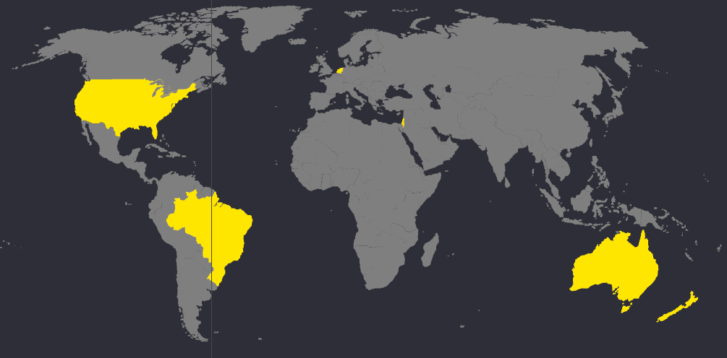

Overview of other agricultural innovation systems examined in this project:

* Brazil has shifted from being a large importer of food to being one of the largest exporters of food in the world in the past 50 years.
* Israel is recognised as a renowned platform for innovation in the world, including innovation in the AgTech space with multinationals drawn to the country.
* New Zealand is a key competitor to Australia, exporting a large part of its production to similar markets as those of Australia.
* The Netherlands is the second largest exporter of agriculture products in the world after the US. It is home to a large number of agriculture innovation hubs.
* The US has active participation from the private sector in undertaking agricultural R&D and attracts large amount of private capital from domestic and international sources.

Key highlights

Agriculture R&D spending

* Both Australia and New Zealand have similar ratios between private and public funding for agricultural R&D with public funding making the larger share of the two
* This is in contrast to Netherlands and the US that have a larger proportion of private funding compared to public funding
* China and Brazil have seen significant growth in agriculture R&D spending overall, with a Compound Annual Growth Rate of 13% and 9% respectively between 2009 and 2013
* The growth in agriculture R&D spending in Brazil is reflective of its focus on agriculture as a national priority and the role of agriculture R&D to support its objectives

Figure Agriculture R&D spending across Australia and different countries

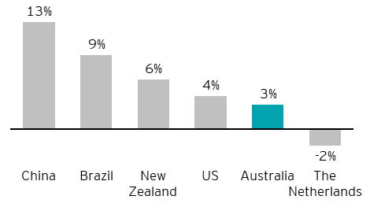

*Statistics on R&D spending in agriculture converted into AUD by using yearly average exchange rates from 2017 (International Food Policy Research Institute)

Research capabilities

* Whilst Israel currently does not have a university in the top 50 for Agriculture and Forestry, its research capabilities in terms of the number of researchers per million inhabitants is higher than that of other countries
* Both the US and the Netherlands have strong scores for Agriculture and Forestry subject area

Gross Expenditure in R&D (GERD)

* Israel has one of the highest ratios of GERD in the world that is reflective of the heavy investment by both the public and private sector in innovation
* The Netherlands has steadily increased its share of GERD as a percentage of GDP. One of the targets of the Europe 2020 strategy is to achieve a GERD ratio of 3% as a percentage of GDP (European Commission, 2013)

Figure Comparison of key statistics for selected countries and Australia

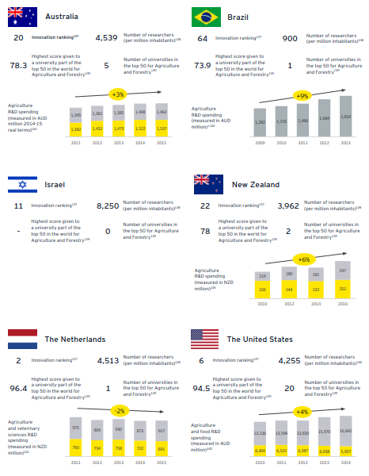

Note:

* Agriculture R&D expenditure data from different sources classify agriculture R&D investment differently, thus the data shown here is meant to give an indicative profile of the investment in agricultural innovation and not absolute comparison
* Detailed breakdown of public and private expenditure for agricultural R&D not available for Brazil. Data for Israel not available

#### 3.4.1. How does Australian agricultural innovation compare with other countries?

As we look to the future to change Australian agricultural innovation to be amongst the world’s best systems, it is important to understand how we currently compare with key market players for agricultural innovation, including Brazil, Israel, New Zealand, the Netherlands and the US.

Note: These assessments provide a summary comparison across international agricultural innovation systems, based on research into each system, including desktop analysis and interviews with people in each system. They are illustrative of relative positioning, and are not necessarily reflective of all aspects of each system.

Based on desktop research and interviews, two assessments were conducted to examine (1) innovation focus and (2) key influences on investment. Analysis on innovation focused examined five capability dimensions:

Figure Relative positioning across key innovation focus areas

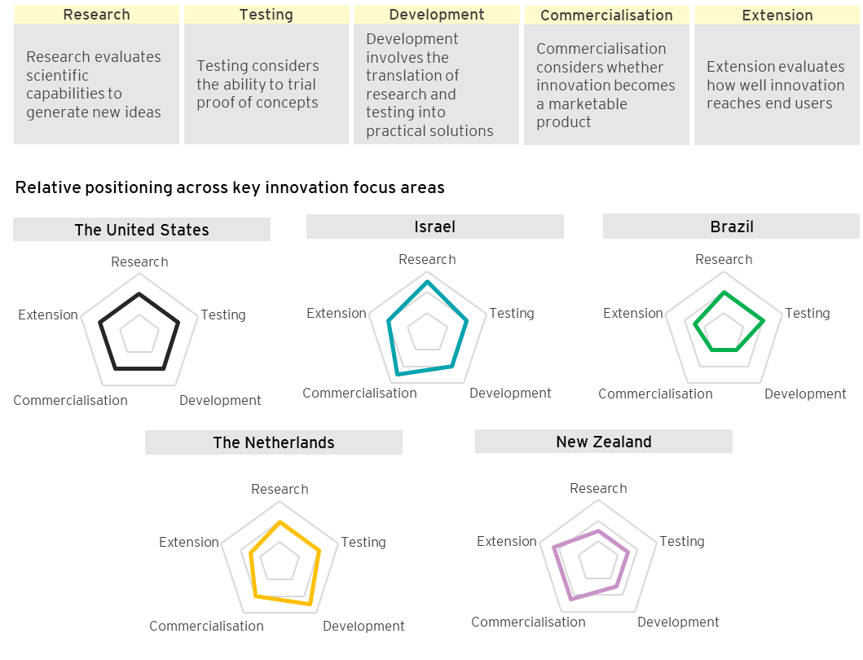

Australia – potential future state

Stakeholders indicated that it is important to maintain Australia’s world-renowned research in our future innovation system. However, Australia’s extension and commercialisation lag behind those of other developed nations. Stakeholders believe that Australia needs to improve the way in which our research capabilities are translated into viable commercial products that have an impact for end users.

Improving our ability to test international innovation was seen as an opportunity by some stakeholders. It is unclear whether there is strong support for Australia becoming a test-bed or whether there is a sizeable market for us to do this. However, Australia becoming a test-bed could build international partnerships, so it serves as a secondary priority.

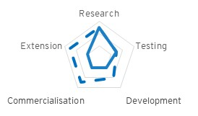

Key influences on investment are critical given the complex nature of the agricultural innovation system. Influences on the system impact how the system functions. These criteria define the direction of the system and they can impact innovation capabilities and focus areas.

Note: These assessments provide a summary comparison across international agricultural innovation systems, based on research into each system, including desktop analysis and interviews with people in each system. They are illustrative of relative positioning, and are not necessarily reflective of all aspects of each system.

Figure Relative positioning across key influences on investment

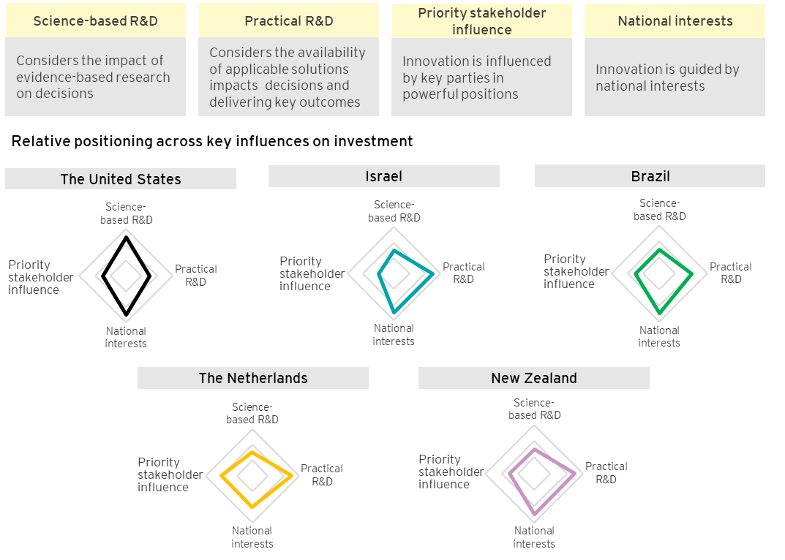

Australia – potential future state

Currently, Australia is least influenced by national interests and practical R&D, and most influenced by priority stakeholder influence. The majority of stakeholders consulted indicated a preference for national priorities to drive decisions, with evidence-based scientific research and practical solutions to be key influences on agricultural innovation.

The desired shift requires greater emphasis on national interests whilst integrating priority stakeholder needs with common sector-wide goals. This will reduce segregation of efforts and provide a more united purpose in future. The timing of this change must be planned effectively in order to transition to a system that brings greater overall gains to Australian producers and consumers.

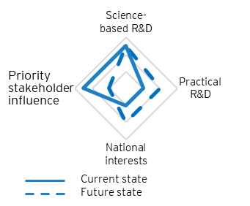

A selection of 12 criteria informed how different countries compare on metrics for both agriculture and innovation – please refer to Appendix F for further information on these criteria. These criteria were used to inform the positioning of nations internationally, creating a distinctive brand for each of these agricultural innovation systems.

Note: These assessments provide a summarised comparison across international agricultural innovation systems, based on our research into each system, including desktop analysis and interviews with stakeholders in each system. Such assessments are illustrative of relative positioning, and are not necessarily reflective of all aspects of each system.

Figure Relative positioning on whole of system dimensions

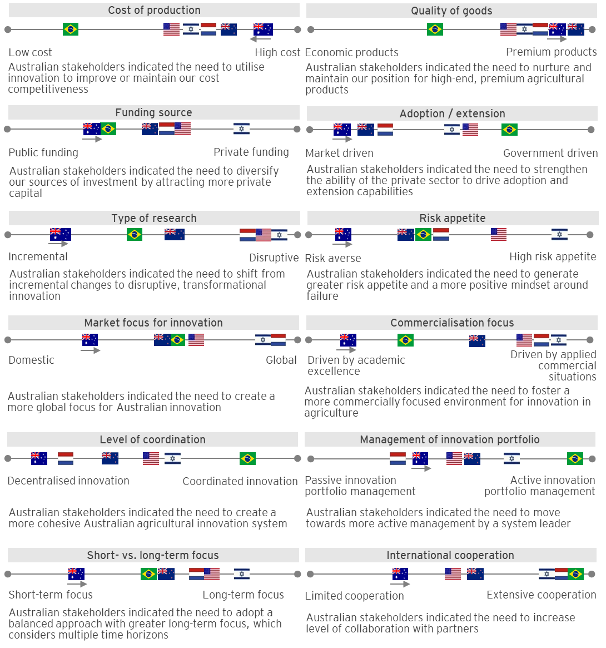

#### 3.4.2. Areas of differentiation observed across countries

As explored in Section 2, many initiatives exist across Australia to drive innovation in the agricultural sector and different stakeholders are involved along the value chain as part of this process. Nonetheless, as explored in Section 3.3, stakeholders engaged have identified some challenges and unrealised opportunities for Australia’s agricultural innovation.

1. International research into other countries has identified eight key areas of differentiation within their agricultural innovation systems.
2. Ecosystem leadership: An ecosystem where varying levels of responsibilities are clear and these align with priorities such as investment, efforts and talents
3. Clear understanding of value proposition and competitive advantages: A clear understanding of strengths and positioning in the global market for innovation that shapes strategic decisions (for example, Israel in AgTech, New Zealand in premium agriculture)
4. Focus on commercial outcomes and applied research: There is a focus on commercial application at early stage of research - universities and research institutes have an extended role to generate industry-relevant solutions that deliver impact and value
5. Diversity of funding environment: The agricultural innovation system provides a diverse range of funding and vehicles that target key areas, such as pre-seeds, start-ups and fundamental science
6. International collaboration: International partnerships and agreements to share knowledge and expertise and to solve common issues (for example, soil, water)
7. Importance of innovation culture: An innovation culture that creates impact from collaboration and recognises the value of trying new approaches and learning from failures rather than giving up
8. Innovation precincts, centres of excellence: Precincts co-locate researchers and industry players, start-ups and accelerators to enable collaboration, idea generation and increase speed of concept development
9. Participants throughout the value chain are engaged and incentivised to ensure adoption of new technologies, such as shared facilities, and dedicated staff

##### 1. Ecosystem leadership

Effective leadership and coordinated approaches to innovation drive strategic mission priorities and alignment of investment efforts and talents

Some countries have a dedicated system leader that operates as an orchestrator: defining roles and responsibilities, incentives for participants across the system to achieve shared objectives, and ensuring accountability

Benefits include:

* Supporting the system to work towards well-defined strategies to tackle national priorities
* Greater clarity on the different roles and responsibilities of actors across the system
* Greater flexibility and agility of agricultural public policies, as circumstances change

Examples identified in other countries

The US agricultural innovation agenda is implemented through shared responsibilities

* Key agencies that are part of the USDA to drive ecosystem leadership at various levels include the National Institute of Food and Agriculture (NIFA) and the Agricultural Research Service (ARS)
* Under NIFA and the ARS provide competitive funding to research projects that are aligned with national priorities
* Regular performance reviews are conducted with a National Retrospective Review every five years to improve performance, maximise outcomes and maintain relevance of National Programs under the ARS

Brazil created Embrapa as a central coordinator for agricultural research to align research efforts across different state units to national interests

* Embrapa is a dedicated federal government research organisation for the entire agricultural sector
* It provides support for agricultural development that enables Brazil’s agricultural innovation to align to national objectives that support the economy and the industry as a whole
* Embrapa endorses themes, which include research areas that are relevant to the wider economy

Considerations for Australia

Currently, agricultural innovation in Australia is operating in siloes. As explored in Section 3.3.1, closer alignment is required to maintain the trajectory gained from existing initiatives to unite stakeholders under national priorities. It will be important to create an ecosystem led by all areas of the value chain to achieve success and collaborate on national issues.

Commitment from everyone in the industry is needed to actively advocate and act on change. Important questions need to be asked to meet the needs of different stakeholders such as:

* How do we unite a decentralised, fragmented landscape to reduce duplication and increase collaboration?
* How do we shift from short-term, incremental innovation to long-term, disruptive innovation?
* How do we support the leaders of the ecosystem to be able to engage and incentivise participants in agricultural innovation to achieve national long-term priorities?

In Section 3.3, stakeholders indicated a desire for the agricultural innovation system to drive a focus on national priorities and galvanise industry capability, rather than become overly controlling or bureaucratic. To do this will require sufficient influence over the sector, including both strategy and funding. As a result, there is support for government to participate in ecosystem leadership, alongside industry to support a uniting mission to drive agricultural innovation.

##### 2. Clear understanding of value proposition and competitive advantages

A clear value proposition is key to global competitiveness. If areas of agricultural industries competitive advantage are agreed, the agricultural innovation system can focus on assisting value chain participants to capitalise on these areas. Agreed focus areas will also allow decision-makers to target resource allocation and help build our international reputation.

International examples demonstrate how understanding its value proposition can help a country consolidate the focus of its agricultural industries and innovation to its strengths and build strong reputations in specific areas.

Benefits include:

* A stronger national brand
* Deep, specialised expertise in certain areas that attracts talent and investment from the private sector and abroad

Examples identified in other countries

Israel has positioned itself as a leader in water technology and actively promotes adoption of these technologies in other countries

* Israel created key strategic partnerships with countries facing water scarcity issues, such as the 2006 agreement with India to collaborate on sustainable agriculture under semi-arid and arid climatic conditions

New Zealand has established a mission to position its products as premium on the world stage

* New Zealand has defined a clear strategy to become the “most trusted source of natural food by 2030”, which affects investment priorities in its agricultural innovation system

Vision for circular agriculture in the Netherlands

* The Netherlands set a goal for its agricultural value chain to operate on the principle of circular agriculture. The concept involves addressing leakages along the value chain to create a more sustainable and environmentally conscious agriculture system that:
* Supports the economic position of farmers, growers and fishers for long term sustainability
* Better connects consumers and primary producers along the value chain and reduce wastage
* Helps the Netherlands maintain a leading role in innovation of production methods in national and international markets

Considerations for Australia

As explored in Section 3.3.3, Australia has established a strong reputation in research on the world stage through its various academic publications and collaboration of researchers with international counterparts. However, more needs to be done to ensure that our agricultural innovation maintains relevance on the world stage so that it is fit-for-future, meets the needs of the country and differentiates us from other countries.

As other countries have supported a clear brand for their capabilities in both agriculture and innovation, Australia needs to do the same with its existing brand to maintain its relevance on the world stage. Important points to consider developing this identity includes:

* What are our competitive advantages in agriculture and in agricultural innovation?
* How do we shift from a scattergun approach to specialisation and realise the best opportunities for our agricultural sector?
* How do we market our strengths to the world?

Stakeholders see an opportunity to enhance our value proposition internationally, and simultaneously benefit from the significant global investment being made into agricultural innovation. There is potential to leverage our established academic reputation and define a clear value proposition by leveraging the brightest minds and agriculture expertise of Australia to deliver leading practical solutions.

##### 3. Focus on commercial outcomes and applied research

A clear focus on commercial outcomes in the early stages of research and development assists in developing innovative solutions that can solve real-world problems. This focus encourages private sector investment to translate research into commercial products and outcomes. International research has shown that both government and the private sector can play a role in encouraging a focus on end user needs and commercialisation at the outset of a research project by considering pathways for adoption during scoping and clear agreements around intellectual property.

Benefits include:

* Greater economic benefits to the agricultural value chain and economy through improved practices and adoption of better technologies
* Attraction of greater private sector and international investment into the future agricultural innovation system
* A more vibrant entrepreneurial community

Examples identified in other countries

Research organisations drive commercial focus in the US

* The Agricultural Research Service manages intellectual property and innovation adoption to ensure the outcomes of the Department of Agriculture’s research are utilised in a commercial context
* New solutions are presented to a Patent Committee to understand the expected research outcome, the potential for commercialisation and how this fits within the mission of the Department of Agriculture

The New Zealand Ministry of Primary Industries allocates funding according to ongoing commercial viability

* Through the Primary Growth Partnership program, joint ventures can be established between government and industry to fund R&D
* Commercial viability of the solution is a key criterion to obtain funding under this program
* The aim is to ensure that projects are applicable to end users of innovation
* If successfully commercialised, the projects will become self-sustaining after the joint venture

Considerations for Australia

As explored in Section 3.3.8, there is a disconnection between implementation of new solutions and application of research in Australian agricultural innovation. Innovation systems around the world face a range of commercialisation and industry impact challenges and have introduced various initiatives to ensure that solutions can be applied in a commercial setting.

Currently, agricultural innovation is under pressure to meet complex and sometimes competing choices to address the needs of the various stakeholders. This requires Australia to consider the following points:

* How do we translate research into products that could be commercialised?
* How do we encourage the research community to consider end user needs?
* How do we provide support for entrepreneurs looking to commercialise and scale their ideas?
* How can we assist players in the value chain to make connections with other stakeholders across the complex agricultural innovation landscape?

##### 4. Diversity of funding environment

A diverse range of funding sources allows investment to be balanced between incremental innovation and transformational outcomes. Private sector funding has a commercialisation focus, which relies on applied research. In contrast, public funding is often drawn to areas in which there is market failure. Both types of investment are required to ensure that research progresses from theory to application. Diversified investment also allows flexibility to respond to changes in the global or domestic market whilst generating innovation targeted at different time horizons.

Benefits include:

* The agricultural innovation system delivers diverse outputs and outcomes that reflect the diversity of funding sources and investors
* Balance of investment with between short- and long-term priorities, appropriate resourcing for research aimed at delivery public good outcomes

Examples identified in other countries

By focusing on PPPs, the Netherlands shifted away from government intervention

* The Top Sector Policy was created to encourage more participation from industry through PPPs
* Under the policy, top consortia for knowledge and innovation acts as a facilitator for PPPs amongst the industry, research institutes and government organisations
* Government engages in joint ventures that are funded by a 50-50 split between government and industry
* By encouraging industry participation in PPPs, knowledge gained can enter into the public domain quicker due to better commercialisation opportunities from R&D through industry involvement and knowledge contributing to research

New Zealand uses a variety of funding programs to support technical innovation

* Both the Ministry of Business, Innovation and Employment and the Ministry of Primary Industries have a variety of funding avenues and programs, allocating funding within different time horizons to balance investment in different types of research
* Callaghan Innovation, New Zealand’s innovation agency, offers funding to smaller businesses innovating in applied technology, with agriculture being a key beneficiary of this program
* The Primary Growth Partnership Program is a joint venture between the government and industry, it was created to encourage investing in long-term innovation research, through business-led projects that are assessed against national requirements

Considerations for Australia

Encouraging a diverse range of funding sources helps to support participation and activity of different parties, such as private sector firms. Currently, private capital availability is limited and it is challenging to attract foreign investment for agricultural innovation. There are approximately seven to eight AgTech incubators and precincts in Australia. To create an active market for investment for these small businesses, more can be done to allow them to grow. By looking at different initiatives implemented by different countries, Australia can target key areas that encourage both domestic and international investment for agricultural innovation. The following points are important considerations to support a diverse funding environment:

* How do we capitalise on the funding opportunities available in Australia to balance key priorities and distribute focus between incremental and transformational innovation?
* How does our funding model entice both domestic and international investment?
* How do we bridge the gap between ideas and commercialisation and enable a start-up companies to grow from pre-seed, seeding and A/B round of funding?

The range of funding sources available for innovation needs to improve the stability of the sector and allows more market forces to operate for a more active sector. As the funding environment diversifies, traditional criteria for allocating funding will need to evolve, which may encourage greater participation of players not traditionally within the sector.

##### 5. International collaboration

Partnerships and agreements with international bodies, such as universities and governments, enable knowledge sharing to solve common issues domestically (for example, aridity, soils, and water usage). They provide commercial and research organisations the opportunity to share expertise and capabilities across borders, gathering deep specialisations and pooling resources for stronger commercialisation and scaling potential. An effective innovation system will naturally draw international interest in collaborating, which can be used to amplify agricultural innovation capabilities.

Benefits include:

* Ability to leverage the expertise and experience of international partners in research
* Greater international perspective in research from the outset, which may help in developing solutions for international, as well as domestic markets
* Ability to develop a reputation in a global context

Examples identified in other countries

New Zealand is conducting research with international partners

* AgResearch has research partnerships with over 50 countries, including the US, China and Australia
* The New Zealand Knowledge Based Bio-Economy (KBBE) is a partnership between the European Commission, Australia, Canada and New Zealand on sustainable agriculture

Israel has formed partnerships with other countries to solve common issues

* The Israeli-US Binational Agricultural Research and Development Fund (USD 7 million per annum) enables organisations from both countries to develop technology into practical solutions internationally

Brazil has fostered strong international research partnerships

* Over 1,500 researchers are being trained overseas to upskill their expertise and build stronger understanding of international markets to ensure scalability of their innovations
* Labex (Virtual Laboratories Program) has been established in partnership with the US, Europe and Asia to conduct joint research operations on selected topics for mutual benefit
* As of 2011, Brazil’s Agricultural Research Corporation (Embrapa) had 78 bilateral agreements with 89 institutions in 56 countries and 20 multilateral agreements

Considerations for Australia

As explored in Section 3.1.2, there are a limited number of large global agricultural companies choosing to set up their R&D operations in Australia, which shows limited international collaboration from the private sector with Australia. There are some initiatives to better connect Australia to key markets for collaboration, such as Charles Sturt University’s Bridge hub linking to Israel and other research collaboration being undertaken at research institutions and universities. There is a potential opportunity for Australia to increase the level of international collaboration to adapt to megatrends and challenges, as summarised in Section 3.2. Stakeholders indicated that far greater levels of international collaboration are required to provide the foundation for a thriving innovation sector in Australia. This will require a shift to a ‘partner first’ approach involving both industry and government with the following points of consideration:

* How do we leverage our globally-renowned research reputation and diverse, innovative agricultural sector to attract international talent, investment and partnerships in research?
* How do we develop niches on the global stage that will attract researchers and programs from abroad with a specific focus (for example, primary production in tropical climates)?

##### 6. Importance of innovation culture

An innovation culture is one that centres on creating an environment for ideas to flourish, generating impact from collaboration, and recognising the value of learning from failure. Many countries with strong innovation culture have a high appetite for risk, which allows for basic research with potentially transformational outcomes to be funded. Such culture also encourages entrepreneurs to enhance their understanding of end user needs when looking to translate research into profitable products.

Benefits include:

* Increased entrepreneurial activities
* Ability to foster a collaborative environment where innovate ideas are generated and pursued
* Increased real-world uptake of innovation

Examples identified in other countries

In the Netherlands, a multi-layered education system supports academic and practical agricultural training

* The Netherlands government has developed the Human Capital Agenda to provide practical experience to people involved in agriculture through private sector internships and training

The US has developed a strong entrepreneurial mindset over time

* One of the key elements of the US’ culture is a ‘fail fast’ mentality. This is best demonstrated in Silicon Valley, where failure is recognised as a learning experience amongst VCs, incubators and accelerators

Israel has encouraged innovation in its ecosystem by attracting talent from other sectors to AgTech

* The Ministry of Agriculture and Rural Development actively promotes the exchange of talent and ideas through establishing collaboration groups and cross-disciplinary research centres
* This system connects a diverse network of people through government-supported organisations (for example, Israel Innovation Authority, Start-Up Nation Central and GrowingIL) to link those who are interested in entrepreneurship with new ideas
* Israel supports testing of ideas with producers through extension centres, helping entrepreneurs to develop solutions that are relevant to end users

Considerations for Australia

As explored in Section 3.3.2, Australia has a risk averse culture when it comes to agricultural innovation. Stakeholders endorsed the importance of enhancing innovation culture across the industry. However, they also strongly acknowledged the challenges of seeking to ‘replicate’ cultures from other countries in a wholesale manner. There are significant advantages to be gained by leveraging existing cultural strengths, particularly in Australian primary production, while blending in a range of new areas. To grow and develop Australia’s innovation culture, it is important to consider the following:

* How do we foster an entrepreneurial mindset with acceptance of risk and failure?
* How could agricultural educators incorporate specialised learning, practical training and business expertise to shape a new generation of agricultural entrepreneurs?
* How do we create investment opportunities that enable an innovative culture to thrive?

Addressing these questions will require change. It is important for leaders across the system to promote new ways to support greater transformational innovation. Such leadership roles will require better communication, and a shift in stakeholder expectations regarding the immediacy of impacts from innovation.

##### 7. Innovation precincts, centres of excellence

Innovation precincts gather skills and expertise in international agricultural innovation systems and other sectors in a central location. Precincts enable researchers, start-ups, accelerators, multinationals, governments and end users to work together to generate and develop ideas. It has been observed in some countries that best-in-class international centres of excellence are focused on a niche area (for example, precision farming, genetic modification research) (Root of the Matter Knowledge Centre 2019). Precincts can evolve to form specialities that are specific to their region, leveraging natural advantages as a value proposition.

Benefits include:

* Co-location of agricultural innovation stakeholders allows each party to better understand the perspectives of other participants in the value chain
* Allows for cross-disciplinary knowledge sharing
* Economies of scale within their niche areas through region-specific research capabilities
* The reputation of the precinct attracts private investors who want to leverage resources and expertise

Examples identified in other countries

In New Zealand, Crown Research Institutes and universities share resources and knowledge through Centres of Research Excellence

* Centres of Research Excellence encourage collaboration among researchers, connect user groups and build research capabilities through post-graduate programs and training new researchers

Piracicaba brings together researchers, end users, investors and start-ups in Brazil

* Piracicaba has become one of most influential AgTech precincts in Latin America
* The region draws start-ups through investments from accelerators and multinationals, both domestically and internationally

Israel implemented knowledge centres that bring experts to solve agricultural issues

* Israel has established 5 knowledge centres, gathering cross-disciplinary expertise and knowledge, to solve specific agricultural issues with applied research
* Each knowledge centre is assigned a 3-year mission on a specific topic, bringing together 20 full time researchers across different disciplines to achieve the mission
* Short timeframes allow evaluation of research outcomes to reassess the benefit of the project

Considerations for Australia

Key opportunities explored in Section 3.3 can be better supported through innovation precincts and centres of excellence, such as innovation culture, system collaboration and innovation capabilities. Precincts represent a significant opportunity for collaboration across different locations in order to accelerate innovation. These centres will require a long term and stable commercial model to be put in place, which may necessitate government and industry partnerships. Choices will need to be made regarding the extent to which these sites build specialised, globally relevant innovation capability, and if so, their best areas of focus. It is also important to consider how to best connect and make these precincts relevant to stakeholders in the value chain by considering points such as:

* How do we scale and invest in existing innovation precincts (for example, Agri Bio) to create a critical mass of capabilities which will attract private companies and multinationals?
* How could we connect precincts to different stakeholder groups within agricultural innovation?
* How can we capitalise on existing innovation precincts and co-locate within communities where multiple disciplines co-exist?

Stakeholders indicated that a small number of globally relevant precincts would be desirable, given their potential for greater impact.

##### 8. Effective adoption pathways

Local organisations play an important role in successful adoption of innovative technologies and practices by building relationships and sharing information that is relevant to producers in that region. These organisations deliver impact by providing information and training to encourage uptake of innovation. Clear end-to-end adoption pathways enable the innovation system to be more responsive to end user needs and foster an environment where ideas are applied to real situations.

Benefits include:

* Increased uptake and usage of innovation by end users
* Easier scaling and application of ideas and research
* Innovation products and services in agriculture developed with stronger end user focus

Examples identified in other countries

The Israeli government implemented and funded extension centres across the country for end users to test new innovation with support from experts

* Extension centres bring researchers, the private sector and end users together. Laboratories provide a platform to perform proof-of-concepts and field trials, enabling user acceptance testing of new innovation with immediate feedback
* The centres serve as an educational facility for end users, offering insights into new technology, with innovators readily available to provide advice or answer questions regarding on-farm application of their products
* For innovators, extension centres can guide research priorities with end user feedback into the design process

The Brazilian government has set up extension services at the federal and state levels to assist adoption of new innovation

* The Ministry of Agrarian Development takes responsibility for adoption at a national level
* Public extension is provided by EMATERs, specialised state agencies found in all states of Brazil
* EMATERs mainly target smaller farmers who cannot afford technical assistance, ensuring greater adoption throughout the Brazilian agricultural landscape
* EMATERs have expertise specific to their state which enables more tailored extension services for end users

Considerations for Australia

As explored in Section 3.3.8, a key challenge for agricultural innovation is enacting change through adoption. Stakeholders mentioned that there are some levels of disconnect between research and end users of solutions, leading to a lack of understanding of their needs and a potential barrier to take up innovation. Strengthening adoption pathways will be a key priority given the potential for both local and global innovation. The following points will need to be considered:

* How do we use existing adoption pathways and networks to provide greater support to producers at a local level?
* How can we better communicate research findings to Australian producers to encourage their adoption of new technologies and practices?
* How can we enhance existing pathways and/or create new adoption pathways?
* How can we improve up-front decision making to factor adoption pathways?

#### Case study – Argentina (Bioceres, accessed 2018)

Private companies have incorporated various strategies within their business model to support an innovation portfolio, which allows them to remain competitive in the long term. One such company examined in the course of the research was Bioceres in Argentina that has grown significantly from its origins as an alliance of agricultural producers to the innovative agricultural company it is today.

The business model and lessons learnt from Bioceres bring important considerations for Australia’s agricultural innovation and inform strategies to drive more commercially focused solutions.

Bioceres is an Argentinian company established by a group of 23 agricultural producers in 2001. It is a fully-integrated provider of crop productivity solutions, with a multi-discipline and multi-product platform capable of providing solutions throughout the entire crop cycle, from pre-planting to transportation and storage. The company was established to provide an avenue for Argentinian producers to undertake agri-biotechnology R&D, which are traditionally undertaken by large multinational companies due to the long-time period and riskiness of potential investment.

To grow its business, Bioceres has enjoyed close collaboration and relationships with local researchers at the National Scientific and Technical Research Council in Argentina to supplement its research teams. Concurrently, researchers participate in commercially focused research that support their capability in co-designing practical solutions.

Bioceres’ business model is designed to offer multi-disciplinary, end-to-end platform solutions in agri-biotechnology. It provides a centralised platform for innovation activities across the supply chain:

1. Technology sourcing: identify and collaborate with academic and independent research institutions; financed through public grants to minimise financial exposure
2. Product development partnering: identify and collaborate with strategy partners, and create joint ventures through an open architecture approach; partner with international entities for co-funding, technology sourcing, IP and market access
3. Production and market access: establish multiple pathways to market leveraging the various networks of the company; direct sales are complemented by licensing technologies developed to other companies

Considerations for Australia

* Australia could leverage and grow the reach of the existing farming system groups to adopt learnings from the Bioceres’ structure as it is already linking key specialists, knowledge networks and producers
* To adopt the Bioceres’ model, it will be important to establish clearer links and involvement with the private sector through strategic partnerships and joint ventures
* Sharing data across the innovation system will be important to better support collaboration and could be achieved through an open innovation model

#### Case study – China’s agricultural innovation system (OECD 2018; Ministry of Agriculture and Rural Affairs of the People’s Republic of China)

China is an important market for the Australian agricultural sector, as it is one of our main export markets for agricultural products. In recent years, concerns for the issue of food security has focused investment from the government to support the agricultural sector domestically. As the agricultural sector in China evolves and grows to better support domestic agricultural production and supply, this could have flow-on effects to Australian agricultural exports to China.

Agricultural policy objectives in China have evolved over the last three decades, reflecting the changing role of agriculture at different stages of economic development. In recent years, the focus has been placed on ensuring food security for the country, increasing farmers’ incomes, boost competitiveness and improve the environmental performance of agriculture. The No.1 Document of 2017 marked the 14th year in a row in which the focus is on the agricultural sector and rural areas. The name of the document is traditionally seen as an indicator of policy priorities. The government’s efforts to improve the current structure of the agricultural sector and boosting innovation has brought significant changes to its agricultural innovation system.

To support the transformation required to achieve its goal of food security for its citizens, the government invests heavily in public agricultural R&D, with private investment accounting for approximately 10-20% of overall investment in agricultural R&D. The government has also recently introduced relevant policies to boost participation from the private sector in agricultural R&D.

The agricultural innovation system in China is divided into three main parts. Examples of key mechanisms and policies in place under these main areas are summarised:

1. Agriculture science and technology

* Approximately 30 Provincial Agricultural Academies in China have formed an agricultural innovation alliance headed by the Chinese Academy of Agricultural Sciences
* The alliance conducts problem-oriented research, particularly looking at regional problems of high quality varieties, such as dairy and cotton
* Agricultural technology parks were introduced to demonstrate new technologies and facilitate the collaboration between agriculture and other industries

1. Agricultural technology promotion

* China’s public agricultural extension system is a key strength of its innovation system
* Extension centres provide a range of services, such as introduction of new technology and information, HR management and capital
* By the end of 2015, there were 16,000 technical service centres, housing 729,000 extension officers who provided technical services to 12.5 million farming households, equivalent to a total 60 million farmers

1. Education and training for farmers

* Several forms of education and training of the New Professional Farmer exist in China:
  + Farmers’ cooperatives offer training courses, which often meet the practical needs of farmers to understand technical issues (for example, rice cultivation technology)
  + Some communities offer farming schools
  + Evening school is organised in many agriculture areas in China, developing an “one village one product” initiative to produce a village speciality product

Considerations for Australia

* Using national priorities and objectives to guide agricultural innovation policies
* Creating various education and support avenues for learning and extension services
* Creating regional hubs and specialty areas for the purpose of education and extension

### 3.5 There is a compelling case to change the current approach to Australian agricultural innovation

Based on insights from stakeholder engagements and research, this report identified key reasons that create a compelling case to change

Australian agricultural innovation was not originally designed to be a coherent or cohesive system. A coordinated approach to transform the system is needed in order to achieve the following outcomes: be optimised to achieve more diverse outcomes from investment in innovation; a more cohesive approach to responding to future opportunities, threats and trends impacting the agricultural sector; and better positioning of Australia as a globally relevant agricultural innovation system.

#### Australian agricultural innovation needs to be optimised to achieve greater and more diverse outcomes from investment in innovation

The impact and efficiency of Australia’s innovation investment in agriculture lags behind international benchmarks. This is driven by a lack of coordinated industry leadership, a risk averse culture, limited incentives for effective collaboration, challenges in tackling cross-commodity issues and investing in basic research that could deliver transformational outcomes. Further, Australia is underinvesting in agricultural innovation and there is an opportunity to grow the total funding pool through new collaborations, engagement of non-traditional participants and greater private sector participation in order to drive increased efficiency and greater impact.

Future opportunities, threats and trends within the agricultural sector will occur in a larger, more complex and faster manner than ever before, requiring Australian agricultural innovation today to adopt a more cohesive and cross-sectoral approach

The effectiveness and efficiency of Australian agricultural innovation today is undermined by poor cross-industry and cross-sectoral collaboration, limited diversity of skills, difficulty in attracting new entrants and limited systematic approaches to innovation. Participants are not yet collaborating in a strategic and sustained manner to address shared challenges and draw on experience from other sectors. In addition, the foundations of agricultural innovation, including infrastructure and the regulatory environment, are not adapted to the needs of the future agricultural sector and there is an opportunity to strengthen capability to better inform decision-making and increase the speed of innovation and adoption.

Looking to 2050, traditional ways of working are unlikely to be sufficient to address new challenges. The innovation focus needs to shift towards a more balanced approach to deliver greater transformational innovation, address cross-commodity challenges, and target economic, environmental and social outcomes. This will require a systematic, planned and coordinated approach across commodities and sectors.

#### Australian agricultural innovation needs to be better positioned within the global innovation landscape

Australian agricultural innovation lacks strong commercialisation capabilities, and pursuit of global commercialisation opportunities is not a clear priority for the sector. Additionally, innovation today is fragmented, creating difficulty for international parties to navigate the system and find the right contacts, limiting collaboration opportunities. Significant global investments in agricultural innovation are occurring and there is an opportunity for us to leverage these funds.

Specifically, there are opportunities to foster an attractive ecosystem for greater private and international involvement and opportunities to develop key collaborations with international organisations to leverage global expertise and resources.

The five key areas of opportunity identified in Australian agricultural innovation today

##### 1. Future opportunities, threats and trends within the agriculture sector will occur in a larger, more complex and a faster manner than ever before, requiring leadership and cohesion across the ecosystem to set strategic priorities and drive a more coordinated and cross-domain approach

The challenges and opportunities facing Australian agriculture are increasingly complex and significant. Responding to these will require a coordinated response that generates large scale transformation and integrates cross-disciplinary knowledge. In addition, some of these challenges and opportunities will be highly disruptive to established industries.

Australian agricultural innovation is not a product of design, it has emerged as a result of uncoordinated activities and initiatives conducted on a small scale and largely siloed around commodities and current industry structures. There is no shared strategic agenda and system coordination and leadership is undefined. There are limited instances of participants collaborating in a strategic and sustained manner to address shared challenges and to draw on experiences from other sectors. Effectiveness and efficiency is undermined by poor cross-industry and cross-sectoral collaboration.

The lack of system cohesion has resulted in a multitude of priorities for agricultural R&D investments, that have been developed and promoted independently of each other and without clear definition of their respective roles and responsibilities. Organisations often set their own strategies in isolation and national priorities are so broad that they rarely influence the R&D investment decisions of participants. The lack of coordination and strategic focus is also reflected in the absence of a clear evaluation framework for assessing system performance, gauging the benefits delivered or assessing the contribution of participants.

Looking to 2050, traditional approaches to innovation are unlikely to be sufficient to address new challenges. National leadership is needed to align organisations and participants with unified and well-defined strategies to tackle national priorities, including driving a mission-oriented approach to tackling opportunities and challenges, if they are to be addressed in a timely and effective manner.

A key feature across countries with leading innovation systems is that they have well-organised, coordinated and strong leadership models to drive innovation. There are a range of models that could effectively and efficiently coordinate and allocate expertise and resources to achieve long-term missions and objectives.

Participants indicated a desire for greater system cohesion and leadership to drive a focus on national priorities and galvanise industry capability. They also recognised the opportunity to improve innovation capabilities to better meet demands of a changing world and provide greater flexibility is needed to respond to global drivers and capitalise on opportunities. External parties looking to interact with Australian agricultural innovation noticed that there is no clear entry point, and an absence of clear direction and coordination.

##### 2. Improving portfolio balance and private sector investment would achieve better outcomes from investment in innovation

Australian agricultural innovation has developed deep commodity expertise and earned considerable success in developing and adopting innovations to reduce input use and contain costs to compete in global markets. However, these opportunities to improve productivity are decreasing and becoming more expensive.

Participants recognise that Australia currently lacks the scalability required and a clear value proposition to attract private and foreign investors and entrepreneurs.

In addition, return on investment from long-term and transformational R&D is less easily demonstrated than those from incremental and applied R&D, resulting in underinvestment in long-term fundamental R&D that drives large breakthrough innovations for the sector. Under current arrangements, public funding to RDCs through levy payments is primarily focused on incremental, producer-focused gains. Although the intention of such funding was to address market failure in investment in basic and long-term agricultural R&D, funding is largely being spent supporting R&D that the sector would otherwise be prepared to fund through other mechanisms.

There is scope for public investment to be directed towards transformational, public good R&D; coupled with stronger system cohesion and leadership to provide coordination and develop influential investment priorities to improve portfolio balance and strategic direction. This would address underinvestment in cross-commodity and transformational innovation, and ensure economic, environmental and social outcomes are balanced. There is also a need to develop incentives and foster cultural change to encourage strategic collaboration.

Private sector investment in agriculture is growing, however, it lags behind international benchmarks. There is an opportunity to grow the total funding pool through new collaborations, engagement of non-traditional participants and greater private sector participation in order to drive increased efficiency and greater impact.

Innovation systems in some key competitor markets demonstrate that diversity of funding supports balanced portfolios with incremental and transformational innovation. Such systems draw funding from a diverse range of organisations, allowing diverse target areas (pre-seed and start-ups and new science to address incremental and transformational innovations) to be addressed.

##### 3. An innovation culture that is more dynamic, encourages entrepreneurship and a more open approach to risk taking, would better position our future agricultural innovation system within the global innovation landscape

The culture of Australian agricultural innovation generally does not encourage disruptive innovation and entrepreneurship. Today’s culture is characterised by a risk-averse mindset, a territorial view of IP and a lack of diversity. In the absence of clear roles for system participants, influential investment priorities, and incentives and culture that support and encourage active fulfilment of these roles, R&D investments are skewed towards applied R&D, collaboration is rare, intellectual property is tightly guarded, and failure and risk in innovation are to be avoided at all costs.

Australian agricultural innovation also lacks strong commercialisation capabilities. Although opportunities exist for the export of Australian innovations, the pursuit of global commercialisation opportunities is not a clear priority for the sector. Innovations created in Australia have largely been developed to address the Australian market. The existing institutional setup and funding incentives often put priority on short-term, transactional projects focused on Australian producers. In particular, RDCs often have goals rooted in the success of specific commodities and associated levy payers.

There is scope for public investment to be directed towards transformational, public good R&D; coupled with stronger system cohesion to provide coordination and develop influential investment priorities to improve portfolio balance and strategic direction. This would address underinvestment in cross-commodity and transformational innovation, and ensure economic, environmental and social outcomes are balanced.

Australia is a relatively small agricultural innovation investor, which is reflective of our overall small footprint in global agriculture and our innovation culture. Private investors find it complex to interact with Australian agricultural innovation. Many institutions and interest groups are risk-averse and non-progressive, limiting our global competitiveness.

Significant global investments in agricultural innovation present opportunities for Australia to foster an attractive ecosystem for greater private and international involvement, and develop key partnerships with international organisations to leverage global expertise and resources.

Participants indicated the need for a stronger innovation culture that is characterised by greater awareness of and appetite for risk. An established innovation culture will create more opportunities for collaboration to drive more impactful solutions. They also mentioned that organisations and regions are often protective of their research, which in turn, contributes to a preference for working in siloes. We lag international peers in the level of international collaboration and partnering. Innovation systems in some key competitor markets demonstrate that fostering an entrepreneurial culture will help to contribute to a more active innovation system. Similarly, international collaboration enables knowledge sharing to solve common issues and greater commercial focus assists in developing innovative and applicable solutions.

Together, these insights support a strong case for a cultural change supported by more cohesive industry leadership, aimed to encourage strategic collaboration, entrepreneurism and a more balanced approach to risk taking.

##### 4. Strengthening the role of regions would maximise innovation uptake

Lack of awareness of the benefits of innovation is a barrier to adoption. Similarly, fragmented extension services limit the speed of innovation uptake and hinder productivity gains. Participants considered existing adoption pathways to be inadequate in providing the independent, tailored advice needed to stimulate on-farm improvements. In addition, private extension services and RDCs do not provide sufficient ongoing support to encourage adoption of new technologies and practices.

Participants recognise that there is an opportunity to improve extension and adoption through greater connection with end users. This is reinforced by observations of innovation systems in some key competitor markets, where local organisations play an important role in successful adoption of innovative technologies.

There is also a desire from producers to contribute to the development of priorities for agricultural innovation as many feel under-represented in the agricultural innovation process and are frustrated that little consideration is given to how research could be applied.

Stakeholders recognised that there is a large opportunity to empower our regions so they can contribute to and influence national priority setting and maximise opportunities from investment in innovation. Regions can also play a vital role in securing new value-adding industries and there are large opportunities to leverage local and regional expertise and knowledge to strengthen our points of competitive advantage and contribute to creating alignment amongst national, state and regional agendas.

Research on international agricultural innovation systems demonstrates that having a clear idea of strengths and value propositions in the global market helps to shape strategic decisions.

##### 5. The foundations of the system need to be improved to meet the needs of the future and to provide a next generation innovation platform

Agriculture is increasingly becoming digitised. Australian agricultural innovation has existing data and is collecting more data that is highly disaggregated and inconsistent. As a result, the ability to connect data and generate insights that enable informed decision-making and speed of innovation and adoption is limited. Work by the RDCs on enabling digital agriculture in Australia has found that digital agriculture in Australia is in an immature state across strategy, culture, governance, technology, data, analytics, and training. Economic modelling identified that the implementation of digital agriculture across all Australian production sectors could lift the gross value of agricultural production by $20.3 billion (a 25% increase on 2014-15 levels) (Council of Rural Research and Development Corporations 2017). To achieve maturity, improvements to data infrastructure and standards as well as greater collaboration is vital as many of the issues are common and the scale of investment required is beyond the means of individual participants.

A key enabler to realising the benefits of digital agriculture is reliable connectivity through physical and digital infrastructure. Participants considered rural areas lacking in reliable physical and digital infrastructure. The impact of this has been limited accessibility to data and knowledge resulting in repetition and a lost opportunity to collaborate, build on already existing research, and commercialise ideas. Further, the inability for people to connect seamlessly across agricultural innovation has hindered the speed of innovation. It will be critical for the future agricultural innovation system to have improved connectivity infrastructure to increase speed of innovation, and realise the benefits of greater adoption of high-impact technology.

Complexity and regulatory burden across different levels of government can restrict innovation and discourage collaboration and investment. Participants indicated that the regulatory requirements for the application and compliance of grant funding and the policies on IP are complex, time consuming and limit the speed-to-innovation. In other countries where processes are simplified, such systems are more flexible in responding to market demands and consumer needs. For example, in the US and Israel, discussions regarding IP management occur at early stages to avoid issues during the development and commercialisation phases. In order to better foster agricultural innovation and respond to market demands and disruptive trends, there is an opportunity for increased flexibility in the regulatory environment.

## Vision for the Australian agricultural innovation system

It’s 2050. Australian agriculture plays a central role in the provision of food to both the Australia population and to the 9.7 billion people, worldwide.

Technology is omnipresent, transforming the way we farm, fish and manage our forests. Intelligent robots work alongside our farmers, foresters and fishers. Capital flows into Australian agriculture with new business models arising. Multiple industries interlock with agriculture to create value for global consumers and the sector.

Our natural environment and resources are protected through leading and sustainable management practices. Energy is abundant and clean - agriculture producers generate much of their own energy. Australian agriculture maintains strong connection with our lands as custodians for future generations.

Consumers track the origin of their food and fibre purchases across the world as safety, ethics and sustainability become prominent. Transboundary pests and diseases continue to arise and consumers across the world look to Australia for its strong biosecurity systems.

Competition in global food and fibre markets is fierce and Australia is ahead of the game. Australian agriculture is a mosaic of value-added products and sets the standards for nutritious, safe, trusted and high-quality products.

Our agricultural industries generate significant economic growth for our country and deliver the best social outcomes to communities around us. They are known for using best practice production and management to sustain and nurture our natural resources over the long term.

Innovation has been and will continue to be critical to our success, as we explore and unlock new opportunities both domestically and internationally.

### Purpose of Australia’s Agricultural Innovation System

Purpose of Australia’s agricultural innovation system: Harness the power of knowledge: to make our food and fibre systems more competitive, prosperous and sustainable

Quotes from stakeholders supporting the purpose of Australia’s agricultural innovation system:

* “If the aspiration is to lead in terms of innovation we need to combine and conquer”
* “I aspire for a future where Australian agriculture is a price-setter in the global market”
* “We need to break down tribalism across the different components of the system”
* “We need a culture that aspires to innovate, drives improvement and respond to trends”
* “Our system needs to be dynamic, interconnected and operate within a high level strategic framework focused on solving major challenges and capitalising on opportunities”
* “We need to understand that we either Innovate or die”
* “Our innovation system needs to be flexible, responsive and attracts ‘outsiders’ into agriculture to provide new insights and adapt innovation from other sectors into agriculture”
* “Australia has no lack of resources (hard or soft) to deliver on a vision – we have the capital and the talent”
* “We are well placed to be the ag-tech hub or food bowl for Asia. We could be the leading source for ag-tech, precision farming and sustainability”
* “We have to set up a completely new research paradigm to give Australia a globally competitive research advantage”

### What will the Australian agricultural innovation system look like in 2050?

Australia’s agricultural innovation system will “harness the power of knowledge: to make our food and fibre systems more competitive, prosperous and sustainable”

Australia’s agricultural innovation system is ranked in the top tier of innovation systems globally developing breakthrough innovations to real world problems.

Participants across the value chain work seamlessly together to shape and define the future of Australian agriculture.

#### 1. Strengthening ecosystem leadership, cohesion and culture

The Australian agricultural innovation system thrives with a clear uniting purpose where participants work seamlessly together to drive change and success. Strong ecosystem leadership and cohesion across the system have been instrumental to the establishment of our global presence through international long-term relationships and collaborations and harnessing all of Government, and cross sectoral knowledge to generate system wide benefits.

Australia is recognised as a leading innovation nation, where interactions between people and information are fluid, allowing increased speed, higher impact and greater outcomes.

#### 2. Funding and investment

Our agricultural innovation system makes visionary investments in national priorities and missions. It is well-funded, leveraging a diverse source of capital to develop breakthrough innovations. Researchers and innovators desire to be part of the Australian agricultural innovation system as capital flows to the best ideas and teams.

#### 3. World-class innovation practices

The Australian agricultural innovation system builds capacity and capability to innovate and transform the agricultural industry. Young innovators are inspired throughout their education to explore, design and develop transformational solutions. Our innovation precincts are world-renowned, pursuing global opportunities for innovation.

#### 4. Funding and investment

Regions are the backbone of Australia’s agricultural innovation system as they influence and shape directions and priorities for agricultural innovation. They are embedded internationally with their expertise and knowledge serving world problems.

#### 5. Next generation innovation platform

The Australian agricultural innovation system is powered by a world-leading platform generating connections and collaborations to inspire cutting-edge science and technology. Data is brought to life through modern technologies, such as machine learning and artificial intelligence, creating the catalyst to innovate. Innovations are well supported by regulations and infrastructures that are evolving on pace with the speed of innovation.

### Outcomes of the future agricultural innovation system

#### Prosperity

Accelerated and higher impact innovation drives growth and value that transcends throughout the Australian agricultural sector. It drives improved productivity and output capacity in agriculture through practical and transformational solutions that create economic value throughout the supply chain.

#### Social impact

Social impact considerations are at the core of the innovation process, improving health, wealth and happiness outcomes for all Australians. Innovation powers fulfilling careers, brings financial opportunities to supply chain participants and reliably provides fresh and safe products to consumers.

#### Sustainability

A commitment to sustainable and ethical practices is engrained in the system’s DNA, ensuring that the full potential of Australia’s natural environment and resources are realised long into the future. The system flourishes in an increasingly connected world as domestic and international consumers and supply chain partners establish complete trust in Australia’s responsible production and commercial practices.

#### Global competitiveness

Australia has a distinct, globally recognised brand that possesses unique, high value qualities. Innovation safeguards Australia’s reputation for providing premium products as new prevention and resilience solutions ensure that our products remain high quality and free from pests and disease. Australia’s foresight exceeds that of its competitors, allowing it to capitalise on opportunities through its speed to market and the ongoing innovation of products and business models.

#### Innovation excellence

Australia is globally recognised as a world leader of agricultural innovation, due to its world-leading practices and capabilities for rapid idea generation and the subsequent development and commercialisation of high quality solutions. A culture of innovation excellence and continuous improvement positions Australia as a hotspot for leading global players, attracting academics and commercial entities looking to research, collaborate or invest.

#### Ahead of the game

The system helps the agricultural sector to anticipate megatrends and threats, and capitalise on market opportunities. Research and development focuses on societal concerns to address challenges that are broader than agriculture. It captures evolving needs to prioritise focus areas based on future issues or changes, creating resilience to future changes and shocks.

### Our values to support

#### Passionate

Our system is supported by people who are passionate about agriculture, innovation and meeting the needs of consumers. They nourish our agricultural industries and drive our people.

#### Ambitious

Our system embraces a culture that is bold, open to change, and prepared to fail fast and learn faster. Ambitious, risk-taking approaches are celebrated, regardless of outcome, and learnings are captured from both failure and success.

#### Collaborative

Trusted relationships built through collaboration and partnerships with shared interests driving a united approach to both opportunities and challenges.

#### Entrepreneurial

Fuel our future through entrepreneurship by fostering an accessible environment that champions a culture of innovation and disruptive thinking.

#### Dynamic

A vibrant and energetic system in which frictionless change, blue-sky thinking and striving for continuous improvement are commonplace.

#### Globally differentiated

We drive value through differentiation by innovating at a deep level of specialisation worthy of global recognition.

## Recommendations and proposed actions

Striving towards our shared vision for the future of Australia’s agricultural innovation system will deliver many benefits as we will create and inspire cutting-edge science and technology breakthroughs.

The Australian agricultural innovation system will generate a wide range of exciting opportunities for those in the sector, including increased collaboration across participants, greater international opportunities and higher impact from innovation.

This will necessitate change and involve significant reform, including for the institutions and stakeholders operating within the system. Components of the agricultural innovation system will need to adapt, such as leadership, investment structures, governance, funding and culture, to be compatible with the rapidly changing world and increasingly technologically-enabled environment.

To achieve this, 5 key recommendation areas and 25 specific recommendations have been identified:

1. Strengthening ecosystem leadership, cohesion and culture: Stronger ecosystem leadership and cohesion across Australian agricultural innovation will generate greater and more diverse outcomes, driving our global competitiveness through clear strategic direction and increased collaboration
2. Funding and investment: Growing and improving the balance of investments will help the Australian agricultural innovation system to deliver both incremental and transformational innovation by addressing cross-commodity challenges, and targeting economic, environmental and social outcomes
3. World-class innovation practices: Establishing world-class innovation practices through collaboration, entrepreneurship and ambition will be critical in order to maximise opportunities from investment in agricultural innovation
4. Strengthening regions: In the future, regions will play a greater role in Australian agricultural innovation, to fully realise its benefits and maximise our innovation uptake
5. Next generation innovation platform: Improving the foundations of Australian agricultural innovation, including data, physical infrastructure and the regulatory environment, will support the transformation of our agricultural sector into the future

### Recommendation 1: Strengthening ecosystem leadership, cohesion and culture

Stronger ecosystem leadership and cohesion across Australian agricultural innovation will generate greater and more diverse outcomes, driving our global competitiveness through clear strategic direction and increased collaboration.

Australian agricultural innovation takes place in an ecosystem comprised of numerous evolving systems (for example, universities, RDCs) with varying roles and responsibilities that operate independently towards different outcomes. Although Australian agricultural innovation has delivered much in terms of productivity and profits to agricultural industries and the Australian economy, it does not benefit from strong cohesion and there is no activated overarching, shared purpose or coordinating body to unite participants. As discussed in Section 2.2 and 3.3.1, Australian agricultural innovation is driven by various users of the innovation value chain, who operate in isolation with their own scope, focus, timeframe and funding cycle, resulting in fragmentation of purpose and duplication of effort and spending.

Acting in a coherent and cohesive manner is critical to ensure our investments in innovation remain relevant and to address risks and opportunities in a complex system. Australian agricultural innovation needs to evolve to respond to change, harness future opportunities, deliver transformational R&D and adapt for the future.

Stronger ecosystem leadership, greater collaboration and accountability will drive the evolution of our innovation culture, better leverage our common and diverse capabilities, improve our impact and efficiency, better drive the activation of shared priorities and position us well in the global innovation market. It will deliver long-term and transformational impacts and realise shared benefits across the innovation system.

There has been a clear call to establish a cohesive ecosystem from stakeholders, which is supported by examining the evolution of agricultural systems around the world to determine leading practice research.

#### Proposed actions:

##### 1.1. Establish shared priorities across the system to guide innovation investment and activities

* These shared priorities should adopt a mission-oriented approach by setting a small number of ambitious national long-term priorities for agriculture that take into account areas of competitive advantage for Australia
* This should drive outcome focused activities as organisations align efforts towards priorities at the national level rather than at the project and task level

##### 1.2. Position Australian agricultural innovation as a cohesive, coherent, fit for the future and globally recognised system

* Co-design, with representatives from across the agricultural innovation ecosystem, a framework that builds cohesion through clear roles and accountabilities and addresses key barriers and constraints
* Empower and incentivise participants with roles and responsibilities so that the system is more coordinated, effective and dynamic
* Improve transparency to encourage continuous improvement and hold system participants accountable for performance. A system-wide performance framework would encourage continuous improvement across the system and set expectations for participants to report on their contribution to system objectives
* Enable alignment across government, including legislative changes to support an innovation ecosystem

##### 1.3. Influence a culture that supports entrepreneurship and risk appetite towards transformational innovation

* Equip leaders and participants to influence system-wide culture change through developing incentives across the agricultural innovation ecosystem and the supply chain (including end users of innovation and consumers) to achieve long-term objectives
* Support and incentivise a collaborative-first approach to innovation
* Develop diverse experiences in agricultural innovation
* Incentivise desired behaviours and recognise effective leadership, entrepreneurship and collaboration
* Encourage a positive sector image

##### 1.4. Establish ecosystem leadership

Stronger leadership would drive a more connected, cohesive and coordinated agricultural innovation ecosystem. A flexible approach to develop a suitable model for Australia is recommended by testing new ways of connecting participants and coordinating activities for achieve more strategic outcomes.

An ecosystem leader (or leaders) should be encouraged to emerge, with support, to have the authority to:

* Implement the shared vision for 2050 and set shared priorities for the agricultural innovation system that align with broader national innovation priorities
* Coordinate strategic planning across the system to drive alignment and identify mutual benefits
* Influence funding decisions and re-allocate human and physical capital to enable priorities to be achieved

#### Implementation guidance

Strengthening system-wide leadership, cohesion and culture will be a complex yet important activity to realise the vision. A considered and phased approach, which continues to involve representatives from across the agricultural innovation ecosystem to shape a solution, is recommended. An interim leadership role could be introduced to continue the conversations on reform and provide advice on an enduring ecosystem leadership model. A key role for the interim leader will be to examine the alternatives for ecosystem leadership with the involvement of participants across the system, as well as make a decision based on an objective criterion. In the transition to more enduring ecosystem leadership, the interim leader will need to address key barriers and constraints to the achievement of the vision (such as modifying existing governance arrangements for key participants). System wide leadership should be encouraged, perhaps through an agreed portfolio of initiatives that organisations and collaborations could own. Consideration should be given to how to establish a progressive, dynamic, inspirational and globally connected system leader, and how it can garner the support of all stakeholders in the ecosystem.

Through the review, several examples of activities that target ecosystem leadership have emerged, such as AgriFutures’ EvokeAg and Rural Women’s Award, and NFF’s 2018 National Congress.

#### Alignment with other strategies

Innovation Science Australia (ISA) 2030:

* Recommendation 28: "Adopt a framework to continue to identify national missions”
* Recommendation 29: "Invest in performance evaluation system for Australian innovation”
* Recommendation 30: “Develop a suite of innovation metrics”

Council of RDC’s Vision 2050:

* Recommendation 1: "Develop and implement a national framework to drive a globally-connected, high-performing and effective knowledge and innovation ecosystem"
* Recommendation 2: "Develop and implement a national, integrated, whole-of-government strategy for an enhanced agrisystem”

NFF 2030 Roadmap:

* Recommendation 3.1: “Public and private R&D efforts work seamlessly to translate research into tools and services which give Australian ag a competitive edge”

Decadal plan for Australian agricultural sciences 2017 to 2026:

* Recommendation 4: “The Australian Government consider reviewing and updating arrangements for national coordination of agricultural research and innovation in Australia

#### Case study: NHMRC

##### Situation

A potential future ecosystem leadership and cohesion model to adopt in agricultural innovation is one similar to that of the National Health and Medical Research Council (NHMRC). In the 2017-18 financial year, NHMRC committed $943 million in new research grants to contribute to advances in knowledge, public health policy and clinical care (NHMRC 2017). NHMRC is an independent statutory agency within the Minister for Health's portfolio. NHRMC is currently recognised as the leading body supporting health and medical research in Australia and has a clear statutory mandate centred around three key priorities:

* To fund high quality health and medical research and build research capability
* To support the translation of health and medical research into better health outcomes
* To promote the highest ethical standards in health and medical research

##### Actions

NHMRC achieves these objectives through:

* Empowering the senior executive and leadership team with statutory backing to oversee the governance of NHMRC. The leadership team develops the corporate plan outlining major national health issues, a national strategy for public health research, and the proposed initiatives to address the identified issues. The CEO also sits on the Australian Medical Research Advisory Board, which advises the Minister on funding allocations for the Medical Research Future Fund
* Being at the forefront of upcoming trends (market, public health, research investment) through the synthesis of current literature to provide evidence-based funding allocation advice
* Seeking independent expert advice from a range of advocacy groups when more specialist expertise is required to inform strategy recommendations. This enables direct insights from ‘end-users’ of research outcomes.
* Creating a community portal allowing extensive stakeholder consultation to inform the NHMRC

##### Outcome

The NHMRC has a well-established funding model that supports both investigator-initiated and nationally prioritised health and medical research. Such a structure enables a transparent decision-making process that is independent of political influence, enabling effective targeting of medical research to achieve mission-based, longer-term objectives.

##### Application of the case study

* There are three key points to be reflected in the future model for agricultural innovation:
* Nationally prioritised missions are most effective when they are evidence-based and industry informed
* The future national leader (or leaders) needs to have statutory authority to oversee, develop the strategy, and advise on funding allocations
* The decision-making process needs to be transparent, collaborative and independent of political influence (i.e. consult both experts and stakeholders across the system)

### Recommendation 2: Funding and investment

Growing and optimising the balance of investments will enable the Australian agricultural innovation system to deliver greater incremental and transformational innovation; more cross-commodity programs; and more economic, environmental and social outcomes.

As explored in Section 3, growth in Australia’s investment in innovation appears to have recently stalled. The overall level of investment lags behind international competitors whilst private and foreign investment in Australia’s agricultural innovation is still small compared to that of other countries. In addition, current investment in Australian agricultural innovation is largely focused on applied, commodity-specific and incremental innovation at the expense of long-term, transformational, cross-commodity and public good activities.

Growing investment in Australian agricultural innovation will be needed to maintain deep commodity specialisation whilst addressing cross-sectoral challenges, which will increase impact across economic, environmental and social outcomes.

In the context of a rapidly changing environment, managing a diverse, balanced and transparent investment portfolio will drive our success in agricultural innovation and deliver long-term and transformational outcomes across the innovation system.

#### Proposed actions

##### 2.1. Shift the balance of public investment in the agricultural innovation system towards transformational, cross-sectoral and public good outcomes

* Consolidating and redirecting portions of government funding to a common funding pool (for example, a new Agricultural Innovation Fund) could be used to invest in projects that address transformational, cross-sectoral and public good challenges

##### 2.2. Increase flexibility and contestability of funding across the system

* This will allow for funding to flow through to the best opportunities and could include providing levy payers with greater choice in where levy funding is allocated

2.3. Encourage new collaborations, non-traditional participants and greater private sector involvement by widening access to public funding

* This could be achieved through increasing contestability and co-investment that leverages public funding and a new sector specific commercially oriented organisation, with the purpose of commercialising Intellectual Property
* Such activities could provide a landing pad and platform for both local and international investors to access the Australian agricultural innovation system

##### 2.4. Foster an attractive environment to attract private investment, including venture capitalists and angel investors

* Tax incentives or a public fund could be used to cover a portion of the downside risk associated with investment in start-ups
* Establishing and leveraging public-private partnerships would also be key to attracting private investment

##### 2.5. Target key partnerships and collaborations with large agribusinesses and multinationals to leverage global expertise and resources

* A key enabler to this could be to encourage Australian research and government organisations engaging with these entities as a norm rather than an exception
* In order to attract these collaborations, establishing long term partnerships and fostering an attractive environment would be an important step

##### 2.6. Improve transparency and access to information on research activities and outcomes

* Increasing transparency of financial and Intellectual Property information would be important to facilitate investment into commercialising research outcomes

##### 2.7. Grow the total funding pool

* Investigating increases in Commonwealth, State and Territory Government funding to incentivise greater private investment in the system could be an initial activity

#### Implementation guidance

To encourage new collaborations and private investment, a potential solution is to establish a Government and private co-invested, dedicated Ag-Innovation or Ag-Tech fund.

#### Alignment with other strategies

ISA 2030:

* Recommendation 19: "Introduce collaboration premium on tax offset to incentivise collaboration”
* Recommendation 26: “ISA to monitor availability of risk capital to high growth businesses”

Decadal plan for Australian agricultural sciences 2017 to 2026:

* Recommendation 1: “The Australian Government establish a national agricultural research translation and commercialisation fund, to invest in promising agricultural discoveries and fast-track their commercialisation”

#### Case study: Infrastructure Australia

##### Situation

Infrastructure Australia is an independent statutory body that was established in 2008 to prioritise and progress infrastructure of national significance (Infrastructure Australia 2019). Investment decisions are guided by infrastructure audits, the Australian Infrastructure Plan and the Infrastructure Priority List.

##### Actions

To ensure that projects addressing national priorities receive funding and resources, Infrastructure Australia produces the Infrastructure Priority List. This involves an iterative prioritisation process, considering which projects best address key infrastructure challenges over the next 15 years. Such projects are evaluated throughout the year, and are often delivered through PPPs, enabling government and the private sector to share resources.

##### Outcomes

Clear direction for investment: investment is coordinated with a holistic focus on national priorities and a long-term horizon. The approach addresses risks and achieves a balance of funding to maximise the benefit to Australia as a whole.

Transparency and accountability: ongoing evaluations of projects, annual reports, statements of intent and corporate plans are produced to assess progress towards priorities.

##### Application of this case study:

Whilst infrastructure has different mandates and drivers, there are key learnings to be considered:

* Establish more targeted shared strategic priorities across the system to guide investment decisions
* Implement an iterative evaluation framework to assess progress against national priorities and provide transparency and accountability

#### Case study: Israel’s Yozma

##### Situation

In the 1990s, there were growing opportunities in innovation and technology. At the time, Israel was an unfamiliar market and international parties were reluctant to invest due to high perceived risk.

##### Actions

In 1993, the Israeli government launched Yozma to provide funding incentives for VC. Yozma offered to cover 80% of the downside risk associated with private investment (Forbes 2017), making investment in Israeli innovation more attractive. Yozma also injected US$100 million into VC funds in the 1990s (Forbes 2017), providing opportunities for start-ups to scale their businesses.

##### Outcomes

Scale and attractiveness to investors: through the 1990s, Israel’s VC grew from US$58 million to US$3.3 billion (Department of Foreign Affairs and Trade 2018), giving Israeli start-ups suitable scale to be at the forefront of Israel’s progress on the world stage.

Multinational involvement: the start-up culture of Israel, ignited by Yozma’s incentives, attracted multinationals to establish R&D centres in Israel. As of 2018, there are approximately 350 multinational R&D centres in Israel (Forbes 2017), which provide significant R&D investment for Israel.

##### Application of this case study:

Although Israeli culture and context is different to Australia, there are key learnings to be considered:

* Implement funding incentives to attract private investment and encourage entrepreneurship
* Utilise incentives and Australia’s value proposition to create long-term, meaningful relationships with multinationals and generate sustained involvement with Australian agricultural innovation

### Recommendation 3: World-class innovation practices

Establishing world-class innovation practices through collaboration, entrepreneurship and ambition will be critical in order to maximise opportunities from investment in agricultural innovation

The effectiveness and efficiency of Australian agricultural innovation is undermined by several factors including poor cross-industry and cross-sectoral collaboration, limited diversity of skills, difficulty in attracting new entrants and limited systematic approaches to innovation. As a result, participants are not yet collaborating in a strategic and sustained manner to address shared challenges, translate research into commercialisation and draw on experience from other sectors.

Establishing world-class innovation practices and leveraging innovation precincts will drive efficiency and increase collaboration amongst participants across regions and the value chain. Similarly, taking a strategic approach to building capabilities and standardised practices has the potential to improve the effectiveness of the system to adapt to disruptive trends.

Research performed and stakeholder consultations have highlighted opportunities to improve connection and collaboration amongst industry and research, existing precincts, regional strategies, and state and national agricultural priorities. This will maximise opportunities from investment and generate better outcomes from agricultural innovation.

#### Proposed actions:

##### 3.1. Scale-up a small number of innovation hubs or precincts into national flagship precincts for agricultural innovation

Innovation precincts:

* Act as key nodes in the innovation system, connecting and supporting innovation in regions
* Provide a physical location where researchers can innovate with potential end users of their research to co-design and test solutions
* Help break down existing silos and encourage a whole-of–supply-chain perspective
* Can develop globally relevant innovation specialisation with unique value propositions
* Can be used as a focal point to generate interest in agriculture, encourage collaboration with people outside agriculture and attract foreign investment
* Have long-term funding commitments, with clear mandates and objectives to enable autonomy in innovation decisions to improve speed, agility and impact.

##### 3.2. Introduce requirements for research funding applications to include commercial and adoption outcomes

* Research funding and project planning should incorporate commercialisation (if appropriate) and adoption strategies, including provision for time and resources as part of investment decisions

##### 3.3. Make more agricultural research publicly available to increase opportunities for potential investors to commercialise innovation

* The development of a database of research projects, along with promoting commercialisation opportunities, will be a first step towards increasing rates of commercialisation
* This will also stimulate the development of a commercialisation market for research

##### 3.4. Encourage diversity of capability and promote the future of the agriculture sector to improve innovation outcomes

* This can be achieved through comparing current capabilities to those required, and designing interventions, such as programs to attract new capability or develop capability through interventions in the education system
* Increase the impact and speed of innovation by developing capabilities including entrepreneurship, commercialisation, design, digital, technology and modern innovation methods. Modern innovation methods include design thinking and hackathons

##### 3.5. Establish common and standard practices for repeatable processes in the innovation system

* This could include defining clear end-to-end commercialisation and adoption pathways based on end user needs, providing guidance on standardised grant application processes, establishing risk management processes and innovation impact assessment processes or implementing knowledge and information management practices

#### Implementation guidance

Establishing innovation precincts with global relevance will take long-term commitment and collaboration. Piloting one flagship innovation precinct would help demonstrate the value and the cultural change needed to fuel our future through entrepreneurship and disruptive thinking.

Innovation precincts should also draw the Government’s Statement of Principles for Australian Innovation Precincts (2018).

#### Alignment with other strategies

Precision to Decision report:

* Recommendation D10: Invest in education and capacity building

ISA 2030:

* Recommendation 10: "Strengthen efforts in talent attraction and skilled immigration.”
* Recommendation 22: “Increase commercialisation capability in research organisations
* Recommendation 23 "Develop and release an Australian Innovation Precincts Statement.”
* Recommendation 24 "Establish long term funding for national research infrastructure”

NFF 2030 Roadmap:

* Recommendation 4.1: “Clear career pathway to attract workers and develop their skills, with tailored streams for new entrants through to seasoned professionals”
* Recommendation 4.2: Robust and sustainable mechanisms to access labour from Australia and around the world

#### Case study: Regional precincts in the Netherlands

##### Situation

The Netherlands has enhanced active knowledge networks and systems by introducing the concept of precincts, which encourage both regional and global collaboration through active participation of PPPs. Through these regional innovation precincts, the Netherlands ensures that its wealth of agriculture and food expertise is a key differentiator for the Netherlands’ knowledge infrastructure. This is in line with the Netherlands’ overarching strategic goal for innovation across all sectors to become of the top five knowledge economies in the world by 2020 (Netherlands Enterprise Agency 2019). The Top Sector Policy also supports increased specialisation in agriculture, aiming to leverage capabilities generated by these hubs for national benefit since they establish the Netherlands as a leader in agricultural innovation.

##### Actions

The shift in policy to create a knowledge marketplace has helped facilitate the gradual shift of knowledge as a public good to knowledge as a marketable product where regions can become specialised (Geerling-Eiff et al. 2014). Consequently, innovation networks and knowledge facilitators have emerged to create clear links amongst different actors in the agriculture innovation system where there are mutually beneficial interests. The regions generate specialisation in their fields and develop capabilities that can be drawn upon by the private sector, government and international players. By pooling resources, the Netherlands enhances the capabilities of individual actors in these regions and fosters networks that result in practical, globally scalable innovation.

##### Outcome

Joint efforts by the private sector and provincial governments led to the establishment of key hubs across the Netherlands. Examples of such joint efforts include the Food and Seed Valleys that are recognised for their knowledge and expertise in agriculture. The hubs attract collaboration opportunities with international partners especially within the European area. Other agriculture hubs, such as Greenports and Food Connection Point, support various sub-sectors within agriculture and have connections with Food Valley to enable knowledge sharing and collaboration opportunities amongst of the innovation system.

##### Application of the case study:

* Developing a unique value proposition for an Australian innovation precinct that is deeply specialised will be key to attaining global attention
* Knowledge sharing between like-minded actors accelerates the pace of knowledge development
* Integration of participants across the value chain increases the speed and impact of innovation

Figure Approximate locations and key facts on various agriculture and food hubs in the Netherlands (Wouters 2014)

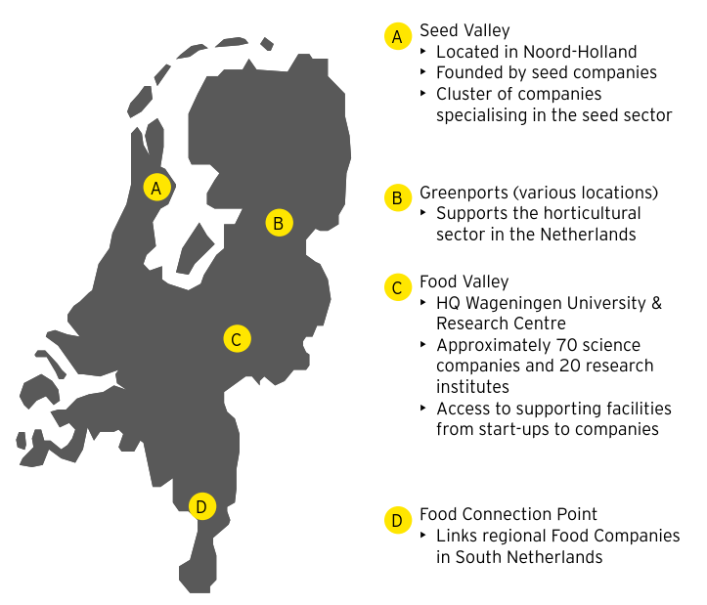

### Recommendation 4: Strengthening regions

In the future, regions will play a greater role in Australian agricultural innovation, to fully realise benefits and maximise our innovation uptake.

Australian agricultural innovation provides fragmented extension services, limiting the speed of innovation uptake and hindering productivity gains. Whilst connections with Australian rural regions and regions with similar characteristics can be improved, there is also a desire from producers to contribute to the development of priorities for agricultural innovation. Many producers feel under-represented in the agricultural innovation process and are frustrated that little consideration is given to how innovation could be adopted.

Stakeholders have identified a strong opportunity to empower our regions so they can better understand and shape the vision for the sustainment of their natural environment, as well as maximise its use. Regions can also play a vital role in securing new value adding industries, such as further processing, or food tourism.

With agriculture becoming increasingly digitised and the rate of innovation being faster than ever before, producers will need to have the knowledge and skills to adopt new technologies to keep pace with competitors and meet consumer expectations.

Increasing the rate and speed of adoption, particularly in regional and rural areas, will be critical for Australian agriculture to capitalise on opportunities and respond to emerging threats. Further, leveraging local expertise and connecting knowledge to end users will enhance our competitive advantages and contribute to creating alignment across national, state and regional agendas.

#### Proposed actions:

##### 4.1. Strengthen the extension and adoption of innovation by enhancing farming systems groups

* Existing farming systems groups can offer tailored support and demonstration of innovation for their region, including mixed farming systems, which will demonstrate the benefits and increase rates of adoption. Trusted groups are shown to be the most effective at creating change on farm

##### 4.2. Create an avenue for agricultural innovation system participants to contribute to national priority setting

* This could be achieved through providing formal roles for farming systems groups and end users to contribute to the development of national priorities for the agricultural innovation system

##### 4.3. Create communities of regions with similar characteristics to network both locally and internationally

* This could be achieved through connecting agriculture leaders in Australian regions with leaders from global regions to discuss common issues that are prevalent within their regions. Through connecting agricultural leaders, common problems can be discussed in order to create innovation demand as well as share potential solutions to increase the speed of uptake
* Communities could be connected through a multi-channel approach, where farmers could connect digitally, face-to-face through conferences, or leverage innovation precincts

##### 4.4. Build capability in digital, collaboration, and risk management tools to better inform decision-making and increase the speed of innovation and adoption in regions

Multiple methods will be used to develop capability in these areas such as:

* Optimising the use of existing online learning platforms;
* Enhancing farming systems groups as discussed in 4.1 to conduct workshops, and meet-ups that explore these topics, build capability and develop collaboration; and
* Supporting the consistent use of a centralised online forums for regions to share experiences and knowledge with each other

#### Case study: FarmLink, a strong example of farming systems groups’ reach to influence extension and adoption

FarmLink Research Limited (FarmLink) is a not-for-profit agricultural research and extension organisation based in southern NSW. Its main objective is to coordinate and communicate private, public and grower group funded research and development activities within the region (FarmLink 2017).

The FarmLink region covers 1.2 million hectares of arable land across southern NSW. The region encompasses high, medium and low rainfall production zones and a range of farming enterprises from continuous cropping, livestock and mixed farming enterprises (FarmLink 2017).

FarmLink reaches over 3,000 people annually through its media and social media presence, events, activities and communications. FarmLink’s activities involve 13 different local government areas and 17 corporate partners across the agribusiness sector (FarmLink 2017).

#### Implementation guidance

Empowering and strengthening regions will be an iterative process. A pilot approach should be taken to increase the profile of regions in the agricultural innovation system before rolling it out more broadly. A selection process should be undertaken in order to identify a high value region willing to participate to demonstrate the impact.

#### Alignment with other strategies

NFF 2030 Roadmap:

* Recommendation 3.1.3: “Invest in the capacity of digital and human networks to share and promote new practices and tools
* Recommendation 3.2: “The agricultural value chain is highly digitised, with the benefits of new technology shared fairly among participants”
* Recommendation 5.3: Innovative tools to reduce the inherent risks of farming are used by every Australian farm business - supported by consistent and well administered government risk management policies
* Recommendation 4.4: We live in strong regional communities that are home to: world class education and health facilities; culture and entertainment; and a diverse economy

#### Case study: State Agricultural Experiment Stations in the US

##### Situation

The land grant university system was established in 1862 to support education in practical areas of agriculture, leading to the creation of several education and research institutions in various states in the US. Whilst the structure led to steady improvements made in the areas of research and academia, there was a need to disseminate this knowledge to local producers and better educate rural communities on advances in agricultural practices and technology. To respond to this need, the US introduced a collaborative platform attached to some land grant colleges to better support producers adopt innovation that is relevant to their state and region.

##### Actions

The introduction of the Hatch Act 1887 (National Institute of Food and Agriculture 2019) created funding for land grant universities to establish State Agricultural Experiment Stations (SAES). The Smith Lever Act 1914 (National Institute of Food and Agriculture 2019) extended the role of the agriculture experiment stations to become part of a national Cooperative Extension Service intended to support outreach programs through the land grant universities to coordinate and integrate extension services within rural communities. Through collaboration and funding from state and federal agriculture departments, the SAES would provide university extension personnel to deliver advice to end users through workshops and training days. This service is supported through websites, which provide the public with further information, such as a calendar of events and reports on trials conducted at the experiment stations.

A strategic planning process for SAES is done by the Experiment Station Committee on Organisation and Policy. The committee is responsible for preparing the strategic agenda of the SAES system, with annual updates and a major revision every 4 year. Input is gathered from producers, consumer groups and the science community to understand the current issues impacting the community and to bring State and Federal agencies together to communicate research priorities for US agricultural science to policy and decision makers (OECD 2016).

##### Outcome

SAES act as the state-based partners within the public agricultural research system in the US and connect the US Department of Agriculture (USDA), land grant universities and stakeholders along the value chain. They act as a physical platform for the USDA and land grant universities to educate local communities about advances in agricultural research. They also support the public agricultural research system to establish a foundation for extension as part of the land grant university system. This provided a mandate for the land grant universities to focus on the pillars of education, research and extension activities, enabling academics to balance their focus on extension, education and research.

##### Application of the case study:

* Support education and extension of agricultural research within local communities to connect producers with researchers
* Create an avenue for local communities to provide input to inform national priorities for agricultural science
* Provide a local research station to undertake specialised research that reflect the needs of the region

### Recommendation 5: Next generation innovation platform

Improving the foundations of Australian agricultural innovation, including data, physical infrastructure and the regulatory environment, will support the transformation of our agricultural sector into the future

Australian agricultural innovation experiences inefficient and disjointed data infrastructure, limiting the ability to draw insights from available data. Physical infrastructure connecting cities, regions and remote areas is still immature, costing billions of dollars each year in terms of lost productivity and profitability, and reducing our overall propensity to take risks and innovate. In addition, Australia’s regulatory environment is not flexible enough to accommodate rapid change.

Improving the foundations of Australian agricultural innovation, including data, physical infrastructure and the regulatory environment, will increase connections and collaborations across the system and enhance our ability to access, assess and use existing, emerging and future technologies and innovations.

Sharing of data and experiences, as well as being able to access knowledge in a centralised location, will allow the system to better leverage the entire mass of combined research available in the pursuit of national priorities.

#### Proposed actions:

##### 5.1. Enhance data infrastructure and its use by establishing a data hub, implementing new data standards and developing data empowerment and literacy programs

* Provide the infrastructure to share and use data across the value chain and the innovation system. This will likely include the establishment of both public and private datasets. A data strategy is an early step that could best inform these developments
* Improve access to public data and deliver more detailed, accurate and timely information
* Improve the consistency of data collection, storage and sharing across organisations
* Ensure that collected data can be used multiple times for multiple purposes, with appropriate privacy protections and terms of use in place
* Assist producers and other supply chain participants to navigate data management systems, maintain protection of their data and increase the use of data for decision making

##### 5.2. Strengthen and demonstrate how data could be created and shared across the system

* This could be achieved through the demonstration of a targeted cross-industry pilot. It is important to note that not only monetary value needs to be demonstrated, but also peace of mind around privacy, data usage and social factors
* This could include an exercise to segment the industry based on end user needs to enable the tailoring of products and services to better meet innovation needs of end users

##### 5.3. Improve awareness amongst producers of the availability of existing telecommunications technology solutions for rural and regional areas and the benefits of such solutions on-farm

* There are existing telecommunications technology solutions for rural and regional areas but more could be done to ensure producers are aware of options. For example, farming systems groups could play a role in providing producers with information on telecommunications options.

##### 5.4. Support the improvement of Australia’s rural and regional infrastructure (rail, roads, ports and telecommunications) to maximise opportunities for investment and adoption of innovations

* Existing efforts by Commonwealth, State and Territory Governments to improve physical infrastructure are recognised, such as inland rail, the mobile black spot program and the regional rollout of the NBN. Such efforts should continue in a coordinated way across Australia.

##### 5.5. Create a more flexible regulatory environment to foster agricultural innovation

* Efforts are underway as the Commonwealth Government works with states and territories in response to the 2017 Innovation and Science Australia report Australia 2030: Prosperity through Innovation and the government's response to the Productivity Commission's 2017 report on its inquiry into the Regulation of Australian Agriculture

##### 5.6. Perform ongoing scanning of global innovation systems to learn, adapt and establish international collaborations

* This could be a shared responsibility amongst the ecosystem leader, groups and individuals who are a part of Australian agricultural innovation
* Systems globally are evolving constantly with new methods and practices for innovation arising. Performing ongoing scanning of global innovation systems will help Australia learn and adapt its future system
* This could also involve establishing bilateral collaboration with international innovation systems, including data sharing and joint research

#### Implementation guidance

System participants are aware of the importance of addressing data information, access and use - and are beginning to implement actions to better share information

#### Alignment with other strategies

Precision to Decision report:

* Recommendation A1: “A data management policy for Australian digital agriculture”
* Recommendation A2: “A voluntary data management code of practice and a data management certification”

ISA 2030:

* Recommendation 13: “Improve provision and use of open Government data”
* Recommendation 11: “Create a more flexible regulatory environment that fosters innovation”

NFF 2030 Roadmap:

* Actions under recommendation 3.2: The agricultural value chain is highly digitised, with the benefits of new tech shared fairly among participants

#### Case study: Brazil

##### Situation

Brazil’s agriculture is critical to its economy, accounting for 23.5% of the nation’s GDP in 2017 (Reuters 2017). Due to the economic significance of Brazil’s agriculture and growing competitiveness in Brazil’s export markets, the government needs to protect and expand the industry to promote economic growth. Hence, it requires a platform to share and pool resources towards its agricultural R&D efforts.

##### Actions

National Agricultural Research System (SNPA)

Embrapa actively collaborates with state agricultural research organisations (Oepas), universities and other research institutions as part of the SNPA, aiming to maximise R&D output for the benefit of Brazilian agriculture. It provides a forum for data sharing among the main agricultural research organisations in Brazil. Key goals of the SNPA (Embrapa viewed 2019) include:

* Establishment of a Brazilian agricultural information system, with a database for agricultural research and development, facilitating access for agricultural research users and clients
* Exchange of information and technical-scientific documentation in areas of common interest
* Joint research projects of common interest, fostering partnerships between institutions and the development of science and technologies for agriculture and livestock

International collaboration

Brazil has active international partnerships that serve as a platform to engage with different thought leaders and provide an opportunity to utilise international expertise for Brazilian benefit:

* Brazil partners with the US, Europe and Asia as part of the Virtual Laboratories Program (Labex) to conduct joint research operations, enabling Brazil to leverage international best practice and adopt overseas innovation. Multinationals, such as Agropolis International, are also involved with Labex. Through this partnership program, over 200 research partners in Europe were involved in projects benefiting Brazilian interests (OECD 2015)
* As of 2011, Embrapa had 78 bilateral agreements with 89 institutions in 56 countries. It had multilateral agreements with 20 international organisations (OECD 2015)
* Embrapa has seconded over 1,500 researchers to overseas universities, enabling them to leverage overseas research and understanding of international markets (OECD 2015)

##### Outcomes

* Data sharing for system-wide benefit: creating a centralised system to exchange information and pooling resources to unite R&D efforts allows prioritisation of larger, transformational research outcomes with broader benefits
* Access to international expertise: enables international innovation to flow into the agricultural innovation system. Through international platforms, issues of mutual benefit can be addressed with diverse knowledge and the latest technologies from around the world

##### Application of this case study:

Although Brazil has different priorities and context to Australia, there are key learnings to be considered from certain elements of its system:

* Establish open platforms that enable easy access to knowledge, ideas and data for system-wide benefit
* Create partnerships to assemble international teams and leverage new ideas to address critical and shared issues

## Roadmap for the future

### Roadmap to 2050

#### 2019: System mobilised to transform

* Appoint an interim leadership role to continue conversations on reform and approaches for enduring ecosystem leadership
* Agreement on sequence of recommendations actioned and implementation plan agreed across the sector
* System-wide governance adjustments identified to enable collaboration

#### 2020: Foundation elements addressed (part 1)

* First innovation mission co-designed, announced and funded
* New sources of funding added to the funding pool, including a public fund created for private sector to participate
* Data infrastructure and standards designed
* Future-state design of the innovation system completed

#### 2021: Foundation elements addressed (part 2)

* Key partnerships with major non-agriculture corporations established
* System-wide governance adjustments implemented
* Ecosystem leadership entity established with the release of a second mission oriented priority
* Capability and continuous learning model developed across the system and regions

#### 2022: Collaboration and coordination enhanced

* First Australian flagship innovation precinct launched and plans for the remaining precincts agreed
* A set of innovation missions co-designed (across the system including regions), informed by data, announced and funded
* Collaboration and sharing insights have become the norm, and extension and adoption is no longer seen as an issue
* Data infrastructure and standards implemented

#### 2025: Economic, social and environmental outcomes demonstrated

* Performance of the system demonstrates a balance of social, economic and environmental outcomes
* Our system is considered top tier globally
* Innovation precincts are vibrant, attracting new partners, talent and capital globally
* Regions are integrated as part of the system and represent a significant voice in shaping strategic plans

#### 2030: Scaled-up

* Network of innovation precincts are established and their value propositions are globally relevant
* Missions are seen as critical to delivering innovation that balances social, economic and environmental outcomes
* Our system consists of the best talent and innovators
* Innovations are well-supported by regulations and infrastructures that are evolving on pace with the speed of innovation

#### 2040: Globally recognised

* System leader entity and innovation precinct network are recognised as global leaders in facilitating innovation
* Missions are solving global issues and are the driving force of innovation efforts across Australia
* Modern technology, such as machine learning and artificial intelligence, are widely adopted and creating the catalyst to innovate

#### 2050: World-leading and continuously learning

* Australia is at the forefront of innovation in agriculture
* The best innovators desire to be part of Australian agriculture
* Users trust our system to deliver innovation that creates social, economic and environmental values

### Success factors

*“We need to reform and undertake a collaborative approach between industry and researchers”*

The magnitude and complexity of the reforms proposed in this project are significant. Stakeholders have identified six key success factors that are required to achieve the vision.

#### 1. Commitment

*“Passion and commitment for innovation are critical for driving real activity”*

Transformation requires significant time and thought. Strong stakeholder involvements will be critical to ensure that commitment to the transformation is endured in the long term. Common goals and objectives need to be established amongst stakeholders, with individual accountability assigned to ensure that roles and responsibilities are well-defined in the future innovation system.

#### 2. Momentum

*“If you have the right people, you have to maintain the momentum and get it to market”*

It is crucial that momentum is maintained and built from this project. In order to achieve this, an operating rhythm will be important to establish. Suggestions include agreeing on a rolling 5-year implementation plan with responsibilities and activities clearly defined. This will be supported by regular forums of participants, including leaders and functional level staff, such as researchers, finance, and middle management, to engage, check-in, and inspire each other along the journey.

#### 3. System-wide involvement

*“If the aspiration is to lead in terms of innovation we need to combine and conquer”*

A co-design approach will be critical for success, as this will enable participants to influence decision making and create accountability within the future system. System-wide involvement will also help neutralise agendas and enhance commitment from system stakeholders.

#### 4. Incentives

*“We will need more incentives and support set-up for the shift [to an effective innovation system]”*

To encourage participants to live the values of our future vision and embrace change, consideration will need to be given to ensure that participants are appropriately incentivised with meaningful rewards. Participants of the future system will need to become more open to taking risk and build a culture that welcomes risk-taking.

#### 5. Global mindset

*“Market forces are driven globally not nationally”*

*“Ag research is an international enterprise”*

To be globally relevant, Australia needs to adopt a global mindset. Given our geographical location, we will need to encourage participants of our future system to connect with other parts of the world and collaborate with people of other agricultural innovation systems to share knowledge, skills and resources in order to enhance our capability and capacity.

#### 6. Agile approach

*“Trying to get everything right all the time you will move so slowly you will not be innovative”*

An agile approach involves delivering packages of value over time, rather than a single ‘big-bang’ release. This approach will help demonstrate reform value faster and more frequently and generate learnings to improve the development of the system. Examples of this approach include piloting a flagship innovation precinct in one location, rather than establishing all of them upfront; or assigning the most critical responsibilities to the ecosystem leader, before expanding their reach of influence.

Now. Let’s build the future.

More than 500 Australian leaders in agriculture have worked to develop this vision for the future of agricultural innovation. We thank them for their engagement, their insights and their enthusiasm.

We now all need the courage to change, the commitment to see things through, the resilience to overcome hurdles and the leadership to realise this vision, for the benefit of all Australians over the years and decades ahead.

## Appendices

### Appendix A: glossary

ABARES: Australian Bureau of Agricultural and Resource Economics

AFI: Australian Farm Institute

ARS: Agricultural Research Service

BOM: Bureau of Meteorology

CAGR: Compound Annual Growth Rate

CRC: Cooperative Research Centres

CSIRO: Commonwealth Scientific and Industrial Research Organisation

The Department: Department of Agriculture and Water Resources

DSIR: Department of Scientific Innovation and Research

Embrapa: Brazilian Agricultural Research Corporation

FAO: Food and Agriculture Organisation

Foodtech: Food technology

GDP: Gross Domestic Product

GERD: Gross domestic expenditure on R&D

GHG: Greenhouse gas

GM: Genetic modification

IP: Intellectual property

ISA: Innovation Science Australia

NFF: National Farmers’ Federation

NIFA: National Institute of Food and Agriculture

NPRIDE framework: National Primary Industries Research, Development and Extension Framework

OECD: Organisation for Economic Co-operation and Development

P2D: Precision to decision

PPPs: Public-private partnerships

RDC: Rural Research and Development Corporations

R&D: Research and development

RD&E: Research, development and extension

US: The United States of America

USDA: United States Department of Agriculture

VC: Venture capital

### Appendix B: definitions

Accelerators (startup accelerators): are fixed-term, cohort-based programs that provide access to early-stage investment, networking, mentorship, educational components and events that help gather publicity (for example, public pitch events, demo demonstration days)

Agriculture: the science or practice of farming, including cultivation of the soil for the growing of crops and the rearing of animals to provide products such as finished food, wool and beef. In this report we also include the fisheries and forestry industries within the broad definition of agriculture

Agricultural sector: finished food and fibre products that reach market, including production from fisheries and forestry

Applied research: scientific study and research that seeks to solve practical problems

Basic research: study and research aimed to increase our scientific knowledge base

Capital: financial assets or their financial value (for example, savings deposit account), as well as the tangible factors of production including equipment used in environments such as machinery

Centres of excellence: facilities that provide leadership, best practices, extension, research, support and training for a specific niche

Commercialisation: the process of making something available to the market for a financial price

Commodity: a primary agricultural product which is used as an article of trade or commerce

Consumer: those that consume or use products derived from the agricultural sector

Economies of scale: cost advantage experienced by a firm when it increases its level of output due to the spreading of fixed costs (for example, machinery) and variable costs (for example, labour)

End users: those that will ultimately be the end user of the innovation such as farmers, producers, processors, supply chain participants

Extension: the application of scientific research and knowledge to agricultural practices through farmer education and training

Feedback loop: an approach of gathering information about a buyer’s perception of a product or service in order to repeatedly refine using the insights gained

Food and fibre products: for the purpose of this strategy, ‘food and fibre’ includes farming, fishing, forestry, food and beverage

Globalisation: trend of increasing interaction from companies and communities worldwide, as a result of technological and transportation advances

Incubators: a place where start-up companies can share their workspaces to benefit from mentorship and peer learning

Precincts: a geographic clustering of knowledge based-activity

Innovation value chain: every production step required to create a product

Input providers: those that provide services and products to producers (for example, feedlot providers, agricultural, construction, forestry machinery)

Knowledge centres: places that interlink specialities in basic and applied research, and extension

Levy: an agricultural levy or charge imposed on primary producers or processors by government at the request of industry for research and development, marketing, the National Residue Survey, membership to Animal or Plant Health Australia and emergency responses. The Department of Agriculture and Water Resources is responsible for collecting and disbursing levies to 18 levy recipient bodies, including the 15 RDCs

Post farmgate: actions that occur after the product leaves the farm (for example, transport, processing and marketing)

Producer: those that makes or grows goods or foods (i.e. a farmer)

Pre-seed funding: funding for early stage product development when there is an idea but it is still unproven and is in a prototype stage

Productivity: the quantity of output produced with a given quantity of inputs

Research providers: individuals and organisations that carry out research other than the Universities, CSIRO and state and territory governments

Social license: when the business’ operating procedures and business practices are aligned with the beliefs, perceptions and opinions held by the community

Supply chain: a network between a company and its suppliers to produce and distribute a product

Traceability: the ability to discover information about where and how a product was made

Value chain: the entire set of production steps required to create, distribute and consume a product

### Appendix C: acknowledgements

The authors of this report would like to thank the following organisations that participated in the development of the vision. Through the invaluable contributions of the organisations listed here, we have cultivated a shared vision of a brighter future for agricultural innovation in Australia.

#### CRCs

ARC Centre of Excellence Plant Energy Biology

CRC for Developing Northern Australia

CRC for High Performance Soil

CRC for Honey Bee Products

Food Agility CRC

Invasive Animals CRC

PoultryHub Australia

Sheep CRC

#### CSIRO

#### Government

ABARES

Academy of Science

Australian Centre for International Agricultural Research

Australian Competition and Consumer Commission

Austrade

Australian Research Council

Bureau of Meteorology

Chief Scientist

Department of Agriculture and Water Resources

Department of Communications and the Arts

Department of Economic Development, Jobs, Transport and Resources

DEDJTR Tatura Research Centre

Department of Industry, Innovation and Science

Department of Infrastructure, Regional Development and Cities

Department of Primary Industries Victoria

Food Standards Australia New Zealand

Hinchinbrook Shire Council

Innovation and Science Australia

IP Australia

National Health and Medical Research Council

Northern Territory Department of Primary Industry and Resources

New South Wales Department of Primary Industries

New South Wales Industry

New South Wales Local Land Services - Northern Tablelands

Queensland Department of Agriculture and Fisheries

Regional Development Victoria

South Australian Department for Trade, Tourism and Investment

South Australian Primary Industries and Resources

South Australian Research and Development Institute

Tasmanian Department of Primary Industries, parks, Water and Environment

The Gate

Western Australian Department of Jobs, Tourism, Science and Innovation

Western Australian Department of Primary Industries and Regional Development

#### Incubators/Accelerators

AgriStart

Beanstalk Ag Tech

Bridge Hub

Cicada Innovations

Food Futures Company

SparkLabs Cultiv8

SproutX

Van Diemen Project

X Lab

#### Industry advisors

Agknowledge

Agricultural Produce Commission

Agriculture Industry Advisory Council

Andrea Koch AgTech

Australian Agribusiness Group

Birchip Cropping Group

Burdekin Productivity Services

Crop Protection Australia

Delta Agribusiness

Elders

ENFAC consulting

Ernst & Young

Evofarm

Farmlink Research

Herbert Cane Productivity Services

Howard Partners

JSA Independent

Livestock Environmental and Planning

Meridian Consultants

Model Agronomics

Progressive Agriculture

Rob Wilson Consulting

Rural Management Strategies

#### Industry representative bodies

AgForce Queensland

Almond Board of Australia

Apple & Pear Australia

Association of Agricultural Consultants

Australasia-Pacific Extension Network

Australian Cane Farmers Association

Australian Chicken Meat Federation

Australian Dairy Farmers

Australian Export Grains Innovation Centre

Australian Food and Grocery Council

Australian Forest Products Association

Australian Macadamia Society and Australian Nut Council

Australian Southern Bluefin Tuna Industry Association

Australian Sugar Milling Council Proprietary

Australian Wine Research Institute

AusVeg

Canegrowers Australia

Cattle Council of Australia

Chestnuts Australia Inc. and Pistachio Growers Association

Corangamite Catchment Management Authority

Cotton Australia

DairyTas

FIAL

Food Leaders Australia

Grain Growers

Grain Industry Association of Western Australia

Grain Producers South Australia

Growcom Australia

Grower Group Alliance

Holbrook Landcare

Lower Murray Water

Market West

Murray Dairy

National Farmers’ Federation

NQ Dry Tropics

NSW Farmers' Association

NT Cattlemens

NT Farmers

Potatoes South Australia

Queensland Dairy Organisation

Queensland Farmers Federation

RDA Barossa Gawler Light Adelaide Plains

Red Meat Advisory Council

Seafood Industry Victoria

Seafood Industry Australia

Sheep Producers Australia

South East Trawl Industry Association

Tasmanian Agricultural Productivity Group

Tasmania Farmers & Graziers Association

Tasmania Forestry

The Western Australian Farmers Federation

Vegetables WA

Victorian Farmers Federation

WA Citrus

Western Rock Lobster Council

WoolProducers Australia

#### Input providers

BASF Australia

Bayer Australia

Croplife

Farm Scan Ag

GreenTech International

Hay Australia

Incitec Pivot Limited

John Deere

Practical Systems

Ridley Agricorp

Sumitomo Chemical Australia

Syngenta Australia

#### International stakeholders

Academy of Agricultural Sciences, China

Aerofarms, US

Aerovision, the Netherlands

AgFunder, US

Agmardt, New Zealand

Department of Agriculture, the Netherlands

Department of Agriculture, US

Embrapa, Brazil

European Commission

GrowingIL, Israel

Impact Innovation, Israel

Lincoln University, New Zealand

Ministry of Agriculture and Rural Affairs, China

Ministry of Agriculture, Israel

Ministry of Primary Industries, New Zealand

National Institute of Food and Agriculture, US

Plant and Food Research, New Zealand

Purdue University, US

Robotics Plus, New Zealand

Sheep Producers, New Zealand

Start-Up Nation Central, Israel

SVG Partners, US

Thrive AgTech, US

University of California, Davis, US

Wageningen University, the Netherlands

#### Other

AgCommunicators

Agrihive

AusPost - Farm Link

Crawford Fund

EY R&D Team

Farm Trade Australia

FKG Group

Hancock Natural Resources Group

ICT International

Iinet

Microsoft

Nuffield Australia Farming Scholars

Pea Co and WimPak

Primary Industries Education Foundation Australia

Regional Australia Institute

RMCG

Startup Status

Telstra

Vodafone

#### Post farm gate

Australian EatWell

AWH

Barossa Grape and Wine

Bega

Borthwick Foods

Cargill

CBH Group

Coles

Conquer Milling

Fletcher International

Freedom Foods

Graincorp

James Boag (Lion Beverages)

JBS Australia

MSM Milling

Queen Victoria Market

Ridley

Saputo

Simplot

TasFoods

Teys

Viterra

Wilmar

Wimmera

#### Producers

AD Commodities

Bergmeier Farm

Bralca UAV and AgTech

Foxwell Farms

Gregsons Farms

Hazelbrae

Houstons Farm

Koorana Crocodile Farm

Natural Evolution Foods

PB Seeds

Roseville Park Merinos

Story Fresh

Sutton Farms

Swinging Bridge

Tasmanian Agricultural Company

Treasury Wine Estates

Von Bibra

Plus about 30 other producers

#### RDCs

AgriFutures Australia

Australian Eggs

Australian Meat Processor Corporation

Australian Pork

Australian Wool Innovation

Cotton Research and Development Corporation

Council of Rural RDCs

Dairy Australia

Fisheries Research and Development Corporation

Forest and Wood Products Australia

Grains Research and Development Corporation

Hort Innovation

LiveCorp

Meat & Livestock Australia

Sugar Research Australia

Wine Australia

#### Research organisations

AEGIC

Australian Exports Grains Innovation Centre

Australian Farm Institute

National Rural Research Council

Panaqautic

#### Start-ups

AgriDigital

AgriFunder

Agmesh

AgThentic

Agworld

Availer

Backpaddock Co

Blockgrain

Croplogic

Data Farming

Decode System

Discovery Ag

Enterprize Tasmania

Fleet Space Technologies

George the farmer

Goterra

Mimictech

Myriota

The Yield

ThingC

Tie Up Farming

Nontox

Platfarm

Red8 Produce

Smart Paddock

Swarm Farm

#### Universities

Centre for Entrepreneurial Agri-technology

Charles Sturt University

Curtin University

Federation University

Longerenong Agricultural College

Monash Food Innovation Centre

Monash University

Murdoch University

SMART Farms (University of New England)

Tasmania Institute of Agriculture

The UWA Institute of Agriculture

University of Adelaide

University of Melbourne

University of New England

UNE Precision Agriculture Research Group

University of Queensland

University of Southern Queensland

University of Sydney

#### Venture capitalists and financial institutions

AgFunder

Artesian Invest

Bank of Queensland

Blue River Group

Duxton Asset Management

Farmers Mutual Limited

Finistere Ventures

Grok Ventures

Main Sequence Ventures

National Australia Bank

National Australia Bank Labs

PMA Australia-New Zealand

Rabobank

Rural Bank

RuralCo

### Appendix D: international research

#### Brazil

Brazil’s agricultural innovation system is coordinated by government bodies, with the Brazilian Agricultural Research Corporation (Embrapa) taking responsibility for research and development whilst the Ministry of Agrarian Development takes responsibility for extension. This structure enables the Brazilian government to use agricultural R&D to focus on priorities for the economy as a whole. Brazil has developed capabilities in tropical agriculture that created a clear value proposition for agricultural innovation within Brazil. As a result, Brazil has attracted numerous international research partnerships and interest from international investors seeking to capitalise on Brazil’s research capacity and growing start-up community.

Figure 1 shows an international comparison on innovation focus and key influences on investment, based on desktop research and interviews suggest Australia has opportunities to expand its relevance on the world-stage (Cornell University, 2018; UNESCO Institute for statistics; 2018).

##### Past

Focus on enhancing research capabilities and increasing output:

* Establishment of the National Agricultural Research Corporation, Embrapa, in 1973 to respond to food scarcity concerns
* R&D coordinated by Embrapa with the aim to cultivate the Cerrado through developments in soil technology to increase arable land and expertise in genetic modification to improve crop yield
* Globalisation and abolition of trade barriers, with Brazil shifting from a net importer to one of the largest food exporters in the world
* International recognition of Embrapa’s tropical agriculture capabilities, with this expertise serving as a clear value proposition for innovation

##### Current

Coordinated approach to facilitate collaboration with increasing private sector involvement:

* Embrapa utilises the National Agricultural Research System to collaborate with key research institutions and align R&D to national priorities, with the private sector also being consulted to meet their needs
* Publicly funded agricultural innovation investment, with 80% of total agricultural R&D spending coming from the Government
* Extension services are primarily provided by the Government, aiming to help smaller, family farmers overcome the barriers to access innovation
* Private investment is focused on start-ups and accelerator programs, with an innovation precinct developing in Piracicaba, which has drawn international interest

##### Future

Coordination of national priorities with development of international precincts and partnerships:

* Innovation efforts dedicated towards agricultural outcomes such as: sustainability, increased crop yield, supporting poverty reduction and developing the biofuel industry
* Investment to develop Brazil’s innovation capability through long-term infrastructure projects
* Expansion of the Labex (Virtual Laboratories) Program, which encourages collaboration with researchers from overseas institutions
* Brazil’s “AgTech Valley” initiative aims to grow Piracicaba as an innovation precinct to attract private investment, creating an environment for multinationals, accelerators, start-ups, researchers and government to collaborate

##### Key success factors

* Embrapa leads public research and encourages R&D collaboration to facilitate practical solutions that are relevant to agribusinesses and farmers
* Embrapa shares facilities, such as laboratories, to encourage cooperation
* Brazil has formed a large number of agreements with other countries to facilitate Brazilian agriculture research projects with international expertise
* Piracicaba as an AgTech innovation precinct, bringing together investors, researchers, multinationals and government

#### Israel

Israel has a world-renowned innovation culture and a rapidly growing AgTech sector, with start-ups utilising Israel’s technological capabilities to address globally relevant issues. The Israeli Government has invested heavily to provide opportunities for innovators in the economy and promote Israel to international stakeholders. As a result, Israeli entrepreneurs focus solutions on global markets, ensuring strong commercialisation capability and scalability to attract private investors.

##### Past

Development of agricultural capabilities and expansion of private investment in agriculture:

* Pioneered water technology and drip irrigation, driven by water scarcity with two-thirds of Israel defined as arid or semi-arid
* Policies to support research centres, water management and farm mechanisation, establishing the country’s agricultural innovation capabilities
* Yozma invested USD$100 million into Israel’s venture capital, igniting the venture capital market for innovative start-ups
* Venture capital grew from USD$58 million to USD$3.3 billion in the 1990s
* Capital grants to encourage the uptake of agricultural innovation

##### Current

Innovation culture and global appeal draw investment and start-ups:

* World-renowned innovation culture and global focus attract major companies and investors to Israel, which amplifies Israeli innovation capabilities
* Growth in AgTech, with 190 AgTech start-ups founded in the last 5 years, with USD$281 million of funding raised for these 190 companies
* Competitive advantage in high-tech areas including smart farming and aquaculture, which are relevant worldwide
* NGOs support and facilitate connections between stakeholders in the innovation system
* Extension centres test proof of concepts and co-design AgTech with end users

##### Future

AgTech industry expansion through enhanced research capabilities and increased international promotion:

* Accelerated growth in Israeli AgTech start-ups, supported by growing global demand for Israeli agricultural innovation and increased global investment in AgTech
* Agriculture set as a focus area of the Israel Innovation Authority, with collaboration between the Authority and the Ministry of Agriculture to fund competitive grants for agricultural research and development
* Continued utilisation of cross-disciplinary knowledge centres to find practical solutions to current and future agricultural issues
* Expansion of demonstration farms program from its pilot in California, in order to showcase Israeli innovation to international investors and collaborators

##### Key success factors

* Israel has a strong culture of innovation and entrepreneurship, with over 5,500 start-ups and over 350 multinational R&D centres
* Start-ups focus on commercialisation and scalability with the objective to solve problems at a global level
* The Ministry of Agriculture provides input into the Israel Innovation Authority’s innovation agenda, which incorporates agriculture into key national priorities
* International partnerships with other countries enables Israel to conduct joint research on mutually beneficial topics
* Extension labs to educate farmers on new technologies improve adoption capabilities within Israel

#### New Zealand

Agriculture has been the main source of exports in New Zealand’s economy since the 1950s, and growing the value of exports has been a key national priority for years. Over time the country managed to develop a strong position in targeted segments. However, New Zealand’s policy has shifted focus from increasing productivity through a subsidy-based model to producing high value differentiated products and better matching market needs, reflecting the changing dynamics in world population and food supply.

##### Past

Focus on growing the overall ag-sector productivity

* Department of Scientific Innovation and Research (DSIR) is in charge of ag-innovation and reports to the Prime Minister
* Research and innovation funding is mostly public, with no or low public-private cooperation
* Allocating high subsidies in order to support the sector productivity (30-40% farmers revenues), but resulting in sector distortion and disconnection between market needs and sector output
* Offering extension services operated by public entities

##### Current

Focus on addressing the needs of the end users and increase innovation commercialisation

* Forming joint ventures between national research institutes and private companies to encourage commercialisation of innovation
* Offering public-private partnerships and support funding to support innovative projects to emerge and scale
* Crown Research Institutes include farmers and producers in the development of innovation
* Encouraging collaboration between distinct research entities to leverage innovation through multi-disciplinary research
* Focusing on adoption and commercialisation from the early stage of research and innovation

##### Future

Focus on environmental sustainability while growing the value of the agricultural exports

* Release of a national ag-strategy, aligning all system stakeholders to support export value growth and positioning New Zealand as the most trusted producer of natural products
* Implementing a strategic fund allocation system in order to align public funding with mission-based projects addressing national priorities, including performance tracking and public governance
* Investment in a strategic science platform to develop infrastructure underpinning the system, to address national priorities
* The innovation system is supported and coordinated to address large scale challenges (for example, ageing farmers, water scarcity)

##### Key success factors

* Research focus is prioritised in mission-based projects that ensure the innovation system is geared around national priorities that deliver transformational outcomes
* Collaboration encouraged throughout the system across different stakeholder groups, including universities, research institutes and Government
* There is a strong focus on applied research to address end user needs
* Strong Government support to encourage innovation in the agricultural sector: development of infrastructures to connect stakeholders, PPP backing-up innovative projects, strategic funding and project monitoring

#### The Netherlands

The Netherlands agriculture innovation system has built strong capabilities in developing specialist knowledge and solutions through a range of interventions meant to embed a culture of collaboration and entrepreneurship across the various actors in the ecosystem.

##### Past

Focus on reducing fragmentation in the system and improving productivity:

* Focus of policies on restoring the production capacity through long-term land consolidation plan to develop small and large farming structures
* Establishment of funds to support development of sub-sectors within agriculture leading to specialised intensive farming
* Creating a multi-layered institutional framework for agricultural education, extension and research
* Consolidation of Government research institutes to better align research efforts
* Privatisation of the Dutch Extension service, which evolved to provide consulting services to farmers and the Government. This change led to specialisation of extension service units into sector teams of specialists

##### Current

Focus on supporting a strong international position and encouraging a collaborative environment:

* Development of the Netherland’s reputation as a knowledge specialist economy in key agri-food areas
* Innovation and collaboration precincts such as Food Valley were established in collaboration with Local and Provincial Governments, research institutes and private sector
* Establishment of Top Sector Strategy to utilise the specialist knowledge of the agriculture innovation system through the tripartite governance of business, Government and knowledge institute. The aim is to encourage involvement of public-private partnerships (PPPs) by establishing a network of key actors to drive collaboration
* Strong involvement and collaboration at the EU and international level through active participation in consortiums such as European Food Alliance and CGIAR

##### Future

Focus on the long term environmental sustainability of the agricultural sector and maintaining the natural environment:

* The Government is placing an increasing focus on preserving and supporting the long term sustainability of the environment and is working with stakeholders to maintain and restore natural areas
* At EU level, Horizon 2020 has established mission based priorities to support Europe’s regional growth and economic development through innovation projects. Collaboration across EU countries is a key requirement to obtain funding
* The Government will continue to play a supporting role in open innovation (at EU level and internationally) through co-investment and strengthening collaboration across various actors of the ecosystem
* Focus on the long term environmental sustainability of the agricultural sector and maintaining the natural environment

##### Key success factors

* The ‘Golden Triangle’ within the Netherlands encourages strong collaboration between government, research and the private sector
* The Netherlands is recognised globally as a knowledge economy for food and agriculture solutions
* The Netherlands provides many incentives to promote private and international investment, which foster active knowledge networks with a commercial focus
* Access to resources locally and at the EU level enables greater international cooperation

#### The United States

This US is the largest exporter of food in the world, attracting 65% of venture capital investment in AgTech. Its agricultural innovation system has evolved over time to provide better education and welfare to growers. A variety of interventions and programs were introduced incrementally to consolidate and build on the innovation capabilities of the US and drive productivity gains.

##### Past

Focus on improving productivity of agricultural sector:

* Establishment of land grant universities to provide support for agriculture education for farmers to improve productivity
* Partnership with State Governments to create enabling infrastructure to support practical studies of agriculture education
* Consolidation of United States Department of Agriculture (USDA) research bureaus to create the Agricultural Research Service (ARS)
* NIFA created to coordinate education, research and extension activities

##### Current

Focus on meeting the needs of farmers in terms of adopting new technologies at the domestic level:

* ARS balances research funding into national programs, which can address long term public outcomes. NIFA focuses on commercial application of innovation and disseminating technical innovation to farmers
* Focus on allocating funding based on competitive process to encourage non-traditional and multi-disciplinary involvement
* National Program priorities and federal legislative policies are assessed in a 5 year cycle and involve input from stakeholders along the value chain
* Active private sector and AgTech environment supported by a strong entrepreneurial culture and mindset

##### Future

Focus on long term sustainability and ability of agriculture to support economic growth:

* Global Food Security Strategy 2017 aims to coordinate efforts across US departments and key players to tackle the challenge of food security and align efforts
* USDA established 7 strategic goals to strengthen the domestic agricultural economy using strategic objectives and associated performance measures to track progress over time

##### Key success factors

* The US has a strong entrepreneurial culture, fostered through leading research and various avenues to commercialisation and adoption
* The US enjoys a mature financial system that drives high involvement of private sector firms in R&D activities particularly VC investment
* The government provides additional education to support commercialisation of research, such as access to research networks involving research institutes and private sector companies
* Government policies have a cyclical strategic focus and involve stakeholder input to reassess priorities

### Appendix E: approach to stakeholder consultations and insights

#### Phase one consultations considered the structure and performance of Australian agriculture innovation today and initial considerations of the future state.

Key statistics:

* 272 stakeholder interviews were conducted
* 84% of engaged stakeholders agreed that reform is needed
* 5 city workshops were conducted
* 18 rural areas were visited

##### Phase one stakeholder interviews considered the current state of Australian agriculture innovation, what agriculture might look like in 2050, and desired characteristics of the future system

Phase one interviews assessed the current state of Australian agriculture innovation, including its purpose, functions, strengths, weaknesses and overall performance.

Stakeholders were then asked to consider what the future of agriculture might look like. This included a discussion of future trends, as well as desired characteristics they would like the future system to possess. The vast majority of interviewees were considered reformists.

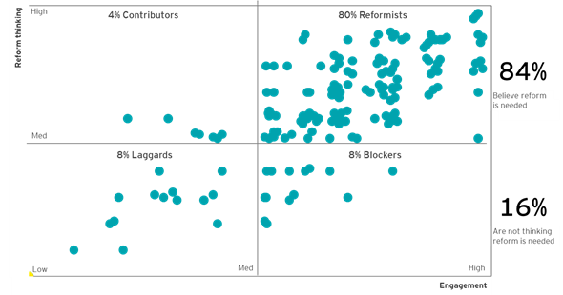

##### A series of workshops between 15 and 25 participants were conducted

The Department and EY co-facilitated five half-day workshops in Sydney, Adelaide, Perth, Canberra and Melbourne. The workshops sought to understand the current state of the Australian agriculture innovation, and explore what the future of innovation might look like. The workshops also considered the strengths and weaknesses of Australian agricultural innovation and analysed how these affected the gap between the current and future states.

There was a broad cross-section of attendees, who generated stimulating discussions and provided a diverse range of viewpoints.

##### Rural stakeholders were engaged in a series of roadshows in New South Wales, Queensland and Victoria

Three week-long regional roadshows were conducted in Queensland, New South Wales and Victoria between October and November. Members of the Department and EY visited producers, processors and innovation hubs in rural areas. These consultations were invaluable in understanding the end users of innovation, what they need to succeed and where they want to see investment.

More than 60 stakeholders were consulted across eight towns, with a variety of roles and capabilities in the agricultural supply chain.

#### Phase two consultations tested insights from phase one and invited stakeholders to guide the focus for the shared vision.

##### Phase two interviews provided stakeholders with a range of strategic choices for the priorities of the future state innovation system

Key statistics:

* 63 stakeholders were interviewed
* 4 focus groups were conducted
* 5 city workshops were facilitated

Stakeholders were presented with a range of strategic choices and asked to identify what they thought should be the primary areas of focus for the future Australian agricultural innovation system.

For example, stakeholders were asked to select whether the agricultural sector should aspire to primarily achieve economic, environmental or social outcomes. The co-design process allowed participants to chart their own vision – please refer to the next page for more information on the co-design process.

##### A series of focus groups addressed specific questions related to key themes that emerged from prior consultations

The team facilitated four focus groups of four to six participants. These discussions adopted a specific focus on key themes that emerged from prior consultations. The four topics addressed were:

* Attracting and allocating capital
* System responsiveness
* Partnerships and collaboration
* Adoption, extension and commercialisation

##### A second phase of workshops were conducted, which focused primarily on the future state vision

Phase two workshops involved stakeholders co-designing the future vision. Stakeholders collaborated to determine what the system should look like and how such a system could be achieved.

Multiple vision options were identified, explored and tested. Such options continued to evolve as phase two progressed.

#### During phase two consultations, a strategic choice framework was introduced.

More than 50 stakeholders were presented with a range of strategic choices, and asked to identify what they thought should be the primary areas of focus for the future Australian agricultural innovation system. Stakeholders were asked to select their top and second preferences out of these options, and provide justifications for their choices.

The co-design process allowed stakeholders to chart their own vision. The chart highlights the strategic choices stakeholders were presented with. The red stars show where the majority of participants voted, while the numbers in the circles represent the average response rate for each option.

Figure Strategic choice framework used during phase 2 stakeholder consultations

The strategic choice framework was tested in phase 2 with various stakeholders and included 7 questions:
1. what outcomes should our agriculture industry be striving towards? 65% responded with economic that is our agricultural industries generate significant economic growth for our country
2. why does our agriculture industry exist? 45% said to provide preimum food and fibre products and services
3. what market should we be targeting? 47% global
4. How far does the system's role extend to? 33% responded with to drive investment in innovation aligned with agricultural outcomes
5. where along the value chain should the agricultural innovation system focus on? 50% across the value chain
6. which horizon should the innovation system focus on? 89% balance between long and short term focus
7. where is the focus for investment in the agriculture innovation system? 59% invest in national agricultural priorities/ missions

#### During phase two, a survey was also conducted to gather additional perspectives from stakeholders on the current state.

##### The Department invited approximately 160 industry representative contacts to participate in the survey.

The study involved 23 eight-minute online surveys collected between 29th October and 29th November 2018. The survey was closed on the 3rd December 2018.

It is important to note that the findings in the survey should be treated as indicative only due to a small base size of n=23 respondents. As such, no sub-group analysis could be performed on the data set.

##### Finding 1: The importance of collaboration is recognised

Almost all respondents to the survey view collaboration amongst stakeholders within the agricultural sector as ‘important’. There is a low level of satisfaction with current collaboration opportunities (17% satisfied). Six in ten (61%) participants stated the ‘lack of collaboration’ as a key risk for the agricultural innovation system in the future.

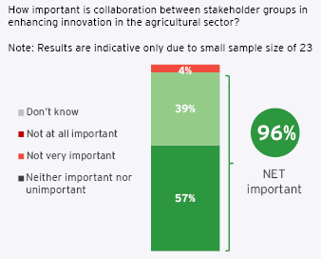

##### Finding 2: Australian agricultural innovation is not currently meeting expectations for all

One in two (52%) participants indicated that the system is not currently meeting expectation. Further, there is a relatively low level of satisfaction in the value of the levy paid (30%), effectiveness of the system (26%) and the transparency and accountability of investment decisions (9%). There is also a lack of consistency among respondents as to the effectiveness of the system. This may be due to varying levels of communication regarding the system’s performance. There appears to be a desire for the system to better meet the needs of those who responded to the survey.

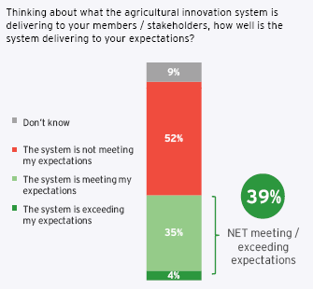

##### Finding 3: A need to build opportunity for user adoption

Survey participants indicated a low level of satisfaction with Australian agricultural innovation’s current ability to support producers in the adoption of innovative technologies (17% satisfied). This is supported by verbatim responses indicating a frustration that a number of R&D opportunities can be too ‘blue sky’ and not viable to be used within a commercial environment. Almost one in two (43%) participants considered user adoption a key barrier for the future development of the agricultural sector.

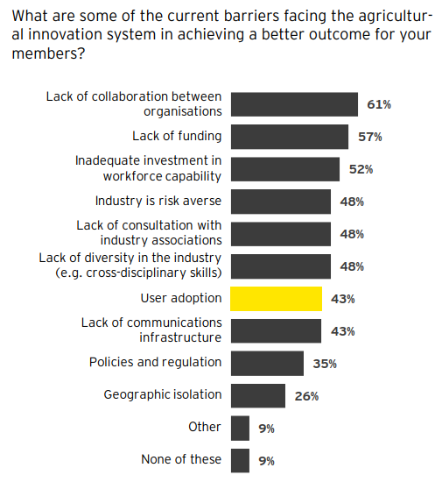

##### Finding 4: A desire for a stronger communications framework

There is a strong desire among survey participants for an improved communications framework – participants highlighted the importance of collaboration and the frustration that innovative solutions have to be deemed viable for the needs of the producer. There is an opportunity to build a more ‘connected’ agricultural innovation system that brings all stakeholders together to ensure that both current and future needs are being met. Survey participants indicated that increasing open communication channels will enhance their feeling of being ‘heard’. This, in turn, will increase relevant R&D and user adoption, stimulating growth in the sector.

How would you describe an ‘ideal’ agricultural innovation system of the future and the key enablers to get there?

“Flexible, responsive and attracts ‘outside the industry’ people and organisations to participate and provide new insights for ag and translate/adapt innovation from other sectors into agriculture”

“A tiered approach for small, medium and large-scale industries (do not ignore the small) - as how do they get larger without innovation support?”

“Dynamic, interconnected, operating within a high level strategic framework and themes that are focused on solving major challenges and capitalising on significant opportunities.”

### Appendix F: approach to relative positioning comparison to other countries

As part of the analysis in international jurisdictions, a relative comparison was undertaken between Australia and other countries across key dimensions. These positions are intended to reflect available public research on the agricultural innovation systems in other countries to better understand their areas of focus and key characteristics. This was supplemented by interviews with participants in all the countries researched.

The relative positions attributed to each country reflect their position against the other countries researched and are not ‘absolute’ positions. It is based on research conducted in each system, including desktop analysis and interviews with people in each system. They are not necessarily reflective of all aspects of each system.

The various dimension of the relative positioning diagram is further explained:

Cost of production: Relative cost of input activities across different countries (e.g. labour cost, power and utilities)
Quality of goods: Relative reputation of agricultural goods produced
Funding source: Relative main driver of funding of agricultural innovation
Adoption/extension: Relative main driver of adoption and extension activities for agricultural innovation
Type of research: Relative primary objective of research conducted in agricultural innovation
Risk appetite: Relative position of willingness to undertake risk in agricultural innovation
Market focus for innovation: Relative main area of focus of agricultural innovation (solutions addressing domestic vs. global issues)
Commercialisation focus: Relative focus on basic research compared to applied research
Level of coordination: Relative involvement of government or a system leader to coordinate R&D activities in agricultural innovation 
Management of innovation portfolio: Relative involvement of government or a system leader to drive decisions on the portfolio of agricultural R&D projects undertaken within agricultural innovation
Short vs long term focus: Relative time horizon focus of a innovation projects undertaken within agriculture 
International cooperation: Relative amount of international partnerships and focus on international collaboration in projects within agricultural innovation

### Appendix G: detailed megatrends

What will shape agriculture in the future? At a global level, agriculture will be influenced by six megatrends, which will drive significant change and transformation to Australia’s agriculture sector within the next 30 years. Specifically, changes in the Australian agricultural sector over the past few decades have been driven by shifts in consumer demand, changes in government policies, technological advances, emerging environmental concerns and a decline in the sector's terms of trade. Consequently, traditional ways of working are no longer sufficient to address the new challenges brought on by such megatrends. Looking to 2050, it is likely that the Australian agricultural sector will be influenced by a growing world population with increasing wealth, a riskier operating environment, increasingly rapid technological change and greater expectations from consumers for their food and fibre products. Together, these megatrends must be considered in order to enable opportunities and mitigate risks.

* Global demand for food and fibre products: The volume and nature of demand for food and fibre will change as populations grow
* Increasing consumer expectations: Future consumers will demand products that are personalised, healthy, and ethical
* Increasing competition for natural resources: Strain on natural resources and declining labour force will drive greater need for adaptive farming
* Increased variability and volatility: Uncertainty will be driven by climate variability and greater threats to the safety of food, crops and livestock
* Embrace non-traditional players: Embrace non-traditional players that can help deliver transformative changes to agriculture
* Digital disruption: Technology will transform farming and commercial practices, and will redefine the innovation process

Note: Six megatrends have been identified based on insights from the CSIRO Rural Industries Futures Report, combined with outcomes from EY research, stakeholder interviews and workshops.

#### Global demand for food and fibre products is rising as the population increases, ages and becomes wealthier; providing export opportunities for Australia

##### Global demand for food and fibre is rising, as the global population continues to grow, age and get wealthier

Agriculture in the 21st century will face multiple demographic challenges. The world population is expected to increase from the current population of 7.3 billion to 9.7 billion people in 2050 (Food and Agriculture Organisation 2017). Similarly, life expectancy is predicted to continue to increase, with the population over 80 years old projected to triple (Food and Agriculture Organisation 2017). Furthermore, the income of the average world citizen is currently 1.4 times higher than what it was in 1990, and is forecasted to continue to grow by 3 times to 2050 (ABARES 2012).

These demographic trends suggest that food demand will continue to increase, backed by the Food and Agriculture Organisation (FAO)’s prediction that by 2050 global food production will need to increase by 70% to feed the world’s population (ABARES 2012).

##### A growing middle class and ageing population will influence demand for more diverse diets and protein

Global agri-food demand is expected to increase noticeably by 2050, due in part to increase in income levels mainly drive by growth in Asia (ABARES 2012). As people move out of poverty into the middle class and beyond, they are more likely to increase their average daily calorie intake and shift their diets from being solely based on staple foods towards high-protein foods, such as dairy, fish, meat and eggs (ABARES 2012). These changes to consumption patterns will require the world food and agricultural production system to adapt.

Figure Share of world agri-food demand, the global diet 2007-50 (kg / person / year) (ABARES 2012)

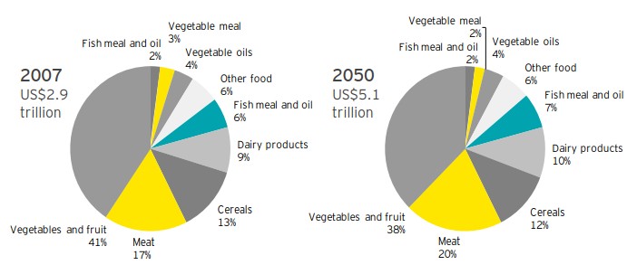

##### What are the implications and opportunities for Australia?

Australian agriculture has a strong export focus, with increasing agri-food exports over the last six years, totalling $49.9 billion in 2016-17 and equating to a total of 14% of Australia’s total goods and services exports in 2016 (Department of Foreign Affairs and Trade 2019).

As demand for food and fibre rises, Australian agriculture will have an increasingly important role in supplying markets and contributing to food security.

In addition to exporting food and fibre, Australia is well placed to export knowledge and technologies. As emerging economies seek to develop their agricultural sectors, they will require advice from those with relevant expertise.

The projected increase in meat, vegetables and fruits consumption in Asia also creates a significant opportunity for Australia, given our proximity to these markets and our established export-oriented meat and horticultural industries.

##### What is required to succeed?

As future agricultural export markets become increasingly competitive, the importance of speed-to-market, price competitiveness, and competitive advantages valued by consumers will heighten. Achieving this will require new, innovative products that will disrupt today’s production practices. The system will need to innovate to develop sustainable production practices capable of producing food and fibre products that meet the specific needs of future consumers and produces at scale to capture the growing opportunity in emerging markets.

#### Consumers are increasingly expecting more information on the nutrition, provenance, sustainability and ethics of food and fibre products

##### Information-empowered consumers of the future will have greater expectations for nutrition, provenance, sustainability and ethics

Health, environmental impacts and ethics will be prominent considerations for consumer’s food choice (Jurcoane et al. 2011). As lifestyle diseases rise and global demographics evolve, public scrutiny of agriculture presents an opportunity to reconnect consumers with the sector as a whole (Lockie 2015).

By 2050, establishing and maintaining a ‘social licence’ will be a key factor for agricultural sector related organisations to succeed, with consumers placing greater emphasis on the ability of businesses to demonstrate ethical operations, and social and environmental responsibility (for example, health, waste, social license, animal welfare or sustainability).

##### Focus on quality, health and nutrition will continue to increase

A recent global survey showed that nearly 90% of consumers would be willing to pay a premium for products with added health and wellness benefits (Nielsen 2015). As future consumers have higher expectations for food and fibre products with specialised characteristics relating to quality, health and nutrition, there is an opportunity for the agricultural sector to better meet these expectations.

Figure Illustrative figure of % of dietary energy obtained from unhealthy food, 2000-30 (CSIRO 2016)

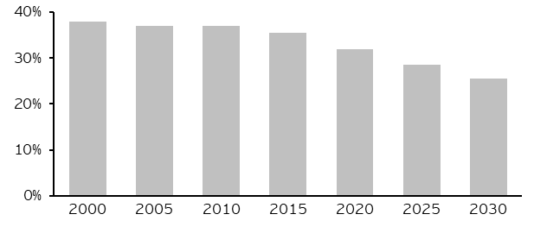

##### What are the implications and opportunities for Australia?

As social and environmental considerations are becoming more prominent, Australia has the opportunity to become recognised as a global provider of premium agriculture, due to its reputation for providing consistent, safe, trusted and high-quality products.

Continuing to demonstrate high safety and biosecurity requirements will be critical to unlock future opportunities. The Australian agricultural sector would benefit from marketing transparency and traceability as part of its value proposition.

In addition, Australian agriculture will need to keep innovating to address growing considerations regarding ethical and sustainable production methods (for example, production practices targeted at protecting our natural resources and our natural environment).

##### What is required to succeed?

Australian agricultural innovation will need to innovate production practices capable of delivering high-value, safe, ethical and affordable food and fibre products. There is merit in establishing a national agriculture strategy that will encourage collaboration and guide focus from the sector to innovating in identified priority areas. This strategy will aim to improve the competitiveness of Australian agriculture by enabling Agricultural innovation to defend and strengthen core focus areas, while broadening the scope to better target growing premium markets, such as luxury food and fibre products.

#### Increasing competition for human and natural resources is creating greater pressure on the Australian agricultural supply chain

##### The rural labour force is ageing and the attractiveness of working in the agricultural sector is declining in Australia

Farmers in Australia are ageing; the proportion of farmers under the age of 35 decreased from 28% in 1981 to approximately 13% in 2011 (ABS 2012). This trend is expected to continue towards 2050 due to, farm aggregation, an increase in the proportion of people pursuing higher level education, and a low exit rate of farmers over the age of 65 (Barr 2014). The agricultural sector accounted for 4.1% and 2.2% of all employed people in Australia in 2011 and 2016, respectively (Binks et al. 2016).

##### Although there is increasing competition for natural resources globally, there are opportunities for Australia to develop new land and water areas

Availability of natural resources continues to decline at an international level. Specifically, the global loss of productive land to desertification and drought is estimated at 12 million hectares each year (United Nations 2018). Global agricultural water use is projected to be 20% higher by 2050 (Global Agriculture 2018). However, Australia has opportunities to convert areas of the country into arable land and leverage underdeveloped water resources that exist in Northern Australia.

##### Consumer preferences for sustainable energy sources is having agricultural implications

Public concerns for environmental emissions have changed the energy market landscape, with growth in agricultural products used in the production of energy. There has been significant growth in the use of sustainable energy sources, such as biofuels in recent years with projections estimating that sugarcane based ethanol, as a share of global ethanol production will increase from 23% in 2009-11 to 28% in 2021 (Food and Agriculture Organization of the United Nations 2012).

Figure Current and estimated potential land use suitable for agriculture in Queensland (% of state land) (Department of Agriculture and Fisheries 2018)

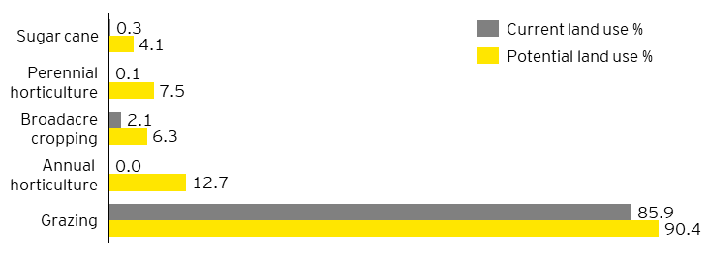

##### What are the implications and opportunities for Australia?

Heading towards 2050, there will be a smaller labour force to satisfy increased demand for food and fibre. Instead, future production systems will rely on intensified mechanisation and advanced technology.

There are considerable opportunities to develop new land and water resources within Australia. As Australia is a water scarce region, there will be an increasing need to focus on innovating to improve the efficiency of demand management through technologies, such as automated irrigation systems.

##### What is required to succeed?

The innovation system will need to adopt a proactive, forward-looking approach to how it can satisfy higher demand levels for food and fibre in an era where natural resources and the rural labour force will be in relative decline. This will be technology driven and will require the system to be flexible and responsive as the increasing pace of innovation transforms production practices and drives ongoing structural change in the agricultural sector. The system will need to determine to what extent it will either leverage best global solutions or develop innovation within Australia.

#### Increasing climate variability and biosecurity threats will impose greater risk and unpredictability for the agricultural sector

##### Future climate conditions are projected to be increasingly variable and volatile

Australia’s risk profile will evolve in future decades as climate change continues to affect our variable climate. Average temperatures in Australia are forecasted to increase by 1-2.5 degrees Celsius by 2070 (CSIRO viewed 2019). Climate change is also expected to alter precipitation patterns, extend heat waves and elevate the frequency and severity of extreme weather events (for example, bushfires, flood and droughts) (CSIRO viewed 2019).

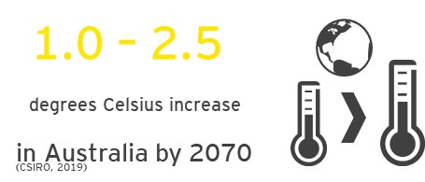

##### Biosecurity risks will threaten the sustainability of food production

The global threat of pests and disease to crop and livestock production has increased in recent decades (Food and Agriculture Organisation 2017). Globally, annual crop losses to plant pests are estimated to be between 20-40% of production (Food and Agriculture Organisation 2017). The impact of pests and disease varies across regions and whilst Australia has strong biosecurity practices, forecasted higher travel and trade (Australian Bureau of Statistics 2015) will increase the risk to agricultural industries and the environment. Agricultural intensification and increased vertical industry integration can also create single point sensitivities in the biosecurity system (Simpson & Srinivasan 2014).

The agricultural sector is inextricably linked to health issues. Since the 1940s, more than 70% of infectious diseases emerged in humans can be traced back to animals, including wildlife (Jones et al. 2008). Food contamination causes approximately 420,000 deaths annually and almost 1 in 10 people to fall ill (World Health Organization 2017). South East Asia, a primary export partner for Australia, is a greatly affected global region, with 175,000 deaths a year attributed to foodborne illnesses (World Health Organization 2015).

##### What are the implications and opportunities for Australia?

Australia will be increasingly challenged by variable climatic conditions and biosecurity threats.

The effects of climate change have amplified the need for resilient and adaptive farming practices, and slow acting countries are at a greater risk of systemic shocks. Australia will need to proactively develop climate-related innovative practices to mitigate the effects of climate variability and natural disasters.

Further, fundamental to Australia’s ‘clean and green’ reputation is our biosecurity system. In a growing and highly competitive global market, remaining pest and disease free will be valuable. Especially as emerging Asian economies become net exporters as this presents a potential opportunity for Australia to market and export innovative biosecurity practices to these countries.

##### What is required to succeed?

Climate change and biosecurity are national issues that will require a system wide coordinated effort to focus innovation investment and research efforts. The system will need to be forward-looking and united around an agreed set of national priorities. Although pesticide and herbicide issues can be commodity-specific, innovation in this area can be accelerated by greater collaboration across industries, sectors and countries.

#### Australian agricultural innovation has an opportunity to embrace non-traditional players who can help deliver transformative changes to the agricultural sector

##### Multinationals from within and outside of the agricultural sector are increasing their R&D investment in Australia

Much of Australia’s recent private sector growth has emerged from firms investing in internal R&D (ABARES 2017). This has been driven by large multinationals; for example, Bayer and John Deere invested €4.5 billion (Bayer 2017) and ~$2 billion in R&D (Deere 2017) in 2017, respectively.

##### AgTech investment is growing in Australia and globally, much of which is being fuelled by non-traditional agricultural investors

AgTech investment has been growing in recent years in Australia and globally (United States Studies Centre 2018). In 2017, the reported amount of funding deals rose by 76% in Australia (AgFunder 2017).

Figure Annual aggregated values of investment in the Australian AgTech market (AgFunder 2017)

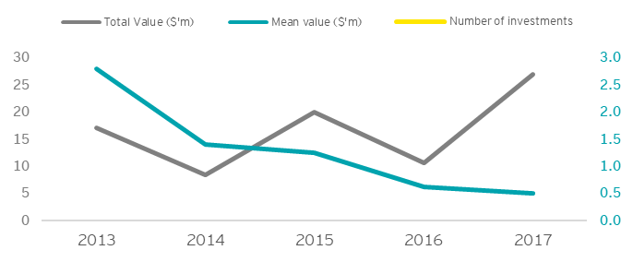

Internationally, 2017 saw AgTech investing become more main stream as non-traditional agricultural players became increasingly prominent. The two most active funding providers in terms of number of investments were non-agricultural sector focused investment entities (AgFunder 2017). There was also growing interest from Silicon Valley VCs, including Google Ventures, and higher investment from sovereign wealth funds (AgFunder 2017). Some of the world's largest companies, such as Google (data), Amazon (food supply chain) and Facebook (connecting and selling to farmers) have also recently entered the space.

##### The scope for agricultural innovation is broadening beyond mainly productivity growth

Emerging technologies are finding application across industries, sectors and borders, which is driving a new innovation in agriculture. Technologies such as blockchain, which can prove provenance and end-to-end supply chain traceability, are enticing new, non-agricultural specific start-ups into the sector. There is greater scope to innovate in agriculture beyond the producer on solutions that affect the broader value chain.

##### What are the implications and opportunities for Australia?

The Australian agricultural innovation system should increase its international presence to enable opportunities for collaborations with multinational corporations, improve the diversity of Australia’s skill base, and establish connections with global supply chains.

With greater investment from non-traditional agricultural investors in AgTech there is opportunity to increase private investment, including VC, private equity and sovereign wealth funds, which are capable of financing larger-scale innovation programs.

Further to this, new funding models, such as structured agricultural investment funds and microfinance investment vehicles, are predicted to play an important role in future agricultural innovation financing (AgFunder 2017), and will provide alternative mechanisms for future funding.

Start-ups and large companies with digital capabilities in areas such as IT, data, and genomics will be important to generating new innovations for the agricultural sector.

##### What is required to succeed?

The system will need to embrace non-traditional players to enhance its capacity to address global trends. Innovation outcomes will be enhanced if the system could encourage greater cross-disciplinary innovation and attract new players to the industry. Australia could facilitate investment in innovation platforms, such as precincts, accelerators and programmes that incentivise R&D investment (for example, tax incentives for R&D).

#### Digital disruption is changing the nature of work, presenting an opportunity to improve existing agricultural practices

##### Digital and technology is disrupting the agricultural sector

Advances in the fields of digital, genetics and materials science continuously change the way that food and fibre products are created and transported. The unconstrained implementation of digital agriculture could lead to a potential increase in value of production by $20.3 billion by 2050 (Council of Rural Research and Development Corporations 2017).

##### Data and AI are driving better farming and commercial decisions

The volume of world data is predicted to more than quintuple by 2025 (Reinsel, Gantz & Rydning 2017). Agricultural data growth will accelerate as an interconnected network of devices that provide data on livestock, crops, soil health, machinery and more. The integration of AI with sophisticated data platforms will improve productivity and drive farm and off-farm decision making. AI in agriculture is forecasted to grow at a CAGR of 24% by 2024 (Energias Market research 2017).

Figure Impact of ‘Internet of Things’ on Australian GDP, 2015 – 2030 (CSIRO 2016)

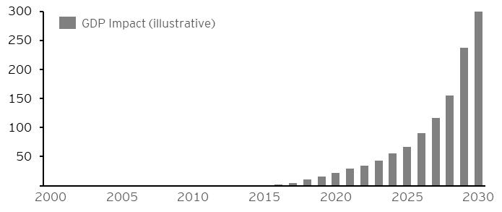

##### Autonomous technologies are creating economic benefits for Australia but are having implications on the role of the labour force

Autonomous technologies, such as robotics, are increasingly performing manual tasks that were traditionally performed by humans. The agricultural sector is utilising higher levels of automation, resulting in decreasing direct employment in agriculture (Trounson 2017). Examples of such technologies include egg collection and sorting, cleaning and automated milking systems. The potential cross-sectoral benefits of automation to the Australian economy have been estimated to be up to $2.2 trillion by 2030 (AlphaBeta 2017).

##### What are the implications and opportunities for Australia?

To enable farming to become less manual and more automated, Australia will need to invest in enabling infrastructure and upskilling farmers to use new innovations and technology.

Further, as accessibility to data continues to increase, Australia will need to consider how data can be best leveraged to drive improved outcomes for national agricultural issues.

Australia will also need to consider how smart devices can be applied on farms to improve labour productivity. For instance, there are opportunities to use mobile robots to assist field workers, reducing injury and improving labour efficiency.

##### What is required to succeed?

Digital agriculture in Australia is immature in many areas, including strategy, culture, governance, technology, data, analytics, and training (CRDC 2017). These issues will need to be addressed if the full benefits of AgTech are to be realised. Many of the challenges impeding digital technology in Australia are common outside of agriculture and therefore, cross-industry and cross-sector collaboration will be crucial in achieving sufficient scale of investment to develop this capability. Significant investment in mobile and internet telecommunication infrastructure will also be required to realise the potential of digital.

### Appendix H: Reference list

ABARE, *National scale land use data*, 2010 http://www.agriculture.gov.au/abares/aclump/land-use/data-download

ABARES, *Agricultural commodity statistics*, 2018 http://www.agriculture.gov.au/abares/research-topics/agricultural-commodities/agricultural-commodities-trade-data

ABARES, Data tables: Rural Research, Development and Extension in Australia, 2017 http://www.agriculture.gov.au/abares/research-topics/productivity/related-research/rural-rde-investment

ABARES, Estimates of Industry Multifactor Productivity, 2018 https://www.abs.gov.au/ausstats/abs@.nsf/mf/5260.0.55.002

ABARES, Food demand to 2050: Opportunities for Australian agriculture, 2012 http://www.agriculture.gov.au/SiteCollectionDocuments/abares/publications/Outlook2012FoodDemand2050.pdf

ABARES, Insights: Snapshot of Australian Agriculture, Issue 1, 2018, http://www.agriculture.gov.au/abares/publications/insights/snapshot-of-australian-agriculture

ABARES, Public investment in agricultural R&D and extension: an analysis of the static and dynamic effects on Australian broadacre productivity, 2011 https://grdc.com.au/__data/assets/pdf_file/0013/142402/public-investment-in-agricultural-rd-and-extension.pdf.pdf

ABARES, Rural research and development corporations, 2017 http://www.agriculture.gov.au/ag-farm-food/innovation/research_and_development_corporations_and_companies

ABARES, Rural research, development and extension investment in Australia, 2018 http://www.agriculture.gov.au/abares/research-topics/productivity/related-research/rural-rde-investment

ABARES, Snapshot of Australia’s Agricultural Workforce, 2018, http://www.agriculture.gov.au/abares/publications/insights/snapshot-of-australias-agricultural-workforce#who-are-australias-agricultural-employees

ABARES, Total Factor Productivity Index for broad acre farming 1977 – 2015, ABARES estimates, 2018

AgFunder, AgFunder AgriFood Tech investment report, 2017, https://research.agfunder.com/2017/AgFunder-Agrifood-Tech-Investing-Report-2017.pdf

Allen Consulting Group, The economic, social and environmental impacts of the Cooperative Research Centres Program, 2012 https://www.business.gov.au/~/media/Business/CRC/Cooperative-Research-Centres-Programme-Economic-Social-and-Environmental-Impacts-2012-PDF.pdf?la=en

AlphaBeta, The Automation Advantage, 2017, https://www.alphabeta.com/wp-content/uploads/2017/08/The-Automation-Advantage.pdf

Alston, JM, Pardey, PG, James, JS & Andersen, MA, The Economics of Agricultural R&D, 2009, https://www.researchgate.net/publication/44019395_The_Economics_of_Agricultural_RD to public agricultural research

ASTI facilitated by International Food Policy Research Institute, Agricultural Science and Technology indicators, http://www.asti.cgiar.org/

Australian Academy of Science, The decadal plan for Australian Agricultural Sciences 2017-26, 2017 https://www.science.org.au/files/userfiles/support/reports-and-plans/2017/agricultural-decadal-plan-2017-26.pdf

Australian Bureau of Statistics, Australian Social Trends, 2012, http://www.abs.gov.au/AUSSTATS/abs@.nsf/Lookup/4102.0Main+Features10Dec+2012

Australian Bureau of Statistics, Overseas arrivals and departures, Australia.’ Cat No. 3401.0 — 2015

Australian Council of Deans of Agriculture, Professional agriculture – a case of supply and demand, 2012 https://www.parliament.vic.gov.au/images/stories/committees/etc/Past_Inquiries/AEV_Inquiry/Submissions/97_Appendix_A.pdf

Australian Council of Learned Academies, Australia’s Agricultural Future. Report for the Australian Council of Learned Academies, 2015 https://acola.org.au/wp/PDF/SAF07/SAF07%20full%20report.pdf

Australian Farm Institute, Enhancing Private-Sector Investment in Agricultural Research & Development and Extension (RD&E) in Australia, 2017

Australian Financial Review, SproutX launches $10m agriculture tech fund and start-up accelerator, 2016 https://www.afr.com/technology/sproutx-launches-10m-agriculture-tech-fund-and-startup-accelerator-20160915-grgp4k

Australian Financial Reviews, Research boosts Australian universities in global Shanghai rankings, 2018, https://www.afr.com/news/policy/education/australian-universities-seal-their-research-reputation-in-global-rankings-20180814-h13y0g

Australian Government, IP Australia, Australian Intellectual Property Report 2018, https://www.ipaustralia.gov.au/ip-report-2018

Barr N, New entrants to Australian agricultural industries – Where are the young farmers? 2014 https://www.agrifutures.com.au/wp-content/uploads/publications/14-010.pdf

Bayer, Annual Report, 2017, https://www.bayer.com/en/entire-bayer-ar17.pdfx

Bellotti, B, How many people can Australia feed, 2017 https://theconversation.com/how-many-people-can-australia-feed-76460

Bettles C, ABARES report – rural R&D up $2.3b to $3b, 2017, https://www.farmonline.com.au/story/4946100/abares-report-rural-rd-up-23b-to-3b/

Binks, B, Stenekes, N, Kruger, H & Kancans, R, Snapshot of Australia’s agricultural workforce, 2016 http://www.agriculture.gov.au/abares/publications/insights/snapshot-of-australias-agricultural-workforce

Bioceres, Corporate Overview, viewed December 2018, http://www.bioceres.com.ar/corporate-overview/

Cooperative Research Centres Association, Overview of CRC program, 2016 https://crca.asn.au/about-the-crc-association/about-crcs/

Cornell University, INSEAD, World Intellectual Property Organisation, Global innovation index, 2018 https://www.globalinnovationindex.org/analysis-indicator

Cotton Seed Distributions, Joint venture to strengthen cotton breeding, 2007 http://www.csd.net.au/news/615-joint-venture-to-strengthen-cotton-breeding

Council of Rural Research and Development Corporations Chairs, Impact of investment in research and development by the rural research and development corporations, 2010, http://www.ruralrdc.com.au/wp-content/uploads/2018/08/CRRDCC-evaluation-report-2009-final-1.pdf

Council of Rural Research and Development Corporations, Accelerating Precision to Decision Agriculture - Enabling digital agriculture in Australia, 2017 https://www.crdc.com.au/precision-to-decision

Council of Rural Research and Development Corporations, Submission 57 Funding Australia’s research, 2018, https://www.aph.gov.au/DocumentStore.ashx?id=3fb371c8-17d8-4a9c-91f0-a6e1b28f59f1&subId=612462

CSIRO Science Health and Excellence Report, 2018 https://publications.csiro.au/rpr/download?pid=csiro:EP15096&dsid=DS1

CSIRO, Australia 2030: Navigating Our Future, 2016, https://www.csiro.au/en/Do-business/Futures/Reports/Australia-2030

CSIRO, Australia's innovation catalyst CSIRO Strategy 2020, 2015 https://www.csiro.au/strategy/

CSIRO, Five Ways to Improve the Agricultural Innovation System in Australia, 2016 https://publications.csiro.au/rpr/pub?pid=csiro:EP16637

CSIRO, How is climate likely to change in the future? viewed January 2019, https://www.csiro.au/en/Research/OandA/Areas/Assessing-our-climate/Climate-change-QA/Future-climate

CSIRO, Transforming the cotton industry for competitive results, 2015 https://www.csiro.au/en/About/Our-impact/Our-impact-in-action/Agriculture-and-Fisheries/Cotton

Department of Agriculture and Fisheries, Queensland agriculture snapshot 2018, 2018 https://www.daf.qld.gov.au/__data/assets/pdf_file/0007/1383928/State-of-Agriculture-Report.pdf

Department of Agriculture and Water Resources, Biosecurity Innovation Program, 2018, viewed January 2019, http://www.agriculture.gov.au/biosecurity/research-innovation/program

Department of Agriculture and Water Resources, Biosecurity, 2018, http://www.agriculture.gov.au/about/commitment/portfolio-facts/biosecurity

Department of Agriculture and Water Resources, Budget 2018-19, 2018, http://www.agriculture.gov.au/about/reporting/budget

Department of Agriculture and Water Resources, Building a strong biosecurity system, 2018, viewed January 2019, https://www.agriculture.gov.au/about/commitment/portfolio-facts/biosecurity

Department of Agriculture and Water Resources, World Trade Organization - Agricultural Trade, Department of Foreign Affairs and Trade, viewed January 2019 https://dfat.gov.au/trade/organisations/wto/Pages/agricultural-trade.aspx

Department of Foreign Affairs and Trade, Agricultural trade, viewed January 2019, https://dfat.gov.au/trade/organisations/wto/Pages/agricultural-trade.aspx

Department of Foreign Affairs and Trade, Israel Insights, 2018, https://dfat.gov.au/trade/engage/economic-diplomacy/Documents/israel-market-insight.pdf

Department of Industry, Innovation and Science, Australia 2030: Prosperity through Innovation, 2017 https://www.industry.gov.au/data-and-publications/australia-2030-prosperity-through-innovation

Department of Industry, Innovation and Science, Australian Innovation System Report, 2017 https://www.industry.gov.au/data-and-publications/australian-innovation-system-report

Department of Industry, Innovation, Science, Research and Tertiary Education (Australia), Powering ideas: an innovation agenda for the 21st century, 2009

Embrapa, Nat. Agric. Research System, viewed January 2019 https://www.embrapa.br/en/snpa

Energias Market Research, Global Artificial Intelligence in Agriculture Market, 2017, https://www.energiasmarketresearch.com/tag/global-artificial-intelligence-in-agriculture-market/

European Commission, Science, technology and innovation in Europe, 2013, https://ec.europa.eu/eurostat/documents/3930297/5969406/KS-GN-13-001-EN.PDF/f25fd4de-8698-461f-970f-ce3608482f4a?version=1.0

EY, The Upside of Disruption: Megatrends Shaping 2018 and Beyond, 2018 https://www.ey.com/Publication/vwLUAssets/EY-the-upside-of-disruption/$FILE/EY-the-upside-of-disruption.pdf

FarmLink, 2017 Research Report, 2017 http://www.farmlink.com.au/research-report

FarmLink, FarmLink Background, 2017 http://www.farmlink.com.au/about

Food and Agriculture Organisation, The future of food and agriculture: Trends and challenges, 2017, http://www.fao.org/3/a-i6583e.pdf

Food and Agriculture Organization of the United Nations, Agricultural Innovation Systems (AIS), reviewed January 2019 http://www.fao.org/in-action/tropical-agriculture-platform/background/ais-a-new-take-on-innovation/en/

Food and Agriculture Organization of the United Nations, OECD-FAO Agricultural Outlook 2012 (Chapter 3), 2012

Food and Agriculture Organization of the United Nations, Water Scarcity – One of the greatest challenges of our time, 2017, http://www.fao.org/zhc/detail-events/en/c/880881/

Forbes, What makes Israel’s innovation ecosystem so successful, 2017, https://www.forbes.com/sites/davidyin/2017/01/09/what-makes-israels-innovation-ecosystem-so-successful/

Geerling-Eiff FA, Linderhof, V & Poppe, K, Study on investment in agricultural research: review for the Netherlands, 2014

Global Agriculture, Water, reviewed January 2019, https://www.globalagriculture.org/report-topics/water.html

Government of the Netherlands, Agricultural exports worth nearly €92 billion in 2017, 2018 https://www.government.nl/latest/news/2018/01/19/agricultural-exports-worth-nearly-%E2%82%AC92-billion-in-2017

Hafi, A, Addai, D, Zhang, K & Gray, E, The value of Australia's biosecurity system at the farm gate: an analysis of avoided trade and on-farm impacts, 2015, http://data.daff.gov.au/data/warehouse/9aab/2015/fgvbsd9aab/FarmGateValueBiosecServices_v1.0.0.pdf

Harvard Business Review, Where the Digital Economy Is Moving the Fastest, 2015, https://hbr.org/2015/02/where-the-digital-economy-is-moving-the-fastest

Heisey P & Fuglie K, Economic returns to public agricultural research, USDA-ERS Economic Brief no.10, 2007

Infrastructure Australia, Our Role, 2019, https://infrastructureaustralia.gov.au/about/role.aspx

Internal Revenue Service, Yearly Average Currency Exchange, viewed January 2019 https://www.irs.gov/individuals/international-taxpayers/yearly-average-currency-exchange-rates

John D, Deere & Company 2017 Annual Report, 2017, https://s22.q4cdn.com/253594569/files/doc_financials/annual_proxy/2017/2017_John-Deere-Annual-Report.pdf

Jones KE, Patel NG, Levy MA, Storeygard A, Balk D, Gittleman JL & Daszak P, Global trends in emerging infectious diseases, 2008 https://www.nature.com/articles/nature06536

Jurcoane, A, Draghici, M, Popa, ME, Niculita, P, Consumer choice and food policy. A literature review, 2011 https://www.researchgate.net/publication/270285136_Consumer_Choice_and_Food_Policy_A_Literature_Review

King, J, Toole, A & Fuglie, K, The Complementary Roles of the Public and Private Sectors in U.S. Agricultural Research and Development, 2012

Lockie S, Australia’s agricultural future: the social and political context. Report to the Australian Council of Learned Academies, 2015 https://acola.org.au/wp/PDF/SAF07/social%20and%20political%20context.pdf

MASHAV, Indo-Israel Agricultural Project (IIAP): A growing partnership https://embassies.gov.il/delhi/Relations/Indo-Israel-AP/Pages/default.aspx

Millist, N, Chancellor, W & Jackson, Rural research, development and extension investment in Australia, 2017 http://www.agriculture.gov.au/abares/research-topics/productivity/related-research/rural-rde-investment

Ministry of Agriculture and Rural Affairs of the People’s Republic of China, CPC No.1 Document, http://english.agri.gov.cn/hottopics/cpc/

National Farmers' Federation, 2030 Roadmap, 2018, https://www.nff.org.au/get/6175.pdf

National Farmers' Federation, Food, Fibre & Forestry Facts, 2017 https://www.nff.org.au/farm-facts.html

National Farmers' Federation, Talking 2030 National Farmers' Federation, 2018, https://www.talking2030.com/

Netherlands Enterprise Agency, Trade and invest information, viewed January 2019 https://www.hollandtradeandinvest.com/business-information/trade-and-invest-information

Netherlands Foreign Investment Agency, Agrifood, 2015 https://investinholland.com/nfia_media/2015/04/NFIA_Agrifood_Brochure2016.FINAL_.WW_.pdf

NHMRC, Annual Report, 2017-2018, https://nhmrc.gov.au/sites/default/files/documents/attachments/publications/Annual-Report-2017%E2%80%9318.pdf

Nielsen Holdings, *We are what we eat: healthy eating trends from around the world*, 2015

OECD, Economic Survey – Australia, 2017, https://www.oecd-ilibrary.org/sites/eco_surveys-aus-2017-7-en/index.html?itemId=/content/component/eco_surveys-aus-2017-7-en

OECD, Innovation, Agricultural Productivity and Sustainability in China, 2018, http://www.oecd.org/innovation/innovation-agricultural-productivity-and-sustainability-in-china-9789264085299-en.htm

OECD, Innovation, Agricultural Productivity and Sustainability in the United States, 2016 http://www.oecd.org/publications/innovation-agricultural-productivity-and-sustainability-in-the-united-states-9789264264120-en.htm

OECD, Innovation, Agricultural Productivity and Sustainability in Brazil, 2015 http://www.oecd.org/environment/innovation-agricultural-productivity-and-sustainability-in-brazil-9789264237056-en.htm

OECD, OECD Science, Technology and Industry Outlook 2012, 2012 http://www.oecd.org/sti/oecdsciencetechnologyandindustryoutlook.htm

OECD, Population with tertiary education, 2017 https://data.oecd.org/eduatt/population-with-tertiary-education.htm

Pratley J, Graduate supply for agriculture – a glimmer of hope, 2016 https://search.informit.com.au/documentSummary;dn=652059273406306;res=IELHSS

QS Top Universities, QS world university rankings – agriculture and forestry, 2018, https://www.topuniversities.com/university-rankings/university-subject-rankings/2018/agriculture-forestry

Reinsel, D, Gantz, J & Rydning, J, Data Age 2025, The Digitization of the World from Edge to Core, 2017 https://www.seagate.com/files/www-content/our-story/trends/files/idc-seagate-dataage-whitepaper.pdf

Reuters, Brazil agriculture, agribusiness contributed 23.5 pct to GDP in 2017 – CNA, 2017 https://www.reuters.com/article/brazil-agriculture/brazil-agriculture-agribusiness-contributed-23-5-pct-to-gdp-in-2017-cna-idUSE6N1ND008

Root of the Matter Knowledge Centre, Vision and objectives, viewed January 2019, http://www.rootofthematter.co.il/en/vision-and-objectives

Rural R&D Corporations, Vision 2050: New thinking about rural innovation in Australia, 2018 http://www.ruralrdc.com.au/wp-content/uploads/2018/12/Vision-2050-Paper-December-2018.pdf

Sheng Y, Gray E M, Mullen J D, and Davidson A, Public investment in agricultural R&D and extension: an analysis of the static and dynamic effects on Australian broadacre productivity, 2011 https://grdc.com.au/__data/assets/pdf_file/0013/142402/public-investment-in-agricultural-rd-and-extension.pdf.pdf

Simpson, M & Srinivasan, V, Australia’s biosecurity future: preparing for future biological challenges, 2014

SmartCompany, Natural advantage: Australian startups are ready to lead the way in global agtech, 2018 https://www.smartcompany.com.au/startupsmart/news-analysis/natural-advantage-australian-startups-lead-way-global-agtech/

Statistics New Zealand, Research and development survey, 2010-16, http://archive.stats.govt.nz/browse_for_stats/businesses/research_and_development/research-development-nz-2016.aspx

Thirlwell, M, *Australia's export performance in FY2017*, 2017 https://www.austrade.gov.au/News/Economic-analysis/australias-export-performance-in-fy2017

Trounson, A, *Farming the Future*, 2017, https://pursuit.unimelb.edu.au/articles/editing-farming-the-future

UNESCO Institute for statistics, How much does your country invest in R&D? viewed December 2018, http://uis.unesco.org/apps/visualisations/research-and-development-spending/

UNESCO Institute for statistics, Science, technology and innovation: GERD by field of R&D, viewed December 2018, http://data.uis.unesco.org/index.aspx?queryid=77#

United Nations, Press Release: World population projected to reach 9.7 billion by 2050, 2015, http://www.un.org/en/development/desa/news/population/2015-report.html

United Nations, Sustainably manage forests, combat desertification, halt and reverse land degradation, halt biodiversity loss, viewed January 2019 https://www.un.org/sustainabledevelopment/biodiversity/

United States Department of Agriculture - National Institute of Food and Agriculture, History, viewed January 2019 https://nifa.usda.gov/history

United States Department of Agriculture, Economic Research Service (ERS), 2015, https://www.ers.usda.gov/data-products/agricultural-research-funding-in-the-public-and-private-sectors/

United States Studies Centre, Australian AgTech: Opportunities and challenges as seen from a US venture capital perspective, 2018 https://www.ussc.edu.au/analysis/australian-agtech-opportunities-and-challenges-as-seen-from-a-us-venture-capital-perspective

University of Queensland, Australia’s role in feeding the world: The future of Australian Agriculture, 2016, https://gci.uq.edu.au/australia%E2%80%99s-role-feeding-world-future-of-australian-agriculture

Wood, P, STEM enrolments hit 20-year low, but scientists have an idea to stop the slide, 2017 https://www.abc.net.au/news/2017-03-30/science-maths-enrolments-hit-20y-low-but-scientists-have-a-plan/8395798

World Bank, Agricultural Innovation Systems: From Diagnostics toward Operational Practices, 2006, http://documents.worldbank.org/curated/en/381521468138591604/pdf/434350NWP0ARDD1Box0327368B01PUBLIC1.pdf

World Economic Forum, Entrepreneurial Ecosystems around the globe and company growth dynamics, 2013, http://www3.weforum.org/docs/WEF_EntrepreneurialEcosystems_Report_2013.pdf

World Health Organization, Food Safety Fact Sheet, 2017, https://www.who.int/news-room/fact-sheets/detail/food-safety

World Health Organization, News Release: WHO’s first ever global estimates of foodborne diseases find children under 5 account for almost one third of deaths, 2015

Wouters, J, Food Valley and the golden triangle for food innovation, 2014, https://www.holanda.es/media/65121/4)%20jeroen%20wouters%20(food%20valley).pdf

EY | Assurance | Tax | Transactions | Advisory

About EY

EY is a global leader in assurance, tax, transaction and advisory services. The insights and quality services we deliver help build trust and confidence in the capital markets and in economies the world over. We develop outstanding leaders who team to deliver on our promises to all of our stakeholders. In so doing, we play a critical role in building a better working world for our people, for our clients and for our communities.

EY refers to the global organisation and may refer to one or more of the member firms of Ernst & Young Global Limited, each of which is a separate legal entity. Ernst & Young Global Limited, a UK company limited by guarantee, does not provide services to clients. For more information about our organisation, please visit ey.com.

© 2019 Ernst & Young, Australia.

All Rights Reserved.

ED none

In line with EY’s commitment to minimise its impact on the environment, this document has been printed on paper with a high recycled content.

Ernst & Young is a registered trademark. Our report may be relied upon by the Department of Agriculture and Water Resources for the purpose of developing the future vision of the Australian agricultural innovation system only pursuant to the terms of our engagement letter in September 2018. We disclaim all responsibility to any other party for any loss or liability that the other party may suffer or incur arising from or relating to or in any way connected with the contents of our report, the provision of our report to the other party or the reliance upon our report by the other party.

Liability limited by a scheme approved under Professional Standards Legislation.

ey.com