Surveillance and reporting of antimicrobial resistance and antibiotic usage in animals and agriculture in Australia
Ramon Z. Shaban, Geoff I. Simon, Darren J. Trott,
John Turnidge, David Jordan
 | 
© Commonwealth of Australia 2014; The University of Adelaide; Griffith University
Ownership of intellectual property rights
Unless otherwise noted, copyright (and any other intellectual property rights, if any) in this publication is owned by the Commonwealth of Australia (referred to as the Commonwealth)
Creative Commons licence
All material in this publication is licensed under a Creative Commons Attribution 3.0 Australia Licence, save for content supplied by third parties, logos and the Commonwealth Coat of Arms.

Creative Commons Attribution 3.0 Australia Licence is a standard form licence agreement that allows you to copy, distribute, transmit and adapt this publication provided you attribute the work. A summary of the licence terms is available from creativecommons.org/licenses/by/3.0/au/deed.en. The full licence terms are available from creativecommons.org/licenses/by/3.0/au/legalcode.
Inquiries about the licence and any use of this document should be sent to copyright@agriculture.gov.au.
This publication (and any material sourced from it) should be attributed as: Shaban RZ, Simon GI, Trott DJ, Turnidge J & Jordan D 2014, Surveillance and reporting of antimicrobial resistance and antibiotic usage in animals and agriculture in Australia. CC BY 3.0.
Cataloguing data
Shaban RZ, Simon GI, Trott DJ, Turnidge J & Jordan D 2014, Surveillance and reporting of antimicrobial resistance and antibiotic usage in animals and agriculture in Australia, report to the Department of Agriculture, Griffith University and University of Adelaide, Australia.
ISBN 978-0-646-93036-7 (printed)
ISBN 978-0-646-93036-7 (online)
This publication is available at agriculture.gov.au/publications.
Department of Agriculture
Postal address GPO Box 858, Canberra ACT 2601, Australia
Switchboard +61 2 6272 2000
Facsimile +61 2 6272 2001
Web agriculture.gov.au
Griffith University
Griffith Heath Institute Centre for Health Practice Innovation
Griffith University, 170 Kessels Road, Nathan, Queensland 4111, Australia
University of Adelaide
Adelaide Research and Innovation
Level 14, 115 Grenfell Street, Adelaide South Australia 5000, Australia
Acknowledgements
The authors (Professor Ramon Z Shaban and Mr Geoff Simon, Centre for Health Practice Innovation, Griffith Health, Griffith University; Associate Professor Darren Trott and Professor John Turnidge, University of Adelaide; Associate Professor David Jordan, NSW Department of Primary Industries) acknowledge the support from the Australian Government Department of Agriculture, the Project Steering Committee (Dr Stephen Page, Prof Mary Barton, Dr Jane Heller, A/Prof Rowland Cobbold), participants in various stakeholder engagements and Ms Kerri Gillespie for their assistance with this project and report.
Disclaimer
The Australian Government acting through the Department of Agriculture has exercised due care and skill in preparing and compiling the information and data in this publication. Notwithstanding, the Department of Agriculture, its employees and advisers disclaim all liability, including liability for negligence, for any loss, damage, injury, expense or cost incurred by any person as a result of accessing, using or relying upon any of the information or data in this publication to the maximum extent permitted by law.
Contents
Foreword 9
Summary 10
Background 12
1 Surveillance and reporting of antimicrobial resistance and antibiotic usage in animals and agriculture in Australia 17
1.1 Animals, microorganisms and antimicrobials considered in the report 18
1.2 Microbes and antimicrobials 28
1.3 The problem of antimicrobial resistance 30
1.4 Reversing trends in antimicrobial resistance 41
1.5 Reasons for surveillance 43
1.6 Historic and current antimicrobial use and resistance surveillance in Australia 43
1.7 Australia’s national focus on surveillance activities 47
1.8 Key differences between surveillance for AMR and drug use in animals and humans in Australia 47
2 The global context: existing programs and activities 50
2.1 Supranational organisations 50
2.2 An overview of key characteristics of global surveillance and reporting systems 65
3 Options and models for the Australian context 69
3.1 Objectives of international antimicrobial resistance surveillance systems 69
3.2 Case studies—existing programs of most relevance to the Australian context 69
3.3 Critical elements contributing to the success of existing systems 85
4 National coordination in Australia: systems, enablers and barriers 87
4.1 Setting the scene—a recent history 87
4.2 Fundamentals to national coordination in animals and agriculture 93
4.3 A generic model for the surveillance of antimicrobial resistance 108
4.4 A generic model for the monitoring of antimicrobial usage 125
4.5 Strategic options and assumptions for national coordination in animals and agriculture: enabler and barrier analysis 147
5 Australia’s response—National surveillance and reporting 148
5.1 Recommendations 148
5.2 Key influences on the recommendations 153
Appendix A Study design and methods 155
Appendix B Evidentiary table 158
International or supranational programs 158
European Country-specific 165
United States and Canada, South and Central America 179
Asia 182
Australia 185
Abbreviations 187
References 189

List of Tables
Table 1 Simplified classification groups of the Australian animal populations for consideration within surveillance 18
Table 2 Sectors not in scope for the report 18
Table 3 Definition of life cycle and production stages in scope showing in general the focus on live animals and the exclusion of commodities 19
Table 4 Antimicrobials of interest 20
Table 5 Microorganisms of interest 26
Table 6 Potential responses to factors influencing AMR 35
Table 7 Estimates of total sales of veterinary antimicrobials (tonnes of active ingredient) 44
Table 8 Estimates of use of veterinary antimicrobials in Australia (tonnes of active ingredient) 44
Table 9 Estimates of use of veterinary antimicrobials in Australia (proportion of sales) 44
Table 10 Examples of antimicrobial resistance surveillance and monitoring programs from 2014 WHO global report on surveillance 50
Table 11 Members of WHO Advisory Group on Integrated Surveillance of Antimicrobial Resistance 52
Table 12 Animal populations prioritised by the EFSA 55
Table 13 EFSA recommendations on combinations of Salmonella/food animal populations and desirable numbers of isolates to be included in susceptibility testing. 58
Table 14 EFSA recommendations on combinations of Campylobacter/food animal populations and desirable numbers of isolates to be included in susceptibility testing 59
Table 15 EFSA recommendations on combinations of indicator commensal E. coli /food animal populations and desirable numbers of isolates to be included in susceptibility testing 60
Table 16 EFSA recommendations on combinations of indicator commensal enterococci, food animal populations and desirable numbers of isolates to be included in susceptibility testing. 60
Table 17 Harmonised set of antimicrobials listed in EFSA technical specifications. 61
Table 18 VetStat definition of animal species, age group and standard weight, and diagnostic group 83
Table 19 Estimate of sample sizes needed for documenting increasing antimicrobial resistance frequencies 94
Table 20 Cefotaxime MICs (mg/L) for commensal E Coli isolated from poultry in ‘Country C’ 106
Table 21 OIE recommendations for national AMR surveillance systems of terrestrial and aquatic animals 108
Table 22 World Organisation for Animal Health (OIE) examples of sampling sources, sample types and monitoring outcomes 112
Table 23 World Organisation for Animal Health (OIE) recommendation for recording, storage and interpretation of antimicrobial resistance data 112
Table 24 World Organisation for Animal Health (OIE) recommendations for national reference laboratories and annual reports 114
Table 25 WHO AGISAR recommendations for national surveillance systems—sampling and system design 115
Table 26 World Health Organization Advisory Group on Integrated Surveillance of Antimicrobial Resistance recommendations for national surveillance systems—laboratory testing 117
Table 27 World Health Organization Advisory Group on Integrated Surveillance of Antimicrobial Resistance recommendations for national surveillance systems—data and reporting 118
Table 28 EFSA Working Group recommendations for surveillance 120
Table 29 EFSA recommended antibiotics 122
Table 30 Intensity of antimicrobial use in selected countries 124
Table 31 APUA list of data categories 125
Table 32 Advantages and limitations of data collection methods 126
Table 33 Committee ratings of six methods for data collection 128
Table 34 OIE recommended elements of a system to monitor antimicrobial use. 129
Table 35 World Health Organization Advisory Group on Integrated Surveillance of Antimicrobial Resistance recommendations for antimicrobial usage surveillance systems 132
Table 36 Groups of veterinary antimicrobials and Anatomic Therapeutic Chemical classification system (vet) codes to be included in monitoring and data submitted to ESVAC 135
Table 37 Animal species and weight groups/production types for which data should be provided to ESVAC 137
Table 38 World Health Organization Advisory Group on Integrated Surveillance of Antimicrobial Resistance recommended data elements 138
Table 39 AGISAR recommendations regarding data intended to monitor antimicrobial consumption. 140
Table 40 A staged approach with five key elements 147
Table 41 Suggested element 2 provisional sampling matrix providing indicative sampling intervals and priorities for further development and discussion 151

List of Figures
Figure 1 Broader surveillance system considerations 12
Figure 2 Time line of major reports, committees and events 14
Figure 3 Examples of how antibiotic resistance spreads 33
Figure 4 Pathways for the flow of resistance genes 34
Figure 5 Discovery dates for antimicrobial classes and the ‘discovery void’ 39
Figure 6 Time line of antibiotic deployment and emergence of resistance 40
Figure 7 Antimicrobial resistance containment and surveillance elements 42
Figure 8 Estimated quantities of veterinary antimicrobials sold in Australia (tonnes of active ingredient) 45
Figure 9 The World Economic Forum's 2013 Global Risks Map 63
Figure 10 Costs, impact and burden of antibiotic resistant bacteria 64
Figure 11 Diagram of CIPARS surveillance activities, extracted from the 2009 CIPARS Annual Report for 2009 72
Figure 12 DANMAP Data flow 82
Figure 13 VetStat reporting pathways 82
Figure 14 VetStat data elements 83
Figure 15 VetCIS data flow schematic 103
Figure 16 EFSA example of presentation of dichotomised data 105
Figure 17 Cefotaxime MICs in poultry from ‘Country C’ 106
Figure 18 Time trend of the mean of the log2 MIC (with 95 per cent confidence intervals), obtained from poultry 107
Figure 19 Examples of sampling considerations through the production chain 117
Figure 20 Distribution of population correction unit (1,000 tonnes) by food-producing animal species, by country, for 2011 141
Figure 21 Distribution of sales aggregated for 25 EU/European Economic Area countries for 2011 142
Figure 22 Distribution of sales of veterinary antimicrobial agents by pharmaceutical form, by country for 2011 143
Figure 23 Sales (a) for food-producing species for 20 countries in 2010 143
Figure 24 Sales (a) for food-producing species for 25 countries in 2011 144
Figure 25 Spatial distribution of sales of tetracyclines (a) for 2011 145
Figure 26 Spatial distribution of sales of first- and second-generation cephalosporins for 2011 145

Foreword
Antimicrobial resistance (AMR) is a global threat to human health, with bodies such as the World Health Organization (WHO) and the World Organisation for Animal Health (Office International des Epizooties [OIE] ) calling on all nations to take urgent action to address the growing threat, with a focus on a ‘One Health’ approach .
One Health is defined as ‘the collaborative effort of multiple health science professions, together with their related disciplines and institutions—working locally, nationally, and globally—to attain optimal health for people, domestic animals, wildlife, plants, and our environment.’ Imperatives for this approach listed by the One Health Commission include:
- worldwide, nearly 75 per cent of all emerging human infectious diseases in the past three decades originated in animals
- environmental health may affect human and animal health through contamination, pollution and poor conditions that may lead to new infectious agents
- the world population is projected to grow from 7 billion in 2011 to 9 billion by 2050
- to provide adequate healthcare, food and water for the growing global population, the health professions, and their related disciplines and institutions, must work together
- the human-animal bond beneficially impacts the health of both people and animals.
While the direct impact on human health of bacteria that have developed resistance to important antimicrobial agents is often the focus of concern, an additional reality is the ever increasing global demand for high quality protein food sources. The preservation of antimicrobial efficacy and appropriate use of key agents in the veterinary setting is critical to ensuring that animal production keeps pace with this demand . Further to these concerns is the fact that many people share their lives with companion and performance animals in the home and in sporting arenas, and there is significant opportunity for transfer of both bacteria and resistance genes in these settings . Humans and animals share many of the same bacteria, and a range of human pathogens are of animal origin, lending weight to the need for coordination of efforts between human health, animal health, and food production sectors .
This report was commissioned by the Australian Government Department of Agriculture to present an analysis of, and recommendations about, surveillance and reporting of antimicrobial resistance and antibiotic usage in animals and agriculture in Australia.

Summary
Surveillance and reporting of antimicrobial resistance (AMR) and antibiotic usage (AU) is a global health priority. Whilst the direct use of antimicrobial agents in human health is recognised as a major contributor to antimicrobial resistance in human pathogens, there are circumstances where antimicrobials used in both food-producing and companion animals are key contributing factors. Therefore, at the core of effective surveillance systems is the integration of human, animal and agriculture programs within a One Health framework.
The establishment of an integrated system for surveillance and reporting of AMR and AU for Australia that encompasses human, animal and agriculture is a national priority. Australia has significant populations of food-producing animals (for example, 74.7 million sheep; 28.5 million cattle), a substantial meat export industry, one of the highest rates of pet ownership in the world, and is home to a prominent and diverse equine population. Programs for AMR and AU surveillance must be tailored to address the many unique features of a dispersed population and resources, livestock production, and animal management in this country.
Australia’s role as a major food producer and exporter demands that programs be of the highest integrity and conform to international standards. Alongside restrictions on fluoroquinolone use in humans, Australia is the only country that has regulatory measures in place to exclude the use of this class of antibiotic in food-animal species. Compared with many other countries, Australian farming methods have a stronger reliance on extensive animal production without housing, and there are quarantine bans in place on the importation of fresh meat and live animals. Given these inherent factors, Australian primary produce could potentially have a very low AMR risk status, providing a competitive trade advantage. However, to confirm this status, a comprehensive national surveillance program is required. This report was commissioned by the Australian Government Department of Agriculture to support national AMR prevention and containment efforts. It presents an analysis of, and recommendations about, surveillance and reporting of antimicrobial resistance and antibiotic usage in animals and agriculture in Australia. The report:
- Presents an analysis of international antimicrobial resistance surveillance and usage monitoring in the animal/agriculture sector;
- Reviews recent antimicrobial resistance surveys and usage monitoring in the animal/agriculture sector in Australia;
- Explores options for the establishment of a nationally coordinated approach to resistance surveillance and usage monitoring and in the animal/agriculture sector appropriate for the Australian context;
- Explores how potential solutions accord with World Organisation for Animal Health (OIE) Standards;
- Investigates the enablers and barriers associated with potential solutions.
In the international context, AMR and AU surveillance programs from nineteen countries spanning five continents were appraised (See Appendix 2 Evidentiary table). Four programs, namely RESAPATH (France), DANMAP (Denmark), CIPARS (Canada) and NARMS (United States) were selected for more in depth analysis on the basis of international reputation for excellence, reliance on approaches applicable to the Australian context and similarities in the political, social and economic operating environments. Key features and lessons learned from these programs are noted.
While Australia currently does not have a federally funded antimicrobial resistance and antibiotic usage surveillance program focused on animals, a number of notable one-off surveys have been conducted in recent years. These surveys have consistently confirmed a low public health risk in the food-animal sector related to resistance including against critically important drugs such as fluoroquinolones. Australian case studies include: (i) a one-year survey sponsored by Zoetis which developed a network of veterinary diagnostic laboratories throughout Australia to submit bacterial pathogens from diseased animals to a centralised laboratory for resistance monitoring; (ii) surveys funded by the Commonwealth and Meat and Livestock Australia (MLA) to investigate antimicrobial resistance in commensal bacteria and foodborne pathogens isolated from healthy food-producing animals at slaughter; and (iii) MLA and Australian Pork Limited (APL) funded studies examining AU patterns in food-animal species in Australia.
The findings of this report culminate in recommendations on surveillance options and models that take into account a range of enablers and barriers, as well as the unique attributes of animal health and production in Australia, and identify short, medium and long-term goals. Recommendations relate to:
- AMR surveillance of animal/zoonotic pathogens in companion, performance and food-producing animals
- AMR surveillance of commensals and foodborne pathogens in food-producing animals only
- AU surveillance in companion, performance and food-producing animals
- planning and stakeholder engagement
- management of outputs for public health, animal health and animal production.
Time-intervals, ranging from two to five years, are suggested for sampling in key animal production species, with intervals reviewed regularly and adjusted according to findings and prevailing circumstances. One-off surveys are recommended for less prominent or lower-risk food-animals such as aquaculture species, game birds and the export horse-meat industry.
Implementation of the recommendations of this report alongside those of the AMRSC Report entitled National surveillance and reporting of antimicrobial resistance and antibiotic usage for human health in Australia is required for optimal cost-effectiveness, efficiencies and synergies within a One Health framework. Without adequate stakeholder engagement and involvement, surveillance will be costly and difficult to achieve, particularly in terms of governance and integration across human and animal/agriculture sectors. Human surveillance programs can to some extent rely on passive surveillance of antimicrobial resistance data from human diagnostic laboratories. This may not be viable with respect to animal pathogens as sampling occurs to a limited extent, and there is variability in methods and approaches currently operating in Australia’s veterinary diagnostic laboratories.
In conclusion, National surveillance of AU and AMR in animals and agriculture requires the co-operation of Commonwealth and State Departments, including Agriculture, Primary Industries and Health portfolios, as well as academic and industry stakeholders at both governance and operational levels. For continued success and efficiency, programs must be integrated with existing and planned surveillance activities for humans and operate under a One Health umbrella.

Background
In February 2013, the Australian Antimicrobial Resistance Prevention and Containment (AMRPC) Steering Group was established. The Steering Group is jointly chaired by the Secretaries of the Department of Health and the Department of Agriculture. The Commonwealth Chief Medical Officer and Chief Veterinary Officer are also members. The Steering Group is providing high level national governance and leadership on AMR, and is charged with overseeing the development of a comprehensive national AMR prevention and containment strategy for Australia.
The work of the AMRPC Steering Group will draw in part on the expertise of the Antimicrobial Resistance Standing Committee (AMRSC) which was established in April 2012 by the Australian Health Protection Principal Committee (AHPPC) and endorsed by the Australian Health Ministers Advisory Council (AHMAC). AMRSC is comprised of representatives from the Australian Government and its agencies in human and animal contexts, clinical experts and professional colleges. AMRSC commissioned a report titled ‘National Surveillance and Reporting of Antimicrobial Resistance and Antibiotic Usage for Human Health in Australia’, to provide a review of AMR issues and activities spanning the previous fifteen years in Australia and internationally, an analysis of existing systems and infrastructure, and views on enablers and barriers to the development of systems to address AMR issues on a national basis. This report assisted AMRSC in developing a number of recommendations, which included the establishment of a national coordinating centre to oversee a range of data collation, analysis, reporting and research activities.
While the scope of the AMRSC Report was analysis of activities, gaps and options in the human health context, the report acknowledged the importance of AMR and antibiotic use in veterinary and agricultural practice, and centred its recommendations on national coordination using a One Health framework linking together data on resistance and antibiotic use from humans, animals and agriculture to provide a national picture on AMR. The report is harmonious with international practice and expert opinion in recommending that effective surveillance across the sectors is the cornerstone of efforts to control AMR. A graphic reproduced from the AMRSC Report indicating the necessity of linking animal data into a national surveillance system is shown in Figure 1 .
Figure 1 Broader surveillance system considerations
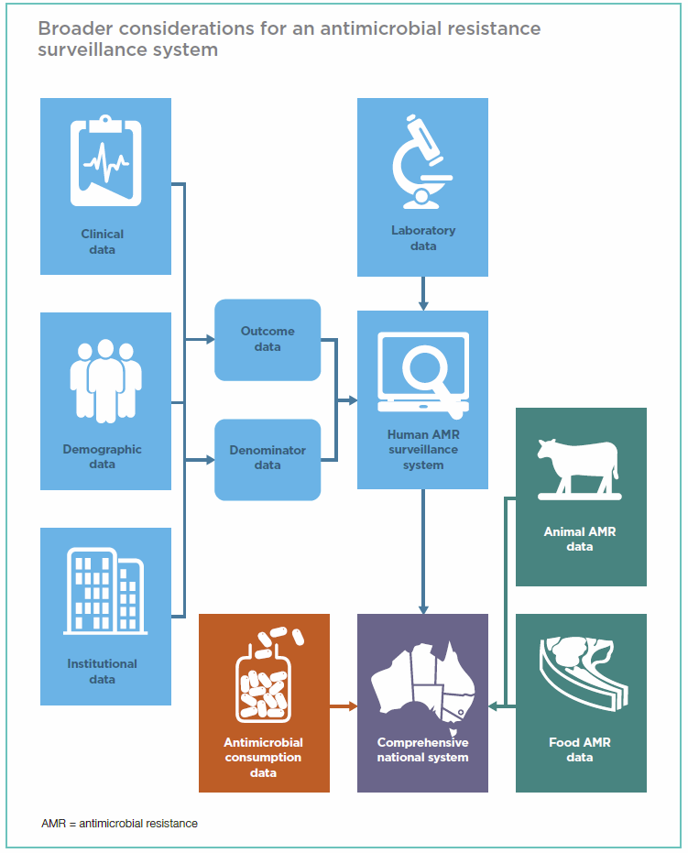
Note: AMR antimicrobial resistance.
Source: Shaban et al. 2013
On 29 November 2012, the Australian Senate referred a number of matters relating to AMR to the Finance and Public Administration References Committee. The Committee undertook a Senate Inquiry, and delivered its report on ‘Progress in the implementation of the recommendations of the 1999 Joint Expert Technical Advisory Committee on Antibiotic Resistance’ in June 2013. The recommendations of the Senate committee are reproduced on the next page .
The purpose of the Senate Inquiry was to investigate what had and had not occurred in Australia following the recommendations of the Joint Expert Technical Advisory Committee on Antibiotic Resistance (JETACAR), which was convened in 1997 and reported in 1999, after reviewing the linkage between antibiotic use in food-producing animals, and the emergence and spread of resistant microorganisms to humans.
Recommendation 1
The committee recommends that the Commonwealth establish an independent body or national centre, to develop a strategy, report publicly on resistance data and measures taken to combat antimicrobial resistance and to manage the response to antimicrobial resistance in Australia.
Recommendation 2
The committee recommends that the independent body be resourced to implement a rigorous monitoring and reporting regime of antibiotic use in humans and animals and of multiple drug resistant infections in humans and animals.
Recommendation 3
The committee recommends that the voluntary reporting of the quantity of antimicrobials sold by volume be made mandatory for the registrants of antimicrobials.
Recommendation 4
The committee recommends that the Australian Pesticides and Veterinary Medicines Authority:
- publish, as a matter of priority, the antibiotic usage report for the period 2005–06 to 2009–10
- publish antibiotic usage reports on an annual basis and within 18 months of the end of the relevant financial year.
Recommendation 5
The committee recommends that the Australian Commission on Safety and Quality in Health Care consider mechanisms to improve coordination and tighten access to antimicrobials in healthcare services, particularly in relation to any new antimicrobials that become available.
Recommendation 6
The committee recommends that the Department of Health and Ageing investigate additional mechanisms to improve antibiotic stewardship in general practice.
Recommendation 7
The committee recommends that consideration be given to banning all antibiotics listed as 'critically important in human medicine' by the World Health Organization for use in animals in Australia.
Recommendation 8
The committee recommends that Australian Commission on Safety and Quality in Health Care coordinate the development of a national system of enhanced infection control including minimum hospital inpatient infection control standards, and standards for community health practices and aged care facilities.
Recommendation 9
The committee further recommends that the Commonwealth consider further support for research and development in infection control in farmed animals with the goal of reducing the need for the use of antibiotics in agriculture, taking into account the costs and impacts of proposed measures on animal health and farming practices.
Recommendation 10
The committee recommends that the Commonwealth consider measures to support research into strategies to deal with antimicrobial resistance, including research into new antibiotics and consideration of antimicrobial resistance being designated a National Research Priority Area.
Further detail on the events and actions taken by a range of government organisations, committees and other bodies subsequent to JETACAR can be found in the AMRSC Report and in the findings of the Senate Inquiry. A timeline of key reports and publications, committees and working groups, and meetings and activities is shown in Figure 2.
Figure 2 Time line of major reports, committees and events
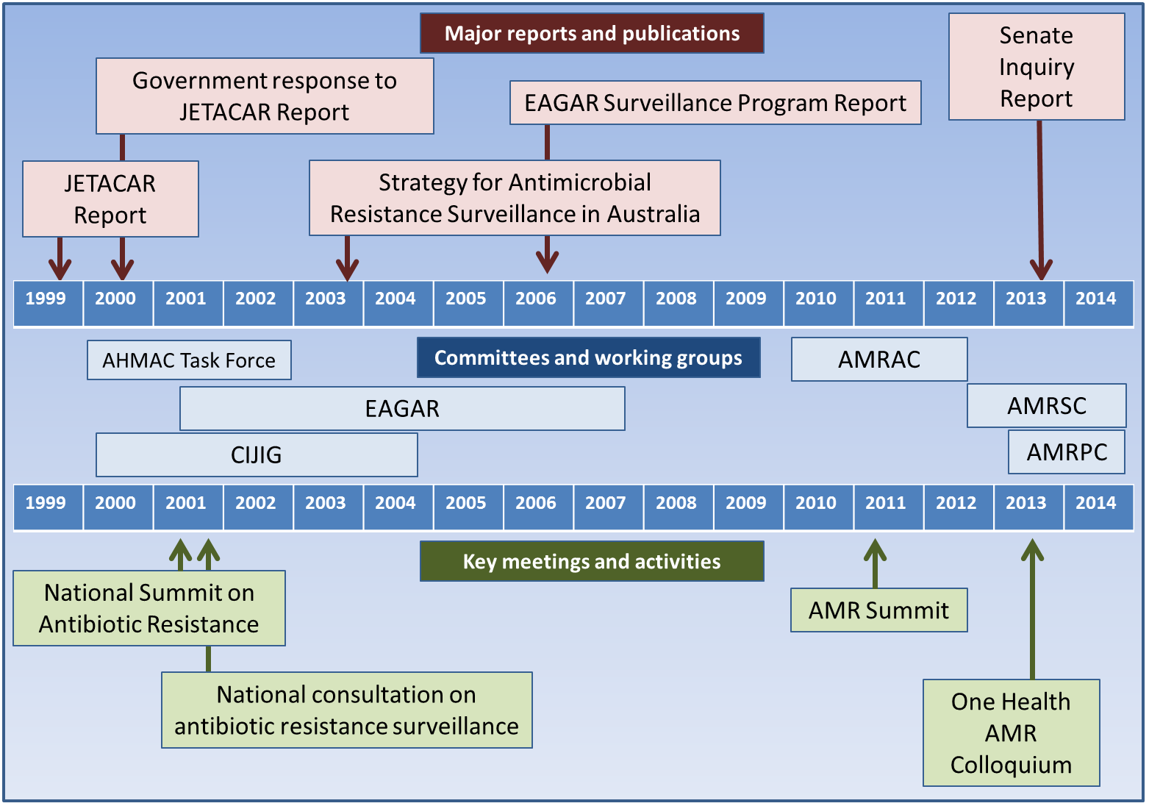
Note: AHMAC Australian Health Ministers Advisory Council; AMR Antimicrobial resistance; AMRAC Anti Microbial Resistance Advisory Committee; AMRPC Australian Antimicrobial Resistance Prevention and Containment Committee; AMRSC Antimicrobial Resistance Standing Committee; CIJIG Commonwealth Interdepartmental JETACAR Implementation Group; EAGAR Expert Advisory Group on Antimicrobial Resistance; JETACAR Joint Expert Technical Advisory Committee on Antibiotic Resistance.
Source: Compiled from a range of government and non-government sources.
Subsequent to the Senate Inquiry, the Australian Commission on Safety and Quality in Healthcare (ACSQHC) has been given the responsibility of establishing a national centre for AMR surveillance, and $11.9 million over three years was committed in the 2013-14 Health Budget to support the development of the Australian National AMR Prevention and Containment Strategy.
The Australian Department of Agriculture has committed to provide AMRSC and the AMRPC Steering Group, through this report, with analysis on surveillance and reporting of antimicrobial resistance and antibiotic usage in animals and agriculture in Australia, including options for monitoring and surveillance in the animal/agriculture sector which could fit within a nationally coordinated One Health framework. This report has been structured to be complementary to the AMRSC ‘National Surveillance and Reporting of Antimicrobial Resistance and Antibiotic Usage for Human Health in Australia’ report, making reference to that report where appropriate, but providing context and pursuing recommendations relevant to animals and agriculture.

Surveillance and reporting of antimicrobial resistance and antibiotic usage in animals and agriculture in Australia
Whilst the direct use of antimicrobial agents in human health is responsible for significant current global AMR issues (for example, multidrug-resistant tuberculosis), the use of antimicrobial agents in animals has been demonstrated to be associated with the emergence and persistence of resistant bacterial strains (for example, E. coli containing extended-spectrum beta-lactamases), with the potential for transfer of the organisms or of genetic material coding for resistance to humans. Multiple World Health Organization (WHO) reports have concluded that both antimicrobial resistance and antimicrobial usage in animals should be monitored on the national level . To be effective in addressing the growing threat presented by antimicrobial resistance, surveillance studies must be based on standardised protocols, be longitudinal, and cover a sufficiently large and representative population, but many programs fall short of these requirements . Existing programs range from those with a narrow base, covering a few disease-causing organisms in a specific area of concern, to those covering many organisms including normal microbiota and multiple antimicrobial compounds .
A common problem in the development of comprehensive and effective surveillance systems has been the availability of sufficient funding to adequately plan, design and implement a sustainable and robust solution. Key characteristics must be considered, including the ability for a system to detect small but significant changes in population resistance characteristics against a range of antimicrobial agents, and the facility to promulgate information to a wide audience in a timely manner. Such information can then be used to determine strategies and criteria for action .
The WHO identifies elements that influence the design of national monitoring programs to include local epidemiology and treatment of foodborne diseases, public health resources, laboratory capacity, government policies, production practices, food animal processing, distribution of food products, and pre-existing public health infrastructure .
Sustainability over time, and the ability to provide data needed to establish trends in antimicrobial resistance that support public-health related decision making are important characteristics to consider. Participation of a range of sectors and professions is a hallmark of programs that are sustained long term, with input incorporated from :
- scientists and clinicians from a range of disciplines including physicians, veterinarians, microbiologists, epidemiologists and soil scientists;
- representatives from food production industries;
- government agencies responsible for risk assessment, risk management and research.
Elements required to establish and operate a sustainable integrated antimicrobial resistance surveillance program include the following :
- a sound sampling scheme along the food chain
- sustained political and financial support arising from a recognition of the public health importance of surveillance
- ongoing quantitative and qualitative risk assessments for emerging and potential hazards and the flexibility to adjust resources and program priorities as necessary
- cooperation and good communication between the agriculture, companion animal and public health sectors
- collaboration and information-sharing between the disciplines, sectors and professional groups identified above
- microbiological and epidemiological research to better understand the implications of data from routine monitoring
- publication of findings for different audiences in a timely manner
- a continuous process of program review and enhancement.

Animals, microorganisms and antimicrobials considered in the report
The range of areas of interest for this report potentially spans from high volume commercial food production animals to boutique small holdings of exotic animals and esoteric pets, and microorganisms ranging from common commensals to pathogens. However, it is important that a pragmatic approach is taken to identifying groupings that present the greatest risk to the greatest number in order that the scope of the report is manageable and it can be delivered in a suitable timeframe, and that responses and actions by government and other stakeholders can be targeted and productive in addressing issues.
For the purposes of designing the research methodology that underpins the report, and to facilitate focussed stakeholder consultation, a model was developed to describe elements of interest and concern incorporating the following parameters:
- animal and agricultural sectors of interest
- microorganisms of interest
- antimicrobials of interest.
The model has been refined through iterative processes including peer review, literature review, and stakeholder consultation. The model developed using this methodology therefore represents a consensus view of the areas of major interest and concern, and then forms the basis for consideration of appropriate actions and responses.
It is acknowledged that not all issues and individual areas of interest and concern can be addressed in this report. The methodology has, however, served to prioritise the elements that warrant broader actions and attention in the short term, leaving open the question of what needs to be done in areas that are defined as out of scope.

Scope of animals and agricultural practices
The first step in prioritising animal and agricultural sectors that are potentially the focus of the report was to define broad sectors of interest, environments in which animals would be found within the sectors, types of animals and their role or end use. The results of the iterative process to reach consensus to underpin the model are shown in Tables 1, 2 and 3. This list should be reviewed systematically by an expert surveillance steering group to identify additional minority species and production systems for survey on a risk basis, such as horse meat for export.
Table 1 Simplified classification groups of the Australian animal populations for consideration within surveillance
Sector | Environment | Animal type | Major commodities
Red meat production | Grazing | Wool breeds of sheep | Wool, meat, animals
Red meat production | Grazing | Meat breeds of sheep | Meat, wool, animals
Red meat production | Feedlot | Meat breeds of sheep | Meat, animals
Red meat production | Feedlot | Beef cattle | Meat
Pork production | Intensive and housed | Pigs | Meat
Poultry production | Intensive and housed | Meat chickens | Meat, fertiliser
Poultry production | Intensive and housed | Layer chickens | Eggs, fertiliser
Poultry production | Low intensity | Meat or layers | Meat, eggs
Dairy production | Pasture based | Dairy cattle | Milk, meat, animals
Aquaculture | Fish farm | Fish, prawns | Seafood
Small scale production | Extensive game habitats | Kangaroo, buffalo, other wild species | Meat
Small scale production | Other, farmed or wild | For example, llama, ostrich, emu, crocodile | Meat, leather
Pets | Domestic | Animals other than dogs and cats, for example, birds, reptiles, ornamental fish | Pets
Honey production | Hive | Bees | Honey
Agricultural use of antibiotics | Orchard | na | Fruit trees
Companion animals | Domestic | Dogs, cats | Pets, service animals
Companion animals | Yard | Horse | Recreation, hobby
Performance animals | Yard | Horse | Professional sport
Performance animals | Yard | Greyhound | Professional sport
Note: na Not applicable.
Table 2 Sectors not in scope for the report
Sector | Environment | Animal type | Major commodities
Small scale production | Extensive game habitats | Kangaroo, buffalo, other wild species | Meat
Small scale production | Other, farmed or wild | For example, llama, ostrich, emu, crocodile | Meat, leather
Pets | Domestic | Animals other than dogs and cats, for example, birds, reptiles, ornamental fish | Pets
Honey production | Hive | Bees | Honey
Agricultural use of antibiotics | Orchard | na | Fruit trees
Note: na not applicable.
The choice of these animal sectors is supported by the following:
- Cattle, pigs and poultry, at a global level, provide the top three sources of meat, are critical in the maintenance of supplies of high quality, low cost food for human consumption, providing 13 per cent of human calorie and 30 per cent of protein consumption, and produce around 40 per cent of global GDP . Australia ranks in the top ten global producers of cattle and sheep.
- The aquaculture industry, while not the largest in terms of food production in many countries , is the fastest growing food animal production segment in the world, and one where it is anticipated consumption will continue to increase in the coming decades .
- Studies have shown that, for example in the United Kingdom, antibiotics are prescribed in approximately one third of veterinary consultations on dogs and almost half of consultations involving cats, with 76 per cent of antibiotics prescribed being beta-lactams , and that humans and companion animals share many of the same micro-organisms including multidrug resistant-pathogens .
Within the sectors defined above, it is necessary to further define the production or lifecycle components that are in scope, as the report requirements are based on animals and agriculture, and not on food or other animal products. Understanding and surveillance of antimicrobial resistance issues in the food chain are of critical importance in a comprehensive national surveillance strategy, but are not the subject of this work. Agreement was therefore reached that Table 3 represents the life cycle and production stages that are in scope.
Table 3 Definition of life cycle and production stages in scope showing in general the focus on live animals and the exclusion of commodities
Sector | In scope | Out of scope
Meat production | Birth to production of carcases or death or culling by other means | End-of-carcase production to plate, fibre and leather products
Egg production | Whole of on-farm life cycle | Processing, transport and delivery
Aquaculture | Breeding to and including point of harvest | Post-farm processing to plate
Companion animals | Whole of life cycle | nil
Performance animals | Whole of life cycle | nil
As shown in the table above, small scale production, exotic pets and honey production are excluded from the scope of the report.

Scope of antimicrobials
There are many antimicrobials that have been developed and are in use across the world.
For the purposes of considering the issues and concepts that underpin this report, using the research methodology outlined elsewhere, the contents of Table 4 were agreed to represent antimicrobials of prime interest in the Australian context, adapted from the recent national ‘Importance Ratings’ list published by the Antimicrobial Resistance Standing Committee . Characteristics of antimicrobials that are of interest to the report include those that:
- Are used to a sufficient degree in animals and where development of antimicrobial resistance has been demonstrated or is of concern, and;
- Have related classes of antimicrobial that are important to human health.
Table 4 Antimicrobials of interest
Antibacterial class and antibacterial | Principal human use | Principal animal use
Benzylpenicillin (pen G) and phenoxymethylpenicillin (pen V)  (Narrow-spectrum penicillin) | Primary agents in pneumococcal and streptococcal infection | na
Procaine penicillin  (Narrow-spectrum penicillin) | Intramuscular—occasional substitute for benzylpenicillin | Primary agent for predominantly Gram-positive infections in a wide range of animals, mostly horses (often in combination with gentamicin) and livestock (intramuscular administration only).
Benzathine penicillin  (Narrow-spectrum penicillin) | Intramuscular—syphilis treatment and rheumatic fever prophylaxis | na
Penethemate hydriodide  (Narrow-spectrum penicillin) | na | Hydrolized to benzylpenicillin following injection for treatment of mastitis, respiratory and uterine infections, mainly in dairy cattle
Amoxycillin and ampicillin  (Moderate-spectrum penicillin) | Principal role in respiratory tract infections; widespread IV hospital use in combination for a range of moderate and serious infections. Surgical and endocarditis prophylaxis | Broad-spectrum primary agent for a large range of infections in dogs and cats, horses and livestock (oral or injectable)
Cloxacillin, dicloxacillin and flucloxacillin (methicillin)  (Antistaphylococcal penicillin) | Standard treatment for Staphylococcus aureus infections (not MRSA).  Surgical prophylaxis, especially orthopaedics | Cloxacillin only: intramammary treatment of mastitis due to staphylococci and streptococci in dairy cattle
Amoxycillin-clavulanate  (ß-lactamase inhibitor combinations) | Second line agent for respiratory tract infections; role in certain types of skin/soft tissue infections and mixed staphylococcal/Gram-negative infections and aerobic/anaerobic infections. | Primary or second line broad-spectrum agent in dogs and cats only (oral and injectable) for a wide range of infections (skin, soft tissue and urinary tract infections). Intramammary formulation only for mastitis in dairy cattle
Ticarcillin-clavulanate  (ß-lactamase inhibitor combinations) | Primary agents for Pseudomonas aeruginosa | Occasionally used for Pseudomonas infection in dogs
Piperacillin-tazobactam  (ß-lactamase inhibitor combinations) | Valuable agents for a range of severe mixed aerobic-anaerobic infections including intra-abdominal infections, aspiration pneumonia, skin/soft tissue infections.  Neutropenic sepsis. | na
Cephalexin, cephalothin and cephazolin  (1st Generation Cephalosporins) | Treatment of minor and staphylococcal infections in penicillin allergic patients. Prophylaxis in orthopaedic and other surgery | Primary agent for skin, soft tissue and urinary tract infections as well as surgical prophylaxis in dogs and cats only
Cephalonium/Caphapirin  (1st Generation Cephalosporins) | na | Intramammary treatment of mastitis due to staphylococci and streptococci in dairy cattle/intrauterine treatment for metritis in cattle
Cefaclor and cefuroxime-axetil  (2nd Generation Cephalosporins) | Treatment of respiratory infections in penicillin-allergic patients | Intramammary treatment of mastitis due to staphylococci and streptococci in dairy cattle
Cefoxitin  (Cephamycins) | Useful anti-anaerobic activity, major role in surgical prophylaxis | na
Ceftriaxone  (3rd Generation Cephalosporins) | Major agent in severe pneumonia and meningitis. Used in selected cases for treatment of gonorrhoea and alternative for prophylaxis of meningococcal infection | na
Cefotaxime  (3rd Generation Cephalosporins) | Major agent in severe pneumonia and meningitis | na
Ceftazidime and cefepime (3rd Generation Cephalosporins) | Restricted role in pseudomonal infection and neutropenic sepsis | na
Cefovecin  (3rd Generation Cephalosporins) | na | Second line agent for skin, soft tissue, periodontal and urinary tract infections in dogs and cats only where compliance with oral medication is compromised (injection only)
Ceftiofur  (3rd Generation Cephalosporins) | na | Second line agent for respiratory infections in cattle. Off label use for infections resistant to first line therapies in individual food-producing animals (injection only).
Ceftaroline  (Anti-MRSA Cephalosporins) | Restricted role in MRSA infection | na
Imipenem, meropenem, doripenem and ertapenem  (Carbapenems) | Very broad-spectrum reserve agents for multi-resistant and serious Gram-negative and mixed infections | Use as a last resort option for multi-resistant Gram-negative infections in dogs has been reported in Australia
Aztreonam  (Monobactams) | Reserve agents for resistant Gram-negative infections or patients with severe ß-lactam allergy
Doxycycline, minocycline (and demeclocycline)  (Tetracyclines) | Major agents for minor respiratory tract infections and acne.  Supportive role in pneumonia for treating Mycoplasma and Chlamydia pneumoniae. Malaria prophylaxis (doxycycline) | Doxycycline: Major primary agent for respiratory infections, skin, soft tissue, urinary tract and periodontal infections in dogs and cats including Mycoplasma and Chlamydia (oral only)
Chlortetracycline, oxytetracycline, tetracycline  (Tetracyclines) | na | Major broad-spectrum primary agent for systemic infections in livestock
Tigecycline  (Clycylcyclines) | Reserve agent for multi-resistant gram-positives and some multi-resistant gram-negatives | na
Vancomycin  (Glycopeptides) | Drug of choice for serious methicillin-resistant staphylococcal infections. Reserve agent for enterococcal infection when there is resistance or penicillin allergy | na
Teicoplanin  (Glycopeptides) | Substitute for vancomycin if intolerance or outpatient IV therapy  vanB vancomycin-resistant enterococcal infections | na
Neomycin (including framycetin)  (Aminoglycosides) | Topical agent for skin infection and gut suppression | Primary agent for enteric infections in livestock (oral form); broad spectrum primary agent for a range of systemic infections in livestock and horses (parenteral form)
Gentamicin and tobramycin  (Aminoglycosides) | Standard agents in combination for serious and pseudomonal infection.  Gentamicin used in combination for endocarditis | Gentamicin only: Primary agent for broad spectrum infections in horses (with penicillin). Primary agent for short term treatment of serious/life threatening infections in dogs and cats due to nephrotoxicity. Cannot be administered to livestock in Australia
Amikacin  (Aminoglycosides) | Reserve agents for Gram-negatives resistant to gentamicin and tobramycin | Use as a last resort option for multi-resistant infections in companion animals has been reported. Use as a second line agent for gentamicin-resistant infections in horses (animal formulations are available in USA).
Spectinomycin  (Aminoglycosides) | Spectinomycin only used for gonorrhoea (infrequently) | Primary agent in combination with lincomycin for gastrointestinal and respiratory infections in pigs and broilers including mycoplasma (oral and injectable)
Streptomycin  (Aminoglycosides) | Rare use in treatment of TB and enterococcal endocarditis | na
Capreomycin  (Aminoglycosides) | Rare use in TB | na
Paromomycin  (Aminoglycosides) | Rare use for Cryptosporidium and Dientamoeba infection | na
Apramycin  (Aminoglycosides) | na | Primary agent for E. coli and Salmonella infections in calves, pigs and broilers
Dihydrostreptomycin  (Aminoglycosides) | na | Banned in livestock (except in oral or intramammary preparations) due to residue issues (apart from treatment of acute leptospirosis in cattle)
Sulfadiazine  (Sulfonamides and DHFR inhibitors) | Treatment of acute toxoplasmosis | na
Sulfacetamide  (Sulfonamides and DHFR inhibitors) | Treatment of conjunctivitis | na
Trimethoprim  (Sulfonamides and DHFR inhibitors) | Treatment and prophylaxis of UTI | na
Trimethoprim-sulfamethoxazole (co-trimoxazole)  (Sulfonamides and DHFR inhibitors) | Minor infections, especially treatment and prophylaxis of UTI.  Standard for treatment and prophylaxis of Pneumocystis carinii infection and nocardiasis. Important for community-acquired MRSA infections | na
Sulfadoxine-pyrimethamine  (Sulfonamides and DHFR inhibitors) | Treatment and prophylaxis of malaria | na
Proguanil  (Sulfonamides and DHFR inhibitors) | Malaria prophylaxis | na
Sulfacetamide  (Sulfonamides and DHFR inhibitors) | na | Trimethoprim/sulphonamide combinations are used as primary agents for broad-spectrum infections in livestock, horses and dogs including enteritis and pneumonia (oral and injectable)
Sulfadimidine  (Sulfonamides and DHFR inhibitors) | na | na
Sulfadiazine  Sulfadoxine  Sulfaquinoxaline  (Sulfonamides and DHFR inhibitors) | na | Oral sulfonamides (without Trimethoprim) are also used for coccidiosis in poultry
Sulfamerazine  (Sulfonamides and DHFR inhibitors) | na | na
Sulfathiazole  (Sulfonamides and DHFR inhibitors) | na | na
Phthalylsulfathiazole  (Sulfonamides and DHFR inhibitors) | na | na
Linezolid  (Oxazolidinones) | Treatment of multi-resistant Gram-positive infections, especially MRSA and VRE | na
Azithromycin  (Macrolides) | Treatment of Chlamydia trachomatis infections. Major agent for treatment and suppression of atypical mycobacterial infection | Occasional use in dogs, cats for chlamydia/mycoplasma infection and foals for Rhodococcus infection (see erythromycin)
Clarithromycin  (Macrolides) | Treatment of minor Gram-positive infections. Major agent for treatment and suppression of atypical mycobacterial infection | Occasional use in dogs, cats for chlamydia/mycoplasma infection and foals for Rhodococcus infection (see erythromycin)
Erythromycin and roxithromycin  (Macrolides) | Treatment of minor Gram-positive, Chlamydia and Mycoplasma infections. | Erythromycin only: Livestock for respiratory infections and other serious systemic infections including mastitis. Respiratory disease in broilers. Administered to foals in combination with rifampicin for Rhodococcus infection.
Spiramycin  (Macrolides) | Treatment of toxoplasmosis in pregnancy | Periodontal and other anaerobic infections in dogs and cats (with metronidazole)
Oleandomycin  (Macrolides) | na | Intramammary formulation in combination with neomycin and tetracycline for mastitis
Tulathromycin  (Macrolides) | na | Primary agent for respiratory infections in cattle and pigs
Tilmicosin  Tylosin  Kitasamycin  (Macrolides) | na | Primary agent for respiratory infections in cattle  Treatment and prevention of enteritis and respiratory diseases in cattle, poultry and pigs (especially Lawsonia infection)  Growth promotion in pigs
Clindamycin and lincomycin  (Lincosamides) | Reserved for Gram-positive and anaerobic infections in penicillin-allergic patients. Clindamycin topical used for acne | Clindamycin: Gram positive and anaerobic infections in dogs and cats including osteomyelitis. Lincomycin: Oral or injectable in livestock for respiratory and enteric infections (often in combination with spectinomycin)
Quinupristin with dalfopristin  (Streptogramins) | Reserve agent for multi-resistant Gram-positive infections (MRSA and vancomycin-resistant Enterococcus faecium) | na
Pristinamycin  (Streptogramins) | As for quinupristin-dalfopristin | na
Virginiamycin  (Streptogramins) | na | Laminitis prevention in horses, rumen acidosis prevention in cattle, necrotic enteritis prevention in broilers
Metronidazole and tinidazole  (Nitroimidazoles) | Major agents for the treatment and prevention of anaerobic Infections in hospitals. Principal agents for the treatment of giardiasis and trichomoniasis | Metronidazole:Major agent for treatment and prevention of anaerobic infections in dogs, cats and horses
Dimetridazole  (Nitroimidazoles) | na | Control and treatment of blackhead and trichomoniasis infection in breeding game birds and pigeons
Ronidazole  (Nitroimidazoles) | na | Treatment of trichomoniasis in aviary birds and pigeons
Norfloxacin  (Quinolones) | Treatment and prevention of complicated UTI | na
Ciprofloxacin  (Quinolones) | Major oral agent for the treatment of Gram-negative infections resistant to other agents. Minor role in meningococcal prophylaxis | na
Moxifloxacin  (Quinolones) | Restricted role in the management of serious respiratory infections, especially pneumonia in patients with severe penicillin allergy | na
Ofloxacin  (Quinolones) | Topical treatment of severe eye infections | na
Enrofloxacin  (Quinolones) | na | Second line agent for treatment of Gram-negative serious, chronic or life-threatening infections in dogs, cats occasionally horses and exotics, treatment of complicated pyoderma due to mixed infections. Cannot be administered to food-producing animals in Australia
Marbofloxacin  (Quinolones) | na | na
Isoniazid  (Antimycobacterials) | Primary agent for treatment and prevention of tuberculosis | na
Ethambutol and pyrazinamide  (Antimycobacterials) | Primary agent for treatment of TB | na
Cycloserine, p-aminosalicylic acid, and prothionamide  (Antimycobacterials) | Reserve agents for complicated or resistant TB | na
Clofazimine and dapsone  (Antileprotics) | Usage predominantly for treatment of leprosy | na
Rifampicin (Rifampin)  (Rifamycins) | Meningococcal and H. influenzae type b prophylaxis; Standard part of TB regimens; Important oral agent in combination for MRSA infections | Used in combination with a macrolide for treatment of Rhodococcus infection in foals
Rifabutin  (Rifamycins) | Treatment and prophylaxis of Mycobacterium avium complex infections | na
Rifaximin  (Rifamycins) | Prevention of hepatic encephalopathy | na
Bacitracin and gramicidin  (Polypeptides) | Topical agents with Gram-positive activity | Treatment and prevention of necrotic enteritis in poultry, topical agents for mucocutaneous infections in companion animals (Gram-positive)
Thiostrepton  (Polypeptides) | na | na
Polymyxin B  (Polymyxins) | Topical agent with Gram-negative activity | Topical agents for mucocutaneous infections in companion animals (Gram-negative)
Colistin  (Polymyxins) | Reserve agent for very multi-resistant gram-negative infection (both inhaled and intravenous) | na
Chloramphenicol  (Amphenicols) | Usage largely as topical eye preparation. Occasional need for the treatment of bacterial meningitis | Second line agent for multi-resistant infections in companion animals (dogs and cats only), especially E. coli and methicillin-resistant Staph pseudintermedius
Florfenicol  (Amphenicols) | na | Respiratory infections in cattle and pigs. Off-label use for multi-resistant E. coli in pigs
Nitrofurantoin  (Nitrofurans) | Treatment and prophylaxis of urinary tract infections only | na
Sodium fusidate  (Fusidanes) | Used in combination therapy with rifampicin for MRSA | Topical preparations (fusidic acid) for ear/eye infections in dogs
Fosfomycin  Fosfomycins | Reserve for combination therapy of infections caused by multiresistant bacteria | na
Mupirocin  Pseudomonic acids | Topical treatment of skin infections and clearance of S. aureus nasal | na
 | carriage (including MRSA) | na
Daptomycin  (Lipopeptides) | Reserve agent for serious MRSA and VRE infections | na
Note: na Not applicable.

Scope of microorganisms
There are myriad microorganisms that can be considered in the context of animals, agriculture and human health. Section discusses microorganisms in the context of the report. For the purposes of developing the model that underpins the report’s findings and recommendations, the list of bacteria shown in Table 5 have been determined to represent the most relevant. In order for microorganisms to be of sufficient importance for inclusion in the model, they need to have the following characteristics:
- The microorganism is a commensal of animals and/or humans, and has the potential to provide sentinel information on trends and emergence of antimicrobial resistance, or;
- The microorganism is a pathogen of animals and/or humans, and has the potential to develop or is known to have developed antimicrobial resistance that is of concern to human health.
Table 5 Microorganisms of interest
Organism | Animal context | Human context
Methicillin-resistant Staphylococcus aureus (MRSA)  (common to humans and animals) | Livestock-associated MRSA present in Australia; some human MRSA sub types now adapted to animal hosts (horses and dogs) | Major human AMR surveillance organism; zooanthroponotic transmission possible; veterinarians in clinical practice have a higher rate of MRSA nasal carriage than the general population
Multidrug-resistant extraintestinal pathogenic E. coli (ExPEC)  (common to humans and animals) | Some human-associated multidrug-resistant sub-types (that is, ST131) can colonise and cause infections in dogs | Major human AMR surveillance organism; Zooanthoponotic transmission possible; some similarity between avian and human strains, though drug resistance not usually an issue in poultry
Clostridium difficile  (common to humans and animals) | Relatively few subtypes identified in animals | Major human AMR surveillance organism; some evidence for a relationship between human and animal strains, but proportion uncertain
Pasturella multocida  (common to humans and animals) | Commensal in dogs and cats; opportunistic pathogen; demonstrated AMR potential | Cause of human infection following dog and cat bite, cat scratch
Multidrug-resistant Salmonella (for example, Newport;Typhimurium DT104)  (Foodborne pathogens) | Highly invasive MDR Salmonella not yet reported in animals in Australia | Usually acquired from overseas travel
Fluoroquinolone-resistant Campylobacter  (Foodborne pathogens) | Not yet reported in animals in Australia | Usually acquired from overseas travel
Methicillin-resistant Staphylococcus pseudintermedius | Recently reported in companion animals in Australia | Infections in humans are rare, can be a reservoir of SCCmec-associated resistance genes
Enterotoxigenic E. coli  Mannheimia haemolytica, Pasteurella multocida, Histophilus somnus  Primary animal pathogens | Relevant to pig and veal production, may drive use of 3rd generation cephalosporins  Major reason for antimicrobial use in feedlot cattle. Resistance to macrolides could promote use of 3rd generation cephalosporins | Multidrug resistant strains coming through the food chain would drive use of broad spectrum cephalosporins and carbapenems in humans  Uncommon to rare human pathogens
Commensal Enterococcus spp.  Commensal E. coli and Klebsiella spp.  (Commensal indicator organisms in livestock) | Gram-positive indicator organism in many surveillance programs  Have been shown to be reservoirs of plasmid-associated resistance of public health significance (for example, ESBL and plasmid-borne AmpC beta-lactamases) | Linkage to vanA type vancomycin resistance, although not seen so far in Australian animals  Gram-negative indicator organisms, frequently harbour multi-resistance
Note: ESBL Extended spectrum beta lactamase.

Microbes and antimicrobials
There is a wide variety of microorganisms occupying niches in all parts of the environment, and a broad range of both naturally occurring and synthesised antimicrobial agents. In order to provide context and support interpretation of the report, it is necessary to define the specific microorganisms and antimicrobial agents that are under consideration in the model.

Microorganisms
The term ‘microorganism’ can be used to describe bacteria, fungi, parasites and viruses, all of which are too small to be seen with the naked eye. Microorganisms have coexisted with humans, animals and plants for millennia, and many are essential to life, while others coexist without causing harm. Some may exist as part of the ‘normal flora’ of a human or animal in good health, but can cause disease when introduced to normally sterile parts of the body, such as during surgery or penetrating injury, or when the host’s immune system is compromised. In other cases, microorganisms may exist as ‘normal microbiota’ or cause mild disease in one species, but be life threatening to another.
Three categories of bacteria are typically monitored in surveillance systems :
- Human and animal pathogens; which are important to be able to treat when they cause disease
- Zoonotic bacteria; which are naturally transmissible from vertebrate animals to humans and vice-versa (zooanthroponotic transmission and foodborne transmission), and present public health risks at the human-animal-ecosystems interface
- Commensals as indicator bacteria; because they are ubiquitous in nature, food, animals and humans, and reflect antimicrobial resistance characteristics arising from selective pressure across these environments and can be reservoirs of transferrable plasmid-mediated resistance genes.
Another method of broadly categorising bacteria in common use is to refer to them as ‘Gram-positive’ and ‘Gram-negative’, which refers to the staining properties of organisms prepared for viewing under the microscope. Differences in the makeup of the cell wall of different bacterial species, which also reflect major taxonomic differences, cause them to take up or resist certain compounds and chemicals used in the ‘Gram staining’ procedure. Staphylococci and enterococci are examples of common Gram-positive bacteria that are included in surveillance programs, while E. coli, Salmonella and Campylobacter are Gram-negative organisms of major significance. Some types and classes of antimicrobials are typically active against either Gram-positive or Gram-negative bacteria but not both (defined as narrow-spectrum antimicrobials), while some broad spectrum agents often have activity against both categories. Some recognition of this classification assists in understanding antimicrobial resistance issues as, for example, much effort and investment was committed during the 1990s to the development of antimicrobial agents effective against Gram-positive organisms to address the increasing threat of methicillin-resistant Staphylococcus aureus (MRSA). Since that time, most pharmaceutical company investment in research for new antimicrobial agents has been abandoned, and, in the human arena, we are faced with highly resistant Gram-negative bacteria such as carbapenem-resistant Enterobacteriaceae and pan-resistant Acinetobacter species against which there are few or no effective agents and little research underway.
For the purposes of this report, only certain bacteria are evaluated within the framework of the model (viruses, parasites and fungi are universally excluded from consideration). Commensal bacteria that commonly transfer to people from animals include E. coli and Enterococcus spp. and some that are pathogenic to humans such as Salmonella spp. and Campylobacter spp. Of more recent concern are organisms such as S. aureus, including methicillin-resistant or MRSA strains, and Clostridium difficile that have been isolated from food animals and later found in food products and environments shared with humans .

Antimicrobials and antibiotics
The World Organisation for Animal Health in its ‘OIE Terrestrial Animal Health Code 2013’ defines an antimicrobial agent as ‘a naturally occurring, semi-synthetic or synthetic substance that exhibits antimicrobial activity (kill or inhibit the growth of micro-organisms) at concentrations attainable in vivo’. This definition includes agents that are active against bacteria, viruses, protozoa and fungi. For the purposes of this report however, the agents described and explored are those antimicrobials that are in most common use and are active against bacteria. The term ‘antibiotic’ will be used in reference to these classes of antimicrobials.

The problem of antimicrobial resistance
The WHO Advisory Group on Integrated Surveillance of Antimicrobial Resistance (AGISAR) state in their 2011 meeting report that ‘The rates of antimicrobial resistant bacteria causing serious and life-threatening infections are rapidly rising.’ The report further notes that the use of antimicrobials in animals for growth promotion, prophylactic and therapeutic purposes include agents that are defined as ‘critically important’ for human medicine. Antimicrobial agents are defined by WHO as ‘critically important’ when they are the only or one of a limited number of therapeutic options to treat serious human disease. It is of great importance that the utility of these agents is preserved, as emerging resistance that leads to loss of the efficacy of these agents has serious consequences for human health, in particular for those with life threatening infections. Australia too has taken a similar approach to defining levels of importance to different classes on antimicrobials used in humans (AMRSC Importance Ratings document). Although the terminology is different (high, medium and low importance), its objective is the same and there is many similarities to the WHO list.
A 2009 joint report from the European Centre for Disease Prevention and Control and the European Medicines Agency speculated that each year, 400,000 patients suffer from an infection caused by one of five now-common multidrug-resistant bacteria. The estimated 25,000 deaths that are a direct consequence of such infections was compared with 45,000 deaths annually due to transport accidents in the EU , with associated healthcare related and productivity costs in the order of US$2 billion . In the United States, the higher treatment costs associated with antimicrobial resistant infections is estimated to add US$5 billion to the national health care system cost , with at least 2 million Americans falling ill from antimicrobial resistant pathogens each year, and 23,000 dying from these infections . Unless the trends of rising antimicrobial resistance can be reversed, a substantial rise in incurable infections and fatalities can be expected .
Resistant Gram-negative bacteria have become a rapidly increasing problem. Compounding issues of emerging resistance is the reality that little research is underway into new types of antibiotics and no new classes of antibiotics active against Gram-negative bacteria are in the pipeline, hence it is unlikely that any new effective antimicrobials for Gram-negative infections will be available within the next decade . In recent times, the emergence and spread of bacteria carrying metallo-β-lactamase genes has been particularly challenging. After first being reported in 2009 in a Swedish patient who travelled to New Delhi and developed a highly resistant urinary tract infection, the Klebsiella pneumoniae strain that caused the infection was shown to have a new type of metallo-β-lactamase that was also found in Escherichia coli from the same patient’s faeces, demonstrating mobility of the genetic material between different Enterobacteriaceae species. This new enzyme, called NDM-1, potentially presents a major global health problem, as it is normally associated with resistances to multiple other drug classes. It has now been isolated in multiple cities in India, and in other countries including Pakistan, the United Kingdom and Canada , and this or similar resistance genes have also been isolated in the United States as well as Australia and other countries and genetic variants are now being seen with increasing frequency.
The metallo-β-lactamase genes have now been found in many genera of bacteria, including Klebsiella, Vibrio and Providencia, and treatment of infections has necessitated the use of intravenous agents of the polymyxin class such as colistin methanesulfonate or polymyxin B. This is a very ‘old’ antimicrobial class that had largely been discarded from systemic clinical use because of toxicity and other problems. In many cases, it is the only agent that has been found to be effective against these multi-resistant isolates, although some bacteria
carrying the NDM gene have been found to be resistant to polymyxins along with all other antimicrobials tested , leading to concerns that the age of the ‘miracle of antibiotics’ may be coming to an end unless effective measures are taken to address resistance.
In the animal context, E. coli isolates carrying genes encoding for extended spectrum β-lactamase (ESBL) have been found in food animal isolates, especially poultry and pigs, and in people with serious clinical infections. Across the world, E. coli exists universally as a benign commensal, but some pathotypes are also important human and animal pathogens causing both intestinal (eg diarrhoea) and extraintestinal (eg. urosepsis) infections. These pathotypes cause substantially more infections than Salmonella and Campylobacter combined . Hence, the importance of antimicrobial resistance development in E. coli cannot be underestimated as plasmids can be transferred between commensals and pathogens. The recent appearance of carbapenem resistant Enterobacteriacae in livestock and pets has heightened these concerns as infections caused by bacteria carrying these resistance genes are very difficult to treat and may be life threatening, and because the genes are easily passed between bacteria of the same or even different species.
Elinor Ostrom, 2009 Nobel Laureate in Economic Sciences, has stated in respect of antimicrobial resistance that ‘the issue is comparable to that of climate change in the sense that both phenomena involve non-renewable global resources, both are caused by human activity and are intrinsically linked to our behaviour. The problem can only be addressed through international cooperation’ .

Emergence of antibiotic resistance
Alexander Fleming, who shared the Nobel Prize in Physiology or Medicine in 1945 for the discovery of penicillin, is quoted as having stated in the New York Times in 1946 that ‘…the public will demand [the drug and]…then will begin an era…of abuses. The microbes are educated to resist penicillin and a host of penicillin-fast organisms is bred out which can be passed to other individuals and perhaps from there to others until they reach someone who gets a septicemia or a pneumonia which penicillin cannot save. In such a case the thoughtless person playing with penicillin treatment is morally responsible for the death of the man who finally succumbs to infection with the penicillin-resistant organism. I hope the evil can be averted.’ During his Nobel lecture on 11 December 1945 while describing the early days of developing penicillin, Fleming said ‘It is not difficult to make microbes resistant to penicillin in the laboratory by exposing them to concentrations not sufficient to kill them, and the same thing has occasionally happened in the body.’
Genes that code for antimicrobial resistance have been traced to long before the advent of modern medicine, or the discovery of antibiotics some 70 years ago. A Canadian group published, in Nature in 2011, that metagenomic analysis of 30,000 year old DNA identified a collection of genes that code for resistance to β-lactam, tetracycline and glycopeptide antibiotics, demonstrating that antibiotic resistance is a natural phenomenon that predates the selective pressure of antibiotics that has occurred in recent times . This is hardly surprising, given that most antimicrobial classes arose from natural compounds produced and excreted by micro-organisms (fungi and bacteria) into their environments for millions of years, thus providing selection pressure for resistance in their susceptible neighbours.
The use of antibiotics in human, animal and agricultural settings drives the selection of antibiotic resistant bacteria, and this is thought to occur not only at lethal concentrations, but at lower levels as well. There is increasing awareness of the quantity of antimicrobials that are excreted from humans and animals that flow into the environment, and then have potential to increase the rates of appearance of mutated, antimicrobial resistant forms of bacteria, and promotes the enrichment of fit and stable bacteria carrying resistance genes over the antimicrobial susceptible populations . The aquatic environment favours the transfer of AMR genes, and some drugs biodegrade slowly, enabling them to exert selective pressure for long periods of time, and facilitating the transfer of resistance genes from aquatic bacteria into plasmids that can be captured by human bacterial pathogens . A study by Murata and colleagues evaluated the presence of a number of commonly used human and veterinary antibiotics in 37 Japanese rivers, and found that concentrations of the twelve targeted antimicrobials ranged from undetectable to 626 ng/L. Levels were found to be higher in urban than rural rivers, and both human and veterinary antibiotics were found, although urban sewerage discharge provided the richest sources of recovery, most likely of human origin .

Association between antibiotic consumption and antimicrobial resistance
A number of studies have addressed the issue of demonstrating linkage between the use of antibiotics and the emergence of resistance. Some studies have reported global sales and use of antimicrobials in one or more countries, and compared this with global levels of antimicrobial resistance within those countries, demonstrating an association between higher antimicrobial use and greater resistance. Other studies have looked at antimicrobial use and resistance on groups of farms and identified similar relationships.
An analysis of the quantities of antimicrobial agents used in nine European countries between 2005 and 2011 found significant differences in the amounts of antimicrobials used in the production of 1 kg of meat. Levels of resistance amongst zoonotic and commensal bacteria in the same countries over the same time period were evaluated, and linear regression analysis demonstrated strong positive correlations between resistance and the consumption of tetracyclines, penicillins, quinolones and macrolides, but did not show the same association for cephalosporins, for which use is highly restricted and consumption was low in all countries. Large differences in the proportions of resistant bacteria were reported between different countries, suggesting differences in veterinary practice. The study also found that, despite the withdrawal from on farm use of avoparcin in 1997, resistance could still be detected. The authors also noted that countries with less restrictive policies on antimicrobial use tended to use larger amounts of all antimicrobial classes than countries with more restrictive policies. A difference in the trends of resistance between different animal species was observed, indicating the importance of surveillance of consumption by animal species .
Vieira and colleagues investigated the probability of isolating a tetracycline resistant E. coli from the intestinal tract of healthy pigs, in relation to the pattern of tetracycline consumption in the herds of origin. These authors concluded that tetracycline usage, and the time span between last exposure and sampling, were related to the likelihood of detecting resistant isolates. Other risk factors including herd size and proportion of animals being treated in the herd were also related . A study by Harado and colleagues across 297 pig farms in Japan found that the development of cross-resistance and co-resistance in commensal bacteria was associated with the therapeutic use of a number of antibiotics in exposed compared with non-exposed herds .
A study by Da Costa et al involving the administration of a sequence of antibiotics at sub-therapeutic levels in drinking water over three days to 16,000 broiler chickens during their rearing period, showed the rapid development of complex resistance patterns in E. coli isolates from faecal samples, when compared with 16,000 controls .

Spread of antibiotic resistance
When a human or animal receives antibiotic treatment, in addition to the organism that is the target of the therapy; commensal bacteria are exposed to the antimicrobial, with susceptible organisms often being replaced by resistant ones. In terrestrial food-producing animals, the most common indications for the therapeutic or prophylactic use of antibiotics are enteric and respiratory disease in young animals, and mastitis in dairy cows . The bacteria carrying the resistance genes then disseminate to inanimate objects and other living beings, and may have the capacity to transfer resistance genes to pathogenic bacteria as well as other commensals. Commensal bacteria with resistance characteristics can contaminate the food chain in the same way that pathogens such as Salmonella, Campylobacter, Listeria or entero-haemorrhagic E. coli may do. These bacteria also exist in manure which is disseminated in the environment, sometimes being used as a source of fertilizer on food crops . Because reservoirs of resistance overlap between human and animal systems, it is essential that a coordinated ‘one health’ approach is taken to addressing this growing problem .
The US Centres for Disease Control and Prevention provide a graphic overview of the spread of antimicrobial resistance in their 2013 publication ‘Antibiotic Resistance Threats in the United States’ (Figure 3), depicting linkages between humans and healthcare systems, and animals and food production.
Figure 3 Examples of how antibiotic resistance spreads
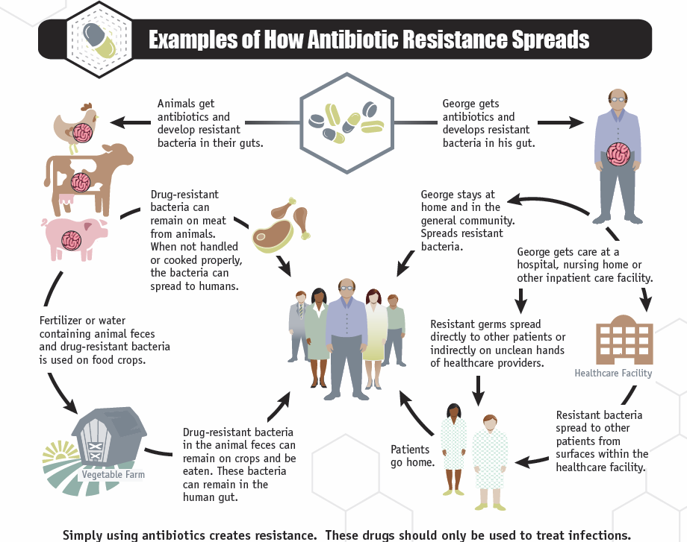
Source:
The importance of antimicrobial resistance genes in commensal organisms has been underscored by recent studies that have shown that a broad spectrum of foodborne commensal bacteria carry antimicrobial resistance genes, and that these can be transferred in laboratory settings to both human commensal and pathogenic bacteria by horizontal gene transfer, leading to acquired antimicrobial resistance in the recipient strains .
Pathways for the flow of resistance genes or genetic determinants of resistance through the ecosystem were depicted by DeVincent and colleagues and reported by Health Canada as shown in Figure 4, where the points at which antibiotics are applied are shown as ovals or circles. The reservoir of resistance genes in the environment represents a mixture of naturally occurring resistance, the genes that are present in bacteria present in human and animal waste, and those that are selected for by antimicrobial substances in human and animal waste .
Figure 4 Pathways for the flow of resistance genes
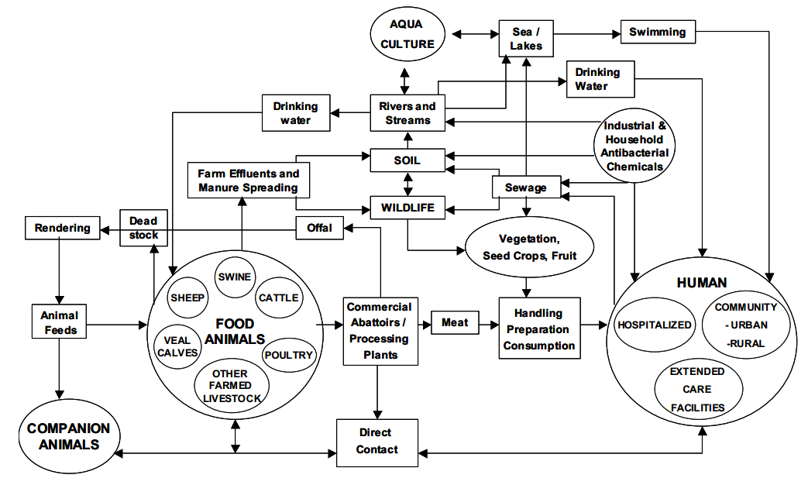
Source: © All rights reserved. Uses of Antimicrobials in Food Animals in Canada: Impact on Resistance and Human Health. Health Canada, 2006. Reproduced with permission from the Minister of Health, 2014
Marti and colleagues have highlighted the importance of aquatic environments in the dissemination and transfer of antimicrobial resistance, as they are frequently impacted by the activities of mankind. These environments, ranging from surface water and groundwater to wastewater treatment plants, provide ideal environments for the horizontal exchange of genetic elements that code for antimicrobial resistance. These environments may also contain low levels of antimicrobial compounds excreted from humans and animals under treatment , and recent research has revealed that selection of resistant bacteria can occur at extremely low concentrations of antibiotic as may exist in soil and water environments .
Zhang et al explored the emergence of antimicrobial resistant bacteria in the normal gut flora of newborns, and found that bacterial populations resistant to several antibiotics and multiple resistance genes could be found in the GI tract within the first week of life. This occurred in the absence of antibiotic exposure, leading the authors to conclude that exposure to maternal and environmental microbes was sufficient to promote the spread of and colonization with antimicrobial resistant bacteria .

Factors contributing to antimicrobial resistance
Some strategies to address antimicrobial resistance address the emergence of new resistance, while others seek to avoid the transmission of resistance, each of which are factors contributing to the problem . Transmission can only occur, however, once resistance has emerged, so this aspect may take primacy in some circumstances. A list of strategies to address the factors that contribute to antimicrobial resistance and potential national responses adapted from a Bulletin of the World Health Organization titled ‘Antimicrobial resistance: a global response’ is presented in Table 6. Many of these strategies could be applied in the context of treatment of animals with antimicrobials. Strategies three to eighteen are for containing the emergence of resistance, strategies 19 to 26 are for containing transmission of resistance, and strategies one and two apply to both.
Table 6 Potential responses to factors influencing AMR
Strategy | Potential national response
Surveillance | Required at all levels in order to obtain an accurate picture of emerging resistances and the rate of transmission of new resistances, and to identify the impact of interventions designed to contain antimicrobial resistance in particular contexts
Financial incentives or disincentives | Could be used at all levels in conjunction with many other policies as a mechanism for improving uptake of or compliance with any intervention. Would include such mechanisms as financial benefits, environmental taxes and use of permit systems
Education of professionals on appropriate clinical indications | On issues most relevant to general national conditions
Education of patients on inappropriate use and importance of compliance with instructions on taking antimicrobials | By providing national information campaigns, for example, as recently conducted in the United Kingdom (leaflets, magazine ads)
Rapid diagnosis of bacterial infections | By providing infrastructure for improved local facilities
Control of sensitivity (susceptibility) data related to prescribers | By providing infrastructure for improved local facilities
Antimicrobial policies | Developed by national medical associations taking account of general national conditions
Restriction of drug availability | Developed by national policymakers taking account of general national conditions
Antimicrobial cycling | Carried out at local level, taking account of prevailing local conditions
Regulation of use of antimicrobials in agriculture | Developed by national policymakers taking account of general national conditions
Choosing optimal agent dose and dosage frequency for different infections | Carried out at patient level, taking account of prevailing local conditions and particular patient characteristics
Removal of potential septic foci/prostheses | Carried out at patient level
Use of drug combinations | At local/patient level, taking account of prevailing local conditions and particular patient characteristics
Using antiseptics as an alternative to antimicrobials | Guidelines suggesting use of alternative agents could be produced at national level
Using probiotics as an alternative to antimicrobials | Guidelines suggesting use of alternative agents could be produced at national level
Increasing vaccination in order to increase immune competence | National policy development concerning vaccination, including both guidance and financial incentives
Improving nutrition in order to increase immune competence | National policy development
Minimizing time patient is immunocompromised | At patient level
More rapid diagnostic techniques | By providing infrastructure for improved local facilities
Screening of patients/staff | Guidelines on screening could be produced at national level
Use of antimicrobials to reduce infectivity | In particular patients
Isolation | Guidelines on isolation could be produced at national level
Handwashing | Guidelines on handwashing could be produced at national level
Improvements in bed spacing | Guidelines on bed spacing could be produced at national level
Improving immunity by vaccination in order to reduce susceptibility to infection | National policy development on vaccination, including both guidance and financial incentives
Improving nutrition in order to reduce susceptibility to infection | National policy development
Grundmann et al in Drug Resistance Updates argue that a range of economic and societal factors are complicating the situation with respect to increasing levels of antimicrobial resistance, and put the proposition that within the next decade, next to untreatable infections will become widespread. Contributing factors identified by these authors include:
- The unprecedented volume, speed and reach of travel and migration
- Vulnerable individuals are left in crowded and unhygienic conditions following civil unrest, food shortages and natural disasters
- Recent generations have been subjected to marketing campaigns that result in the tacit conviction that microbes are causing disease, rather than being part of the natural environment, bringing about a change in health seeking behaviour
- Growing demand for antibiotic chemotherapy which is often inappropriately provided
- The availability of generic compounds in emerging economies and often unregulated markets that lead to massive increases in consumption, often under inappropriate circumstances and of substandard medicines.

Cross-resistance and co-selection
In order for an antimicrobial to demonstrate activity against a bacterial isolate, there must be elements of the bacterial metabolism or structure that are susceptible to the effects of the agent. For example, if the antimicrobial cannot pass through the cell wall of the bacteria, or targets a metabolic pathway that the particular bacterial species does not exploit, the antimicrobial will not be effective, and the bacterium is by definition resistant to it. The bacterial species could be described as being intrinsically or naturally resistant, or ‘resistant due to an innate mechanism’. The population of bacteria in an ecosystem will therefore be changed by the presence of antimicrobial substances .
In addition to such innate resistance against a specific antimicrobial agent, a bacterial species may possess broad-spectrum resistance mechanisms that can also be effective against related types of antimicrobials. This is referred to as ‘cross-resistance’, a term which also applies where resistance arises in a bacterial species due to mutations that are selected for by the pressure of a particular antimicrobial, and the bacterium is then also resistant to other antimicrobials to which is has not been exposed, but which have a similar mechanism of action. One example is the multi-resistance cfr gene, which has been shown to confer resistance to several antimicrobials including amphenicols, lincosamides, pleuromutilins, streptogramin A antibiotics and some macrolides, as well as linezolid, a last-resort antimicrobial agent for the treatment of serious infections in humans caused by resistant Gram-positive bacteria .
There are cases where the genetic material on a bacterial chromosome or plasmid that codes for resistance to one antimicrobial is in close proximity to genes that code for resistance to other antimicrobials. Exposure to any of the antimicrobial agents allows the full array of resistance genes to persist and be passed from one bacterial generation to the next, even though the unrelated antimicrobials may no longer be present. This phenomenon is referred to as ‘co-resistance.’

Mechanisms of resistance
There are a number of mechanisms employed by bacteria to combat the effectiveness of antibiotics :
- Changes in the bacterial cell membrane, which exclude or limit the amount of antimicrobial entering into the bacterium
- Active efflux of the antimicrobial out of the bacterium by protein pumps in the bacterial cell wall
- Alteration of the site targeted by an antimicrobial to reduce its availability, sensitivity to the effects of the drug, or the ability of the drug to bind to the target site
- Inactivation or destruction of the antimicrobial by enzymes produced inside the bacteria
- Creation of altered enzymatic pathways around those targeted or blocked by the antimicrobial
- Intracellular sequestration of the antimicrobial to limit its impact, for example, by binding the antibiotic to another compound that reduces or removes its activity
- Defective antimicrobial activation through the loss or modification of enzymes, effective in cases where antimicrobials are ‘pro-drugs’ that utilise bacterial enzymes to convert them to an active form.
Some of the resistance mechanisms employed by bacteria have an associated ‘biological fitness cost’, whereby there is an increased metabolic impost of utilizing an alternative chemical pathway to bypass a blockage caused by an antibiotic, or to incorporate different components in a cell wall to prevent the entry of an antibiotic. In the absence of the selective pressure of an antimicrobial, these bacteria are out-competed by bacteria that do not carry the mutation, and diminish in number or disappear from an ecological niche. In the presence of an antimicrobial however, the susceptible bacteria are compromised and the resistant bacteria employing the less efficient metabolic process dominate. Other modifications, however, do not impose a biological cost on bacteria, some resistance mutations even enhance the biological fitness of bacteria, and in some cases bacteria are able to develop other mechanisms over time to compensate for the biological cost of the resistance mutation. Compensated or enhanced fitness associated with antimicrobial resistance can facilitate the spread of antimicrobial resistant Salmonella and Campylobacter, even in the absence of antibiotic selective pressure . Resistance mechanisms may be generated by mutation of genetic material within the bacteria, be transferred in genetic material acquired from another bacterium, or through a combination of these two mechanisms .
Some resistance, for example to fluoroquinolones, can arise through the accumulation of mutations in bacterial genes that are responsible for coding for different bacterial components, such as specific drug targets, cell wall permeability, or active efflux mechanisms. Such resistance has been characterised in both Gram-positive and Gram-negative bacteria, and results in a step-wise decrease in susceptibility with each separate mutation .

Lack of new antimicrobials
Both economic and regulatory barriers exist to the development of new antimicrobial agents. Bartlett et al report that of eighteen large pharmaceutical companies that previously developed antibiotics, fifteen have left the field; there has been no new class of antibiotic active against Gram-negative bacteria for forty years, and since 1998, only two drugs with new microbial targets have been introduced. Bartlett sums up with the statement ‘The pipeline is sparse, the problem is global, and the prognosis is poor.’
The newest antibiotics to come to market in recent years are the result of scientific discoveries made decades ago. Silver provides a timeline showing the dates that distinct classes of antimicrobial were discovered, as opposed to the dates they came to market (see Figure 5), with no discovery of new antibiotic classes since 1987. A number of factors are contributing to the lack of activity in this area.
Figure 5 Discovery dates for antimicrobial classes and the ‘discovery void’
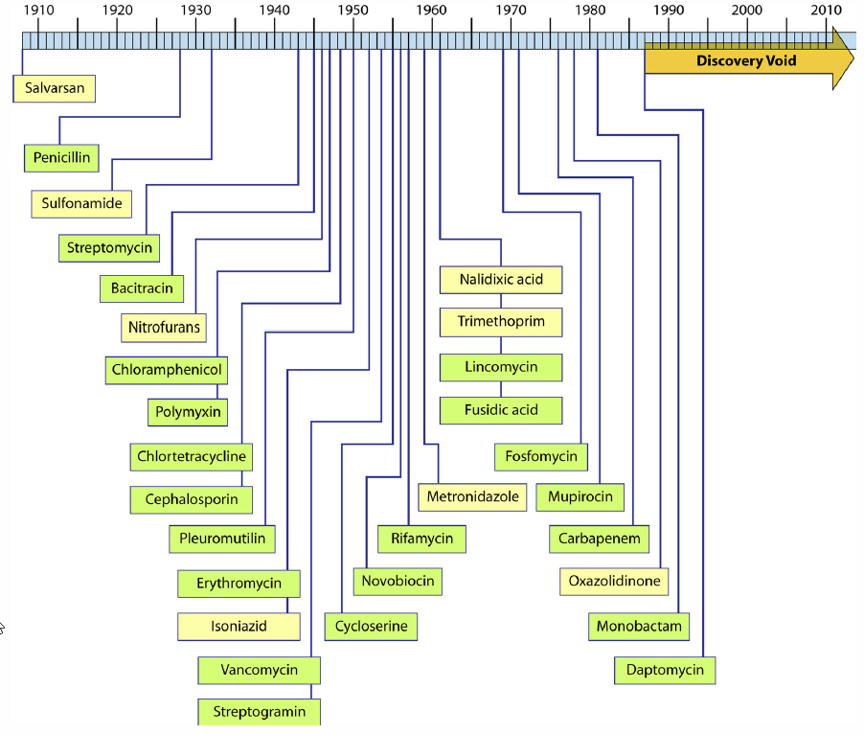
Source:
From a purely financial perspective, drugs that are used to treat chronic illnesses such as diabetes and hypertension offer far greater return on investment for pharmaceutical companies, and resistance is usually not an issue with these drugs . With antibiotics, by contrast, resistance inevitably emerges within a foreseeable time frame of a new agent being brought into use (see Figure 6) , and any new antimicrobials are likely to be reserved for ‘last resort’ situations, limiting the potential sales volume . The World Economic Forum describes the current situation as highlighting ‘a global market failure to incentivize front-end investment in antibiotic development through the promise of longer-term commercial reward.’ A lack of financial incentive arising from sales potential is compounded by regulatory burdens that impose significant costs on the development of new drugs, alongside varying licensing regimes and requirements for clinical trials and registration across the globe that further complicate the process of bringing a product to market. While new drugs used to treat chronic diseases have the potential to generate global sales revenue of several billion US dollars annually, sales of the most recently introduced antibiotics such as linezolid or daptomycin are likely to peak at between US$0.5 to $1 billion globally . The Office of Health Economics in London has calculated that, based on development costs and potential return, the net value of a new antibiotic is –US$50 million, compared to +US$1 billion for a drug to treat neuromuscular disease . However, the public health benefit of bringing a new class of antimicrobial has been estimated to be in the vicinity of +US$12 billion. For an animal health perspective, it is important to stress that virtually all new classes of antimicrobial will be developed for the human market only and will never be registered for administration to food-producing animals.
Figure 6 Time line of antibiotic deployment and emergence of resistance
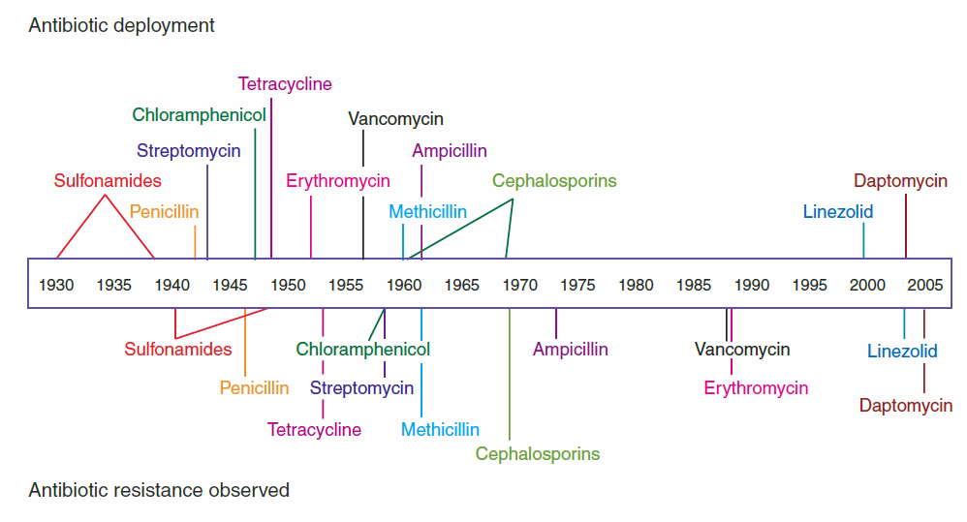
Source:
Most of the antibiotic development activity that is taking place is focused on developing new analogues of existing compounds that strengthen them against known and class-specific resistance mechanisms. While showing some benefit, this approach only partially addresses the clinical crisis of emerging multi-drug resistance, particularly in the case of Gram-negative bacteria . Acquired resistance genes encoding carbapenemases pose one of the most pressing antimicrobial resistance related public health threats in many countries due to their strong association with multi-drug resistance, and the epidemiological status of these strains is continuing to worsen. Woodford et al report that there are increasing numbers of reports of carbapenemases being found in bacteria of non-human origin but no systemic approach to searching for them, hence the extent of the potential problem is unknown. They identify an urgent need for active surveillance and monitoring of carbapenemase producing bacteria in humans and across the food chain and other non-human sources.

Reversing trends in antimicrobial resistance
Actions to reverse trends in antimicrobial resistance need to balance a range of priorities, including threats to human health, while at the same time promoting animal health and the sustainability of livestock systems for both food production and trade. In some circumstances the priorities are complementary, in that highly resistant microorganisms can be a threat to both human and animal health, and the preservation of the effectiveness of existing antimicrobials is of vital importance in all spheres. In other contexts, there will be tension between outcomes being sought for human health versus animal health for certain classes of drug such as the third generation cephalosporins and fluoroquinolones. Several elements of antimicrobial use need to be considered, including when to use or not use them, how to use them, and for which conditions to use them .
It is not however, realistic or desirable to establish a goal of eradicating antimicrobial resistance. The strategies promoted by the World Health Organization are geared towards containing resistance , which is described as a ‘public good’ in that it is impossible to exclude people from benefiting from containment, and where one person benefits, this does not prevent another from also benefitting. This approach also highlights the need for a global approach as some people and nations will rely on interventions carried out by others.
While the selection for and dissemination of antimicrobial resistance can occur rapidly under the selective pressure of antibiotics, reversion is slow and complex by comparison . Johnsen et al investigated the persistence of glycopeptide-resistant enterococci in Norwegian and Danish poultry farms 12 years after the European ban on the use of avoparcin as a growth promoter, and reached the conclusion that eradication of specific antimicrobial resistance characteristics following the removal of selective pressure is not straightforward.
In some cases, the cessation of use of an antimicrobial is associated with a marked reduction in resistance rates, particularly when there is a high fitness cost to the bacteria associated with the resistance mechanism. In other situations, this is not the case, particularly when there is co-resistance, or the fitness cost of the resistance mechanism is low .
Because of the number of animal species, the diversity of rearing environments, range of bacteria involved, restrictions on the classes of antimicrobials available, and variety of resistance mechanisms, antimicrobial resistance in veterinary medicine is a complex issue .

Lowering levels of antibiotic use
An approach that has been used in several countries has been to set global reduction targets for veterinary antibiotic use. In France, for example, a key part of the EcoAntibio strategy is to reduce antibiotic use in veterinary medicine by 25 per cent in 5 years . While reduction in total antimicrobial use is a desirable outcome, such strategies need to complement antimicrobial stewardship programs, education and other programs that together work towards the goals of improved human and animal health, and sustainable primary industries.

Comprehensive and coordinated surveillance
Simonsen et al in the World Health Organization Bulletin present a simplified schematic to explore and describe the program elements that are needed to contain antimicrobial resistance (see Figure 7). The graphic clearly depicts the need for coordinated strategies between human and animal health and production systems, but also makes it clear that surveillance is a critical component to underpin our understanding of the need for and impacts of most interventions related to either the supply and use of antimicrobials, or the resistance that occurs. The diagram also depicts the key data systems that need to feed a coordinated surveillance system, laboratory diagnostics to inform resistance patterns, and information on drug supply and use to provide data on prescribing and utilisation.
Figure 7 Antimicrobial resistance containment and surveillance elements
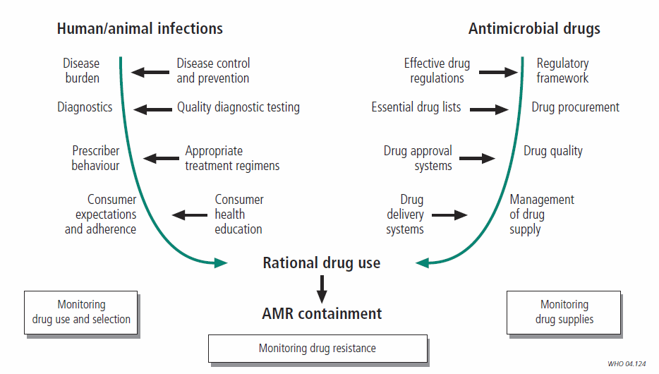
Source:

Reasons for surveillance
As detailed elsewhere in this report, there is broad consensus internationally that surveillance of the use of antimicrobials and of the levels of antimicrobial resistance occurring in various systems underpins strategies to address the issue. The key reasons for surveillance of resistance described by Hunter and Reeves are to determine:
- The size of the problem
- Whether resistance is increasing
- Whether previously unknown types of resistance are emerging
- Whether a particular type of resistance is spreading
- Whether a particular type of resistance is associated with a particular outbreak.
The implications of acquiring and utilizing this information need to be considered in the design of a surveillance system.

Historic and current antimicrobial use and resistance surveillance in Australia
The One Health Antimicrobial Resistance Colloquium held in 2013 identified that ‘Ongoing and systematic surveillance and monitoring of antibiotic use and AMR resistance in animals is required to complement the proposed improved surveillance and monitoring of human use’, while identifying that ‘In animals, the purpose of surveillance, and the interpretation of data, is different to that in humans, and more complex.’

Australian surveillance of antimicrobial resistance
While there are no nationally coordinated veterinary or agricultural AMR surveillance programs in Australia, there have been a number of notable one-off surveys and projects that have provided valuable information. It is also important to recognise that prominent examples of prior survey activity in animals could be used to inform the development of a national surveillance strategy through lessons learned, and experience with the identification of enablers and barriers. Two examples of former activities are:
- Department of Agriculture, Fisheries and Forestry ‘Antimicrobial resistance in bacteria of animal origin’ pilot surveillance program, conducted from November 2003 to July 2004 and reported in 2007
- A report for the Rural Industries Research and Development Corporation titled ‘Antibiotic resistance in bacteria isolated from poultry’ published in 2001, and based on samples collected during 2000 .

Australian surveillance of antimicrobial usage
The Australian Pesticides and Veterinary Medicines Authority (APVMA) have produced two reports providing information on the quantity of antimicrobials sold for veterinary use in Australia. The first report, published in 2005, covers the three financial years from July 1999 to June 2002 , while the second report, released in 2014, covers five financial years from July 2005 to June 2010 . As no antimicrobials are manufactured in Australia, all relevant products are imported and subject to prohibitions under Customs legislation, and require import permits issued by the Office of Chemical Safety of the Therapeutic Goods Administration (TGA).
The three main contexts for the use of veterinary antimicrobials in Australia are given in the second report:
- Therapeutic administration under the direction of a veterinarian to individual animals that display evidence of infection (therapeutic).
- Prophylactic administration under the direction of a veterinarian to healthy animals that are believed to be at risk of developing an infection (prophylactic).
- Administration via feed or water in concentrations to increase the efficiency of feed conversion or to prevent disease (growth promotants, coccidiostats). Most of these products are limited to those considered to be low risk to human health, and may be used without veterinary intervention.
Data included in both reports was provided voluntarily by registrants, and is potentially incomplete. In a number of cases, products are registered for use in different animal species, and some may be used in companion as well as food-producing animals. The reports highlight where assumptions have been made and the potential for inaccuracies, and caution that the data should not be over-interpreted. Estimated uses for therapeutic and prophylactic purposes are often combined in the reports under the therapeutic heading due to difficulties in discriminating end use when the data set of origin is sales information, rather than end use or prescribing information.
The first APVMA report provides estimates of total imports of veterinary antimicrobials from July 1999 to June 2002 as well as total sales, while the second report lists estimated sales, broken down between food-producing and non-food animal use. The latter analysis suggest that 98 per cent of the total antimicrobials by weight sold for veterinary use in Australia during the period were for use in food-producing animals, with only 2 per cent to 3 per cent for non-food animals (Table 7).
Table 7 Estimates of total sales of veterinary antimicrobials (tonnes of active ingredient)
Year | 1999–2000 | 2000–01 | 2001–02 | 2005–06 | 2006–07 | 2007–08 | 2008–09 | 2009–10
Food animals | 389 | 475 | 547 | 655 | 572 | 580 | 482 | 644
Non-food animals | 14 | 16 | 15 | 10 | 11 | 12 | 11 | 17
Total | 403 | 491 | 562 | 665 | 582 | 592 | 492 | 661
Source:
Of the quantity used in food-production, during the period from July 2005 to June 2010, it is estimated that 43 per cent was for therapeutic or prophylactic purposes, 4 per cent to 7 per cent for growth promotion purposes, with over half of total sales being for coccidiostats used to control coccidiosis disease in chickens. Almost all coccidiostats belong to classes of antimicrobials (ionophores) that are not used in humans, and are at this point not considered to contribute to AMR risk in humans, although there are concerns that link resistance between ionophores and other resistances of importance in Gram-positive bacteria. Significant contrasts can be seen between the reports in the large increase in use of coccidiostats and the reduction in use of antimicrobials for growth promotion (Table 8 and 9, Figure 8).
Table 8 Estimates of use of veterinary antimicrobials in Australia (tonnes of active ingredient)
Year | 1999–2000 | 2000–01 | 2001–02 | 2005–06 | 2006–07 | 2007–08 | 2008–09 | 2009–10
Coccidiostat | 71 | 100 | 115 | 336 | 303 | 279 | 259 | 327
Growth promotant | 157 | 200 | 233 | 47 | 38 | 38 | 24 | 29
Therapeutic/prophylactic | 161 | 176 | 199 | 272 | 230 | 262 | 199 | 288
Total | 403 | 491 | 562 | 655 | 572 | 580 | 482 | 644
Source:
Table 9 Estimates of use of veterinary antimicrobials in Australia (proportion of sales)
Year | 1999–2000 | 2000–01 | 2001–02 | 2005–06 | 2006–07 | 2007–08 | 2008–09 | 2009–10
Coccidiostat | 18% | 20% | 20% | 51% | 53% | 48% | 54% | 51%
Growth promotant | 39% | 41% | 41% | 7% | 7% | 7% | 5% | 5%
Therapeutic/prophylactic | 40% | 36% | 35% | 42% | 40% | 45% | 41% | 45%
Source:
Figure 8 Estimated quantities of veterinary antimicrobials sold in Australia (tonnes of active ingredient)
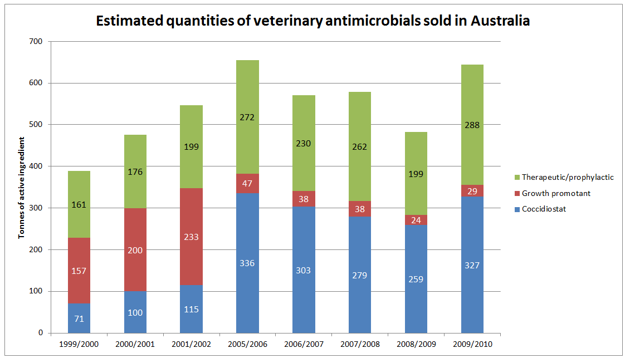
Source:
The APVMA reports provide additional detail and analysis of data limitations, the importance of various antimicrobials to human health, populations of target animals, and a range of other parameters. Information in the reports is intended to support the following:
- First APVMA Report, intended to assist regulatory authorities to
- monitor changes in the overall use of antimicrobial products
- relate these to changes to antimicrobial resistance
- identify where reviews of prescribing practices might be appropriate
- respond in a precise and targeted way
- Second APVMA Report to
- facilitate risk analysis for registration and extensions of use applications
- contribute to formal reviews of antimicrobials by regulatory authorities
- assist with the evaluation of the effectiveness of prudent use efforts and mitigation strategies
- assist with the study of trends in antimicrobial usage
- facilitate international reporting and comparisons.

Australia’s national focus on surveillance activities
In February 2013, the Australian Antimicrobial Resistance Prevention and Containment (AMRPC) Steering Group was established. The Steering Group is jointly chaired by the Secretaries of the Department of Health (DoH) and the Department of Agriculture (DAFF). The Commonwealth Chief Medical Officer and Chief Veterinary Officer are also members. The Steering Group is providing high level national governance and leadership on AMR, and is charged with overseeing the development of a comprehensive national AMR prevention and containment strategy for Australia.
The work of the AMRPC Steering Group will draw in part on the expertise of the Antimicrobial Resistance Standing Committee (AMRSC) which was established in April 2012 by the Australian Health Protection Principal Committee (AHPPC) and endorsed by the Australian Health Ministers Advisory Council (AHMAC). AMRSC is comprised of representatives from the Australian Government and its agencies in human and animal contexts, clinical experts and professional colleges. AMRSC commissioned a report titled ‘National Surveillance and Reporting of Antimicrobial Resistance and Antibiotic Usage for Human Health in Australia’, to provide a review of AMR issues and activities spanning the previous fifteen years in Australia and internationally, an analysis of existing systems and infrastructure, and views on enablers and barriers to the development of systems to address AMR issues in human health on a national basis. This report assisted AMRSC in developing a number of recommendations, which included the establishment of a national coordinating centre to oversee a range of data collation, analysis, reporting and research activities.
While the scope of the AMRSC Report was analysis of activities, gaps and options in the human health context, the report acknowledged the importance of AMR and antibiotic use in veterinary and agricultural practice, and centred its recommendations on national coordination using a One Health framework linking together data on resistance and antibiotic use from humans, animals and agriculture to provide a national picture on AMR. The report is harmonious with international practice and expert opinion in recommending that effective surveillance across the sectors is the cornerstone of efforts to control AMR.
DAFF has committed to provide AMRSC and the AMRPC Steering Group, through this report, with an analysis on surveillance and reporting of antimicrobial resistance and antibiotic usage in animals and agriculture in Australia, and options for monitoring and surveillance in the animal/agriculture sector which could fit within a nationally coordinated One Health framework. This report has been structured to be complementary to the AMRSC ‘National Surveillance and Reporting of Antimicrobial Resistance and Antibiotic Usage for Human Health in Australia’ report, making reference to that report where appropriate, but providing context and pursuing recommendations relevant to animals and agriculture.

Key differences between surveillance for AMR and drug use in animals and humans in Australia
It is often assumed that delivery of veterinary services to the animal population is very similar to delivering medical services to humans. However, in the context of performing surveillance for AMR and antimicrobial use there are very distinct human-animal differences in the respective delivery systems as they operate in Australia:
- Virtually all veterinary practices and veterinary hospitals providing clinical services are private businesses.
- Virtually all veterinary clinical activities are paid for by animal owners with no reliance on government assistance by way of subsidy or provision of infrastructure.
- In the majority of cases, veterinary laboratory procedures such as ‘isolation, culture and susceptibility testing’ are performed on a fee basis with the fee being met by the client. Cost considerations have a strong impact on whether or not such investigations occur.
- Government subsidy of diagnostic services for food animals has declined to a negligible level in most states.
- There is no equivalent of the Pharmaceutical Benefits Scheme—animal owners pay the full cost of antimicrobial drugs and there is no organised collection of data on what antimicrobials are consumed.
- Veterinarians mostly prescribe AND dispense the antimicrobials they use.
- Many chronic bacterial infections in animals are resolved by culling the animals (food animals) or euthanasia (companion animals) as opposed to reliance on protracted antimicrobial therapy.
As a result of the above:
- Compared to humans, a smaller proportion of cases of bacterial disease in animals are likely to be seen by a veterinarian. A much lower proportion of cases examined by veterinarians are also likely to be investigated by isolation, culture and antimicrobial susceptibility testing.
- Surveillance for resistance in animal pathogens based on submissions to laboratories (as occurs in human medicine) is only likely to generate comparative data for companion animals (dogs, cats, horses). In food animals, the internationally accepted approach is to place additional reliance on the assessment of enteric commensal bacteria (such as E. coli and Enterococcus spp.) which provide valuable insight into the resistance attributes entering the environment and food chain.
- Surveillance for AMR based on commensal bacteria requires a much stronger emphasis on study design than the passive surveillance approach suitable for pathogens obtained from veterinary diagnostic laboratories. It also demands substantial funds and resources to collect specimens, move them to laboratories for testing and meet the costs of primary isolation.
- The cooperation of veterinarians, the owners of animals and the owners of premises on which animals are kept is necessary for implementing most surveillance activities.
Information in the international literature and media on AMR in animals, although widely reported in Australia, is often incorrectly interpreted as being directly relevant to Australia. Some prominent features of drug registration in Australia and animal production do distinguish this country from most others with respect to AMR and antimicrobial use. For example:
- Red meat species of food animals are typically not housed at any time of the year and most are kept wholly on pasture. These management features strongly discourage many important bacterial diseases thus providing limited opportunity or need for antimicrobial treatments, including those administered in animal feed.
- Drugs in the fluoroquinolone group, a class of agent classified as of high importance in Australia in human medicine and companion animals, have not been registered for use in food animals in Australia.
- Only one third generation cephalosporin (ceftiofur) is registered for use in food animals in Australia and can only be used under limited circumstances. Additional third generation cephalosporins have been registered in Europe for food animals. However, with respect to dogs and cats, a third generation cephalosporin, cefovecin, is registered for use in Australia. This class of drug is of also classified as of high importance in human medicine.
- National quarantine measures appear to have effectively excluded some important antimicrobial resistant pathogens from entry into Australia and subsequent colonisation of livestock (eg. specific types of multidrug-resistant non-typhoidal Salmonella).
- Of the antimicrobials provided to certain livestock in feed, a large amount (by volume) has no corresponding equivalent antimicrobial class in human medicine.

The global context: existing programs and activities
The following section provides an overview of supranational organisations and surveillance systems, and explores the key characteristics of existing global systems.

Supranational organisations

World Organisation for Animal Health
The Office International des Epizootie (OIE) was established in 1924 following worldwide recognition of the need to fight animal diseases at a global level. In 2003, the OIE became the World Organisation for Animal Health, but retained the acronym OIE. It is an intergovernmental organisation responsible for improving animal health worldwide. In 2013 the OIE had 178 Member Countries with offices on every continent, and is recognised as a reference organisation by the World Trade Organization (WTO). The organisation operates under the authority and control of a World Assembly of Delegates, constituted by appointments from member countries. The headquarters, based in Paris, is responsible for implementing resolutions passed by the World Assembly, with day-today operations being the responsibility of a Director General elected by the World Assembly . Australia’s delegate is Dr Mark Schipp, Australian Chief Veterinary Officer.
OIE committees produce a range of documents that support the role of the organisation and provide guidance to member countries. Key among these documents are the ‘OIE Terrestrial Animal Health Code’ and the ‘OIE Aquatic Animal Health Code’. Recommendations from these manuscripts that relate to the surveillance of antimicrobial resistance and use are outlined in section 4.3 ‘A generic model for the surveillance of antimicrobial resistance‘.

World Health Organization
In 2014, the WHO released a report entitled ‘Antimicrobial Resistance: global report on surveillance’ , which provides a snapshot of AMR surveillance activities across the world, and includes detailed survey results indicating reported resistance rates for a range of microbe/antimicrobial combinations by region and country. The report identifies the following antibiotic resistances in bacteria as being of international concern, some of which are relevant in the context of surveillance of AMR in animals:
- Escherichia coli—resistance to third-generation cephalosporins and to fluoroquinolones
- Klebsiella pneumoniae—resistance to third-generation cephalosporins and to carbapenems
- Staphylococcus aureus—resistance to methicillin
- Streptococcus pneumoniae—resistance (non-susceptibility) to penicillin
- Nontyphoidal Salmonella—resistance to fluoroquinolones
- Shigella species—resistance to fluoroquinolones
- Neisseria gonorrhoeae—decreased susceptibility to third-generation cephalosporins.
The report highlights significant gaps in surveillance, and a lack of standards for methodology, data sharing and coordination as being current barriers to effective global surveillance, and reinforces the importance of harmonised, integrated surveillance of AMR in humans, food-producing animals and food. In relation to animal production systems, differences in sampling methodology, sites and procedures along with variance in laboratory methodology and prevailing bacteria confound attempts to compare data between countries, further supporting the need for harmonisation. The report includes a table that compares the source of samples and bacterial species surveyed in several international programs (Table 10).
Table 10 Examples of antimicrobial resistance surveillance and monitoring programs from 2014 WHO global report on surveillance
Program | Healthy animals | Diseased animals | Food | Healthy humans | Diseased humans | Bacterial species included
CIPARS  (Canada) | Yes | Yes | No | No | Yes | Salmonella, Campylobacter, Escherichia coli, Enterococci, animal pathogens
Danmap  (Denmark) | Yes | Yes | Yes | Yes | Yes | Salmonella, Campylobacter, Escherichia coli, Enterococci, animal pathogens
FINRES-VET  (Finland) | Yes | Yes | Yes | No | Yes | Salmonella, Campylobacter, Escherichia coli, Enterococci, animal pathogens
ONERBA  (France) | Yes | Yes | Yes | No | Yes | Salmonella, Campylobacter, Escherichia coli, Enterococci, animal pathogens
GERM-VET  (Germany) | No | Yes | No | No | No | Salmonella, Escherichia coli, Enterococci, animal pathogens
JVARM  (Japan) | No | No | Yes | No | No | Salmonella, Campylobacter, Escherichia coli, Enterococci
NORM/NORMVET  (Norway) | Yes | Yes | Yes | No | Yes | Salmonella, Campylobacter, Escherichia coli, Enterococci, animal pathogens
ITAVARM  (Italy) | Yes | Yes | Yes | No | Yes | Salmonella, Escherichia coli, Enterococci, animal pathogens
NETHMAP/MARAN  (Netherlands) | Yes | Yes | No | No | Yes | Salmonella, Campylobacter, Escherichia coli, Enterococci, animal pathogens
NARMS  (United States) | Yes | No | Yes | No | Yes | Salmonella, Campylobacter, Escherichia coli, Enterococci, animal pathogens
SWEDRES/SVARM  (Sweden) | Yes | Yes | Yes | No | Yes | Salmonella, Campylobacter, Escherichia coli, Enterococci, animal pathogens
Source:
The WHO oversees a number of programs related to the surveillance of antimicrobial use and resistance, two of which are outlined below.

WHO Global Foodborne Infections Network
The challenge of foodborne and other infectious enteric diseases led the WHO, in collaboration with a number of partners to create the Global Foodborne Infections Network (GFN), which superseded the WHO Global Salmonella Surveillance (GSS) program. The GFN has six major components :
- international training courses,
- a passive Salmonella surveillance system,
- an annual External Quality Assurance System (EQAS),
- focused regional and national projects,
- reference testing services and
- communications
While this program has a surveillance element, its primary concern is with foodborne enteric illness and infections.

World Health Organization Advisory Group on Integrated Surveillance of Antimicrobial Resistance
In December 2008, the WHO Advisory Group on Integrated Surveillance of Antimicrobial Resistance (AGISAR) was established to support efforts to minimise health impacts of AMR associated with the use of antimicrobials in food animals . The Terms of Reference for AGISAR are provided below .
- Develop harmonized schemes for monitoring antimicrobial resistance in zoonotic and enteric bacteria. This should include appropriate sampling.
- Support WHO capacity-building activities in Member countries for antimicrobial resistance monitoring (AMR training modules for Global Foodborne Infections Network (GFN) training courses).
- Promote information sharing on AMR.
- Provide expert advice to WHO on containment of antimicrobial resistance with a particular focus on Human Critically Important Antimicrobials.
- Support and advise WHO on the selection of sentinel sites and the design of pilot projects for conducting integrated surveillance of antimicrobial resistance.
- Support WHO capacity-building activities in Member countries for antimicrobial usage monitoring.
Approximately 30 internationally recognised experts covering a broad range of disciplines make up the advisory group, as shown below . At their inaugural meeting in Copenhagen in 2009, the Group acknowledged that there are differences in the proficiency of existing AMR surveillance programs monitoring foodborne and zoonotic bacteria around the world, and developed a five-year strategic framework to address this.
Table 11 Members of WHO Advisory Group on Integrated Surveillance of Antimicrobial Resistance
Prof. Frank M. Aarestrup  Head, Antimicrobial Resistance and Molecular Epidemiology Unit, Danish National Food Institute, Denmark  Prof. Jacques Acar  Consultant to the World Organisation for Animal Health (OIE), France  Dr Awa Aidara-Kane  Lead, WHO-AGISAR, Department of Food Safety and Zoonoses, World Health Organization, Switzerland  Dr Frederick Angulo  Chief of the Global Disease Detection Branch in the Division of Global Disease Detection and Emergency Response, Center for Global Health, at the US Centers for Disease Control and Prevention (CDC), United States Of America  Dr Ezra Barzilay  Lead, National Surveillance Team (NST), National Antimicrobial Resistance Monitoring System (NARMS), CDC, United States Of America  Dr Hege Salvesen Blix  Senior Advisor, Dept. of Pharmacoepidemiology, Norwegian Institute of Public Health, Oslo, Norway  Dr Stef Bronzwaer  European Food Safety Authority, Italy  Prof. Peter Collignon  Director, Infectious Diseases Unit and Microbiology, Canberra Hospital, Professor, Medical School, Australian National University, Australia  Dr Paula J. Fedorka Cray  Research Leader, USDA-ARS Bacterial Epidemiology and Antimicrobial Resistance Research Unit, Athens, GA, United States Of America  Prof. Heriberto Fernández  Professor, Clinical Microbiology, Institute of Clinical Microbiology, Universidad Austral de Chile, Valdivia, Chile  Prof. Kari Grave  Professor, Norwegian School of Veterinary Science, Department of Food Safety and Infection Biology, Norway | Dr Christina Greko  Associate Professor, Department of Animal Health and Antimicrobial Strategies, National Veterinary Institute, Sweden  Dr Ole E. Heuer  Senior Expert, European Centre for Disease Prevention and Control (ECDC), Sweden  Dr Rebecca Irwin  Director, Antimicrobial Resistance Program, Laboratory for Foodborne Zoonoses, Public Health Agency of Canada  Dr Samuel Kariuki  Chief Research Officer and Department Head, Centre for Microbiology Research, Kenya Medical Research Institute (KEMRI), Kenya  Dr Danilo Lo Fo Wong  Senior Adviser Antimicrobial Resistance, WHO Regional Office for Europe, Copenhagen, Denmark  Prof. Ran Lu  Deputy Director, Office for Disease Control and Emergency Response, Chinese Center for Disease Control and Prevention, Beijing, China  Ghassan M. Matar, Ph.D  Professor, Department of Experimental Pathology, Immunology & Microbiology, American University of Beirut (AUB), Lebanon  Dr Patrick McDermott  Director, United States National Antimicrobial Resistance Monitoring System and Director, US FDA's Center for Veterinary Medicine, United States of America  Prof. Scott A. McEwen  Professor, Department of Population Medicine, Ontario Veterinary College, Canada  Dr Eric Mitema  Professor of pharmacology and toxicology, Faculty of Veterinary Medicine, University of Nairobi, Kabete, Kenya  Dr Kåre Mølbak  Danish Department of Epidemiology Head, Denmark | Dr Gérard Moulin  Deputy Director, National Agency for Veterinary Medicinal Products, Fougères, France  Dr Enrique Pérez-Gutiérrez  Food Safety Officer, Pan-American Health Organization, Area of Health Surveillance and Disease Management, Rio de Janeiro, Brazil  Dr John H. Powers  Senior Medical Scientist, National Institute of Allergy and Infectious Diseases, George Washington University School of Medicine, United States Of America  Dr Richard Reid-Smith  Veterinary Epidemiologist, Laboratory for Foodborne Zoonoses, Public Health Agency of Canada and Professor, University of Guelph, Canada  Prof. H. Morgan Scott  Professor of Epidemiology, Kansas State University, United States Of America  Dr Sittana Shaseldin Elshafie  Head, Division of Microbiology, Hamad Medical Corporation, Doha, Qatar  Dr Rene Sjøgren Hendriksen  Scientist, Technical University of Denmark (DTU), Denmark  Caroline Smith DeWaal  Director, Food Safety Program, Center for Science in the Public Interest, United States Of America  Dr John Stelling  Co-Director, WHO Collaborating Centre for Surveillance of Antimicrobial Resistance, Brigham and Women’s Hospital, Boston, United States Of America  Dr Haruo Watanabe  Deputy-Director General, National Institute of Infectious Diseases, Tokyo, Japan  Dr Mussaret Zaidi  Head, Microbiology Research Laboratory, Hospital General O’Horan and Hospital Regional de Alta Especialidad de la Peninsula de Yucatan, Mexico
A guidance document, which aims to provide the basic information countries need to establish an integrated program for integrated antimicrobial surveillance, was developed over a four year period, and published in 2013 . In order to promote compatibility of programs worldwide, the document:
- provides guidance on surveillance and monitoring approaches, including minimum requirements for integrated monitoring systems;
- provides guidance on sampling strategies;
- sets out guidelines and standards for laboratory culture, bacterial identification, antimicrobial susceptibility testing methods and quality assurance;
- proposes analysis and reporting methods that allow findings to be compared within and between countries;
- makes recommendations for international harmonization of integrated antimicrobial resistance monitoring systems for foodborne bacteria, including both pathogenic and commensal organisms.
Recommendations from the World Health Organization Advisory Group on Integrated Surveillance of Antimicrobial Resistance group in relation to national surveillance programs are described in section of this report.

WHO—antimicrobial usage surveillance
A report of WHO consultation with the Food and Agriculture Organization of the United Nations and the Office International des Epizooties published in 2000 states that :
- Relevant authorities should establish systems to determine the amounts of antimicrobials given to food animals.
- Information on the amounts of antimicrobials given to food animals should be made publicly available at regular intervals, be compared to data from surveillance programs on antimicrobial resistance, and be structured to permit further epidemiological analysis.
A WHO report of a 2001 meeting involving over sixty participants from twenty-four countries indicates that data generated from the monitoring of antimicrobial usage and the surveillance of antimicrobial resistance plays a key role in the :
- development of national and international (for example WHO, the Food and Agricultural Organization of the United Nations - FAO, Codex Alimentarius and the Organization International des Epizooties - OIE) policies for the containment of antimicrobial resistance;
- comparison of the use of antimicrobials at different levels (local, regional, national, international);
- informing and in the education of stakeholders;
- correlation with data from antimicrobial resistance monitoring in humans, animals, and food;
- application of risk analysis processes pertaining to the issue of antimicrobial resistance;
- evaluation of the impact of the implementation of the prudent use of antimicrobials and of other interventions.

The European Food Safety Authority
The European Food Safety Authority (EFSA) is an independent European agency funded by the EU budget that operates separately from the European Commission, European Parliament and EU Member States. It works in close collaboration with national authorities and in open consultation with stakeholders to provide independent scientific advice and clear communication on existing and emerging risks in relation to food and feed safety .
The work program of the EFSA is guided towards managing the potential exposure of consumers through food, with a focus on food-producing animals and products thereof, rather than on animal species. Table 12 indicates the combination of animal populations and bacterial species presented at the 7th EURL-AMR Workshop in Denmark in 2013 as being those prioritised by the EFSA. For animal populations not primarily aimed at consumption or in which AMR is low, a relaxed program of surveillance, for example 3rd yearly screening, is in place . Reporting of AMR data on Salmonella and Campylobacter spp. is mandatory, while reporting on indicator bacteria is voluntary .
Table 12 Animal populations prioritised by the EFSA
Animal population | Salmonella | Campylobacter jejuni | Campylobacter coli | Indicator  E. coli | Indicator enterococci
Laying hens | Yes | No | No | No | No
Broilers | Yes | Yes | Yes | Yes | Yes
Fattening turkeys | Yes | No | No | No | No
Calves | Yes | No | No | Yes | Yes
Fattening pigs | Yes | No | Yes | Yes | Yes
Source:
Development of AMR surveillance in the European Union has evolved over the last decade. The following sections provide historical information and context to that evolution.

EU Directive 2003/99/EC
EU Directive 2003/99/EC on the monitoring of zoonoses and zoonotic agents imposed a number of requirements on European Union Member States including to:
- ensure that data on the occurrence of zoonoses and zoonotic agents and antimicrobial resistance related thereto are collected, analysed and published without delay
- designate a competent authority or competent authorities for the purposes of the Directive
- ensure effective and continuous cooperation based on free exchange of general information and specific data
- ensure that relevant officials undertake suitable initial and ongoing training in veterinary science, microbiology or epidemiology.
Member States are required to assess trends and sources of zoonoses, zoonotic agents and antimicrobial resistance and submit a report to the European Commission by the end of May each year. EFSA and the European Centre for Disease Prevention and Control (ECDC) then jointly analyse the individual country data sets and issue a report reflecting the situation across Europe . A number of characteristics of the monitoring systems to be used are prescribed in Directive 2009/99/EC, including:
- the animal population or subpopulations and stages in the food chain to be covered by monitoring
- zoonoses and agents to be monitored
- the nature and type of data to be collected
- sampling schemes and the methods of analysis to be used
- frequency of reporting of diseases or risks
- data fields to be submitted.
Information must be gathered and submitted on, at a minimum, a representative number of isolates of Campylobacter and Salmonella species from cattle, pigs, poultry, and food of animal origin.

EU Commission Decision 2007/407/EC
In 2007, the European Commission issued Commission Decision 2007/407/EC, which lays down more detailed requirements for harmonised monitoring antimicrobial resistance of Salmonella isolated from laying hens, broilers, turkeys and pigs. Monitoring and reporting of the animal species was phased in between 2008 and 2011. The Decision also specifies that :
- Not more than one isolate per Salmonella serovar from the same epidemiological unit per year shall be included in the monitoring
- The epidemiological unit for laying hens, broilers, and turkeys is the flock and for pigs is the holding
- The number of Salmonella isolates per Member State per year shall be 170 for each study population (that is, laying hens, broilers, turkeys and slaughter pigs)
- Where a lower number of isolates than the target sample size is available, all shall be included
- Where a higher number of isolates is available all isolates, or a representative random selection equal or larger than the target sample size, shall be included
- At least the antimicrobials that are specified in the Directive will be tested, using the cut-off values given and an appropriate concentration range to determine the susceptibility of Salmonella
- Dilution methods shall be performed according to the methods described by the European Committee on Antimicrobial Susceptibility Testing (EUCAST) and the Clinical and Laboratory Standards Institute (CLSI), accepted as international reference method (ISO standard 20776-1:2006)
- It is recommended that the selected isolates of S. Enteritidis and S. Typhimurium are phage-typed.
Work leading up to and the promulgation of Decision 2007/407/EC were regarded as a first step towards gradual implementation of a comprehensive, harmonized antimicrobial resistance monitoring scheme across the European Union . Other important changes from Directive 2003/99/EC included recommendations to report quantitative MIC data instead of qualitative (susceptible/resistant) data, and the use of harmonised epidemiological cut-off values (ECOFFs) as interpretive criteria .

EU Implementing Decision 2013/652/EU
Commission Implementing Decision 2013/652/EU on the monitoring and reporting of antimicrobial resistance in zoonotic and commensal bacteria was published in November 2013. It lays out rules for harmonised monitoring and reporting of AMR resistance by Member States in accordance with Directive 2003/99/EC, and includes lists of bacteria to be monitored, and describes sampling plans that should be implemented. This Decision is discussed further in Section 4.3.3 ‘European Food Safety Authority recommendations‘ below.

Revision of technical specifications
In 2011, the EFSA received a mandate from the European Commission to update the existing technical specifications on monitoring and reporting of AMR in animals and food, to include :
- Detailed guidance on bacterial species, animal species and/or food
- Detailed guidance on methods considered most relevant from the public health perspective and taking into account AMR mechanisms
- Antimicrobials, ranges, ECOFFs to be tested
- Optimal format for collection and reporting of data
- An extension to include monitoring of MRSA in food- producing animals and food
The inclusion of MRSA monitoring was primarily to provide comparative data against MRSA strains isolated in humans, detect emerging livestock-associated MRSA with particular virulence factors, and monitor potential emergence of community-acquired MRSA in livestock populations. Secondary objectives include monitoring prevalence and assessing the epidemiology of MRSA in livestock populations. Food-producing animals that are considered MRSA reservoirs and monitored 3rd yearly on a rotating basis are broilers, dairy cattle, and fattening pigs, turkeys and veal calves. The monitoring of MRSA in companion animals is beyond the remit of the mandate.
Other changes introduced with the revision of technical specifications include:
- Phenotypic monitoring of ESBL and AmpC β-lactamase producing Salmonella and indicator E. coli in animals and food
- Monitoring resistance to antimicrobials used for treatment of highly-resistant Gram-negative infections in humans (colistin, carbapenems)
- Other antimicrobials introduced for further testing on a voluntary basis (florfenicol, tigecycline)
The revised specifications recommend the use of a logistic regression modelling approach as this will allow for a quantification of significant trends, and for calculating 95 per cent confidence bands of the time trend. Trend analysis should explore the full scale of MIC distributions in order to increase the early detection of reduced susceptibility. Graphical display of spatial distribution in maps is recommended as the best solution for displaying national data, as no further (regional) level of detail is available in the EU-wide dataset . The importance of using standardised dilution methods and common ECOFFs, and of reporting quantitative rather than binary (susceptible/resistant) data are stressed.
There were no changes to the 2007 Decision regarding bacterial species to be reported, but the reporting of indicator bacteria was given greater prominence, and requirements to identify Salmonella at serovar level made. Food animal species to be monitored remained unchanged, but it was recommended that AMR data reported be stratified by animal age, production stage and/or production type, as levels of resistance may be quite distinct between these groups, reflecting the widely differing treatment regimes, management practices, and hygienic conditions encountered .
Given the increasing importance of multi-resistant bacteria, greater efforts are outlined in developing methodology to gather and submit data using Excel or XML based tools that will allow aggregated data to be examined for multiple resistances of relevance to human health. A pilot exercise to test the data model involving eleven Member States using XML and Excel files was conducted successfully in 2011. The ability to collect more detailed data such as serovar of the Salmonella strains, the geographical area and production type/food category of origin is thought to add significant value to the surveillance program, and assist epidemiological study.

Bacterial species, food animal populations and sampling methods
Table 13 shows the combinations of animal populations, sampling types and numbers recommended by the EFSA for monitoring Salmonella, while Tables 14, 15 and 16 show the same for monitoring Campylobacter, and indicator bacteria E. coli and enterococci in major food-producing animal species.
Table 13 EFSA recommendations on combinations of Salmonella/food animal populations and desirable numbers of isolates to be included in susceptibility testing.
Animal populations | Where to collect | Sample to collect | Target no. isolates | Monitoring recommended to be performed consistently on a yearly basis | Monitoring yearly (if production exceeds 10,000 tons/year slaughtered) | Monitoring recommended to be performed on a regular basis (every 3 years)
Laying hens | Farm (a) | Boot swabs | 170 (b) | Yes | No | No
Broilers | Farm (a) | Boot swabs | 170 (b) | Yes | No | No
Fattening turkeys | Farm (a) | Boot swabs | 170 | Yes | No | No
Fattening pigs | Slaughterhouse | Caecal spl. | 170 | Yes | No | No
Calves under 1 year | Slaughterhouse | Caecal spl. | 170 | Yes | No | No
Sheep | Slaughterhouse | Caecal spl. | 170 | No | Yes | No
Goats | Slaughterhouse | Caecal spl. | 170 | No | Yes | No
Breeders of Gallus gallus, egg sector | Farm | Boot swabs | 170 | No | No | Yes
Breeders of Gallus gallus, meat sector | Farm | Boot swabs | 170 | No | No | Yes
Turkey breeders | Farm | Boot swabs | 170 | No | No | Yes
Dairy cattle | Slaughterhouse | Caecal spl. | 170 | No | No | Yes
Young bovines (1 to 2 years) | Slaughterhouse | Caecal spl. | 170 | No | No | Yes
(a) In the framework of the national Salmonella control programme. If prevalence is low and fewer than 170 isolates are available, all isolates from national control programmes to be tested for AMR.
(b) Or one isolate per serovar per epidemiological unit per year.
Source:
Table 14 EFSA recommendations on combinations of Campylobacter/food animal populations and desirable numbers of isolates to be included in susceptibility testing
Animal populations | Where to collect | Sample to collect | Target no. isolates | Monitoring recommended to be performed consistently on a yearly basis | Monitoring yearly (if production exceeds 10,000 tons/year slaughtered) | Monitoring recommended to be performed on a regular basis (every 3 years)
Broilers | Slaughterhouse | Caecal spl. | 170 (a) | Yes | No |  | No
Fattening pigs | Slaughterhouse | Caecal spl. | 170 (b) | Yes | No |  | No
Fattening turkeys | Slaughterhouse | Caecal spl. | 170 | No | Yes |  | No
Calves under 1 year | Slaughterhouse | Caecal spl. | 170 | No | No |  | Yes
(a) At least 170 C. jejuni strains in poultry. Available C. Coli strains isolated in the framework of the monitoring should also be tested for antimicrobial susceptibility.
(b) Only C. coli from pigs.
Source:
Table 15 EFSA recommendations on combinations of indicator commensal E. coli /food animal populations and desirable numbers of isolates to be included in susceptibility testing
Animal populations | Where to collect | Sample to collect | Target no. isolates | Monitoring recommended to be performed consistently on a yearly basis | Monitoring yearly (if production exceeds 10,000 tons/year slaughtered) | Monitoring recommended to be performed on a regular basis (every 3 years)
Broilers | Slaughterhouse | Caecal spl. | 170 | Yes | No | No
Fattening pigs | Slaughterhouse | Caecal spl. | 170 | Yes | No | No
Calves under 1 year | Slaughterhouse | Caecal spl. | 170 | Yes | No | No
Fattening turkeys | Slaughterhouse | Caecal spl. | 170 | No | Yes | No
Sheep | Slaughterhouse | Caecal spl. | 170 | No | Yes | No
Goats | Slaughterhouse | Caecal spl. | 170 | No | Yes | No
Laying hens | Farm | Boot swabs | 170 | No | No | Yes
Breeders of Gallus gallus, egg sector | Farm | Boot swabs | 170 | No | No | Yes
Breeders of Gallus gallus, meat sector | Farm | Boot swabs | 170 | No | No | Yes
Turkey breeders | Farm | Boot swabs | 170 | No | No | Yes
Dairy cattle | Slaughterhouse | Caecal spl. | 170 | No | No | Yes
Young bovines (1 to 2 years) | Slaughterhouse | Caecal spl. | 170 | No | No | Yes
Source:
Table 16 EFSA recommendations on combinations of indicator commensal enterococci, food animal populations and desirable numbers of isolates to be included in susceptibility testing.
Animal populations | Where to collect | Sample to collect | Target no. isolates | Monitoring recommended to be performed consistently on a yearly basis | Monitoring yearly (if production exceeds 10,000 tons/year slaughtered) | Monitoring recommended to be performed on a regular basis (every 3 years)
Broilers | Slaughterhouse | Caecal spl. | 170 | Yes | No | No
Fattening pigs | Slaughterhouse | Caecal spl. | 170 | Yes | No | No
Calves under 1 year | Slaughterhouse | Caecal spl. | 170 | Yes | No | No
Fattening turkeys | Slaughterhouse | Caecal spl. | 170 | No | Yes | No
Laying hens | Farm | Boot swabs | 170 | No | No | Yes
Breeders of Gallus gallus, egg sector | Farm | Boot swabs | 170 | No | No | Yes
Breeders of Gallus gallus, meat sector | Farm | Boot swabs | 170 | No | No | Yes
Turkey breeders | Farm | Boot swabs | 170 | No | No | Yes
Dairy cattle | Slaughterhouse | Caecal spl. | 170 | No | No | Yes
Young bovines (1 to 2 years) | Slaughterhouse | Caecal spl. | 170 | No | No | Yes
Source:

Harmonised set of antimicrobials
Table 17 presents the harmonised list of antimicrobials that are reported by European Union Members States for Salmonella and Campylobacter, and for the indicator organisms E. coli and Enterococci .
Table 17 Harmonised set of antimicrobials listed in EFSA technical specifications.
 | Salmonella | Campylobacter | E. coli | Enterococci
Ampicillin | Yes | No | Yes | Yes
Cefotaxime | Yes | No | Yes | No
Chloramphenicol | Yes | No | Yes | Yes
Ciprofloxacin | Yes | Yes | Yes | No
Erythromycin | No | Yes | No | Yes
Gentamicin | Yes | Yes | Yes | Yes
Linezolid | No | No | No | Yes
Nalidixic acid | Yes | No | Yes | No
Quinopristin/ dalfopristin | No | No | No | Yes
Streptomycin | Yes | Yes | Yes | Yes
Sulphonamides | Yes | No | Yes | No
Tetracycline | Yes | Yes | Yes | Yes
Trimethoprim | Yes | No | Yes | No
Vancomycin | No | No | No | Yes
Source:

Current reporting by the European Union
Since 2009, European Union Summary Reports have contained sections on resistance in human sourced Salmonella and Campylobacter isolates alongside the data on animal isolates. The reports now include a chapter titled ‘Farm-to-Fork Analysis’, which looks at resistance to ciprofloxacin and cefotaxime along the food chain for S. Typhimurium and S. Enteritidis in cattle, fowl and pigs, and meat thereof, and C. jejuni and C. coli vs ciprofloxacin and erythromycin in fowl and poultry meat. Analysis of this component of data has been limited to some extent by the variance that exists across the Member States in the breakpoints used to assess resistance in the human isolates, but inclusion of this data is seen as an important stimulus to progressing the harmonisation and monitoring at a comprehensive level .
The most recent report on antimicrobial resistance among zoonotic and indicator bacteria in the European Union, released in 2013 and containing 2011 data, indicates that 26 Member States submitted data on antimicrobial resistance in:
- zoonotic Salmonella and Campylobacter isolates from humans, food and animals
- indicator Escherichia coli and Enterococci isolates from animals and food
- methicillin-resistant Staphylococcus aureus in animals and food (some jurisdictions only).
This report included for the first time, results on multi-resistance and co-resistance to critically important antimicrobials in both human and animal isolates. Resistance was commonly found in isolates from humans, animals and food, with disparities in resistance frequently observed between Member States .

European surveillance of antimicrobial usage
In Europe, surveillance on antimicrobial consumption in humans is monitored by the European Centre for Disease Prevention and Control (ECDC), through the European Surveillance of Antimicrobial Consumption Network (ESAC-Net). Usage surveillance in animals, however, is more complex than for human consumption, because of variations in usage patterns in different animal species and production types (for example, beef and dairy cattle).
In Europe, the surveillance of consumption of antimicrobial agents in animals is coordinated by the European Medicines Agency (EMA), through the European Surveillance of Veterinary Antimicrobial Consumption (ESVAC) system, which collects information on overall national sales of veterinary antimicrobial agents across the European Union (EU) .
The denominator used by ESVAC to derive data that can be used for comparisons of annual antimicrobial use is the population correction unit (PCU), an estimate of the combined weight of livestock slaughtered in the country. Overall sales data are expressed as mg/PCU, where 1 PCU is the equivalent of a kilogram of a category of livestock and slaughtered animals .

Other
The World Economic Forum is amongst organisations with a global view that are highlighting antimicrobial resistance as a priority issue. In their ‘Global Risks 2013’ report, antibiotic resistant bacteria are one of four risks listed in the category ‘The dangers of hubris on human health’, ranking alongside rising rates of chronic disease, vulnerability to pandemics, and unforeseen consequences of new life science technologies (see Figure 9) .
Figure 9 The World Economic Forum's 2013 Global Risks Map
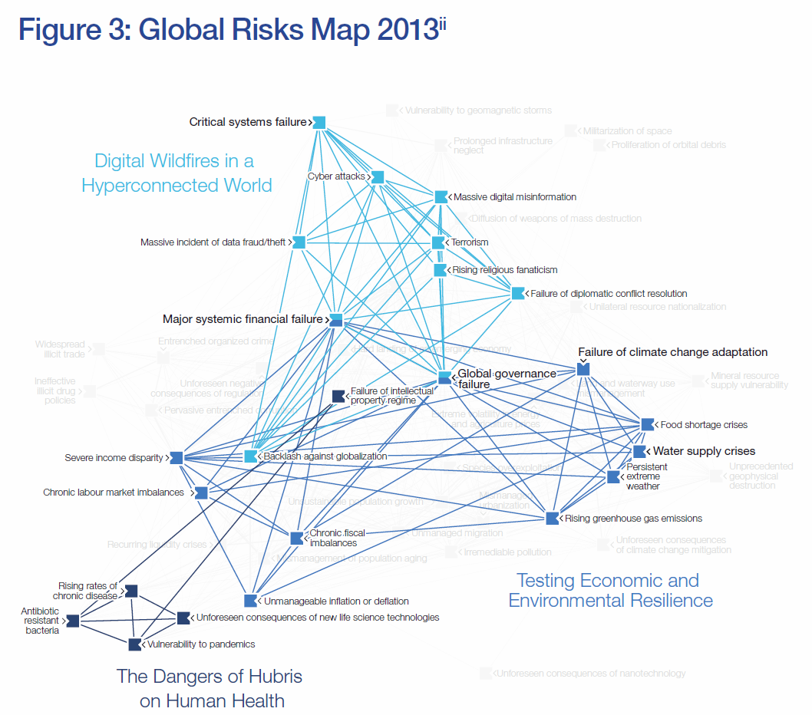
Source:
The World Economic Forum report also provides a snapshot of the costs, impact and burden of antibiotic resistant bacteria globally (see Figure 10) , and highlights the added concern that pandemic spread of antibiotic resistant bacteria could result in food shortages due to untreatable infections in livestock, as well as restrictions on trade and potentially travel and migration.
Figure 10 Costs, impact and burden of antibiotic resistant bacteria
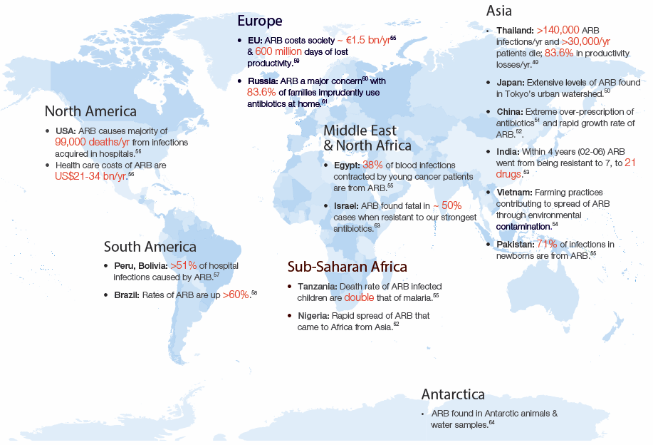
Source:

An overview of key characteristics of global surveillance and reporting systems
This section seeks to outline the key attributes exhibited by existing surveillance systems across the world, summarising the characteristics of the programs listed in the evidentiary table commencing on page 148. The design of an Australian system will need to consider such features and the implications of including or omitting various aspects.

Program type
A number of highly regarded programs incorporate the monitoring and reporting of both antimicrobial resistance and antimicrobial use, while others monitor either use or resistance in isolation.

Program scope
Some of the listed programs gather data on antimicrobial use and/or resistance in animals only, some include veterinary and human data sets, and other examples bring in data on bacterial isolates from food.

Program status
The majority of programs listed appear to be currently operational, while a few have ceased to exist, or have been incorporated or transformed into other programs.

Program focus
There is considerable variance in the focus of programs operating across the globe. It is common that microorganisms and antimicrobials of interest and consequence to human health are monitored. The range of animal species and settings within which monitoring occurs also varies.

Geographic range of surveillance
Some existing programs bring together data from several nations, while others concentrate on national data sets. In some cases, notably across Europe, national systems gather data and then report a subset of the information to a supra-national program.

Types of bacteria
Some existing programs focus on bacteria that are human pathogens and may or may not be pathogenic to animals, while others include commensals. This allows the program to detect emerging resistance and explore the potential for resistance characteristics that may emerge in one bacterial species to be transmitted to others, including human pathogens.

Bacterial characteristics
While it is common for surveillance programs to gather data on antimicrobial susceptibility in bacterial species of interest, some programs also gather data on genotypical characteristics. This additional level of information can greatly inform epidemiological investigations and help to clarify mechanisms of resistance, which may show that changes in levels of resistance are due to changes in clonal types predominating, not because a particular strain is becoming more or less resistant. There are, however, potentially significant resource implications associated with the levels of testing required to genotypic analysis.

Specimen types and sampling programs
Decisions regarding the types of specimens to be collected, and the locations and frequency of sampling will underpin a critical component of surveillance efforts. An appropriate balance needs to be established between efficiency, costs and impact on producers on the one hand, and the sensitivity, validity and reliability of data for decision making on the other.

Laboratory participants
A key decision in program design will be whether to establish or utilise existing reference laboratories for bacterial identification and susceptibility testing, or engage current laboratories that already provide clinical, research or other testing services to process surveillance samples. Both models exist internationally, with a range of implications including cost, quality, standardisation, and data access.

Standardised laboratory practice
Standardisation of laboratory methodology and an acute understanding of the implications of testing according to different standards are essential to interpreting surveillance data and making decisions. The level of standardisation of approaches will dictate both the ability to interpret data from different locations across Australia, and efforts to harmonise Australian data with international data sets to understand local performance, policy and issues in a global context.

Basis of participation
Key to the design of Australian surveillance programs will be decisions regarding the basis of participation for producers, pharmaceutical suppliers, microbiology laboratories, and regulatory bodies. In international programs, producers may be mandated to collect and report data and supply samples for testing, or may be subject to randomised sampling schemes, or may have the option for voluntary participation, either industry supported and self-regulated or government decreed. Suppliers of pharmaceuticals may be required to provide sales data to different levels of granularity and with or without data on likely levels of use in different species, or may have the option to voluntarily provide information. In some countries, regulatory authorities are required to conduct programs to gather and report antimicrobial use. Microbiology laboratories will need to be resourced for the activities associated with surveillance. Internationally, laboratory involvement ranges from passive contribution of data relating to veterinary clinical specimens through to large scale centralised processing of targeted surveillance samples. Laboratory proprietorship includes examples of government, university and commercial ownership.

Frequency of data gathering
Options for frequency of data gathering range from daily or weekly to monthly, quarterly or annual submission from laboratories, producers, suppliers, and other stakeholder bodies. Issues to consider will include the level of reporting overhead placed on owners of data and information, and the timeliness of analysis, reporting and action.

Frequency and methods of reporting
The majority of programs examined report on an annual basis, and often provide publicly available versions of reports in pdf format. Data are also reported in peer reviewed journal articles. In some cases, a sophisticated level of reporting is available on-line, where visitors to a web site can select organisms, antimicrobials and geographical areas of interest, and generate reports showing a range of information on susceptibility, usage and trends.

Population monitored
Hand in hand with decisions regarding the design of sampling regimens will be assessments of the relevant species and locations to be monitored for both antimicrobial use and resistance. Beyond decisions regarding species will be judgements regarding elements such as types of production systems, for example feed-lot versus grass-fed, and end use, for example beef cattle versus dairy cattle.

Funding source and governance
Funding and governance issues will be germane to the development of surveillance programs, and will potentially impact most components of system design, and the level of acceptance and uptake of the programs. International programs report government funding sources ranging from agricultural to human health department budgets, and some programs are funded by the World Health Organization. In some cases, specific programs that feed into larger surveillance efforts may be funded by an industry body, or be a component of university activity.

Options and models for the Australian context
This section of the report explores international experience with the development and operation of surveillance systems and networks that are informative in considering desirable attributes and requirements for Australian surveillance.

Objectives of international antimicrobial resistance surveillance systems
The World Health Organization proposes that an antimicrobial resistance surveillance system for bacteria commonly transmitted by food should provide data that can be used to :
- document the levels of antimicrobial resistance in different reservoirs;
- identify trends over time and from place to place in antimicrobial resistance;
- describe the spread of resistant bacterial strains and genetic determinants of resistance;
- clarify the association between antimicrobial resistance and use of antimicrobial agents;
- generate hypotheses about sources and reservoirs of resistant bacteria;
- identify appropriate interventions to contain the emergence and spread of resistant bacteria and evaluate their effectiveness;
- develop targeted epidemiological and microbiological research for source attribution studies, and identify risk factors and clinical outcomes of infections caused by resistant bacteria;
- inform risk analysis of foodborne antimicrobial resistance hazards;
- guide evidence-based policies and guidelines to control antimicrobial use in hospitals, communities, agriculture, aquaculture, and veterinary medicine;
- deliver education on current and emerging hazards.

Case studies—existing programs of most relevance to the Australian context
The following section describes a number of international surveillance systems and programs that are relevant to the Australian context. These case studies are informative in considering the needs and future directions for surveillance in Australia.

French surveillance of antimicrobial resistance and use

Overview
The French National Observatory for Epidemiology of Bacterial Resistance to Antibiotics (ONERBA) centralises data from human and animal surveillance covering 17 surveillance networks. Created in 1997, ONERBA is an organization whose scientific and technical activities rely mainly on the networks for surveillance of resistance already established, only one of which (RESAPATH) is devoted to isolates obtained from animals. RESAPATH, operated by ANSES, the French Agency for Food, Environmental and Occupational Health & Safety, coordinates the voluntary contribution of antimicrobial susceptibility data from isolates from diseased food-producing animals and companion animals obtained by 63 public and private diagnostic laboratories distributed through the country. It commenced in 1982 (bovine isolates only) and was expanded to include swine and poultry isolates in 2000 and other animal species including companion animals and horses in 2007. RESAPATH is a key component of the EcoAntibio 2017 plan to combat antimicrobial resistance in animals. The EcoAntibio 2017 plan aims to reduce antimicrobial use in the veterinary sector by 25 per cent by 2017 by introducing/refining 40 broad measures divided into 5 axes. EcoAntibio 2017 supports the mission of EFSA and ESVAC. ANSES manages the Salmonella surveillance network and also publishes reports on antimicrobial sales data in the French animal sector (from 1999 onwards).

Participants
The ANSES program is directly funded by the Ministry of Agriculture.

Objectives
The objectives of the French National Observatory for Epidemiology of Bacterial Resistance to Antibiotics are:
- To gather and analyse data regarding bacterial resistance to antibiotics in France, and to compare these data with those obtained in other countries
- To provide data regarding bacterial resistance to antibiotics to Health Authorities, Scientific Organizations, and Health Professionals, upon request.
The objectives of RESAPATH, the French surveillance network for antimicrobial resistance in pathogenic bacteria of animal origin, include:
- To monitor antimicrobial resistance in pathogenic bacteria of animal origin in France
- To collect resistant isolates of particular interest, and to characterize their genetic background (including deciphering mechanisms of resistance)
- To contribute to updated comparative data between animals and humans in France.
The objectives of EcoAntibio 2017 are to:
- Reduce the contribution to bacterial resistance made by antibiotics used in veterinary medicine
- Preserve therapeutic arsenal on a sustainable basis given prospects for new antimicrobials in veterinary medicine are limited.

Collection and processing of data on pathogens and commensals from animals
RESAPATH integrates disc diffusion antimicrobial susceptibility data obtained from participating private and public veterinary diagnostic laboratories distributed throughout France. Particular emphasis, however, is placed on E. coli isolates resistant to critically important classes of antimicrobial used in humans (3rd/4th generation cephalosporins and fluoroquinolones). These isolates are collected and characterised. In addition measuring the degree of multidrug-resistance and identifying nosocomial infections in veterinary practice are a priority. Methicillin-resistance in coagulase-positive staphylococci has been a recent focus, in particular MRSA ST398 in dairy cattle. ANSES facilitates the collection of isolates from food-producing animals at slaughter to comply with EFSA and supports standardization of methodology.

Collection and processing of data on antimicrobial usage
ANSES monitors sales of antibiotics for veterinary use in France by compiling declarations from the point of sale. Data is cross-matched against declarations of turnover and prescriptions. The collection of data encompasses veterinary medicines only, that is, it does not cover off-label prescriptions of drugs registered for humans for use in companion animals. Since 2009, declarations have been broken down into target species. Dosage and duration of treatment are taken into account.

Publication of data
RESAPATH produce annual reports that are freely available from their website. Publications arising from RESAPATH data have been focused on epidemiology and sampling methodology . The ANSES report on antimicrobial usage is available from their website. The EcoAntibio 2017 national action strategic plan is publicly available.

Program impact
ANSES antimicrobial use data were able to demonstrate an increase in consumption of antimicrobials of 27.9 per cent between 1999 and 2009, though data collected between 2009 and 2010 show a 12.2 per cent fall. However, during this time there has been a concomitant increase in the use of critically important antimicrobials (third and fourth generation cephalosporins and fluoroquinolones). The RESAPATH data is of great comparative interest for Australia due to the similarities in recruiting laboratory networks, methodology (disc diffusion as the initial screening technique using clinical breakpoints rather than ECOFFs performed on clinical isolates from sick animals) and target species (livestock and companion animals) with the Australian-based Zoetis-funded pilot survey (see section 4.1.4 below). RESAPATH have been able to rely on the submission of passive data generated from susceptibility reports because all veterinary diagnostic laboratories within France use the same susceptibility criteria. RESAPATH have confirmed high rates of resistance to critical antimicrobials among E. coli isolates from cattle, horses and companion animals concomitant with increased availability and prescribing of these drugs. However they were able to demonstrate a drop in resistance frequency in their most recent report when EcoAntibio 2017 energies were focused on education and therapeutic guidelines.

The Canadian Integrated Program for Antimicrobial Resistance Surveillance

Overview
The Canadian Integrated Program for Antimicrobial Resistance Surveillance (CIPARS) was established in 2002. Prior to this, a national scientific taskforce ‘the Canadian Committee on Antimicrobial Resistance’ had identified the need for surveillance as part of a comprehensive review on the issue of antimicrobial resistance in humans and animals in Canada . CIPARS is an attractive case study in this present report because of the many parallels that exist between Canada and Australia both in terms of socio-political and economic attributes but also animal-food systems. These include similarities in the landmass and population densities of both countries, the diversity of food-animal production, the mechanisms of drug regulation, the level and quality of veterinary training and infrastructure, and a common reliance on the federal system of government. Canada, like Australia, is also a major exporter of farm-food products. Nevertheless, there are some notable dissimilarities. These include the geographic isolation of Australia in comparison to Canada with the latter having a large common border with the United States involving considerable two-way cross-border trade in livestock, livestock products and food. Also, with respect to red-meat production and consumption, Australia has a much larger emphasis on extensive rearing and finishing of animals with pasture-based production systems that require only very limited use of antimicrobials to maintain animal welfare and production. Dairy cattle production in Australia has a much larger emphasis on pasture as forage. In Australia, most forms of ruminant production rarely involve housing or provision of shelter for livestock in winter as in the case of Canada. Australia also has a more conservative regulation of antimicrobials used in food animals as detailed elsewhere in this report.
A key feature of CIPARS is that reports are an amalgamation of human data with animal data on antimicrobial resistance and antimicrobial use. This section now focuses on the animal-related components of CIPARS with details of the human-related having been addressed in the recent AMRAU report in Australia .

Participants
The integrated nature of CIPARS and the geographic diversity of Canada demand the use of an extensive network of human expertise and laboratory resources. These include:
- National Centre for Food-borne, Environmental and Zoonotic Infectious Diseases
- National Microbiology Laboratory
- Laboratory for Foodborne Zoonoses
- Provincial public health laboratories in ten provinces
- Provincial animal health laboratories in nine provinces
- A large number of individuals and organisations from the animal and food production sectors and public health agencies involved in coordination, sample collection, data collection, data management and interpretation. Some of these contributions are made on a voluntary basis and these are regarded as a critical element of the program .

Objectives
CIPARS objectives are stated in the 2009 annual report as follows:
- Provide a unified approach to monitor trends in antimicrobial resistance and antimicrobial use in humans and animals.
- Disseminate timely results.
- Facilitate assessment of the public health impact of antimicrobials used in humans and agricultural sectors.
- Allow accurate comparison with data from other countries that use similar surveillance systems.

Collection and processing of data
The 2009 CIPARS report outlines the organisation of surveillance activities for that year and the flow of information (for both human and animal components) through the constituent elements as shown in Figure 11.
Figure 11 Diagram of CIPARS surveillance activities, extracted from the 2009 CIPARS Annual Report for 2009
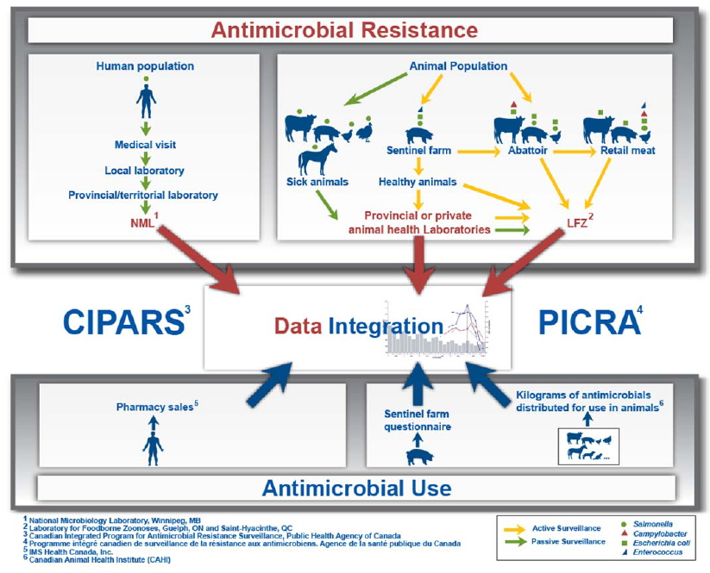
Source:
Within CIPARS, the most notable aspects of data collection and data handling from an animal and veterinary perspective are:
- Assessment of AMR in organisms is based on both passive and active components, and both pathogens and commensal bacteria.
- The diversity of animal production is so great that it is not possible to include assessment of all aspects (microbiological outcomes) of all animal production systems in all years. As CIPARS has developed, components have been included and excluded on a needs basis to ensure that the most important risks are assessed more frequently.
- Some bacterial isolates derived from animals are obtained by sampling animal products at the retail and abattoir level presumably as a more convenient and inexpensive approach (compared to sampling on-farm) to obtaining good representative samples. Importantly, the broadening of the scope of the system to include sampling from food substantially increases the number of objectives, the size of the system and the cost of the system. A drawback of reliance on acquisition of commensal isolates from retail meat products is that there is no certainty that any given isolate was derived from the corresponding animal production system because of the opportunity for cross-contamination by processors and/or butchers.
- Considerable emphasis is placed on designing the collection of specimens from abattoirs, farms and retail sources in a statistically-sound manner to prevent bias in the data and allow for valid comparison between years.
- There is no permanently in-place system for recording veterinary prescription data at the animal or herd level (as exists in Denmark). Consequently, within CIPARS strong reliance is placed on the acquisition of aggregated data provided voluntarily by the pharmaceutical industry.
- Canada has a large intensive pork industry. To supplement the above aggregated data from the pharmaceutical industry and to increase the number of samples for microbiological analysis additional reliance is placed on sentinel-swine veterinarians for procurement of data and specimens.
- The geographic extent and diversity of Canada makes it useful to provide province-specific estimates of prevalence (resistance) and consumption (antimicrobial). This is in distinct contrast with, for example, European programs with the exception of EFSA . It requires data collection and analysis to be designed for this purpose. An advantage is that animal production and antimicrobial usage practices can vary considerably from province to province (for example, the recent example of ceftiofur use in the Quebec poultry industry-see-program impact below).
- The program involves a very large number of microbiological outcomes, sources of specimens and data on drug consumption. From the scale of the CIPARS report it is evident that a considerable effort is required to manage, collect, store, organise and analyse the data especially considering it is derived from so many distinct sources. Many of these processes are unlikely to have existed prior to the establishment of CIPARS. Scientific leadership and effective coordination of these processes, thereby enabling centralised reporting and interpretation, appears essential in this model for surveillance and appears a successfully implemented element of CIPARS.
Resistance data within CIPARS is confined to food animals only (including horses). The following combinations of organism and origin-of-specimen are included in the 2009 report:
- Beef cattle: clinical isolates of Salmonella, commensal E. coli from retail meat, commensal E. coli from caecal samples collected at abattoirs, Campylobacter isolates from caecal samples collected at abattoirs
- Chickens: Salmonella, E. coli, Enterococcus (faecium, faecalis and other) and Campylobacter isolates from retail meat samples, clinical Salmonella isolates mostly from layer and broiler chickens sometimes derived from environmental samples
- Pigs: Salmonella and commensal E. coli isolates from caecal samples collected at abattoirs; Salmonella, commensal E. coli and Enterococcus isolates from pig faecal samples collected on-farm; clinical isolates of Salmonella; and E. coli from retail meat samples
- Turkeys: Salmonella isolates of clinical and environmental origins.
- Horses: Salmonella from clinical isolates.
At present, resistance data published in official CIPARS reports is confined to phenotypic data, although additional genetic and epidemiological information is included in some journal publications based on CIPARS activities. All Salmonella spp. and E. coli isolates are tested for susceptibility to a panel of 15 antimicrobials. Enterococcus spp. are evaluated against a panel of 16 antimicrobials. Campylobacter spp. isolates are tested against a panel of nine drugs. In each case MIC data are obtained on especially designed Sensititre® custom-made micro-dilution plates performed to CLSI standards.

Publication of data
Four forms of reporting are used for releasing findings from CIPARS :
- Annual reports—these are comprehensive documents detailing the approach, methods, data sources, laboratory aspects and so on for a given year and include both the human and animal data. These are complex and moderately-large documents that would demand a substantial degree of organisation in preparation for publication. For example the 2009 CIPARS report is 189 pages long featuring 63 figures and boxes (many of which are very complex) and 79 tables (including those within appendices). The magnitude of effort required to compile, review and finalise such a report may explain why annual reports can take several years before becoming publicly available (as at July 2014, the CIPARS 2009 annual report is the most recent such report publicly available).
- Short reports—the greater simplicity of reports in this format (the most recently available 2011 short report had a length of 70 pages) allows for their more timely release. These reports provide raw (summarised) data without interpretation.
- Quarterly summaries—focus on information about Salmonella broken down by animal species of origin.
- Extracts and derivations published in scientific journals and conference proceedings with or without additional data or analysis (see below). Examples include: surveillance findings from finisher pigs , genetic analysis of multidrug-resistant Salmonella from animals and food , international comparison of antimicrobial resistance data , methodology for the isolation of Salmonella from animal faeces , integration of surveillance and research data on Salmonella , ciprofloxacin resistance in Campylobacter , integrated surveillance for Salmonella Enteritidis , and ceftiofur-resistant Salmonella in animals and humans .

Program impact
Surveillance data from CIPARS has been instrumental in strengthening the understanding of how antimicrobial resistance in animals can have an adverse effect on public health. Presentation of human and animal data in an integrated fashion is useful for ensuring the animal surveillance and future interventions both have a focus on human health. Several examples of the impact of CIPARS have been reported and are summarised as follows:
- Data concerning MDR Salmonella and E. coli were collected by CIPARS from 2004 onwards and later reported in a scientific journal . The work provides perhaps the best documented example of how AMR in animals can have a detrimental impact on public health on a large scale. The data demonstrated a link between an increasing frequency of detection of multi-drug resistant Salmonella Heidelberg in humans and the use of ceftiofur in poultry production in parts of Canada. S. Heidelberg is one of several strains of Salmonella with an ability to cause severe and invasive infections with a high rate of complications such as septicaemia. Moreover, because these S. Heidelberg were multiple-drug resistant, including resistance to third generation cephalosporins, they represented a substantial threat to successful therapy of human cases. CIPARS data concurrently revealed an elevation in the proportion of ceftiofur resistance in both commensal E. coli and S. Heidelberg obtained from retail chicken from Quebec. It was identified from the investigation that ceftiofur was in common use in Quebec chicken flocks and was being administered en-masse to fertilised eggs as a means of controlling E. coli infections in chicks post-hatching. The consequence of ceftiofur use was selection for resistance in the population of S. Heidelberg resident in the chicken population. These MDR Salmonella were then propagated through the food chain to result in human illness. The ongoing nature of CIPARS resulted in the provision of data demonstrating temporal change in the prevalence of ceftiofur resistance in E. coli and Salmonella including a fall in the prevalence of ceftiofur resistance in isolates apparently in response to an intervention comprised of voluntary withdrawal of ceftiofur in the Quebec chicken meat industry .
- CIPARS data also revealed elevated levels of ciprofloxacin resistance in Campylobacter isolated from Canadian retail chicken meat. Campylobacter is one of the most common causes of food-borne illness in Canada. None of the drugs within the fluoroquinolone class (including ciprofloxacin) are registered for use in chickens in Canada. The surveillance data showed that this resistance was much higher in Western Canada than other parts of the country but has declined since first detected. Human data on Campylobacter were not collected by CIPARS and were not available from other sources. However, the findings did indicate the need for collection of susceptibility data from human isolates and, presumably, an examination of the off-label use of fluoroquinolones in farm animals.
- CIPARS has worked with the food-borne surveillance network in Canada (FoodNet) and demonstrated that Salmonella Enteritidis is present in a variety of animals species within the food-production system, but most commonly in chicken. CIPARS has reported a decreasing incidence of human S. Enteritidis infections in Canada since 2012 with human isolates having a higher level of antimicrobial resistance than isolates from food and animals. The data are regarded as extremely useful for monitoring the impact of future interventions on control of S. Enteritidis and resistance in the food chain.

The United States National Antimicrobial Resistance Monitoring System

Overview
In 1996, collaboration was established between federal, state, and local agencies in the United States for performing surveillance on antimicrobial resistance in enteric bacteria from humans, retail meats and animals (NARMS). An important feature of NARMS is that methodology in sampling and laboratories has been sufficiently stable since inception to allow for sound comparison of results between years thus demonstrating time-based trends in emergence of resistance. As well, the laboratory methodology is comparable across the three arms of NARMS (humans, food and animals) which provides for a strong basis for ‘one health’ comparisons between these three sources. Together this provides a powerful mechanism for informing on the evolution of resistance in zoonotic enteric pathogens over time. An excellent example of this, evident in the 2011 annual report , is the evolution of resistance to third generation cephalosporins in non-typhoidal Salmonella obtained from animal sources.
The main focus in this report is to describe the animal component of NARMS which is directed at the evaluation of enteric isolates obtained from food animals.

Participants
The NARMS program is a collaboration between the U.S. Food and Drug Administration (FDA), the U.S. Centers for Disease Control and Prevention (CDC), the U.S. Department of Agriculture (USDA) and various state and local health agencies throughout the U.S. Data on human isolates and food isolates are managed by the CDC and FDA (Food and Drug Administration), respectively. The component that is focused on enteric isolates from food animals is managed and reported by the USDA with laboratory work performed by the Agricultural Research Service of USDA in Athens, Georgia.

Objectives
The objectives for NARMS are expressed as a mission statement in the 2012-2016 Strategic Plan ‘…to monitor (sic) the susceptibility of enteric bacteria to antimicrobial agents of medical importance in order to help assess the impact of veterinary antimicrobial use on human health.’ In contrast to other systems of surveillance for major food producing nations, the scope of NARMS is constrained to address enteric bacteria from humans, retail meats and animals. The NARMS Strategic Plan identifies the following activities as requirements for accomplishing the stated mission:
- Monitor trends in resistance amongst enteric bacteria
- Disseminate timely information and promote interventions that reduce resistance.
- Conduct research
- Provide data to assist the agency responsible for approval of antimicrobial drugs for use in animals (FDA).
NARMS does not have a component that assesses antimicrobial resistance in isolates from small animals, equines and minority animal species.

Collection and processing of data on pathogens and commensals from animals
USDA NARMS assesses the resistance status of isolates of Salmonella spp., Campylobacter spp., Enterococcus spp. and E. coli obtained from food-producing animal specimens at federally inspected slaughter and processing plants throughout the United States. Some additional specimens are acquired from National Animal Health Monitoring Scheme (NAHMS) activities performed on-farm and from diagnostic samples obtained on-farm. Specimens are then submitted for isolation of target organisms and antimicrobial susceptibility testing. The data on animal isolates is thus not pre-existing but involves active collection of samples and active measurement of resistance. However, the collection of samples is performed as part of the Pathogen Reduction Program that is enforced in all federally-inspected slaughter facilities in the U.S., with additional laboratory work on antimicrobial sensitivity within NARMS performed on isolates in addition to laboratory work for the Pathogen Reduction Program.
The main source of isolates from animals is carcase rinsates (chicken) and carcase swabs (turkey, cattle and swine). Isolates also are obtained from ground products (turkey, chicken and beef) in processing plants. Because specimen collection is combined with that for the pathogen reduction program the sampling scheme (frequency of collection from individual carcases and from specific processing establishments) is defined by the rules under that program. The pathogen reduction program is primarily a regulatory based program and in particular emphasises control of E. coli O157:H7. It results in a sampling scheme that is complex and includes elements of non-probability sampling and this quite likely introduces bias into the estimates for prevalence of resistance . However, the isolates come at minimal additional expense and results in a very large collection of isolates for each of the target bacteria. Moreover these are sourced from many different herds and flocks across the entire US processing industry.
Although NARMS investigates the resistance status of Salmonella, Campylobacter, E. coli and Enterococcus spp. all of these organisms are not studied in all of the major food animal species. Typically, data on Salmonella is provided for chickens, pigs, cattle and turkeys, while data for Enterococcus spp., Campylobacter and E. coli are only provided for chickens. The selection of organism-animal combinations to be included in NARMS is likely to have been informed by the perceived risk posed by each pathogen in each species of animal, ease with which organisms can be acquired, type of animal product available for sampling and information on the causes of food-borne illness in humans.
All isolates tested under the NARMS program are assessed using CLSI standardised methods based on a widely used broth microdilution platform (Sensititre®, ThermoFisher). Salmonella isolates are all serotyped. Testing plates are custom designed for each pathogen. Over the course of the program the inclusion of specific antimicrobials in the testing panel has varied according to the range of drugs that is available for use in food animals. Break points for interpretation of resistance have also varied according to changes in the accepted standards. A strength of this approach is that each isolate is comprehensively tested for phenotypic resistance traits. However, a disadvantage is that a great deal of resources are directed at defining MICs for a very wide range of drugs which arguably detracts from the ability to test a much larger number of isolates for dichotomous resistance traits involving only the most important drugs.
Efficiency in the NARMS project comes from an ability to inexpensively acquire a large number of the targeted isolates. This arises from partially ‘piggybacking’ on the Pathogen Reduction Program and this negates the need for extensive visits to individual farms which would add substantial cost and complexity to the program. The pathogens being targeted mostly behave as commensals in livestock, and because they are common in faecal material they are recovered from carcases sufficiently often to be useful for surveillance.

Collection and processing of data on antimicrobial usage
The NARMS program does not involve collection of data on consumption of antimicrobials. It appears there is no scheme operating in the USA that provides this data.

Publication of data
Data outputs from the NARMS program are freely available from the web pages of agencies responsible for the human, food and animal components (CDC, FDA and USDA, respectively). Data are typically comprehensive and are embedded in annual reports for each component.
A large number of publications in peer reviewed journals and attributed in part or full to NARMS activities are listed on the FDA website. Examples include: general descriptions of the program contributions and outcomes and detailed phenotypic and genetic characterisation of resistance in animal isolates . NARMS reports and data also are widely cited in journal publications.

Program impact
NARMS has links to policy making bodies and interest groups through the publication of findings and a series of meetings conducted on a regular basis . This provides the main pathway for impacting on policies of individual agencies. However, although NARMS is one of the longest running programs, it is difficult to identify documents providing a comprehensive description of program impacts. Possibly this arises because NARMS is not performed within a single organisation, instead being a large number of organisations with diverse functions potentially making a wide range of decisions based on the data. Nevertheless, there have been a number of notable uses of the results from NARMS animal studies other than as a stimulus for new research . For example, data on the occurrence of fluoroquinolone resistance in Campylobacter spp. isolated from poultry, has been used in regulatory and legal processes in the US to reduce the availability of enrofloxacin in animal production. As well, applications to register new antimicrobial products for use in the animal industries are now interpreted against the backdrop of NARMS findings through the conduct of risk assessments . Arguably one of the most important outcomes of NARMS has been the demonstration of the widespread and increasing level resistance to third generation cephalosporins in non-typhoidal Salmonella from food animals. These data were clearly very influential in the FDA decision to introduce additional legal constraints on the use of cephalosporin drugs in food-producing animals .

Danish Integrated Antimicrobial Resistance Monitoring & Research Program

Overview
DANMAP was established by the Danish Ministry of Food, Agriculture and Fisheries and the Danish Ministry of Health in 1995 to monitor antimicrobial use in the human and veterinary sectors and antimicrobial resistance in human and animal pathogens, zoonotic bacteria and indicator bacteria. DANMAP had its genesis in the 1990s when Danish scientists established the link between avoparcin use in poultry and carriage and contamination of meat with vancomycin-resistant enterococci. It is the first national surveillance program to be initiated by a country and forms a successful blueprint that has been replicated, albeit with modifications by several other countries. From the outset, DANMAP adopted a coordinated, One Health strategy, developing a highly integrated, systematic and continuous program covering the entire chain, relating antibiotic consumption with resistance, from ‘farm to fork to sickbed.’ Unique methods of integrating data were developed which created outcomes for action through cross-sector collaboration between scientists and authorities. DANMAP has been highly successful due to adequate funding, excellent planning and collaboration at all sectors, but also because Denmark is a small country with a large economic reliance on high quality agricultural produce (approximately 80 per cent of antimicrobials used in the animal sector are administered to pigs) and relatively short distances between farms, processing facilities and laboratories. A key feature of the DANMAP program is separation of risk assessment from risk management. Surveillance and assessment of risks (responsibility of scientists) are separated from the handling of potential risks (responsibility of authorities from the Danish Vet and Food Administration and Danish National Board of Health).

Participants
The program’s main participants are the National Food Institute and the National Veterinary Institute, both located at the Technical University of Denmark and the Statens Serum Institut (SSI). Seamless integration with secondary institutes provides a strong network of sample collection from diverse sources. The DANMAP program is funded jointly by the Ministry of Health, the Ministry of Science, Innovation and Higher Education, and the Ministry of Food, Agriculture and Fisheries.

Objectives
The objectives on DANMAP are clearly outlined in an information pamphlet entitled: ‘The Danish approach to surveillance’ available on the DANMAP website.
- To monitor food animal and human consumption of antimicrobial agents
- To monitor the occurrence of antimicrobial resistance in bacteria isolated from food animals, food and humans
- To study associations between antimicrobial consumption and antimicrobial resistance
- To identify routes of transmission and areas for further research studies.

Collection and processing of data on pathogens and commensals from animals
From the initial task of monitoring the effect of the removal of growth promotants on the antibiotic resistance status of bacteria isolated from food-producing animals, DANMAP has now moved focus to classes of antimicrobial that are critically important to human health (third-generation cephalosporins, fluoroquinolones, macrolides and recently, carbapenems). Foodborne zoonotic organisms that DANMAP assesses for resistance status include Salmonella (with a focus on MDR S. Typhimurium), Campylobacter (with a focus on fluoroquinolone and macrolide resistance), and most recently, Clostridium difficile. Indicator bacteria include enterococci (E. faecium and E. faecalis) and E. coli with particular reference to ESBL-producing strains and most recently, carbapenemase-producing strains. Human pathogens include E. coli (bloodstream and urine isolates), Klebsiella pneumoniae, Pseudomonas aeruginosa, Enterococcus faecalis/faecium, Neisseria gonorhoeae and coagulase-positive Staphylococcus. A particular recent focus has been livestock-associated MRSA with CC398 now the second-most common cause of MRSA infections in humans in Denmark.
The main source of isolates from healthy animals (mainly poultry, pigs and cattle) are samples taken directly from processing facilities by meat inspectors and/or plant employees in the form of caecal samples (pigs) rectal samples (cattle), and cloacal swabs (broilers). Samples are collected every month from January to November. The stratified random sampling is estimated to be representative of >84 per cent of farms.
All food samples are collected at wholesale and retail outlets during routine inspections by the Regional Veterinary and Food Control Authorities (Salmonella and Campylobacter spp.) or on request from DANMAP (enterococci and E. coli). Bacterial isolates included in the monitoring program originate from food from Denmark as well as imported food.
All samples are sent to the Technical University of Denmark’s National Food Institute for microbiological investigation. Clinical isolates from diseased food-producing animals (enterotoxigenic E. coli and S. hyicus) are obtained from DTU National Veterinary Research Institute and the Danish Agriculture and Food Council’s Laboratory for Swine Diseases.
DTU’s National Food Institute is the national reference laboratory for Salmonella in animals and food and receives all isolates for typing. Salmonella isolates investigated include those obtained from random sampling of healthy animals and the national surveillance program.
Susceptibility testing (one isolate per bacterial species per farm, meat sample or patient; 16 antimicrobials for Salmonella and E. coli; 14 for enterococci and 7 for Campylobacter) is performed using commercial Sensititre® plates according to CLSI guidelines using ECOFFs validated by EUCAST where possible.

Collection and processing of data on antimicrobial usage
DANMAP has the most integrated and accurate systems for measuring antimicrobial consumption data in animals and humans. Data on veterinary use of antimicrobial agents derives from an IT monitoring program called VetStat, which was initiated in 2000 by the Danish Government. VetStat collects data on prescribed drugs used to treat animals. Through VetStat, antimicrobial consumption in both food-producing animals and pet animals is now accurately reported in annual reports in comparison to antimicrobial consumption data in humans.

Publication of data
Data outputs from the DANMAP program are freely available from the DANMAP web page as yearly reports covering food animals, food and humans (from 1996-2012). Data are typically comprehensive and are embedded in annual reports for each major component covering zoonotic and indicator organisms from healthy animals, animal and human pathogens.
A large number of publications in peer reviewed journals are attributed in part or full to DANMAP. Recent examples include descriptions of the program, epidemiological modelling, and trends in resistant organisms over time . DANMAP reports and data also are widely cited in additional journal publications.

Program impact
Data from DANMAP documenting the increasing prevalence of vancomycin-resistant enterococci in poultry and pig meat was instrumental in the Danish government initiating a ban on the use of antimicrobials for growth promotion in the 1990s. Steady increases in the amount of therapeutic use of antimicrobials in animals were recorded following the ban, concomitant with the increased detection of ESBLs in commensal E. coli isolates from livestock. Despite the introduction of new guidelines governing use, consumption continued to increase, necessitating the introduction of the ‘yellow card’ system in 2010 for veterinarians and their clients designed to reduce overall antimicrobial use, and a voluntary withdrawal of the use of cephalosporins in pig production. This has resulted in a decrease in detection of ESBLs in indicator E. coli from pigs . These initiatives have stimulated major technological changes within the pig industry to reduce overall antimicrobial consumption, such as the introduction of low protein diets and all in-all out management systems to control post-weaning diarrhoea due to E. coli. Significant increases in the prevalence of ESBL-producing E. coli and fluoroquinolone-resistant Campylobacter were observed in imported compared to domestically-produced poultry meat. Despite the major DANMAP initiatives over 15 years, between 2001 and 2007, increases in the prevalence of resistance to fluoroquinolones and third generation cephalosporins were identified in human bloodstream E. coli isolates. An increase in methicillin resistance prevalence in S. aureus clinical isolates from humans has occurred together with a concomitant rise in the significance of ST398 as a cause of human infection. ST398 is now commonly detected on pig carcases and recently, in bulk milk. Steady improvements in technology for gathering and reporting antimicrobial use and resistance in animals have been introduced throughout the program, for example, most recently, the introduction of defined daily dose per animal and defined daily dose per animal per day in antimicrobial consumption data. Whole genome sequencing to identify antimicrobial resistance genes has been evaluated as an alternative to antimicrobial resistance phenotyping.
Figure 12 shows the data flows associated with the DANMAP program .
Figure 12 DANMAP Data flow
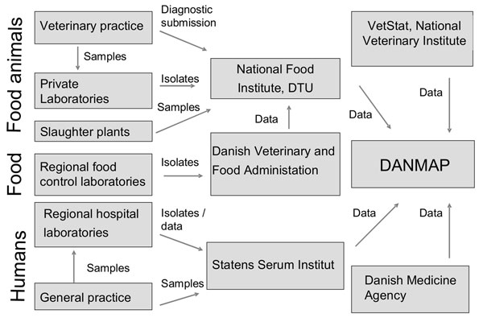
Source:

VetSTAT
Figure 13 outlines the flow of data and reporting pathways for the Danish VetStat program .
Figure 13 VetStat reporting pathways
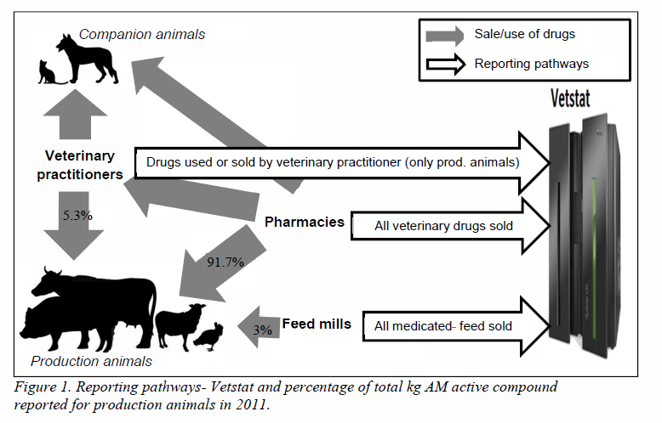
Source:
Figure 14 shows the data elements that are maintained in VetStat. In this figure, the Nordic Commodity Number (*) identifies the name of the medicinal product, strength, form and the size of packaging. The Anatomic Therapeutic Chemical (ATC) classification system (**) identifies all human drugs using a five-digit hierarchical system. Products with the same active substance in the same pharmaceutical formulation are given the same ATC code. ACTVet is the veterinary counterpart of the ACT system .
Figure 14 VetStat data elements
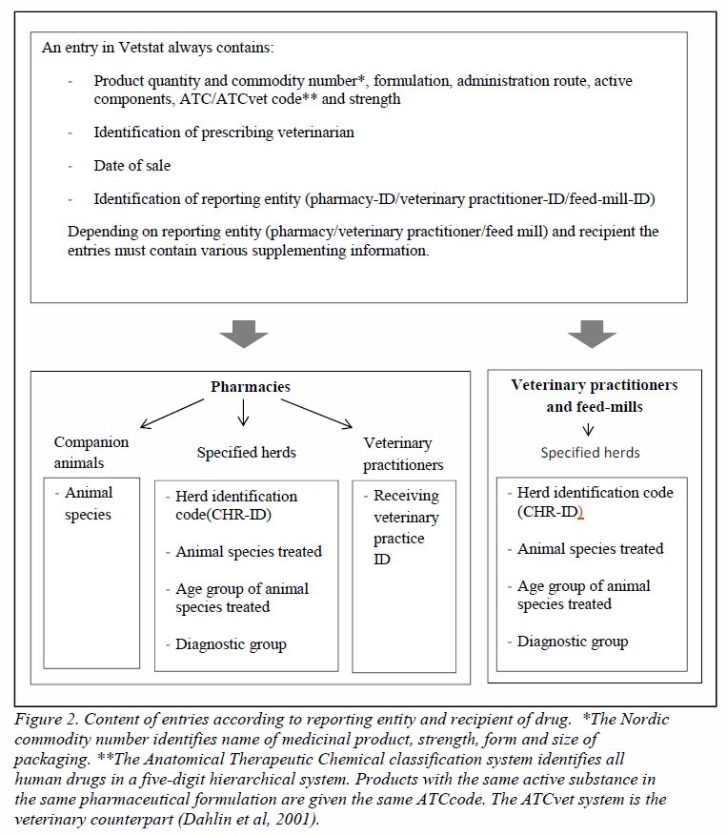
Source:
A list of VetStat definitions for animal species, age group, the ‘standard weight’ assigned to the age group for the purposes of calculating dosage amounts, and the diagnostic groupings used is shown in Table 18 .
Table 18 VetStat definition of animal species, age group and standard weight, and diagnostic group
Animal species | Age group (standard weight in kilograms) | Diagnostic group
Pigs | Breeding animals, gilts, suckling pigs (200)  Weaners (15)  Finishers (50) | Reproduction, urogenital system, udder, gastro-intestinal system, respiratory system, joints, limbs, hooves, CNS, skin, metabolism, digestion, circulation.
Cattle | Bulls, cows (600)  Calves <12 months (100)  Heifers, steers (300) | Reproduction, urogenital system, udder, gastro-intestinal system, respiratory system, joints, limbs, hooves, CNS, skin, metabolism, digestion, circulation.
Sheep, goats | >12 months (50)  <12 months (20) | Reproduction, urogenital system, udder, gastro-intestinal system, respiratory system, joints, limbs, hooves, CNS, skin, metabolism, digestion, circulation.
Mink | Not recorded (1) | Other (mink only)
Aquaculture | Not recorded (1) | Red mouth disease  Furuncolosis  Brood syndrome  Other
Poultry | Broilers (0,2)  Layers (1)  Rearing flocks (1) | Abdominal organs  Coccidiosis  Enteritis  Hepatitis  Salpingitis  Other  Respiratory system/organs
Other production animals (llamas, rabbits, deer, ostriches)  Horses  Pets | Not recorded (1)  Not recorded (500)  Not recorded (not given) | Not recorded
Source:

Critical elements contributing to the success of existing systems
The countries that have been the most successful in controlling antimicrobial resistance are those that have implemented comprehensive national strategies. These strategies are reported by the Lancet Infectious Diseases Commission (LIDC) to include:
- Good health-care infrastructure and health insurance for all
- Limited drug advertising
- Surveillance of antibiotic use and to detect resistance in human beings and animals
- Policies for prudent antibiotic use in human beings and animals
- Standardised infection control policies and sufficient staffing
- Antibiotic stewardship programs in hospitals and other health-care facilities
- Isolation or decontamination of patients with resistant organisms.
The LIDC further suggests that programs need time and patience for establishment, and the backing of visionary governments with adequate provision of funds, and recommends a stepwise approach to developing a national strategy, backed by a roadmap that prioritises and contextualizes issues .
Moreover, several key assumptions are deemed critical to establishment of nationally coordinated system for surveillance of antimicrobial resistance and antibiotic usage. These assumptions include:
- Scientific: that antimicrobial susceptibility testing will be conducted using standardised, internationally recognised methods, and laboratories will be subject to rigorous internal and external quality assurance
- Partnership: that government and industry sectors will work together in a spirit of partnership, each recognising the imperatives and objectives of the other participants, as well as defining and working towards common goals and outcomes
- Technical: that the design of sampling and surveillance programs will be technically robust and scientifically based
- Financial: it must be recognised that a range of financial barriers and potential incentives will exist, and need to considered in the design, implementation, and operation of surveillance programs
- Political: different stakeholders will seek to influence different aspects of programs, or seek different outcomes from common aspects of programs, and political factors need to be considered openly rather than remain as ‘elephants in the room’
- Operational: transparency and robustness of operational systems and processes will inspire confidence in outputs

National coordination in Australia: systems, enablers and barriers

Setting the scene—a recent history
The report ‘National surveillance and reporting of antimicrobial resistance and antibiotic usage for human health in Australia’ which was developed for the Antimicrobial Resistance Standing Committee (AMRSC) provides background on relevant events in Australia . Following the release of the JETACAR report in 1999 and Commonwealth Government response in 2000, a range of activities ensued under the auspice of a number of organisations, including some initial planning for surveillance activities.
An inquiry by the Senate’s Finance and Public Administration References Committee into progress in the implementation of JETACAR recommendations reported in 2013. Recommendations from the Senate inquiry included the establishment by the Commonwealth of an ‘independent body or national centre, to develop a strategy, report publicly on resistance data and measures taken to combat antimicrobial resistance and to manage the response to antimicrobial resistance in Australia.’ The other nine recommendations relate to surveillance of both antimicrobial usage and antimicrobial resistance in humans and animals, improved stewardship of antimicrobials in hospital, community and animal environs, and research that will impact the use of and resistance to antimicrobials.
A steering group, jointly chaired by the Secretaries of the Department of Health (DoH) and the Department of Agriculture (DAFF) was established in February 2013. Named the Antimicrobial Resistance Prevention and Containment (AMRPC) Steering Group, the Commonwealth Chief Medical Officer and Chief Veterinary Officer are also members. High level national governance and leadership on AMR is being provided by this group, which is charged with overseeing the development of a comprehensive national AMR prevention and containment strategy for Australia. The work of this group is being supported in part by the AMRSC, which was established in April 2012 and reports to Health Ministers through the Australian Health Protection Principal Committee.
Funding was provided to the Australian Commission on Safety and Quality in Health Care by the Commonwealth in a 2013/14 funding measure to support an AMR and AU surveillance project. During the three year funding period, deliverables for the Commission include the provision of data and analysis to support policy and program development, commissioning of reports to explore existing human health surveillance programs and data, analysis of procedures and systems that have potential to contribute to AMR and AU surveillance, conduct of a national survey of prescribing practices, and establishment of a national alert system for emerging and re-emerging highly resistant bacteria.
The One Health Antimicrobial Resistance Colloquium, conducted in July 2013, brought together professionals and policy-makers from medical, veterinary and agricultural areas to exchange views on the development and implementation of a national AMR strategy for Australia. The Colloquium was requested by the AMRSPC and convened by the ACSQHC. Key discussion points during the meeting related to regulation, research and surveillance, and key action points were agreed in relation to AMR surveillance and reduction of inappropriate antimicrobial use .
Outlined below are a number of key programs that have contributed to current Australian AMR research and knowledge in agricultural settings.

(a) DAFF Pilot surveillance program for antimicrobial resistance in bacteria of animal origin

Overview
In November 2003, the then Department of Agriculture, Forestry and Fisheries (DAFF) commissioned a pilot study in direct response to the publication and acceptance of the 1999 JETACAR report. The study examined antimicrobial resistance in commensal E. coli, Enterococcus spp. and Campylobacter jejuni isolated from the gastrointestinal contents of Australian beef cattle, pigs and poultry following slaughter. No genotyping of the isolates was undertaken.

Participants
The project was co-ordinated by Ms Gwendeline Lee (DAFF). The sampling protocol was designed by A/Prof David Jordan, NSW Department of Primary Industries with MIC testing undertaken at the Department of Primary Industries, Wollongbar under the supervision of A/Prof Jordan (E. coli), The University of South Australia by Prof Mary Barton (enterococci) and Qld Dept of Primary Industries by Dr Pat Blackall (Campylobacter). Data was analysed by Ms Gwendeline Lee and A/Prof David Jordan.

Objectives
The major objective of the study was to establish baseline antimicrobial susceptibility data for commensal bacteria isolated from major Australian food-producing animal species. MIC data was used to determine the proportion of commensal organisms in each category/animal species that were resistant to 5-10 selected antimicrobials of public health significance.

Collection and processing of data on pathogens and commensals from animals
Caecal specimens were obtained from healthy livestock at slaughter in Queensland, NSW, Victoria and South Australia. High throughput processing facilities were selected in each state with no two samples obtained from the same primary source. Over a six month period to account for seasonal variation, greater than two hundred caecal specimens were obtained for each animal species based on power calculations with the assistance of AQIS on-site Veterinary Officers and the Australian Chicken Meat Federation. Culturing of samples was performed by Veterinary Diagnostic Laboratories in three States. Susceptibility testing was performed by specialist laboratories according to CLSI recommended standards on over 500 E. coli and Enterococcus isolates and over 100 Campylobacter isolates.

Publication of data
Data outputs from the DAFF pilot survey are freely available from the Department of Agriculture website .

Program impact
The study confirmed a low antimicrobial risk status for Australian food-producing animals. No enterococci were resistant to vancomycin, none of the E. coli isolates was resistant to third generation cephalosporins or fluoroquinolones, and no Campylobacter isolates were resistant to fluoroquinolones. Multidrug resistance to classes of antimicrobial commonly used in each sector was identified, with pigs yielding the highest number of MDR phenotypes, followed by chickens and beef cattle. Approximately 8 per cent of Campylobacter isolates from chickens were resistant to erythromycin. The study confirmed that existing resources within DAFF at the time could be adapted and equipped to assist with routine surveillance from processing plants.

(b) Australian Pork Limited Research Project: Identification of antimicrobial resistance genes of public health significance in E. coli isolated from pigs.

Overview
Following publication of the JETACAR report and the recommendation for funding bodies to make antimicrobial resistance a major priority, Australian Pork Limited funded a multi-centre project in 2004-2008 focused on determining the public health impact of antimicrobial use in the Australian pig industry. Following a review, the project team concluded that off-label use of ceftiofur, in particular for the treatment and prevention of post-weaning diarrhoea (PWD) in pigs caused by enterotoxigenic Escherichia coli (ETEC), represented the biggest risk to public health faced by the industry. This was based on:
1) The recent emergence of extended-spectrum beta-lactamases in both pathogenic and commensal E. coli isolated from pigs from Europe, Asia and North America.
2) The fact that PWD remained a major disease in Australia requiring administration of antimicrobials to large numbers of pigs at a key growing stage in the production cycle.
The study focused on a survey of antimicrobial practices by specialist Australian porcine veterinarians followed by detailed analysis of the resistance phenotype and genotype of a collection of Australian MDR porcine ETEC. The study then screened populations of commensal isolates from slaughter age pigs throughout Australia for phenotypic resistance to four antimicrobials including ceftiofur and presence of antimicrobial resistance genes (ARGs) encoding resistance to seven drug classes including extended-spectrum and AmpC beta-lactamase (ESBLs) genes.

Participants
The project represented a multi-centre collaboration between The University of Qld (Associate Professor Darren Trott), NSW (A/Prof David Jordan; Prof James Chin) and Victorian Departments of Primary Industries (Dr Tony Fahy), and The University of South Australia (Prof Mary Barton). The project had the support of the Australian Pig Veterinarians Group, who completed surveys on their antimicrobial use on a per farm basis (accessed from herd health records) and provided samples from slaughter age pigs for antimicrobial resistance phenotype and genotype screening, and State Departments of Agriculture throughout Australia, who provided clinical isolates of enterotoxigenic Escherichia coli for susceptibility testing.

Objectives
The first objective of the study was to establish, on a farm by farm basis, broad indications of the major pig diseases that require antimicrobial therapy and which classes of antimicrobial were most commonly being used. The second objective was to then characterise a collection of MDR porcine ETEC for resistance phenotype and genotype to understand the evolution of resistance in Australian strains and its likely impact on antimicrobial choices. The third objective was to then determine whether antibiotic use during production was resulting in resistance genes of public health significance being detected in slaughter age pigs. In summary, the project aimed on an Australia-wide basis to determine the scale of ceftiofur use, whether this was driving the acquisition of ESBLs by both pathogenic and commensal E. coli isolated from pigs, and whether this represented a public health risk to the consumer.

Collection and processing of data on pathogens and commensals from animals
A web-based survey was designed to capture on a per piggery basis, which classes of antimicrobial were in common use within the last 12 months as well as the major on-farm diseases driving antimicrobial treatments. Based on these responses, an antimicrobial use index was calculated with a weighting for the EAGAR importance rating of the antimicrobial class and assigned to each piggery surveyed to provide an indication of antimicrobial use across the whole industry. State Government VDLs contributed isolates to an Australia-wide collection that was characterised based on its virulence, phylogeny and antimicrobial resistance phenotype (both MIC determination and disc diffusion) and genotype (presence or absence of 28 common E. coli ARGs). An antimicrobial resistance index was calculated based on the combination of resistance phenotype and genotype, and comparison was made between the resistance status of the Australian isolates (highly regulated antimicrobial environment) and a collection from south east Asia (no regulation). Specialist pig veterinarians were then requested to submit 30 faecal samples from slaughter age pigs at each of their farms to a centralised laboratory for population screening of commensal E. coli for resistance phenotype and ARGs.

Publication of data
A series of papers were published from the study focused on antimicrobial use in the Australian pig industry , detailed phenotypic and genetic characterisation of the Australian MDR porcine ETEC collection , including comparison with a collection of equivalent isolates from south east Asia , and population based screening of commensals for resistance genes of public health significance .

Program impact
The study identified that whilst some degree of ceftiofur use was reported on 20 per cent of Australian piggeries, no evidence of resistance mediated by ESBLs was apparent, either in porcine ETEC pathogens or commensal E. coli. The study highlighted how industry, government and universities in Australia could collaborate together to access high quality information and samples to provide a snapshot of the current public health status of the Australian pig industry with respect to antimicrobial resistance. No further studies have been undertaken in the industry since the study concluded in 2009.

(c) Meat and Livestock Australia reports on antimicrobial resistance surveillance and usage in the Australian cattle industry

Overview
In response to the recent call by the World Health Organization for more data on antimicrobial usage and resistance in food-animal species in different countries, Meat & Livestock Australia (MLA) with support from the Department of Agriculture and Dairy Australia organised a one-day symposium of stakeholders to review recent research activities and industry perspectives focused on antimicrobial use and resistance in the Australian cattle industries. The results of recently funded MLA studies on antimicrobial use in the cattle industry (completed in February 2013) and a survey on the antimicrobial resistance status of commensal bacteria (E. coli, Enterococcus spp. and Salmonella) isolated from the gut of healthy animals at slaughter (completed in April 2014) were presented. Whilst these reports are not yet publicly available, their study designs provide excellent blueprints for how regular surveillance could be undertaken in the future in this sector.

Participants
The antimicrobial use survey was undertaken by Ian Lean, Stephen Page, Ahmad Rabiee and Scott Williams. The antimicrobial resistance survey was undertaken by CSIRO Animal, Food and Health Sciences (Lead Scientist Dr Robert Barlow) in collaboration with NSW Department of Primary Industries (A/Prof David Jordan).

Objectives
The objective of the antimicrobial use project was to produce a well-researched, comprehensive review of the therapeutic and non-therapeutic usage of antimicrobial agents by the beef cattle industry, focusing on both extensive (grazing) and intensive (feedlot) systems. The objective of the antimicrobial resistance survey was to determine the prevalence and phenotypic AMR status of Salmonella, E. coli and Enterococcus isolates from Australian cattle populations.

Publication of data
The reports arising from these projects have not yet been publicly released. The results of the antimicrobial resistance survey will be submitted for publication in an international peer-reviewed journal. Full reports of both projects will be made available on the MLA website.

Program impact
The studies revealed low rates of antibiotic use in extensive and intensive cattle production systems and low levels of resistance in commensal bacteria. No resistance was detected to antibiotics of high or critical importance in human medicine. The reports are being extensively discussed within the veterinary and cattle-raising communities with the aim of reinforcing responsible use of antibiotics and keeping resistance levels low.

(d) Zoetis sponsored survey of antimicrobial resistance in animal pathogens of public health significance (E. coli and coagulase-positive Staphylococcus)

Overview

Overview
Zoetis (formally Pfizer Animal Health) formed the Australian Infectious Diseases Advisory Panel in 2010. AIDAP is a body of independent experts advising veterinarians on the correct management of infectious diseases in companion animals. AIDAP conducted an antimicrobial usage survey among companion animal veterinary practitioners and developed antimicrobial prescribing guidelines for treatment of infectious diseases in cats and dogs (web application and hard copy) that are now widely adopted by the profession. AIDAP strongly advocated the need for antimicrobial resistance surveillance and was able to secure funding from Zoetis for a 1-year pilot survey. All 22 veterinary diagnostic laboratories in Australia participated in the pilot study that commenced in January 2013. The study focused on pathogenic E. coli and coagulase-positive Staphylococcus as the two most significant zooanthroponotic groups of organisms for which the development of antimicrobial resistance is critical to both animal and human health. Over 2600 isolates were obtained with an approximate ratio of companion animal to livestock of 4:1.

Participants
The project was co-ordinated by A/Prof Darren Trott and Dr Sam Abraham at The University of Adelaide in collaboration with A/Prof David Jordan, NSW DPI. All 22 private, state government and university veterinary diagnostic laboratories (VDLs) signed material transfer agreementsand contributed isolates with accompanying patient data and report of laboratory results.

Objectives
The major objective of the study was to establish baseline antimicrobial susceptibility data for a panel of 15-18 drugs of significance to both human and animal for pathogenic E. coli and coagulase positive Staphylococcus (mainly S. aureus and S. pseudintermedius) when they are isolated as a cause of disease in any animal species in Australia. CLSI disc diffusion was chosen as the initial technique as it is predominantly used by all VDLs to support susceptibility data to their clients. Some laboratories use the Australian CDS system whereas others have adopted the CLSI standard. Both methods are highly standardized and incorporate the essential quality control measures to assure test accuracy and reproducibility. A second objective therefore was to provide each laboratory with a report on the accuracy of their testing with the goal of facilitating adoption of the CLSI standard industry-wide. Utilization of a single test method would permit both the comparison and pooling of test results from the participating laboratories.

Collection and processing of data on pathogens and commensals from animals
The study focused on pathogens only, with all isolates and accompanying clinical and laboratory data sent to a centralised laboratory at The University of Adelaide for processing. The selection criteria were that each isolate must be considered by the veterinary diagnostic microbiologist to be the predominant cause of infection in an animal showing clinical signs of disease and subcultured for purity. Occasionally, faecal samples were sent from calves with diarrhoea that were positive for F4 fimbriae for isolation of enterotoxigenic E. coli by the centralised laboratory. Purity and identity of the isolates was confirmed. They were then subjected to disc diffusion susceptibility testing for 15-18 antimicrobials and stored at -80ºC.

Publication of data
Preliminary data was presented at the 2014 Australian Veterinary Association Annual Scientific Conference.

Program impact
Close to 2600 isolates were received over the one year study period with the data confirming the absence of carbapenem resistance in Australian animal E. coli isolates. A very low incidence of extended-spectrum cephalosporin and fluoroquinolone resistance was confirmed in E. coli isolates from livestock, with isolates from companion animals have a resistance frequency (<10%) similar to that identified in humans in Australia from equivalent surveillance studies. Low numbers of MRSA were identified in dogs and horses only, with staphylococci isolates from livestock showing uniform susceptibility to most of the tested antimicrobials. Methicillin-resistant Staphylococcus pseudintermedius (MRSP) was identified in isolates from dogs (approximately 10% prevalence), with skin and soft tissue infection isolates showing the highest frequency of resistance compared to otitis and urinary tract infection isolates. With further funding, isolates are now being subjected to MIC testing. The survey has led into a successful multi-site Australian Research Council Linkage grant to characterise resistant genotypes and determine their zooanthroponotic potential.

Fundamentals to national coordination in animals and agriculture
Prior to discussion of the elements that are fundamental to national coordination of surveillance of antimicrobial use and resistance, it is useful to explore a range of challenges. Some of these issues are peculiar to the veterinary setting, while others are common to human and veterinary monitoring systems. There are major differences between programs that are designed to detect changes in a national population, individual herds or groups of animals, and it is important to decide upon the key purpose of the program to achieve the desired outcome .
There is a strong desire internationally to share and compare the results of antimicrobial resistance surveillance programs, to help gauge the effectiveness of prevention and control programs and guide investment in programs and initiatives. Stephen et al (2007) enunciated a number of challenges to their attempt to compare Canadian AMR surveillance data with that from other nations. Fundamental barriers included :
- lack of shared targets for performance and predictive measures of success
- variations in goals, methods, pathogens, drugs, and priorities within and between jurisdictions
- lack of information on potential biases associated with different microbiological testing and sampling methods
- lack of information with which to conclude whether or not different programs examined comparable spectra of cases sampled or outcomes
- inadequate description of the epidemiological rationale for sampling strategies
- use of aggregated national data that can hide regional or local variations
- rarity of studies designed explicitly for multinational comparison
- lack of international agreement on methods, continuing education, and quality control needed to ensure program comparability.
It is also desirable to compare antimicrobial usage rates between countries, and additional factors confound attempts to address this task, including differing regulatory regimes that mandate different reporting requirements, and the lack of a direct relationship between total sales of an antibiotic and the ability to infer its end use or, in many cases, the target animal species. Fraser et al when attempting to quantify the use of veterinary antimicrobials in British Colombia cited a number of obstacles:
- a lack of an appropriate regulatory mandate to collect data from all relevant sources
- insufficient personnel and resources to collect, store, and analyse data
- no available data on how drugs were used, including dose, duration, conditions, species, apart from the labelled indications for specific products, which can be assumed to be a poor estimate of use due to the common practice of off-label drug use
- while the weight of antimicrobials sold provides a rough measure of overall use for trend analyses, it is not necessarily an appropriate measure of the magnitude of selective pressure being exerted on bacterial communities, because different antimicrobials are not equal in their biological activity per unit weight.
The UK Veterinary Medicines Directorate provides additional cautions on the use of sales data :
- sales may over-estimate usage due to a number of factors, including wastage due to pack sizes not meeting dose need, and product expiry
- larger animals require larger doses, and greater antimicrobial sales may reflect a different mix of animal species in different countries or over time, rather than being reflective of profligacy of use.
In an attempt to compensate for these issues, EU Member States now use a ‘Population Correction Unit’ to improve the approximation of use extrapolated from sales data .

Statistical and epidemiological issues
Smith et al postulate that antimicrobial resistance initially arises from natural sources, but is magnified by the use of antimicrobials, and undertook extensive mathematical modelling to evaluate the impact of antimicrobial use in agriculture on the emergence of AMR bacteria in humans. Their studies caution that statistical power is critical in detecting the early emergence of AMR, and that once AMR is detected in human populations, the spread of AMR bacteria is probably irreversible. Small increases in prevalence when AMR bacteria are rare can have dramatic effects akin to sparks starting bush fires. The greatest impact occurs very early in the emergence of resistance when the prevalence of AMR bacteria is low, possibly below the detection limits of current surveillance systems.
A WHO publication titled ‘Surveillance standards for antimicrobial resistance’ published in 2002 provides the following table to demonstrate the relationship between sample numbers, and the sensitivity of a surveillance system to detect increases in resistance (Table 19) . For example, if a sample size of 200 yields a resistance rate of 5 per cent to a particular antibiotic, the resistance level measured in a second sample of the same size would need to rise above 11 per cent before it can be stated that the level of resistance in the population has increased. However, the sensitivity of the system can be improved by increasing the number of samples. If 1,000 samples were included in each round, an increase from 5 per cent to 7 per cent is indicative of increasing resistance. It is possible that these numbers do not account for the non-random distribution (clustering) of resistance isolates and where clustering occurs the sample size requirements will be much higher.
Table 19 Estimate of sample sizes needed for documenting increasing antimicrobial resistance frequencies
Resistance detected in original sample (%) | Level of resistance that would indicate a significant increase in a second sample (%)
Resistance detected in original sample (%) | Sample size 100 | Sample size 200 | Sample size 300 | Sample size 400 | Sample size 500
2 | 9 | 7 | 5 | 4 | 3
5 | 14 | 11 | 9 | 8 | 7
10 | 21 | 17 | 15 | 14 | 12
25 | 39 | 35 | 32 | 31 | 28
50 | 65 | 60 | 58 | 56 | 54
Source:

Sampling, laboratory and diagnostics issues
An important element underpinning both the appropriate use of antimicrobials and the surveillance of AMR is the availability and use of laboratory and diagnostic services and products to sufficiently speciate bacterial isolates and identify resistance patterns to guide therapy, and data to inform on current and emerging patterns. Dryden et al describe antibiotic stewardship as providing guidance based on ‘the use of the right antibiotic, at the right dose, route and duration, for the right bacterial infection at the right time’. To this should be added the provision of guidance for refraining from using antibiotics when the disease is not bacterial or if bacterial, where the effects of their use have not been shown to be of clinical benefit or when a non-antimicrobial therapy is available and could be used to provide a superior outcome. Diagnostics are critical to identifying the bacteria responsible for an infection and the antibiotic (s) to which they are susceptible. Berkelman and colleagues refer to the lack of laboratory diagnostics as the ‘Achilles heel’ in addressing containment of AMR for a range of organisms, particularly in the developing world. This may also be the case unless there is sufficient availability and use of testing services in the animal and agricultural sector.

Sampling methods
A range of sampling methods is reported in the literature.
In a study investigating AMR in feedlot cattle at slaughter, Wagner and colleagues determined that collection of pooled faecal samples from pen floors yielded comparable AMR profiles to the collection of sampling of individual faecal or rectum samples when the prevalence of resistance to a particular antimicrobial exceeded 2 per cent. Hence, pooling may be a practical and cost efficient sampling methodology for surveillance of resistance patterns that are not rare, but may not be appropriate for the detection or monitoring of emerging or low level resistance .
Benedict et al , in a study involving feedlot cattle in the United States, found that composite pen-floor sampling or individual animal sampling per rectum might be used interchangeably for E. coli surveillance. The composite approach yields benefits to the cattle and is less resource intensive, in that collection of individual samples may require restraining in chutes. However, AMR results obtained for E. coli could not be extrapolated to Mannheimia haemolytica isolates obtained from nasopharyngeal swabs. This is an important finding in cases where the aim of a surveillance program is to monitor a particular animal pathogen, rather than broad based surveillance aiming to detect the emergence of resistance characteristics in an animal population. However, the authors found comparable E. coli resistance patterns in cattle that were culture positive for M. haemolytica and those that were culture negative. The inference of this finding is that, where cattle are identified for targeted nasopharyngeal collection for M. haemolytica investigation, the same cattle could be sampled for E. coli without biasing results .
AMR data derived from clinical samples usually depend on veterinarians to submit isolates for laboratory testing. While such isolates are important for monitoring organisms that are less frequently encountered and may not be included in formal active surveillance, they introduce biases to the data set that need to be considered when interpreting results. This occurs in human health surveillance. The data obtained from these isolates may overestimate the occurrence of resistance. Sources of bias arising from clinical samples include :
- participation varies among veterinarians
- some infections are more likely to generate symptoms, and isolates from such infections are more likely to be sent for susceptibility testing
- in many cases, isolates are sent to a laboratory only after the animals have received antimicrobial treatment
- some veterinarians will send samples only after they have observed treatment failure, thus preselecting bacteria that are likely to show resistance characteristics.
The number of animals to be sampled is an important variable to consider when designing an active surveillance system. The EFSA Working Group on Developing Harmonised Schemes for Monitoring Antimicrobial Resistance in Zoonotic Agents recommended that European Member States should collect data on at least 170 isolates each year. This number was determined based on a range of assumptions and to achieve a desired level of accuracy for estimates of resistance. If resistance is already widespread, only a relatively large change in proportion of resistance is considered relevant. For the detection of the initial emergence of resistance, an increase of a few per cent should be detectable. Assumptions and parameters included :
- Assume an infinite population size for the number of bacterial isolates in each study population and Member State,
- A desired 95 per cent CI and a power of 80 per cent to be achieved,
- 100 per cent sensitivity and specificity of the diagnostic test (that is,, categorization of isolates into susceptible or resistant categories by means of antimicrobial susceptibility testing),
- Allow the detection of a change of 15 per cent in a setting with widespread resistance (50 per cent resistance) and an increase of 5 per cent in a setting with few pre-existing resistant isolates (0.1 per cent resistance),
- Provide an accuracy of ±8 per cent in the worst-case scenario of 50 per cent resistance
- If a linear trend exists within a country, smaller changes in proportion can be detected over time. Over a 3-year period of continuous monitoring, an average 5 per cent decrease in the proportion of resistant isolates ⁄ year can be detected, starting from an initial proportion of resistance of 50 per cent, and an average increase of 2 per cent per year can be detected starting from an initial proportion of resistance of 0.1 per cent.
There is an important caveat on information on sample sizes. Although several groups have provided guidelines on sample sizes many of these are unlikely to be correct because they invariably overlook a critical requirement: for the sample size estimates to be valid it must be assumed that resistance is randomly distributed throughout the population of isolates (assumption of statistical independence). This assumption is impossible to justify in most surveillance settings if it is accepted that some animals (including humans) do and do not have resistant microbiota and locations of herds (or hospitals) vary in the amount of disease and resistance according to the management and stewardship practices in place. Unfortunately the technical solution to sample size calculation given this phenomenon of ‘clustering’ of resistance and ‘lack of statistical independence’ (correlation in resistance status) is not straight forward. However, it can be said that sample size estimates based on the simple and popular (convenient) approach of ignoring clustering indicate the bare minimum sample size. The true sample size required to meet the specified objective is much higher due to the effect of clustering.
In order for an informed analysis to be made of data originating from different surveillance systems, it is necessary for the sampling methodology to be well defined and clearly described. While one system may be reporting based on a comprehensive and systematic sampling program, another may contain data from a few isolates taken as part of a targeted research project, and the two are not comparable .

Number of samples per farm
A Japanese study by Yamamoto and colleagues sought to evaluate the cost benefit of different sampling regimens. The prime drivers of the cost of a targeted sampling program were identified as the number of staff involved, travelling costs, and the costs of on-site sample collection. The number of farms tested has a greater impact on the total program cost than the number of samples per farm, so there is a motivation to reduce the number of farms visited and increase the number of samples per farm in order to maintain a targeted number of samples overall. The authors noted, however, that nations such as Denmark, the Netherlands, Sweden and Canada specify the collection of one AMR testing sample per farm, and this strategy is endorsed by the EFSA on the basis that multiple samples from one farm are likely to show similar resistance patterns. A study was undertaken to provide evidence to either support this approach, or refute it and recommend a better strategy .
The study evaluated 1,500 E. coli isolates from 30 farrow-to-finish pig farms from four prefectures tested for resistance against twelve antimicrobials, and simulated sampling strategies involving 1, 2, 3, 4 or 6 animals sampled per farm. Data were resampled at the level of farm, animal and isolate, with the resampling performed 10,000 times. The prevalence of resistance ranged from 75 per cent for oxytetracycline to 0.5 per cent for cefotaxime. A major objective for a national AMR surveillance program is the ability to detect changes in susceptibility over time, which relies on the precision of the methodology used. Maximum precision was shown in the study to be achieved by using a sampling strategy of one sample per farm. This approach of investigating sample size requirements is commendable because it overcomes the problem highlighted earlier of having to assume ‘statistical independence’ or ‘random distribution of resistance’. However, a disadvantage is that it requires either a source of existing data or assumptions to be made about the nature of clustering.
Another key objective for a surveillance program is the ability to detect emerging resistance where it was not previously observed, which depends on the sensitivity of the approach. The sampling strategy that demonstrated the greatest sensitivity was the one employing a single sample per farm. These findings support the ‘single sample per farm’ approach in use in many countries and advocated by the EFSA. Although the study is limited by only focussing on a single bacterial and single animal species, the authors suggest the results are generalizable to other species .
Regula et al undertook a study in Europe to evaluate the cost-effectiveness of various sampling methods for detecting resistance in Campylobacter isolated from poultry cloacal swabs using a Markov Chain Monte Carlo model. Their study, involving 100 flocks, five birds per flock, and a single Campylobacter isolate per bird concluded that when the total number of samples to be tested was kept constant, testing the maximum number of flocks and only one bird per flock yielded the most precise prevalence estimate. An example provided to explain this finding is that while ciprofloxacin resistance was relatively rare across the study group, in flocks where the resistance was detected, a large proportion of the flock carried resistant Campylobacter. Submitting more than one Campylobacter colony for resistance testing did not improve the prevalence estimate . While the study used a commendable approach the findings may not be completely useful from an Australian perspective. The cost of visiting and sampling flocks in Europe and Australia are probably very different for a variety of reasons and the within-flock distribution of resistance used in this study would need to be verified for an Australian setting.
A partial budget analysis indicated however, that the most cost-effective strategy involved testing two birds per flock. The sampling program in place at the time of the study, which specified sampling of five birds per flock across 100 flocks was estimated to result in median expenditure of $17,510. By changing the sampling program to two birds per flock across 155 flocks, the median cost estimate reduced to $12,861, while maintaining the precision of the prevalence estimate for fluoroquinolone resistance. When one bird per flock was sampled, an estimate of 250 flocks needed to be sampled to maintain the precision of prevalence estimate, at a median cost of $12,998 .

Animal groups surveyed
Distinct differences can be found in AMR levels between different animals at different stages of production or in different production regimes, reflecting widely differing treatment regimes, management practices, and hygienic conditions encountered. It is therefore important to adequately define production types and levels of epidemiological interest and structure AMR data collection accordingly. In this way, poultry data from broilers, layers and breeders, or cattle data from dairy cows, beef animals, veal calves and other calves can be discriminated .

Laboratory methods
Several studies have demonstrated that variance in laboratory testing methodology impinges on the ability to draw together data from disparate laboratories and systems in a meaningful way. Brooks et al undertook a survey of veterinary diagnostic laboratories across the United States, and determined by reviewing submissions from 86 respondents that, while veterinary diagnostic laboratories are a potentially comprehensive data source, their data was not easily accessible. Variability in testing methodology and data storage provided further challenges to data aggregation, summary and interpretation .
Antimicrobial susceptibility testing results have historically been intended primarily to guide physicians and veterinarians regarding appropriate antimicrobial therapy. Results are generally reported as ‘susceptible’’ ‘intermediate’ or ‘resistant’ after applying relevant clinical breakpoints, and there has been little incentive to report quantitative AMR data. For the purposes of surveillance however, quantitative results achieved using a myriad of laboratory methods and applying non-standard breakpoints are of limited value to detect trends or evaluate levels of resistance on a broader level, and almost excludes comparison of the data .
Reporting and retaining quantitative MIC data provides a mechanism to detect shifts in MIC over time and facilitate early detection of emerging resistance. This approach supports comparison with surveillance data from other systems, and also allows data to be re-interpreted :
- if breakpoints or cut-off values change,
- from the perspective of animal clinical breakpoints (if available) versus human clinical breakpoints,
- if epidemiological cut-off values are applied, or
- if data from different laboratories are compared.
In order for AMR data to be broadly comparable, laboratory methods must be standardised and harmonised, and AMR data be reported quantitatively .
Benedict et al evaluated two laboratory testing methods, disc diffusion and broth microdilution, and found differences in the likelihood of detecting resistance in E. coli and M. haemolytica isolates. The work of the group investigated whether the broth microdilution method, regarded as a ‘gold standard’ for clinical purposes, and the less expensive disc diffusion method, gave comparable results, adequate for surveillance program purposes. Results of the study indicated strong differences, with disc diffusion having a higher likelihood of classifying E. coli isolates as resistant to ampicillin, ceftiofur, streptomycin, and trimethoprim-sulfamethoxazole than broth microdilution, but a lesser likelihood of classifying tetracycline resistance. In the case of M. haemolytica, disc diffusion was more likely to indicate resistance to ampicillin, amoxicillin-clavulanic acid, and tetracycline than broth microdilution . It should be noted that outcomes will be influenced by the breakpoints that are chosen in the testing method.

Antibiotic breakpoints and cut off values
The definition of ‘cut-offs’ and ‘breakpoints’ is essential to interpretation of the results of antibiotic susceptibility tests and the interpretation of surveillance data. Breakpoints typically express either a concentration of an antimicrobial in mg/litre or ug/ml, or a zone diameter on an agar plate in mm . They are generally nominated by regulatory or professional groups following careful study of microbiological, pharmacokinetic, pharmacodynamic and clinical data applicable to each agent :
- A breakpoint indicates the likelihood of treatment success at concentrations of the antibiotic likely to be achieved in vivo, and are often interpreted for reporting purposes into classifications of ‘susceptible’, ‘intermediate’ or ‘resistant’. When the degree of antimicrobial resistance shown indicates a high likelihood of therapeutic failure, a micro-organism is defined as clinically resistant to that agent .
- Breakpoints for human and different animal species may vary, due to differences in absorption and pharmacokinetic characteristics, and because the behaviour of an antibiotic at the site of infection may be different between man and animal .
- Clinical breakpoints need to be established for each animal/organism/antibiotic combination .
By contrast, epidemiological cut off-values (ECOFFs) are MICs or zone diameters used to discriminate between the susceptible wild-type bacterial population from populations with no acquired or mutational resistance mechanisms, and the non-wild type populations with decreased susceptibility to a given antimicrobial. ECOFFS facilitate the early detection of emerging resistance . Breakpoints and ECOFFs may be the same, although it is often the case that the ECOFF is lower than the clinical breakpoint . ECOFFs, once established on a large enough data set, are expected to be constant over time, and are independent of geographical origin and species of origin (animal or humans). Some changes may occur, for example, after improving the quantity and quality of data on MIC distribution, or in acknowledgement of true species differences between bacterial populations .
It is critical that appropriate breakpoints or cut off values are used for different purposes. While clinical breakpoints are useful in guiding antibiotic therapy as they attempt to reflect the response of a bacterial isolate to an antimicrobial concentration that can be achieved in vivo, they are not appropriate for systems attempting to detect the emergence of resistance in broader surveillance systems. This understanding is critical to appropriate risk management approaches being applied in response to an emerging public health issue arising from changes in antimicrobial resistance patterns . Epidemiological cut off values are important for early detection of decreased susceptibility, but are not appropriate for reporting resistance to the clinician . ‘Resistance’ defined by an epidemiological cut off value is not the same as clinically important resistance. The use of different thresholds, clinical breakpoints and epidemiological cut-off values means that data from human isolates, animal clinical isolates, and animal screening programs may not be directly comparable , and this aspect needs to be considered carefully when interpreting and communicating results.
Huys et al for example undertook an international research project to explore laboratory methods and performance related to disc diffusion methods for hazard analysis of AMR in aquaculture-associated organisms, and concluded that new interpretive breakpoints should be specifically designed and validated for aquaculture programs. Indeed, the CLSI Subcommittee on Veterinary Antimicrobial Susceptibility Testing—Aquaculture Working Group (VAST-AWG) has done precisely that .
After reviewing some of the leading AMR surveillance systems in the world, including those in Denmark (DANMAP), The Netherlands (MARAN), Spain (VAV) and Sweden (SVARM) as well as the European Antimicrobial Susceptibility Surveillance in Animals (EASSA), Silley et al determined that the ‘greatest challenge arises from the lack of agreement between programs on what is meant by resistance through the use of different interpretive criteria.’ Key drivers of difference that complicates comparison between programs the authors identified were the antibiotic being investigated, the methodology used, and the interpretive criteria applied, emphasising a need to agree definitions for resistance and for epidemiological cut-off values, and for harmonisation of antimicrobials that are monitored in surveillance programs.
Reports from EFSA and European Centre for Disease Prevention and Control generally use clinical breakpoints in relation to human isolates, and epidemiological cut off values for animal and food isolates .

Laboratory performance
Participation and demonstration of adequate performance in external laboratory quality assurance programs has been shown to be an important prerequisite for laboratory proficiency . The most common reasons for inaccurate susceptibility testing results being obtained are the presence of contaminants, incorrect identification of bacteria, user error and the use of non-validated methods .

Analysis of spatial distribution of resistant isolates
In order to analyse the spatial distribution of resistant isolates, information regarding the geographic location of the animal holding needs to be collected. For isolates arising from on-farm collection programs, this may be a straightforward process. However, in the case of samples collected at slaughter, the geographic location of sample collection might differ substantially from the holding of origin, and data on the location of the latter may be difficult to collect without the introduction of specific traceability requirements. This factor should be taken into account when designing systems that seek to associate AMR patterns with particular holdings or geographical locations.
Further detailed information regarding the EFSA approach to analysing temporal and spatial trends can be found in Part I (2009) and Part II (2011) of the EFSA Scientific Report Statistical analysis of temporal and spatial trends of zoonotic agents in animals and food. Wangia et al propose that the use of robust geospatial statistical techniques through collaboration with geographers and global information system (GIS) technologies could strengthen studies of the use of medications.

Analysis of multi-resistant isolates
While reporting of overall resistance levels provides valuable information, it is becoming increasingly important to be able to detect patterns of multiple resistance. Rapid detection of new multi-resistance profiles including resistance to antimicrobials of high importance and of strains exhibiting a high number of co-resistance patterns (resistance to more than four different classes of antimicrobials) will provide significantly greater value to a surveillance system. Simple data collection and consolidated reporting mechanisms can satisfy the requirement to report overall resistance levels, but do not inform questions regarding which co-resistances are appearing in isolates. For example, low level resistance to ciprofloxacin in the absence of nalidixic acid resistance can be seen in transferable fluoroquinolone resistance in both Salmonella and E. coli . Detection of emerging or new multi-resistance profiles facilitates the investigation of the mechanism of acquisition of resistance, which may provide valuable information on the potential stability of this multi-resistance in the population. Combined with a view of the epidemiology of the bacteria in question, mitigation measures can then be proposed seeking to prevent further diffusion of the multi-resistance profile in question .
A trial conducted in 2011 involving eleven EU Member States and one non-Member State submitting Excel/XML files to the EFSA’s Data Collection Framework (DCF) tool successfully demonstrated the ability to analyse a combined dataset to the isolate level. Data from 174,561 test observations on 14,843 bacterial isolates were submitted within a three month window during the trial, with no participants reporting major difficulties during any phase of the project .
Schwarz et al report that there is no internationally consistent definition of multi-resistance, and the term is used inconsistently in the literature . It is therefore essential to develop and apply a definition of multi-resistance so that data between datasets is interpreted consistently , and would be of greater value if aligned with other international systems.

New technologies
Plans and future activities need to be cognisant of and remain sensitive to emerging technologies that have the potential to contribute to analysis and data provision relating to AMR. Technologies will include those needing specialised equipment and laboratory environments, to field testing kits that provide rapid diagnostics and information. Examples at the present time include new generation nucleic acid sequencing technologies as described by Diaz-Sanchez and colleagues , which have the potential to be used to determine gut microbial characteristics in poultry, presence of plasmids, and screening for antimicrobial susceptibility .
Challenges to the incorporation of new technology in a surveillance program will include:
- Operational costs for disposable equipment, reagents and kits
- Capital cost, particularly where expensive equipment and/or complex operating environments are necessary
- Training associated with roll out of any new initiatives
- Data capture, particularly in the case of field testing kits or equipment where manual data management is necessary.
New technologies will, however, offer significant incentives which may include :
- Increased speed, throughput and scalability
- More rapid turnaround of results
- Greater reproducibility of results in the hands of different operators
- Increased yields of target organisms
- Greater economy associated with higher throughput
- Access to information otherwise unobtainable on a wide scale.
Where technologies have application for the improvement of animal production as well as food safety and public health there may be a greater appetite for investment and uptake at various levels of industry and government.

Data collection, analysis and reporting

Data collection types for antimicrobial resistance surveillance
Two distinct and complementary AMR surveillance methodologies are required to provide broad coverage :
- Passive surveillance systems typically operate by collecting data on samples that have been submitted to diagnostic laboratories for clinical purposes,
- Active or targeted surveillance systems are centred on collection of data related to samples collected and analysed under programmed conditions including frequency of sampling, animal type, and sample type.
Using an active surveillance program ideally involves random sampling from a specified class of animals that is determined by program objectives. The most convenient time is usually at the point of slaughter and this also gives good information about resistance entering the food chain. However, the context in which sampling is performed defines the extent to which inferences may be drawn. Active surveillance is particularly suited for assessment of AMR in commensals because it allows apparently healthy animals to be used to gain information on AMR selection occurring in the population. In animal settings it can be logistically difficult to appraise resistance using active sampling of diseased animals and assessment of recovered pathogens. In this case, specimens from clinically sick animals are investigated in the clinical laboratory, with pathogens being identified and antimicrobial susceptibility test data based on clinical breakpoints being generated primarily for clinical reporting purposes. Submission of data for surveillance purposes provides added value from a holistic perspective.
When a target organism is widely prevalent, for example Salmonella species, E. coli or Campylobacter in certain animal species, it is appropriate to use targeted surveillance. Programs will often involve sampling at the point of slaughter or on farm, with information derived being useful in assessing the contribution of AMR in animal-derived bacteria .
In Great Britain, Kavanagh et al developed a probabilistic model to assess the likelihood of detecting antimicrobial resistance in Salmonella at the faecal, pen and farm levels. The authors concluded that the likelihood of detecting resistant Salmonella is dependent on the level of resistance within the sampled population, and the diagnostic power of the testing protocol . The likelihood of detecting low levels of resistance, for example when resistance is first emerging, is low. Therefore the use of techniques in the laboratory such as selective plating media to enhance isolation and identification of isolates of interest can improve overall sensitivity of the system.

Data collection types for monitoring antimicrobial use
Systems that are used for the monitoring of antimicrobial use should be clear and transparent, and facilitate not only the analysis of trends within a country or jurisdiction, but also comparison between countries. Information regarding therapeutic, prophylactic and growth promotion use should be recorded, and analysed in conjunction with resistance data, and made available in a timely manner .
Saini and colleagues describe the use of specially provided receptacles into which dairy farmers were asked to deposit empty drug containers as a means of gathering data to quantify antimicrobial use.
Mateus et al in a study of antimicrobial use in dogs and cats found that data recorded in electronic veterinary practice software provided useful baseline data on antimicrobial usage in pets.

Data gathering and management
Dutch animal production sectors began recording antimicrobial consumption data in 2011, with data being used by the Netherlands Veterinary Medicines Authority to create transparency in and define benchmark indicators for veterinary consumption of antimicrobials. Calculations derive animal defined daily dosages per year (ADDD/Y) per pig or veal calf farm, and for broilers, the number of animal treatment days per year. Approximately 70 per cent of prescription data transfers occur through VetCIS (www.vetcis.nl), a data hub system set up by a joint collaboration of the Royal Dutch Veterinary Association (KNMvD), the main veterinary drug wholesaler in the Netherlands (AUV), and the association of the veterinary pharmaceutical industry in the Netherlands (FIDIN) . A schematic from the VetCIS web site indicates the design principle underpinning the data collection system of having a central data hub with access from Veterinary Practice Management Systems (PMS Dierenarts) on one side, and farmer (veehouder), industry and other management systems on the other, in preference to attempting to link each of these entities to the other (see Figure 15) .
Figure 15 VetCIS data flow schematic
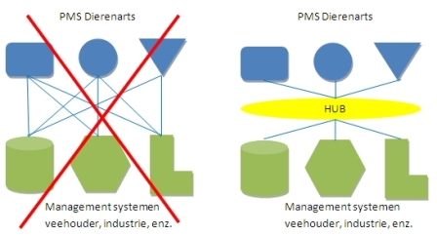
Source:
An external audit performed on data entry by veterinarians showed a maximal margin of error of 10–20 per cent. Some data is directly transferred from veterinary practice management systems to the sector databases, and some is entered by veterinarians through internet portals. Farmers and veterinarians have internet access to central databases to retrieve data on prescriptions and the consumption of veterinary medicines .
Data entered per medicine delivery includes:
- a unique farm identifier (UFI)
- a unique veterinarian identifier (UVI)
- EAN code (unique European Article Number)
- number of packages supplied
- animal species
- animal category
- delivery date.
Data that is linked to the EAN code can also be collected:
- REG NL number (Dutch authorisation number for veterinary pharmaceuticals)
- ATCvet code (Immunologicals for Aves, being a therapeutic subgroup of the Anatomical Therapeutic Chemical Classification System for veterinary medicinal products; a system of alphanumeric codes for the classification of pharmaceuticals and other agents for veterinary use developed by the WHO)
- administration route
- product name
- content (including unit) of packaging.
Product data are derived from the so-called Branche Code Table (BCT; provided by FIDIN). In addition, the DDkg (Defined Dosage of medicine (g or ml) needed for the treatment of one kilogram of animal during one day) is derived from veterinary medicine criterion which is designated and registered in the databases.
The European Medicines Agency in their report ‘Sales of veterinary antimicrobial agents in 25 EU/EEA countries in 2011’ caution that it takes at least three to four years to establish a valid baseline for data on the sales of antimicrobial agents, and data collected in the first one to two years should be interpreted with caution .

Trend analysis
A principal element of AMR surveillance systems is the detection and demonstration of significant differences in proportion of resistant isolates from year to year, and significant trends over periods of three or more years. The 2012 EFSA ‘Technical specification for the analysis and reporting of data on AMR in the EU Summary Report’ recommends graphical exploration of data to initiate an intuitive, visual exploration of trends. Once MIC data are converted to a dichotomous outcome through the application of common ECOFFs, the data sets can be subjected to longitudinal investigation using the Cochrane-Armitage test and/or logistic regression analysis to examine for trends, the Cochrane-Armitage test being equivalent to testing for a slope of zero in the logistic regression model. The fit of the linear regression model allows for quantification of possible trends, and for the calculation of 95 per cent confidence intervals across the time span. Covariates and heterogeneity arising from various sources can also be incorporated in the logistic regression model . The Cochrane-Armitage test has been used by groups in various countries, including Meyer et al , Theelen et al , and Cummings et al , to investigate trends in resistance over time.
Figure 16 shows an example of dichotomised data derived using linear regression modelling presented in the EFSA technical document, representing tetracycline resistance levels detected in Campylobacter jejuni isolates from broilers in a single country. In this case, data points representing ‘proportion positive’ (y-axis) are shown over a time period (x-axis), with 95 per cent confidence intervals displayed as red lines. A black, descending trend line is shown, and a blue line representing a ‘zero trend’ is overlaid on the chart. The observation that the ‘no trend’ line does not lie completely within the 95 per cent confidence interval provides a visual illustration of the significance of the negative time trend .
Figure 16 EFSA example of presentation of dichotomised data
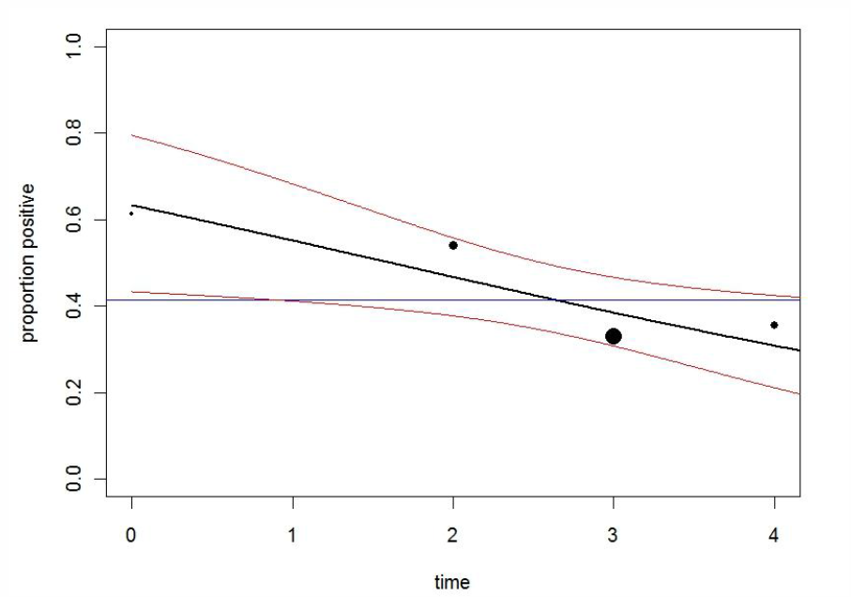
Source:
While reducing collections of MIC data to a dichotomised set facilitates rapid assimilation of trend data over time as shown in Figure 16, this approach also reduces the richness of information that is contained in the data set. To evaluate temporal trends in AMR over time, the EFSA technical specifications document provides further details of methodology, with an illustrative example showing data from an unidentified ‘Country C’, showing MIC distributions in successive years for cefotaxime resistance in commensal E. coli poultry isolates (Table 20) .
Table 20 Cefotaxime MICs (mg/L) for commensal E Coli isolated from poultry in ‘Country C’
Year | 0.016 | 0.03 | 0.06 | 0.13 | 0.25 | 0.5 | 1 | 2 | 4 | 8
2004 | na | 6 | 67 | 48 | 4 | 4 | 4 | 3 | 3 | 13
2005 | na | 2 | 25 | 26 | 3 | 1 | 1 | 2 | 2 | 12
2006 | na | 3 | 61 | 11 | 1 | 2 | 4 | 2 | 3 | 9
2008 | na | na | 48 | 26 | 5 | 0 | 1 | 2 | 5 | 26
2009 | na | na | 99 | 43 | 3 | 0 | 0 | 4 | 10 | 38
“na” = results not available
Source:
The data from Table 20 is then processed for graphical display as demonstrated in Figure 17, where the size of a dot for an MIC value in a particular year is proportional to the number of isolates with that MIC value in that year. The left hand graphic in Figure 17 shows the annual data plotted against MIC on a linear scale, while the right hand graphic shows annual data plotted against MIC on a log-2 scale, providing better visual separation. In both cases, the horizontal red line shows the ECOFF value .
Figure 17 Cefotaxime MICs in poultry from ‘Country C’
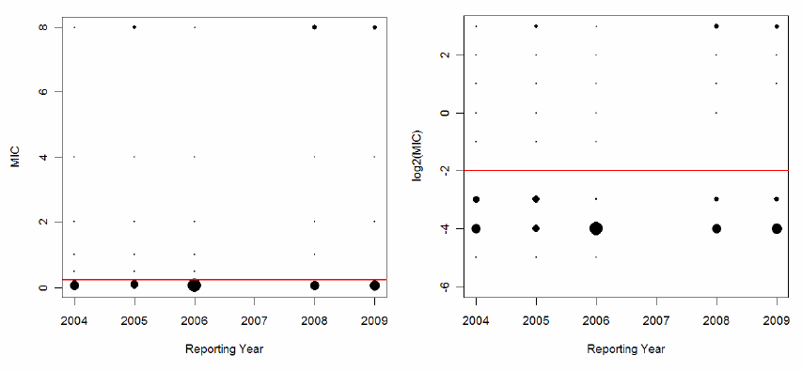
Source:
Further analysis of this data using more complex modelling (in this case, interval-censored accelerated failure time modelling, selected as the best model using the Akaike information criterion) leads to a graphical demonstration of the distribution of resistant and non-resistant isolates over the time period, as shown in Figure 18. Here it can be clearly seen that that the upper line representing resistant isolates and lower line signifying non-resistant isolates are diverging over time. This is interpreted to mean that the ‘microbiologically resistant’ population is characterised by reducing susceptibility, as the MIC values of the population progressively shift towards higher MICs. Solid lines in this diagram represent the mean of the population, while the dotted lines represent the 2.5 per cent and 97.5 per cent lower and upper confidence intervals .
Figure 18 Time trend of the mean of the log2 MIC (with 95 per cent confidence intervals), obtained from poultry
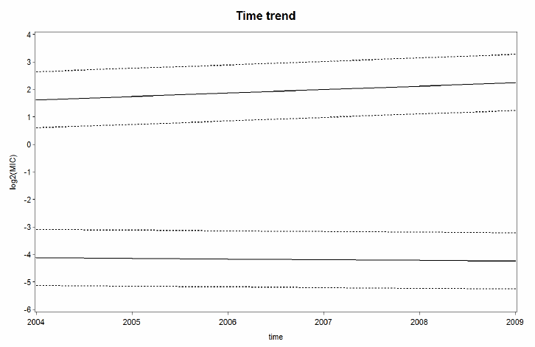
Note: Cefotaxime resistant E. coli (top solid line) shows decreasing susceptibility over time, and cefotaxime susceptible E. coli (bottom) shows no change in susceptibility over time.
Source:
Risk assessment
While risk assessment is beyond the scope of this report, it is germane to the development of surveillance systems for antimicrobial resistance and use that the output be suitable and appropriate to support the identification and management of risk. Documents such as the OIE Terrestrial Animal Health Code and the Aquatic Animal Health Code contain sections dealing with risk assessment and management.

A generic model for the surveillance of antimicrobial resistance
Key questions for an antimicrobial resistance surveillance program include :
- How do you sample?
- Which animal species?
- Which bacterial species?
- Which antibiotics are tested?
- How do you interpret the data?

OIE recommendations for the surveillance of antimicrobial resistance
In recognising that antimicrobial resistance is a global public and animal health concern that is influenced by the usage of antimicrobial agents in humans, animal, and elsewhere, the World Organisation for Animal Health (OIE) provides a series of recommendations regarding the design of surveillance systems in the annually published ‘OIE Terrestrial Animal Health Code’ and ‘OIE Aquatic Animal Health Code’ . Examination of these documents assists in understanding key elements of surveillance and systems that helps to answer the key questions listed above. The OIE states that active (targeted) surveillance is a core component of national AMR surveillance program, and that passive surveillance may offer additional information. It identifies the monitoring of AMR in terrestrial and aquatic animals to be necessary in order to:
- establish baseline data on the prevalence of antimicrobial resistant microorganisms and determinants;
- assess and determine the trends and sources of antimicrobial resistance in bacteria;
- detect the emergence of new antimicrobial resistance mechanisms;
- provide the data necessary for conducting risk analyses as relevant to animal and human health;
- provide a basis for policy recommendations for animal and human health;
- provide information for evaluating and guiding antimicrobial prescribing practices and for prudent use recommendations
- explore the potential relationship between antimicrobial resistance in aquatic animal microorganisms and the use of antimicrobial agents;
Key elements of national AMR surveillance programs identified by the OIE are listed in Table 21 .
Table 21 OIE recommendations for national AMR surveillance systems of terrestrial and aquatic animals
Element | Guidance recommendations
General aspects | Programs should be scientifically based and may include:  - statistically based surveys  - sampling and testing of food-producing animals on the farm, at live animal market or at slaughter  - an organised sentinel program, for example targeted sampling of food-producing animals, herds, flocks and vectors (for example, birds, rodents)  - analysis of veterinary practice and diagnostic laboratory records.
Sampling strategies | Sampling should be conducted on a statistical basis. The sampling strategy should ensure:  - the sample is representative of the population of interest  - the robustness of the sampling method  - The following criteria are to be considered:  - sample source such as food-producing animal, food, animal feed  - animal species  - category of animal within species such as age group, production type  - health status of the animals such as healthy, diseased  - sample selection such as targeted, systematic random  - type of sample (for example, faecal, carcass, food product)  - sample size
Sample size | The sample size should be large enough to allow detection of existing and emerging antimicrobial resistance phenotypes  A table of sample size estimates for prevalence of antimicrobial resistance in a large population are provided in the Code
Sample sources | Member Countries should examine their livestock production systems on basis of available information and assess which sources are likely to contribute most to a potential risk to animal and human health.  a) Animal feed  Member Countries should consider including animal feed in surveillance and monitoring programs as they may become contaminated with antimicrobial resistant bacteria, for example, Salmonella.  b) Food-producing animals  Categories of food-producing animals considered for sampling should be relevant to the country's production system.  c) Food  Member Countries should consider including relevant food products originating from food-producing animals in surveillance and monitoring programs as foodborne transmission is considered to be an important route
Types of sample | Feed samples should be collected in amounts sufficient for isolation of resistant bacteria of concern (at least 25g) and should be linked to pathogen surveillance programs.  Faecal samples should be collected in amounts sufficient for isolation of the resistant bacteria of concern (at least 5g from bovine and porcine and whole caeca from poultry).  Sampling of carcasses at the abattoir provides information on slaughter practices, slaughter hygiene and the level of microbiological contamination and cross-contamination of meat.  Further sampling of the product at retail sales level may provide additional information on the overall microbiological contamination from slaughter to the consumer.  Existing food processing microbiological monitoring, risk-based management and other food safety programs may provide useful samples for surveillance and monitoring of resistance in the food chain after slaughter.
Bacterial isolates—terrestrial animals | The following categories of bacteria could be monitored:  a) Animal bacterial pathogens relevant to the countries' priorities  Monitoring of antimicrobial resistance in animal pathogens is important, both to:  i) detect emerging resistance that may pose a concern for animal and human health;  ii) guide veterinarians in their prescribing decisions.  Information on the occurrence of antimicrobial resistance in animal pathogens is in general derived from routine clinical material sent to veterinary diagnostic laboratories.  These samples, often derived from severe or recurrent clinical cases including therapy failure, may provide biased information.  b) Zoonotic bacteria  i) Salmonella  Salmonella should be sampled from animal feed, food-producing animals and animal derived food products.  For the purpose of consistency and harmonisation, samples should be preferably taken at the abattoir.  Surveillance and monitoring programs may also include bacterial isolates obtained from designated national laboratories originating from other sources.  Isolation and identification of bacteria and bacterial strains should follow nationally or internationally standardised procedures.  Serovars of public health importance such as S. Typhimurium and S. Enteritidis should be included.  The inclusion of other relevant serovars will depend on the epidemiological situation in each country.  All Salmonella isolates should be serotyped and, where appropriate, phage-typed according to standard methods used at the nationally designated laboratories.  For those countries that have the capabilities, Salmonella could be genotyped using genetic finger-printing methods.  ii) Campylobacter  Campylobacter jejuni and C. coli should be isolated from food-producing animals and associated food products (primarily from poultry).  Isolation and identification of these bacteria should follow nationally or internationally standardised procedures.  Campylobacter isolates should be identified to the species level.  iii) Other emerging bacterial pathogens  Other emerging bacterial pathogens such as methicillin resistant Staphylococcus aureus (MRSA), Listeria monocytogenes or others which are pathogenic to humans, may be included in resistance surveillance and monitoring programs.  c) Commensal bacteria  E. coli and enterococci (Enterococcus faecium and E. faecalis) may be sampled from animal feed, food-producing animals and animal-derived food products.  These bacteria are commonly used in surveillance and monitoring programs as indicators, providing information on the potential reservoir of antimicrobial resistance genes, which may be transferred to pathogenic bacteria.  It is considered that these bacteria should be isolated from healthy animals, preferably at the abattoir, and be monitored for antimicrobial resistance.
Selection of microorganisms—aquatic animals | Information on the occurrence of antimicrobial resistance in microorganisms that infect aquatic animals should be derived from regular monitoring of isolates obtained from diagnostic laboratories.  These isolates should have been identified as primary causal agents of significant disease epizootics in aquatic animals.  It is important that monitoring programs focus on microorganisms that are associated with the commonly encountered infections of the major aquatic species farmed in the region / local growing area.  Selection should be designed to minimise bias resulting from over representation of isolates obtained from severe epizootics or epizootics associated with therapeutic failures.  Microorganisms belonging to a specific species or group may be selected for intensive study in order to provide information on a particular problem.  It is important to note that the word 'commensal' as used in Chapter 6.7. of the OIE Terrestrial Animal Health Code has less relevance due to the transient nature of the intestinal microflora of aquatic animals.  The inclusion of intestinal microflora in surveillance and monitoring programs should only be considered when there is evidence that these are resident for sufficient time to be a risk factor affected by antimicrobial agents.  When designing a sampling program it is important to consider that contamination of aquatic animal products with resistant microorganisms that are capable of infecting humans may arise from sources other than the aquatic animal.  All sources of contamination should be taken into account, for example entry of raw manure into the aquatic environment.  The number of such microorganisms associated with aquatic animals is much less than that found in terrestrial animals.  However the following species should be included, as a minimum, in a surveillance and monitoring program:  Salmonella spp.;  Vibrio parahaemolyticus;  Listeria monocytogenes
Storage of bacterial strains | If possible, isolates should be preserved at least until reporting is completed.  Preferably, appropriate isolates should be permanently stored.  Bacterial strain collections, established by storage of all isolates from certain years, will provide the possibility of conducting retrospective studies.
Antimicrobial susceptibility testing | Clinically important antimicrobial agents or classes used in human and veterinary medicine should be included in antimicrobial resistance surveillance programs.  Member Countries should refer to the OIE List of antimicrobials of veterinary importance for monitoring purposes.  The number of tested antimicrobial agents may have to be limited according to financial resources.  Appropriately validated antimicrobial susceptibility testing methods should be used in accordance with Chapter 1.1.6. of the Terrestrial Manual  Antimicrobial susceptibility data should be reported quantitatively (minimum inhibitory concentrations [MICs] or inhibition zone diameters), rather than qualitatively.
Laboratory requirements | Laboratories involved in national or regional monitoring of antimicrobial resistance should be of sufficient capability and have relevant expertise to comply with all the quality control requirements of the standardised test protocols.  They should also be capable of participating in all necessary inter-laboratory calibration studies and method standardisation trials.
Surveillance and monitoring for epidemiological purposes | Use of the epidemiological cut-off value (also referred to as microbiological breakpoint), which is based on the distribution of MICs or inhibition zone diameters of the specific microbial species tested, is preferred.  When reporting interpretations made by application of epidemiological cut-off values, the resultant categories should be referred to as wild type (WT) or non-wild type (NWT).  When interpretations are made by the application of breakpoints the resultant categories should be referred to as susceptible, intermediate or resistant.  For microbial species and antimicrobial agent combinations, where internationally agreed epidemiological cut-off values have not been set, laboratories may establish their own laboratory-specific values provided the methods they use are clearly reported.
Surveillance and monitoring for clinical purposes | The application of clinical breakpoints may be appropriate when the aim of the program is to provide information to facilitate prudent use, including guidance for professionals in prescribing antimicrobial agents in aquatic animals.  Selecting antimicrobial agents for therapeutic administration on the basis of information gained from the application of validated clinical breakpoints to antimicrobial susceptibility test data for microorganisms isolated from aquatic animals is an important element in the prudent use of these agents.  Use of these clinical breakpoints allows microorganisms to be identified as unlikely to respond to the in vivo concentrations of antimicrobial agents achieved by a given standard therapeutic regime.  In order to facilitate the development of these breakpoints, data is required that allows clinical correlation to be completed.  For this purpose, where possible, data that relates in vitro susceptibility of isolates to the clinical outcome of treatments with specified dose regimes under specific environmental conditions should be collected and reported.  Valuable information with respect to setting clinical breakpoints can be gained from situations where therapeutic failure is reported.  The Competent Authority should include, in a surveillance and monitoring program, systems for capturing details of failed treatments and the laboratory susceptibility test of the microorganisms involved.
Source:
Table 22, reproduced from the Code, provides examples of sampling sources, sample types and monitoring outcomes.

Table 22 World Organisation for Animal Health (OIE) examples of sampling sources, sample types and monitoring outcomes
Source | Sample type | Outcome | Additional information required or additional stratification
Herd or flock of origin | Faecal or bulk milk | Prevalence of resistant bacteria originating from animal populations (of different production types). Relationship resistance - antimicrobial use. | Age categories, production types.  Antimicrobial use over time.
Abattoir | Faecal | Prevalence of resistant bacteria originating from animals at slaughter. | na
Abattoir | Caeca or intestine | As above. | na
Abattoir | Carcass | Hygiene, contamination during slaughter. | na
Processing, packing | Food products | Hygiene, contamination during processing and handling. | na
Point of sales (Retail) | Food products | Prevalence of resistant bacteria originating from food, exposure data for consumers. | na
Various origin | Animal feed | Prevalence of resistance in bacteria originating from animal feed, exposure data for animals. | na
Note: na Not applicable.
Source:

World Organisation for Animal Health (OIE) recommendations for recording, storage and interpretation of antimicrobial resistance data
Detail regarding the recording, storage and interpretation of data recommended by the OIE Terrestrial Manual is provided in Table 23 .
Table 23 World Organisation for Animal Health (OIE) recommendation for recording, storage and interpretation of antimicrobial resistance data
Element | Guidance recommendations
Database design | - Because of the volume and complexity of the information to be stored and the need to keep these data available for an undetermined period of time, careful consideration should be given to database design.
Raw data | - The storage of raw (primary, non-interpreted) data is essential to allow the evaluation in response to various kinds of questions, including those arising in the future.
Computer systems | - Consideration should be given to the technical requirements of computer systems when an exchange of data between different systems (comparability or compatibility of automatic recording of laboratory data and transfer of these data between and within resistance monitoring programs) is envisaged.  - Results should be collected in a suitable national database. They should be recorded quantitatively:  - as distributions of MICs in milligrams per litre;  - or inhibition zone diameters in millimetres.
Information recorded | The information to be recorded should include, where possible, the following aspects:  - sampling program;  - sampling date;  - animal species or type;  - type of sample;  - purpose of sampling;  - type of antimicrobial susceptibility testing method used;  - geographical origin (geographical information system data where available) of herd, flock or animal;  - animal factors (for example, age, condition, health status, identification, sex).
Reporting | The reporting of laboratory data should include the following information:  - identity of laboratory  - isolation date  - reporting date  - bacterial species  and, where relevant, other typing characteristics, such as:  - serotype or serovar  - phage type  - antimicrobial susceptibility result or resistance phenotype  - genotype.
Resistant isolates | - The proportion of isolates regarded as resistant should be reported, including the defined interpretive criteria used.
Breakpoints | - In the clinical setting, breakpoints are used to categorise bacterial strains as susceptible, intermediate or resistant.  - These clinical breakpoints may be elaborated on a national basis and may vary between Member Countries.  - For surveillance purposes, use of the microbiological breakpoint (also referred to as epidemiological cut-off point), which is based on the distribution of MICs or inhibition zone diameters of the specific bacterial species tested, is preferred.  - When using microbiological breakpoints, only the bacterial population with acquired resistance that clearly deviates from the distribution of the normal susceptible population will be designated as resistant.
Standards and guidelines | - The antimicrobial susceptibility testing standards and guidelines used should be recorded.
Data granularity | - Ideally, data should be collected at the individual isolate level, allowing antimicrobial resistance patterns to be recorded.
Source:

World Organisation for Animal Health (OIE) recommendations regarding reference laboratories and annual reports
Table 24 outlines OIE recommendations regarding national reference laboratories and annual reports .
Table 24 World Organisation for Animal Health (OIE) recommendations for national reference laboratories and annual reports
Element | Guidance recommendations
National reference centre | Member countries should designate a national reference centre that assumes the responsibility to:  - coordinate the activities related to the antimicrobial resistance surveillance and monitoring programs  - coordinate and collect information from participating surveillance laboratories within the country  - produce an annual report on the antimicrobial resistance situation in the country.
Access to information | The national reference centre should have access to the:  - raw data  - complete results of quality assurance and inter-laboratory calibration activities  - inter-laboratory proficiency testing results  - information on the structure of the monitoring system  - information on the chosen laboratory methods.
Source:

World Health Organization Advisory Group on Integrated Surveillance of Antimicrobial Resistance recommendations
The WHO AGISAR group provide guidance on the establishment and operation of an AMR surveillance program that can provide data facilitating comparison with other national systems. The AGISAR group identify the major issues that need to be addressed when establishing an integrated monitoring system as follows :
- Study population—Humans, retail meats, food producing animals
- Sampling strategy
- Representativeness
- Sampling bias
- Frequency of testing
- Sample size
- Sample source
- Culture methodology
- Target organisms
- In vitro antimicrobial susceptibility testing methods
- Antimicrobials to be used in susceptibility testing
- Data management and reporting
- Database design for appropriate data extraction
- Type of data to be reported
- Analysis and interpretation of data
- Information sharing
- Confidentiality policies should be established to protect proprietary data.
Key guidance principles from AGISAR in relation to sampling and system design for the surveillance of animal populations are listed in Table 25 :
Table 25 WHO AGISAR recommendations for national surveillance systems—sampling and system design
Element | Guidance recommendations
Sample sources | - Isolates should be tested using recognised methods and comparable antimicrobial arrays  - Data should be made available for comparison with human isolates  - Monitoring can be implemented incrementally, or limited to priority study populations, or sources and organisms alternated over time  - Sampling should relate to retail meats for human consumption  - If on-farm sampling is not possible, samples from healthy animals at slaughter may be used
Target organisms | Human pathogens  - Selection of bacterial pathogens to be included in monitoring depends on local public health priorities, antimicrobial use practices, and the local burden of foodborne illness  - Because Salmonella is a major foodborne pathogen worldwide, it is the first priority for testing  - Campylobacter spp. are also important foodborne pathogens and included in many national programs  Sentinel organisms  - E. coli and Enterococcus serve as reservoirs of resistance genes that can be transferred to overt human pathogens transiting the intestinal tract, provide information on the flow of Gram-positive and Gram-negative resistance traits in the food chain, and are often monitored  Other bacteria  - Other veterinary or human bacteria that may be considered relevant include Staphylococcus and Clostridium, and in aquaculture, Vibrio
Sampling design | - Sampling design has a major impact on the reliability of inferences that can be drawn from surveillance data  - For food animals, there are many potential sampling points in the production chain, and each will reveal different information  - Other factors that may impact include the season, latitude, processing methodology, transportation and storage of samples  - Figure 19 depicts a more comprehensive array of sampling considerations through the production chain  Sampling at the production site (for example, farm, aquaculture facility):  - Will produce bacterial strains and resistance patterns directly associated with the antimicrobial use environment  - May not reflect strains that survive processing and reach the food chain  Sampling the environment (for example, composite chicken litter samples):  - Can be considered an alternative to individual animal sampling if representativeness has been established  Sampling at the slaughterhouse:  - Is generally the most convenient and affordable point for sampling  - It is generally preferable to collect caecal samples, as they:  - provide a higher recovery of isolates than carcass or rectal swabs  - better reflect farm-level exposure by reducing likelihood of contamination from the processing environment  - The microbiota of the animal caecum can be affected by the time spent in transport and holding pens, and the persisting microorganisms that can be acquired in each environment
Sample information | - Basic information must be recorded for each sample to support comprehensive analysis, help clarify potential biases for different sample types, and help identify critical points for mitigating resistance  - Samples collected during production might include animal species, time and place of collection, age and clinical status of the animal, and possibly the history of antimicrobial use on the farm  - Samples collected at slaughter may include the origin of the animal (domestic or imported), slaughter class (for example, dairy or beef cattle), and the processing plant
Sampling approach | Sampling approaches include the following, and relative strengths and weaknesses of each approach should be considered:  - Active (prospectively targeted)  - Passive (data from samples collected for other purposes)  - Sentinel (facilities report a specific disease when detected)  - Random or systematic  - Statistically based or convenience based
Sampling frequency | - Sampling should occur on a regular or continuous basis using consistent methodology to facilitate analysis of trends  - Frequency should be based on the incidence and seasonality of bacteria or diseases under surveillance
Sample size | - Several statistical methods can be employed to calculate the number of isolates needed for testing  - Sample size will be influenced by  - The desired precision for estimates of the prevalence of resistance and the magnitude of change in resistance to be detected over a specified period of time  - the initial or expected prevalence of resistance and the size of the population to be monitored  - the desired level of statistical significance and power to detect a change when it occurs  - A number of statistical packages are available to assist in calculating sample size, and the EFSA has compiled tables showing samples sizes required for different AMR monitoring program objectives
Source:

Figure 19 Examples of sampling considerations through the production chain
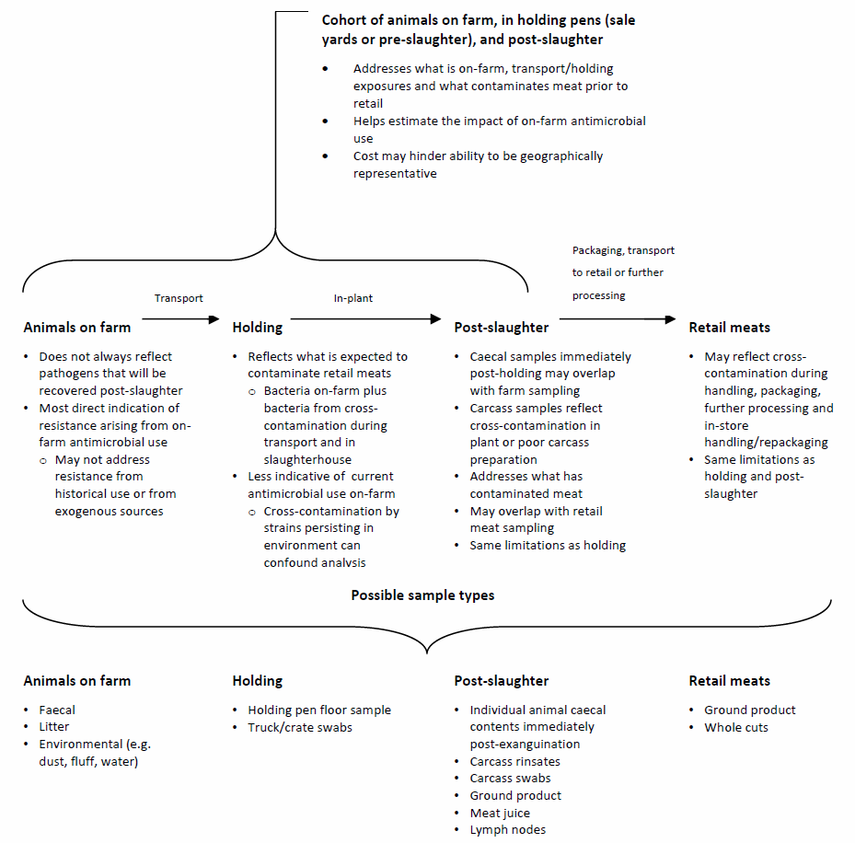
Source:
The WHO AGISAR group provide guidance in relation to laboratory testing, which is summarised in Table 26 .
Table 26 World Health Organization Advisory Group on Integrated Surveillance of Antimicrobial Resistance recommendations for national surveillance systems—laboratory testing
Element | Guidance recommendations
Laboratory capability | - Laboratory should be able to achieve the following at a minimum:  - Isolate, on artificial growth medium, the target pathogens from different specimen types  - Identify bacteria to the genus and species levels using accepted microbiological methods  - Determine serotypes of Salmonella or have access to a reference testing centre  - Perform antimicrobial susceptibility testing using validated methods according to established standards, such as those of the Clinical and Laboratory Standards Institute (CLSI) or the International Organization for Standardization (ISO)  - Laboratory should participate in an external quality assurance program
Bacterial culture methods | - Culture methods should be designed in advance, bearing in mind that different recovery methods can differentially enrich bacterial sub-populations  - Culture methods should meet internationally recognised laboratory standards
Storage of bacterial isolates | - Laboratories are encouraged to collaborate with established monitoring systems, national reference laboratories, WHO collaborating centres and other partners to provide long-term storage for a representative number of isolates that can be used for future testing and analysis
Isolate identification | - Bacteria should be identified to the species level  - Salmonella should be serotyped to aid understanding of epidemiology
Susceptibility testing | - Only susceptibility testing methods that have been standardised and validated under the auspices of internationally recognised consensus standards organization, such as CLSI or the European Committee on Antimicrobial Susceptibility Testing (EUCAST), should be used  - Methods described in these standards should be strictly followed and should not be modified for local use  - Regardless of whether MIC or disc diffusion methods are used, quantitative results (MIC values or zone diameters respectively) should be measured and recorded
Data quality and quality control | - Quality control testing and frequency should follow international guidelines  - Expert rules for discordant susceptibility results, as published by CLSI and EUCAST, should be applied to ensure data integrity
Recommended antimicrobials | Antibiotics are proposed for testing on the basis that some provide clinically and some epidemiologically useful information as follows:  - Salmonella and E. coli, ceftriaxone (recommended) or cefotaxime, nalidixic acid (optional), ciprofloxacin, ampicillin, tetracycline, chloramphenicol, gentamicin, trimethoprim-sulfamethoxazole  - Campylobacter, erythromycin and ciprofloxacin at a minimum.
Source:
Reporting of data using an integrated approach requires comprehensive analysis of surveillance data from all sources, with joint evaluation by microbiologists, clinical practitioners, epidemiologists and food scientists. AGISAR suggest that it may be advantageous to appoint a coordinating body to audit and evaluate surveillance findings, to oversee organisation, analysis, reporting and risk communication, and undertake reviews and recommend modifications to the program over time. Analysis of the data should be performed with an emphasis on the human health significance of findings, while reporting should be timely, transparent, easily accessible, and understandable by non-specialists. Recommendations with respect to data and reporting are compiled in Table 27 .
Table 27 World Health Organization Advisory Group on Integrated Surveillance of Antimicrobial Resistance recommendations for national surveillance systems—data and reporting
Element | Guidance recommendations
Program description | - Reports should include detailed information on program structure and methodology to facilitate comparison with results from other systems, including:  - a description of the sampling design and specimen collection  - the microbiological methods used for culture, identification and susceptibility testing  - the interpretative criteria used for reporting  - quality control and quality assurance measures  - a glossary of terms; statistical methods  - any changes made in the methodology over time.
Interpretation of data | - ECOFFs should be used when interpreting results of in vitro susceptibility testing  - The use of the term ‘resistant’ should be reserved for when clinical breakpoints have been used
Data presentation | - Quantitative data should be presented, and in a way that permits differential interpretive criteria to be applied  - Databases should be constructed in a way that allows data:  - to be extracted appropriately  - to be shared in a way that preserves confidentiality  - Data sets should centre on individual isolates with links to metadata including denominator data  - WHONET database software achieves these objectives, and is available free of charge  - Once data integrity and confidentiality have been ensured, data should be made freely available for independent analysis and reporting
Data analysis | - Surveillance data should be analysed in conjunction with other available data sets such as information on antimicrobial use, pulsed-field gel electrophoresis (PFGE), whole genome sequences, plasmid typing data (or other strain typing data), as well as outbreak investigations involving isolates recovered in surveillance
Source:
Once the fundamental elements of an integrated surveillance system are in place, other goals that AGISAR suggest can be considered include :
- Increase the timeliness of data collection and reporting. Data collection should occur at least annually, although not necessarily for all target organisms and all study populations.
- Establish avenues of cooperation, communication and data publication between agencies and disciplines.
- Publish analyses describing emerging and ongoing human public health issues related to resistant pathogens.
- Carry out research to support and develop surveillance, identify intervention points, and track the spread of resistance genes between ecological niches.
- Collect and report subtyping data (for example, PFGE, phage type, genomic sequence) for serotypes with important resistance patterns.
- When possible, compare monitoring data with data on strains isolated from clinical veterinary cases, to evaluate the utility of clinical isolates as an early warning system.
- Periodically evaluate the surveillance methods used and the data collected to ensure that they are the most useful for public health purposes; make adjustments to address emerging hazards, for example, other pathogens and commodities.
- Improve methods, but ensure that improvements do not compromise comparisons with historical data.
- Collaborate with colleagues in other countries to ensure that new methods are adopted in a way that enables and encourages comparison of data among countries.
- Report data on resistance together with data on antimicrobial use in humans and animals, to help increase understanding of practices that may contribute to resistance.

European Food Safety Authority recommendations
Members of the EFSA Working Group on Developing Harmonised Schemes for Monitoring Antimicrobial Resistance in Zoonotic Agents provide detailed specifications for a range of elements that need to be addressed when establishing a monitoring scheme :
- animal species
- bacterial species
- study population
- sampling plan
- sample size
- detection, identification and storage of isolates
- methods for susceptibility testing
- antimicrobial agents to include
- cut-off values to use
- data collection and reporting.
In 2008, the EFSA Working Group published a guideline for EU Member States for the monitoring of AMR in Salmonella spp and Campylobacter spp in selected animal populations as the first step towards a comprehensive, harmonised AMR surveillance system. The recommendations of the Working Group, in relation to each of these elements described above, is shown in Table 28 :
Table 28 EFSA Working Group recommendations for surveillance
Element | Recommendation
Animal species | Laying hens  Broiler chickens  Turkeys  Pigs
Bacterial species | Salmonella
Study population | Broilers, turkeys and pigs—collect close to slaughter  Laying hens—periodically throughout egg production cycle
Sampling plan | Include:  - Clinical samples submitted to diagnostic laboratories  - Actively collected samples from healthy or diseased animals  - All epidemiological units (flocks or holdings) of the national production  Specific study populations and sampling plan:  - Laying hens: every 15 weeks during laying phase  - Broiler flocks: animals leaving for slaughter  - Turkeys: animals leaving for slaughter  - Slaughter pig herds: animals leaving for slaughter or carcasses at slaughterhouse
Sample size | - Target sample size may vary depending on:  - whether the size is calculated for estimating the proportion of resistance, or for determining a trend over time  - the magnitude of change it is desired to be able to detect, desired accuracy of the estimate, and the initial level of resistance
Detection, identification and storage of isolates | - Validated methods must be used for isolation and confirmation of bacteria  - Isolates should be stored for at least 2 years  - All Salmonella isolates should be identified to the serovar level  - S. Enteritidis and S. Typhimurium species should be phage-typed to assist interpretation of AMR patterns  - Campylobacter should be identified to the species level, and monitoring restricted to C. jejuni and C. coli
Methods for susceptibility testing | - Epidemiological cut off values rather than clinical breakpoints should be used as interpretive criteria  - Disk-diffusion methods are not advocated because:  - There is wide methodological variance  - Epidemiological cut-off values have not been established  - Problems with reproducibility of results for Campylobacter spp  - Only quantitative data providing MIC values will be accepted  - EUCAST and CLSI methods for obtaining MICs are acceptable for Salmonella spp  - CLSI dilution methodology should be used for Campylobacter spp., as this was the only international standard providing guidance for these species  - Laboratories must participate in a defined external quality assurance program
Antimicrobial agents to include | - See Table 28
Cut-off values to use | - EUCAST developed epidemiological cut-off values, being the highest MIC value of the wild-type population that is appropriate to detect biological resistance where available  - See Table 28
Data collection and reporting | - European data should be collected and evaluated at country level, and a European level  - Data should be reported as MICs rather than susceptible and resistant to allow comparisons over time, even if cut-off values change  - Multiple resistance involving different antimicrobials with unrelated resistance mechanisms should be identified and reported  - Some Salmonella serovars should be reported individually.
Source:
A survey by the ESFA Working Group determined that many different antimicrobials were being tested in national surveillance programs. For example, across five national programs reviewed, the susceptibility of Salmonella isolates was being tested against a total of 36 different antimicrobials, but only four were common to all programs. In the case of Campylobacter, 17 different agents were being tested, but only two were common to all programs. This highlights one of the difficulties in generating meaningful international comparisons, and reinforces the need for harmonisation.
The Working Group determined that, in order for the antimicrobials being uniformly tested to provide the most valuable information, they should be selected to ensure the highest possible sensitivity in detecting different resistance mechanisms. Antimicrobials that can be used to infer the likely susceptibility of bacteria to a range of other agents which are impacted by the same resistance mechanism are desirable test candidates. Where some types of resistance genes generate complex patterns of resistance, the antimicrobial agent that is most likely to detect resistance across the entire group should be used.
Using these principles, a limited range of antimicrobials can be selected for testing that will provide information about the likely resistance patterns of a much broader group of agents, and can also be used to indicate isolates that should be subjected to additional testing. The antimicrobials selected by the Working Group to begin the process of harmonisation are shown in Table 29, along with their epidemiological cut-off values, and the range of dilutions that should be tested for each :
Table 29 EFSA recommended antibiotics
Bacterial species and antimicrobial | Epidemiological cut-off value (mg/L) | Recommended optimum testing range (mg/L)
Cefotaxime (Salmonella) | 0.5 | 0.06–8
Nalidixic acid (Salmonella) | 16 | 2–256
Ciprofloxacin (Salmonella) | 0.06 | 0.008–8
Ampicillin (Salmonella) | 4 | 0.5–64
Tetracycline (Salmonella) | 8 | 0.5–64
Chloramphenicol (Salmonella) | 16 | 2–256
Gentamicin (Salmonella) | 2 | 0.25–32
Streptomycin (Salmonella) | 32 | 2–256
Trimethoprima (Salmonella) | 2 | 0.25–32
Sulphonamides (Salmonella) | 256 | 8–1024
Erythromycin (Campylobacter jejuni) | 4 | 0.5–64
Ciprofloxacin (Campylobacter jejuni) | 1 | 0.06–8
Tetracycline (Campylobacter jejuni) | 2 | 0.125–16
Streptomycin (Campylobacter jejuni) | 2 | 0.5–32
Gentamicin (Campylobacter jejuni) | 1 | 0.125–16
Erythromycin (Campylobacter coli) | 16 | 0.5–64
Ciprofloxacin (Campylobacter coli) | 1 | 0.06–8
Tetracycline (Campylobacter coli) | 2 | 0.125–16
Streptomycin (Campylobacter coli) | 4 | 0.5–32
Gentamicin (Campylobacter coli) | 2 | 0.125–16
Source:
In 2014, in response to the Commission Implementing Decision 2013/652/EU, the EFSA published a further paper titled Technical specifications on randomised sampling for harmonised monitoring of antimicrobial resistance in zoonotic and commensal bacteria, which provides guidance on two approaches for AMR surveillance :
- Prospective surveillance which involves collecting sufficient samples from representative animal and food sources, from which isolates of Campylobacter, E. coli, and enterococci from broilers, turkeys, pigs and calves are tested for antibiotic sensitivity
- Retrospective sampling plans whereby a random selection of Salmonella isolates are tested for antibiotic susceptibility
The guidance applies to poultry populations from 1 January 2014, and to pigs and calves from 1 January 2015, with requirements laid down for AMR testing of isolates from a randomised sampling of:
- Carcases of broilers, fattening turkeys, pigs and calves under one year at slaughter for Salmonella
- Caeca of broilers and fattening turkeys at slaughter for Campylobacter, indicator commensal Escherichia coli and ESBL- or AmpC- or carbapenemase producing E. coli
- Caeca of pigs and calves under one year at slaughter for indicator commensal and ESBL- or AmpC- or carbapenemase producing E. coli
- Fresh meat from poultry, pig and cattle collected at retail for ESBL- or AmpC- or carbapenemase-producing E. Coli.
The sampling procedures laid out in the document aim to provide a balance between good statistical methodology, and practical issues of implementation, involving stratified sampling approaches.

A generic model for the monitoring of antimicrobial usage
International literature identifies a range of challenges associated with the surveillance and reporting of antimicrobial use, including the difference in active ingredients in antimicrobial compounds contributing to variance in antimicrobial potency and pharmacokinetics, and different methods for recording animal demographics between nations .
Bondt et al explored the potential for existing data sets to provide a basis for meaningful comparisons of veterinary use of antimicrobial agents between Denmark and the Netherlands, both countries with mature surveillance systems, based on total antibiotic sales data and animal census data. The authors concluded that :
- simple country comparisons based on total sales data entail the risk of serious misinterpretation
- more precise model calculations that take into account differences in dosage regimens and farm demographics only slightly reduces the risk
- animal demographics strongly influence model estimates and the reported differences in exposure per animal species
- to reliably evaluate the true differences in antimicrobial exposure between countries it is essential to have reliable information about use on a per species basis.
Bondt el al assert that there is not yet a scientifically sound, generally accepted and easily applicable method for performing inter-country comparisons of veterinary antimicrobial use. Expressions of antimicrobial use such as milligrams of active substance sold per kilogram of animal are influenced by differences in denominator data including practices of estimating live biomass, slaughtered weight, or a mixture of estimates, and in some cases, the application of population correction factors. The authors suggest that an alternative method to those currently in use will be needed for international comparison, bearing in mind that in most countries, only total sales figures may be available as numerator data in calculations.
In their 2012 report titled ‘Asia-Human health risks from the human-animal interface’, Otte and Grace provide a crude estimate of the intensity of antimicrobial use in livestock production, expressed as kg of antimicrobial use per tonne of meat produced, as shown in Table 30 . The authors observe that ‘…the lowest rates of antimicrobial use are found in the Nordic countries, in which non-therapeutic use has been banned, followed by Australia and other EU countries (which have banned antimicrobial use for growth promotion), while the highest use intensity is recorded in the USA.’
Table 30 Intensity of antimicrobial use in selected countries
Country | Year (s) | Kg/tonne meat
Norway | 2005–2009 | 0.02
Sweden | 2005–2009 | 0.03
Finland | 2005–2009 | 0.04
Denmark | 2005–2009 | 0.06
Australia | 1991–2001 | 0.10
UK | 2005–2009 | 0.12
Czech Republic | 2005–2009 | 0.13
Switzerland | 2004–2009 | 0.16
France | 2005–2009 | 0.22
Netherlands | 2005–2009 | 0.22
USA | 2000–2007 | 0.27
Note: Estimates based on reported antimicrobial sales and meat production.
Sources: APVMA, 2005; EMA, 2011; US Animal Health Institute; and FAOSTAT 2012 (meat production)
To support consideration of desirable elements for a system monitoring antibiotic usage, findings of a stakeholder engagement process facilitated by the Alliance for Prudent Use of Antibiotics (APUA) are described below. Recommendations from the OIE, World WHO AGISAR and EFSA in relation to surveillance of antimicrobial use at a national level are also outlined.

United States Alliance for Prudent Use of Antibiotics
In 2006, the findings of an Advisory Committee on Animal Antimicrobial Use Data Collection, established by the Alliance for Prudent Use of Antibiotics (APUA), were reported in Preventive Veterinary Medicine . The committee undertook consultation with stakeholders representative of a range of areas including academia/research, government officials, animal health industry representatives, public interest scientists and advocates, food animal producers, and veterinary professionals. The consultation process aimed to gather opinion that would inform the development of a strategy for the gathering of antimicrobial usage data in the United States. Four categories of antibiotic use data were identified:
- end-user data
- prescription data
- manufacturing data
- distribution data.
Some characteristics of these data categories are summarised in Table 31 .
Table 31 APUA list of data categories
Element | End user data | Prescription data | Manufacturing data | Distribution data
Data sources | Veterinarians, food animal producers, companion or sport animal owners | Pharmacies, veterinarians | Manufacturers | Distributors, veterinarians, buying groups, dealers
Data types | Quantity administered, indication, timing and duration of administration, route of administration, species, market class, stage of production, number of animals, weight | Prescription data—quantity prescribed, species, market class, stage of production, number of animals, weight, dose, duration, indication, route of administration | Production data, sales data, quantity of active ingredient, approved label claims | Sales data, quantity of active ingredient, approved label claims
Source:
A multi-stage process was employed by the Committee to gather input on a range of potential strategies for tracking antibiotic use. A number of potential methods were proposed for gathering information from each data category, and feedback sought on potential issues and concerns is summarised in Table 32.
Table 32 Advantages and limitations of data collection methods
Data type | Advantages | Potential method | Limitations or concerns
End user—veterinarian | Data has potential to be high quality, directly relate to animal species and indications for use. | Require veterinarians to record all direct use | Tracking all use may be impractical due to resource impost, high costs.  Vets are regulated by states hence legislative requirements and reporting formats vary. Data compatibility of electronic systems.  Capturing data from manual systems.
End user—veterinarian |  | Enrol sentinel practices that keep track of use electronically | Potential for significant bias as those most willing to participate may not be representative of industry.  Difficult to track those without electronic systems.  Need to deal with data from practices that drop out of program.  Data comparability between practices.
End user—veterinarian |  | Ask individual practices to record use for a defined period of time | Similar limitations to sentinel sites.  Potential for greater number of practices may mitigate some bias issues.
End user—veterinarian |  | Periodically survey a cross-section of veterinarians | No comprehensive listing of veterinary practices, so target population difficult to define.  Retrospective data collection would be subject to recall bias, recording deficits.
End user—producer | Data has potential to be high quality, directly relate to animal species and indications for use. | Require all producers to record use | Similar limitations to veterinary end users
End user—producer |  | Enrol sentinel farms that keep track of use electronically | As above
End user—producer |  | Ask individual producers to record use for a defined period of time | As above
End user—producer |  | Periodically survey a cross-section of producers | As above
End user—producer |  | Drug use reporting data from on-farm quality assurance programs | On-farm quality assurance programs tend to focus on education. Data collection neither rigorous nor consistent.
End user—producer |  | Purchase from market research companies | Data may be proprietary, making it impossible to evaluate quality.  Data may be limited in scope.
End user—producer |  | Interviews with individual farmers | Information likely to be qualitative rather than quantitative.
End user—sport and companion animal | Data has potential to be high quality, directly relate to animal species and indications for use. | Periodically survey a cross-section of owners | Similar limitations to veterinary end users
Prescription—veterinarian | May be more feasible than attempting to record end use. Data has potential to be high quality, directly relate to animal species and indications for use. | Require veterinarians to record all prescriptions | Data is limited to prescription antimicrobials  Similar limitations to end user data collection
Prescription—veterinarian |  | Enrol sentinel practices that keep track of prescriptions electronically | As above
Prescription—veterinarian |  | Ask individual practices to record prescriptions for a defined period of time | As above
Prescription—veterinarian |  | Periodically survey a cross-section of veterinarians | As above
Prescription—pharmacy | Could provide data on off-label use of human drugs for animals | Conduct periodic surveys | Similar limitations to prescription - veterinarian
Prescription—pharmacy |  | Establish an electronic ‘capture’ system | Potential cost and feasibility
Manufacturing data | A limited number of data sources need to be accessed. | Request voluntary disclosure by manufacturers | Manufacturers may not voluntarily disclose data, particularly where commercially sensitive.
Manufacturing data | A limited number of data sources need to be accessed. | Require public disclosure | Production data may not align with sales and use data due to stockpiling, warehousing, distribution delays.  Conversion of data may be required to obtain comparable data that can be accumulated.  Where there is a sole or limited number of suppliers of an agent, data may be commercially sensitive.
Distribution data | No specific advantages identified. | Require or request voluntary reporting | The complexity of distribution networks could make tracking of drugs through the system difficult.  As drugs may pass through a number of points in the distribution chain, double counting may occur.
Distribution data | No specific advantages identified. | Implement tracking system | As above
Source:
Based on the findings of the second stage of consultation, six options for data gathering were evaluated for:
- Feasibility—including current incentives, likelihood of stakeholder participation, cost of implementation, perceived political will, legal constraints;
- Representativeness—intended as a measure of external validity, indicating how well data collected would reflect actual conditions;
- Data quality—an indication of internal validity, or freedom from error in data collection;
- Overall usefulness—average or composite of other scores
Committee members were asked to provide ratings of Low, Medium or High for each of the six options, along with relevant comments. The options explored were as follows:
- All practices/ producers record all prescriptions/use indefinitely
- Sentinel practices/ farms track use electronically
- Selected practices/producers record all prescriptions/use for a defined period of time
- Periodically survey a cross-section of veterinarians/ producers
- Solicit production and sales information from manufacturers
- Publicly disclose production information obtained by FDA from manufacturers
Ratings and summarised comments provided by members of the Committee are summarised in Table 33 .
Table 33 Committee ratings of six methods for data collection
Option | Feasibility | Representative-ness | Data quality | Overall usefulness
Option 1:  All practices/ producers record all prescriptions/use indefinitely | Low  May be improved if included in mandatory quality assurance program. | High  Would represent a ‘census’ of use. | ‘Database nightmare’ | Low  Uniform implementation of electronic prescribing could raise to medium or high.
Option 2:  Sentinel practices/ farms track use electronically | High | Low—Medium  Subject to ‘volunteer bias’ unless sampling is random. | High  Could be higher with sentinel sites than global coverage, as sentinel sites would be committed to accuracy and completeness. | Medium
Option 3:  Selected practices/producers record all prescriptions/use for a defined period of time | Opinion varied widely | Medium  Subject to ‘volunteer bias’. | Medium | Medium
Option 4:  Periodically survey a cross-section of veterinarians/ producers | High | Medium (but with responses ranging from Low to High) A low response rate and inherent bias is inevitable. | Variable  Difficult to collect high quality quantitative data using survey. | Variable  Data may be useful to inform prudent use guidelines more than for surveillance.
Option 5:  Solicit production and sales information from manufacturers | Low for voluntary disclosure | Variable  Depends on sampling scheme. Sales data are not necessarily representative of use. | High  Manufacturers will have good data on their production and sales. | Low for voluntary disclosure
Option 6:  Publicly disclose production information obtained by FDA from manufacturers | Variable opinion | High in terms of representation of manufacturers  May be Low for representation of actual use. | High | Variable  Usefulness may be highest if paired with end-use data.
Source:
In summary, the Committee determined that an ideal antimicrobial use data collection strategy would combine two or more of the methods identified, as each have advantages and limitations. Policy makers would need to consider economic, legal, political and social constraints, and remain cognisant of the need for the data set to be sufficiently robust for use in risk assessment.

OIE recommendations for the surveillance of antimicrobial use
The Terrestrial Animal code describes a recommended approach to the monitoring of quantities of antimicrobial agents used in food-producing animals. The Code promotes the collection of quantitative information by animal species, antimicrobial agent or class of agent, type of use, including therapeutic and non-therapeutic, and route of administration. The collection and analysis of such information is intended to support planning and risk analysis, and to assist in understanding and responding to trends in antimicrobial resistance in a targeted way. It can help manage risk by indicating where changes in prescribing practices may be warranted, and support promotion of prudent use and mitigation strategies. Publication of these data assists by promoting transparency and allowing interested parties to assess trends, and contribute to risk assessment and risk communication .

OIE recommendations for the development and standardisation of antimicrobial monitoring systems
The elements of a system for monitoring antimicrobial use that are recommended for consideration by the OIE are outlined in Table 34 .
Table 34 OIE recommended elements of a system to monitor antimicrobial use.
Element | Guidance recommendations
Sources of antimicrobial data | Basic sources  - Sources of data will vary from country to country.  - Such sources may include customs, import and export data, manufacturing and sales data.  Direct sources  - Data from veterinary medicinal product registration authorities, wholesalers, retailers, pharmacists, veterinarians, feed stores, feed mills and pharmaceutical industry associations can be efficient and practical sources.  - A possible mechanism for the collection of this information is to make the provision of appropriate information by pharmaceutical manufacturers to the regulatory authority one of the requirements of antimicrobial registration.  End-use sources (veterinarians and food animal producers)  - This may be appropriate when basic or direct sources cannot be used for the routine collection of the information or when more accurate and locally specific information is required (such as off label use).  - Periodic collection of this type of information may be sufficient.  - Collection, storage and processing of data from end-use sources should be carefully designed, well managed and have the capability to produce accurate and targeted information.  Other sources  - Non-conventional sources including Internet sales data related to antimicrobial agents could be collected where available.
Breadth of program | - Member Countries may wish to consider, for reasons of cost and administrative efficiency, collecting medical, food-producing animal, agricultural and other antimicrobial use data in a single program.  - A consolidated program would also facilitate comparisons of animal use with human use data for risk analysis purposes and help to promote optimal usage of antimicrobial agents.
Types of data | Type of antimicrobial use data  - The data collected at minimum should be the weight in kilograms of the active ingredient of the antimicrobial (s) used in food-producing animals per year.  - It is possible to estimate total usage by collecting sales data, prescribing data, manufacturing data, import and export data or any combination of these.  - The total number of food-producing animals by species, type of production and their weight in kilograms for food production per year (as relevant to the country of production) is essential basic information.  - Information on dosage regimens (dose, dosing interval and duration of the treatment) and route of administration are elements to include when estimating antimicrobial usage in food-producing.
Reporting formats | - The antimicrobial agents, classes or sub-classes to be included in data reporting should be based on current known mechanisms of antimicrobial activity and antimicrobial resistance data.  - Nomenclature of antimicrobial agents should comply with international standards where available.  - For active ingredients present in the form of compounds or derivatives, the mass of active entity of the molecule should be recorded.  - For antimicrobial agents expressed in International Units, the factor used to convert these units to mass of active entity should be stated.  - The reporting of antimicrobial use data may be further organised by species, by route of administration (specifically in-feed, in-water, injectable, oral, intramammary, intra-uterine and topical) and by type of use (therapeutic or non-therapeutic).  - Regarding data coming from end-use sources, further breakdown of data for analysis of antimicrobial use at the regional, local, herd and individual veterinarian or veterinary practice levels may be possible.
Interpretation of data | - Factors such as the number or percentage of animals treated, treatment regimes, type of use and route of administration are key elements to consider.  - When comparing antimicrobial use data over time, changes in the size and composition of animal populations should also be taken into account.  - The interpretation and communication of results should take into account factors such as seasonality and disease conditions, animal species and age affected, agricultural systems (for example, extensive range conditions and feedlots), animal movements, and dosage regimens with antimicrobial agents.
Interpretation of data in aquaculture | The OIE Aquatic Animal Health Code provides the following guidance regarding interpretation of data in aquaculture :  - When available, the following information may support the interpretation of antimicrobial usage data and further characterisation of exposure pathways:  - type of aquaculture system (extensive or intensive, ponds or tanks, flow-through or recirculating, hatchery or grow-out, integrated system);  - animal movements (transfer between facilities or from wild to the facility, grading);  - species, life stage, and/or stage of the production cycle;  - environmental and culture parameters (seasonality, temperature, salinity, pH);  - geographical location, specific rearing units;  - weight/biomass, dosage regimes and duration of treatment with antimicrobial agents;  - basis for treatment (historical, empirical, clinical, clinical with laboratory confirmation and sensitivity testing).  - Factors such as the number/percentage of animals / culture units treated, treatment regimens, type of use and route of administration are key elements to consider for risk assessment.  - When comparing use of antimicrobial agents over time, changes in size and composition of animal populations should also be taken into account.  - Regarding data coming from end-user sources, analysis of the use of antimicrobial agents may be possible at the regional, local, farm, and the level of the individual veterinarian or other aquatic animal health professional.
Source:

World Health Organization Advisory Group on Integrated Surveillance of Antimicrobial Resistance recommendations for surveillance of antimicrobial use
In addition to the recommendations for surveillance of antimicrobial resistance outlined in Section , the WHO AGISAR group provide advice in relation to monitoring antimicrobial usage. Data types are broadly described as:
- Quantitative, including information collected from wholesalers, pharmaceutical companies, pharmacies, or through regular surveys
- Qualitative, where the data is linked to reasons for use.
Collection of antimicrobial usage data will vary from country to country because of differences in the infrastructure of drug distribution systems. AGISAR however, propose that the following steps and factors should be considered when developing a system to monitor usage :
- Describe the system of distribution of antimicrobial agents in the country and identify sales points outside the mainstream regulatory system, for example, internet sales, import of medicated animal feeds and movement of antimicrobial agents across borders
- Identify the antimicrobial agents in commercial circulation.
- Identify potential points of data collection
- Assess what each data source represents
- Set parameters for precision and completeness of the surveillance system
- Establish priorities according to the needs and resources available
- Consider and address the need for confidentiality and data protection.
AGISAR identify that both the European ESVAC program and the OIE provide information and guidance on data collection, including publicly available data collection forms from ESVAC, and further development is underway. It is desirable that information on consumption is available by animal species, production type and age class, and that refined measurement units such as defined daily dose animals (DDDA) or defined course dose animal (DCDA) are utilised. As well as supporting the correlation of AMR surveillance data, data in this form can be used to assess and follow stewardship and prudent use practices. Because antimicrobials are often approved for use in more than one animal species or class, grossed up sales data does not provide data granularity at a desirable level. Additional data collection systems are needed to achieve stratification to animal species, production types and age groups, requiring infrastructure and resources for continuous management of the system. Decisions on the level of investment to be made and overheads associated with maintaining and operating a system will be driven by seeking to achieve an appropriate level of precision and meaningfulness in the resulting data. The desirable balance point is where precision is acceptable and resource inputs are minimised.
Species-level data should be reported in a standardised way that accounts for the number of animals treated within a reporting period. While defined daily dosage levels have been assigned to human medicines for standardised reporting purposes, equivalent measures for animals have not been agreed .
In some countries, farmers are required to maintain records of antimicrobial treatment, while in others it is necessary to carry out point prevalence surveys of a sample of farms, with the aim of obtaining data representative of the national population. Where survey is used as a method of data gathering, epidemiological and statistical expert input is essential to ensure data is valid and representative. It may be desirable to balance demands made upon veterinarians and farmers with the quantum of data requested in order to maximise compliance. Data can be collected continuously, or on a rotating basis by species. System design elements proposed for consideration by AGISAR include those listed in Table 35 :
Table 35 World Health Organization Advisory Group on Integrated Surveillance of Antimicrobial Resistance recommendations for antimicrobial usage surveillance systems
Element | Recommendation
Confidentiality | - Confidentiality of individual farm data must be guaranteed  - Compliance and data accuracy are likely to be improved if participants are reassured that data will not lead to regulatory or other penalties
Identification of animal species | As it is not possible to include all animal species, priority needs to be given to particular:  - Species—for example, cattle  - production types—for example, beef, veal, dairy.  When setting priorities, account may need to be taken of:  - the size of animal populations  - preliminary data on consumption of antimicrobials by species  - species-specific rates of carriage of important foodborne pathogens  - other factors that could contribute to the exposure of humans to resistant bacteria.  Priority should usually be given to the animal species and production types that are:  - most important to food production  - suspected to have the highest rates of exposure to antimicrobial agents  - known sources of resistant bacteria for humans.
Farm-level data collection | - Accurate, detailed data should be obtained from all farms, but this is usually only possible in the few countries in which reporting of consumption is mandatory and reporting systems are automated.  - In the absence of detailed and up-to-date records, periodic surveys involving the use of questionnaires or other tools are often needed.  - Most farmers are not trained in veterinary medicine or pharmacology, and many do not clearly distinguish among various types of medication.  - Except on very small farms, farmers frequently do not know precisely how many animals are on the premises at any one time, or how they are distributed by production type, for example, cows, calves, heifers, fattening cattle, so it may be necessary to rely on estimates.  - It is strongly recommended that pilot studies of farm-level data collection should be undertaken for the most important species, in order to evaluate and refine the methodologies, for example, farm sampling methods, data collection instruments and validation mechanisms.
Recruitment of farmers | - Some type of sampling is usually required because it is rarely possible to include all farmers in a region or country.  - Efforts should be made to ensure that the sample of participating farms is representative of the larger population.  - If an inventory of farms exists, it should be used as a basis for probability-based sampling, for example, for a given region, selection of a random sample, stratified by farm size for a given species.  - In most countries, it will be difficult or impossible to obtain registries of farms for this purpose, and alternative ways of selecting participants, such as non-probability sampling, will be necessary.  - Options include asking practising veterinarians to identify farms, or soliciting volunteers through notices in trade magazines or abattoirs.  - It needs to be recognized that such non-probability samples may produce biased estimates.  - Sampling of farmers should be stratified on the basis of the animal species of concern; consideration should also be given to animal type (for example, beef or dairy), production type (for example, intensive or extensive), and farm size (in terms of number of animals).  - Incentives for participation for example, financial remuneration, may be useful but can result in substantial program costs.  - There are obvious advantages to recruiting farmers who maintain good quality records of antimicrobial treatments, as well as animal inventories and records of the dates when animals enter and leave the herd, needed for calculation of treatment rates.
Data to be collected | Minimum data set for collection at the farm level for the period of interest (for a point prevalence study, the day of the survey):  - number of treated animals on the farm, by species, age, stage of production and weight in kilograms  - names of antimicrobial product (s) used for treatment  - name of the supplier of the product  - dose  - dosing interval (per day)  - number of days of treatment  - route of administration  - individual or herd treatment and  - total number of food-producing animals on the farm by species, age, age class and weight.  Data elements 1 to 7 are required to determine the frequency, dose and duration of administration of antimicrobial agents  Data element 9 is needed to calculate the prevalence of treatment  If possible, the reason for the use of the antimicrobial agents should be recorded as:  - growth promotion  - individual or group-level prophylaxis  - therapy.
Antimicrobial agents to be included | - Table 36 lists groups of antimicrobials and associated ATCvet codes recommended by AGISAR to be considered for inclusion in surveillance  - Some antimicrobial growth promoters are not included in the ATCvet system, and should be reported by classes as defined in relevant textbooks.
Animal demographic data | Demographic data for the animal population at risk of treatment on the farm should be recorded, for example:  - general characteristics of the farm, for example, all livestock on the premises, all livestock owned by the farmer but located on other properties  - species  - age classes for example, piglets, sows, weaner pigs, finishing pigs  - general housing and grouping information for example, cows and calves on pasture, broilers in confinement in one barn.
Methods of data collection | - Considerable planning is needed to focus on collecting the most important data, using the methods that are simplest and quickest for the participants, in order to increase the likelihood of obtaining accurate and complete information  - Collection of data that vary with time, for example, therapeutic treatment of individual animals, should be limited to a short and recent interval, for example, the day of or the week before completion of the questionnaire  - If farms have treatment records, they may be uploaded or accessed for relevant data Informal records (for example, bills for medicated feed) may also be useful sources of data  Questionnaires completed by farmer  Provide data pertaining mainly to:  - treatment prevalence—for example, the proportion of animals administered a course of treatment during a specified time period  - qualitative data on use for example, whether or not a specific antimicrobial agent was used on the study farm during the specified time period and the route of administration  - May be completed by hand or electronically  - Relatively simple to use and entail low administrative costs  Questionnaire completed by survey team during visit  Useful for collection of:  - point prevalence data, for example, the number of animals treated the previous day  - information on routine or general treatment practices  - farm characteristics and management practices  - May provide more complete data  - Allow some data to be validated e.g by inspection of facilities, drug storage cabinets, refrigerators Collection of data that vary with time, for example, therapeutic treatment of individual animals, should be limited to a short and recent interval, for example, the day of or the week before completion of the questionnaire
Farm-level point prevalence data collection | - Known seasonal incidence in disease patterns and AMR prescribing patterns should be considered when collecting data  - Data should be collected separately by food animal species and production type, for example:  - Cattle—beef  - cows and bulls  - replacement heifers  - suckling calves  - veal calves  - feeder cattle  - Cattle - dairy  - lactating cows  - dry cows and bulls  - replacement heifers  - calves
Source:
Table 36 Groups of veterinary antimicrobials and Anatomic Therapeutic Chemical classification system (vet) codes to be included in monitoring and data submitted to ESVAC
Groups of antimicrobial agents | ATCvet codes
Antimicrobial agents for intestinal use | QA07AA; AQ07AB
Antimicrobial agents for intrauterine use | QG01AA; QG01AE; QG01BA; QG01BE; QG51AA; QG51AG
Antimicrobial agents for systemic use | QJ01
Antimicrobial agents for intramammary use | QJ51
Antimicrobial agents for antiparasitic use | QP51AG
Source:

European Medicines Agency and antimicrobial consumption surveillance
In 2013, the European Medicines Agency published a report developed by the European Surveillance of Veterinary Antimicrobial Consumption (ESVAC) group titled ‘Revised ESVAC reflection paper on collecting data on consumption of antimicrobial agents per animal species, on technical units of measurement and indicators for reporting consumption of antimicrobial agents in animals’ . The paper was based on contributions by a range of experts, and a further document was issued in the same year, consisting of compilation of comments by stakeholders and organisations across Europe . The paper aimed to lay groundwork for the establishment of systems for the collection of reliable and standardised data on antimicrobial consumption in animal species, and for the reporting of collated data, taking into account the differences in dosing, animal species, and other variables between Member States across Europe.
The ESVAC paper promotes that, ideally, data should be continuously collected from farmer’s or veterinarian’s records in order to obtain the most comprehensive and accurate estimates of consumption, recognising that this implies electronic systems for data capture and transfer to be feasible. Where such collection is not practical, the collection of data from farmer and veterinarian records through the use of cross-sectional studies or prospective longitudinal studies is the recommended alternative.
Automated data collection systems are in place in Denmark and the Netherlands, and under development in Belgium, Finland and Norway. These methods typically use data stored in pharmacy, veterinary practice, farming and administration systems, and are based on two types of linked data:
- Data used to calculate consumption (numerator) from farmers, veterinarians, pharmacies, feed mills, and including data on prescribed or administered antimicrobials
- Data used to calculate the population at risk of being treated (denominator), including farm data such as herd size and length of production cycles, obtained from national databases and verified or refined by the farmer
Where manual systems are in use, gathering of data is time consuming and expensive, and sampling approaches are used to attempt to gain representative information. Herds should be selected at random and include sufficiently large numbers to provide reasonably accurate estimates of consumption.
Data collected should permit extrapolation to provide estimates of consumption by animal species, weight group, and production type for the country and year. Data to be provided to ESVAC should comprise prescribed or estimated amounts used, by weight of active ingredient, by country and year for each product, defined by animal species and weight group or production type. Use of ‘defined daily dose animals (DDDA) is recommended to correct for difference in daily dosing between different antimicrobial agents, pharmaceutical forms and animal species, and is a corollary to the ‘defined daily dose (DDD) measurement reported in human medicine. A further recommended measurement is ‘defined course dose animal’ (DCDA), which takes into account differences in treatment duration. These parameters should be collected by kg body weight, and by animal species.
Surveillance should be conducted by Member States for all food producing animals, including poultry, pigs, cattle, other ruminants, horses, fish and rabbits, however, pigs, poultry and cattle are indicated as priorities. Three different indicators will be reported by species:
- Weight of active ingredient consumed per 1000 animals by species, weight group/production type per year (mg/1000 animals produced per year) by country.
- Number of DDDA consumed per 1000 animals by species, weight group/production type per year (number of DDDAs/1000 animals produced or livestock per year).
- Number of DCDA consumed per 1000 animals produced by species, weight group/production type per year (number of DCDAs/1000 animals produced or livestock per year).
The animal species for which data should be collected and submitted to ESVAC are listed in Table 37, and the antimicrobials to be reported have been listed by ACTvet (Anatomical, Therapeutic and Chemical veterinary classification) code in Table 36 above .
Table 37 Animal species and weight groups/production types for which data should be provided to ESVAC
Species | Weight group/Production type | Weight group
Pigs | Suckling piglets | 4 kg
Pigs | Weaners | 12 kg
Pigs | Sows/boars  Finishers | 220 kg  50 kg
Cattle | Veal calves  Dairy cattle  Meat cattle (beef) | 80 kg  500 kg  500 kg
Poultry | Broilers | 1 kg
Poultry | Turkeys | 6 kg
Note: kg kilogram.
Source:
The ESVAC papers provide comprehensive detail on data elements that should be collected, potential sources of data, data collection methods, data formats for submission, and suggestions for implementation.

Data management and systems
A number of publications outline desirable elements of systems to manage and report data.

World Health Organization Advisory Group on Integrated Surveillance of Antimicrobial Resistance recommendations on data management for integrated AMR surveillance
An isolate-level database is at the core of any program for the surveillance of antimicrobial resistance. The database will contain relevant details of demographic and microbiological characteristics, derived from routine diagnostic samples, convenience samples, or targeted surveillance program samples. Appropriate denominators should be specified and reporting standardised. Where relationships are to be analysed, for example between antimicrobial consumption and resistance, the datasets must be suitable for the purpose and implications of data associations understood. Caution must be exercised when interpreting temporal associations between consumption and resistance data that may be observable in longitudinal studies.
Data should be stored in secure databases that facilitate simple data entry and retrieval, flexible reporting, and ad hoc analysis. Compatibility with similar national and international databases is important. Electronic transfer of data from other systems is highly recommended, rather than manual data entry, which is time and resource consuming and error-prone. Table 38 provides guidance from AGISAR on data elements to be collected in a surveillance system . As different programs may have different public health or scientific objectives, and the feasibility of different approaches will vary between countries, the list is indicative rather than prescriptive.
Table 38 World Health Organization Advisory Group on Integrated Surveillance of Antimicrobial Resistance recommended data elements
Element | Recommendation
Minimum data elements | Data elements to the collected should take into account:  Specific scientific and public health objectives of the program  Feasibility of consistent collection of the desired fields
Microbial isolates | Sample information:  Sample identifier, date of sample collection, sample type  Sampling rationale  Clinical sample, screening sample  Organism results:  Microbial species, serotype (where relevant)  Antimicrobial susceptibility test results:  Susceptibility test method, quantitative susceptibility test results, qualitative test interpretations  Any additional relevant laboratory tests performed  For example, polymerase chain reaction (PCR), pulsed-field gel electrophoresis (PFGE), phage type
Animal data | Animal identifiers  Herd identifier, animal identifier  Animal demographics  Animal species, production class  Animal location  For example, town, region, farm, clinic, abattoir
Data analysis | Data analysis software should:  Have a variety of analysis options to support flexible exploration of resistance characteristics and associations  Be able to generate a list of isolates with specific sample or microbiological characteristics  It is desirable to have alerts to flag organisms with unlikely, infrequent, or important resistance phenotypes  It is often of interest to summarise lists as statistics that permit organisms to be tracked by time of collection, geographical location, animal species .  It is desirable to be able to dynamically interpret results against different breakpoints and cut-offs, for example, for the same data set:  Against CLSI and/or EUCAST clinical breakpoints to show resistant, intermediate and susceptible populations  Against ECOFF values, to show susceptible and resistant populations
Test measurements | Quantitative test results (MIC values or zone diameters in mm) provide much greater insight than simple categorical interpretations (resistant, intermediate susceptible), and allow:  Evaluation of data quality  Flexible analysis and re-analysis of data using different interpretation guidelines for example, CLSI v EUCAST, clinical breakpoints v ECOFF values, changes in cut off values over time  Characterisation of levels of resistance  Detection of new low-level resistance  Discrimination between microbial sub-populations  Evaluation of adequacy and robustness of reference range interpretative criteria
Co-resistance and cross-resistance | Correlation of resistance findings between two or more antibiotics of the same or different classes in the same isolate provides valuable information  Cross-resistance is resistance to more than one antimicrobial agent of the same or different classes  Cross-resistance is a specific type of co-resistance, in which resistance can be attributed to a single genetic mechanism, and is often seen within a class of antibiotics, or where different antibiotics share a common target  A quantitative scatterplot, with susceptibility to different antimicrobial agents plotted on the x- and y-axes, provides greater discrimination of resistance phenotypes and microbial sub-populations than is possible when susceptibility to single antibiotics is plotted
Multi-drug resistance | Comparison of test results for multiple antimicrobials can provide improved characterisation of resistance mechanisms and help to:  Discriminate and identify phenotypic sub-populations  Determine likely resistance mechanisms  Identify therapeutic alternatives in geographical areas
Software tools | Software tools need to be able to identify individual microbial isolates, their antimicrobial susceptibility test results, and descriptive information regarding the source  WHONET is freely available software for the management of microbiology test results, developed and supported since 1989 by the WHO Collaborating Centre for Surveillance of Antimicrobial Resistance at the Brigham and Women’s Hospital in Boston, United States of America  WHONET is currently used in over 100 countries  WHONET software and educational tutorials are available from www.whonet.org
Source:

World Health Organization Advisory Group on Integrated Surveillance of Antimicrobial Resistance recommendations on data management to support integrated antimicrobial consumption surveillance
Due to the multitude of ways to document antimicrobial use and the wide array of potential data sources, data available for surveillance in different jurisdictions varies greatly in:
- Granularity, for example, individual pills vs prescriptions vs aggregate statistics
- Type for example, antimicrobials sold, purchased, dispensed, administered
- Antimicrobial use scenario for example, therapeutic, prophylactic, growth promotion
A wide range of supporting information relating to the decision to use an antimicrobial agent may be available, or may be difficult to obtain, including clinical diagnosis and diagnostic test results. Two primary and complementary strategies can be used to track antimicrobial use, and to inform the evaluation of educational and regulatory interventions designed to impact on use :
- Quantitative: the quantity of antimicrobials used is valuable for tracking total antimicrobial use in different populations over time
- Qualitative: information on why and how antimicrobials are used is valuable for understanding the factors that contribute to decisions to use antimicrobials, and the appropriateness of use
AGISAR recommendations with respect to data for monitoring antimicrobial consumption are summarised in Table 39 .
Table 39 AGISAR recommendations regarding data intended to monitor antimicrobial consumption.
Element | Recommendation
Quantitative antimicrobial use data | Depending on the data available, quantities may be expressed in terms of:  - Economic cost  - Total weight  - DDDs  - Days of treatment  - Other measures of total use.  - Recommended data fields include:  - Sample population for example, geographical location, year, animal species  - Period covered for example, month, quarter, year  - Identity of antimicrobial, including medicinal product identifier code, name  - Active substance, including name, ATC code, ATC DDD  - Package content, for example, quantity, quantity of active ingredient, unit of measurement of active ingredient, number of items per package, conversion factor for associated salts and pro-drugs  - Administration, including pharmaceutical form, route of administration  - Consumption for example, duration of treatment, number of packages used, sold, prescribed, reimbursed, delivered  - Statistics derived from the above for example, number of kg of drug used, number of DDDs, number of days of treatment.
Qualitative antimicrobial use data | - Qualitative data which informs on why and how antimicrobials are used is more complex to collect than quantitative data  - Qualitative snapshot surveys may provide a means to gather information  - The use of drug use indicators has proven a simple but valuable tool to highlight deficiencies and prioritise interventions in drug procurement, compliance with standard treatment guidelines, and education regarding use.
Source:

Examples of data analysis
The European Surveillance of Antimicrobial Consumption (ESAC) and European Surveillance of Veterinary Antimicrobial Consumption (ESVAC) programs are regarded as providing some of the best models for antimicrobial usage surveillance. ESVAC has developed protocols for the collection of aggregate statistics on sales of antimicrobials intended for animals.
The Third ESVAC report, published in October 2013, contains information on the sales of veterinary antimicrobial agents in 25 European countries during the 2011 year, covering approximately 95 per cent of the food-producing animal population in the European Union/European Economic Area . Countries obtained information submitted for the report from the following sources:
- Wholesalers (fifteen countries)
- Marketing-authorisation holders (six countries)
- Both wholesalers and marketing-authorisation holders (two countries)
- Pharmacies (two countries)
In addition, some countries obtained data from feed mills on the sales of pre-mixes used in medicated feed. In twenty one of the countries, a legal basis exists for the national competent authority to request sales or prescription data from distributors, while in four countries, data were provided voluntarily to the national competent authority.
A population correction unit (PCU) is applied to the data as a proxy for the size of the animal population in each country (Figure 20), and data on dogs and cats is not included because those data are not available from all countries. Hence data on tablets, which are used almost solely in companion animals, were also excluded from further analysis. While injectable preparations are used to some extent in companion animals, the majority of use by weight of active ingredient is in food-producing animals, and these statistics are included.
Figure 20 Distribution of population correction unit (1,000 tonnes) by food-producing animal species, by country, for 2011
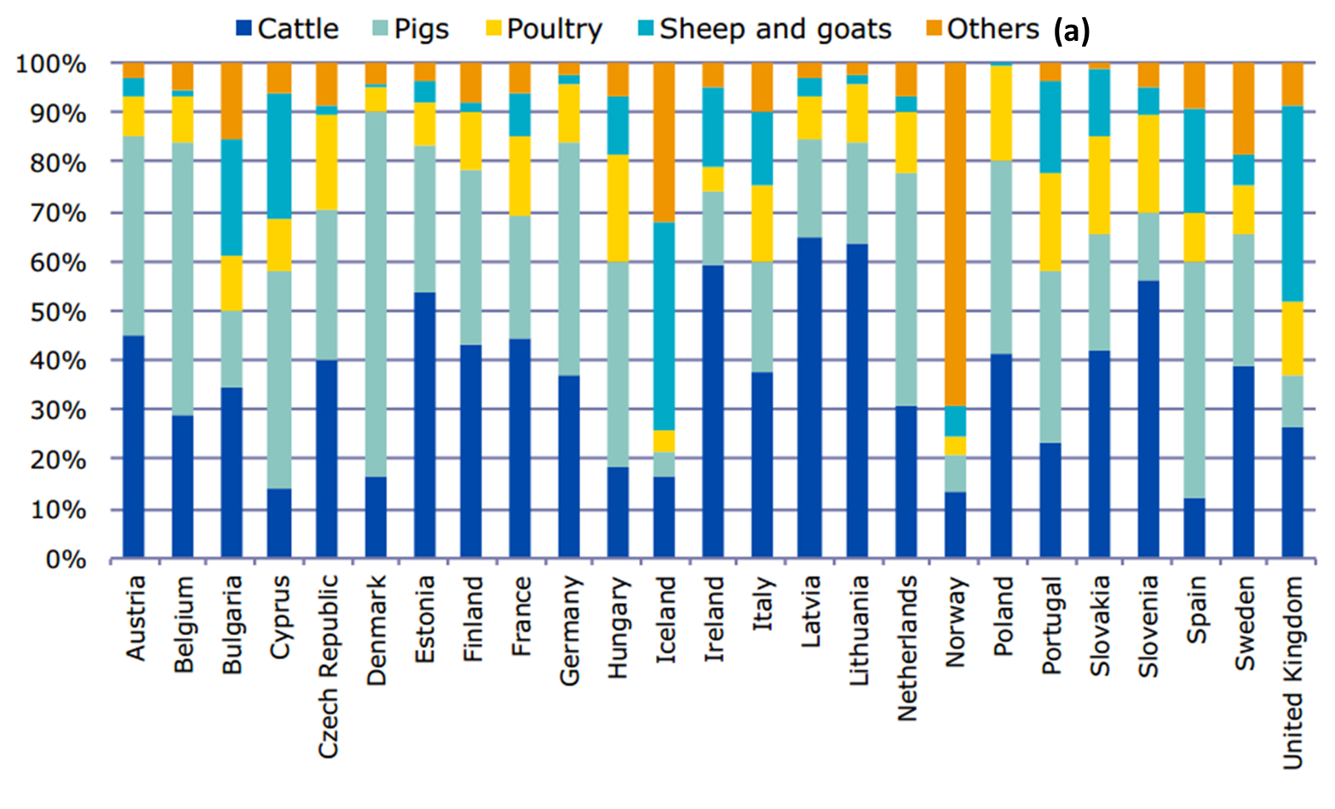
Note: (a) Other includes horses, fish and rabbits;
PCU population correction unit.
Source:
The national sales of antimicrobial agents (numerator) covers all food producing animal species, including horses, and the ‘population at risk of being exposed’ (denominator) includes all of these species. The main indicator used in the report to express sales is mg of active ingredient sold per population correction unit (mg/PCU).
Of the twenty countries that submitted data to ESVAC in both 2010 and 2011, nineteen reported a decrease in sales, ranging from 0.4 per cent to 28 per cent expressed as mg/PCU. Explanations proposed for the decrease include the implementation of prudent use campaigns, restrictions in use, increasing awareness of the threat of antimicrobial resistance, and the setting of reduction targets. Of the overall sales, the largest proportion of sales expressed as mg/PCU, together making up 78 per cent of sales, were:
- Tetracyclines (37 per cent)
- Penicillins (23 per cent)
- Sulfonamides (11 per cent)
- Polymyxins (7 per cent).
For the antimicrobial classes listed on the WHO List of critically important antimicrobials (CIAs) with highest priority in human medicine, the sales for food-producing animals (including horses) were reported as a proportion of total sales for all countries, and with ranges between countries, as follows:
- third- and fourth-generation cephalosporins (overall 0.2 per cent, range 0.05 per cent to 0.78 per cent)
- fluoroquinolones (overall 1.6 per cent, range 0.01 per cent to 13.8 per cent)
- macrolides (overall 8 per cent, range 0 per cent to 14 per cent).
Explanations given for the extent of difference between countries include differences in veterinarian prescribing behaviour, relative proportion of different animal species, different animal-production systems (for example, veal as opposed to beef cattle on pasture), the differing availability of veterinary antibacterials in different markets, prices, and different types and rates of infectious diseases. However, these factors only partially explain the difference in sales patterns between countries.
The level at which data is provide to ESVAC supports a wide range of investigations and analyses, For example, Figure 21 shows an aggregation of the total sales of different forms of pharmaceutical agents across the 25 EU/EEA countries, while Figure 22 shows the difference in forms of antimicrobial agents sold in different countries in mg/PCU.
Figure 21 Distribution of sales aggregated for 25 EU/European Economic Area countries for 2011
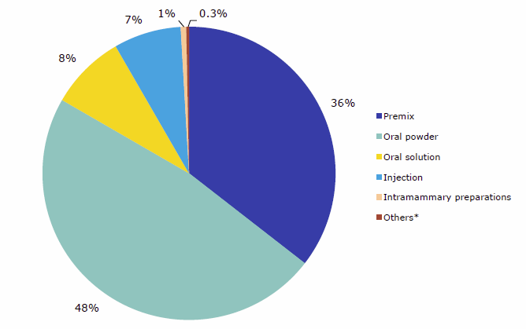
Note: (a) Sales by milligram per population correction unit of various forms of pharmaceutical agents
Source:
Figure 22 Distribution of sales of veterinary antimicrobial agents by pharmaceutical form, by country for 2011
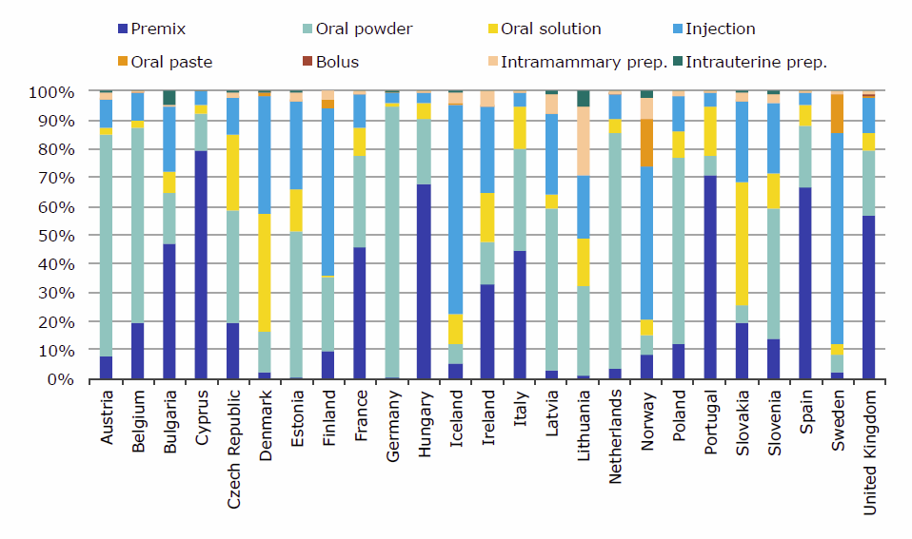
Note: (a) Sales for food-producing animals in milligram per population correction unit
Source:
With data available to populate both numerator (sales, mg) and denominator (animal population, PCU), comparisons can be made between sales patterns in different countries and in different years (Figure 23 and Figure 24).
Figure 23 Sales (a) for food-producing species for 20 countries in 2010
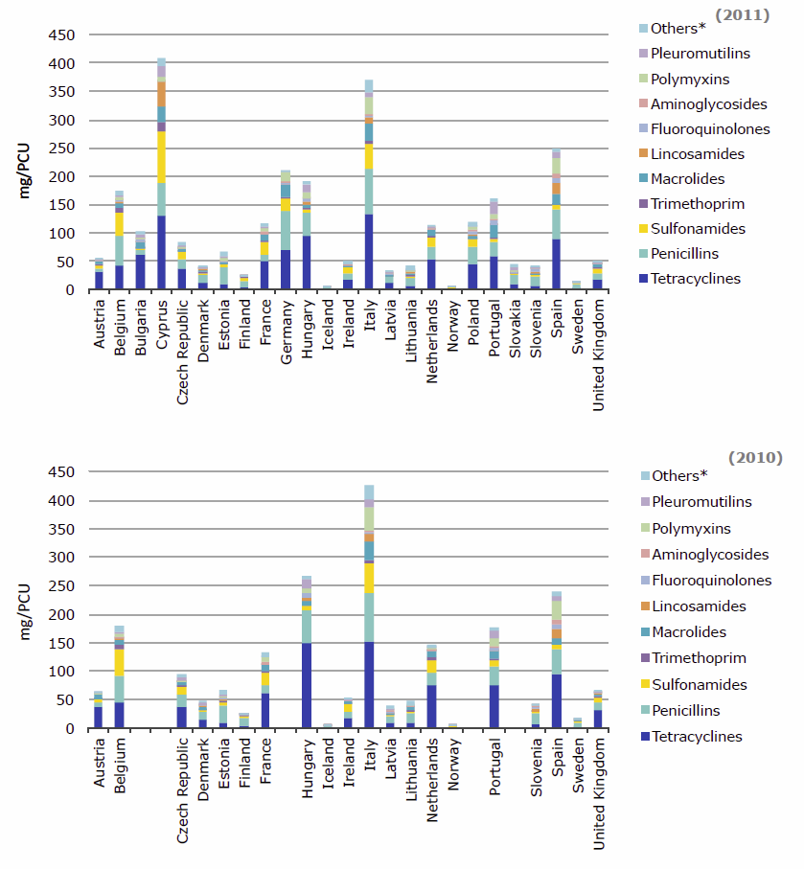
Note: (a) Sales in mg/PCU of various veterinary antimicrobial classes, by country
Source:
Figure 24 Sales (a) for food-producing species for 25 countries in 2011
Note: (a) Sales in mg/PCU of various veterinary antimicrobial classes, by country
Source:
Geo-spatial representations of the data are also possible, again demonstrating differences in practice from country to country or year to year (Figure 25 and 26).
Figure 25 Spatial distribution of sales of tetracyclines (a) for 2011
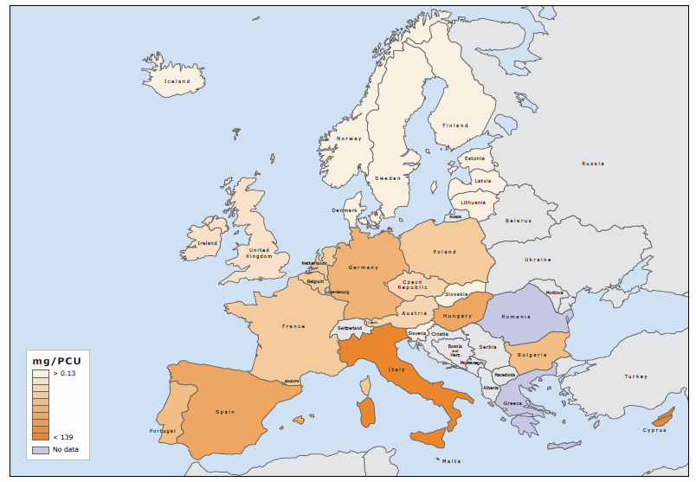
Note: (a) Sales of tetracyclines for food-producing animals, in milligrams per population correction unit, in 25 European Union / European Economic Area countries
Source:
Figure 26 Spatial distribution of sales of first- and second-generation cephalosporins for 2011
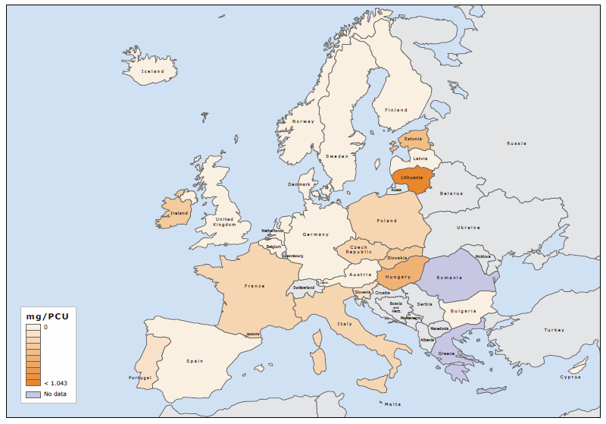
Note: (a) Sales of first- and second-generation cephalosporins for food-producing animals, in milligrams per population correction unit, in 25 European Union / European Economic Area countries
Source:
Many other presentations and analyses of data are included in the ESVAC reports .

Strategic options and assumptions for national coordination in animals and agriculture: enabler and barrier analysis
Collection of antimicrobial use data at an individual farm level provides the richest source of information for understanding and analysing trends as well as for targeting prudent use and other interventions. However, barriers to the collection of farm level data include the resource impost on individual farmers and/or veterinarians from collecting, recording and keeping data, and the view that regional or national data may be of little benefit to the individual holding’s animal health program. Gathering data at this level would need to be enabled by clear incentives and tangible production benefits . The financial cost of obtaining such data would be high and some form of legislative support needed.
A study of antimicrobial use in Swiss dairy farms exploring the quality and comprehensiveness of data collection found that recording of drug name and dosage was often incomplete or inaccurate. Veterinarians were found to record more drug use than farmers, and electronic systems were found to provide better traceability of the animals treated. Authors propose that integration of farm and veterinarian data would improve data quality .
Barriers noted elsewhere in the report include the cost and availability of veterinary diagnostic services for surveillance purposes, and the potential for variability in laboratory methods and quality of testing performance to impact on the validity and reliability of data. The standardisation of laboratory methodologies requires time, funding and commitment as has been demonstrated in a number of areas of human surveillance, and is currently a focus of European programs.
Conflicting and competing objectives for producers, suppliers of antimicrobials, veterinary professionals, regulatory authorities, and laboratory operators potentially provide further barriers to the development and implementation of effective surveillance.
Key enablers include the commitment at a high level of government in both agricultural and human health domains to addressing the issue of antimicrobial surveillance, and the desire from industry for sound, practical and effective solutions that will support good agricultural practice management.

Australia’s response—National surveillance and reporting

Recommendations
- Implementation of the recommendations of this report align as much as possible with AMRSC national antimicrobial usage and resistance surveillance in humans report for cost-effectiveness, efficiencies and synergies within a One Health framework. Adequate resourcing will be essential.
- Without adequate stakeholder engagement and involvement, surveillance will be costly and difficult (governance needs to be defined and the relationship and communication strategy between stakeholders established).
- Human surveillance programs can to some extent rely on passive surveillance of antimicrobial resistance data from human diagnostic laboratories. This may not be viable with respect to animal pathogens as there is too much variability in methods and approaches in veterinary diagnostic laboratories. Use of non-standard methods is common; vet labs use different antimicrobial panels, and data is too variable; therefore active surveillance is recommended.
Table 40 A staged approach with five key elements
Stream | Stage 1-short term  1-2 years | Stage 2-medium term  2-5 years | Stage 3-long term  5+ years
Element 1  Surveillance of antimicrobial resistance (animal/zoonotic pathogens) | Leverage existing systems  Develop information and isolate acquisition processes and laboratory testing systems (AGAR Salmonella reference laboratory collaboration and support) | Establish data and isolate collection and produce annual surveillance reports (AGAR/Salmonella collaboration and support) | Review medium term findings and tailor future surveillance accordingly
Element 2  Surveillance of antimicrobial resistance (commensals and foodborne pathogens) | Leverage existing systems  Develop information and sample acquisition  Select animal species, organisms of interest and sampling interval  Develop bacterial isolation and screening processes | Establish data and isolate collection and produce annual surveillance reports  Consult with stakeholders on baseline survey data | Review medium term findings and tailor future surveillance accordingly
Element 3  Surveillance of antimicrobial consumption and usage | Facilitate centralised recording of antimicrobial wholesale distribution volumes | Facilitate voluntary data submission by focus groups of veterinarians | Facilitate reporting of veterinary use of designated high importance EAGAR drugs
Element 4  Planning and stakeholder engagement | Establish governance and surveillance and reporting framework | Integrate results into reports acceptable to domestic and international stakeholders | Conduct overall program review of all aspects of work
Element 5  Outputs for a) Public Health, b) Animal Health and c) Primary Production | Establish program costing, risk assessments on baseline survey data risk management and risk communication strategies | Facilitate and strengthen cross-sector support to facilitate ongoing collection/generation of representative high quality data | Correlate yearly resistance surveillance reports with antimicrobial use data to identify and focus on ‘hot spots’ and publicise success stories

Element 1: Surveillance of antimicrobial resistance (animal/zoonotic pathogens)
Rationale: Enhancing existing models already established for human/veterinary isolates will provide an integrated One Health framework by focusing on key similarities/differences with human surveillance at the individual (companion animal) vs herd/flock level (livestock). Major pathogens include: Salmonella, coagulase positive Staphylococcus and Escherichia coli.
Approach: Recent surveys provide a basis for estimating number of isolates and have already established the network of veterinary diagnostic laboratories and submission pathways throughout Australia that can be harnessed for future national surveillance.
Stage 1
- Define systems for capturing isolates over a calendar year (pathogens isolated by private, state and university veterinary diagnostic laboratories).
- Define animal species eg. companion animals (dogs/cats/horses) and food-producing animals (livestock/intensive animals).
- Establish processes for data entry and storage.
- Stage 2
- Technical implementation of the elements of commensal surveillance as indicated (Table 39).
- Review, analyse and report baseline data (annual reports).
- Facilitate stakeholder consultation and review.
- Stage 3
- Review results, findings, risk assessments and strategies.
- Redesign sampling strategies to improve value and efficiencies.

Element 2: Surveillance of antimicrobial resistance (commensals and foodborne pathogens)
Rationale: Commensal gastrointestinal microorganisms (including Salmonella, which behave as commensals in most food animal herds and flocks) are internationally recognised indicators of antimicrobial resistance. They are inevitably present on raw meat and within animal environs, subjected to antimicrobial administration selection pressures, can be sampled in real time and potentially, can transfer resistance elements to human and animal pathogens. Screening commensals also provide an opportunity to highlight the unique attributes of some aspects of Australian animal production (for example, extensive grazing systems) that are sparing of antimicrobial use. Responsible antimicrobial use and low levels of AMR may provide considerable competitive advantage to Australian animal production.
Approach: Stakeholder engagement and participation in governance and reporting will be essential for sampling. The recent MLA survey (page 82) provides an excellent framework. Sampling at the point of slaughter is preferable to on-farm and retail meat sampling, though product packaged at the processing point may be more convenient for poultry meat.
Stage 1 (1-2 years)
- Establish animal species/key organisms/sampling interval matrix (Table 39).
- Design and execute sampling strategies and logistics.
- Develop systems for recording, storing and analysing data prior to interpretation.
- Establish laboratory assays for isolation of target organisms and define resistance attributes to be measured.
Stage 2 (2-5 years)
- Adjust sampling methodology in response to outcomes of Stage 1 (Table 39).
- Review and analyse baseline data to suit schedule of reporting.
- Initiate systematic review and analysis of data in consultation with stakeholders.
Stage 3 (5+ years)
- Review composite results, findings, risk assessments and strategies.
- Redesign sampling strategies to improve value and efficiencies.

Element 3: Surveillance of antimicrobial consumption and usage
Rationale: Currently, collection of data on all prescriptions of all drugs in all veterinary use situations is both impractical and cost prohibitive. Antimicrobials of critical importance in humans should have the highest priority. Aggregated data, whilst useful, does not provide sufficient detail to identify major risks and meet future policy needs. Information of this kind can be beneficial for product integrity in domestic and international markets.
Approach: Commence with strategies that are achievable and informative and develop more refined and targeted rather than generalised systems.
Stage 1 (1-2 years)
- Aggregate drug use reporting systems to continue to provide useful data.
- Acquire adequate funding and resources to achieve annual reporting of veterinary antimicrobial sales (APVMA 2014 report as a model to be further developed and refined to include off label use and prescriptions from compounding pharmacies).
Stage 2 (2-5 years)
- Enhance existing systems and develop voluntary systems focused on key animal species, production systems and drugs to facilitate a national veterinary antimicrobial stewardship program.
- Obtain support by stakeholders and the Australian Veterinary Association.
Stage 3 (5+ years)
- Establish reporting of veterinary usage of critically important drug classes (high EAGAR rating that is, carbapenems, fluoroquinolones and third generation cephalosporins (3GCs) in companion animals and 3GCs in food-producing animals, supported by stakeholders and the Australian Veterinary Association.

Element 4: Planning and stakeholder engagement
Rationale: Integration between, current human surveillance programs, and key animal and food industry stakeholders is essential for meeting the objectives of the program.
Approach: There must be seamless integration with respect to design, implementation and interpretation of surveillance findings and recommendations to government and industry. This necessitates the presence of medical, veterinary and industry expertise at a governance level.
Stage 1 (1-2 years)
- Establish Advisory Group consisting of medical, veterinary, government and industry representatives.
- Establish reporting methods.
- Recommend research priorities.
- Make recommendations to industry bodies and regulators.
Stage 2 (2-5 years)
- Respond to feedback from peak bodies at national and state level (eg. pharma, food, agriculture, R+D corps, AVA).
- Analyse and integrate responses into governance framework.
- Re-prioritise surveillance systems.
Stage 3 (5+ years)
- External program review to determine sustainability, cost-effectiveness and outcomes to public health and industry.

Element 5: Outputs for Public Health, Animal Health and Primary Production
Rationale: Major stakeholders (public health, animal health and primary production) require clarity of reporting. Public health stakeholders will wish to be assured that the food supply is safe and that data is comparative with local human surveillance (that is, animal pathogens only) and compliant with international programs. Animal health stakeholders (AVA) will want the data to underpin an evidence based approach to antimicrobial stewardship and prudent use as well as strategies to reduce overall usage whilst preserving existing drug classes ; primary producers will want assurance that publicly released data will not be misinterpreted or sensationalised and could be used to improve animal production and market access.
Approach: Recommendation of clear separation of risk assessment and risk management as per DANMAP. Risk communication strategies to be identified at the commencement of the project and refined throughout. Iterative approach to surveillance of use and resistance to provide high quality outputs.
Stage 1 (1-2 years)
- Baseline surveillance data report
- Human/animal comparative data (pathogens only)
- Risk assessments to underpin further surveillance
- Risk management of identified hot spots
- Risk communication strategy.
Stage 2 (2-5 years)
- Annual reports of usage and resistance
- International benchmarking
- Publications in international journals.
Stage 3 (5+ years)
- Trends established relating use to resistance to further guide policy and procedures.
Table 41 Suggested element 2 provisional sampling matrix providing indicative sampling intervals and priorities for further development and discussion
Animal Species (a) | Salmonella spp. | Campylobacter spp. | Escherichia coli spp. | Enterococcus spp.
Pigs-commence baseline study year 1 | Biennial | Low priority (b) | Biennial | Biennial
Poultry (meat chickens) baseline study year 1 | Biennial | Biennial | Biennial | Biennial
Sheep/Goat (grazing) -baseline study year 1 | Every 5 years | Low priority | Every 5 years | Every 5 years
Beef cattle (grazing)- baseline study year 2 | Biennial | Low priority | Biennial | Every 5 years
Beef cattle (feedlot)-  baseline study year 2 | Biennial | Low priority | Biennial | Every 5 years
Dairy cattle baseline study year 2 | Biennial | Low priority | Biennial | Every 5 years
Note: (a) Surveillance activities involving combinations of particular animal species, particular production systems, particular commensal bacteria and particular pathogens are prioritised by a process of qualitative appraisal of risk. A framework for this appraisal will need to be developed and the approach would include information on prior surveillance results (in Australia and abroad), production practices in use in Australia, anticipated level of antimicrobial usage, extent of human exposure to animal bacterial flora, consequences of resistance in human pathogens. Minority species and production systems (for example, aquaculture species, turkeys, backyard chickens, horses destined for human consumption) might only be included very infrequently if indicated by the risk appraisal. In some cases, such as aquaculture, further research is needed to give firm recommendations on target organisms.
(b) Low priority objectives may involve initial establishment of baseline levels of resistance with repeated surveillance contingent on the findings and risk appraisal.
Sample size rationale: Sampling rationale should be based on specific objectives for each animal species. This might, for example, emphasise an ability to detect a low level of resistance to high importance drugs (presence absence) or estimating the prevalence of isolates, animals or herds with resistance to a specified drug. Sample size should take into account the effect of clustering, cost and logistic aspects.

Key influences on the recommendations

Broad support for a combined ‘one health’ approach.
At the antimicrobial resistance colloquium in Canberra in August 2013 it was evident that an integrated animal-human ‘one-health’ approach to surveillance has broad support amongst professions, government agencies and industry. Arranging surveillance activities so they are coordinated, creates many efficiencies in terms of cost, access to specialised expertise and interpretation of findings. From the case studies in this report it is evident that a consolidated approach can deliver surveillance findings sooner, particularly by improving inter-agency involvement. Moreover, there appears to be growing community expectations for stronger coordination of human and animal health in terms of surveillance, prevention and management. A ‘one health’ approach has proven to be very efficient and effective in Scandinavia and the Netherlands.

Economic impacts and consumer expectations
Consumers in Australia and abroad are becoming increasingly aware of food-integrity issues including those related to antimicrobial resistance. There is growing potential for this to impact on demand for foods derived from animals. Fortunately, the evidence summarised in this report is consistent with Australian animal products being amongst the world’s best with respect to the risk posed to human health from antimicrobial resistance in animals. To preserve this status a future Australian surveillance program for antimicrobial resistance and antimicrobial usage in animals should be performed to high standards of technical and scientific integrity within a governance framework that ensures the information has strong credibility both in Australia and abroad. The latter is one important reason why a ‘one-health’ approach to surveillance has been keenly favoured in this report.

Logistical issues affecting the acquisition of animal isolates
The size and diversity of food animal production in Australia is a major factor influencing the recommendations in this report. Given that resources for surveillance are finite and that results should be delivered in a timely manner, the establishment of priorities is essential for the success of an Australian program. Priorities will need to be based on the likely risk of antimicrobial resistance emergence or exacerbation in specific animals and animal management systems (including companion and performance animals). In this process, factors to be considered would include the ‘importance’ of drugs being used, likely level of human exposure (through direct contact, environmental, and/or commodity consumption) and the amount of uncertainty. The latter is, for example, affected by the time elapsed since data on each particular objective were last acquired.
Collection of samples from livestock at the point of slaughter represents the best opportunity for efficient surveillance of AMR in both commensals and food-borne pathogens. Sampling at this point provides information useful for the assessment of risks to do with AMR in animal-derived food. The possible exception would be poultry where sampling from the gastrointestinal tract of individual animals directly after slaughter is more difficult. In some poultry processing plants, meat that is directly packaged at the poultry plant and not subjected to further handling by humans (for example, butchers) prior to retail sale would be a suitable alternative.
Further, we acknowledge that substantial consultation and planning will be required to ensure that for each objective an epidemiologically valid collection of isolates is obtained. The practical issues to do with physically procuring faecal (or caecal) specimens from healthy animals for isolation of commensal bacteria will present a challenge because of the need to negotiate with many different private organisations and individuals for necessary permissions. Similar issues exist with the procurement of animal-pathogen isolates. The recommendations therefore emphasise a collaborative approach amongst surveillance coordinators, government agencies and each level of industry to ensure the benefits, need for and direction of surveillance is understood.

Logistical issues surrounding the acquisition of veterinary prescribing data.
Procurement of comprehensive data on the volume and type of antimicrobials prescribed by veterinarians according to animal species and production system would in theory provide the best basis for a new surveillance program describing antimicrobial use. This has been shown to be possible in Denmark where there exists broad-based community support for publicly funded efforts to control antimicrobial resistance and is made feasible there by geographic and animal demographic factors. The Danish approach results in a census of antimicrobial use allowing detailed analysis on consumption trends. However, the range and severity of impediments to collecting such data in Australia are large. Most of these relate to the cost and inconvenience that would be borne by veterinarians who provide clinical services which is an entirely privately funded activity with little reserve capacity for supporting new reporting responsibilities.

Appendix A Study design and methods
The study adopted the methodology used to develop the 2013 Antimicrobial Resistance Standing Committee report ‘National surveillance and reporting of antimicrobial resistance and antibiotic usage for human health in Australia’. In the context of the animal and agriculture sectors, the study was designed to answers the following questions:
- What activities for the surveillance and reporting of antibiotic resistance and antibiotic usage occur globally?
- What options or models for a nationally-coordinated approach to the surveillance and reporting of antibiotic resistance and antibiotic usage are most applicable to the Australian context with due reference to the World Organisation for Animal Health (OIE) Standards?
- What are the enablers and barriers to the establishment of a nationally coordinated approach for the surveillance and reporting of antibiotic resistance and antibiotic usage in Australia, with a particular focus on regulatory reform?
The study comprised a cross-sectional, mixed methods study, and was made up of four iterative stages as follows:
- Stage 1, Project commencement
- Stage 2, Integrative literature review including document and policy analysis
- Stage 3a, Key stakeholder engagement analysis
- Stage 3b, Options for developing a nationally coordinated surveillance plan and assessment of enablers and barriers for each option
- Stage 4, Compilation of final report.
Two of the key stages are described blow in more detail.
Stage 2: Integrative literature review including document and policy analysis
The literature search aimed to locate national and supranational programs for the surveillance of antimicrobial resistance and antimicrobial usage in animals. Key program elements were elicited to inform potential models for national surveillance in Australia, and a reference table listing programs and key attributes was constructed.
Databases included for the search were Agricola, the Cochrane Library, MEDLINE (via EBSCOhost), CINAHL (via EBSCOhost), Web of Science (Thomson, ISI), Scopus (Elsevier Science), Health Management Information Consortium (HMIC; Ovid), TRIP, ScienceDirect and Google Scholar. Search syntax and search strategies were optimised for each database. 15,527 citations were screened during the literature review, and 1,223 references imported to bibliographic management software (EndNote X6) where abstracts were assessed for relevance and context. Grey literature (government reports and relevant professional association publications) relating to antimicrobial use and resistance published internationally were also identified and reviewed, resulting in a total of 1,347 references scrutinised.
A number of caveats are noted with respect to the search of the literature:
- Many antimicrobial surveillance and monitoring activities are reported in the grey literature rather than peer-reviewed literature.
- The dynamic and emerging nature of antimicrobial resistance and antibiotic usage makes reporting challenging, and the detail and reporting accuracy of information available can be inconsistent. However, it is considered that substantive international programs would be presented in the literature.
- Referenced grey literature (government or agency reports, .) and identified websites provided valuable depth to program detail. However, it is acknowledged that program funding or infrastructure limitations also make the information that can be elicited from these sources variable.
- This review focused on key international systems and experience in the context of a potential national system for the surveillance of antibiotic resistance in bacteria important to human health and associated use of antimicrobials.
- A comprehensive review of global activities has meant some information is only available in languages other than English and currently not accessible.
Stage 3a: Key stakeholder engagement analysis
A Project Steering Group was established, and membership of this group was agreed with the Department of Agriculture. Members of the Steering Group provided input at a number of stages of the project, and facilitated discussions during a meeting of key national stakeholders held in Canberra on 1 May 2014. The broader stakeholder group reviewed a draft of Chapter One of this report, and provided input on enablers and barriers, key characteristics of nationally coordinated programs, and important policy and operational features for surveillance systems.
Members of the Project Steering Group, appointed on individual merit rather than organisational affiliations, were:
- Emeritus Professor Mary Barton, University of South Australia
- Dr Jane Heller, Charles Sturt University
- Dr Rowland Cobbold, University of Queensland
- Dr Stephen Page, Advanced Veterinary Therapeutics.
Organisations and groups invited to attend the 1 May Stakeholder Forum in Canberra were as follows:
- Department of Agriculture
- Aquaculture industry delegate
- Sub-committee on Animal Health Laboratory Standards delegate
- Australian Veterinary Association - central policy delegate
- Australian Veterinary Association - companion animal/equine delegate
- Australian Pesticides and Veterinary Medicines Authority
- Meat & Livestock Australia
- Australian Pork Limited
- Chicken Meat Federation
- Egg industry delegate
- Dairy Australia
- Animal Medicines Australia
- Cattle Council/Australian Lotfeeders Association
- Elanco Animal Health
- Zoetis Australia
- Australian Dairy Cattle Veterinarians
- Australian Pig Veterinarians.

Appendix B Evidentiary table
The following tables provide outline descriptions of systems and programs found during database searches for literature relating to the surveillance of antimicrobial usage and resistance in animals. While some of the programs listed are fundamentally surveillance and reporting systems, in the interests of providing a comprehensive overview of international activities, the list also includes programs that provide support, promote collaboration and harmonisation, or capacity building in the subject areas.

International or supranational programs
Table B1 International or supranational programs
Program | Country or Region | Program status | Type of activity | Funding model, governance | Program focus | Population | Sampling type, methods | Data | Organisms | Report type/  frequency
GFN  WHO Global Foodborne Infections Network | Global | Established 2001  Active  Formerly known as WHO Global Salm-Surv (GSS) | Promote integrated, lab-based surveillance, intersectoral collaboration among human health, veterinary and food-related disciplines through training courses and activities around the world | WHO program | Building capacity to detect, control and prevent foodborne and other enteric infections from farm to table.  Conducts external QA program for foodborne pathogens, organised through Technical University of Denmark, National Food Institute | Laboratories in WHO member states globally  200 labs enrolled in 2012 | Countries contribute top 15 Salmonella serotype and other pathogen data annually  Confidential laboratory data from External Quality Assurance System (EQAS) program | Key activities:  1) training courses,  2) passive  Salmonella surveillance system,  3) annual (EQAS)  4) focused regional and national projects  5) reference testing services  6) communications | Historic focus on Salmonella, EQAS program expanding to include other pathogens for example, Shigella, Campylobacter | Direct output includes plans and reviews of programs  AMR data is published by members in peer reviewed journals, conference presentations  EQAS data and summaries published annually and in a range of publications
AGISAR  WHO Advisory Group on Integrated Surveillance of Antimicrobial Resistance | Global | Estalished 2008 | The Group  comprises over 30 internationally renowned experts in a broad range of disciplines relevant to AMR. Develops lists and guidelines, supports capacity building, provides advice, information sharing.  Support WHO's effort to minimize the public health impact of AMR associated with the use of antimicrobials in food animals. | WHO program | TOR:  (i) develop harmonized schemes for monitoring AMR in zoonotic and enteric bacteria  (ii) capacity-building activities for AMR monitoring  (iii) information sharing on AMR,  (iv) expert advice on containment of AMR  (v) selection of sentinel sites, design of pilot projects  (vi) capacity-building activities for usage monitoring | Programs in member countries | Varies according to country programs | Focus is on coordination and harmonisation of data and systems | Zoonotic and enteric bacteria | Range of publications and guidelines
GARP  The Global Antibiotic Resistance Partnership | Global | Established 2009  Current | Create a platform for developing actionable policy proposals on antibiotic resistance in low-income and middle-income countries.  Two areas of focus:  (i) target use of antibiotics in human health and livestock production;  (ii) reduce demand for antibiotics by reducing incidence of infections in hospital, community, and on the farm. | GARP is funded by the Bill & Melinda Gates Foundation, with support from Center for Disease Dynamics, Economics & Policy (CDDEP) project, | Phase 1 2009-11 established national working groups in India, Kenya, South Africa and Vietnam.  GARP Phase 2 began 2012, establishing national working groups in Mozambique, Nepal, Tanzania and Uganda. | Both human and animal antibiotic use | Broadly focussed program of capacity building and support | Varies by country | Varies by country | Range of publications at the CDDEP website.  http://www.cddep.org/projects/global_antibiotic_resistance_partnership
EASSA  European Antimicrobial Susceptibility Surveillance in Animals  VetPath  MycoPath  ComPath  Coordinated by  CEESA  European Animal Health Study Centre | EU member states  Scandinavia in north to Italy and Spain in south | Eestablished 1998  Current (2012) | EFSA Compiles data from EU programs coordinated by CEESA, for example,  a) Food-borne bacteria at slaughter  b) Pathogens from sick animals | International non-profit foundation, funded by collaboration of vet pharmaceutical companies. 6 to 12 companies per project. | AMR in pathogens and commensals | VetPath: Commensals in food animals  MycoPath: mycoplasma in food animals  ComPath: pathogens in companion animals | Varies by country | External labs contracted for each project  Laboratory AMR data | Salmonella  Campylobacter  E coli  Enterococcus | Data used internally by companies. Also made available for conferences and publication.
EFSA – ECDC  European Food Safety authority  European Centre for Disease Prevention and Control | EU | Current | EU member states are obliged to monitor and report AMR in Salmonella and Campylobacter isolates from animals and food. | EU program | AMR in zoonotic and indicator bacteria from humans, animals and food | Includes ‘farm to fork’ analysis covering reports from all EU member states | Collates and reports data from EU member countries | Collation of data from all EU members states  Human, food and animal AMR data | Salmonella  Campylobacter  E coli  MRSA | EU summary report on antimicrobial resistance in zoonotic and indicator bacteria from humans, animals and food produced annually
ESVAC  European Surveillance of Veterinary Antimicrobial Consumption  EMA  European Medicines Agency | EU | Established 2009, first report in 2011  Current | Collects information on how antimicrobial medicines are used in animals across the European Union | EU program | Antibiotic sales and use in veterinary medicine, emphasis on food producing animals | Food animals across the EU | Antibiotic sales data from 25 EU countries | Collation of data from EU member states  Antimicrobial sales data | na | Annual ESVAC report, eg: Sales of veterinary antimicrobial agents in 25 EU/EEA countries in 2011
ARBAO-II  Antimicrobial Resistance in Bacteria of Animal Origin-II | EU | 2003 to 2005  Forerunner of EURL-AR | Aimed to establish monitoring of antimicrobial susceptibility among the veterinary laboratories in all European countries based on validated methodologies | EU program | Monitoring of susceptibility patterns  External QA system for susceptibility testing of important bacteria | Animals in EU member states  19 labs testing veterinary samples in 18 EU member states | Susceptibility data from testing labs  External QA program for laboratories performing susceptibility testing | QA program data for susceptibility tests | Salmonella  E coli  Staphylococci  Streptococci  Actinobacillus pleuropneumoniae  Mannheimia haemolytica  Pasteurella multocida | Summary reports  Journal articles
EURL-AR  European Union Reference Laboratory—Antimicrobial Resistance | EU | Established 2006, replacing ARBAO-II | Provide scientific advice to the European Commission on matters in relation to antimicrobial resistance | EU program | Provide scientific advice on organisation, implementation and evaluation of monitoring schemes for antimicrobial resistance, operate proficiency testing program, organise workshops, confirmatory testing. | Labs in EU member states | Annual proficiency testing for Campylobacter, Salmonella, E. coli, enterococci and staphylococci for the National Reference Laboratories | Summary data on susceptibility patterns  Confidential laboratory data from EQAS program | Foodborne bacteria | Range of summary reports, workshop reports, proficiency testing results, journal articles

European Country-specific
Table B2 European Country-specific
Program | Country or Region | Program status | Type of activity | Funding model, governance | Program focus | Population | Sampling type, methods | Data | Organisms | Report type/  frequency
DANMAP | Denmark | Established 1995  Current | Systematic and continuous monitoring program of antimicrobial drug consumption (VetStat) and antimicrobial agent resistance in animals, food, and humans | Funded jointly by the Ministry of Health, the Ministry of Science, Innovation and Higher Education, and the Ministry of Food, Agriculture and Fisheries | Antimicrobial consumption and resistance in food animals, food of animal origin, and humans | Food animals  Food of animal origin  Humans | Healthy production animals at slaughter:  Pigs –caecum samples  Cattle—rectum samples  Broilers—cloacal swabs  Salmonella isolates from surveillance programs | Animal AMR data from vet practices, laboratories, slaughterhouses | Zoonotic bacteria:  Salmonella  Campylobacter  Clostridium difficile  Indicator bacteria:  Enterococcus  E coli  ESBL producers | Annual report
VetStat | Denmark | Established 2000  Current | Usage surveillance  Data on all medicines prescribed by veterinarians have been registered at the farm and species level by the official VetStat program since 2001. | Danish Ministry of Food, Agriculture and Fisheries | Antimicrobials administered to food animals | Food animals | Data originates from three sources: pharmacies, veterinarians and feed mills | Data entry via website or upload includes veterinarian, receiving herd, product name and amount, species, age group, diagnostic group.  Kg active compound  Calculations performed eg: ADD (animal daily dose) per 100 animals | na | Range of reports, journal articles, conference publications  Detailed data available to farmers (own herds) and veterinarians (own submissions) via the VetStat website (vetstat.dk)  Higher level data available to public
RESAPATH  Réseau d’Épidémiosurveillance de l’Antibiorésistance des bactéries PATHogènes animales  AFSSA-ANMV  French Agency for Food Safety - National Agency for Veterinary Medicinal Products | France | Established 1982 as RESABO  Became RESAPATH in 2001  Animal coverage extended in 2007 | 63 public and private labs participate voluntarily to contribute AMR data  Antibiotic sales data obtained | Under Directorate General for Food (DGAl) of the Ministry of Agriculture | Monitor AMR, promote appropriate use, compare vet and human data, provide technical support to labs, monitor antibiotic sales | Samples from sick food and companion animals | Antibiogram data from French veterinary laboratories  Approx 25,000 data points annually (2012) | Regulatory monitoring  Antibiogram data from vet practice isolates  Antibiotic sales data  Ad hoc programs eg: MRSA in pigs, mastitis in cattle  AMR and epidemiological data | Zoonotic:  Salmonella  Campylobacter  Indicator:  E coli  Enterococcus | Annual
EcoAntibio 2017  Ministry of Agriculture, Agrofood and Forestry | France | Current plan launched in 2012 for the period to 2017 | Coordination of range of programs including improving systems for monitoring antibiotic use and antibiotic resistance | Government program | Reduce antibiotic use in veterinary medicine by 25 per cent in 5 years in particular, fluoroquinolones  and third and fourth-generation cephalosporins.  1 plan  5 themes  40 measures | All use in veterinary medicine | na | Range of programs | na | Plans and brochures available at the government website  http://agriculture.gouv.fr/plan-ecoantibio-2017
ANSES  French Agency for Food, Environmental and Occupational Health Safety | France | Current | Responsible for monitoring antibiotic resistance in bacteria of non-human origin | Government program | AMR based on activities of three networks coordinated by ANSES’ laboratories: RESAPATH,  The Salmonella Network, targeted surveys  Sales info based on National Agency for Veterinary Medicinal Products (ANMV) data | Food production animals | Data is fed to ANSES from other programs | AMR data  Antibiotic sales data | Range of zoonotic and sentinel bacteria eg:  Salmonella  Campylobacter  E coli  Enterococcus | Range of reports on usage, AMR
ONERBA  National Observatory of Epidemiology of Bacterial Resistance to Antibiotics  (Observatoire  National de l’Epidémiologie de la Résistance aux Antibiotiques) | France | Most recent annual report published 2011 | Centralises data from RESAPATH, fifteen French networks for human medicine and three national reference centres for human medicine. | Government program | Scientific advisory committee collects, validates and compares French resistance data with global data | Animals and human | Animal data is from RESAPATH | Collation of data from multiple networks  Human and animal data | Animal data is from RESAPATH | ONERBA report published annually
VAV Network  Red de Vigilancia de Resistencias Antibioticas en Bacterias de Origen Veterinario | Spain | Established in 1997  Current | Modelled on DANMAP | Coordinated by Ministry of Environment, Rural and Marine Affairs (MARM) | Three programs: Sick animals, healthy animals, food animals | Food animals, companion animals | Zoonotic and commensal bacteria from pigs and broilers sampled at slaughterhouse  Pathogenic bacteria from diagnostic laboratories | Healthy animals—active sampling  Sick animals—passive sampling  Food animals—passive sampling  AMR data on selected antibiotics | Healthy animals:  E coli  Enterococcus  Salmonella  Campylobacter  Sick animals:  E coli  Enterococcus  Staph aureus  Food animals:  E coli  Enterococci  Salmonella  Campylobacter | Annual report  Periodic bulletins
NORM-VET | Norway | Established 2000  Current | Collates data on antimicrobial use and AMR, reports trends  Collaborates with NORM (human program) | Coordinated by Norwegian Zoonosis Centre at the Norwegian Veterinary Institute | Antimicrobial use in animals  AMR in animals | Range of animals including food, companion | Sales figures from drug wholesaler and feed mills  Range of active sampling programs and passive data collection | Usage data  AMR data  Mandatory reporting by pharmaceutical wholesalers  Data on antimicrobial feed additives collated by Norwegian Food Safety  Authority | Clinical isolates and pathogens  Eg.Salmonella  MRSA  Indicator bacteria eg. E coli | Joint annual report by NORM and NORM-VET
SVARM  Swedish Veterinary Antimicrobial Resistance Monitoring | Sweden | Current | Collaborates with Swedish Institute for Communicable  Disease Control (SMI) that operates SWEDRES (human program) | Coordinated by National Veterinary Institute, Sweden | Antimicrobial use in animals  AMR in animals | Range of animals including food, companion | Pharmacy sales data, includes animal species  Range of specimen types for example, caecal content from broilers and laying hens, rectal swabs from dogs, samples collected at slaughter (carcass swabs, neck skins and lymph nodes), clinical submissions, post-mortem examinations | Antibiotic use data  AMR data  Antimicrobial sales data  Aggregated lab AMR data submitted to web based platform ResNet | Indicator bacteria: E coli  Enterococcus  Zoonotic bacteria: | Annual joint reports with SWEDRES
CODA-CERVA (Veterinary and Agrochemical Research Centre) | Belgium | Current  AMR monitoring program started 2011 | Research establishment focusing on food production safety, animal health and public health,. Activities include some AMR related programs | Administratively connected to the Federal Public Service for Public Health, Food Chain Safety and Environment | Three major strategic themes for food chain are:  (1) climate change  (2) AMR  (3) nanoparticles | Poultry  Pigs  Cattle  Calves | Range of sampling depending on program focus, eg: caecal content of broiler chickens at slaughter, pooled fresh faecal material collected from the floor for pigs, cattle | Annual data collection  MICs | E coli  Enterococci  MRSA  Salmonella | ‘Trends and sources 2010-11’ report includes AMR
FINRES-VET  Zoonosis Centre  Finnish Food Safety Authority - Evira  Finish Medicines Agency - Fimea | Finland | FINRES-VET established 2002  Zoonoses Centre 2007  Current | Coordinates AMR activities between Finnish Food Safety  Authority (Evira), Finnish Medicines Agency (Fimea) and the National Institute for Health and Welfare THL | Government agency | Monitoring of zoonoses, food-borne outbreaks and AMR is co-ordinated through the Zoonosis Centre.  Consumption of antibiotics monitored by FIMEA. | Food animals | Antibiotic sales figures from wholesalers  Range of sample types, for example, indicator bacteria from healthy broiler caeca, pig and cattle faeces at slaughter. Pathogens from clinical isolates. | Sample collection varies by program for example, cattle, pigs, poultry  MICs | Salmonella  Campylobacter  E coli  Enterococcus | Publications through various bodies for example, FINRES-VET 2007-09 Report (2011)
ARCH-VET  SwissMedic  Swiss Agency for Therapeutic Products | Switzerland | Established 2002  Current | Collates and publishes sales statistics for antibiotics in veterinary use  Coordinated AMR monitoring programs | Government agency | Antibiotic sales  AMR | Chickens  Pigs  Cattle | Antibiotic sales data  Passive sampling eg: clinical samples for Salmonella from cattle, pigs, poultry.  Screening programs eg: cloacal swabs for Salmonella Campylobacter in poultry. Rectum-anal swabs from cattle, pigs at slaughter for Campylobacter | Sales data linked to animal numbers an theoretical weight at slaughter  AMR data from clinical and screening isolates for range of zoonoses, indicator and pathogenic bacteria | Salmonella  Campylobacter  E coli  Enterococcus  ESBL producers  MRSA | Annual reports of antibiotic sales and AMR in ARCH-VET
ANRESIS  Institut für Infektionskrankheiten Universität Bern | Switzerland | Human program in place, veterinary program in development | Regional and national surveillance and research program for antibiotic resistance and antibiotic consumption in human medicine. ANRESIS website .  http://www.anresis.ch/en/index.html | Funded by Swiss Federal Office of Public Health (FOPH), Swiss Conference of the Cantonal Ministers of Public Health, University of Bern | AMR in human medicine  AMR in veterinary medicine is under development  Provides Swiss data on antibiotic resistance and consumption to European surveillance programs (EARSS, ESAC) | Animal program under development | Animal program under development | Antibiotic resistance data from laboratories  Antibiotic sales data 2002-2006 purchased from IMS Health GmbH (Hergiswil, Switzerland)  Long-term project has been started to collect representative antibiotic consumption data directly from a selection of Swiss pharmacies and hospitals | Animal program under development | Systems for resistance and consumption in veterinary medicine are under development
UK-VARSS  Veterinary Antibiotic Resistance and Sales Surveillance | UK | Current | Combines UK data on antimicrobial sales for animal use with England and Wales AMR data for veterinary pathogens and food-borne pathogens | Government program under the Veterinary Medicines Direcotorate (VMD) | Sales of veterinary antibiotics  AMR in food animals | Estimates made of animal population to link with antimicrobial sales data.  AMR data focusses on food producing animals in England and Wales | Antimicrobial sales data converted to active ingredient, (mg), sold for food producing animals / population correction unit, (PCU)  Clinical specimen data analysed for low incidence pathogens  Active screening for indicator and zoonotic bacteria | Antimicrobial sales data  AMR data from clinical specimens and targeted surveillance  AMR data for 25 bacterial species, 26 antibiotics from 14 Animal Health and Veterinary Laboratories Agency (AHVLA) labs across England and Wales, and one lab in Scotland | Focus on: Salmonella  Campylobacter  E coli  25 bacterial species in total | Annual report.  2012 report released in 2013 was first to combine sales and AMR data.
SAVSNET  The Small Animal Veterinary Surveillance Network | UK | Current | Data gathering and analysis. Details available at the SAVSNET website  http://www.savsnet.co.uk/ | Initiative from the British Small Animal Veterinary Association and the University of Liverpool | Aims to fill a gap in health surveillance of the UK’s pet population by the ethical collection and analysis of large volumes of health information about companion animals | Companion animals | SAVSNET collaborates with diagnostic laboratories and veterinary surgeons in practice. | Surveys of prescribing habits  Data help to identify risk factors associated with disease and to see how patterns in disease change over time | na | Range of publications and information via the SAVSNET website  savsnet.co.uk
ZAP  Zoonoses Action Plan—British Pig Executive | UK | Established 2002  Current | Monitoring Salmonella in pigs at slaughter | British Pig Executive in association with the Department for Environment, Food and Rural Affairs and the Food Standards Agency | Monitor Salmonella prevalence in quality-assured British pigs at slaughter. Farms were assigned a ZAP level (1 to 3). ZAP 2 or 3 farms were required to act to reduce the prevalence.  If a farm were assigned to ZAP 3 for more than 11 consecutive months their assured status could be suspended | Swine | Small  pieces (approx 20 g) of skeletal muscle are removed from a sample of carcasses at slaughter and are frozen.On thawing, the meat juice is used as a substrate for the test.  At least three carcasses from every batch sent to slaughter, with an aim to collect at least 15 samples from all participating pig farms every 3 months. | Meat juice mix enzyme-linked immunosorbent assay (ELISA) (MJE) system to detect antibodies against group B and C1 Salmonella  Estimate of the  seroprevalence was obtained for each farm | Salmonella | Regular review of seroprevalence data by program
MARAN  Monitoring of Antimicrobial Resistance  and Antibiotic Usage in Animals in The Netherlands | Netherlands | Current | Reports on antimicrobial sales data and AMR data in veterinary field | Government program Central Veterinary Institute, part of Wageningen UR with the Food and Consumer Product Safety Authority, and the National Institute for Public Health and the  Environment. | Sales of veterinary antibiotics  AMR in food animals | Pigs  Chickens  Calves  Cows | Antibiotic sales data from the federation of the Dutch veterinary pharmaceutical industry (FIDIN)  Range of sampling programs, eg: intestine of randomly picked broilers, pigs, veal calves at slaughter. Campylobacter samples from food animals collected by Dutch Food and Consumer Product Safety Authority (NVWA). | Overall antibiotic sales data and usage data per animal species.  AMR in food borne pathogens and commensal indicator bacteria  Total sales data of antimicrobial agents in animal husbandry  AMR in bacteria of animal origin and of relevance to public health. | Salmonella  Campylobacter  E coli  Enterococcus  MRSA | Combined report of NETHMAP (human) and MARAN published annually  Comprehensive sales data available as XLS file on web site
SDa  Netherlands Veterinary Medicines  Authority | Netherlands | Established 2010  Current | Creating  transparency in and setting benchmark indicators for consumption  of antimicrobials in livestock production, based on consumption  data | Government program | Each time a vet prescribes, data is transferred from practice management system | Pig  Veal calf  Broiler | Data collected by private animal sectors and  sent to the SDa after encryption of identifiers | Complete  consumption of antimicrobials as registered on individual farm level, for all pig, veal calf, and broiler farms in the Netherlands.  Animal defined daily  dosages per year (ADDD/Y) | na | SDa  monitors, analyses, and reports data on consumption of antimicrobials  annually, making trends in consumption  patterns in the various sectors transparent
BfT-GermVet | Germany | Single study  Sampling period January 2004 to March 2006 | AMR surveillacne in animals | Joint initiative of (i) Institute of Animal Breeding, Federal Agricultural Research Centre, (ii) Institute of Microbiology and Epizootics, Free University Berlin, (iii) Institute for Medical Microbiology, Ludwig-Maximilians University, Munich (iv)Federal Office of Consumer Protection and Food Safety, Berlin | Determine the Status of antimicrobial susceptibility of bacterial pathogens from animals in Germany. Complementary to and aligned with the Germ-Vet program. | Pathogens isolated from cattle, swine, horse, dog, cat with acute clinical infections, not treated with antibiotics in prior 4 weeks. Total of 1,626 bacteria from 31 clinical indications tested. | Sampling over 27 months. Sample size calculation indicated at least 80 to 100 bacterial strains per indication/animal should be included. Isolates from routine diagnostic cultures submitted as pure cultures. Animal source, geographic area, organ system, pre-treatment recorded. | In vitro susceptibility tests performed for 22 single antibiotics, and two combinations. Recorded as MIC values against CLSI M31-S1 and M100-S17 breakpoints where available, or as a distribution of MIC values where no breakpoint available | Range of organisms | Published articles in peer reviewed journals, conferences
Germ-Vet | Germany | Established 2001 Current | AMR surveillance in animals | Federal Office of Consumer Protection and Food Safety | Pathogenic bacteria isolated from sick producing animals. Data to guide appropriate prescribing | Initial focus on dairy cows, pigs, expanded to include poultry, cattle, dogs, horses, cats,  sheep and goats | Clinical isolates from sick animals, submitted from 40 national laboratories, specified random sampling | MICs determined for submitted isolates against 24 antibiotics | Range of pathogens reported | Published in peer reviewed journal articles
GERMAP | Germany | Published 2008 and 2010 | Compilation of usage and AMR data from German sources | Federal Office of Consumer Protection and Food Safety (BVL), through the Paul Ehrlich Society for Chemotherapy and the Department of Infectious Diseases at University Hospital in Freiburg | Use of antibiotics and emergence of resistance in human and veterinary medicine | Human and veterinary use | Draws information from a range of sources | Antibiotic sales data (human and veterinary), some usage data, AMR data | Range of organisms | Reported in 2008, 2010. Report for 2012 mentioned on web sites but not located. Indication that reporting will occur every two years.
SINZoo  National Reference Centre of Epidemiology and Risk Analysis (COVEPI) of the Istituto G. Caporale (ICT) appointed by the Italian Ministry of Health | Italy | Current | National web-based platform for collecting data on zoonoses and food contamination at vetinfo.sanita.it  https://www.vetinfo.sanita.it/ | Government program | Part of a ‘farm to fork’ program in response to EU Directive 2003/99/EC | Farm to fork | Data input by veterinary services, , public health institutes, national reference centres | Occurrence of a range of microorganisms  AMR results for E coli, Campylobacter, Salmonella  Data in 4 categories:  Animal health  Food  Feed  Human | Brucella  Campylobacter  Listeria  Coxiella burnetii  Salmonella  Mycobacterium bovis  Verotoxigenic Escherichia coli  Yersinia | Data reviewed by national panel of 15 experts, then submitted to EU’s EFSA annually
ITAVARM  Italian Veterinary Antimicrobial Resistance Monitoring | Italy | Reported in 2003  Listed in 2011 WHO report | Report discusses Reference Centre for Antibiotic Resistance (CRAB) setting up a national network consisting of the  Istituti Zooprofilattici Sperimentali (IIZZSS), and Veterinary  Regional Institutions for the prevention and control of animal  infectious diseases and zoonoses. | Government program | Standardisation and harmonisation of methods of analysis and reporting.  Initiate and maintain a  system for the surveillance of antibiotic resistance in veterinary  medicine. | Food animals: bovine, ovine, swine, and poultry  Companion animals: dogs, cats, horses | Isolates from clinical specimens  Intestinal samples at slaughter from random cattle,  swine, sheep, poultry | The activity of  the Centre is not limited to the laboratory surveillance, but includes data collection on the use of antimicrobial pharmaceuticals  in veterinary clinical practice and in the animal  production | Food borne pathogens:  Salmonella  E coli  Animal pathogens:  E coli  Pasturella  Staphylococci  Streptococci  Brachyspira hyodysenteriae  Commensals:  E coli  Enterococcus | 2003 report available
Hungarian National System | Hungary | Established 2001  Current status unknown | Each of the 19 counties of Hungary submits to the laboratory three tied colon samples from a herd of the specified animals every month. | Ministry of Agriculture and Regional Development entrusted the Central Veterinary Institute with the task of developing a national antibiotic resistance monitoring system. | Antibiotic susceptibility of E. coli, Salmonella, Campylobacter and Enterococcus strains isolated from the colons of slaughter cows, pigs and broiler chickens.  Develop and promote standardised methodology. | Pigs, cows, poultry at slaughter | Each of the 19 counties submits a 10–12 cm long tied colon sample from three animals each of poultry, pig and cattle stock (from poultry the entire caecum is submitted). | Antibiotic sensitivity testing results from all samples tested  Results from monthly target samples | E coli  Salmonella  Campylobacter  Enterococcus | Journal articles

United States and Canada, South and Central America
Table B3 United States and Canada, South and Central America
Program | Country or Region | Program status | Type of activity | Funding model, governance | Program focus | Population | Sampling type, methods | Data | Organisms | Report type/frequency
CIPARS | Canada | Current | Monitors trends in antimicrobial use and antimicrobial resistance in selected bacterial organisms from human, animal and food sources across Canada. | Public Health Agency of Canada program | Creation of evidence-based policies to control antimicrobial use  Identification of measures to contain the emergence and spread of resistant bacteria between animals, food, and people | Food production animals, food and humans | Both active  and passive surveillance elements  Tracks trends in antimicrobial use and resistance in selected species of enteric bacteria obtained at different stages of food production and from human clinical laboratory submissions | Integrates data on zoonotic foodborne bacteria from public health laboratories with that from animal and food-chain isolates | Resistance surveillance in Salmonella, Campylobacter, and the indicator organisms, Enterococci and Escherichia coli. | Some annual reports, short reports and quarterly summaries available on PHAC web site  http://www.phac-aspc.gc.ca/cipars-picra/pubs-eng.php#ar  Other reports offered on request.
NARMS | United States | Established 1996, 50 states participating  Current | Collaboration among state and local public health departments, CDC, U.S. FDA, and U.S. Dept of Agriculture. | Collaboration between the U.S. Food and Drug Administration (FDA), U.S. Department of Agriculture, Centers for Disease Control and Prevention (CDC), and state and local health departments | National public health surveillance system tracking changes in AMR of certain enteric bacteria found in ill people (CDC), retail meats (FDA), and food animals (USDA) in the US at CDC website. | 50 US states | Participating public health labs submit to CDC for AMR testing:  every 20th non-typhoidal Salmonella, Shigella, and E coli O157  every Salmonella ser. Typhi, Salmonella ser. Paratyphi A, and Salmonella ser. Paratyphi C  Vibrio isolates other than V. cholerae  sample of Campylobacter isolates | AMR data | Salmonella  Shigella  E coli O157  Vibrio  Campylobacter | Helps protect public health by providing information about emerging bacterial resistance, ways in which resistance is spread, and how resistant infections differ from susceptible infections.
NAHMS  National Animal Health Monitoring System - United States Department of Agriculture | United States | Current | Primary source for national-level statistical data on animal health and management.  Data and corresponding analyses used to develop regulatory policy, to promote trade, and to inform industry and the general public | Non-regulatory division of USDA–APHIS–VS  (US Dept of Agriculture—Animal and Plant Health Inspection Service—Veterinary Services) | National studies on animal health and health management practices of US livestock and poultry | Dairy  Bison  Cervids  Layers  Swine | NAHMS often asks producers to voluntarily provide sensitive information about their management practices, animal health, and other operational issues related to on-farm production | Performs anonymous sampling to address sensitive issues such as AMR in which regulatory action and trace backs are not required.  Sampling provides voluntary response data on prevalence, distribution, and risk factors that are difficult to obtain without strong confidentiality protections. | Broad based program monitoring animal health | All NAHMS CIPSEA activities provide the respondent with a pledge of confidentiality and state that the information collected will be used for statistical purposes only.
NAHSS  National Animal Health Surveillance System | United States | Current | Integrates animal health monitoring and surveillance activities conducted by many Federal and State government agencies into a comprehensive and coordinated system. | US Department of Agriculture, Animal and Plant Health Inspection Service | Mainly disease and biosecurity focused. AMR activity may be incidental. | Aquaculture  Cattle  Equine  Poultry  Sheep and Goats  Swine | Aims to collect, collate, and analyze animal health data, disseminate information, especially to those obligated to respond | Broader than AMR—covers disease emergence, info on endemic disease and prevalence | Broad based program focussing on animal health and emerging threats | Reports through National Animal Health Reporting System (NAHRS), information on web site, range of bulletins and reports
COIPARS  Colombian Integrated Program for Antimicrobial Resistance Surveillance | Colombia | Current | Report of pilot program to establish an integrated surveillance system. | Pilot jointly funded by the Instituto Colombiano Agropecuario, the Pan American Health Organization, the World Health Organization, and the Public Health Agency of Canada | Pilot program focussed on Salmonella in poultry | Poultry—livestock and food | Poultry | Compare AMR data from animals, food, humans | Salmonella | Journal article, conference presentations

Asia
Table B4 Asia
Program | Country or Region | Program status | Type of activity | Funding model, governance | Program focus | Population | Sampling type, methods | Data | Organisms | Report type/  frequency
JVARM , ,  Japanese Veterinary Antimicrobial Resistance Monitoring | Japan | Established 1999  Current | MAFF compiles antibiotic consumption data from pharmaceutical companies (mandatory reporting) and AMR data from reference laboratory network. | Japanese Ministry of Agriculture, Forestry and Fisheries (MAFF) | Antimicrobial use  AMR in zoonotic and indicator bacteria in food animals  AMR in pathogens in sick animals | Food animals—cattle, pigs, chickens | Antimicrobial sales data, estimated consumption by animal species.  AMR screening samples: fresh faecal samples from healthy cattle, pigs, and layer and broiler chickens on farm | Pharmaceutical companies must provide data to National Veterinary  Assay Laboratory (NVAL)  Livestock Hygiene Service Center (LHSCs) laboratories analyse samples, send results to NVAL | Zoonotic:  Campylobacter  Salmonella  Indicator:  E coli  Enterococcus  Pathogens:  Salmonella  Staphylococcus  Actinobacillus pleuropneumoniae  Pasteurella multocida  Streptococcus  Mannheimia haemolytica | Annual report from MAFF  Data published on MAFF website:  http://www.maff.go.jp/nval/tyosa_kenkyu/taiseiki/index.html  MAFF weekly newspaper ‘Animal Hygiene News’
MAFF program  Japanese Ministry of Agriculture, Forestry and Fisheries (MAFF) | Japan | Current | Sales amount of veterinary antimicrobials for therapeutic use is reported to MAFF by manufacturers and importers of veterinary antimicrobials, in accordance with Regulations for Control of Veterinary Pharmaceutical Products | Government program | Volumes of antimicrobials used in animals | Veterinary antimicrobials for therapeutic use | Pharmaceutical companies must submit data to National Veterinary Assay Laboratory (NVAL) annually. NVAL analyses, evaluates data and MAFF headquarters publishes this data | Reported data include the names of antimicrobial products, routes of administration, concentrations of active ingredient in each product, and the target animal species | na | Annual report entitled the ‘Amount of medicines and quasi-drugs for animal use’  Data also incorporated in JVARM program data  Journal articles
Domestic and veterinary use and drug residues in products of animal origin database retrieval system  Chinese Department of Commerce | China | Current | Web-based data entry system capturing anitimicrobial use | Government program | Veterinary drug use and residues  Website information at: | Antimicrobials for veterinary use | Web based form | Active ingrdients  Type of disease  Animal type | na | No specific reporting information discovered
NAMP  National Antimicrobial Resistance Monitoring Program | Korea | Established 2009 | National antimicrobial resistance management program for AMR surveillance in human and veterinary medicine | Government program | AMR in human and veterinary medicine | Not ascertained | Not ascertained | Not ascertained | Not ascertained | Journal articles
Note: na Not applicable.

Australia
Table B5 Australia
Program | Country or Region | Program status | Type of activity | Funding model, governance | Program focus | Population | Sampling type, methods | Data | Organisms | Report type/  frequency
Pilot Surveillance Program for Antimicrobial Resistance in Bacteria of Animal Origin  Department of Agriculture, Fisheries and Forestry | Australia | Sample collection occurred from Nov 2003 to July 2004 | Pilot surveillance program | Government program | Program initiated as part of Australian Government’s response to Recommendation 10 of JETACAR Report | Cattle, pigs, chickens | Samples of gut contents obtained from healthy animals at 31 slaughter establishments in ,New South Wales, Victoria, Queensland and South Australia | AMR data for isolates recovered from caecal specimens collected from healthy livestock following slaughter | E coli  Enterococcus  Campylobacter | Report
National Salmonella Surveillance Scheme  NSSS | Australia | Commenced 1980  Most recent annual report citing located is 1994  Current status not determined | Data collection scheme for information on enteric organisms including Salmonella, Shigella, Vibrio and Yersinia | Initial $10,000 grant from NHMRC in 1979. Intermittent NHMRC funding until 1990.  From 1991 AHMAC provided funding, agreed NSSS would be national coordinating centre for enteric pathogen surveillance. | Custodian laboratory is Microbiological Diagnostic Unit (MDU) University of Melbourne.  MDU is WHO-affiliated reference laboratory for S. typhi and S. paratyphi, undertakes national Salmonella phage typing. | Public and private labs provide data on isolations of enteric pathogens from human, veterinary, environmental  and food sources. | Laboratory data | Enteric pathogen data | Salmonella | Not determined
Australian Salmonella Reference Centre | Australia | Current | Holds data on Australian Salmonella isolates dating back to the 1940s and is an important source of information on Salmonella in Australia. | Not determined | Not determined | Not determined | Not determined | Not determined | Salmonella | Data are published in monthly and annual reports.  (Reports not sighted)

Abbreviations
ACSQHC | Australian Commission on Safety and Quality in Health Care
AGISAR | World Health Organization Advisory Group on Integrated Surveillance of Antimicrobial Resistance
AHMAC | Australian Health Ministers Advisory Council
AHPPC | Australian Health Protection Principal Committee
AMR | Antimicrobial resistance
AMRAC | Anti Microbial Resistance Advisory Committee
AMRAU | Antimicrobial Resistance and Antibiotic Usage for Human Health in Australia (study and report)
AMRPC | Australian Antimicrobial Resistance Prevention and Containment Committee
AMRSC | Antimicrobial Resistance Standing Committee
ANSES | French Agency for Food, Environmental and Occupational Health & Safety
APUA | Alliance for Prudent Use of Antibiotics
APVMA | Australian Pesticides and Veterinary Medicines Authority
ATC | Anatomic Therapeutic Chemical classification system
ATCVet | Veterinary counterpart of the ACT system
AU | Antimicrobial usage
CDC | United States Centers for Disease Control and Prevention
CIJIG | Commonwealth Interdepartmental JETACAR Implementation Group
CIPARS | Canadian Integrated Program for Antimicrobial Resistance Surveillance
CLSI | Clinical Laboratory Standards Institute
DAFF | Department of Agriculture, Fisheries and Forestry
DANMAP | Danish program for surveillance of antimicrobial consumption and resistance in bacteria from animals, food and humans
DCDA | Defined course dose animal
DDD | Defined daily dose
DDDA | Defined daily dose animals
DHFR | Dihydrofolate reductase
DoH | Department of Health
DTU | Technical University of Denmark
EAGAR | Expert Advisory Group on Antimicrobial Resistance
EASSA | European Antimicrobial Susceptibility Surveillance in Animals
ECDC | European Centre for Disease Prevention and Control
ECOFF | Epidemiological cut-off value
EEA | European Economic Area
EFSA | European Food Safety Authority
EMA | European Medicines Agency
EQAS | External quality assurance system
ESBL | Extended Spectrum β-lactamase
ESVAC | European Surveillance of Veterinary Antimicrobial Consumption
ETEC | Enterotoxigenic Escherichia coli
EU | European Union
EUCAST | European Committee on Antimicrobial Susceptibility Testing
EURL | European Union Reference Laboratories
FDA | United States Food and Drug Administration
GFN | World Health Organization Global Foodborne Infections Network
JETACAR | Joint Expert Technical Advisory Committee on Antibiotic Resistance
LIDC | Lancet Infectious Diseases Commission
MARAN | Monitoring of Antimicrobial Resistance and Antibiotic Usage in Animals in the Netherlands
MLA | Meat and Livestock Australia
MDR | Multi-drug resistant
MIC | Minimal inhibitory concentration
MRSA | Methicillin resistant Staphylococcus aureus
MRSP | Methicillin-resistant Staphylococcus pseudintermedius
NARMS | United States National Antimicrobial Resistance Monitoring System
NA (na) | Not applicable
OIE | World Organisation for Animal Health (Office International des Epizooties)
ONERBA | French National Observatory for Epidemiology of Bacterial Resistance to Antibiotics
PCR | Polymerase chain reaction
PCU | Population correction unit
PFGE | Pulsed-field gel electrophoresis
PWD | Post-weaning diarrhoea
RESAPATH | French surveillance network for antimicrobial resistance in pathogenic bacteria of animal origin
SVARM | Swedish Veterinary Antimicrobial Resistance Monitoring
TB | Tuberculosis
USDA | United States Department of Agriculture
UTI | Urinary tract infection
VAV | Spanish Veterinary Antimicrobial Resistance Surveillance Network
VDL | Veterinary diagnostic laboratory
VetStat | Danish veterinary database
VRE | Vancomycin resistant enterococcus
WHO | World Health Organization
WHONET | World Health Organization antimicrobial resistance surveillance database

References

The epidemiological unit for hens, broilers and turkeys is defined as the flock because most holdings practice all-in-all-out production. For pigs it is the holding, as most farms do not practice all-in-all-out production.

