Aquatic Animal Diseases Significant to Australia:
Identification Field Guide 4th Edition

Infection with Batrachochytrium dendrobatidis
(Also known as chytridiomycosis, cutaneous chytridiomycosis and
amphibian chytrid fungus)
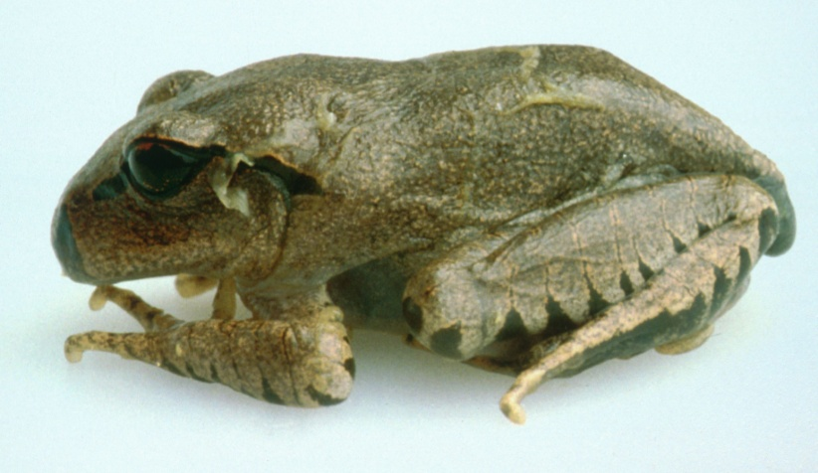
Great barred frog (Mixophyes fasciolatus) with severe infection with Batrachochytrium dendrobatidis; note pieces of shedding skin on the body
Source: L Berger

Signs of disease
Important: Animals with disease may show one or more of the signs below, but the pathogen may still be present in the absence of any signs.
Disease signs at the tank or pond level (or in the wild) are:
- lethargy
- ataxia
- paralysis
- loss of flee response
- loss of righting reflex
- abnormal sitting posture

- tetanic spasms
- nocturnal species emerging during daylight
- burrowing species remaining outside of burrows.
Gross pathological signs are:
- erythema (redness) of the ventral surface
- lesions ranging from no obvious change to sloughing (as small flakes of skin).
Note that gross changes to the skin may be seen in severe infections; however, these are not specific to the disease.
Microscopic pathological signs are:
- loss of pigmented jaw sheaths and teeth rows in tadpoles’ mouthparts
- zoosporangia in the outer epidermal layers that are seen on fresh pieces of shed skin and in histological sections
- hyperkeratosis of the epidermis in areas where zoosporangia occur.

Disease agent
The disease is caused by infection with the parasitic chytrid fungus, Batrachochytrium dendrobatidis, of the class Chytridiomycota, order Rhizophydiales.

Host range
Most, if not all, amphibians, including all members of the orders Anura (frogs and toads), Caudata (including salamanders, newts and sirens) and Gymnophiona (caecilians), appear to be susceptible to infection with B. dendrobatidis. Amphibian species differ in degree of susceptibility; some are naturally resistant.

Presence in Australia
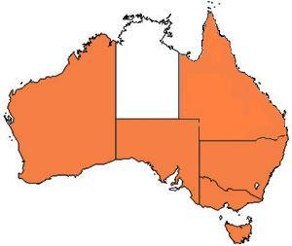
Infection with B. dendrobatidis has been officially reported across Australia in Queensland, New South Wales, the Australian Capital Territory, Victoria, South Australia, Tasmania and Western Australia. It does not occur in arid inland areas.

Epidemiology
- All age classes, except eggs, are known to be susceptible to infection. Mortality has only rarely been reported in tadpoles.
- The pathogen infects only keratinised tissues (skin of metamorphosed amphibians or the mouthparts of tadpoles).
- Some species are more resistant to B. dendrobatidis than others; some do not develop disease following infection, while others are susceptible to the disease.
- Incubation times vary from about 14 to more than 70 days, with mortalities usually occurring within 2–3 days of the first clinical signs. Mortalities have approached 100% in some Australian amphibians.
- Horizontal transmission is via waterborne, motile zoospores and is likely to be by direct animal-to-animal contact. Vertical transmission via eggs has not been demonstrated.
- Outbreaks may be associated with seasons (cooler months), altitude (most declines are generally restricted to high-altitude populations) and breeding habitat.
- Temperature affects the survival and growth of B. dendrobatidis; maximum growth occurs between 17 °C and 25 °C. The sporangia die in temperatures of 32 °C or higher. The pathogen can persist in very low host densities.
- Large-scale mortality of newly metamorphosed amphibians may indicate infection, as some species appear to be most susceptible at this time.

Differential diagnosis
The list of similar diseases below refers only to the diseases covered by this field guide. Gross pathological signs may be representative of a number of diseases not included in this guide, which therefore should not be used to provide a definitive diagnosis, but rather as a tool to help identify the listed diseases that most closely account for the gross signs.

Similar diseases
No diseases in this field guide are similar to infection with B. dendrobatidis.

Sample collection
Due to the uncertainty in differentiating diseases using only gross pathological signs, and because some aquatic animal disease agents might pose a risk to humans, only trained personnel should collect samples. You should phone your state or territory hotline number and report your observations if you are not appropriately trained. If samples have to be collected, the state or territory agency taking your call will provide advice on the appropriate course of action. Local or district fisheries or veterinary authorities may also provide advice regarding sampling.

Emergency disease hotline
The national disease hotline number is 1800 675 888. This number will put you in contact with the appropriate state or territory agency.

Further reading
The accepted procedures for a conclusive diagnosis of infection with B. dendrobatidis are summarised in the World Organisation for Animal Health Manual of diagnostic tests for aquatic animals 2011, available at www.oie.int/en/international-standard-setting/aquatic-manual/access-online.
Further information can be found on the following websites:
- Australian Government Department of Sustainability, Environment, Water, Population and Communities: www.environment.gov.au/biodiversity/threatened/publications/tap/chytrid.html
- James Cook University’s Amphibian Diseases: www.jcu.edu.au/school/phtm/PHTM/frogs/batrachochytrium.htm
- Global Bd-mapping project: http://www.spatialepidemiology.net/bd-maps.
These hyperlinks were correct and functioning at the time of publication.

