Aquatic Animal Diseases Significant to Australia:
Identification Field Guide 4th Edition

Infection with Ranavirus
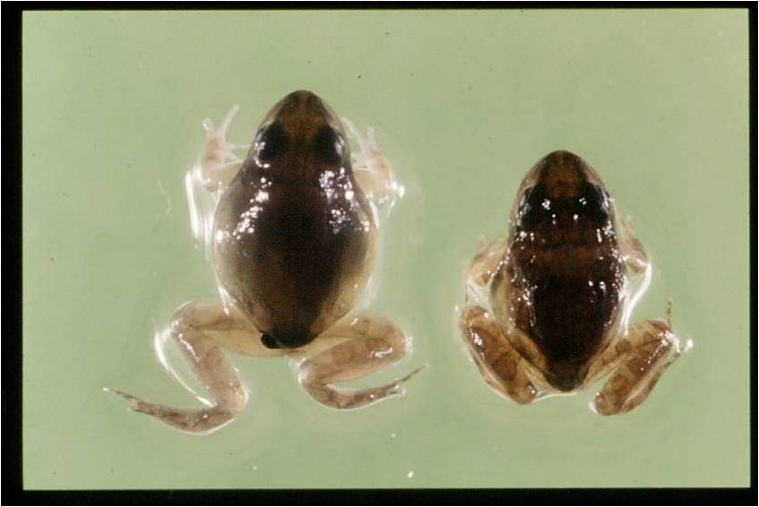
Ornate burrowing frog (Limnodynastes ornatus) metamorphs with ascites due to infection with Bohle iridovirus, a species of Ranavirus
Source: R Speare

Signs of disease
Important: Animals with disease may show one or more of the signs below, but the pathogen may still be present in the absence of any signs.
Disease signs at the tank or pond level (or in the wild) are:
- erratic swimming
- lethargy
- loss of equilibrium
- buoyancy problems
- morbidity
- rapid severe mortality events.
Note that behavioural changes differ between species, life stages and severity of disease.
Gross pathological signs are:
- poor body condition
- lordosis (abnormal forward curvature of the spine).
In tadpoles and metamorphs, additional gross pathological signs are:
- ascites (free fluid in the abdominal cavity)
- generalised oedema (fluid swelling) of tissues
- focal haemorrhages.
In adults, additional gross pathological signs are:
- skin ulcers
- focal and systematic haemorrhages
- oedema of subcutaneous tissue (particularly around the jaw and head, with the tongue protruding).
Microscopic pathological signs are:
- severe renal, pulmonary, hepatic, splenic and haematopoietic necroses and haemorrhages
- basophilic intracytoplasmic inclusion bodies
- erosion, ulceration and hyperplasia of epithelial epidermal cells.

Disease agent
The disease is caused by infection with members of the genus Ranavirus (family Iridoviridae). Species include frog virus 3 (FV-3), Bohle iridovirus (BIV), epizootic haematopoietic necrosis virus (EHNV), European catfish virus (ECV), European sheatfish virus (ESV) and Santee-Cooper ranavirus. There are many other tentative species in this genus. Bohle iridovirus is known from northern Australia in native frogs and cane toads.

Host range
Amphibians (all members of the class Amphibia) are considered to be susceptible to infection with ranavirus. Natural infections are known from most of the major families of the orders Anura (frogs and toads) and Caudata (including salamanders, newts and sirens). Infection with ranaviruses in fish and reptiles can result in asymptomatic infections through to epizootics, depending on species, stress and environmental factors.
In challenge experiments, juvenile green tree frogs (Litoria caerulea), striped burrowing frogs (L. alboguttata), short-footed frogs (Cyclorana brevipes) and red-backed toadlets (Pseudophryne corieacea) were acutely susceptible to Bohle iridovirus.
Adult red tree frogs (Litoria rubella), bumpy rocketfrog (L. inermis ), green tree frogs, ornate nursery frogs (Cophixalus ornatus), sharp-snouted day frogs (Taudactylus acutirostris) and cane toads (Bufo marinus) were less susceptible in trials (Cullen & Owens 2002).

Presence in Australia
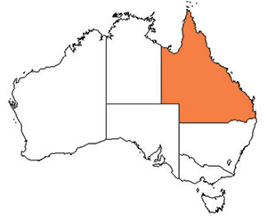
Infection with ranavirus (species type Bohle iridovirus) has been officially reported in Australia. The disease was originally isolated from tadpoles of ornate burrowing frogs (Limnodynastes ornatus) in far north Queensland. It has since been isolated from moribund green tree frogs and captive juvenile red-backed toadlets. There is serological evidence of ranavirus infection in cane toads across northern Australia.

Epidemiology
- Two syndromes in frogs are associated with ranavirus infection: ulcerative syndrome and haemorrhagic syndrome.
- The most common presentation is a rapid, severe mortality event with death due to peracute systemic haemorrhagic disease, although in Australia morbidity is more common.
- Mortality and morbidity vary from species to species (0–100%), and may be variable depending on virus type, and age and health status of the host.
- Horizontal transmission occurs via contaminated water, animal-to-animal contact and cannibalism.
- The virus can be spread between widely separated river systems and impoundments, which suggests viral persistence and the existence of transmission mechanisms other than direct horizontal transmission.
- Vertical transmission is considered likely, but has not been experimentally documented.
- Possible vectors include nets, boats and other equipment, or amphibians used for bait by recreational fishers. Birds are potential mechanical vectors.
- Temperature is considered a likely factor influencing disease outbreaks, with the prevalence or severity of outbreaks greater during warmer months.

Differential diagnosis
The list of similar diseases below refers only to the diseases covered by this field guide. Gross pathological signs may be representative of a number of diseases not included in this guide, which therefore should not be used to provide a definitive diagnosis, but rather as a tool to help identify the listed diseases that most closely account for the gross signs.

Similar diseases
No diseases in this field guide are similar to infection with ranavirus.

Sample collection
Due to the uncertainty in differentiating diseases using only gross pathological signs, and because some aquatic animal disease agents might pose a risk to humans, only trained personnel should collect samples. You should phone your state or territory hotline number and report your observations if you are not appropriately trained. If samples have to be collected, the state or territory agency taking your call will provide advice on the appropriate course of action. Local or district fisheries or veterinary authorities may also provide advice regarding sampling.

Emergency disease hotline
The national disease hotline number is 1800 675 888. This number will put you in contact with the appropriate state or territory agency.

Further reading
Cullen, BR & Owens, L 2002, ‘Experimental challenge and clinical cases of Bohle iridovirus (BIV) in native Australian anurans’, Diseases of Aquatic Organisms, vol. 49, no. 2, pp. 83–92.
The currently accepted procedures for a conclusive diagnosis of infection with ranavirus are summarised in the World Organisation for Animal Health Manual of diagnostic tests for aquatic animals 2011, available at www.oie.int/en/international-standard-setting/aquatic-manual/access-online.
This hyperlink was correct and functioning at the time of publication.

